Supporting Information
For
Diazocine functionalized TATA Platforms
Roland Löw, Talina Rusch, Fynn Röhricht, Olaf Magnussen, Rainer Herges*
Address: Otto Diels Institute for Organic Chemistry, University of Kiel, Otto-Hahn-Platz 4, 24118 Kiel, Germany, Email: Rainer Herges - rherges@oc.uni-kiel.de
Institute for Experimental and Applied Physics, University of Kiel, Leibnizstraße 19, 24098 Kiel, Germany, Olaf Magnussen - magnussen@physik.uni-kiel.de
* Corresponding author

Analytial equipment and methods, experimental procedures
and NMR spectra

Table of Contents
I. Analytical equipment and methods
II. Experimental procedures
III. NMR spectra
IV. UV/Vis absorption spectra
V. Kinetic studies in solution by ¹H NMR spectroscopy
VI. DFT Calculations

I. Analytical equipment and methods

NMR Spectroscopy
NMR spectra were measured in deuterated solvents (Deutero). All compounds were characterized using ¹H and ¹³C NMR spectroscopy. The signals were assigned using 2D spectroscopy. For ¹H and ¹³C NMR assignment we performed HSQC and HMBC. The degree of deuteration is given in parentheses. ¹H NMR spectra in reference to the following signals:

chloroform-d (99.8%): δ = 7.26 ppm. (s)
acetone-d₆ (99.5%): δ = 2.05 ppm. (quint.)
The signal multiplicities are abbreviated as follows:
s: singlet, d: doublet, dd: double doublet, t: triplet,
Measurements were performed by the following instruments:
Bruker CABAV 500neo (¹H NMR: 500 MHz, ¹³C NMR: 125 MHz, ²⁹Si NMR: 99 MHz)
Bruker AV 600 (¹H NMR: 600 MHz, ¹³C NMR: 150 MHz)

IR spectroscopy
Infrared spectra were measured on a Perkin-Elmer 1600 Series FT-IR spectrometer with an A531-G Golden-Gate-Diamond-ATR-unit. Signals were abbreviated with w, m, s and for weak, medium and strong intensities. Broad signals are additionally labeled with br.

Mass spectrometry
The high resolution (HR) mass spectra were measured with an APEX 3 FT-ICR with a 7.05 T magnet by co. Bruker Daltonics. Electron impact (EI).

Chromatrography stationary phases
For column chromatography purifications silica gel (Merck, particle size 0.040–0.063 mm) was used. R_{f} values were determined by thin layer chromatography onPolygram® Sil G/UV254 (Macherey-Nagel, 0.2 mm particle size).

II. Experimental procedures
II.1 1-Methyl-2-nitro-5-(2-(trimethylsilyl)ethynyl)-benzene (5)
In triethylamine (dry, 80 mL) 4-bromo-2-methyl-1-nitrobenzol^{[1]} 3 (6.00 g, 27.8 mmol), trimethylsilylacetylene (5.21 mL, 36.1 mmol), Pd(dppf)Cl₂ (1.02 g, 1.39 mmol, 5%) and cupper(I)iodide (530 mg, 2.78 mmol, 10%) were suspended under nitrogen atmosphere and stirred for 1 h at 60 °C. The reaction solution was filtered over celite and the solvent was removed under reduced pressure. The crude product was purified via column chromatography (silica gel, dichloromethane) to obtain an grey solid (6.14 g, 26.3 mmol, 95%).
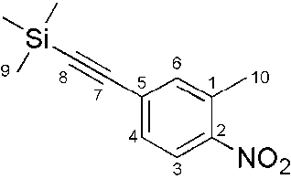
¹H NMR (500.1 MHz, CDCl₃, 298 K, TMS): δ = 7.93 (d, ³J = 8.4 Hz, 1H, H-3), 7.43 (s, 1H,
H-6), 7.40 (dd, ³J = 8.5 Hz, ⁴J = 1.6 Hz, 1H, H-4), 2.58 (s, 3H, H-10), 0.27 (s, 9H, H-9) ppm.
¹³C NMR (125.8 MHz, CDCl₃, 298 K, CH₃Cl): δ = 148.43 (s, C-2), 136.21 (s, C-6), 133.98 (s, C-1), 130.30 (s, C-4), 128.47 (s, C-5), 124.93 (s, C-3), 102.91 (s, C-7), 99.44 (s, C-8), 20.53 (s, C-10), -0.12 (s, C-9) ppm.
²⁹Si NMR (99.4 MHz, CDCl₃, 298 K): δ = -16.99 ppm.
MS (EI, 70eV): m/z = 233.09 [M]⁺.
IR (ATR): ν̃ = 2957 (w), 2159 (w), 1601 (w), 1578 (w), 1515 (s), 1479 (w), 1348 (s), 1244 (s), 949 (m), 834 (vs), 756 (s), 698 (m), 663 (s), 450 (m) cm⁻¹.
m.p. = 76.5 °C.
HRMS (EI, 70 eV): m/z [M]⁺ calcd. for C₁₂H₁₅NO₂Si: 233.08720; found: 233.08700.

II.2 Trimethyl((4-nitro-3-(4-methoxy-2-nitrophenylethyl)phenyl)acetylene (7)
In tetrahydrofurane (abs., 250 mL) 1-methyl-2-nitro-5-(2-(trimethylsilyl)ethynyl)-benzene 5 (5.00 g, 21.4 mmol) and 4-methoxy-1-methyl-2-nitrobenzene 6 (2.97 ml, 21.4 mmol) were dissolved under nitrogen atmosphere and the solution was cooled to 0 °C. Potassium butoxide (3.40 g, 27.8 mmol) was added and stirred for 3 min before addition of bromine (1.42 mL, 27.8 mmol). After stirring for 5 min, the reaction was poured onto ice/water (500 mL). The solution was extracted with dichloromethane (3x 300 mL) and the combined organic layers were washed with saturated sodium thiosulfate solution and saturated sodium chloride solution and then dried over magnesium sulfate. The solvent was removed under reduced pressure and the crude product was purified via column chromatography (silica gel, cyclohexane/ethyl acetate, 2/1) to obtain a beige solid (615 mg, 1.89 mmol, 9%).
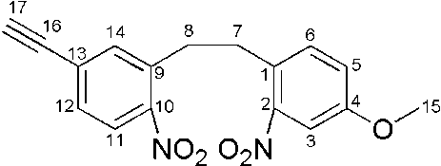
¹H NMR (500.1 MHz, CDCl₃, 298 K, TMS): δ = 7.92 (d, ³J = 8.5 Hz, 1H, H-11), 7.55 (d, ⁴J = 1.8 Hz, 1H, H-14), 7.50 (d, ⁴J = 2.7 Hz, 1H, H-3), 7.47 (dd, ³J = 8.4 Hz, ⁴J = 1.8 Hz, 1H,
H-12), 7.31 (d, ³J = 8.5 Hz, 1H, H-6), 7.11 (dd, ³J = 8.5 Hz, ⁴J = 2.7 Hz, 1H, H-5), 3.87 (s, 3H, H-15), 3.30 (s, 1H, H-17), 3.23-3.13 (m, 4H, H-7, H-8) ppm.
¹³C NMR (125.8 MHz, CDCl₃, 300 K, TMS): δ = 158.61 (s, C-4), 149.43 (s, C-2), 148.63 (s,
C-10), 136.49 (s, C-9), 136.01 (s, C-14), 133.27 (s, C-6), 130.94 (s, C-12), 127.76 (s, C-1), 127.59 (s, C-13), 124.98 (s, C-11), 120.28 (s, C-5), 109.35 (s, C-3), 81.55 (s, C-17), 55.85 (s, C-15), 34.36 (s, C-8), 33.79 (s, C-7) ppm.
MS (EI, 70eV): m/z = 326.08 [M]⁺.
IR (ATR): ν̃ = 3286 (m), 2939 (br. w), 1602 (s), 1573 (w), 1485 (vs), 1461 (m), 1309 (w), 1278 (s), 1245 (vs), 1156 (w), 1107 (w), 1037 (m), 898 (w), 865 (w), 812 (m), 658 (w), 616 (w)
cm⁻¹.
m.p. = 104.1 °C.
HRMS (EI, 70 eV): m/z [M]⁺ calcd. for C₁₇H₁₄N₂O₅: 326.09027; found: 326.09052.

II.3 (Z)-4-Ethynyl-9-methoxy-11,12-dihydrodibenzo(c,g)(1,2)-diazocine (8)
In ethanol (100 mL) trimethyl(4-nitro-3-(4-methoxy-2-nitrophenylethyl)phenyl)acetylene 7 (400 mg, 1.23 mmol) was dissolved, an aqueous solution of barium hydroxide [Ba(OH)₂.8H₂O] (1.16 g, 3.68 mmol) in H₂O (40 mL) and zinc powder (1.29 g, 19.7 mmol) were added. The reaction was refluxed for 4.75 h. The reaction mixture was filtered through celite and the solvent was removed under reduced pressure. The crude product was dissolved in dichloromethane, filtered through celite and the solvent was removed under reduced pressure. The crude product was dissolved in 0.1 M methanolic NaOH solution (120 mL), CuCl₂ (6.60 mg, 49.1 µmol) was added and air was bubbled through the solution for 6 h at room temperature. The reaction was neutralized with 1 M hydrogen chloride solution and saturated sodium bicarbonate solution (150 mL) was added. The aqueous layer was extracted with dichloromethane (3x 150 mL) and the solvent was removed under reduced pressure. The crude product was purified via column chromatography (silica gel, cyclohexane/ethyl acetate, 2/1) to obtain an orange solid (51.0 mg, 194 µmol, 16%).
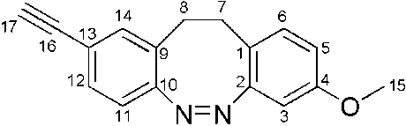
¹H NMR (500.1 MHz, acetone-d₆, 298 K, TMS): δ = 7.28 (dd, ³J = 8.1 Hz, ⁴J = 1.7 Hz, 1H,
H-12), 7.20 (d, ⁴J = 1.6 Hz, 1H, H-14), 6.97 (d, ³J = 8.4 Hz, 1H, H-6), 6.83 (d, ³J = 8.1 Hz, 1H, H-11), 6.61 (dd, ³J = 8.4 Hz, ⁴J = 2.6 Hz, 1H, H-5), 6.39 (d, ⁴J = 2.7 Hz, 1H, H-3), 3.71 (s, 3H, H-15), 3.59 (s, 1H, H-17), 2.87-2.81 (m, 4H, H-7, H-8) ppm.
¹³C NMR (125.8 MHz, acetone-d₆, 298 K, acetone): δ = 159.44 (s, C-4), 157.41 (s, C-2), 156.85 (s, C-10), 134.12 (s, C-14), 131.82 (s, C-6), 131.10 (s, C-12), 130.21 (s, C-9), 121.72 (s, C-13), 120.61 (s, C-1), 119.68 (s, C-11), 113.61 (s, C-5), 104.60 (s, C-3), 83.52 (s, C-16), 79.25 (s, C-17), 55.66 (s, C-15), 31.86 (s, C-8), 31.10 (s, C-7) ppm.
MS (EI, 70eV): m/z = 262.11 [M]⁺.
IR (ATR): ν̃ = 3275 (m), 1605 (w), 1493 (s), 1393 (w), 1251 (m), 1143 (w), 1065 (w), 1030 (vs), 999 (s), 899 (w), 811 (vs), 671 (s), 616 (s), 509 (s) cm⁻¹.
m.p. = 133.8 °C.
HRMS (EI, 70 eV): m/z [M]+ calcd. for C₁₇H₁₄N₂O: 262.11061; found: 262.11019.

II.4 (Z)-12c-(4-Ethynyl-9-methoxy-11,12-dihydrodibenzo(c,g)(1,2)diazocin-10-yl)ethynyl-4,8,12-tri-n-octyl-4,8,12-triazatriangulene (1)
In tetrahydrofurane (abs., 30 mL) (Z)-4-ethynyl-9-methoxy-11,12-dihydrodibenzo(c,g)(1,2)-diazocine 8 (46.0 mg, 175 µmol), octyl-TATA-BF₄^{[2]} 9 (161 mg, 228 µmol) and powdered potassium hydroxide (105 mg, 1.87 mmol) were suspended under nitrogen atmosphere and refluxed for 3.5 h. The reaction was poured onto saturated sodium chloride solution (20 mL) and the aqueous layer was extracted with diethyl ether (3x 30 mL). The combined organic layers were dried over magnesium sulfate and the solvent was removed under reduced pressure. The crude product was purified via column chromatography (aluminium oxide, basic, diethylether) to obtain an orange solid (153 mg, 174 µmol, 99%).
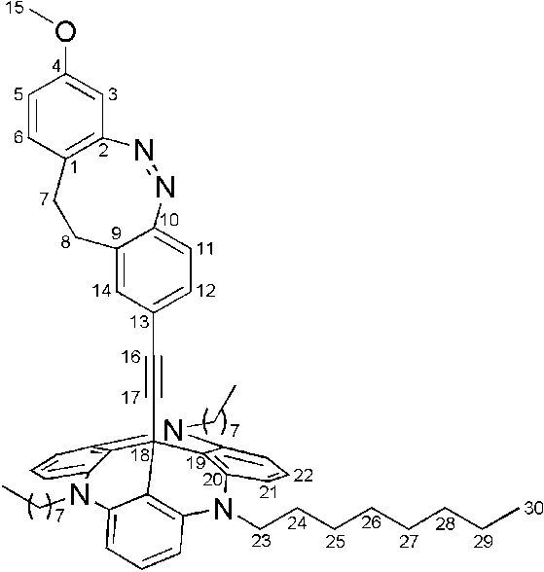
¹H NMR (500.1 MHz, acetone-d₆, 298 K, TMS): δ = 7.18 (t, ³J = 8.3 Hz, 3H, H-22), 6.85-6.80 (m, 2H, H-6, H-12), 6.72 (d, ⁴J = 1.6 Hz, 1H, H-14), 6.65-6.60 (m, 7H, H-11, H-21), 6.47 (dd, ³J = 8.4 Hz, ⁴J = 2.7 Hz, 1H, H-5), 6.26 (d, ⁴J = 2.6 Hz, 1H, H-3), 3.99-3.93 (ps. t, 6H, H-23), 3.63 (s, 3H, H-15), 2.76-2.62 (m, 4H, H-7, H-8), 1.84-1.77 (ps. sechst., 6H, H-24), 1.52-1.45 (ps. pent., 6H, H-25), 1.41-1.21 (m, 24H, H-26, H-27, H-28, H-29), 0.90-0.85 (ps. t, 9H, H-30) ppm.
¹³C NMR (125.8 MHz, acetone-d₆, 298 K, acetone): δ = 159.31 (s, C-4), 157.40 (s, C-2), 156.04 (s, C-10), 141.34 (s, C-20), 133.14 (s, C-14), 131.61 (s, C-6), 130.32 (s, C-12), 129.81 (s, C-9), 129.38 (s, C-22), 123.01 (s, C-13), 120.62 (s, C-1), 119.25 (s, C-11), 113.28 (s, C-5), 110.82 (s, C-19), 106.03 (s, C-21), 104.50 (s, C-3), 94.77 (s, C-17), 83.72 (s, C-16), 55.56 (s, C-15), 46.72 (s, C-23), 32.58 (s, C-29), 31.77 (s, C-8), 31.01 (s, C-7), 30.11 (s, C-26), 30.06 (s, C-27), 27.43 (s, C-25), 26.62 (s, C-24), 23.33 (s, C-28), 14.40 (s, C-30) ppm.
MS (MALDI-TOF, Cl-CCA): m/z = 879.6 [M]⁺.
IR (ATR): ν̃ = 2924 (m), 2852 (m), 1614 (vs), 1579 (vs), 1482 (vs), 1457 (vs), 1393 (vs), 1267 (m), 1242 (s), 1167 (s), 1145 (m), 1036 (w), 895 (w), 809 (w), 772 (m), 748 (m), 726 (s), 657 (w) cm⁻¹.

II.5 Trimethyl((3-nitro-4-(5-methoxy-2-nitrophenylethyl)phenyl)acetylene (12)
In tetrahydrofurane (abs., 280 mL) 1-methyl-2-nitro-4-(2-(trimethylsilyl)ethynyl)-benzene^{[3]} 10 (6.00 g, 25.7 mmol) and 4-methoxy-2-methyl-1-nitrobenzene 11 (6.45 g, 30.9 mmol) were dissolved under nitrogen atmosphere and cooled to 0 °C. Potassium butoxide (4.40 g, 36.0 mmol) was added and stirred for 3 min before addition of bromine (1.84 mL, 36.0 mmol). After stirring for 5 min, the reaction was poured onto ice/water (500 mL). The solution was extracted with dichloromethane (3x 300 mL) and the combined organic layers were washed with saturated sodium thiosulfate solution and saturated sodium chloride solution and then dried over magnesium sulfate. The solvent was removed under reduced pressure and the crude product was purified via column chromatography (silica gel, cyclohexane/ethyl acetate, 2/1) to obtain a beige solid (817 mg, 2.50 mmol, 10%).
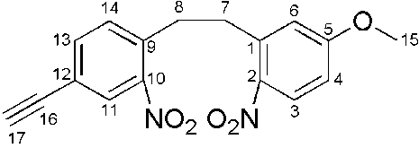
¹H NMR (600.1 MHz, CDCl₃, 298 K, TMS): δ = 8.10 (d, ³J = 9.0 Hz, 1H, H-3), 8.06 (d, ⁴J = 1.6 Hz, 1H, H-11), 7.63 (dd, ³J = 8.0 Hz, 1H, H-13), 7.44 (d, ³J = 7.9 Hz, 1H, H-14), 6.85 (dd, ³J = 9.1 Hz, ⁴J = 2.8 Hz, 1H, H-4), 6.83 (d, ⁴J = 2.8 Hz, 1H, H-6), 3.88 (s, 3H, H-15), 3.30-3.21 (m, 4H, H-7, H-8), 3.18 (s, 1H, H-17) ppm.
¹³C NMR (150.9 MHz, CDCl₃, 298 K, TMS): δ = 163.40 (s, C-5), 149.01 (s, C-10), 141.85 (s, C-2), 139.20 (s, C-1), 136.67 (s, C-9), 136.38 (s, C-13), 132.67 (s, C-14), 128.24 (s, C-11), 127.97 (s, C-3), 121.96 (s, C-12), 116.85 (s, C-4), 112.97 (s, C-6), 81.00 (s, C-16), 79.56 (s, C-17), 55.89 (s, C-15), 35.37 (s, C-7), 34.14 (s, C-8) ppm.
MS (EI, 70eV): m/z = 326.06 [M]⁺.
]⁺. IR (ATR): ν̃ = 3274 (m), 1601 (m), 1586 (m), 1548 (w), 1521 (s), 1500 (s), 1455 (w), 1343 (m), 1327 (vs), 1298 (w), 1258 (vs), 1211 (m), 1077 /m), 1069 (m), 1030 (m), 896 (m), 870 (m), 831 (m), 804 (m), 762 (m), 699 (m) cm⁻¹.
m.p. = 127.1 °C.
HRMS (EI, 70 eV): m/z [M]⁺ calcd. for C₁₇H₁₄N₂O₅: 326.09027; found: 326.09068.

II.6 (Z)-3-Ethynyl-10-methoxy-11,12-dihydrodibenzo(c,g)(1,2)-diazocine (13)
In ethanol (80 mL) trimethyl(3-nitro-4-(5-methoxy-2-nitrophenylethyl)phenyl)acetylene 12 (396 mg, 1.21 mmol) was dissolved, an aqueous solution of barium hydroxide [Ba(OH)₂.8H₂O] (1.15 g, 3.64 mmol) in H₂O (34 mL) and zinc powder (1.27 g, 19.4 mmol) were added. The reaction was refluxed for 4.75 h. The reaction mixture was filtered through celite and the solvent was removed under reduced pressure. The crude product was dissolved in dichloromethane (50 mL), filtered through celite and the solvent was removed under reduced pressure. The crude product was dissolved in 0.1 M sodium hydroxide solution in methanol (120 mL), CuCl₂ (6.5 mg, 48 µmol) was added and air was bubbled through the solution for 13 h at room temperature. The reaction was neutralized with 1 M hydrogen chloride solution and saturated sodium bicarbonate solution (200 mL) was added. The aqueous layer was extracted with dichloromethane and the solvent was removed under reduced pressure. The crude product was purified via column chromatography (silica gel, cyclohexane/ethyl acetate, 2/1) to obtain an orange solid (69.0 mg, 263 µmol, 22%).
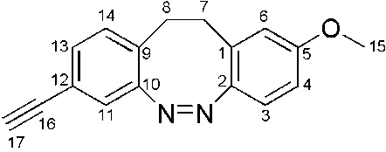
¹H NMR (500.1 MHz, CDCl₃, 298 K, TMS): δ = 7.15 (dd, ³J = 7.9 Hz, ⁴J = 1.6 Hz, 1H, H-13), 6.96 (d, ³J = 7.8 Hz, 1H, H-14), 6.94 (d, ⁴J = 1.6 Hz, 1H, H-11), 6.83 (d, ³J = 8.7 Hz, 1H, H-3), 6.69 (dd, ³J = 8.6 Hz, ⁴J = 2.6 Hz, 1H, H-4), 6.49 (d, ⁴J = 2.6 Hz, 1H, H-6), 3.71 (s, 3H, H-15), 3.03 (s, 1H, H-17), 2.85 (m, 4H, H-7, H-8) ppm.
¹³C NMR (125.8 MHz, CDCl₃, 298 K, TMS): δ = 158.36 (s, C-5), 155.27 (s, C-10), 148.95 (s,
C-2), 130.61 (s, C-13), 129.64 (s, C-14), 129.46 (s, C-9), 129.15 (s, C-1), 122.37 (s, C-11), 120.94 (s, C-3), 120.54 (s, C-12), 114.77 (s, C-6), 111.98 (s, C-4), 82.71 (s,
C-16), 77.62 (s, C-17), 55.27 (s, C-15), 32.08 (s, C-7), 31.47 (s, C-8) ppm.
MS (EI, 70eV): m/z = 262.11 [M]⁺.
IR (ATR): ν̃ = 3265 (m), 2919 (br. w), 2851 (w), 1609 (w), 1575 (m), 1483 (s), 1464 (m), 1427 (m), 1308 (m), 1259 (vs), 1154 (m), 1110 (m), 1040 (m), 864 (m), 819 (m), 798 (vs), 703 (m), 613 (s), 586 (s) cm⁻¹.
m.p. = 112.1 °C.
HRMS (EI, 70 eV): m/z [M]+ calcd. for C₁₇H₁₄N₂O: 262.11061; found: 262.11016.

II.7 (Z)-12c-(3-Ethynyl-10-methoxy-11,12-dihydrodibenzo(c,g)(1,2)diazocin-10-yl)ethynyl-4,8,12-tri-n-octyl-4,8,12-triazatriangulene (2)
In tetrahydrofurane (abs., 10 mL) (Z)-3-ethynyl-10-methoxy-11,12-dihydrodibenzo(c,g)(1,2)-diazocine 13 (20.0 mg, 76.2 µmol), octyl-TATA-BF₄^{[2]} 9 (64.6 mg, 91.5 µmol) and powdered potassium hydroxide (34.2 mg, 610 µmol) were suspended under nitrogen atmosphere and refluxed for 2 h. The reaction was poured onto saturated sodium chloride solution (30 mL) and extracted with diethylether (3x 25 mL). The combined organic layers were dried over magnesium sulfate and the solvent was removed under reduced pressure. The crude product was purified via column chromatography (aluminium oxide, basic, diethylether) to obtain an orange solid (59.0 mg, 67.0 µmol, 88%).
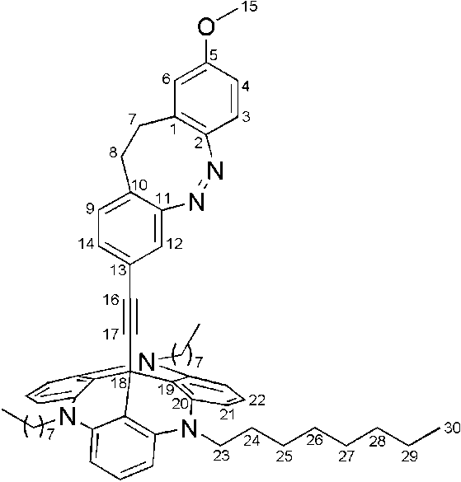
¹H NMR (500.1 MHz, acetone-d₆, 298 K, TMS): δ = 7.18 (t, ³J = 8.24 Hz, 3H, H-22), 6.89 (d, ³J = 8.0 Hz, 1H, H-9), 6.71 (dd, ³J = 8.0 Hz, ⁴J= 1.7 Hz, 1H, H-14), 6.68 (d, ³J = 8.5 Hz, 1H, H-3), 6.65-6.60 (m, 7H, H-4, H-21), 6.52 (d, ⁴J = 2.6 Hz, 1H, H-6), 6.44 (d, ⁴J = 1.6 Hz, 1H,
H-12), 3.99-3.93 (ps. t, 6H, H-23), 3.63 (s, 3H, H-15), 2.78-2.69 (m, 4H, H-7, H-8), 1.85-1.76 (ps. pent., 6H, H-24), 1.52-1.44 (ps. pent., 6H, H-25), 1.41-1.22 (m, 24H, H-26, H-27, H-28, H-29), 0.90-0.85 (ps. t, 9H, H-30) ppm.
¹³C NMR (125.8 MHz, acetone-d₆, 298 K, acetone): δ = 159.25 (s, C-5), 156.54 (s, C-11), 150.00 (s, C-2), 141.36 (s, C-20), 130.52 (s, C-9), 130.38 (s, C-14), 130.27 (s, C-1), 129.44 (s, C-10), 129.38 (s, C-22), 122.89 (s, C-13), 121.52 (s, C-12), 121.15 (s,
C-3), 115.65 (s, C-6), 112.54 (s, C-4), 110.86 (s, C-19), 106.05 (s, C-21), 95.09 (s,
C-17), 83.45 (s, C-16), 55.48 (s, C-15), 46.67 (s, C-23), 32.57 (s, C-29), 32.38 (s,
C-7), 31.73 (s, C-8), 30.10 (s, C-26), 30.05 (s, C-27), 27.43 (s, C-25), 26.65 (s, C-24), 23.32 (s, C-28), 14.40 (s, C-30) ppm.
MS (MALDI-TOF): m/z = 879.6 [M]⁺.
IR: ν̃ = 2924 (s), 2852 (m), 1614 (s), 1579 (vs), 1482 (vs), 1457 (vs), 1393 (vs), 1374 (m), 1243 (s), 1167 (s), 1039 (w), 911 (w), 807 (w), 772 (m), 750 (s), 724 (s), 657 (w) cm⁻¹.

III. NMR Spectra
III.1 1-methyl-2-nitro-5-(2-(trimethylsilyl)ethynyl)-benzene
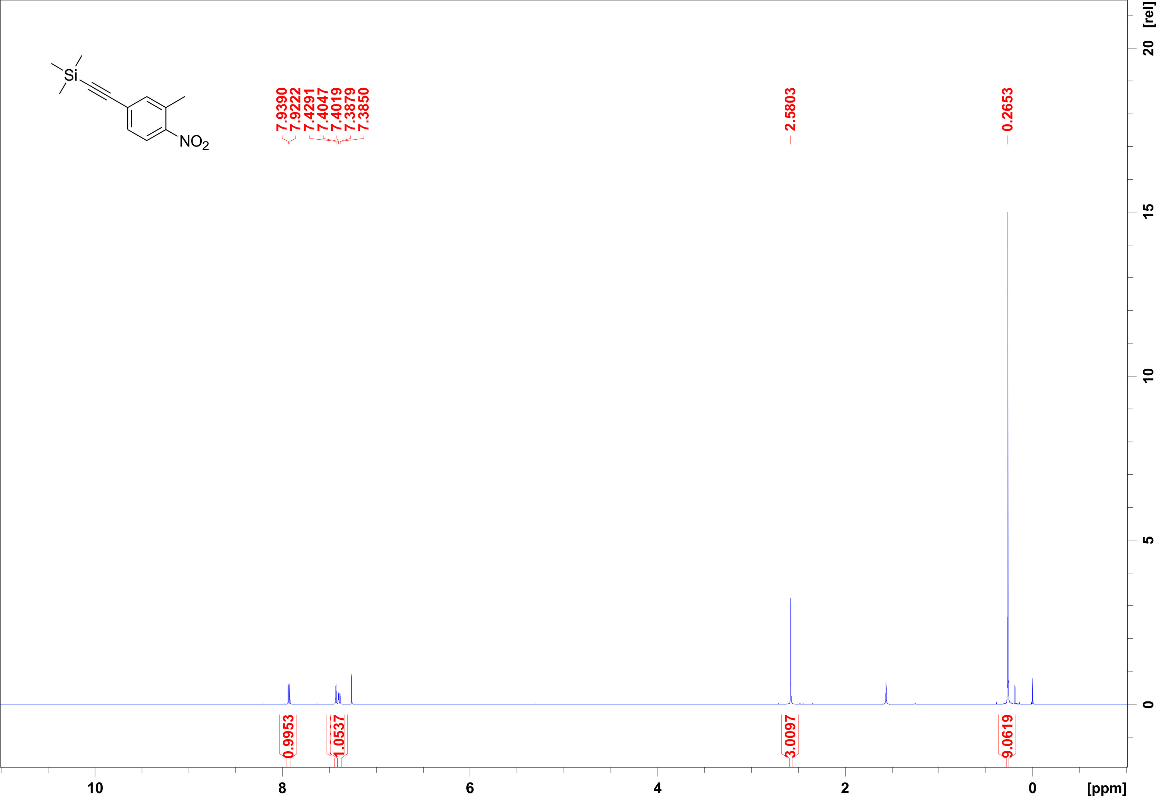
Figure S1. ¹H NMR spectrum (500.1 MHz, CDCl₃) of compound 5.
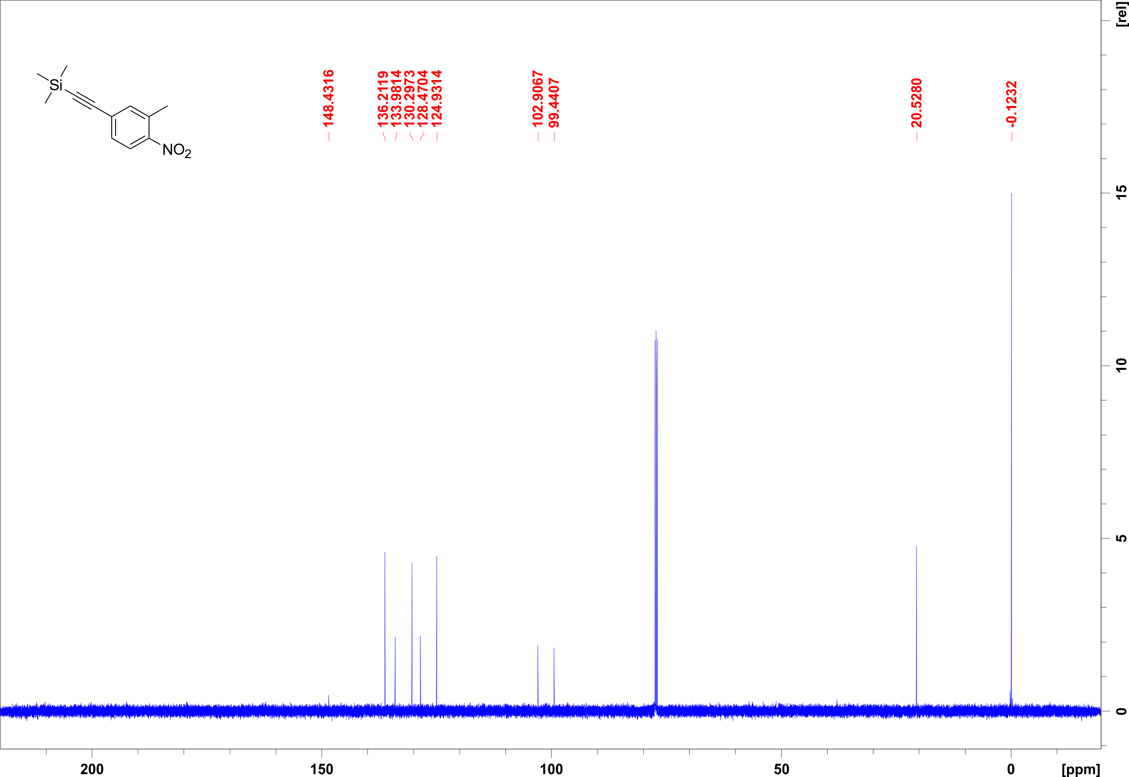
Figure S2. ¹H NMR spectrum (125.8 MHz, CDCl₃) of compound 5.
III.2 Trimethyl((4-nitro-3-(4-methoxy-2-nitrophenylethyl)phenyl)acetylene
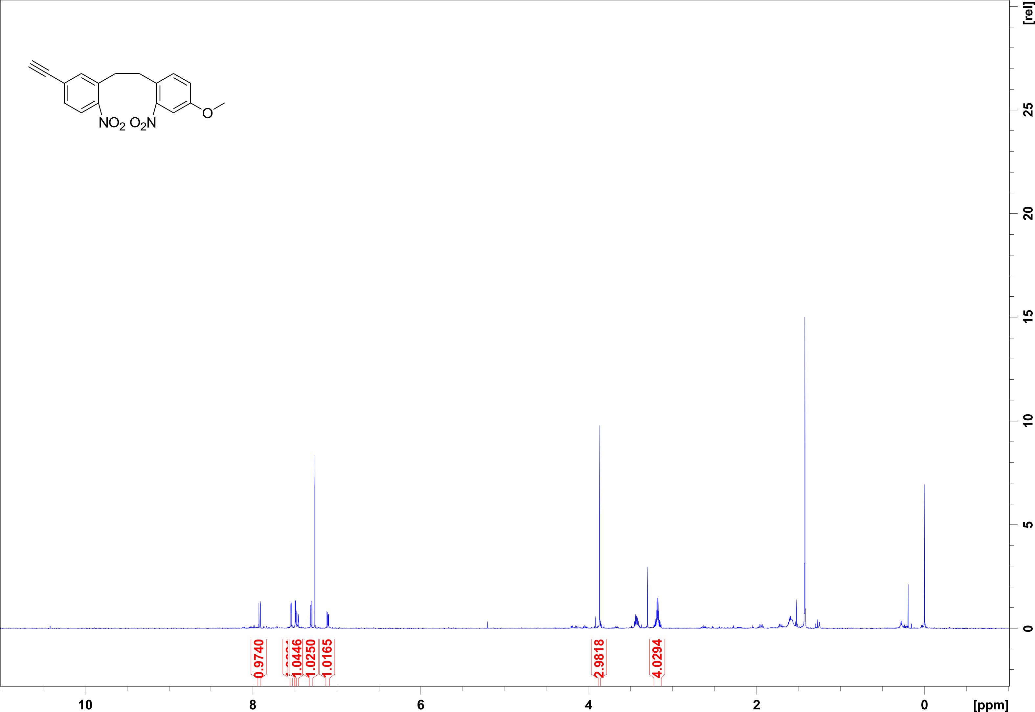
Figure S3. ¹H NMR spectrum (500.1 MHz, CDCl₃) of compound 7.
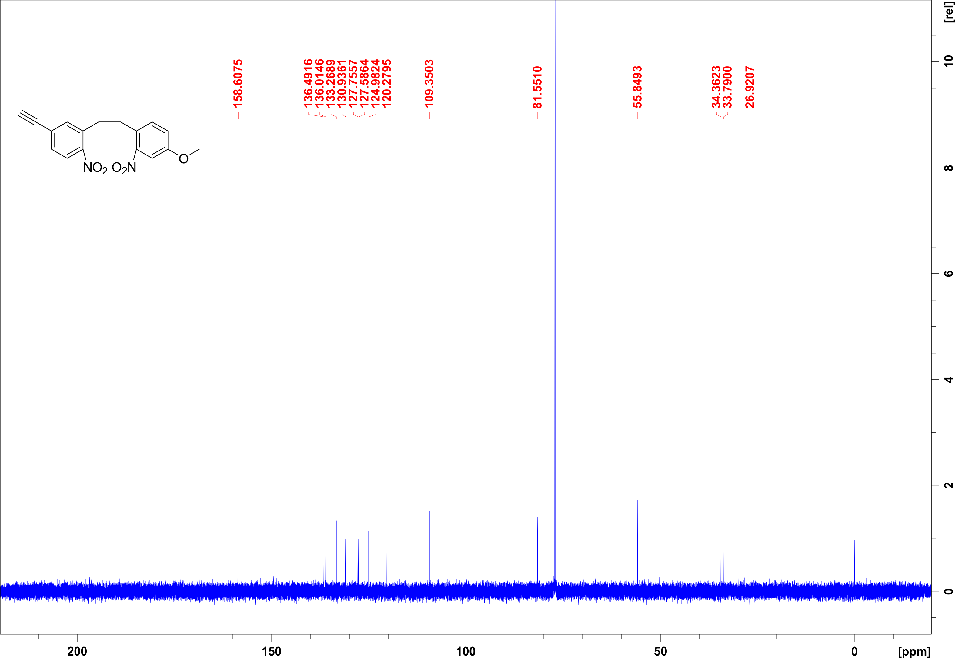
Figure S4. ¹H NMR spectrum (125.8 MHz, CDCl₃) of compound 7.
III.3 (Z)-4-ethynyl-9-methoxy-11,12-dihydrodibenzo(c,g)(1,2)-diazocine
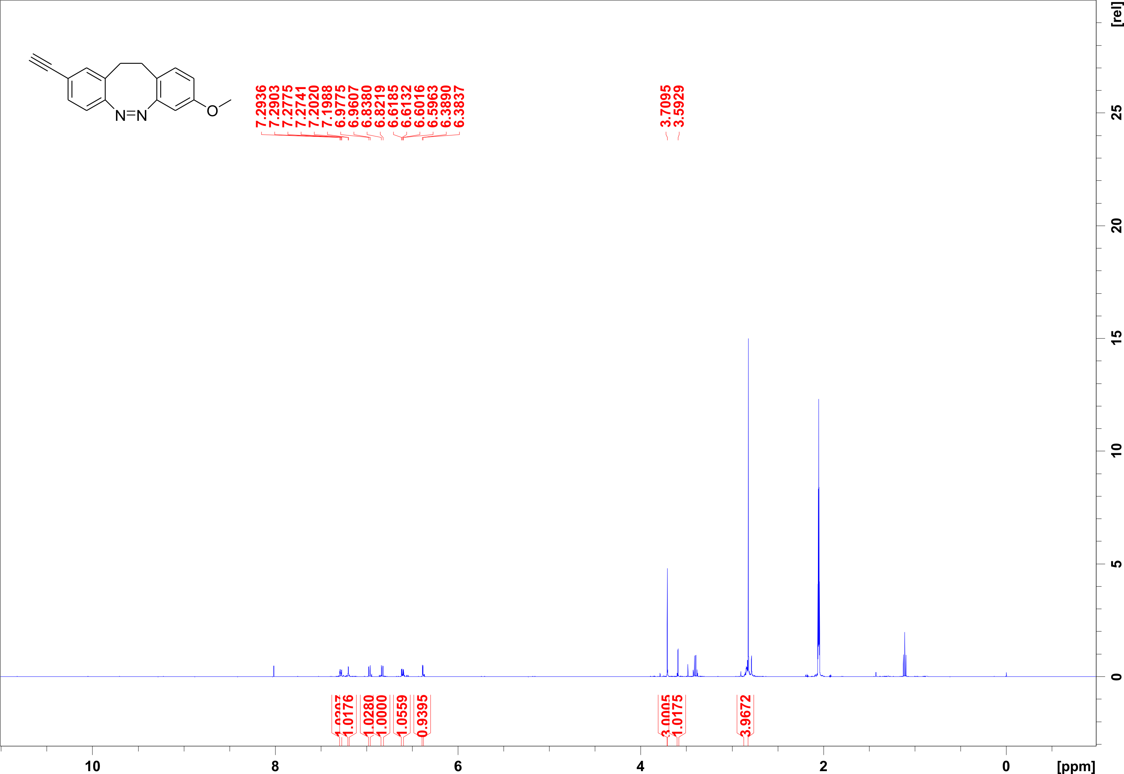
Figure S5. ¹H NMR spectrum (500.1 MHz, acetone-d₆) of compound 8.
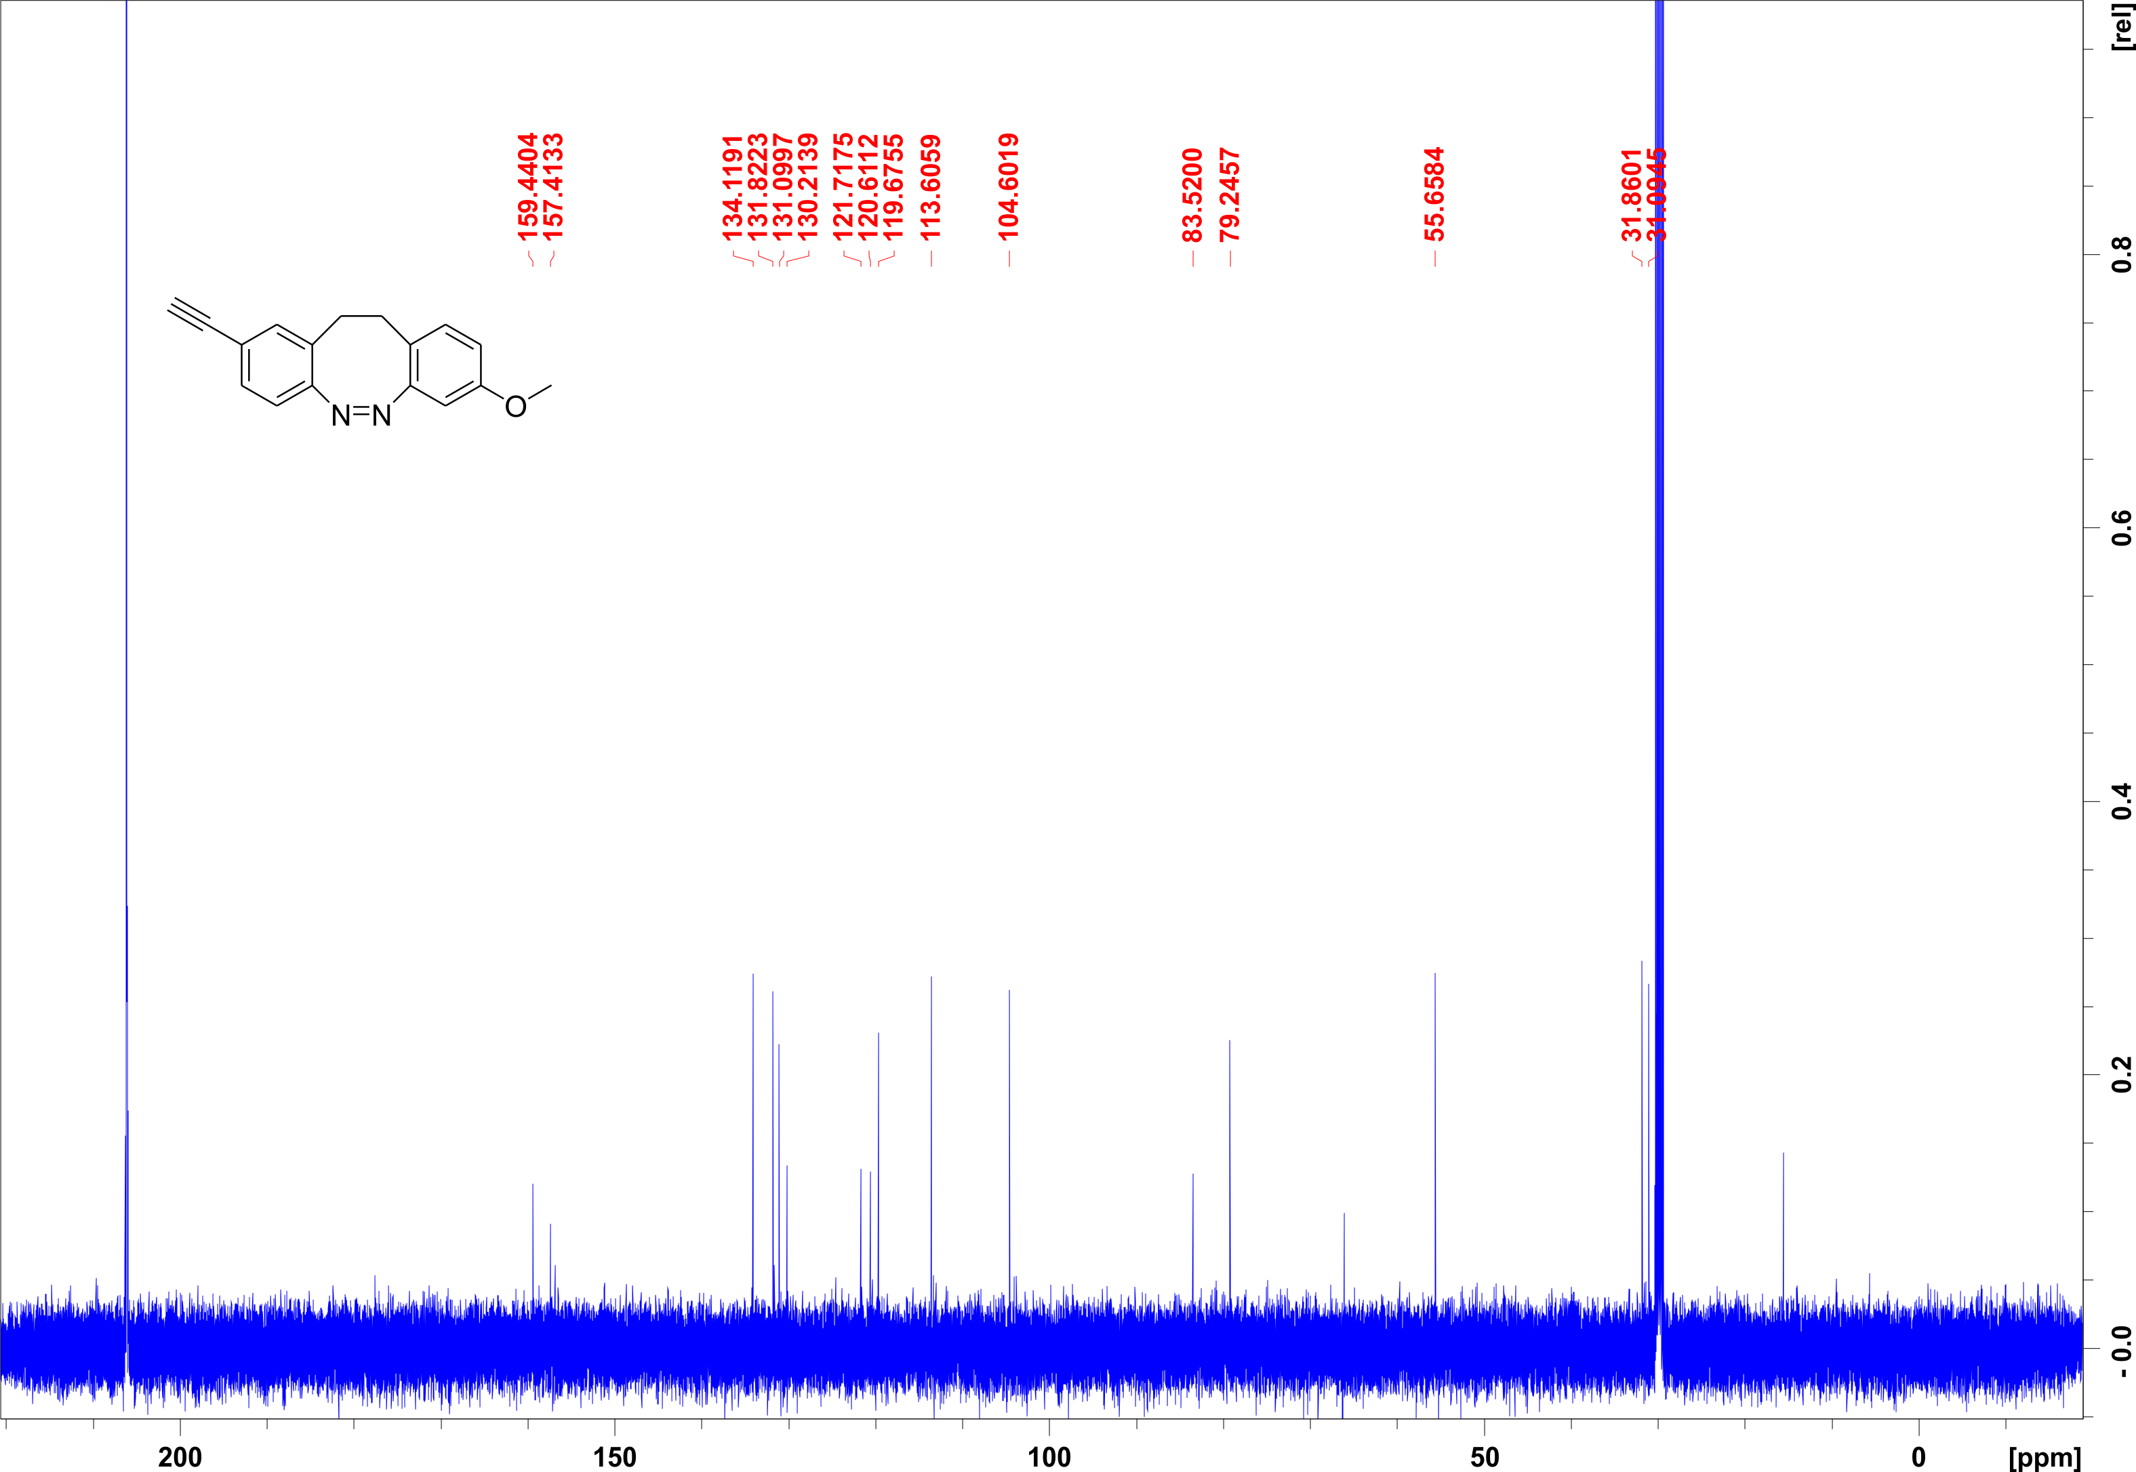
Figure S6. ¹H NMR spectrum (125.8 MHz, acetone-d₆) of compound 8.
III.4 (Z)-12c-(4-ethynyl-9-methoxy-11,12-dihydrodibenzo(c,g)(1,2)diazocin-10-yl)ethynyl-4,8,12-tri-n-octyl-4,8,12-triazatriangulene
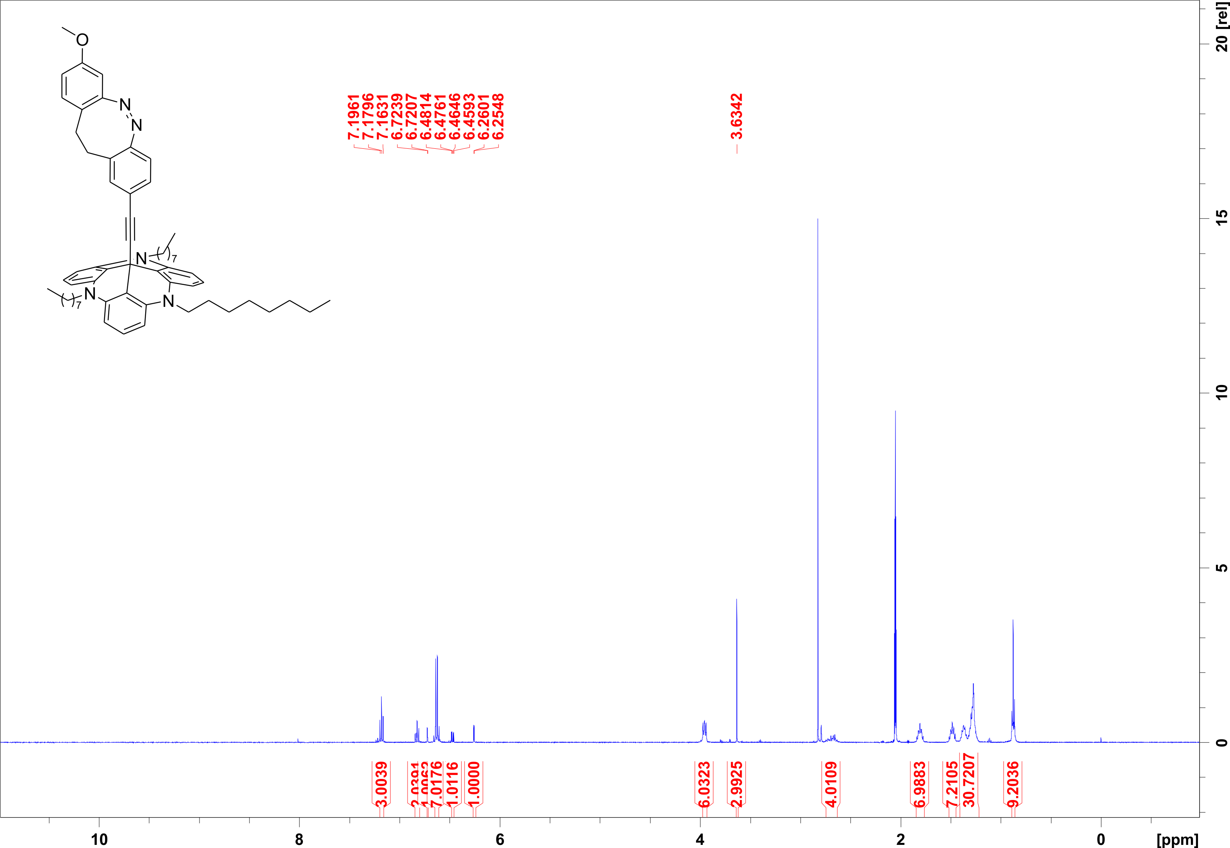
Figure S7. ¹H NMR spectrum (500.1 MHz, acetone-d₆) of compound 1.
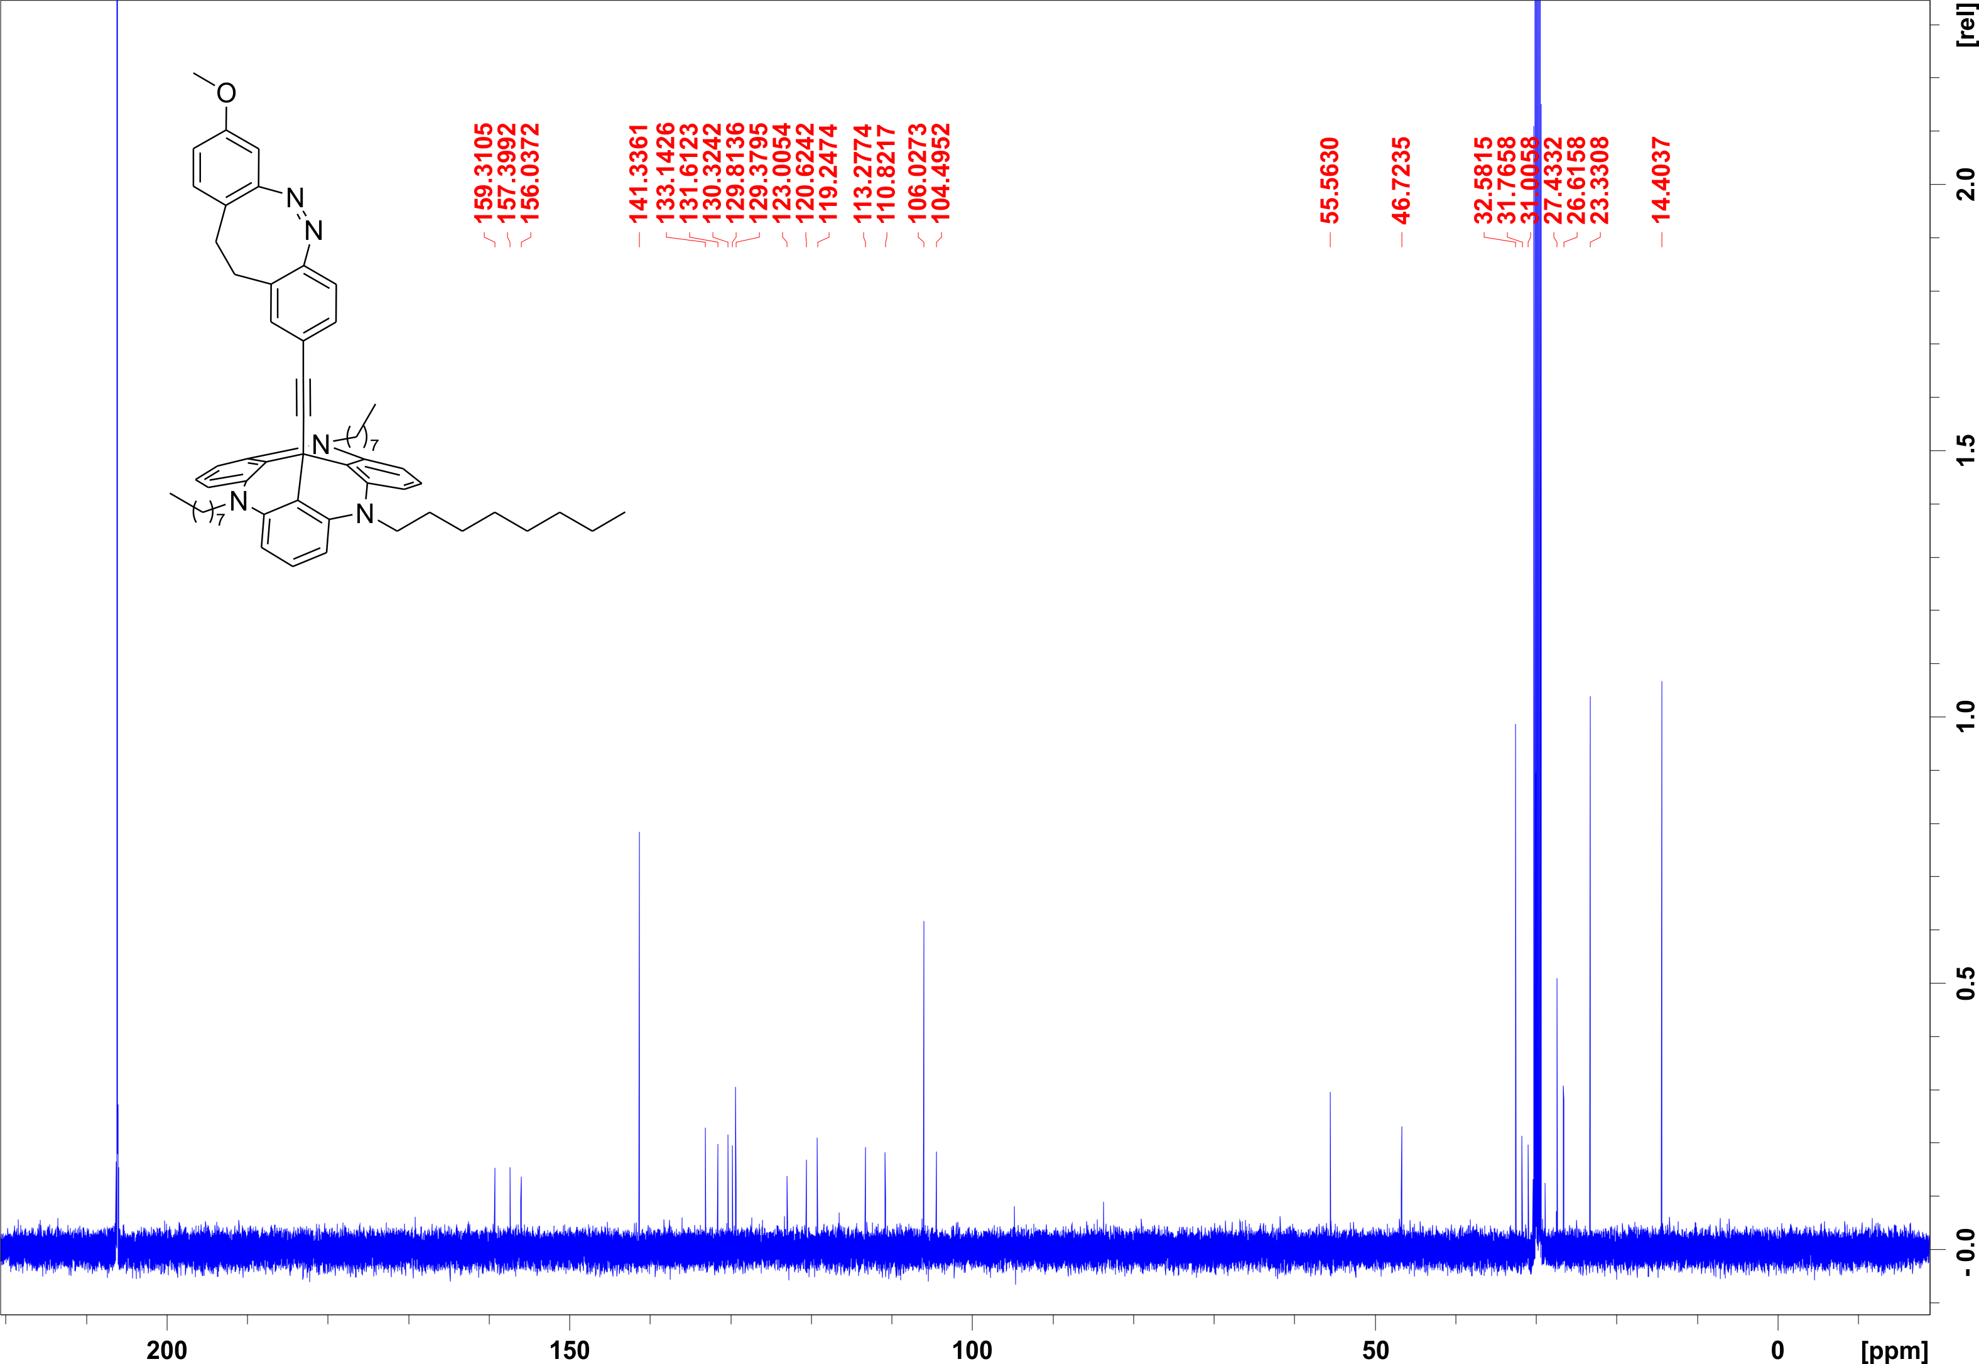
Figure S8. ¹H NMR spectrum (125.8 MHz, acetone-d₆) of compound 1.

III.5 Trimethyl((3-nitro-4-(5-methoxy-2-nitrophenylethyl)phenyl)acetylene
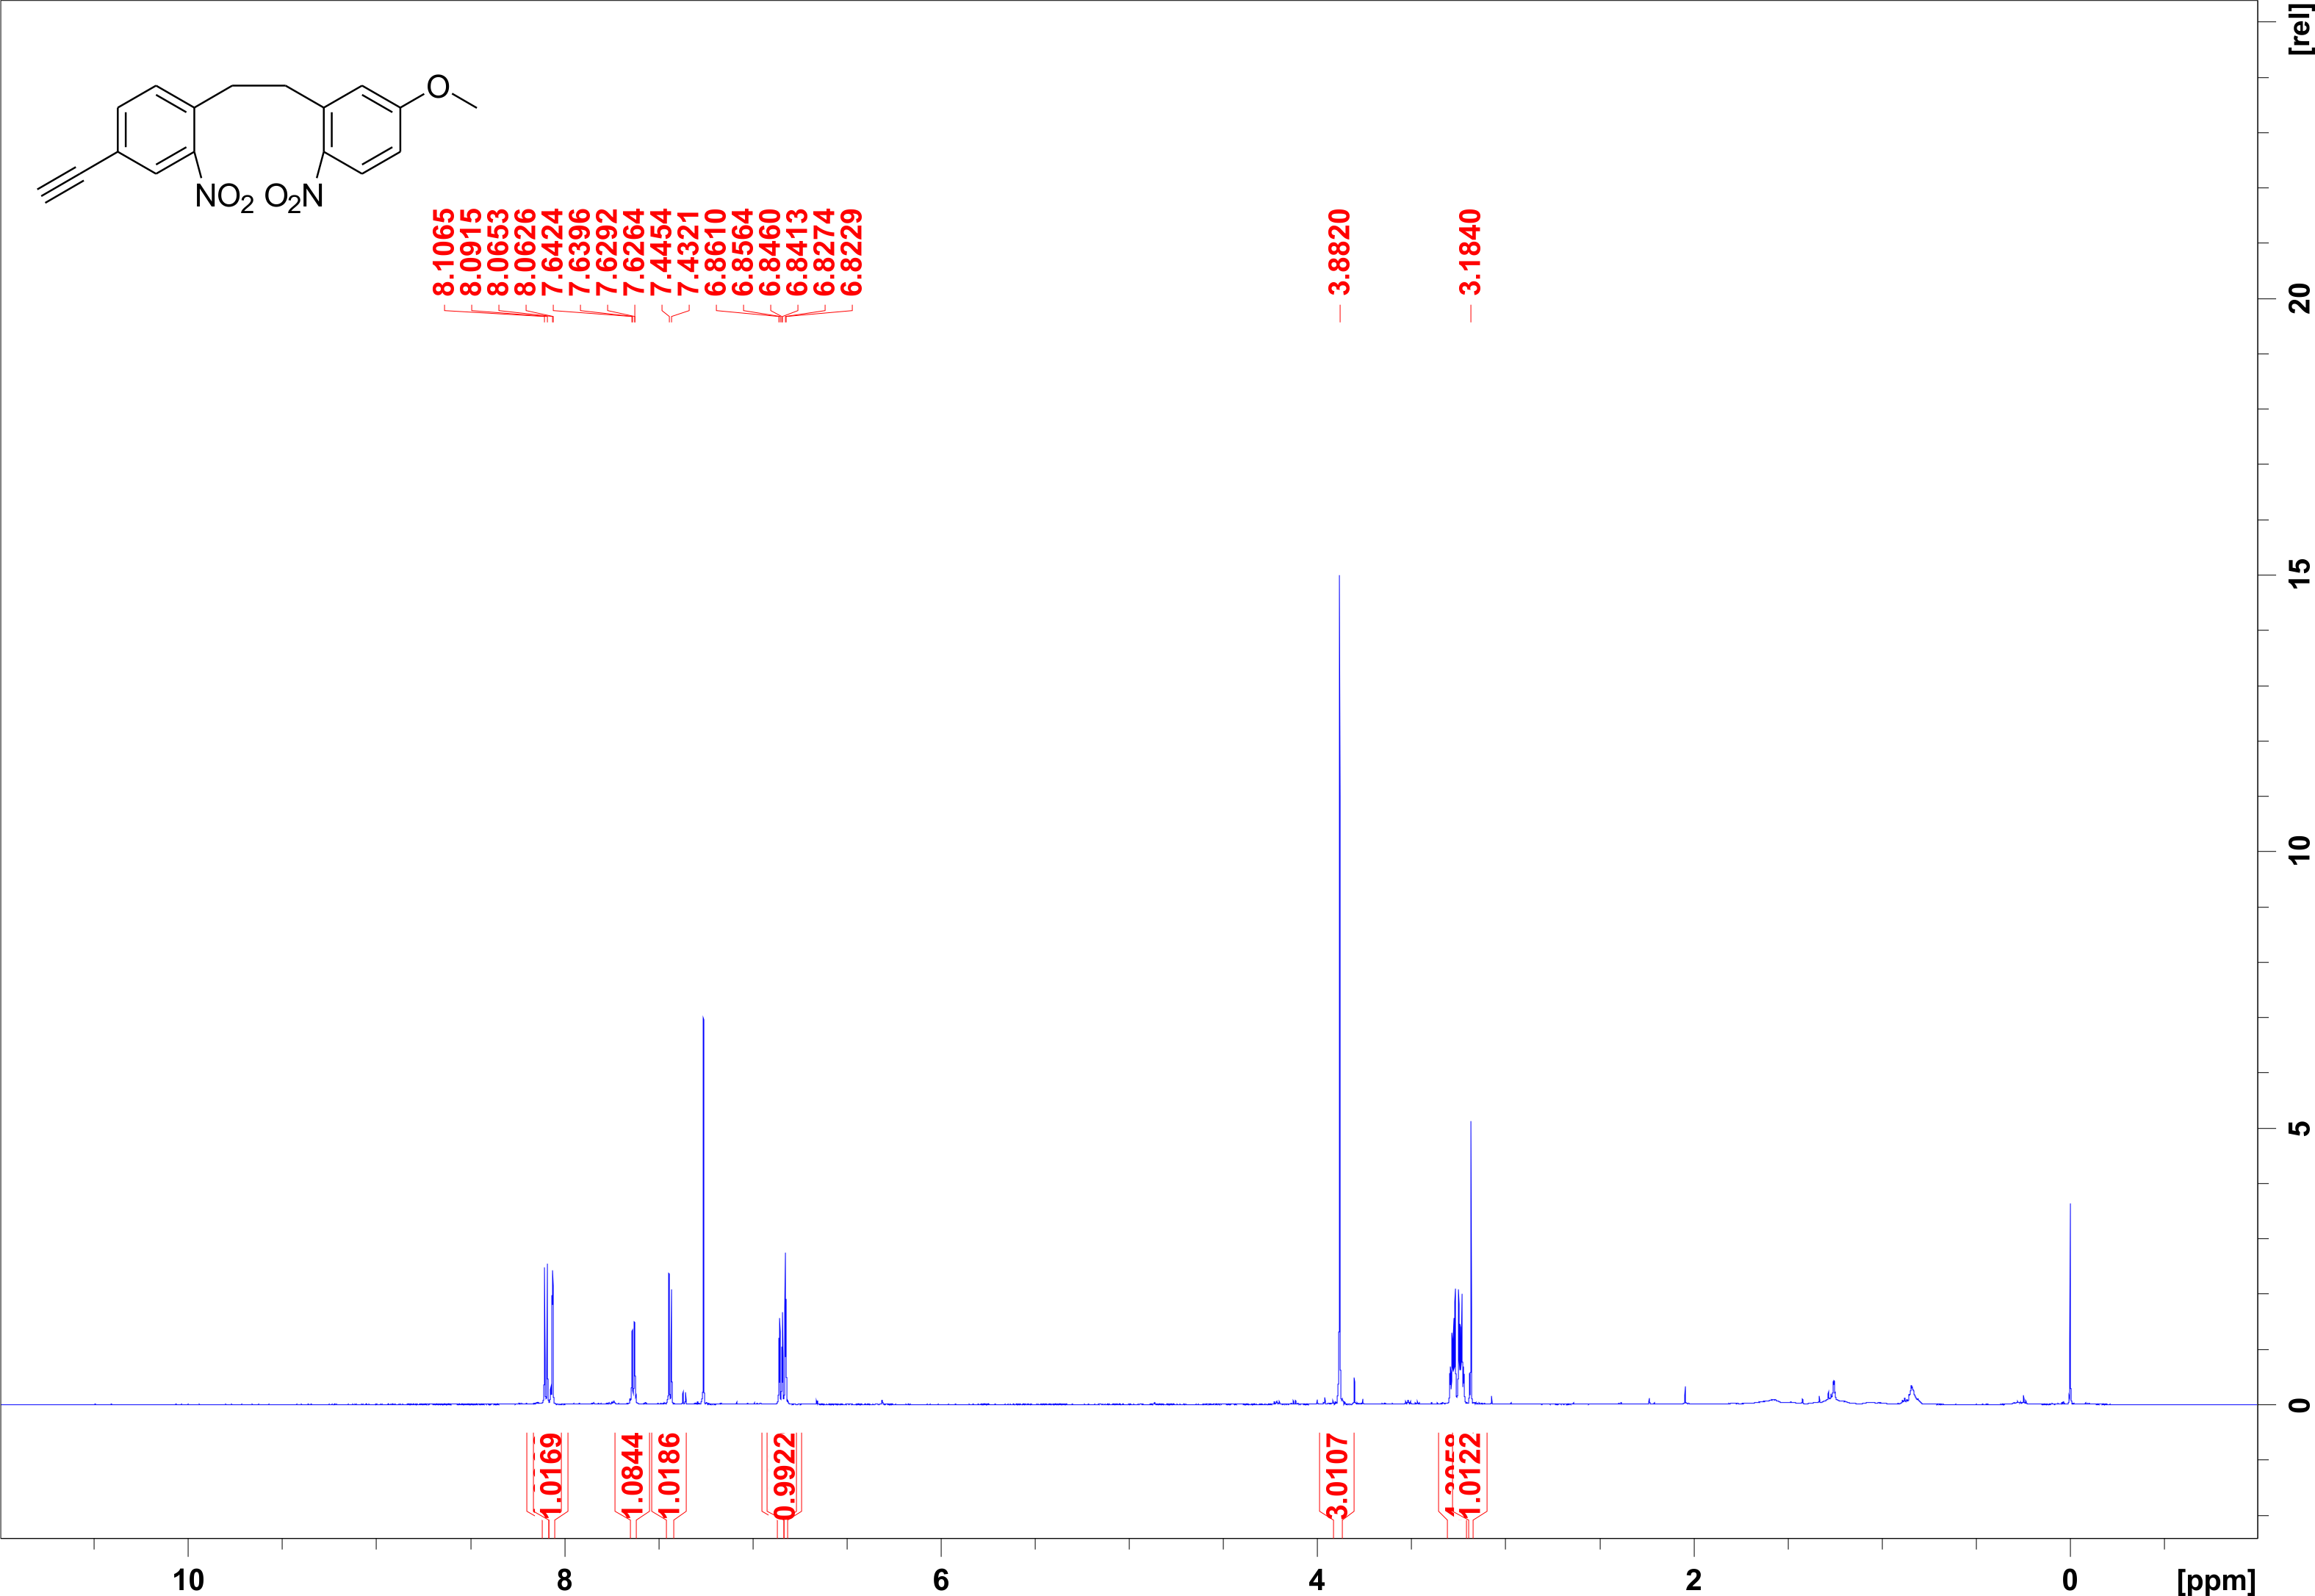
Figure S9. ¹H NMR spectrum (600.1 MHz, CDCl₃) of compound 12.
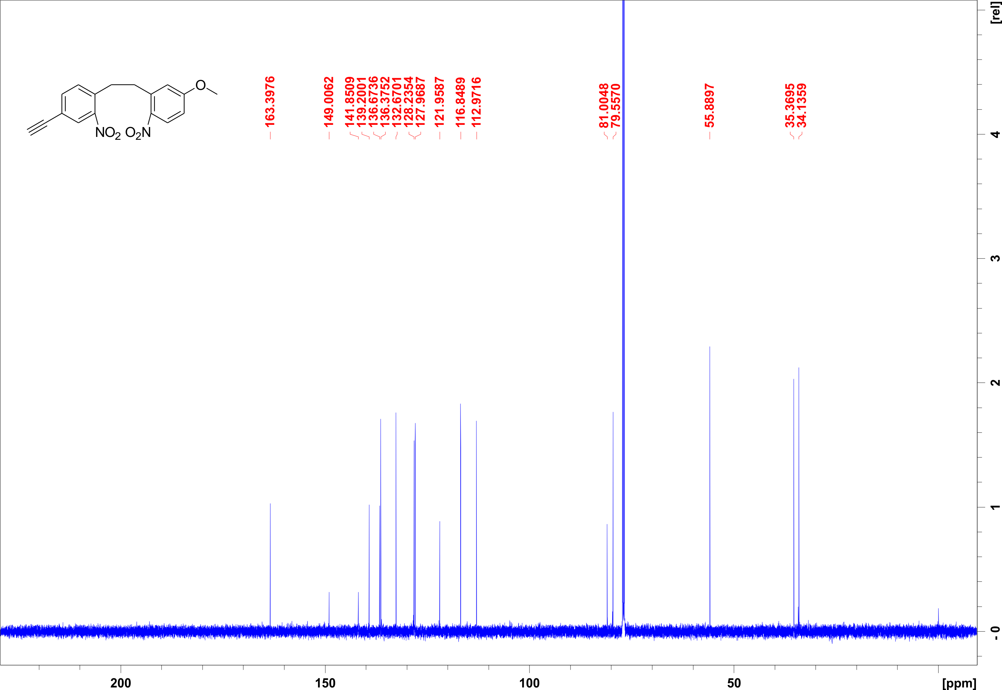
Figure S10. ¹H NMR spectrum (150.9 MHz, CDCl₃) of compound 12.
III.6 (Z)-3-ethynyl-10-methoxy-11,12-dihydrodibenzo(c,g)(1,2)-diazocine
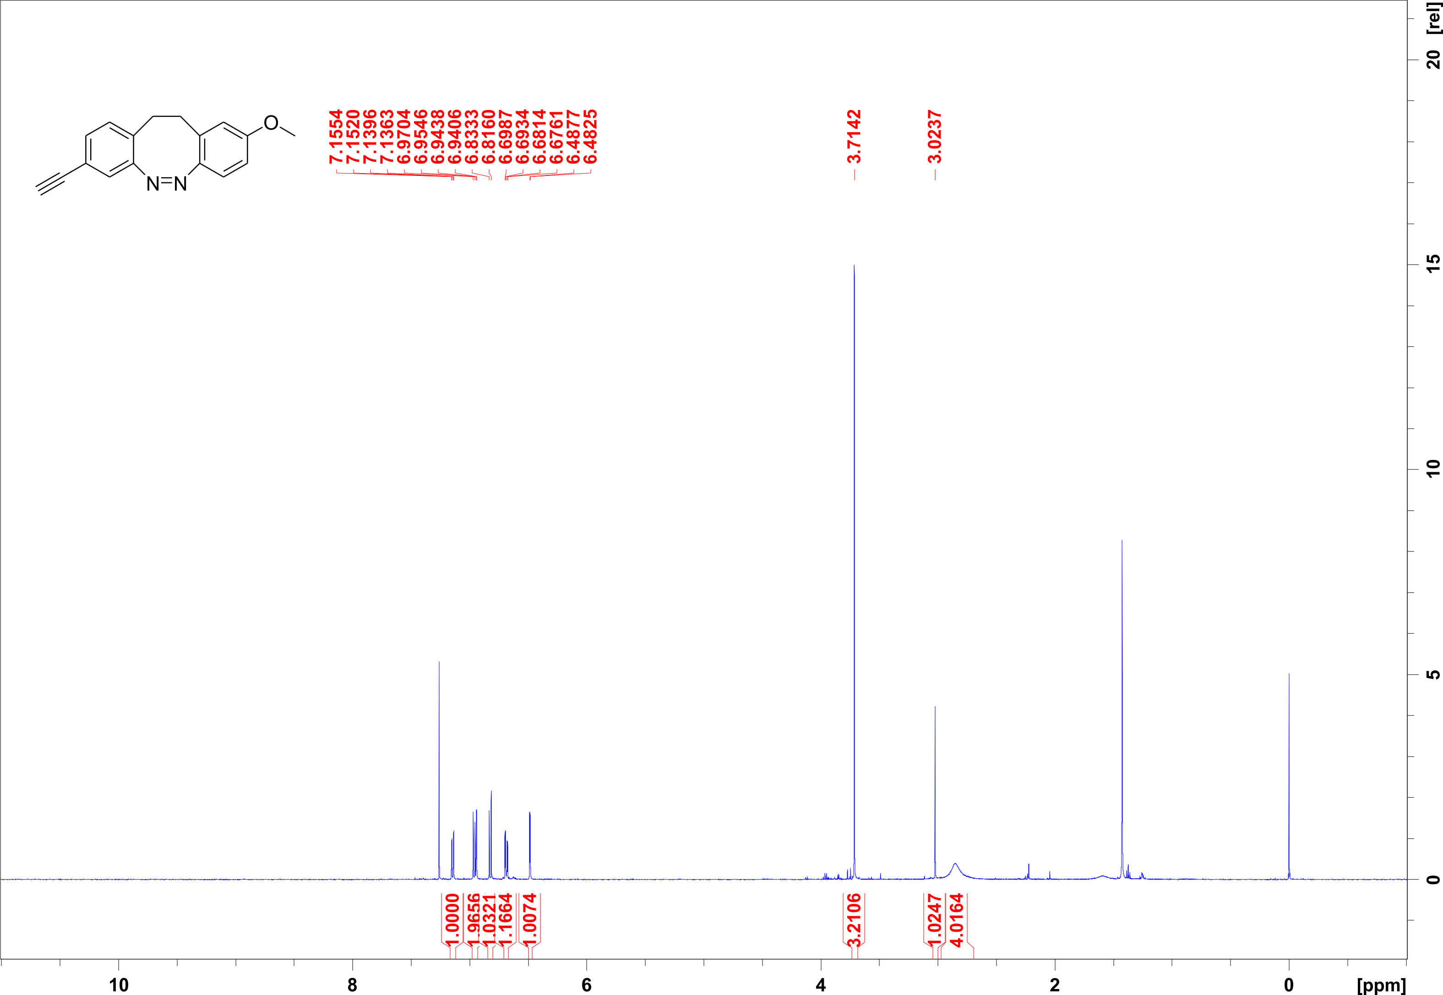
Figure S11. ¹H NMR spectrum (500.1 MHz, CDCl₃) of compound 13.
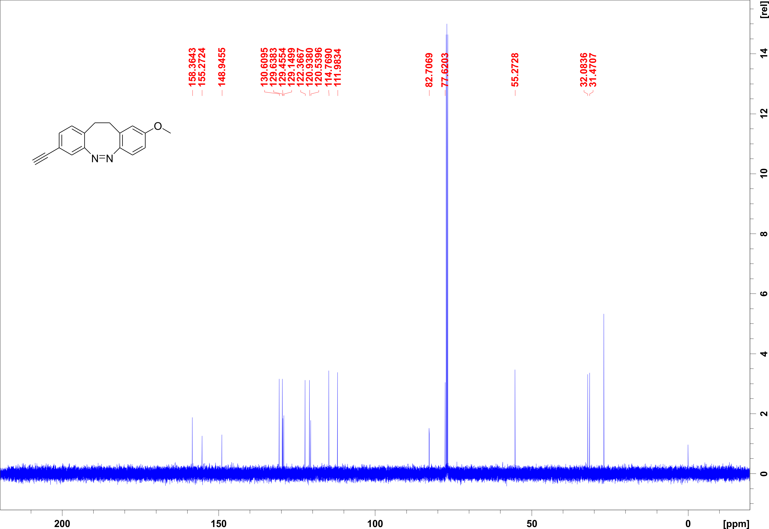
Figure S12. ¹H NMR spectrum (125.8 MHz, CDCl₃) of compound 13.
III.7 7(Z)-12c-(3-ethynyl-10-methoxy-11,12-dihydrodibenzo(c,g)(1,2)diazocin-10-yl)ethynyl-4,8,12-tri-n-octyl-4,8,12-triazatriangulene
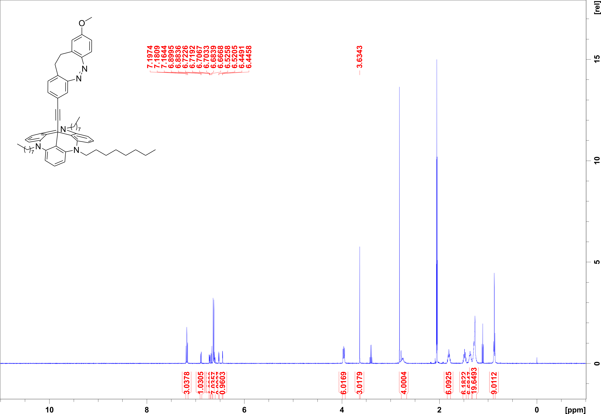
Figure S13. ¹H NMR spectrum (500.1 MHz, acetone-d₆) of compound 2.
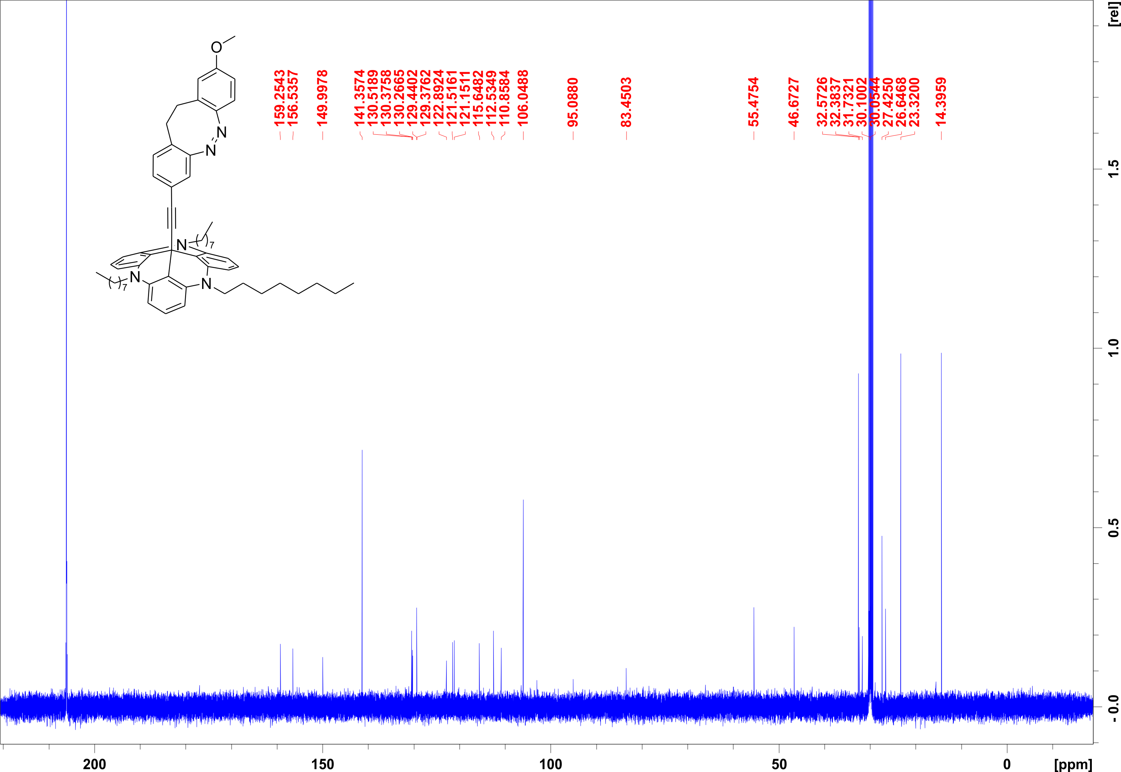
Figure S14. ¹H NMR spectrum (125.8 MHz, acetone-d₆) of compound 2.

IV. UV-Vis absorption spectra
IV.1 Methods
UV-Vis spectra were recorded on a PerkinElmer Lambda 650 Photospectrometer in a 1 cm path length quartz cuvette. Irradiation of UV-Vis samples were carried out at 25 °C using a custom-made LED positioned at a distance of 1 cm from the sample.

IV.2 UV-Vis spectra
Compound 1:
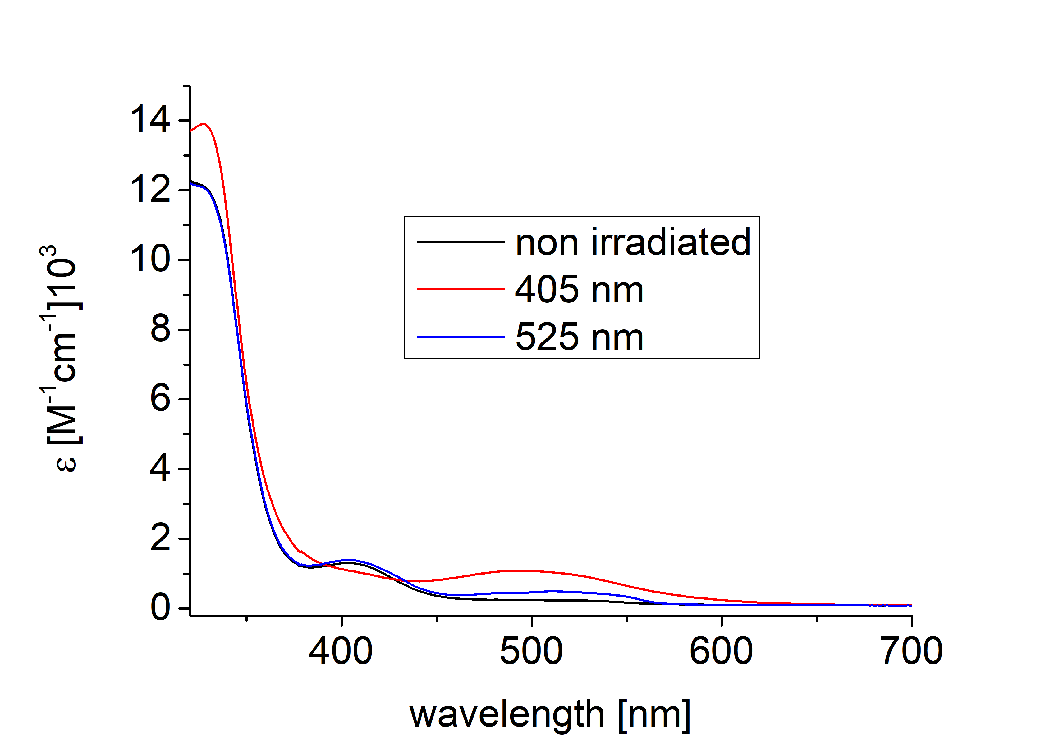
Figure S15. UV-Vis spectra of compound 1 in tetrahydrofurane at room temperature (68 μmol/L). Upon irradiation with 405 nm and 530 nm.
Compound 2:
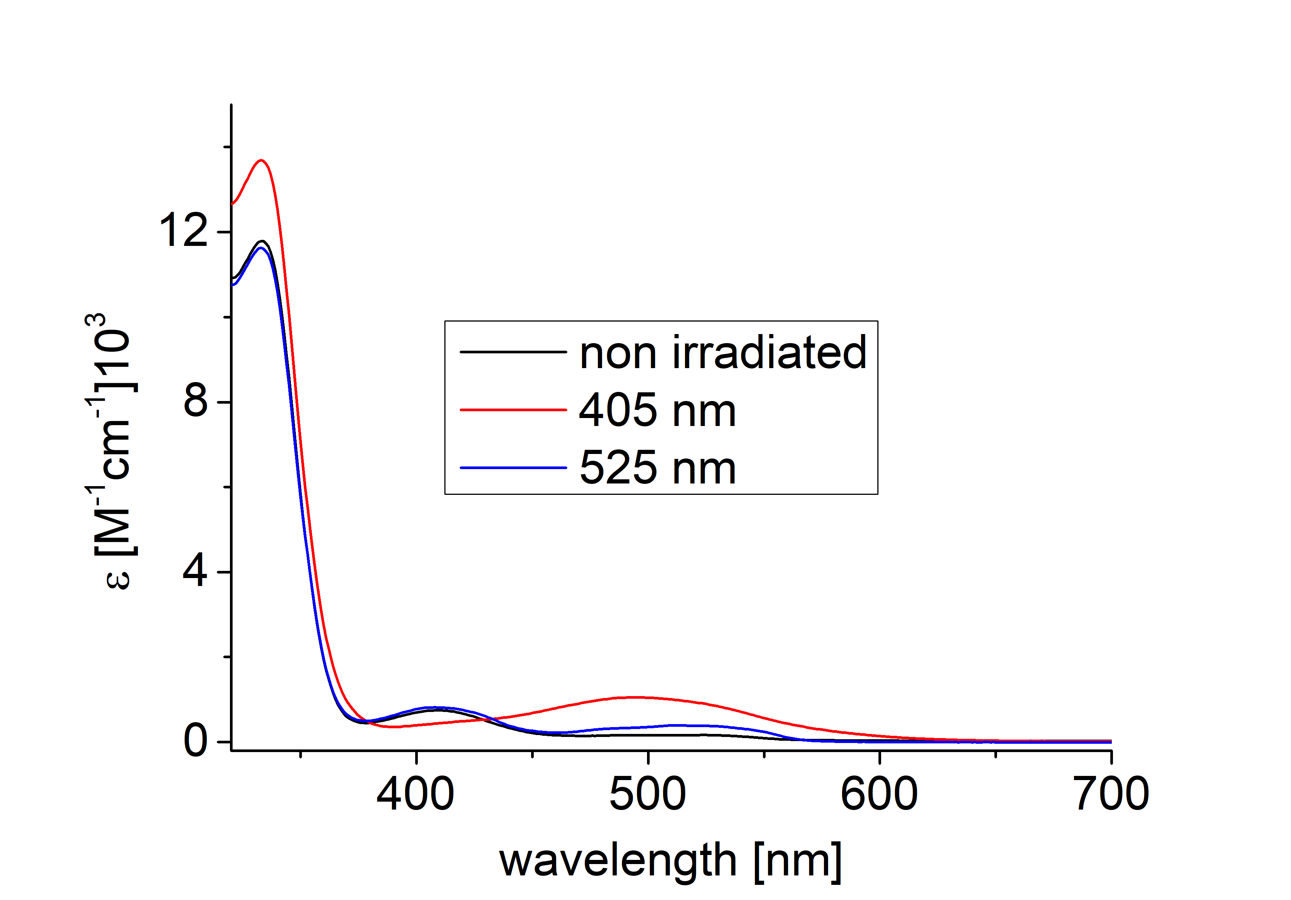
Figure S16. UV-Vis spectra of compound 2 in tetrahydrofurane at room temperature (68 μmol/L). Upon irradiation with 405 nm and 530 nm.
V. Kinetic studies in solution by ¹H NMR spectroscopy
V.1 Thermal isomerization measurements by ¹H NMR
V.1.1 Compound 1: (Z)-12c-(4-Ethynyl-9-methoxy-11,12-dihydrodibenzo(c,g)(1,2)
diazocin-10-yl)ethynyl-4,8,12-tri-n-octyl-4,8,12-triazatriangulene
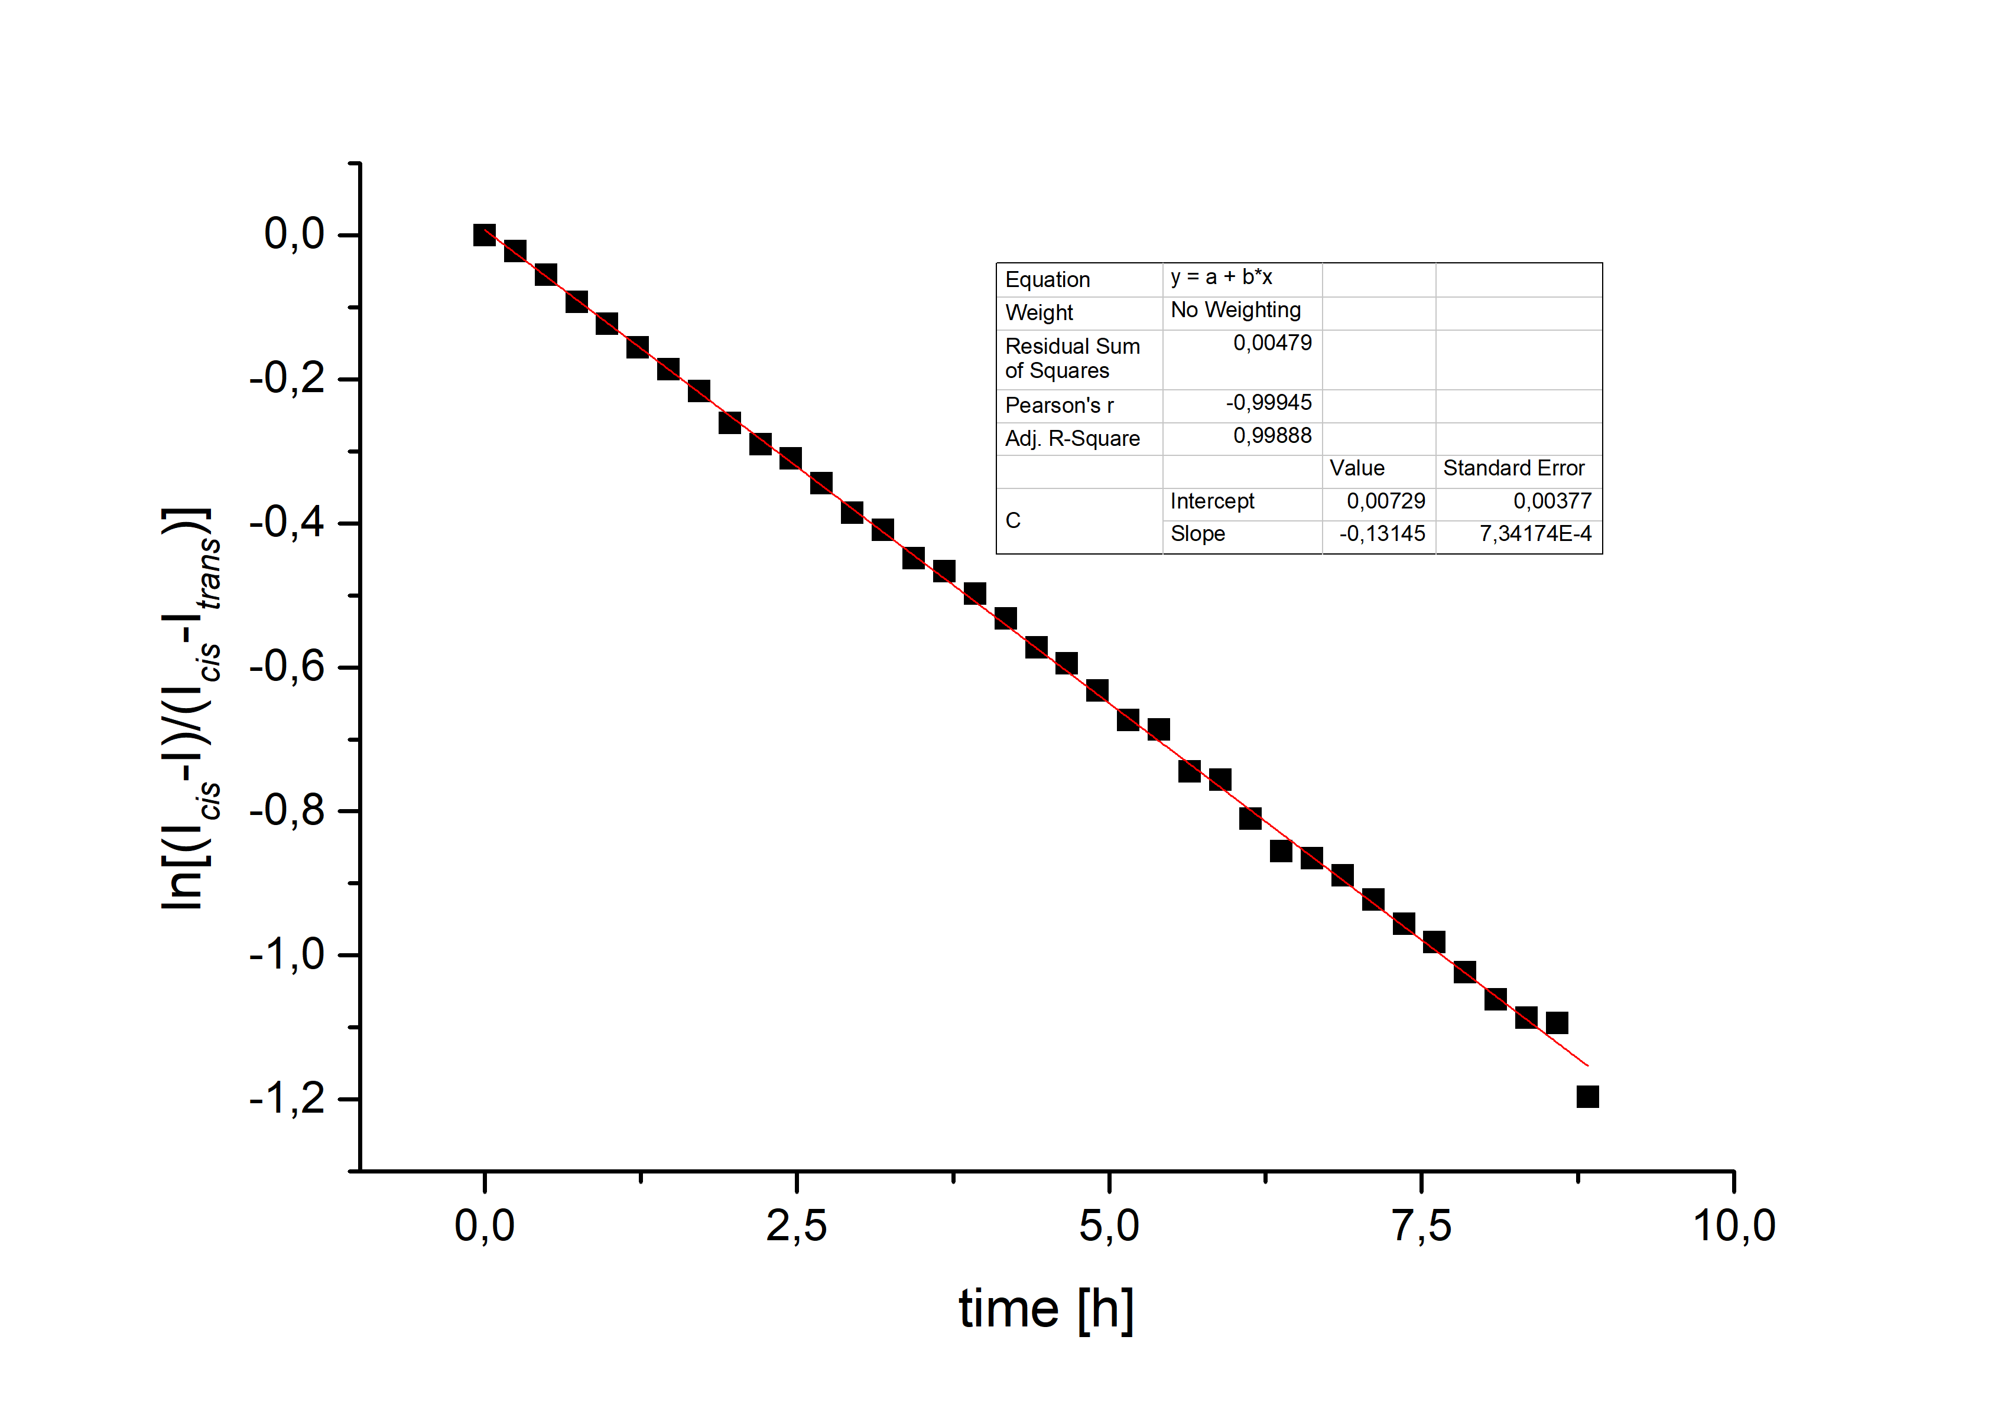
Figure S17. Determination of the thermal isomerization rate k of 1b→1a by ¹H NMR spectroscopy (deuterated toluene, 290.5 K, 2.05 mmol/L). (I_{cis}-I): ¹H NMR integral of the CH₃ signal of the methoxy group at time t, (I_{cis}-I_{trans}) corresponding ¹H integral at t = 0. A rate constant of k = 0.131 [s⁻¹] was determined from a linear fit of the ln[(I_{cis}-I)/ (I_{cis}-I_{trans})]/t curve. The half-life of 1 at 290.5 K in toluene was determined as 5.27 h.
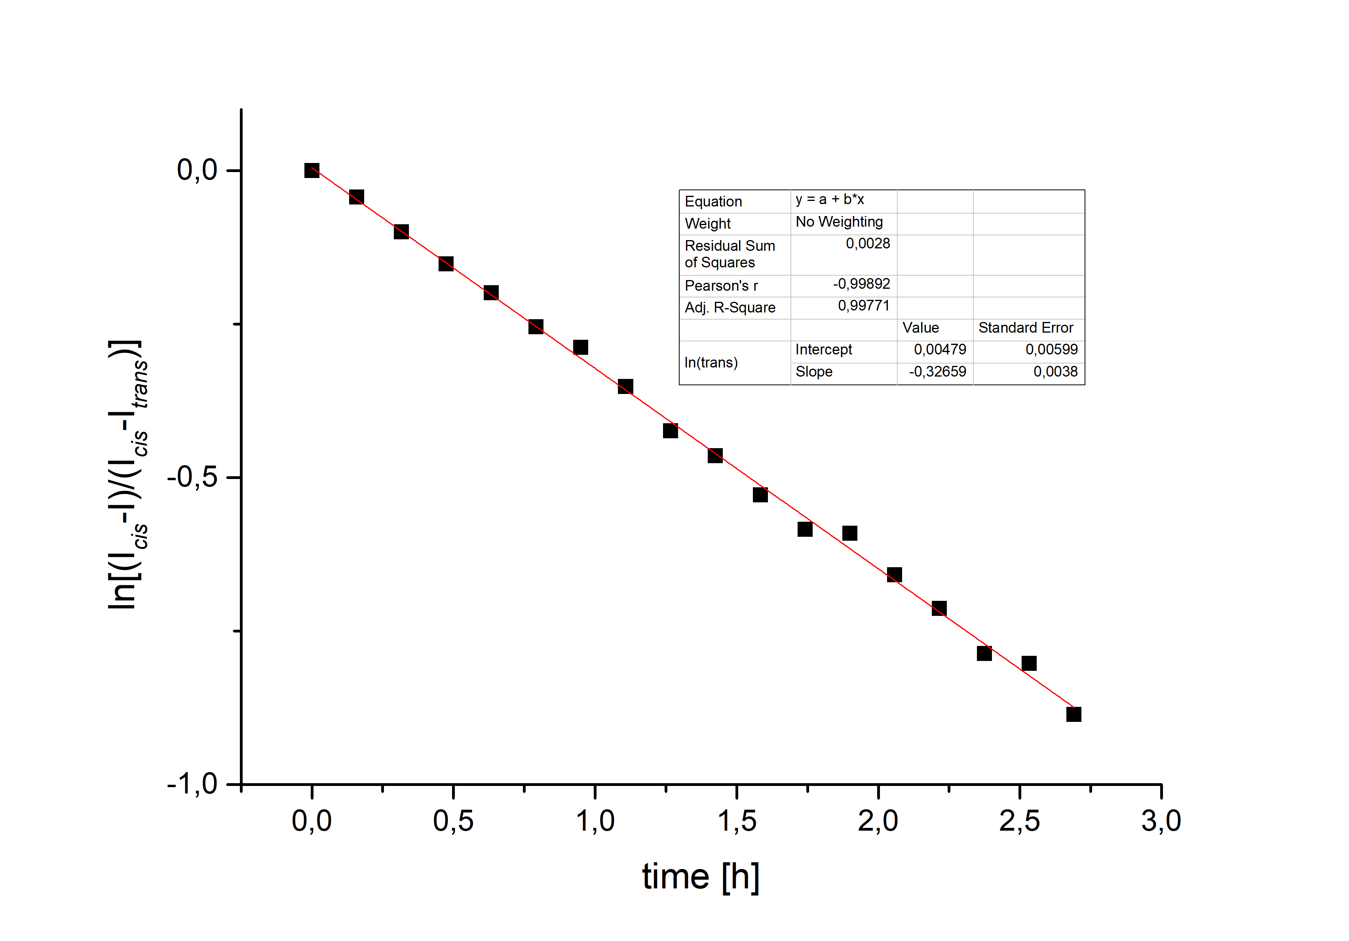
Figure S18. Determination of the thermal isomerization rate k of 1b→1a by ¹H NMR spectroscopy (deuterated toluene, 298 K, 2.05 mmol/L). (I_{cis}-I): ¹H NMR integral of the CH₃ signal of the methoxy group at time t, (I_{cis}-I_{trans}) corresponding ¹H integral at t = 0. A rate constant of k = 0.327 [s⁻¹] was determined from a linear fit of the ln[(I_{cis}-I)/ (I_{cis}-I_{trans})]/t curve. The half-life of 1 at 298 K in toluene was determined as 2.12 h.
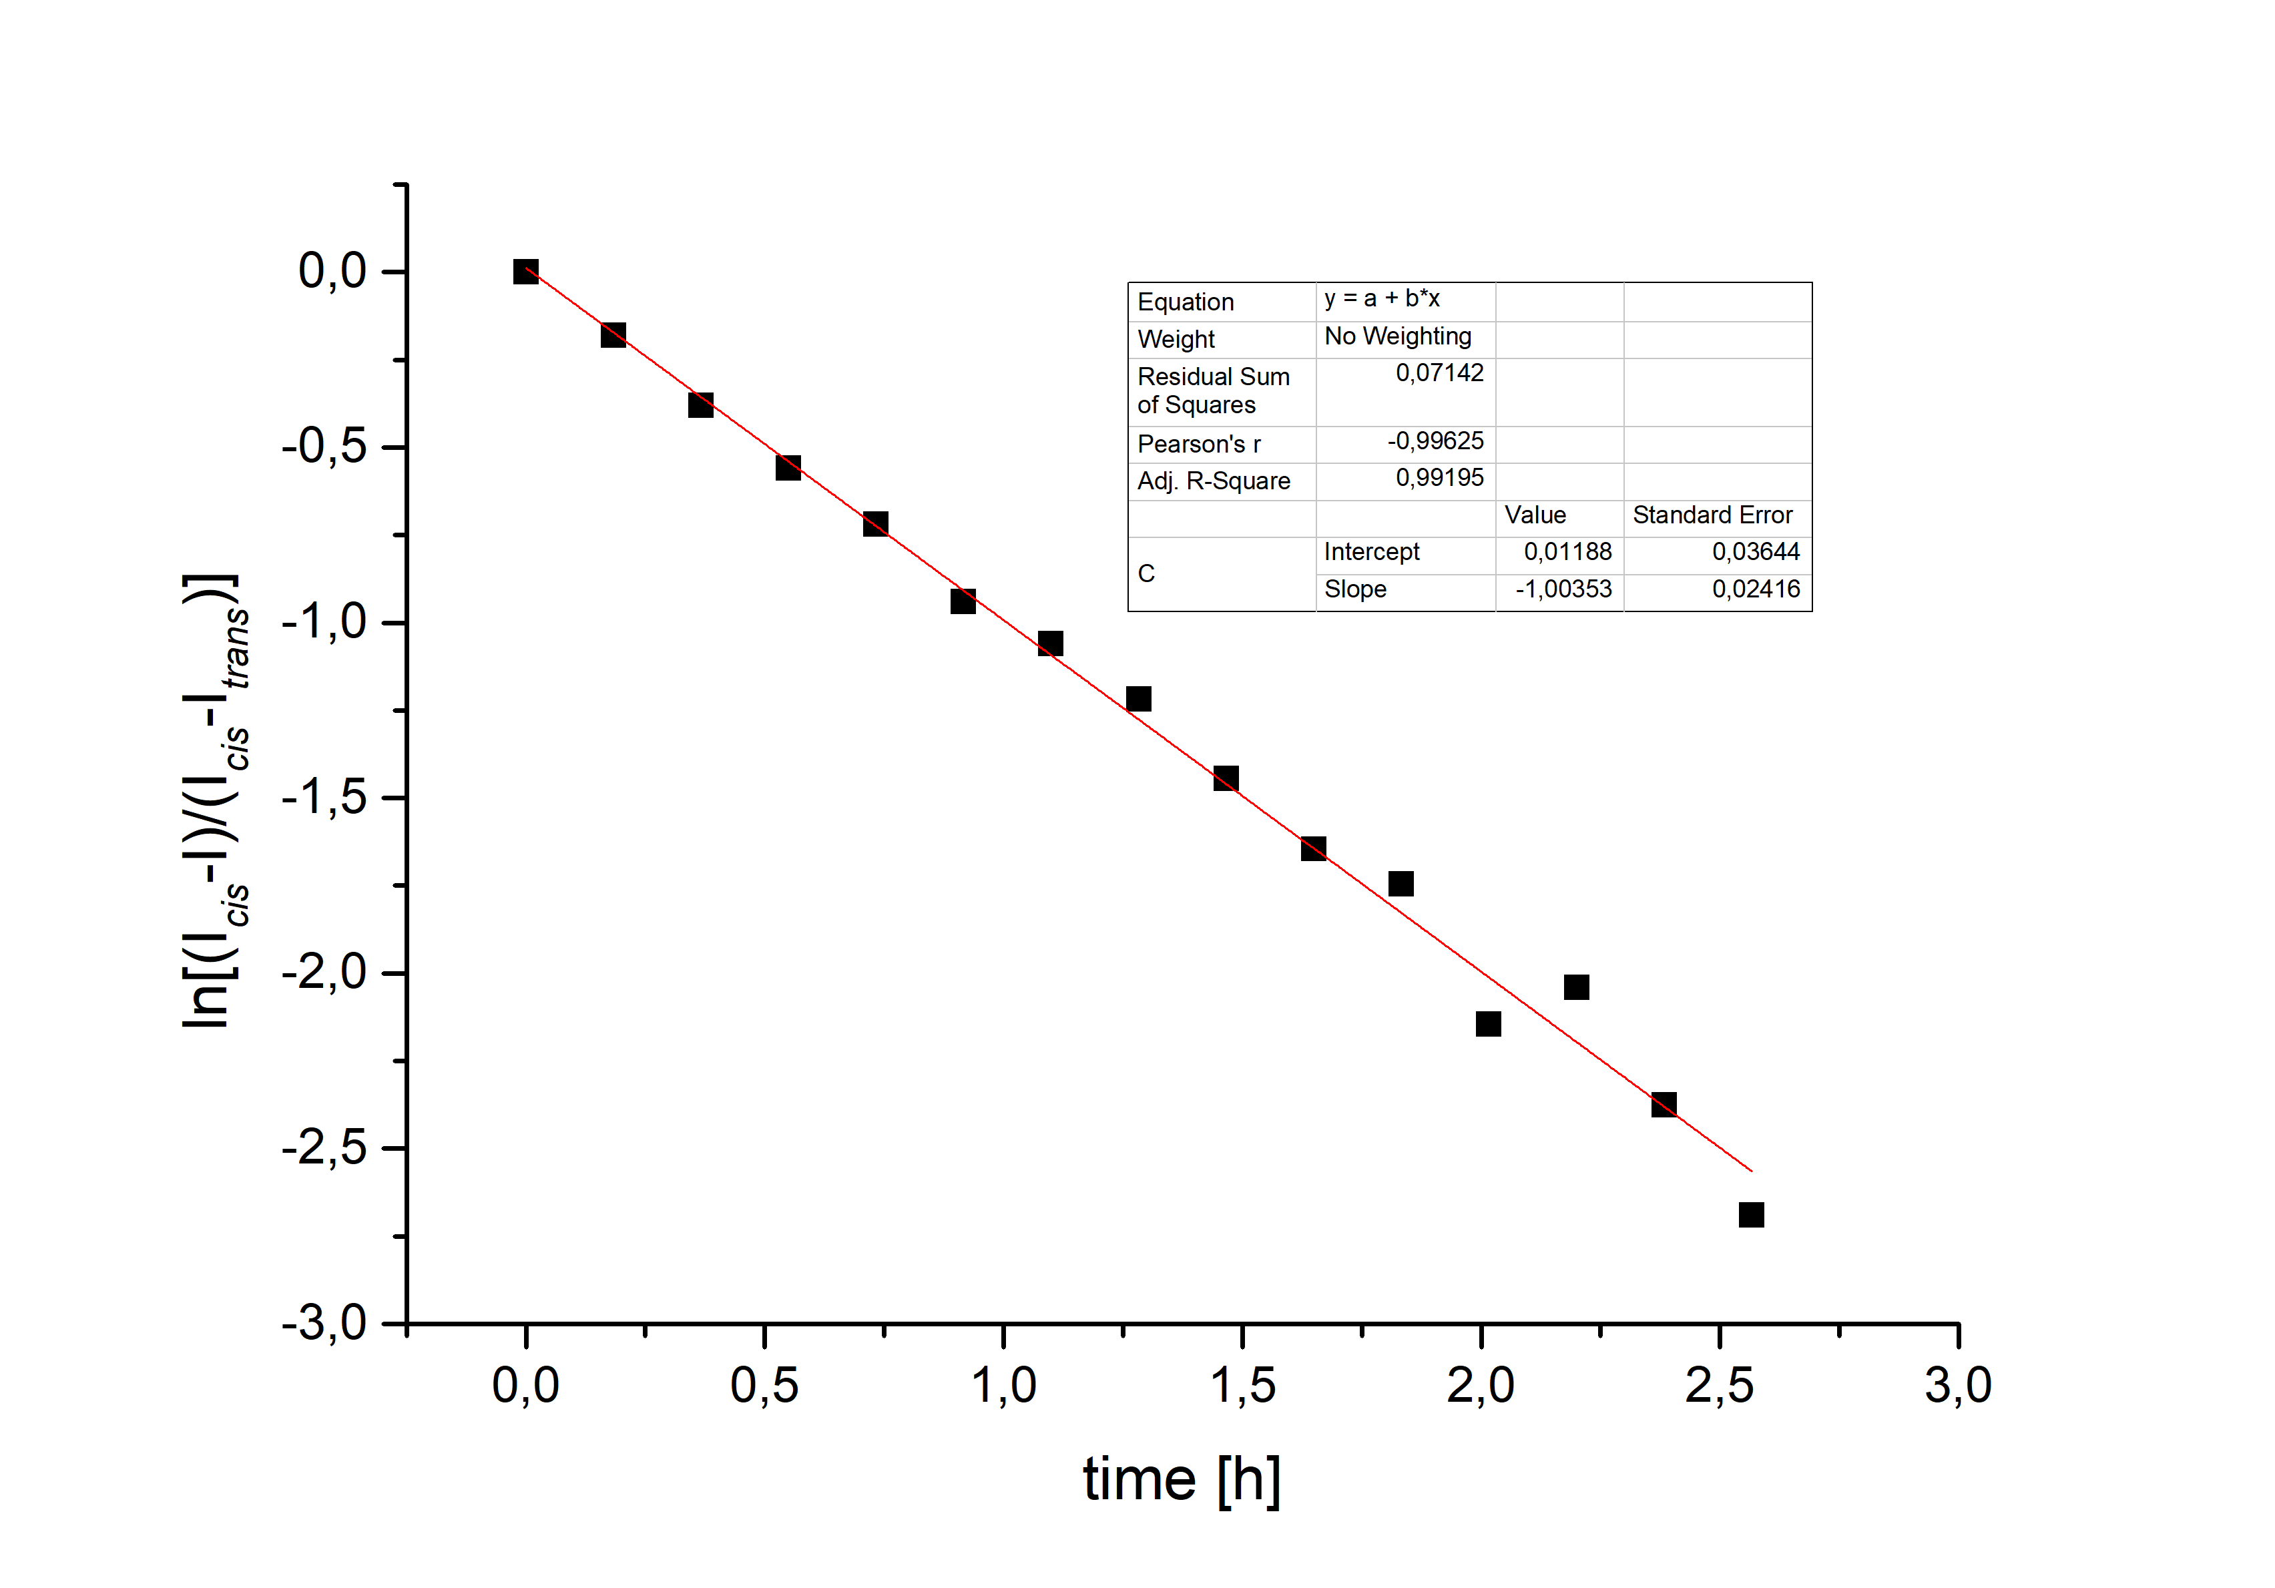
Figure S19. Determination of the thermal isomerization rate k of 1b→1a by ¹H NMR spectroscopy (deuterated toluene, 308 K, 2.05 mmol/L). (I_{cis}-I): ¹H NMR integral of the CH₃ signal of the methoxy group at time t, (I_{cis}-I_{trans}) corresponding ¹H integral at t = 0. A rate constant of k = 1.00 [s⁻¹] was determined from a linear fit of the ln[(I_{cis}-I)/ (I_{cis}-I_{trans})]/t curve. The half-life of 1 at 308 K in toluene was determined as 0.69 h.
V.1.2 Compound 2: (Z)-12c-(3-ethynyl-10-methoxy-11,12-dihydrodibenzo(c,g)(1,2)
diazocin-10-yl)ethynyl-4,8,12-tri-n-octyl-4,8,12-triazatriangulene
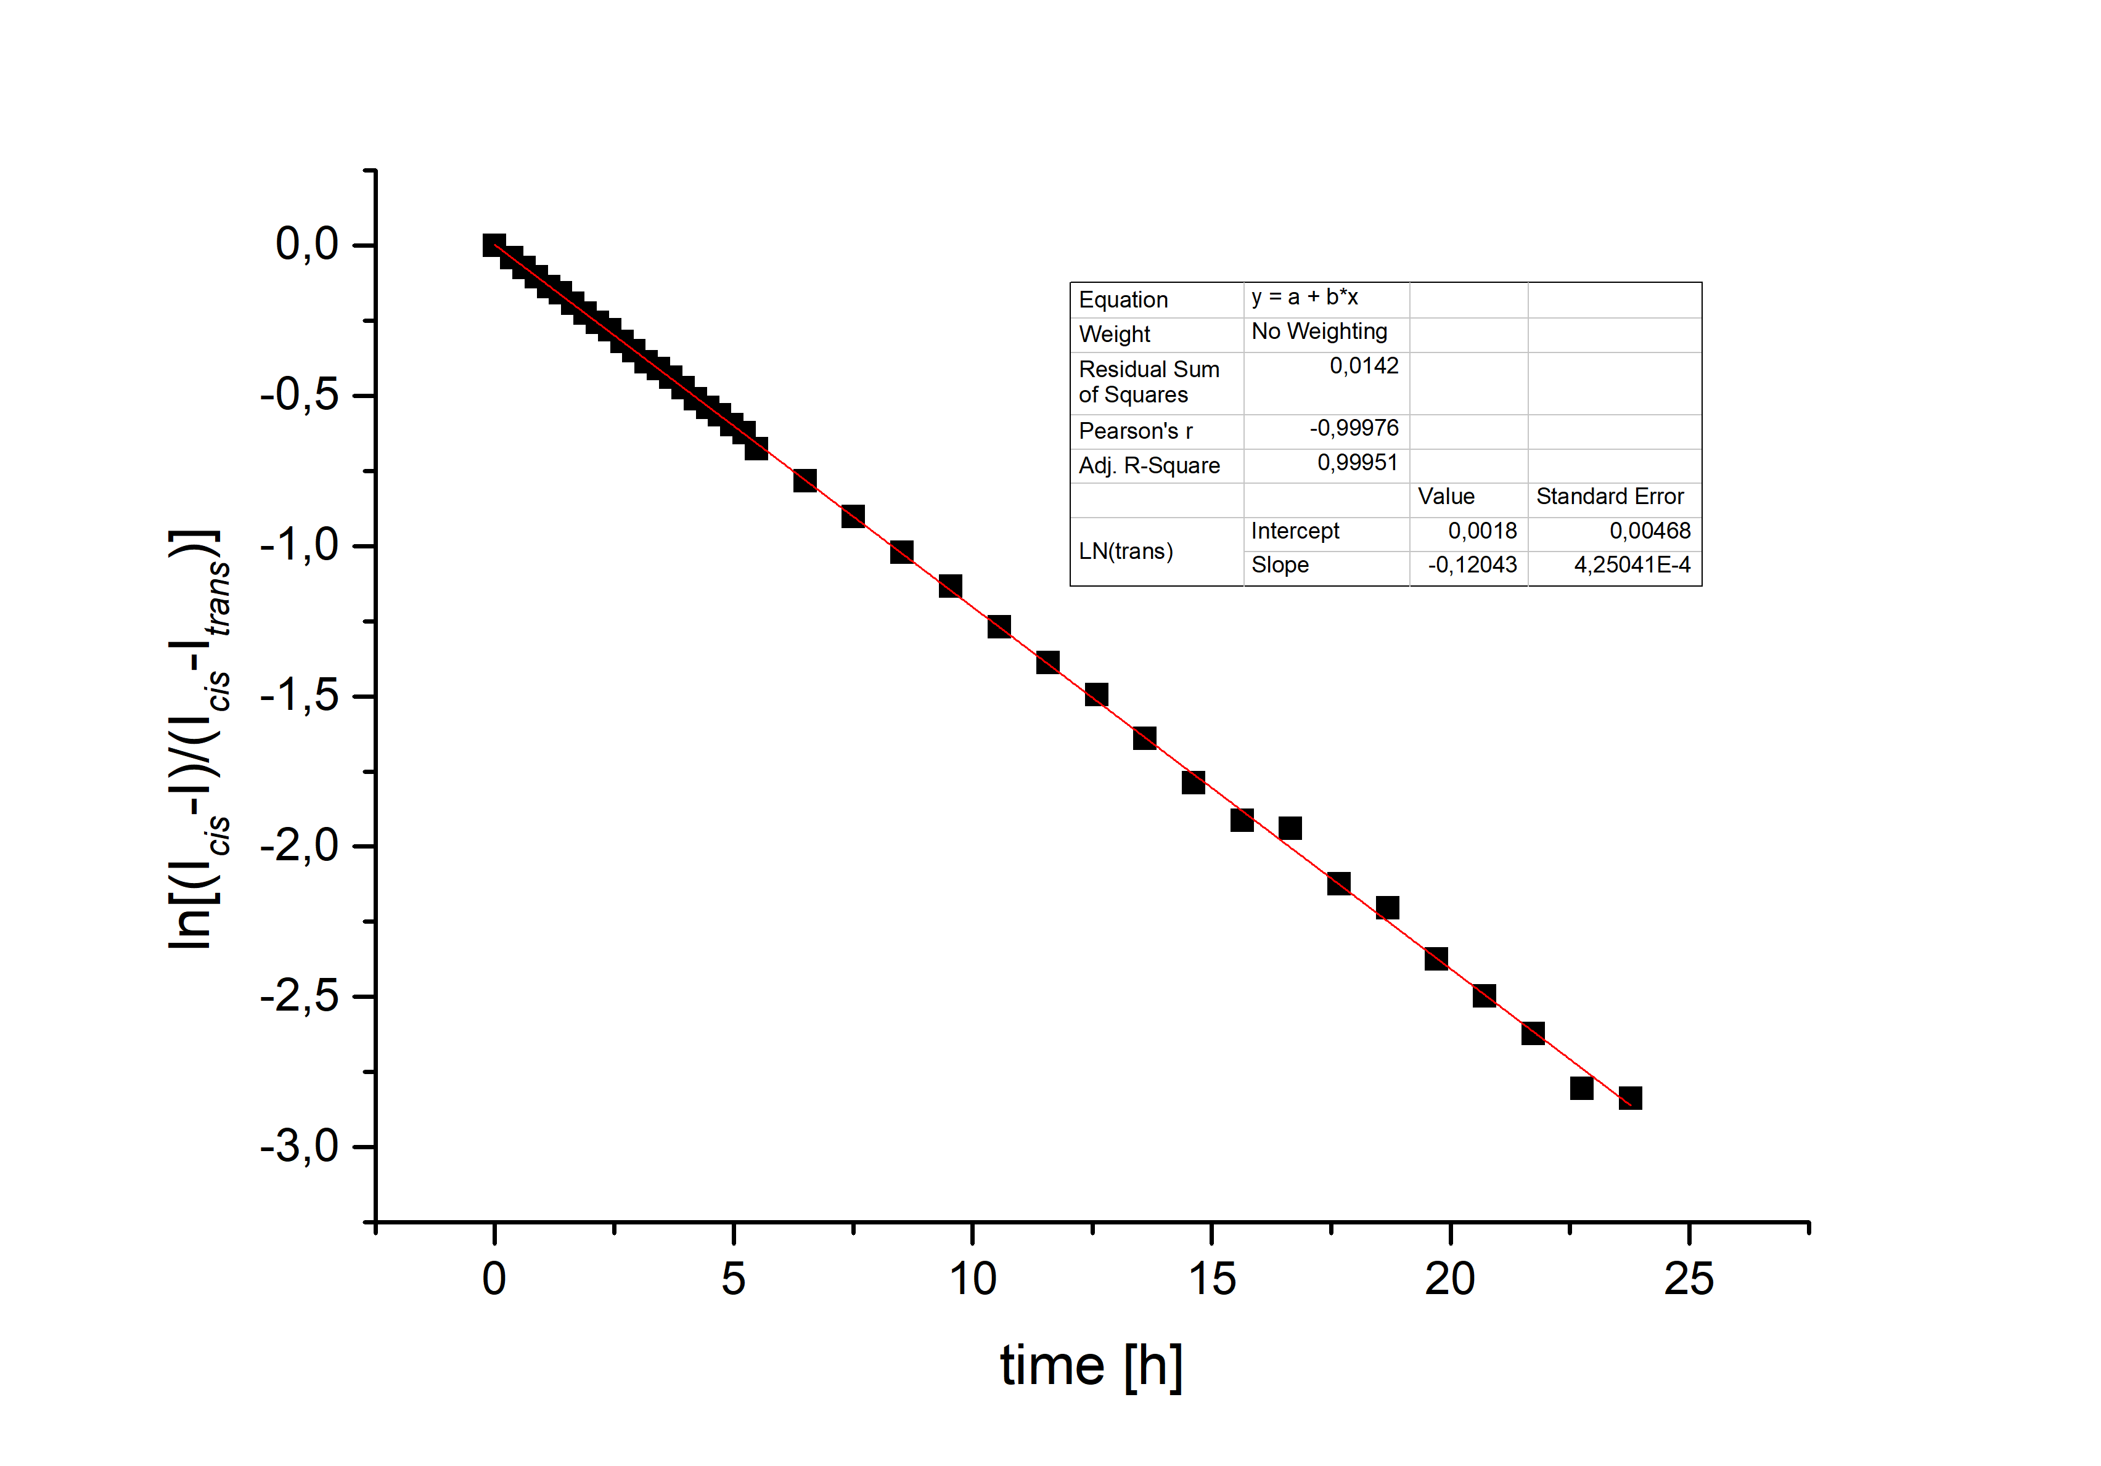
Figure S20. Determination of the thermal isomerization rate k of 2b→2a by ¹H NMR spectroscopy (deuterated toluene, 290.5 K, 2.27 mmol/L). (I_{cis}-I): ¹H NMR integral of the CH₃ signal of the methoxy group at time t, (I_{cis}-I_{trans}) corresponding ¹H integral at t = 0. A rate constant of k = 0.120 [s⁻¹] was determined from a linear fit of the ln[(I_{cis}-I)/ (I_{cis}-I_{trans})]/t curve. The half-life of 2 at 290.5 K in toluene was determined as 5.76 h.

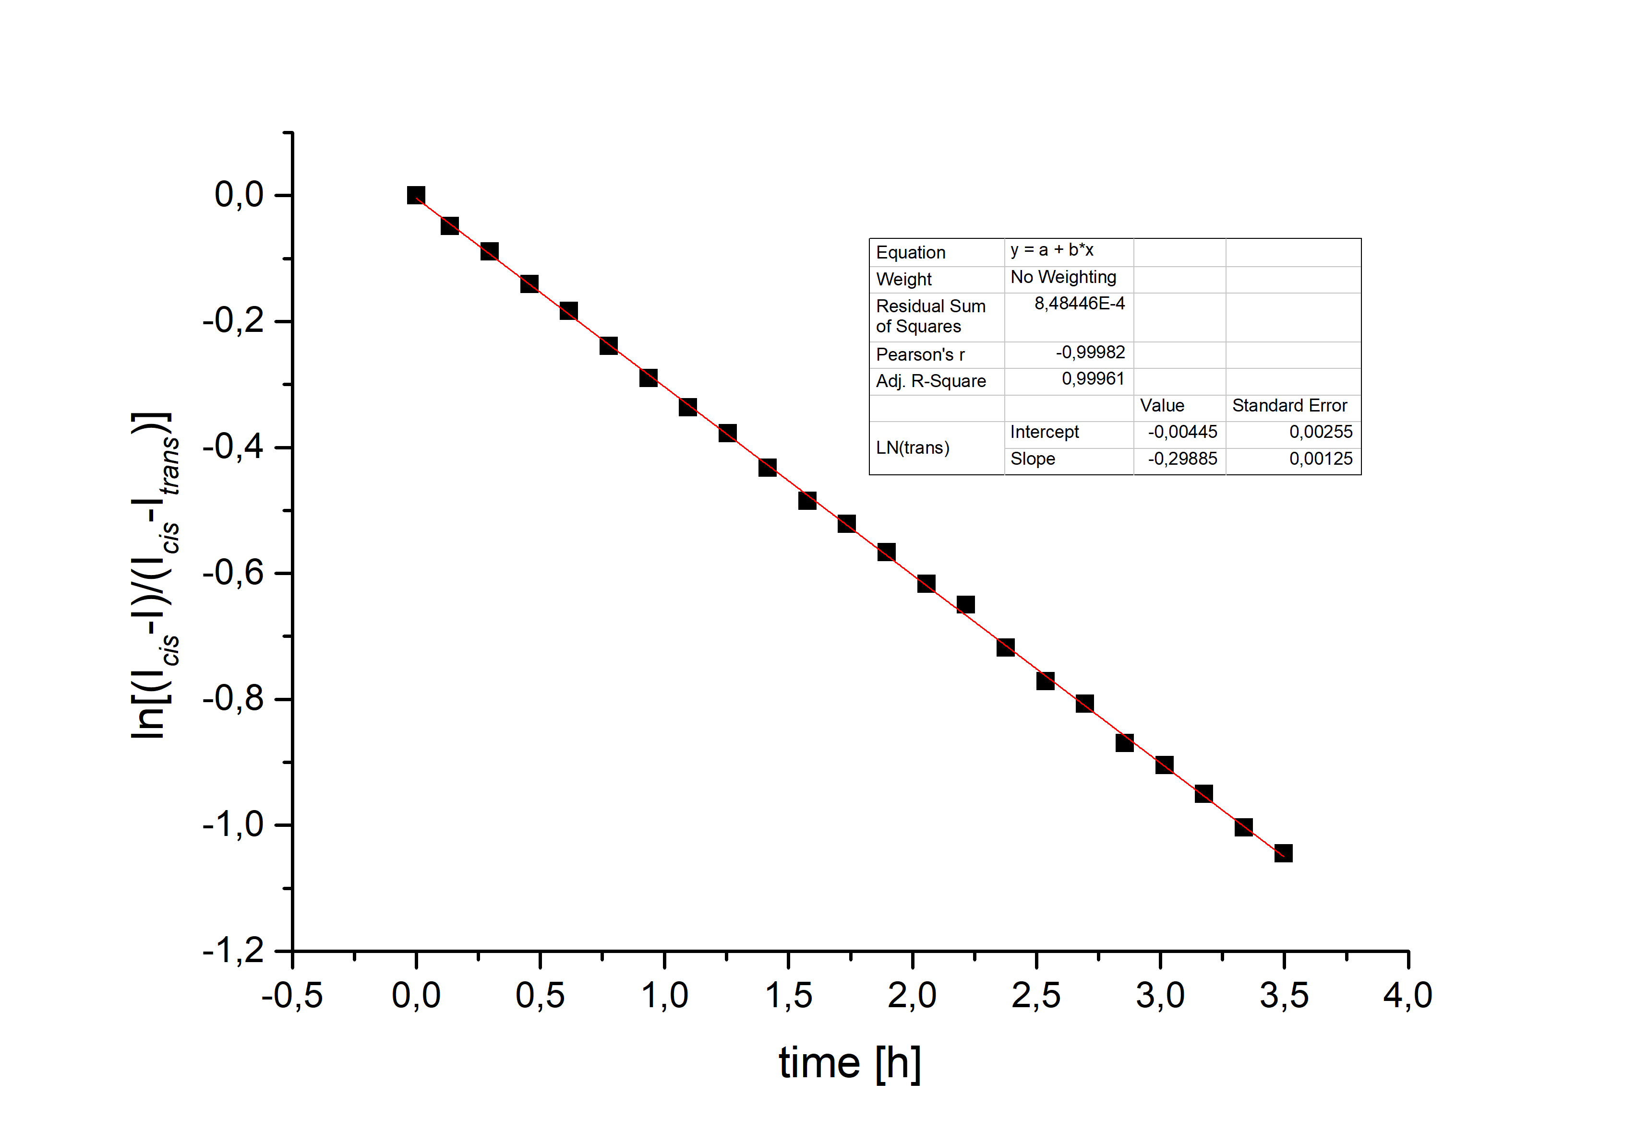
Figure S21. Determination of the thermal isomerization rate k of 2b→2a by ¹H NMR spectroscopy (deuterated toluene, 298 K, 2.27 mmol/L). (I_{cis}-I): ¹H NMR integral of the CH₃ signal of the methoxy group at time t, (I_{cis}-I_{trans}) corresponding ¹H integral at t = 0. A rate constant of k = 0.299 [s⁻¹] was determined from a linear fit of the ln[(I_{cis}-I)/ (I_{cis}-I_{trans})]/t curve. The half-life of 2 at 298 K in toluene was determined as 2.32 h.
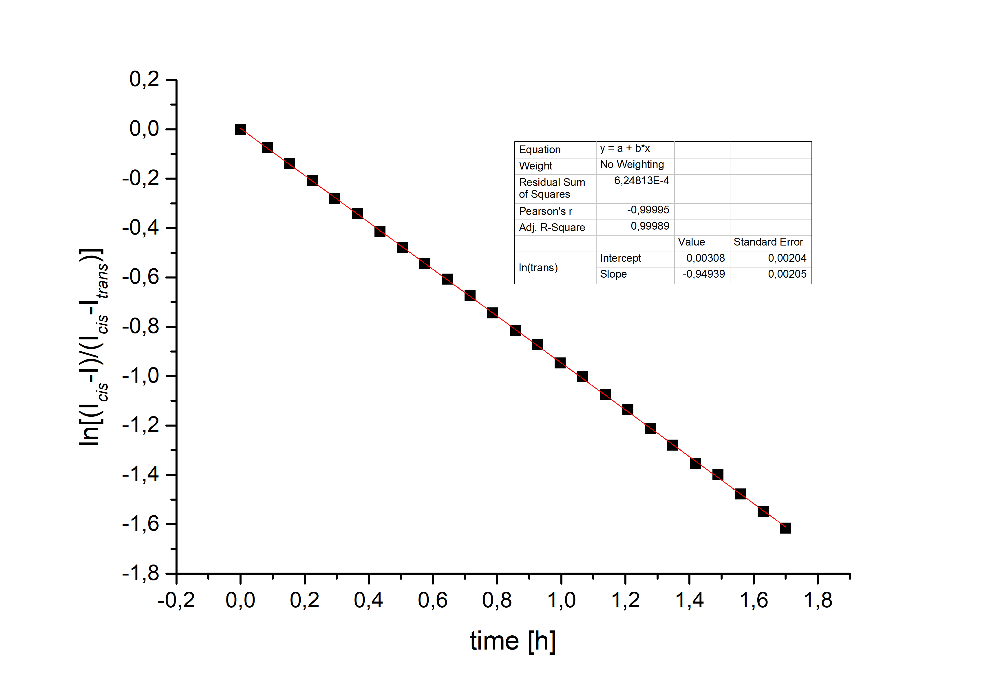
Figure S22. Determination of the thermal isomerization rate k of 2b→2a by ¹H NMR spectroscopy (deuterated toluene, 308 K, 2.27 mmol/L). (I_{cis}-I): ¹H NMR integral of the CH₃ signal of the methoxy group at time t, (I_{cis}-I_{trans}) corresponding ¹H integral at t = 0. A rate constant of k = 0.949 [s⁻¹] was determined from a linear fit of the ln[(I_{cis}-I)/ (I_{cis}-I_{trans})]/t curve. The half-life of 2 at 308 K in toluene was determined as 0.73 h.
V.2 Arrhenius Plots in solution
V.2.1 Compound 1: (Z)-12c-(4-Ethynyl-9-methoxy-11,12-dihydrodibenzo(c,g)(1,2)-diazocin-10-yl)ethynyl-4,8,12-tri-n-octyl-4,8,12-triazatriangulene
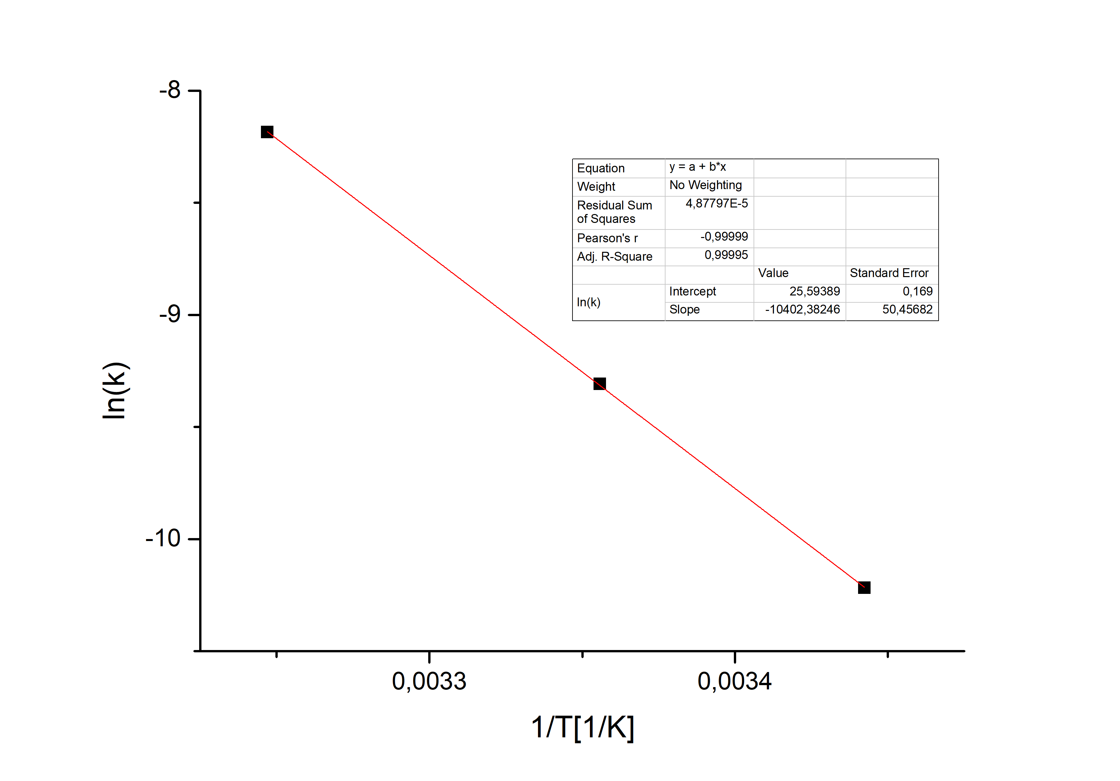
Figure S23. Arrhenius plot of the thermal isomerization of diazocine-TATA 1 in toluene-d₈ (2.05 mmol/L). An activation energy of 86.5 kJ/mol was determined from the linear fit.

V.2.2 Compound 2: (Z)-12c-(3-Ethynyl-10-methoxy-11,12-dihydrodibenzo(c,g)(1,2)-diazocin-10-yl)ethynyl-4,8,12-tri-n-octyl-4,8,12-triazatriangulene
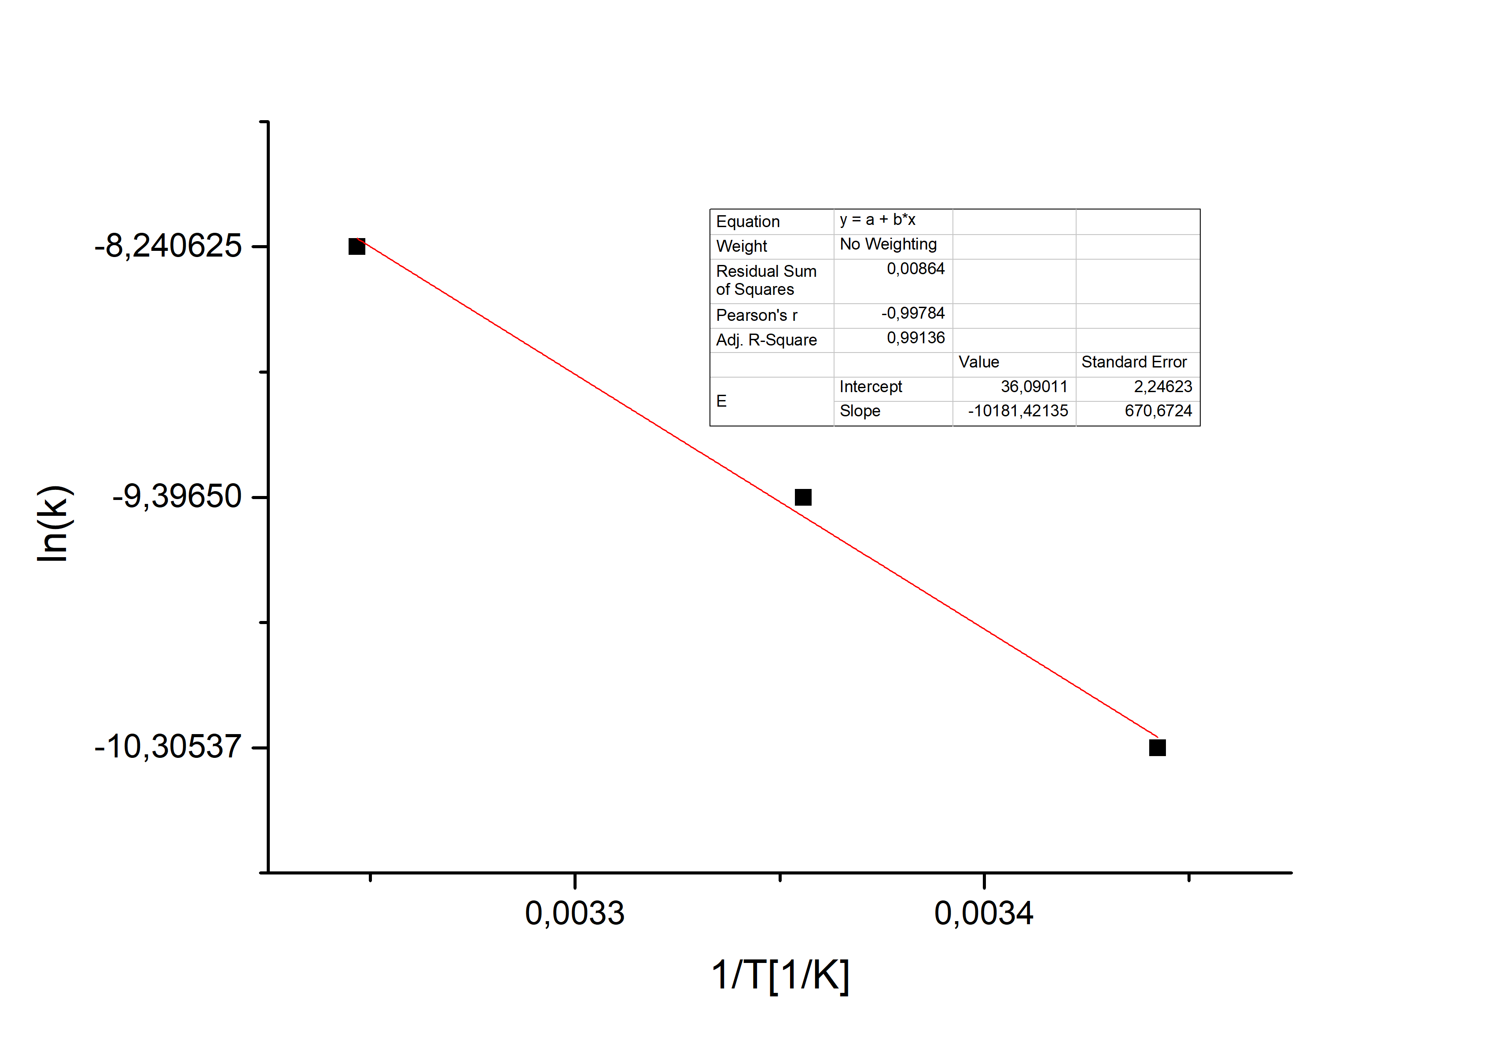
Figure S24. Arrhenius plot of the thermal isomerization of diazocine-TATA 1 in toluene-d₈ (2.27 mmol/L). An activation energy of 84.7 kJ/mol was determined from the linear fit.

VI. Calculations
The geometry optimizations were carried out using density functional theory with the Minnesota functional M06-2X^{[4]} including Grimmes D3^{[5]} dispersion correction and the large triple zeta basis def2-TZVP^{[6]}. This theoretical level performed well in Grimme’s latest study on basic properties of a large set of organic molecules.^{[7]} The calculations were performed with Turbomole7.2^{[8]}, including the m4 grid (in Turbomole nomenclature) and resolution-of-identity (RI) with multipole accelerated RI-J (marij) to speed up the calculations. All stationary points are characterized by frequency calculations.

Coordinates
1a cis para-diazocine platform molecule
E_{M062X-D3/def2TZVP} = -1735.7479869
Nimag = 0

C 0.8423706 1.1888220 -0.6747150
C -0.1996660 2.0068443 -1.1074483
C -0.1398925 3.3967441 -1.0422542
C 1.0223796 3.9601501 -0.5091298
C 2.0852794 3.1594786 -0.1005557
C 1.9973550 1.7838344 -0.1632224
H -1.0914091 1.5383759 -1.5056817
H 2.9819589 3.6400909 0.2693096
C -1.3105728 4.1869891 -1.5808886
C -1.7461674 5.4307277 -0.7760201
H -1.0924538 4.4946436 -2.6076251
H -2.1542639 3.4983177 -1.6405533
C -1.5420640 5.2802242 0.7041029
H -1.1986834 6.3052325 -1.1276249
H -2.8003327 5.6183047 -0.9827574
C -0.2844198 5.5415248 1.2574631
N 0.7413389 6.0835543 0.4087727
N 1.2900393 5.3763382 -0.4349021
C -2.5394135 4.8649177 1.5709273
C -2.3125004 4.7020769 2.9341852
C -1.0516817 4.9786282 3.4537246
C -0.0360076 5.4225193 2.6090289
H 0.9345117 5.6637019 3.0215445
H -3.5272321 4.6583588 1.1749579
C 3.9125498 -4.1448213 0.3982673
C 4.6345339 -4.2440201 -0.7810573
C 4.0471275 -4.0005035 -2.0127256
C 2.7057736 -3.6212184 -2.0624485
C 1.9807273 -3.4750703 -0.8830149
C 2.5715400 -3.7649591 0.3435754
H 4.3769412 -4.3609439 1.3520549
H 5.6758958 -4.5362731 -0.7404083
H 4.6160706 -4.1032279 -2.9281033
C 0.5801611 -2.9076635 -0.9274357
C -0.0865050 -3.2926499 -2.2284278
C -0.2242457 -3.4401278 0.2368146
C 0.6802168 -3.4448358 -3.3805660
C 0.0558928 -3.6574386 -4.6095389
C -1.3272498 -3.7326336 -4.6601775
C -2.1007592 -3.6268692 -3.5146184
C -1.4719191 -3.4135487 -2.2880545
H 0.6499490 -3.7641717 -5.5083383
H -1.8132084 -3.8967404 -5.6133066
H -3.1789158 -3.7116775 -3.5641797
C -1.6068547 -3.5584966 0.1271758
C -2.3664292 -3.9129133 1.2420571
C -1.7241891 -4.1607832 2.4452278
C -0.3444466 -4.0889102 2.5578823
C 0.4109032 -3.7338574 1.4403335
H -3.4428446 -3.9956847 1.1611128
N 1.7986504 -3.6621140 1.4954364
H 2.2277130 -3.9774921 2.3498833
N 2.0648118 -3.3781377 -3.2723777
H 2.5885516 -3.5904101 -4.1056892
N -2.2006654 -3.3137539 -1.1070004
H -3.1844787 -3.5174147 -1.1741062
H -2.3115962 -4.4356067 3.3117727
H 0.1467189 -4.3085544 3.4973437
H -3.1193570 4.3721736 3.5712556
H 2.8166211 1.1625062 0.1714491
C 0.7345624 -0.2343858 -0.7608235
C 0.6573516 -1.4322857 -0.8353981
O -0.7193084 4.8615394 4.7621776
C -1.7112975 4.4038811 5.6523843
H -2.5641030 5.0876124 5.6803824
H -1.2455211 4.3680744 6.6333135
H -2.0578418 3.4040073 5.3772583

1b trans-twist para-diazocine platform molecule
E_{M062x-D3/def2TZVP} = -1735.735229021
Nimag = 0

C 0.8401254 0.1948635 0.0360794
C -0.2729335 1.0400154 -0.0243101
C -0.1386510 2.4177595 -0.1184809
C 1.1692801 2.9299883 -0.1589074
C 2.2860807 2.1127853 -0.1424469
C 2.1232416 0.7436426 -0.0203797
H -1.2612185 0.5966497 -0.0038849
H 3.2718125 2.5534381 -0.2131845
C -1.3762462 3.3088971 -0.2078395
C -1.3958483 4.4404894 -1.2796657
H -1.5828978 3.7407077 0.7731500
H -2.2121142 2.6432411 -0.4262808
C -1.0454856 5.8625000 -0.8489445
H -2.4099923 4.4858328 -1.6793384
H -0.7578972 4.1453934 -2.1157176
C 0.0446053 6.1544622 -0.0072817
N 0.6676551 4.9751295 0.4861435
N 1.2069869 4.3266472 -0.4148385
C -1.8014483 6.9456693 -1.2654587
C -1.4995793 8.2533712 -0.8897991
C -0.4193272 8.4956810 -0.0487556
C 0.3481191 7.4278275 0.4164893
H 1.1741032 7.6128466 1.0894853
H -2.6574324 6.7748141 -1.9084151
C 3.5638146 -5.2305087 1.7091597
C 4.2663082 -5.5114055 0.5476077
C 3.6905641 -5.3535140 -0.7035748
C 2.3831539 -4.8759661 -0.7939827
C 1.6815291 -4.5471477 0.3626292
C 2.2567143 -4.7528786 1.6135244
H 4.0166120 -5.3816756 2.6808333
H 5.2813791 -5.8800634 0.6200090
H 4.2410387 -5.6009943 -1.6023805
C 0.3289959 -3.8804263 0.2572901
C -0.3762696 -4.3491317 -0.9954210
C -0.5054668 -4.2208910 1.4711478
C 0.3668245 -4.6830394 -2.1244616
C -0.2819383 -4.9747604 -3.3241070
C -1.6670613 -4.9435670 -3.3672287
C -2.4206648 -4.6546030 -2.2400173
C -1.7673524 -4.3637036 -1.0426123
H 0.2940887 -5.2256625 -4.2058178
H -2.1720674 -5.1679745 -4.2978623
H -3.5024669 -4.6564358 -2.2814871
C -1.8939926 -4.2381829 1.3740998
C -2.6704482 -4.4080346 2.5200733
C -2.0402677 -4.5761731 3.7433375
C -0.6584129 -4.6055172 3.8483196
C 0.1139022 -4.4345541 2.6994767
H -3.7506721 -4.4106999 2.4483676
N 1.5031637 -4.4697177 2.7472178
H 1.9131286 -4.7240231 3.6308465
N 1.7533543 -4.7140140 -2.0231881
H 2.2519580 -5.0547658 -2.8288416
N -2.4760349 -4.0792681 0.1203924
H -3.4736538 -4.2078232 0.0747186
H -2.6411549 -4.7051841 4.6343589
H -0.1789633 -4.7616051 4.8063518
H -2.1184867 9.0621580 -1.2483986
H 2.9820643 0.0874583 0.0154085
C 0.6625517 -1.2214745 0.1247796
C 0.5137014 -2.4133541 0.1878260
O -0.0431878 9.7250870 0.3812710
C -0.7941606 10.8319233 -0.0627180
H -0.7673156 10.9161225 -1.1524606
H -0.3318585 11.7103496 0.3792683
H -1.8338887 10.7629892 0.2688271

1c trans-chair para-diazocine platform molecule
E_{M062x-D3/def2TZVP} = -1735.731545735
Nimag = 0

C 0.7082396 0.2261391 0.3888250
C -0.4046217 1.0614675 0.2314074
C -0.2849941 2.4414148 0.2850565
C 1.0007728 2.9625528 0.4950667
C 2.1123435 2.1672652 0.6774918
C 1.9642902 0.7891610 0.6158220
H -1.3765155 0.6102457 0.0722836
H 3.0803611 2.6185564 0.8488864
C -1.5061101 3.3514154 0.2289882
C -1.6607090 4.3745881 -0.9415195
H -1.5656470 3.8990432 1.1732130
H -2.3764585 2.6950228 0.1951461
C -1.1663037 5.8043388 -0.7656366
H -2.7274781 4.4439738 -1.1594537
H -1.1907471 3.9507376 -1.8329601
C 0.2023232 6.0942363 -0.6210724
N 0.9487146 4.8766153 -0.5838408
N 0.9462892 4.3884030 0.5463486
C -2.0148260 6.8953695 -0.8368125
C -1.5428375 8.2069148 -0.7754406
C -0.1791626 8.4431141 -0.6536034
C 0.7104348 7.3675658 -0.5800397
H 1.7703948 7.5530838 -0.4742390
H -3.0801986 6.7293631 -0.9492613
C 3.5743751 -5.1778347 1.6618947
C 4.3126377 -5.3407285 0.4998894
C 3.7562225 -5.1153072 -0.7495741
C 2.4308280 -4.6891601 -0.8360845
C 1.6909782 -4.4801618 0.3245306
C 2.2491018 -4.7524653 1.5704019
H 4.0140529 -5.3795116 2.6304364
H 5.3414802 -5.6696257 0.5691698
H 4.3367669 -5.2682985 -1.6506197
C 0.3127289 -3.8653812 0.2367203
C -0.3442793 -4.2665333 -1.0642772
C -0.5305801 -4.3325596 1.4012316
C 0.4365903 -4.4806247 -2.1968641
C -0.1730496 -4.7078390 -3.4304774
C -1.5569448 -4.7354486 -3.5047030
C -2.3461503 -4.5684054 -2.3773795
C -1.7319121 -4.3403067 -1.1460741
H 0.4325221 -4.8623801 -4.3146005
H -2.0316730 -4.9100628 -4.4615777
H -3.4256106 -4.6166721 -2.4445513
C -1.9144591 -4.4048704 1.2698584
C -2.7057063 -4.6940063 2.3816618
C -2.0940015 -4.9238661 3.6041398
C -0.7147348 -4.8982802 3.7399250
C 0.0722537 -4.6091744 2.6252323
H -3.7829147 -4.7398869 2.2837639
N 1.4605433 -4.5859946 2.7037064
H 1.8630241 -4.8885180 3.5755163
N 1.8207175 -4.4604832 -2.0646164
H 2.3506686 -4.7175443 -2.8812164
N -2.4773722 -4.1802558 0.0176199
H -3.4666843 -4.3500615 -0.0617535
H -2.7062303 -5.1471152 4.4684313
H -0.2482327 -5.1022131 4.6953042
H -2.2460488 9.0242121 -0.8319690
H 2.8198825 0.1391608 0.7391279
C 0.5573863 -1.1953463 0.3306599
C 0.4404436 -2.3915078 0.2864734
O 0.3839256 9.6744167 -0.5924437
C -0.4759518 10.7901697 -0.6398201
H -1.0379749 10.8166874 -1.5770790
H 0.1608989 11.6680495 -0.5756017
H -1.1750720 10.7851469 0.2009318

1 TS twist2cis para-diazocine platform molecule
E_{M062x-D3/def2TZVP} = -1735.699182956
Nimag = 1 (XXX)

C 0.3680808 3.0635202 -1.7967020
H 1.4206581 3.3321159 -1.9122578
H 0.1870829 2.2465766 -2.4948836
C 1.5150269 7.2471821 -3.6040155
C 0.5711058 6.2222035 -3.5199735
C 0.3483589 5.5219119 -2.3548531
C 1.0645587 5.9255925 -1.1951874
C 2.0245940 6.9382330 -1.2563942
C 2.2557916 7.5756926 -2.4706701
C 0.1568622 2.5000834 -0.4078982
N 0.7453893 5.2639332 -0.0846180
N 0.1954972 4.6962046 0.8387140
C 0.1274746 3.2532519 0.7772774
C -0.0218188 1.1277480 -0.2776612
C -0.2307323 1.2843465 2.1192757
C -0.0876462 2.6528749 2.0121935
H 1.6748239 7.7496302 -4.5452462
H 0.0278154 5.9351164 -4.4133732
H 2.5754089 7.2395767 -0.3776367
H -0.0246564 0.5086138 -1.1662823
H -0.3831785 0.8111169 3.0794798
H -0.1375282 3.2948706 2.8825064
C -0.4954302 4.2871743 -2.2331561
H -0.9593991 4.0757152 -3.1961138
H -1.3122196 4.4290282 -1.5196740
O 3.2142652 8.5378853 -2.4446310
C 3.4409836 9.2685310 -3.6271398
H 4.2160590 9.9932868 -3.3929059
H 3.7849098 8.6185118 -4.4362434
H 2.5370770 9.7939634 -3.9469266
C -0.2002532 0.5049472 0.9612639
C 2.4895026 -4.8998917 2.7418355
C 3.2222827 -5.2009076 1.6042425
C 2.6809430 -5.0620322 0.3356202
C 1.3783239 -4.5821830 0.2022019
C 0.6465310 -4.2344514 1.3341981
C 1.1870723 -4.4209895 2.6034216
H 2.9158329 -5.0356485 3.7276160
H 4.2340577 -5.5703028 1.7098117
H 3.2553655 -5.3243057 -0.5437306
C -0.7029324 -3.5698917 1.1822805
C -1.3739700 -4.0543798 -0.0824149
C -1.5699436 -3.8903029 2.3782215
C -0.6008122 -4.4047363 -1.1858380
C -1.2174065 -4.7100340 -2.3990481
C -2.6008789 -4.6739611 -2.4807512
C -3.3844571 -4.3688074 -1.3786551
C -2.7635184 -4.0658609 -0.1670248
H -0.6182965 -4.9748522 -3.2610530
H -3.0810260 -4.9079900 -3.4220505
H -4.4646521 -4.3669946 -1.4502161
C -2.9554900 -3.9053726 2.2436902
C -3.7626836 -4.0525310 3.3715127
C -3.1657951 -4.2001418 4.6138920
C -1.7871955 -4.2313172 4.7567481
C -0.9839561 -4.0828977 3.6262269
H -4.8406042 -4.0527639 3.2711848
N 0.4038289 -4.1172850 3.7118856
H 0.7889869 -4.3607933 4.6097254
N 0.7827099 -4.4360360 -1.0463831
H 1.3015911 -4.7930127 -1.8320117
N -3.5022211 -3.7674134 0.9725318
H -4.4998958 -3.8822935 0.9006233
H -3.7906782 -4.3115957 5.4905843
H -1.3342079 -4.3717034 5.7299641
C -0.3696216 -0.9118524 1.0349016
C -0.5157470 -2.1039058 1.0999901

2a cis meta-diazocine platform molecule
E_{M062x-D3/def2TZVP} = -1735.747650270
Nimag = 0

C 0.1005678 2.0463851 -1.6611740
C 0.1244073 3.4153545 -1.4781007
C 0.7130306 4.0163742 -0.3630355
C 1.2868067 3.1637902 0.5831543
C 1.2988344 1.7871428 0.3978979
C 0.6918946 1.2092155 -0.7130393
H -0.3378961 4.0541600 -2.2213399
H 1.7871697 1.1619962 1.1338705
C 0.7099925 5.5242194 -0.2786540
C 0.4815875 6.1424476 1.1150637
H 1.6510426 5.9104667 -0.6810430
H -0.0769943 5.8768182 -0.9470539
C -0.4742917 5.3447437 1.9565171
H 1.4327406 6.2320394 1.6393818
H 0.0967099 7.1536497 0.9821977
C 0.0059671 4.2661577 2.7064472
N 1.4213897 4.0190734 2.7520312
N 2.0108712 3.5881256 1.7613586
C -1.8264152 5.6321308 2.0079822
C -2.6969736 4.8639713 2.7811628
C -2.2029403 3.8069115 3.5385827
C -0.8410511 3.5297002 3.5119781
H -0.4364720 2.7266271 4.1144295
H -2.2356606 6.4635855 1.4468042
C 4.0897990 -3.9732270 0.1421640
C 4.8082534 -4.0066847 -1.0429093
C 4.2012367 -3.7644020 -2.2653270
C 2.8420994 -3.4536913 -2.2988122
C 2.1181236 -3.3737001 -1.1125317
C 2.7309982 -3.6613529 0.1036630
H 4.5710484 -4.1868645 1.0881025
H 5.8635872 -4.2451046 -1.0148008
H 4.7690474 -3.8147211 -3.1856659
C 0.6889933 -2.8809961 -1.1359764
C 0.0353231 -3.2679406 -2.4425163
C -0.0786814 -3.4833737 0.0191137
C 0.8015296 -3.3523428 -3.6018550
C 0.1811351 -3.5685847 -4.8323503
C -1.1965427 -3.7149123 -4.8774026
C -1.9670395 -3.6775307 -3.7255399
C -1.3422967 -3.4604759 -2.4974708
H 0.7740172 -3.6230725 -5.7365064
H -1.6794983 -3.8821422 -5.8315473
H -3.0395489 -3.8177913 -3.7713730
C -1.4543099 -3.6684836 -0.0855904
C -2.1878228 -4.0825863 1.0260646
C -1.5260397 -4.3208304 2.2205889
C -0.1507140 -4.1830826 2.3270657
C 0.5786095 -3.7681373 1.2128009
H -3.2594800 -4.2162373 0.9499809
N 1.9610137 -3.6247413 1.2618042
H 2.4118516 -3.9345560 2.1070827
N 2.1813889 -3.2148393 -3.4994084
H 2.7099417 -3.3819104 -4.3399593
N -2.0670041 -3.4282827 -1.3108427
H -3.0412989 -3.6733052 -1.3771396
H -2.0935535 -4.6405729 3.0848896
H 0.3566416 -4.3956912 3.2595875
C 0.6842865 -1.4072352 -0.9999765
C 0.6860142 -0.2113059 -0.8745509
H -0.3703190 1.6143836 -2.5337616
H -2.8539400 3.2060591 4.1558922
O -4.0021655 5.2313538 2.7416285
C -4.9167402 4.4812763 3.5077115
H -5.8942076 4.9215863 3.3313237
H -4.6799219 4.5375812 4.5736596
H -4.9281323 3.4333820 3.1952714

2b trans-twist meta-diazocine platform molecule
E_{M062x-D3/def2TZVP} = -1735.735003400
Nimag = 0

C -2.1201189 1.1640095 0.3349273
C -2.0441739 2.5472550 0.4061257
C -0.8270935 3.2145272 0.3230141
C 0.3189743 2.4198439 0.1554423
C 0.2658510 1.0463880 0.0392032
C -0.9668891 0.3987491 0.1512976
H -3.0763636 0.6637760 0.4063100
H -2.9545174 3.1229730 0.5277103
H 1.1706741 0.4763477 -0.1233989
C -0.7594651 4.7373026 0.3952480
C 0.1419966 5.4914029 -0.6287705
H -0.4746584 5.0371531 1.4064247
H -1.7796641 5.0957765 0.2527965
C 1.5341116 5.9330840 -0.1804562
H -0.3872137 6.4014109 -0.9138505
H 0.2279727 4.8943782 -1.5385119
C 2.3922304 5.1013830 0.5657239
N 1.7936363 3.8652328 0.9362226
N 1.4842046 3.2043174 -0.0606603
C 1.9837288 7.2076388 -0.4741841
C 3.2415142 7.6509661 -0.0576418
C 4.0608894 6.8208816 0.6990162
C 3.6115521 5.5463920 1.0289074
H 4.2233081 4.8903872 1.6343800
H 5.0296099 7.1500063 1.0441630
H 1.3632781 7.8987385 -1.0316748
O 3.5663912 8.9162750 -0.4230688
C 4.8167397 9.4175165 -0.0094065
H 4.8900513 9.4457824 1.0812618
H 4.8849324 10.4283219 -0.4021967
H 5.6368064 8.8160132 -0.4108599
C -1.0401240 -1.0267811 0.0648989
C -1.0894704 -2.2260766 -0.0088607
C 2.2092428 -4.8554828 1.2801515
C 2.9515644 -4.9384196 0.1123476
C 2.3773709 -4.7119779 -1.1288916
C 1.0278230 -4.3666047 -1.1999369
C 0.2812975 -4.2368301 -0.0321556
C 0.8599973 -4.5097456 1.2041016
H 2.6643420 -5.0572791 2.2415058
H 3.9993015 -5.2037807 0.1696615
H 2.9628532 -4.8018011 -2.0351253
C -1.1313215 -3.7028733 -0.0990262
C -1.7688725 -4.1052817 -1.4094306
C -1.9409540 -4.2514505 1.0537321
C -0.9812203 -4.2412175 -2.5492410
C -1.5813166 -4.4709512 -3.7870490
C -2.9614729 -4.5783564 -3.8587020
C -3.7547439 -4.4885414 -2.7254234
C -3.1500815 -4.2583607 -1.4899072
H -0.9712587 -4.5650708 -4.6764685
H -3.4288887 -4.7549405 -4.8188167
H -4.8298392 -4.5975954 -2.7915149
C -3.3186930 -4.4013471 0.9233912
C -4.0870360 -4.7693676 2.0277829
C -3.4577002 -4.9987404 3.2414473
C -2.0817637 -4.8958517 3.3747525
C -1.3176054 -4.5274066 2.2675762
H -5.1600369 -4.8761676 1.9309700
N 0.0670082 -4.4247611 2.3431776
H 0.4907396 -4.7235177 3.2061270
N 0.3998080 -4.1403675 -2.4200155
H 0.9408966 -4.3425779 -3.2447035
N -3.8988187 -4.1731661 -0.3203735
H -4.8770293 -4.3974894 -0.4020633
H -4.0520136 -5.2831363 4.1001247
H -1.6002797 -5.1009146 4.3224631

2c trans-chair meta-diazocine platform molecule
E_{M062x-D3/def2TZVP} = -1735.731545735
Nimag = 0

C 0.7082396 0.2261391 0.3888250
C -0.4046217 1.0614675 0.2314074
C -0.2849941 2.4414148 0.2850565
C 1.0007728 2.9625528 0.4950667
C 2.1123435 2.1672652 0.6774918
C 1.9642902 0.7891610 0.6158220
H -1.3765155 0.6102457 0.0722836
H 3.0803611 2.6185564 0.8488864
C -1.5061101 3.3514154 0.2289882
C -1.6607090 4.3745881 -0.9415195
H -1.5656470 3.8990432 1.1732130
H -2.3764585 2.6950228 0.1951461
C -1.1663037 5.8043388 -0.7656366
H -2.7274781 4.4439738 -1.1594537
H -1.1907471 3.9507376 -1.8329601
C 0.2023232 6.0942363 -0.6210724
N 0.9487146 4.8766153 -0.5838408
N 0.9462892 4.3884030 0.5463486
C -2.0148260 6.8953695 -0.8368125
C -1.5428375 8.2069148 -0.7754406
C -0.1791626 8.4431141 -0.6536034
C 0.7104348 7.3675658 -0.5800397
H 1.7703948 7.5530838 -0.4742390
H -3.0801986 6.7293631 -0.9492613
C 3.5743751 -5.1778347 1.6618947
C 4.3126377 -5.3407285 0.4998894
C 3.7562225 -5.1153072 -0.7495741
C 2.4308280 -4.6891601 -0.8360845
C 1.6909782 -4.4801618 0.3245306
C 2.2491018 -4.7524653 1.5704019
H 4.0140529 -5.3795116 2.6304364
H 5.3414802 -5.6696257 0.5691698
H 4.3367669 -5.2682985 -1.6506197
C 0.3127289 -3.8653812 0.2367203
C -0.3442793 -4.2665333 -1.0642772
C -0.5305801 -4.3325596 1.4012316
C 0.4365903 -4.4806247 -2.1968641
C -0.1730496 -4.7078390 -3.4304774
C -1.5569448 -4.7354486 -3.5047030
C -2.3461503 -4.5684054 -2.3773795
C -1.7319121 -4.3403067 -1.1460741
H 0.4325221 -4.8623801 -4.3146005
H -2.0316730 -4.9100628 -4.4615777
H -3.4256106 -4.6166721 -2.4445513
C -1.9144591 -4.4048704 1.2698584
C -2.7057063 -4.6940063 2.3816618
C -2.0940015 -4.9238661 3.6041398
C -0.7147348 -4.8982802 3.7399250
C 0.0722537 -4.6091744 2.6252323
H -3.7829147 -4.7398869 2.2837639
N 1.4605433 -4.5859946 2.7037064
H 1.8630241 -4.8885180 3.5755163
N 1.8207175 -4.4604832 -2.0646164
H 2.3506686 -4.7175443 -2.8812164
N -2.4773722 -4.1802558 0.0176199
H -3.4666843 -4.3500615 -0.0617535
H -2.7062303 -5.1471152 4.4684313
H -0.2482327 -5.1022131 4.6953042
H -2.2460488 9.0242121 -0.8319690
H 2.8198825 0.1391608 0.7391279
C 0.5573863 -1.1953463 0.3306599
C 0.4404436 -2.3915078 0.2864734
O 0.3839256 9.6744167 -0.5924437
C -0.4759518 10.7901697 -0.6398201
H -1.0379749 10.8166874 -1.5770790
H 0.1608989 11.6680495 -0.5756017
H -1.1750720 10.7851469 0.2009318

TS twist2cis meta-diazocine platform molecule
E_{M062x-D3/def2TZVP} = -1735.698417078
Nimag = 3 (-463.03; -18.65; -2.32 cm⁻¹)

C 0.4799215 4.6077299 -1.0428513
H 1.5222966 4.8365489 -0.8076583
H 0.3519139 4.8427689 -2.0994513
C 1.4973969 8.1459795 1.8710647
C 0.5952935 7.6009605 0.9560476
C 0.3644579 6.2456689 0.8695926
C 1.0246275 5.4037812 1.8052373
C 1.9419284 5.9222488 2.7217206
C 2.1865545 7.2913146 2.7289713
C 0.2627984 3.1169252 -0.9037511
N 0.6974296 4.1155555 1.7230108
N 0.1460550 3.0388924 1.6188545
C 0.1601110 2.4172185 0.3088229
C 0.1568715 2.3517604 -2.0646549
C -0.1240261 0.3010979 -0.8239645
C -0.0531469 1.0479938 0.3489530
H 1.6660685 9.2113567 1.8840302
H 0.0947795 8.2612853 0.2566753
H 2.4496623 5.2811995 3.4271215
H 0.2131162 2.8546373 -3.0228562
H -0.1643234 0.5727886 1.3150540
C -0.4253919 5.5679075 -0.2110369
H -0.8493481 6.3246529 -0.8705902
H -1.2692739 5.0063543 0.2002082
O 3.1040306 7.7095069 3.6390832
C 3.3534692 9.0928038 3.7289544
H 4.0990851 9.2172372 4.5095784
H 3.7446132 9.4875180 2.7873006
H 2.4475795 9.6415438 4.0009548
C -0.0172281 0.9777680 -2.0401502
C 2.4232220 -5.1695126 0.9080849
C 3.1714259 -5.4707343 -0.2193676
C 2.6552021 -5.3103711 -1.4958937
C 1.3632179 -4.8074844 -1.6473329
C 0.6170237 -4.4589826 -0.5251350
C 1.1312007 -4.6682404 0.7515975
H 2.8296724 -5.3219104 1.8997767
H 4.1752428 -5.8571539 -0.0996717
H 3.2408962 -5.5730393 -2.3676682
C -0.7162267 -3.7662612 -0.6934121
C -1.3729216 -4.2227615 -1.9759393
C -1.6112999 -4.0850220 0.4822614
C -0.5867566 -4.5777178 -3.0686879
C -1.1868169 -4.8599145 -4.2958372
C -2.5676338 -4.7971328 -4.4021645
C -3.3651688 -4.4876107 -3.3113904
C -2.7607848 -4.2079487 -2.0858075
H -0.5771265 -5.1283003 -5.1492822
H -3.0349356 -5.0137972 -5.3540457
H -4.4437291 -4.4654312 -3.4020525
C -2.9941002 -4.0714820 0.3226532
C -3.8245367 -4.2152921 1.4337832
C -3.2534891 -4.3874558 2.6851476
C -1.8786421 -4.4466038 2.8526059
C -1.0521531 -4.3019687 1.7385257
H -4.9002516 -4.1930909 1.3138813
N 0.3328030 -4.3642201 1.8486167
H 0.6983818 -4.6185056 2.7515772
N 0.7929774 -4.6382656 -2.9048351
H 1.3189669 -4.9971936 -3.6847541
N -3.5146759 -3.9085644 -0.9567422
H -4.5128435 -4.0034988 -1.0481155
H -3.8962065 -4.4955385 3.5492407
H -1.4462945 -4.6047040 3.8324077
C -0.3249636 -1.1136338 -0.7831670
C -0.4987671 -2.3029686 -0.7490388
H -0.0872305 0.4193083 -2.9640899

References

[1] Wahhab, A.; Therrien, E.; inventor; Methylgene Inc., assignee. Small Molecule Inhibitors of Protein Arginine methyltransferases. WO 2008104077 (A1). 2007-02-28.

[2] Laursen, B. W.; Krebs, F. C. Chem. Eur. J. 2001, 7, 1773-1783.

[3] Park, K.; Lee, B. M. inventor; Yuhan Corp., assignee. Novel phenylethynyl benzamide glucokinase activator and method for preparing same. WO 2014112798 (A1). 2013-01-16.

[4] Zhao, Y.; Truhlar, D. G. Theor. Chem. Account 2008, 120, 215-241. https://doi.org/10.1007/s00214-007-0310-x.

[5] Grimme, S.; Antony, J.; Ehrlich, S.; Krieg, H. J. Chem. Phys. 2010, 132, 154104. DOI: 10.1063/1.3382344

[6] Weigend, F.; Häser, M.; Patzelt, H.; Ahlrichs, R. Chem. Phys. Lett. 1998, 294, 143-152.

[7] Goerigk, L.; Hansen, A.; Bauer, C.; Ehrlich, S.; Najibi, A.; Grimme, S. Phys. Chem. Chem. Phys. 2017, 19, 32184–32215.

[8] Turbomole7.2: TURBOMOLE V7.2 2017, a development of University of Karlsruhe and
Forschungszentrum Karlsruhe GmbH, 1989-2007, TURBOMOLE GmbH, since 2007; available from http://www.turbomole.com.

