Supporting Information

Title:
Magnetic-plasmonic Ni@Au core-shell nanoparticle arrays and their SERS properties

Author:
Lu Wang^{a,c}, Zuobin Wang^{a,c}*, Li Li^{a,c}*, Jingran Zhangª, Jinyun Liu^{d}, Jing Huª, Xiaomin Wuª, Zhankun Weng^{a,c}, Xueying Chu^{e}, Jinhua Li^{e} and Zhongliang Qiao^{b}*

Affiliation:
ªInternational Research Centre for Nano Handling and Manufacturing of China, Changchun University of Science and Technology, Changchun 130022, China
^{b}Key Laboratory of Laser Technology and Optoelectronic Functional Materials of Hainan Province, School of Physics and Electronic Engineering, Hainan Normal University, Haikou 571158, China
^{c}Ministry of Education Key Laboratory for Cross-Scale Micro and Nano Manufacturing, Changchun University of Science and Technology, Changchun 130022, China
^{d}College of Information Engineering, North China University of Science and Technology, Tangshan 063210, China
^{e}School of Science, Changchun University of Science and Technology, Changchun 130022,
China

Corresponding author:
Zuobin Wang: phone: +86 431 85582926, fax: +86 431 85582925, e-mail address: wangz@cust.edu.cn
Zhongliang Qiao: phone: +86 898 65861468, fax: +86 898-65861468, e-mail address: qzhl2007@hotmail.com
Li Li: phone: phone: +86 431 85582926, fax: +86 431 85582925, e-mail address: lil@cust.edu.cn

Figures
Figure S1. Low magnification SEM image of the Ni₅₀@Au₅₀ NPAs corresponding to Figure 1(c).

Figure S2. Higher magnification EDS mapping of single crystalized particle corresponding to Figure 2(d).

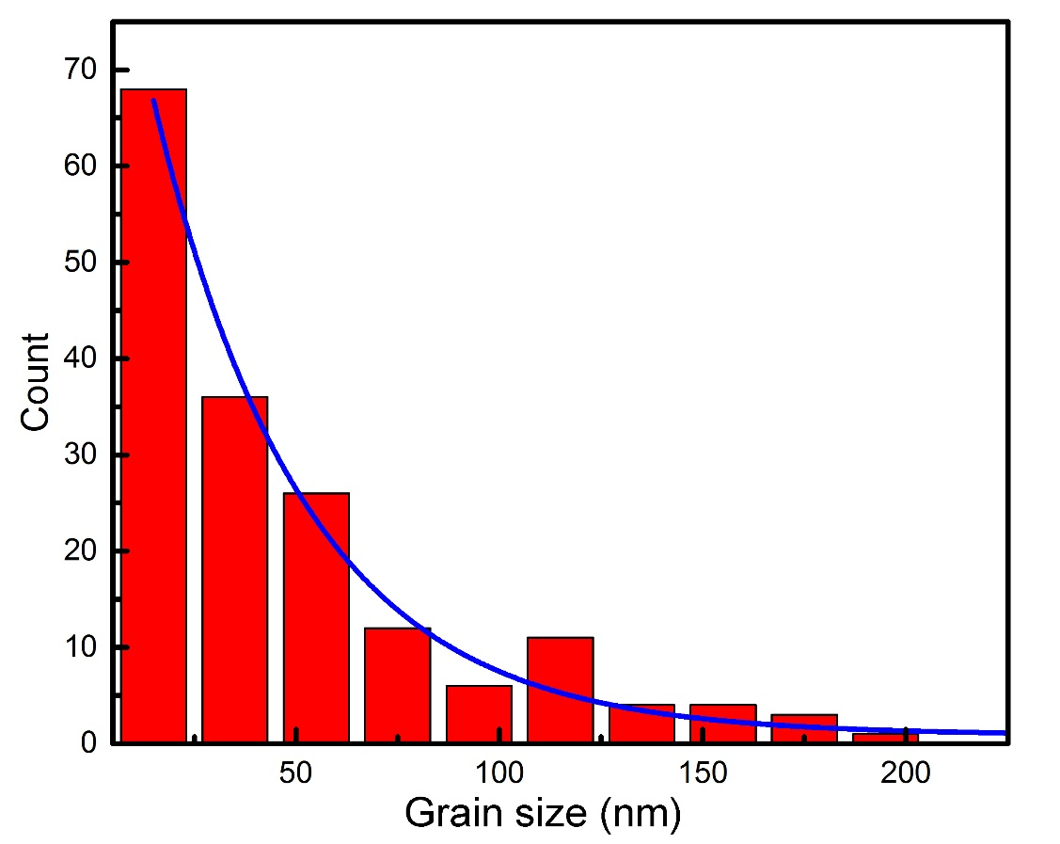
Figure S3. Plots of the grainsize distribution of the as-annealed Ni₅₀@Au₅₀ core–shell particles in the TEM image of Figure 7(a).

