Synthesis, Crystal structures, and Thermal behaviors of MBTO·nPhen with M=Co, Ni, Cu, Zn and Phen=1,10-Phenanthroline

Jiaping Zhu,ª Xiaoqing Yao,ª Gang Wang,ª Jianfeng Ban,^{b} Dang Wu,^{b*} Hao Ma^{a†}

a. Department of Applied Chemistry, School of Chemistry, Guangdong University of Petrochemical Technology, Maoming, China.
b. Department of polymers, School of materials science and engineer, Guangdong University of Petrochemical Technology, Maoming, China, E-mail:wudangxtu@163.com.
†Electronic supplementary information (ESI) available. CCDC 1576747 and 1585532.
Fig S1. IR spectra of BTO·Phen and its salts

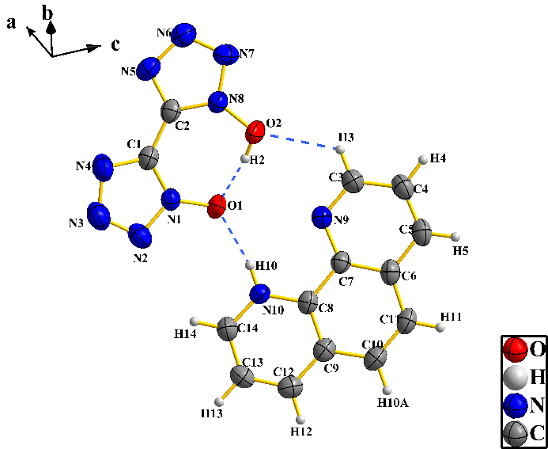
Fig S2. Crystal Structure of BTO·Phen

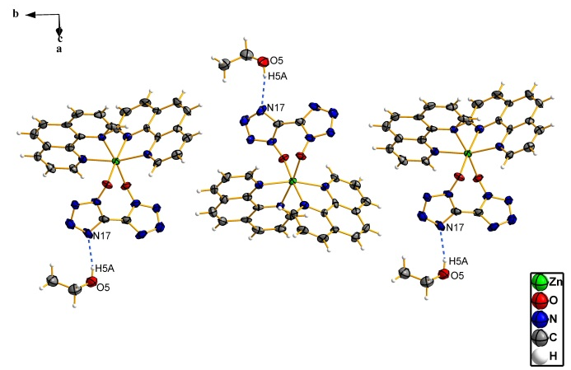
Fig S3. Hydrogen bond of BTO·Phen

Fig S4. TG curve of CuBTO·2Phen

Fig S4. DSC curves at different heating rates (left) and Ozawa and Kissinger kinetic plots (rifht) for BTO·Phen and its salts

Fig S4 (Continued)

Table S2 Selected bond length (Å) of BTO·Phen and its metal salts
1 |  | 2 |  | 4
O(1)–N(1) | 1.3396(19) | N(1)–Ni(1) | 2.088(5) | Zn(1)–O(1) | 2.077(5) | Zn(2)–O(3) | 2.096(5)
O(2)–N(8) | 1.350(2) | N(2)–Ni(1) | 2.110(4) | Zn(1)–O(2 | 2.117(5) | Zn(2)–O(4) | 2.080(5)
N(1)–N(2) | 1.338(2) | N(3)–Ni(1) | 2.069(5) | Zn(1)–N(9v | 2.144(6) | Zn(2)–N(21) | 2.132(6)
N(1)–C(1) | 1.341(2) | N(4)–Ni(1) | 2.076(5) | Zn(1)–N(10) | 2.142(5) | Zn(2)–N(22) | 2.222(6)
N(2)–N(3) | 1.319(2) | N(5)–Ni(1) | 2.115(4) | Zn(1)–N(11) | 2.216(6) | Zn(2)–N(23) | 2.134(5)
N(3)–N(4) | 1.353(3) | N(6)–Ni(1) | 2.074(5) | Zn(1)–N(12) | 2.159(6) | Zn(2)–N(24) | 2.144(6)
N(4)–C(1) | 1.334(2) | N(7)–O(1) | 1.328(7) | O(1)–N(1) | 1.311(7) | O(3)–N(13) | 1.328(7)
N(5)–N(6) | 1.357(2) | N(7)–N(8) | 1.363(8) | O(2)–N(5) | 1.332(7) | O(4)–N(20) | 1.308(7)
N(5)–C(2) | 1.331(3) | N(8)–N(9) | 1.302(8) | N(1)–N(2) | 1.335(9) | N(13)–N(14) | 1.320(9)
N(6)–N(7) | 1.311(2) | N(9)–N(10) | 1.366(8) | N(1)–C(1) | 1.352(9) | N(13)–C(28) | 1.363(9)
N(7)–N(8) | 1.335(2) | N(11)–N(12) | 1.346(8) | N(2)–N(3) | 1.304(10) | N(14)–N(15) | 1.316(9)
N(8)–C(2) | 1.344(2) | N(11)–O(2) | 1.349(7) | N(3)–N(4) | 1.354(11) | N(15)–N(16) | 1.336(9)
N(9)–C(3) | 1.323(2) | N(12)–N(13) | 1.315(9) | N(4)–C(1) | 1.348(10) | N(16)–C(28 | 1.305(10)
N(9)–C(7) | 1.358(2) | N(13)–N(14) | 1.347(10) | N(5)–N(6) | 1.353(9) | N(17)–N(18) | 1.356(9)
N(10)–C(8) | 1.361(2) | C(13)–N(3) | 1.310(7) | N(5)–C(2) | 1.336(9) | N(17)–C(27) | 1.322(9)
N(10)–C(14) | 1.330(2) | C(13)–C(14) | 1.419(9) | N(6)–N(7) | 1.322(9) | N(18)–N(19) | 1.298(9)
 |  | C(37)–N(7) | 1.311(8) | N(7)–N(8) | 1.339(10) | N(19)–N(20) | 1.327(8)
 |  | C(37)–C(38) | 1.449(9) | N(8)–C(2) | 1.306(10) | N(20)–C(27) | 1.351(9)
 |  | C(38)–N(11) | 1.326(8) | N(9)–C(3) | 1.331(9) | N(21)–C(29) | 1.323(9)
 |  | C(38)–N(14) | 1.340(8) | N(9)–C(7) | 1.353(9) | N(21)–C(33) | 1.355(9)
 |  |  |  | N(10)–C(8) | 1.347(9) | N(22)–C(34) | 1.356(9)
 |  |  |  | N(10–C(14) | 1.325(9) | N(22)–C(40) | 1.331(9)
 |  |  |  | N(11–C(15) | 1.321(9) | N(23)–C(41) | 1.336(9)
 |  |  |  | N(11–C(19) | 1.375(9) | N(23)–C(45) | 1.364(9)
 |  |  |  | N(12)–C(20) | 1.372(9) | N(24)–C(46) | 1.343(8)
 |  |  |  | N(12)–C(26) | 1.336(9) | N(24)–C(52) | 1.333(9)
 |  |  |  | C(1)–C(2) | 1.439(10) | C(27)–C(28) | 1.427(10)

Table S6 The calculated parameters for the exothermic process from the DSC curves
compound | β (ºC min^{–1}) | T_{o} (ºC) | T_{p} (ºC) | E_{K}(kJ mol^{–1}) | r_{K} | A (s^{–1}) | E_{O} (kJ mol^{–1}) | r_{O} | E_{a} (kJ mol^{–1})
BTO·Phen | 5 | 237.9 | 254.2 | 164.1 | 0.9991 | 6.772×10¹⁵ | 164.5 | 0.9992 | 164.3
BTO·Phen | 10 | 239.4 | 263.0
BTO·Phen | 15 | 240.5 | 269.4
BTO·Phen | 20 | 241.8 | 273.2
CoBTO·3Phen | 5 | 249.5 | 269.0 | 173.6 | 0.9995 | 1.929×10¹⁶ | 173.8 | 0.9995 | 173.7
CoBTO·3Phen | 10 | 255.2 | 278.7
CoBTO·3Phen | 15 | 261.7 | 284.5
CoBTO·3Phen | 20 | 264.3 | 288.0
NiBTO·3Phen | 5 | 264.9 | 272.6 | 194.1 | 0.9994 | 1.342×10¹⁸ | 193.3 | 0.9994 | 193.7
NiBTO·3Phen | 10 | 274.7 | 281.7
NiBTO·3Phen | 15 | 281.6 | 286.3
NiBTO·3Phen | 20 | 285.6 | 290.1
CuBTO·2Phen | 5 | 255.3 | 260.0 | 215.2 | 0.9997 | 4.463×10²⁰ | 213.2 | 0.9998 | 214.2
CuBTO·2Phen | 10 | 263.9 | 267.2
CuBTO·2Phen | 15 | 268.2 | 271.6
CuBTO·2Phen | 20 | 271.5 | 275.1
ZnBTO·2Phen | 5 | 268.6 | 269.1 | 170.1 | 0.9997 | 8.923×10¹⁵ | 170.5 | 0.9998 | 170.3
 | 10 | 276.0 | 278.3
 | 15 | 278.8 | 284.5
 | 20 | 282.8 | 288.6
T_{o}: onset temperature in the DSC curve; T_{p}: peak temperature. Subscript K: Kissinger’s method; O: Ozawa’s method.

Table S7 The critical explosion temperatures of BTO·Phen and its metal salts
 | BTO·Phen | 1 | 2 | 3 | 4
T_{e0} (°C) | 235.4 | 249.3 | 252.2 | 239.1 | 250.8
T_{b} (°C) | 249.2 | 263.1 | 264.6 | 249.8 | 264.9

