Supporting Information
for
Synthesis of 4-(2-fluorophenyl)-7-methoxycoumarin: experimental and computational evidence for intramolecular and intermolecular C-F…H-C bond

Vuyisa Mzozoyana *, Fanie R. van Heerden and Craig Grimmer

School of Chemistry and Physics, University of KwaZulu-Natal, Private Bag X01, Scottsville, 3209, Pietermaritzburg, South Africa.

Email:
Vuyisa Mzozoyana * - mzozoyanav@ukzn.ac.za
* Corresponding author

Table of content:
NMR spectra for compound 3, 5 and 6…………………………………………………..S2
HRMS for compound 6……………………………………………………………………..S6
Single crystal X-ray data for compound 6………………………………………………...S7

¹H and ¹³C NMR spectra for methyl 2-fluorobenzoylacetate (3) in CDCl₃.

¹H and ¹³C NMR spectra for 7-hydroxy-4-(2-fluorophenyl)coumarin (5) in DMSO-d₆.

¹H and ¹³C NMR spectra for 4-(2-fluorophenyl)-7-methoxycoumarin (6) in CDCl₃.

¹⁹F and ¹⁹Fdecoupled NMR spectra for 4-(2-fluorophenyl)-7-methoxycoumarin (6) in CDCl₃.
HRMS for compound 6

Single crystal X-ray data for compound 6.

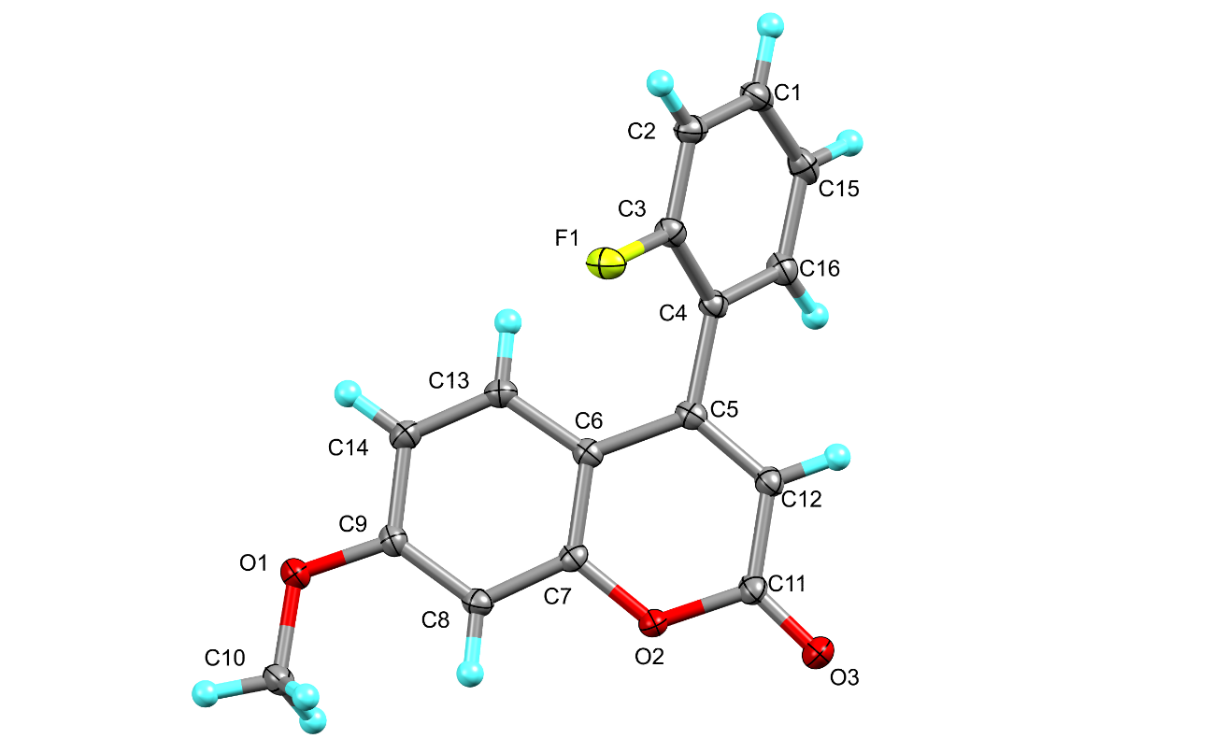
Figure S1: Single crystal X-ray structure of compound 6.

Table 1. Crystal data and structure refinement for 6.

Identification code shelx
Empirical formula C16 H11 F O3
Formula weight 270.25
Temperature 100(2) K
Wavelength 0.71073 Å
Crystal system Monoclinic
Space group C 2/c
Unit cell dimensions a = 24.3682(12) Å α= 90°.
b = 4.0911(2) Å β= 114.677(2)°.
c = 26.7036(13) Å γ = 90°.
Volume 2419.0(2) Å3
Z 8
Density (calculated) 1.484 Mg/m3
Absorption coefficient 0.112 mm-1
F(000) 1120
Crystal size 0.250 x 0.220 x 0.050 mm3
Theta range for data collection 1.678 to 28.535°.
Index ranges -32<=h<=32, -5<=k<=4, -35<=l<=35
Reflections collected 14829
Independent reflections 3060 [R(int) = 0.0168]
Completeness to theta = 25.242° 99.7 %
Absorption correction Semi-empirical from equivalents
Max. and min. transmission 0.998 and 0.962
Refinement method Full-matrix least-squares on F2
Data / restraints / parameters 3060 / 0 / 182
Goodness-of-fit on F2 1.080
Final R indices [I>2sigma(I)] R1 = 0.0394, wR2 = 0.1081
R indices (all data) R1 = 0.0442, wR2 = 0.1122
Extinction coefficient n/a
Largest diff. peak and hole 0.369 and -0.223 e.Å-3
Table 2. Atomic coordinates ( x 104) and equivalent isotropic displacement parameters (Å2x 103)
for 6. U(eq) is defined as one third of the trace of the orthogonalized Uij tensor.
________________________________________________________________________________
x y z U(eq)
________________________________________________________________________________
F(1) 741(1) 9677(2) 7783(1) 22(1)
O(1) -904(1) 4183(3) 8763(1) 21(1)
O(2) 951(1) 9882(2) 9721(1) 17(1)
O(3) 1806(1) 12469(3) 10200(1) 24(1)
C(1) 2035(1) 5839(3) 7710(1) 21(1)
C(2) 1484(1) 7410(3) 7550(1) 19(1)
C(3) 1280(1) 8105(3) 7948(1) 17(1)
C(4) 1599(1) 7335(3) 8503(1) 16(1)
C(5) 1372(1) 8136(3) 8928(1) 15(1)
C(6) 780(1) 7089(3) 8870(1) 15(1)
C(7) 592(1) 8000(3) 9277(1) 15(1)
C(8) 36(1) 7130(3) 9265(1) 16(1)
C(9) -347(1) 5203(3) 8829(1) 16(1)
C(10) -1122(1) 5329(4) 9154(1) 21(1)
C(11) 1525(1) 10813(3) 9797(1) 18(1)
C(12) 1730(1) 9825(3) 9384(1) 17(1)
C(13) 382(1) 5113(3) 8440(1) 17(1)
C(14) -167(1) 4175(3) 8419(1) 18(1)
C(15) 2376(1) 5086(4) 8260(1) 22(1)
C(16) 2161(1) 5847(3) 8654(1) 19(1)
________________________________________________________________________________
Table 3. Bond lengths [Å] and angles [°] for 6.
_____________________________________________________
F(1)-C(3) 1.3590(14)
O(1)-C(9) 1.3595(14)
O(1)-C(10) 1.4339(15)
O(2)-C(7) 1.3773(15)
O(2)-C(11) 1.3799(15)
O(3)-C(11) 1.2118(16)
C(1)-C(2) 1.3858(18)
C(1)-C(15) 1.3885(19)
C(1)-H(1) 0.9500
C(2)-C(3) 1.3792(16)
C(2)-H(9) 0.9500
C(3)-C(4) 1.3925(17)
C(4)-C(16) 1.3966(17)
C(4)-C(5) 1.4898(16)
C(5)-C(12) 1.3556(17)
C(5)-C(6) 1.4495(16)
C(6)-C(7) 1.3945(16)
C(6)-C(13) 1.4080(17)
C(7)-C(8) 1.3884(17)
C(8)-C(9) 1.3923(17)
C(8)-H(4) 0.9500
C(9)-C(14) 1.4037(17)
C(10)-H(2) 0.9800
C(10)-H(11) 0.9800
C(10)-H(3) 0.9800
C(11)-C(12) 1.4463(17)
C(12)-H(10) 0.9500
C(13)-C(14) 1.3705(17)
C(13)-H(5) 0.9500
C(14)-H(6) 0.9500
C(15)-C(16) 1.3901(18)
C(15)-H(8) 0.9500
C(16)-H(7) 0.9500

C(9)-O(1)-C(10) 117.37(10)
C(7)-O(2)-C(11) 121.47(10)
C(2)-C(1)-C(15) 120.17(12)
C(2)-C(1)-H(1) 119.9
C(15)-C(1)-H(1) 119.9
C(3)-C(2)-C(1) 118.31(12)
C(3)-C(2)-H(9) 120.8
C(1)-C(2)-H(9) 120.8
F(1)-C(3)-C(2) 117.25(11)
F(1)-C(3)-C(4) 119.13(11)
C(2)-C(3)-C(4) 123.61(11)
C(3)-C(4)-C(16) 116.67(11)
C(3)-C(4)-C(5) 122.72(11)
C(16)-C(4)-C(5) 120.58(11)
C(12)-C(5)-C(6) 119.04(11)
C(12)-C(5)-C(4) 119.41(11)
C(6)-C(5)-C(4) 121.54(11)
C(7)-C(6)-C(13) 116.79(11)
C(7)-C(6)-C(5) 118.32(11)
C(13)-C(6)-C(5) 124.86(11)
O(2)-C(7)-C(8) 115.28(10)
O(2)-C(7)-C(6) 121.49(11)
C(8)-C(7)-C(6) 123.23(11)
C(7)-C(8)-C(9) 118.15(11)
C(7)-C(8)-H(4) 120.9
C(9)-C(8)-H(4) 120.9
O(1)-C(9)-C(8) 124.46(11)
O(1)-C(9)-C(14) 115.35(11)
C(8)-C(9)-C(14) 120.20(11)
O(1)-C(10)-H(2) 109.5
O(1)-C(10)-H(11) 109.5
H(2)-C(10)-H(11) 109.5
O(1)-C(10)-H(3) 109.5
H(2)-C(10)-H(3) 109.5
H(11)-C(10)-H(3) 109.5
O(3)-C(11)-O(2) 116.65(11)
O(3)-C(11)-C(12) 125.79(12)
O(2)-C(11)-C(12) 117.53(11)
C(5)-C(12)-C(11) 121.98(11)
C(5)-C(12)-H(10) 119.0
C(11)-C(12)-H(10) 119.0
C(14)-C(13)-C(6) 121.48(11)
C(14)-C(13)-H(5) 119.3
C(6)-C(13)-H(5) 119.3
C(13)-C(14)-C(9) 120.13(12)
C(13)-C(14)-H(6) 119.9
C(9)-C(14)-H(6) 119.9
C(1)-C(15)-C(16) 120.22(12)
C(1)-C(15)-H(8) 119.9
C(16)-C(15)-H(8) 119.9
C(15)-C(16)-C(4) 120.97(12)
C(15)-C(16)-H(7) 119.5
C(4)-C(16)-H(7) 119.5
_____________________________________________________________
Symmetry transformations used to generate equivalent atoms:

Table 4. Anisotropic displacement parameters (Å2x 103) for 6. The anisotropic
displacement factor exponent takes the form: -2π2[ h2a*2U11 + ... + 2 h k a* b* U12 ]
______________________________________________________________________________
U11 U22 U33 U23 U13 U12
______________________________________________________________________________
F(1) 21(1) 27(1) 18(1) 4(1) 8(1) 10(1)
O(1) 17(1) 27(1) 20(1) -4(1) 10(1) -5(1)
O(2) 15(1) 22(1) 13(1) -2(1) 6(1) -2(1)
O(3) 20(1) 34(1) 18(1) -7(1) 7(1) -6(1)
C(1) 23(1) 21(1) 25(1) -3(1) 16(1) -3(1)
C(2) 23(1) 19(1) 17(1) -1(1) 11(1) -2(1)
C(3) 17(1) 15(1) 19(1) 0(1) 9(1) 1(1)
C(4) 17(1) 15(1) 16(1) 0(1) 8(1) -1(1)
C(5) 16(1) 16(1) 15(1) 4(1) 7(1) 3(1)
C(6) 15(1) 15(1) 15(1) 3(1) 7(1) 2(1)
C(7) 16(1) 15(1) 13(1) 2(1) 4(1) 2(1)
C(8) 17(1) 18(1) 14(1) 2(1) 8(1) 2(1)
C(9) 14(1) 17(1) 18(1) 2(1) 7(1) 0(1)
C(10) 18(1) 28(1) 21(1) 0(1) 11(1) -1(1)
C(11) 15(1) 22(1) 15(1) 2(1) 5(1) -1(1)
C(12) 16(1) 20(1) 17(1) 2(1) 7(1) 0(1)
C(13) 19(1) 17(1) 16(1) -1(1) 8(1) 1(1)
C(14) 19(1) 18(1) 17(1) -3(1) 7(1) -2(1)
C(15) 17(1) 23(1) 29(1) 1(1) 13(1) 2(1)
C(16) 16(1) 21(1) 21(1) 2(1) 8(1) 0(1)
______________________________________________________________________________
Table 5. Hydrogen coordinates ( x 104) and isotropic displacement parameters (Å2x 103)
for 6.
________________________________________________________________________________
x y z U(eq)
________________________________________________________________________________

H(1) 2180 5277 7441 25
H(9) 1253 7994 7176 23
H(4) -81 7831 9545 19
H(2) -853 4573 9524 32
H(11) -1530 4474 9057 32
H(3) -1134 7724 9149 32
H(10) 2129 10377 9434 21
H(5) 497 4415 8158 20
H(6) -426 2826 8126 22
H(8) 2757 4047 8369 26
H(7) 2400 5348 9030 23
________________________________________________________________________________
Table 6. Torsion angles [°] for 6.
________________________________________________________________
C(15)-C(1)-C(2)-C(3) -1.8(2)
C(1)-C(2)-C(3)-F(1) 179.30(11)
C(1)-C(2)-C(3)-C(4) 0.5(2)
F(1)-C(3)-C(4)-C(16) -177.31(11)
C(2)-C(3)-C(4)-C(16) 1.5(2)
F(1)-C(3)-C(4)-C(5) 0.63(19)
C(2)-C(3)-C(4)-C(5) 179.43(12)
C(3)-C(4)-C(5)-C(12) -126.92(14)
C(16)-C(4)-C(5)-C(12) 50.93(17)
C(3)-C(4)-C(5)-C(6) 54.41(18)
C(16)-C(4)-C(5)-C(6) -127.73(13)
C(12)-C(5)-C(6)-C(7) 2.93(18)
C(4)-C(5)-C(6)-C(7) -178.40(11)
C(12)-C(5)-C(6)-C(13) -174.90(12)
C(4)-C(5)-C(6)-C(13) 3.77(19)
C(11)-O(2)-C(7)-C(8) 177.36(11)
C(11)-O(2)-C(7)-C(6) -3.32(18)
C(13)-C(6)-C(7)-O(2) 178.87(11)
C(5)-C(6)-C(7)-O(2) 0.87(18)
C(13)-C(6)-C(7)-C(8) -1.86(19)
C(5)-C(6)-C(7)-C(8) -179.87(11)
O(2)-C(7)-C(8)-C(9) -179.45(11)
C(6)-C(7)-C(8)-C(9) 1.25(19)
C(10)-O(1)-C(9)-C(8) 3.59(19)
C(10)-O(1)-C(9)-C(14) -176.44(11)
C(7)-C(8)-C(9)-O(1) -179.71(12)
C(7)-C(8)-C(9)-C(14) 0.32(19)
C(7)-O(2)-C(11)-O(3) 179.97(11)
C(7)-O(2)-C(11)-C(12) 1.92(17)
C(6)-C(5)-C(12)-C(11) -4.37(19)
C(4)-C(5)-C(12)-C(11) 176.93(12)
O(3)-C(11)-C(12)-C(5) -175.85(13)
O(2)-C(11)-C(12)-C(5) 2.01(19)
C(7)-C(6)-C(13)-C(14) 0.95(18)
C(5)-C(6)-C(13)-C(14) 178.81(12)
C(6)-C(13)-C(14)-C(9) 0.5(2)
O(1)-C(9)-C(14)-C(13) 178.85(11)
C(8)-C(9)-C(14)-C(13) -1.2(2)
C(2)-C(1)-C(15)-C(16) 1.2(2)
C(1)-C(15)-C(16)-C(4) 0.9(2)
C(3)-C(4)-C(16)-C(15) -2.14(19)
C(5)-C(4)-C(16)-C(15) 179.88(12)
________________________________________________________________
Symmetry transformations used to generate equivalent atoms:

