Supporting information for
Construction of NiMoO₄ nanorods@ZIF-67 derived Co₃O₄ supported on cellulose based carbon aerogel for asymmetric supercapacitors

Meixia Wang, Jing Zhang,∗ Xibin Yi, Benxue Liu, Xinfu Zhao, Xiaochan Liu

Shandong Key Laboratory for Special Silicon-containing Material, Advanced Materials Institute, Qilu University of Technology (Shandong Academy of Sciences), Jinan, 250014, P. R. China

Preparation and characterization of asymmetric supercapacitors (ASC)
The ASC device was assembled used NiMoO₄@Co₃O₄/CA as the positive electrode, and AC as the negative. A piece of cellulose paper as the separator soaked in the electrolyte was sandwiched between the two electrodes. The electrochemical tests of ASCs device (denoted as NiMoO₄@Co₃O₄/CA//AC) was measured at 2.0 M KOH alkaline electrolyte. Positive and negative charges should be balanced in ASCs by the formula q⁺ = q–, where q⁺ and q– represent the charges stored in the positive and negative electrodes, respectively. The following equation was used to calculate q [1]:
q = mC_{m}ΔV (S1)
When q⁺ = q–, the ratio between the masses of the positive electrode (m₊) and a negative electrode (m–) is determined by the following equation [2]:
$\frac{m_{+}}{m_{−}=C_{−\frac{{ΔV}_{−}}{C_{+{ΔV}_{+}}}}}$ (S2)
The device specific capacitance, energy density (E) and power density (P) are calculated from the charging-discharge curve by the following equation [3, 4]:
$C=\frac{I×∆t}{m×∆V}$ (S3)
$E=\frac{C×{∆V}^{2}}{2×3.6}$ (S4)
$P=\frac{3600×E}{∆t}$ (S5)
Where C (F/g) is specific capacitance, I (A) is the current, Δt (s) is the discharge time, ΔV (V) is the working voltage window, m (g) is the mass of the active material, E (Wh/kg) is energy density and P (W/kg) is power density.

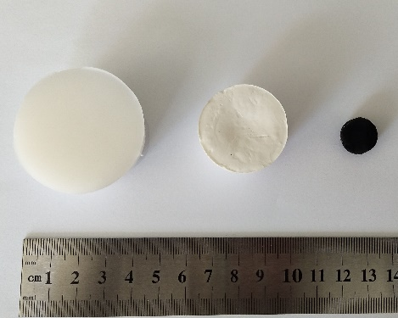
Fig. S1 A digital photograph of the cellulose hydrogel. cellulose aerogel and CA

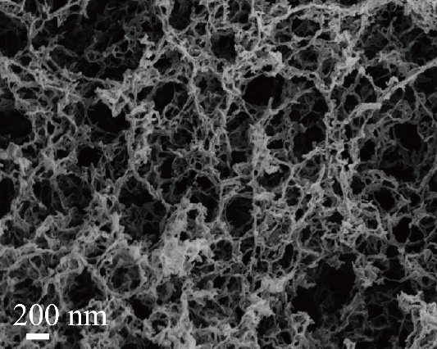
Fig. S2 SEM of cellulose aerogel

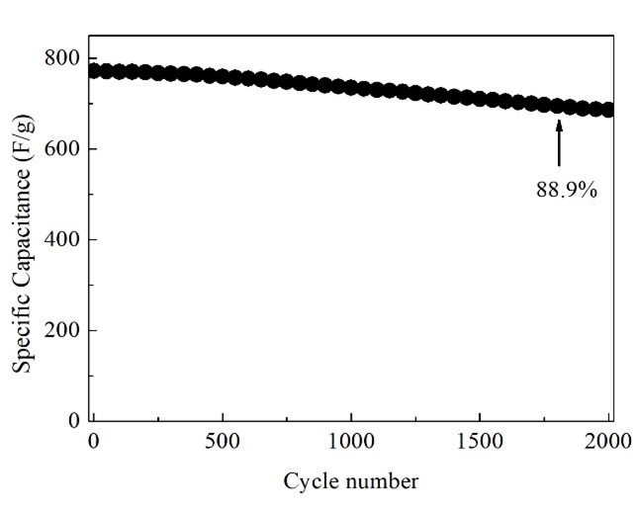
Fig. S3 Cycle performance of NiMoO₄@Co₃O₄/CA at current density of 5.0 A/g

- S. Chen, H. Chen, C. Li; M. Fan, C. Lv, G. Tian; K. Shu, J. Mater. Sci., 52 (2017) 6687-6696.
- R. R. Salunkhe, J. Lin, V. Malgras, S. X. Dou, J. H. Kim, Y. Yamauchi, Nano Energy, 11 (2015) 211-218.
- M. C. Liu, Y. Xu, Y. X. Hu, Q. Q. Yang, L. B. Kong, W. W. Liu, W. J. Niu, Y. L. Chueh, ACS Appl. Mater. Interfaces, 10 (2018) 35571-35579.
- J. T. Zhang, J. W. Jiang, H. L. Li, X. S. Zhao, Energy Environ. Sci., 4 (2011) 4009-4015.

∗ Corresponding author. Tel.: +86-531-82605448; fax: +86-531-82605475. E-mail address: zhangjing@sdas.org

