Supporting information

Straighforward Synthesis of Various Chiral Pyrimidines Bearing Stereogenic Center at the C² position, Including C-Terminal Peptide Isosters

Sami Sahtel,^{1,2} Rafâa Besbes,² Emmanuel Vrancken^{1*} and Jean-Marc Campagne^{1*}
¹ Institut Charles Gerhardt, UMR 5253 CNRS-UM-ENSCM, Laboratoire Architectures Moléculaires et Matériaux Nanostructurés, 240 Avenue Emile Jeanbrau, 34296 Montpellier Cedex 5, France.
² University of Tunis-El Manar, Faculty of Sciences of Tunis, Department of Chemistry, Laboratory of Analytical Chemistry and Electrochemistry, Campus Universities 2092 Tunis El-Manar, Tunisia
E-mail : emmanuel.vrancken@enscm.fr

Contents
General Considerations 2
General Procedures 3
1. Synthesis of β-enaminones (1a-d) 3
2. Synthesis of N-protected-L-amino amides (2a’-j’) 3
3. Synthesis of N-Boc-(S)-3-aminobutyric acid (A) 5
4. Synthesis of (S)-2-methoxy-2-phenylacetamide (5) and (R)-3,3,3-trifluoro-2-methoxy-2-phenylpropanamide (8) 6
5. Synthesis of (R)-2-(tert-Butyldimethylsilyloxy)-2-phenylacetamide (6) 6
6. Synthesis of (R)-2-(4-((tert-Butyldimethylsilyl)phenoxy)propanamide (7) 7
7. Synthesis of chiral amides (9-11) 8
8. Synthesis of pyrimidines (3aa’-3aj’), (3bb’-3db’) and (12-18) 9
9. Synthesis of dipeptides (19-20) 22
1H and 13C NMR Spectra of the Products 25
Chiral HPLC Chromatograms 47

General Considerations
Unless otherwise specified, all commercial products and reagents were used as purchased, without further purification. Reactions were carried out in round-bottom flasks and microwave tubes equipped with a magnetic stirring bar under argon atmosphere. Reactions with irradiation under microwave were realized with a Discover® SP - microwave synthesizer - CEM. Analytical thin-layer chromatography (TLC) of all reactions was performed on silica gel 60 F254 TLC plates. Visualization of the developed chromatogram was performed by UV absorbance (254 nm), using KMNO₄. Flash chromatography was carried out on silica gel 60 Å (35-70 nm) and Biotage IsoleraTM Flash Purification System. FT-IR spectra were recorded with a Perkin-Elmer Spectrum 1000; absorptions are given in wave numbers (cm⁻¹). ¹H (400 MHz), ¹³C (100 MHz), NMR spectra were recorded with a Bruker Ultra Shield 400 Plus. ¹H chemical shifts are reported in delta (δ) units in parts per million (ppm) relative to the residual solvent peak at 7.26 ppm for CDCl₃ and at 2.50 ppm for (CD₃)₂SO. ¹³C chemical shifts are reported in ppm relative to the central line of the triplet at 77.16 ppm for d-chloroform and to the central line of the septuplet at 39.52 ppm for d- DMSO. Splitting patterns are designated as s, singlet; d, doublet; t, triplet; q, quartet; m, multiplet; and brs, broad and combinations thereof. All coupling constants (J values) are reported in Hertz (Hz). Data are reported as follows: chemical shift (δ in ppm), multiplicity, coupling constants (Hz), integration and attribution. Enantiomeric excesses were measured on a Shimadzu® LC 20A HPLC with a UV/visible detector at 254 nm and 210 nm. Optical rotations were measured with a Bellingham + Stanley® ADP 440 Polarimeter or a Perkin Elmer® Polarimeter with a sodium lamp at 589 nm. Low resolutions mass spectra were recorded on a Waters QTof-I spectrometer using electrospray ionization. High resolution mass spectra were obtained using the mass spectrometers operated by the “Laboratoire de Mesures Physiques of the University of Montpellier”. Melting points were measured with a Stuart SMP 50 Automatic melting point instrument. THF was dried by distillation over sodium metal and benzophenone under argon. DCM and toluene were dried over molecular sieves.

General Procedures
- Synthesis of β-enaminones (1a-d)

β-enaminones were synthesized according to the methodology developed by Gayon & al.
In a 50 mL round-bottom flask, equipped with a magnetic stirrer bar, the corresponding propargylic hydroxylamine (2 mmol, 1 equiv), acetonitrile (20 mL) and sodium hydroxide powder (0.2 mmol, 0.1 equiv) were added by turn and the mixture was heated at 50 °C for 1 h. Thus, the reaction mixture was filtered through a silica gel pad and eluted with ethyl acetate, the filtrate was concentrated, and the residue was purified by flash chromatography on silica gel to give the corresponding β-enaminone.
The analytical data of compounds 1a-d were identical in all aspects to those previously reported by Gayon & al.¹
- Synthesis of N-protected-L-amino amides (2a’-j’)

A solution of N-protected-L-amino acid (10 mmol) in dry THF (20 mL) was cooled to 0 °C and triethylamine (1.4 mL, 10 mmol) was added. After 15 min at 0 °C, ethyl chloroformate (1 mL, 10 mmol) was added dropwise and the clear solution stirred for 30 min, before addition of 25 % aqueous ammonia solution (2.5 mL). After 30 min at 0 °C, the mixture was diluted with H₂O (12 mL) and extracted with ethyl acetate (2 x 20 mL). The combined organic layers were dried (MgSO4), filtered, concentrated under reduced pressure. The obtained amide was used in the next step without further purification.
The analytical data of Cbz-Phe-NH2 (2a’), Boc-Phe-NH2 (2b’), Boc-Ala-NH2 (2d’), Boc-Val-NH2 (2e’) and Boc-Met-NH2 (2h’) were identical in all aspects to those previously reported by Ezawa & al
The analytical data of Boc-Gly-NH2 (2c’) were identical in all aspects to those previously reported by Xu & al.
The analytical data of Boc-Pro-NH2 (2f’) were identical in all aspects to those previously reported by Wang & al.
The analytical data of Boc-Ile-NH2 (2g’) were identical in all aspects to those previously reported by Toumi & al.
The analytical data of Boc-Glu(Bn)-NH2 (2i’) were identical in all aspects to those previously reported by Trotter & al.
The analytical data of Boc-Tyr(Bzl)-NH2 (2j’) were identical in all aspects to those previously reported by Boeijen & al.
- Synthesis of N-Boc-(S)-3-aminobutyric acid (A)
N-Boc-(S)-3-aminobutyric acid (A) was synthesized according to the methodology developed by McKiernan & al.
To a solution of (S)-3-aminobutyric acid (2.3 g, 22 mmol) in H₂O (12 mL) were added di-tert-butyl dicarbonate (4.9 g, 22 mmol), sodium hydroxide (1.0 g, 25 mmol) in H₂O (10 mL), and 2-methyl-2-propanol (16.5 mL). The reaction mixture was heated to 30 °C and stirred at room temperature. After 18 h, the solution was evaporated in vacuo and H₂O added (50 mL). The product was extracted into EtOAc (3 X 30 mL), dried (MgSO₄), and evaporated to dryness under vacuum to afford the desired product. The obtained acid was used in the next step without further purification.
The analytical data of N-Boc-(S)-3-aminobutyric acid (A) were identical in all aspects to those previously reported by McKiernan & al.⁸
- Synthesis of (S)-2-methoxy-2-phenylacetamide (5) and (R)-3,3,3-trifluoro-2-methoxy-2-phenylpropanamide (8)

Amides (5) and (8) were synthesized according to the methodology developed by Tietze & al.

A solution of carboxylic acid (6.5 mmol) in dry MeOH (27 mL) was cooled to 0 °C and Acetyl chloride (1.3 mL, 17.6 mmol) was added dropwise to the flask via syringe at 0 °C. After stirring 12 h at room temperature the solvent was evaporated on a rotary evaporator. The residue was dissolved in MeOH (5 mL), and 25% aqueous ammonia solution (12.5 mL) was added. The flask was stored in the fridge overnight. Solvent was then evaporated to give a solid, which was recrystallized from EtOH – pentane to afford the corresponding amide.

The analytical data of (S)-2-methoxy-2-phenylacetamide (5) were identical in all aspects to those previously reported by Kimura & al.
The analytical data of (R)-3,3,3-trifluoro-2-methoxy-2-phenylpropanamide (8) were identical in all aspects to those previously reported by Santangelo & al.
- Synthesis of (R)-2-(tert-Butyldimethylsilyloxy)-2-phenylacetamide (6)
- Step 1:
(R)-2-hydroxy-2-phenylacetamide (B) was synthesized according to the methodology (4).
The analytical data of (R)-2-hydroxy-2-phenylacetamide (B) were identical in all aspects to those previously reported by Jeevan & al.
- Step 2:
A solution of (R)-2-Hydroxy-2-phenylacetamide (0.73 g, 4.83 mmol) DMAP (0.12 g, 0.97 mmol) and imidazole (0.99 g, 14.50 mmol) in dry CH₃CN (9.6 mL) was cooled to 0 °C and stirred for 20 min. TBDMS-Cl (2.18 g, 14.50 mmol) was added portion wise over the period of 30 min. After the addition is completed, the reaction mixture was stirred at room temperature over night. The residue was purified by flash chromatography on silica gel to give the corresponding O-protected amide (6) as a white solid (1.10 g, 86 %).

The analytical data of (R)-2-(tert-Butyldimethylsilyloxy)-2-phenylacetamid (6) were identical in all aspects to those previously reported by Jeevan & al.¹²
R_{f} = 0.42 (eluent: Pentane/AcOEt 80:20, UV and KMNO₄ staining)
- Synthesis of (R)-2-(4-((tert-Butyldimethylsilyl)phenoxy)propanamide (7)

- Step 1:
(R)-(+)-2-(4-Hydroxyphenoxy)propionic amide (C) was prepared according to the Representative Procedure (4) from(R)-(+)-2-(4-Hydroxyphenoxy)propionic acid (1.2 g, 6.5 mmol) to give amide (C) as a white solid (0.93 g, 79 %).
[α] _{D}²⁵ = -18.66 (c = 1.5, MeOH)
Mp: 158.6-163.4
R_{f} = 0.21 (eluent: Pentane/AcOEt 40:60, UV and KMNO₄ staining)
¹H NMR (400 MHz, CDCl₃): δ 9.03 (brs, 1H), 7.45 (m, 1H), 7.24 (m, 1H), 6.80-6.69 (m, 4H), 1.41 (d, J = 6.7 Hz, 3H).
¹³C NMR (100 MHz, CDCl₃): δ 174.0, 151.7, 150.1, 116.5, 115.6, 74.5, 18.7.
FTIR neat (cm⁻¹): 3391, 3215, 3152, 2290, 2938, 1650, 1606, 1508, 1441, 1369, 1297, 1125, 1096, 1084, 1037, 917, 842, 712, 674.
HRMS (ESI+): calculated for C₉H₁₂NO₃ (m/z): [M+H]⁺: calculated : 182.0817, found: 182.0818
- Step 2:
A solution of (R)-(+)-2-(4-Hydroxyphenoxy)propionic amide (0.39 g, 2.1 mmol), DMAP (0.05 g, 0.43 mmol) and Imidazole (0. 43 g, 6.3 mmol) in dry CH₃CN (4.2 mL) was cooled to 0 °C and stirred for 20 min. TBDMS-Cl (0.95 g, 6.3 mmol) was added. After the addition is completed, the reaction mixture was stirred at room temperature over night. The residue was purified by flash chromatography on silica gel to give the corresponding O-protected amide (7) as a white solid (0.52 g, 83 %).
(R)-2-(4-((tert-Butyldimethylsilyl)phenoxy)propanamide (7)
[α] _{D}²⁵ = -10.66 (c = 1.5, MeOH)
Mp: 57.6-62.2
R_{f} = 0.23 (eluent: Pentane/AcOEt 70:30, UV and KMNO₄ staining)
¹H NMR (400 MHz, CDCl₃): δ 6.74-6.79 (m, 4H), 6.47 (brs, 1H), 6.23 (brs, 1H), 4.54 (q, J = 6.8 Hz, 1H), 1.54 (d, J = 6.8 Hz, 3H), 0.96 (s, 9H), 0.16 (s, 6H).
¹³C NMR (100 MHz, CDCl₃): δ 175.7, 151.4, 150.6, 120.98, 116.7, 75.7, 25.8, 18.7, 18.3, -4.4.
FTIR neat (cm⁻¹): 3381, 3190, 2955, 2930, 1658, 1502, 1471, 1462, 1416, 1363, 1254, 1213, 1091, 1038, 1007, 908, 826, 777, 727, 683.
HRMS (ESI+): calculated for C₁₅H₂₆NO₃Si (m/z): [M+H]⁺: calculated : 296.1676, found: 296.1682
- Synthesis of chiral amides (9-11)
A solution of carboxylic acid (10 mmol) in dry THF (20 mL) was cooled to 0 °C and triethylamine (1.4 mL, 10 mmol) was added. After 15 min at 0 °C, ethyl chloroformate (1 mL, 10 mmol) was added dropwise and the clear solution stirred for 30 min, before addition of 25% aqueous ammonia solution (2.5 mL). After 30 min at 0°C, the mixture was diluted with H₂O (12 mL) and extracted with ethyl acetate (2 x 20 mL). The combined organic layers were dried (MgSO4), filtered, concentrated under reduced pressure. The obtained amide was used in the next step without further purification.

The analytical data of (S)-2-phenylpropanamide (9) were identical in all aspects to those previously reported by Wang & al.
The analytical data of (S)-2-methylbutanamide (10) were identical in all aspects to those previously reported by Santangelo & al.¹¹
The analytical data of Tert-butyl (S)-(4-amino-4-oxobutan-2-yl)carbamate (11) were identical in all aspects to those previously reported by Fisher & al.
- Synthesis of pyrimidines (3aa’-3aj’), (3bb’-3db’) and (12-18)
A dry microwave tube (35 mL) equipped with a magnetic stirrer bar was successively loaded with the corresponding vinylogous amide (1 equiv), the corresponding amide (2.5 equiv) and 4 Å MS (175 mg). The tube was flushed with argon for 3 times. Then, toluene (c= 0.1 M) was added and the mixture was stirred at room temperature. After 5 minutes at room temperature, base (2.5 equiv) was added. The tube was then transferred into the microwave oven, irradiated at 200 W and was stirred at 140 °C for 4 h. The reaction was quenched with an aqueous solution of NH₄Cl (30 mL) and diluted with EtOAc (30 mL). The layers were separated, and the aqueous layer was extracted with EtOAc. The combined organic layers were dried over MgSO₄, concentrated in vacuo and purification of the crude material via chromatography on silica gel (pentane/EtOAc) afforded the corresponding pyrimidine.

benzyl (S)-(1-(4-butyl-6-phenylpyrimidin-2-yl)-2-phenylethyl)carbamate (3aa’)
The title compound was prepared according to the general procedure (8) from the corresponding β‐enaminone 1a (101.6mg, 0.3 mmol), amide 2a’ (224.6 mg, 0.8 mmol) and NaH (90%, 20 mg, 0.8 mmol) to give a pale yellow oil (61.6 mg, 44 %).
[α] _{D}²⁵ = -16.0 (c = 1.0, CHCl₃)
R_{f} = 0.18 (eluent: Pentane/AcOEt 94:06, UV and KMNO₄ staining)
¹H NMR (400 MHz, CDCl₃): δ 7.99-7.96 (m, 2H), 7.49-7.47 (m, 3H), 7.38-7.32 (m, 6H), 7.13-7.12 (m, 3H), 6.98-6.87 (m, 2H), 6.19-6.03 (m, 1H), 5.38-5.33 (m, 1H), 5.15 (q, J = 12.7 Hz, 2H) 3.36 (qd, J = 13.4 Hz and J = 5.7 Hz, 2H), 2.74 (t, J = 7.7 Hz, 2H), 1.67-1.63 (m, 2H), 1.37-1.32 (m, 2H), 0.94 (t, J = 7.4 Hz, 3H).
¹³C NMR (100 MHz, CDCl₃): δ 171.6, 167.9, 163.8, 155.9, 137.0 (2C),136.9, 130.9, 129.8, 129.5, 129.0, 128.8, 128.7 (2C), 128.6, 128.3, 128.2 (2C), 128.1, 127.4, 126.4, 114.0, 66.8, 57.5, 41.6, 37.8, 31.2, 22.5, 14.0.
FTIR neat (cm⁻¹): 3417, 2927, 2859, 1716, 1587, 1578, 1536, 1494, 1370, 1213, 1046, 769, 741, 693.
HRMS (ESI+): calculated for C₃₀H₃₂N₃O₂ (m/z): [M+H]⁺: calculated : 466.2495, found: 466.2499

Tert-butyl (S)-(1-(4-butyl-6-phenylpyrimidin-2-yl)-2-phenylethyl)carbamate (3ab’)
The title compound was prepared according to the general procedure (8) from the corresponding β‐enaminone 1a (194 mg, 0.5 mmol), amide 2b’ (381 mg, 1.4 mmol) and KHMDS (0.5 M in toluene, 0.7 ml, 1.3 mmol) to give a white solid (148.6 mg, 60 %).
e.e: 94% (determined by HPLC)
[α] _{D}²⁵ = -29.23 (c = 2.6, CHCl₃)
Mp: 73.9-79.6
R_{f} = 0.18 (eluent: Pentane/AcOEt 95:05, UV and KMNO₄ staining)
¹H NMR (400 MHz, CDCl₃): δ 8.00-7.98 (m, 2H), 7.98-7.47 (m, 3H), 7.37 (s, 1H), 7.16-7.14 (m, 3H), 7.04-6.93 (m, 2H), 5.87-5.79 (m, 1H), 5.29-5.12 (m, 1H), 3.40-3.27 (m, 2H), 2.75 (dd, J = 7.9 Hz and J = 7.3 Hz, 2H), 1.71-1.63 (m, 2H), 1.47-1.31 (m, 11H), 0.95 (t, J = 7.4 Hz, 3H).
¹³C NMR (100 MHz, CDCl₃): δ 171.5, 168.3, 163.7, 155.4, 137.4, 137.0, 130.8, 129.8, 129.4, 128.9, (2C) 128.6, 128.0, (3C) 127.3, 126.2, 113.8, 79.2, 77.5, 77.2, 76.8, 67.2, 57.1, 41.6, 37.8, 31.2, 28.6, 28.3, 22.5, 14.0.
FTIR neat (cm⁻¹): 3373, 2959, 2927, 1691, 1588, 1579, 1539, 1516, 1495, 1455, 1365, 1284, 1245, 1166, 1056, 1009, 868, 765, 690, 638.
HRMS (ESI+): calculated for C₂₇H₃₄N₃O₂ (m/z): [M+H]⁺: calculated : 432.2651, found: 432.2657
Tert-butyl (1-(4-butyl-6-phenylpyrimidin-2-yl)-2-phenylethyl)carbamate (3ab’)
The title compound was prepared according to the general procedure (8) from the corresponding β‐enaminone 1a (194 mg, 0.5 mmol), DL-amide 2b’ (381 mg, 1.4 mmol) and KHMDS (0.5 M in toluene, 0.7 ml, 1.3 mmol) to give a white solid (148.6 mg, 60 %).
Mp: 78.5-86.2
R_{f} = 0.18 (eluent: Pentane/AcOEt 95:05, UV and KMNO₄ staining)
¹H NMR (400 MHz, CDCl₃): δ 8.00-7.98 (m, 2H), 7.98-7.47 (m, 3H), 7.37 (s, 1H), 7.16-7.14 (m, 3H), 7.04-6.93 (m, 2H), 5.87-5.79 (m, 1H), 5.29-5.12 (m, 1H), 3.40-3.27 (m, 2H), 2.75 (dd, J = 7.9 Hz and J = 7.3 Hz, 2H), 1.71-1.63 (m, 2H), 1.47-1.31 (m, 11H), 0.95 (t, J = 7.4 Hz, 3H).
¹³C NMR (100 MHz, CDCl₃): δ 171.5, 168.3, 163.7, 155.4, 137.4, 137.0, 130.8, 129.8, 129.4, 128.9, (2C) 128.6, 128.0, (3C) 127.3, 126.2, 113.8, 79.2, 77.5, 77.2, 76.8, 67.2, 57.1, 41.6, 37.8, 31.2, 28.6, 28.3, 22.5, 14.0.

Tert-butyl ((4-butyl-6-phenylpyrimidin-2-yl)methyl)carbamate (3ac’)
The title compound was prepared according to the general procedure (8) from the corresponding β‐enaminone 1a (210 mg, 0.6 mmol), amide 2c’ (270 mg, 1.6 mmol) and KHMDS (0.5 M in toluene, 0.7 ml, 1.6 mmol) to give a pale yellow oil (110.3 mg, 52 %).
R_{f} = 0.14 (eluent: Pentane/AcOEt 94:06, UV and KMNO₄ staining)
¹H NMR (400 MHz, CDCl₃): δ 8.09-8.07 (m, 2H), 7.50-7.49 (m, 3H), 7.41 (s, 1H), 5.83 (brs, 1H), 4.6 (dd, J = 5.0 Hz and J = 2.5 Hz, 2H), 2.79 (dd, J = 8.5 Hz and J = 7.5 Hz, 2H), 1.79-1.71 (m, 2H), 1.50 (s, 9H), 1.45 -1.39 (m, 2H), 0.96 (t, J = 7.3 Hz, 3H).
¹³C NMR (100 MHz, CDCl₃): δ 171.9, 166.0, 164.0, 156.2, 137.0, 130.9, 128.7, 127.3, 113.9, 79.4, 46.6, 37.9, 31.2, 28.6, 22.6, 14.0.
FTIR neat (cm⁻¹): 3427, 2959, 2930, 1709, 1588, 1578, 1537, 1493, 1455, 1365, 1244, 1161, 1049, 1027, 992, 937, 865, 762, 691.
HRMS (ESI+): calculated for C₂₀H₂₈N₃O₂ (m/z): [M+H]⁺: calculated : 342.21760, found: 342.21781
Tert-butyl (S)-(1-(4-butyl-6-phenylpyrimidin-2-yl)ethyl)carbamate (3ad’)
The title compound was prepared according to the general procedure (8) from the corresponding β‐enaminone 1a (261 mg, 0.8 mmol), amide 2d’ (363 mg, 1.9 mmol) and KHMDS (0.5 M in toluene, 0.9 ml, 1.9 mmol) to give a pale yellow oil (129.1 mg, 47 %).
[α] _{D}²⁵ = -46.66 (c = 1.8, CHCl₃)
R_{f} = 0.16 (eluent: Pentane/AcOEt 95:05, UV and KMNO₄ staining)
¹H NMR (400 MHz, CDCl₃): δ 8.09-8.07 (m, 2H), 7.49-7.47 (m, 3H), 7.39 (s, 1H), 6.00-5.98 (m, 1H), 5.01-4.98 (m, 1H), 2.79 (dd, J = 8.2 and Hz J = 7.4 Hz, 2H), 1.78-1.70 (m, 2 H), 1.55 (d, J = 6.8 Hz, 3H), 1.47-1.38 (m, 11H), 0.95 (t, J = 7.4 Hz, 3H).
¹³C NMR (100 MHz, CDCl₃): δ 171.8, 170.1, 163.9, 155.4, 137.1, 130.8, 128.9, 127.3, 113.7, 79.2, 67.0, 52.5, 37.9, 31.2, 28.6, 22.6, 14.0.
FTIR neat (cm⁻¹): 3426, 2960, 2930, 1705, 1578, 1537, 1489, 1446, 1367, 1244, 1163, 1050, 1026, 869, 769, 692.
HRMS (ESI+): calculated for C₂₁H₃₀N₃O₂ (m/z): [M+H]⁺: calculated : 356.23325, found: 356.23335
Tert-butyl (S)-(1-(4-butyl-6-phenylpyrimidin-2-yl)-2-methylpropyl)carbamate (3ae’)

The title compound was prepared according to the general procedure (8) from the corresponding β‐enaminone 1a (380 mg, 1.1 mmol), amide 2e’ (608 mg, 2.8 mmol) and KHMDS (0.5 M in toluene, 1.3 ml, 2.8 mmol) to give a pale yellow oil (194.3 mg, 45 %).
[α] _{D}²⁵ = -52.50 (c = 1.6, CHCl₃)
R_{f} = 0.22 (eluent: Pentane/AcOEt 95:05, UV and KMNO₄ staining)
¹H NMR (400 MHz, CDCl₃): δ 8.10-8.08 (m, 2H), 7.50-7.47 (m, 3H), 7.39 (s, 1H), 5.85-5.74 (m, 1H), 4.89-4.77 (m, 1H), 2.79 (dd, J = 8.0 and Hz J = 7.2 Hz, 2H), 2.33-2.28 (m, 1 H), 1.79-1.71 (m, 2H), 1.47-1.36 (m, 11H), 0.97-0.94 (m, 6H), 0.87 (d, J = 7.2 Hz, 3H).
¹³C NMR (100 MHz, CDCl₃): δ 171.4, 168.9, 163.4, 156.1, 137.2, 130.8, 128.9, 127.3, 113.6, 79.1, 61.1, 37.9, 34.1, 31.2, 28.6, 22.5, 19.6, 17.6, 14.0.
FTIR neat (cm⁻¹): 3434, 2960, 2929, 1710, 1578, 1537, 1489, 1389, 1365, 1298, 1228, 1166, 1084, 1043, 1002, 924, 867, 766, 691.
HRMS (ESI+): calculated for C₂₃H₃₄N₃O₂ (m/z): [M+H]⁺: calculated : 384.2646, found: 384.2647
Tert-butyl (S)-(2-(4-butyl-6-phenylpyrimidin-2-yl)-pyrrolidine-1-carboxylate (3af’)

The title compound was prepared according to the general procedure (7) from the corresponding β‐enaminone 1a (345 mg, 1 mmol), amide 2f’ (547.7 mg, 2.6 mmol) and KHMDS (0.5 M in toluene, 1.2 ml, 2.6 mmol) to give a pale yellow oil (261 mg, 67 %).
[α] _{D}²⁵ = -69.09 (c = 1.1, CHCl₃)
R_{f} = 0.11 (eluent: Pentane/AcOEt 94:06, UV and KMNO₄ staining)
¹H NMR (400 MHz, CDCl₃): δ 8.11-8.07 (m, 2H), 7.49-7.45 (m, 3H), 7.39 (s, 0.7H), 7.35 (s, 0.3H), 5.12-4.94 (m, 1H), 3.81-3.53 (m, 2H), 2.78 (dd, J = 8.7 Hz and J = 6.9 Hz, 2H), 2.45-2.38 (m, 1H), 2.11-1.85 (m, 3H), 1.77-1.70 (m, 2H), 1.45-1.36 (m, 4H), 1.12 (s, 7H), 0.95 (t, J = 7.4 Hz, 3H).
¹³C NMR (100 MHz, CDCl₃): δ 172.3, 171.6, 163.7, 154.6, 137.2, 130.8, 129.0, 127.3, 113.1, 78.8, 63.5, 47.2, 38.0, 33.7, 31.4, 28.3, 23.5, 22.6, 14.0.
FTIR neat (cm⁻¹): 2957, 2929, 1692, 1577, 1536, 1390, 1364, 1248, 1159, 1119, 882, 769, 692, 639.
HRMS (ESI+): calculated for C₂₃H₃₂N₃O₂ (m/z): [M+H]⁺: calculated : 382.24890, found: 382.24966
Tert-butyl ((1S,2R)-1-(4-butyl-6-phenylpyrimidin-2-yl)-2-methylbutyl)carbamate (3ag’)
The title compound was prepared according to the general procedure (7) from the corresponding β‐enaminone 1a (233 mg, 0.7 mmol), amide 2g’ (397.3 mg, 1.7 mmol) and KHMDS (0.5 M in toluene, 0.8 ml, 1.7 mmol) to give a pale yellow oil (222.4 mg, 81 %).
[α] _{D}²⁵ = -40.0 (c = 1.3, CHCl₃)
R_{f} = 0.26 (eluent: Pentane/AcOEt 95:05, UV and KMNO₄ staining)
¹H NMR (400 MHz, CDCl₃): δ 8.11-8.08 (m, 2H), 7.51-7.49 (m, 3H), 7.40 (s, 1H), 5.88-5.767 (m, 1H), 4.94-4.81 (m, 1H), 2.79 (dd, J = 8.1 Hz and J = 6.9 Hz, 2H), 2.06 (brs, 1H), 1.79-1.71 (m, 2H), 1.47-1.37 (m, 12H), 1.23-1.14 (m, 1H), 0.96 (t, J = 7.3 Hz, 3H), 0.92-0.87 (m, 6H).
¹³C NMR (100 MHz, CDCl₃): δ 171.3, 168.8, 163.3, 155.9, 137.2, 130.8, 129.0, 127.3, 113.6, 79.1, 60.4, 40.7, 37.9, 31.2, 29.8, 28.6, 25.0, 22.5, 15.8, 14.1, 12.0.
FTIR neat (cm⁻¹): 3434, 2960, 2929, 1710, 1578, 1537, 1489, 1454, 1365, 1321, 1244, 1228, 1165, 1081, 1043, 1013, 864, 764, 691.
HRMS (ESI+): calculated for C₂₄H₃₆N₃O₂ (m/z): [M+H]⁺: calculated : 398.2802, found: 398.2819
Tert-butyl (S)-(1-(4-butyl-6-phenylpyrimidin-2-yl)-3-(methylthio)propyl)carbamate (3ah’)
The title compound was prepared according to the general procedure (7) from the corresponding β‐enaminone 1a (240 mg, 0.7 mmol), amide 2h’ (441 mg, 1.8 mmol) and KHMDS (0.5 M in toluene, 0.8 ml, 1.8 mmol) to give a white solid (251 mg, 85 %).
[α] _{D}²⁵ = -21.81 (c = 1.1, CHCl₃)
Mp: 45.2-52.6
R_{f} = 0.14 (eluent: Pentane/AcOEt 95:05, UV and KMNO₄ staining)
¹H NMR (400 MHz, CDCl₃): δ 8.09-8.06 (m, 2H), 7.50-7.48 (m, 3H), 7.41 (s, 1H), 5.99-5.89 (m, 1H), 5.03-5.01 (m, 1H), 2.79 (dd, J = 8.5 and Hz J = 7.2 Hz, 2H), 2.63-2.56 (m, 1H), 2.54-2.46 (m, 1H), 2.33-2.23 (m, 1H), 2.16-2.07 (m, 1H), 2.06 (s, 3H), 1.78-1.70 (m, 2H), 1.47 (s, 9H), 1.45-1.36 (m, 2H), 0.95 (t, J = 7.4 Hz, 3H).
¹³C NMR (100 MHz, CDCl₃): δ 171.8, 168.8, 136.8, 155.7, 137.0, 130.9, 129.0, 127.3, 113.8, 79.4, 56.1, 37.8, 36.3, 31.1, 30.2, 28.5, 22.5, 15.6 (2C), 14.0.
FTIR neat (cm⁻¹): 3361, 2955, 2916, 1717, 1692, 1589, 1579, 1539, 1514, 1444, 1424, 1366, 1333, 1293, 1249, 1166, 1044, 1026, 963, 867, 799, 771, 690, 659.
HRMS (ESI+): calculated for C₂₃H₃₄N₃O₂S (m/z): [M+H]⁺: calculated : 416.2366, found: 416.2391.
Tert-butyl (S)-(2-(4-(benzyloxy)phenyl)-1-(4-butyl-6-phenylpyrimidin-2-yl)ethyl)carbamate (3aj’)
The title compound was prepared according to the general procedure (7) from the corresponding β‐enaminone 1a (194 mg, 0.5 mmol), amide 2j’ (235 mg, 1.7 mmol) and KHMDS (0.5 M in toluene, 0.8 ml, 1.7 mmol) to give a pale yellow solid (201.3 mg, 54 %).
[α] _{D}²⁵ = -25.88 (c = 1.7, CHCl₃)
Mp: 96.6-104.2
R_{f} = 0.14 (eluent: Pentane/AcOEt 93:07, UV and KMNO₄ staining)
¹H NMR (400 MHz, CDCl₃): δ 8.02-8.00 (m, 2H), 7.50-7.48 (m, 3H), 7.40-7.30 (m, 6H), 6.92-6.79 (m, 4H), 5.86-5.77 (m, 1H), 5.24-5.09 (m, 1H), 4.98 (s, 2H), 3.35-3.09 (m, 2H), 2.76 (dd, J = 8.4 Hz and J = 7.2 Hz, 2H), 1.73-1.65 (m, 2H), 1.47-1.33 (m, 11H), 0.96 (t, J = 7.4 Hz, 3H).
¹³C NMR (100 MHz, CDCl₃): δ 171.6, 168.4, 163.8, 157.6, 155.6, 137.3, 137.2, 130.8 (2C), 129.8, 129.0, 128.7, 128.0, 127.5, 127.4, 114.5, 113.8, 79.3, 70.1, 57.3, 40.8, 37.9, 31.3, 28.6, 22.5, 14.1,
FTIR neat (cm⁻¹): 3389, 2955, 2927, 1696, 1604, 1586, 1579, 1539, 1504, 1448, 1364, 1297, 1234, 1166, 1111, 1023, 917, 863, 771, 695.
HRMS (ESI+): calculated for C₃₄H₃₉N₃O₃ (m/z): [M+H]⁺: calculated : 538.3064, found: 538.3065
Tert-butyl (S)-(1-(4-butyl-6-(p-tolyl)pyrimidin-2-yl)-2-phenylethyl)carbamate (3bb’)
The title compound was prepared according to the general procedure (7) from the corresponding β‐enaminone 1b (222 mg, 0.631 mmol), amide 2b’ (416.9 mg, 1.6 mmol) and KHMDS (0.5 M in toluene, 0.7 ml, 1.6 mmol) to give a white solid (163 mg, 58 %).
[α] _{D}²⁵ = -36.36 (c = 1.1, CHCl₃)
Mp: 75.1-81.9
R_{f} = 0.15 (eluent: Pentane/AcOEt 95:05, UV and KMNO₄ staining)
¹H NMR (400 MHz, CDCl₃): δ 7.91 (d, J = 8.1 Hz, 2H), 7.35 (s, 1H), 7.29 (d, J = 8.1 Hz, 2H), 7.16-7.14 (m, 3H), 7.05-6.94 (m, 2H), 5.91-5.83 (m, 1H), 5.30-5.13 (m, 1H), 3.41-3.13 (m, 2H), 2.74 (dd, J = 7.9 Hz and J = 7.3 Hz, 2H), 2.43 (s, 3H), 1.71-1.62 (m, 2H), 1.48-1.32 (m, 11H), 0.96 (t, J = 7.4 Hz, 3H).
¹³C NMR (100 MHz, CDCl₃): δ 171.3, 168.1, 163.6, 155.3, 141.1, 137.4, 134.2, 129.8, 129.6, 129.4, 128.0, 127.2, 126.2, 113.4, 79.2, 57.1, 41.6, 37.8, 31.2, 28.6, 22.5, 21.5, 14.0.
FTIR neat (cm⁻¹): 3367, 2981, 2930, 1690, 1584, 1575, 1519, 1454, 1367, 1291, 1246, 1162, 1058, 1009, 925, 869, 821, 748, 698, 595
HRMS (ESI+): calculated for C₂₈H₃₆N₃O₂ (m/z): [M+H]⁺: calculated : 446.2802, found: 446.2803
Tert-butyl (S)-(1-(4-(4-bromophenyl)-6-butylpyrimidin-2-yl)-2-phenylethyl)carbamate (3cb’)
The title compound was prepared according to the general procedure (7) from the corresponding β‐enaminone 1c (300 mg, 0.7 mmol), amide 2b’ (477 mg, 1.8 mmol) and KHMDS (0.5 M in toluene, 0.8 ml, 1.8 mmol) to give a white solid (227.2 mg, 62 %).
[α] _{D}²⁵ = -32.0 (c = 1.0, CHCl₃)
Mp: 80.1-87.9
R_{f} = 0.13 (eluent: Pentane/AcOEt 95:05, UV and KMNO₄ staining)
¹H NMR (400 MHz, CDCl₃): δ 7.85 (d, J = 8.3 Hz, 2H), 7.59 (d, J = 8.3 Hz, 2H), 7.33 (s, 1H), 7.16-7.14 (m, 3H), 7.03-6.93 (m, 2H), 5.84-5.76 (m, 1H), 5.30-5.12 (m, 1H), 3.38-3.13 (m, 2H), 2.75 (dd, J = 7.9 Hz and J = 7.3 Hz, 2H), 1.71-1.63 (m, 2H), 1.47-1.35 (m, 11H), 0.96 (t, J = 7.3 Hz, 3H).
¹³C NMR (100 MHz, CDCl₃): δ 171.8, 168.4, 162.4, 155.3, 137.3, 135.8, 132.0, 129.7, 128.8, 128.0, 126.3, 125.4, 113.4, 79.2, 57.1, 41.6, 37.8, 31.1, 28.5, 22.4, 14.0.
FTIR neat (cm⁻¹): 3371, 2955, 2931, 1683, 1582, 1571, 1520, 1494, 1367, 1247, 1181, 1010, 837, 749, 699, 590
HRMS (ESI+): calculated for C₂₇H₃₃BrN₃O₂ (m/z): [M+H]⁺: calculated : 510.17507, found: 510.17569
Tert-butyl (S)-(1-(4,6-diphenylpyrimidin-2-yl)-2-phenylethyl)carbamate (3db’)
The title compound was prepared according to the general procedure (7) from the corresponding β‐enaminone 1d (149 mg, 0.4 mmol), amide 2b’ (275 mg, 1 mmol) and KHMDS (0.5 M in toluene, 0.5 ml, 1 mmol) to give a white solid (105.8 mg, 56 %).
[α] _{D}²⁵ = -37.14 (c = 1.3, CHCl₃)
Mp: 153.0-159.4
R_{f} = 0.16 (eluent: Pentane/AcOEt 95:05, UV and KMNO₄ staining)
¹H NMR (400 MHz, CDCl₃): δ 8.08-8.06 (m, 4H), 7.94 (s, 1H), 7.54-7.51 (m, 6H), 7.19-7.02 (m, 5H), 5.89-5.81 (m, 1H), 5.41-5.24 (m, 1H), 3.45-3.18 (m, 2H), 1.48-1.37 (m, 9H).
¹³C NMR (100 MHz, CDCl₃): δ 168.9, 164.7 (2C), 155.5, 137.5, 137.2, 131.0, 129.9, 129.0, 128.2, 127.5, 126.4, 110.9, 79.4, 57.4, 41.8, 28.6.
FTIR neat (cm⁻¹): 3372, 2981, 2927, 1725, 1686, 1602, 1585, 1573, 1516, 1602, 1496, 1447, 1366, 1293, 1246, 1171, 1054, 1012, 991, 872, 759, 741, 688.
HRMS (ESI+): calculated for C₂₉H₃₀N₃O₂ (m/z): [M+H]⁺: calculated : 452.2333, found: 452.2345
(S)-4-butyl-2-(methoxy(phenyl)methyl)-6-phenylpyrimidine (12)
The title compound was prepared according to the general procedure (7) from the corresponding β‐enaminone 1a (204 mg, 0.6 mmol), amide 5 (249 mg, 1.5 mmol) and KHMDS (0.5 M in toluene, 0.7 ml, 1.5 mmol) to give a pale yellow oil (148.7 mg, 74 %).
[α] _{D}²⁵ = -13.33 (c = 1.2, CHCl₃)
R_{f} = 0.28 (eluent: Pentane/AcOEt 95:05, UV and KMNO₄ staining)
¹H NMR (400 MHz, CDCl₃): δ 8.10-8.07 (m, 2H), 7.69-7.66 (m, 2H), 7.50-7.46 (m, 3H), 7.40 (s, 1H), 7.37-7.25 (m, 3H), 5.57 (s, 1H), 3.50 (s, 3H), 2.84 (dd, J = 8.7 Hz and J = 6.8 Hz, 2H), 1.78-1.71 (m, 2H), 1.45-1.36 (m, 2H), 0.95 (t, J = 7.4 Hz, 3H).
¹³C NMR (100 MHz, CDCl₃): δ 172.2, 168.9, 164.1, 140.0, 137.2, 130.7, 128.9, 128.3, 127.9, 127.7, 127.4, 114.0, 87.0, 57.4, 38.0, 31.4, 22.6, 14.0.
FTIR neat (cm⁻¹): 2955, 2927, 1737, 1587, 1577, 1532, 1495,1453, 1371, 1197, 1098, 1028, 988, 764, 717, 691.
HRMS (ESI+): calculated for C₂₂H₂₅N₂O (m/z): [M+H]⁺: calculated : 333.1961, found: 333.1967
(R)-4-butyl-2-(((tert-butyldimethylsilyl)oxy)(phenyl)methyl)-6-phenylpyrimidine (13)
The title compound was prepared according to the general procedure (7) from the corresponding β‐enaminone 1a (205 mg, 0.6 mmol), amide 6 (402.7 mg, 1.5 mmol) and KHMDS (0.5 M in toluene, 0.7 ml, 1.5 mmol) to give a pale yellow oil (215 mg, 82 %).
[α] _{D}²⁵ = +73.84 (c = 1.3, CHCl₃)
R_{f} = 0.37 (eluent: Pentane/AcOEt 97:03, UV and KMNO₄ staining)
¹H NMR (400 MHz, CDCl₃): δ 8.12-8.10 (m, 2H), 7.64-7.62 (m, 2H), 7.49-7.47 (m, 3H), 7.37 (s, 1H), 7.32-7.29 (m, 2H), 7.22-7.20 (m,1H), 6.05 (s, 1H), 2.77-2.81 (m, 2H), 1.75-1.70 (m, 2H), 1.43-1.33 (m, 2H), 0.96-0.92 (m, 12H), 0.06 (s, 1H), -0.00 (s, 1H).
¹³C NMR (100 MHz, CDCl₃): δ 171.8, 171.0, 163.8, 143.1, 137.4, 130.7, 128.9, 128.0, 127.3, 127.2, 126.7, 113.7, 78.5, 38.0, 31.3, 26.0, 22.5, 18.6, 14.1,-4.5, -4.8.
FTIR neat (cm⁻¹): 3063, 3029, 2955, 2927, 1587, 1577, 1533, 1495, 1453, 1422, 1372, 1251, 1194, 1118, 1067, 1028, 990, 867, 834, 775, 708, 691, 669.
HRMS (ESI+): calculated for C₂₇H₃₇N₂OSi (m/z): [M+H]⁺: calculated : 433.2670, found: 433.2677
(R)-4-butyl-2-(1-(4-((tert-butyldimethylsilyl)oxy)phenoxy)ethyl)-6-phenylpyrimidine (14)

The title compound was prepared according to the general procedure (7) from the corresponding β‐enaminone 1a (170.6 mg, 0.5 mmol), amide 7 (373.5 mg, 1.3 mmol) and KHMDS (0.5 M in toluene, 0.7 ml, 1.3 mmol) to give a pale yellow oil (177.1 mg, 76 %).
[α] _{D}²⁵ = +20.0 (c = 1.2, CHCl₃)
R_{f} = 0.20 (eluent: Pentane/AcOEt 97:03, UV and KMNO₄ staining)
¹H NMR (400 MHz, CDCl₃): δ 8.07-8.05 (m, 2H), 7.49-7.47 (m3H), 7.47 (s, 1H), 6.86-6.83 (m, 2H), 6.67-6.65 (m, 2H), 5.44 (q, , J = 6.6 Hz, 1H), 2.81 (dd, , J = 9.1 Hz, J = 6.8 Hz, 2H), 1.78 (d, J = 6.6 Hz, 3H), 1.67-1.73 (m, 2H), 1.39-1.34 (m, 2H), 0.95-0.91 (m, 12H), 0.12 (s, 6H).
¹³C NMR (100 MHz, CDCl₃): δ 172.1, 170.2, 164.2, 153.0, 149.4, 137.2, 130.8, 129.0, 127.4, 120.5, 116.8, 114.2, 77.8, 38.0, 31.3, 25.8, 22.5, 21.4, 18.3, 14.0,-4.4 (2C).
FTIR neat (cm⁻¹): 3059, 3038, 2955, 2929, 2857, 1588, 1578, 1535, 1501, 1424, 1373, 1252, 1215, 1137, 1086, 1033, 1007, 908, 826, 813, 769, 691.
HRMS (ESI+): calculated for C₂₈H₃₉N₂O₂Si (m/z): [M+H]⁺: calculated : 463.2775, found: 463.2789

(S)-4-butyl-6-phenyl-2-(1-phenylethyl)pyrimidine (16)
The title compound was prepared according to the general procedure (7) from the corresponding β‐enaminone 1a (175 mg, 0.5 mmol), amide 9 (193.3 mg, 1.3 mmol) and KHMDS (0.5 M in toluene, 0.6 ml, 1.3 mmol) to give a pale yellow oil (78.4 mg, 48 %).
[α] _{D}²⁵ = +93.33 (c = 1.5, CHCl₃)
R_{f} = 0.33 (eluent: Pentane/AcOEt 97:03, UV and KMNO₄ staining)
¹H NMR (400 MHz, CDCl₃): δ 8.12-8.10 (m, 2H), 7.54-7.48 (m, 5H), 7.35 (s, 1H), 7.31-7.21 (m, 2H), 7.21-7.17 (m, 1H), 4.46 (q, J = 7.2 Hz, 1H), 2.78 (dd, J = 8.2 Hz and J = 7.4 Hz, 2H), 1.80 (d, J = 7.2 Hz, 3H), 1.78-1.71 (m, 2H), 1.44-1.38 (m, 2H), 0.96 (t, J = 7.4 Hz, 3H).
¹³C NMR (100 MHz, CDCl₃): δ 172.7, 171.6, 163.7, 144.9, 137.6, 130.6, 128.9, 128.3, 128.1, 127.3, 126.4, 113.0, 49.2, 38.0, 31.3, 22.6, 21.2, 14.1.
FTIR neat (cm⁻¹): 2956, 2927, 1735, 1576, 1534, 1495, 1451, 1376, 1283, 1180, 1072, 1029, 931, 865, 780, 757, 691.
HRMS (ESI+): calculated for C₂₂H₂₅N₂ (m/z): [M+H]⁺: calculated : 317.2012, found: 317.2020

(S)-2-(sec-butyl)-4-butyl-6-phenylpyrimidine (17)
The title compound was prepared according to the general procedure (7) from the corresponding β‐enaminone 1a (225 mg, 0.7 mmol), amide 10 (168 mg, 1.6 mmol) and KHMDS (0.5 M in toluene, 0.8 ml, 1.6 mmol) to give a pale yellow oil (72 mg, 40 %).
[α] _{D}²⁵ = +24.62 (c = 1.3, CHCl₃)
R_{f} = 0.36 (eluent: Pentane/AcOEt 97:03, UV and KMNO₄ staining)
¹H NMR (400 MHz, CDCl₃): δ 8.12-8.09 (m, 2H), 7.51-7.48 (m, 3H), 7.35 (s, 1H), 3.03-2.98 (m, 1H), 2.78 (t, J = 7.8 Hz, 2H), 1.99-1.92 (m, 1H), 1.79-1.65 (m, 3H), 1.45-1.39 (m, 2H), 1.36 (d, J = 6.9 Hz, 3H), 0.96 (t, J = 7.4 Hz, 3H), 0.90 (t, J = 7.4 Hz, 3H).
¹³C NMR (100 MHz, CDCl₃): δ 174.8, 171.3, 163.6, 137.9, 130.5, 128.9, 127.3, 112.8, 45.0, 38.1, 3.5, 29.4, 22.6, 19.8, 14.1, 12.2.
FTIR neat (cm⁻¹): 2959, 2929, 1575, 1537, 1496, 1461, 1372, 1307, 1182, 1073, 1028, 934, 864, 767, 690.
HRMS (ESI+): calculated for C₁₈H₂₅N₂ (m/z): [M+H]⁺: calculated : 269.2012, found: 269.2030

Tert-butyl (S)-(1-(4-butyl-6-phenylpyrimidin-2-yl)propan-2-yl)carbamate (18)

The title compound was prepared according to the general procedure (7) from the corresponding β‐enaminone 1a (220 mg, 0.7 mmol), amide 11 (329 mg, 1.6 mmol) and KHMDS (0.5 M in toluene, 0.7 ml, 1.6 mmol) to give a pale yellow oil as a mixture of 2 rotamers ((60:40)132.3 mg, 55 %).
[α] _{D}²⁵ = -10.90 (c = 1.1, CHCl₃)
R_{f} = 0.12 (eluent: Pentane/AcOEt 93:07, UV and KMNO₄ staining)
¹H NMR (400 MHz, CDCl₃): δ 8.08-8.06 (m, 2H), 7.50-7.47 (m, 3H), 7.40 (s, 1H), 5.86 (brs, 0.6H), 4.69 (s, 0.4H), 4.25-4.22 (m, 1H), 3.16-3.08 (m, 2H), 2.78 (dd, J = 8.2 Hz and J = 7.4 Hz, 2H), 1.79-1.71 (m, 2H), 1.46-1.37 (m, 11H), 1.22 (d, J = 6.6 Hz, 3H), 0.96 (t, J = 7.3 Hz, 3H).
¹³C NMR (100 MHz, CDCl₃): δ 171.5, 168.3, 163.8, 155.5, 141.1, 137.2, 130.8, 129.0, 128.6, 127.7, 127.3 (3C), 127.1, 126.5 113.4, 78.9, 65.4, 46.0, 45.3, 38.0, 31.3, 28.5, 22.6, 21.0, 14.1.
FTIR neat (cm⁻¹): 3356, 2961, 2929, 1704, 1577, 1537, 1496, 1454, 1365, 1246, 1167, 1052, 1028, 865, 771, 691.
HRMS (ESI+): calculated for C₂₂H₃₂N₃O₂ (m/z): [M+H]⁺: calculated : 370.2489, found: 370.2492
- Synthesis of dipeptides (19) and (20)

To a solution of the corresponding pyrimidine (1 eq) in dichloromethane (4 mL) was added dropwise 4 mL of trifluoroacetic acid and the mixture was stirred at room temperature for 30 minutes. After reaction completion (TLC monitoring), the mixture was diluted with Et₂O and concentrated under vacuum. Then, the crude product was dissolved in dichloromethane [0.5 M] and Cbz-L-alanine (1.2 eq), PyBoP (1.2 eq) and i-Pr₂NEt (5 eq) were respectively added. The reaction mixture was stirred at room temperature for 120 minutes. After reaction completion (TLC monitoring), the mixture was diluted with AcOEt (50 mL), washed respectively with a 10 % solution of NaHCO₃ (3 x 50 mL) and a 5 % solution of KHSO₄ (3 x 50 mL), concentrated in vacuo and purification of the crude material via chromatography on silica gel (pentane/EtOAc) afforded the corresponding dipeptide.
Benzyl ((S)-1-(((S)-1-(4-butyl-6-phenylpyrimidin-2-yl)-2-phenylethyl)amino)-1-oxopropan-2-yl)carbamate (19)
The title compound was prepared according to the representative procedure (8) from the corresponding pyrimidine 3ab’ (194 mg, 0.4495 mmol) and Cbz-L-alanine (153.5 mg, 0.6742 mmol) to give a white solid (156.2 mg, 65 %).
[α] _{D}²⁵ = -34.66 (c = 1.5, CHCl₃)
Mp: 99.6-105.8
R_{f} = 0.20 (eluent: Pentane/AcOEt 80:20, UV and KMNO₄ staining)
¹H NMR (400 MHz, CDCl₃): δ 8.01-7.99 (m, 2H), 7.49-7.32 (m, 9H), 7.26-7.10 (m, 4H), 6.87 (s, 2H), 5.61-5.52 (m, 2H), 5.18-5.06 (m, 2H), 4.40-4.36 (m, 1H), 3.4 (qd, , J = 13.9 Hz, J = 5.5 Hz, 2H), 2.75 (t, J = 7.6 Hz, 2H), 1.71-1.64 (m, 2H), 1.42 (d, J = 7.1 Hz, 3H), 1.38-1.31 (m, 2H), 0.96 (t, J = 7.4 Hz, 3H).
¹³C NMR (100 MHz, CDCl₃): δ 171.6, 171.4, 167.3, 163.7, 155.9, 136.8, 136.4, 130.9, 129.7, 128.9, 128.5, 128.1 (2C), 128.0 (2C), 127.2, 126.4, 113.9, 66.9, 55.6, 50.8, 40.8, 37.7, 31.0, 22.4, 19.1, 14.0.
FTIR neat (cm⁻¹): 3297, 2952, 2928, 1690, 1651, 1588, 1579, 1532, 1496, 1453, 1369, 1319, 1254, 1237, 1121, 1072, 1049, 1029, 994, 932, 844, 771, 746, 687.
HRMS (ESI+): calculated for C₃₃H₃₇N₄O₃ (m/z): [M+H]⁺: calculated : 537.2860, found: 537.2869
Benzyl ((S)-1-(((S)-1-(4-butyl-6-phenylpyrimidin-2-yl)-2-methylpropyl)amino)-1-oxopropan-2-yl)carbamate (20)
Benzyl ((S)-1-(((S)-1-(4-butyl-6-phenylpyrimidin-2-yl)-2-methylpropyl)amino)-1-oxopropan-2-yl)carbamate
The title compound was prepared according to the representative procedure (8) from the corresponding pyrimidine 3ae’ (64 mg, 0.167 mmol) and Cbz-L-alanine (45.6 mg, 0.20 mmol) to give a white solid (44.9 mg, 55 %).
[α] _{D}²⁵ = -46.15 (c = 1.3, CHCl₃)
Mp: 109.7-113.9
R_{f} = 0.26 (eluent: Pentane/AcOEt 80:20, UV and KMNO₄ staining)
¹H NMR (400 MHz, CDCl₃): δ 8.09-8.08 (m, 2H), 7.51-7.25 (m, 9H), 5.61-5.59 (m, 1H), 5.21-5.07 (m, 3H), 4.42-4.38 (m, 1H), 2.79 (t, J = 7.6 Hz, 2H), 2.39-2.31 (m, 1H), 1.77-1.73 (m, 2H), 1.43-1.38 (m, 5H), 0.98-0.93 (m, 6H), 0.85 (d, J = 7.0 Hz, 3H).
¹³C NMR (100 MHz, CDCl₃): δ 171.8, 171.5, 168.1, 163.5, 156.0, 136.9, 136.5, 130.9, 129.0, 128.6, 128.2, 128.1 (2C), 127.3 (2C), 113.8, 66.9, 59.6, 50.9, 37.8, 34.1, 31.1, 22.5, 19.6, 19.2, 17.6, 14.0.
FTIR neat (cm⁻¹): 3317, 2958, 2925, 1685, 1589, 1579, 1557, 1519, 1467, 1449, 1393, 1368, 1249, 1230, 1185, 1096, 1075, 1050, 992, 967, 927, 841, 770, 751, 727, 688, 669.
HRMS (ESI+): calculated for C₂₉H₃₇N₄O₃ (m/z): [M+H]⁺: calculated : 489.2860, found: 489.2869

¹H and ¹³C NMR Spectra of the Products
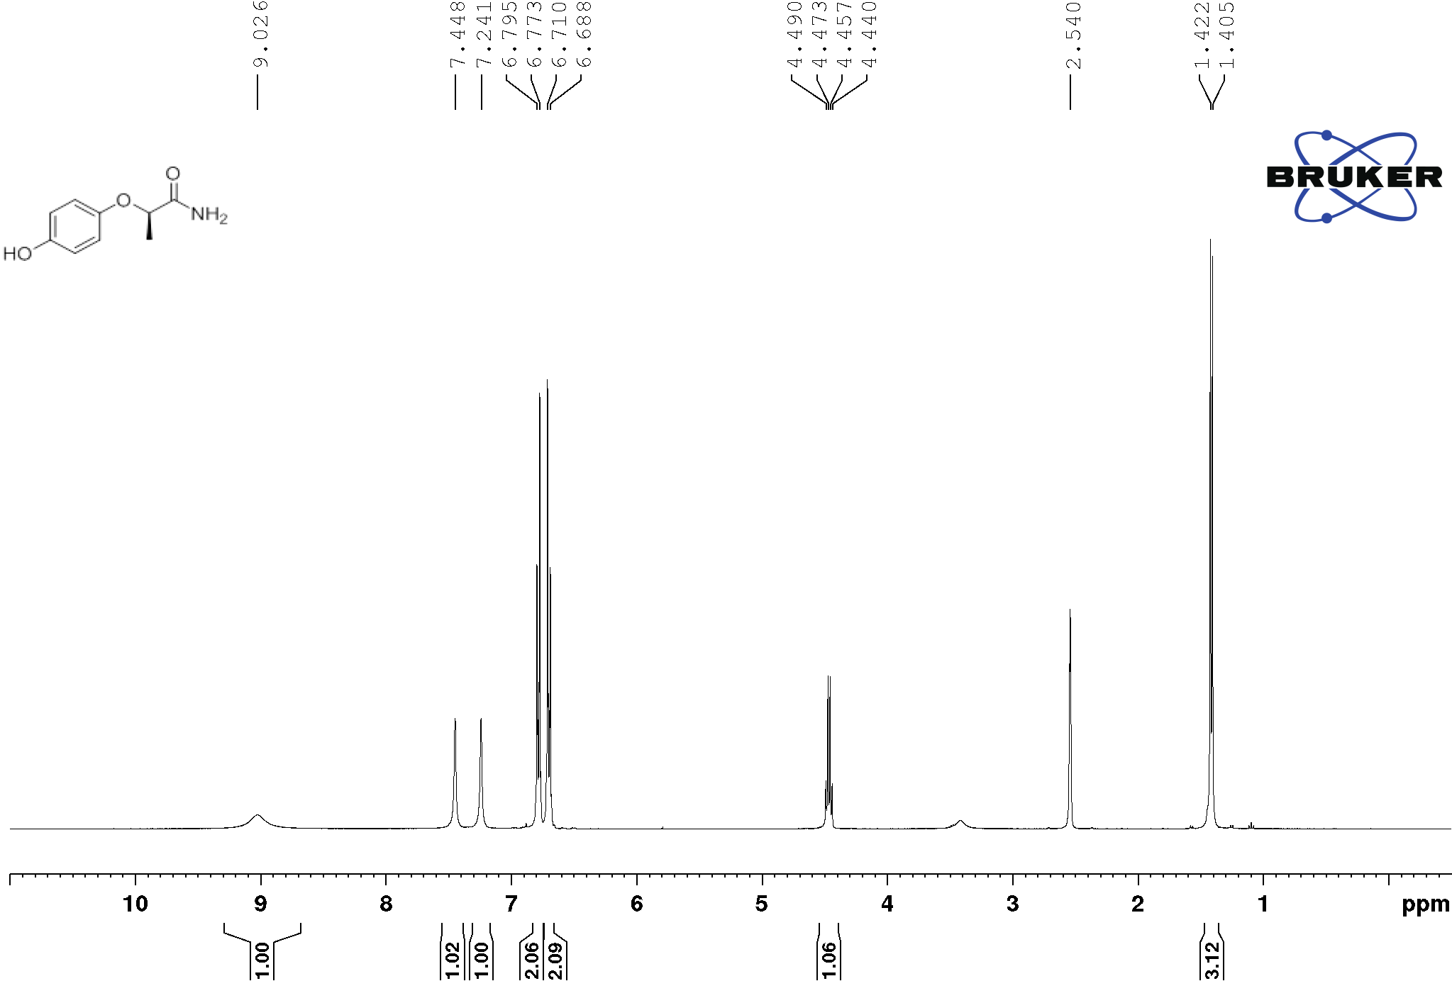
C

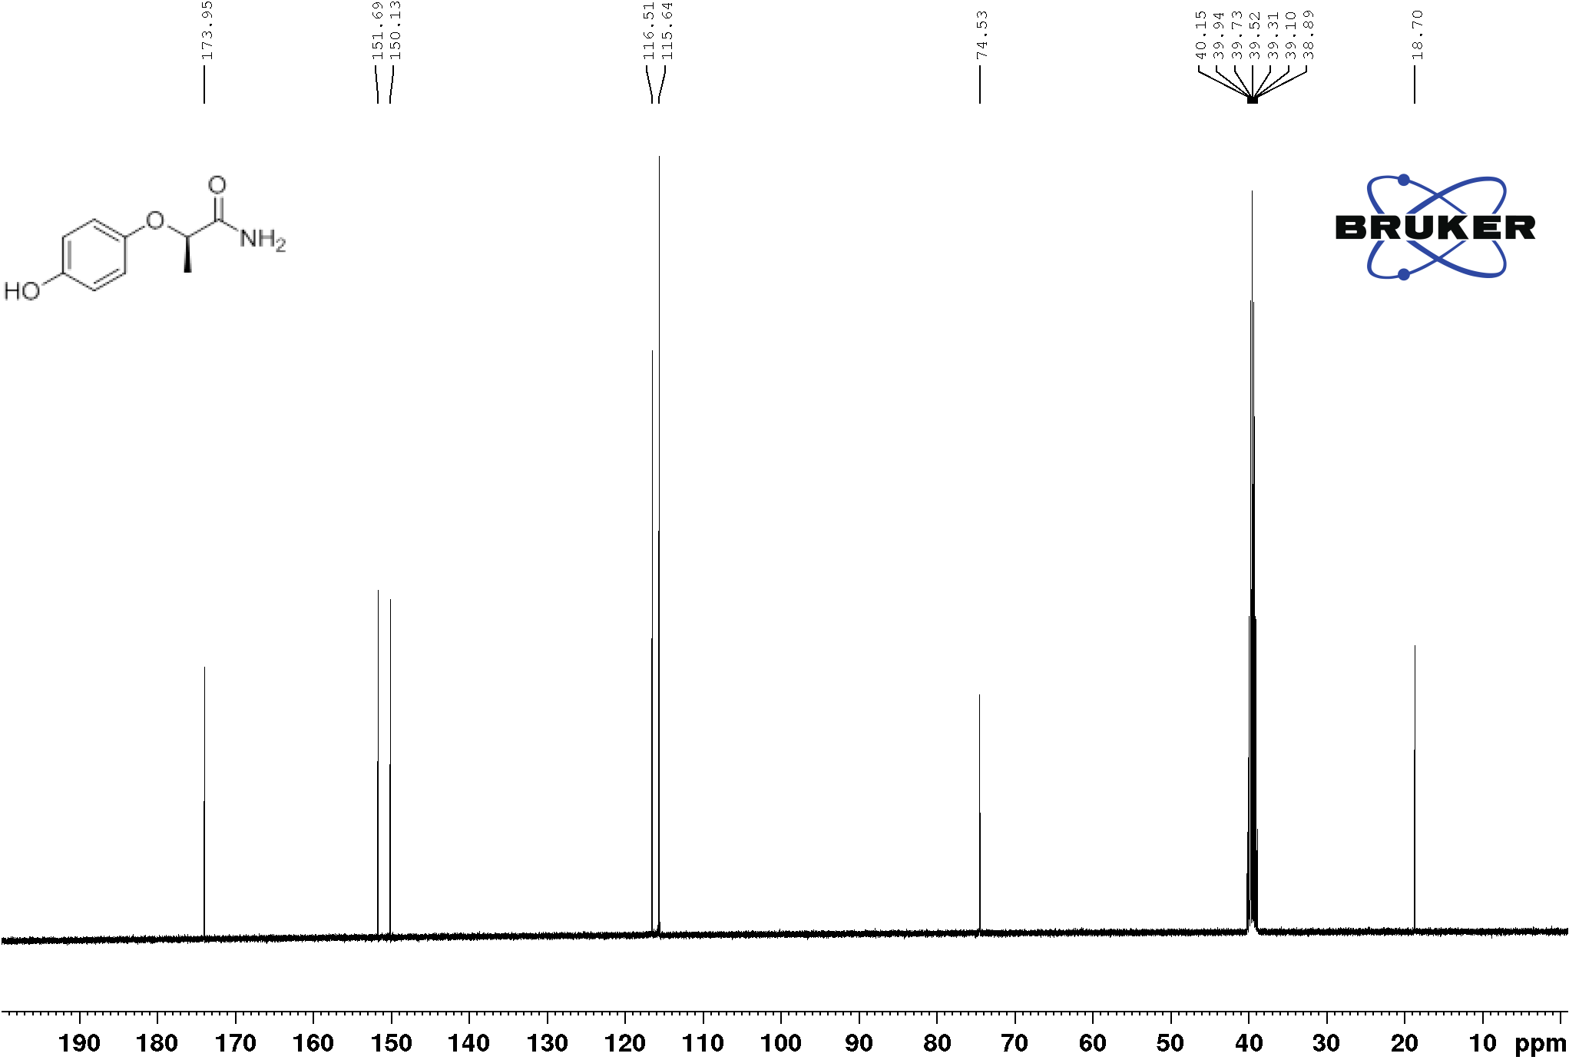
C

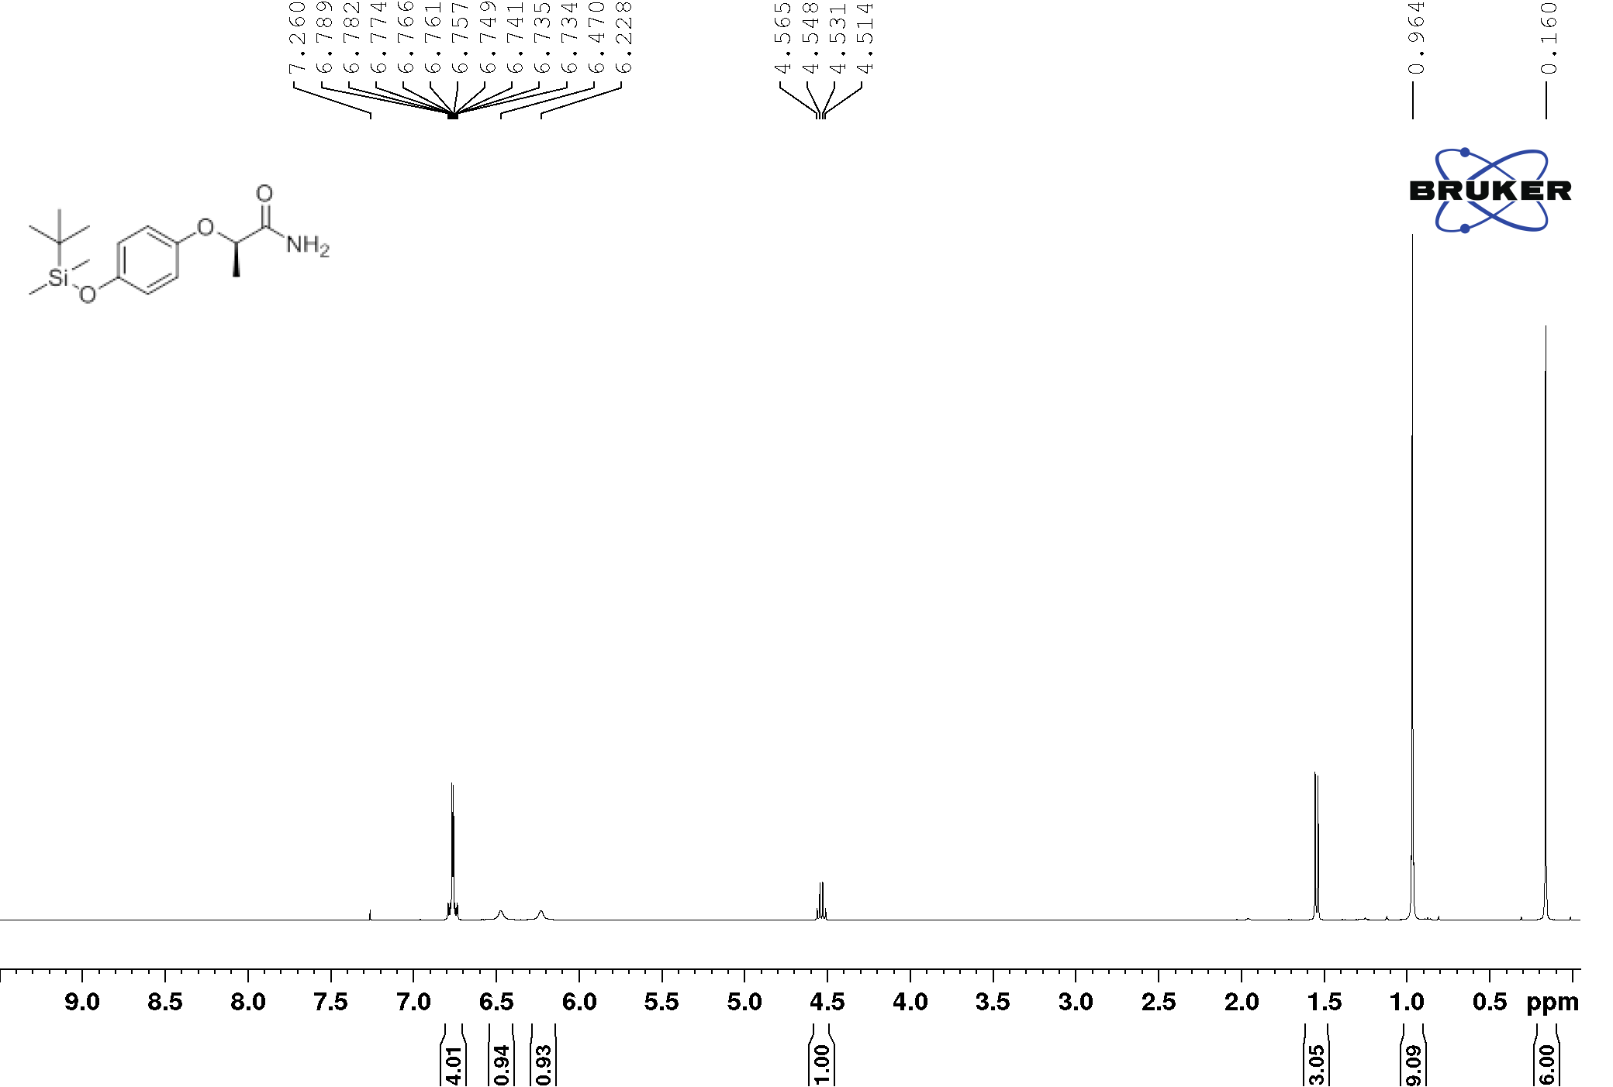
D

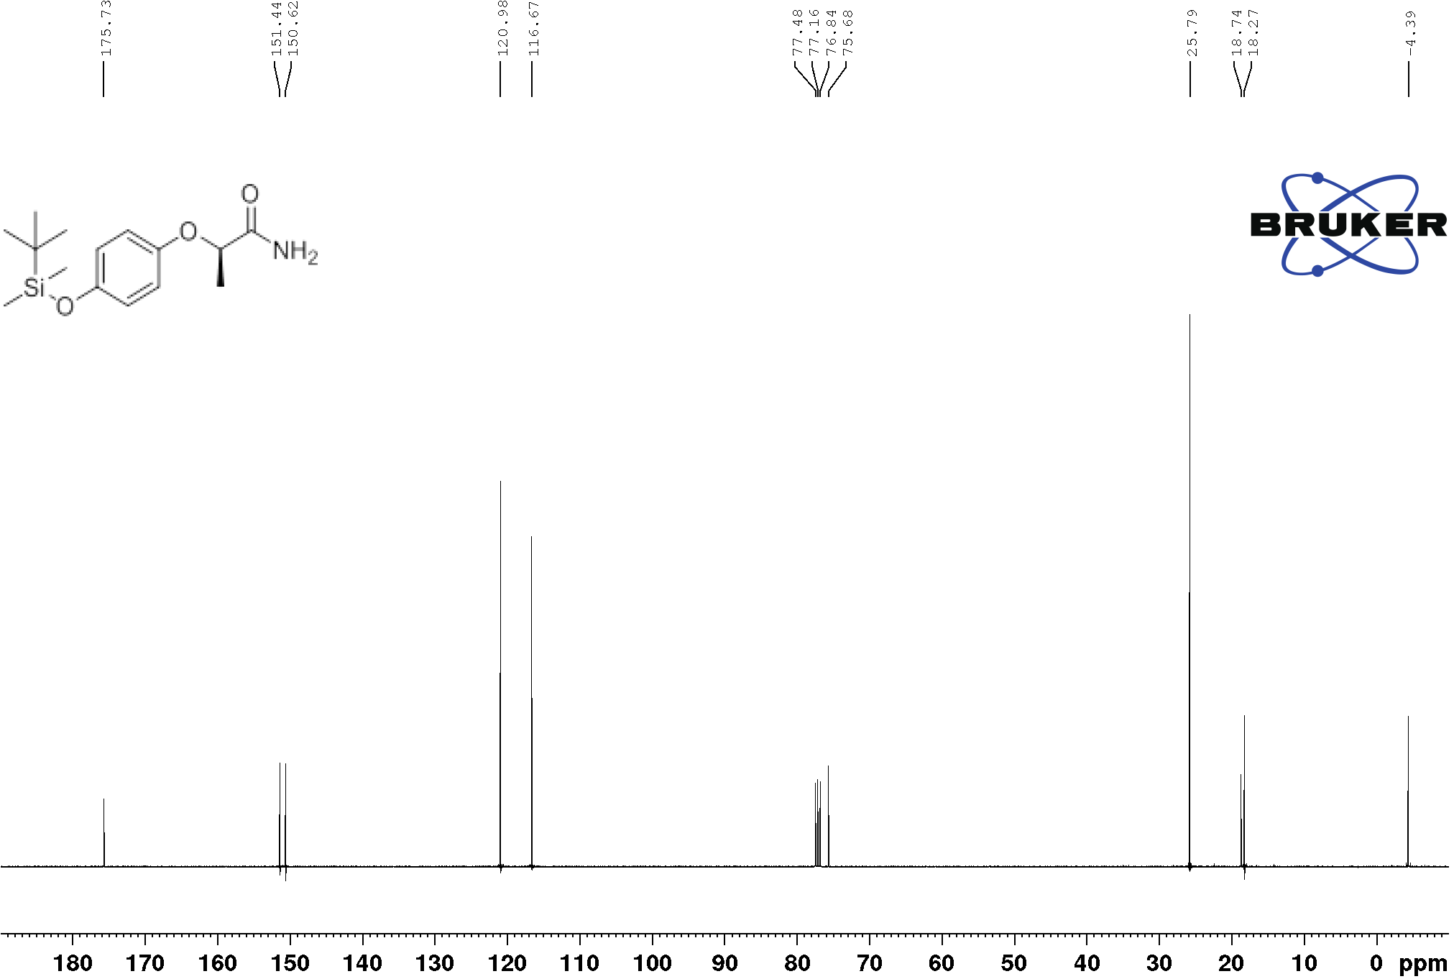
D

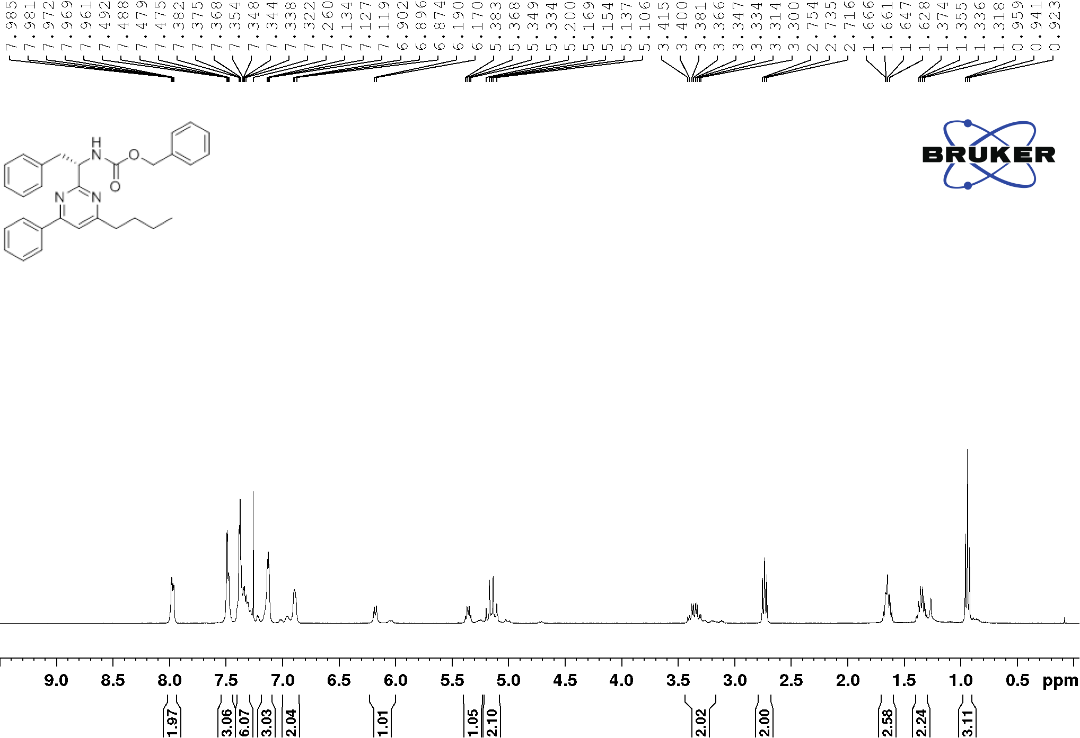
3aa’

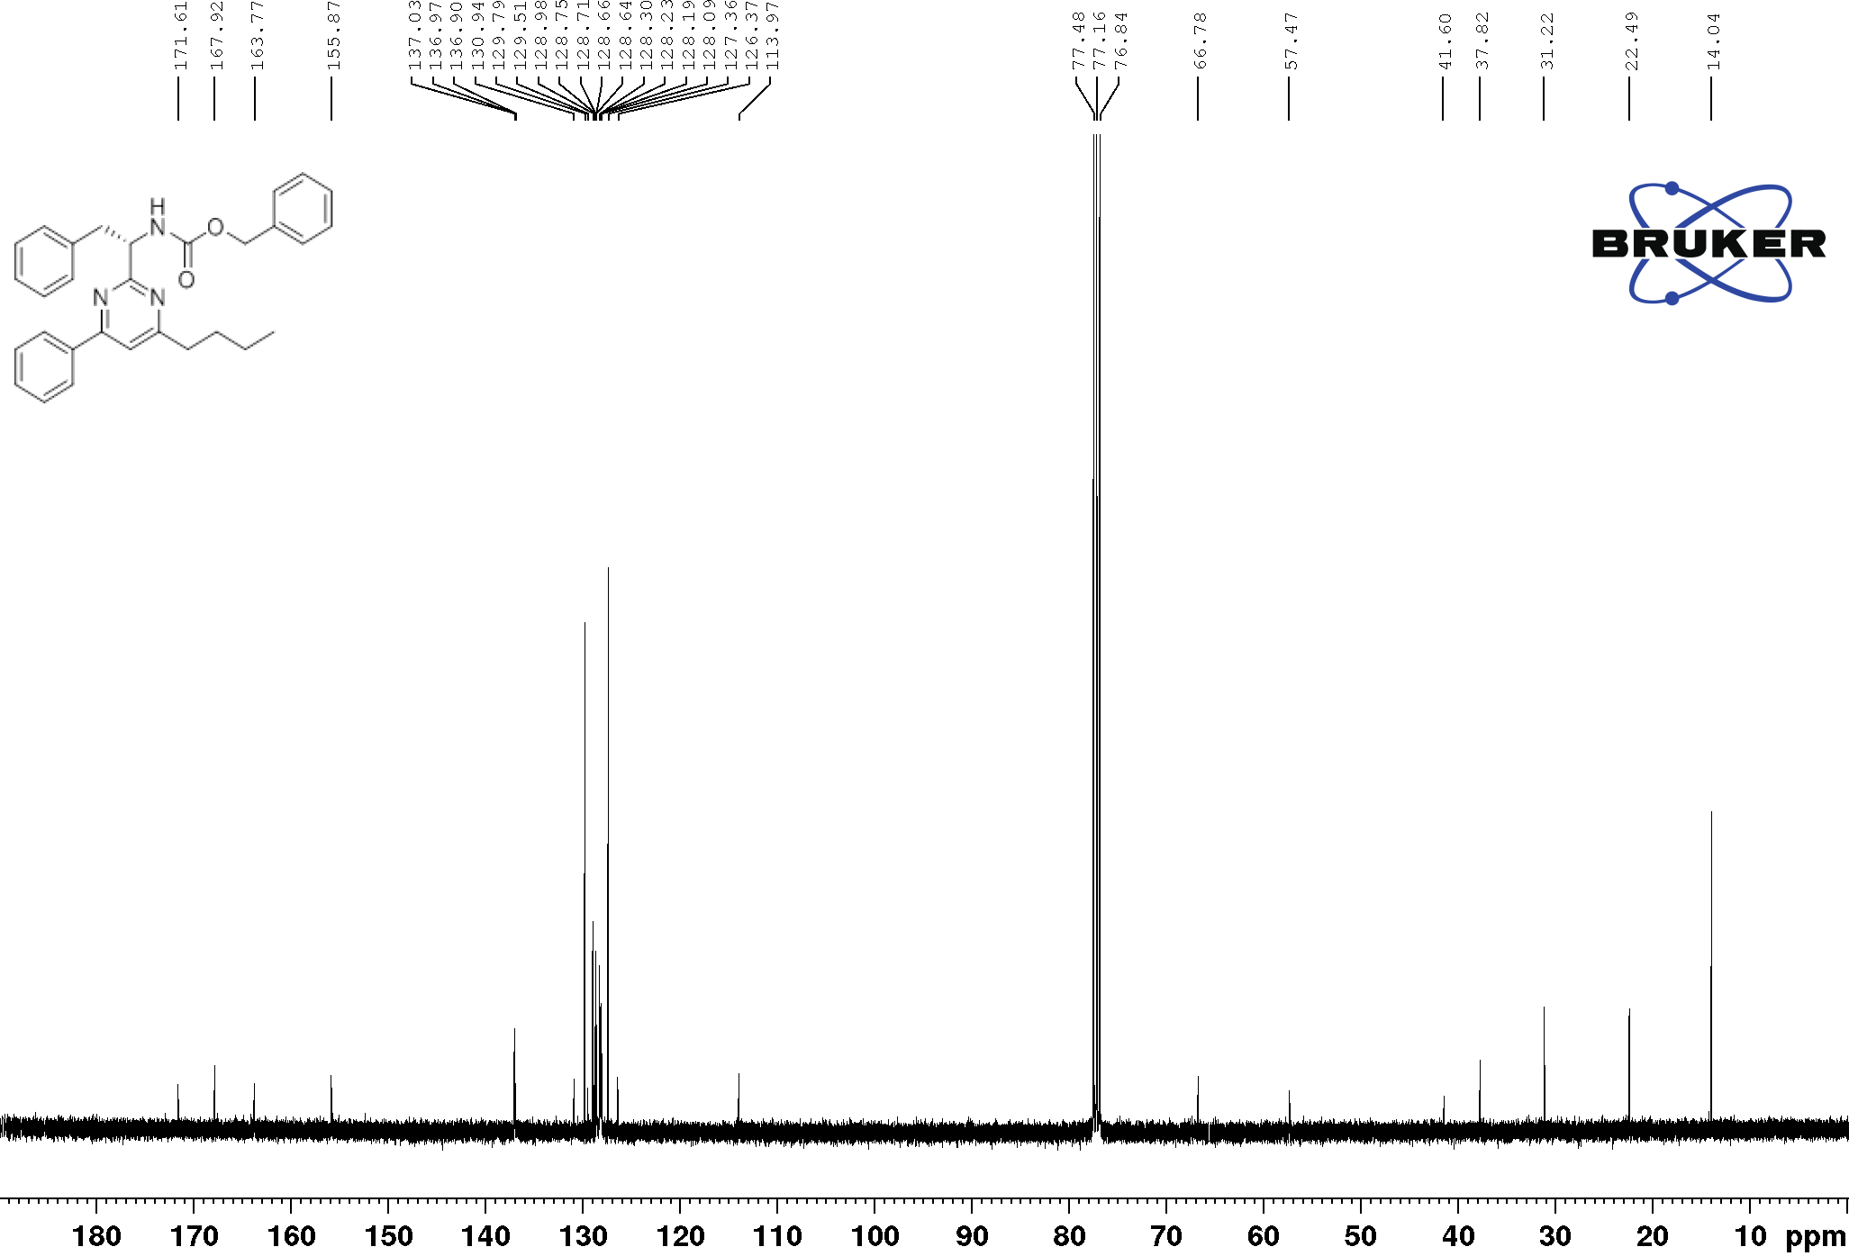
3aa’
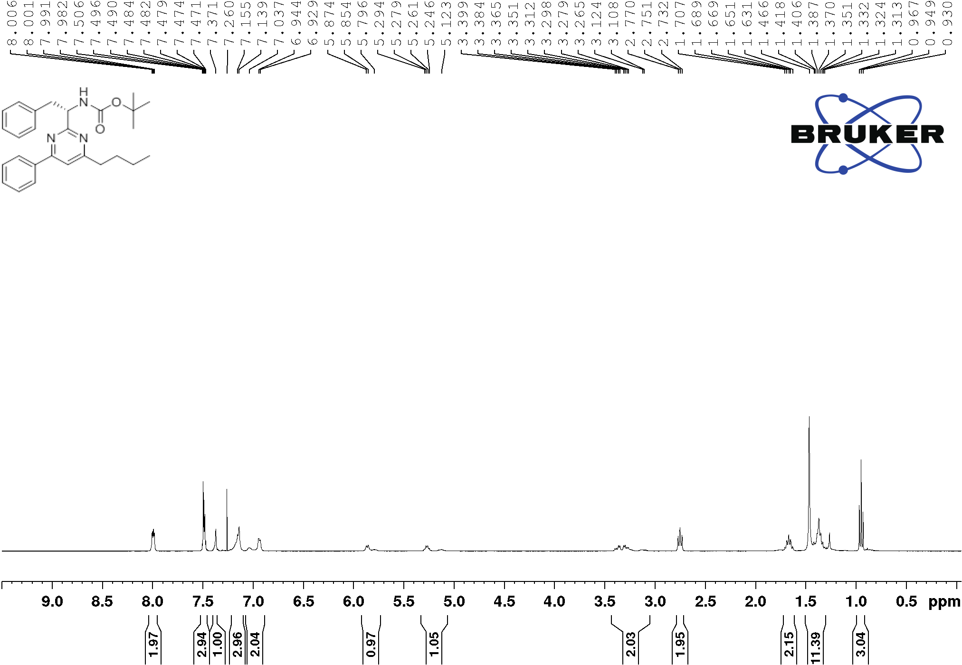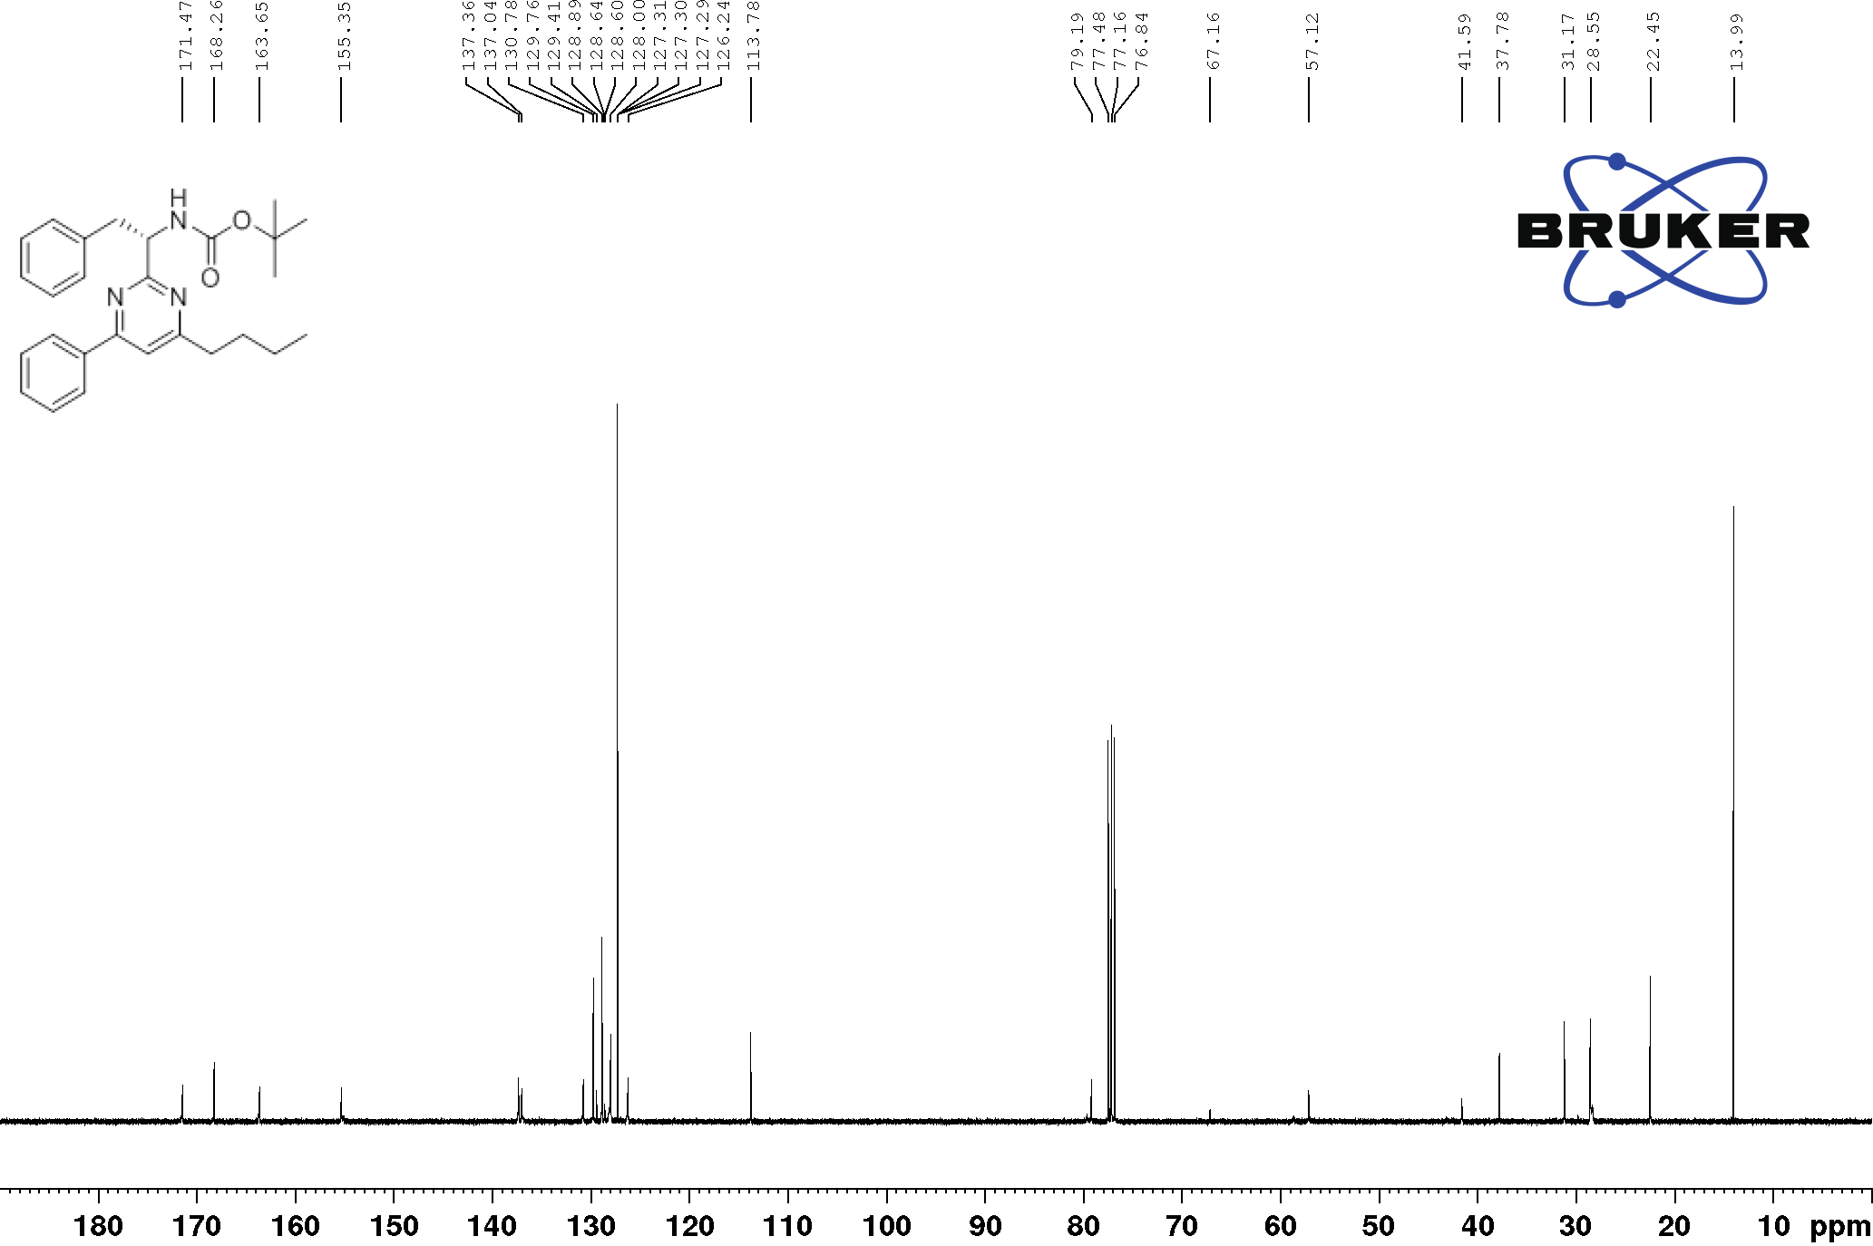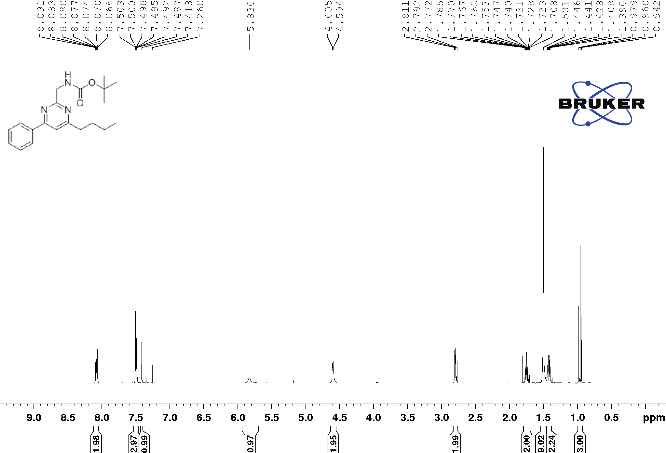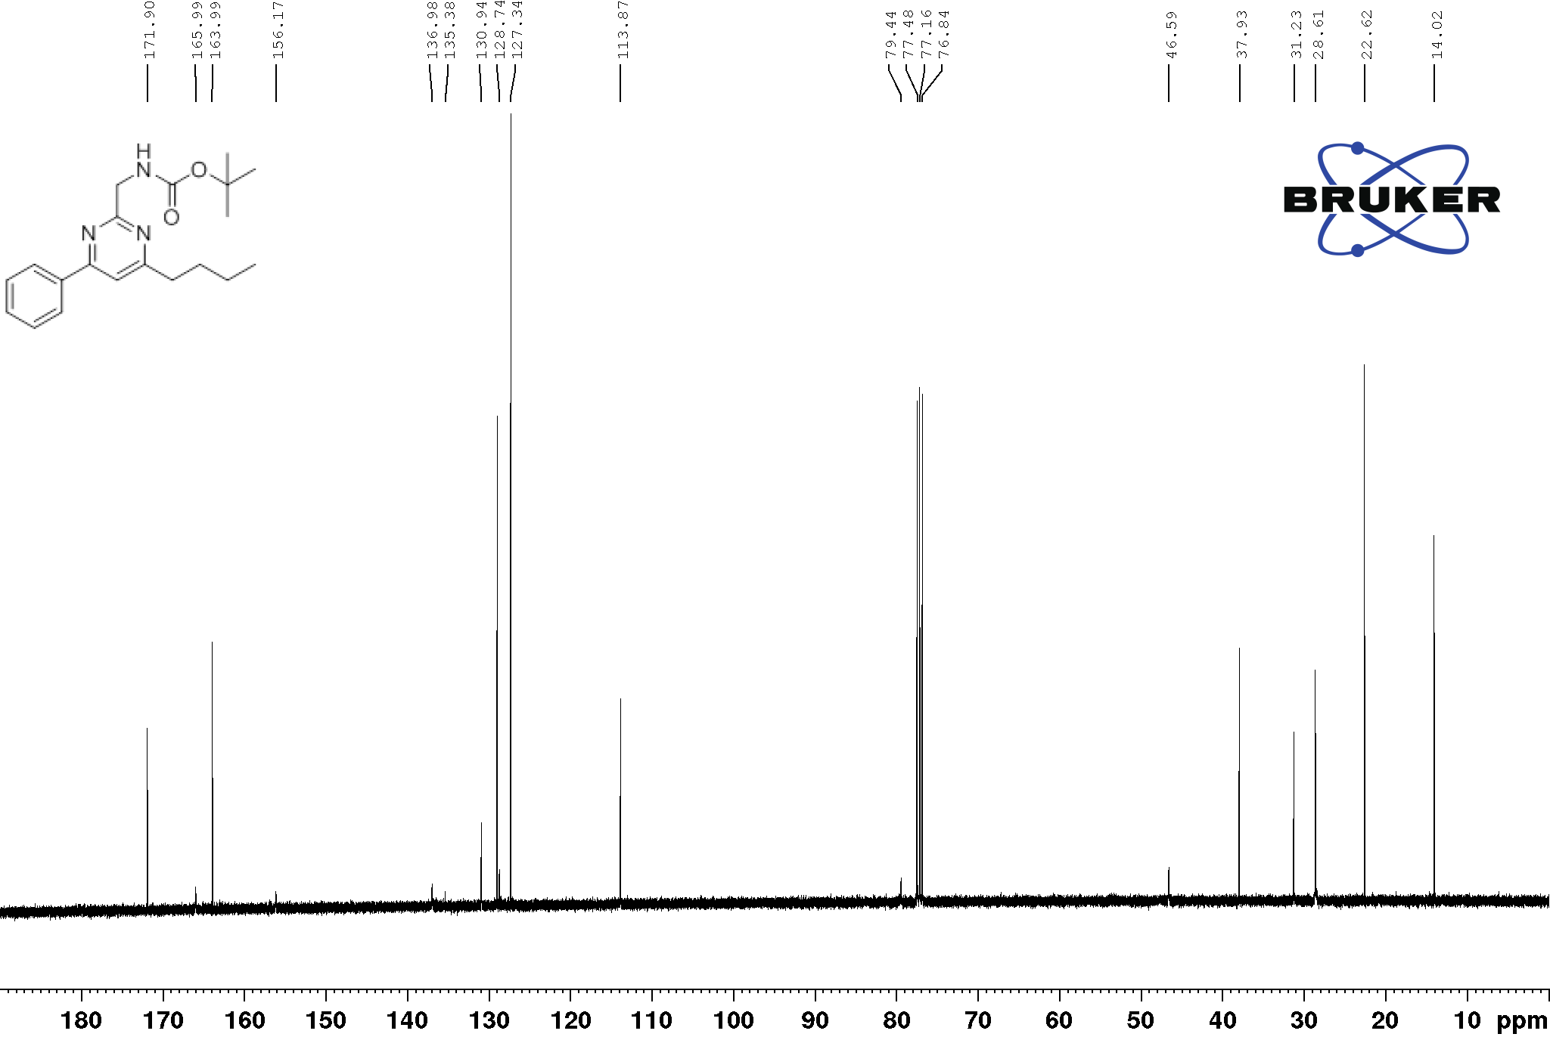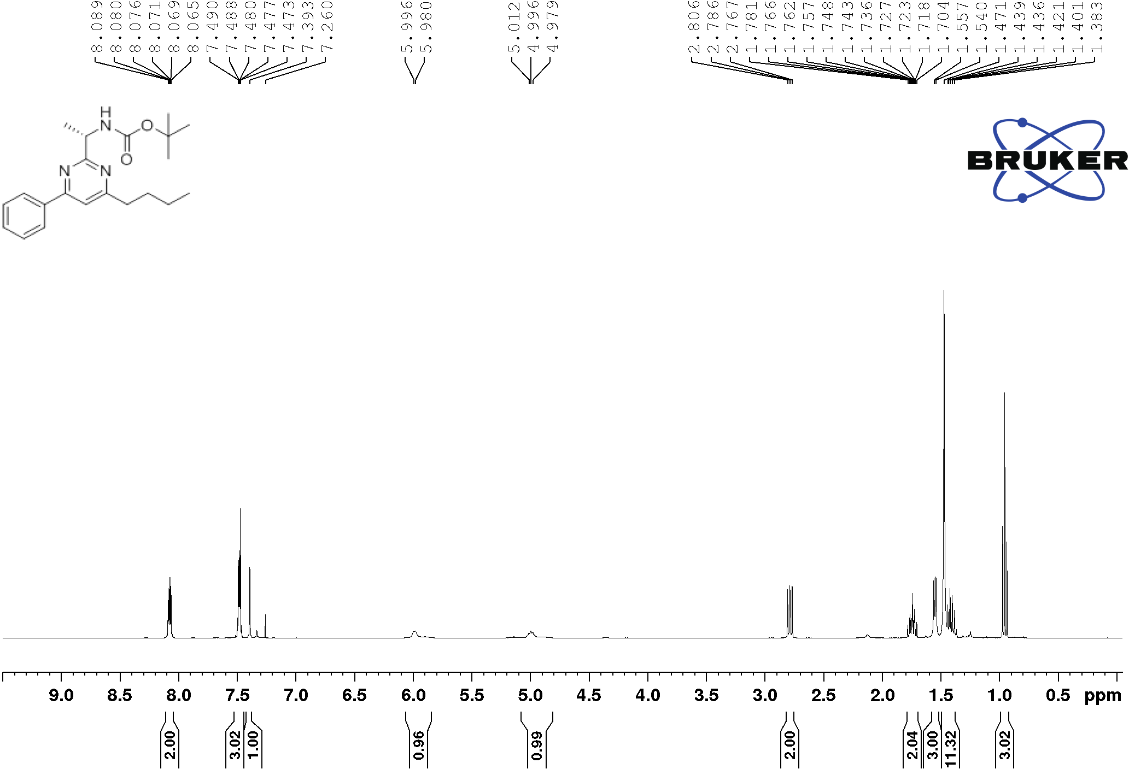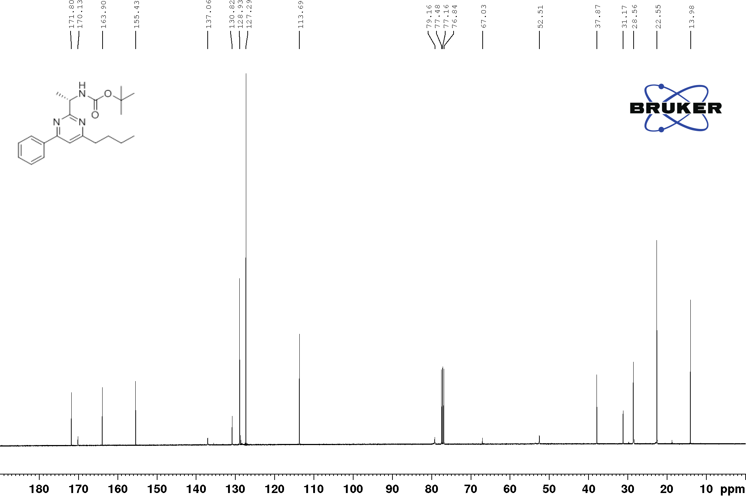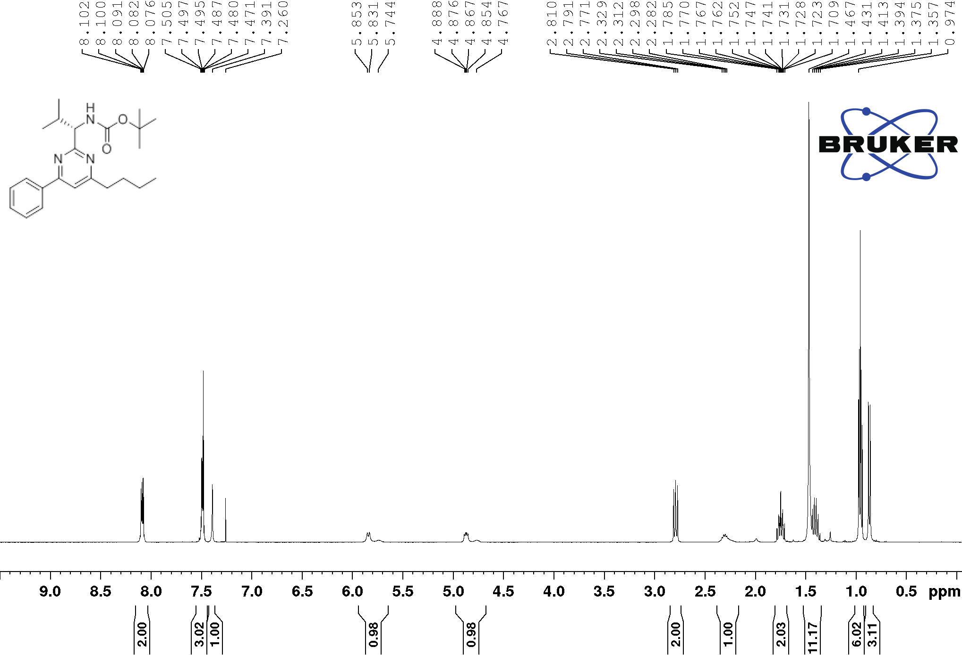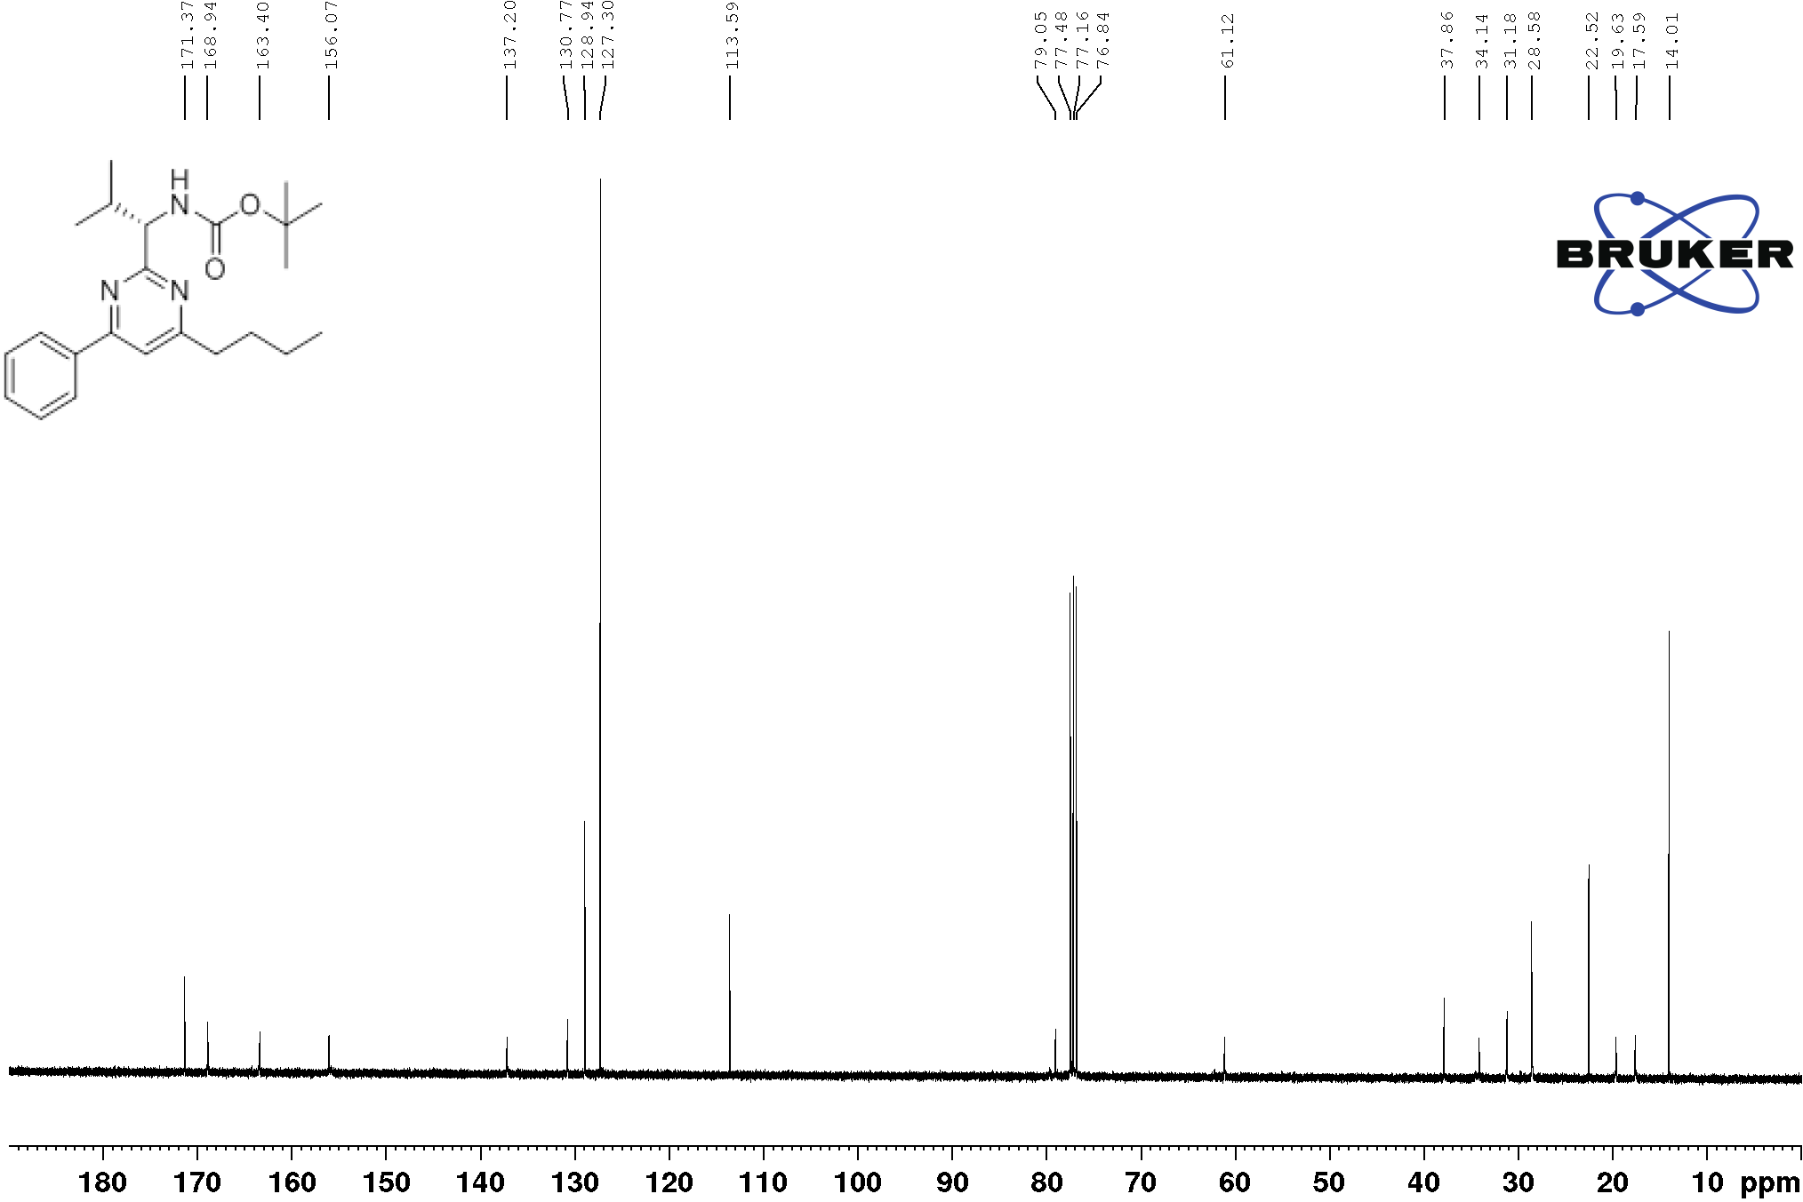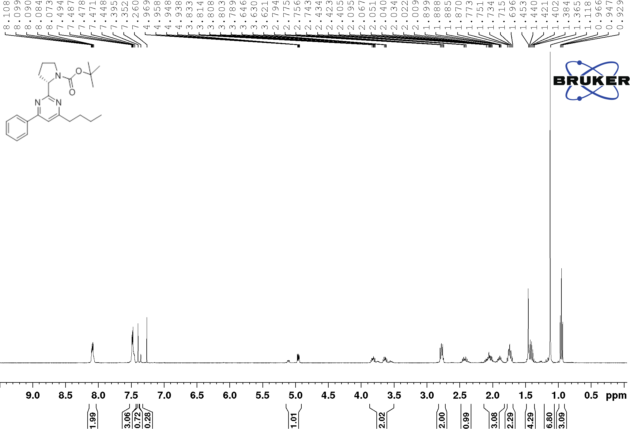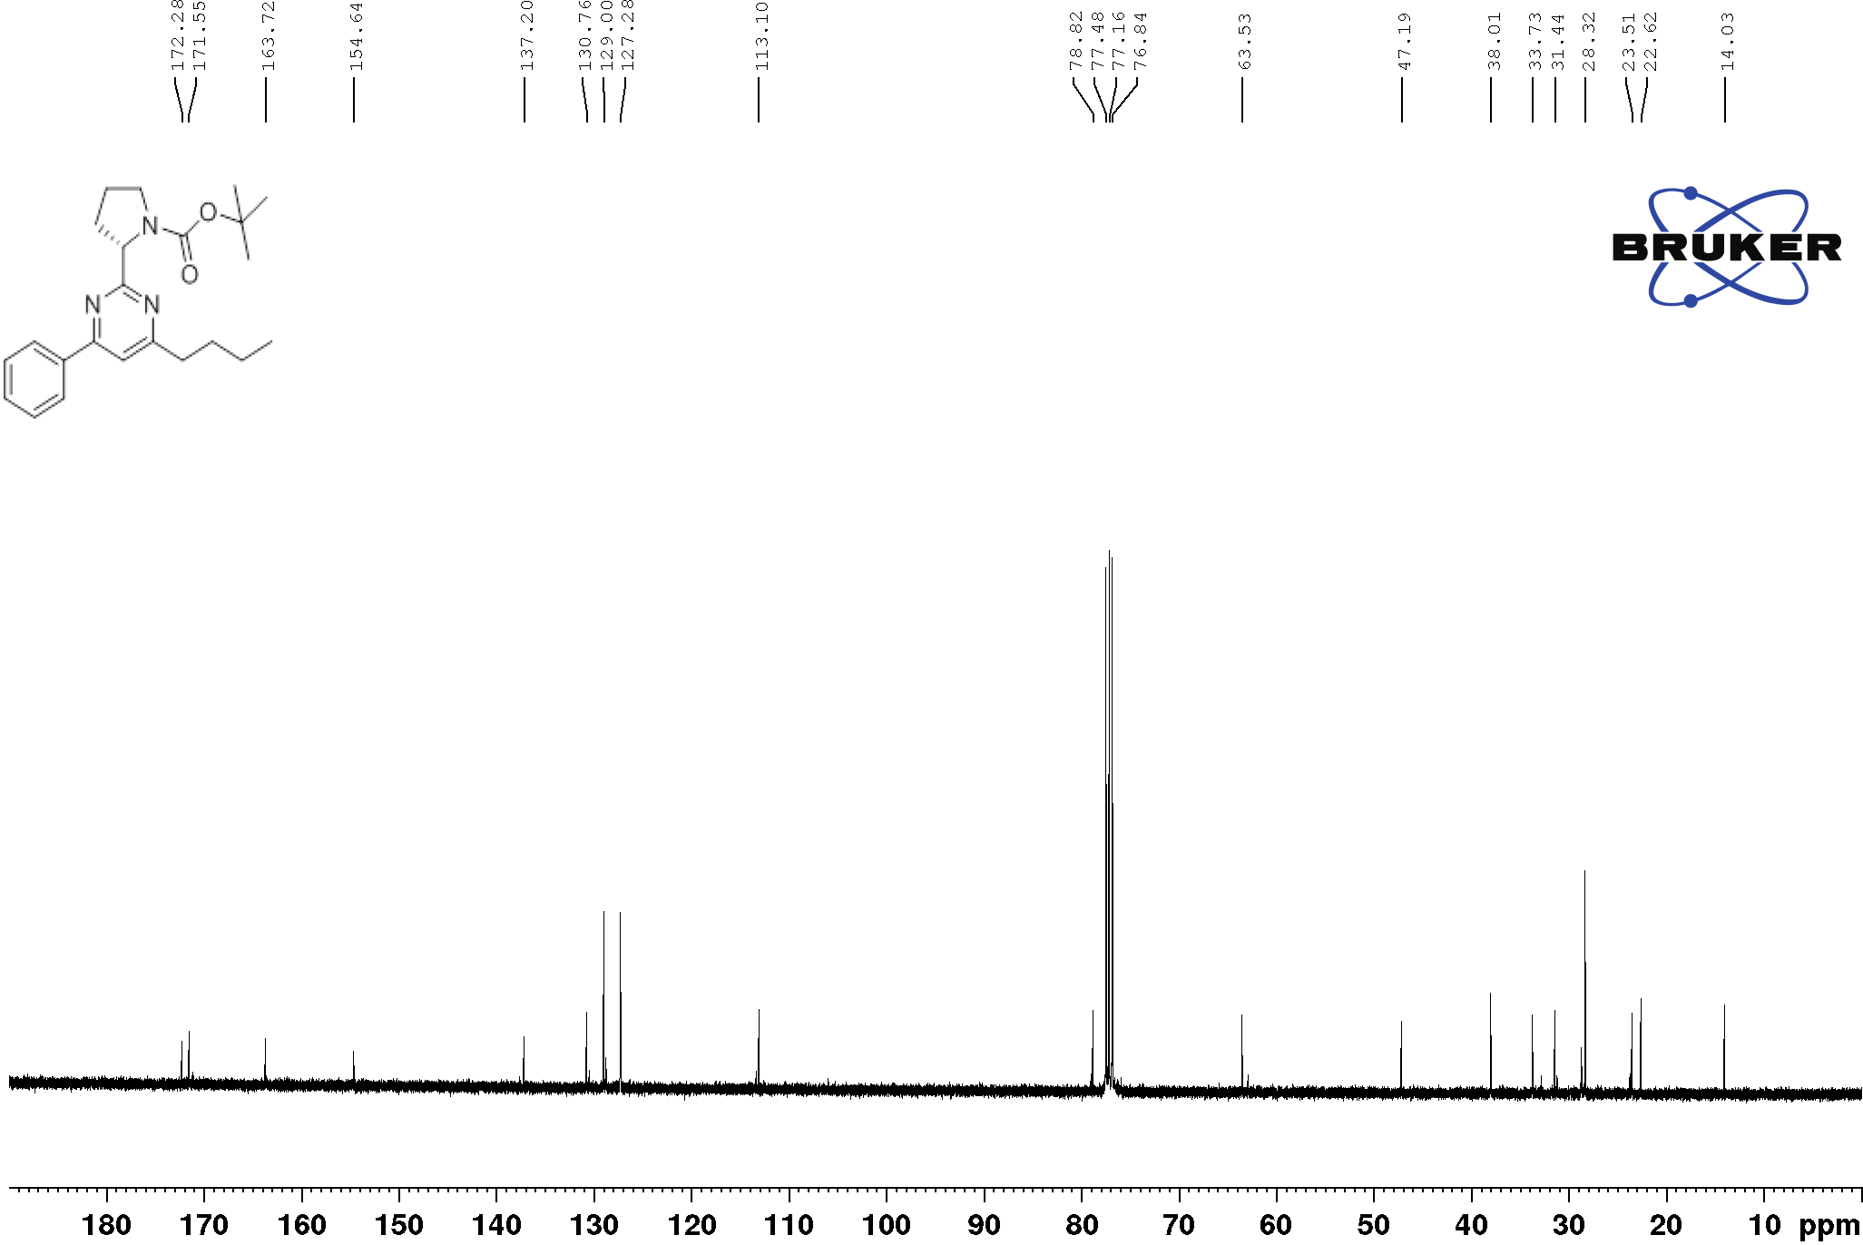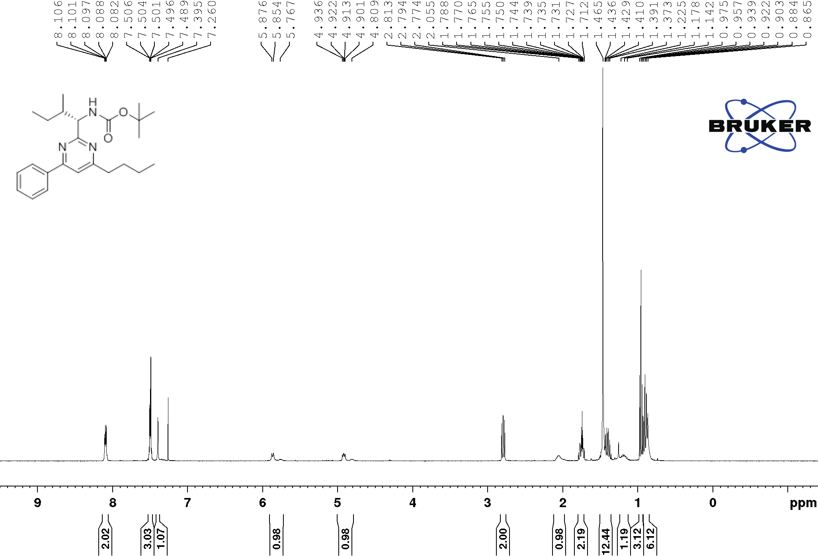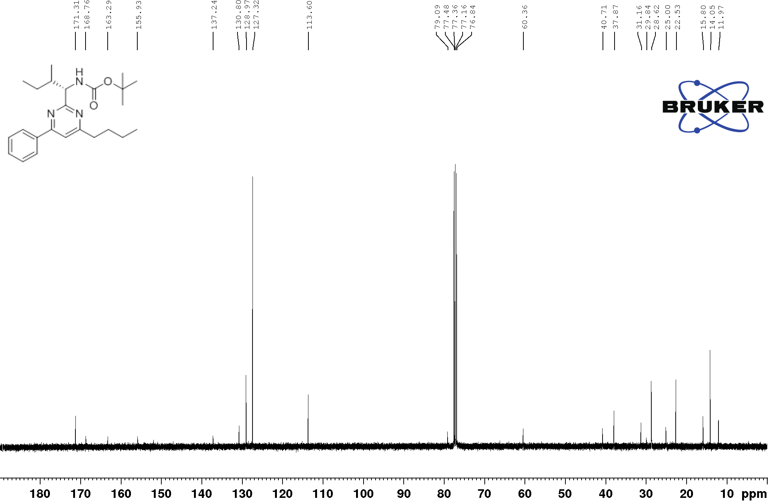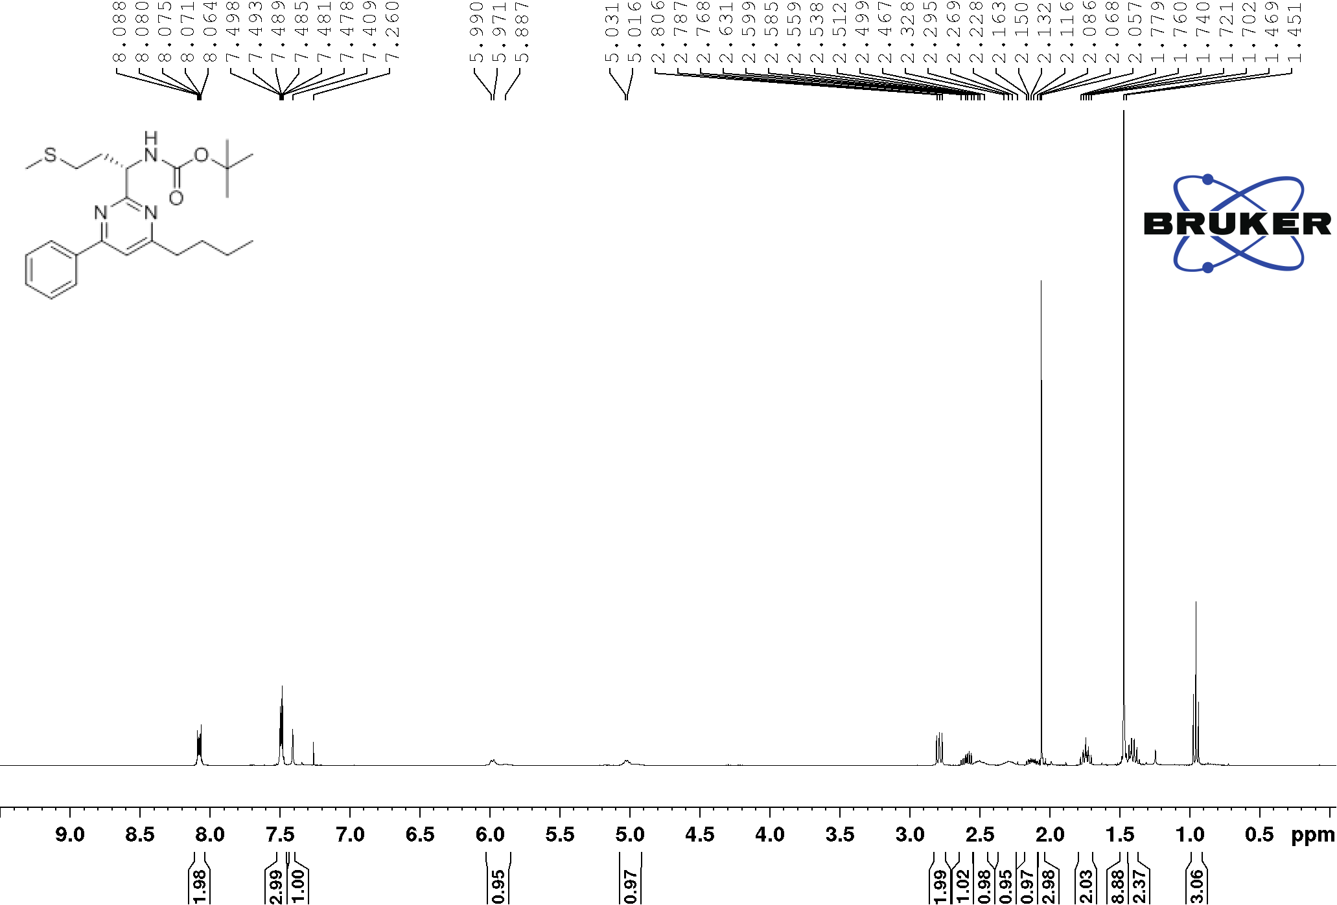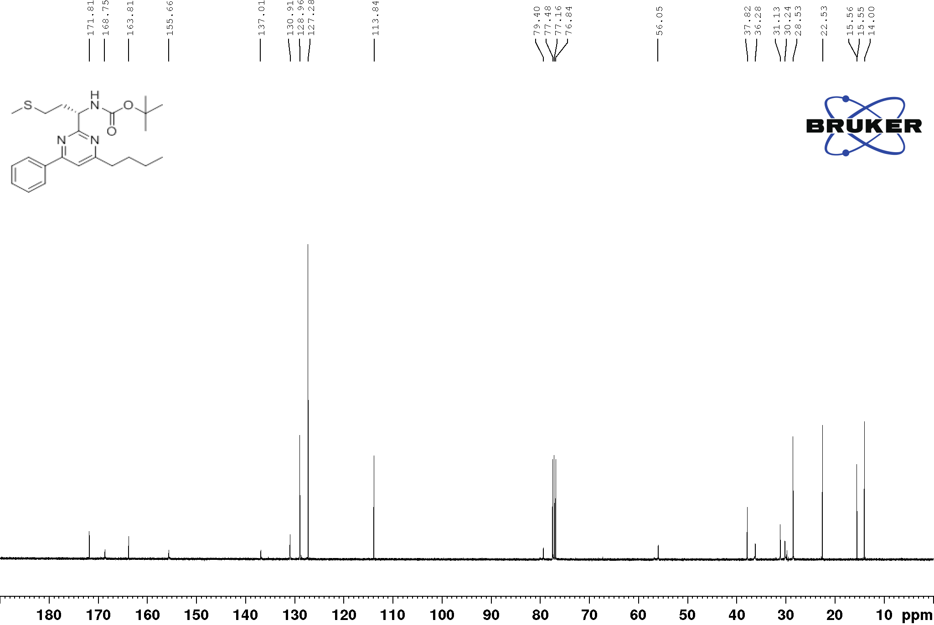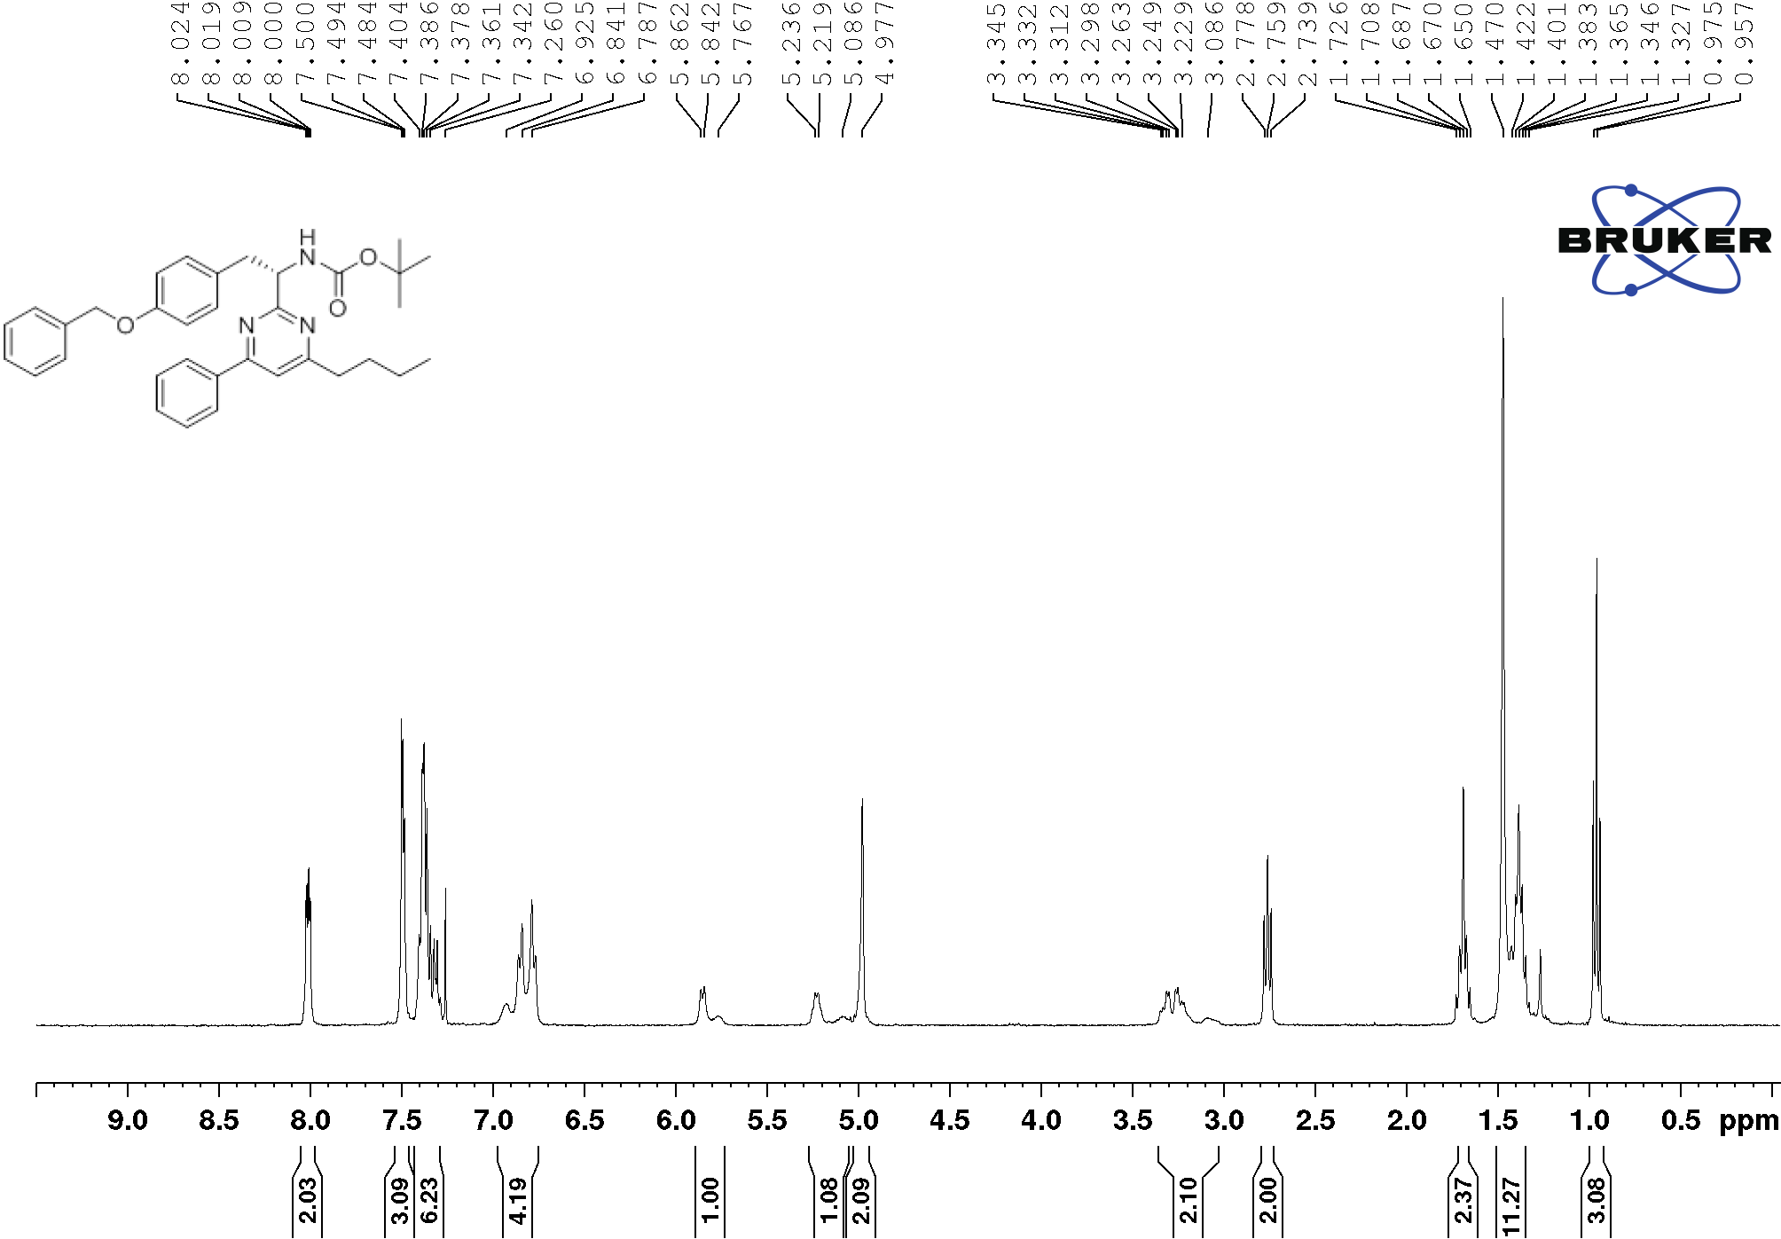
3ab’
3ab’
3ac’
3ac’
3ad’
3ad’
3ae’
3ae’
3af’
3af’
3ag’
3ag’
3ah’
3ah’
3aj’
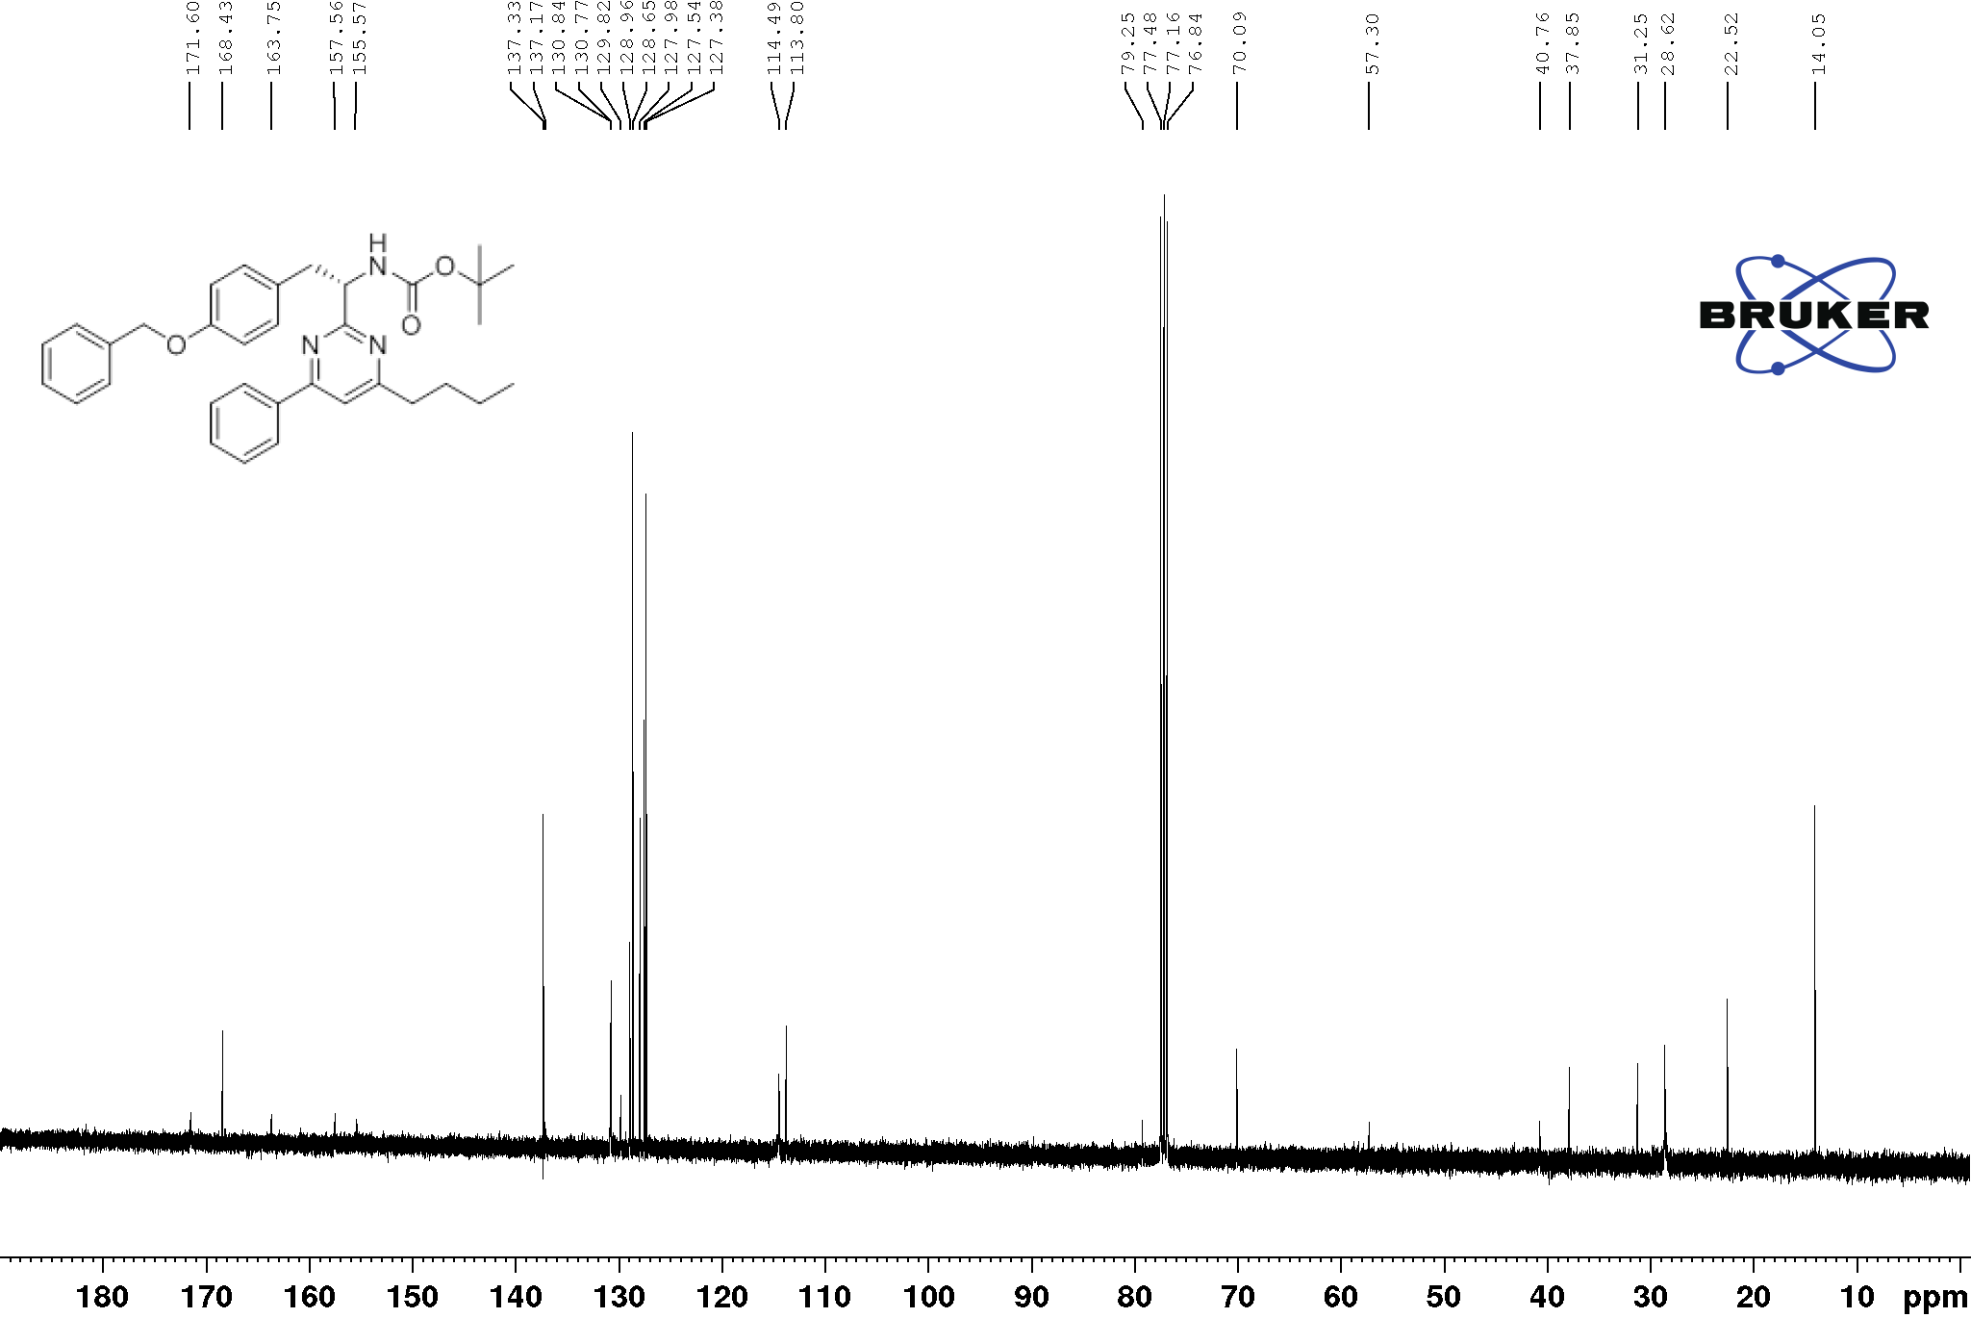
3aj’
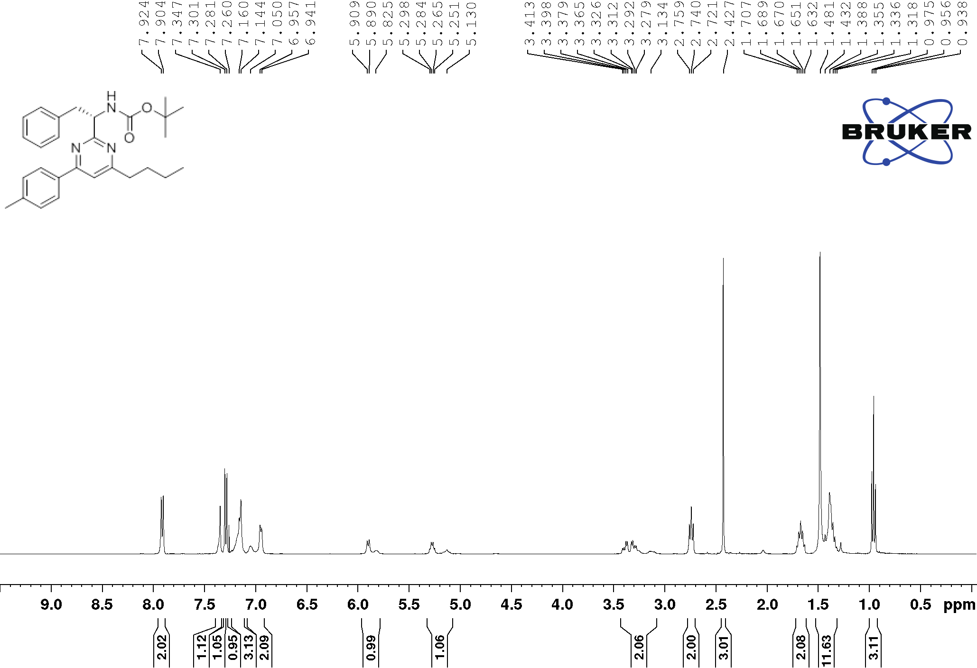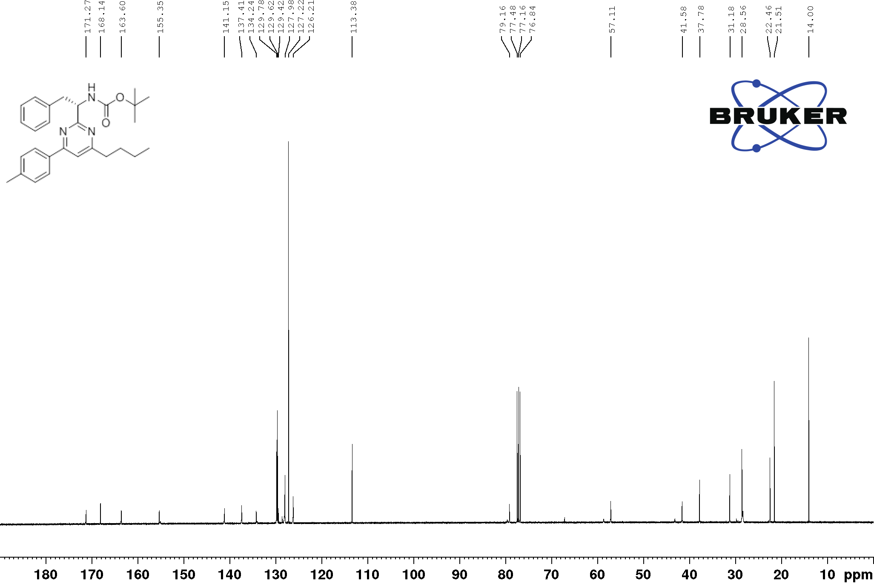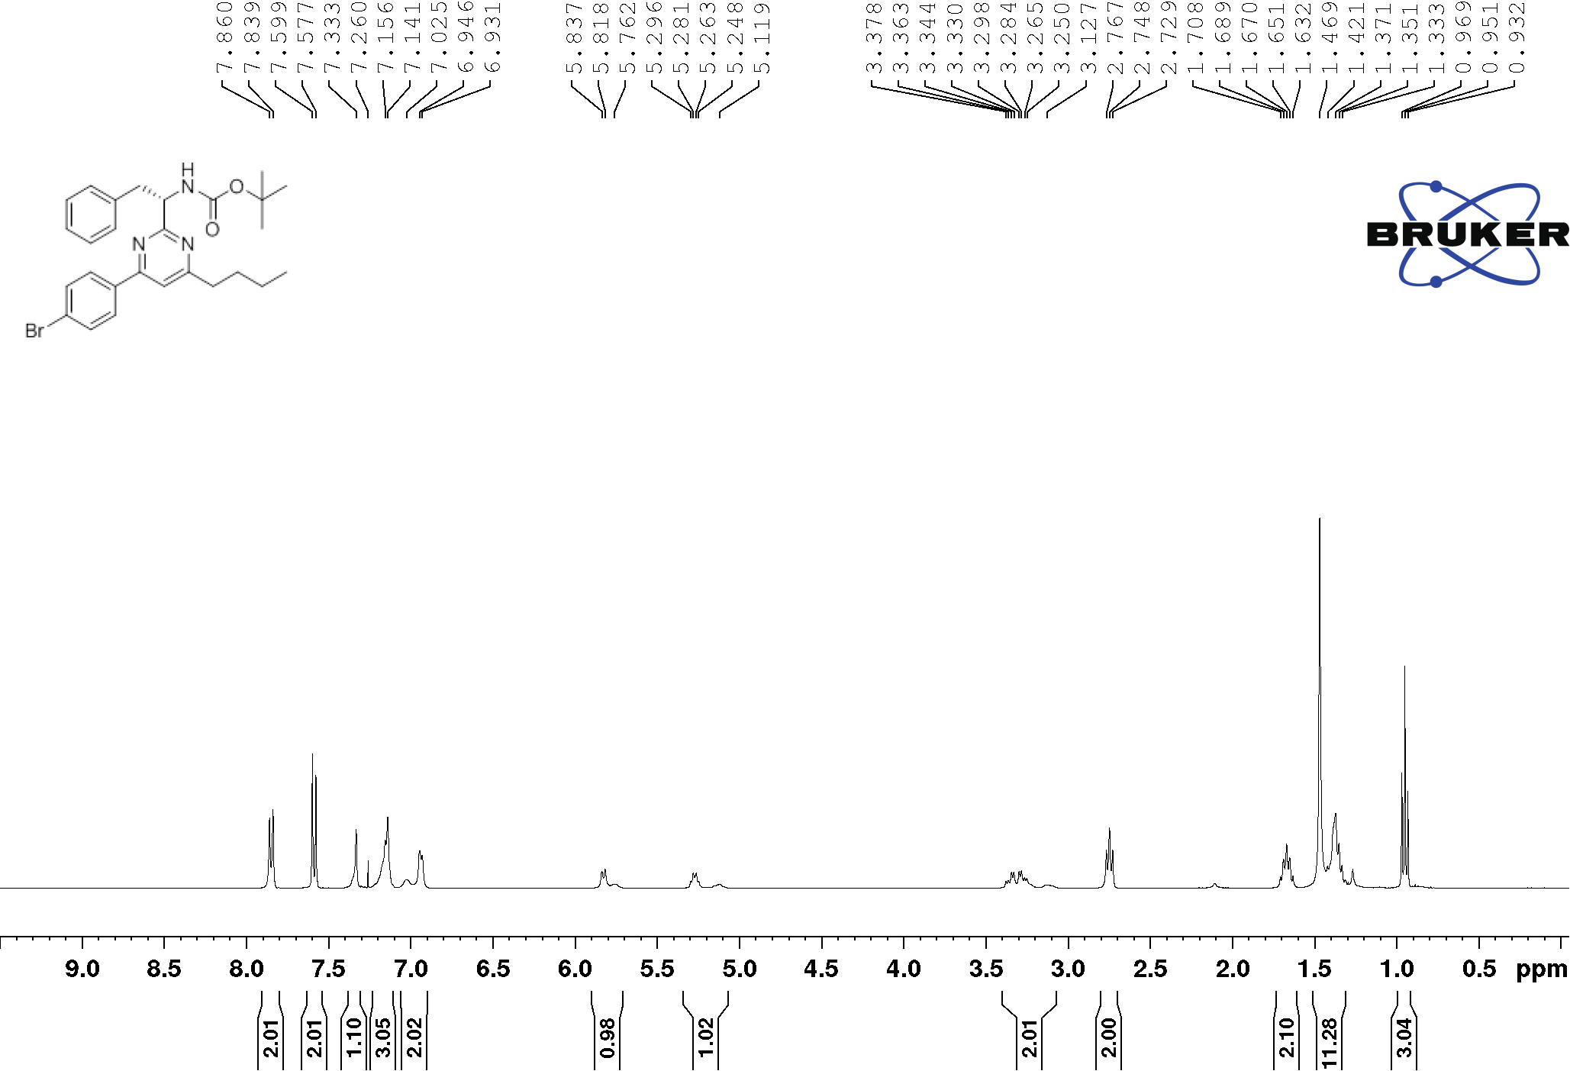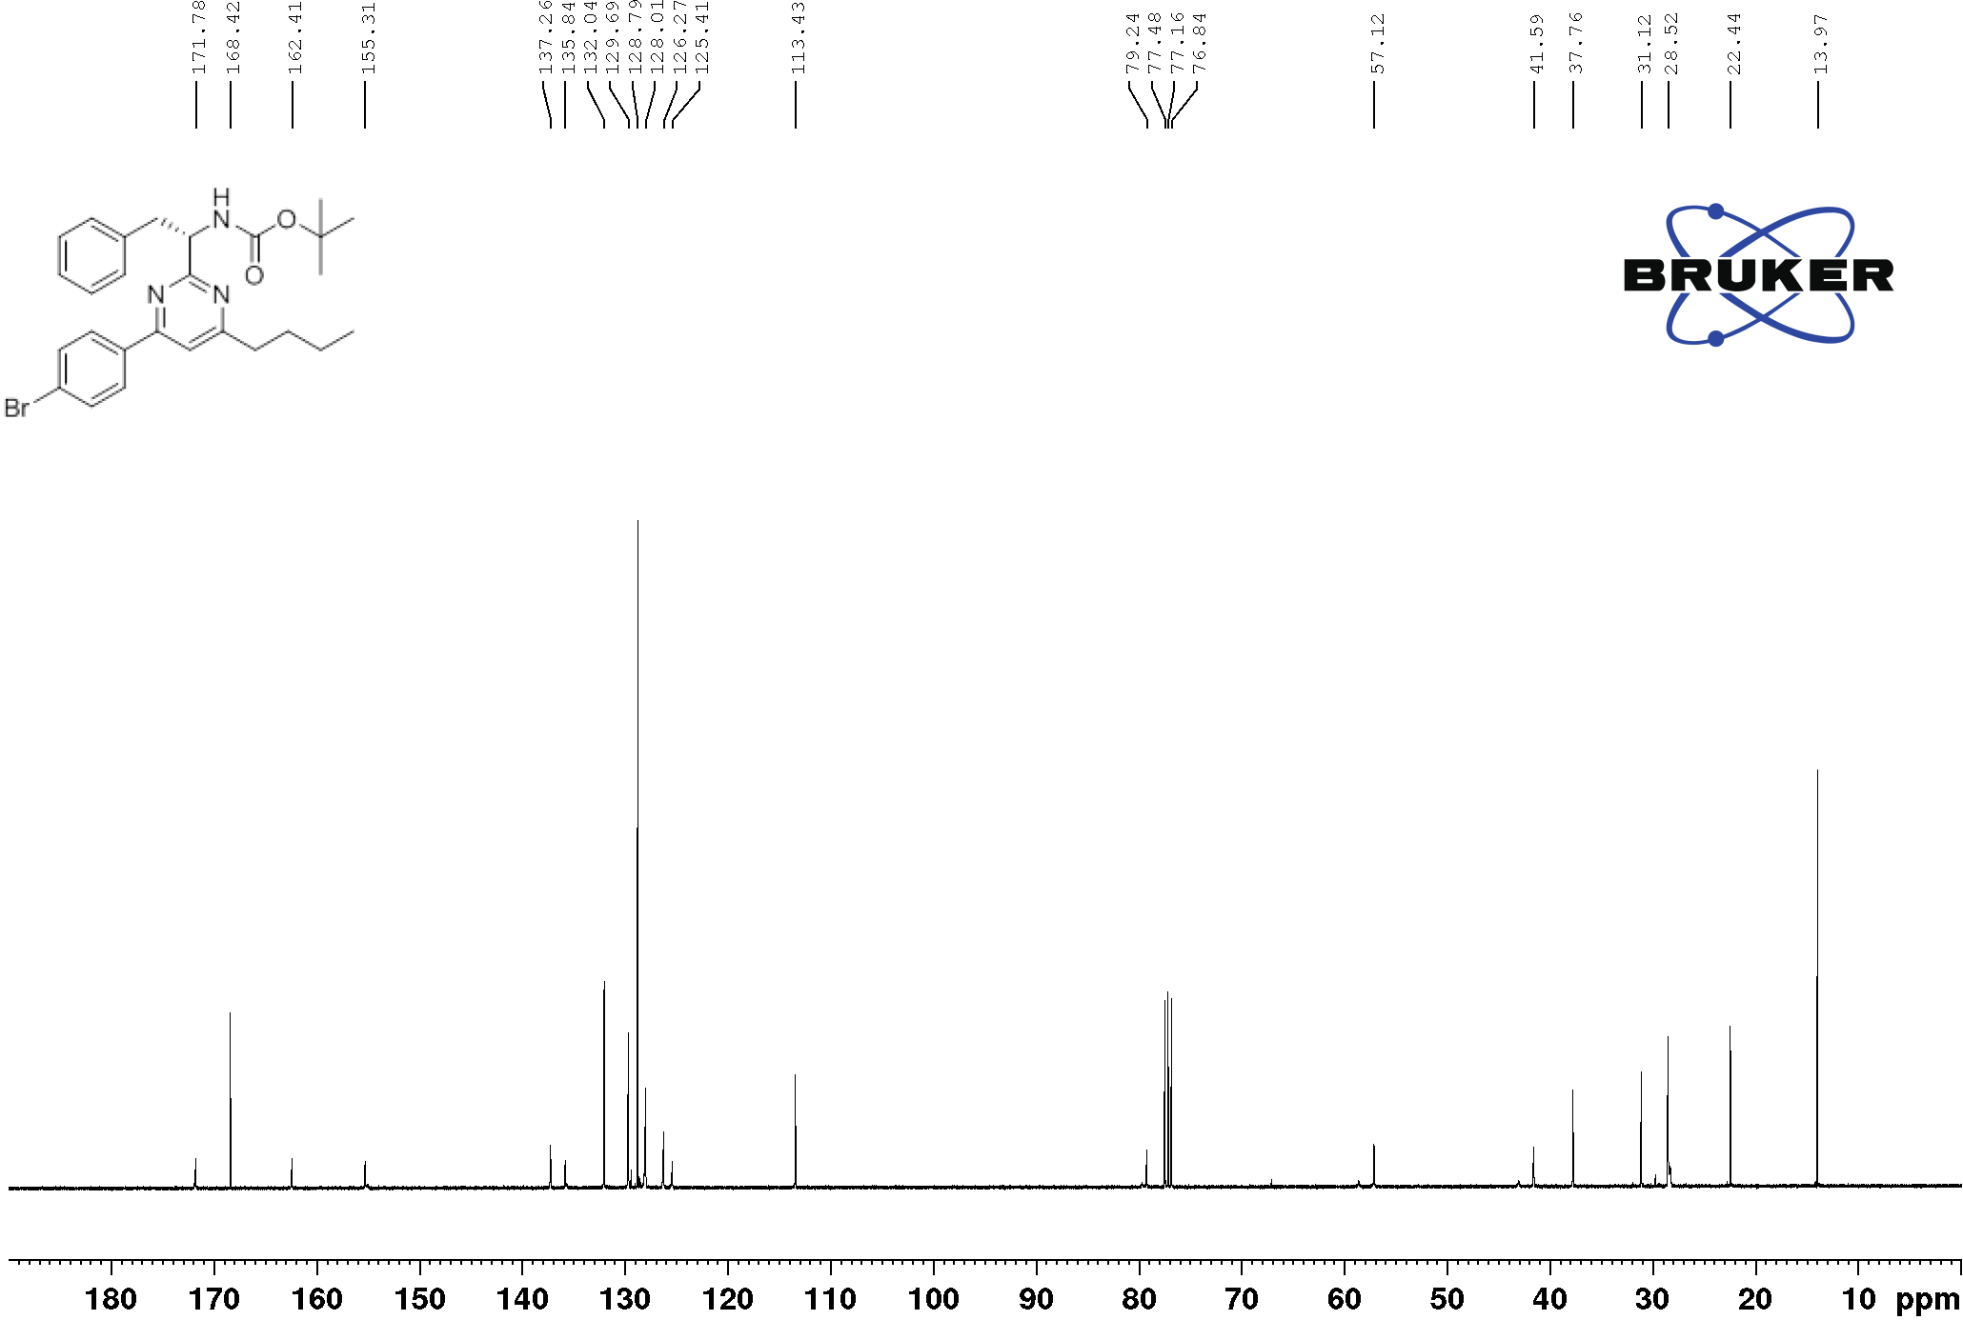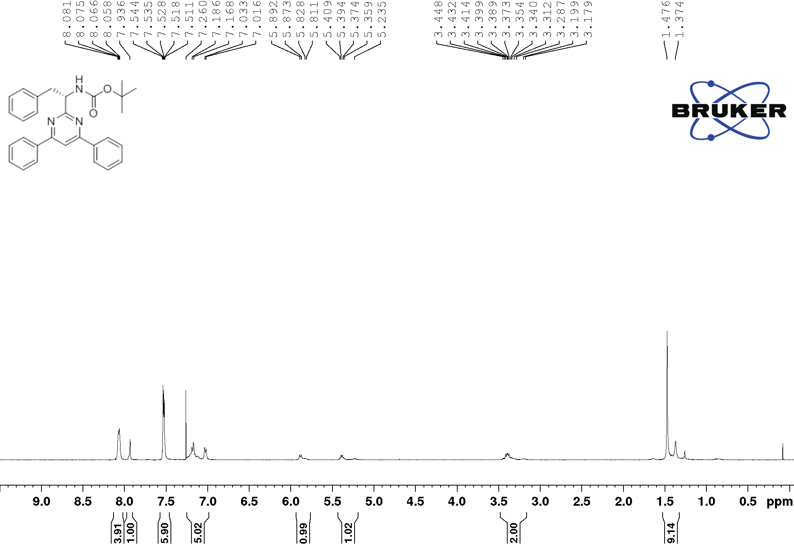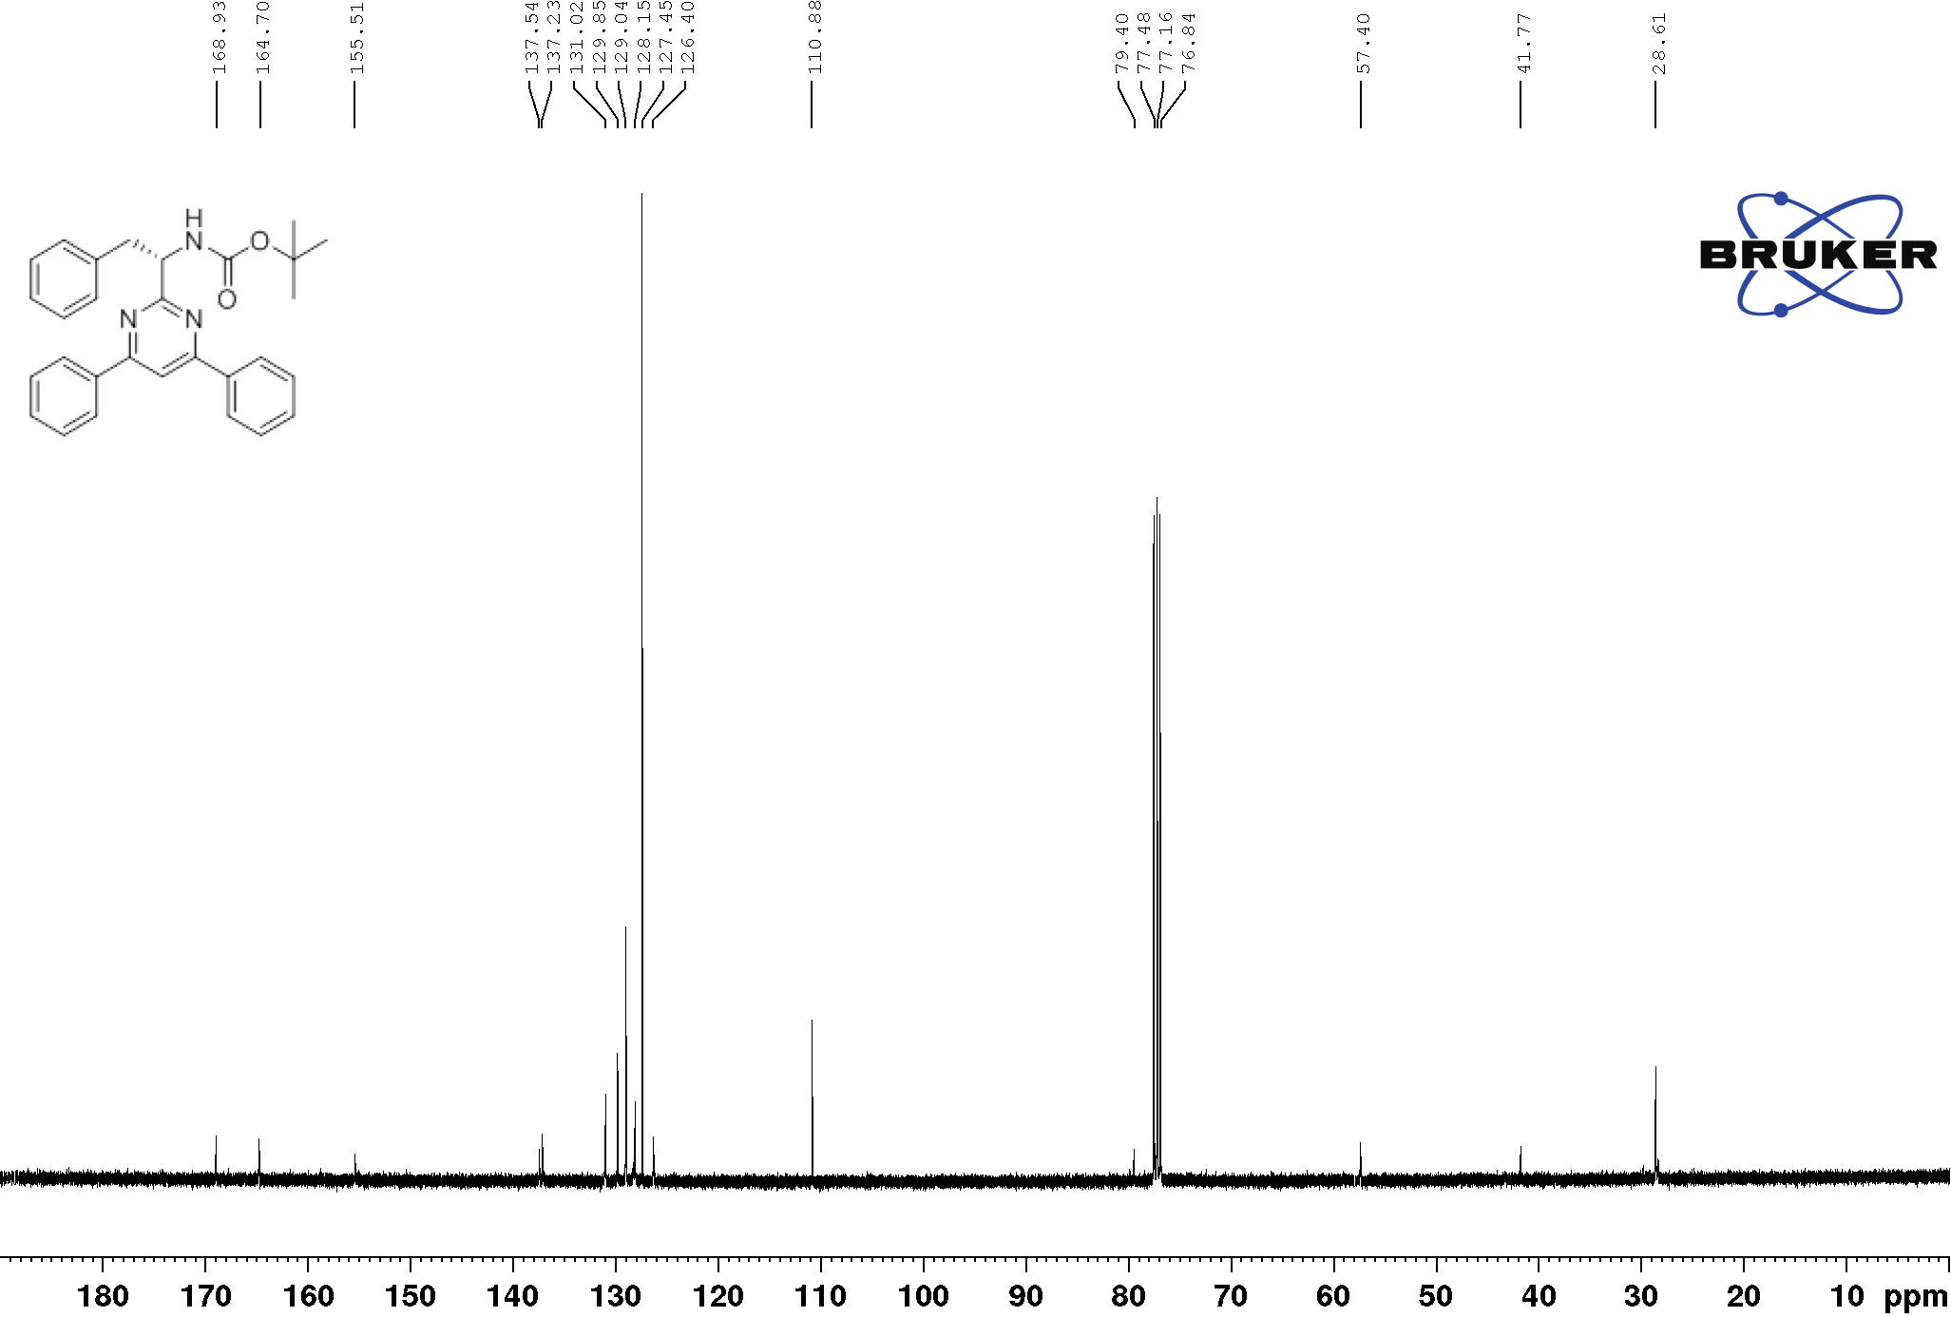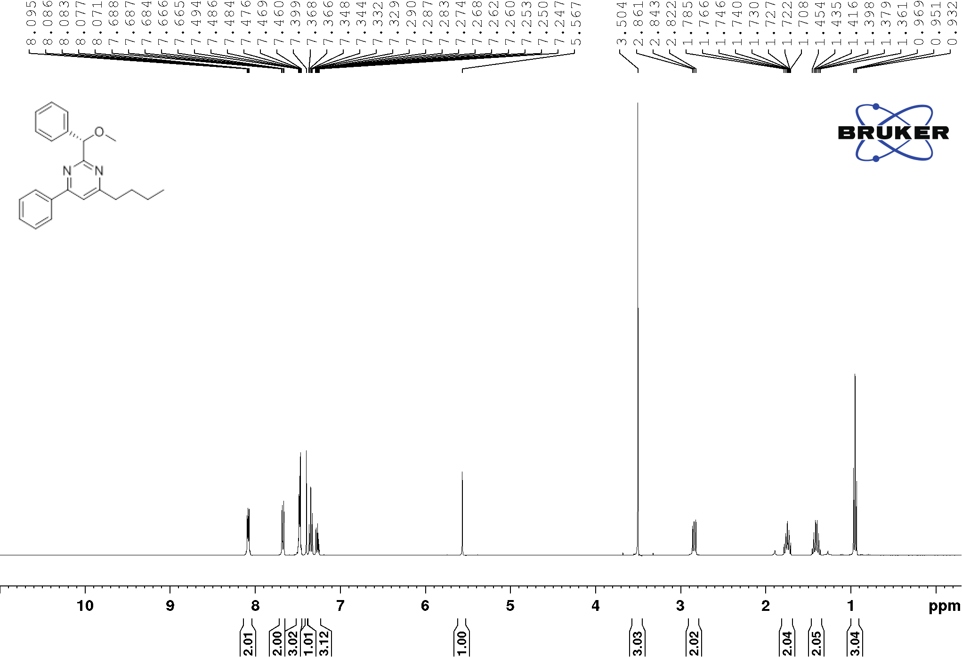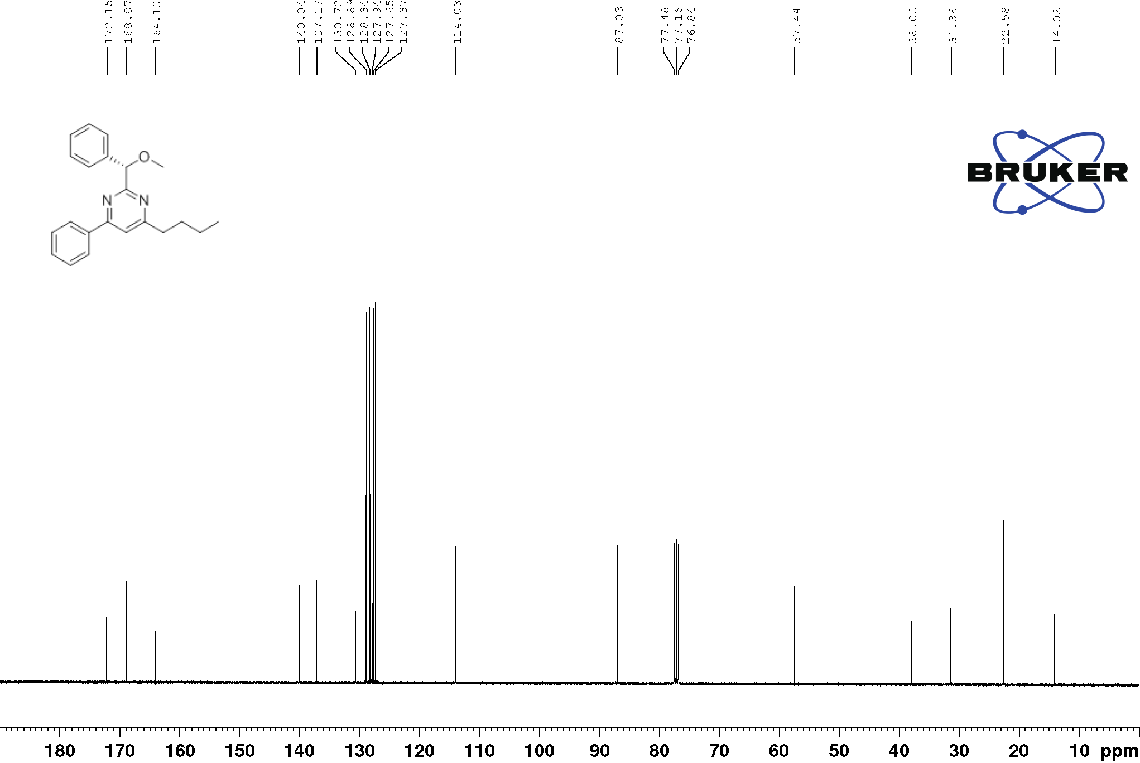
3bb’
3bb’
3cb’
3cb’
3db’
3db’
12
12

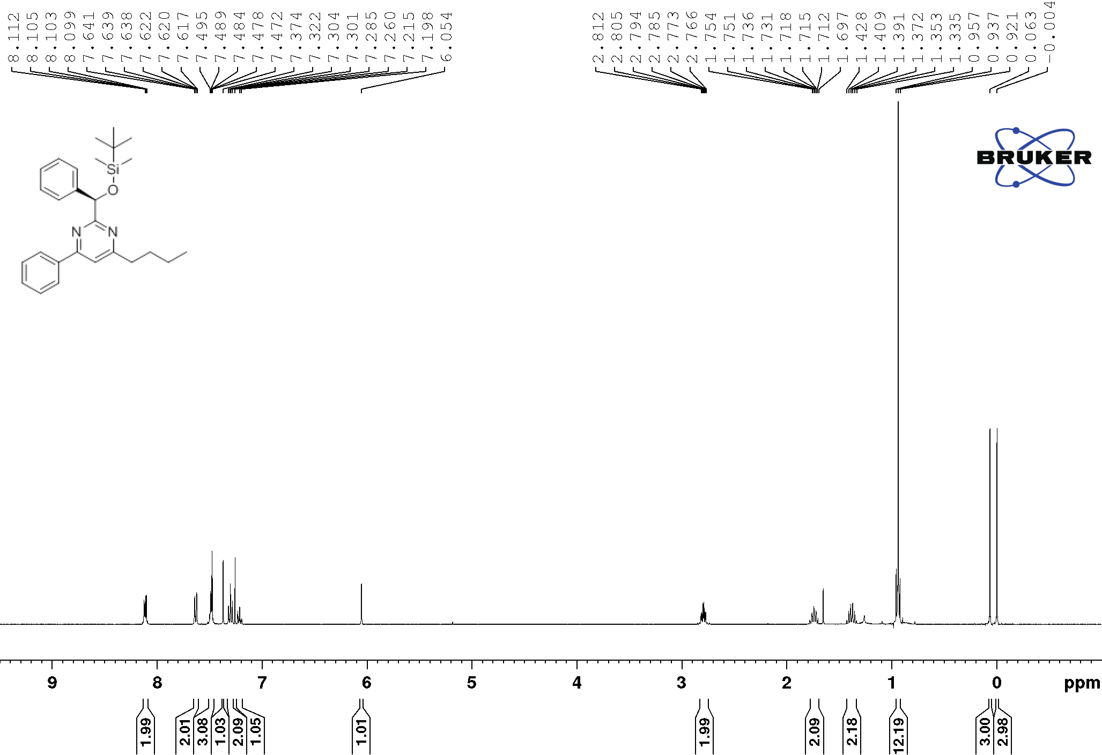
13
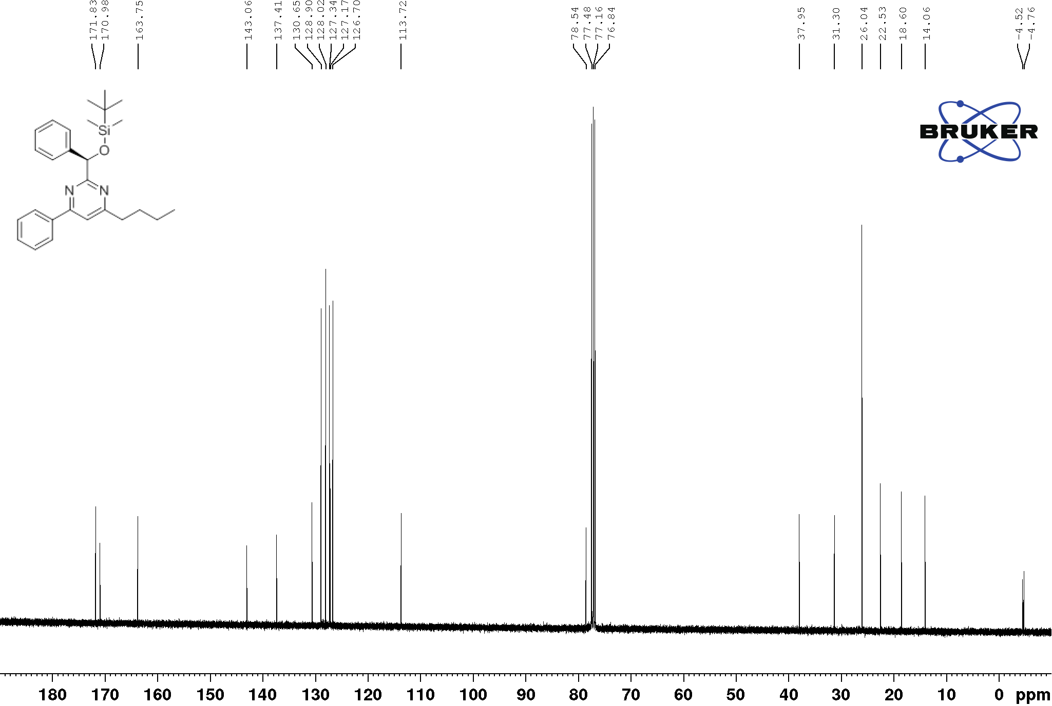
13
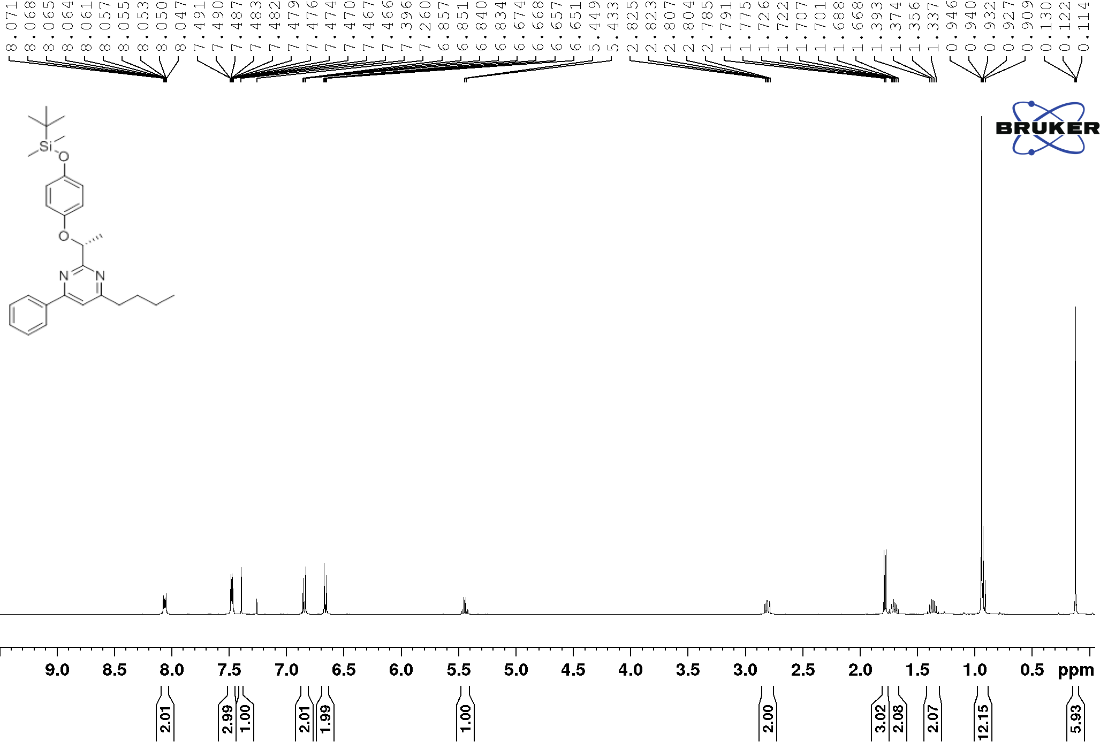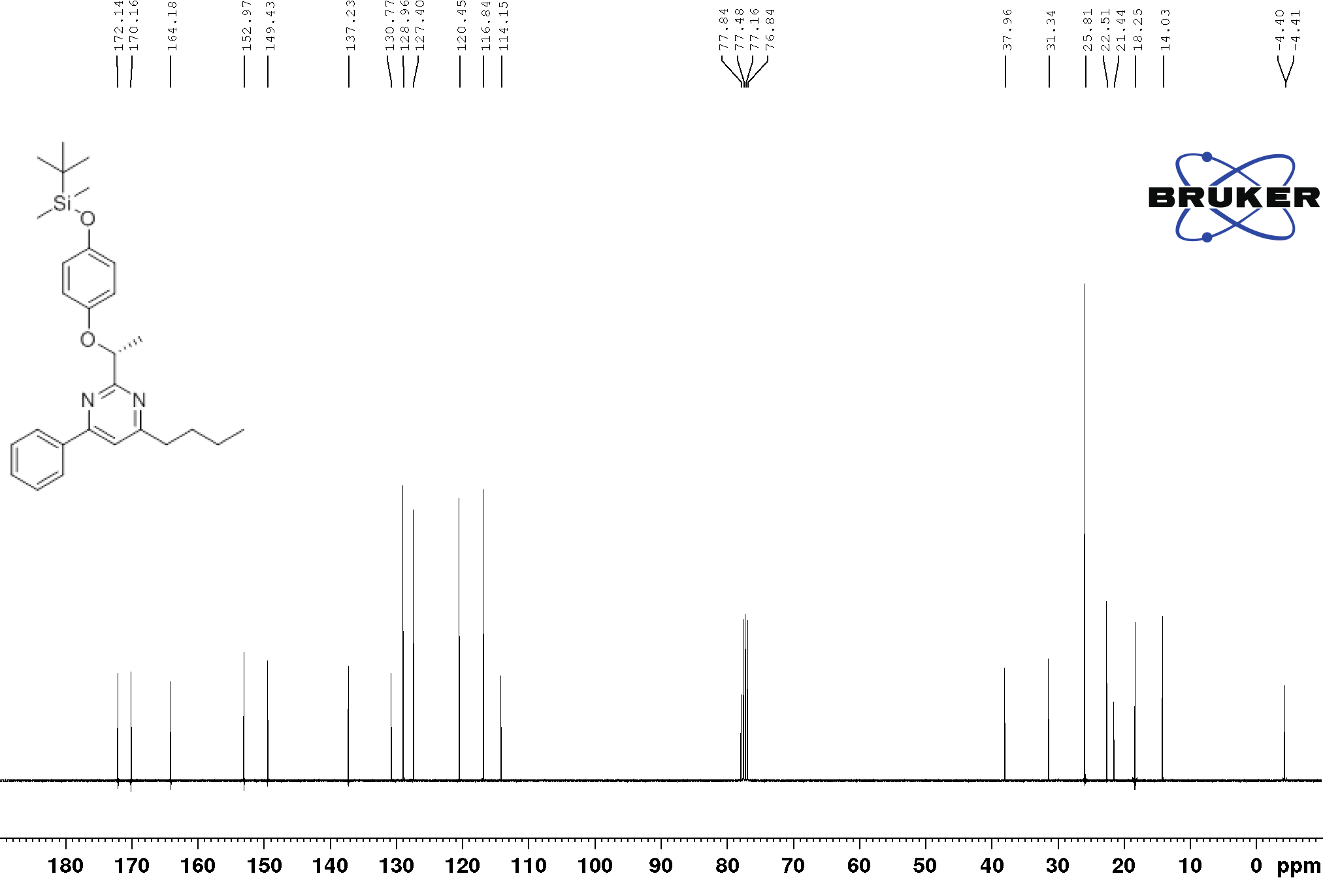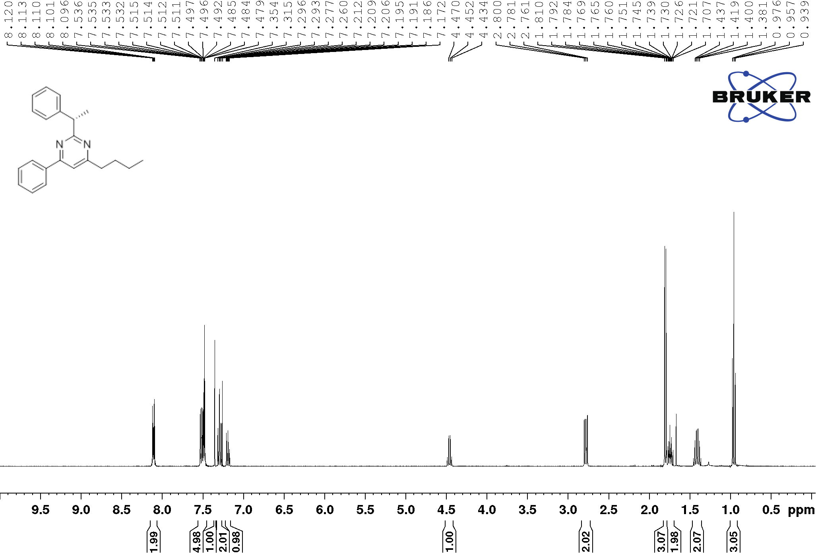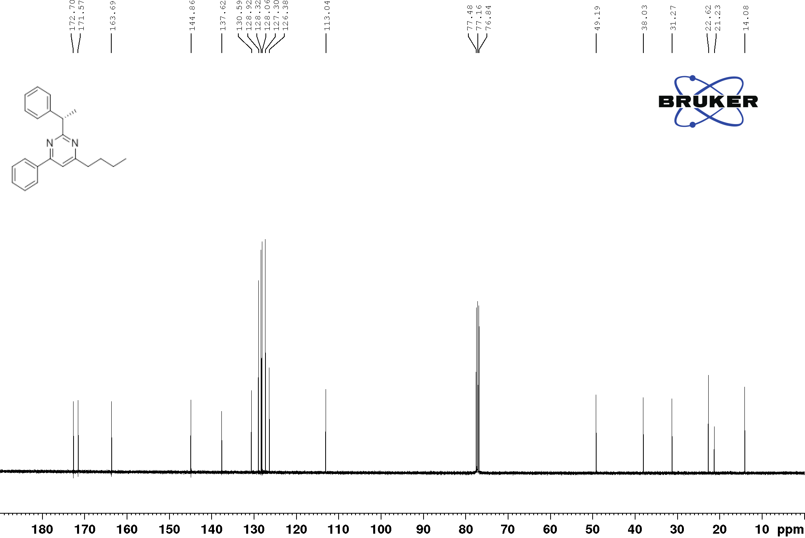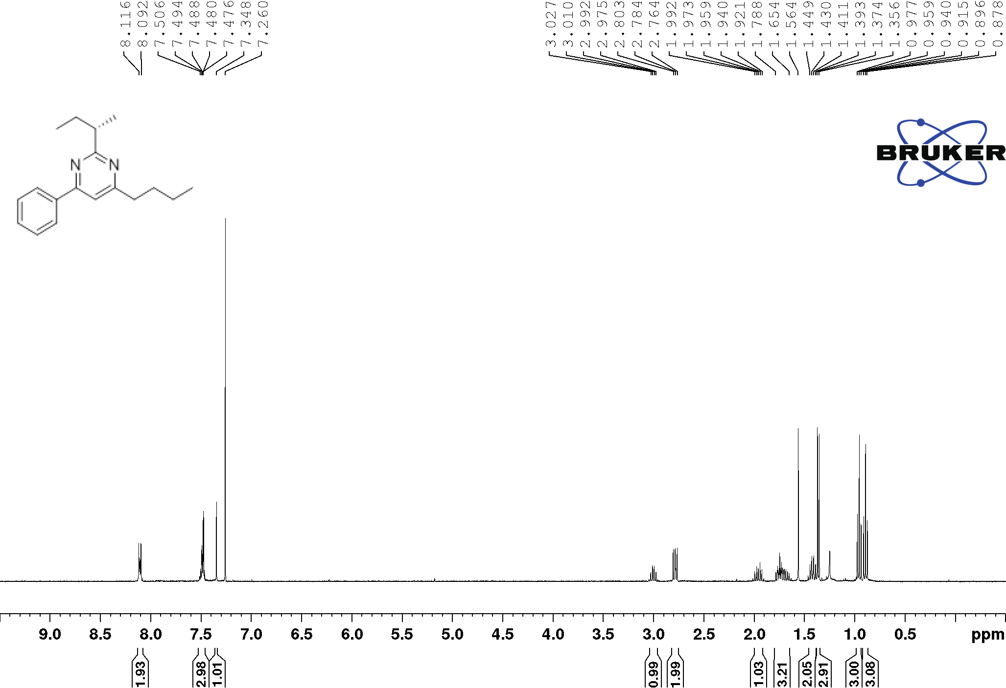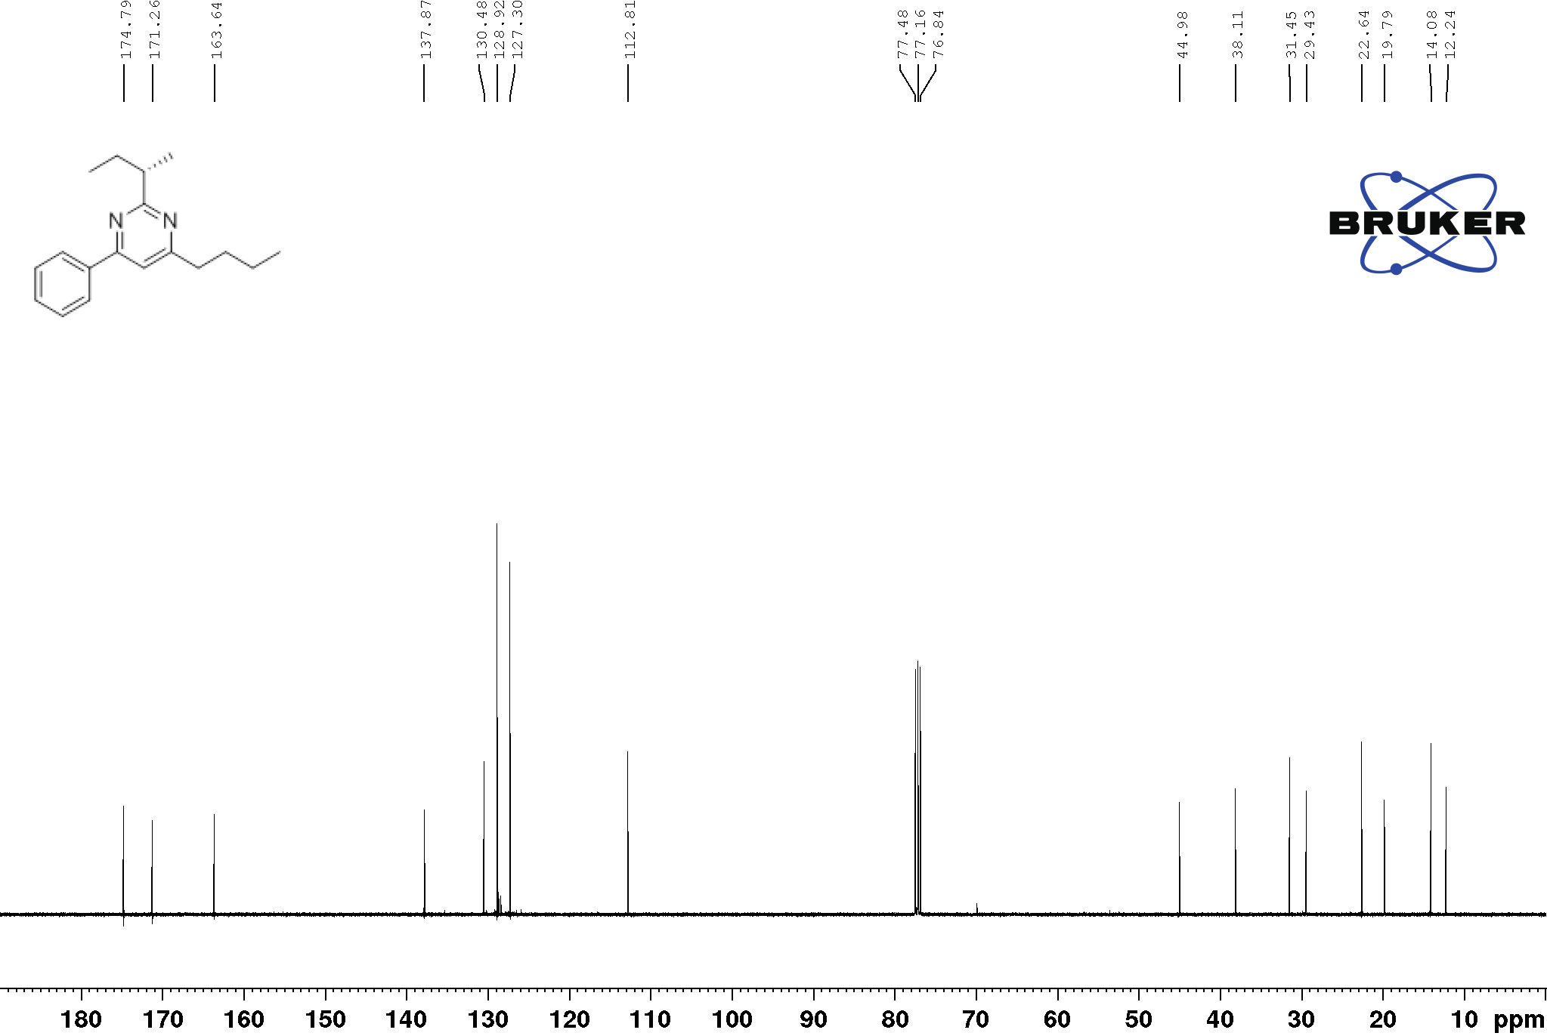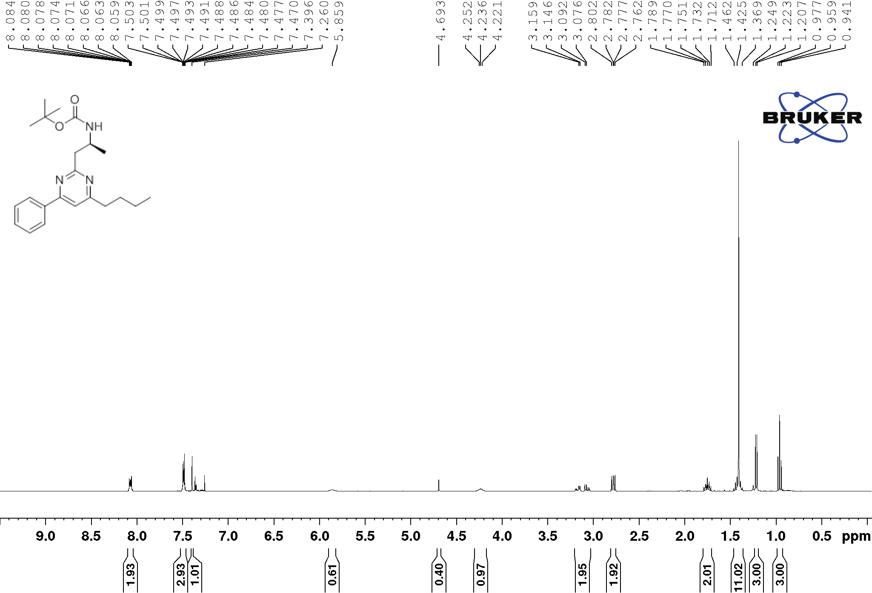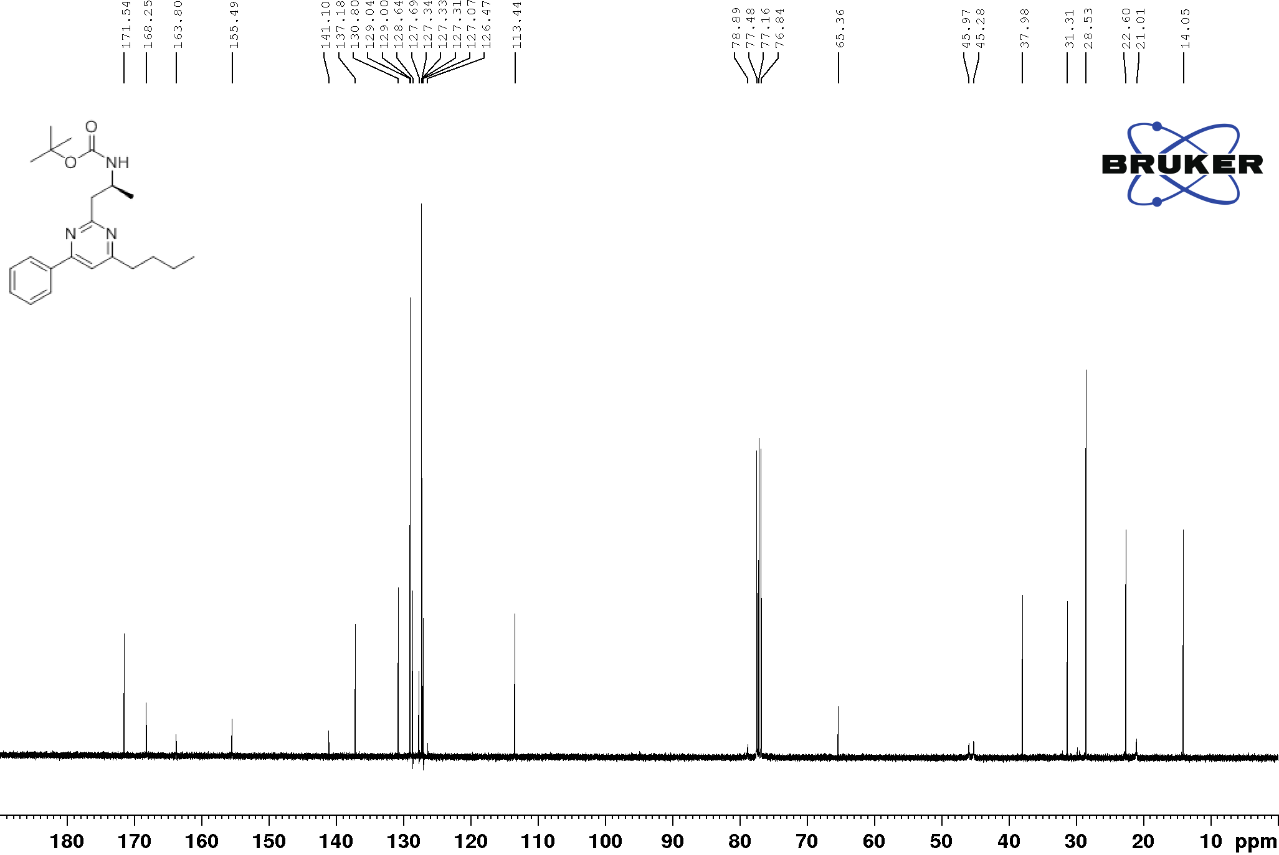
14
14
16
16
17
17
18
18
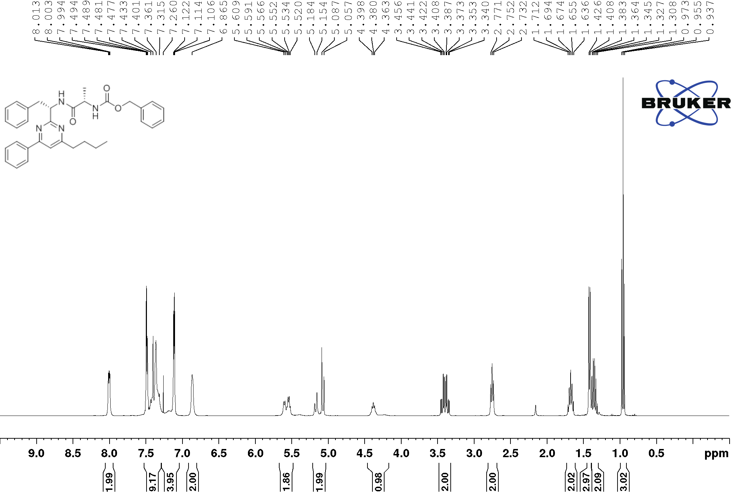
19

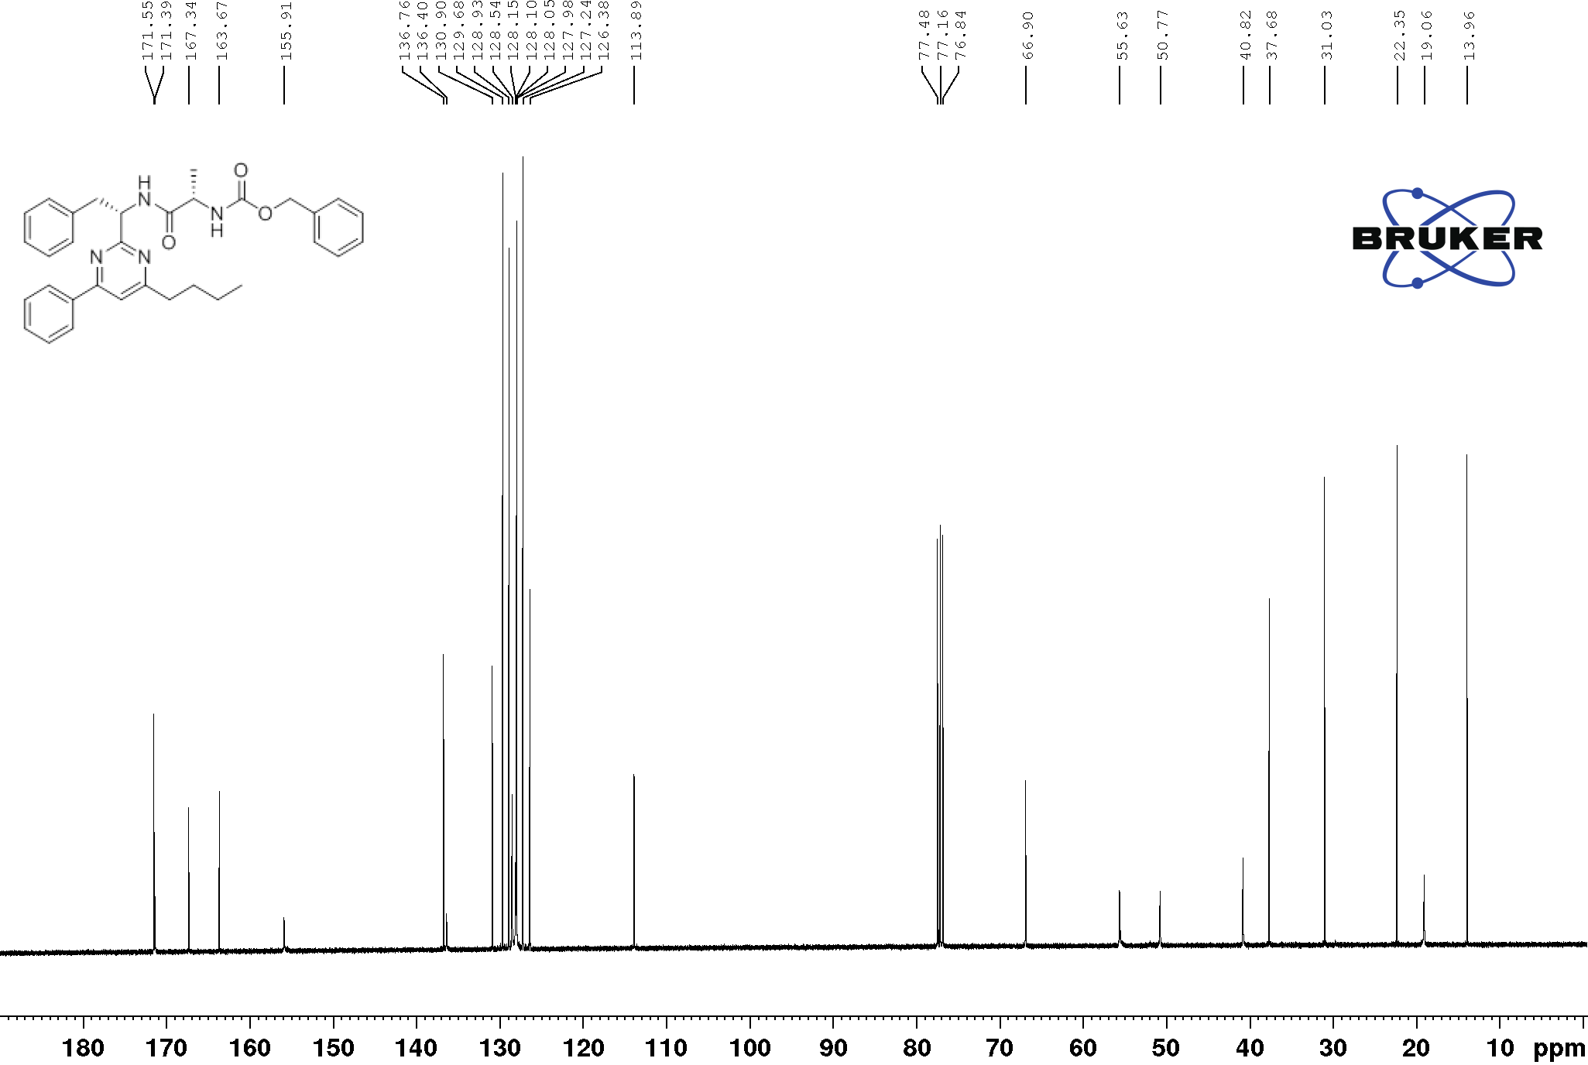
19
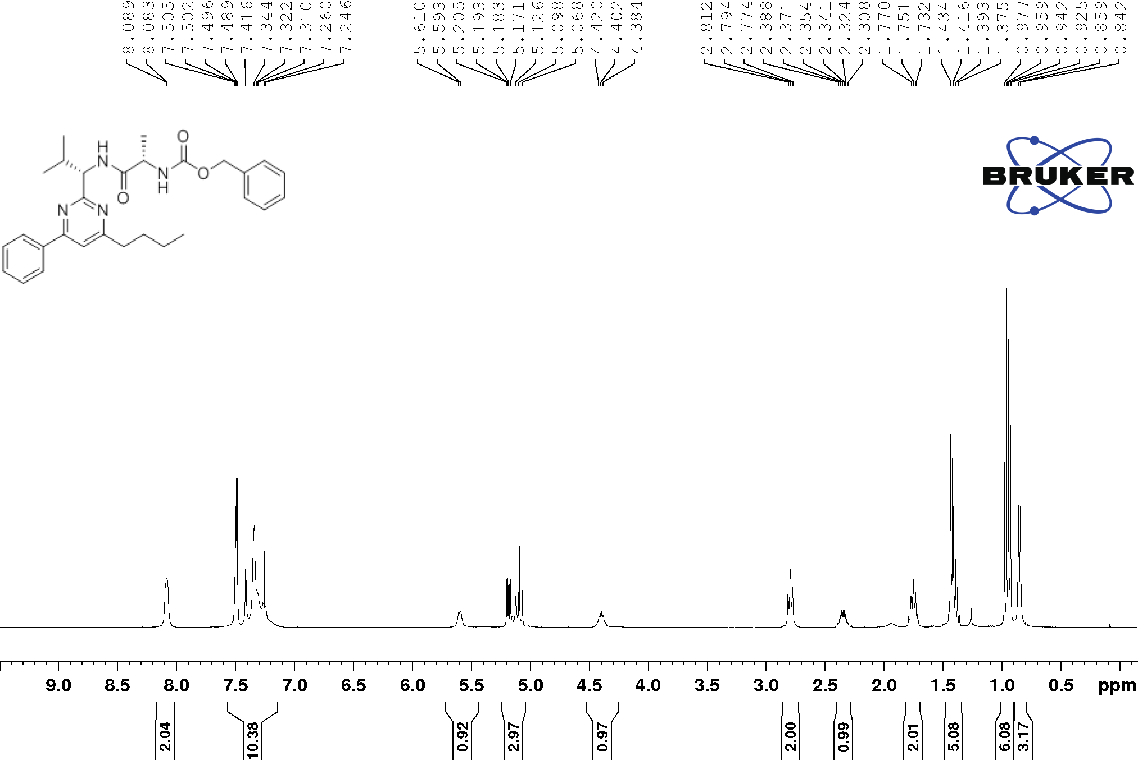
20
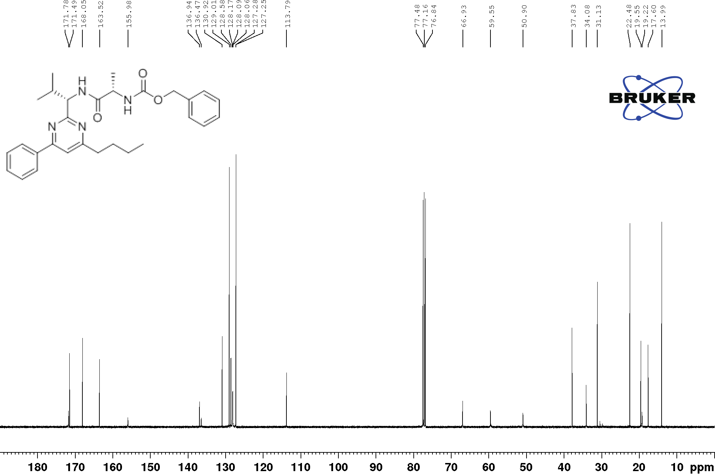
20

Chiral HPLC Chromatograms
Chiral HPLC: analytical column CHIRALPAK® IA column (250 x 4.6 mm); n-hexane/iPrOH 98:2, 1.0 mL/min, 25 °C): t_{R1} = 8.18 min and t_{R2} = 10.53 min
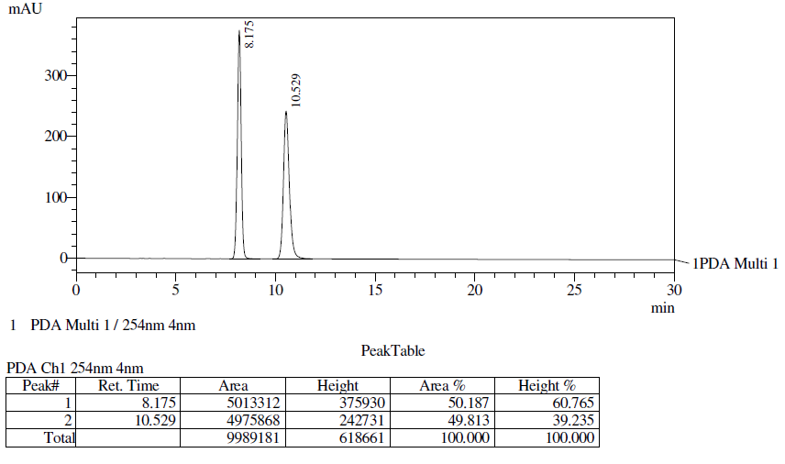
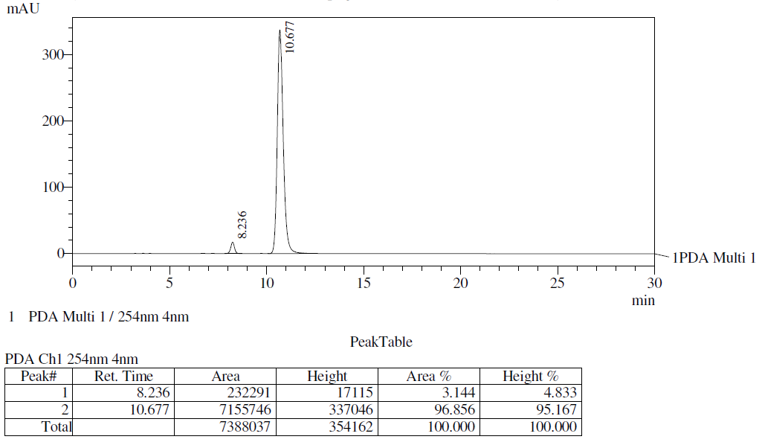

Gayon E.; Scymczyk, M.; Gérard, H.; Vrancken E.; Campagne J. -M. J. Org. Chem., 2012, 77, 9205-9220.
Ezawa T.; Kawashima Y.; Noguchi T.; Jung S.; Imai N. Tetrahedron Asymmetry, 2017, 28, 1690-1699.
Xu Z.; DiCesare J. C.; Baures P. W. J. Comb. Chem. 2010, 12, 248–254.
Wang J.; Feng Y.; Ji X.; Deng G.; Leng Y.; Liu H. Bioorg. Med. Chem., 2013, 21, 7418–7429.
Toumi M.; Couty F.; Evano G. J. Org. Chem. 2008, 73, 1270-1281.
Trotter N. S.; Brimble M. A.; Harris P. W. R.; Callis D. J.; Sieg F. Bioorg. Med. Chem., 2005, 13, 501–517.
Boeijen A.; Liskamp R. M. J. Eur. J. Org. Chem. 1999, 2127-2135.
McKiernan M.; Huck J.; Fehrentz J. –A.; Roumestant M. –L.; Viallefont P.; Martinez J. J. Org. Chem., 2001, 66, 6541-6544.
Tietze L. F.; Hölsken S.; Adrio J.; Kinzel T.; Wegner C. Synthesis, 2004, 13, 2236-2239.
Kimura M.; Kuboki A.; Sugai T. Tetrahedron: Asymmetry 2002, 13, 1059–1068.
Santangelo E. M.; Zarbin P.H. G.; Cass Q. B.; Ferreira J.T. B.; Corrêa A. G. Synth. Commun., 2001, 31, 3685-3698.
Jeevan B.V.; Umashankara M.; Sunil Kumar Y. C.; Kumara M. N.; Rangappa K. S. Asian J. Chem. 2018, 30, 927-932.
Wang M. -X.; Lu G.; Ji G. -J.; Huang Z. -T.; Meth-Cohn O.; Colby J. Tetrahedron: Asymmetry 2000, 11, 1123-1135
Fisher L. G.; Sher P. M.; Skwish S.; Michel I. M.; Seiler S.M.; Dickinson K. E. J. Bioorg. Med. Chem. 1996, 6, 2253-2258.

