Supporting information for
Microwave-assisted Synthesis of 2-Substituted 4,5,6,7-Tetrahydro-1,3-thiazepines from 4-aminobutanol
María C. Mollo,ª Natalia B. Kilimciler,ª Juan A. Bisceglia,ª and Liliana R. Orelliª*

Universidad de Buenos Aires. CONICET. Departamento de Química Orgánica. Facultad de Farmacia y Bioquímica. Junín 956, (1113) Buenos Aires, Argentina.

- General Information | S2
- Representative Procedures for Synthesis | S2
- Characterization data for compounds 1-4 | S4
- Copies of ¹H and ¹³C NMR Spectra of compounds 1-4 | S17
- References | S71

1. General Information

Chromatography was carried out using Merck Kieselgel 60 (230 – 400 mesh). Thin layer chromatography was performed on Silica gel and was visualized by U.V. Melting points were determined with a Büchi capillary apparatus and are uncorrected. ¹H and ¹³C NMR spectra were recorded on a Bruker Bio Spin Avance III 600 MHz spectrometer or a Bruker Avance II 500 MHz spectrometer, using deuteriochloroform as the solvent. In ¹H NMR spectra, chemical shifts (ppm) referenced to CHCl₃ (7.27 ppm in CDCl₃). In ¹³C NMR spectra, chemical shifts (ppm) were referenced to the deuterated solvent (77.0 ppm in CDCl₃). D₂O was employed to confirm exchangeable protons (ex). Splitting multiplicities are reported as singlet (s), broad signal (bs), doublet (d), double doublet (dd), triplet (t), quartet (q), heptet (h) and multiplet (m). HRMS (ESI) were performed with a Bruker MicroTOF-Q II spectrometer. Reagents, solvents and starting materials were purchased from standard sources and purified according to literature procedures.

2. Representative Procedures for Synthesis

- General procedure for the synthesis of N, O-diaroyl-1,4-aminobutanols (1)

A solution of the acyl chloride or anhydride (5 mmol) in anhydrous dichloromethane (5 mL) was added dropwise to a mixture of 1,4-aminobutanol (2.5 mmol), DMAP (0.10 mmol) and 0.7 mL of triethylamine. The reaction mixture was stirred at room temperature until the disappearance of the acid chloride by TLC was observed. For compounds 1l,m the reaction was carried out at reflux for 48 h. After the reaction was completed, dichloromethane was evaporated in vacuo. The crude product was purified by column chromatography (Silicagel, hexane: ethyl acetate 3: 2→1:1).

- General procedure for the synthesis of N-thioaroyl-O-aroyl-1,4-aminobutanols (2)

To a solution of amidoester 1 (2 mmol) in toluene (20 mL) was added LR (0.75 mmol). The mixture was heated at reflux for 30 min. After the reaction is complete, the toluene is evaporated in vacuo. The resulting residue is purified by column chromatography (Silicagel, dichloromethane).

- General procedure for the synthesis of N-(4-hydroxybutyl) benzothioamides (3)

Thioamidoester 2 (1.5 mmol) was placed in a round bottomed flask and a solution of K₂CO₃ in water: methanol 1: 1 was added. The mixture was stirred at 70 °C for 30 minutes. After completion of the reaction, as indicated by TLC, the solvent is evaporated in vacuo. For compounds 3l,m the reaction was carried out using 10% NaOH:methanol at reflux for 4h. The mixture obtained is diluted with water (15 mL) and extracted with dichloromethane (3 x 30 mL). The combined organic phases were washed with water, dried over anhydrous Na ₂ SO ₄, filtered and concentrated in vacuo. The crude product was purified by column chromatography (Silicagel, hexane: ethyl acetate 1: 1→2: 3)

- General procedure for the synthesis of 4,5,6,7-Tetrahydro-1,3-thiazepines (4)
A mixture of the corresponding compound 3 (1 mmol) and neat PPSE (6 g) was reacted in the microwave reactor (Monowave 300, Anton Paar) at the indicated temperature and time. After reaching room temperature, the resulting oil was treated with ethyl acetate (25 mL) and 10% aqueous NaOH (10 mL). The aqueous phase was extracted with ethyl acetate (2 x 25 mL). The organic phases were pooled, washed with water (5 mL), filtered, dried over Na₂SO₄ and filtered. The solvent was removed in vacuo. The crude products were purified by column chromatography (Silicagel, hexane: ethyl acetate 3:2).
3. Characterization data for compounds 1-6

Compounds 1a,¹ 1b,² 1i,³ 3a,⁴ 3j,⁵ 4a,⁶ 4f ⁷ were described in the literature.

4-Benzamidobutyl benzoate (1a) ¹

Prepared according to the general procedure, 706.25 mg, 95%. White solid, mp (hexane/CHCl₃): 42-44°C.
¹H NMR (600 MHz, CDCl₃) δ 1.71-1.74 (m, 2H), 1.79-1.84 (m, 2H), 3.47-3.50 (m, 2H), 4.31 (t, J=6.5 Hz, 2H), 6.86 (bs ex, 1H), 7.35-7.45 (m, 5H), 7.53 (t, J=7.5 Hz, 1H), 7.77 (d, J=7.2 Hz, 2H), 8.00 (d, J=7.2 Hz, 2H).
¹³C NMR (151 MHz, CDCl₃) δ 26.1, 26.15, 39.5, 64.4, 126.8, 128.2, 128.3, 129.4, 130.0, 131.2, 132.8, 134.5, 166.5, 167.6.
HRMS (ESI): m/z Calcd. for C₁₈H₂₀NO₃⁺ [M+H]⁺: 298.1438; found: [M+H]⁺: 224.1443.

4-(4-Chlorobenzamido)butyl 4-chlorobenzoate (1b) ²

Prepared according to the general procedure, 824.0 mg, 90%. White solid, mp (ethyl acetate): 147-148°C.
¹H NMR (500 MHz, CDCl₃) δ 1.74-1.80 (m, 2H), 1.84-1.89 (m, 2H), 3.51-3.55 (m, 2H), 4.36 (t, J= 6.4 Hz, 2H), 6.26 (bs ex, 1H), 7.39-7.42 (m, 4H), 7.70 (ddd, J=8.7, 2.3, 2.0 Hz, 2H), 7.96 (ddd, J=8.7, 2.3, 2.0 Hz, 2H).
¹³C NMR (125 MHz, CDCl₃) δ 26.27, 26.30, 39.7, 64.7, 128.3, 128.6, 128.7, 128.8, 130.9, 132.9, 137.7, 139.4, 165.8, 166.5.
HRMS (ESI): m/z Calcd. for C₁₈H₁₈Cl₂NO₃⁺ [M+H]⁺: 366.0658; found: [M+H]⁺: 366.0662.

4-(4-Methylbenzamido)butyl 4-methylbenzoate (1c)

Prepared according to the general procedure, 756.0 mg, 93 %. White solid, mp (hexane/ CHCl₃): 103-105°C.
¹H NMR (500 MHz, CDCl₃) δ 1.75-1.81 (m, 2H), 1.84-1.90 (m, 2H), 2.39 (s, 3H), 2.41 (s, 3H), 3.51-3.55 (m, 2H), 4.35 (t, J=6.4 Hz, 2H), 6.28 (bs ex, 1H), 7.21-7.24 (m, 4H), 7.67 (d, J=8.0 Hz , 2H), 7.91 (d, J= 8.0 Hz, 2H).
¹³C NMR (125 MHz, CDCl₃) δ 21.4, 21.6, 26.3, 26.4, 39.6, 64.3, 126.8, 127.5, 129.1, 129.2, 129.5, 131.7, 141.7, 143.6, 166.7, 167.5
HRMS (ESI): m/z calcd. for C₂₀H₂₄NO₃⁺ [M+H]⁺: 326.1751; found: [M+H]⁺: 326.1756.

4-(4-Methoxybenzamido)butyl 4-methoxybenzoate (1d)

Prepared according to the general procedure, 849.0 mg, 95%. White solid, mp (isopropanol): 132-134°C.
¹H NMR(500 MHz, CDCl₃) δ 1.74-1.80 (m, 2H), 1.83-1.88 (m, 2H), 3.51-3.54 (m, 2H), 3.84 (s, 3H) ,3.86 (s, 3H), 4.32-4.35 (m, 2H), 6.29 (bs ex, 1H), 6.90-6.92 (m, 4H), 7.74 (ddd, J=8.9, 2.8, 2.1 Hz, 2H), 8.00 (ddd, J=8.9, 2.8, 2.1 Hz, 2H).
¹³C NMR (125 MHz, CDCl₃) δ 26.38, 26.43, 39.6, 55.36, 55.40, 64.2, 113.6, 113.7, 122.6, 126.8, 128.6, 131.5, 162.1, 163.3, 166.4, 167.1.
HRMS (ESI): m/z calcd. for C₂₀H₂₄NO₅⁺ [M+H]⁺: 358.1649; found: [M+H]⁺: 358.1655.

4-(4-Nitrobenzamido)butyl 4-nitrobenzoate (1e)
Prepared according to the general procedure, 871,5 mg, 90 %. Yellow solid, mp (isopropanol): 130-131°C.
¹H NMR (500 MHz, CDCl₃) δ 1.80-1.86 (m, 2H), 1.90-1.96 (m, 2H), 3.58-3.62 (m, 2H), 4.46 (t, J=6.4 Hz, 2H), 6.33 (bs ex, 1H), 7.94 (d, J=8.7 Hz 2H), 8.22 (d, J= 8.9 Hz, 2H), 8.29-8.31 (m, 4H).
¹³C NMR (125 MHz, CDCl₃) 26.1, 26.1, 39.9, 65.2, 123.5, 123.8, 128.1, 130.7, 135.5, 140.1, 149.5, 150.5, 164.7, 165.6.
HRMS (ESI): m/z Calcd. for C₁₈H₁₈N₃O₇⁺ [M+H]⁺: 388.1139; found: [M+H]⁺: 388.1134.

4-(2,4-Dichlorobenzamido)butyl 2,4-dichlorobenzoate (1f)
Prepared according to the general procedure, 1022,6 mg, 94 %. White solid, mp (ethyl acetate): 100-102°C.
¹H NMR (500 MHz, CDCl₃) δ 1.77-1.82 (m, 2H), 1.86-1.91 (m, 2H), 3.51-3.55 (m, 2H), 4.38 (t, J=6.5 Hz, 2H), 6.36 (bs ex, 1H), 7.27-7.31 (m, 2H), 7.41 (d, J=2.0 Hz, 1H), 7.47 (d, J=2.0 Hz, 1H), 7.61 (d, J= 8.0 Hz, 1H), 7.79 (d, J=8.0 Hz, 1H) .
¹³C NMR (125 MHz, CDCl₃) δ 26.1, 26.2, 39.7, 65.2, 127.0, 127.5, 128.4, 130.0, 131.0, 131.2, 131.3, 132.5, 133.4, 134.8, 136.7, 138.3, 164.8, 165.5.
HRMS (ESI): m/z calcd. for C₁₈H₁₆Cl₄NO₃⁺ [M+H]⁺: 433.9879; found: [M+H]⁺: 433.9885 .

4-(2-Fluorobenzamido)butyl 2-fluorobenzoate (1g)

Prepared according to the general procedure, 800 mg, 96%. White solid, mp (ethyl acetate): 60-62°C
¹H NMR (500 MHz, CDCl₃) δ ), 1.79-1.84 (m, 2H), 1.85-1.92 (m, 2H), 3.56-3.60 (m, 2H), 4.39-4.41 (m, 2H), 6.82 (bs ex, 1H), 7.10-7.16 (m, 2H), 7.20-7.23 (m, 1H), 7.25-7.28 (m, 1H), 7.45-7.49 (m, 1H), 7.50-7.55 (m,1H), 7.94 (td, J=7.5, 1.8 Hz, 1H), 8.10 (td, J=8.0, 1.8 Hz, 1H).
¹³C NMR (125 MHz, CDCl₃) δ 26.1, 26.3, 39.6, 64.9, 115.9 (d, J= 25.4 Hz), 117.0 (d, J= 22.7 Hz), 118.7 (d, J= 9.1 Hz), 121.0 (d, J= 10.9 Hz),123.9 (d, J= 3.6 Hz), 124.8 (d, J= 2.7 Hz), 132.0 (d, J= 3.6 Hz), 132.1 (d, J= 2.7 Hz),133.2 (d, J= 9.1 Hz), 134.4 (d, J= 9.1 Hz), 160.5 (d, J= 247.1 Hz), 162.2 (d, J= 259.8 Hz), 163.3 (d, J= 2.7 Hz),164.5 (d, J= 3.6 Hz).
HRMS (ESI): m/z Calcd. for C₁₈H₁₈F₂NO₃⁺ [M+H]⁺: 334.1249; found: [M+H]⁺: 334.1253.

4-(2-Methylbenzamido)butyl 2-methylbenzoate (1h)

Prepared according to the general procedure, 732.2 mg, 90 %. White solid, mp (hexane/ CHCl₃): 100-102°C.
¹H NMR (600 MHz, CDCl₃) δ 1.76-1.81 (m, 2H), 1.86-1.90 (m, 2H), 2.44 (s, 3H), 2.60 (s, 3H), 3.50-3.54 (m, 2H), 4.35 (t, J=6.4 Hz, 2H), 5.89 (bs ex, 1H), 7.18-7.25 (m, 4H), 7.31 (t, J=7.5 Hz, 1H), 7.34 (d, J=7.5 Hz, 1H), 7.40 (d, J= 7.5 Hz, 1H), 7.90 (d, J=8.0 Hz, 1H) .
¹³C NMR (151 MHz, CDCl₃) δ 19.7, 21.7, 26.3, 26.5, 39.4, 64.2, 125.7, 126.5, 129.6, 129.8, 130.5, 131.0, 131.7, 132.0, 135.9, 136.5, 140.1, 167.6, 170.2.
HRMS (ESI): m/z calcd. for C₂₀H₂₄NO₃⁺ [M+H]⁺: 326.1751 ; found: [M+H]⁺: 326.1745.

4-Cinnamamidobutyl cinnamate (1i) ³

Prepared according to the general procedure, 830.0 mg, 95%. White solid, mp (hexane/ethyl acetate): 103-106°C.
¹H NMR (600 MHz, CDCl₃) δ 1.69-1.74 (m, 2H), 1.78-1.83 (m, 2H) , 3.45-3.49 (m, 2H), 4.25 (t, J=6.5 Hz, 2H), 5.90 (bs ex, 1H), 6.42 (d, J=15.6 Hz, 1H), 6.44 (d, J=16 Hz, 1H), 7.34-7.36 (m, 3H), 7.37-7.40 (m, 3H), 7.48-7.50 (m, 2H), 7.50-7.54 (m, 2H), 7.64 (d, J=15.6 Hz, 1H), 7.70 (d, J=16 Hz, 1H).
¹³C NMR (151 MHz, CDCl₃) δ 26.3, 26.3, 39.3, 64.1, 118.0, 120.6, 127.7, 128.1, 128.8, 128.9, 129.6, 130.3, 134.3, 134.8, 141.0, 144.9, 165.9, 167.0.
HRMS (ESI): m/z calcd. for C₂₂H₂₄NO₃⁺ [M+H]⁺: 350.1751; found: [M+H]⁺: 350.1755.

4-(2-Phenylacetamido)butyl 2-phenylacetate (1j)

Prepared according to the general procedure, 700.0 mg, 86%. White solid, mp (hexane/ethyl acetate): 47-49°C.
¹H NMR (600 MHz, CDCl₃) δ 1.43−1.48 (m, 2Η), 1.55-1.60 (m, 2H), 3.21 (c, J = 7.0 Hz, 2H), 3.58 (s, 2H), 3.61 (s, 2H), 4.07 (t, J = 6.5 Hz, 2H), 5.40 (bs ex, 1H), 7.26-7.28 (m, 5H), 7.31-7.34 (m, 3H), 7.37–7.39 (m, 2H).
¹³C NMR (151 MHz, CDCl₃) δ 25.9, 26.0, 39.1, 41.4, 43.8, 64.3, 127.1, 127.4, 128.5, 129.0, 129.2, 129.4, 134.0, 134.9, 170.9, 171.5.
HRMS (ESI): m/z calcd. for C₂₀H₂₄NO₃⁺ [M+H]⁺: 326.1751; found: [M+H]⁺: 326.1744.

4-Hexanamidobutyl hexanoate (1k)

Prepared according to the general procedure, 499.5 mg, 70%. Colorless oil.
¹H NMR (600 MHz, CDCl₃) δ 0.85−0.88 (m, 6Η), 1.25-1.33 (m, 8H), 1.52-1.66 (m, 8H), 2.14 (t, J = 7.7 Hz, 2H), 2.25 (t, J = 7.6 Hz, 2H), 3.24-3.27 (m, 2H), 4.05 (t, J = 6.5 Hz, 2H), 5.78 (bs ex, 1H).
¹³C NMR (151 MHz, CDCl₃) δ 13.80, 13.83, 22.2, 22.3, 24.6, 25.4, 26.1, 26.2, 31.2, 31.4, 34.2, 36.7, 38.9, 63.7, 173.3, 173.9.
HRMS (ESI): m/z calcd. for C₁₆H₃₂NO₃⁺ [M+H]⁺: 286.2377; found: [M+H]⁺: 286.2380.

4-Isobutyramidobutyl isobutyrate (1l)
Prepared according to the general procedure, 533 mg, 93%. Yellow oil.
¹H NMR (600 MHz, CDCl₃) δ 1.14-1.16 (m, 12H), 1.54-1.59 (m, 2H) 1.63-1.68 (m, 2H), 2.33 (h, J = 6.5 Hz, 1H), 2.53 (h, J = 6.5 Hz,1H), 3.26-3.29 (m, 2H), 4.07 (t, J = 6.5 Hz, 2H), 5.62 (bs ex, 1H).
¹³C NMR (151 MHz, CDCl₃) δ 18.9, 19.6, 26.1, 26.2, 34.0, 35.6, 38.9, 63.8, 177.0, 177.2.
HRMS (ESI): m/z calcd. for C₁₂H₂₄NO₃⁺ [M+H]⁺: 230.1751; found: [M+H]⁺: 230.1744.

4-Pivalamidobutyl pivalate (1m)

Prepared according to the general procedure, 533 mg, 77%. Yellow solid, mp (ethyl acetate): 38-40°C.
¹H NMR (600 MHz, CDCl₃) δ 1.19 (s, 18 H), 1.54-1.59 (m, 2H) 1.63-1.68 (m, 2H), 3.26-3.29 (m, 2H), 4.07 (t, J = 6.5 Hz, 2H), 5.70 (bs ex, 1H).
¹³C NMR (151 MHz, CDCl₃) δ 26.1, 26.3, 27.2, 27.6, 38.6, 38.7, 39.1, 63.9, 178.4, 178.6.
HRMS (ESI): m/z calcd. for C₁₄H₂₈NO₃+ [M+H]⁺: 258.2064; found: [M+H]⁺: 258.2081.

4-Phenylthioamidobutyl benzoate (2a)

Prepared according to the general procedure, 595.4 mg, 95%. Yellow oil.
¹H NMR (600 MHz, CDCl₃) δ 1.90-1.97 (m, 4H), 3.92-3.95 (m, 2H), 4.40 (t, J=5.9 Hz, 2H), 7.36-7.39 (m, 2H), 7.43-7.46 (m, 3H), 7.57 (t, J=7.4 Hz, 1H), 7.73-7.74 (m, 3H), 8.05 (d, J=7.3 Hz, 2H).
¹³C NMR (151 MHz, CDCl₃) δ 24.8, 26.4, 46.3, 64.3, 126.6, 128.4, 128.5, 129.5, 130.1, 131.0, 133.0, 141.9, 166.6, 199.5.
HRMS (ESI): m/z Calcd. for C₁₈H₂₀NO₂S⁺ [M+H]+: 314.1209; found: [M+H]⁺: 314.1215.

4-(4-Chlorophenylthioamido)butyl 4-chlorobenzoate (2b)

Prepared according to the general procedure, 711,0 mg, 93%. White solid, mp (ethyl acetate): 141-143°C.
¹H NMR (500 MHz, CDCl₃) δ 1.90-1.95 (m, 4H), 3.91-3.95 (m, 2H), 4.40 (t, J= 6.0 Hz, 2H), 7.36 (ddd, J=8.6, 2.6, 2.0 Hz, 2H), 7.42 (ddd, J=8.6, 2.3, 2.0 Hz, 2H), 7.66 (bs ex, 1H), 7.69 (ddd, J=8.6, 2.6, 2.0 Hz, 2H), 7.98 (ddd, J=8.6, 2.3, 2.0 Hz, 2H).
¹³C NMR (125 MHz, CDCl₃) δ 24.8, 26.4, 46.4, 64.5, 127.9, 128.5, 128.7, 128.8, 131.0, 137.3, 139.6, 140.1, 165.8, 198.0.
HRMS (ESI): m/z Calcd. for C₁₈H₁₈Cl₂NO₂S⁺ [M+H]+: 382.0430; found: [M+H]⁺: 382.0425.

4-(4-Methylphenylthioamido)butyl 4-methylbenzoate (2c)

Prepared according to the general procedure, 648.8 mg, 95%. Yellow solid (Hexane/ CHCl₃), mp 108-110°C.
¹H NMR (500 MHz, CDCl₃) δ 1.88-1.97 (m, 4H), 2.37 (s, 3H), 2.42 (s, 3H), 3.91-3.95 (m, 2H), 4.38 (t, J= 6.0 Hz, 2H), 7.17-7.18 (m, 2H), 7.23-7.25 (m, 2H), 7.66 (d, J= 8.2 Hz, 2H) , 7.70 (bs ex, 1H), 7.93 (d, J= 8.2, 2H).
¹³C NMR (125 MHz, CDCl₃) δ 21.3, 21.7, 24.9, 26.5, 46.3, 64.2, 126.6, 127.4, 129.11, 129.12, 129.6, 139.1, 141.6, 143.7, 166.7, 199.2.
HRMS (ESI): m/z Calcd. for C₂₀H₂₄NO₂S⁺ [M+H]⁺: 342.1522; found: [M+H]⁺: 342.1530.

4-(4-Methoxyphenylthioamido)butyl 4-methoxybenzoate (2d)

Prepared according to the general procedure, 694.7 mg, 93%. Yellow solid (ethyl acetate), mp 119-121°C.
¹H NMR (500 MHz, CDCl₃) δ 1.87-1.96 (m, 4H), 3.84 (s, 3H), 3.86 (s, 3H), 3.91-3.95 (m, 2H), 4.36 (t, J= 6.1 Hz, 2H), 6.87 (d, J= 8.9 Hz, 2H), 6.92 (d, J=8.9 Hz, 2H), 7.67 (bs ex, 1H), 7.76 (d, J= 8.9 Hz, 2H), 7.99 (d, J= 8.9, 2H).
¹³C NMR (125 MHz, CDCl₃) δ 24.9, 26.5, 46.3, 55.42, 55.45, 64.0, 113.6, 113.6, 122.5, 128.4, 131.6, 134.1, 162.1, 163.4, 166.4, 198.2.
HRMS (ESI): m/z Calcd. for C₂₀H₂₄NO₄S⁺ [M+H]⁺: 374.1421; found: [M+H]⁺: 374.1425.

4-(4-nitrophenylthioamido)butyl 4-nitrobenzoate (2e)

Prepared according to the general procedure, 807,0 mg, 100 %. Yellow solid, mp (isopropanol): 133-135°C
¹H NMR (600 MHz, CDCl₃) δ 1.97-2.01 (m, 4H), 3.95-3.97 (m, 2H), 4.47 (t, J=6.0 Hz, 2H), 7.83 (bs ex, 1H), 7.86 (d, J=8.6 Hz 2H), 8.21-8.23 (m, 4H), 8.29 (d, J= 8.7 Hz, 2H).
¹³C NMR (151 MHz, CDCl₃) 24.6, 26.2, 46.4, 65.1, 123.6, 123.7, 127.6, 130.7, 135.4, 146.9, 148.9, 150.6, 164.7, 197.0.
HRMS (ESI): m/z Calcd. for C₁₈H₁₈N₃O₆S⁺ [M+H]+: 404.0911; found: [M+H]⁺: 404.0905.

4-(2,4-dichlorophenylthioamido)butyl 2,4-dichlorobenzoate (2f)

Prepared according to the general procedure, 785.0 mg, 87 %. Yellow solid, mp (ethyl acetate): 134-136°C
¹H NMR (600 MHz, CDCl₃) δ 1.90-1.98 (m, 4H), 3.89-3.92 (m, 2H), 4.41 (t, J=5.7 Hz, 2H), 7.26 (dd, J=8.4, 2.0 Hz, 1H), 7.31 (dd, J=8.4, 2.0 Hz, 1H), 7.37 (d, J=2.0 Hz, 1H), 7.47 (d, J=2.0 Hz, 1H), 7.51 (d, J=8.4 Hz, 1H), 7.58 (bs ex, 1H), 7.80 (d, J=8.4 Hz, 1H).
¹³C NMR (151 MHz, CDCl₃) δ 24.6, 26.2, 45.9, 65.1, 127.1, 127.4, 128.3, 129.1, 129.6, 131.0, 131.1, 132.5, 134.7, 135.7, 138.4, 140.3, 164.9, 196.1
HRMS (ESI): m/z Calcd. for C₁₈H₁₆Cl₄NO₂S⁺ [M+H]⁺: 449.9650; found: [M+H]⁺: 449.9656.

4-(2-Fluorophenylthioamido)butyl 2-fluorobenzoate (2g)

Prepared according to the general procedure, 629.0 mg, 90%. Yellow oil.
¹H NMR (500 MHz, CDCl₃) δ 1.91-1.98 (m, 4H), 3.94-3.97 (m, 2H), 4.41 (d, J= 6 Hz, 2H), 7.03-7.08 (m, 1H), 7.18-7.23 (m, 1H), 7.37-7.40 (m, 1H), 7.50-7.5m (m, 1H), 7.94 (td, J=7.5, 1.8 Hz, 1H), 7.96 (bs ex, 1H), 8.10 (td, J=8.0, 1.9 Hz, 1H).
¹³C NMR (125 MHz, CDCl₃) δ 24.7, 26.1, 46.4, 64.7, 115.8 (d, J= 23.6 Hz), 116.9 (d, J= 22.5 Hz), 118.7 (d, J= 10.0 Hz) , 124.0 (d, J= 3.6 Hz),124.5 (d, J= 3.6 Hz), 128.1 (d, J= 10.7 Hz), 132.1, 132.2 (d, J= 9.0 Hz),133.3 (d, J= 1.6 Hz), 134.5 (d, J= 9.0 Hz), 157.6 (d, J= 248.4 Hz), 161.9 (d, J= 259.6 Hz), 164.5 (d, J= 3.6 Hz), 193.6 (d, J= 1.7 Hz).
HRMS (ESI): m/z Calcd. for C₁₈H₁₈F₂NO₂S⁺ [M+H]+: 350.1021; found: [M+H]⁺: 350.1014.

4-(2-Methylphenylthioamido)butyl 2-methylbenzoate (2h)

Prepared according to the general procedure, 628.0 mg, 92%. White solid (Hexane/ CHCl₃), mp 91-93°C.
¹H NMR (500 MHz, CDCl₃) δ 1.90-1.93 (m, 4H), 2.37 (s, 3H), 2.59 (s, 3H), 3.88-3.92 (m, 2H), 4.35-4.37 (m, 2H), 7.17-7.20 (m, 2H), 7.23-7.27 (m, 4H), 7.41 (td, J= 7.4, 1,2 Hz, 2H) , 7.46 (bs ex, 1H), 7.90 (d, J= 7.4, 2H).
¹³C NMR (125 MHz, CDCl₃) δ 19.3, 21.7, 24.9, 26.4, 45.4, 64.0, 125.7, 125.9, 126.5, 128.9, 129.5, 130.5, 130.7, 131.7, 132.0, 132.8, 140.1, 143.9, 167.5, 201.9.
HRMS (ESI): m/z Calcd. for C₂₀H₂₄NO₂S⁺ [M+H]+: 342.1522; found: [M+H]⁺: 342.1525.

4-((E)-3-Phenylprop-2-enethioamido)butyl cinnamate (2i)

Prepared according to the general procedure, 694.4 mg, 95%. White solid, mp (hexane/ethyl acetate): 122-125°C.
This compound was obtained as inseparable mixture of E/Z diasteroisomers.⁸ Only the major isomer is reported.
¹H NMR (600 MHz, CDCl₃) δ 1.81-1.90 (m, 4H), 3.89-3.92 (m, 2H), 4.29 (t, J=6.0 Hz, 2H), 6.47 (d, J=16.0, 1H), 6.86 (d, J=15.3 Hz, 1H), 7.35-7.37 (m, 3H), 7.39-7.41 (m, 3H), 7.52-7.57 (m, 4H), 7.57 (bs ex, 1H), 7.71 (d, J=16 Hz, 1H), 7.82 (d, J=15.3 Hz, 1H).
¹³C NMR (151 MHz, CDCl₃) δ 24.8, 26.5, 45.6, 63.9, 117.8, 127.6, 128.0, 128.1, 128.85, 128.89, 129.8, 130.4, 134.3, 134.9, 141.6, 145.1, 167.1, 194.9.
HRMS (ESI): m/z Calcd. for C₂₂H₂₄NO₂S⁺ [M+H]+: 366.1522; found: [M+H]⁺: 366.1518.

4-(2-Phenylethanethioamido)butyl 2-phenylacetate (2j)

Prepared according to the general procedure, 546.0 mg, 80%. Yellow oil.
¹H NMR (600 MHz, CDCl₃) δ 1.55−1.57 (m, 4Η), 3.60-3.62 (m, 4H)*, 4.06 (t, J = 6.0 Hz, 2H), 4.13 (s, 2H), 6.99 (bs ex, 1H), 7.25-7.27 (m, 5H), 7.30-7.40 (m, 5H).
¹³C NMR (151 MHz, CDCl₃) δ 24.3, 25.9, 41.4, 45.5, 53.2, 64.1, 127.1, 127.9, 128.6, 129.2, 129.3, 129.5, 134.0, 134.8, 171.5, 202.1.
HRMS (ESI): m/z Calcd. for C₂₀H₂₄NO₂S⁺ [M+H]⁺: 342.1522; found: [M+H]⁺: 342.1527.
*overlapping signals

4-Hexanethioamidobutyl hexanoate (2k)

Prepared according to the general procedure, 603.0 mg, 100%. Yellow oil.
¹H NMR (600 MHz, CDCl₃) δ 0.88−0.91 (m, 6Η), 1.27-1.38 (m, 8H), 1.60-1.65 (m, 2H), 1.70-1.79 (m, 6H), 2.30 (t, J = 7.6 Hz, 2H), 2.64 (t, J = 7.7 Hz, 2H), 3.69-3.73 (m, 2H), 4.11 (t, J = 6.0 Hz, 2H), 7.37 (bs ex, 1H).
¹³C NMR (151 MHz, CDCl₃) δ 13.87, 13.90, 22.3, 22.4, 24.5, 24.6, 26.2, 29.1, 31.1, 31.3, 34.3, 45.5, 47.3, 63.5, 174.0, 205.9.
HRMS (ESI): m/z Calcd. for C₁₆H₃₂NO₂S⁺ [M+H]⁺: 302.2148; found: [M+H]⁺: 302.2154.

4-(2-methylpropanethioamido)butyl isobutyrate (2l)

Prepared according to the general procedure, 417.0 mg, 85%. Yellow oil.
¹H NMR (600 MHz, CDCl₃) δ 1.15 (d, J = 7.0 Hz, 6H), 1.25 (d, J = 6.6 Hz, 6H), 1.70-1.75 (m, 4H), 2.54 (h, J = 7.0 Hz, 1H), 2.80 (h, J = 6.6 Hz,1H), 3.70-3.73 (m, 2H), 4.09-4.11 (m, 2H), 7.40 (bs ex, 1H).
¹³C NMR (151 MHz, CDCl₃) δ 18.9, 22.6, 24.5, 26.2, 34.0, 44.5, 45.2, 63.6, 177.2, 211.7.
HRMS (ESI): m/z calcd. for C₁₂H₂₄NO₂S⁺ [M+H]⁺: 246.1522; found: [M+H]⁺: 246.1526.

4-(2,2-Dimethylpropanethioamido)butyl pivalate (2m)
Prepared according to the general procedure, 475 mg, 87%. White solid, mp (Hexane/ CHCl₃): 35-47°C.
¹H NMR (600 MHz, CDCl₃) δ 1.20 (s, 9 H), 1.35 (s, 9 H), 1.69-1.73 (m, 4H), 3.71-3.74 (m, 2H), 4.10 (t, J = 6.2 Hz, 2H), 5.70 (bs ex, 1H).
¹³C NMR (151 MHz, CDCl₃) δ 24.5, 26.2, 27.2, 30.1, 38.7, 44.5, 45.8, 63.6, 178.6, 213.46.
HRMS (ESI): m/z calcd. for C₁₄H₂₈NO₂S⁺ [M+H]⁺: 274.1835; found: [M+H]⁺: 274.1841.

N-(4-Hydroxybutyl)benzothioamide (3a)⁴

Prepared according to the general procedure, 298.0 mg, 95%. White solid (Hexane/ CHCl₃), mp 61-62°C.
¹H NMR (600 MHz, CDCl₃) δ 1.70-1.74 (m, 2H), 1.82 (bs ex, 1H), 1.86-1.91 (m, 2H), 3.74 (t, J= 6.0 Hz, 2H), 3.83-3.87 (m, 2H), 7.36-7.38 (m, 2H), 7.43-7.46 (m, 1H), 7.75 (d, J= 7.3 Hz, 2H) , 8.32 (bs ex, 1H).

4-Chloro-N-(4-hydroxybutyl)benzothioamide (3b)

Prepared according to the general procedure, 318.0 mg, 87%. White solid (Hexane/ CHCl₃), mp 89-90°C.
¹H NMR (500 MHz, CDCl₃) δ 1.69-1.74 (m, 2H), 1.86-1.91 (m, 2H), 1.97 (bs ex, 1H), 3.73 (t, J= 6.0 Hz, 2H), 3.79-3.83 (m, 2H), 7.33 (ddd, J=8.6, 2.6, 2.0 Hz, 2H), 7.70 (ddd, J=8.6, 2.6, 2.0 Hz, 2H), 8.50 (bs ex, 1H).
¹³C NMR (125 MHz, CDCl₃) δ 24.7, 29.6, 46.9, 62.2, 128.1, 128.5, 137.1, 139.9, 197.2
HRMS (ESI): m/z Calcd. for C₁₁H₁₅ClNOS+ [M+H]⁺: 244.0557; found: [M+H]⁺: 244.0561.

N-(4-Hydroxybutyl)-4-methylbenzothioamide (3c)

Prepared according to the general procedure, 274.0 mg, 82%. Yellow oil.
¹H NMR (500 MHz, CDCl₃) δ 1.71-1.76 (m, 2H), 1.90-1.93 (m, 2H), 2.38 (s, 3H), 3.76 (t, J= 6.0 Hz, 2H), 3.85-3.88 (m, 2H), 7.18 (d, J=8.1 Hz, 2H), 7.68 (d, J=8.1 Hz, 2H), 8.20 (bs ex, 1H).
¹³C NMR (125 MHz, CDCl₃) δ 21.3, 24.7, 29.7, 46.6, 62.3, 126.7, 129.1, 139.0, 141.5, 198.7.
HRMS (ESI): m/z Calcd. for C₁₂H₁₈NOS⁺ [M+H]⁺: 224.1104; found: [M+H]⁺: 224.1111.

N-(4-Hydroxybutyl)-4-methoxybenzothioamide (3d)

Prepared according to the general procedure, 312.0 mg, 87%. Yellow oil.
¹H NMR (500 MHz, CDCl₃) δ 1.70-1.75 (m, 2H), 1.85 (bs ex, 1H), 1.86-1.92 (m, 2H), 3.75 (m, J= 6.0 Hz, 2H), 3.84-3.87 (m, 5H), 6.87 (ddd, J=8.8, 3.1, 2.0 Hz, 2H), 7.78 (ddd, J=8.8, 3.1, 2.0 Hz, 2H), 8.19 (bs ex, 1H).
¹³C NMR (125 MHz, CDCl₃) δ 24.7, 29.7, 46.6, 55.4, 62.3, 113.5, 128.5, 134.1, 162.0, 197.7.
HRMS (ESI): m/z Calcd. for C₁₂H₁₈NO₂S⁺ [M+H]⁺: 240.1053; found: [M+H]⁺: 240.1059.
*Overlapping signals

N-(4-Hydroxybutyl)-4-nitrobenzothioamide (3e)

Prepared according to the general procedure, 347.3 mg, 91%. Yellow oil.
¹H NMR (500 MHz, CDCl₃) δ 1.70 (bs ex, 1H) 1.76-1.81 (m, 2H), 1.93-1.98 (m, 2H), 3.80 (t, J= 5.8 Hz, 2H), 3.84-3.87 (m, 2H), 7.91 (ddd, J=8.6, 2.5, 1.9 Hz, 2H), 8.22 (ddd, J=8.6, 2.5, 1.9 Hz, 2H), 8.76 (bs ex, 1H).
¹³C NMR (125 MHz, CDCl₃) δ 24.7, 29.5, 47.2, 62.4, 123.6, 127.8, 146.9, 148.8, 196.0.
HRMS (ESI): m/z Calcd. for C₁₁H₁₅N₂O₃S⁺ [M+H]⁺: 255.0798; found: [M+H]⁺: 255.0793.

2,4-Dichloro-N-(4-hydroxybutyl)benzothioamide (3f)

Prepared according to the general procedure, 408.9 mg, 98%. Yellow oil.
¹H NMR (600 MHz, CDCl₃) δ 1.69-1.74 (m, 3H)*, 1.86-1.90 (m, 2H), 3.72 (t, J= 6.0 Hz, 2H), 3.82-3.85 (m, 2H), 7.26 (dd, J=8.3, 2 Hz; 1H), 7.38 (d, J=8.3 Hz, 1H), 7.49 (d, J=2.0 Hz, 1H), 8.11 (bs ex, 1H).
¹³C NMR (151 MHz, CDCl₃) δ 24.5, 29.7, 46.3, 62.2, 127.3, 129.2, 129.6, 130.9, 135.5, 140.5, 195.6.
HRMS (ESI): m/z Calcd. for C₁₁H₁₄Cl₂NOS⁺ [M+H]⁺: 278.0168; found: [M+H]⁺: 278.0164.
*overlapping signals

2-Fluoro-N-(4-hydroxybutyl)benzothioamide (3g)

Prepared according to the general procedure, 307 mg, 90%. Pale yellow oil.
¹H NMR (500 MHz, CDCl₃) δ 1.69-1.74 (m, 3H)*, 1.86-1.92 (m, 2H), 3.74 (t, J=6.1 Hz, 2H), 3.88-3.91 (m, 2H), 7.05-7.09 (m, 1H), 7.18-7.22 (m, 1H), 7.37-7.42 (m, 1H), 8.08 (td, J=8.0, 1.8 Hz, 1H), 8.33 (bs ex, 1H).
¹³C NMR (125 MHz, CDCl₃) δ 24.5, 29.6, 46.7, 62.2, 115.8 (d, J=23.5 Hz), 124.5 (d, J=3.3 Hz), 128.4 (d, J=10.9 Hz), 132.2 (d, J=9 Hz), 133.2 (d, J=1.6 Hz), 156.6 (d, J=248.6 Hz), 193.3.
HRMS (ESI): m/z Calcd. for C₁₁H₁₅FNOS⁺ [M+H]⁺: 228.0853; found: [M+H]⁺: 228.0856.
*overlapping signals

N-(4-Hydroxybutyl)-2-methylbenzothioamide (3h)

Prepared according to the general procedure, 278 mg, 83%. Yellow oil.
¹H NMR (500 MHz, CDCl₃) δ 1.68-1.74 (m, 2H), 1.84-1.90 (m, 2H), 2.38 (s, 3H), 3.73 (t, J= 6.0 Hz, 2H), 3.83-3.87 (m, 2H), 7.18 (d, J=7.5, 2H), 7.23-7.27 (m, 3H), 7.76 (bs ex, 1H).
¹³C NMR (125 MHz, CDCl₃) δ 19.4, 24.6, 29.7, 45.8, 62.20, 126.0, 126.5, 128.9, 130.7, 132.9, 144.0, 201.5.
HRMS (ESI): m/z Calcd. for C₁₂H₁₈NOS⁺ [M+H]⁺: 224,1104; found: [M+H]⁺: 224,1099.

(E)-N-(4-Hydroxybutyl)-3-phenylprop-2-enethioamide (3i)

Prepared according to the general procedure, 282 mg, 80%. Yellow solid (Hexane/ CHCl₃), mp 80-83°C
This compound was obtained as inseparable mixture of E/Z diasteroisomers.⁸ Only the major isomer is reported.
¹H NMR (600 MHz, CDCl₃) δ 1.68-1.72 (m, 2H), 1.83-1.88 (m, 3H)*, 3.74 (t, J=6 Hz, 2H), 3.81-3.84 (m, 2H), 6.84 (d, J=16 Hz, 1H), 7.34-7.37 (m, 4H), 7.52-7.53 (m, 2H), 7.80 (d, J=16 Hz, 1H), 8.09 (bs ex, 1H).
¹³C NMR (151 MHz, CDCl₃) δ 24.8, 29.7, 45.8, 62.2, 127.7, 128.0, 128.8, 129.7, 134.9, 141.3, 194.3.
HRMS (ESI): m/z Calcd. for C₁₃H₁₈NOS⁺ [M+H]⁺: 236.1104; found: [M+H]⁺: 236.1110.
*overlapping signals

N-(4-Hydroxybutyl)-2-phenylethanethioamide (3j)⁵

Prepared according to the general procedure, 268 mg, 80%. Yellow oil.
¹H NMR (600 MHz, CDCl₃) δ 1.47 (bs ex, 1H), 1.51-1.55 (m, 2H), 1.65-1.69 (m, 2H), 3.58 (t, J= 6.0 Hz, 2H), 3.64-3.67 (m, 2H), 4.13 (s, 2H), 7.26 (d, J=7.1 Hz, 2H), 7.32-7.34 (m, 1H), 7.37-7.39 (m, 2H), 7.56 (bs ex, 1H).

N-(4-Hydroxybutyl)hexanamide (3k)

Prepared according to the general procedure, 284.0 mg, 93%. Yellow oil.
¹H NMR (600 MHz, CDCl₃) δ 0.88 (t, J=7.1 Hz, 2H), 1.26-1.34 (m, 4H), 1.63-1.67 (m, 2H), 1.73-1.80 (m, 4H), 2.27 (bs ex, 1H) 2.62 (t, J=7.7 Hz, 2H), 2.78-2.79 (m, 2H), 3.65-3.69 (m, 2H), 3.70 (t, J=6.0 Hz, 2H), 8.00 (bs ex, 1H).
¹³C NMR (151 MHz, CDCl₃) δ 13.9, 22.3, 24.5, 29.0, 29.5, 31.0, 45.8, 47.1, 62.1, 205.4.
HRMS (ESI): m/z Calcd. for C₁₀H₂₂NOS⁺ [M+H]⁺: 204.1417; found: [M+H]⁺: 204.1421.

N-(4-Hydroxybutyl)-2-methylpropanethioamide (3l)

Prepared according to the general procedure, 187mg, 71%. White solid (hexane/CHCl₃ crystallized): 44-46°C.
¹H NMR (600 MHz, CDCl₃) δ 1.22 (d, J=6.7 Hz, 6H), 1.62-1.66 (m, 2H), 1.75-1.80 (m, 2H), 2.46 (bs ex, 1H), 2.81 (h, J=6.7 Hz, 1H), 3.65-3.70 (m, 4H), 8.04 (bs ex, 1H).
¹³C NMR (151 MHz, CDCl₃) δ 22.4, 24.4, 29.5, 44.3, 45.5, 62.0, 211.1.
HRMS (ESI): m/z Calcd. for C₈H₁₈NOS⁺ [M+H]⁺: 176.1104; found: [M+H]⁺: 176.1106.

N-(4-Hydroxybutyl)-2,2-dimethylpropanethioamide (3m)

Prepared according to the general procedure, 252 mg, 89%. Yellow oil.
¹H NMR (600 MHz, CDCl₃) δ 1.34 (s, 9H), 1.63-1.67 (m, 2H), 1.77-1.82 (m, 2H), 2.09 (bs ex, 1H), 3.68-3.72 (m, 4H), 7.88 (bs ex, 1H).
¹³C NMR (151 MHz, CDCl₃) δ 24.3, 29.5, 30.0, 44.4, 46.2, 62.0, 213.1.
HRMS (ESI): m/z Calcd. for C₉H₂₀NOS⁺ [M+H]⁺: 190.1260; found: [M+H]⁺: 190.1251.

2-Phenyl-4,5,6,7-tetrahydro-1,3-thiazepine (4a) ⁶

Prepared according to the general procedure, 139.0 mg, 73%. Colorless oil.
¹H NMR (600 MHz, CDCl₃) δ 1.89-1.92 (m, 2H), 2.07-2.11 (m, 2H), 2.91-2.93 (m, 2H), 4.07-4.09 (m, 2H), 7.37-7.39 (m, 2H), 7.43 (t, J = 7.3 Hz, 1H), 7.95 (d, J = 7.8 Hz, 2H).
¹³C NMR (151 MHz, CDCl₃) δ 25.6, 28.0, 30.9, 53.8, 128.1, 128.5, 130.5, 139.8, 163.8.
HRMS (ESI): m/z calcd. for C₁₁H₁₄NS⁺ [M+H]⁺: 192.0841; found: 192.0845.

2-(4-Chlorophenyl)-4,5,6,7-tetrahydro-1,3-thiazepine (4b)
Prepared according to the general procedure, 185 mg, 82%. Yellow oil.
¹H NMR (500 MHz, CDCl₃) δ 1.87-1.92 (m, 2H), 2.06-2.11 (m, 2H), 2.91-2.93 (m, 2H), 4.05-4.07 (m, 2H), 7.35 (ddd, J=8.6, 2.5, 1.8 Hz, 2H), 7.91 (ddd, J=8.6, 2.5, 1.8 Hz, 2H).
¹³C NMR (125 MHz, CDCl₃) δ 25.5, 28.0, 31.0, 53.8, 128.3, 129.8, 136.8, 138.0, 163.1.
HRMS (ESI): m/z calcd. for C₁₁H₁₃ClNS⁺ [M+H]⁺: 226.0452; found: 226.0448.

2-(4-Methylphenyl)-4,5,6,7-tetrahydro-1,3-thiazepine (4c)

Prepared according to the general procedure, 147.8 mg, 72%. Yellow oil.
¹H NMR (300 MHz, CDCl₃) δ 1.85-1.93 (m, 2H), 2.04-2.11 (m, 2H), 2.38 (s, 3H), 2.88-2.92 (m, 2H), 4.03-4.07 (m, 2H), 7.18 (d, J=8.1 Hz, 2H), 7.85 (ddd, J=8.1 Hz, 2H).
¹³C NMR (75 MHz, CDCl₃) δ 21.3, 25.7, 28.0, 30.9, 53.7, 128.5, 128.8, 137.1, 140.8, 163.7.
HRMS (ESI): m/z calcd. for C₁₂H₁₆NS⁺ [M+H]⁺: 206.0998; found: 206.0992.

2-(4-Methoxyphenyl)-4,5,6,7-tetrahydro-1,3-thiazepine (4d)

Prepared according to the general procedure, 177.1 mg, 80%. Colorless oil.
¹H NMR (500 MHz, CDCl₃) δ 1.85-1.89 (m, 2H), 2.03-2.08 (m, 2H), 2.87-2.89 (m, 2H), 3.83 (s, 3H), 4.01-4.03 (m, 2H), 6.88 (ddd, J=8.9, 2.9, 2.0 Hz, 2H), 7.91 (ddd, J=8.9, 2.9, 2.0 Hz, 2H).
¹³C NMR (125 MHz, CDCl₃) δ 25.8, 28.0, 30.9, 53.6, 55.3, 113.3, 130.1, 132.4, 161.6, 163.2.
HRMS (ESI): m/z calcd. for C₁₂H₁₆NOS⁺ [M+H]⁺: 222.0947; found: 222.0952.

2-(4-Nitrophenyl)-4,5,6,7-tetrahydro-1,3-thiazepine (4e)

Prepared according to the general procedure, 153.6 mg, 65%. Yellow solid, mp (hexane/CHCl₃ crystallized): 89-91°C.
¹H NMR (500 MHz, CDCl₃) δ 1.90-1.96 (m, 2H), 2.09-2.14 (m, 2H), 2.95-2.97 (m, 2H), 4.11-4.14 (m, 2H), 8.12 (ddd, J=9.0, 2.3, 2.0 Hz, 2H), 8.22 (ddd, J=9.0, 2.3, 2.0 Hz, 2H).
¹³C NMR (125 MHz, CDCl₃) δ 25.3, 28.1, 31.0, 54.1, 123.3, 129.3, 145.1, 149.0, 162.2.
HRMS (ESI): m/z calcd. for C₁₁H₁₃N₂O₂S⁺ [M+H]⁺: 237.0692; found: 237.0700.

2-(2,4-Dichlorophenyl)-4,5,6,7-tetrahydro-1,3-thiazepine (4f)⁷
Prepared according to the general procedure, 182.0 mg, 70%. Pale yellow oil.
¹H NMR (500 MHz, CDCl₃) δ 1.90-1.94 (m, 2H), 2.16-2.20 (m, 2H), 2.94-2.96 (t, 2H), 4.04-4.06 (m, 2H), 7.23 (dd, J=8.3, 1.5 Hz; 1H), 7.26 (d, J=8.3 Hz, 1H), 7.39 (d, J=1.5 Hz, 1H).
¹³C NMR (125 MHz,CDCl₃) δ 25.6, 28.3, 31.8, 53.5, 127.0, 129.7, 130.4, 132.8, 135.2, 138.6, 161.5.
HRMS (ESI): m/z calcd. for C₁₁H₁₂Cl₂NS⁺ [M+H]⁺: 260.0062; found: 260.0058.

2-(2-Fluorophenyl)-4,5,6,7-tetrahydro-1,3-thiazepine (4g)

Prepared according to the general procedure, 134.0 mg, 64%. Pale yellow oil.
¹H NMR (500 MHz, CDCl₃) δ 1.91-1.95 (m, 2H), 2.14-2.18 (m, 2H) , 2.95-2.97 (m, 2H), 4.09-4.11 (m, 2H), 7.07-7.10 (m, 1H), 7.13-7.15 (m, 1H), 7.33-7.37 (m, 1H), 7.52 (td, J=7.5, 1.7 Hz, 1H).
¹³C NMR (125 MHz, CDCl₃) δ 25.5, 28.1, 31.4, 53.4, 116.1 (d, J=22.0 Hz), 123.8 (d, J=3.7 Hz), 129.0 (d, J=10.5 Hz), 130.3 (d, J=2.4 Hz), 131.1 (d, J=8.5 Hz), 159.8 (d, J=251.6 Hz), 160.4.
HRMS (ESI): m/z calcd. for C₁₁H₁₃FNS⁺ [M+H]⁺: 210.0747; found: 210.0750.

2-(4-Methylphenyl)-4,5,6,7-tetrahydro-1,3-thiazepine (4h)

Prepared according to the general procedure, 133.5 mg, 65%. Colorless oil.
¹H NMR (500 MHz, CDCl₃) δ 1.96-2.01 (m, 2H), 2.18-2.22 (m, 2H), 2.44 (s, 3H), 2.99-3.01 (m, 2H), 4.06-4.08 (m, 2H), 7.17-7.20 (m, 2H), 7.23-7.26 (m, 1H), 7.17-7.20 (m, 2H), 7.35-7.37 (m, 1H).
¹³C NMR (125 MHz, CDCl₃) δ 19.8, 26.2, 28.0, 31.4, 52.7, 125.5, 128.9, 129.0, 130.6, 135.5, 140.5, 164.6.
HRMS (ESI): m/z calcd. for C₁₂H₁₆NS⁺ [M+H]⁺: 206.0998; found: 206,1000.

(E)-2-Styryl-4,5,6,7-tetrahydro-1,3-thiazepine (4i)

Prepared according to the general procedure, 141.2 mg, 65%. Colorless oil.
¹H NMR (600 MHz, CDCl₃) δ 1.79-1.83 (m, 2H), 2.02-2.06 (m, 2H), 2.79-2.81 (m, 2H), 4.01-4.03 (m, 2H), 6.88 (d, J=16 Hz, 1H), 7.30-7.32 (m, 1H), 7.35-7.37 (m, 2H), 7.50 (d, J=7.5 Hz, 2H), 7.54 (d, J=16 Hz, 1H).
¹³C NMR (151 MHz, CDCl₃) δ 25.6, 28.5, 30.7, 53.7, 127.5, 128.7, 129.0, 130.5, 135.8, 138.8, 163.5.
HRMS (ESI): m/z calcd. for C₁₃H₁₆NS⁺ [M+H]⁺: 218.0998; found: 218.0991.

2-Benzyl-4,5,6,7-tetrahydro-1,3-thiazepine (4j)
Prepared according to the general procedure, 154 mg, 75%. Colorless oil.
¹H NMR (600 MHz, CDCl₃) δ 1.79-1.83 (m, 2H), 1.91-1.95 (m, 2H), 2.68-2.70 (m, 2H), 3.72 (s, 2H), 3.85-3.87 (m, 2H), 7.24-7.33 (5H, m).
¹³C NMR (151 MHz, CDCl₃) δ 25.8, 28.0, 30.5, 49.7, 52.4, 126.7, 128.4, 129.1, 136.7, 164.8. HRMS (ESI): m/z calcd. for C₁₂H₁₆NS⁺ [M+H]⁺: 206.0998; found: 206.1003.

2-Pentyl-4,5,6,7-tetrahydro-1,3-thiazepine (4k)
Prepared according to the general procedure, 148.3 mg, 80%. Colorless oil.
¹H NMR (600 MHz, CDCl₃) δ 0.88-0.90 (m, 3H), 1.28-1.35 (m, 4H), 1.60-1.67 (m, 2H), 1.78-1.83 (m, 2H), 1.98-2.02 (m, 2H), 2.38 (t, J=7.7 Hz, 2H), 2.78-2.79 (m, 2H), 3.79-3.81 (m, 2H).
¹³C NMR (151 MHz, CDCl₃) δ 14.0, 22.4, 26.0, 27.3, 28.0, 30.3, 31.3, 43.4, 52.2, 166.5.
HRMS (ESI): m/z calcd. for C₁₀H₂₀NS⁺ [M+H]⁺: 186.1311; found: 186.1307.

2-Isopropyl-4,5,6,7-tetrahydro-1,3-thiazepine (4l)
Prepared according to the general procedure, 149.4 mg, 95%. Colorless oil.
¹H NMR (600 MHz, CDCl₃) δ 1.16 (d, J=6.9 Hz, 6H), 1.76-1.80 (m, 2H), 1.95-1.99 (m, 2H), 2.60 (h, J=6.9 Hz, 1H), 2.74-2.76 (m, 2H), 3.81-3.83 (m, 2H).
¹³C NMR (151 MHz, CDCl₃) δ 20.5, 25.7, 28.0, 30.2, 41.5, 52.3, 171.6.
HRMS (ESI): m/z calcd. for C₈H₁₆NS⁺ [M+H]⁺: 158.0998; found: 158.1051.

2-(Tert-butyl)-4,5,6,7-tetrahydro-1,3-thiazepine (4m)
Prepared according to the general procedure, 68.5 mg, 40%. Colorless oil.
¹H NMR (600 MHz, CDCl₃) δ 1.20 (s, 9H), 1.71-1.75 (m, 2H), 1.91-1.95 (m, 2H), 2.67-2.69 (m, 2H), 3.83-3.85 (m, 2H).
¹³C NMR (151 MHz, CDCl₃) δ 25.3, 28.0, 28.2, 30.3, 43.1, 52.8, 173.9.
HRMS (ESI): m/z calcd. for C₉H₁₈NS⁺ [M+H]⁺: 172.1154; found: 172.1147.

4. Copies of ¹H and ¹³C NMR spectra of compounds 1-4
¹H NMR (600 MHz, CDCl₃) spectrum of compound 1a
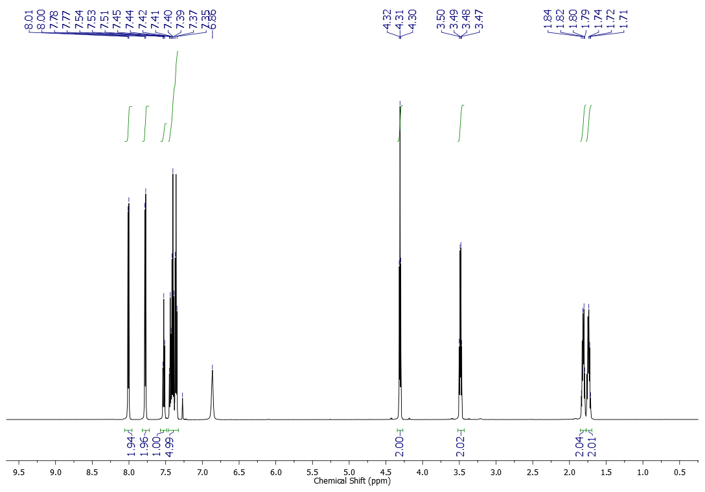
¹³C NMR (151 MHz, CDCl₃) spectrum of compound 1a
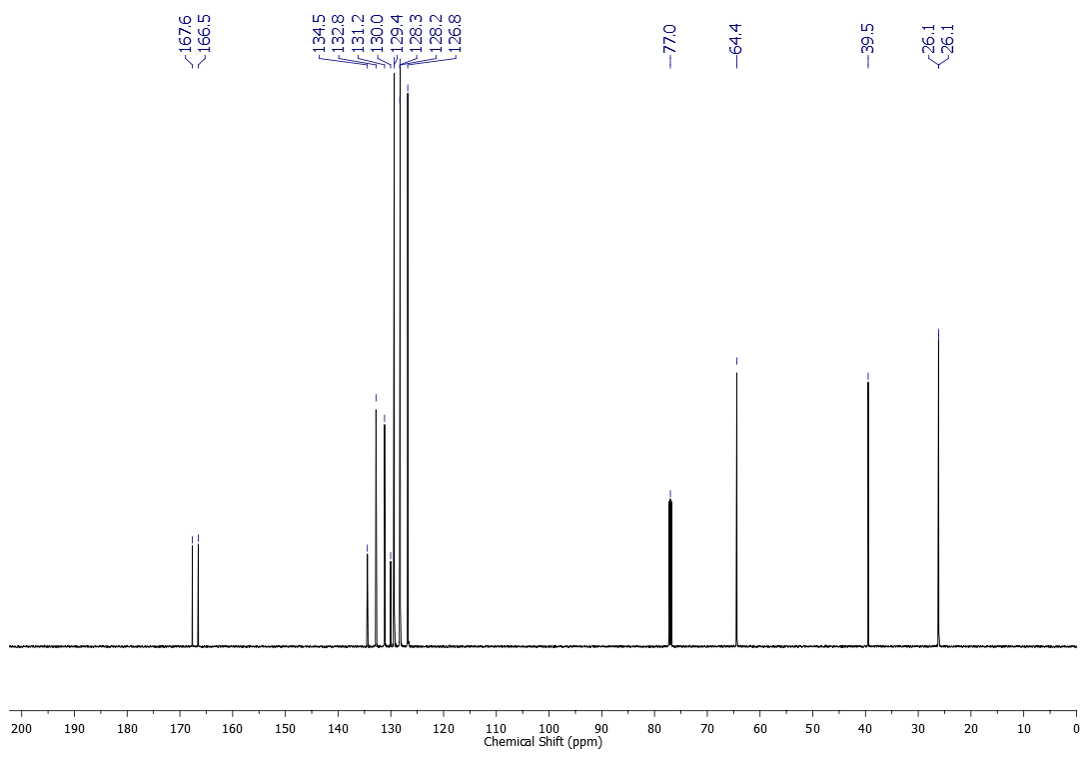
¹H NMR (500 MHz, CDCl₃) spectrum of compound 1b
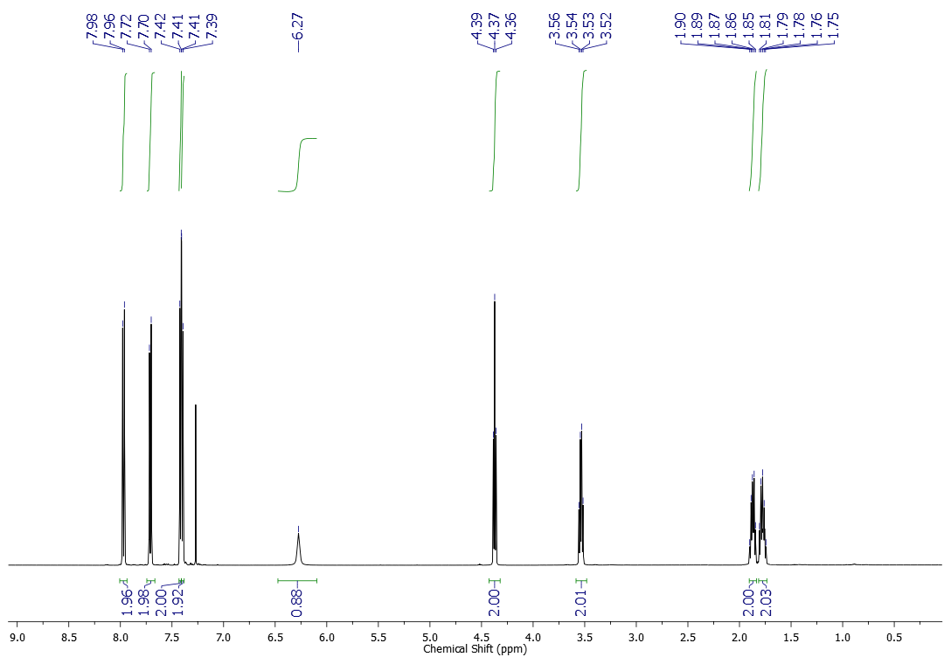
¹³C NMR (125 MHz, CDCl₃) spectrum of compound 1b
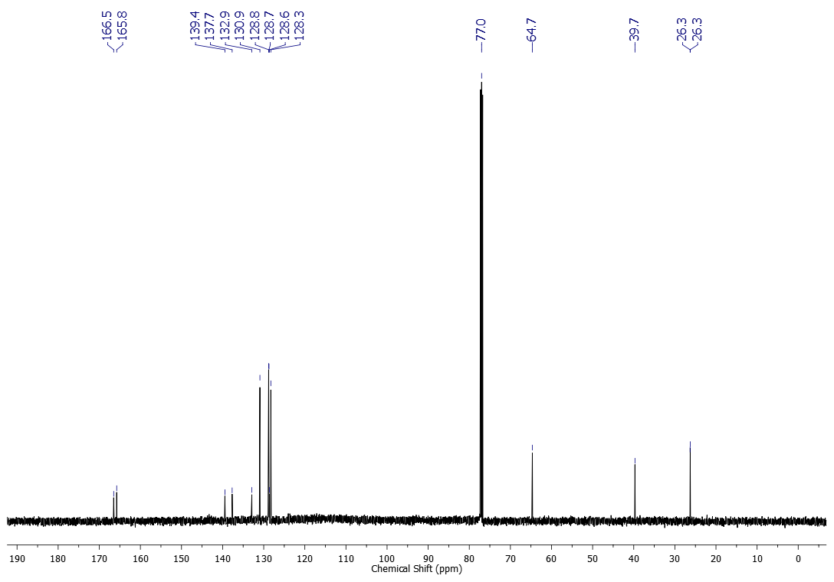

¹H NMR (500 MHz, CDCl₃) spectrum of compound 1c
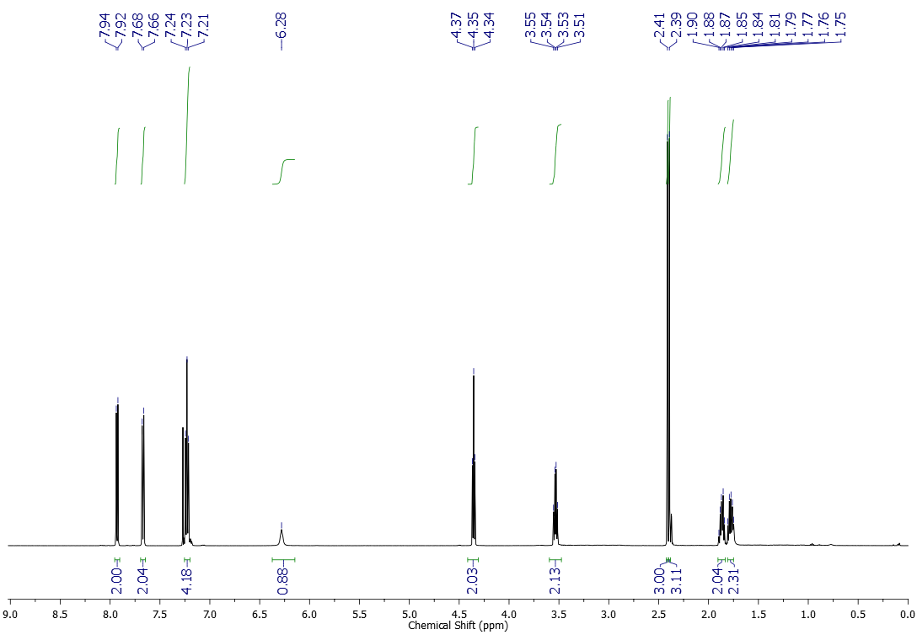
¹³C NMR (125 MHz, CDCl₃) spectrum of compound 1c
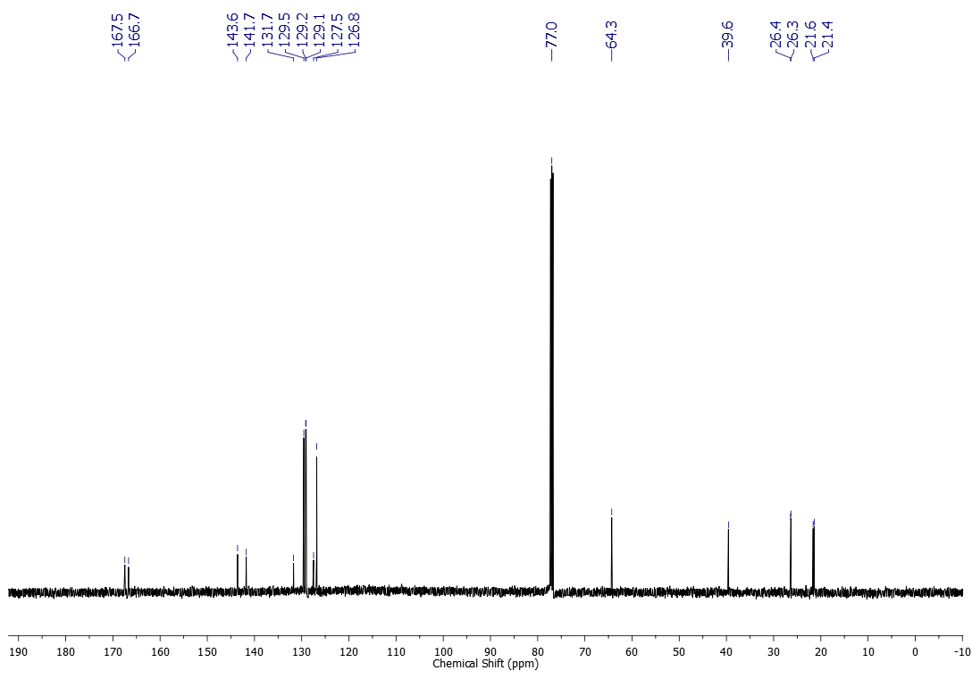

¹H NMR (500 MHz, CDCl₃) spectrum of compound 1d
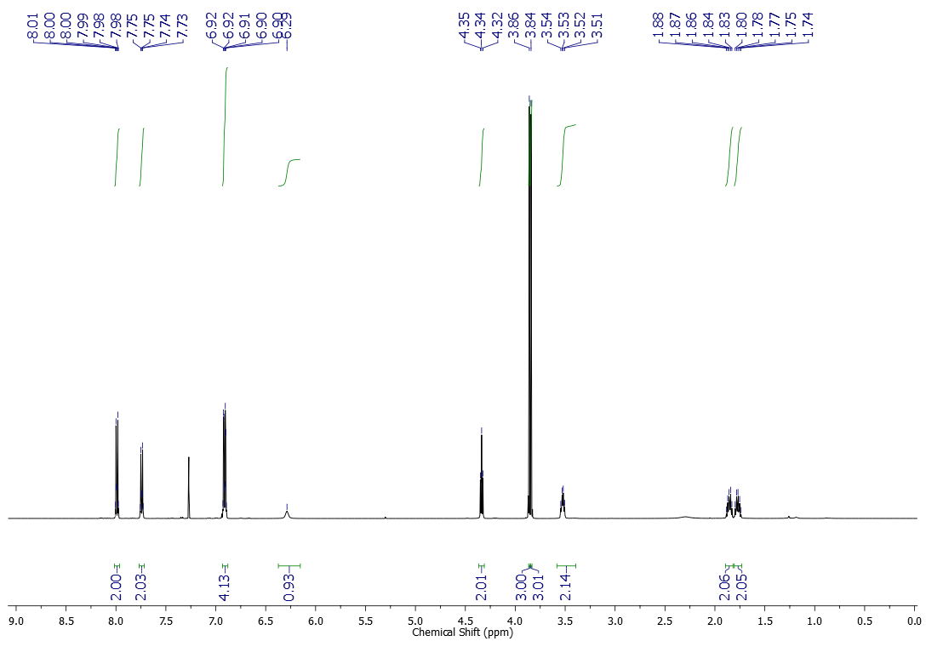
¹³C NMR (125 MHz, CDCl₃) spectrum of compound 1d
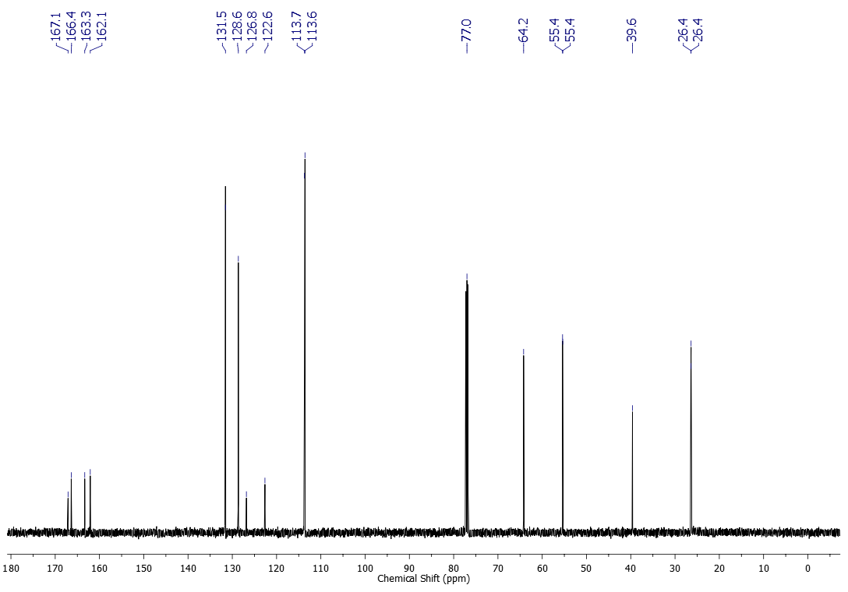

¹H NMR (500 MHz, CDCl₃) spectrum of compound 1e
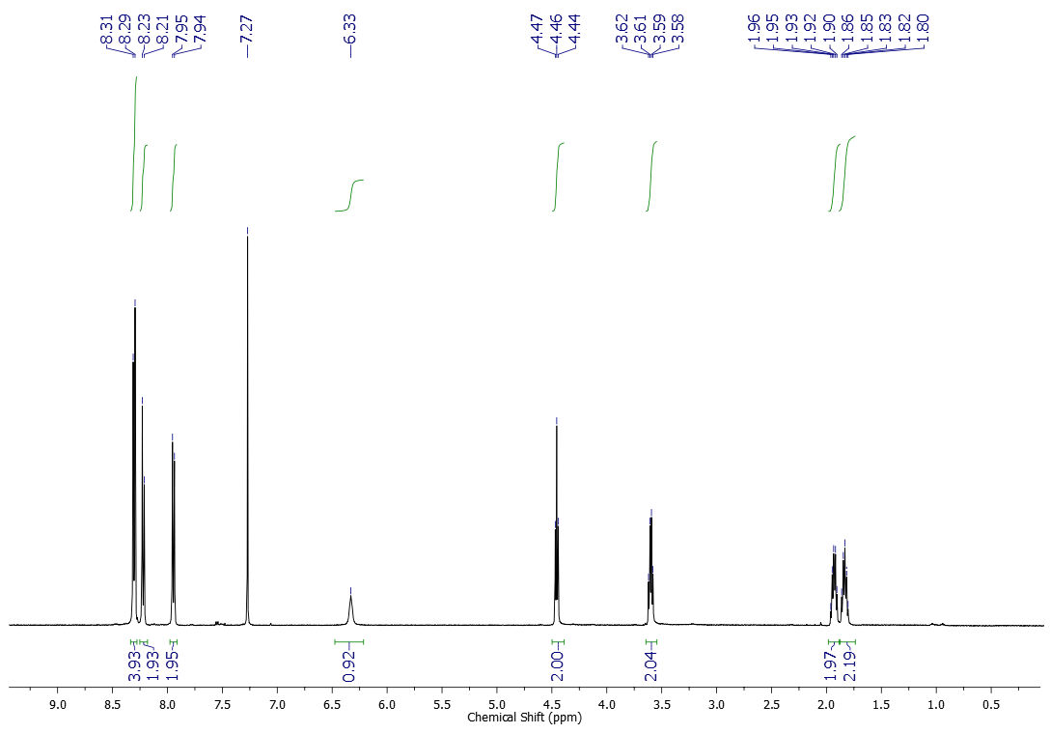
¹³C NMR (125 MHz, CDCl₃) spectrum of compound 1e
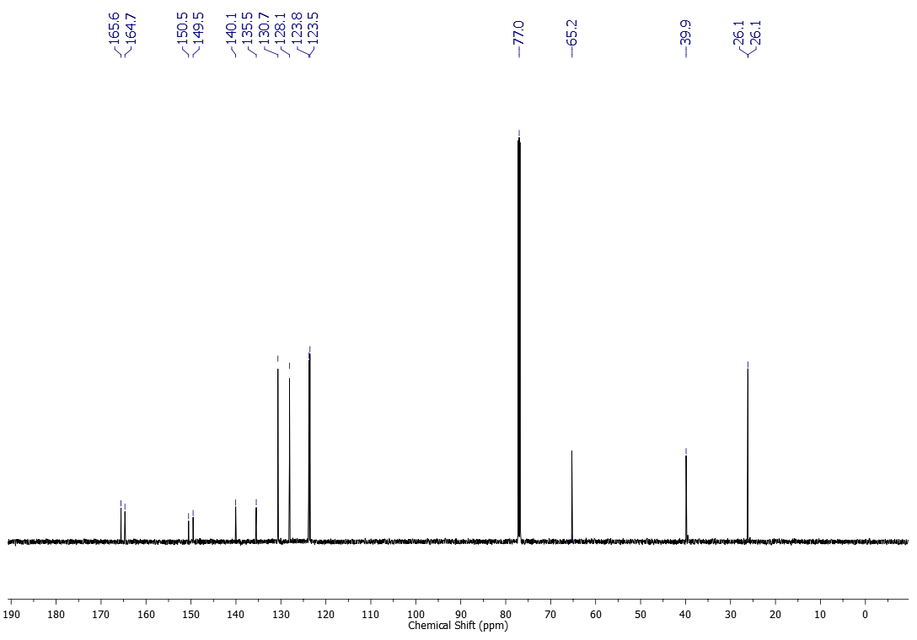

¹H NMR (500 MHz, CDCl₃) spectrum of compound 1f
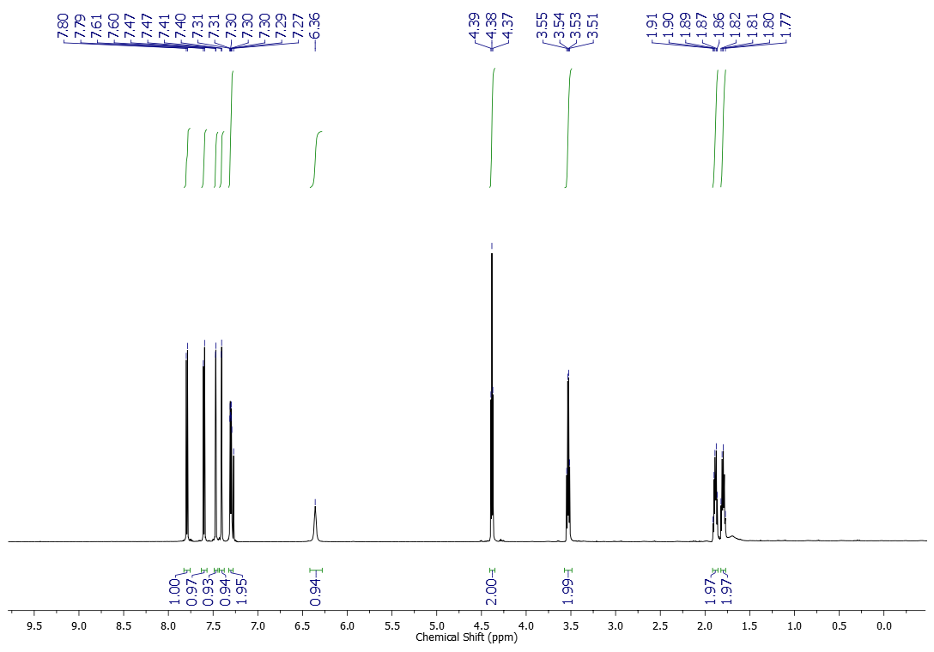
¹³C NMR (125 MHz, CDCl₃) spectrum of compound 1f
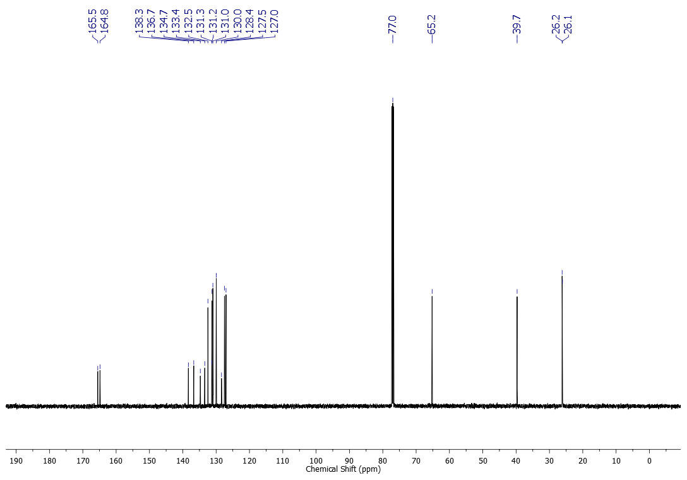

¹H NMR (500 MHz, CDCl₃) spectrum of compound 1g
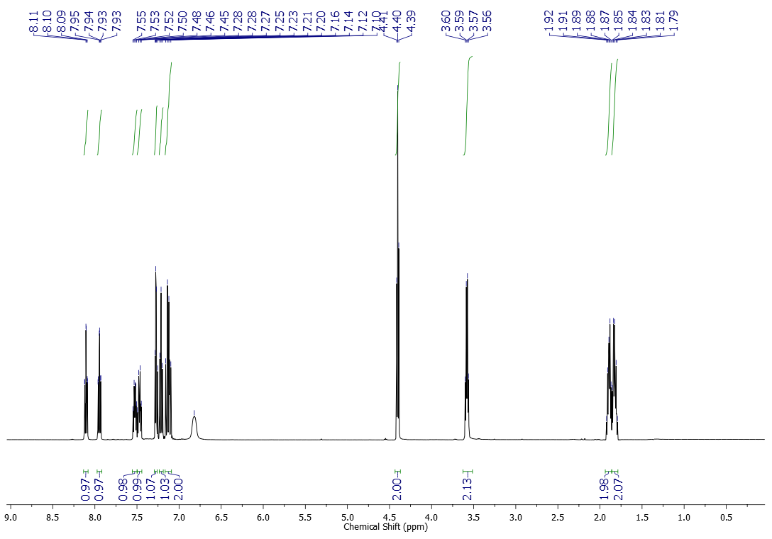
¹³C NMR (125 MHz, CDCl₃) spectrum of compound 1g
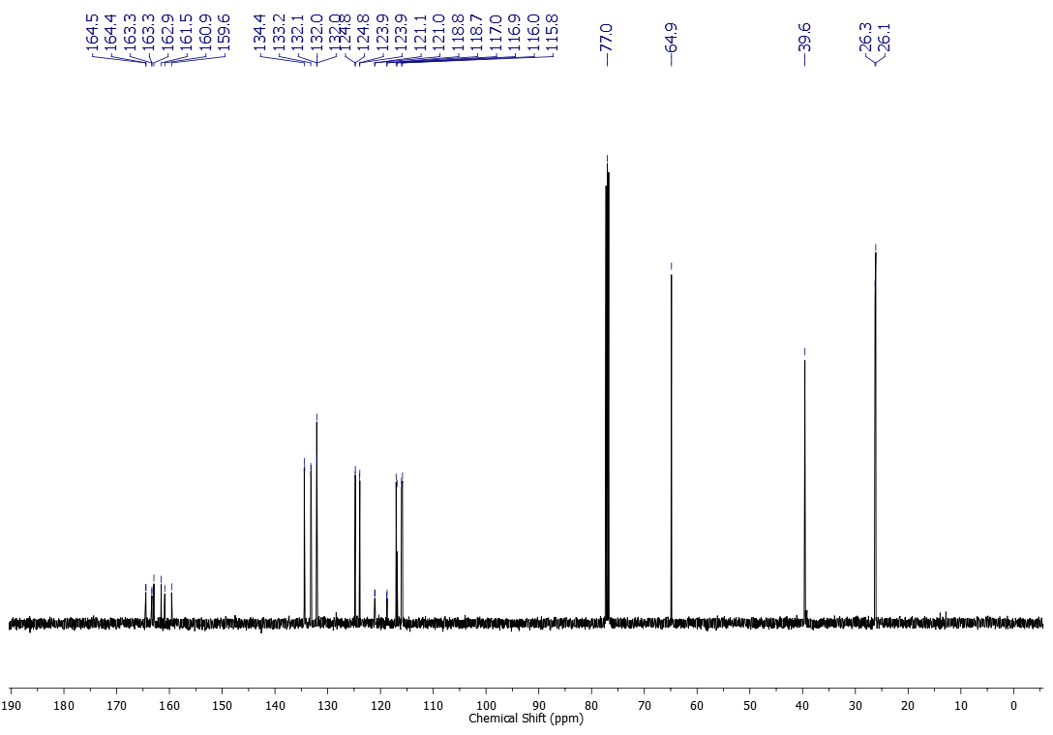
¹H NMR (600 MHz, CDCl₃) spectrum of compound 1h
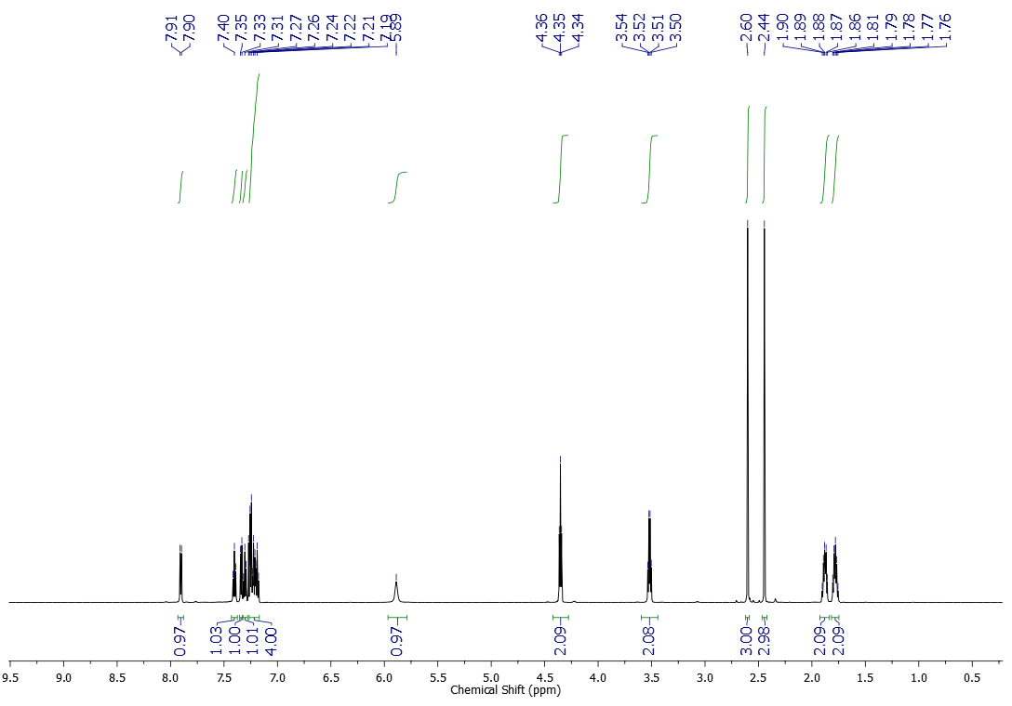
¹³C NMR (151 MHz, CDCl₃) spectrum of compound 1h
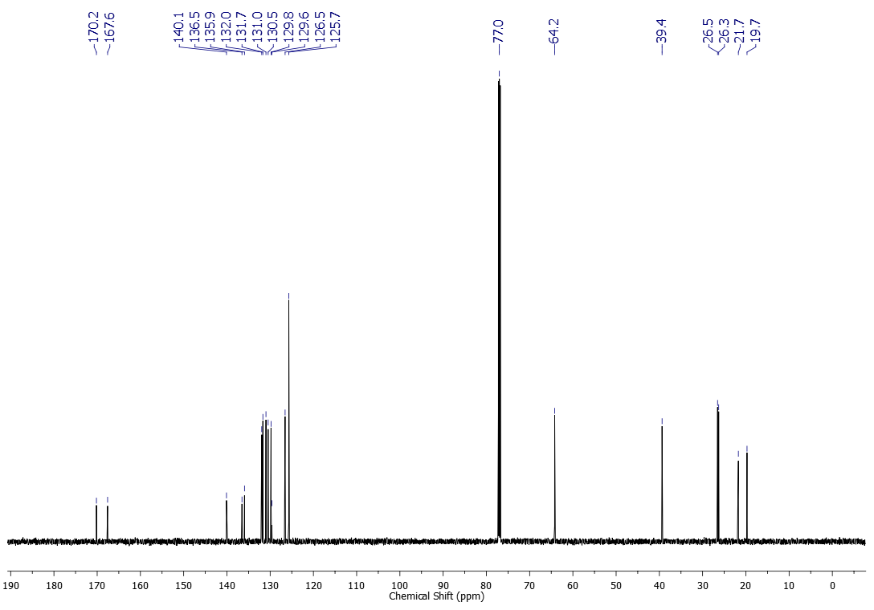
¹H NMR (600 MHz, CDCl₃) spectrum of compound 1i
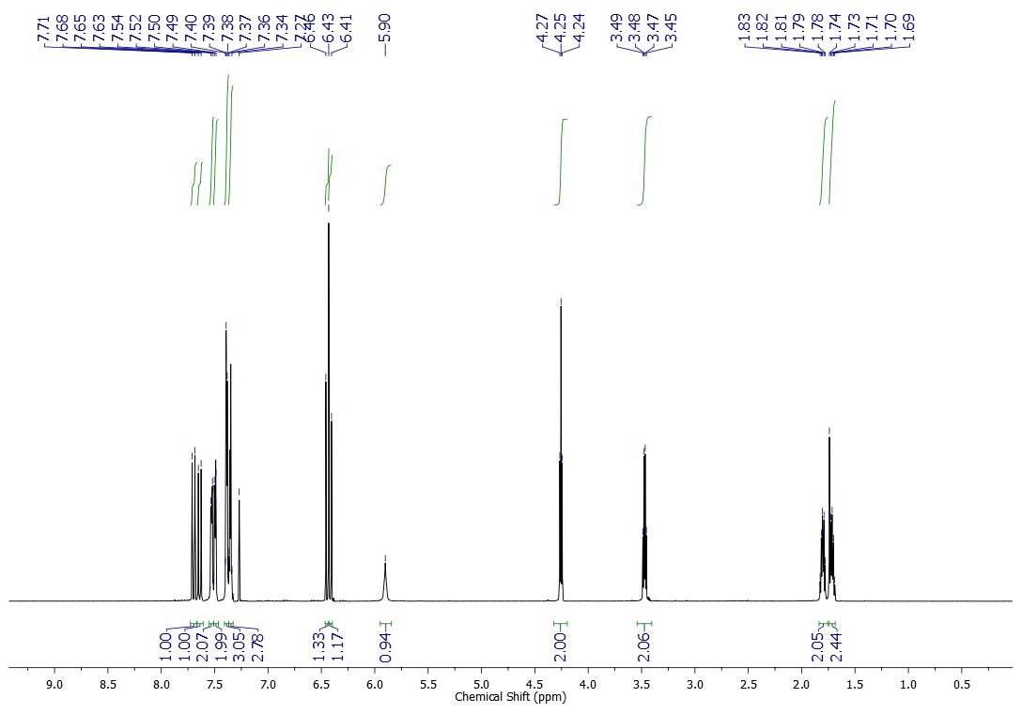

¹³C NMR (151 MHz, CDCl₃) spectrum of compound 1i
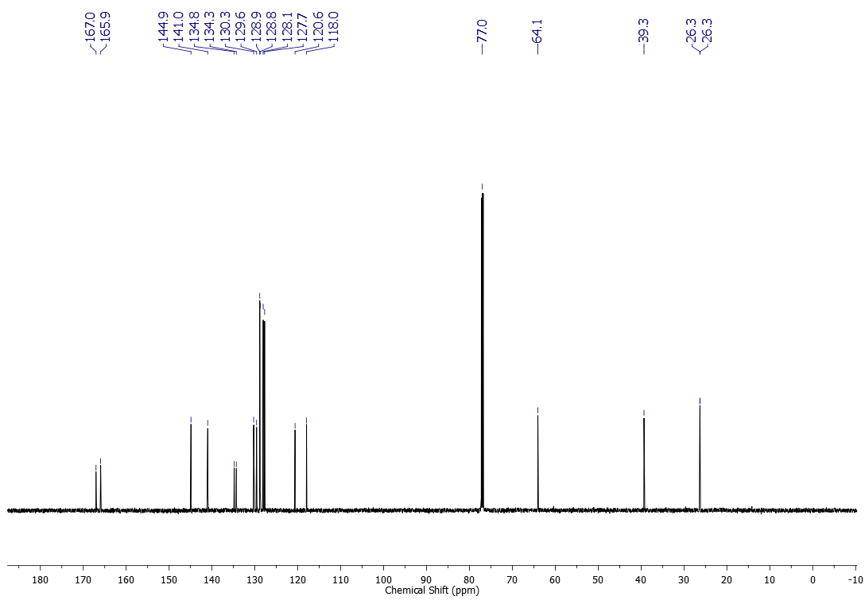
¹H NMR (600 MHz, CDCl₃) spectrum of compound 1j
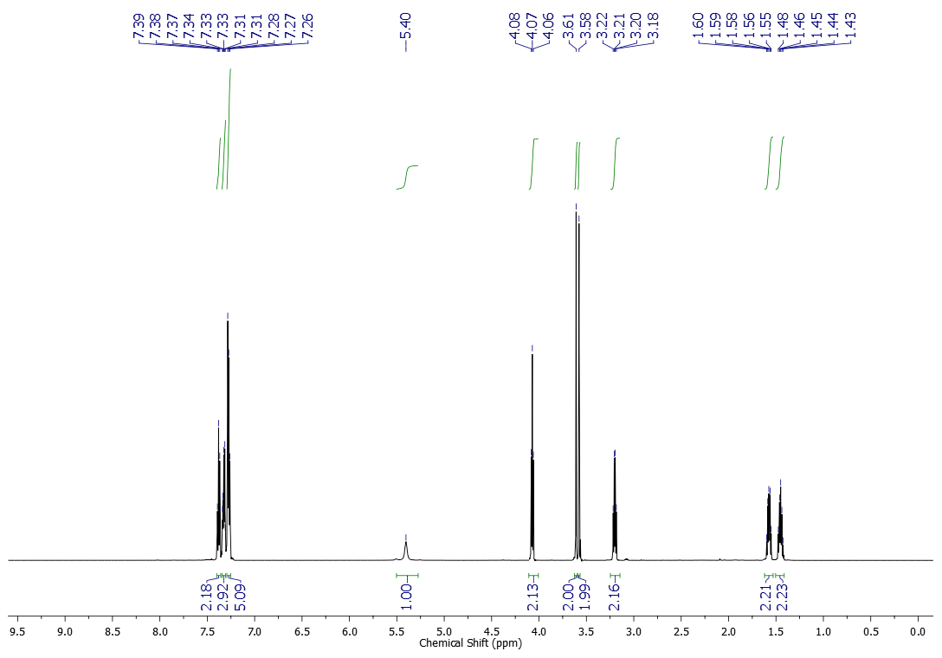
¹³C NMR (151 MHz, CDCl₃) spectrum of compound 1j
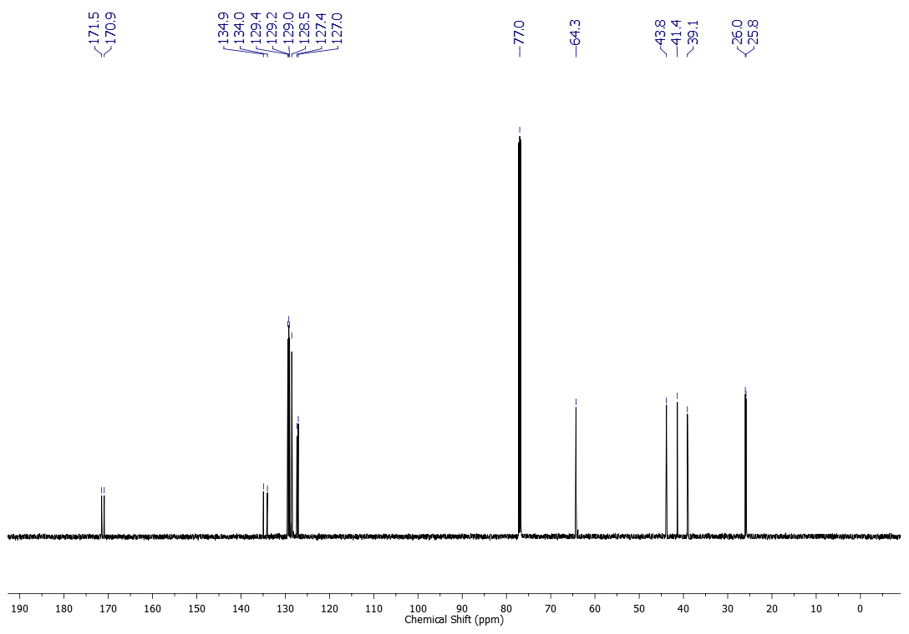
¹H NMR (600 MHz, CDCl₃) spectrum of compound 1k
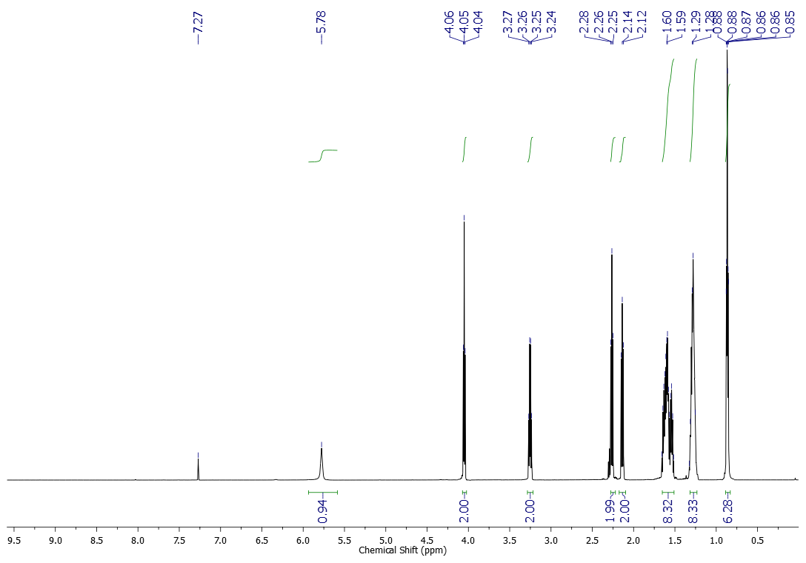
¹³C NMR (151 MHz, CDCl₃) spectrum of compound 1k
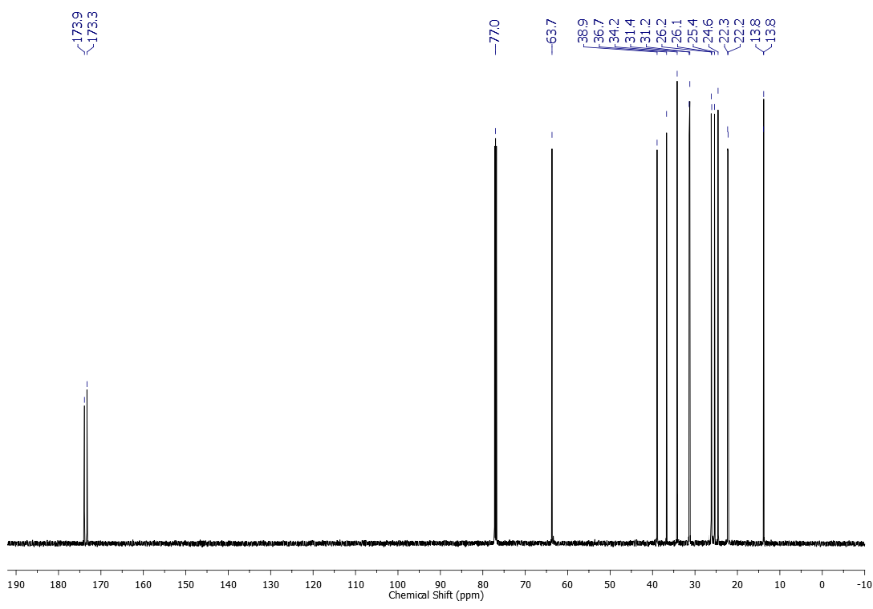
¹H NMR (600 MHz, CDCl₃) spectrum of compound 1l
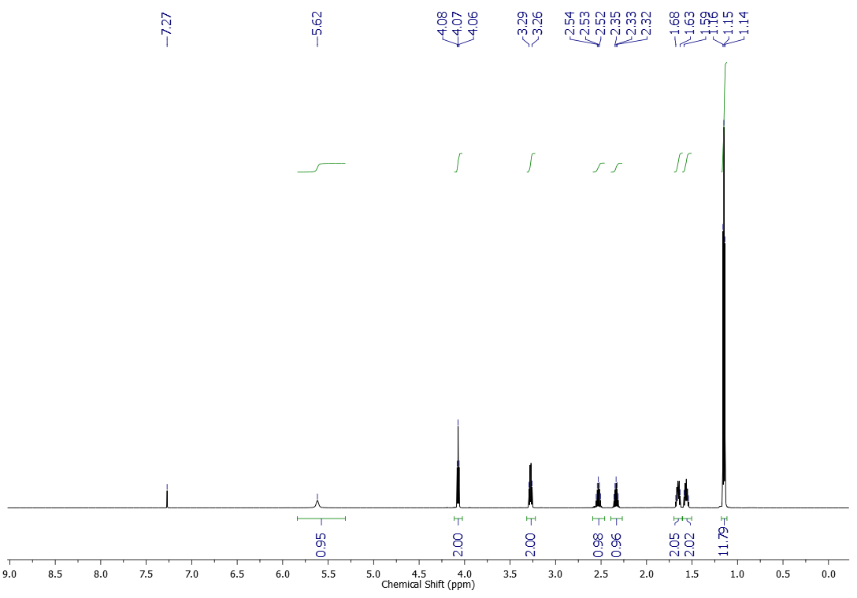
¹³C NMR (151 MHz, CDCl₃) spectrum of compound 1l
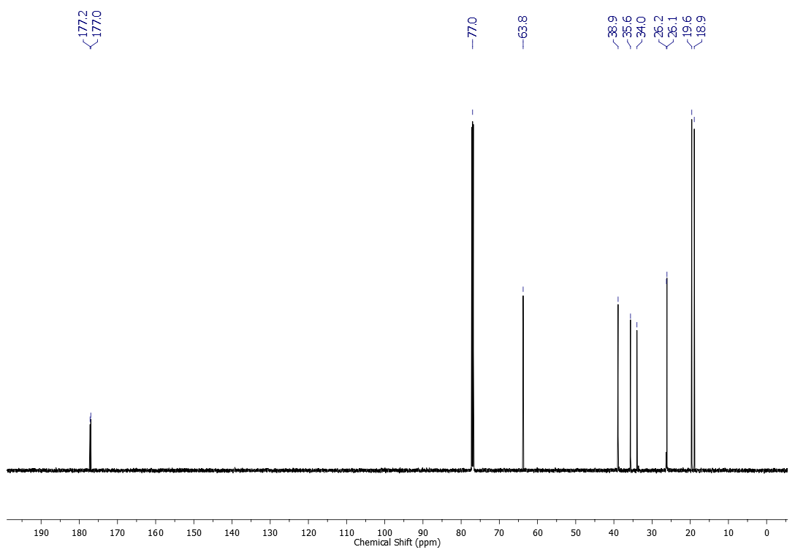

¹H NMR (600 MHz, CDCl₃) spectrum of compound 1m
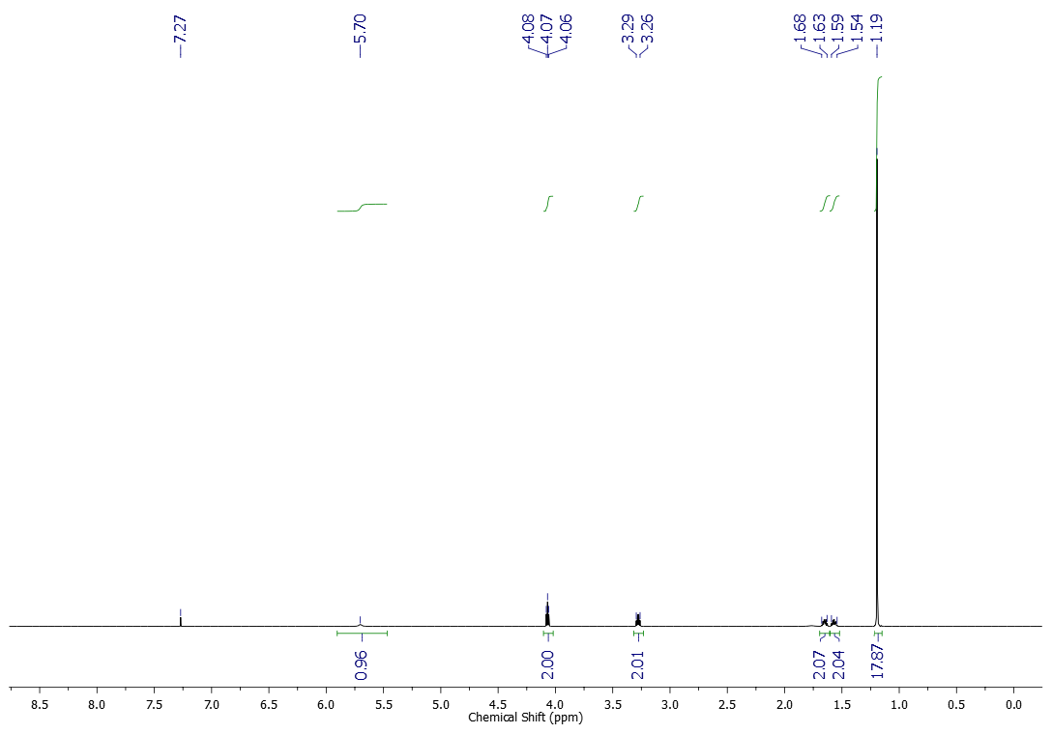
¹³C NMR (151 MHz, CDCl₃) spectrum of compound 1m
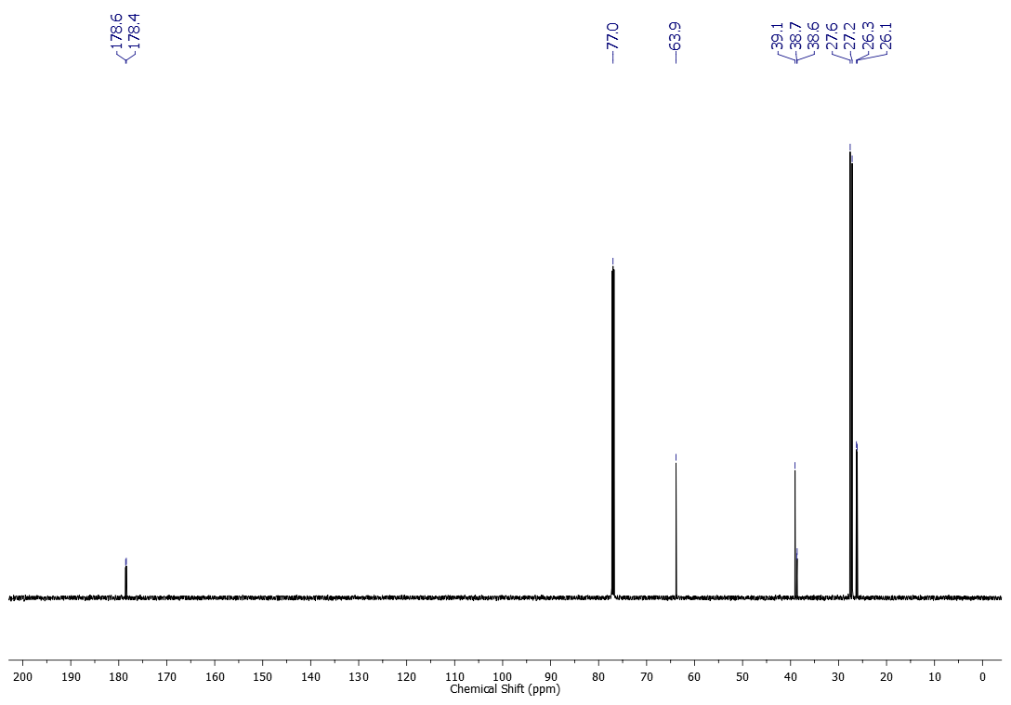
¹H NMR (600 MHz, CDCl₃) spectrum of compound 2a
¹³C NMR (151 MHz, CDCl₃) spectrum of compound 2a
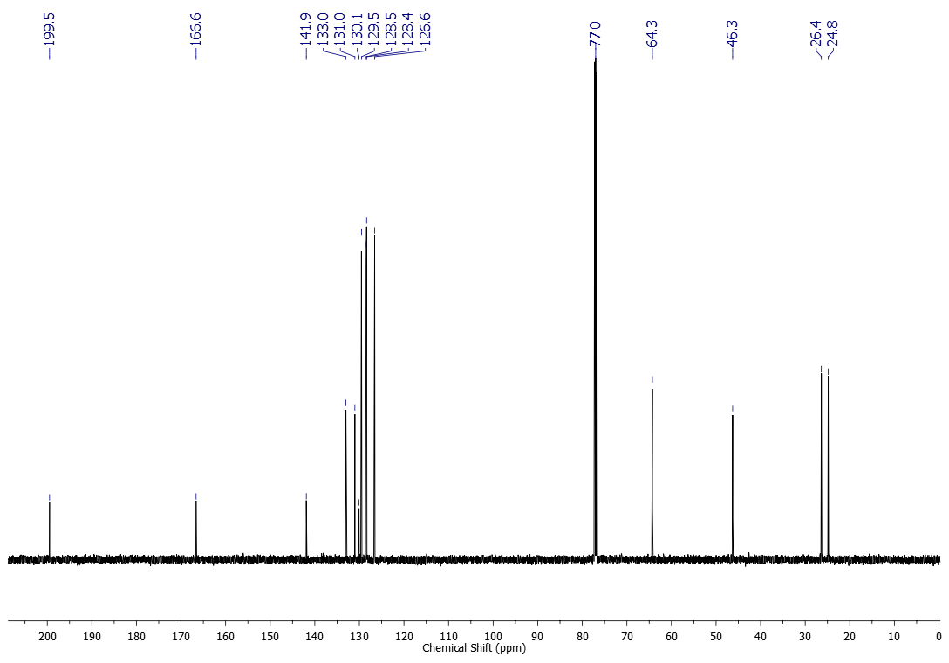
¹H NMR (500 MHz, CDCl₃) spectrum of compound 2b
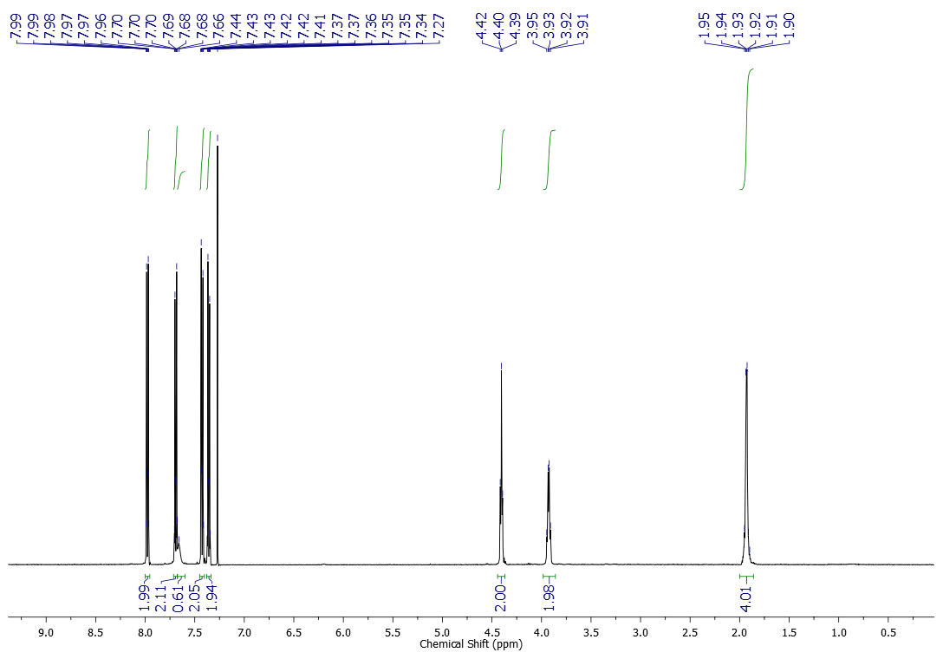
¹³C NMR (125 MHz, CDCl₃) spectrum of compound 2b
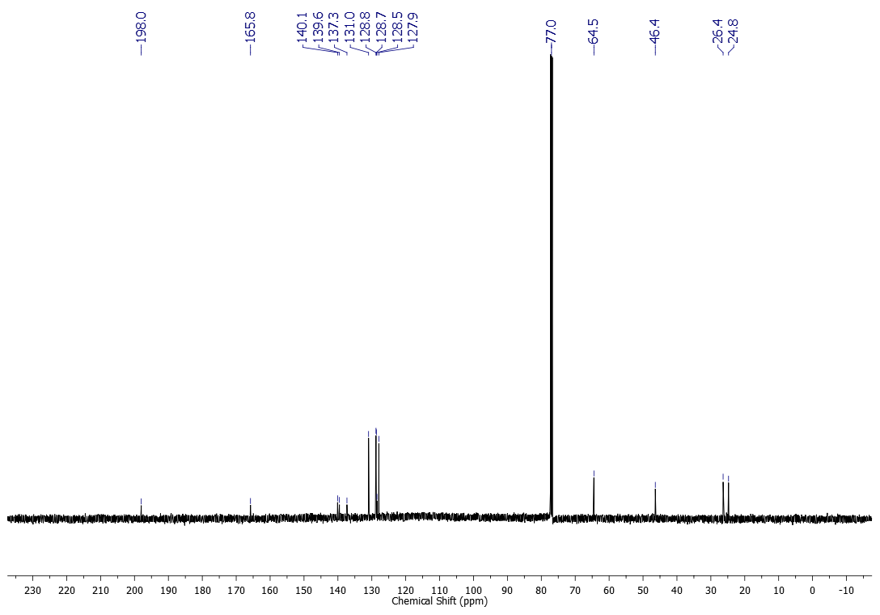
¹H NMR (500 MHz, CDCl₃) spectrum of compound 2c
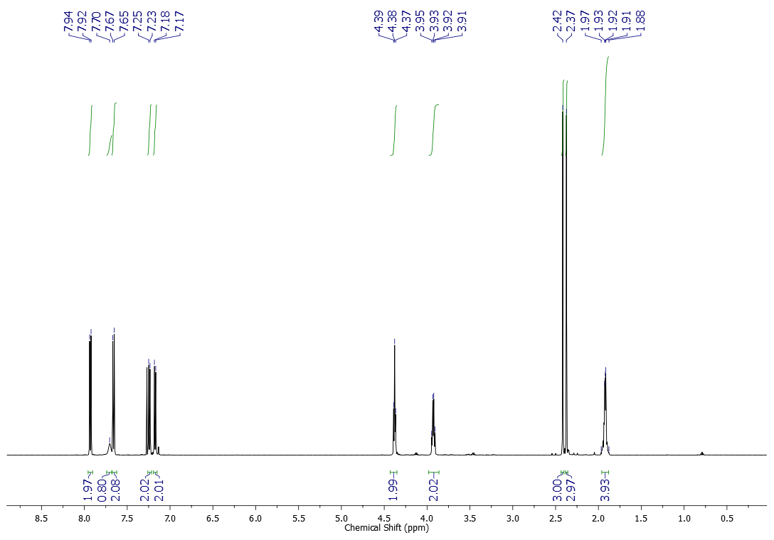
¹³C NMR (125 MHz, CDCl₃) spectrum of compound 2c
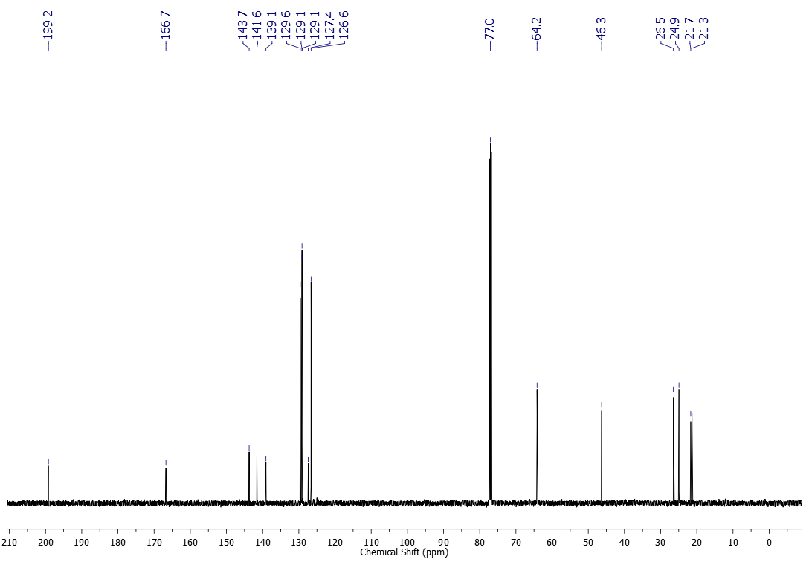
¹H NMR (500 MHz, CDCl₃) spectrum of compound 2d
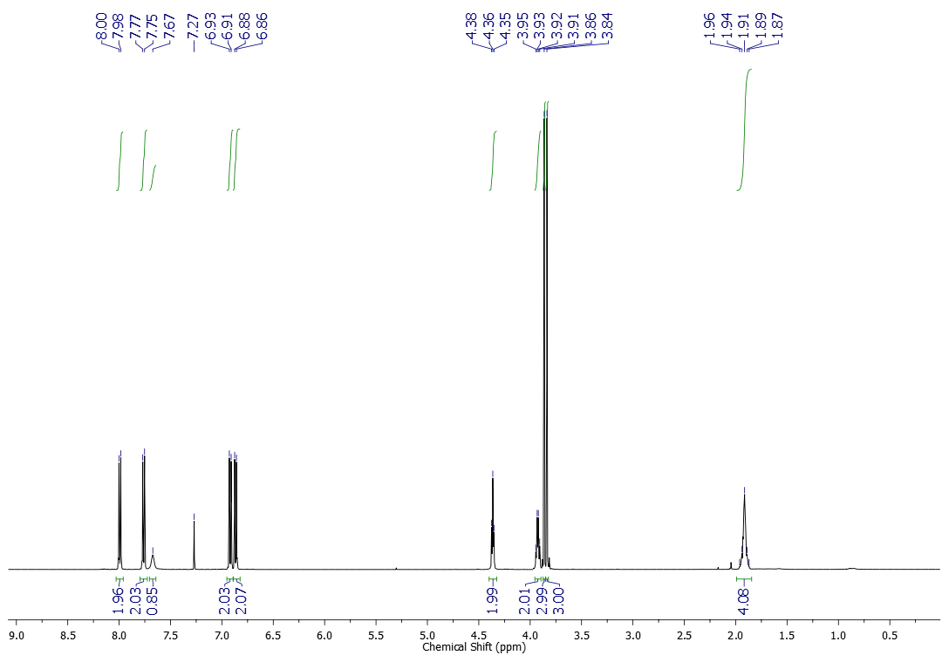
¹³C NMR (125 MHz, CDCl₃) spectrum of compound 2d
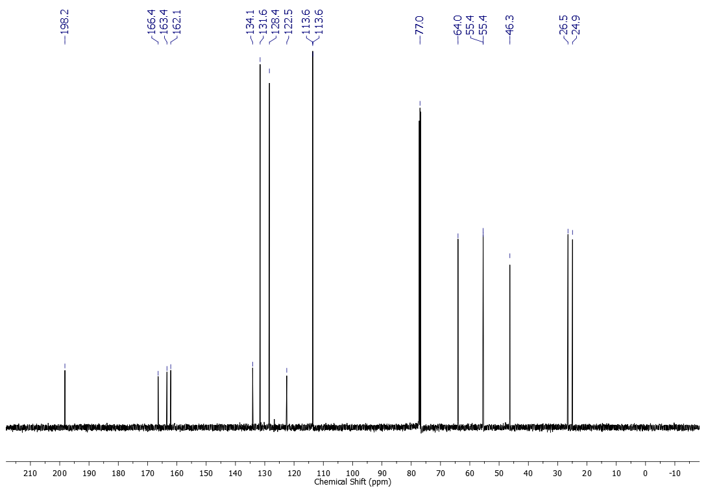
¹H NMR (600 MHz, CDCl₃) spectrum of compound 2e
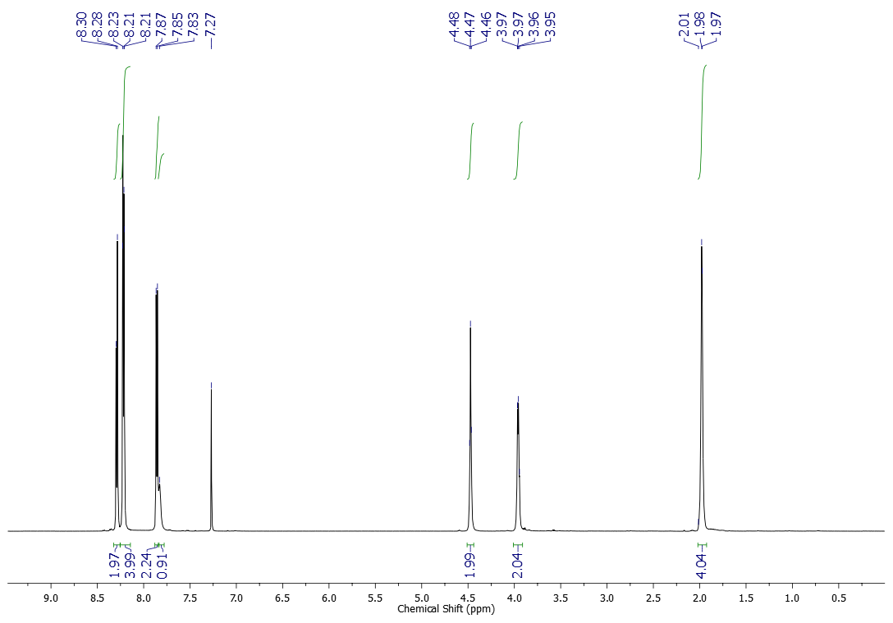
¹³C NMR (151 MHz, CDCl₃) spectrum of compound 2e
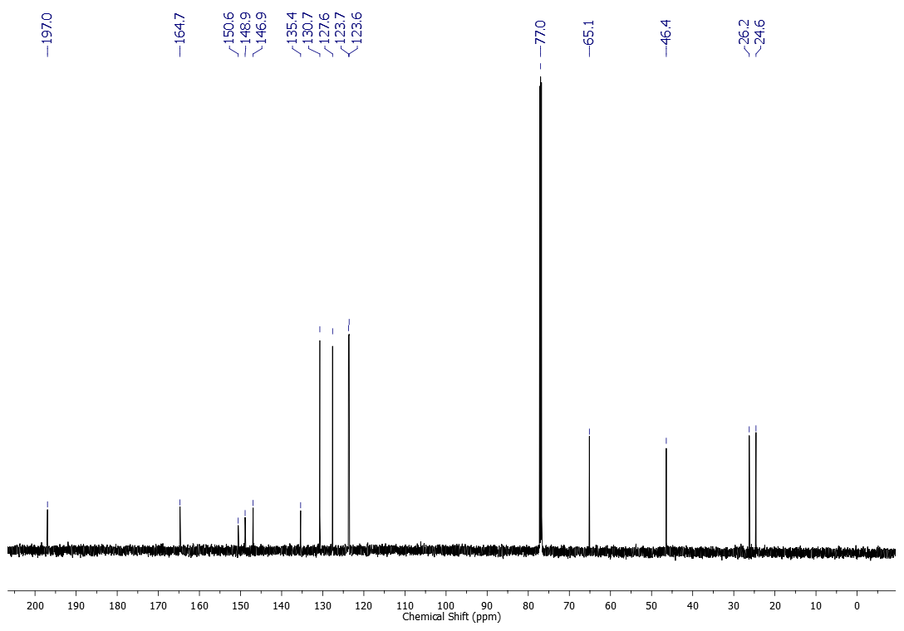
¹H NMR (600 MHz, CDCl₃) spectrum of compound 2f
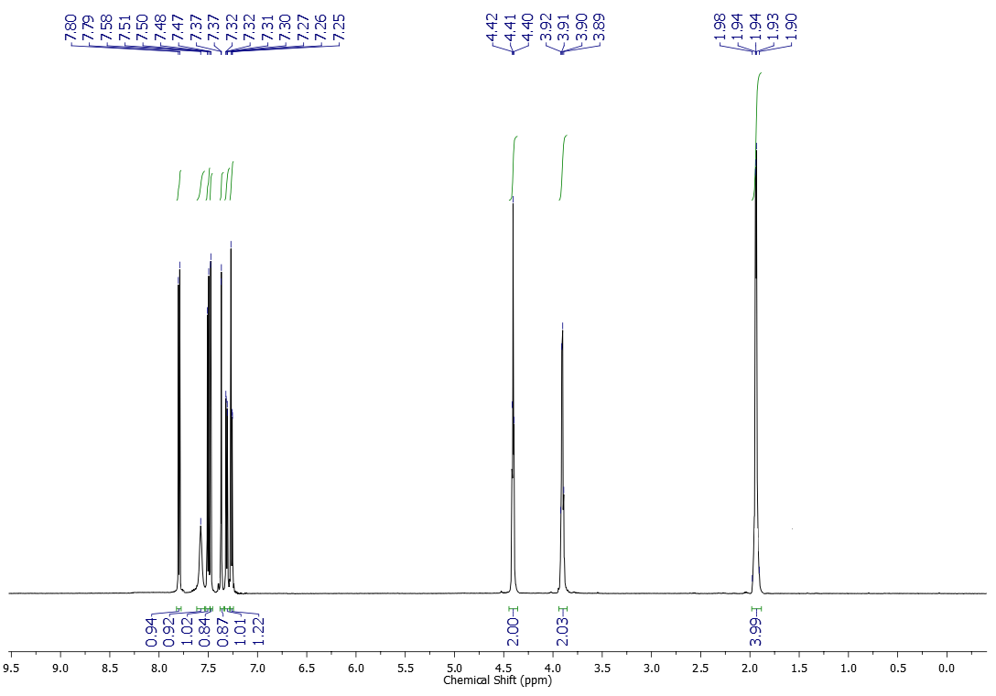
¹³C NMR (151 MHz, CDCl₃) spectrum of compound 2f
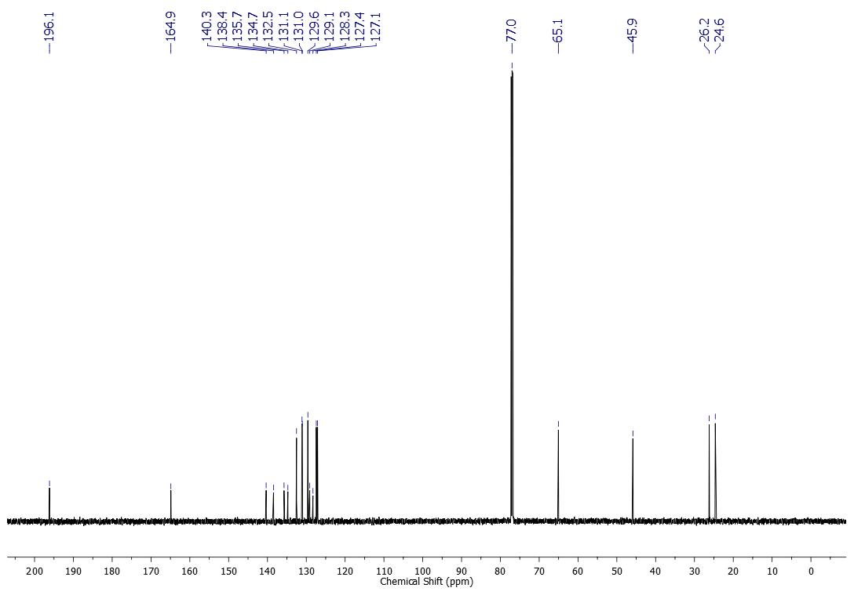
¹H NMR (500 MHz, CDCl₃) spectrum of compound 2g
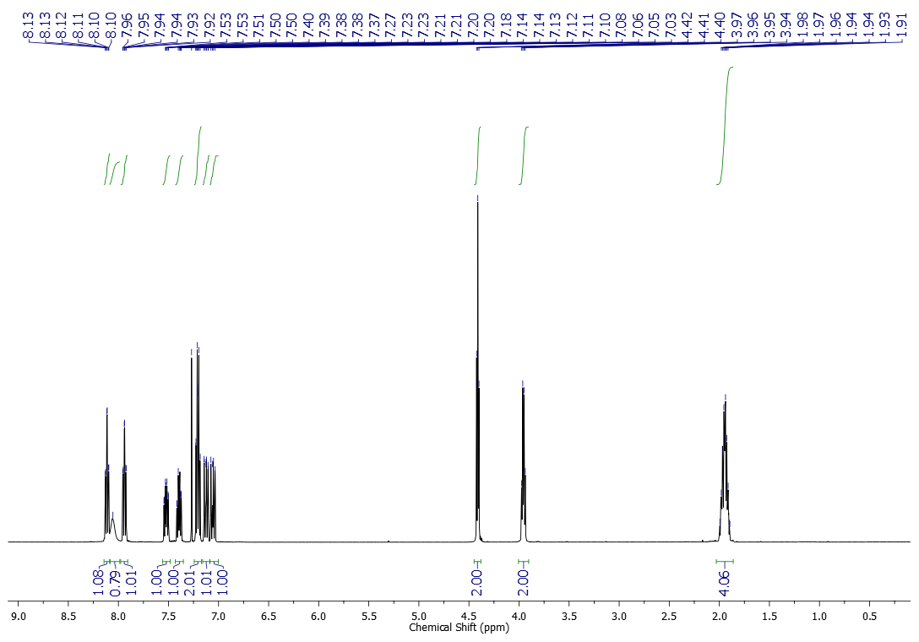
¹³C NMR (125 MHz, CDCl₃) spectrum of compound 2g
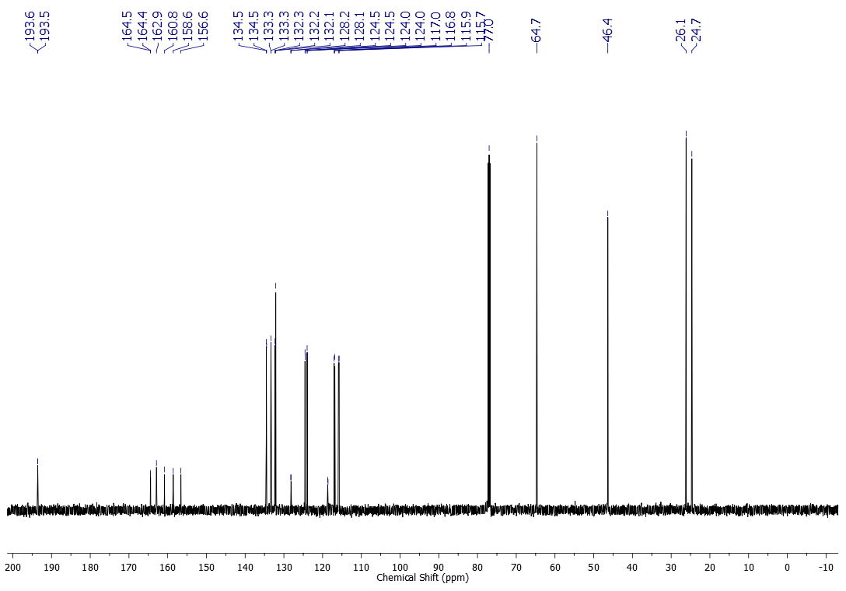
¹H NMR (500 MHz, CDCl₃) spectrum of compound 2h
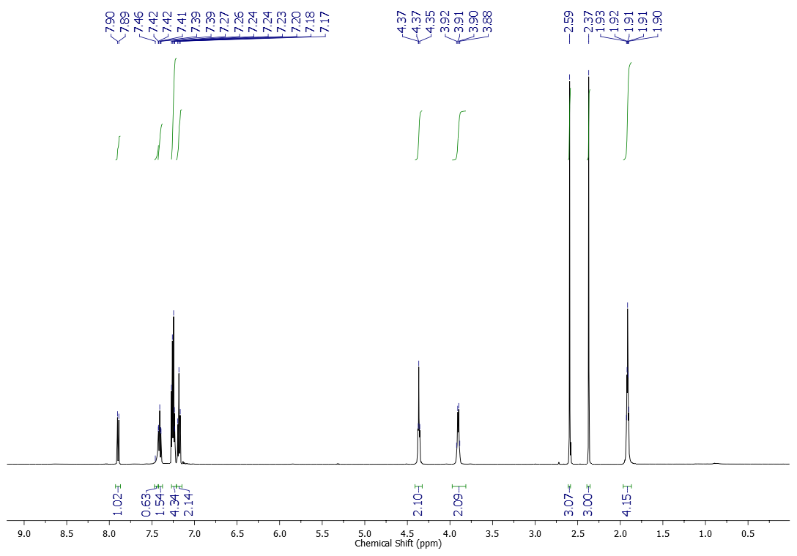
¹³C NMR (125 MHz, CDCl₃) spectrum of compound 2h
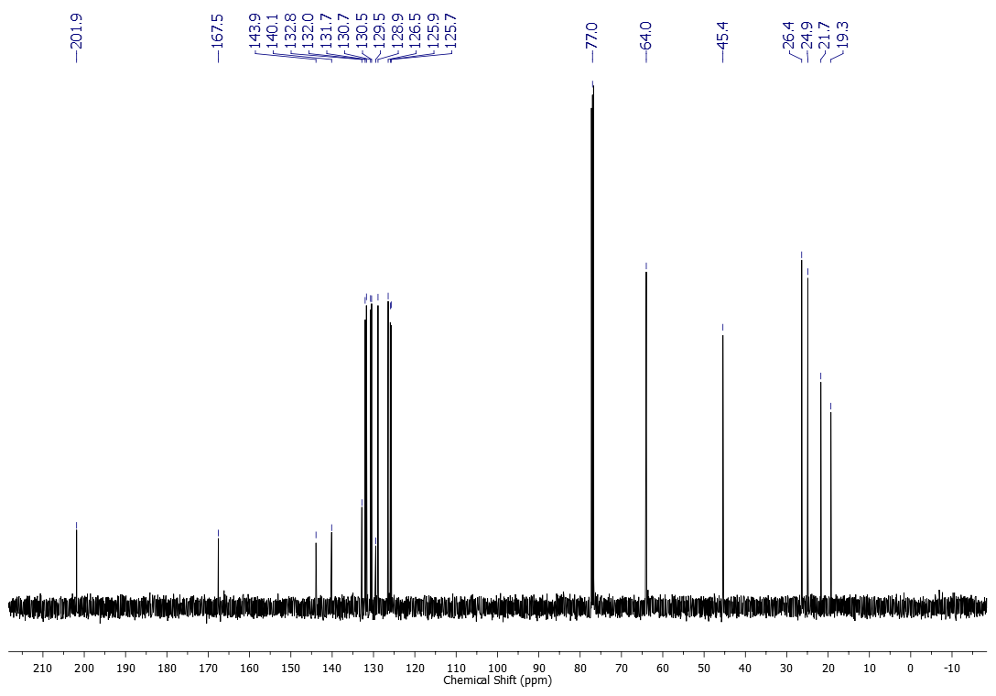
¹H NMR (600 MHz, CDCl₃) spectrum of compound 2i
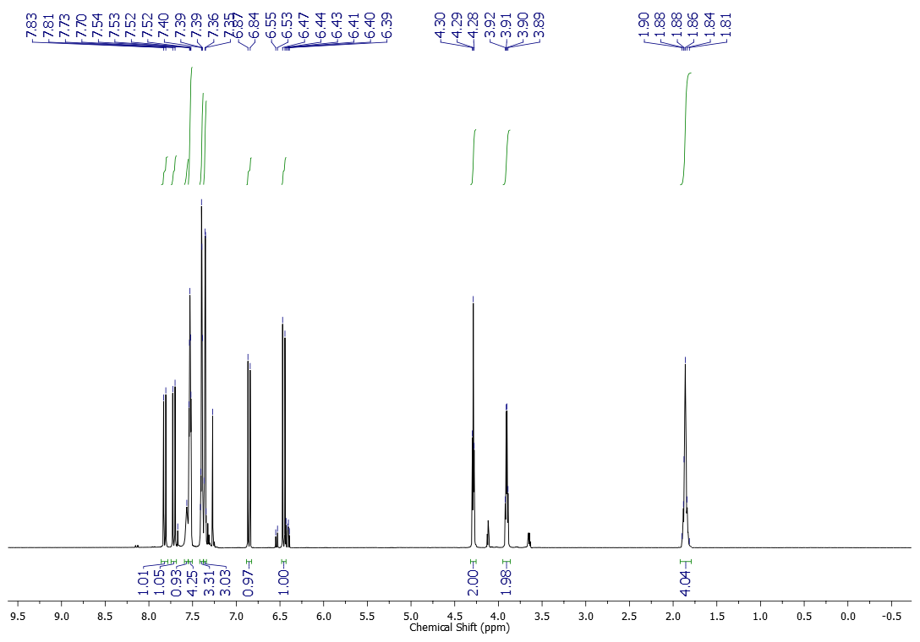
¹³C NMR (151 MHz, CDCl₃) spectrum of compound 2i
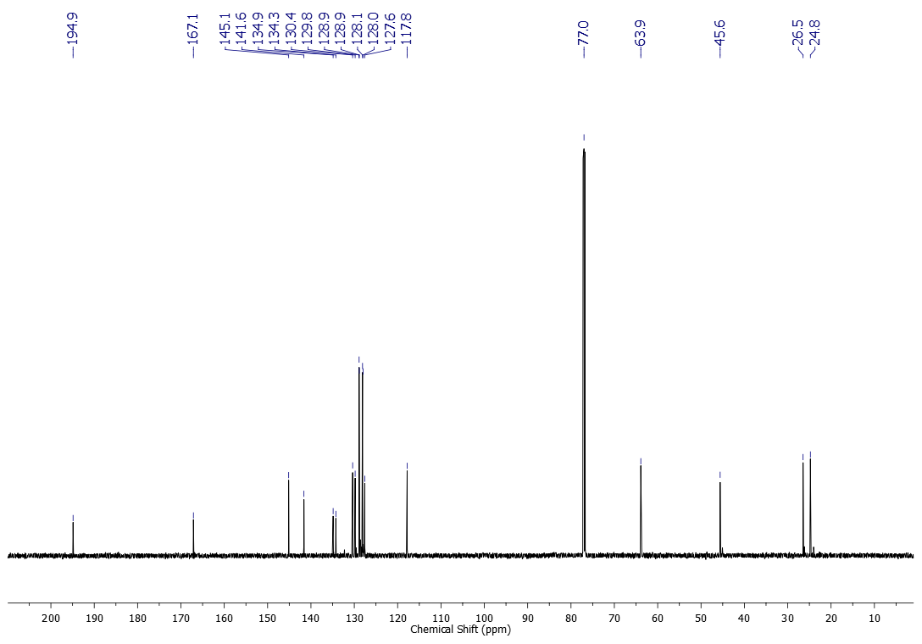
¹H NMR (600 MHz, CDCl₃) spectrum of compound 2j
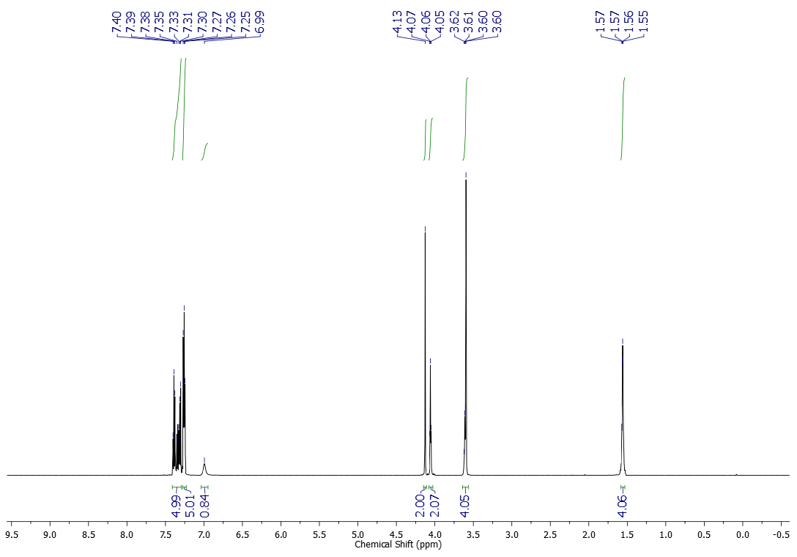
¹³C NMR (151 MHz, CDCl₃) spectrum of compound 2j
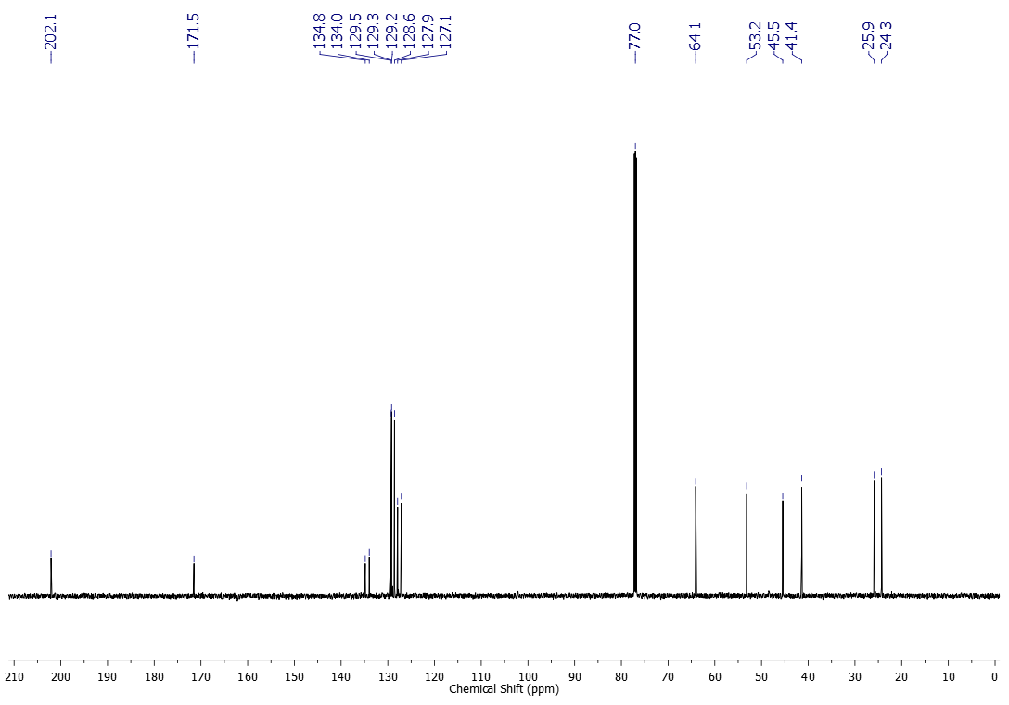
¹H NMR (600 MHz, CDCl₃) spectrum of compound 2k
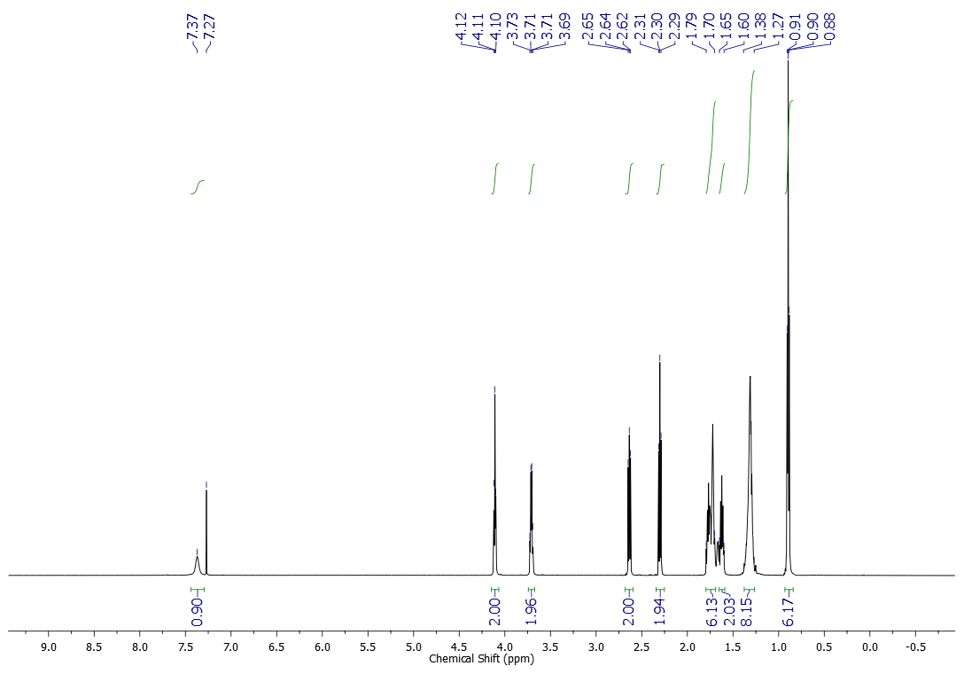
¹³C NMR (151 MHz, CDCl₃) spectrum of compound 2k
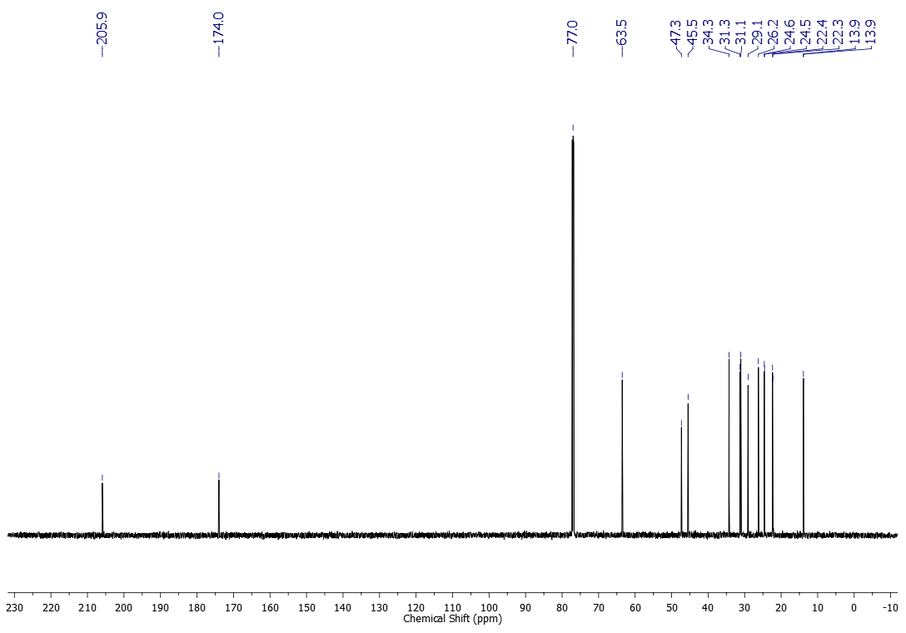
¹H NMR (600 MHz, CDCl₃) spectrum of compound 2l
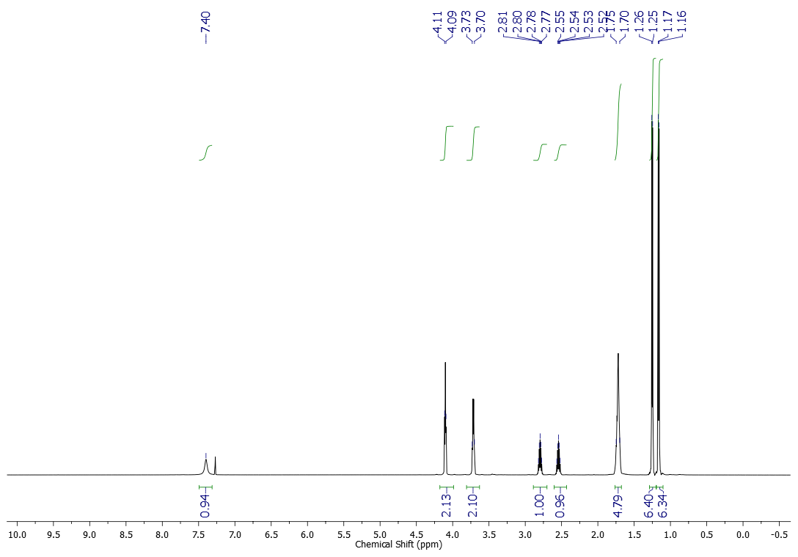
¹³C NMR (151 MHz, CDCl₃) spectrum of compound 2l
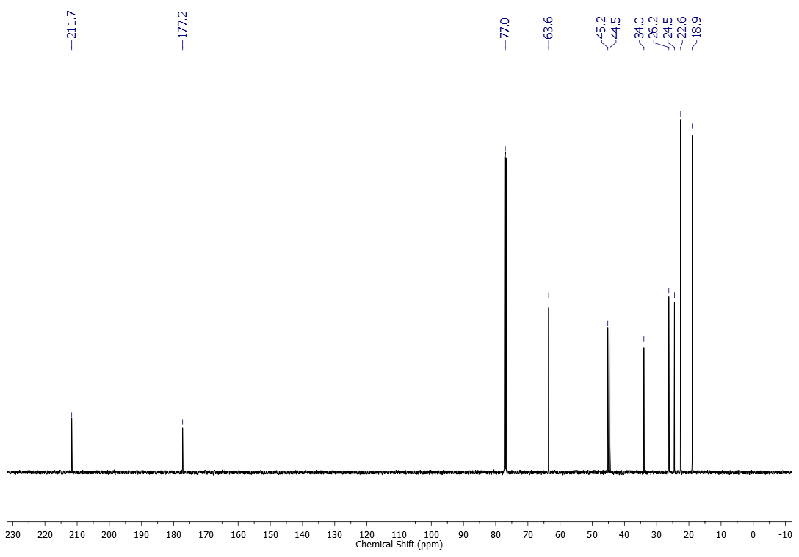
¹H NMR (600 MHz, CDCl₃) spectrum of compound 2m
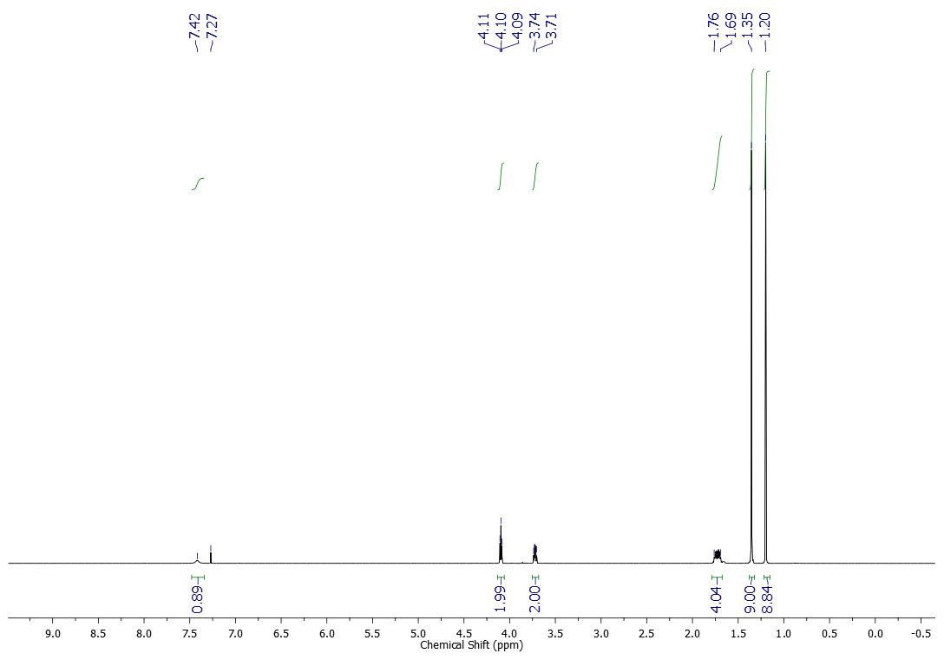
¹³C NMR (151 MHz, CDCl₃) spectrum of compound 2m
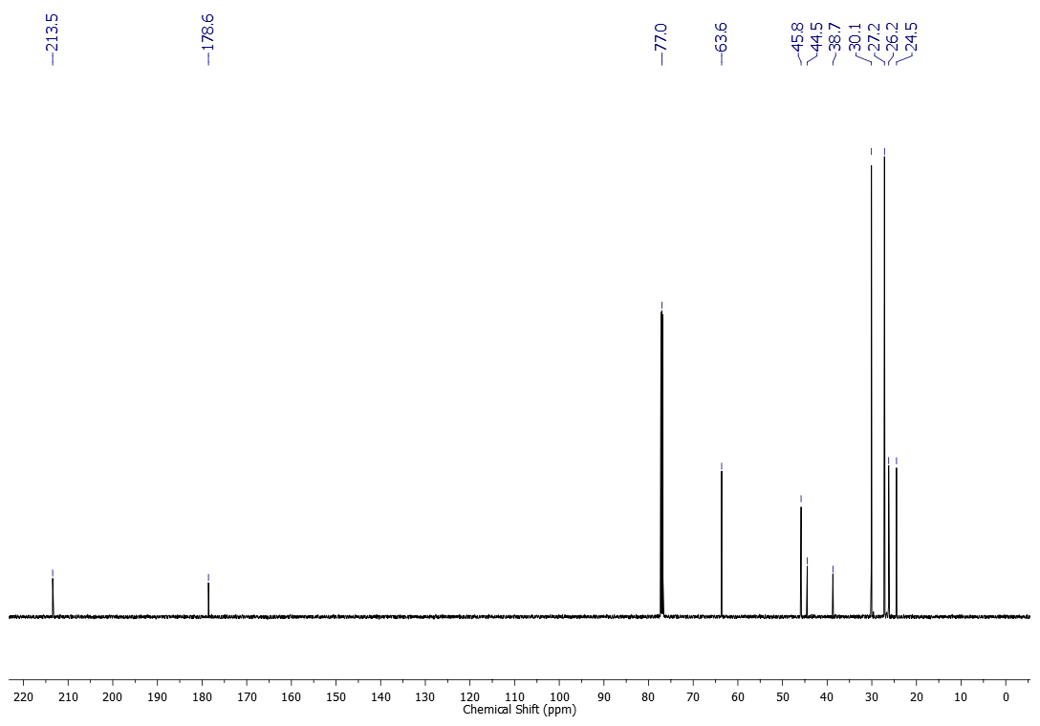
¹H NMR (600 MHz, CDCl₃) spectrum of compound 3a
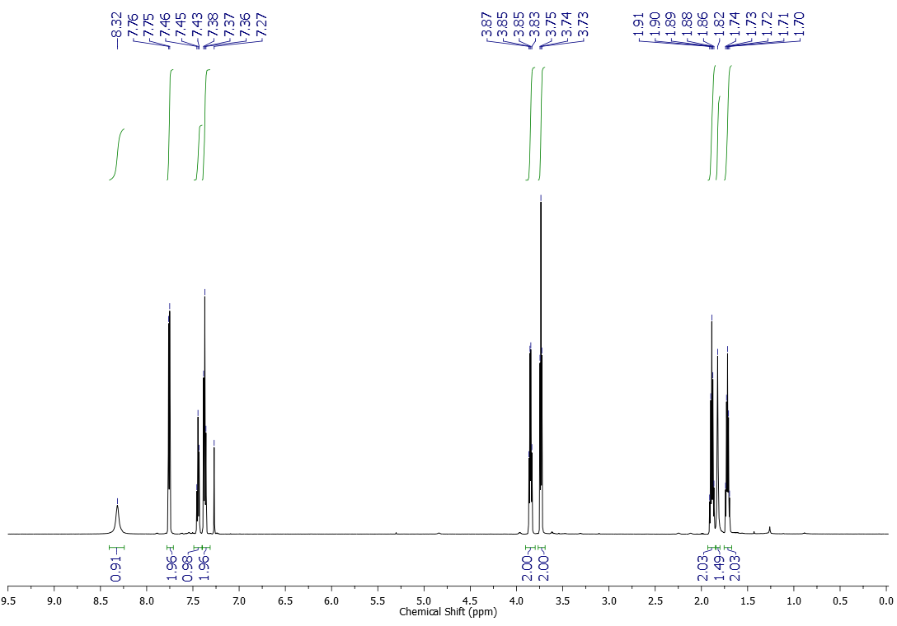
¹H NMR (500 MHz, CDCl₃) spectrum of compound 3b
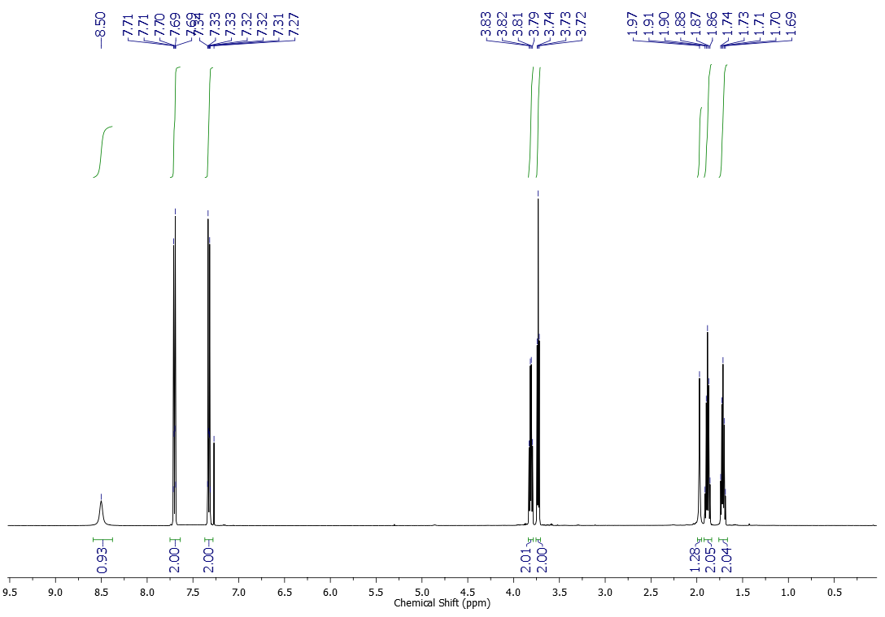
¹³C NMR (125 MHz, CDCl₃) spectrum of compound 3b
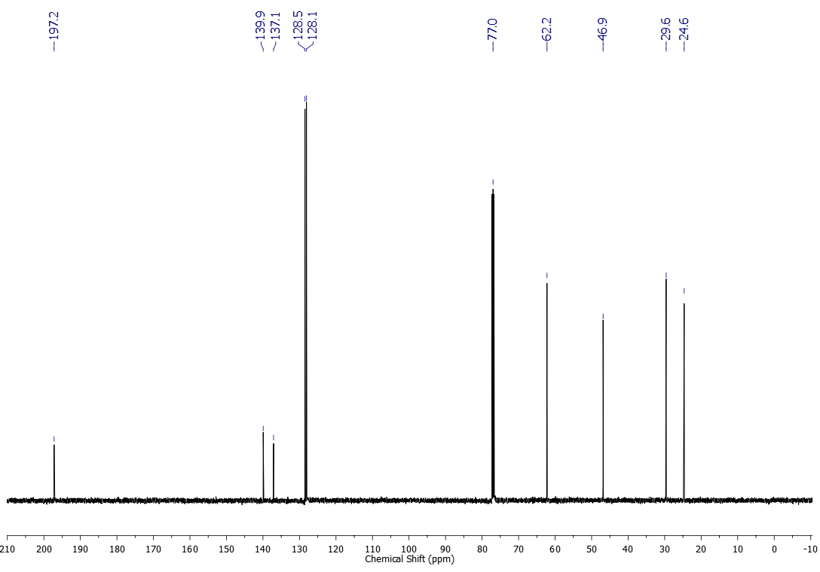
¹H NMR (500 MHz, CDCl₃) spectrum of compound 3c
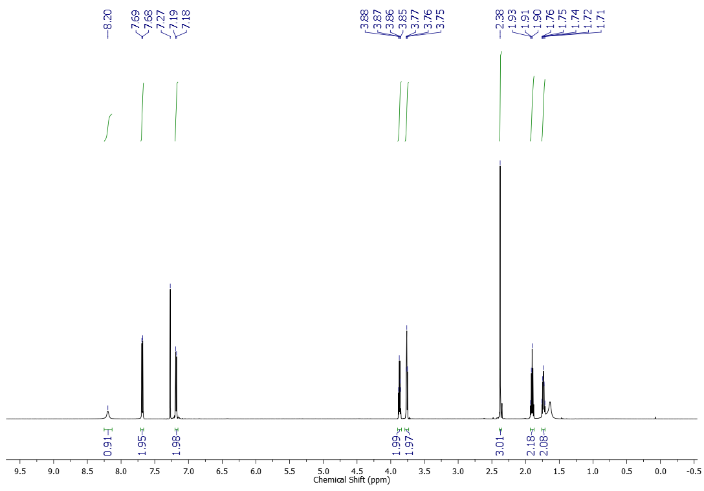
¹³C NMR (125 MHz, CDCl₃) spectrum of compound 3c
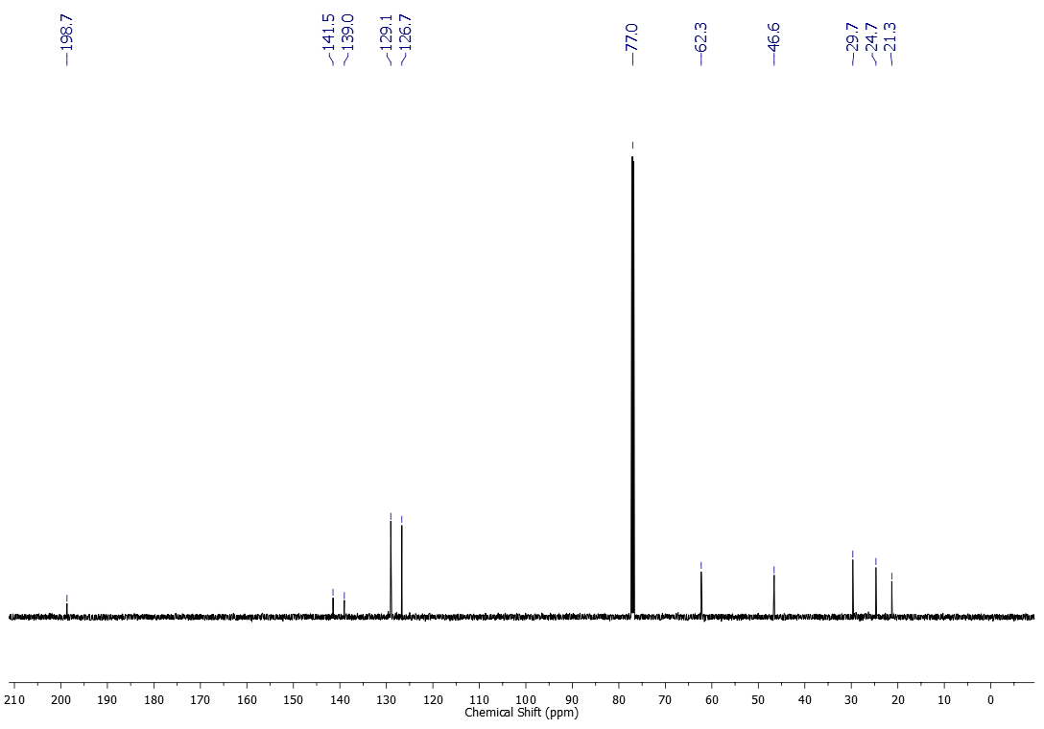
¹H NMR (500 MHz, CDCl₃) spectrum of compound 3d
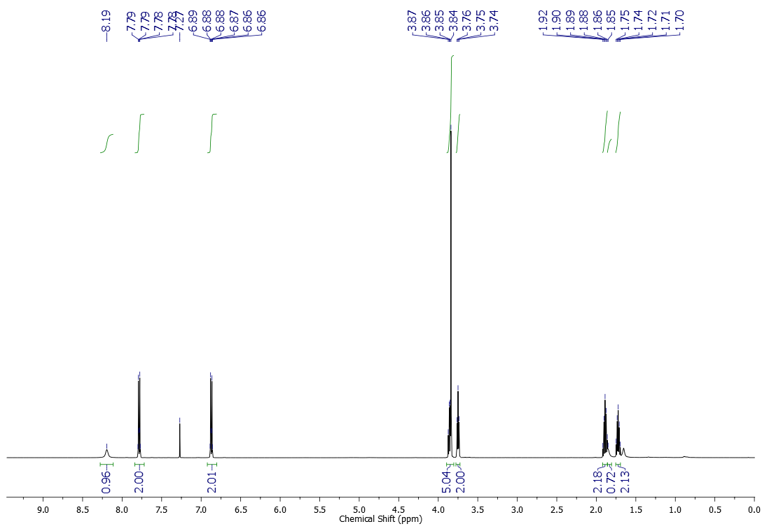
¹³C NMR (125 MHz, CDCl₃) spectrum of compound 3d
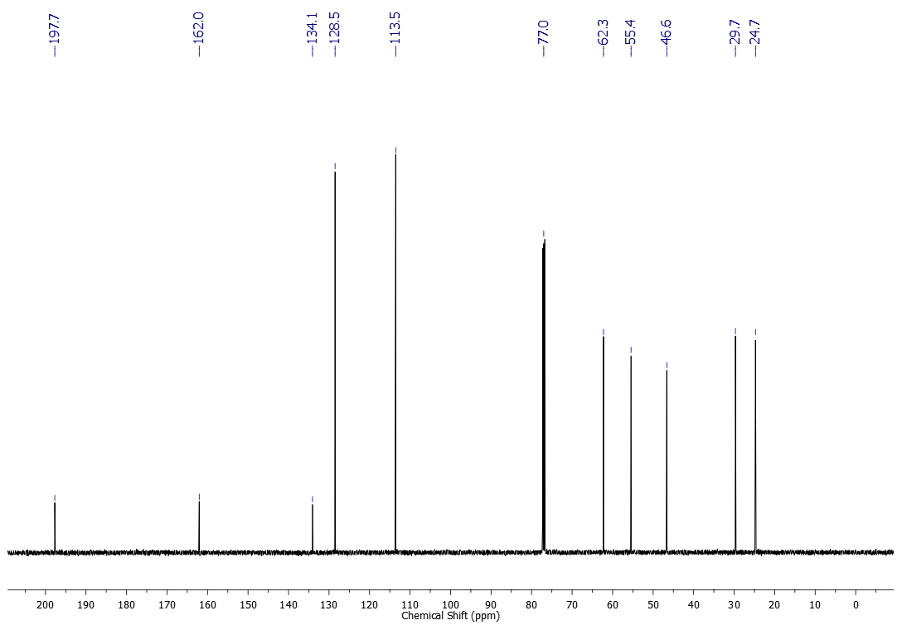
¹H NMR (500 MHz, CDCl₃) spectrum of compound 3e
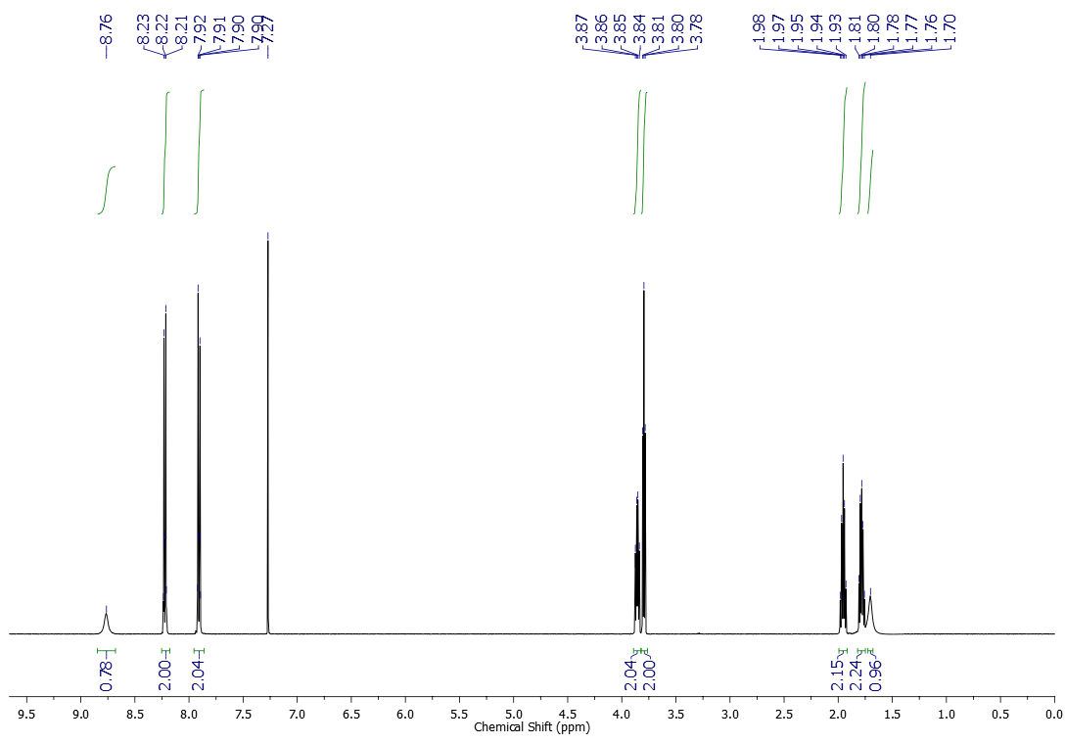
¹³C NMR (125 MHz, CDCl₃) spectrum of compound 3e
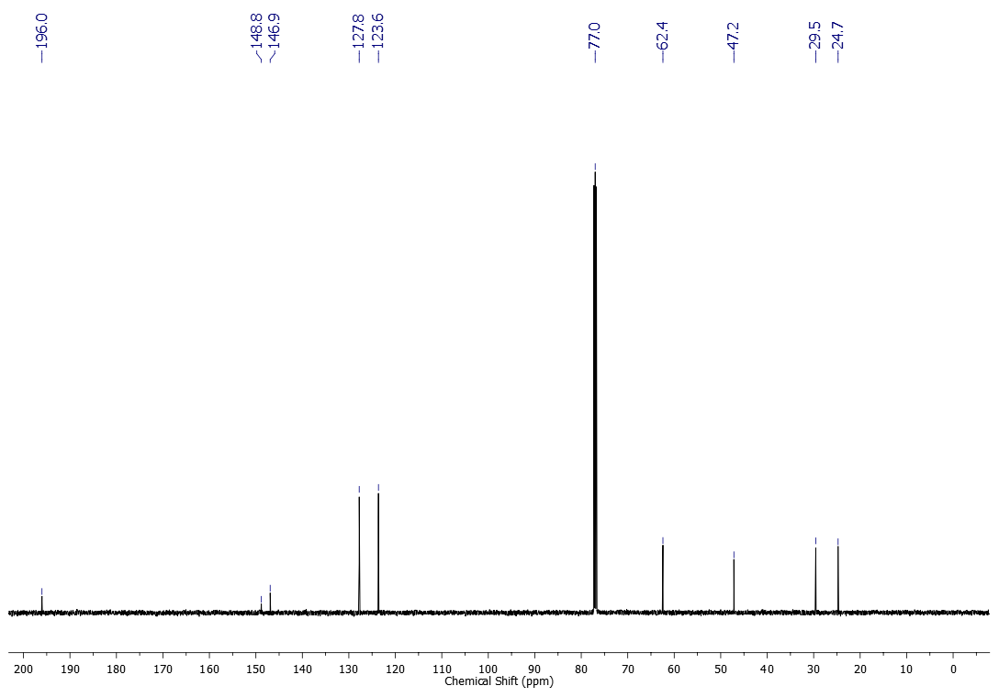
¹H NMR (600 MHz, CDCl₃) spectrum of compound 3f
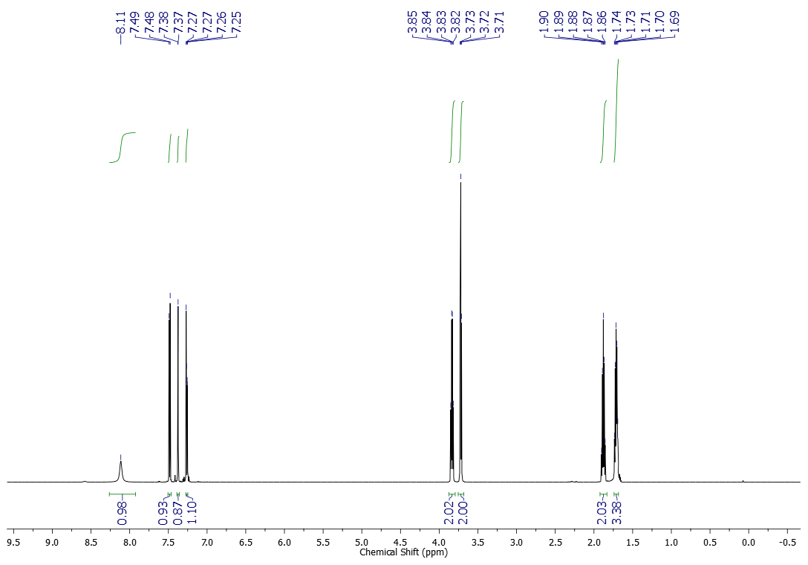
¹³C NMR (151 MHz, CDCl₃) spectrum of compound 3f
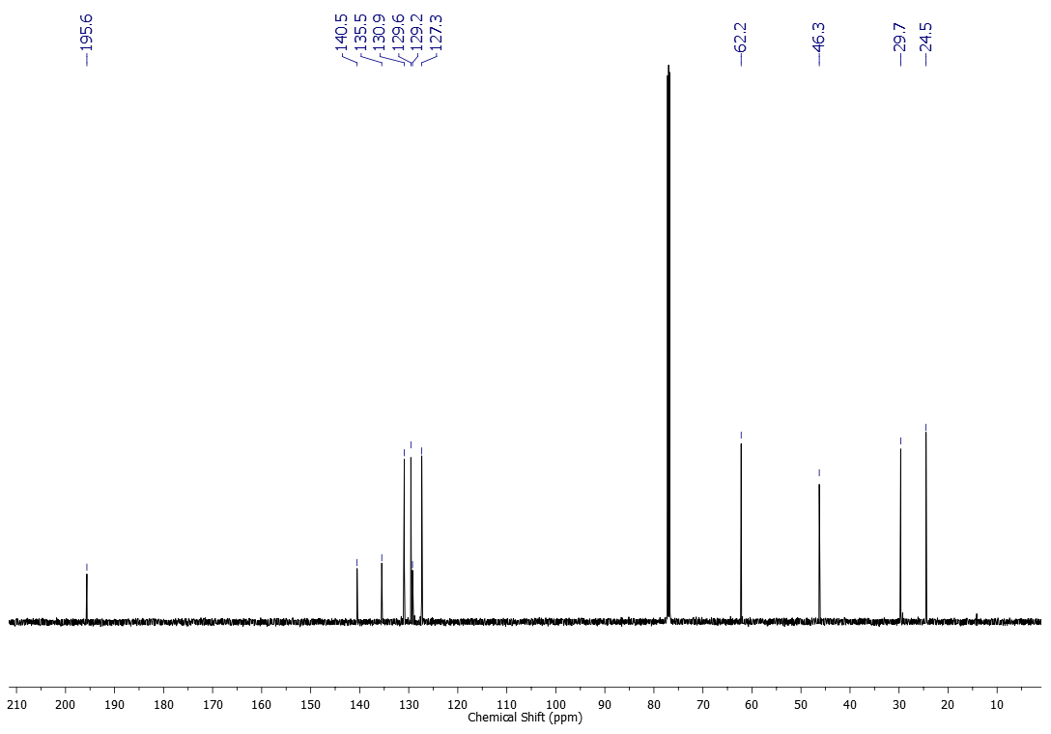
¹H NMR (500 MHz, CDCl₃) spectrum of compound 3g
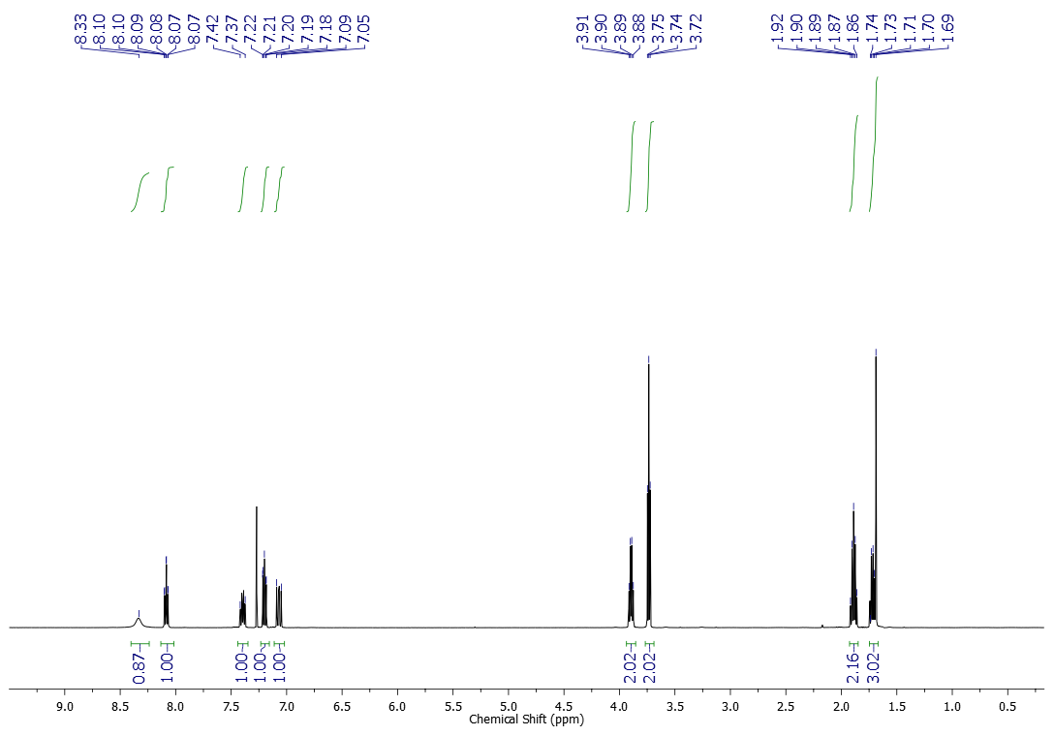
¹³C NMR (125 MHz, CDCl₃) spectrum of compound 3g
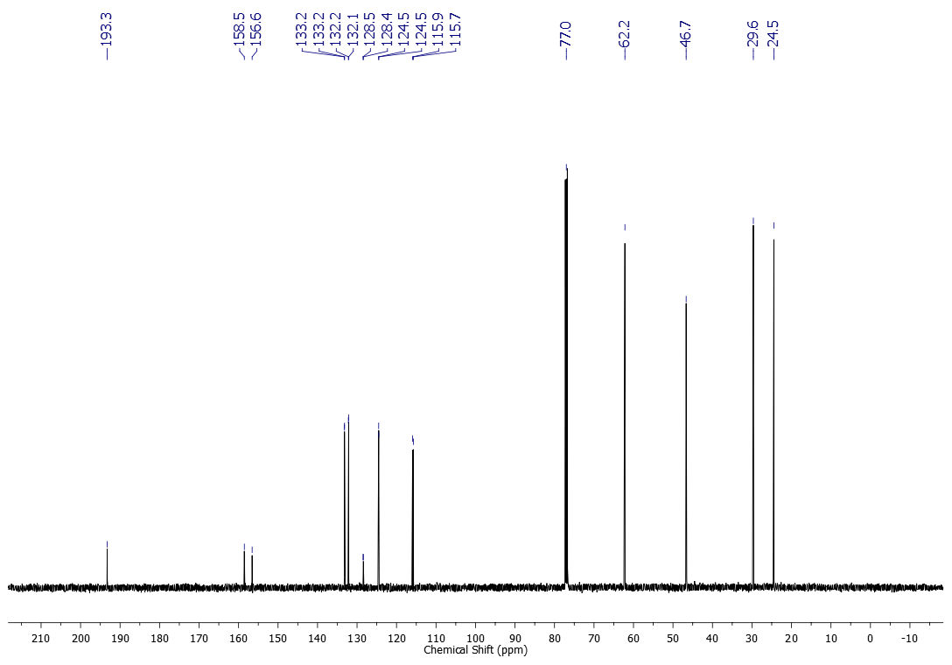
¹H NMR (500 MHz, CDCl₃) spectrum of compound 3h
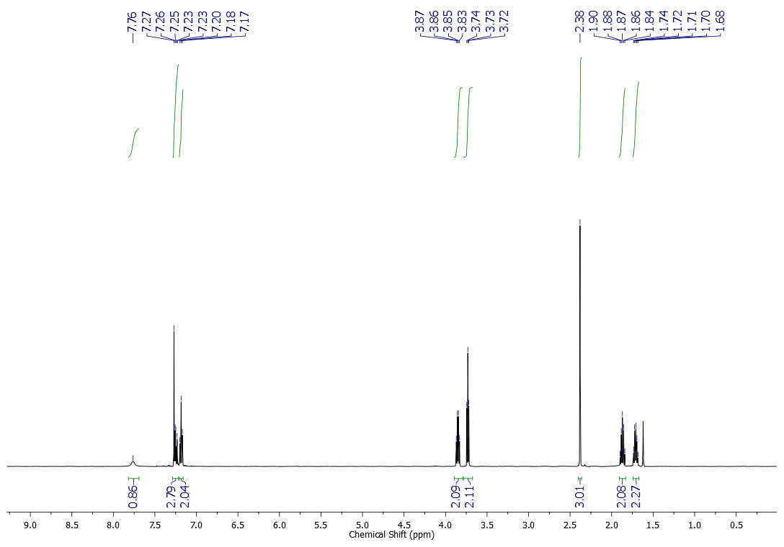
¹³C NMR (125 MHz, CDCl₃) spectrum of compound 3h
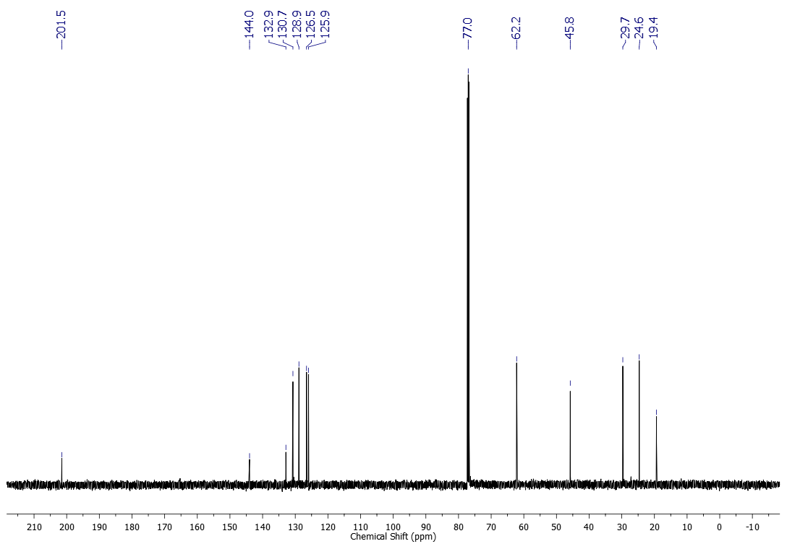
¹H NMR (600 MHz, CDCl₃) spectrum of compound 3i
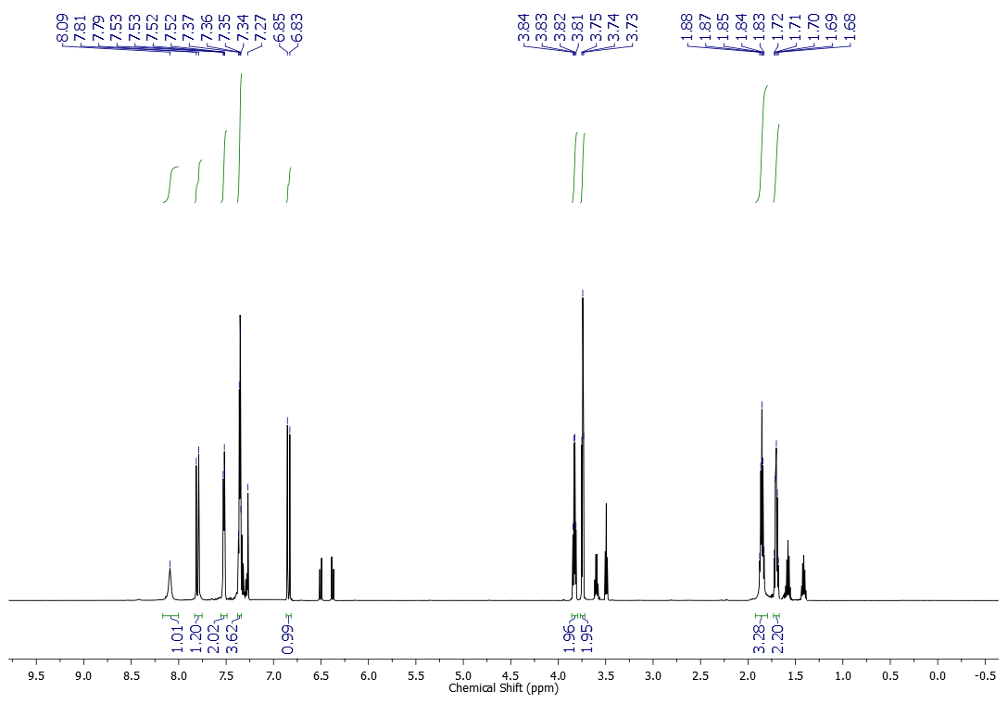
¹³C NMR (151 MHz, CDCl₃) spectrum of compound 3i
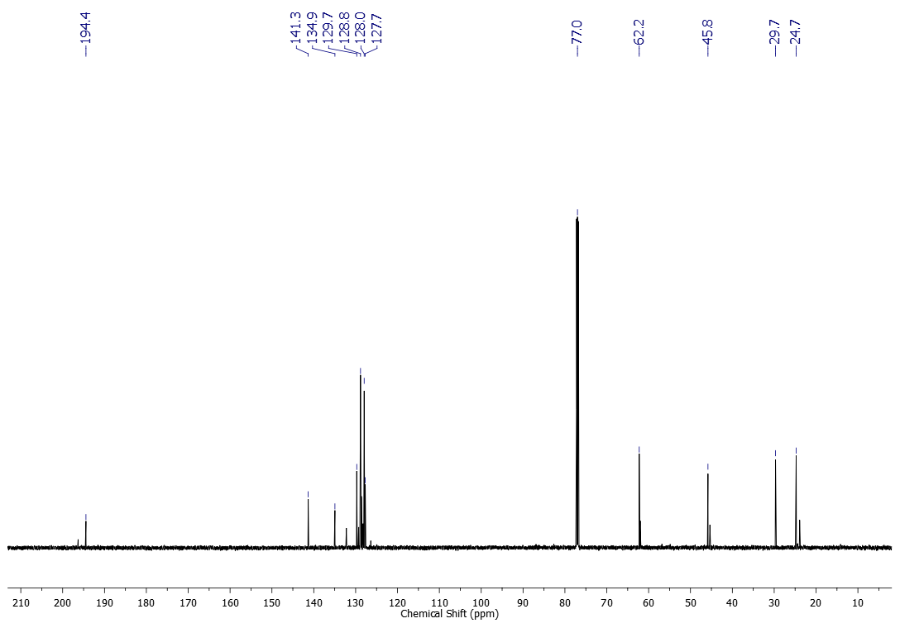
¹H NMR (600 MHz, CDCl₃) spectrum of compound 3j
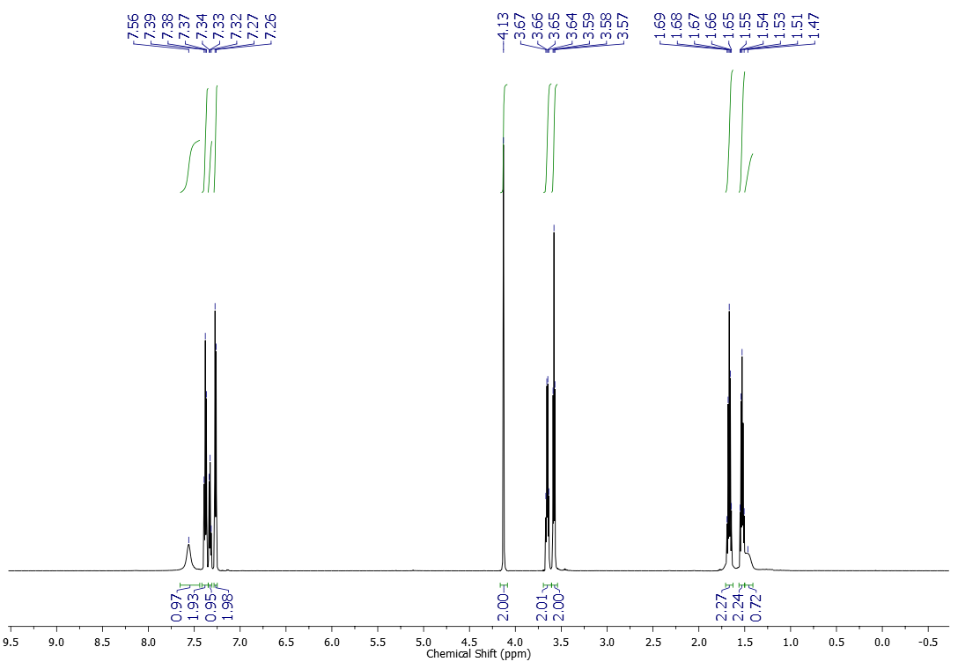
¹H NMR (600 MHz, CDCl₃) spectrum of compound 3k
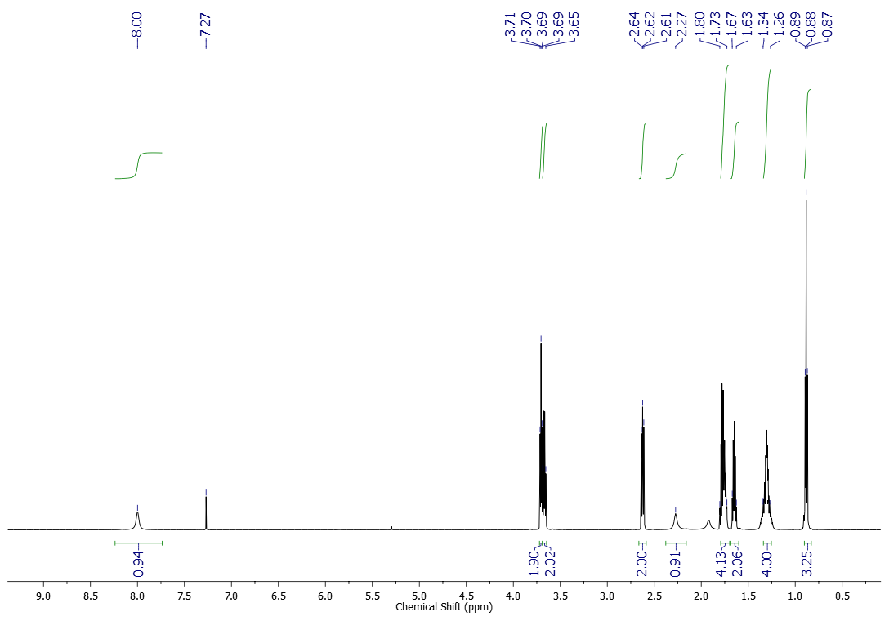
¹³C NMR (151 MHz, CDCl₃) spectrum of compound 3k
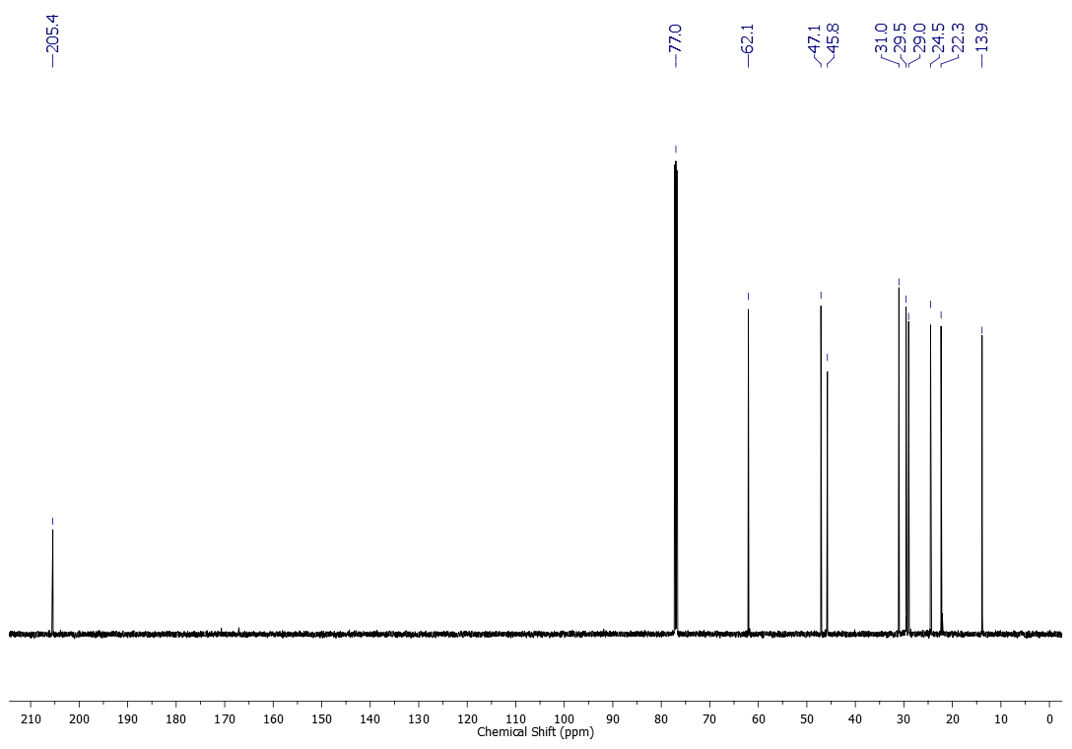
¹H NMR (600 MHz, CDCl₃) spectrum of compound 3l
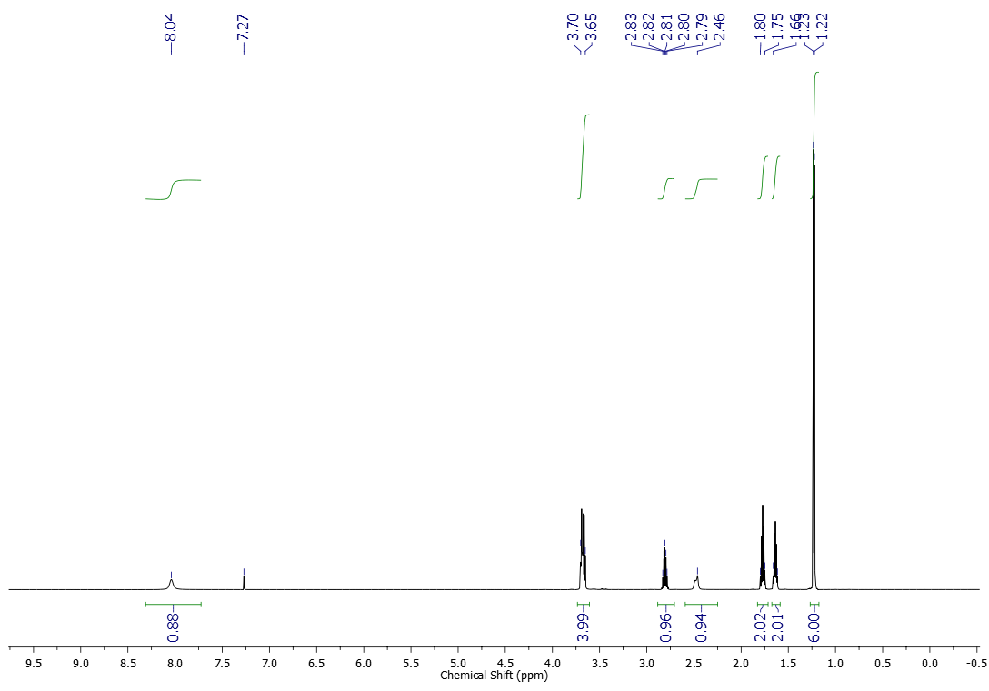
¹³C NMR (151 MHz, CDCl₃) spectrum of compound 3l
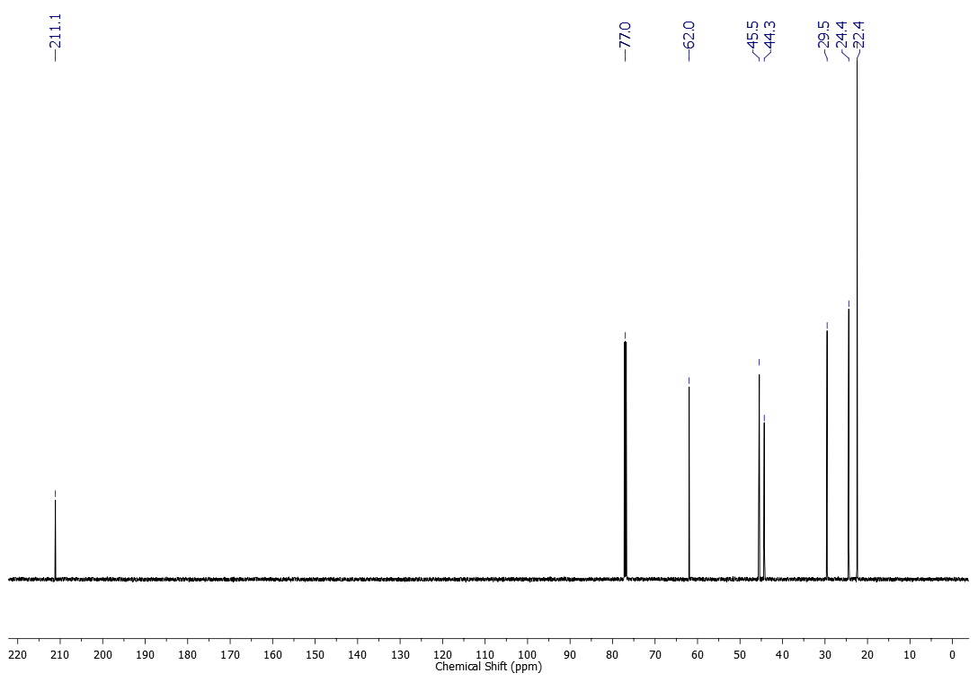
¹H NMR (600 MHz, CDCl₃) spectrum of compound 3m
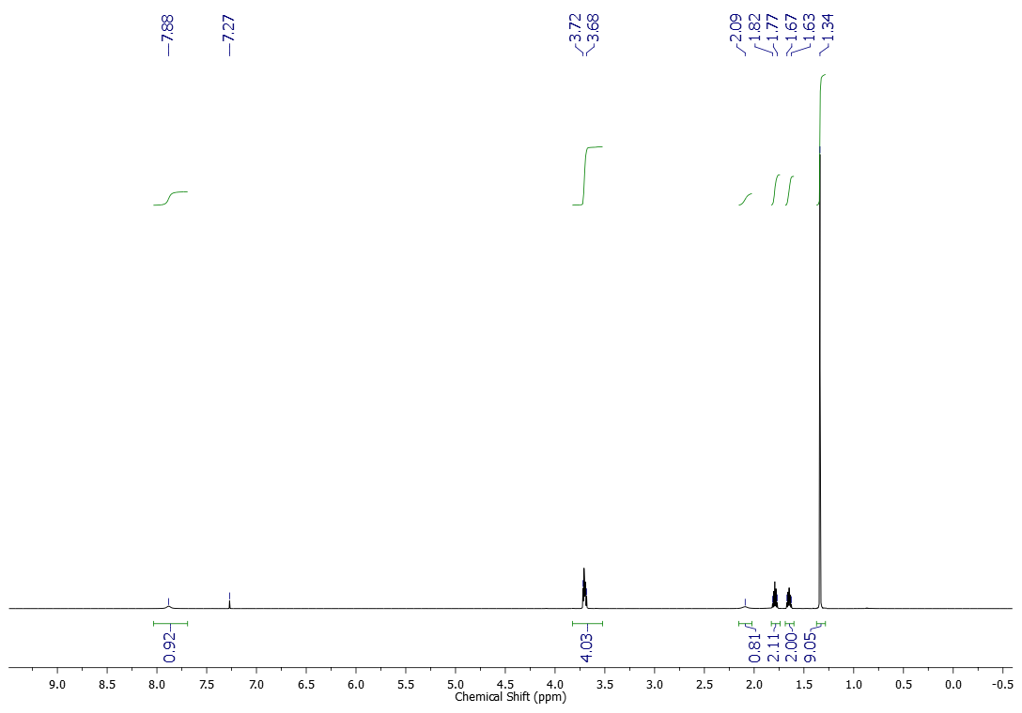
¹³C NMR (151 MHz, CDCl₃) spectrum of compound 3m
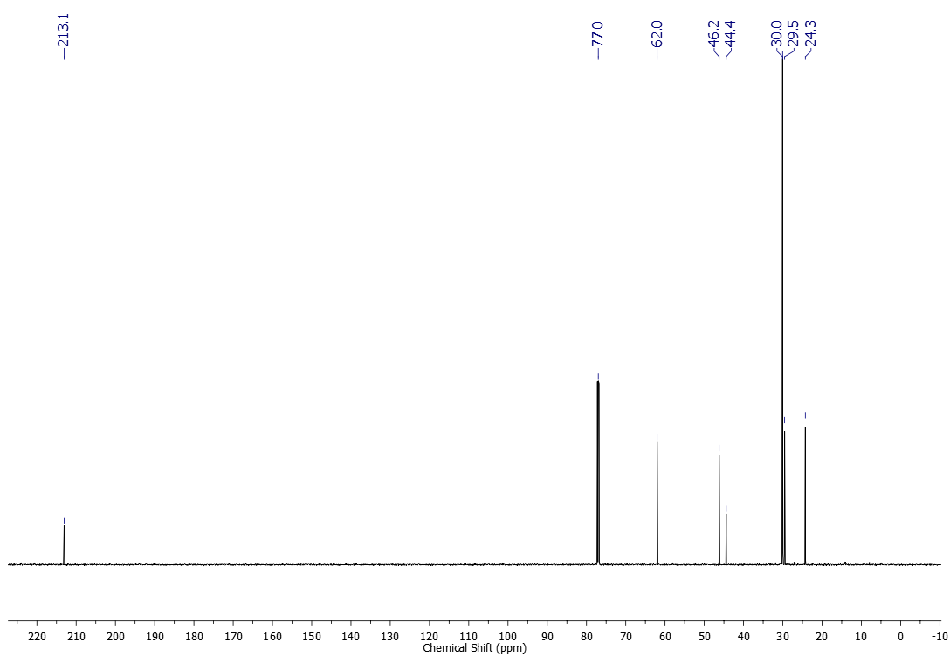
¹H NMR (600 MHz, CDCl₃) spectrum of compound 4a
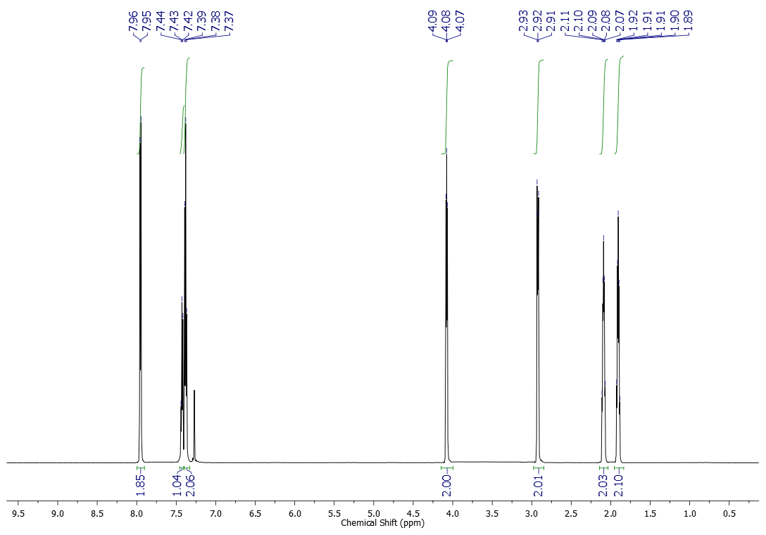
¹³C NMR (151 MHz, CDCl₃) spectrum of compound 4a
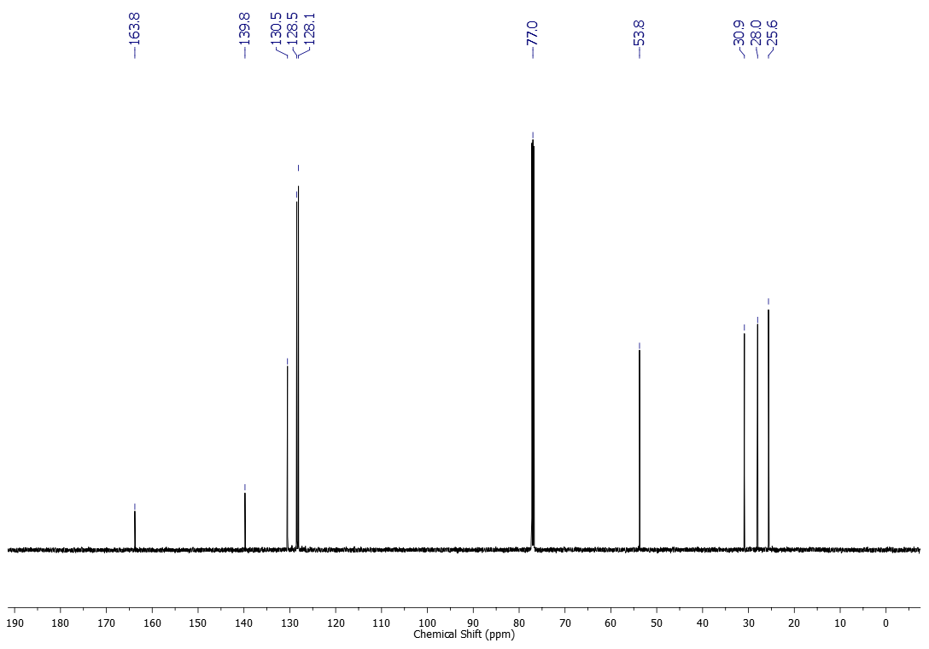
NOESY spectrum of compound 4a
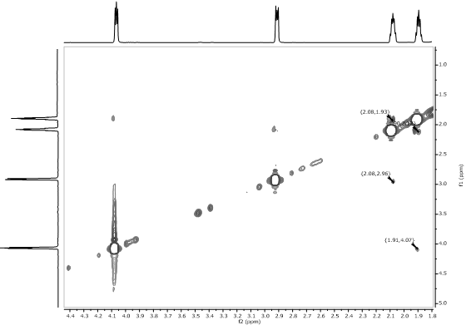
HSQC spectrum of compound 4a
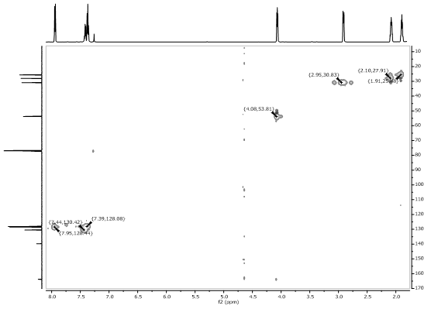
HMBC spectrum of compound 4a
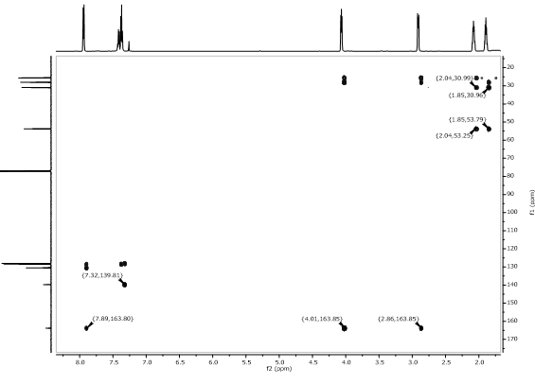
¹H NMR (500 MHz, CDCl₃) spectrum of compound 4b
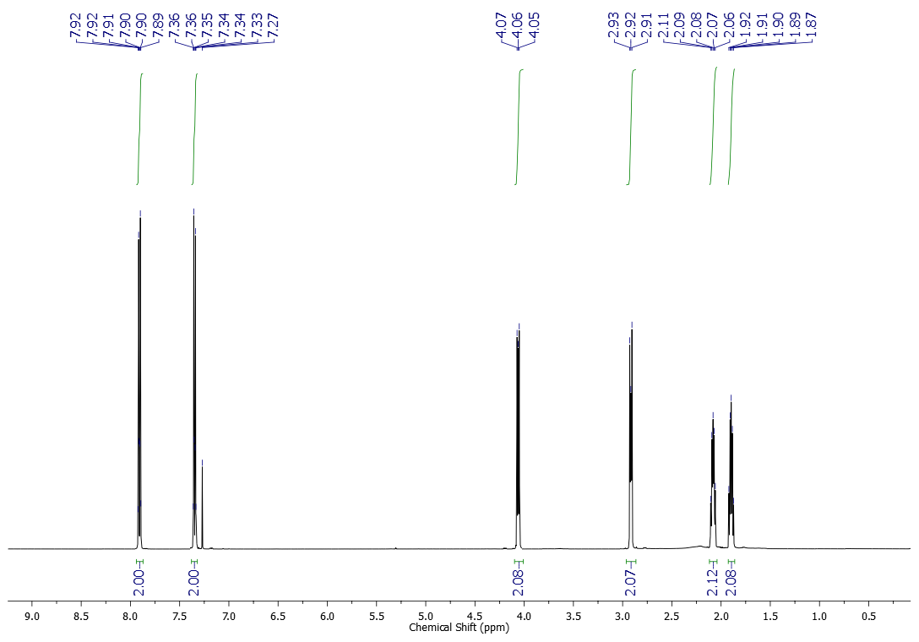

¹³C NMR (125 MHz, CDCl₃) spectrum of compound 4b
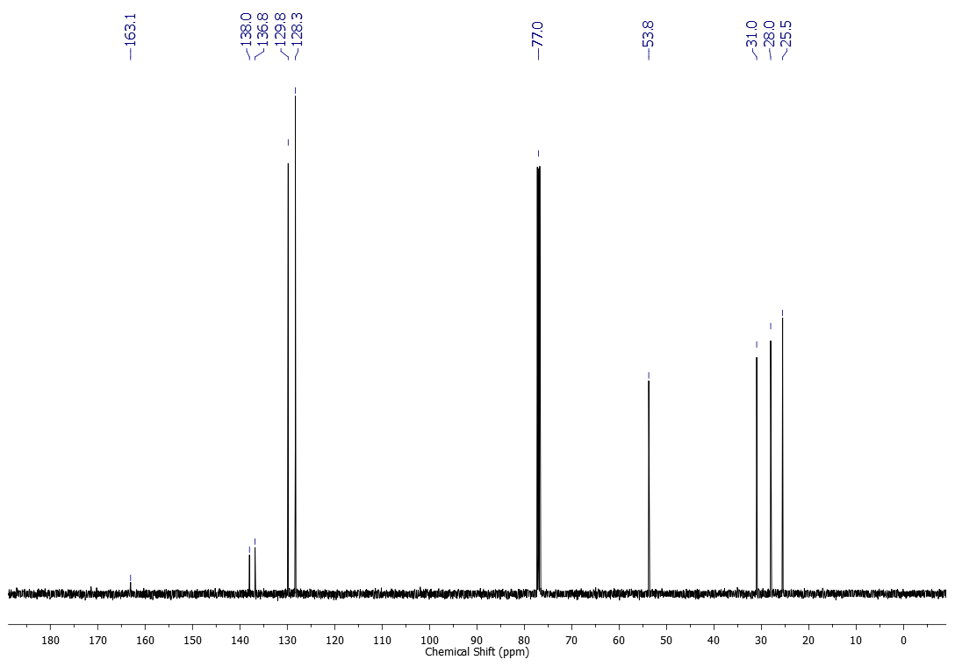
¹H NMR (300 MHz, CDCl₃) spectrum of compound 4c
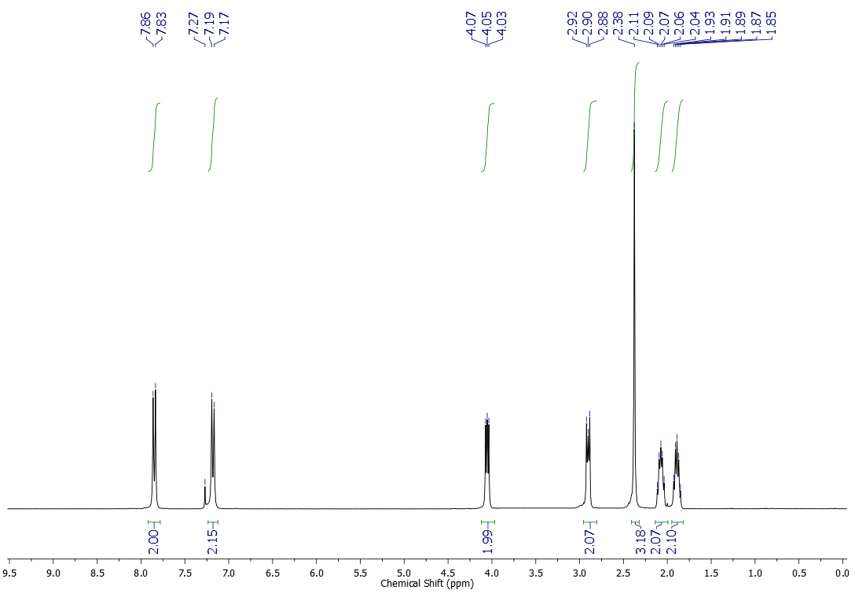
¹³C NMR (75 MHz, CDCl₃) spectrum of compound 4c
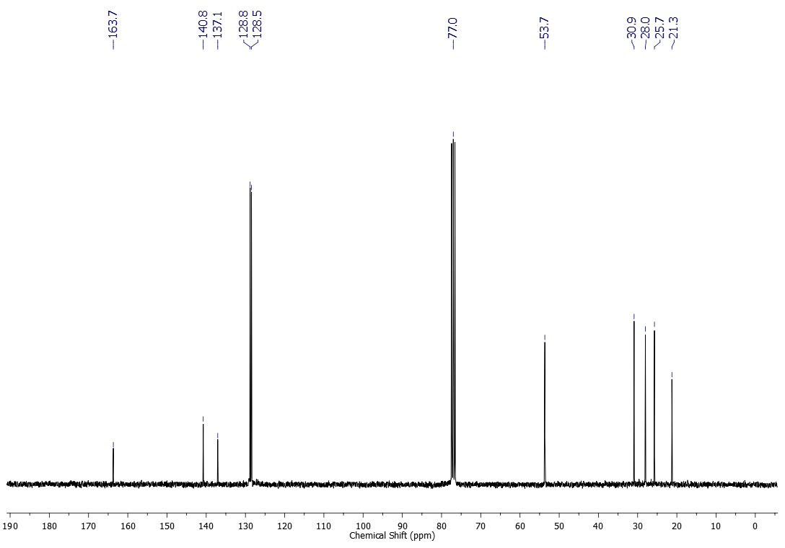
¹H NMR (500 MHz, CDCl₃) spectrum of compound 4d
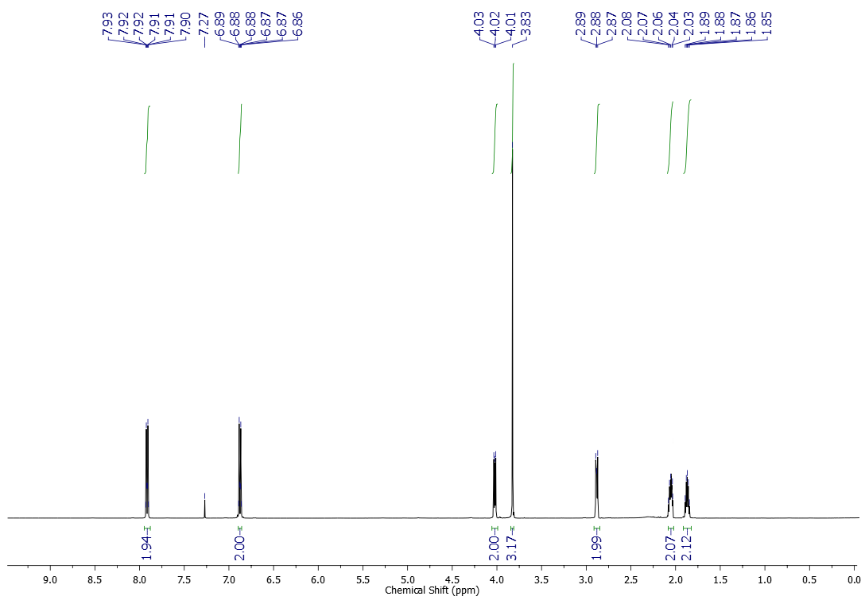

¹³C NMR (125 MHz, CDCl₃) spectrum of compound 4d
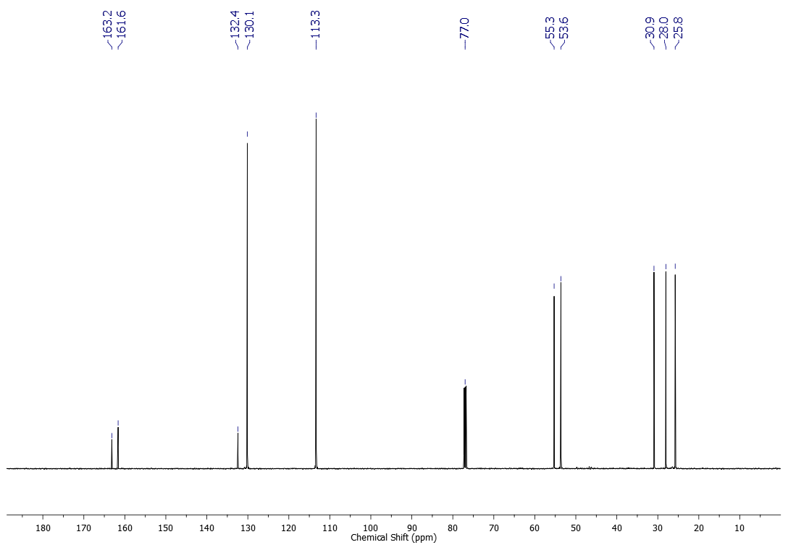
¹H NMR (500 MHz, CDCl₃) spectrum of compound 4e
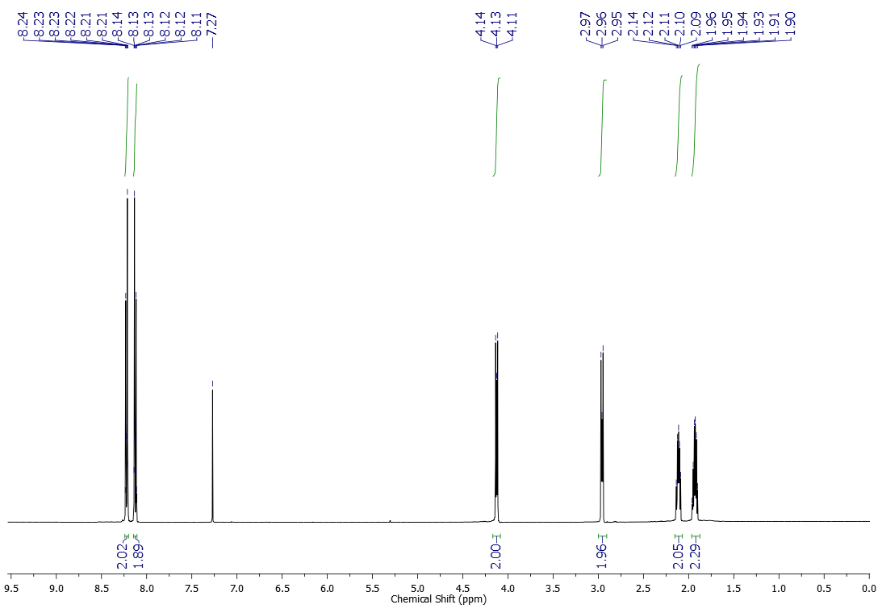
¹³C NMR (125 MHz, CDCl₃) spectrum of compound 4e
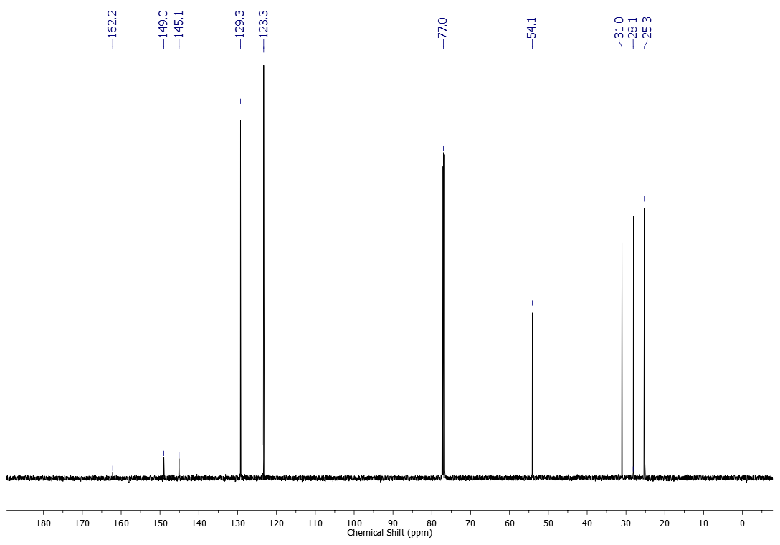
¹H NMR (500 MHz, CDCl₃) spectrum of compound 4f
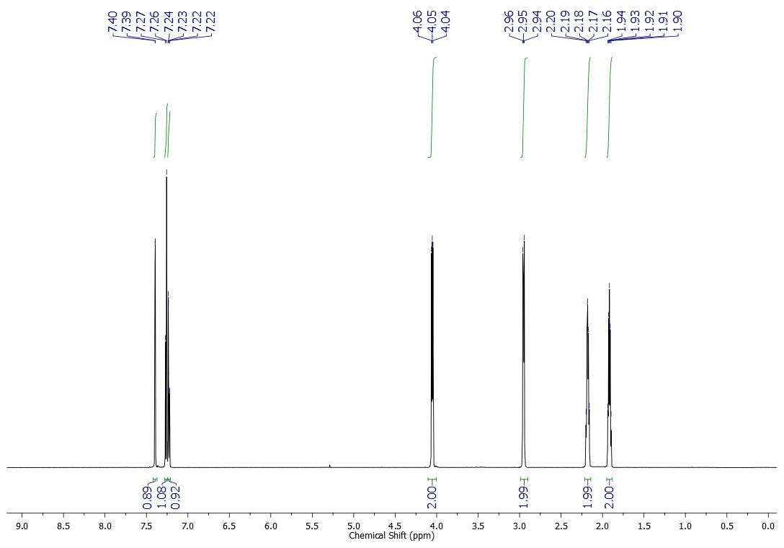
¹³C NMR (125 MHz, CDCl₃) spectrum of compound 4f
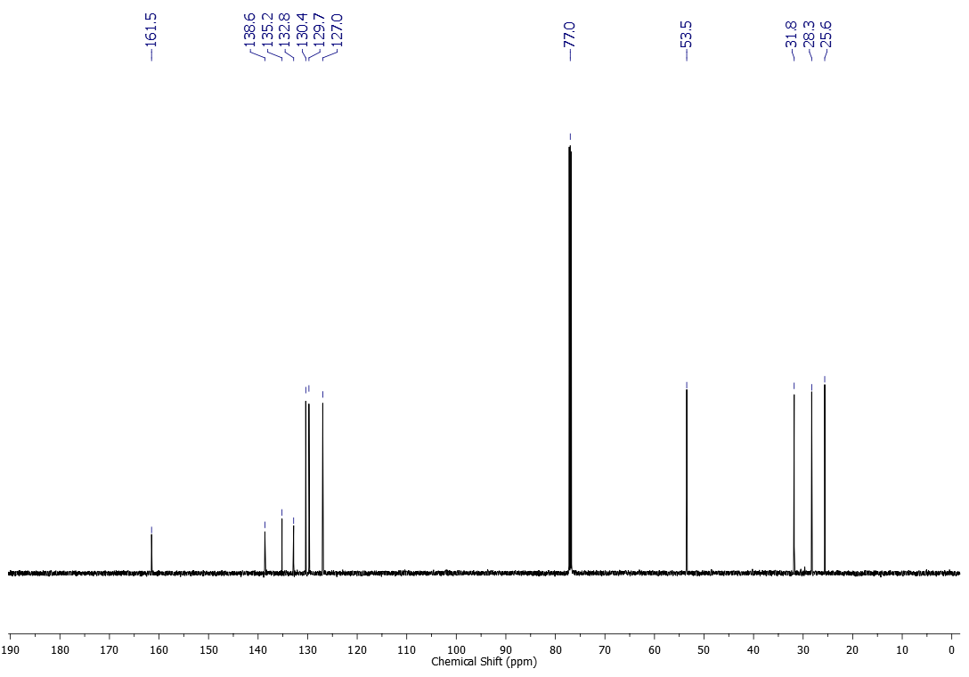
¹H NMR (500 MHz, CDCl₃) spectrum of compound 4g
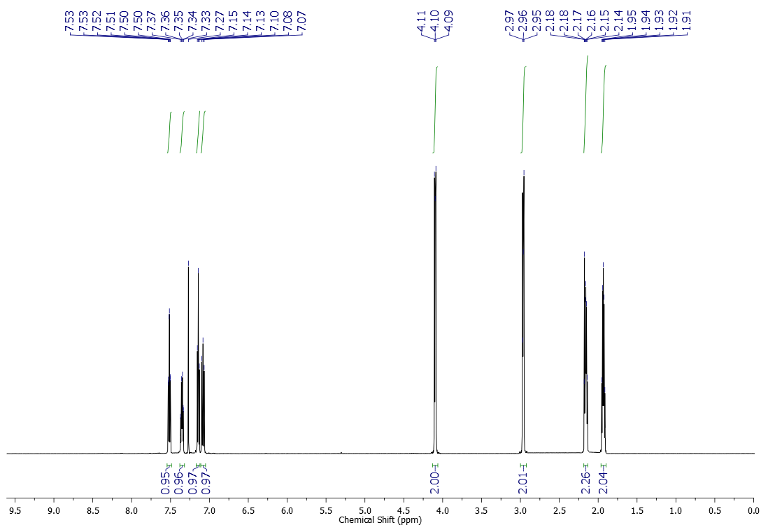
¹³C NMR (125 MHz, CDCl₃) spectrum of compound 4g
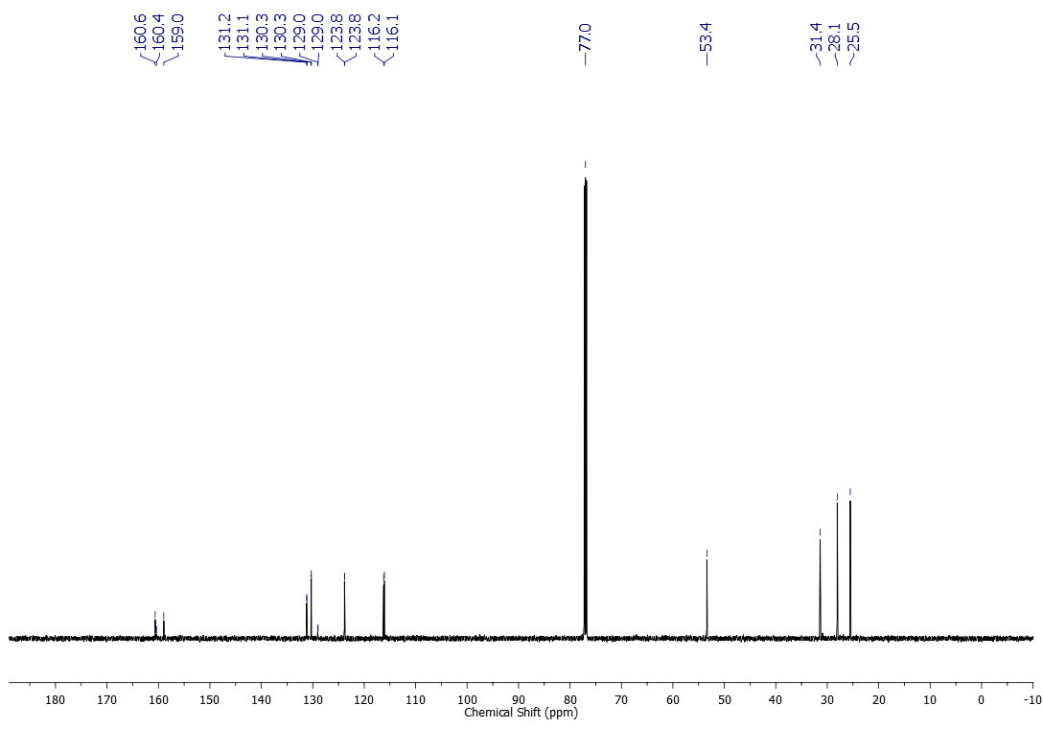
¹H NMR (500 MHz, CDCl₃) spectrum of compound 4h
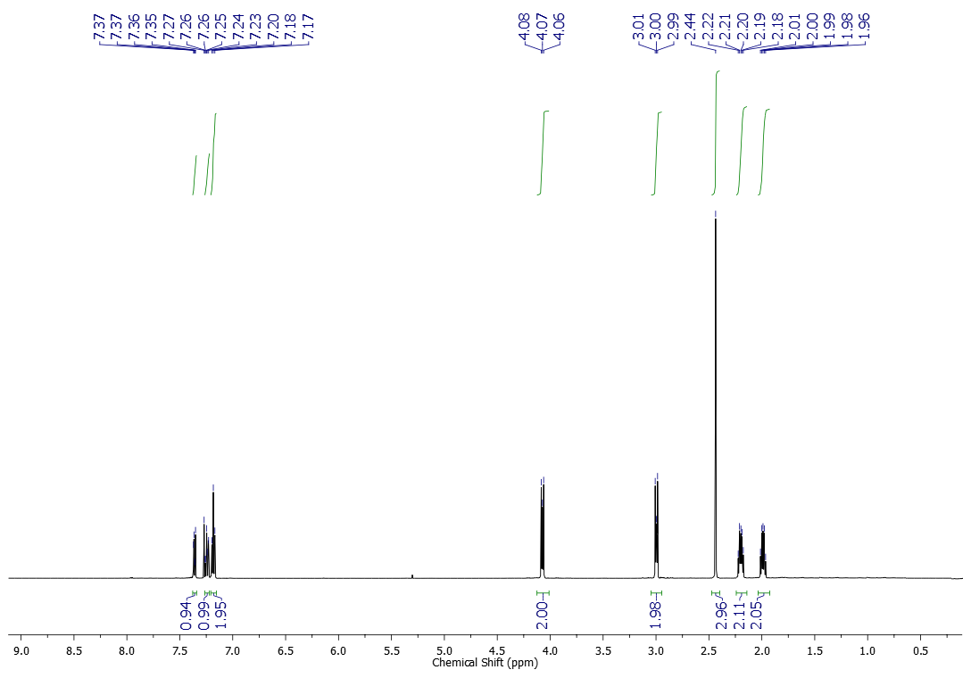
¹³C NMR (125 MHz, CDCl₃) spectrum of compound 4h
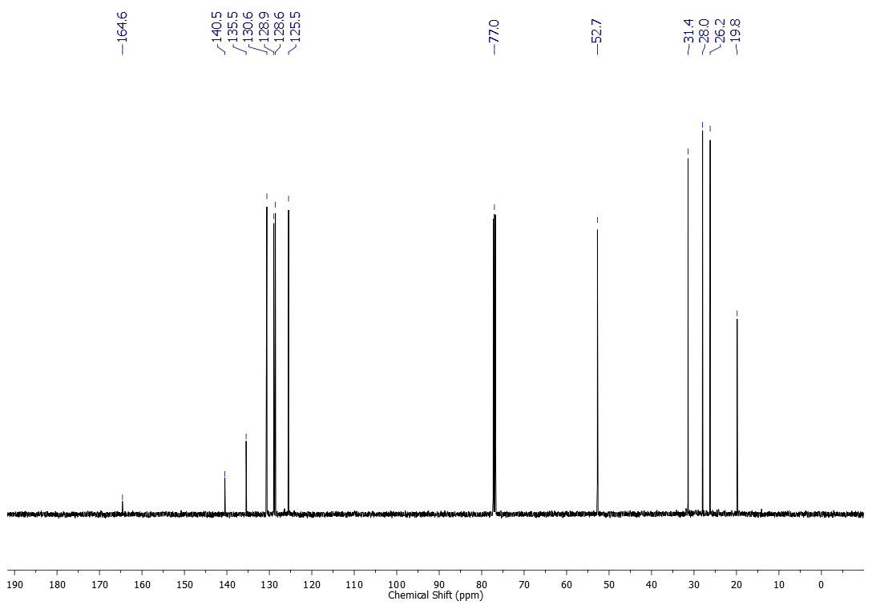
¹H NMR (600 MHz, CDCl₃) spectrum of compound 4i
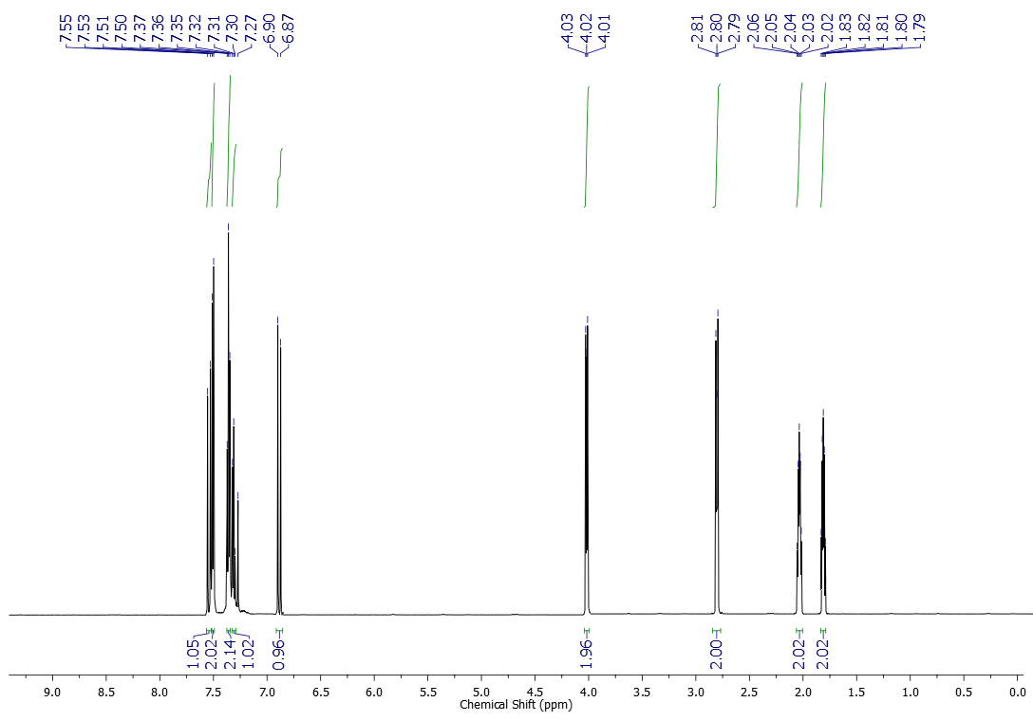
¹³C NMR (151 MHz, CDCl₃) spectrum of compound 4i
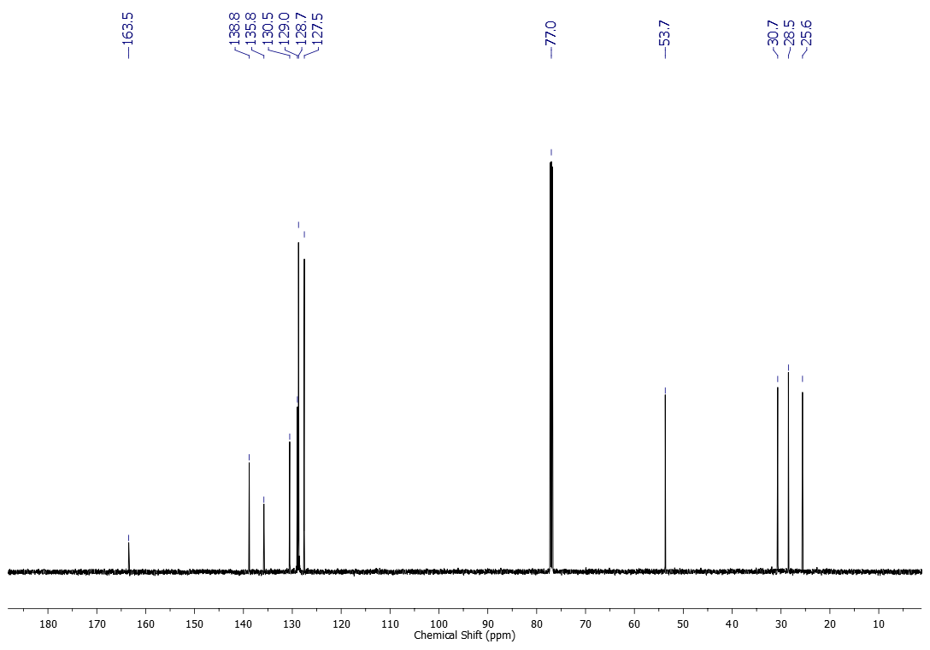
¹H NMR (600 MHz, CDCl₃) spectrum of compound 4j
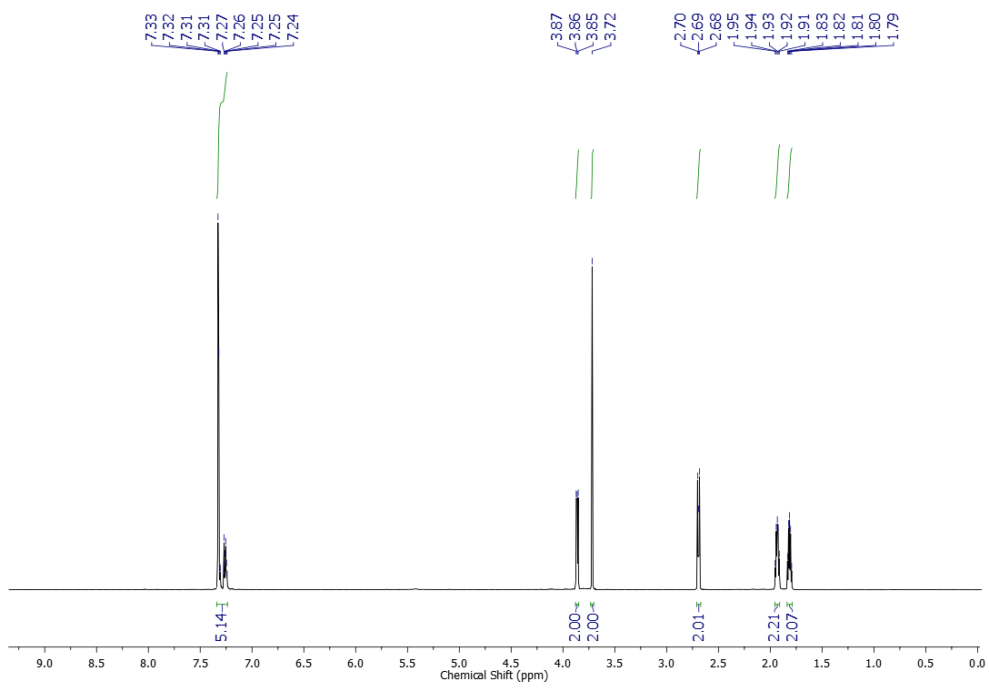
¹³C NMR (151 MHz, CDCl₃) spectrum of compound 4j
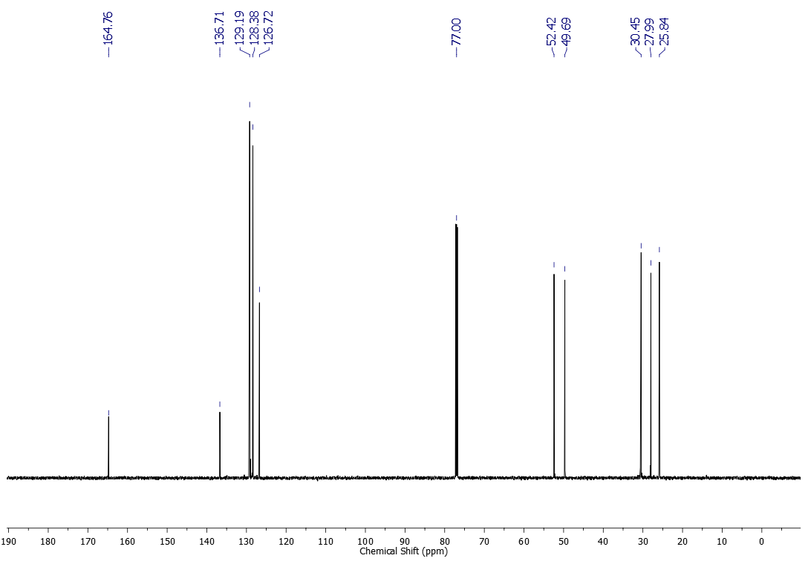
¹H NMR (600 MHz, CDCl₃) spectrum of compound 4k
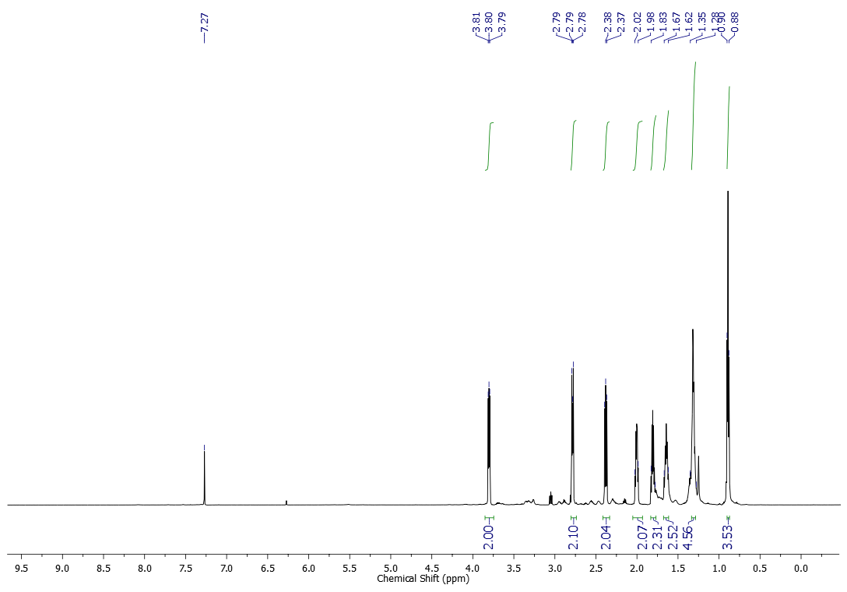
¹³C NMR (151 MHz, CDCl₃) spectrum of compound 4k
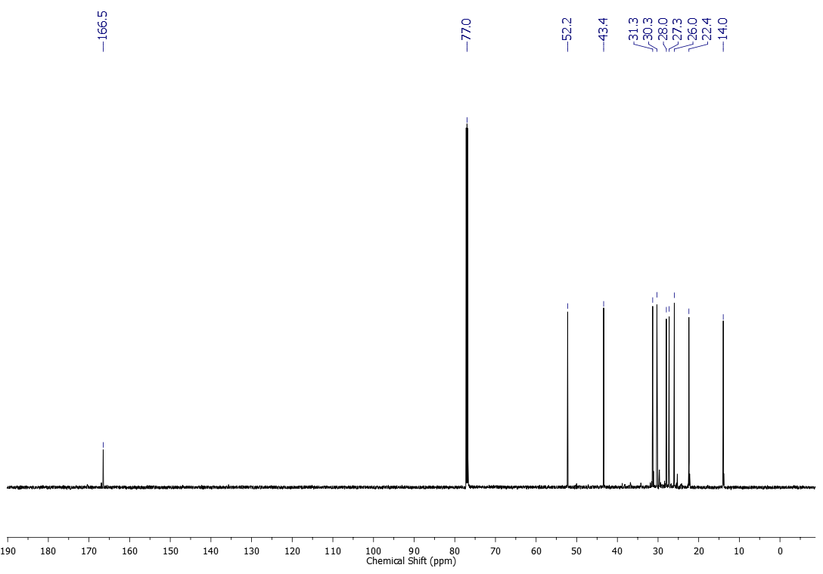
Compound 4k underwent partial decomposition after purification.
¹H NMR (600 MHz, CDCl₃) spectrum of compound 4l
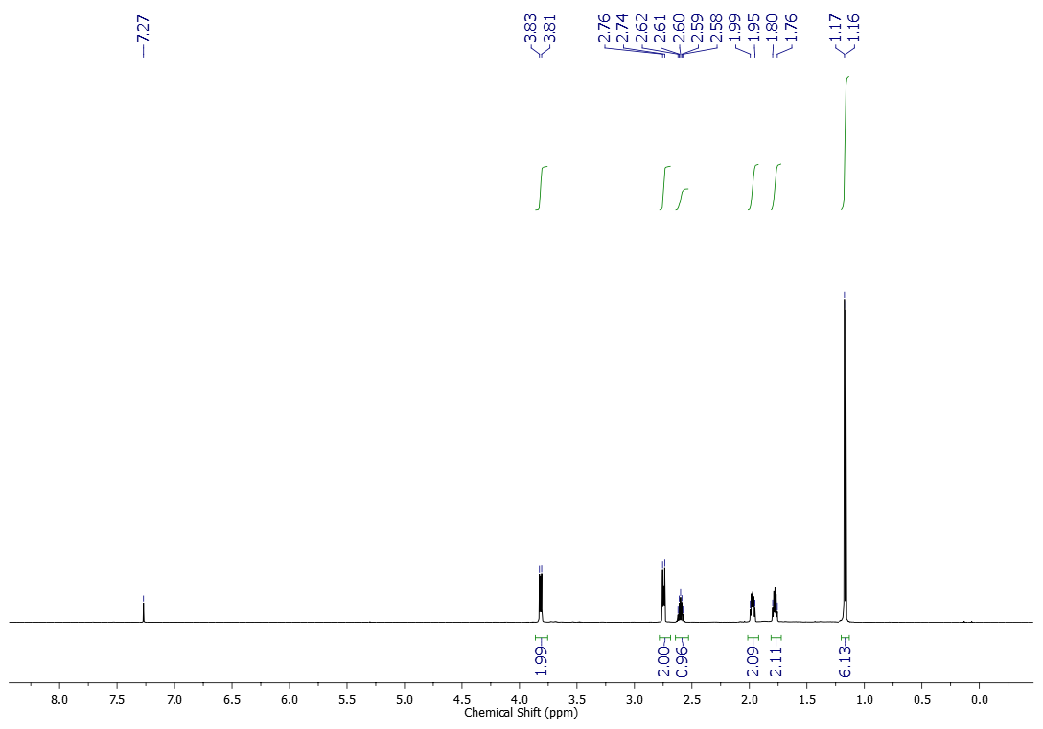
¹³C NMR (151 MHz, CDCl₃) spectrum of compound 4l
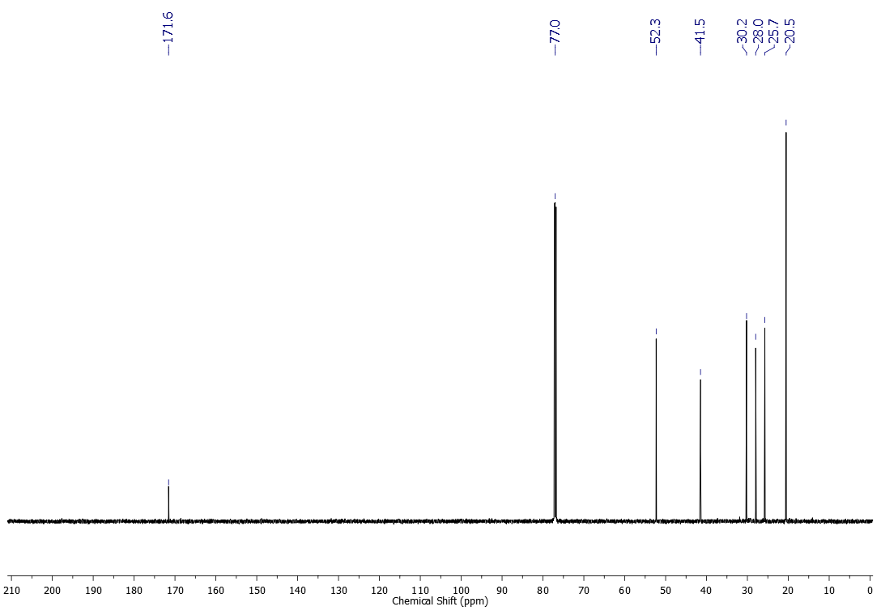
¹H NMR (600 MHz, CDCl₃) spectrum of compound 4m
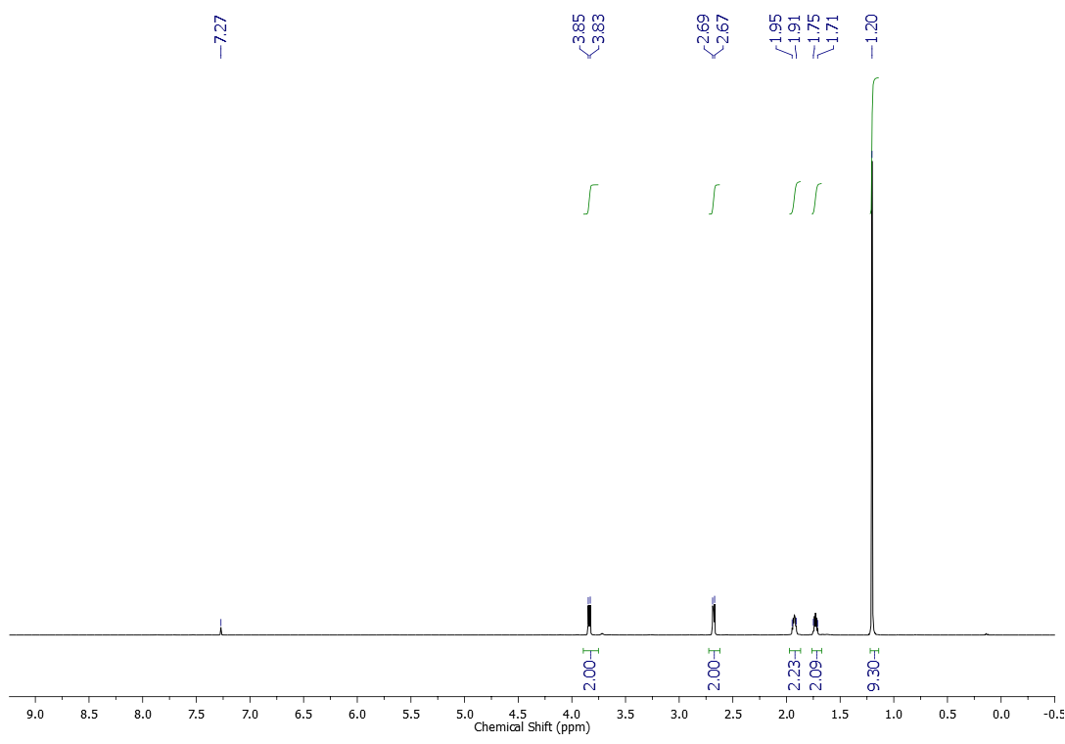
¹³C NMR (151 MHz, CDCl₃) spectrum of compound 4m
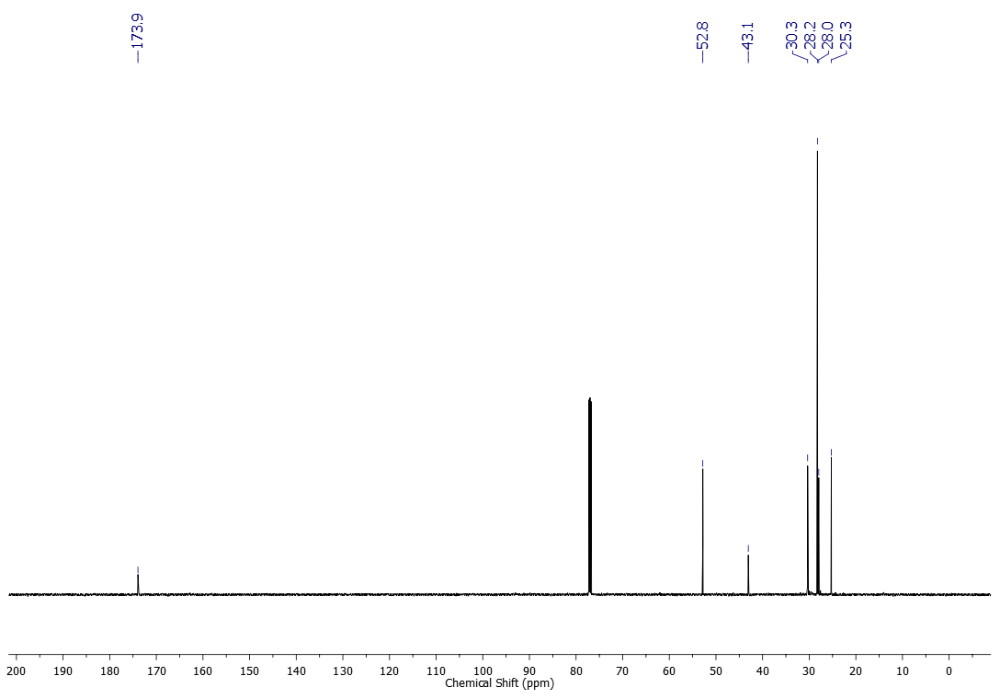

5. References
- Wang, J.; Changxiu, L.; Mingzhi, G.; Jiyu, L.; Xianzhong, L.; Jing, M.; Renqi, P. Chinese Patent CN101104589, 2008.
- Inada, H.; Kuwayama, Y.; Noro, M.; Fukagawa, N. Chinese Patent CN103709449, 2004.
- Greger, H.; Hofer, M.; Teichmann, K.; Schinnerl, J.; Pannell, C. M.; Vajrodaya, S.; Hofer, O. Phytochemistry, 2008, 69, 928.
- Nguyen, T. B.; Al-Mourabit., A. Org. Lett. 2012, 14, 4274.
- Nguyen, T. B.; Tran, M. Q.; Ermolenko, L; Al-Mourabit., A. Org. Lett. 2014, 16, 310.
- Wipf, P.; Hayes, G. B. Tetrahedron 1998, 54, 6987.
- Yates, J.; Rosinger, H. P.; Hackmann, J. T. GB Patent 1013441A, 1963.
- Stewart, W. E.; Siddall, T. H. Chem. Rev. 1970, 70, 517.

