Supporting Information
For

SYNTHESIS, CHARACTERIZATION, CRYSTAL STRUCTURE OF NOVEL COMPOUNDS FROM CONDENSATION REACTION BETWEEN
2-ACETYLPYRIDINE AND 2-PYRIDINECARBOXALDEHYDE;
ANTIMICROBIAL, ANTIFUNGAL ACTIVITY

Roman Rusnac^{1*}, Maria Botnaru¹, Nicanor Barba¹, Victor Tsapkov¹, Olga Burduniuc^{2,3}, Greta Balan^{2,3}, Peter Petrenko⁴, Yurii Chumakov ^{4,5}, Aurelian Gulea¹

Laboratory of Scientific Research
"Advanced Materials in Biopharmaceutics and Technique"
¹State University of Moldova, Chisinau, Republic of Moldova
²National Agency for Public Health, Chisinau, Republic of Moldova
³State University of Medicine and Pharmacy "N.Testemitanu", Chisinau, Republic of Moldova
⁴Institute of Applied Physics, Chisinau, Republic of Moldova
⁵Gebze Tehnical University, Kocaeli/Turkey
*Email: Rusnac Roman- romanrusnac8@gmail.com

Experimental procedures and analytical data

Experimental procedures

General information

NMR spectra: Bruker 400MHz (¹H NMR: 400 MHz, ¹³C NMR: 100 MHz), the spectra were recorded in CDCl₃ and DMSO-d₆ using TMS as internal standard and are reported in ppm. ¹H NMR data are reported as: (s = singlet, d = doublet, t = triplet, q = quartet, m = multiplet, ArH = aromatic, integration, proton assignment). In the ¹H NMR spectra, signal positions (δ) are given in parts per million (ppm) from tetramethylsilane (δ = 0) and were measured relative to residual solvent signal (CDCl₃ = 7.26 ppm, NMR water signals = 1.6 ppm), ( DMSO-d₆ = 2.50 ppm, NMR water signals = 3.3 ppm). ¹³C NMR spectra were recorded using the same spectrometers. Signal positions (δ) are given in parts per million (ppm) from tetramethylsilane (δ = 0) and were measured relative to the signal of CDCl₃ (δ = 77.16 ppm), DMSO-d₆ (δ = 39.5 ppm). Reagents were purchased and used without further purification. All significant resonances (carbon skeleton) were assigned by DEPT-135 correlations. FTIR-ATR spectra were recorded in powder form on the Bruker ALPHA apparatus in the wavelength range 4000-400 cm⁻¹. The spectral results were interpreted using OPUS version 7.5. The multiplicities of signals are given as strength/shape s = strong, m = medium, w = weak. All other commercially available solvents were used without purification. Thin-layer chromatography was carried out on silica gel 60 F254 (Merck). Column chromatography was performed on silica gel 60 (70–230 mesh, Merck). The organic solutions were dried over MgSO₄ or Na₂SO₄.
Synthesis of compound 1,3-bis(pyridin-2-yl)prop-2-en-1-one (3)
The mixture of 1.21 g (0.01 mol) of 2-acetylpyridine, 1.07 g (0.01 mol) of 2-formylpyridine, 0.28 g of Na₂CO₃ and 300 mL of water was subjected to microwave irradiation at 480 W for 5 minutes. On cooling the reaction mixture of the solution is deposited pale yellowish crystals and a yellowish oil is deposited on the bottom of the flask, which then crystallizes and represents a mixture of product (3) and (4). (TLC monitoring: EtOAc). The crystals were separated by filtration, washed on the filter with water, dried. 1.40 g (65%) of the product (3) are obtained with m.p. = 66-67 °C, Rf = 0.6 (eluent: EtOAc), corresponds to literature [1]. IR (FTIR, ν_{max}, cm⁻¹): (C-H,sp²) stretch (alkene) 3059(m), 3085(m); (C-H)_{py} stretch (heterocyclic) 3008(m), 2929(m); (C=O) stretch 1670 (s); (C=C) conjugated alkenes-1,2-subst. 1609(m); (C-C) stretches in the aromatic ring 1579 (s); (C-H in-plane bending 1090 (m); alkenes-trans-1,2-subst. 983(s); the pyridine ring in the plane 618(m). ¹H-NMR (CDCl₃, 298 K) δ (ppm), 400 MHz: 8.825-8.655 (m, 3H); 8.139-8.040 (m, 2H); 7.934-7.793 (m, 3H); 7.809 (d, 1H); 7.735-7.691(m, 1H); 7.713 (m, 1H); 7.450 (m, 1H); 7.471-7.429 (m, 1H). ¹³C-NMR (CDCl₃, 298 K) δ (ppm), 100 MHz: 189.574(C=O); 153.701(C¹); 153.095(C₁); 150.654(C²); 149.754(C₂); 143.120(Cβ); 138.267(C₄); 137.791(C⁴); 128.287(C₃); 126.167(C³); 125.463(C⁵); 124.709(Cα); 122.982(C₅).

Figure S-1: ¹H NMR spectrum of compound 3 (CDCl₃).

Figure S-2: ¹³C NMR spectrum of compound 3 (CDCl₃).
Figure S-3. FTIR spectrum of compound 3
Synthesis of compound 1,3,5-tri(pyridin-2-yl) pentane-1,5-dione (4)
Method A. A mixture of 2.42 g (0.02 mol) of 2-acetylpyridine and 1.07 g (0.01 mol) of 2-formylpyridine, 1.40 g of NaOH and 30 mL of EtOH was stirred at room temperature for 4 hours. The mixture was red-orange color was neutralized with 10% HCl solution until pH = 6-7, the solution was deposited a colorless microcrystalline substance. The crystals were filtered and washed on the filter with cold ethanol to give 1.50 g (45%) of the product (4), m.p. = 130-132 ° C, corresponds to the literature [12]. Method B. A mixture of 2-acetylpyridine (0.97 g, 0.008 mol), 0.43 g (0.004 mol) of 2-formylpyridine was dissolved in 15 mL of EtOH. The reaction mixture was cooled to 0 °C, to which 2 mL of HCl (con.) was added dropwise and vigorously. The mixture was further stirred for 1 hour at 0-5 °C, then another 5 hours at room temperature, then neutralized with 10% NaOH solution. The reaction product was filtered and washed on the filter with cold, dried water and recrystallized from EtOH. Are obtained 0.70 g (53%) of the product (4) m.p. = 130-132 °C. IR (FTIR, ν_{max},
cm⁻¹): (C-H)_{py} stretch 3090(w), 3019(w); (C-H) stretch from (CH₂) as 2914, sy 2882; (C=O) stretch 1692(s); the pyridine ring in the plane 617(m). ¹H-NMR (DMSO-d6) δ (ppm), 400 MHz: 8.679(C16-H, C22-H, d, 2H); 8.364-8.278 (C6-H, d, 1H); 7.983-7.941 (C18-H, C24-H, m, 2H); 7.871(C17-H, C23-H, d, 2H); 7.677-7.613(C3-H, C19-H, C25-H, m, 3H); 7.353(C4-H, d, 1H); 7.143-7.112(C5-H, m, 1H); 4.065(C7-H, p, 1H); 3.879-3.814(C11-H, C8-H, m, 4H). ¹³C-NMR (DMSO-d6) δ (ppm), 100 MHz: 200.428 (C9=O, C12=O); 163.334(C2); 153.156(C14, C20); 149.602(C16, C22); 149.132(C6); 138.009(C18, C24); 136.826(C4); 128.225(C23, C17); 123.645(C5); 121.939(C3); 121.737(C19, C25).
The molecular structure is represented in Figure S-4. CCDC reference: 665647
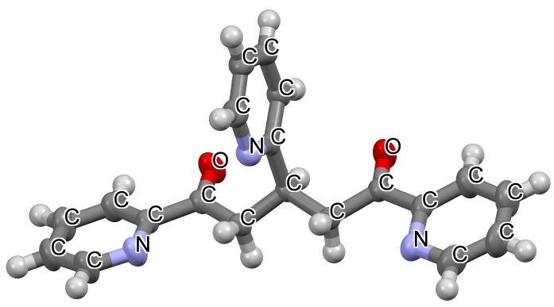
Figure S-4. Molecular structure of 1,3,5-tri(pyridin-2-yl) pentane-1,5-dione (4).
Figure S-5: ¹H NMR spectrum of compound 4 (DMSO-d₆).
Figure S-6: ¹³C NMR spectrum of compound 4 (DMSO-d₆).
Figure S-7. FTIR spectrum of compound 4
Synthesis of compound 2,4-dihidroxi-2,4,6-tri(pyridin-2-il)ciclohexil)(pyridin-2-il)metanon (5).
A mixture of 2-acetylpyridine (0.36 g, 0.003 mol), 2-formylpyridine (0.107 g, 0.001 mol), NaOH (0.16 g) and MeOH (6 mL) was heated at reflux for 6 h, the TLC analysis showed the completion of the reaction. The reaction mixture was neutralized with HCl until pH= 7, MeOH, the reaction mixture was concentrated to dryness under reduced pressure. The organic phase was extracted with EtOAc, separated and dried with Na₂SO₄, followed by filtration and concentration. After removal of the solvent, the residue was purified by column chromatography on silica gel (eluent: EtOAc), yield 0.22 g (48%) of a colorless crystalline substance of m.p.= 164-166 °C, corresponds to literature [3]. IR (FTIR, ν_{max}, cm⁻¹): (O-H) stretch 3341, 3325 (m); (C-H)_{py} stretch 3050 (w), 3008(w); (C-H) stretch from CH₂ as 2963, sy 2912; (C=O) stretch 1686 (s); (C=C) 1470 (s); CH₂ bending 1431 (w); (C-O) 1219 (m); (C-OH) axial 929 (s); the pyridine ring in the plane 1569, 618, 469 (m). ¹H-NMR (CDCl₃) δ (ppm), 400 MHz: 8.536-8.518(C31-H, m, 1H); 8.413-8.396(C23-H, m, 1H); 8.240-8.224(C17-H, C6-H, m, 2H); 7.787(C20-H, d, 1H); 7.694(C34-H, t, 1H); 7.615(C33-H, d, 1H); 7.504-7.465(C25-H, C4-H, m, 2H); 7.429-7.374(C3-H, C26-H, m, 2H); 7.160-7.127(C32-H, C19-H, m, 2H); 6.867-6.834(C18-H, m, 2H); 6.477(C24-H, s, 1H); 6.232(C5-H, s, 1H); 5.545(C12-H, d, 1H); 4.420-4.349(C7-OH; C9-OH, m, exchange with HOH); 3.144(C11-H, d, 1H); 2.885(C8-H, t, 1H); 2.228-2.021(C10-H, m, 2H). ¹³C-NMR (CDCl₃) δ (ppm) 100 MHz: 204.244(C27=O); 165.031(C21); 162.436(C15); 162.025(C2); 153.971(C29); 148.725(C23); 148.068(C6, C17); 147.470(C31); 136.734(C33); 136.227(C4); 136.069(C25); 136.037(C19); 125.820(C32); 123.092(C18); 121.889(C20, C3, C26); 121.283(C24); 120.542(C5); 119.441(C34).

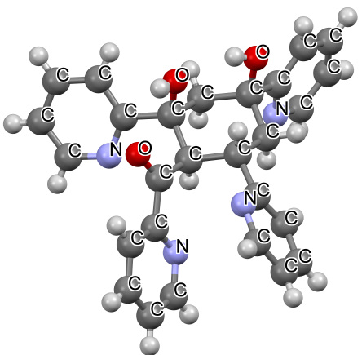
Figure S-8: Molecular structure of 2,4-dihydroxy-2,4,6-tri(pyridin-2-il)ciclohexil)(pyridin-2-il)metanon (5).

Figure S-9: ¹H NMR spectrum of compound 5 (CDCl₃).
Figure S-10: ¹³C NMR spectrum of compound 5 (CDCl₃).
^{b}CH₂
ªCH₂
Figure S-11: DEPT-135 spectrum NMR of compound 5 (CDCl₃).
Figure S-12: FTIR spectrum of compound 5.
Synthesis of compound 4-hydroxy-2,4,6-tris (pyridin-2-yl)cyclohexane-1,3-diyl)bis
(pyridin-2-yl)methanone (6)
Method A. To the solution of 0.64 g (0.006 mol) of 2-formylpyridine in 30 mL of EtOH was added dropwise the solution formed from 0.6 g NaOH and 6 mL water. 2-Acetylpyridine 1.09 g (0.009 mol) was added dropwise to the reaction mixture by vigorous stirring. The reaction mixture was stirred at room temperature for 6 hours, then left for a further 60 hours. The reaction time was determined by thin layer chromatography (TLC) analysis showed the completion of the reaction as against 2-formylpyridine (eluent: EtOAc). The reaction mixture was neutralized with HCl until pH = 6-7. The reaction product was extracted with CH₂Cl₂, dried with anhydrous Na₂SO₄ after removing the solvent, the residue was purified on a silica gel column (eluent: EtOAc, then MeOH). There was thus obtained 0.40 g (24%) of a colorless substance of m.p. 220-222 ° C. Method B. A mixture of 1,3-bis(pyridine)1,3,5-tri(pyridin-2-yl)pentane-1,5-dione (4) 0.35 g (0.015 mol) 1,3-bis(pyridin-2-yl)prop-2-en-1-one (3) is dissolved in 6 mL of EtOH. To the mixture was added a solution of 0.26 g of NaOH and 3 mL of water. The mixture was stirred at room temperature for 5 hours, then left for 48 hours. The reaction time was determined by thin layer chromatography (TLC) analysis showed the completion of the reaction as against (4), (eluent: EtOAc). Purification of the product as in Method A. Obtained 0.35 g (44%) of a colorless substance of m.p. 220-222 °C. The molecular structure is represented in Figure S-13. IR (FTIR, ν_{max}, cm⁻¹): (O-H) stretch 3350 (w); (C-H)_{py} stretch 3045 (w), 3004(w); (C-H) stretch from CH₂ as 2925, sy 2852; (C=O) stretch 1676, 1583 (s); (C=C) stretch 1470 (s); CH₂ bending 1438 (s); (C-O) 1232 (m); (C-OH) axial 937 (s); the pyridine ring in the plane 1449, 618, 505 (m). ¹H-NMR (CDCl₃) δ (ppm), 400 MHz: 8.583-8.531(C32-H, C38-H, m, 2H); 8.418(C16-H, d, 1H); 8.250-8.195(C24-H, C-6H, m, 2H); 8.139-8.055(C41-H, C35-H, m, 2H); 7.880(C3-H, t, 1H); 7.678-7.607(C40-H, C34-H, m, 2H); 7.543-7.402(C18-H, C4-H, C33-H, C39-H, C26-H, C27-H, m, 6H); 7.198-7.168(C19-H, C25-H, m, 2H); 7.002(C5-H, t, 1H); 6.876(C17-H, t, 1H); 5.869(C12-H, d, 1H); 5.339(C7-OH, s, 1H); 4.879(C10-H, d, 1H); 4.175-4.1234.1(C9-H, m, 1H); 3.446(C11-H, t, 1H); 2.217-2.176(C8-H, m, 2 H). ¹³C-NMR (CDCl₃) δ (ppm) 100 MHz: 201.704(C20=O); 201.055(C28=O); 167.241(C14); 162.540(C22); 161.758(C2); 154.255(C36); 153.996(C30); 148.330(C24); 148.211(C16); 148.015(C38, C32); 146.878(C6); 137.778(C34); 136.729(C40); 136.354(C26); 136.064(C4); 135.808(C18); 126.246(C39); 125.975(C33); 124.202(C3); 122.605(C35); 122.118(C5); 121.884(C41, C25); 120.939(C19); 120.791(C27); 120.235(C17); 75.443(C7); 49.001(C12); 46.408(C10); 45.596(C11); 42.381(C8); 38.623(C9).
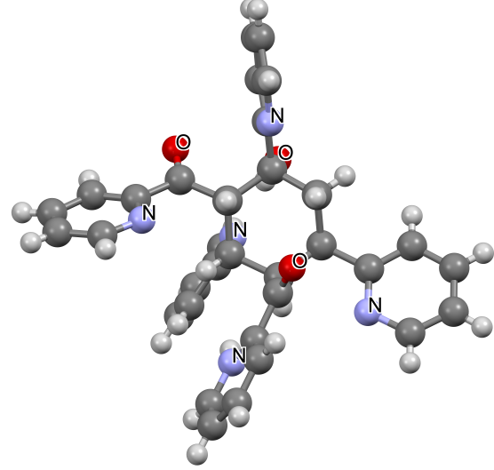

Figure S-13: Molecular structure of 4-hydroxy-2,4,6-tris(pyridin-2-yl)cyclohexane-
1,3-diyl)bis(pyridin-2-yl)methanone (6).
Figure S-14: ¹ H NMR spectrum of compound 6 (CDCl₃).
Figure S-15: ¹³C NMR spectrum of compound 6 (CDCl₃).
CH₂
CH
Figure S-16: DEPT 135 spectrum NMR of compound 6 (CDCl₃).
Figure S-17: FTIR spectrum of compound 6

Reference
1. Marvel CS, et al. In: The journal of organic chemistry, 1955, vol. 20, no. 12, p. 1785-1792.
2. Jian F-F, et al. In: Acta crystallographica section E, 2007, vol. 63, no. 12, p. o4846-o4846.
3. Chang Meng-Yang, Wu Ming-Hao. In: Tetrahedron, 2012, vol. 68, no. 47, p. 9616-9623.

