Supporting Information
For

SYNTHESIS, CHARACTERIZATION, CRYSTAL STRUCTURE OF NOVEL COMPOUNDS FROM CONDENSATION REACTION BETWEEN
2-ACETYLPYRIDINE AND 2-PYRIDINECARBOXALDEHYDE;
ANTIMICROBIAL, ANTIFUNGAL ACTIVITY

Roman Rusnac^{1*}, Maria Botnaru¹, Nicanor Barba¹, Victor Tsapkov¹, Olga Burduniuc^{2,3}, Greta Balan^{2,3}, Peter Petrenko⁴, Yurii Chumakov ^{4,5}, Aurelian Gulea¹

Laboratory of Scientific Research
"Advanced Materials in Biopharmaceutics and Technique"
¹State University of Moldova, Chisinau, Republic of Moldova
²National Agency for Public Health, Chisinau, Republic of Moldova
³State University of Medicine and Pharmacy "N.Testemitanu", Chisinau, Republic of Moldova
⁴Institute of Applied Physics, Chisinau, Republic of Moldova
⁵Gebze Tehnical University, Kocaeli/Turkey
*Email: Rusnac Roman- romanrusnac8@gmail.com

Additional figures and tables
Crystallographic data for compounds 5 and 6.
Crystallographic measurement
Crystallographic measurements of compounds 5 and 6 were carried out with an Oxford-Diffraction XCALIBUR E CCD diffractometer (Santa Clara, CA, USA) equipped with graphite-monochromated Mo K_{α} radiation. The unit cell determination and data integration were carried out using the CrysAlis package of Oxford Diffraction (CrysAlisProAgilentTechnologies, Version1.171.34.49 (release20-01-2011 CrysAlis171.net; compiled Jan 20 2011,15:58:25)). All structures were solved by direct methods using SHELXS-97 and refined by full-matrix least-squares on F_{o}² with SHELXL-97 . All atomic displacements for non-hydrogen, non-disordered atoms were refined using an anisotropic model. The main crystallographic data together with refinement details are summarized in Table 3. The selected bond lengths, angles and hydrogen bonds are presented in Table 4 and Table 5 respectively. The geometric parameters were calculated and the figures were drawn with the use of the PLATON program . The hydrogen atoms that are not involved in the hydrogen bonding were omitted from the generation of the packing diagrams.
X-ray Analysis compounds 5 and 6.
Three pyridine-2-carbonyl groups are attached to cyclohexane rings in (5) and (6) while one and two pyridine cycles are bound with cyclohexane in these compounds respectively (Figure 1). In both compounds the central cyclohexane ring adopts a chair conformation with puckering parameters Q, θ, φ which are 0.5935 Å, 173.45°, 0.9° and 0.5414 Å, 169.64°, 110.4° for (5) and (6) respectively. In compounds of (5) and (6) the planes through the coplanar atoms (C1C(E)/C1D/C7/C8) form dihedral angles with pyridine cycles (N1/C2-C6) which are equal to 89.44, 59.51, 76.45, 39.82° and 83.86, 85.13, 84.02,45.12, 82.46° for rings A-E and A-D (Figure 4). The bond lengths and the bond angles in studied compounds are consistent with those in .
The molecular structures of (5) and (6) are stabilized by intramolecular C—H⋯N, C—H⋯O and O—H⋯O hydrogen bonds (HB) (Table 3, Figure 5) and for 5 by π–π interaction between the pyridine rings B and D [centroid–centroid distance is equal to 3.775 Å]. In the crystal structure of 5 the molecules form the centrosymmetric dimers which are link by C(5C)-H…O(1B) HB. Dimers are joined into the chains along [1 1 0] direction through the hydrogen bonds C(1D)-H...O(1B) and O(1C)-H...N(1D) (Table 3, Figure 5). In the chains, molecules translated by a unit along the y axis, are linked via C(5D)-H…Cg (Cg is the pyridine A ring centroid) interactions with H… Cg distance 2.77 Å.
Between the chains in 5 the van der Waals interaction occurs. In the crystal structure of 6 the molecules are linked into a complex three-dimensional framework structure by a combination of C(5A)-H...N(1B), C(5E)-H...O(1B) and C(6B)-H...O(1A) hydrogen bonds (Table 3, Figure 5). The A and C pyridine rings related by symmery operator (1 - x, -y, -z) are stacked with a centroid–centroid separation of 3.986 Å. A C(5C)-H…π interaction is also observed for these cycles with H… Cg distance 2.97 Å.

Compound 5
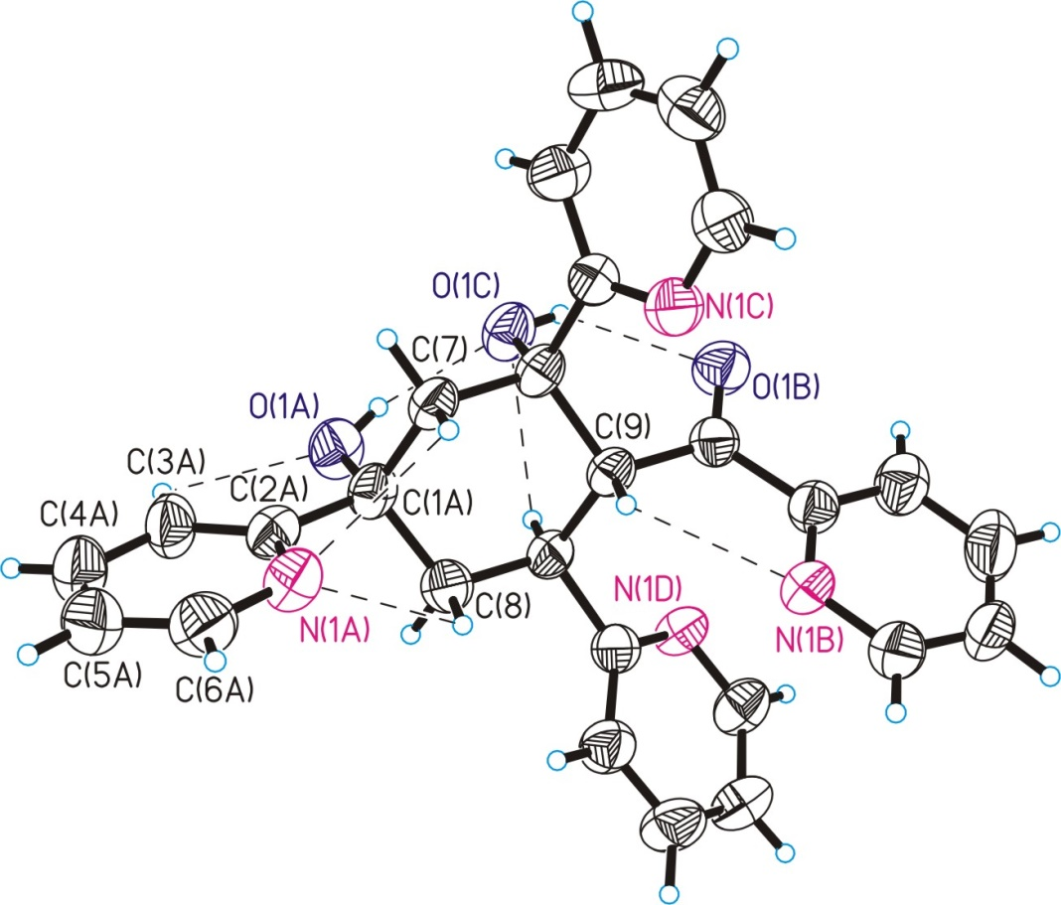
Compound 6
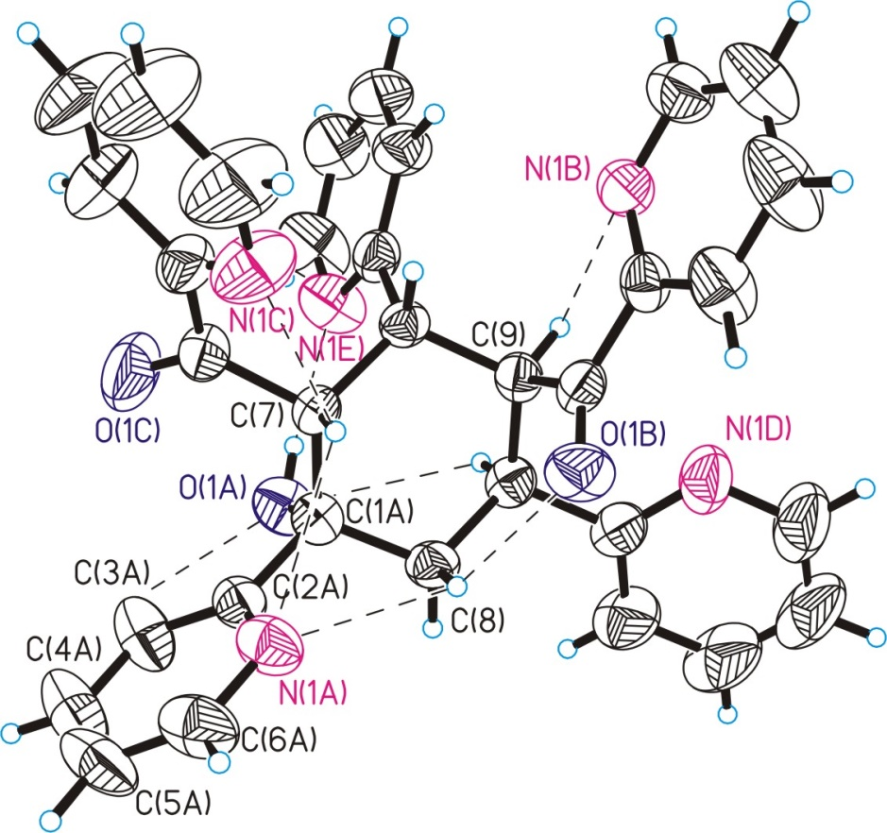

Figure S 1.2: A ORTEP plot of (a) 5 and (b) 6, showing 50% probability displacement ellipsoids and the atomic numbering.
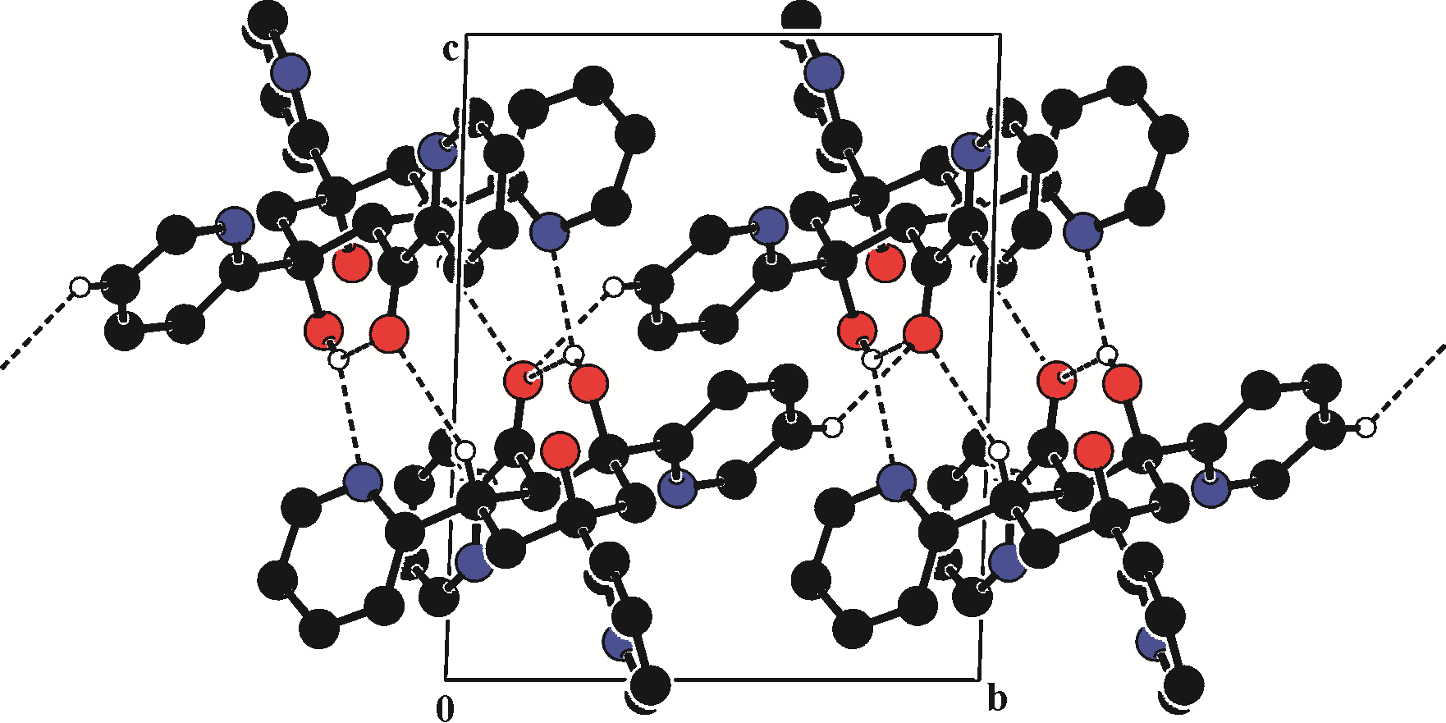
Figure S 2.1: View of centrosymmetric dimmers in 5 which are aligned along [1 1 0] direction forming the chains.
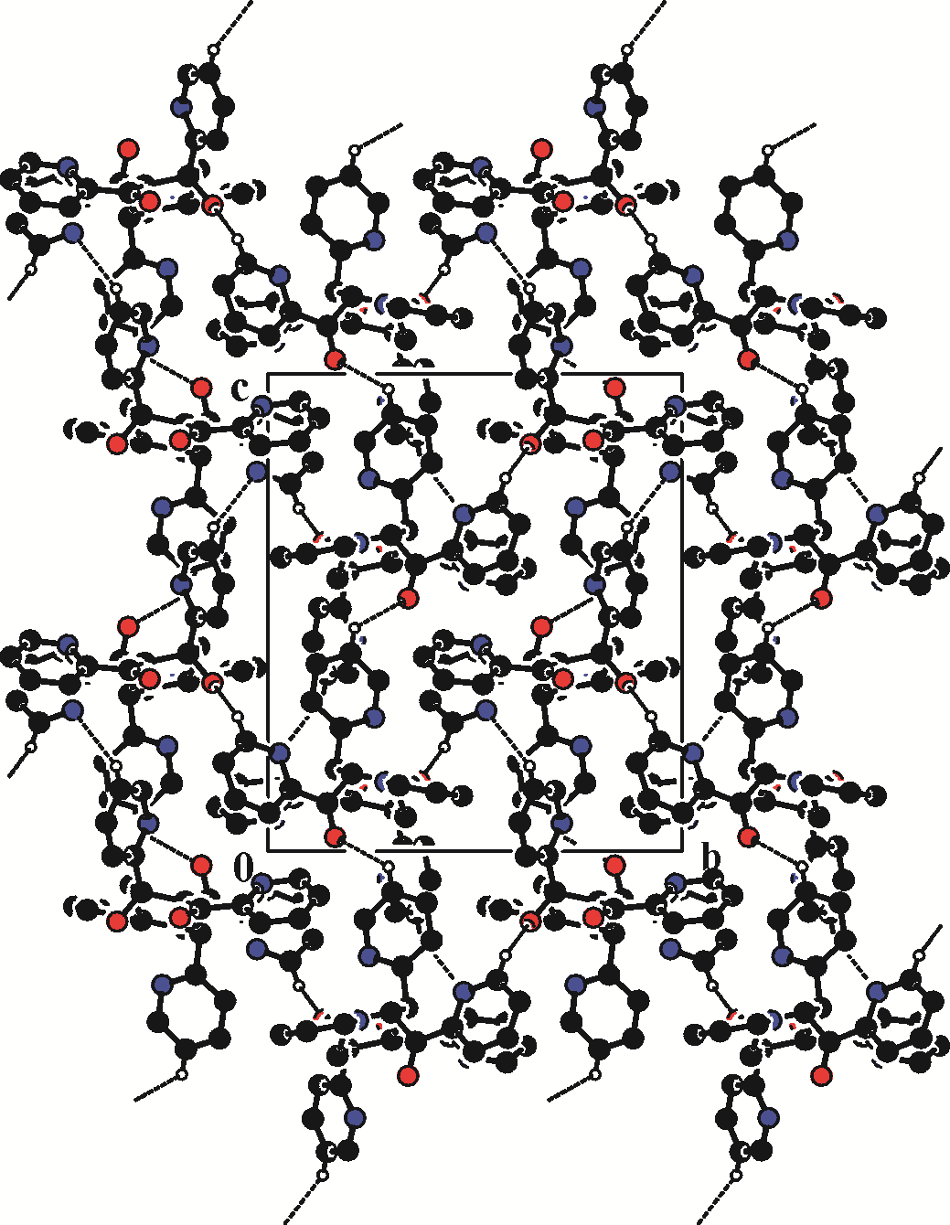
Figure S 3.1: Packing of the molecules viewed down the a axis showing the 3D molecular network in 6.
Table S 1: Crystallographic data, details of data collection and structure refinement parameters
for compounds 5 and 6.
Compound | 5 | 6
CCDC | 1880245 | 1880244
Chemical formula | C₂₇H₂₄N₄O₃ | C₃₃H₂₇N₅O₃
M (g mol⁻¹) | 452.50 | 541.60
Temperature, (K) | 293(2) | 293(2)
Wavelength, (Å) | 0.71073 | 0.71073
Crystal system | triclinic | monoclinic
Space group | P-1 | P2₁/c
a (Å) | 10.0138(12) | 11.8346(4)
b (Å) | 10.7521(15) | 14.3760(6)
c (Å) | 11.5927(14) | 19.5697(7)
α (⁰) | 87.587(11) | 90
β (⁰) | 88.336(10) | 121.940(2)
γ (⁰) | 9062.875(13) | 90
V ( Å³) | 1109.8(2) | 2825.40(18)
Z, D_{calc} (g cm⁻³) | 2, 1.354 | 4, 1.273
μ (mm⁻¹) | 0.090 | 0.084
F(0 0 0) | 476 | 1136
Goodness-of-fit on F² | 0.906 | 1.067
Final R₁ , wR₂ [I > 2σ(I)] | 0.0663, 0.1370 | 0.0504, 0.1199
R₁ , wR₂ (all data) | 0.1351, 0.1735 | 0.0780, 0.1330
Largest difference in peak and hole (e Å⁻³) | 0.374, -0.187 | 0.179, -0.154

Тable S 2: Selected bond lengths and angles for 5, 6.

Bond lengths | d, Å
Bond lengths | Compound 5 | Compound 6
O(1A)-C(1A) | 1.432(3) | 1.420(2)
O(1B)-C(1B) | 1.217(3) | 1.210(2)
O(1C)-C(1C) | 1.445(3) | 1.213(2)
N(1A)-C(2A) | 1.345(4) | 1.327(2)
N(1A)-C(6A) | 1.326(4) | 1.342(3)
N(1D)-C(2D) | 1.341(4) | 1.333(3)
N(1D)-C(6D) | 1.339(4) | 1.350(3)
N(1C)-C(2C) | 1.336(4) | 1.326(3)
N(1C)-C(6C) | 1.334(4) | 1.336(3)
N(1E)-C(2E) |  | 1.331(2)
N(1E)-C(6E) |  | 1.349(3)
N(1B)-C(2B) | 1.327(4) | 1.334(2)
N(1B)-C(6B) | 1.338(4) | 1.338(3)
C(9)-C(1B) | 1.500(4) | 1.524(2)
C(9)-C(1D) | 1.576(4) | 1.529(3)
C(9)-C(1E) |  | 1.558(2)
C(1E)-C(2E) |  | 1.518(2)
C(1E)-C(7) |  | 1.554(2)
C(7)-C(1C) | 1.531(4) | 1.517(3)
C(7)-C(1A) | 1.532(4) | 1.549(2)
C(1A)-C(8) | 1.537(4) | 1.528(3)
C(8)-C(1D) | 1.528(4) | 1.535(2)
C(2A)-C(3A) | 1.371(4) | 1.372(3)
C(3A)-C(4A) | 1.371(5) | 1.369(4)
C(4A)-C(5A) | 1.381(5) | 1.342(4)
C(5A)-C(6A) | 1.385(5) | 1.362(4)
C(1A)-C(2A) | 1.517(4) | 1.531(3)
C(2B)-C(1B) | 1.526(4) | 1.504(3)
C(2C)-C(1C) | 1.518(4) | 1.501(3)
C(1D)-C(2D) | 1.522(4) | 1.515(3)
Bond angles | ω, deg.
C(2A)-N(1A)-C(6A) | 117.7(3) | 117.0(2)
C(1B)-C(9)-C(1D) | 112.1(3) | 114.39(14)
C(1B)-C(9)-C(1E) |  | 108.68(14)
C(1D)-C(9)-C(1E) |  | 112.70(15)
C(2E)-C(1E)-C(7) |  | 116.87(14)
C(2E)-C(1E)-C(9) |  | 110.28(14)
C(7)-C(1E)-C(9) |  | 111.64(14)
C(1C)-C(7)-C(1A) | 114.2(3) | 115.33(16)
C(1C)-C(7)-C(1E) |  | 108.75(14)
C(1A)-C(7)-C(1E) |  | 116.53(15)
O(1A)-C(1A)-C(8) | 110.6(3) | 108.14(15)
O(1A)-C(1A)-C(2A) | 107.2(2) | 107.49(15)
C(8)-C(1A)-C(2A) | 108.2(2) | 109.21(14)
O(1A)-C(1A)-C(7) | 110.5(2) | 114.50(14)
C(8)-C(1A)-C(7) | 109.4(2) | 109.00(15)
C(2A)-C(1A)-C(7) | 110.9(3) | 108.40(15)
C(1A)-C(8)-C(1D) | 114.0(2) | 111.23(14)
C(2D)-C(1D)-C(9) | 112.5(2) | 112.22(16)
C(2D)-C(1D)-C(8) | 111.8(2) | 112.44(15)
C(9)-C(1D)-C(8) | 108.5(3) | 112.04(15)
N(1A)-C(2A)-C(3A) | 121.8(3) | 121.86(19)
N(1A)-C(2A)-C(1A) | 114.8(3) | 116.19(17)
C(3A)-C(2A)-C(1A) | 123.4(3) | 121.95(19)
N(1A)-C(6A)-C(5A) | 123.7(4) | 124.1(2)
N(1D)-C(2D)-C(1D) | 114.7(3) | 117.33(19)
C(3D)-C(2D)-C(1D) | 123.3(3) | 121.0(2)
N(1C)-C(2C)-C(1C) | 117.8(3) | 117.27(18)
N(1E)-C(2E)-C(1E) |  | 118.44(17)
C(3E)-C(2E)-C(1E) |  | 119.96(17)
N(1B)-C(2B)-C(3B) | 124.7(3) | 122.62(19)
N(1B)-C(2B)-C(1B) | 116.8(3) | 117.27(16)
C(3B)-C(2B)-C(1B) | 118.4(3) | 120.10(17)
N(1B)-C(6B)-C(5B) | 123.5(4) | 123.7(2)
O(1B)-C(1B)-C(2B) | 118.5(3) | 119.43(16)
O(1B)-C(1B)-C(9) | 122.3(3) | 123.31(18)
C(2B)-C(1B)-C(9) | 119.2(3) | 117.16(15)
O(1C)-C(1C)-C(2C) | 110.0(2) | 119.22(19)
O(1C)-C(1C)-C(7) | 105.3(2) | 123.7(2)
C(2C)-C(1C)-C(7) | 108.3(3) | 117.11(18)

Table S 3 . Hydrogen bonds in X-ray structures for 5 and 6.

D−H...A | d(D...H), Å | d(H...A), Å | d(D...A), Å | ∠(DHA), deg. | Symmetry transformation for H-acceptor.
Compound 5
O(1A)-H(1A)...O(1C) | 0.82 | 1.98 | 2.689(3) | 144 | x,y,z
O(1C)-H(1C)...O(1B) | 0.82 | 2.21 | 2.799(4) | 129 | x,y,z
O(1C)-H(1C)...N(1D) | 0.82 | 2.26 | 2.929(3) | 139 | 1-x,-y,1-z
C(1D)-H(1D)...O(1C) | 0.98 | 2.53 | 2.913(4) | 103 | x,y,z
C(1D)-H(1D)...O(1B) | 0.98 | 2.51 | 3.405(4) | 152 | 1-x,-y,1-z
C(3A)-H(3A)...O(1A) | 0.93 | 2.36 | 2.705(5) | 102 | x,y,z
C(5C)-H(5C)...O(1B) | 0.93 | 2.54 | 3.318(5) | 141 | -x,1-y,1-z
C(7)-H(7B)...N(1A) | 0.97 | 2.57 | 2.940(4) | 103 | x,y,z
C(8)-H(8A)...N(1A) | 0.97 | 2.53 | 2.906(5) | 103 | x,y,z
C(9)-H(9)...N(1B) | 0.98 | 2.47 | 2.860(5) | 103 | x,y,z
Compound 6
O(1A)-H(1A)...N(1E) | 0.82 | 1.92 | 2.728(2) | 168 | x,y,z
C(1D)-H(1D)...O(1A) | 0.98 | 2.58 | 2.967(3) | 103 | x,y,z
C(3A)-H(3A)...O(1A) | 0.93 | 2.36 | 2.703(3) | 101 | x,y,z
C(5A)-H(5A)...N(1B) | 0.93 | 2.56 | 3.410(3) | 152 | 1+x,3/2-y,1/2+z
C(5E)-H(5E)...O(1B) | 0.93 | 2.58 | 3.260(3) | 131 | x,3/2-y,-1/2+z
C(6B)-H(6B)...O(1A) | 0.93 | 2.54 | 3.275(3) | 136 | -x,-1/2+y,1/2-z
C(7)-H(7)...N(1A) | 0.98 | 2.62 | 3.009(2) | 104 | x,y,z
C(7)-H(7)...N(1C) | 0.98 | 2.46 | 2.845(3) | 103 | x,y,z
C(8)-H(8A)...O(1B) | 0.97 | 2.38 | 3.028(3) | 124 | x,y,z
C(8)-H(8A)...N(1A) | 0.97 | 2.52 | 2.860(3) | 101 | x,y,z
C(9)-H(9)...N(1B) | 0.98 | 2.47 | 2.824(3) | 101 | x,y,z

