Supporting Information
For

SYNTHESIS, CHARACTERIZATION, CRYSTAL STRUCTURE OF NOVEL COMPOUNDS FROM CONDENSATION REACTION BETWEEN
2-ACETYLPYRIDINE AND 2-PYRIDINECARBOXALDEHYDE;
ANTIMICROBIAL, ANTIFUNGAL ACTIVITY

Roman Rusnac^{1*}, Maria Botnaru¹, Nicanor Barba¹, Victor Tsapkov¹, Olga Burduniuc^{2,3}, Greta Balan^{2,3}, Peter Petrenko⁴, Yurii Chumakov ^{4,5}, Aurelian Gulea¹

Laboratory of Scientific Research
"Advanced Materials in Biopharmaceutics and Technique"
¹State University of Moldova, Chisinau, Republic of Moldova
²National Agency for Public Health, Chisinau, Republic of Moldova
³State University of Medicine and Pharmacy "N.Testemitanu", Chisinau, Republic of Moldova
⁴Institute of Applied Physics, Chisinau, Republic of Moldova
⁵Gebze Tehnical University, Kocaeli/Turkey
*Email: Rusnac Roman- romanrusnac8@gmail.com

Antimicrobial (antibacterial and antifungal) activity and antioxidant activity

Methods
Antimicrobial (antibacterial and antifungal) activity.
The antimicrobial activity of the synthesized compounds was tested against Staphylococcus aureus ATCC 25923, Escherichia coli ATCC 25922, KIebsiella pneumonae ATCC 700603 and their anti-fungal activity against Candida albicans ATCC 10231, Candida krusei ATCC 6258, Candida parapsilosis ATCC 22019, Cryptococcus neoformans CECT 1043 strains. Antibacterial and antifungal activity of the synthesized compounds are assessed using the microdilution broth test, which allows determination of minimum inhibitory concentration (MIC) and minimum bactericide/fungicide concentration (MBC/MFC) [1,2]. For MIC assays a stock solution (10 mg/mL) of each test compound was prepared in dimethylsulfoxide (DMSO). This stock solution was then diluted in Muller Hinton Broth (MHB) for bacteria and liquid RPMI 1640 (RPMI) medium with both L-glutamine and 0,165 M MOPS buffer and without sodium bicarbonate was provided (ready for use) for fungi. Further, a serial dilution of test compounds were carried out to achieve concentrations ranging from 500 to 0,24 µg/mL. One hundred microliters of each concentration was introduced into a well (96-well microplate) containing 90 μl of RPMI or MHB, and 10 μl of inoculum (1 × 10⁶ CFU/mL for bacteria and 1 × 10⁵ CFU/ml for yeasts) was added. Plates were covered and incubated on the shaker at 37°C for 24 h (bacteria), 48 h (Candida spp.), and 72 h (Cryptococcus spp.). MICs were assessed visually after the corresponding incubation period and were taken as the lowest sample concentration at which there was no growth or virtually no growth. For the minimum bactericidal and fungicidal concentrations (MMC) determination, 10 μl aliquots from each well that showed no growth of microorganism were plated on Mueller-Hinton Agar or Sabouraud Dextrose Agar and incubated at 37°C for 24 h (bacteria), 48 h (Candida spp.), and 72 h (Cryptococcus spp.). The lowest concentration that yielded no growth after the subculturing was taken as the MBCs or MFCs. Furacilin for bacteria and nystatin for yeasts were used as positive controls and broth with 20 μL of DMSO was used as a negative control. All the experiments were carried out in triplicates.

In vitro antioxidant activity.
ABTS radical cation scavenging activity. The antioxidant activity by the ABTS•+ method was assessed according to the method described [3] with modifications. The ABTS•+ radical was formed through the reaction of ABTS•+ solution 7 mM with potassium persulfate solution 140 mM, incubated at 25 °C in the dark for dilution were transferred in microtitre plate and 180 μl of working solution were dispense 12–16 h. Once formed, the radical was diluted with acetate buffered saline (0.02 M, pH 6,5). Were prepared dilutions of 30 experimental substances in DMSO. After that, 20 μl of each experimental complexes ed with dispense module of hybrid reader (Biotek), shake 15 s. The decrease in Abs. at 734 nm was measured exactly after 30 min of incubation at 25 °C. All the determination was made in triplicate. DMSO was used as control. Trolox and Rutin were used as standard. The percentage inhibition was calculated according to the formula: [(A₀‐A₁)/A₀]×100, where A₀ was the absorbance of the control, and A₁ was the absorbance of the sample. IC₅₀ was calculated using statistical program.
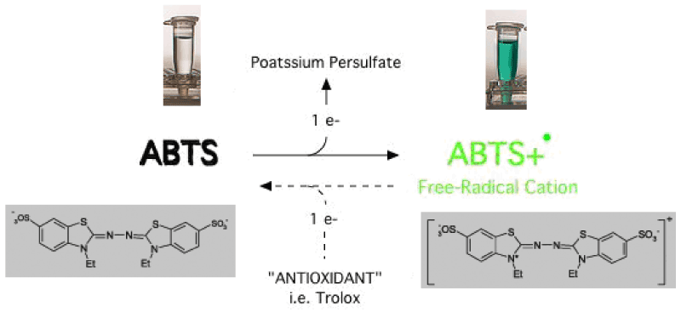
Boligon et al., Med chem 2014, 4:7 DOI: 10.4172/2161-0444.1000188
Figure S1.1: ABTS chemical reaction (adapted of Pannala et al. in 2011 [4]).

Reference
- CLSI, Reference Method for Broth Dilution Antifungal Susceptibility Testing of Yeasts, Approved Standard, 2nd ed., NCCLS document M27-A2. CLSI, 940 West Valley Road, Suite 1400, Wayne, Pennsylvania 19087-1898, USA, 2002.
- CLSI, Methods for Dilution Antimicrobial Susceptibility Tests for Bacteria that Grow Aerobically, Approved Standard, 9th ed., CLSI document M07-A9. Clinical and Laboratory Standards Institute, 950 West Valley Road, Suite 2500, Wayne, Pennsylvania 19087, USA, 2012.
- Re R., Pellegrini N., Proteggente A., Pannala A., M. Yang, Rice-Evans C. Antioxidant activity applying an improved ABTS radical cation decolorization assay. Free Radic. Biol. Med. 1999; 26(9-10), p. 1231-1237.
- Sekher Pannala A, Chan TS, O'Brien PJ, Rice-Evans CA (2001) Flavonoid B-ring chemistry and antioxidant activity: fast reaction kinetics. Biochem Biophys Res Commun 282, p. 1161-1168.

