Supporting Information

Facile synthesis and assessment of 2-alkoxy-4-(4-hydroxyphenyl)-6-arylnicotinonitrile derivatives as new inhibitors for C1018-steel corrosion in HCl: A combined theoretical and experiential investigations
Hany M. Abd El-Lateef^{a,b}*¹, Antar A. Abdelhamid^{c}*¹, Mounir A.A. Mohamed^{d}, Amr H. Moustafa^{c}
ª Physical Chemistry Lab., Chemistry Department, Faculty of Science, Sohag University, 82524 Sohag, Egypt
^{b}Department of Chemistry, College of Science, King Faisal University, Al Hufuf, 31982 Al Hassa, Saudi Arabia
^{c} Synthetic Organic Chemistry Lab., Chemistry Department, Faculty of Science, Sohag University, 82524 Sohag, Egypt
^{d} Theoretical Chemistry Lab., Chemistry Department, Faculty of Science, Sohag University, 82524 Sohag, Egypt

* Corresponding authors: hmahmed@kfu.edu.sa, Hany_shubra@yahoo.co.uk (Hany M. Abd El-Lateef); drantar25@yahoo.com (Antar A. Abdelhamid)

1. General Information:

All commercially available reagents were purchased from Merck, Aldrich and Fluka and were used without further purification. All reactions were monitored by thin layer chromatography (TLC) using precoated plates of silica gel G/UV-254 of 0.25 mm thickness (Merck 60F254) using UV light (254 nm/365 nm) for visualization. Melting points were detected with a Kofler melting points apparatus and uncorrected. Infrared spectra were recorded with a FT-IR-ALPHBROKER-Platinum-ATR spectrometer and are given as cm⁻¹ using the attenuated total reflection (ATR) method. ¹H NMR and ¹³C NMR spectra for all compounds were recorded in DMSO-d₆ on a Bruker Bio Spin AG spectrometer at 400 MHz and 100 MHz, respectively. For ¹H NMR, chemical shifts (δ) were given in parts per million (ppm) with reference to tetramethylsilane (TMS) as an internal standard (δ=0); coupling constants (J) were given in hertz (Hz) and data are reported as follows: chemical shift, integration, multiplicity (s=singlet, d=doublet, t=triplet, q=quartet, m=multiplet). For ¹³C NMR, TMS (δ=0) or DMSO (δ=39.51) was used as internal standard and spectra were obtained with complete proton decoupling. Elemental analyses were obtained on a Perkin-Elmer CHN-analyzer model.

2. General Procedure for the Synthesis of 2-Alkoxy-4-(4-Hydroxyphenyl)-6-Arylnicotinonitrile (AHAN-1, AHAN-2, AHAN-3, and AHAN-4):

An equimolar amount of 4-hydroxybenzaldehyde (2 mmol, 0.244 g) and appropriate acetophenones: acetophenone, 4-methyl- , 4-methoxyacetophenone (2 mmol) was added to 4.2 mmol of sodium alkoxide solution (RONa, prepared by dissolving 0.1 g of sodium metal in 50 mL of appropriate alcohol: CH₃OH and/or cellosolve). The reaction mixture was stirred for 30 mins at room temperature (25-30 °C) and allowed at the same temperature for overnight. Malononitrile (2 mmoles, 0.14 g) was then added to the reaction mixture and refluxed for 2–4 hrs (monitored by TLC). The reaction mixture was allowed to cool and added dropwise onto crushed-ice, (in case AHAN-2, after cooling the reaction, the formed precipitate of AHAN-2 was collected and filtered as sodium salt without acidification). The solution was filtered off from impurities, and the filtrate was acidified by using HCl solution. The formed precipitate was collected, filtered, dried and recrystallized from ethanol.

4. Characterization Data of (AHAN-1, AHAN-2, AHAN-3, and AHAN-4):

4-(4-Hydroxyphenyl)-2-methoxy-6-(4-methylphenyl)nicotinonitrile (AHAN-1):

Yield 96 %; white solid; m.p.: 266-267 °C. IR (ATR) ν_{max} 3334 (O-H), 3063, 3019 (C-H aromatic), 2980, 2946 (C-H aliphatic), 2227 (C≡N), 1612 (C=N) cm⁻¹; ¹H NMR (400 MHz, DMSO-d₆) δ (ppm): 2.37 (s, 3H, CH₃), 4.10 (s, 3H, OCH₃), 6.94-6.96 (d, J = 8.2 Hz, 2H, CH_{arom.}), 7.30-7.32 (d, J = 7.7 Hz, 2H, CH_{arom.}), 7.58-7.60 (d, J = 8.2 Hz, 2H, CH_{arom.}), 7.62 (s, 1H, CH_{arom.}), 8.08-8.10 (d, J = 7.8 Hz, 2H, CH_{arom.}), 10.05 (s, 1H, OH); ¹³CNMR (100 MHz, DMSO-d₆) δ (ppm): 21.4, 54.7, 91.6, 113.3, 116.1, 116.2, 126.8, 127.7, 129.9, 130.6, 134.5, 140.9, 156.6, 157.5, 159.8, 164.9. Elemental Analysis Calcd. (%) for C₂₀H₁₆N₂O₂ (316.35): C, 75.93; H, 5.10; N, 8.86. Found: C, 75.88; H, 5.13; N, 8.74.

Sodium 4-[3-cyano-2-(2-ethoxyethoxy)-6-phenylpyridin-4-yl]phenolate (AHAN-2):
Yield 95 %; white solid; m.p.: 300-310 °C (Dec.). IR (ATR) ν_{max} 3356 (O-H), 3065 (C-H aromatic), 2974, 2950, 2873 (C-H aliphatic), 2229 (C≡N), 1608 (C=N) cm⁻¹; ¹H NMR (400 MHz, DMSO-d₆) δ (ppm): 1.11-1.15 (t, J = 7.0 Hz, 3H, CH₃), 3.53-3.58 (q, J = 7.0 Hz, 2H, CH₃CH₂), 3.80-3.83 (t, J = 4.7 Hz, 2H, CH₂), 4.68-4.70 (t, J = 4.8 Hz, 2H, CH₂), 6.95-6.97 (d, J = 8.6 Hz, 2H, CH_{arom.}), 7.52-7.55 (m, 3H, CH_{arom.}), 7.62-7.64 (d, J = 8.6 Hz, 2H, CH_{arom.}), 7.71 (s, 1H, CH_{arom.}), 8.20-8.22 (m, 2H, CH_{arom.}); ¹³CNMR (100 MHz, DMSO-d₆) δ (ppm): 15.5, 66.2, 67.0, 68.3, 92.2, 113.8, 116.1, 116.2, 126.8, 127.8, 129.3, 130.7, 131.0, 137.3, 156.9, 157.5, 159.9, 164.7. Elemental Analysis Calcd. (%) for C₂₂H₁₉N₂NaO₃ (382.38): C, 69.10; H, 5.01; N, 7.33. Found: C, 69.03; H, 4.89; N, 7.31.

2-(2-Ethoxyethoxy)-4-(4-hydroxyphenyl)-6-(4-methylphenyl)nicotinonitrile (AHAN-3):
Yield 94 %; white solid; m.p.: 162-164 °C. IR (ATR) ν_{max} 3298 (O-H), 3027 (C-H aromatic), 2969, 2917, 2866 (C-H aliphatic), 2229 (C≡N), 1615 (C=N) cm⁻¹; ¹H NMR (400 MHz, DMSO-d₆) δ (ppm): 1.14-1.15 (t, 3H, CH₃), 2.39 (s, 3H, Ar-CH₃), 3.58 (q, 2H, CH₃CH₂), 3.82 (t, 2H, CH₂CH₂), 4.70 (t, 2H, CH₂CH₂), 6.96 (s, 2H, CH_{arom.}), 7.34 (s, 2H, CH_{arom.}), 7.68 (s, 1H, CH_{arom.}), 8.12 (s, 2H, CH_{arom.}), 9.91 (s, 1H, OH); ¹³CNMR (100 MHz, DMSO-d₆) δ (ppm): 15.5, 21.4, 66.2 (disappeared by Dept-135), 66.9 (disappeared by Dept-135), 68.4 (disappeared by Dept-135), 91.8, 113.4, 116.1, 126.9, 127.8, 128.0, 129.9, 130.7, 134.6, 140.9, 156.8, 157.5, 159.8, 164.6. Elemental Analysis Calcd. (%) for C₂₃H₂₂N₂O₃ (374.43): C, 73.78; H, 5.92; N, 7.48. Found: C, 73.72; H, 5.75; N, 7.35.

2-(2-Ethoxyethoxy)-4-(4-hydroxyphenyl)-6-(4-methoxyphenyl)nicotinonitrile (AHAN-4):
Yield 88 %; white solid; m.p.: 200-202 °C. IR (ATR) ν_{max} 3284 (O-H), 3025 (C-H aromatic), 2974, 2913, 2867 (C-H aliphatic), 2225 (C≡N), 1607 (C=N) cm⁻¹; ¹H NMR (400 MHz, DMSO-d₆) δ (ppm): 1.13-1.16 (t, J = 6.9 Hz, 3H, CH₃), 3.55-3.60 (q, J = 6.9 Hz, 2H, CH₃CH₂), 3.81-3.83 (t, J = 4.3 Hz, 2H, CH₂), 3.85 (s, 3H, OCH₃), 4.67-4.70 (t, J = 4.3 Hz, 2H, CH₂), 6.95-6.97 (d, J = 8.3 Hz, 2H, CH_{arom.}), 7.06-7.09 (d, J = 8.4 Hz, 2H, CH_{arom.}), 7.61-7.63 (d, J = 8.3 Hz, 2H, CH_{arom.}), 7.64 (s, 1H, CH_{arom.}), 8.18-8.20 (d, J = 8.4 Hz, 2H, CH_{arom.}), 9.93 (s, 1H, OH); ¹³CNMR (100 MHz, DMSO-d₆) δ (ppm): 15.5, 55.9, 66.2 (disappeared by Dept-135), 66.9 (disappeared by Dept-135), 68.4 (disappeared by Dept-135), 91.2, 112.9, 114.8, 116.1, 127.0, 129.5, 129.8, 130.5, 130.6, 156.7, 157.3, 159.8, 161.9, 164.6. Elemental Analysis Calcd. (%) for C₂₃H₂₂N₂O₄ (390.43): C, 70.75; H, 5.68; N, 7.17. Found: C, 70.82; H, 5.49; N, 7.15.
¹H and ¹³C NMR Spectra of AHAN-1:
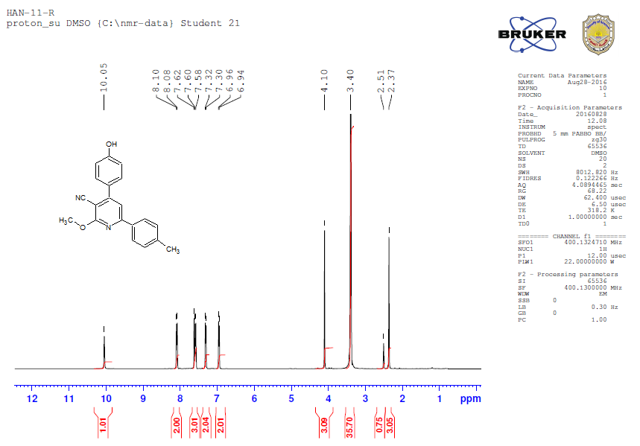
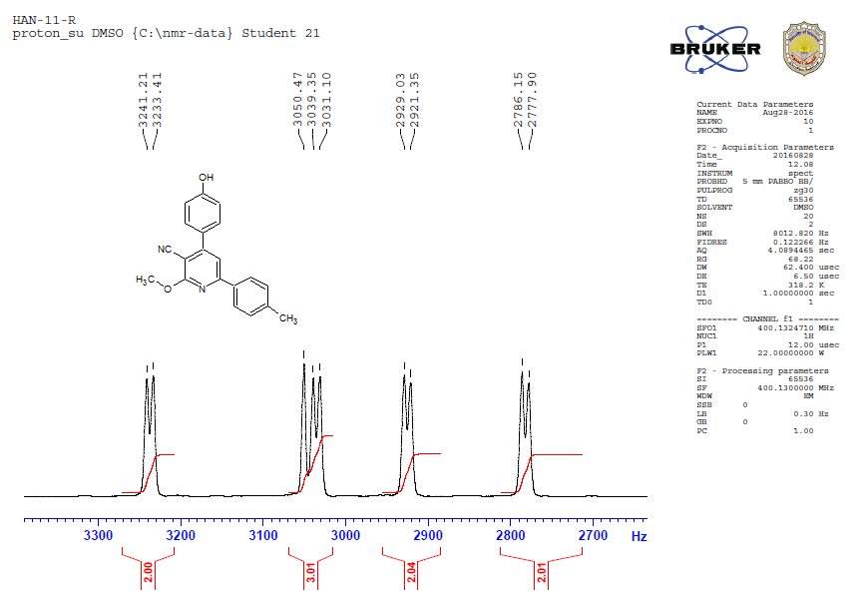

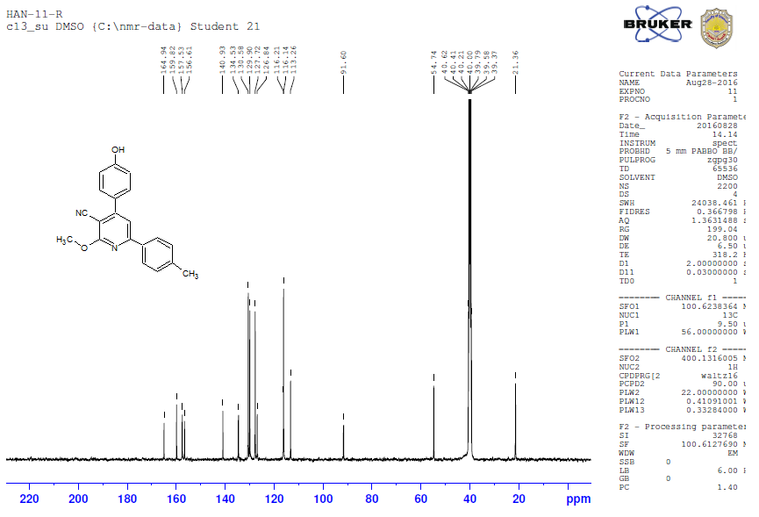
¹H and ¹³C NMR Spectra of AHAN-2:
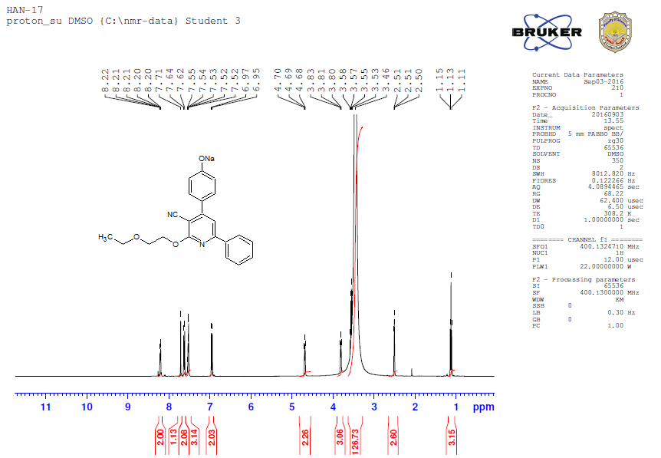
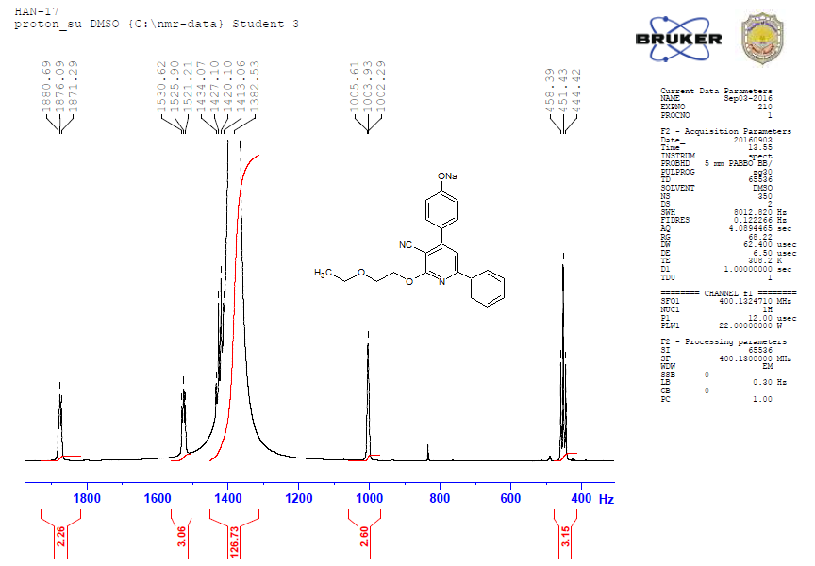
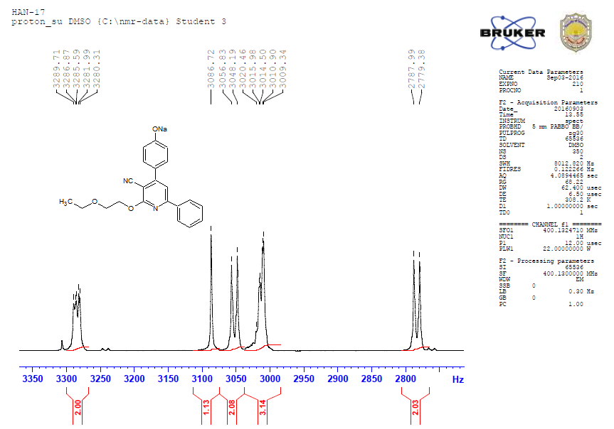
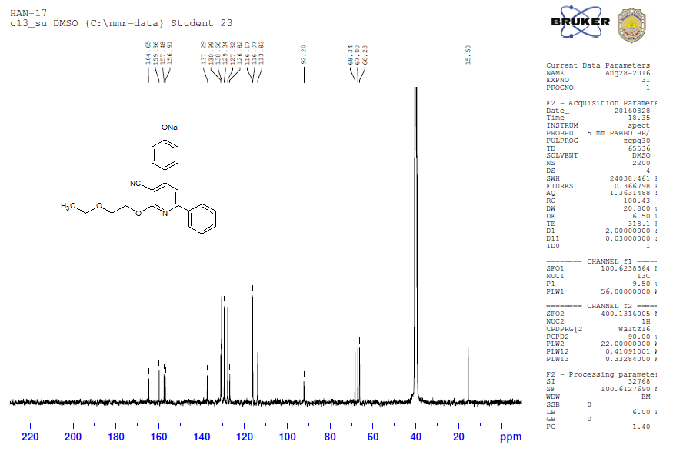
¹H, ¹³C NMR and Dept-135 Spectra of AHAN-3:
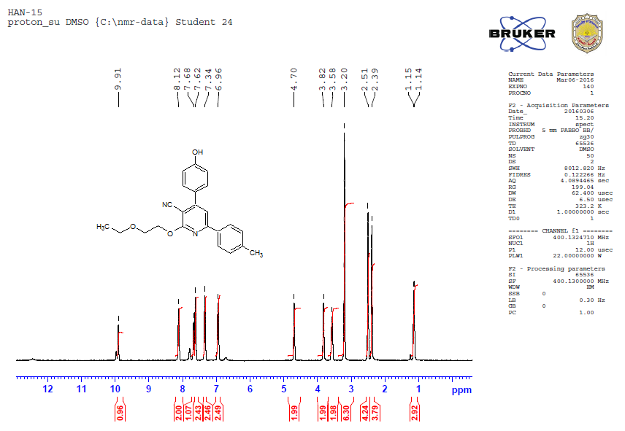
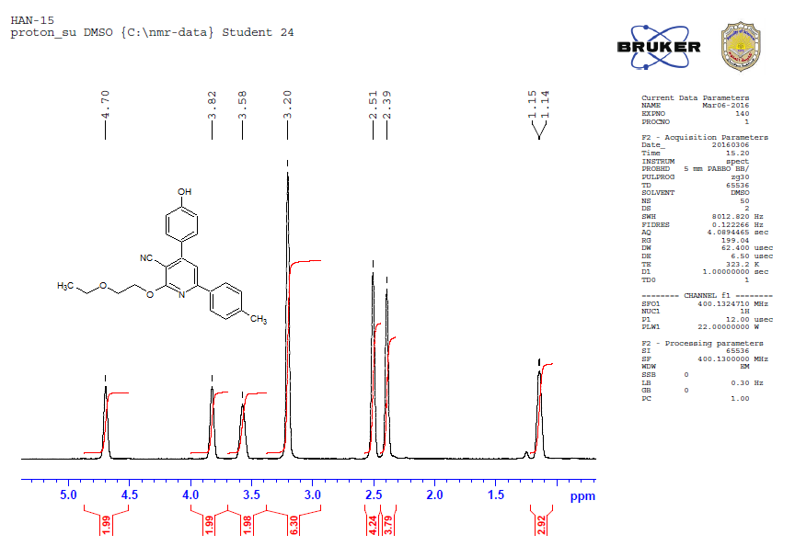
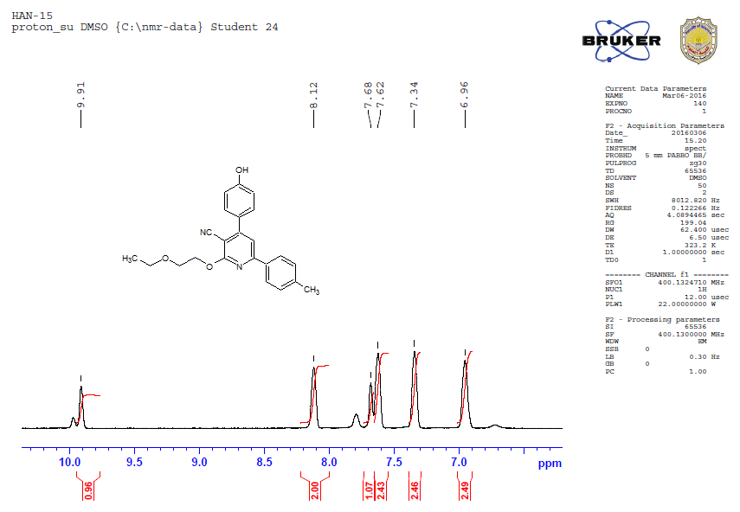
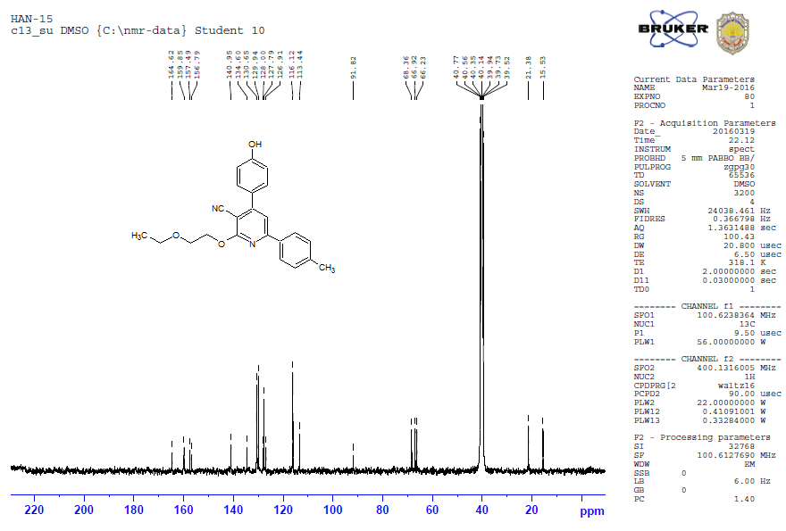
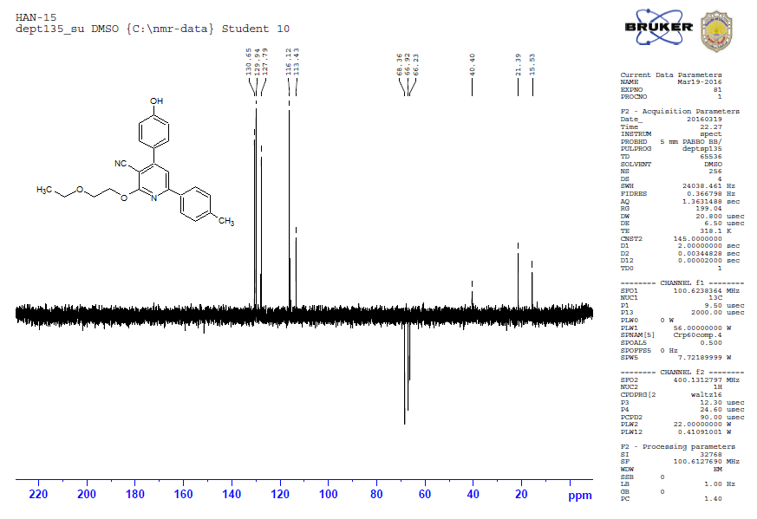
¹H, ¹³C NMR and Dept-135 Spectra of AHAN-4:
