Supporting Information

Interaction of Small Biothiols with Silver and Gold Nanoparticles

Barbara Pem, Igor M. Pongrac, Lea Ulm, Ivan Pavičić, Valerije Vrček,Darija Domazet Jurašin, Marija Ljubojević, Adela Krivohlavek, Ivana Vinković Vrček

Figure S1. The percentage of research papers focusing on silver (AgNPs) and gold nanoparticles (AuNPs) out of the total amount of papers discussing nanoparticles for biomedical applications (larger chart). Two smaller charts present the percentage of papers on interaction of AgNPs and AuNPs with cysteine (CYS) or glutathione (GSH).
Figure S2. ¹H NMR spectrum of the mixture cysteine : cystine = 25 : 1, in D₂O. Commercial samples (Sigma Aldrich) of both compounds were used.
Figure S3. ¹³C NMR spectrum of the reaction mixture cysteine : NaBH₄ = 1 : 10, in D₂O. The aliqout is taken after 75 min. The arrows show how signals (for cysteine and cystine) change with time.
Figure S4. ¹H NMR spectra of the reaction mixture aliquots (cysteine : NaBH₄ = 1 : 10, in ultrapure water/ D₂O added) taken at several time points. The arrows show how signals (for cysteine and cystine) change with time. Upfield signals correspond to NaBH₄.
Figure S5. ¹H NMR spectra of the reaction mixture aliquots (GSH : NaBH₄ = 1 : 10, in ultrapure water/D₂O added) taken at several time points.
Figure S6. Uptake of silver (AgNPs) and gold nanoparticles (AuNPs) stabilized with cysteine (CYS) or glutathione (GSH) in L929 cells.
Table S1. List of different methods employed for preparation of silver nanoparticles (AgNPs) in the presence of cysteine (CYS) and glutathione (GSH).
Table S2. List of different methods employed for preparation of gold nanoparticles (AuNPs) in the presence of cysteine (CYS) and glutathione (GSH).
Table S3. Overview of published data on the toxic effects of silver (AgNPs) and gold nanoparticles (AuNPs) to L929 cells in vitro, depending on their physico-chemical properties and concentration.
Table S4. Overview of the results of 48 h acute toxicity testing of gold and silver nanoparticles to Daphnia magna Straus, depending on their physico-chemical properties and concentration.
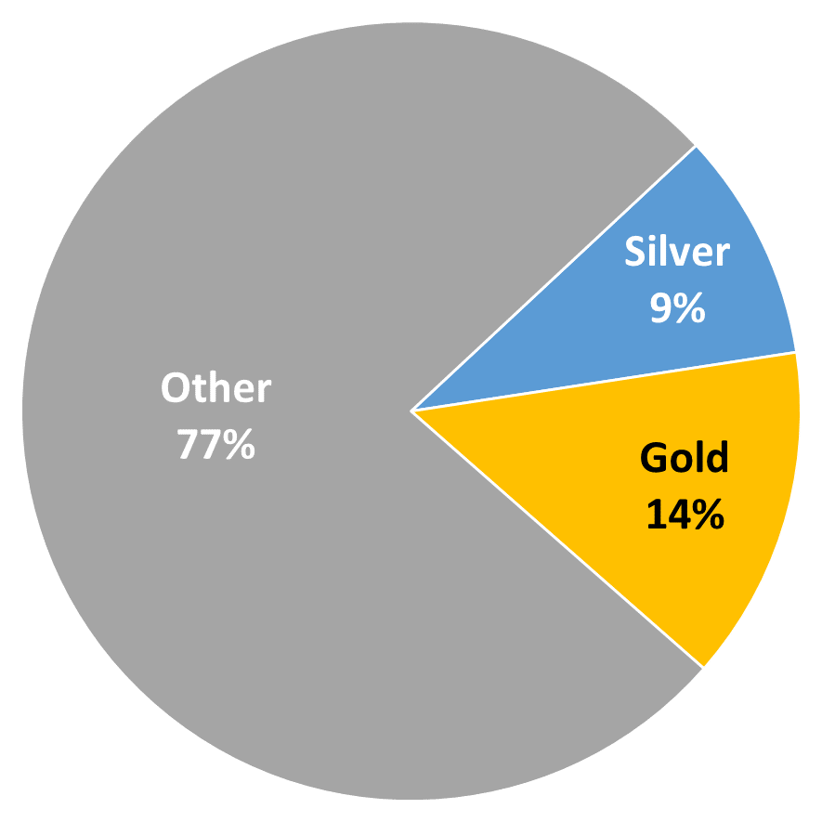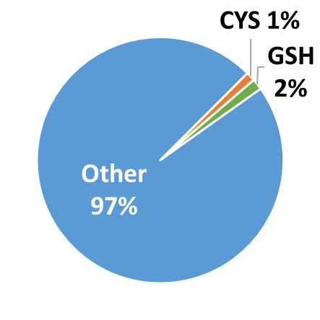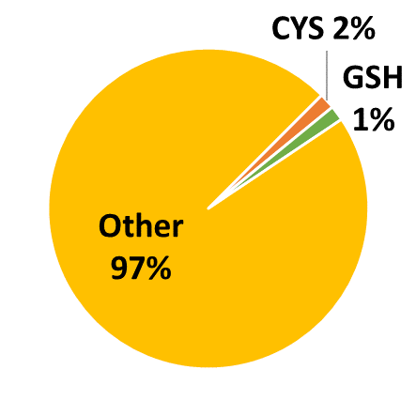
Figure S1. The percentage of research papers focusing on silver (AgNPs) and gold nanoparticles (AuNPs) out of the total amount of papers discussing nanoparticles for biomedical applications (larger chart). Two smaller charts present the percentage of papers on interaction of AgNPs and AuNPs with cysteine (CYS) or glutathione (GSH).

NMR analysis 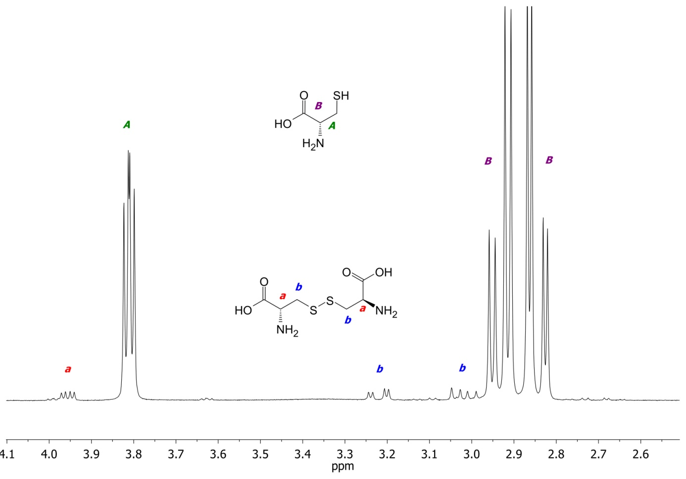
Figure S2. ¹H NMR spectrum of the mixture cysteine : cystine = 25 : 1, in D₂O. Commercial samples (Sigma Aldrich) of both compounds were used.
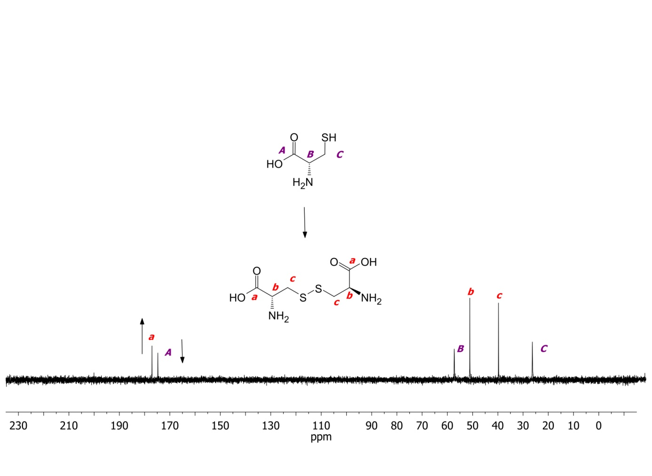
Figure S3. ¹³C NMR spectrum of the reaction mixture cysteine : NaBH₄ = 1 : 10, in D₂O. The aliqout is taken after 75 min. The arrows show how signals (for cysteine and cystine) change with time.
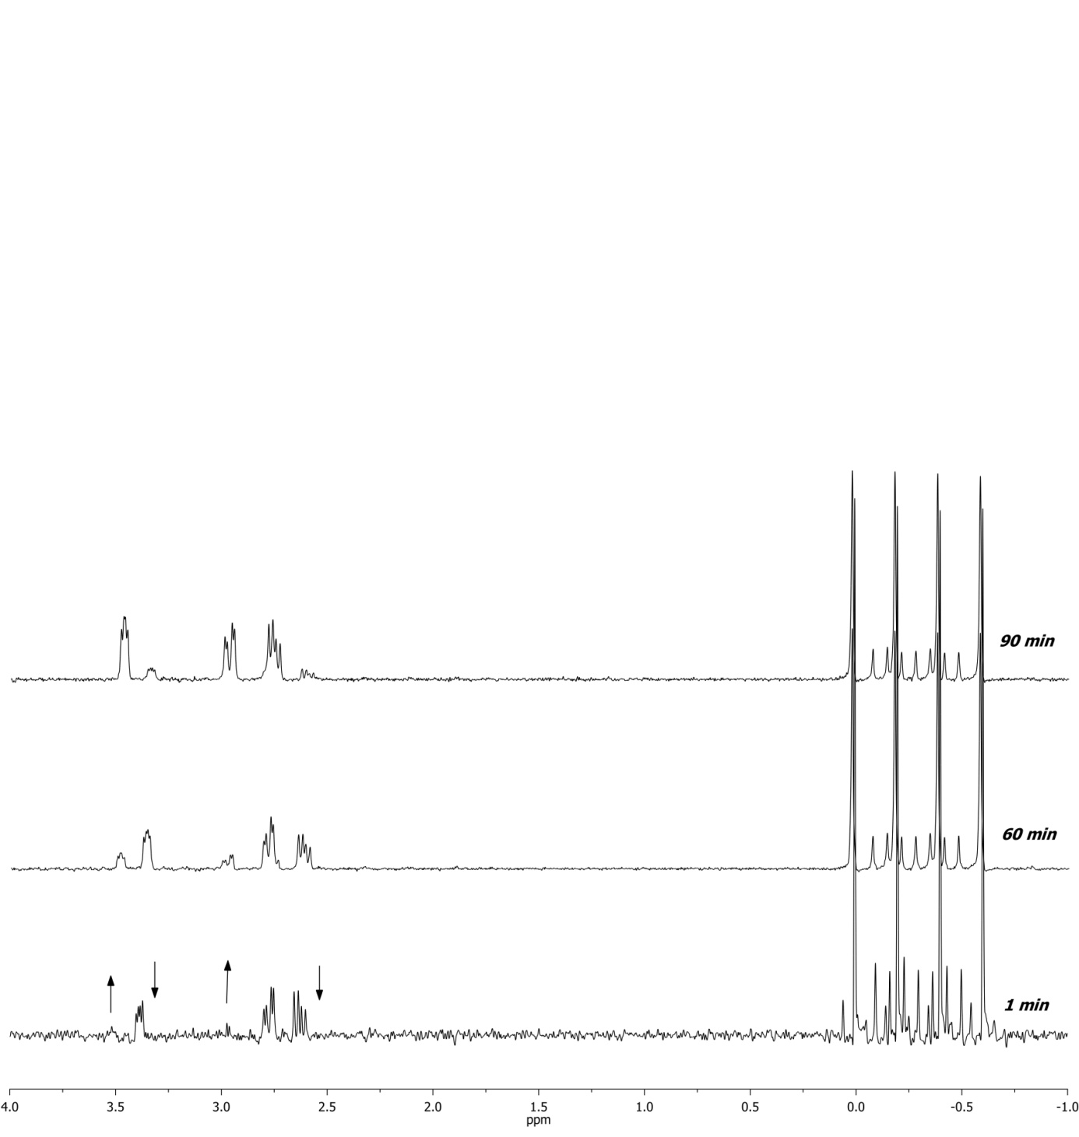
Figure S4. ¹H NMR spectra of the reaction mixture aliquots (cysteine : NaBH₄ = 1 : 10, in ultrapure water/D₂O added) taken at several time points. The arrows show how signals (for cysteine and cystine) change with time. Upfield signals correspond to NaBH₄.

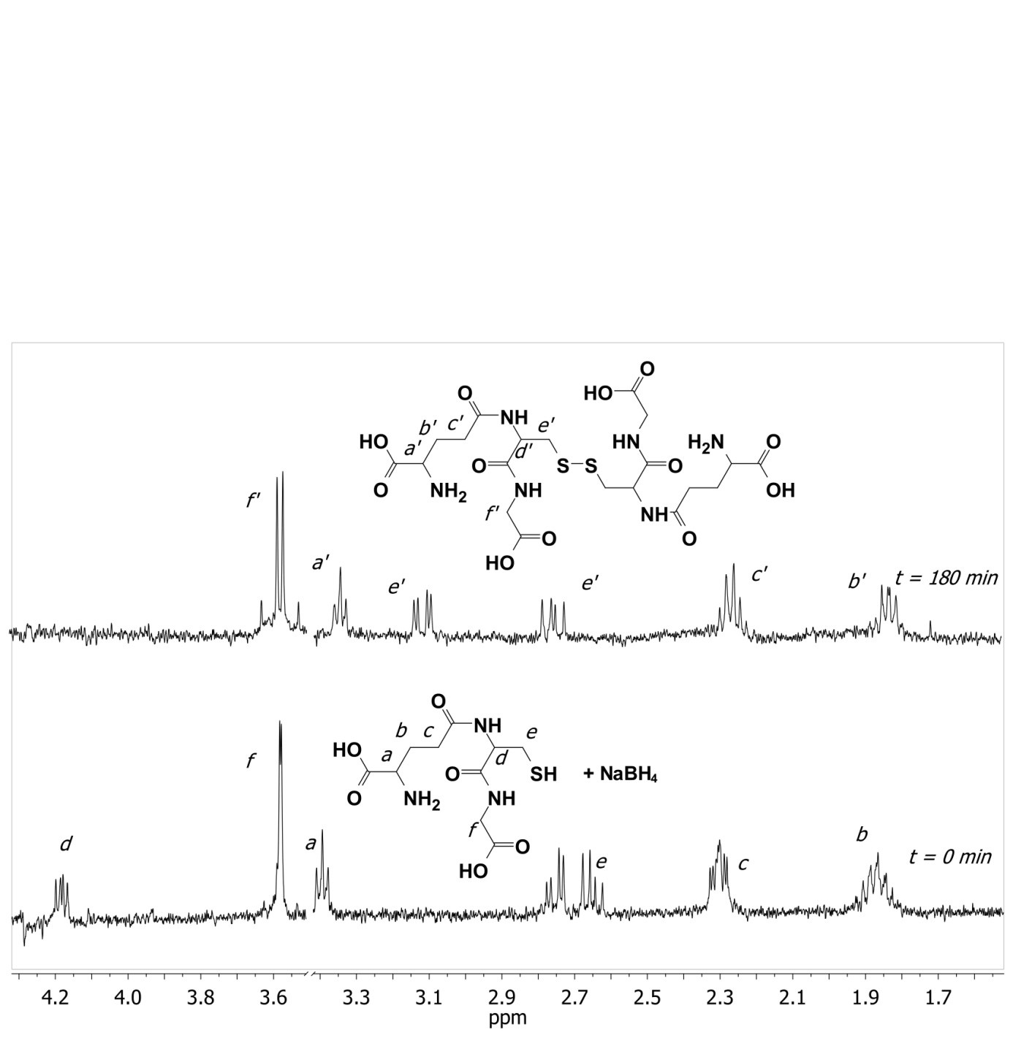
Figure S5. ¹H NMR spectra of the reaction mixture aliquots (GSH : NaBH₄ = 1 : 10, in ultrapure water/D₂O added) taken at several time points.

Figure S6. Uptake of silver (AgNPs) and gold nanoparticles (AuNPs) stabilized with cysteine (CYS) or glutathione (GSH) in L929 cells.

Table S1. List of different methods employed for preparation of silver nanoparticles (AgNPs) in the presence of cysteine (CYS) and glutathione (GSH).
Biothiol |  | [AgNO₃], mM | [AgNO₃]:[NaBH₄]:[biothiol] |  | Last added reactant |  | Visual observation |  | Size [nm] (% Volume)
CYS | 1 |  |  | 1 : 2 : 0.2 | CYS | Brown, stable |  | 3.0 ± 0.3 (100%)
CYS | 1 |  |  | 1 : 2 : 0.2 | NaBH₄ | Dark brown, stable |  | 15.5 ± 2.0 (100%)
CYS | 1 |  |  | 1 : 2 : 0.5 | CYS | Brown-gray, stable |  | n.a.
CYS | 1 |  |  | 1 : 2 : 0.5 | NaBH₄ | Dark gray, black precipitate |  | n.a.
CYS | 1 |  |  | 1 : 10 : 0.2 | CYS | Brown, unstable |  | 3.3 ± 0.6 (100%)
CYS | 1 |  |  | 1 : 10 : 0.2 | NaBH₄ | Brown, unstable |  | 1.7 ± 0.8 (98%)  15.2 ± 1.7 (2%)
CYS | 5.6 |  |  | 1 : 10 : 1 | NaBH₄ | Dark greenish-gray, stable but precipitates |  | 8.0 ± 0.9 (99%)  30.9 ± 9.8 (<1%)
GSH | 1 |  |  | 1 : 2 : 0.2 | GSH | Brown, stable |  | 4.8 ± 1.2 (99%)  51.6 ± 3.4 (<1%)
GSH | 1 |  |  | 1 : 2 : 0.2 | NaBH₄ | Dark brown, stable |  | n.a.
GSH | 1 |  |  | 1 : 2 : 0.5 | GSH | Brownish-gray, stable |  | n.a.
GSH | 1 |  |  | 1 : 2 : 0.5 | NaBH₄ | Dark gray, black precipitate |  | n.a.
GSH | 1 |  |  | 1 : 10 : 0.2 | GSH | Brownish, stable |  | 14.6 ± 3.1 (18%)  46.9 ± 6.3 (82%)
GSH | 5.6 |  |  | 1 : 10 : 1 | NaBH₄ | Brown, stable |  | 6.0 ± 1.2 (99%)  315.1 ± 74.3 (<1%)

Table S2. List of different methods employed for preparation of gold nanoparticles (AuNPs) in the presence of cysteine (CYS) and glutathione (GSH).
Biothiol | [HAuCl₄], mM | [HAuCl₄]:[NaBH₄]:[biothiol] | Last added reactant | Visual observation | Size [nm] (% Volume)
CYS | 1 | 1 : 2 : 0.2 | CYS | Dark red, turns blue-gray, unstable | n.a.
CYS | 1 | 1 : 2 : 0.2 | NaBH₄ | Unstable | n.a.
CYS | 1 | 1 : 2 : 1 | CYS | Purple, precipitates | n.a.
CYS | 1 | 1 : 2 : 1 | NaBH₄ | Unstable, black precipitate | n.a.
CYS | 1 | 1 : 10 : 0.2 | NaBH₄ | Yellow, turns purple, stable | 10.7 ± 3.7 (30%)  48.5 ± 5.8 (70%)
CYS | 3 | 1 : 10 : 1 | NaBH₄ | Yellow, turns purple, stable but precipitates | 24.2 ± 3.4 (54%)  80.0 ± 2.1 (10%)  21.7 ± 4.8 (35%)
GSH | 1 | 1 : 2 : 0.2 | GSH | Dark grey, unstable | n.a.
GSH | 1 | 1 : 2 : 0.2 | NaBH₄ | Dark grey. unstable | n.a.
GSH | 1 | 1 : 2 : 1 | GSH | Red, unstable | n.a.
GSH | 1 | 1 : 2 : 1 | NaBH₄ | Brown, unstable | n.a.
GSH | 1 | 1 : 10 : 0.2 | NaBH₄ | Yellow, turns purple, stable | 10.2 ± 1 (48%)  37.4 ± 6.5 (29%)  168.4 ± 67.3 (22%)
GSH | 3 | 1 : 10 : 1 | NaBH₄ | Yellow, turns reddish, stable | 6.4 ± 0.8 (65%)  65.1 ± 3.8 (33%)

Table S3. Overview of published data on the toxic effects of silver (AgNPs) and gold nanoparticles (AuNPs) to L929 cells in vitro, depending on their physico-chemical properties and concentration.
NP type | Size [nm] | ζ [mV] | Coating | Concentration applied, mg L⁻¹ | Endpoint measured | Method | Result | Refe-rence
AuNP | 36.3 ± 12.4 | -49.4 ± 3.0 | PVP | 1 – 400 | viability | WST-8 | No reduction in viability at highest concentration | [1]
AuNP | 0.8, 1.2, 1.4, 1.8, 15.0 | / | TPPMS^{I} | / | viability | MTT | Viability reduction in NPs of 1.8 nm or smaller; EC₅₀ 250 µm, 140 µm, 56 µm, 230 µm, respectively | [2]
AuNP | 19 ± 3 | -35.7 | citrate | 1 – 25 | viability | MTT | Significant cell death at 5 µg/mL or higher, after 48 h exposure, EC₅₀ 18. mg L⁻¹ | [3]
AgNP | / | / | PVP | 25 – 100 | apoptosis | annexinV/PI | >90% live cells after 24h, 5.5% early apoptotic at highest conc., no necrosis | [5]
AgNP | 5 | / | PVP | 0.1 – 100 | viability | MTT | Significant cell death at 25 µg/mL (cca 50%) | [6]
^{I} triphenylphosphine monosulfonated

Table S4. Overview of the results of 48 h acute toxicity testing of gold and silver nanoparticles to Daphnia magna Straus, depending on their physico-chemical properties and concentration.
NP type | Size [nm] | ζ [mV] | Coating | Concentration(s) applied | Result | Reference
AgNP | 55.4 ± 10.1 and  89.3 ± 21.5 | -33,6±8.3 and  -25,7 ± 7,9 | PVP | N/A | 100% mortality at 100 µg L⁻¹, no mortality below 10 µg L⁻¹ | [7]
AgNP | 39 ± 10 | -0.13 | PVP | N/A | EC₅₀ 14.81 µg L⁻¹ | [8]
AgNP | 8.4 ± 2.8 | / | PVP | N/A | EC₅₀ 54.0 ± 1.4 µg L⁻¹ | [9]
AgNP | 35 | / | PVP | N/A | EC₅₀ 10.48 ± 3.23 µg L⁻¹ | [10]
AgNP | 40-50 | -19.6 ± 3.5 | carbonate | 20, 50, 100, 200 and 500 mg L⁻¹ | No mortality up to 500 mg L⁻¹ | [11]
AgNP | 28.3 ± 0.8 | / | PVP | 0−51  nmol L⁻¹ | EC₅₀ 55 ± 16 nmol L⁻¹ | [12]
AuNP | 21 | / | bare | N/A | EC₅₀ ∼70 mg L⁻¹ | [13]
AuNP | 14 ± 4 | −14 ± 8 | citrate | 0.1 – 10 mg L⁻¹ | EC₁₀ ≥ 10 mg L⁻¹ | [14]
AuNP | 17.9 ± 0.9 | 17.9 ± 0.9 | PAH^{I} | 0.001–25 mg L⁻¹ | 40% mortality at 10 µg/L | [15]
AuNP | 12.8 ± 1.2 | −15.3 ± 1.5 | citrate | 0.001–25 mg L⁻¹ | No mortality at highest conc. | [15]
AuNP | 8.0 ± 1.2 | −18.5 ± 1.3 | MPA^{II} | 0.001–25 mg L⁻¹ | No mortality at highest conc. | [15]
^{I} polyallylamine hydrochloride
^{II} 3-mercaptopropionic acid

References
[1] M. Hashimoto, S. Yamaguchi, J. I. Sasaki, K. Kawai, H. Kawakami, Y. Iwasaki, S. Imazato, Eur. J. Oral Sci. 2016, 124, 68.
[2] Y. Pan, S. Neuss, A. Leifert, M. Fischler, F. Wen, U. Simon, G. Schmid, W. Brandau, W. Jahnen-Dechent, Small 2007, 3, 1941.
[3] G. Tan, M. A. Onur, J. Biomed. Mater. Res. - Part A 2018, 106, 1708.
[4] E. J. Park, J. Yi, Y. Kim, K. Choi, K. Park, Toxicol. Vitr. 2010, 24, 872.
[5] L. Wei, J. Tang, Z. Zhang, Y. Chen, G. Zhou, T. Xi, Biomed. Mater. 2010, 5, 044103.
[6] A. S. Takamiya, D. R. Monteiro, D. G. Bernabé, L. F. Gorup, E. R. Camargo, J. E. Gomes-Filho, S. H. P. Oliveira, D. B. Barbosa, J. Endod. 2016, 42, 953.
[7] L. Z. Li, H. Wu, C. Ji, C. A. M. van Gestel, H. E. Allen, W. J. G. M. Peijnenburg, Ecotoxicol. Environ. Saf. 2015, 119, 66.
[8] K. M. Newton, H. L. Puppala, C. L. Kitchens, V. L. Colvin, S. J. Klaine, Environ. Toxicol. Chem. 2013, 32, 2356.
[9] I. Blinova, J. Niskanen, P. Kajankari, L. Kanarbik, A. Käkinen, H. Tenhu, O. P. Penttinen, A. Kahru, Environ. Sci. Pollut. Res. 2013, 20, 3456.
[10] H. C. Poynton, J. M. Lazorchak, C. A. Impellitteri, B. J. Blalock, K. Rogers, H. J. Allen, A. Loguinov, J. L. Heckman, S. Govindasmawy, Environ. Sci. Technol. 2012, 46, 6288.
[11] C. M. Zhao, W. X. Wang, Environ. Toxicol. Chem. 2011, 30, 885.
[12] F. R. Khan, K. B. Paul, A. D. Dybowska, E. Valsami-Jones, J. R. Lead, V. Stone, T. F. Fernandes, Environ. Sci. Technol. 2015, 49, 4389.
[13] T. Li, B. Albee, M. Alemayehu, R. Diaz, L. Ingham, S. Kamal, M. Rodriguez, S. Whaley Bishnoi, Anal. Bioanal. Chem. 2010, 398, 689.
[14] L. M. Skjolding, K. Kern, R. Hjorth, N. Hartmann, S. Overgaard, G. Ma, J. G. C. Veinot, A. Baun, Ecotoxicology 2014, 23, 1172.
[15] J. S. Bozich, S. E. Lohse, M. D. Torelli, C. J. Murphy, R. J. Hamers, R. D. Klaper, Environ. Sci. Nano 2014, 1, 260.

Corresponding author. ivinkovic@imi.hr

