Title: A novel 3D flower-like Fe-photocatalyst with high degradative ability for water contaminant under visible light
Author: Siwei Yang, Yuanfang Shen ,Yixin Hong, Ankang Hu, Xuewei Tu, Yutong Chen, Jiefei Zhou, Yan Xu, Hui Zheng*
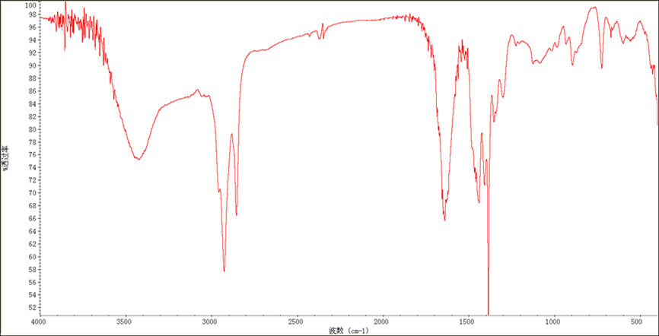
Figure S1. FT-IR absorption spectra of 2A5F@Fe-MOF
The strong band at 1380 cm⁻¹, assigned to C-F stretching. And the bands at 1600 and 1480 cm⁻¹, assigned to skeleton vibration of benzene. The peak at 3450 cm⁻¹ is assigned to v (N-H) bond. The absence of other two peaks near 2950 and 2850 cm⁻¹ corresponds to C-H stretching vibrations of benzene.

