Supporting Information

Synthesis of C₆₀ fullerene-quadricyclane hybrid compound and its preliminary in vitro antitumor activity in combination with cisplatin

Usein M. Dzhemilev, Artur A. Khuzin, Arslan R. Akhmetov, Vladimir A. D'yakonov, Lilya U. Dzhemileva, Milyausha M. Yunusbaeva, Airat R. Tuktarov

Institute of Petrochemistry and Catalysis, Russian Academy of Sciences. 141 Pr. Octyabrya, Ufa, 450075, Russia

Table of Contents
General Information S3
Procedure for the synthesis of compound 2 S3
Preparative photo isomerization S4
Procedure for the synthesis of methanofullerenes 4 and 5 S4
Biological assay S5
Cytotoxicity assay S6
Copies of ¹H, ¹³C spectra of compound 2 S7
Copies of ¹H, ¹³C spectra of compound 3 S8
Copies of MALDI, ¹H, ¹³C spectra of compound 4 S9
Copies of MALDI, ¹H, ¹³C spectra of compound 5 S10
Figures 1-4 S12
General Information.
All reactions were performed under an argon atmosphere and in anhydrous solvent. The solvents and reagents were dried or refined according to the literature procedures. Commercially available [60]fullerene (99.5% pure, Sigma-Aldrich) and cisplatin (ABCR) were used. The reaction products were analyzed on a HPLC chromatograph Shimadzu SPD-20A (Japan) equipped with the UV detector at 313 or 340 nm. The mixtures were separated on a preparative column Cosmosil Buckyprep Waters (250×10 mm) at ~20 ºC. Toluene was used as eluent, the flow rate was 3.0 mL•min–1. The 1H and 13C NMR spectra were run on a Bruker Avance-500 spectrometer at 500.17 and 125.78 MHz, respectively. A mixture of CDCl₃ and CS₂ (1:5) was used as a solvent. The chemical shifts are reported as δ values in parts per million relative to internal standard Me₄Si. The coupling constants (J) are reported in Hertz. The mass spectra were obtained on an UltraFlex III TOF/TOF (Bruker Daltonik GmbH, Germany) operating in linear (TOF) and reflection (TOF/TOF) positive and negative ion modes. S₈ and DCTB (trans-2-[3-(4-tert-butylphenyl)-2-methyl-2-propenyliden]malononitrile) were used as the matrix. For the application on a metal target, toluene solutions of the samples were used. Hamamatsu Lightningcure LC-8 150 W was used for UV irradiation of norbornadienes. Elemental analyses were measured on 1106 Carlo Erba apparatus. Compound 1 synthesized in accordance literature data.¹
Procedure for the synthesis of compound 2. A 50 mL glass reactor was charged with ester 1 (3.79 mmol) in dry dichloromethane (30 mL), mono acylated triethylene glycol (4.17 mmol), DCC (3.79 mmol) and 4-dimethylaminopyridine (0.379 mmol) at room temperature. After 2 h, reaction mixture was passed through a column with small amount of silica gel and concentrated in vacuo. The product was purified by column chromatography, eluent hexane/EtOAc 1:3. Yield 54 %, light yellow oil. UV (i-PrOH), λ_{max}, nm: 217, 269. ¹H NMR (500 MHz, CDCl₃, δ): 2.06 (s, 3H, CH₃), 2.07 and 2.25 (both d, J = 6.5 Hz, 2Н, СН₂), 3.38 (s, 2H, CH₂), 3.69 (m, 8H, 4CH₂), 3.84 and 4.05 (both broad s, 2Н, 2СН), 4.20 (m, 2H, CH₂), 4.29 (broad s, 6H, 3CH₂), 6.91 and 6.98 (both t, J = 3.5 Hz, 2Н, 2CН), 7.30 (m, 3Н, 3СН), 7.49 (d, J = 7.0 Hz, 2Н, 2СН). ¹³C NMR (125 MHz, CDCl₃, δ): 20.8, 41.0, 52.8, 58.6, 61.4, 63.0, 63.4, 64.4, 68.7, 69.0, 70.4, 127.6, 127.7, 128.6, 135.5, 138.5, 140.7, 143.6, 164.8, 166.14, 166.19, 167.7, 170.8. Anal. calcd. for C₂₇H₃₂O₁₀: C, 62.78 %; H, 6.24 %; found C, 62.69 %; H 6.14 %.
Preparative photo isomerization (general procedure): The norbornadiene 2 was dissolved in acetonitrile and irradiated with a 150 W UV Lamp for 60 min. The photo isomerization was confirmed by ¹H and ¹³C NMR spectroscopy’s; the product was not isolated.
Yield 100 %, colorless oil. ¹H NMR (500 MHz, CDCl₃, δ): 1.70 (d, J = 3.5 Hz, 1Н, СН), 2.06 (s, 3H, CH₃), 2.14 and 2.38 (both d, J = 12.0 Hz, 2Н, СН₂), 2.24 (broad s, 1H, CH), 2.48 (d, J = 3.5 Hz, 1Н, СН), 2.60 (broad s, 1H, CH), 3.36 (s, 2H, CH₂), 3.69 (m, 6H, 3CH₂), 4.12 (broad s, 4H, 2CH₂), 4.21 and 4.29 (both m, 6Н, 3CH₂), 7.17 (m, 1Н, СН), 7.24 (d, J = 4.0 Hz, 4Н, 4СН). ¹³C NMR (125 MHz, CDCl₃, δ): 20.7, 20.9, 29.8, 31.4, 31.7, 32.1, 32.7, 37.5, 41.1, 61.1, 63.1, 63.5, 64.5, 68.8, 69.1, 70.50, 70.54, 126.2, 127.6, 128.7, 136.8, 166.1, 166.3, 171.0, 171.6.
General procedure for the synthesis of norbornadiene and quadricyclane containing methanofullerenes 4 and 5. A 50 mL glass reactor was charged with C₆₀ (100 mg, 0.139 mmol) in o-xylole (12 mL), corresponding malonic ester (0.2085 mmol), CBr₄ (69 mg, 0.2085 mmol) and DBU (0.031 mL, 0.2085 mmol) at room temperature. The resulting reaction mixture was stirred for 1 h and was quenched with water. The layers were separated and the organic layer was passed through a column with small amount of C18 silica gel. The reaction products and the starting fullerene C₆₀ were separated by the semi-preparative HPLC, using toluene as eluent. The samples were washed with hexane and Et₂O before NMR analysis.
Methanofullerene (4): Yield 94 mg (55%), brown powder. UV (СНСl₃), λ_{max}, nm: 260, 330, 427. ¹H NMR (500 MHz, CDCl₃, δ): 2.06 and 2.24 (both d, J = 6.5 Hz, 2Н, СН₂), 2.09 (s, 3H, CH₃), 3.57-3.67 (m, 12H, 6CH₂), 3.88 (m, 1H, CH), 4.28 (m, 1H, CH), 4.49 (m, 2H, CH₂), 4.72 (m, 2H, CH₂), 6.92 (t, J = 4.5 Hz, 1H, CH), 7.01 (t, J = 4.5 Hz, 1H, CH), 7.35 (m, H, CH), 7.40 (m, 2H, 2CH), 7.58 (d, J = 8.0 Hz, 2H, 2CH). ¹³C NMR (125 MHz, CDCl₃, δ): 21.0, 52.0, 53.0, 58.6, 61.6, 63.5, 64.8, 66.2, 68.8, 69.2, 70.5, 71.3, 127.7, 127.9, 128.9, 135.4, 138.2, 139.0, 140.7, 140.9, 141.0, 141.8, 142.2, 143.0, 143.7, 143.8, 144.6, 144.9, 145.0, 145.20, 145.29, 163.4, 164.7, 168.4, 171.0. MALDI TOF, m/z 1234.1848 [M]⁻, calcd. for C₈₇H₃₀O₁₀ 1234.1839.
Methanofullerene (5): Yield 89 mg (52%), brown powder. UV (СНСl₃), λ_{max}, nm: 259, 327, 429. ¹H NMR (500 MHz, CDCl₃, δ): 1.72 (m, 1H, CH), 2.03 (s, 3H, CH₃), 2.13 (m, 1H, CH), 2.25 (m, 1H, CH), 2.36 (m, 1H, CH), 2.51 (m, 1H, CH), 2.61 (m, 1H, CH), 4.3-4.7 (m, 16H, 8CH₂), 7.21 (m, 2H, 2CH), 7.40 (m, 2H, 2CH), 7.57 (m, 1H, CH). ¹³C NMR (125 MHz, CDCl₃, δ): 21.0, 29.7, 30.1, 31.3, 31.8, 32.2, 32.9, 37.7, 51.8, 63.5, 66.2, 68.8, 69.2, 70.6, 71.3, 126.2, 127.7, 128.6, 138.9, 139.1, 140.7, 140.9, 141.8, 141.9, 142.2, 143.0, 143.9, 144.6, 144.9, 145.1, 145.2, 145.3, 163.3, 163.4, 171.0. MALDI TOF, m/z 1234.1839 [M]⁻, calcd. for C₈₇H₃₀O₁₀ 1234.1839.
Biological assays
Cell culturing
Jurkat cells were purchased from Russian Cell Culture Collection (Institute of Cytology of the Russian Academy of Sciences) and cultured according to standard mammalian tissue culture protocols and sterile technique. All cell lines used in the study were tested and shown to be free of mycoplasma and viral contamination.
Jurkat cells were maintained in RPMI 1640 (Gibco) supplemented with 4 mM glutamine, 10% FBS (Sigma) and 100 units/ml penicillin-streptomycin (Sigma). Cells were grown in an atmosphere of 5 % CO₂ at 37 °C. The cells were subcultured at 2-3 days intervals. Cells were then seeded in 24 well plates at 5x10⁴ cells per well and incubated overnight. Jurkat cells were subcultured at 2 day intervals with a seeding density of 1×10⁵cells per 24 well plates in RPMI with 10% FBS.
Cytotoxicity assay
Viability (Live/dead) assessment was performed by staining cells with 7-AAD (7-Aminoactinomycin D) (Biolegend). Cells after treatment with compounds at various concentrations and incubated in an atmosphere of 5 % CO₂ at 37 °C during 24 h (cisplatin added simultaneously) or 24+24 h (cisplatin added after 24 h) were harvested, washed 1-2 times with phosphate-buffered saline (PBS) and centrifuged at 400g for 5 minutes. Cell pellets were resuspended in 200 uL of flow cytometry staining buffer (PBS without Ca²⁺and Mg²⁺, 2,5% FBS) and stained with 5 uL of 7-AAD staining solution for 15 minutes at room temperature in the dark. Samples were acquired on NovoCyteTM 2000 FlowCytometry System (ACEA) equipped with 488 nm argon laser. Detection of 7-AAD emission was collected through a 675/30 nm filter in FL4 channel.

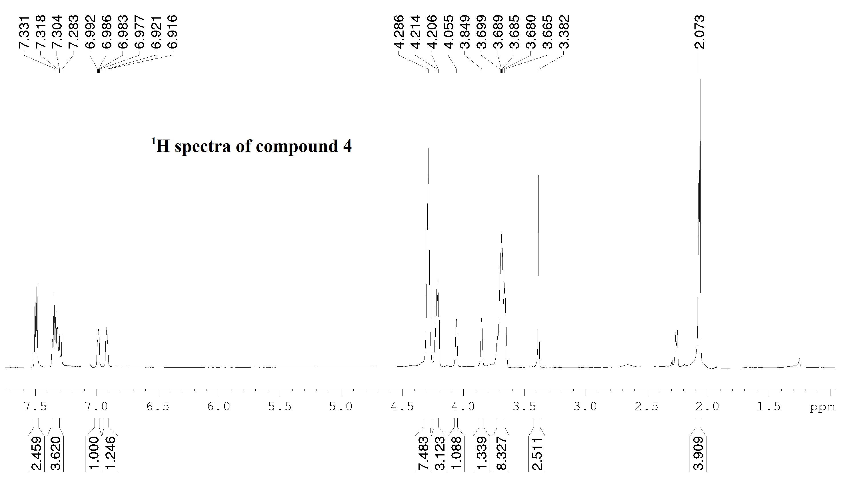

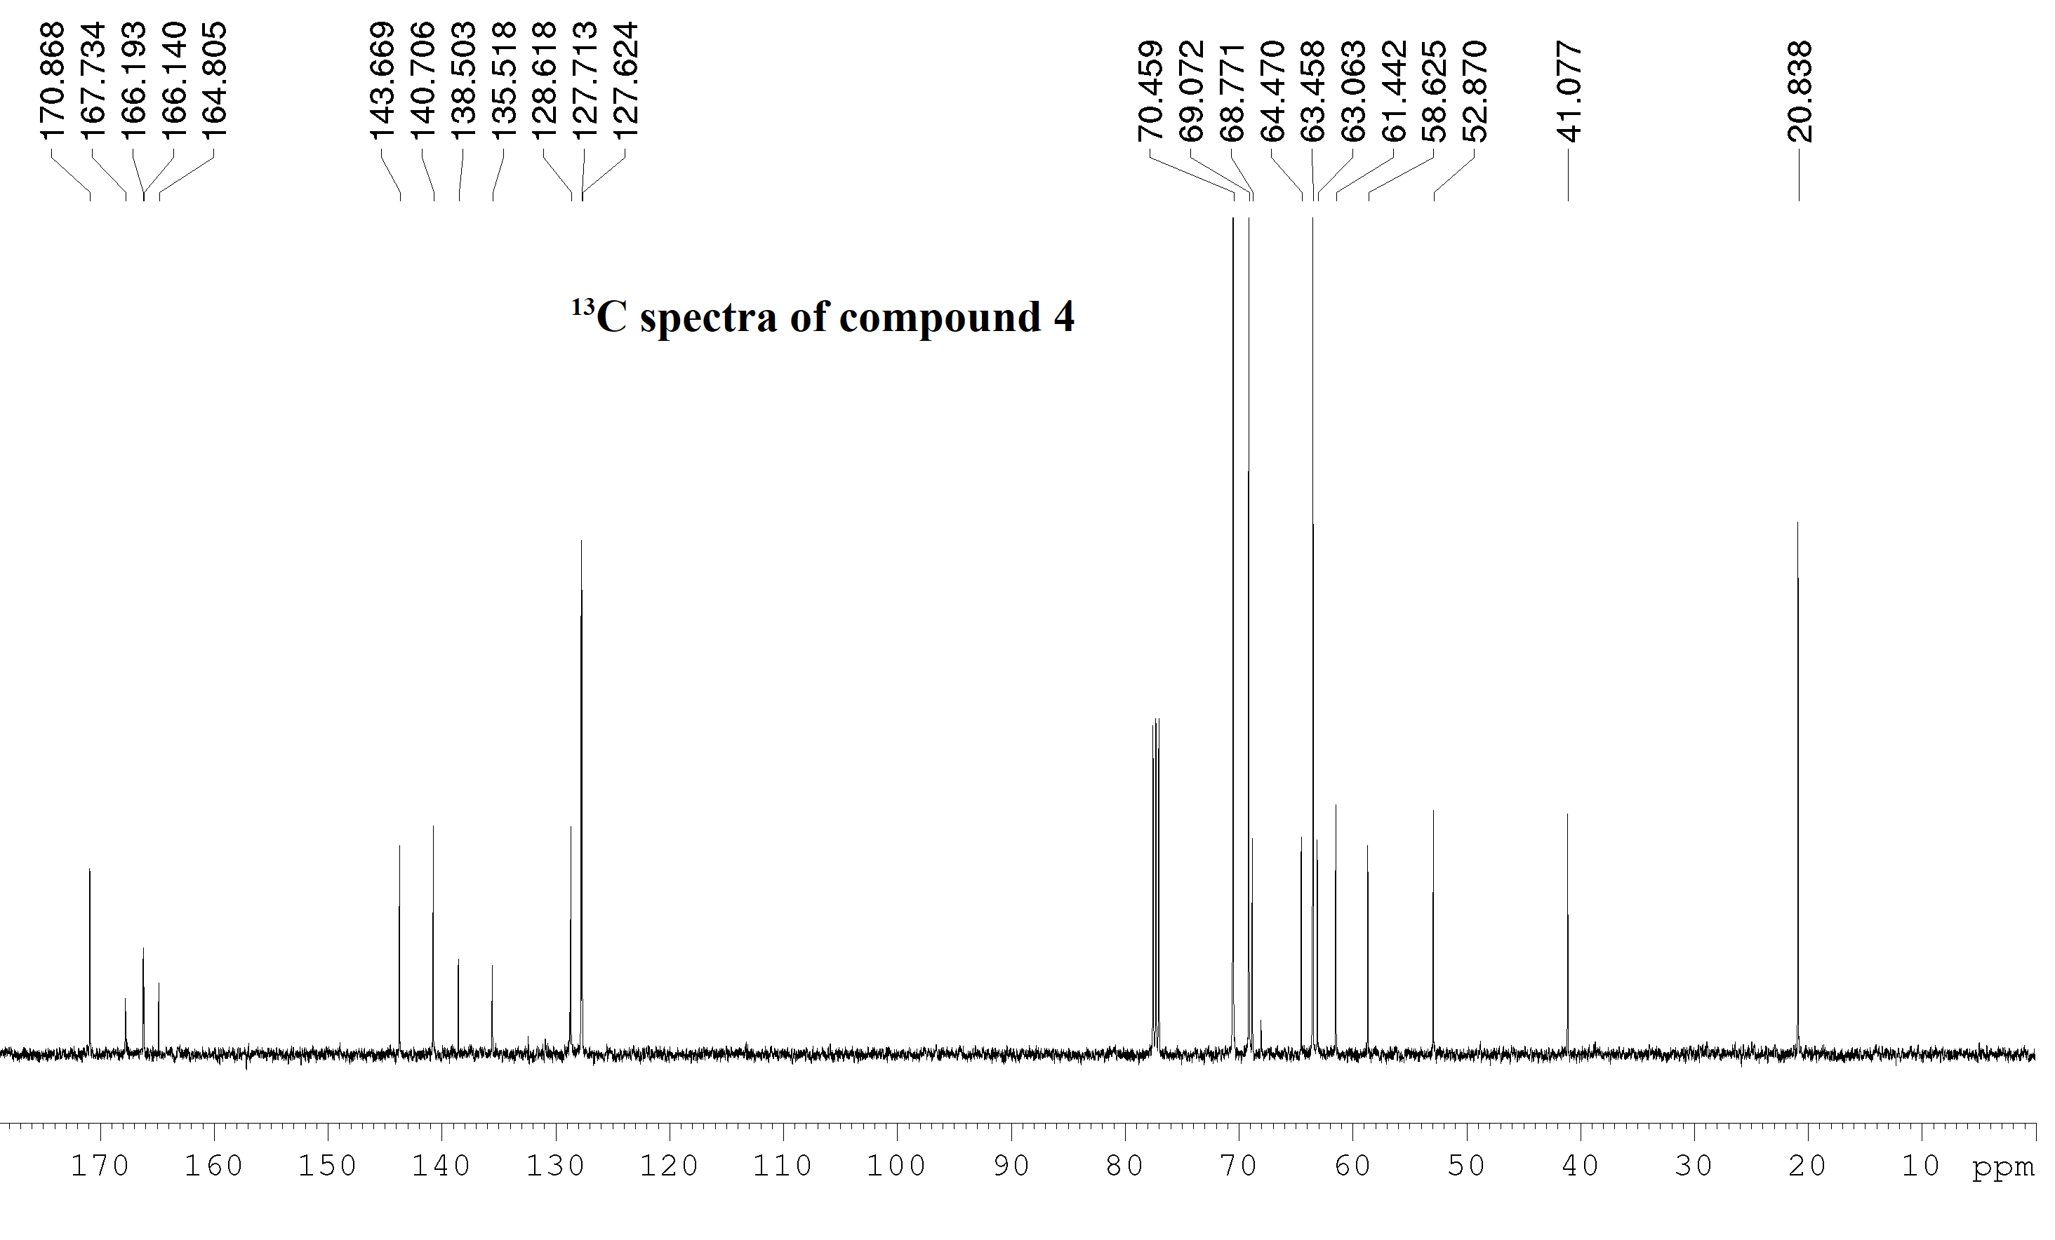

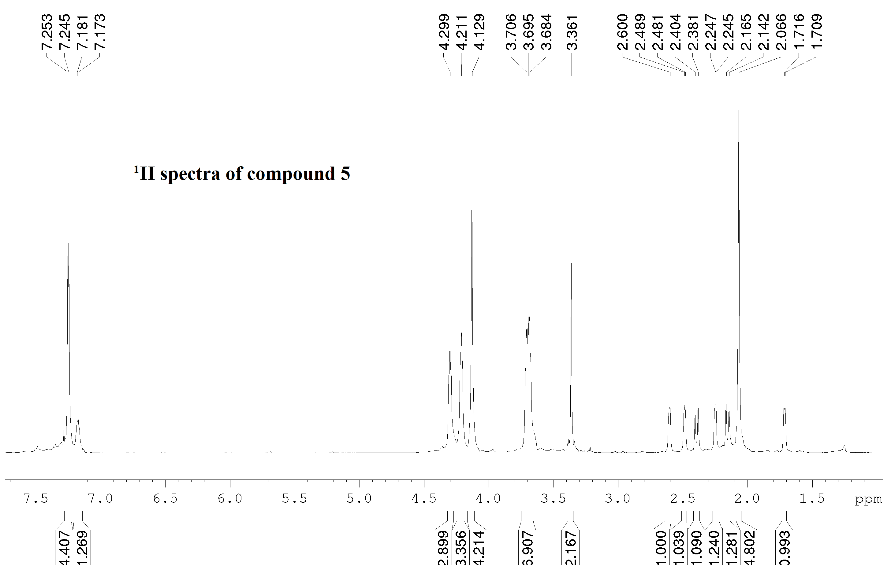

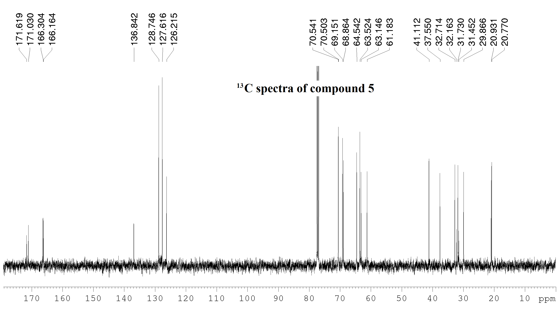

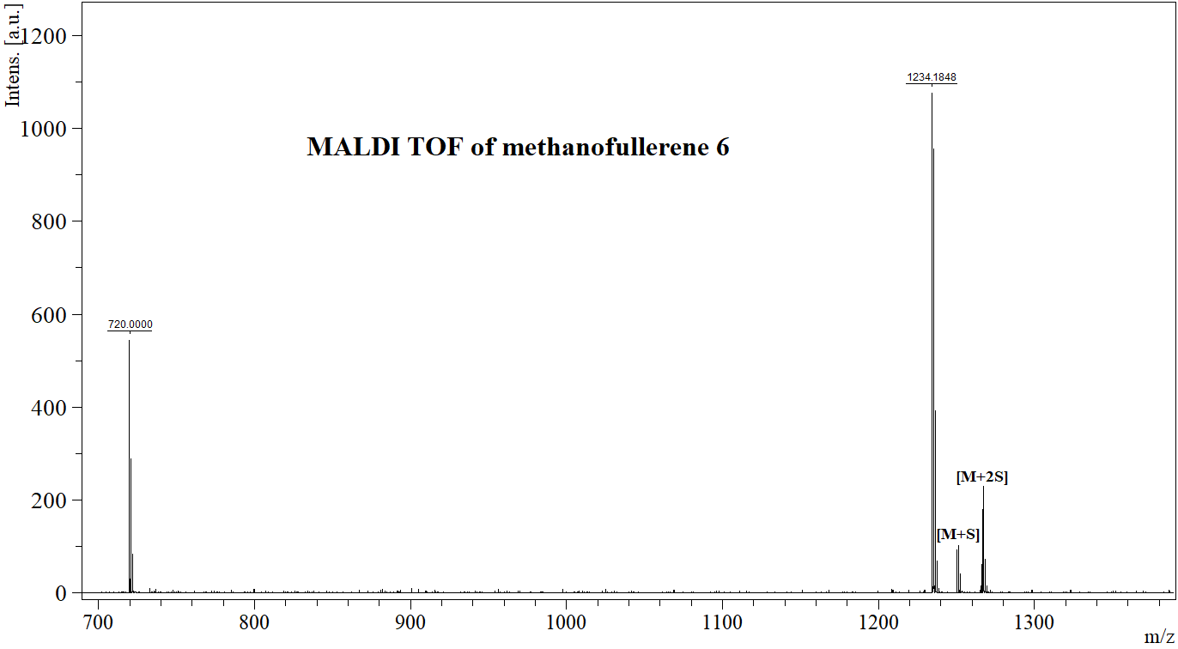

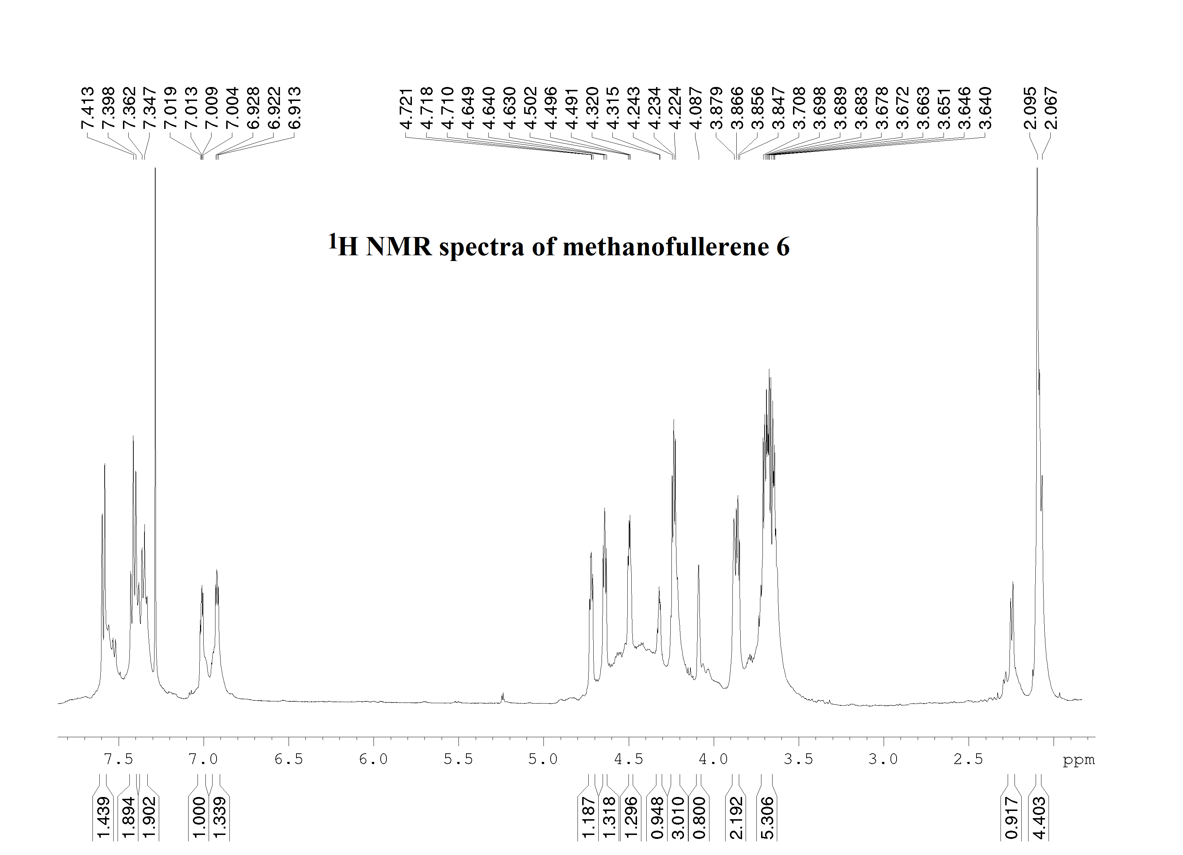
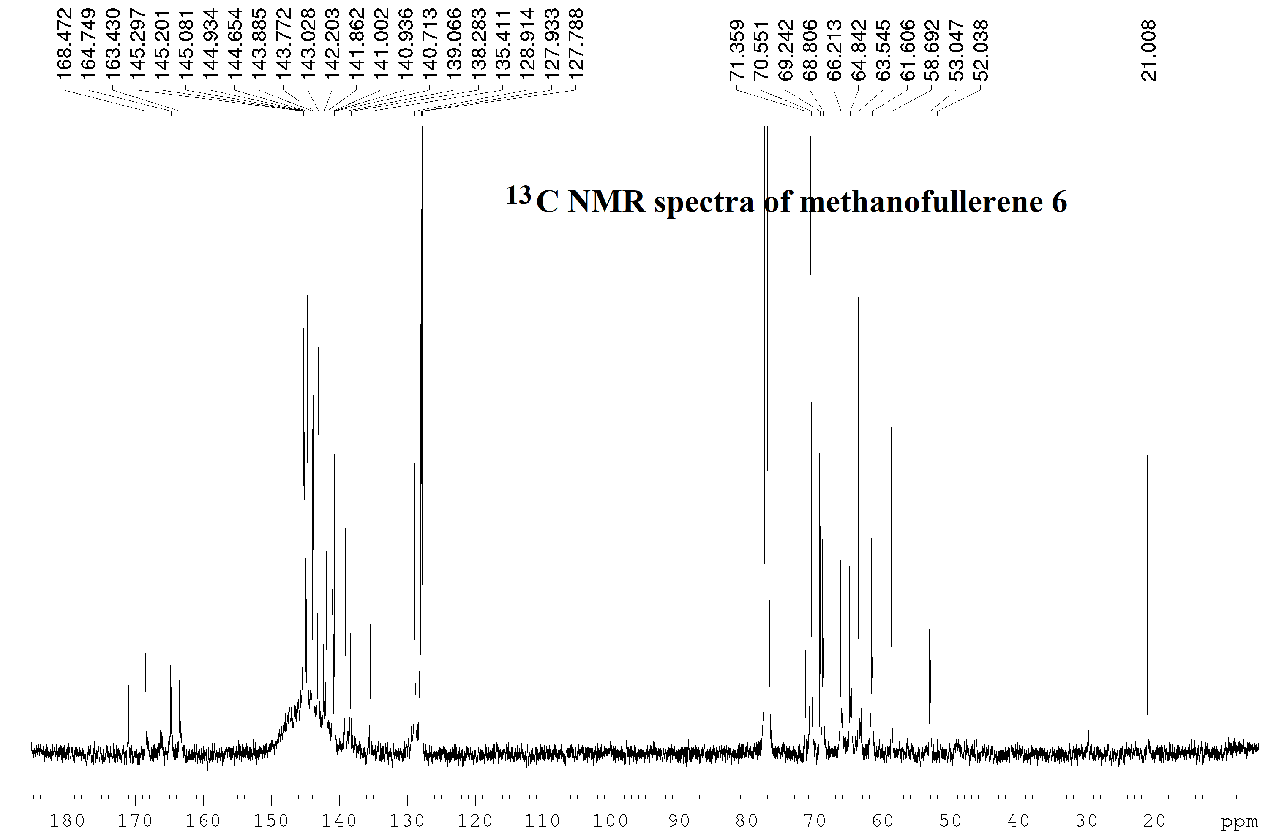

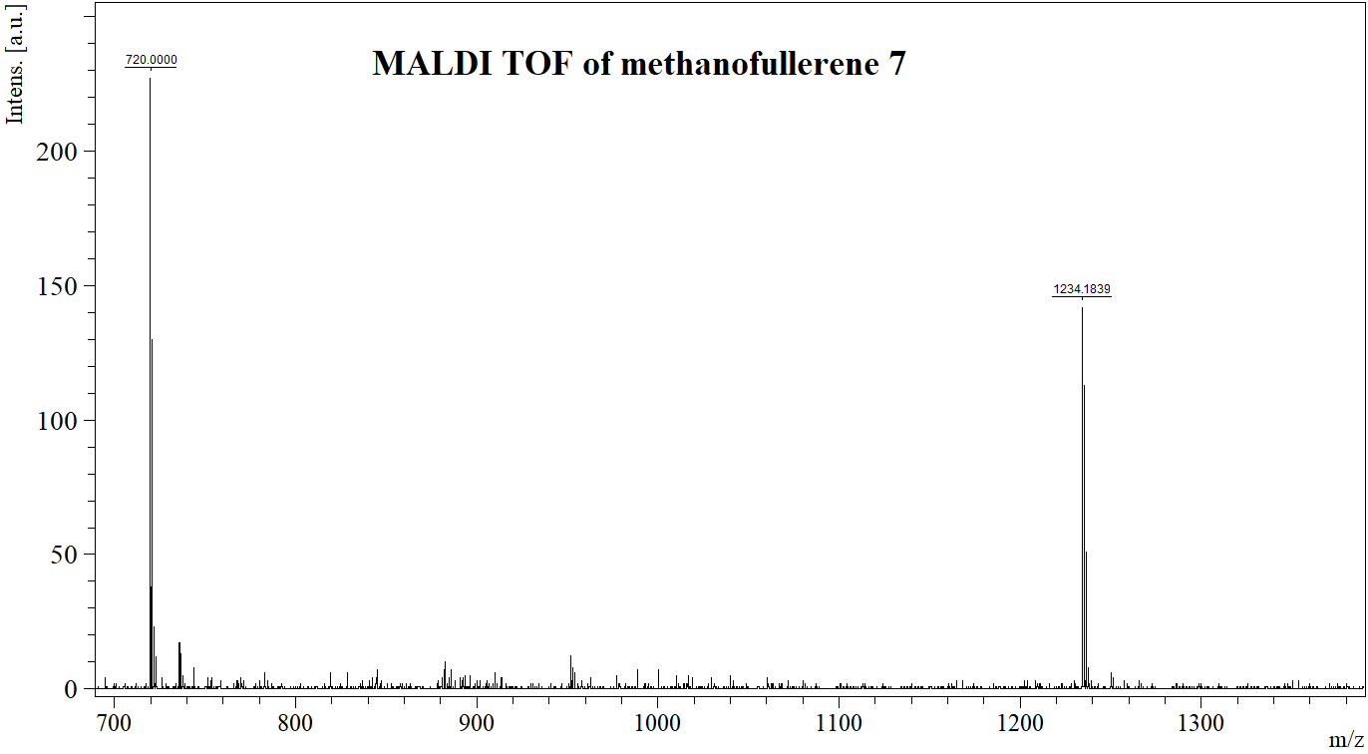
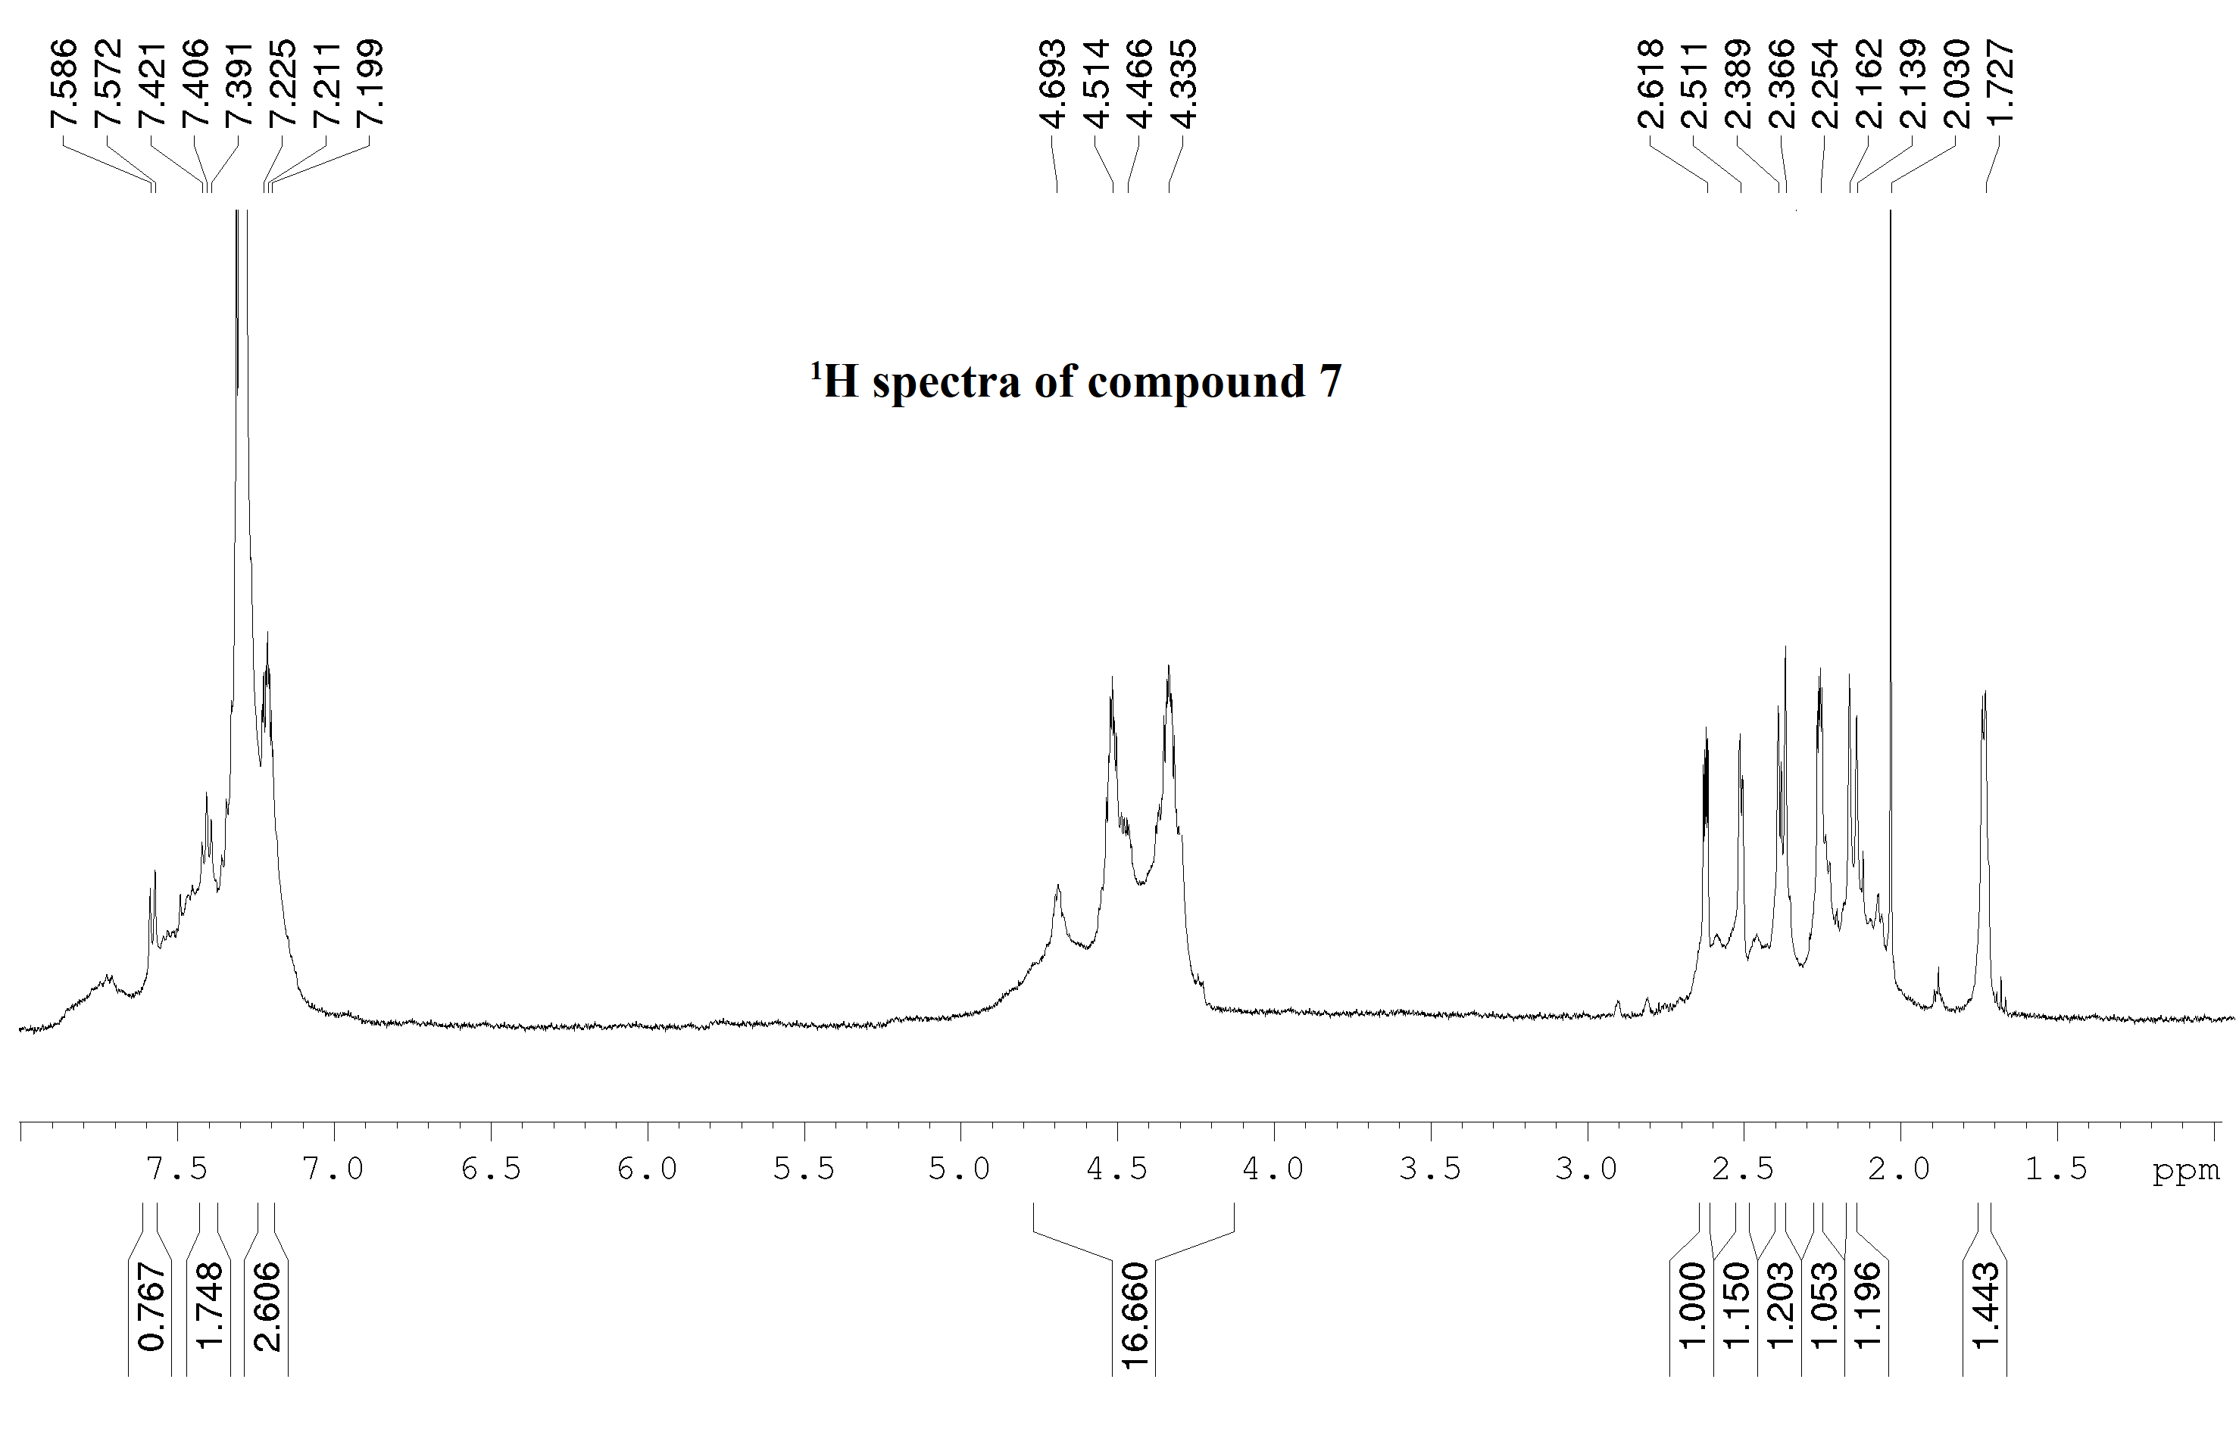

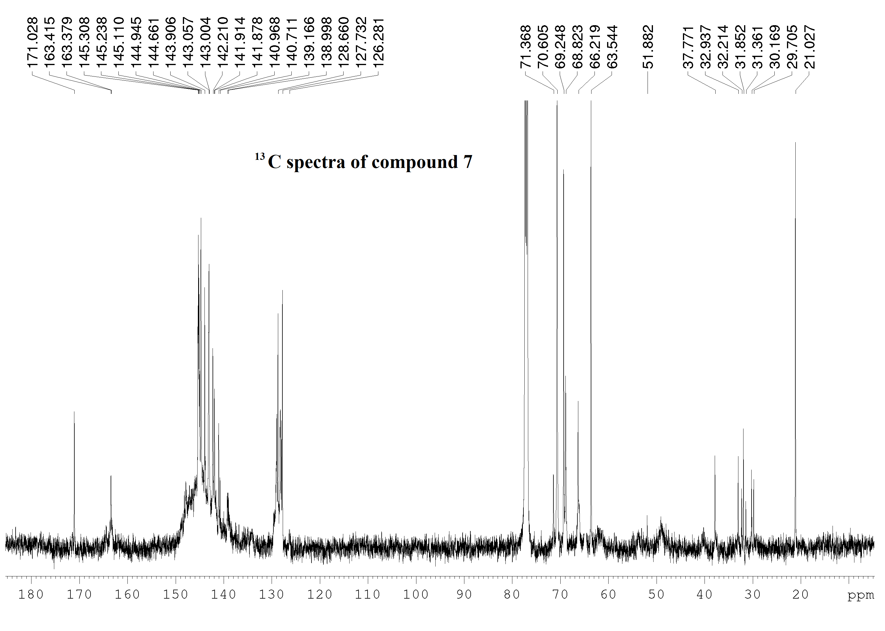

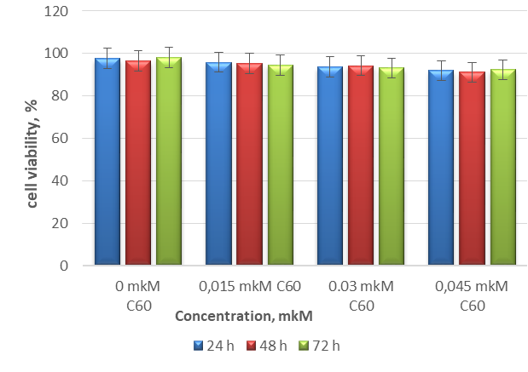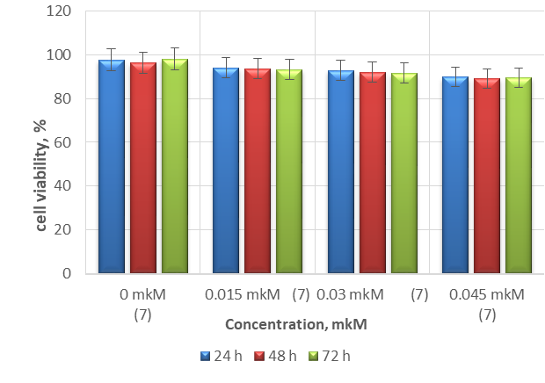
Figure 1. Effect of the concentration and incubation time of an aqueous solution of С₆₀ (on the left) and methanofullerene 5 (on the right) on the viability of Jurkat cells (the histogram shows the percentage of viable cells).

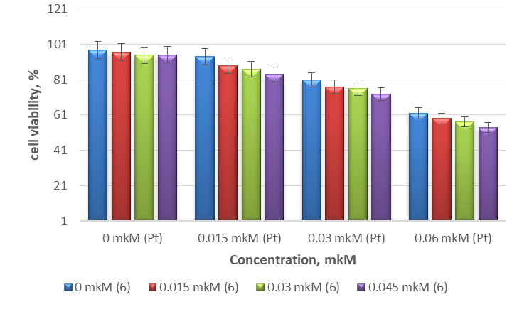
Figure 2. Joint effect of concentrations of cisplatin and aqueous solution of C₆₀ on the viability of Jurkat cells (the histogram shows the percentage of viable cells).
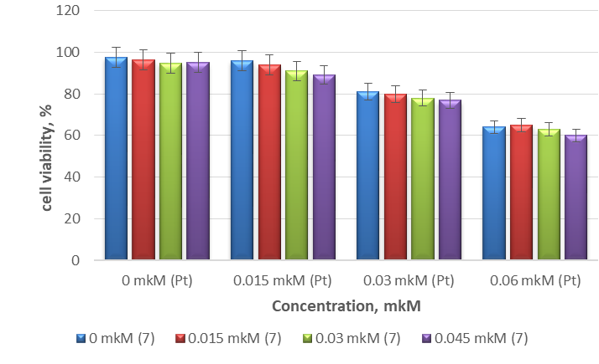
Figure 3. Joint effect of concentrations of methanofullerene 5 and cisplatin added simultaneously on the viability of Jurkat cells (the histogram shows the percentage of viable cells).
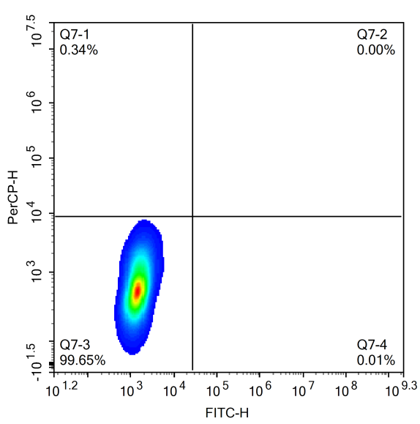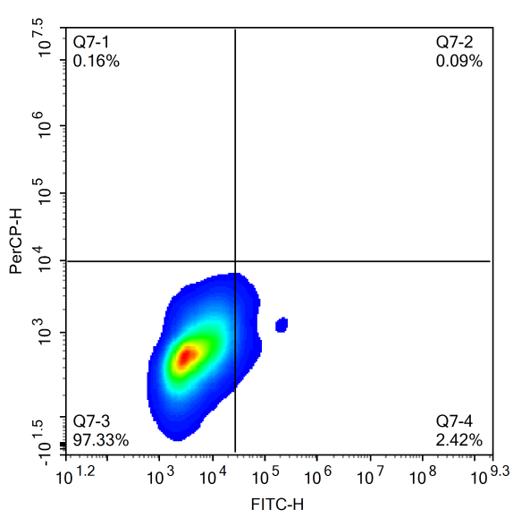
A
B
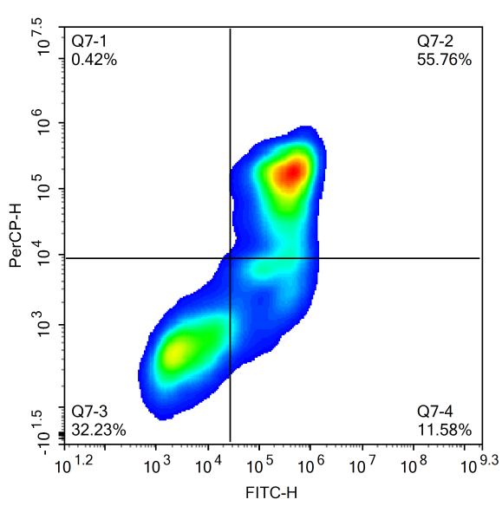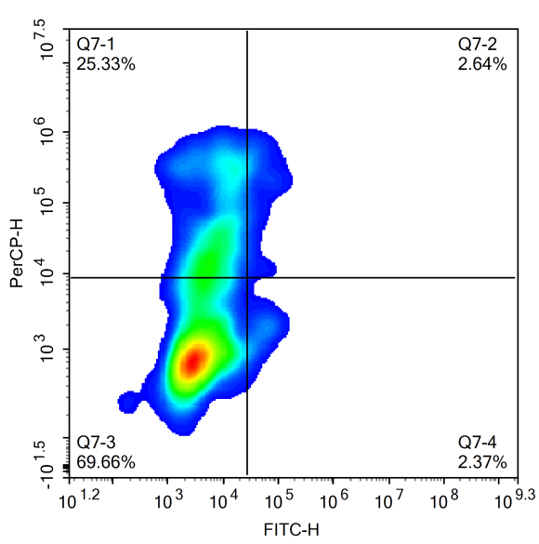
C
D
Figure 4. Induction of apoptosis in the Jurkat cell line when treated with quadricyclan and / or cisplatin stained with annexineV / PI. (A - Control; B - Cells treated with quadricyclan for 24 hours; C - Cells treated with cisplatin for 24 hours; D - Cells treated with quadricyclan, followed by addition of cisplatin after 24 hours.)

