Supporting information

Host–guest interactions in nor-seco-cucurbit[10]uril: novel guest-dependent molecular recognition and stereoisomerism

Xiaodong Zhang, Wei Wu, Zhu Tao, and Xin-Long Ni*

Key Laboratory of Macrocyclic and Supramolecular Chemistry of Guizhou Province, Guizhou University, Guiyang 550025, China.

E-mail: longni333@163.com.

Synthesis of G1: 1-adamantanamine hydrochloride (1.87 g, 10.0 mmol) was dissolved in 30 ml ether，and an aqueous solution (10 ml) of 2.75 M NaOH was added into the ether solution with magnetic stirring for 30 minutes and then separated out the organic phase. Next, benzaldehyde (1.23 ml, 12 mmol), p-toluenesulfonic acid (0.1 g, 0.58 mmol) were added into the organic phase with magnetic stirring at room temperature for 5 h, then removed the ether by rotary evaporator. The white solid was dissolved in 50 ml ethanol and NaBH₄ (1.0 g, 0.026 mol) was added under ice bath for 1h. The mixture was stirred at 75℃ for another 3 h and concentrated by rotary evaporator. The solid was dissolved in HCl (0.3 M, 200 ml), and extracted with ether (50 ml) in order to remove unreacted impurities. Then the water phase become alkalinity used an aqueous sodium hydroxid, and extracted with ether (150 ml), and then removed the organic phase by rotary evaporator. The precipitation was recrystallized by HCl (2M, 10 ml), dried under vacuum to obtain a white solid 2.49 g (yield 89.8%). ¹H NMR (500 MHz, D₂O), δ 7.38-7.40 (5H, Ar-H) , 4.14 (2H, CH₂), 2.16 (3H, CH), 1.92 (6H, CH₂), 1.61-1.72 (6H, CH₂). MALDI-TOF: m/z calcd for C₁₇H₂₄N⁺: 242.38; found: 243.27; elemental analysis calcd (%) for C₁₇H₂₄NCl: C 73.49, H 8.71, N 5.04; found: C 72.78, H 8.91, N, 4.96.
Synthesis of G2: A mixture of 1-adamantanamine hydrochloride (200 mg, 1.1 mmol) and sodium hydroxide (1.6 g, 0.04 mol) were heated at 40℃ in methanol (25 ml) with magnetic stirring for 1 h. The solution was recovered by filtration and the solution was transferred to flask, the 1-pyrenecarboxaldehyde (230 mg, 1 mmol) in 20 ml methanol was then added. The solution was refluxed for 12h and cooled to room temperature. The cooled solution was added NaBH₄ (500 mg, 13.2 mmol) and then refluxed about 6 h and cooled to room temperature. The mixture was concentrated by rotary evaporator and the solid was dissolved in 60 ml CH₂Cl₂ and washed with 100 ml water three times. The organic layer was then concentrated by rotary evaporator and dissolved in 10 ml acetone solution accompany addition of small amount of HCl (1M, 0.5 ml). The precipitation was collected under vacuum to obtain a yellow solid 258 mg (yield 64.2 %). ¹H NMR (500 MHz, D₂O), δ 7.67-8.33 (9H，Pyrene-H), 4.10 (2H, CH₂), 2.20 (3H, CH), 1.90 (6H, CH₂), 1.64-1.76 (6H, CH₂). MALDI-TOF: m/z calcd for C₂₇H₂₈N⁺: 366.52; found: 366.91; elemental analysis calcd (%) for C₂₇H₂₈NCl: C 80.67, H 7.02, N 3.48; found: C 79.56, H 7.64, N, 3.31.

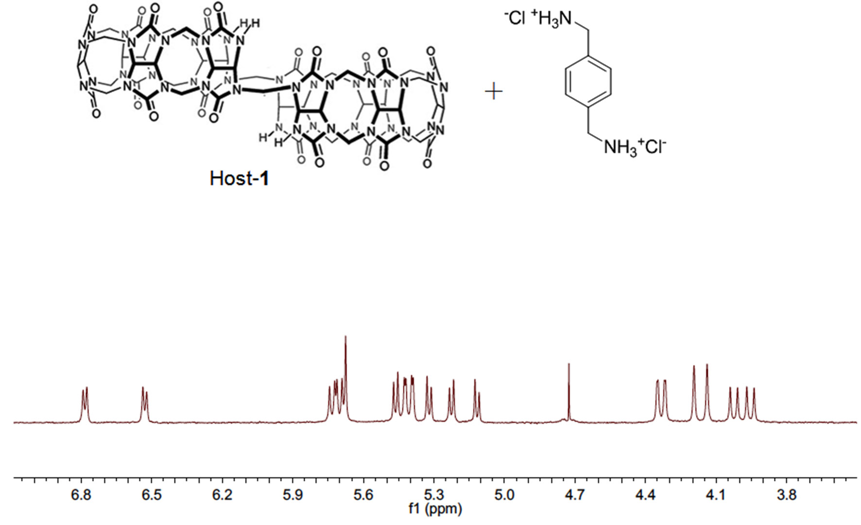
Figure S1 ¹H NMR spectra of host-1 (1.0 mmol, D₂O, pD=2.0) in the presence of p-xylylenediamine guest. The result is fully in line with the reference J. Am. Chem. Soc., 2006, 128, 14744−14755.
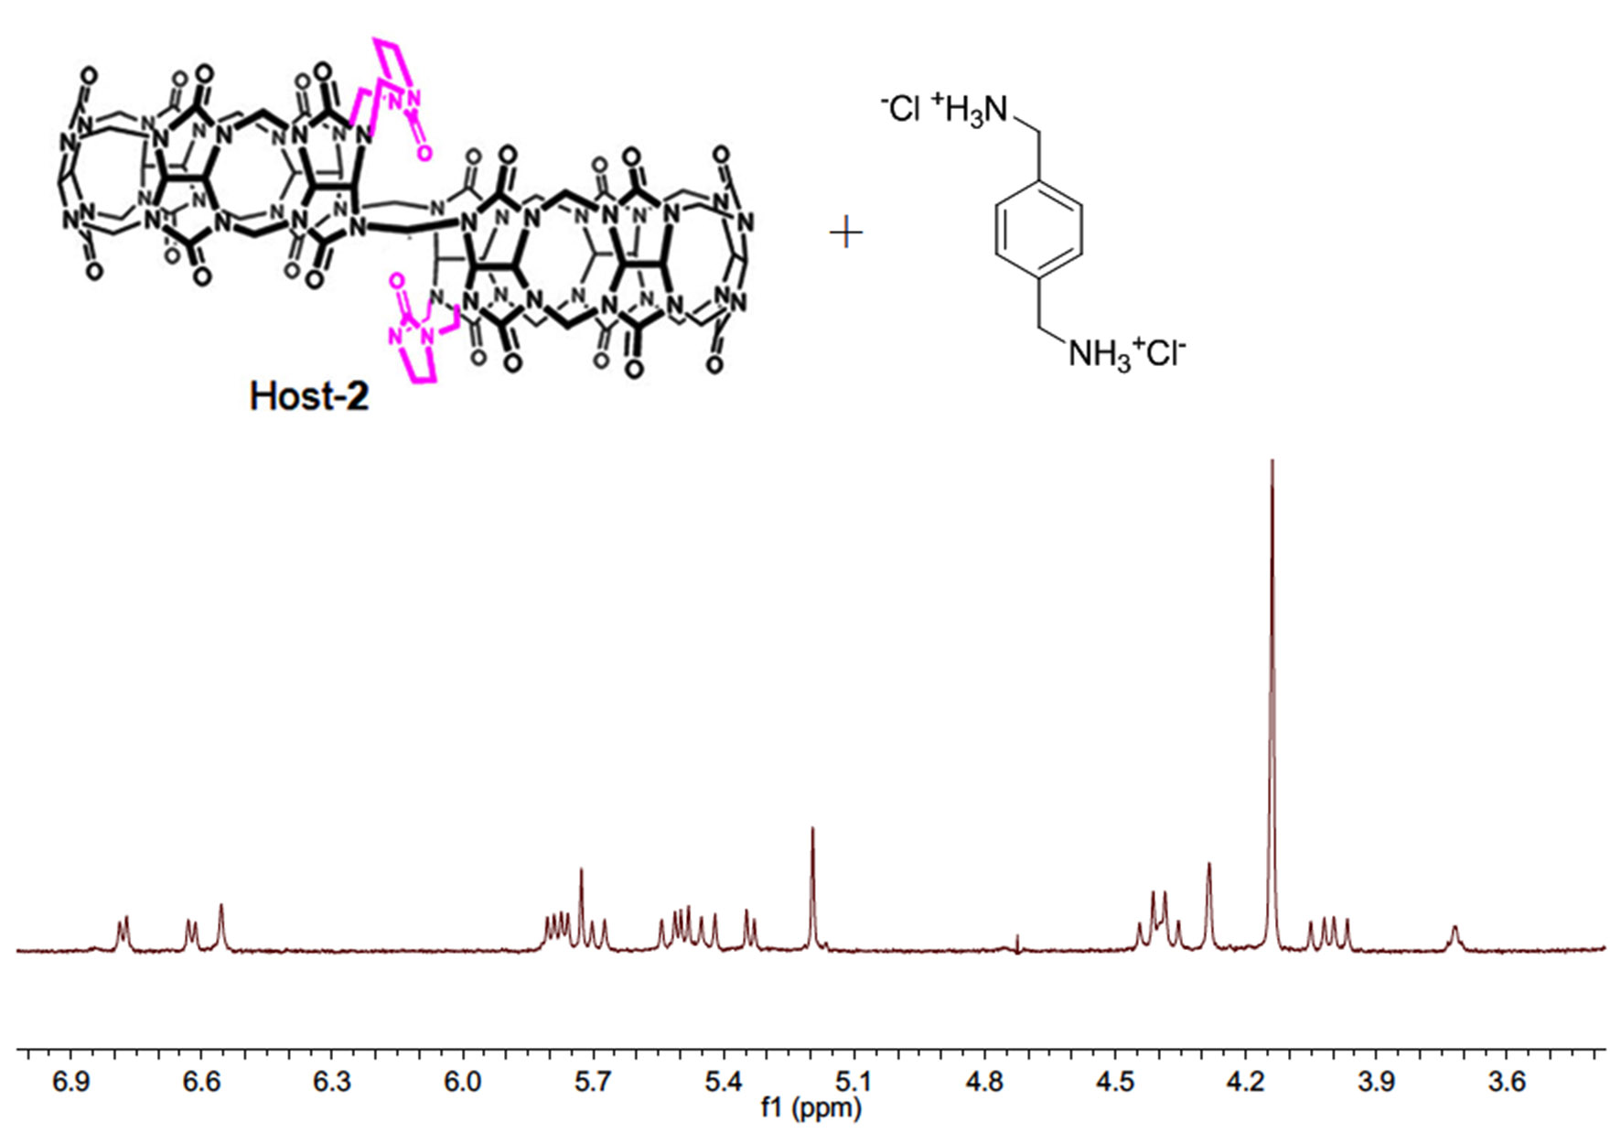
Figure S2 ¹H NMR spectra of host-2 (1.0 mmol, D₂O, pD=2.0) in the presence of p-xylylenediamine guest. The result is fully in line with the reference Chem. Commun., 2011, 47, 9420–9422.

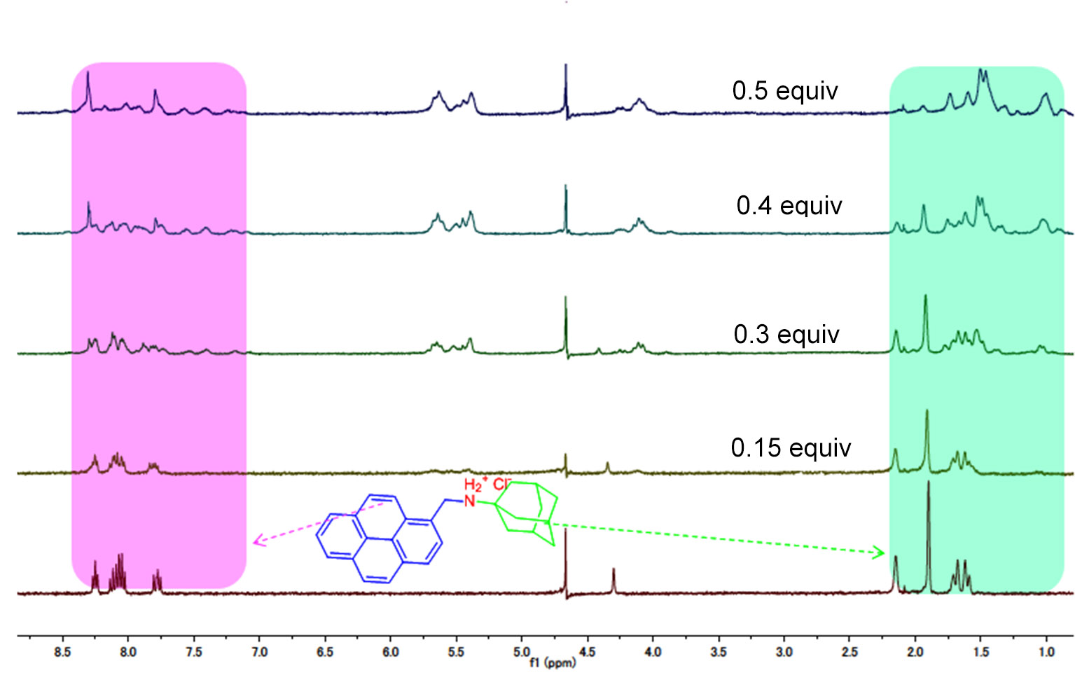

Figure S3 ¹H NMR spectra of G2 (1.0 mmol, D₂O, pD=2.0) in the presence of different concentrations of host-1.

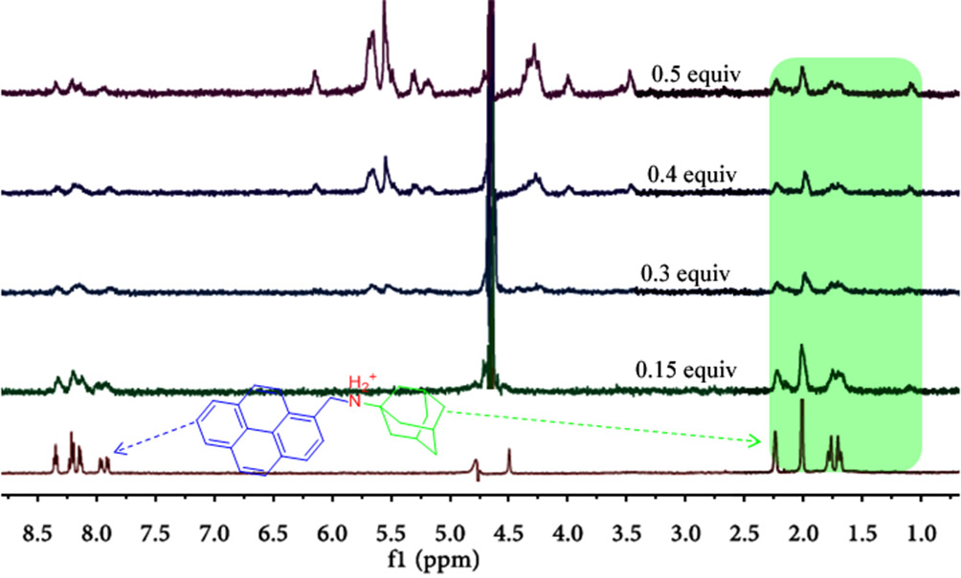
Figure S4 ¹H NMR spectra of G2 (1.0 mmol, D₂O, pD=2.0) in the presence of different concentrations of host-2.
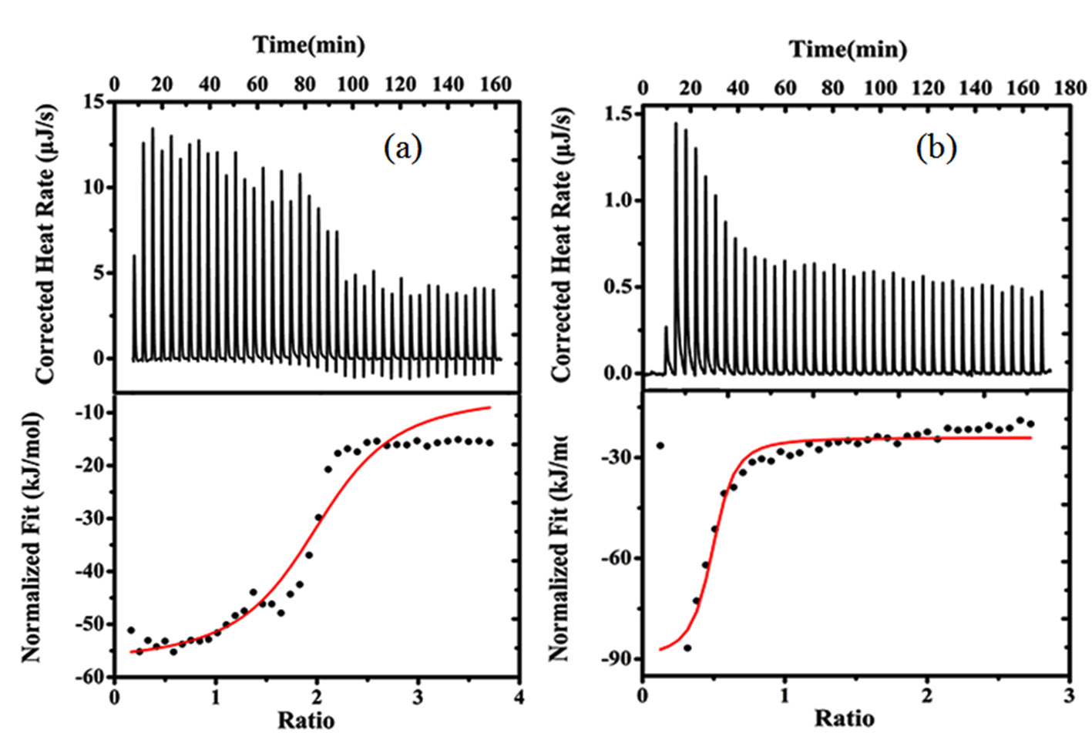
Figure S5 Isothermal titration calorimetry (ITC) binding curves for G1•host-1 (a), and G2•host-1 (b) in aqueous solution (pH=2.0) at 298.15 K (an independent model was used).

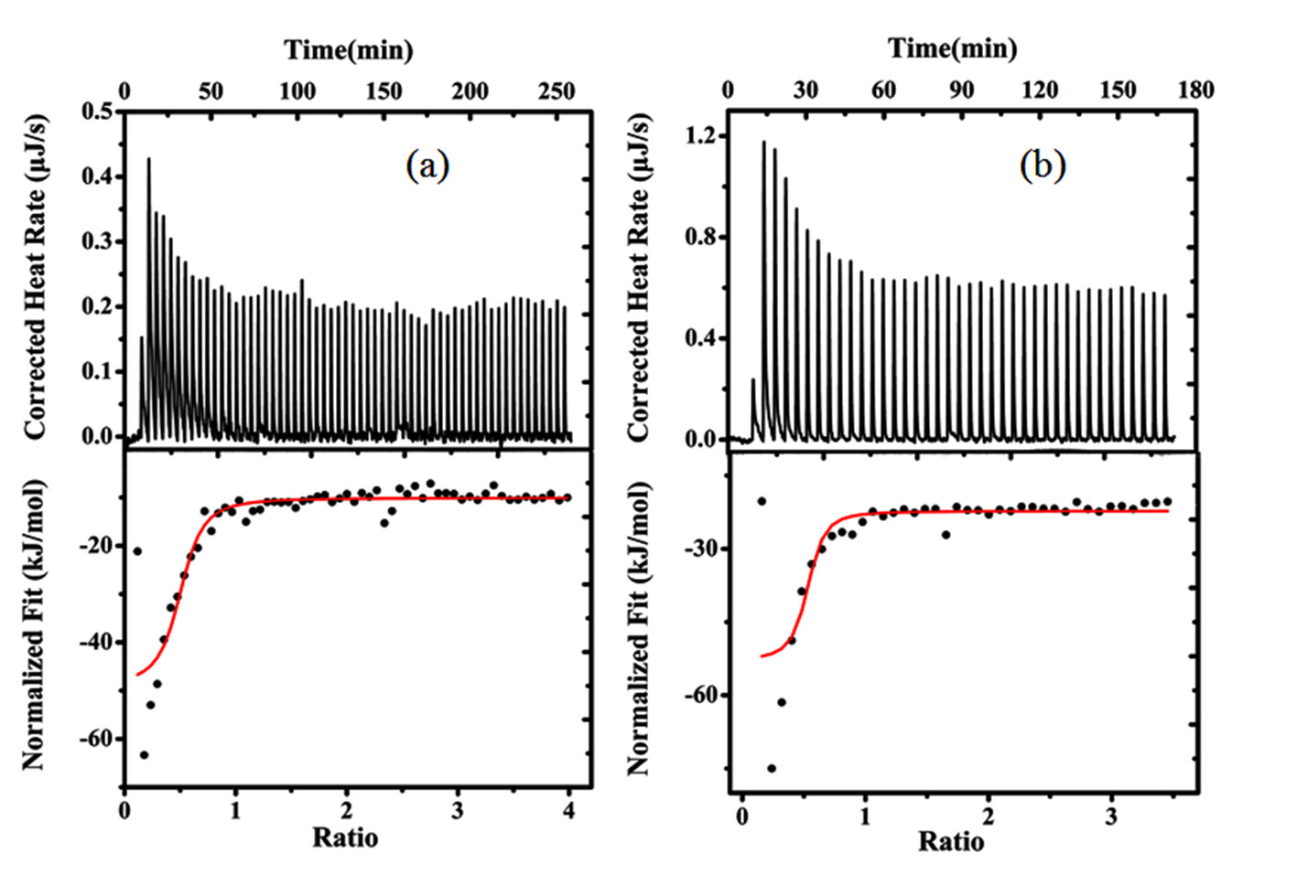
Figure S6 Isothermal titration calorimetry (ITC) binding curves for G1•host-2 (a), and G2•host-2 (b) in aqueous solution (pH=2.0) at 298.15 K (an independent model was used).

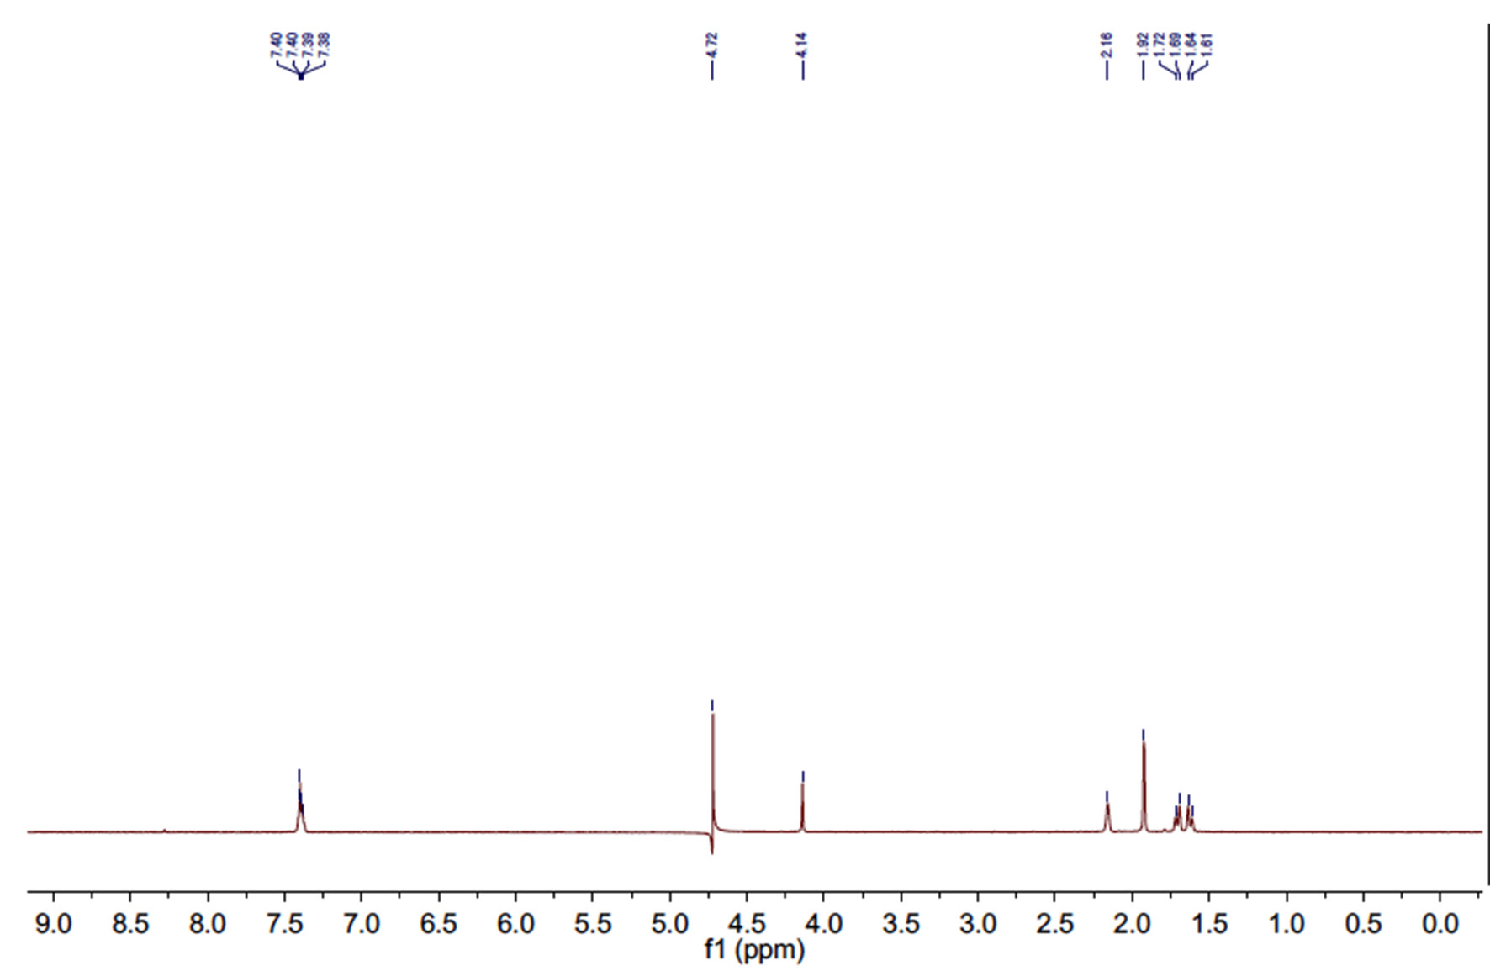
Figure S7 ¹H NMR spectra of G1 (500 MHz, D₂O).

Figure S8 ¹H NMR spectra of G2 (500 MHz, D₂O).

