Tautomerism as primary signalling mechanism in metal sensing: the case of amide group
Vera Deneva*¹, Georgi Dobrikov¹, Aurelien Crochet², Daniela Nedeltcheva¹, Katharina M. Fromm² and Liudmil Antonov*¹

¹Institute of Organic Chemistry with Centre of Phytochemistry, Bulgarian Academy of Sciences, Sofia 1113, Bulgaria and ²University of Fribourg, Department of Chemistry, Chemin du Musée 9, CH-1700 Fribourg, Switzerland

* Corresponding authors e-mails: Liudmil Antonov – lantonov@orgchm.bas.bg; Vera Deneva - vdeneva@orgchm.bas.bg
Supporting Information
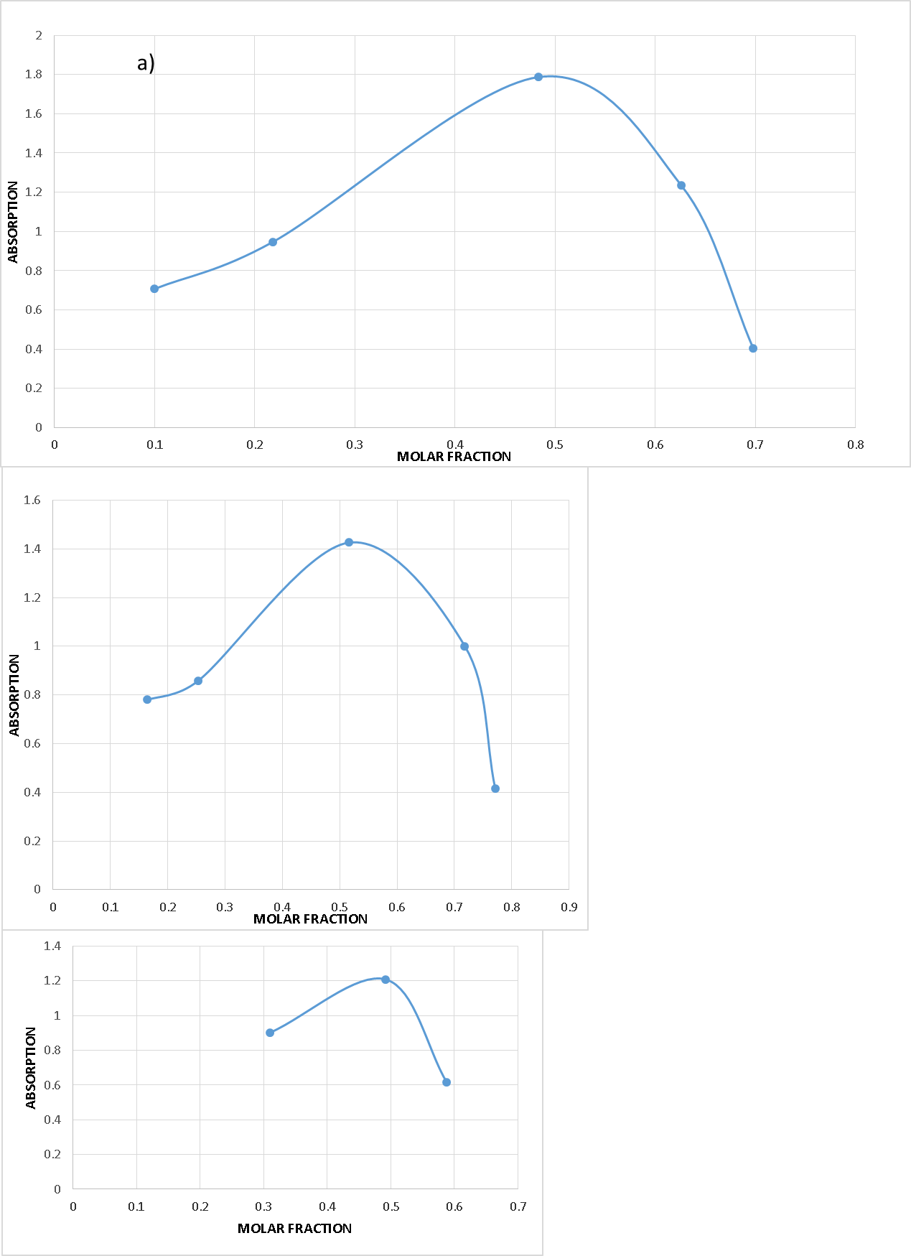
Figure S1: Job’s plots of the complexes of 6 with Mg²⁺, Ca²⁺ and Ba²⁺. Molar fractions are calculated as: X_{L}= (C_{L}/C_{M)} +C_{L,} where C_{L} is the concentration of the ligand and C_{M} is the concentration of the metal ion.
Table S1: Relative stability* of the tautomers, M062X in kcal/mol for 1 in acetonitrile**.
Level of theory | ΔE, [kcal/mol]
6-31++G** | 0.33
6-311++G** | -0.24
cc-pVTZ | -0.36
TZVP | -0.40
def2TZVP | -0.85
*) positive value, means more stable enol form and vice versa.
**) the experimentally determined value is 0.33 kcal/mol¹.

Reference
1. Fabian, W. M. F., Antonov, L., Nedeltcheva, D., Kamounah, F. S. & Taylor, P. J. Tautomerism in Hydroxynaphthaldehyde Anils and Azo Analogues: a Combined Experimental and Computational Study. The Journal of Physical Chemistry A 108, 7603–7612 (2004).

