Flexible freestanding MoS₂ based paper-like material for energy conversion and storage
Florian Zoller^{a,b}, Jan Luxa^{c}, Thomas Beinª, Dina Fattakhova-Rohlfing^{b,d}, Daniel Bouša^{c} and Zdeněk Sofer^{c}
[a] F. Zoller, T. Bein, D. Fattakhova-Rohlfing
Department of Chemistry and Center for NanoScience (CeNS), Ludwig-Maximilians-Universität München (LMU Munich), Butenandtstrasse 5-13 (E), 81377 Munich, Germany
[b] F. Zoller
Faculty of Engineering and Center for Nanointegration Duisburg-Essen (CENIDE), University of Duisburg-Essen, Lotharstraße 1, 47057 Duisburg, Germany
[c] J. Luxa, D. Bouša, Z. Sofer
Department of Inorganic Chemistry, University of Chemistry and Technology Prague, Technická 5, 166 28 Prague 6, Czech Republic
[d] D. Fattakhova-Rohlfing
Forschungszentrum Jülich GmbH, Institute of Energy and Climate Research (IEK-1) Materials Synthesis and Processing, Wilhelm-Johnen-Straße, 52425 Jülich, Germany

Keywords: single wall carbon nanotubes, molybdenum disulfide, paper-like composite materials, supercapacitors, batteries
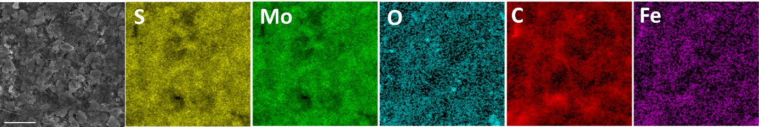
Figure S1. Elemental distribution maps of the MoS₂/SWCNT-paper.

Table S1. Elemental composition obtained from SEM-EDS
Sample | S wt.% | Mo wt.% | O wt.% | C wt.% | Fe wt.%
MoS₂ based composite paper | 29.7 | 40.9 | 2.1 | 25.1 | 2.1

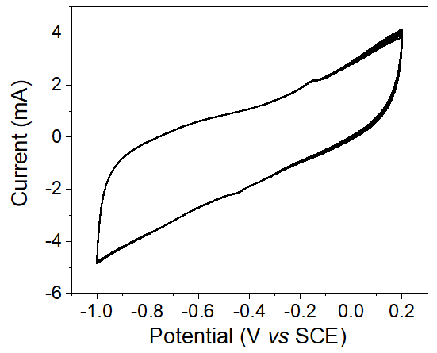
Figure S2. Cyclic voltammograms of MoS₂ based composite paper in 1 M KCl. Scan rate 100 mV s⁻¹.

Kinetics analysis
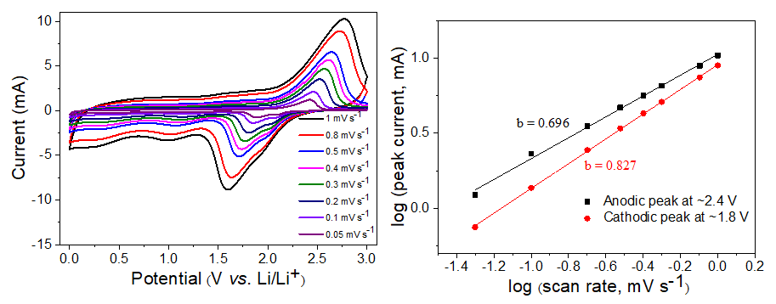
Figure S3. Kinetic analysis of the freestanding MoS₂ based composite paper. (a) CV curves at different scan rates, (b) relationship between logarithmic peak current (cathodic peak at ~1.8 V and anodic peak at ~2.4 V) and logarithmic scan rates.
CV measurements were conducted at different scan rates ranging from 1 to 0.05 mV s⁻¹ to gain insights into the reaction kinetics (Figure S2). The degree of capacitive effect can be qualitatively analyzed according to the power law:
i = aν^{b} (5)
which relates the measured peak current (i) to the scan rate (ν), a and b are adjustable parameters.^{[1]} The b value can be determinate by fitting log(i) versus log(ν) (FigureS2).^{[2]} In general, b = 1 entails a capacitive surface-limited process, while b = 0.5 implies a semi-infinite linear diffusion-controlled mechanism.^{[1-3]} For the cathodic peak at ~1.8 V and the anodic peak ~2.4 V b values of 0.827 and 0.696 were calculated, respectively. Those values indicate a higher capacitive contribution in the case of the reduction process compared to the oxidation analogue.

[1] S. Xia, Y. Wang, Y. Liu, C. Wu, M. Wu and H. Zhang, Chem. Eng. J. 2018, 332, 431-439.
[2] J. Wu, Z. Lu, K. Li, J. Cui, S. Yao, M. Ihsan-ul Haq, B. Li, Q.-H. Yang, F. Kang, F. Ciucci and J.-K. Kim, J. Mater. Chem. A 2018, 6, 5668-5677.
[3] G. Wang, J. Zhang, S. Yang, F. Wang, X. Zhuang, K. Müllen and X. Feng, Adv. Energ. Mater. 2017, 8, 1702254.

