Multicomponent bionanocomposites based on clay-nanoarchitectures for electrochemical devices
Supporting Information
Giulia Lo Dico^{1,2}, Bernd Wicklein¹, Lorenzo Lisuzzo², Giuseppe Lazzara², Pilar Aranda¹, Eduardo Ruiz-Hitzky^{1,*}.

Address: ¹Instituto de Ciencia de Materiales de Madrid (ICMM), Consejo Superior de Investigaciones Científicas (CSIC), c/Sor Juana Inés de la Cruz 3, 28049 Madrid, Spain. ²Dipartimento di Fisica e Chimica, Università degli Studi di Palermo, Viale delle Scienze pad 17, 90128 Palermo, Italy

Email: Eduardo Ruiz-Hitzky, eduardo@icmm.csic.es
* Corresponding author

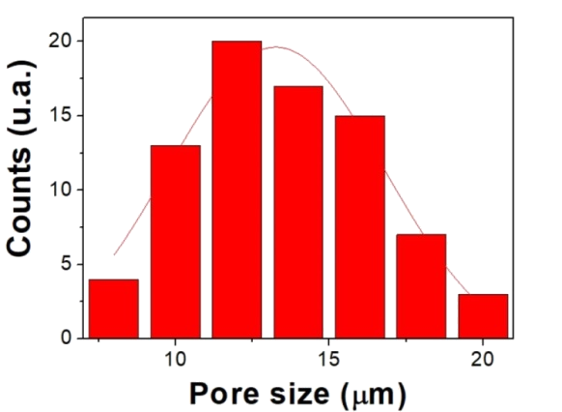
Figure S1. Pore size distribution of the bionanocomposite Foam-1 obtained by image analysis of SEM cross-section micrographs.

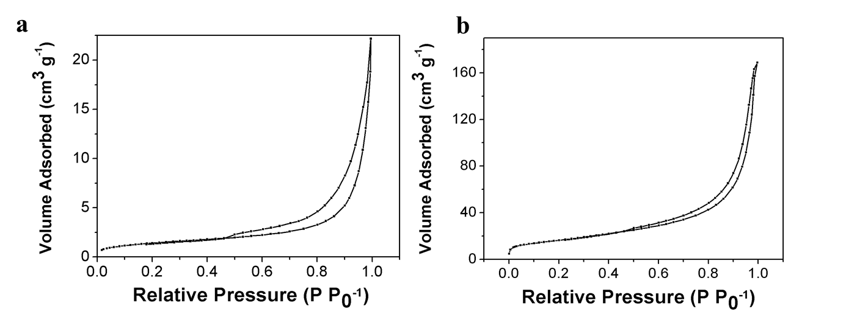
Figure S2. N₂ adsorption–desorption isotherm of bionanocomposite a) Film-1 and b) Foam-1.

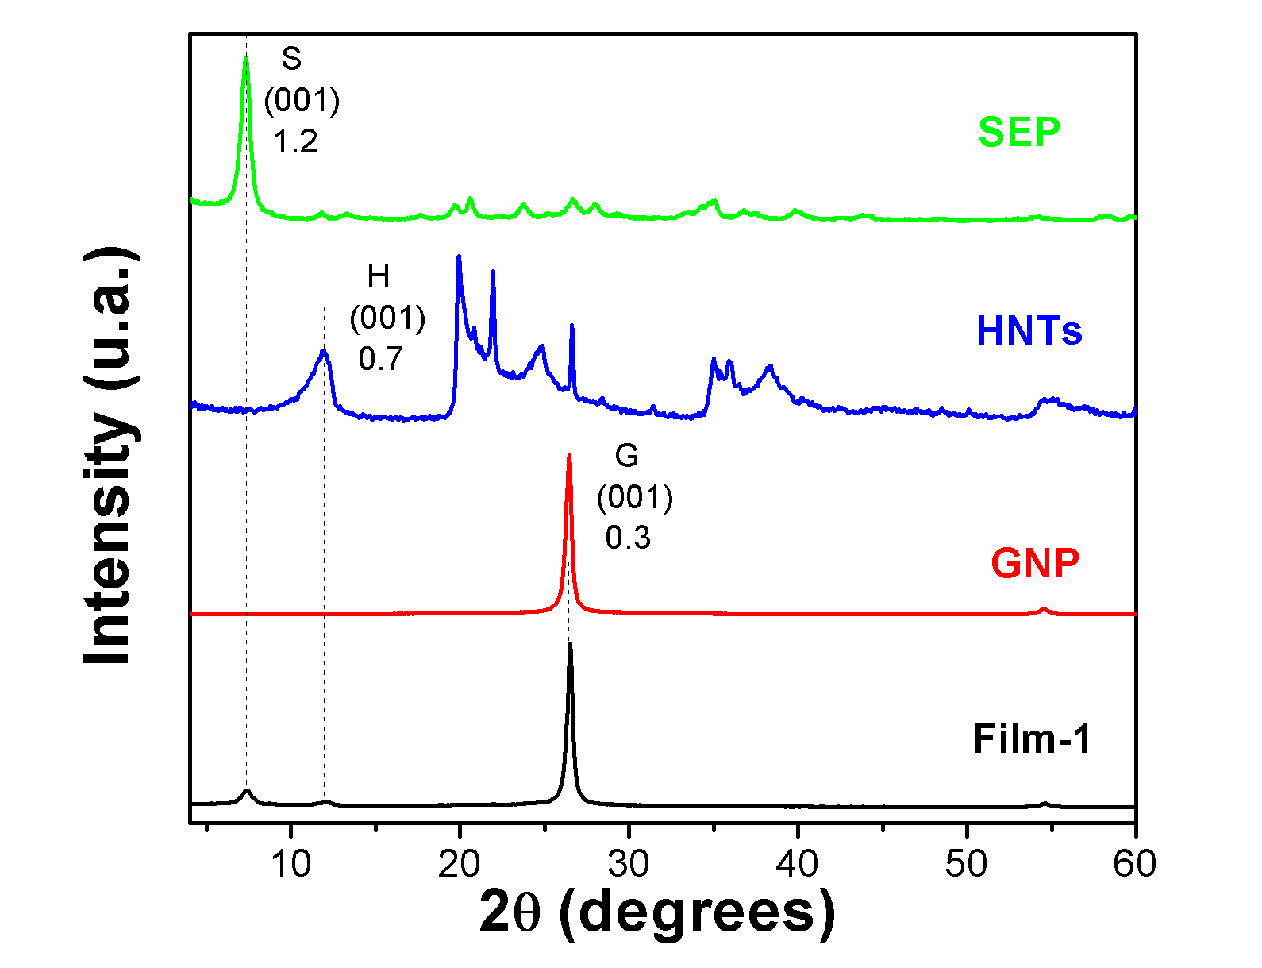
Figure S3. XRD pattern of sepiolite (SEP), halloysite nanotubes (HNT), graphene nanoplatelets (GNP) and the bionanocomposite film (Film-1). The main reflection planes of sepiolite (S), halloysite (H), and graphene nanoplatelets (G) are shown with the corresponding Miller index and the interlayer distance values (nm).

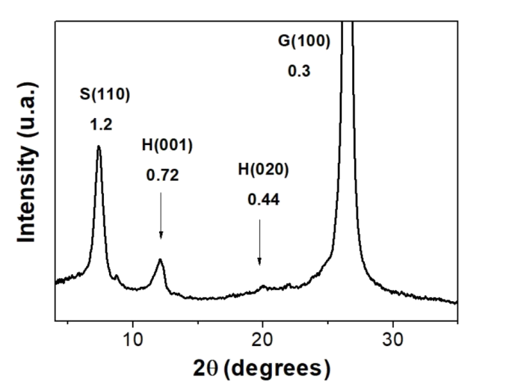
Figure S4. Magnification of XRD pattern of the bionanocomposite Film-1. The principal reflection planes of sepiolite (S) halloysite (H) and graphene nanoplatelets (G) are shown with the corresponding Miller index and interlayer distance.

Generally, the (001) diffractions are dominant when nanotubes are oriented lying in the plane of the film, while the other diffractions (e.g. the (020) plane) appear as weak reflections. This alignment of the tubes, with their long axis in the plane, increases the intensity of the (001) reflection with respect to the (020) reflection, i.e. the (001)/(020) intensity ratio increases from 0.5 in powder halloysite to 1.8 in the Film-1.^{[1]}

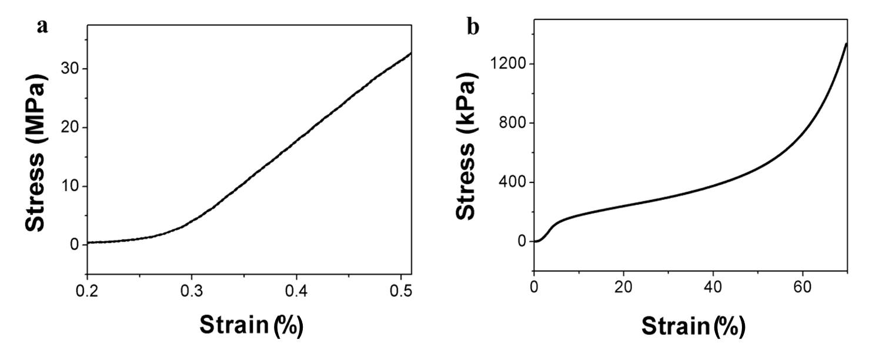
Figure S5. Stress-strain curve of bionanocomposite a) Film-1 and b) Foam-1.

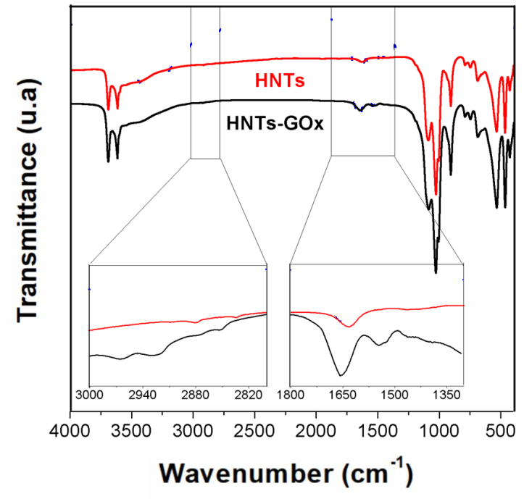

Figure S6. FTIR spectra of pristine GOx, HNT and HNT-GOx, with their magnifications in the aliphatic region (3000-2800 cm⁻¹) and double bonds region (1800-1300 cm⁻¹).

Table S1. Summary of assigned main peaks.
Position (cm⁻¹) | Assignments
3695, 3656 | O-H stretching of inner-surface hydroxyl group^{a)}
3620 | O-H stretching of inner hydroxyl group
3600, 3450 | O-H stretching of water
~ 2900 | Symmetric stretching of C-H₂
1655 | Amide I (C=O)
1633 | O-H deformation of water in HNT
1543 | Amide II (N-H)
^{a)} The transition moment is nearly perpendicular to the (001) plane.

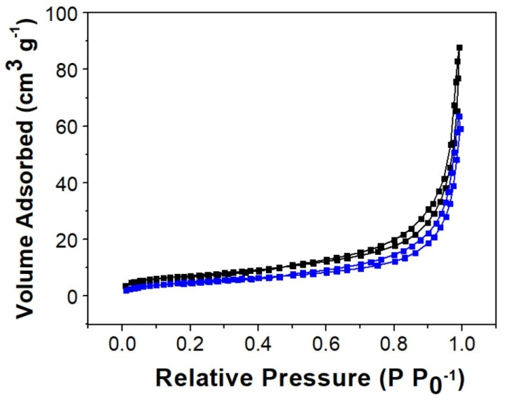
Figure S7. N₂ adsorption–desorption isotherms of pristine HNTs (black curves) and HNTs-GOx (blue curves).

Table S2. Specific BET surface area and the mesopore characteristics of HNT and HNT-GOx.
 | S_{BET}^{a)} (m² g⁻¹) | d_{mes}^{b)} (nm) | V_{mes}^{c)} (cm³ g⁻¹) | S_{mes}^{d)} (m² g⁻¹)
HNT | 25.1 | 11.2 | 0.063 | 22.2
HNT-GOx | 18.8 | 11.2 | 0.046 | 15.9
^{a)} = Specific surface area calculated by means of the Brunauer-Emmet-Teller (BET) equation in the linear interval of relative pressure from 0.05 to 0.3 (P P₀⁻¹).
^{b)} = Average mesopores diameter calculated with Barret-Joyner-Hallenda (BJH) method from the isotherm data in the adsorption part.
^{c)} = Average mesopores volume calculated with Barret-Joyner-Hallenda (BJH) method from the isotherm data in the adsorption part.
^{d)} = Average mesopores surface area calculated with Barret-Joyner-Hallenda (BJH) method from the isotherm data in the adsorption part.

Figure S8. Peroxidase assay of Film-GOx in 800 μL of buffered solution (PBS), 50 μL of ABTS/peroxidase stock (50 mM and 25 units/ml respectively), 100 µL of glucose stock (0.1 M), at time 0 a) and after 10 minutes b).

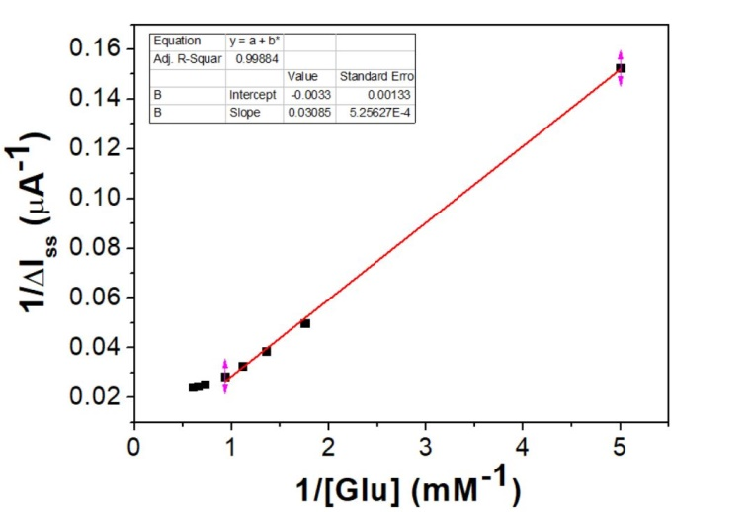
Figure S9. Lineweaver–Burk plot obtained by CV of Film-GOx working in PBS at pH 7 and 0.1 mM of ferricyanide, at scan rate of 5 mV s⁻¹.
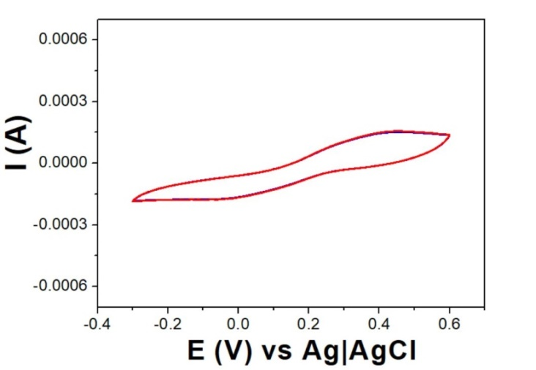
Figure S10. CV for the bionanocomposite film prepared in absence of halloysite nanocontainer. The measurement was acquired in PBS at pH 7 and 0.1 mM of ferricyanide and at scan rate of 5 mV s⁻¹. Red curve is absence of glucose and the blue one is in presence of 5 mM glucose.

Figure S11. Polarization curve obtained by LSV measurement at a scan rate of 1 mV s⁻¹. The Foam-GOx was tested in the PBS medium with glucose 1 M and in presence of Fe(CN₆)⁴⁻ 0.1 M. The anode and the cathode chambers were separated by a Nafion® membrane.

References
[1] M. S. Żbik, N. A. Raftery, R. S. C. Smart, R. L. Frost, Appl. Clay Sci. 2010, 50, 299.

