Supporting Information
for
Zwitterion π–conjugated nanoporous polymer based on guanidinium and β-ketoenol as a heterogeneous organo-catalyst for chemical fixation of CO₂ into cyclic carbonates
Mousumi Garai*, Vepa Rozyyev, Cafer T. Yavuz

Address: Graduate School of Energy, Environment, Water and Sustainability (EEWS), Korea Advanced Institute of Science and Technology (KAIST), 291 Daehak-ro, Yuseong-gu, Daejeon 34141, Republic of Korea

Email: mousumi@kaist.ac.kr
* Corresponding author

Materials and methods
Materials used for the synthesis of organo-catalyst such as Guanidine hydrochloride, acetyl chloride and boron trifluoride-acetic acid-complex were purchased from Sigma Aldrich. Styrene oxide, epichlorohydrin, propylene oxide, were also purchased from Sigma Aldrich. All other chemicals and solvents were obtained from Samchun Pure Chemicals, Korea and used without further purification.

Materials and instrumentation
¹H NMR spectra were taken using CDCl₃/D₆ DMSO as the solvent in a 300 MHz Bruker NMR spectrometer. Powder X-ray diffraction (PXRD) patterns were recorded on Phillips PANalytical diffractometer for Cu Kα radiation (α=1.5406 Å), with a scan speed of 1° min⁻¹ and a step size of 0.02° in 2θ and Rigaku SmartLab diffractometer. Fourier transform infrared (FT-IR) spectra were recorded on a SHIMADZU IRTracer-100 spectrometer with GladiATR 10 (single reflection ATR accessory) in the 400−4000 cm^{–1}. Thermogravimetric analyses were performed on a Shimadzu DTG-60A by heating the samples up to 800°C at a rate of 5°C min⁻¹ under nitrogen or air atmosphere. In order to evaluate the porosity nature of the polymers, N₂ adsorption isotherm was obtained with a Micromeritics 3FLEX accelerated surface area and porosimetry analyzer at 77K. Prior to measurement, sample was degassed at 120 °C for 12 hrs under vacuum. The specific surface areas were calculated from Brunauer-Emmett-Teller (BET) method.

General synthetic procedure
Triaminoguanidinium chloride (TGCl) and β-ketoenol derivative (Figure S1) were synthesized following reported methods [S1-S3]. Nanoporous organocatalysts (COP-213) were prepared Schiff base condensation between 0.07 mmol β-ketoenol derivative (40 mg) and 0.07 mmol amines (TGCl: 10 mg) in a sealed Pyrex tube in dioxane: water (2: 0.6 mL) system. The reaction mixtures were charged into Pyrex tube and sonicated for 20 min. The mixtures were degassed under liquid N₂ (77K) by freeze-pump-thaw cycles for three times. The Pyrex tube was sealed and kept at room temperature until the reaction mixtures attended the room temperature. The sealed Pyrex tube containing the reaction mixture was kept at 120˚C for 3 days. The precipitate was washed thoroughly with dioxane, water and acetone respectively and dried at 90˚C under vacuum for overnight to obtain ~50% isolated yield. FTIR (ATR, cm-1): 1610 (s), 1555 (w), 1280 (s), 1180 (m), 965 (w), 820 (w).

General procedure for the synthesis of cyclic carbonates
In a typical reaction, a Schlenk reactor was charged with the catalyst (30 mg) and epoxides (5 mmol). After that the tube was kept in an oil bath and stirred at 100℃ under connecting CO₂ (1 atm). After the reaction, the reaction mixture was cooled to room temperature. The mixture was filtered and washed thoroughly with chloroform to ensure complete removal of the product. The collected filtrate was evaporated under reduced pressure and the samples were analyzed by ¹H NMR spectroscopy. The recovered catalyst was dried at 100 °C under vacuum and reused for further cycles.

Procedure for the synthesis of propylene carbonate
In a typical reaction, a glass lined stainless-steel reactor containing a stirring bar was charged with the catalyst (30 mg) and epoxides (5 mmol). After sealing and purging with CO₂ (1 atm), the reactor was placed in a preheated sand-bath and stirred for 48 h at 100℃. After the reaction, the reactor was cooled to room temperature and CO₂ was released slowly. The reaction mixture was filtered off and washed thoroughly with chloroform to ensure complete removal of the product. The collected filtrate was evaporated under reduced pressure and the sample was analyzed by ¹H NMR spectroscopy.
a
b
c
c
b
a

Figure S1: ¹H NMR (300 MHz, D⁶ DMSO, 298 K) of β-ketoenol derivative.
b'
a'
b'
c'
a
b
c'
c

a'

Figure S2: ¹H NMR (300 MHz, CDCl3, 298 K) of (±)-epichlorohydrin conversion reaction into the corresponding cyclic carbonate.

a'
c'
b'
a
b
c
b'
c'
a'

Figure S3: ¹H NMR (300 MHz, CDCl3, 298 K) of (±)-propylene oxide conversion reaction into the corresponding cyclic carbonate.

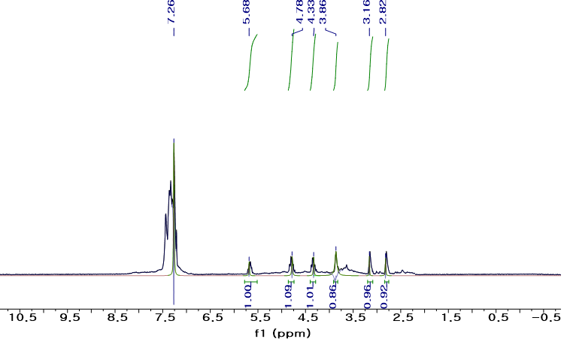
a
b
c
a'
b'
c'
a
b
c
a'
b'
c'

Figure S3: ¹H NMR (300 MHz, CDCl3, 298 K) of styrene oxide conversion reaction into the corresponding cyclic carbonate.

References
S1. Mitra, S.; Kandambeth, S.; Biswal, B. P.; M. A. K.; Choudhury, C. K.; Mehta, M.; Kaur, G.; Banerjee, S.; Prabhune, A.; Verma, S.; Roy, S.; Kharul, U. K.; Banerjee, R. J. Am. Chem. Soc. 2016, 138, 2823−2828.
S2. Vilhanová, B.; Ranocchiari, M.; Bokhoven, J. A. v. ChemCatChem 2016, 8, 308–312.
S3. Goörlitz, G.; Hartmann, H. Heteroatom Chemistry 1997, 8, 147-155.

