Supporting Information
for
A photochemical determination of luminescence efficiency of upconverting nanoparticles
Baptiste Amouroux, Clément Roux, Jean-Claude Micheau, Fabienne Gauffre, Christophe Coudret

Experimental details and characterization data

Table of contents

General procedure for the preparation of UCNP batch S2
Characteristics of UCNP batch (stoichiometry, datas from TEM, datas from XRD) S3
TEM analysis of UCNP batch S4
XRD analysis of UCNP batch S5
Discoloration of DAE induced by UCNP batch (S1) S6
General procedure for the preparation of a second UCNP batch with a diameter of 35 nm S7
Discoloration of DAE induced by 35nm-UCNP S8

S2- Experimental section

Photochromic actinometer: 1,2-Bis(2,4-dimethyl-5-phenyl-3-thienyl)-3,3,4,4,5,5-hexafluoro-1-cyclopentene (≥98%, CAS: 172612-67-8) was obtained from TCI chemicals and used as received.
The molar extinction coefficient of 1-c at 540nmm was determined by normalizing a UV vis spectrum of a 1-o/1-c mixture using the published value at 562 nm¹ (since only the 1-c form exist in this spectral range there is no need of determining its concentration

Procedure for the preparation of UCNP batch
UCNP were prepared adapting the protocols of Li and Zhang² and Zhai et al.³ Rare earth (RE) chloride hydrates were mixed in a oleic acid (OA): octadecene (ODE) (7:38) mixture and heated to 160°C under Ar flush until a clear solution was obtained. To the cooled reaction mixture were slowly added freshly prepared solutions of NaOH (0.326 mM) and NH₄F (0.5 mM) in MeOH via syringe pump at 0.4 mL min⁻¹. Volatile compounds were then removed under Ar flush then the reaction mixture iwa brought to 300-310 for 90 minutes. Timer was started when temperature reached 300°C. It should be noted that temperature never reached 310 but stayed at around 305°C.

S3-Characteristics of UCNP batch (stoichiometry, datas from TEM, datas from XRD)
 | UCNPs
Matrix | NaYF₄
n(RE) | 11.6 mmol
n(Y) | 7.9 mmol (68% RE)
n(Yb) | 3.5 mmol (30% RE)
n(Yb) | 0.23 mmol (2% RE)
n(Na)/n(RE) | 4
n(F)/n(RE) | 5.5
V(OA) mL | 35
V(ODE) mL | 190
{Na+F} addition | Separated addition via double syringe pump
Diameter | 21.8 nm
Area | 1.49 * 10³ nm²
Volume | 5.42 * 10³ nm³
Unit cell volume U(NaYF₄:Yb,Er) | 107.6 Å³
Z | 1.5
N(Yb/NP) | 22670
N(Er/NP) | 1510

S4-TEM analysis of UCNP batch

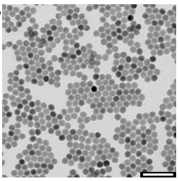 scale bar =100nm

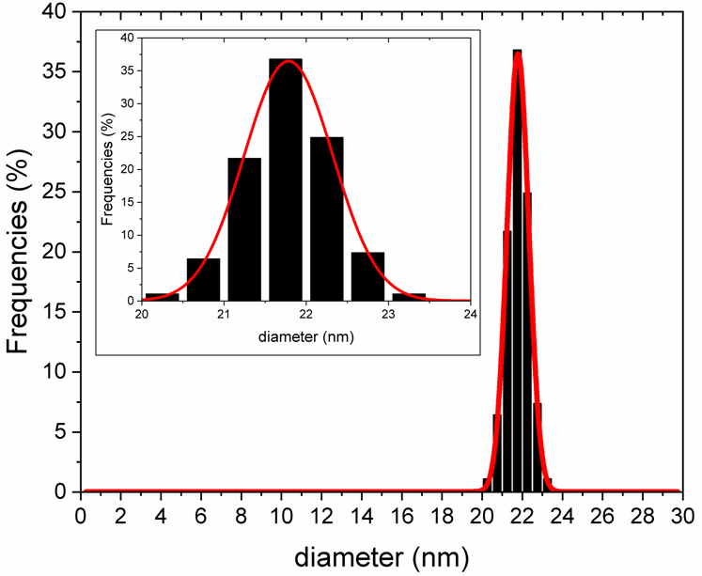

UCNP synthesized are homogeneous in size and shape. We have assimilated them to a pseudo-sphere of a diameter of 21.8 ± 1.3 nm (average size ± FWHM)

S5-XRD analysis of UCNP batch

XRD is consistent with the hexagonal phase

S6-Discoloration of DAE induced by UCNP batch (S1)

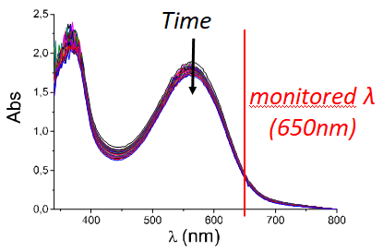

DAE discoloration induced by UCNP under 976m CW laser at a power of 4.1W (49 W cm⁻²). Conditions are reported in the main text. The high absorbance ensures total light absorption at 540nm.
A convenient parameter is the characteristic “optical thickness”⁴ L defined from the rewritten Beer Lambert law:
$I=I_{0}{10}^{\frac{−l}{L}}$
as
$L=\frac{1}{ε_{540}\left[1c\right]}$

L is therefore the inverse of the absorbance measured for an optical path of 1cm. Thus, an absorbance at 530nm of 2.1 (over 1cm) gives a characteristic length of 0.47 cm, comparable to the dimensions of the cuvette:

Quartz cell containing the mixture of DAE and UCNP (21.8nm) was placed in UV-visible spectrophotometer. Absorbance spectra were recorded in a kinetic mode, while the cell was irradiated from the side by a fibered collimated NIR laser.

S7-General procedure for the preparation of a second UCNP batch with a diameter of 35 nm
NaYF₄,Yb,Er UCNPs were prepared by applying the protocol described by Li and Zhang³, using a doping molar ratio of 80% Y, 18% Yb, 2% Er.

S8-Summary table

Step | parameter | symbol | unit | value
Photolysis of 1-c | DAE 1-c concentration | [1-c] | mol L⁻¹ | 2.12 × 10⁻⁴
Photolysis of 1-c | 1-c molar extinction coefficient at 650nm (monitoring) | ε₆₅₀ | L mol⁻¹ cm⁻¹ | 2154
Photolysis of 1-c | 1-c molar extinction coefficient at 540nm | ε₅₄₀ | L mol⁻¹ cm⁻¹ | 9784
Photolysis of 1-c | Volume of the DAE solution | V | L | 1.96 × 10⁻³
Photolysis of 1-c | DAE opening quantum yield at 540nm | Φ_{CO} | - | 0.02
Photolysis of 1-c | DAE Absorbance at 540 nm (irradiation) | Abs₅₄₀ | - | 2.07
Photolysis of 1-c | Optical length at 540 nm | L | cm | 0.48
Photolysis of 1-c | Initial slope DAE photobleaching | -dAbs₆₅₀/dt | Abs s⁻¹ | 1.46 × 10⁻⁵
Photolysis of 1-c | DAE bleaching rate | -d[1-c]/dt | mol L⁻¹ s⁻¹ | 6.78 × 10⁻⁹
Photolysis of 1-c | DAE consumption |  | molecule s⁻¹ | 8.00 × 10¹²
Incoming NIR energy | Upconversion photon flux at 540nm | J₀ | photon s⁻¹ | 4.00 × 10¹⁴
Incoming NIR energy | Laser power at 976 nm (NIR) | P | W | 4.7
Incoming NIR energy | Laser power density at 976 nm (NIR) |  | W cm⁻² | 49
Incoming NIR energy | Incident NIR photon flux | J₀^{NIR} | photon s⁻¹ | 2.31 × 10¹⁹
Incoming NIR energy | Absorbance of UCNP solution at 976 nm | Abs₉₇₆ | - | 0.0014
Incoming NIR energy | Absorbed NIR photon flux | J_{a}^{NIR} | photon s⁻¹ | 7.45 × 10¹⁶
Incoming NIR energy | Up-conversion QY | Φ_{UC} | - | 0.54%
Single NP power | Laser beam section |  | cm² | 9.6 × 10⁻²
Single NP power | Laser beam volume inside the cell (“lamp”) | v | L | 9.6 × 10⁻⁵
Single NP power | Yb molar extinction coefficient at 976 nm | ε_{Yb} | L mol⁻¹ cm⁻¹ | 3.1
Single NP power | number of Yb atoms inside the beam volume | n_{Yb} | atom | 2.58 × 10¹⁶
Single NP power | Total number of RE per nanoparticle (from XRD) | N_{RE} | atom NP⁻¹ | 75490
Single NP power | percentage of Yb | p_{Yb} | % | 30
Single NP power | percentage of Er | p_{Er} | % | 2
Single NP power | number of ytterbium per nanoparticle | N_{Yb} | atom NP⁻¹ | 22670
Single NP power | number of erbium per nanoparticle | N_{Er} | atom NP⁻¹ | 1510
Single NP power | number of NPs inside the laser beam | n_{Yb} | NP | 1.14 × 10²
Single NP power | emitted photons per erbium atom | J₀/N_{Er} | photon s⁻¹ | 0.24
Single NP power | number of emitted photons per NP’s | J₀/n_{NP} | photon s⁻¹ | 350
Single NP power | Power per NP’s | $$℘^{NP}$$ | W | 1.29 × 10¹⁶

S9-Discoloration of DAE induced by 35nm-UCNP

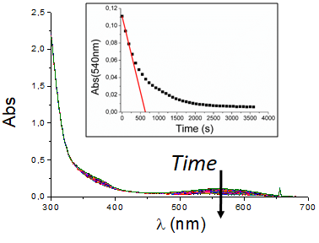
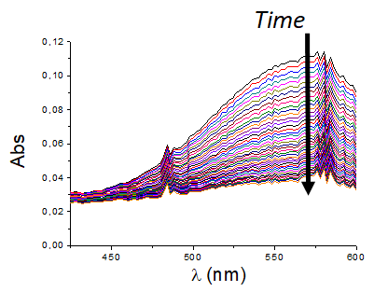
Photoizomerization of DAE induced by UCNP emission was monitored in diluted conditions : Abs(500-600nm)≈0.15. Complete kinetic is represented on top, while zoom-in of the region of interest (where only 1-c absorbs) is shown at the bottom.

In such conditions it is not possible to define simply the absorbed flux density [loubiere]. Thus, no quantum yield could be determined. Nevertheless, the activity of the nanolamp could be determined: in this geometry, one single 35nm-UCNP induces 20 dyes switching per second (ratio of the measured disappearance slope by the number of UCNP within the 976nm-irradiated volume).

S10-References:
(1) Sumi, T.; Takagi, Y.; Yagi, A.; Morimoto, M.; Irie, M. Chemical Communications 2014, 50 (30), 3928–3930. https://doi.org/10.1039/C4CC00396A.
(2) Li, Z.; Zhang, Y. Nanotechnology 2008, 19 (34), 345606. https://doi.org/doi:10.1088/0957-4484/19/34/345606.
(3) Zhai, X.; Wang, Y.; Liu, X.; Liu, S.; Lei, P.; Yao, S.; Song, S.; Zhou, L.; Feng, J.; Zhang, H. ChemPhotoChem 2017, 1 (8), 369–375.
(4) Aillet, T.; Loubiere, K.; Dechy-Cabaret, O.; Prat, L. International Journal of Chemical Reactor Engineering 2014, 12 (1), 257–269. https://doi.org/10.1515/ijcre-2013-0121.

