Formation of exceptionally stable ketene during photo transformations of Bicyclo[2.2.2]oct-5-en-2-ones having mixed chromophores

Asitanga Ghosh*

Address: Assistant Professor, Dept. of Chemistry, Hooghly Mohsin College, Chinsurah, Hooghly, West Bengal, India- 712101

Experimental
The melting points were uncorrected and were measured in a Gallenkamp melting point apparatus. The IR spectra were recorded on a FTIR-8300 Shimadzu spectrometer. All NMR spectra were recorded in CDCl₃ solution at 300 MHz for ¹H and at 75 MHz for ¹³C on a Brucker AC-300 spectrometer using tetramethylsilane as an internal standard. Elemental analyses were performed with a Heraeus Combustion apparatus or on a 2400 series-II Perkin Elmer CHN analyzer. High Resolution Mass Spectra were recorded on a Qtof Micro YA263 spectrometer using Electron Spray Ionization (ESI) technique. UV absorption spectra were recorded on a Shimadzu UV-2401PC spectrophotometer. Flash Column Chromatography was performed using silica gel (230–400 mesh) under medium pressure and ordinary column chromatography was performed using silica gel (60–120 mesh). Preparative Thin layer chromatography was performed using silica gel GF-254 (Merck). Petroleum ether and ethyl acetate have been abbreviated as PE and EA. PE used was of the boiling range 60-80 °C. Spectral grade solvents were used for recording UV spectra. Solvents were purified and dried before using. Irradiation experiments were carried out in a Southern New England Rayonet Photochemical Reactor using lamps of desired wavelength. Dibenzoyl acetylene, 9 (DBA) [1] were prepared according to literature procedure.
Synthesis of 5,6-Dibenzoyl-4-phenylbicyclo[2.2.2]oct-5-en-2-one (6) The trimethyl-(5-phenyl-cyclohexa-1,5-dienyloxy)-silane (8a, 3.66 gm, 15 mmol) was prepared from the 3-Phenylcyclohexenone [2] following our previously reported procedure [3,4]. Dry benzene (3 mL) and a solution of DBA (9, 2.34 gm,10 mmol) in dry benzene (10 mL) were immediately added to the diene and the mixture was stirred for overnight under argon atmosphere. After that 5% methanolic–HCl (5 mL) was added to it and the mixture was stirred for additional 20 min. After removal of MeOH, the mixture was extracted with ether (3x25 mL). The organic phases were combined, dried over Na₂SO₄, and evaporated in vacuo. The residue was filtered through a small column with 10% EA in PE which gave a solid of 5,6-Dibenzoyl-4- phenyl-bicyclo[2.2.2]oct-5-en-2-one (6, 3.41 g, 84%), mp 224-226 ⁰C, as colorless crystals after recrystallization from DCM–PE (1:10) mixture. HRMS Calcd for C₂₈H₂₂O₃: [M+Na]⁺ 429.1467; Found: 429.1462; IR (neat) λ_{max} (cm⁻¹): 3060, 2979, 2935, 2860(C-H), 1726 (C=O), 1666 (C=O), 1647 (C=O), 1595(C=C); UV (MeCN) λ_{max} (nm): 255 (log ε 4.01), 283 (3.6), 343 (2.4); 1H-NMR δ (ppm): 2.15-2.32 (m, 3H), 2.55 (d, J 18.5 Hz) superimposed with 2.50-2.59 (m) total 2H, 3.04 (dd, J 18.5 and 3.3 Hz, 1H), 3.82 (t, J 2.5 Hz, 1H), 7.12-7.49 (m, 15H); ¹³C NMR δ (ppm): 23.9 (CH₂), 31.3 (CH₂), 45.5 (CH₂), 49.1(C), 51.1 (CH), 126.6 (CH), 127.2 (CH), 128.25 (CH), 128.29 (CH), 128.34 (CH), 129.1 (CH), 133.0 (CH), 133.15 (CH), 136.1 (C), 137.1 (C), 138.4 (C), 140.3 (C), 154.8 (C), 193.3 (CO), 195.4 (CO), 208.4 (CO).

Synthesis of 5,6-dibenzoyl-4-isopropenylbicyclo[2.2.2]oct-5-en-2-one (7)
To a solution of freshly distilled di-isopropylamine (2.1 mL, 15 mmol) in dry THF (20 mL) n-butyllithium (8 mL of 1.5 M solution in hexane, 12 mmol) was added dropwise under argon atmosphere at -78 ºC. Temperature of the reaction bath was then slowly raised to -10 ºC and then again cooled to -78 ºC after 30 min. A solution of 3-Isopropenyl-cyclohex-2-enone [5] (1.36 g, 10.0 mmol) in dry THF (5 mL) was added in drops to the reaction mixture for a period of 2-3 min via syringe when the color of the solution turned deep yellow. Stir brought to room temperature during next 2 h. The solvent was removed reduced pressure followed by immediate flushing of the reaction vessel with argon. The residue was stirred three times with dry n-pentane (3x15 mL) under inert atmosphere and the supernatant liquid was transferred very carefully via a cannula to an oven dried thoroughly argon flushed flask. The total solvent (~45 mL) was then removed in vacuo to get the pale yellow liquid of trimethyl(5-phenylcyclohexa-1,5-dienyloxy)silane (8b) [4]. Dry benzene (5 mL) and a solution of DBA (1.638 gm, 7 mmol) in dry benzene (5 mL) were immediately added to the diene and the mixture was stirred for 6 h under inert atmosphere. A solution of 5% methanol-HCl (5 mL) was added to it and the mixture was stirred for additional 20 min. After removal of MeOH the mixture was extracted with ether (3x25 mL). The organic phases were combined, dried over anhydrous Na₂SO₄, and evaporated in vacuo. The residue was chromatographed over a silica gel column. Elution of the column with 15% EA in PE gave a solid of 5,6-Dibenzoyl-4-isopropenyl-bicyclo[2.2.2]oct-5-en-2-one (7, 1.09 g, 43%), mp 144-146 ºC, as colorless crystals after recrystallization from DCM–PE (1:10) mixture. HRMS Calcd for C₂₅H₂₃O₃: [M+H]⁺ 371.1321, found: 371.1327. IR (neat) ν_{max} (cm⁻¹): 2943, 2869 (C-H), 1722 (C=O), 1664 (C=O), 1595 (C=C), 1577, 1446, 1311, 1247, 1220, 985, 923, 756, 704, 694. UV (MeCN) λ_{max} (nm): 256 (log ε 3.7), 284 (3.4), 346 (2.3). ¹H NMR δ (ppm): 1.64 (s, 3H), 1.91-1.99 (m, 1H), 2.06-2.22 (m, 2H), 2.29 (d, J 18.5 Hz) superimposed with 2.26-2.35 M total 2H, 2.79 (dd, J 18.5 and 2.9 Hz, 1H), 3.73 (t, J 2.7 Hz, 1H) 4.96 (s, 1H), 4.98 (s, 1H), 7.24-7.51(m, 10H). ¹³C NMR δ (ppm): 21.6 (CH₃), 24 (CH₂), 29.9(CH₂), 44.2(CH₂), 50.9(C), 51.1(CH), 114.5 (=CH₂), 128.5 (CH), 128.6 (CH), 128.8 (CH), 129.2 (CH), 133.3 (CH), 133.5 (CH), 136.5(C), 137.1 (C), 139.2 (C), 44.1 (C), 152.7 (C), 194.8 (CO), 208.9 (CO).

Photolysis of 5,6-dibenzoyl-4-phenylbicyclo[2.2.2]oct-5-en-2-one (6)
a. at 254 nm:
i. In Benzene: A 100 mL solution of 6 (380 mg, 0.94 mmol) in dry benzene was degassed with argon for 10 minutes and then irradiated at 254 nm for 3h in a quartz tube. Solvent was removed under reduced pressure and the residue was subjected to flash chromatography. Elution of the column with 8% EA in PE gave a yellow solid of vinyl ketene (Z)-5-formyl-6-(phenoxy(phenyl)methylene)-4-phenylbicyclo[2.2.2]octan-2-one (10, 144 mg, 38%), m.p. 162-164 ⁰C. HRMS for C₂₈H₂₂O₃Na calcd. 429.1467; found ([M+Na]⁺): 429.1463. UV (MeCN) λ_{max}(nm): 227 (log ε 3.64), 316 (3.59). IR (neat) ν_{max} (cm⁻¹): 3082, 2931, 2868, 2087 (=C=C=O), 1730 (C=O), 1591, 1487, 1444, 1371, 1230, 1209, 1178, 1159, 1068, 761, 702. ¹H-NMR δ (ppm): 1.95-2.18 (m, 3H), 2.46-2.59 (m) superimposed with 2.56 (d, J 18.2 Hz) total 2H, 3.01 (dd, J 18.2 and 3 Hz, 1H), 3.69 (brs, 1H), 6.68 (d, J 8 Hz, 2H), 6.79 (t, J 7.4 Hz, 3H), 7.02 -7.03 (m, 10H). ¹³C NMR δ (ppm): 24.3 (CH₂), 32.6 (CH₂), 41.9 (C), 46.9 (CH), 48.9 (C=C=O), 51.0 (CH₂), 116.5 (CH), 117.4 (C), 122.5 (CH), 126.3 (CH), 128.1 (CH), 128.2 (CH), 128.7 (CH), 128.9 (CH), 129.6 (CH), 129.8 (CH), 133.2 (C), 140.9 (C), 141.3 (C), 155.9 (C(Ph)OPh), 200.2 (CO), 209.9 (CO).
Further elution with same solvent gave a white solid of unreacted starting material 5,6-dibenzoyl-4-phenylbicyclo[2.2.2]oct-5-en-2-one (6, 185 mg, 49%),
ii. Trapping of the Ketene 10: The ketene 10 (150 mg) was refluxed in dry methanol for overnight. Solvent was removed and the reaction mixture was found to contain two isomeric esters (2R,Z)-methyl 5-oxo-3-(phenoxy(phenyl)methylene)-1-phenylbicyclo[2.2.2]octane-2-carboxylate (11a) and (2S,Z)-methyl 5-oxo-3-(phenoxy(phenyl)methylene)-1-phenylbicyclo [2.2.2]- octane-2-carboxylate (11b) in a quantitative amount. From the NMR spectrum, 11a and 11b were found to be in ~ 1:6 ratio in the mixture. Since, the polarity of these two isomers were almost same, it was difficult to separate them from the mixture and only 21 mg of 11a could be isolated as a white solid (m.p. 174-176 ⁰C) by repeated thin layer chromatography with 12% EA in PE. HRMS calcd. for C₂₉H₂₆O₄Na: 461.1729; found ([M+Na]⁺): 461.1729. IR (neat) ν_{max} (cm⁻¹): 3059, 3024, 2947, 2870, 1728 (C=O), 1593, 1489, 1444, 1433, 1330, 1288, 1261, 1168, 1064, 1026, 925, 752. ¹H NMR δ (ppm): 1.71-1.78 (m, 1H), 1.99-2.06 (m, 1H), 2.38 (d, J 11.4 Hz, 1H), 2.42-2.47 (m, 1H), 2.72-2.78 (m, 1H), 2.85 (dd, J 11.4 and 2.1 Hz, 1H), 3.50 (t, J 3 Hz, 1H), 3.77 (s, 1H), 6.65 (d, J 4.8 Hz, 2H), 6.77 (t, J 4.2 Hz, 3H), 7.01-7.05 (m, 2H), 7.15-7.32 (m, 10H). ¹³C NMR δ (ppm) : 23.6 (CH₂), 24.9 (CH₂), 43.0 (C), 46.9 (CH₃), 51.3 (CH), 51.4 (CH₂), 53.2 (CH), 111.9 (C), 116.8 (CH), 120.6 (CH), 122.2 (CH), 125.9 (CH), 127.3 (CH), 128.57 (CH), 128.63 (CH), 128.9 (CH), 129.3 (CH), 129.4 (CH), 133.0 (C), 142.7 (C), 148.4 (C), 155.5 (C), 172.4 (CO₂Me), 210.3 (CO).

ii. In Acetonitrile: A 100 mL solution of the 6 (380 mg, 0.94 mmol) in dry acetonitrile was degassed with argon for 10 minutes and then irradiated for 3h in a quartz tube. Solvent was removed under reduced pressure and the residue was subjected to flash chromatography. Elution of the column with 8% EA in PE gave a yellow solid of 10 (205 mg, 54%), m.p. 162-164 ⁰C (mmp 164 ⁰C). Further elution with same solvent gave a white solid of unreacted starting material 6 (132 mg, 35%), m.p. 225 ⁰C (mmp 224-226 ⁰C).

iii. In Acetone: A 100 mL solution of the 6 (380 mg, 0.94 mmol) in dry acetone was degassed with argon for 10 minutes and then irradiated for 3h in a quartz tube. Solvent was removed under reduced pressure and the residue was subjected to flash chromatography. Elution of the column with 8% EA in PE gave a yellow solid of 10 (167mg, 44%), m.p. 162-164 ⁰C (mmp 164 ⁰C). Further elution with same solvent gave a white solid of unreacted starting material 6 (161 mg, 42%), m.p. 225 ⁰C (mmp 224-226 ⁰C).

iv. In Methanol: A 50 mL solution of 6 (110 mg, 0.5 mmol) in dry methanol was degassed with argon for 10 minutes and then irradiated for 4 h in a quartz tube. Solvent was removed under reduced pressure and the residue was chromatographed over silica gel. Elution of the column with 10% EA in PE gave a mixture of two isomeric esters 11a and 11b (71 mg, 60%). From the NMR spectrum, 11a and 11b were found to be in ~ 1:6 ratio in the mixture.

b. at 300 nm:
i. In Benzene: A 60 mL solution of 6 (240 mg, 0.59 mmol) in dry benzene was degassed with argon for 10 minutes and then irradiated for 5h in a Pyrex tube. Solvent was removed under reduced pressure and the residue was subjected to flash chromatography. Elution of the column with 8% EA in PE gave a yellow solid of 10 (110 mg, 46%), m.p. 162-164 ⁰C (mmp 164 ⁰C). Further elution with same solvent gave a white solid of unreacted starting material 6 (82 mg, 34%), m.p. 225 ⁰C (mmp 224-226 ⁰C).

ii. In Acetonitrile: A 60 mL solution of 6 (240 mg, 0.59 mmol) in dry acetonitrile was degassed with argon for 10 minutes and then irradiated for 5h in a Pyrex tube. Solvent was removed under reduced pressure and the residue was subjected to flash chromatography. Elution of the column with 8% EA in PE gave a yellow solid of 10 (98 mg, 41%), m.p. 162-164 ⁰C (mmp 164 ⁰C). Further elution with same solvent gave a white solid of unreacted starting material 6 (101 mg, 42%), m.p. 225 ⁰C (mmp 224-226 ⁰C).

iii. In Acetone: A 70 mL solution of 6 (200 mg, 0.5 mmol) in dry acetone was degassed with argon for 10 minutes and then irradiated for 5h in a pyrex tube. Solvent was removed under reduced pressure and the residue was subjected to flash chromatography. Elution of the column with 8% EA in PE gave a yellow solid of 10 (98 mg, 49%), m.p. 162-164 ⁰C (mmp 164 ⁰C). Further elution with same solvent gave a white solid of unreacted starting material 6 (80 mg, 40%), m.p. 225 ⁰C (mmp 224-226 ⁰C).

c. at 350 nm:
i. In Benzene: A 70 mL solution of 6 (180 mg, 0.45 mmol) in dry benzene was degassed with argon for 10 minutes and then irradiated for 5h in a Pyrex tube. Solvent was removed under reduced pressure and the residue was subjected to flash chromatography. Elution of the column with 8% EA in PE gave a yellow solid of 10 (77 mg, 43%), m.p. 162-164 ⁰C (mmp 164 ⁰C). Further elution with same solvent gave a white solid of unreacted starting material 6 (83 mg, 46%), m.p. 225 ⁰C (mmp 224-226 ⁰C).

ii. In Acetonitrile: A 70 mL solution of 6 (180 mg, 0.45 mmol) in acetonitrile was degassed with argon for 10 minutes and then irradiated for 5h in a Pyrex tube. Solvent was removed under reduced pressure and the residue was subjected to flash chromatography. Elution of the column with 8% EA in PE gave a yellow solid of 334(88 mg, 49%), m.p. 162-164 ⁰C (mmp 164 ⁰C). Further elution with same solvent gave a white solid of unreacted starting material 10 (70 mg, 39%), m.p. 225 ⁰C (mmp 224-226 ⁰C).

Photolysis of 5,6-dibenzoyl-4-isopropenylbicyclo[2.2.2]oct-5-en-2-one (7)
a. at 254 nm:
i. In Benzene: A 50 mL solution of 7 (185 mg, 0.5 mmol) in dry benzene was degassed with argon for 10 minutes and then irradiated for 4h in a quartz tube. Solvent was removed under reduced pressure and the residue was chromatographed over silica gel. Elution of the column with 5% EA in PE gave a yellow solid of vinyl ketene (Z)-5-formyl-6-(phenoxy(phenyl)methylene)-4-(prop-1-en-2-yl)bicyclo[2.2.2]-octan-2-one (12, 60 mg, 32%), m.p. 128-130 ⁰C. HRMS calcd. for C₂₅H₂₂O₃K: 409.1206; found ([M+K]⁺): 409.1208. IR (neat) ν_{max} (cm⁻¹): 2928, 2094 (=C=C=O), 1732 (C=O), 1593 (C=C), 1489, 1209, 1070, 1026, 688. UV (MeCN) λ_{max}(nm): 230 (log ε 3.63), 314 (3.34). ¹H-NMR δ (ppm) : 1.73 (s, 3H), 1.75-2.11 (m, 3H), 2.37 (d, J 17 Hz) superimposed with 2.29-2.40 (m) total 2H, 2.85 (dd, J 17 and 2.7 Hz, 1H), 3.67 (brs, 1H), 5.01 (s, 1H), 5.04 (s, 1H), 6.76-6.92 (m, 5H), 7.12-7.37 (m, 5H). ¹³C NMR δ (ppm) : 20.2 (CH₃), 24.2 (CH₂), 30.6 (CH₂), 43.4 (C), 46.6 (CH), 48.9 (C=C=O), 49.2 (CH₂), 114.3 (=CH₂), 116.5 (CH), 122.5 (CH), 125.8 (C), 125.9 (C), 128.1 (CH), 128.5 (CH), 128.6 (CH), 129.2 (C), 129.6 (CH), 133.2 (C), 144.3 (C), 204.6 (CO), 210.3 (CO). Further elution with 12% EA in PE gave a white crystalline solid of unreacted starting material 7 (91 mg, 49%), m.p. 145 ⁰C (mmp 144-146 ºC ).

ii. In Acetonitrile: A 50 mL solution of 7 (185 mg, 0.5 mmol) in dry acetonitrile was degassed with argon for 10 minutes and then irradiated for 4h in a quartz tube. Solvent was removed under reduced pressure and the residue was chromatographed over silica gel. Elution of the column with 5% EA in PE gave a yellow solid of 12 (71 mg, 38%, mmp 130 ºC ). Further elution with 12% EA in PE gave a white crystalline solid of unreacted starting material 7 (76 mg, 41%), m.p. 145 ⁰C (mmp 144-146 ºC).

iii. In Acetone: A 50 mL solution of the 7 (185 mg, 0.5 mmol) in dry acetonitrile was degassed with argon for 10 minutes and then irradiated for 4h in a quartz tube. Solvent was removed under reduced pressure and the residue was chromatographed over silica gel. Elution of the column with 5% EA in PE gave a yellow solid of 12 (61 mg, 33%, mmp 130 ºC). Further elution with 12% EA in PE gave a white crystalline solid of unreacted starting material 7 (87 mg, 47%), m.p. 145 ⁰C (mmp 144-146 ºC ).

b. at 300 nm:
i. In Benzene: A 60 mL solution of 7 (200 mg, 0.54 mmol) in dry benzene was degassed with argon for 10 minutes and then irradiated for 5.5h in a quartz tube. Solvent was removed under reduced pressure and the residue was chromatographed over silica gel. Elution of the column with 5% EA in PE gave a yellow solid of 12 (82 mg, 41%, mmp 130 ºC ). Further elution with 12% EA in PE gave a white crystalline solid of unreacted starting material 7 (102 mg, 51%), m.p. 145 ⁰C (mmp 144-146 ºC).

ii. In Acetonitrile: A 60 mL solution of the 7 (200 mg, 0.54 mmol) in acetonitrile was degassed with argon for 10 minutes and then irradiated for 5.5h in a quartz tube. Solvent was removed under reduced pressure and the residue was chromatographed over silica gel. Elution of the column with 5% EA in PE gave a yellow solid of 12 (80 mg, 40%, mmp 130 ºC ). Further elution with 12% EA in PE gave a white crystalline solid of unreacted starting material 7 (94 mg, 47%, m.p. 145 ⁰C (mmp 144-146 ºC ).

References
1. Lutz, R. E.; Smithey, W. R. J. Org. Chem. 1951, 16, 51.
2. Shawe, T. T.; Hansen, D. B.; Peet, K. A.; Prokopowicz, S. A.; Robinson, P. M.; Cannon, A.; Dougherty, K. E.; Ross, A. A.; Landino, L. M. Tetrahedron. 1997, 53, 1547.
3. Ghosh, A.; Chakraborty, I.; Adarsh, N. N.; Lahiri, S. Tetrahedron. 2010, 66, 164.
4. The O-silyloxydienes were highly unstable and in presence of trace amount of air or moisture, it hydrolyzed back to the enone. Hence all of the steps of the reaction, even the work up procedure were performed in presence of inert (argon) atmosphere while preparing the diene.
5. Barriault, L.; Thomas, J. D. O.; Cle´ment, R. J. Org. Chem. 2003, 2317.

NMR and UV Spectrum:
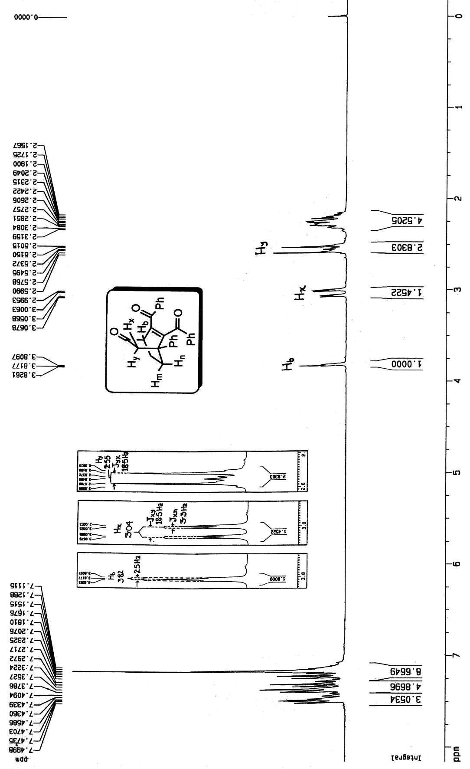
Fig.1: ¹H-NMR spectrum of 6

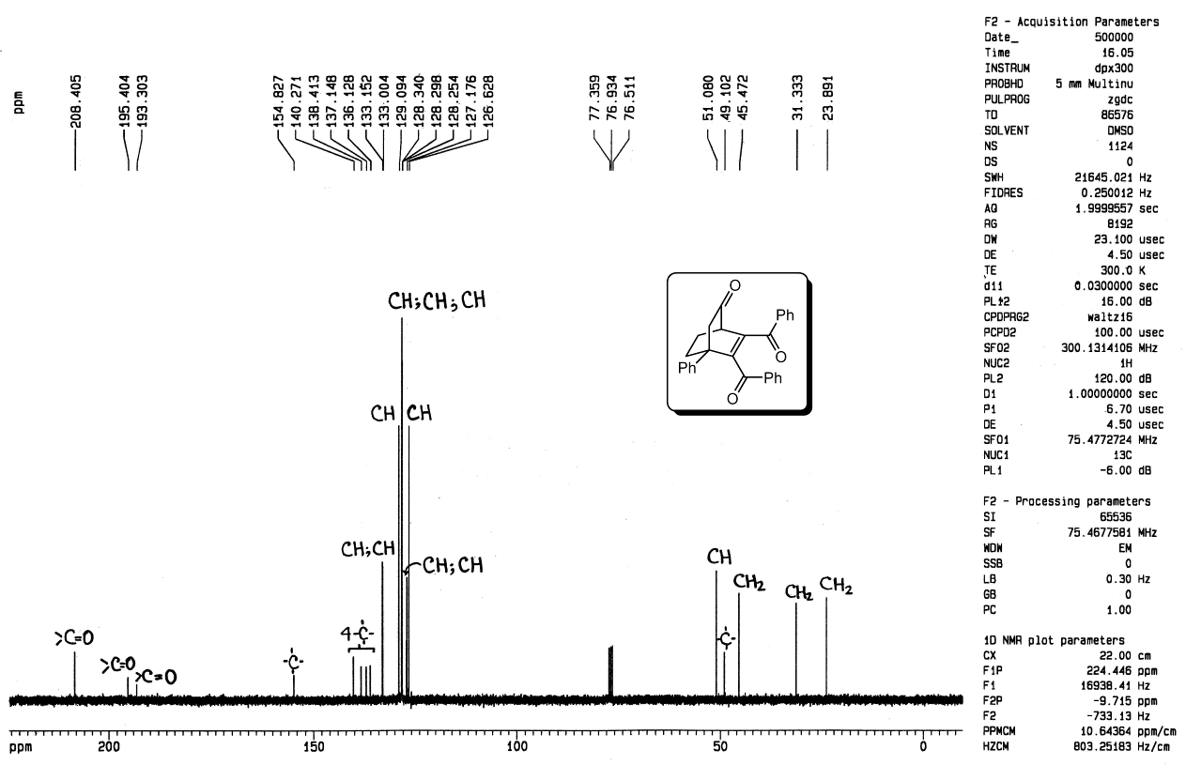

Fig.2: ¹³C-NMR spectrum of 6

Fig.3: UV absorption spectrum of 6 in acetonitrile

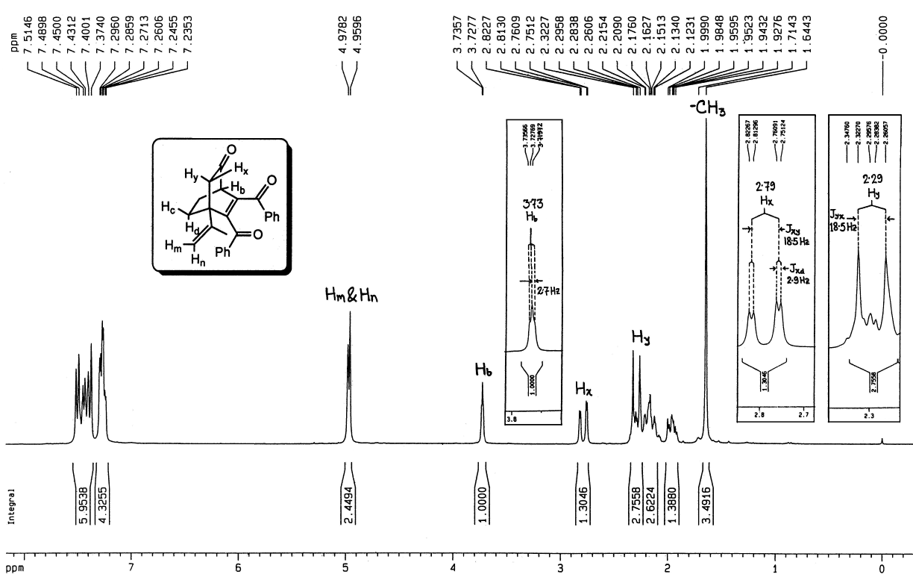

Fig.4: ¹H-NMR spectrum of 7

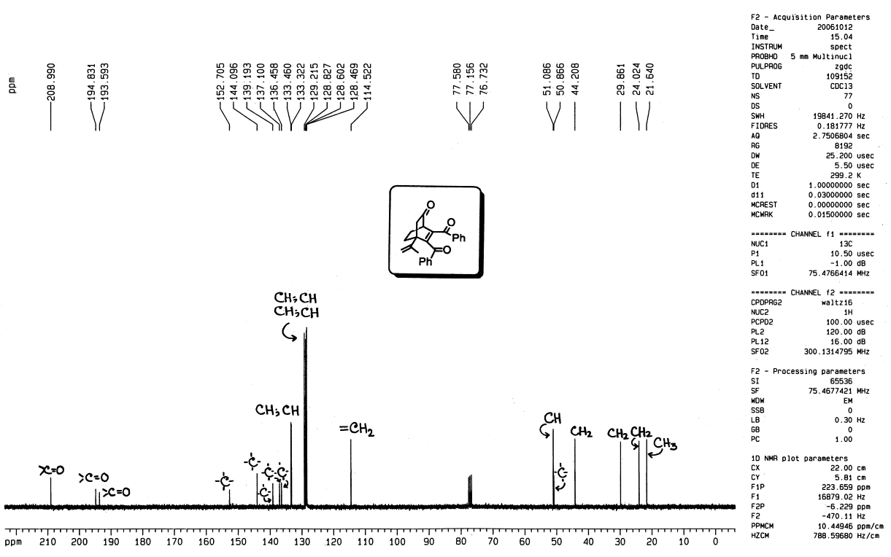

Fig.5: ¹³C-NMR spectrum of 7

Fig.6: UV absorption spectrum of 7 in acetonitrile

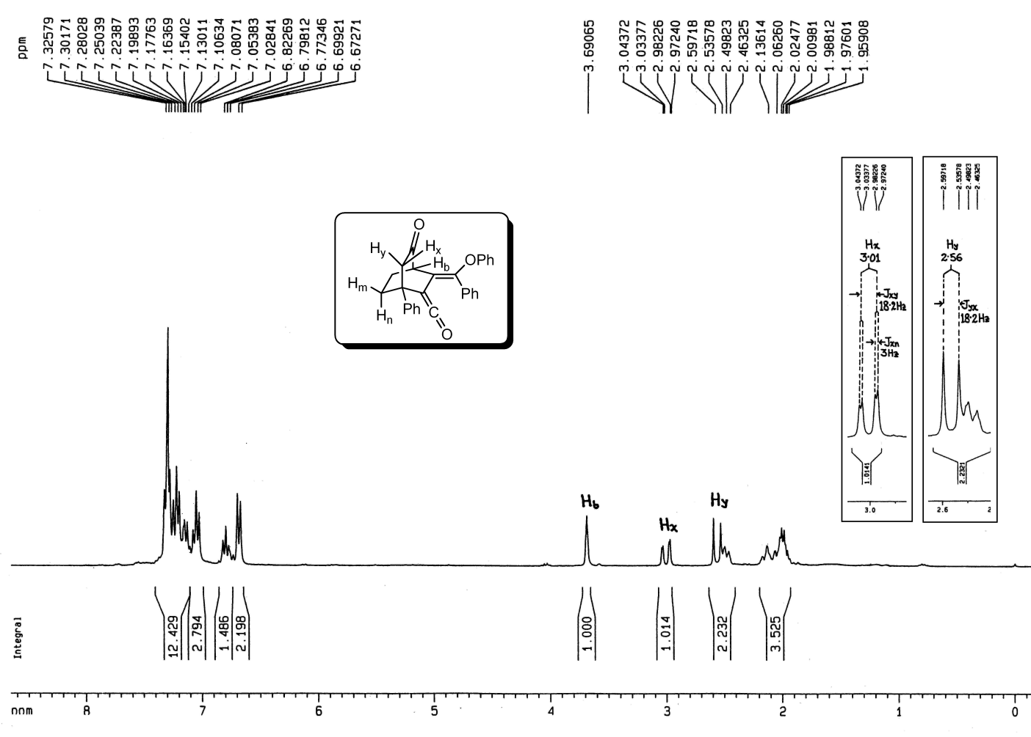

Fig.7: ¹H-NMR spectrum of 10

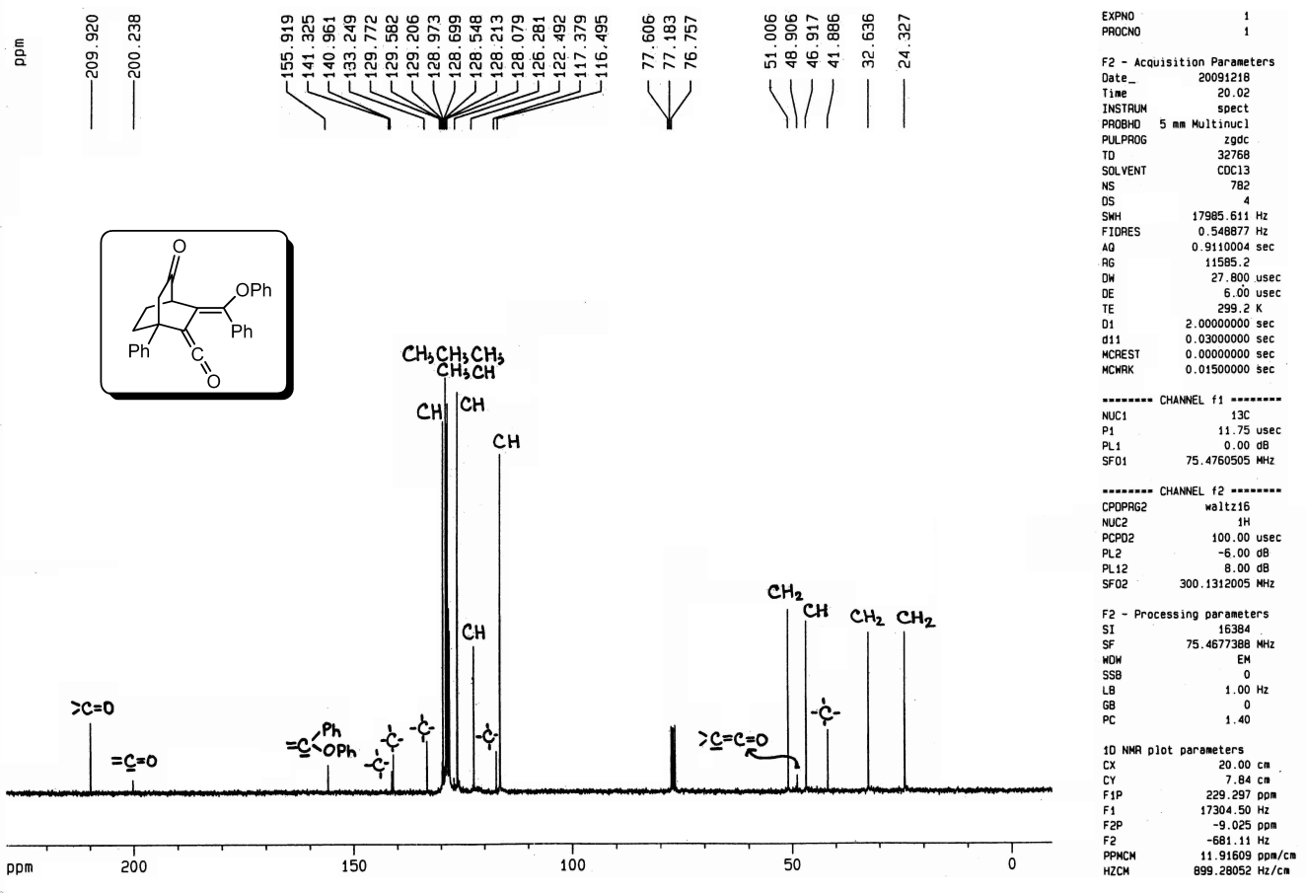

Fig.8: ¹³C-NMR spectrum of 10

Fig.9: UV absorption spectrum of 10 in acetonitrile

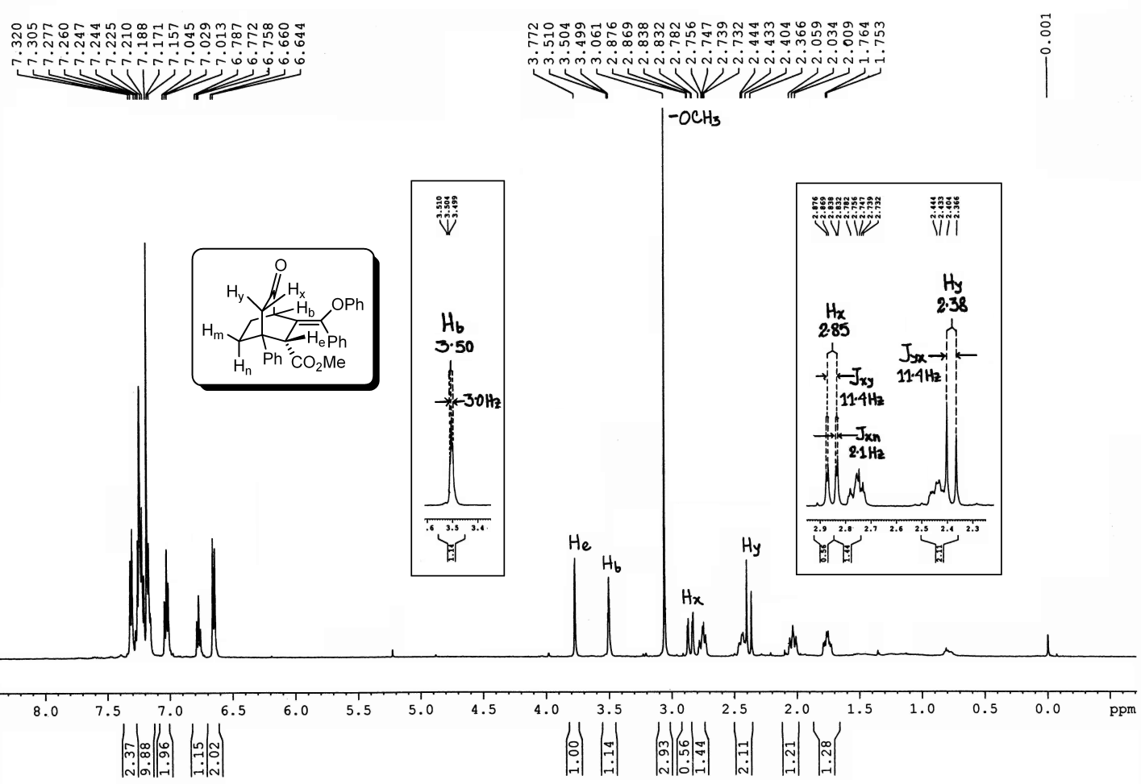

Fig.10: ¹H-NMR spectrum of 11a

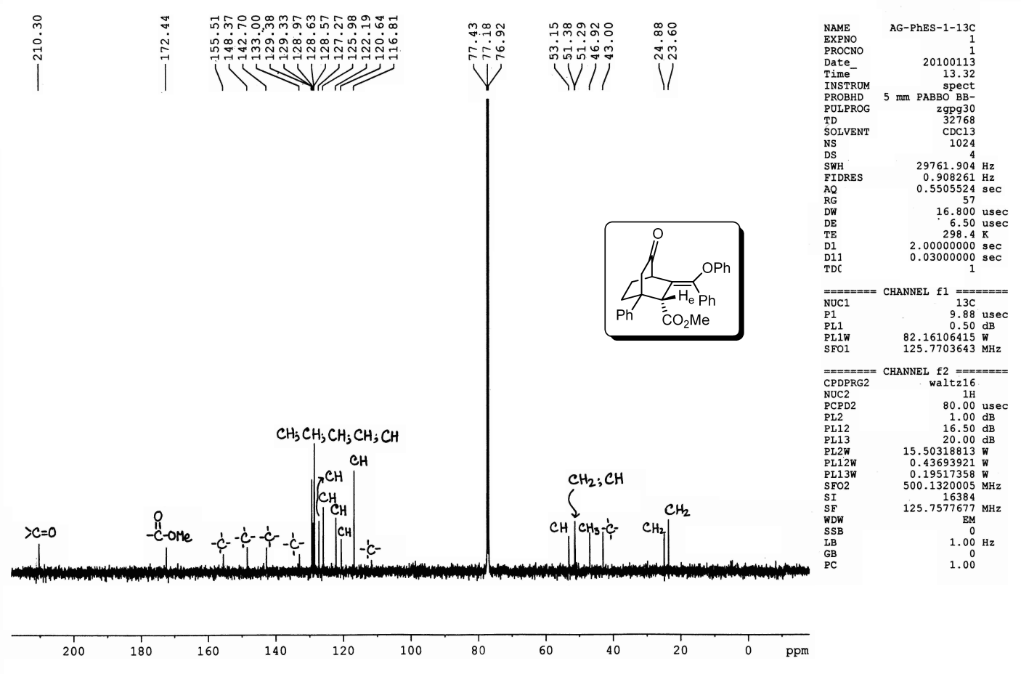

Fig.11: ¹³C-NMR spectrum of 11a

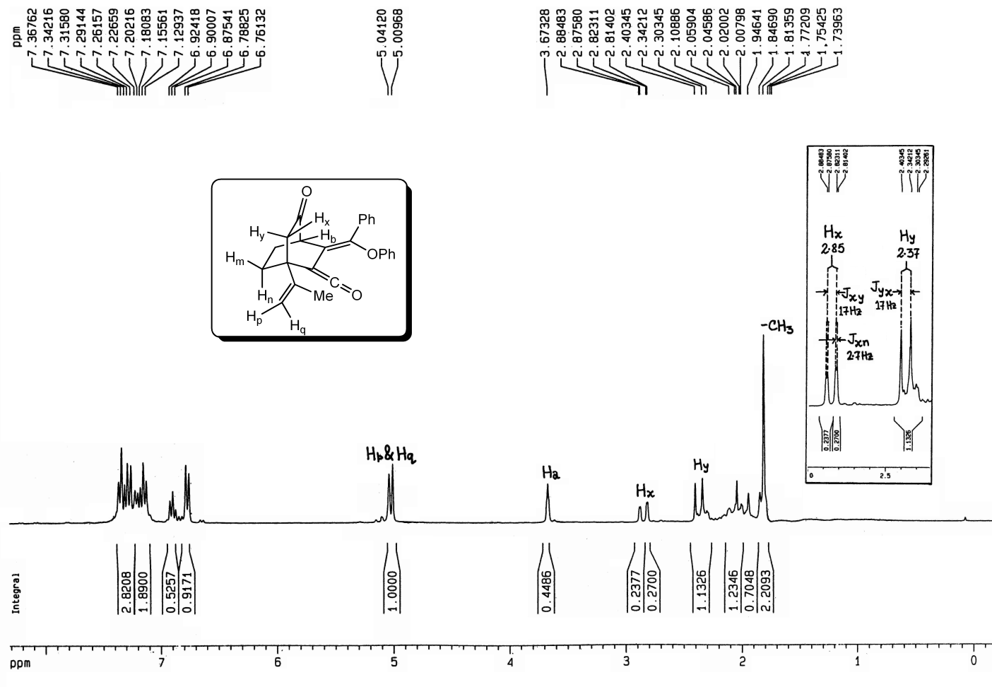

Fig.12: ¹H-NMR spectrum of 12

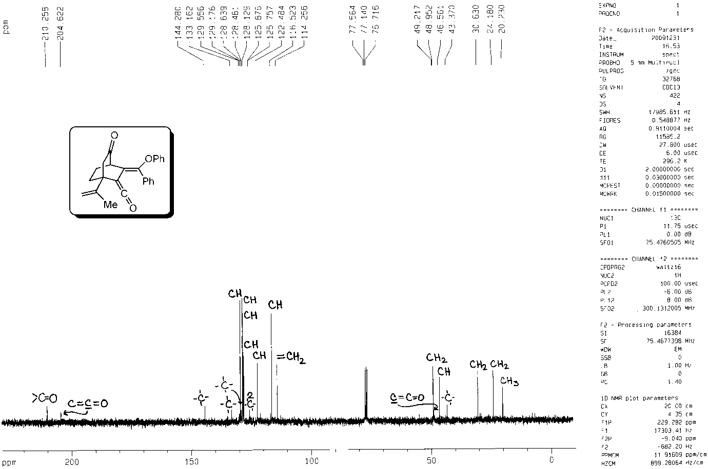

Fig.13: ¹³C-NMR spectrum of 12

Fig.14: UV absorption spectrum of 12 in acetonitrile

