Efficient pyrazole moiety-containing ligands for Cu-catalyzed O-arylation of phenols

Yingying Zhao,ª Xiangyong Wang,ª Ryo Kaneyama,ª Koichi Kodama,ª and Takuji Hirose^{*a}

ªGraduate School of Science and Engineering, Saitama University, 255 Shimo-Okubo, Sakura-ku, Saitama 338-8570, Japan.
*Corresponding author. E-mail: hirose@apc.saitama-u.ac.jp;
Fax: +81 48-858-3522.

Crystallographic Data

Table S1: Summary of crystallographic data
………………………………………S2
Figure S1: Thermal ellipsoid plot (50% probability level) of [CuI·L1]₂.
………………………………………S3
Figure S2: Thermal ellipsoid plot (50% probability level) of CuBr·L6.
………………………………………S3

Table S1: Summary of crystallographic data.

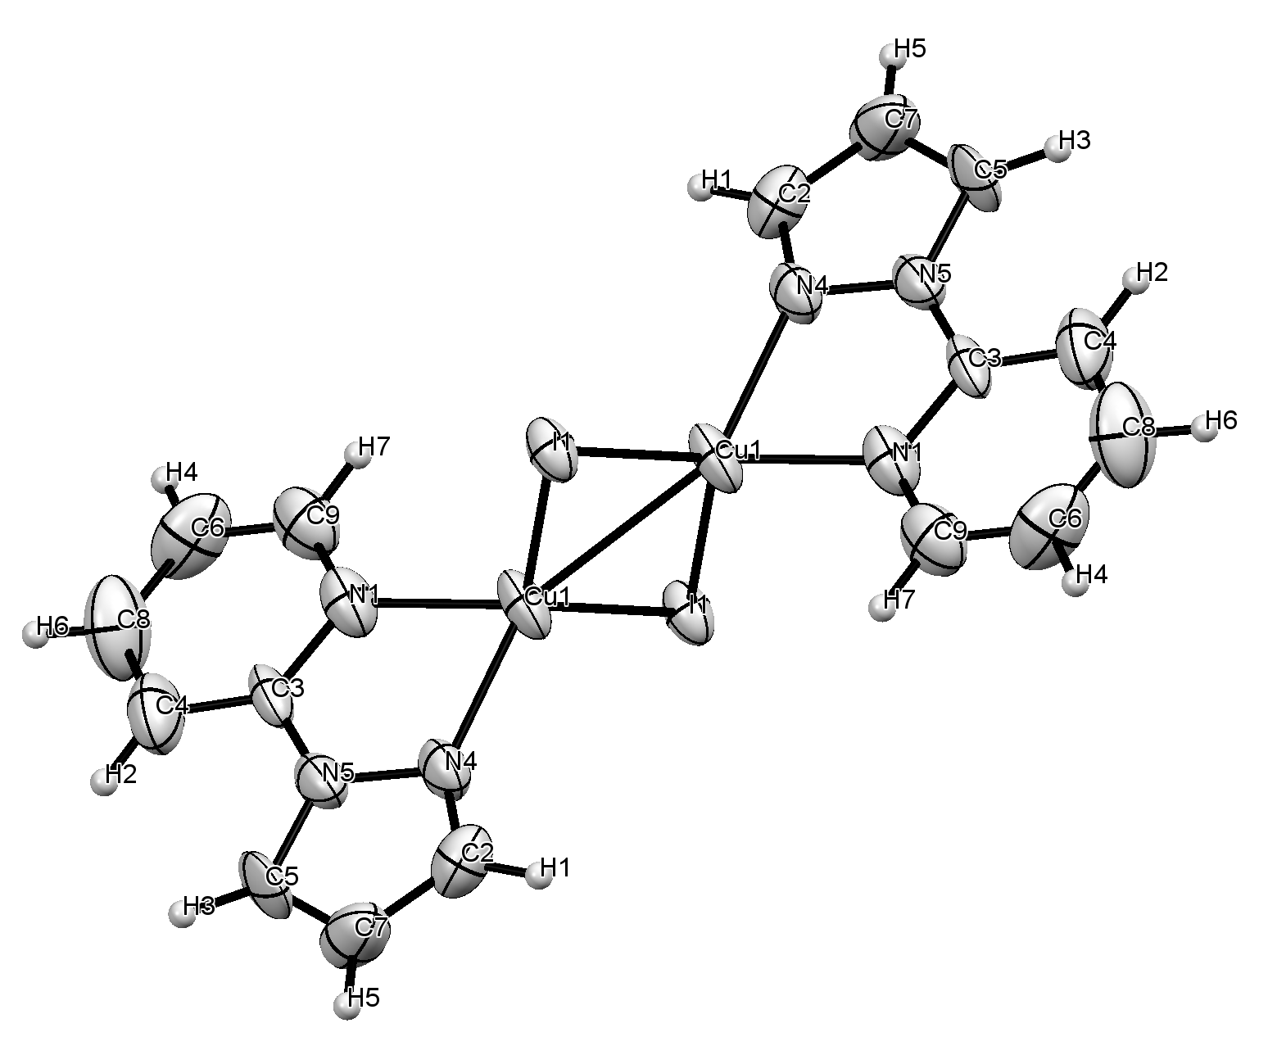
Figure S1: Thermal ellipsoid plot (50% probability level) of [CuI·L1]₂.

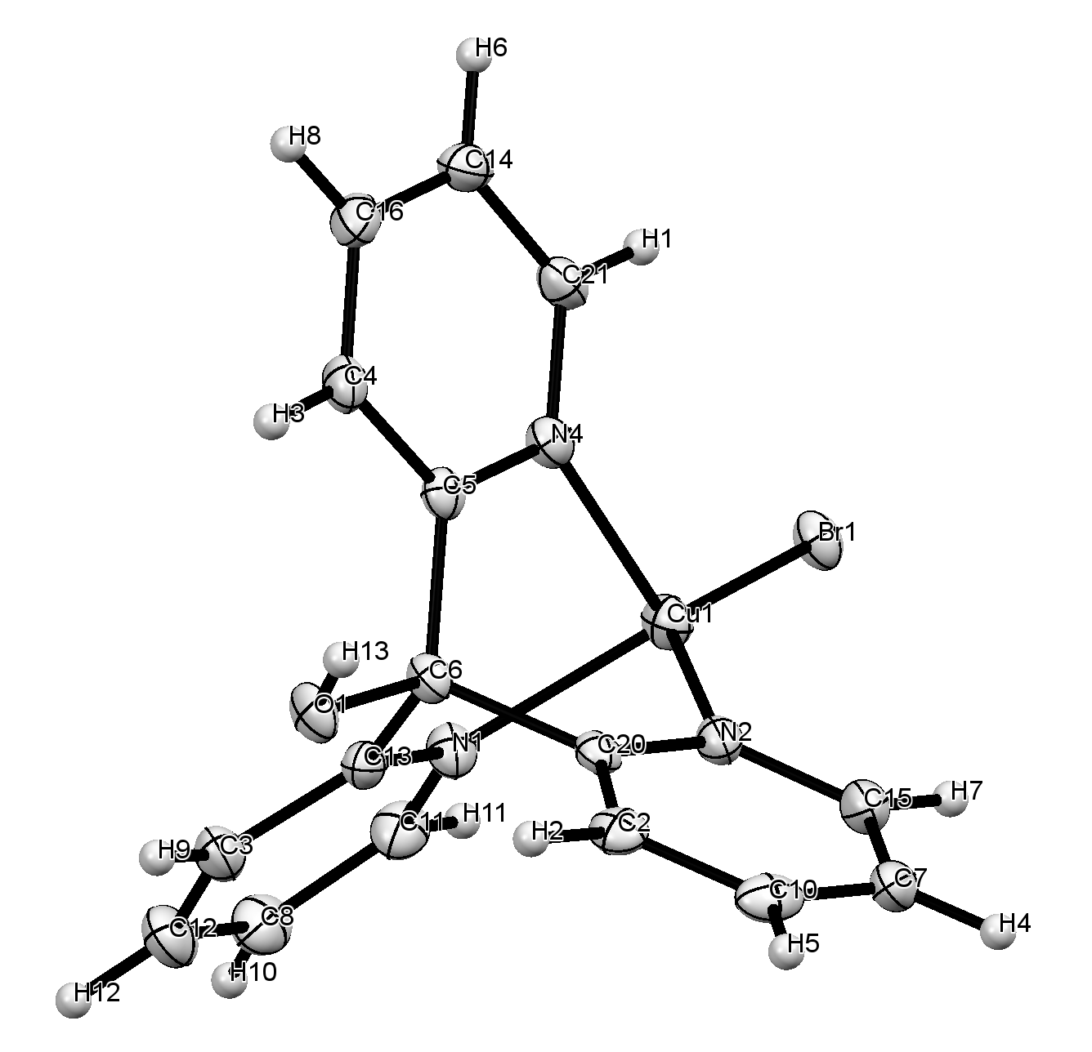
Figure S2: Thermal ellipsoid plot (50% probability level) of CuBr·L6.

