Enantioselective Sulfa-Michael Reaction of Naphthalene-1-thiol with Chalcone Derivatives in the Presence of a Bifunctional Cinchona-Sulfonamide Organocatalyst
Deniz Tözendemir, Cihangir Tanyeli*

CONTENTS

I. General Information 1
II. ¹H and ¹³C NMR Spectra of Catalyst 5 2
III. ¹H and ¹³C NMR Spectra of Products 12a-o 3
IV. HPLC Chromatograms of Products 12a-o 18
V. ¹H and ¹³C NMR Spectra of Sulfones 33
VI. HPLC Chromatograms of Sulfones 37

- General Information
All chemicals were purchased from Sigma-Aldrich or Acros Organics. Column chromatographies were performed using silica gel 60 (200-300 mesh) as supporting material. All the eluents were distilled prior to use. ¹H NMR and ¹³C NMR spectra were recorded on a 400 MHz spectrometer, using CDCl₃ as the solvent. Chemical shift values are reported in ppm with TMS a standard, J values are given in hertz. Optical rotations were determined by the use of a polarimeter and reported as [α]_{D}^{T} (c in per 100 mL, solvent). Enantiomeric excess values were determined by chiral HPLC chromatography using Thermo-Finnigan instrument. All new products were further analyzed by LC/MS-HRMS-TOF.

- ¹H and ¹³C NMR Spectra of Catalyst 5
- ¹H and ¹³C NMR Spectra of Products 12a-o

- HPLC Chromatograms of Products 12a-o

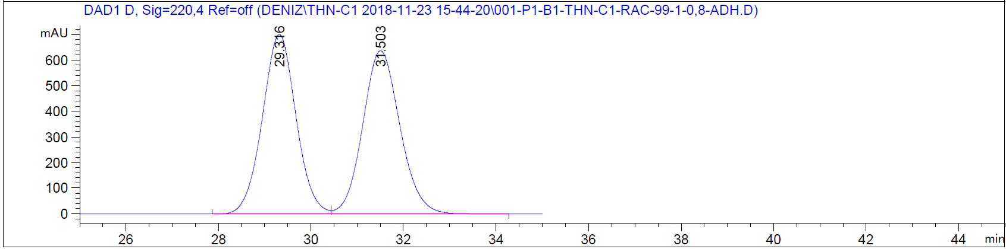
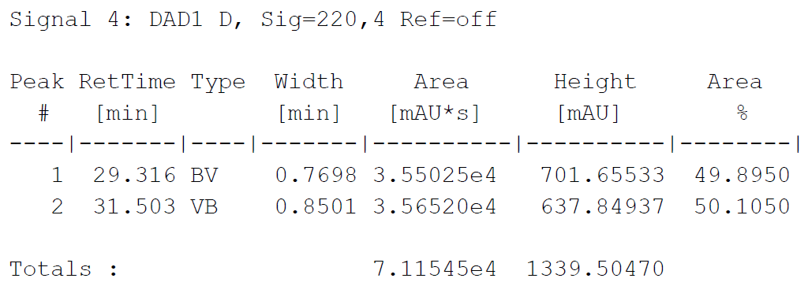

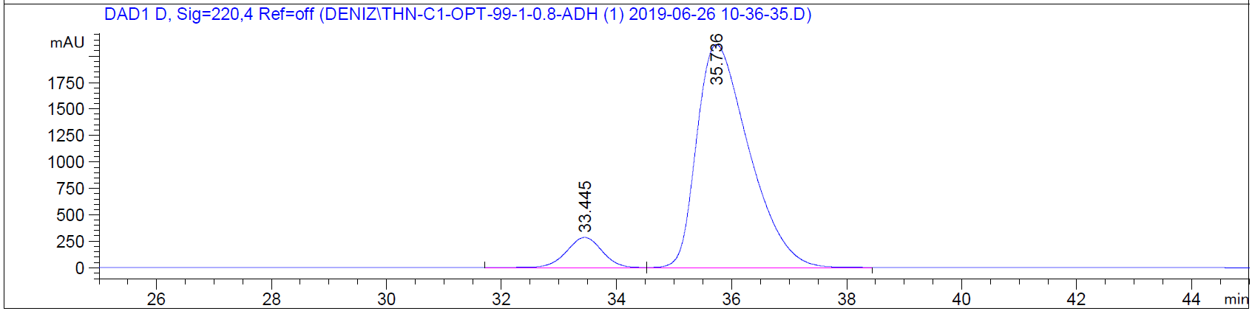
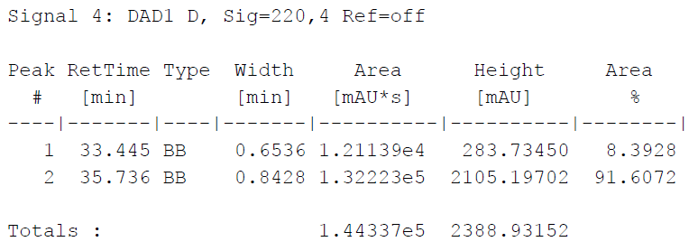

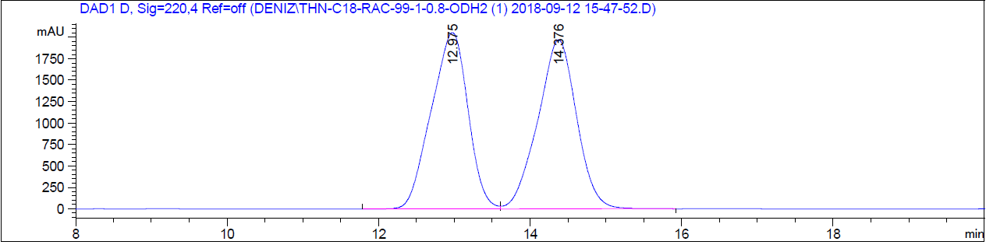
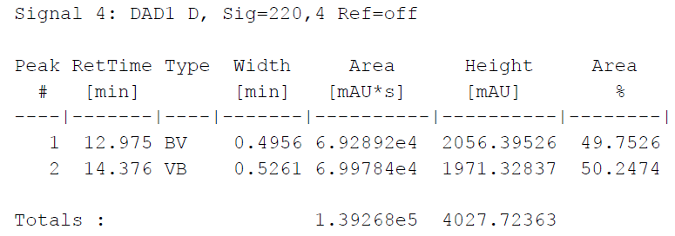

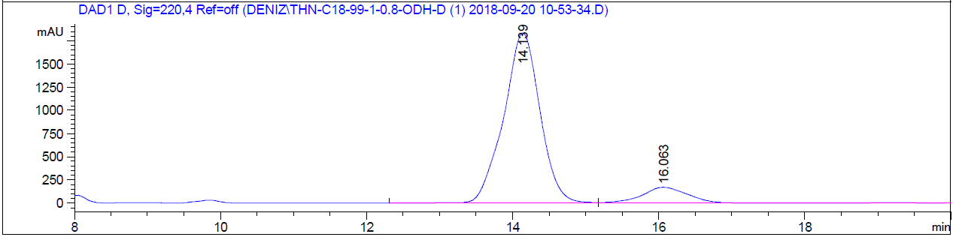
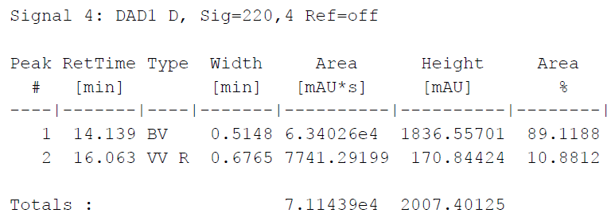

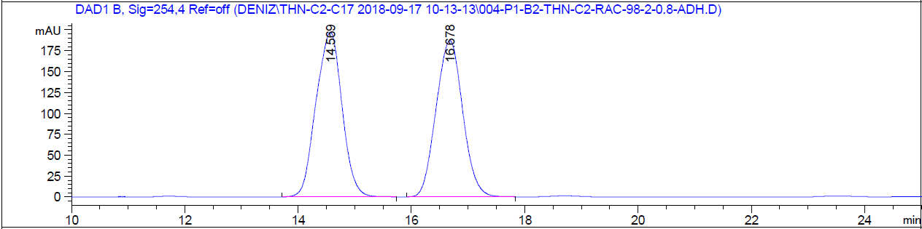
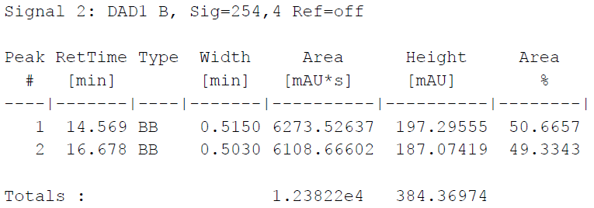

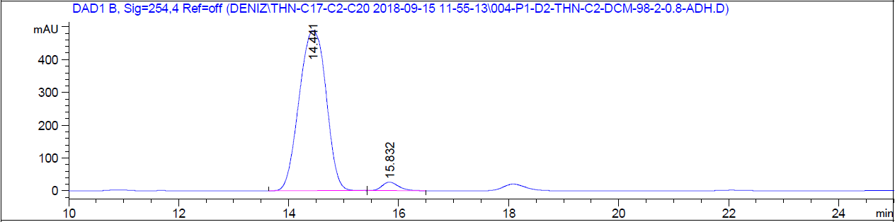
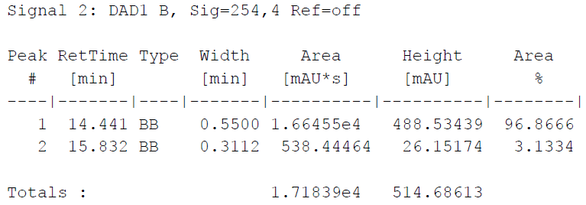

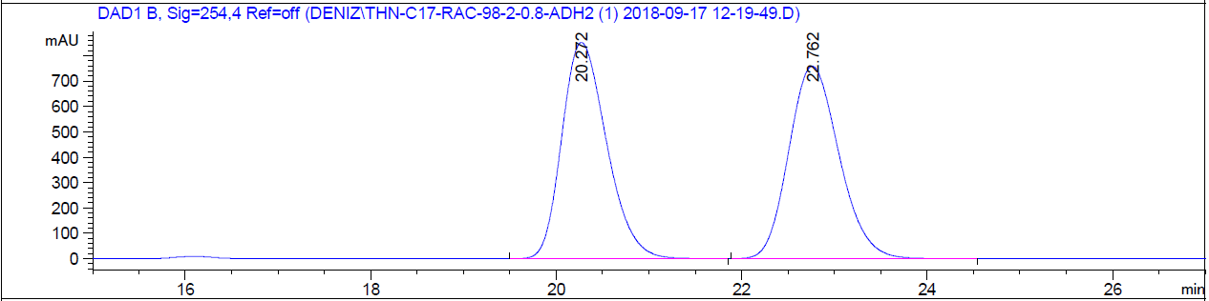
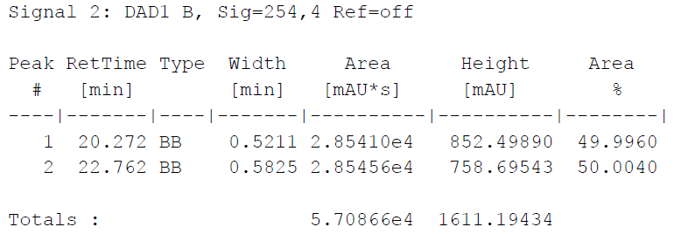

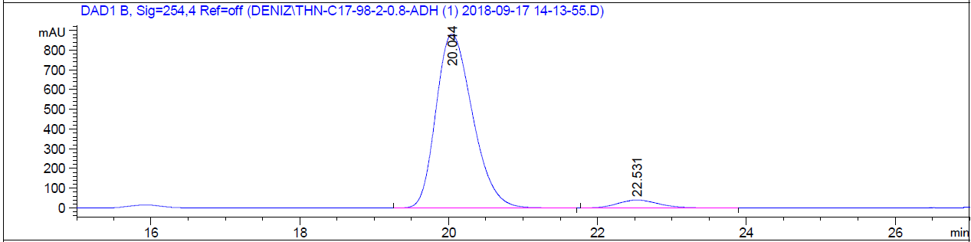
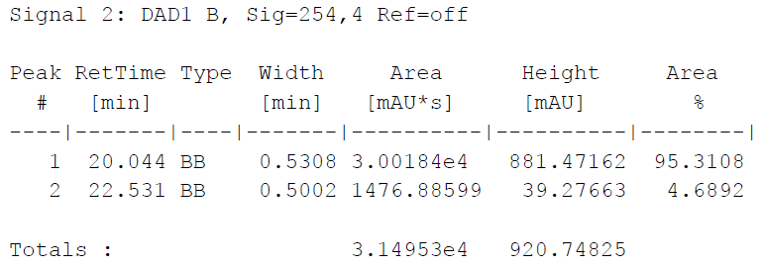

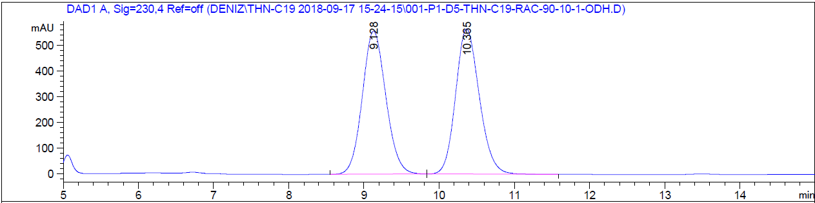
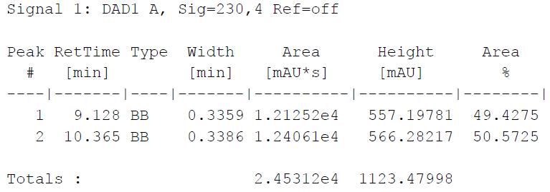

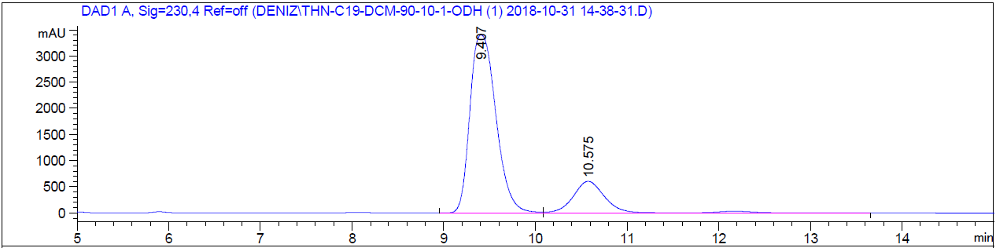
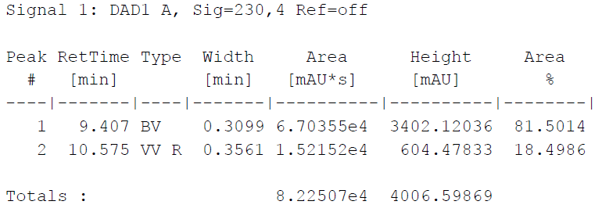

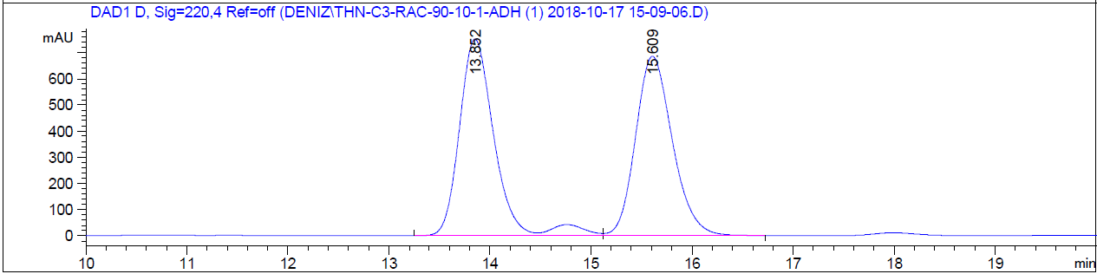
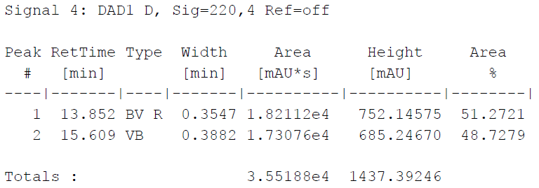

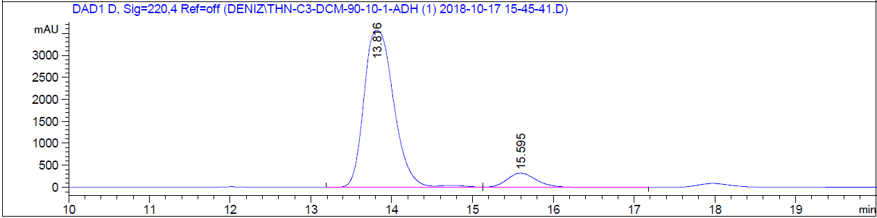
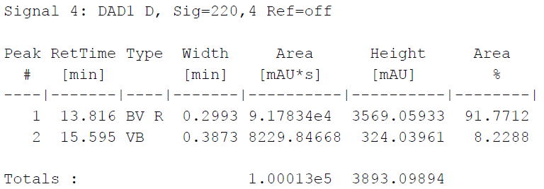

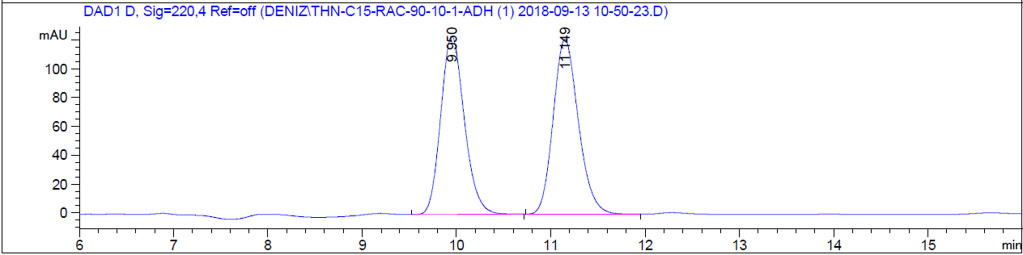
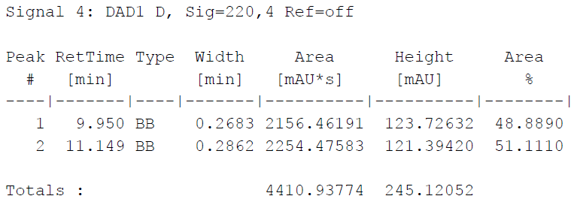

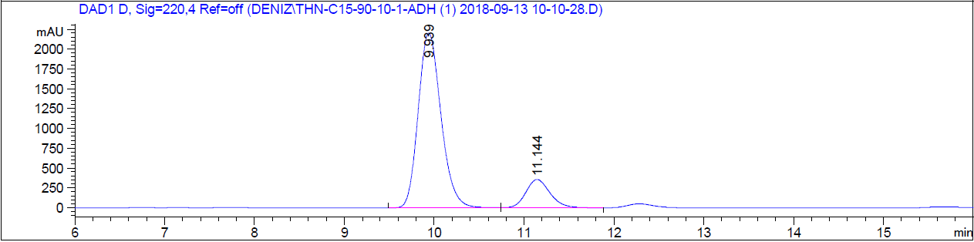
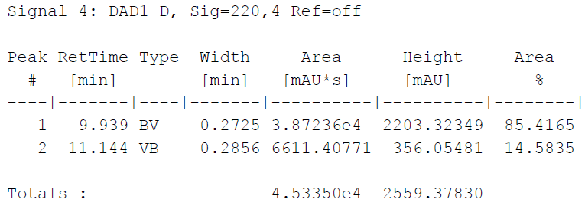

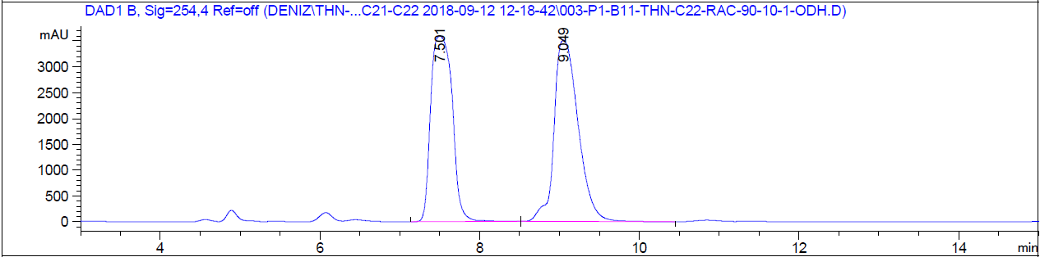
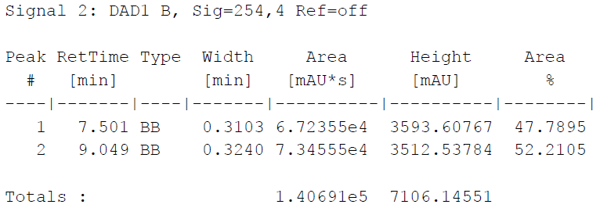

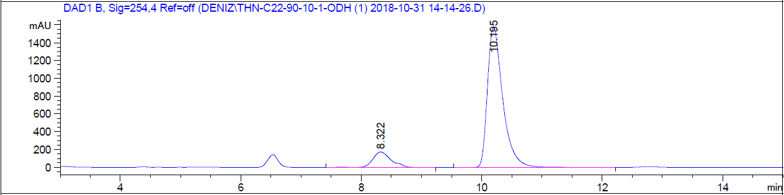
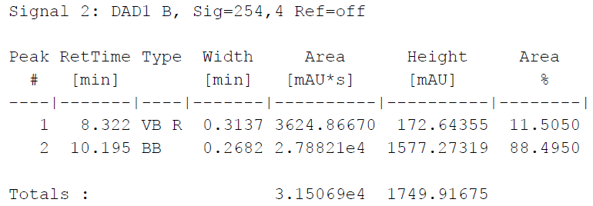

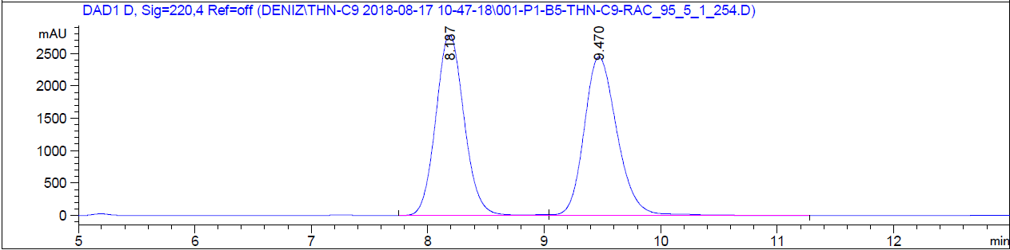
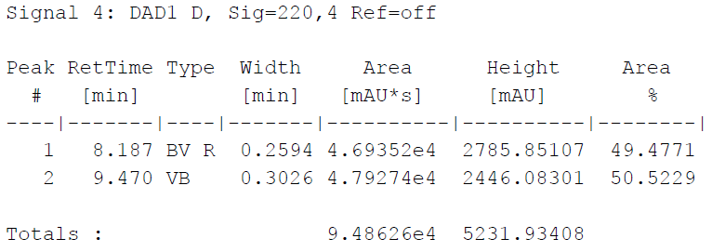

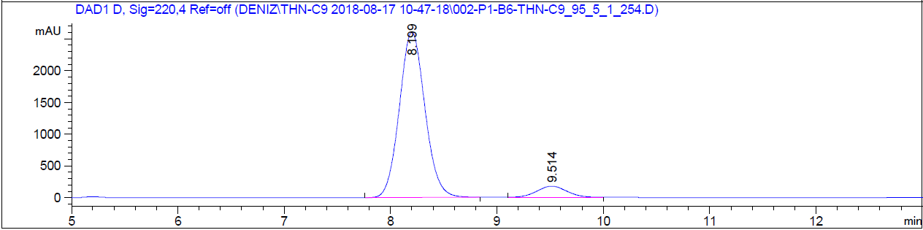
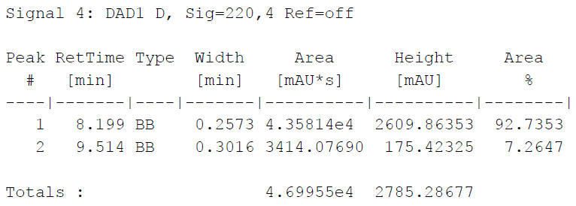

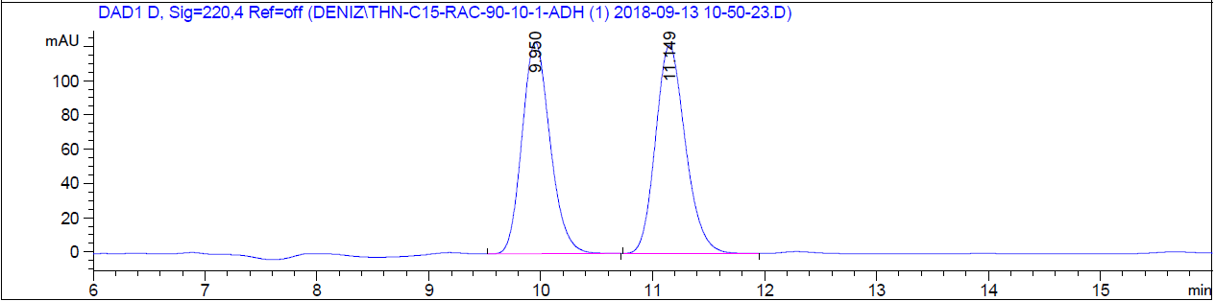
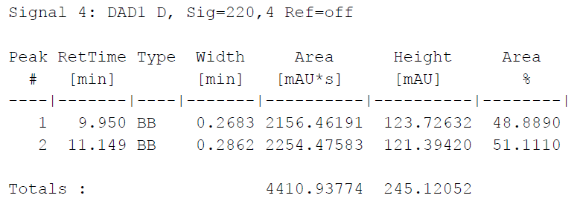

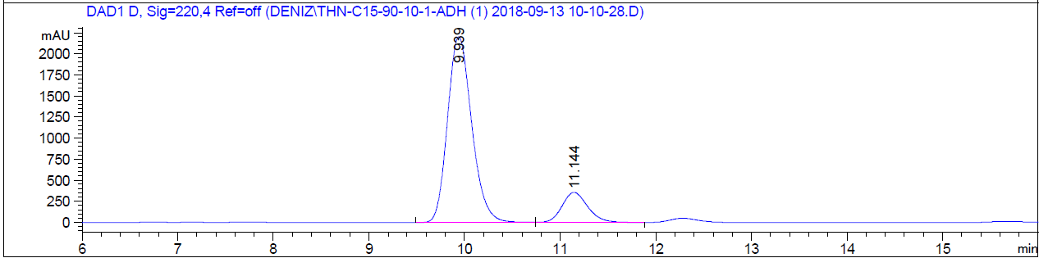
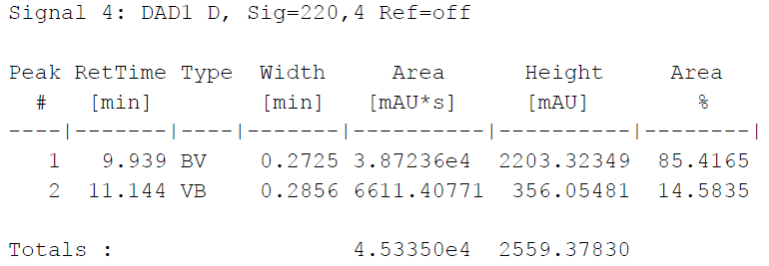

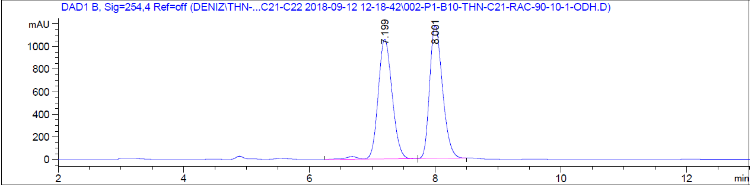
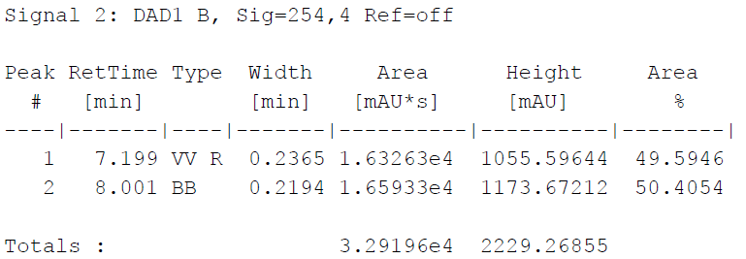

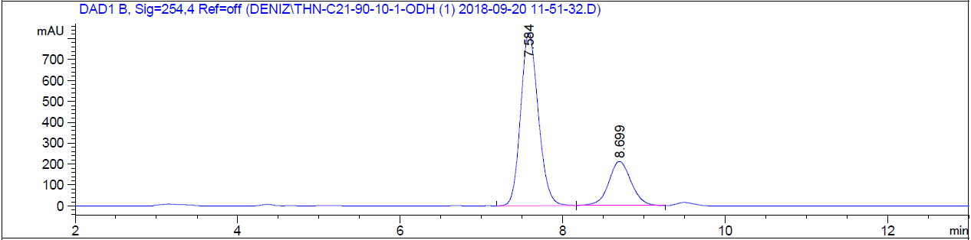
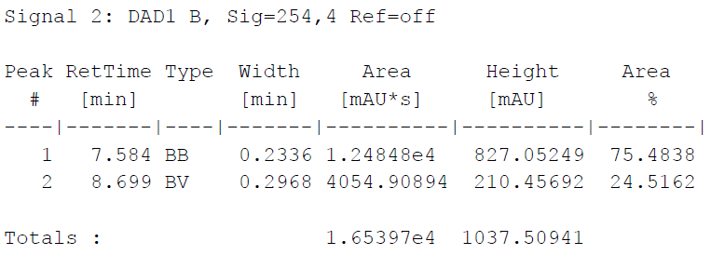

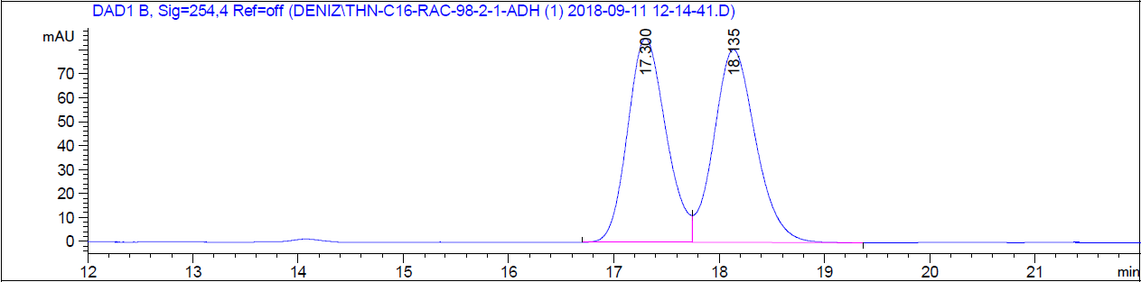
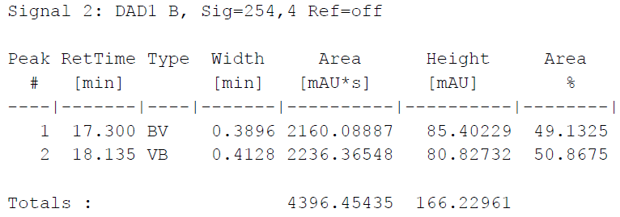

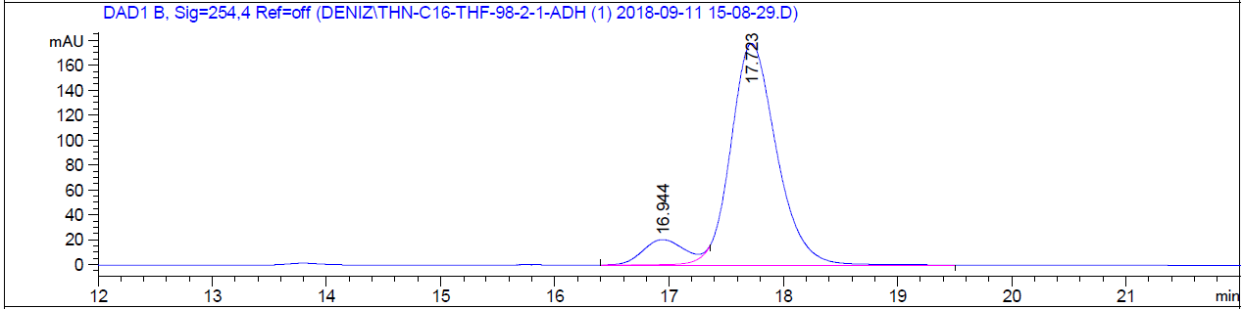
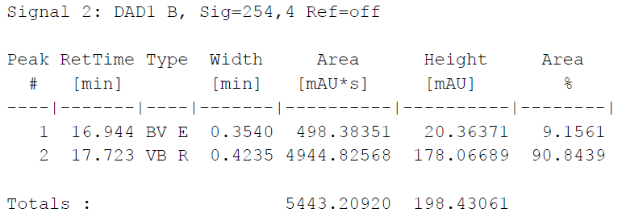

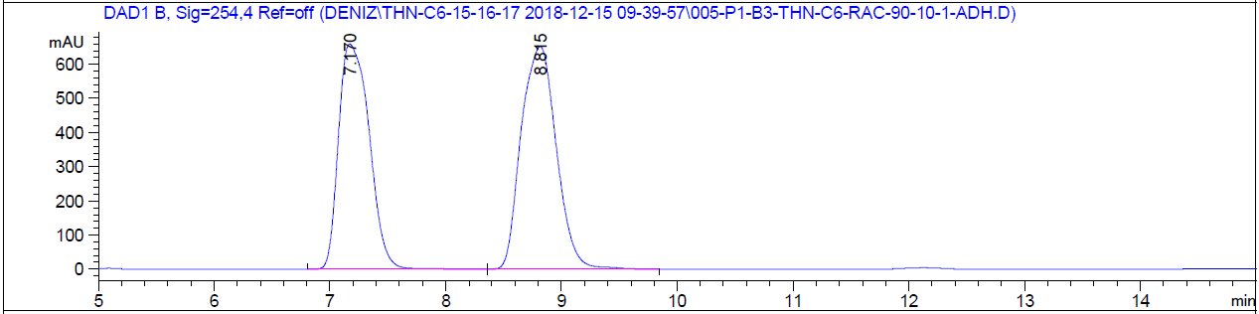
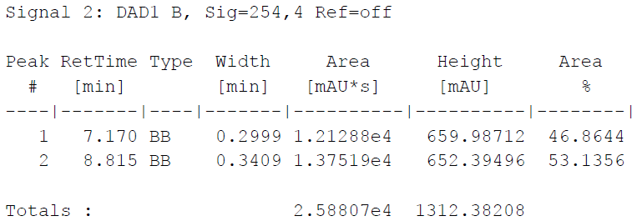

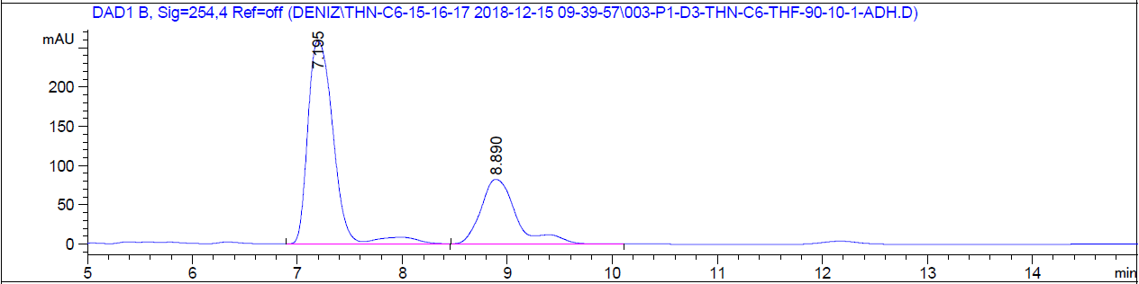
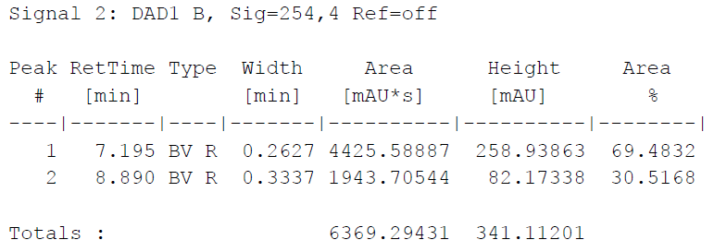

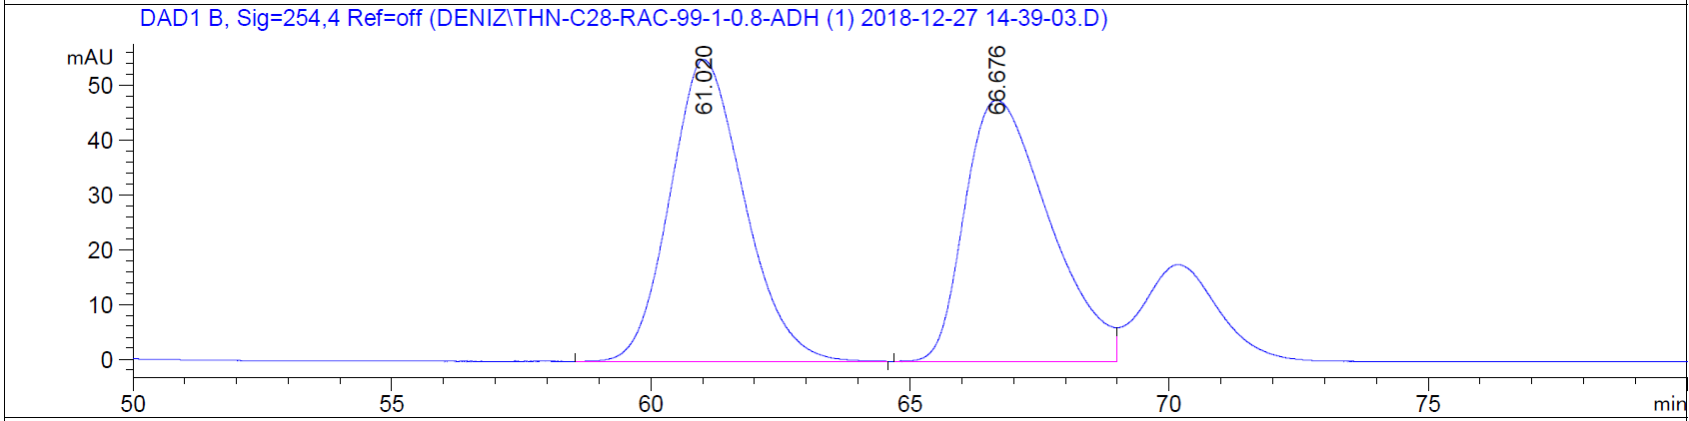
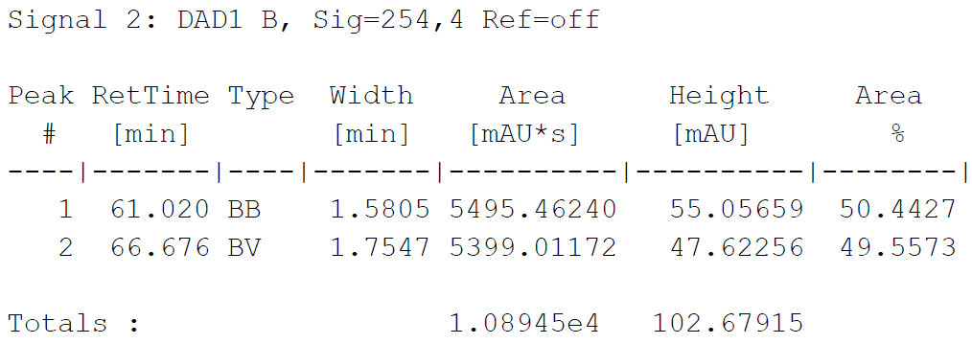

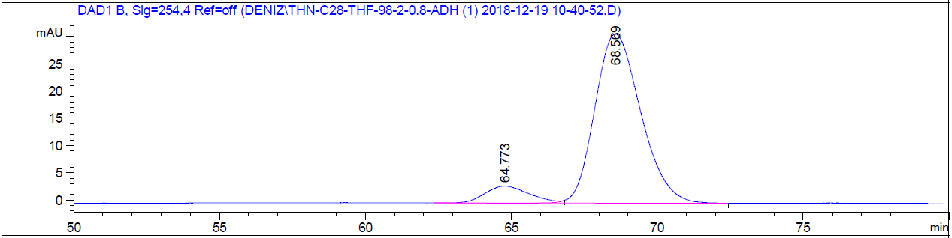
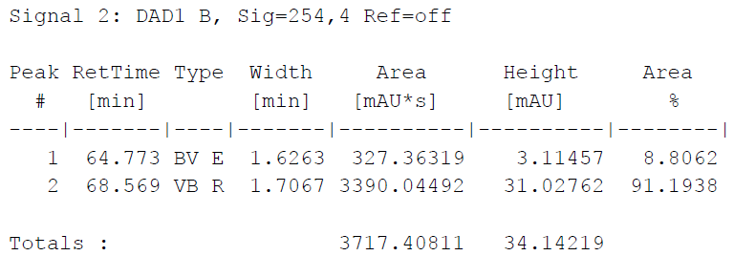

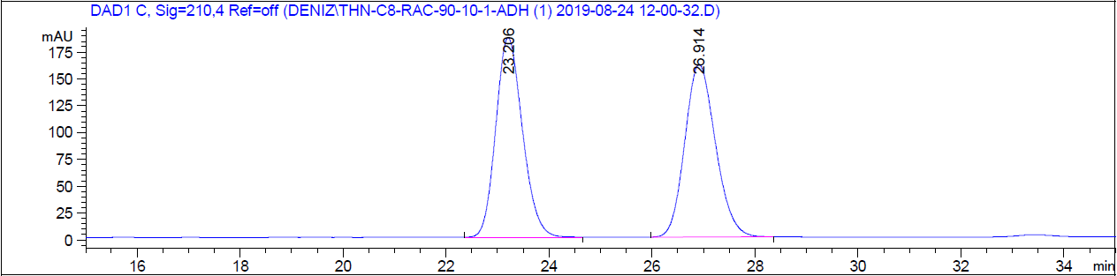
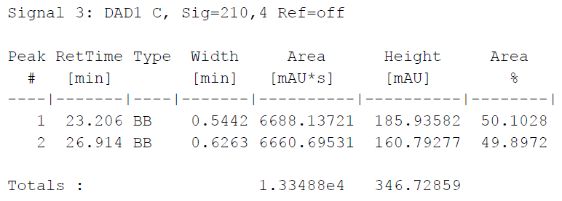

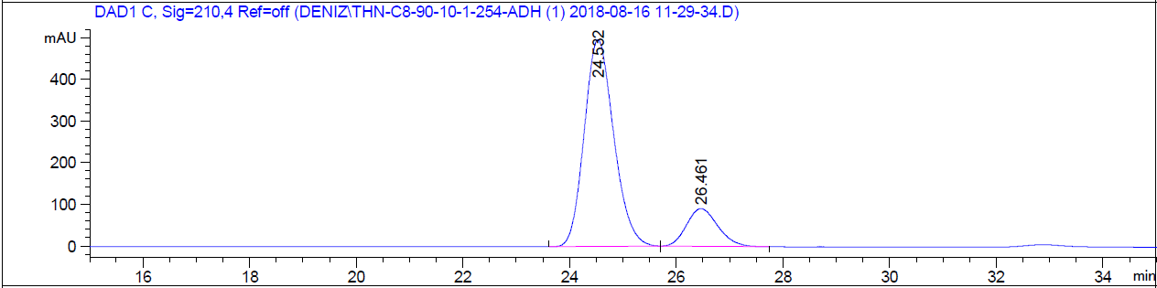
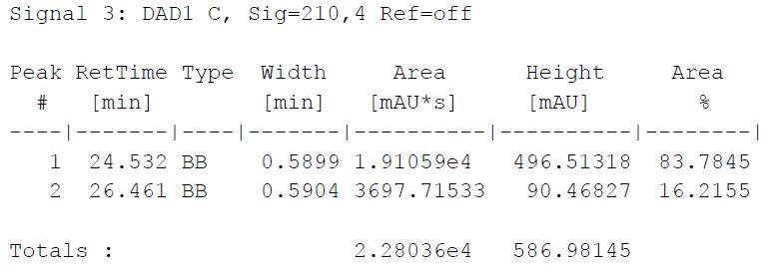

- ¹H and ¹³C NMR Spectra of Sulfones

- HPLC Chromatograms of Sulfones
