Supporting Information
for
Synthesis of novel multifunctional carbazole based molecules, their thermal, electrochemical and optical properties

Nuray Altinolcek¹, Ahmet Battal^{2,3}, Mustafa Tavasli^{1*}, William J. Peveler³, Holly A. Yu³ and Peter J. Skabara³

Address: ¹Department of Chemistry, Faculty of Science-Art, Uludag University, 16059 Nilufer, Bursa, Turkey, ²Department of Elementary School Education, Faculty of Education, Mus Alparslan University, 49100, Mus, Turkey and ³WestCHEM, School of Chemistry, University of Glasgow, Joseph Black Building, G128QQ Glasgow UK.

Email: Mustafa Tavaslı* - mtavasli@uludag.edu.tr
* Corresponding author

NMR, FTIR, MS and HRMS spectra of compounds and relative quantum yield calculations

Table of contents
- ¹H and ¹³C NMR Spectra | Figure S1: | ¹H NMR spectrum of 3-bromocarbazole (2) | SI-3
- ¹H and ¹³C NMR Spectra | Figure S2: | ¹H NMR spectrum of 3-bromo-N-hexylcarbazole (4) | SI-3
- ¹H and ¹³C NMR Spectra | Figure S3: | ¹H NMR spectrum of N-hexylcarbazole-3-yl-boronic acid pinocolate ester (5) | SI-4
- ¹H and ¹³C NMR Spectra | Figure S4: | ¹H NMR spectrum of compound 7a | SI-4
- ¹H and ¹³C NMR Spectra | Figure S5: | ¹³C NMR spectrum of compound 7a | SI-5
- ¹H and ¹³C NMR Spectra | Figure S6: | ¹H NMR spectrum of compound 7b | SI-5
- ¹H and ¹³C NMR Spectra | Figure S7: | ¹³C NMR spectrum of compound 7b | SI-5
- FT-IR Spectra | Figure S8: | FT-IR spectrum of compounds 7a and 7b | SI-6
- Mass and HRMS Spectra | Figure S9: | Mass spectrum of compound 7b | SI-6
- Mass and HRMS Spectra | Figure S10: | HRMS result of compound 7b | SI-6
- Calculations of Relative Fluorescence Quantum Yields | Figure S11: | Absorption at 355 nm-Integrated Emission of samples (7a and 7b) and reference (Rhodamine B) | SI-7
- Calculations of Relative Fluorescence Quantum Yields | Table S1: | Optical density and integrated PL intensity values of reference (Rhodamine B) and samples (7a and 7b) | SI-8
- Calculations of Relative Fluorescence Quantum Yields | Figure S12: | Absorption spectra of Rhodamine B, 7a and 7b | SI-8
- Calculations of Relative Fluorescence Quantum Yields | Figure S13: | Emission (PL) spectra of Rhodamine B, 7a and 7b, excited at 355 nm | SI-8

- ¹H and ¹³C NMR Spectra
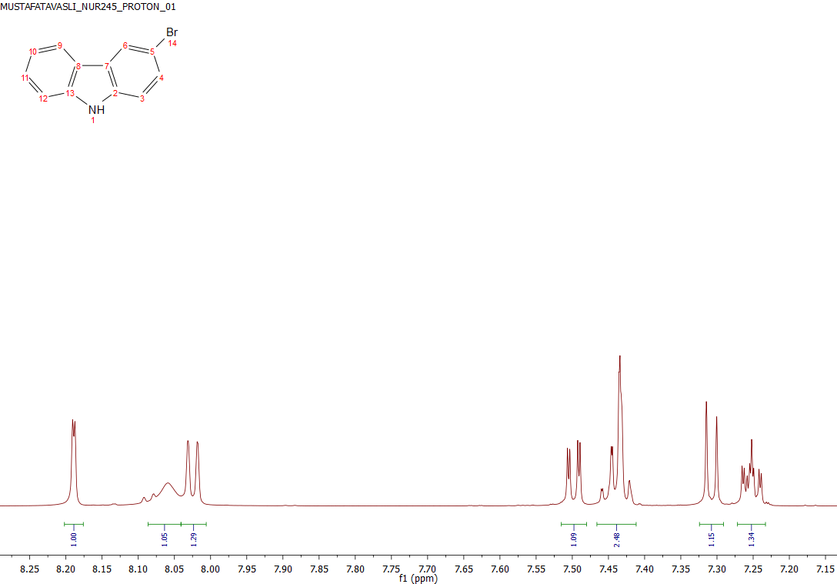
Figure S1: ¹H NMR spectrum of 3-bromocarbazole (2).
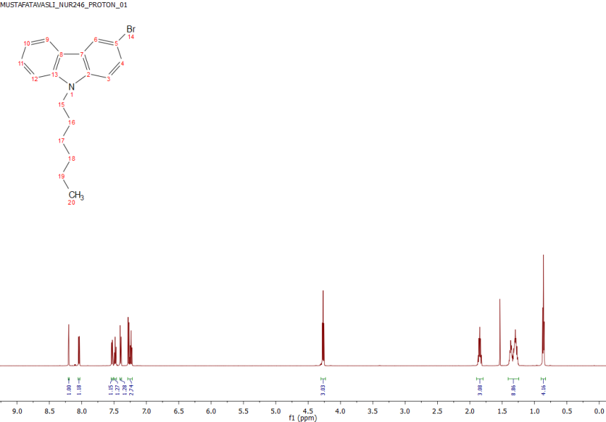
Figure S2: ¹H NMR spectrum of 3-bromo-N-hexylcarbazole (4)

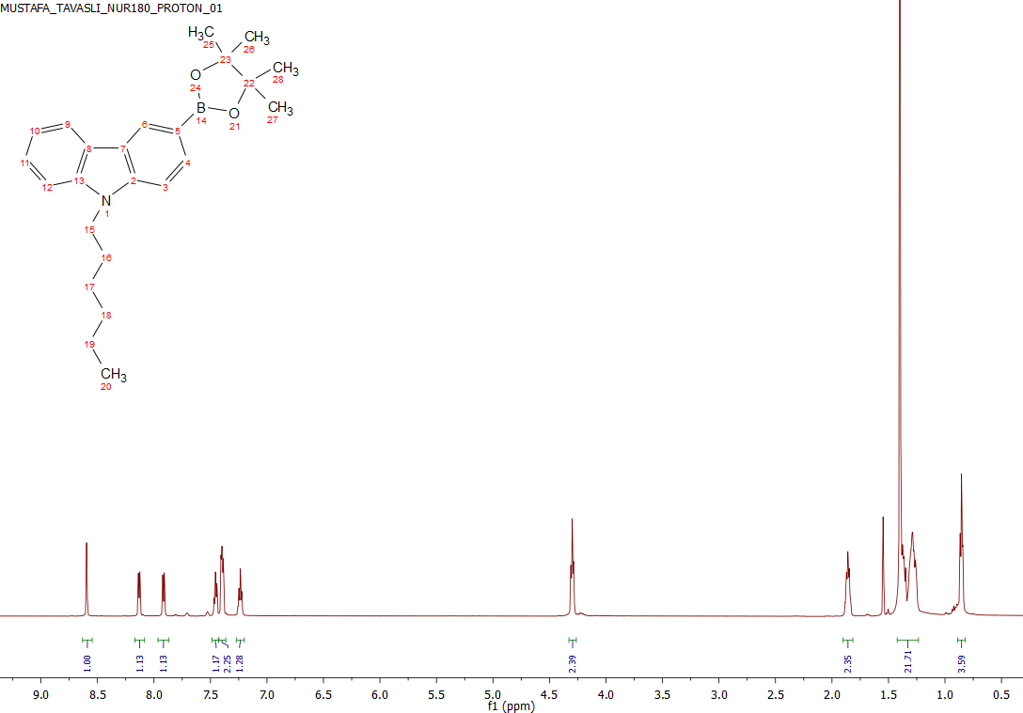
Figure S3: ¹H NMR spectrum of N-hexylcarbazole-3-yl-boronic acid pinocolate ester (5)

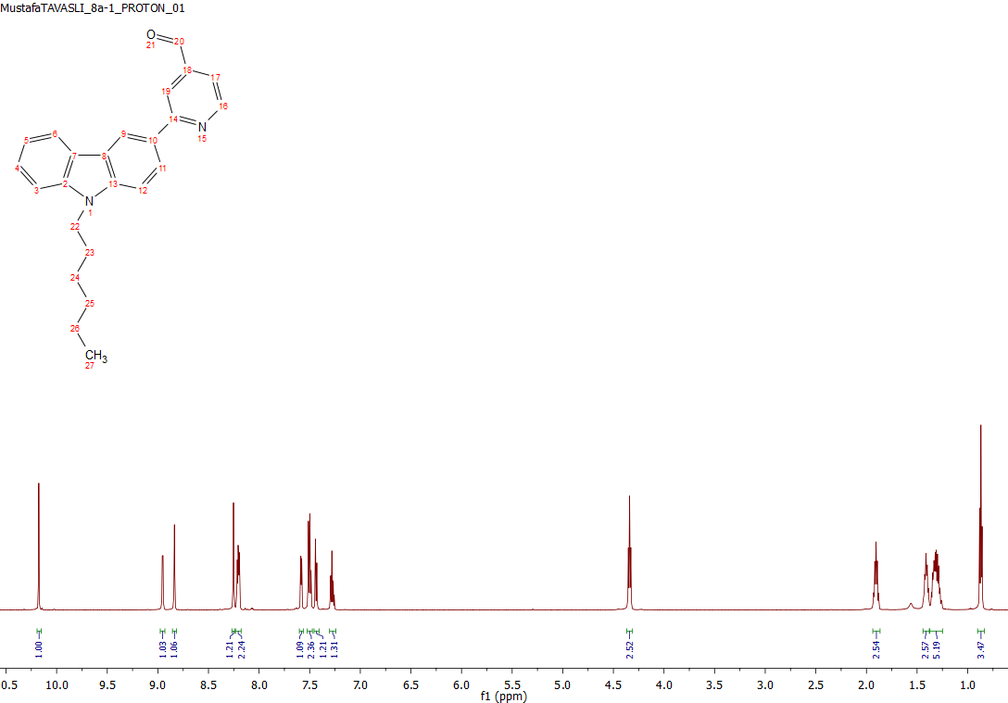
Figure S4: ¹H NMR spectrum of compound 7a

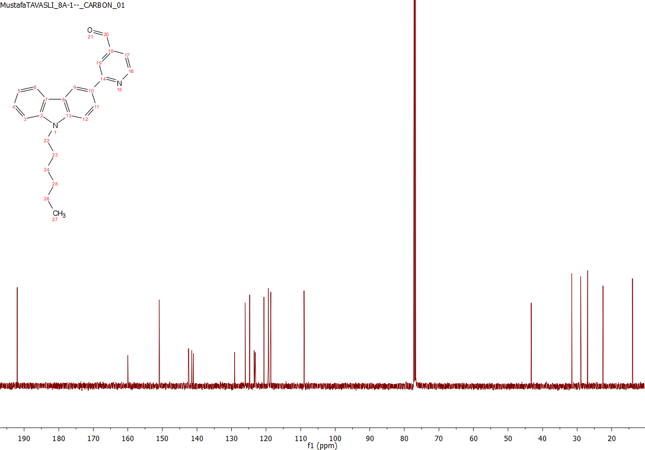
Figure S5: ¹³C NMR spectrum of compound 7a
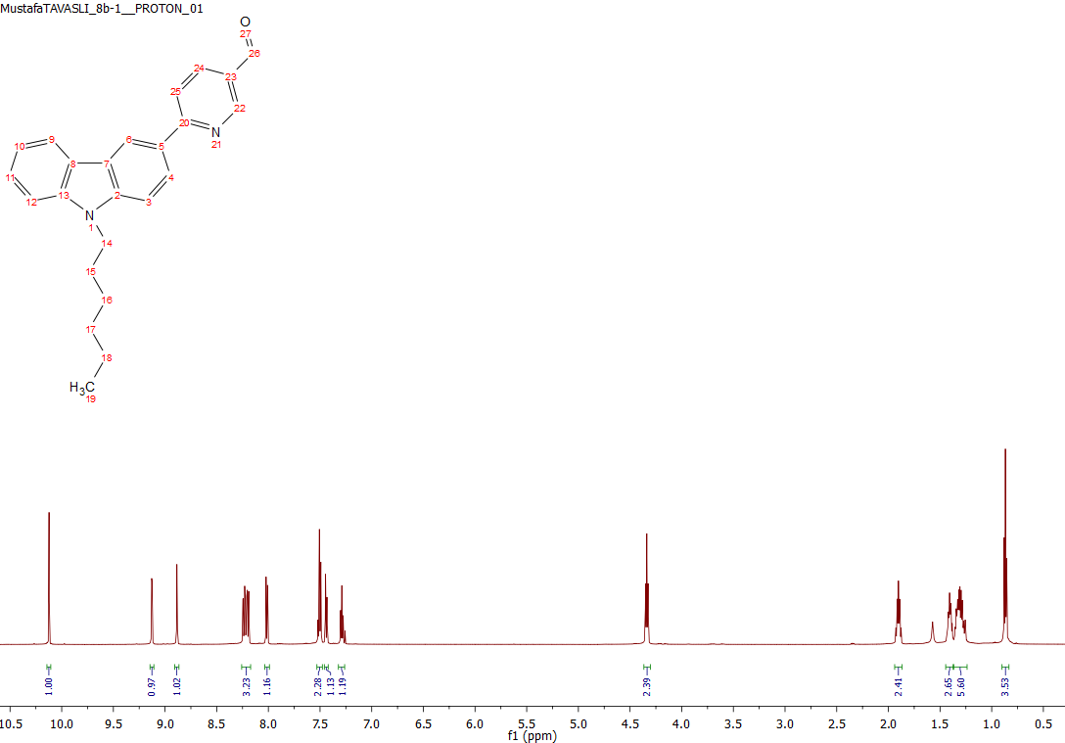
Figure S6: ¹H NMR spectrum of compound 7b
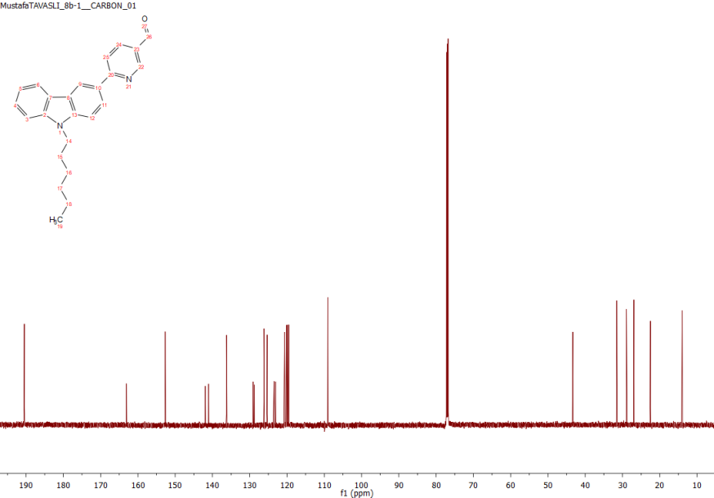
Figure S7: ¹³C NMR spectrum of compound 7b
- FT-IR Spectra
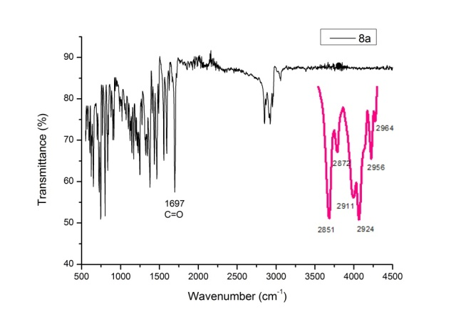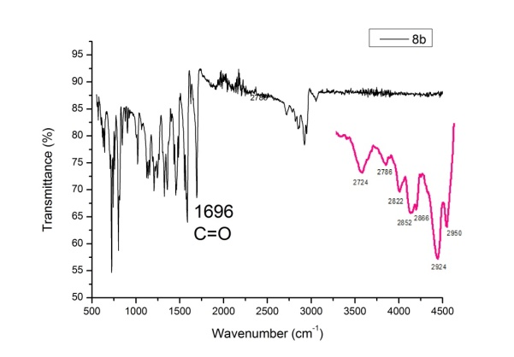
Figure S8: FT-IR spectrum of compounds 7a and 7b

- Mass and HRMS Spectrum
Figure S9: Mass spectrum of compound 7b
Figure S10: HRMS result of compound 7b

- Calculations of Relative Fluorescence Quantum Yields
Relative fluorescent quantum yields of samples (φ_{S}) were calculated from Figure S11 by using equation 1, where y_{S} is the integrated fluorescence intensity of samples (7a/7b), y_{R} is the integrated fluorescence intensity of reference (Rhodamine B), n is the refractive index of solvents used.
$${}_{s}=y_{S}.\frac{{}_{R}}{y_{R}}.\frac{{n_{s}}^{2}}{{n_{r}}^{2}}\left(1\right)$$
Figure S11, plotted from Table S1, depicts absorption at 355 nm (OD, optical density) versus integrated emission (integrated fluorescence intensity of reference and samples).
For this, samples (7a and 7b) were dissolved in dichloromethane (n=1.435) and reference (Rhodamine B) was dissolved in absolute ethanol (n=1.361). Different concentrations of reference (C1-C7) and samples (7a: C1-C5 and 7b: C1-C8) were then prepared. For each concentration absorption spectra of reference and samples were recorded as depicted in Figure S12. Both reference and samples were excited at 355 nm, then emission spectra of reference and samples were recorded as depicted in Figure S13. All of these values are summarised in Table S1.

Figure S11: Absorption at 355 nm-Integrated Emission of samples (7a and 7b) and reference (Rhodamine B)

Table S1: Optical density and integrated PL intensity values of reference (Rhodamine B) and samples (7a and 7b)
Rhodamine B |  |  | 7a |  |  | 7b
(λ_{exc}= 355 nm) |  |  | (λ_{exc}= 355 nm) |  |  | (λ_{exc}= 355 nm)
Unsorted | OD (a.u) | Integrated PL intensity (a.u) | Unsorted | OD (a.u) | Integrated PL intensity (a.u) | Unsorted | OD (a.u) | Integrated PL intensity (a.u)
C1 | 0.00873 | 37591.15917 | C1 | 0.02143 | 14075.26276 | C1 | 0.03855 | 312854.9439
C2 | 0.00849 | 35459.07801 | C2 | 0.03538 | 20063.43206 | C2 | 0.03810 | 307049.5385
C3 | 0.00804 | 33547.29896 | C3 | 0.04274 | 28371.31840 | C3 | 0.03599 | 297563.9041
C4 | 0.00786 | 33095.41848 | C4 | 0.06100 | 35022.74323 | C4 | 0.03441 | 286229.5682
C5 | 0.00762 | 31942.84488 | C5 | 0.07916 | 41000.28228 | C6 | 0.03284 | 256749.5341
C6 | 0.00734 | 30932.30389 |  |  |  | C7 | 0.02933 | 240013.4747
C7 | 0.00726 | 29668.39935 |  |  |  | C8 | 0.02770 | 218127.6961
Gradient=PL/OD |  | 4,793,252.39 | Gradient=PL/OD |  | 474,455.83 | Gradient=PL/OD |  | 8,579,616.58
Refractive index of ethanol |  | 1.361 | Refractive index of dichloromethane |  | 1.435 | Refractive index of dichloromethane |  | 1.435
PLQY | 0.49 |  | PLQY | 0.054 |  | PLQY | 0.974
Unit PLQY | 1.02227E-07 |  | Estimated error on values ca. ± 10% RSD.

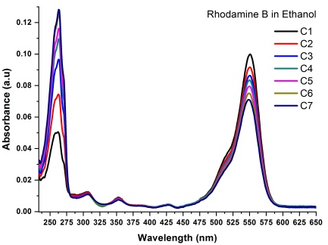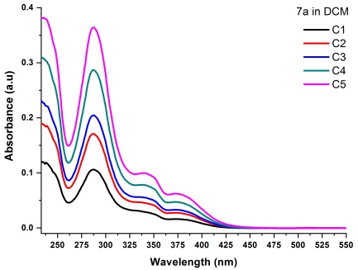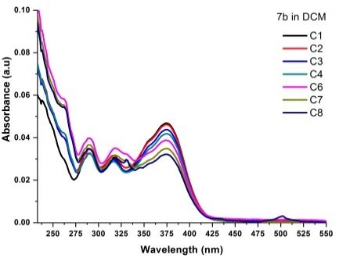
Figure S12: Absorption spectra of Rhodamine B, 7a and 7b

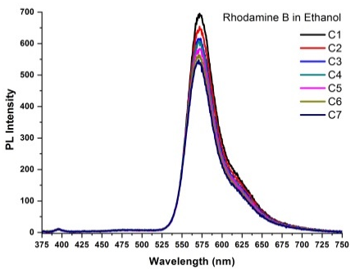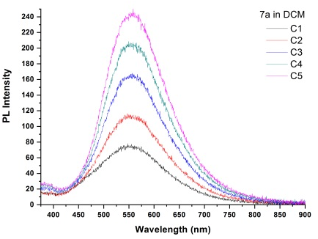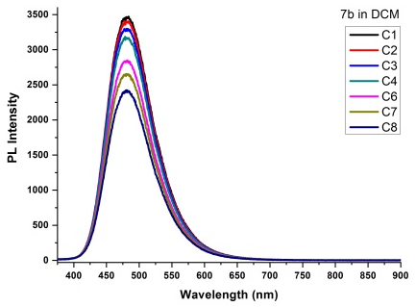
Figure S13: Emission (PL) spectra of Rhodamine B, 7a and 7b, excited at 355 nm.

