Synthesis of new fluorescent molecules having an aggregation-induced emission property derived from 4-fluoroisoxazoles

Kazuyuki Sato, Akira Kawasaki, Yukiko Karuo, Atsushi Tarui, Kentaro Kawai, Masaaki Omote*

Faculty of Pharmaceutical Sciences, Setsunan University
45-1, Nagaotoge-cho, Hirakata, Osaka 573-0101, Japan

Supporting Information

General Information ………………………………………………. S2
Materials ………………………………………….………………. S2
Experimental Section
General procedure for the synthesis of
4-fluoroisoxazoles (3). …………….. S2
General procedure for the synthesis of
boron ketoiminates (6). …………..…S3
General procedure for the synthesis of
α-fluorinated boron ketoiminates (F-BKIs, 9). …S3
Spectroscopic Data …………………………….……………... S4–S7
References ……….…………………………..…….……………... S7
UV/Vis and FL spectra …………….…………………...……. S8–S9
NMR charts …………….……………………………...…. S10–S23

General Information:
¹H NMR, ¹³C NMR and ¹⁹F NMR spectra were recorded on JEOL JNM-ECZS-400 spectrometers. Chemical shifts of ¹H NMR are reported in ppm from tetramethylsilane (TMS: 0 ppm) as an internal standard. Chemical shifts of ¹³C NMR are reported in ppm from tetramethylsilane (TMS: 0 ppm) or from the solvent (DMSO-d6: 39.520 ppm) as an internal standard. Chemical shifts of ¹⁹F NMR are reported in ppm from trichlorofluoromethane (CFCl₃: 0 ppm) as an internal standard. All data are reported as follows: chemical shifts, relative integration value, multiplicity (s = singlet, d = doublet, t = triplet, q = quartet, br = broad, m = multiplet), coupling constants (Hz). Mass spectra were obtained on JEOL JMS-700T spectrometers. Melting points were measured on Yanagimoto micro melting point apparatus MP-S3. UV-Visible absorption spectra were measured on a Jasco V-650 spectrometer. Fluorescence spectra were measured on a Jasco FP-8600 spectrofluorometer and appropriate blank spectrum was subtracted. Microwave reactions were performed in microwave tubes with clip lids using Biotage Initiator+ microwave reactor.

Materials:
Solvents (sulfolane, CH₃CN and EtOH) were distilled under inert argon atmosphere or under reduced pressure before use. Tetrahydrofuran (THF) was purchased from Kanto Chemical Co. Inc. as “Dehydrated”. All commercially available reagents were used without further purification. All experiments were carried out under argon atmosphere unless otherwise noted.

Experimental Section:
General procedure for the synthesis of 4-fluoroisoxazoles (3).¹
1,3-Diketone (1; 1 mmol), hydroxylamine hydrochloride (3 mmol) and SelectfluorTM (1 mmol) were added to a microwave vial and suspended in sulfolane (4 mL). The vial was sealed and heated by microwave irradiation for 1 hour at 150 °C. The resulting mixture was quenched with NaHCO₃ and, extracted with AcOEt. The AcOEt layer was washed with sat. NaCl and dried over MgSO₄. The solvent was removed in vacuo and the residue was purified by column chromatography to give 4-fluoroisoxazole (3).

General procedure for the synthesis of boron ketoiminates (6).
The mixture of 1,3-diketone (3, 1 mmol) and ammonium formate (5 mmol) in ethanol (5.5 mL) was stirred under reflux condition for 24 hours, and then the ethanol was distilled off under reduced pressure. To the residue was added AcOEt and water, and extracted. The AcOEt layer was dried over MgSO₄ and the solvent was removed in vacuo. The residue was passed through a silica gel column for yielding the enaminoketone (5), which was checked by NMR for the formation.
To a solution of enaminoketone (5, 1 mmol) in THF (14 mL) was added BF₃·Et₂O (10 mmol) and triethylamine (10 mmol), and the mixture was heated under reflux condition for 24 hours. The resulting mixture was quenched with H₂O and, extracted with AcOEt. The AcOEt layer was washed with sat. NaCl and dried over MgSO₄. The solvent was removed in vacuo and the residue was purified by column chromatography to give boron ketoiminate (BKIs, 6).

General procedure for the synthesis of α-fluorinated boron ketoiminates (F-BKIs, 9).
The solution of 4-fluoroisoxazoles (3, 1 mmol) in CH₃CN/H₂O (9:1, 27 mL) was stirred for 15 min. at room temperature. Then Mo(CO)₆ (1.1 mmol) was added into the solution, and the mixture was heated at 70 °C for 3 hours. The resulting mixture was quenched with sat. NaCl and, extracted with AcOEt. The AcOEt layer was dried over MgSO₄ and the solvent was removed in vacuo. The residue was passed through a silica gel column for separation of the corresponding defluorinated enaminoketone (5) and α-monofluoro-1,3-diketone to give the α-fluorinated enaminoketone (8), which was checked by NMR for the formation.
To a solution of α-fluorinated enaminoketone (8, 1 mmol) in THF (14 mL) was added BF₃·Et₂O (10 mmol) and triethylamine (10 mmol), and the mixture was heated under reflux condition for 24 hours. The resulting mixture was quenched with H₂O and, extracted with AcOEt. The AcOEt layer was washed with sat. NaCl and dried over MgSO₄. The solvent was removed in vacuo and the residue was purified by column chromatography to give α-fluorinated boron ketoiminate (F-BKIs, 9).

Spectroscopic Data:
4-Fluoro-3,5-bis(3-(trifluoromethyl)phenyl)isoxazole (3d)
Colorless solid; M.p. 96.5–97.5 °C; ¹H NMR (400 MHz, CDCl₃) δ: 7.66–7.81 (4H, m), 8.06–8.23 (4H, m); ¹³C NMR (100 MHz, CDCl₃) δ: 122.11 (m), 123.59 (q, J = 272.6 Hz), 123.69 (q, J = 272.6 Hz), 123.92 (m), 126.25 (d, J = 5.2 Hz), 126.96 (m), 127.03 (d, J = 4.0 Hz), 127.39 (m), 129.33 (d, J = 4.9 Hz), 129.74, 129.87, 130.20, 131.69 (q, J = 32.8 Hz), 131.83 (q, J = 33.0 Hz), 141.92 (d, J = 261.0 Hz), 152.28, (d, J = 10.5 Hz), 152.70 (d, J = 19.1 Hz); ¹⁹F NMR (376 MHz, CDCl₃) δ: -62.78 (3F, s), -62.89 (3F, s), -175.83 (1F, s); MS m/z: 375 (M⁺); HRMS Calcd for C₁₇H₈F₇NO: 375.0494 (M⁺), Found: 375.0497.

3-Amino-1,3-diphenylprop-2-en-1-one (5a)²
¹H NMR (400 MHz, CDCl₃) δ: 5.45 (1H, bs), 6.15 (1H, s), 7.41–7.53 (6H, m), 7.63–7.66 (2H, m), 7.94–7.97 (2H, m), 10.42 (1H, bs).

3-Amino-1,3-bis(4-methoxyphenyl)prop-2-en-1-one (5b)²
¹H NMR (400 MHz, CDCl₃) δ: 3.86 (3H, s), 3.87 (3H, s), 5.33 (1H, bs), 6.10 (1H, s), 6.92–7.00 (4H, m), 7.58–7.61 (2H, m), 7.92–7.96 (2H, m), 10.41 (1H, bs).

3-Amino-1,3-bis(4-(trifluoromethyl)phenyl)prop-2-en-1-one (5c)²
¹H NMR (400 MHz, CDCl₃) δ: 5.55 (1H, bs), 6.11 (1H, s), 7.69–7.71 (2H, m), 7.76 (4H, s), 8.01–8.03 (2H, m), 10.42 (1H, bs); ¹⁹F NMR (376 MHz, CDCl₃) δ: -62.70 (3F, s), -62.80 (3F, s).

2,2-Difluoro-4,6-diphenyl-2H-1,3,2λ⁴-oxazaborinine (6a)³
Colorless solid; M.p. 204.5–206.5 °C; ¹H NMR (400 MHz, DMSO-d6) δ: 6.93 (1H, d, J = 1.8 Hz), 7.53–7.73 (6H, m), 8.04–8.14 (4H, m), 10.33 (1H, bs); ¹³C NMR (100 MHz, DMSO-d6) δ: 92.08, 127.17, 127.92, 128.73, 128.93, 132.30, 132.77, 132.91, 133.33, 169.40, 170.70; ¹⁹F NMR (376 MHz, DMSO-d6) δ: -128.03–-128.15 (2F, m); MS m/z: 271 (M⁺); HRMS Calcd for C₁₅H₁₂BF₂NO: 271.0980 (M⁺), Found: 271.0982.

2,2-Difluoro-4,6-bis(4-methoxyphenyl)-2H-1,3,2λ⁴-oxazaborinine (6b)⁴
Pale yellow solid; M.p. 220.0–223.0 °C; ¹H NMR (400 MHz, DMSO-d6) δ: 3.86 (3H, s), 3.88 (3H, s), 6.82 (1H, d, J = 1.3 Hz), 7.07–7.14 (4H, m), 8.08–8.10 (4H, m), 9.85 (1H, bs); ¹³C NMR (100 MHz, DMSO-d6) δ: 55.42, 55.55, 90.20, 114.11, 114.31, 124.71, 125.78, 129.18, 129.97, 162.55, 163.05, 167.56, 170.02; ¹⁹F NMR (376 MHz, DMSO-d6) δ: -128.87–-128.95 (2F, m); MS m/z: 331 (M⁺); HRMS Calcd for C₁₇H₁₆BF₂NO₃: 331.1191 (M⁺), Found: 331.1193.

2,2-Difluoro-4,6-bis(4-(trifluoromethyl)phenyl)-2H-1,3,2λ⁴-oxazaborinine (6c)
Pale yellow solid; M.p. 265.0–270.0 °C; ¹H NMR (400 MHz, DMSO-d6) δ: 7.10 (1H, d, J = 1.4 Hz), 7.91–8.00 (4H, m), 8.23–8.35 (4H, m), 10.82 (1H, bs); ¹³C NMR (100 MHz, DMSO-d6) δ: 93.86, 123.58 (q, J = 272.6 Hz), 123.72 (q, J = 272.6 Hz), 125.67 (q, J = 4.1 Hz), 125.75 (q, J = 4.1 Hz), 128.05, 129.12, 132.06 (q, J = 31.9 Hz), 132.38 (q, J = 31.9 Hz), 136.46, 136.94, 169.01, 169.26; ¹⁹F NMR (376 MHz, DMSO-d6) δ: -61.44 (3F, s), -61.55 (3F, s), -127.35–-127.42 (2F, m); MS m/z: 407 (M⁺); HRMS Calcd for C₁₇H₁₀BF₈NO: 407.0728 (M⁺), Found: 407.0724.

3-Amino-2-fluoro-1,3-diphenylprop-2-en-1-one (8a)
¹H NMR (400 MHz, CDCl₃) δ: 7.42–7.51 (6H, m), 7.63–7.65 (2H, m), 7.89–7.92 (2H, m); ¹⁹F NMR (376 MHz, CDCl₃) δ: -170.44 (1F, s).

3-Amino-2-fluoro-1,3-bis(4-methoxyphenyl)prop-2-en-1-one (8b)
¹H NMR (400 MHz, CDCl₃) δ: 3.86 (3H, s), 3.86 (3H, s), 6.92–7.01 (4H, m), 7.58–7.62 (2H, m), 7.93–7.97 (2H, m); ¹⁹F NMR (376 MHz, CDCl₃) δ: -169.97 (1F, s).

3-Amino-2-fluoro-1,3-bis(4-(trifluoromethyl)phenyl)prop-2-en-1-one (8c)
¹H NMR (400 MHz, CDCl₃) δ: 7.70–7.73 (2H, m), 7.77 (4H, s), 7.99–8.01 (2H, m); ¹⁹F NMR (376 MHz, CDCl₃) δ: -62.83 (3F, s), -62.86 (3F, s), -170.60 (1F, s).

2,2,5-Trifluoro-4,6-diphenyl-2H-1,3,2λ⁴-oxazaborinine (9a)
Pale yellow solid; M.p. 172.5–174.0 °C; ¹H NMR (400 MHz, DMSO-d6) δ: 7.57–7.73 (6H, m), 7.79–7.81 (2H, m), 7.96–7.98 (2H, m), 10.80 (1H, bs); ¹³C NMR (100 MHz, DMSO-d6) δ: 128.49 (d, J = 8.3 Hz), 128.63, 128.75, 129.05 (d, J = 3.8 Hz), 129.34, 130.79 (d, J = 5.7 Hz), 132.16, 132.61, 139.59 (d, J = 221.5 Hz), 157.0 (d, J = 20.8 Hz), 165.24 (d, J = 26.1 Hz); ¹⁹F NMR (376 MHz, DMSO-d6) δ: -129.38–-129.50 (2F, m), -171.41 (1F, s); MS m/z: 289 (M⁺); HRMS Calcd for C₁₅H₁₁BF₃NO: 289.0886 (M⁺), Found: 289.0888.

2,2,5-Trifluoro-4,6-bis(4-methoxyphenyl)-2H-1,3,2λ⁴-oxazaborinine (9b)
Yellow solid; M.p. 188.0–189.0 °C; ¹H NMR (400 MHz, DMSO-d6) δ: 3.87 (3H, s), 3.88 (3H, s), 7.11–7.17 (4H, m), 7.78–7.81 (2H, m), 7.95–7.97 (2H, m), 10.28 (1H, bs); ¹³C NMR (100 MHz, DMSO-d6) δ: 55.43, 55.54, 114.15, 114.26, 121.50, 123.12 (d, J = 5.8 Hz), 130.66 (d, J = 9.1 Hz), 131.38 (d, J = 4.7 Hz), 139.28 (d, J = 220.9 Hz), 156.68 (d, J = 20.8 Hz), 162.28, 162.81, 163.42 (d, J = 25.1 Hz); ¹⁹F NMR (376 MHz, DMSO-d6) δ: -130.66–-130.73 (2F, m), -171.94 (1F, s); MS m/z: 349 (M⁺); HRMS Calcd for C₁₇H₁₅BF₃NO₃: 349.1097 (M⁺), Found: 349.1102.

2,2,5-Trifluoro-4,6-bis(4-(trifluoromethyl)phenyl)-2H-1,3,2λ⁴-oxazaborinine (9c)
Pale yellow solid; M.p. 224.0–226.0 °C; ¹H NMR (400 MHz, DMSO-d6) δ: 7.95–8.05 (6H, m), 8.15–8.17 (2H, m), 11.29 (1H, bs); ¹³C NMR (100 MHz, DMSO-d6) δ: 123.52 (q, J = 272.8 Hz), 123.61 (q, J = 272.5 Hz), 125.49 (q, J = 3.8 Hz), 125.69 (d, J = 3.8 Hz), 129.31 (d, J = 8.3 Hz), 130.16 (d, J = 3.4 Hz), 131.64 (q, J = 32.6 Hz), 132.28 (q, J = 32.4 Hz), 132.91, 134.43 (d, J = 5.3 Hz), 140.08 (d, J = 225.4 Hz), 155.22 (d, J = 20.7 Hz), 164.82 (d, J = 26.9 Hz); ¹⁹F NMR (376 MHz, DMSO-d6) δ: -61.60 (3F, s), -61.63 (3F, s), -128.26–-128.34 (2F, m), -170.12 (1F, s); MS m/z: 425 (M⁺); HRMS Calcd for C₁₇H₉BF₉NO: 425.0633 (M⁺), Found: 425.0632.

References:
[1] Sato, K.; Sandford, G.; Shimizu, K.; Akiyama, S.; Lancashire, M. J.; Yufit, D. S.; Tarui, A.; Omote, M.; Kumadaki, I.; Harusawa, S.; Ando, A. Tetrahedron 2016, 72, 1690–1698.
[2] H. S. P. Rao, N. Muthanna, Eur. J. Org. Chem. 2015, 1525–1532.
[3] I. Bally, E. Ciornei, A. Vasilescu, A. T. Balaban, Tetrahedron 1973, 29, 3185–3187.
[4] R. Yoshii, A. Nagai, K. Tanaka, Y. Chujo, Chem. -Eur. J. 2013, 19, 4506–4512.

UV/Vis and FL spectra:
2,2-Difluoro-4,6-diphenyl-2H-1,3,2λ⁴-oxazaborinine (6a)
UV/Vis and FL spectra of 6a with solvent compositions of the THF/H₂O mixture
upon excitation at 352 nm (1.0 x 10⁻⁵ M).

2,2-Difluoro-4,6-bis(4-methoxyphenyl)-2H-1,3,2λ⁴-oxazaborinine (6b)
UV/Vis and FL spectra of 6b with solvent compositions of the THF/H₂O mixture
upon excitation at 389 nm (1.0 x 10⁻⁵ M).

2,2-Difluoro-4,6-bis(4-(trifluoromethyl)phenyl)-2H-1,3,2λ⁴-oxazaborinine (6c)
UV/Vis and FL spectra of 6c with solvent compositions of the THF/H₂O mixture
upon excitation at 332 nm (1.0 x 10⁻⁵ M).

2,2,5-Trifluoro-4,6-diphenyl-2H-1,3,2λ⁴-oxazaborinine (9a)
UV/Vis and FL spectra of 9a with solvent compositions of the THF/H₂O mixture
upon excitation at 365 nm (1.0 x 10⁻⁵ M).

2,2,5-Trifluoro-4,6-bis(4-methoxyphenyl)-2H-1,3,2λ⁴-oxazaborinine (9b)
UV/Vis and FL spectra of 9b with solvent compositions of the THF/H₂O mixture
upon excitation at 380 nm (1.0 x 10⁻⁵ M).

2,2,5-Trifluoro-4,6-bis(4-(trifluoromethyl)phenyl)-2H-1,3,2λ⁴-oxazaborinine (9c)
UV/Vis and FL spectra of 9c with solvent compositions of the THF/H₂O mixture
upon excitation at 366 nm (1.0 x 10⁻⁵ M).

NMR charts:
4-Fluoro-3,5-bis(3-(trifluoromethyl)phenyl)isoxazole (3d)
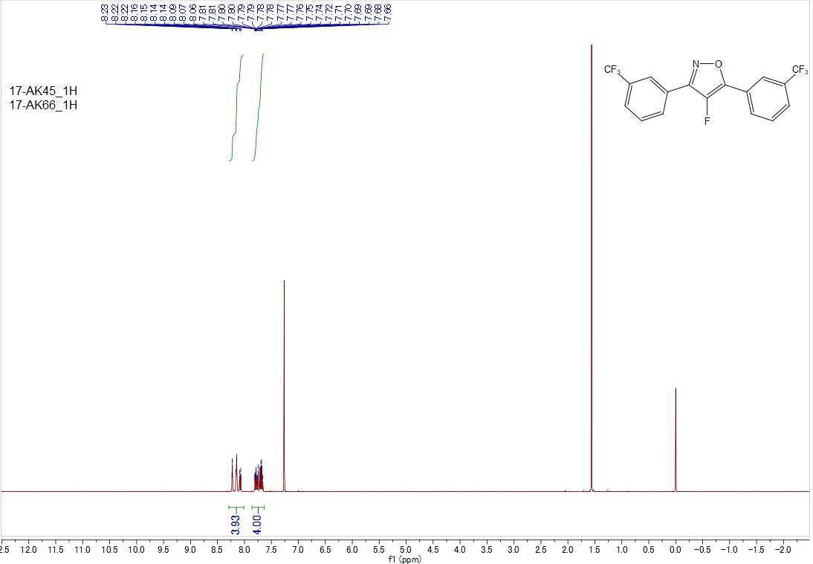
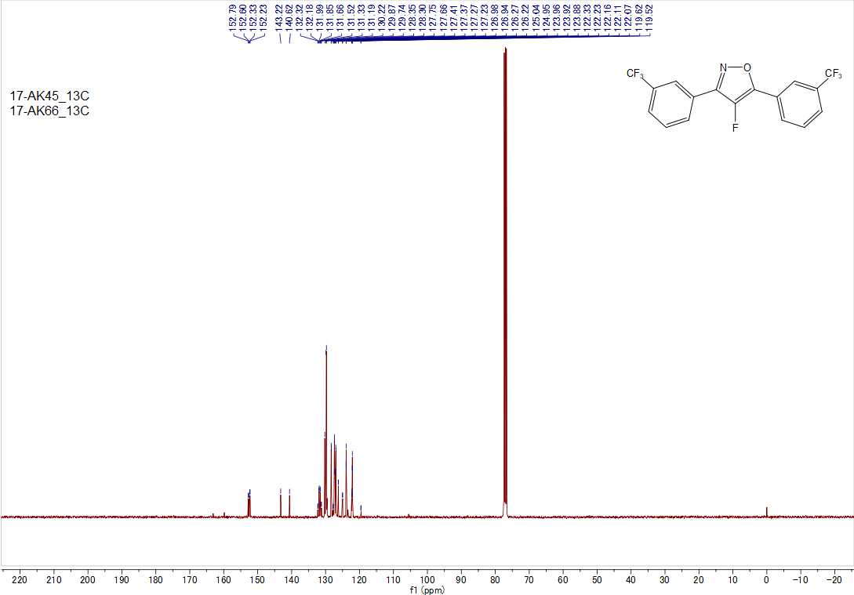
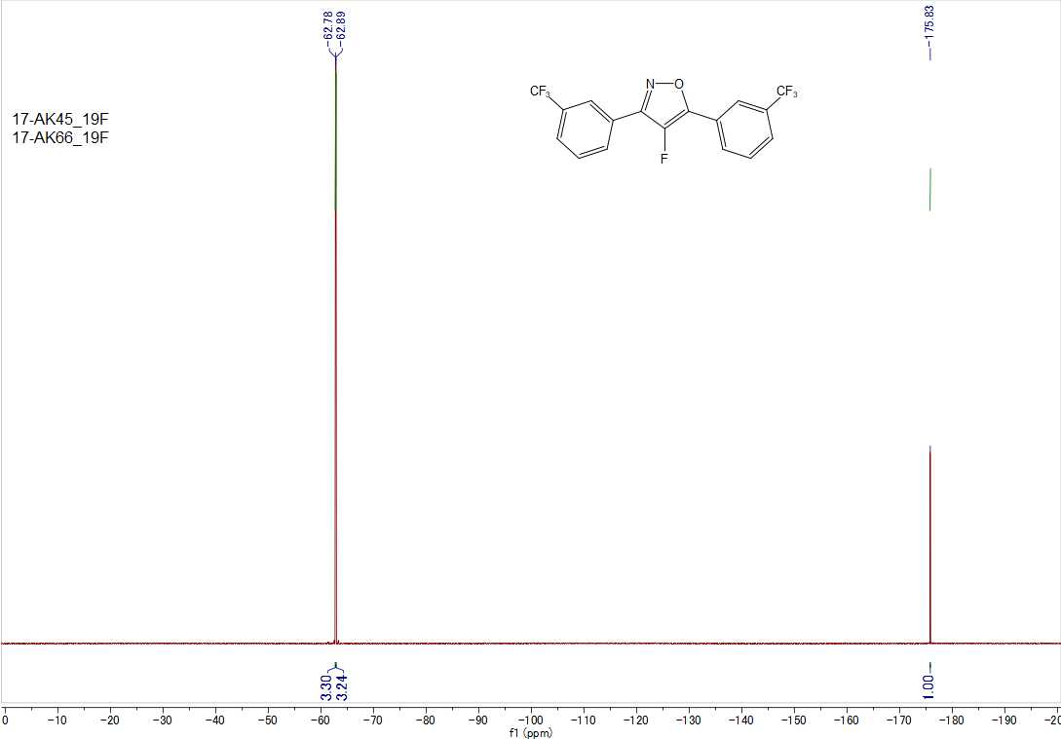

2,2-Difluoro-4,6-diphenyl-2H-1,3,2λ⁴-oxazaborinine (6a)
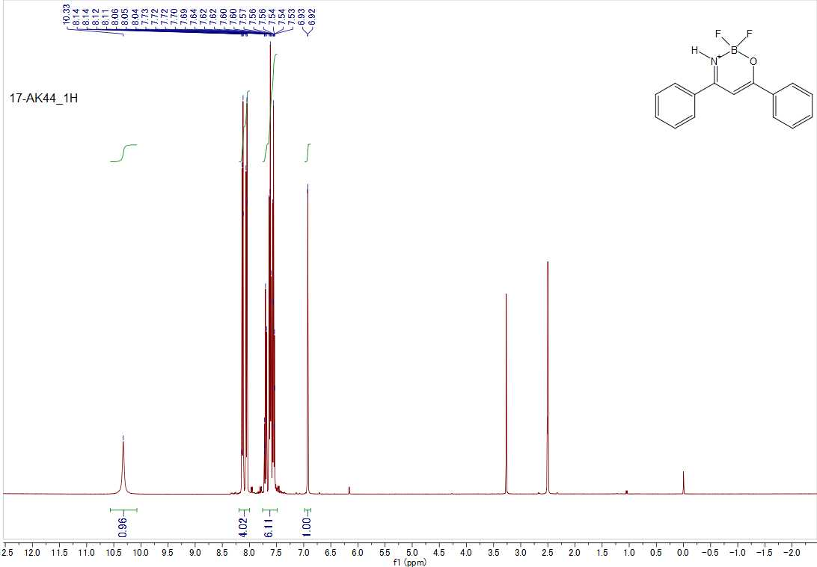
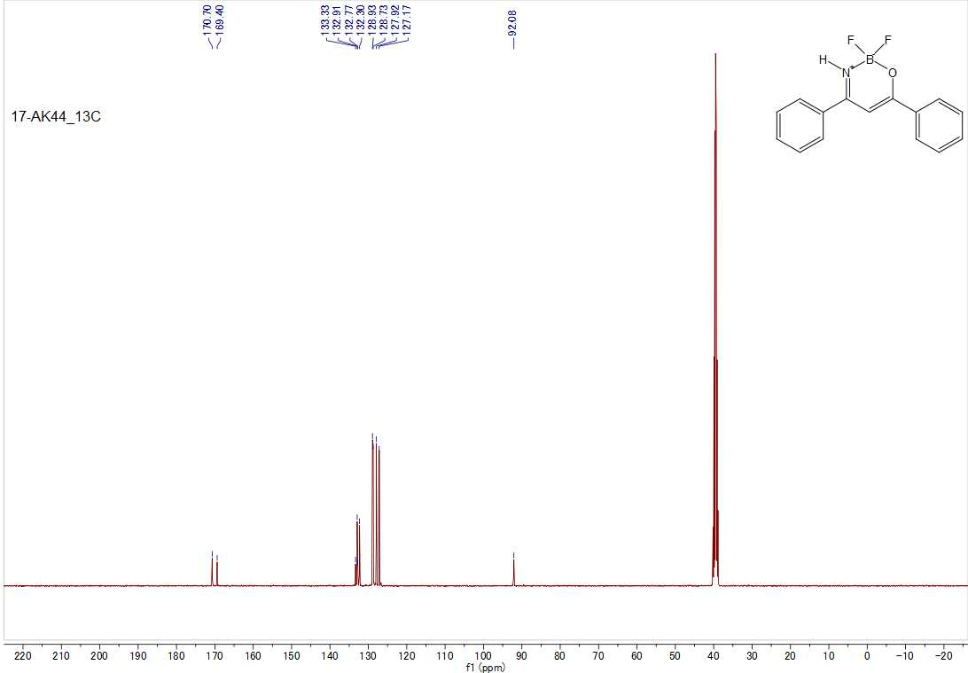

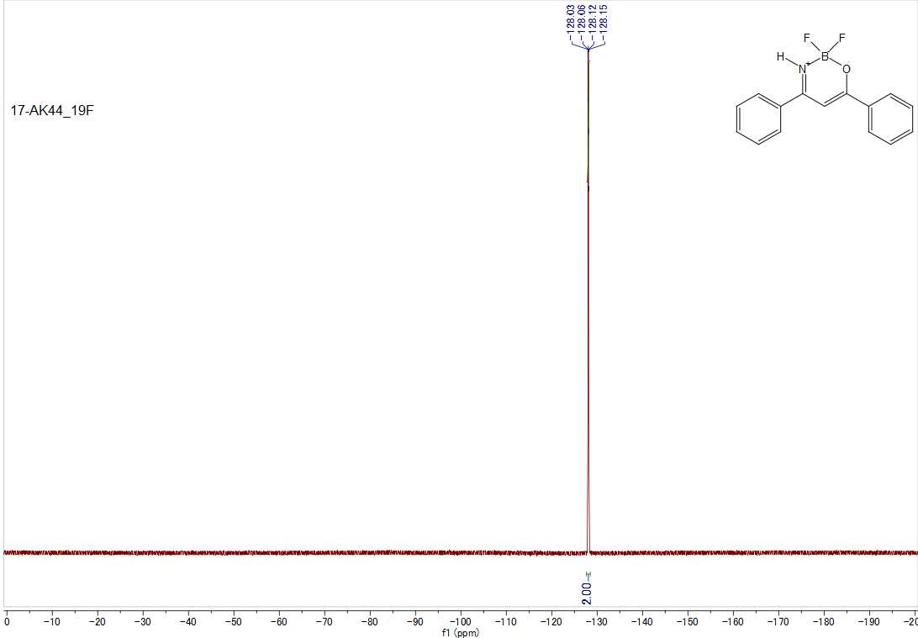

2,2-Difluoro-4,6-bis(4-methoxyphenyl)-2H-1,3,2λ⁴-oxazaborinine (6b)
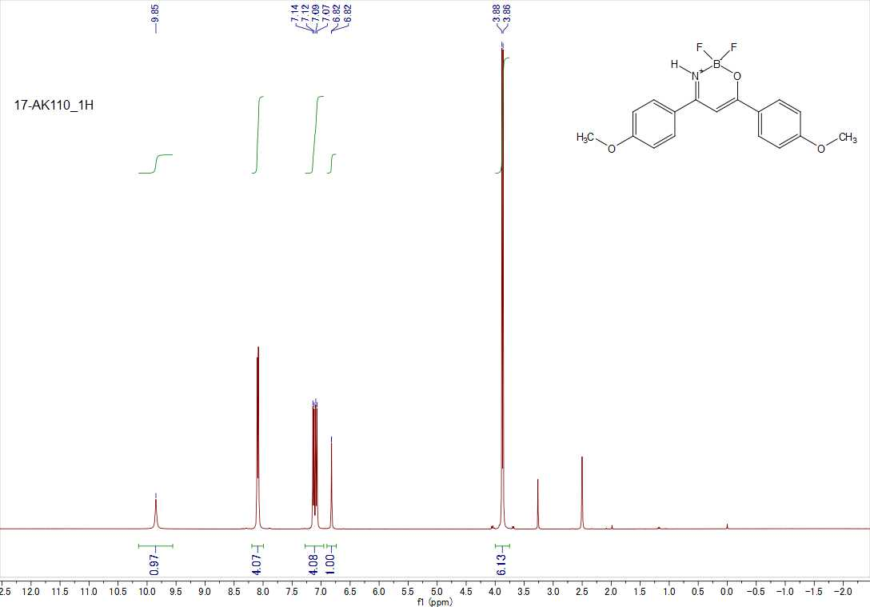

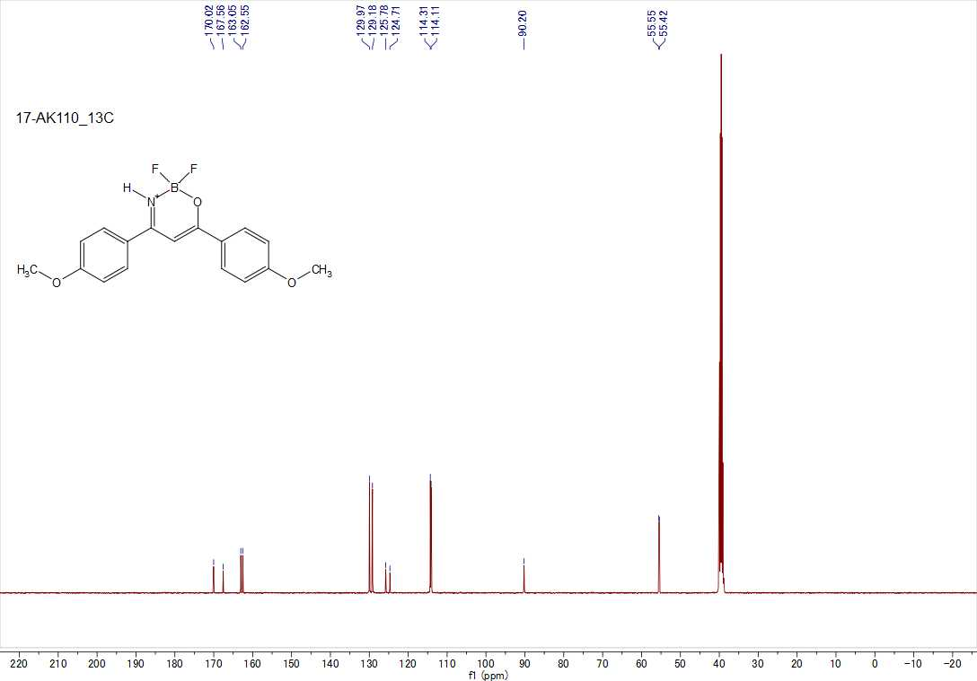
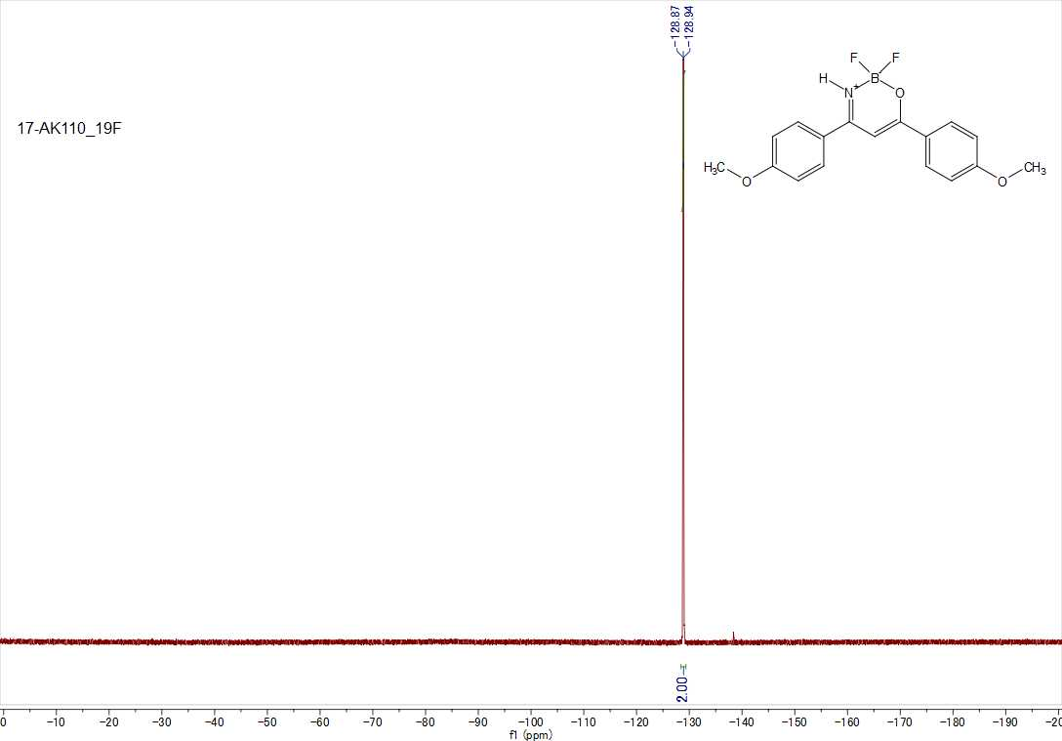

2,2-Difluoro-4,6-bis(4-(trifluoromethyl)phenyl)-2H-1,3,2λ⁴-oxazaborinine (6c)
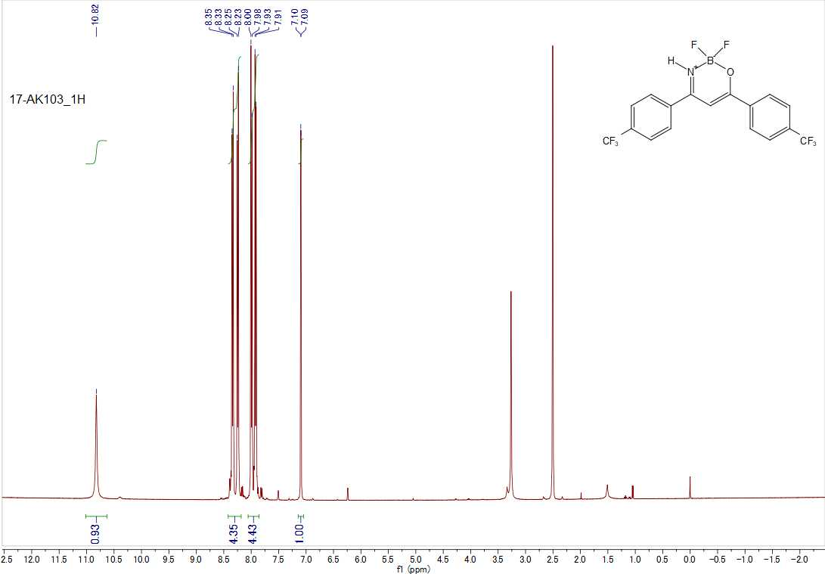
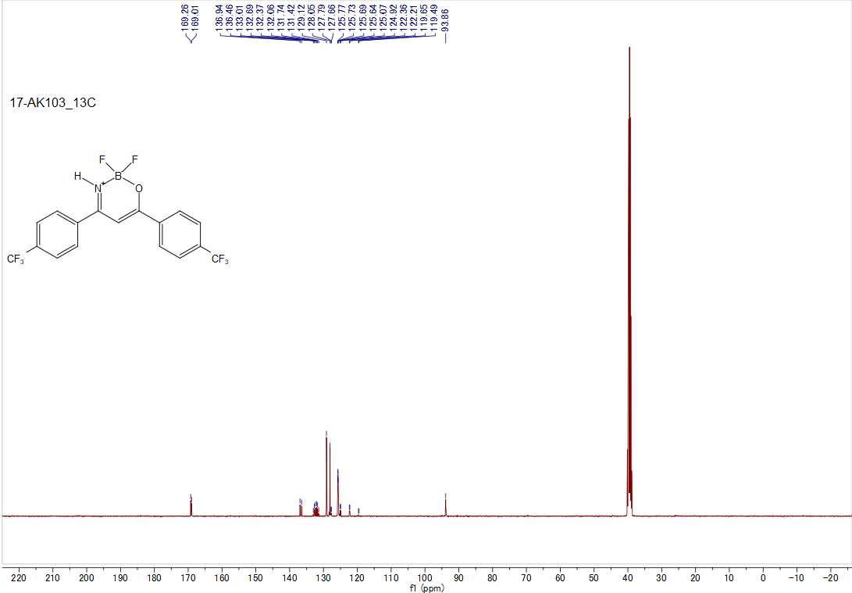

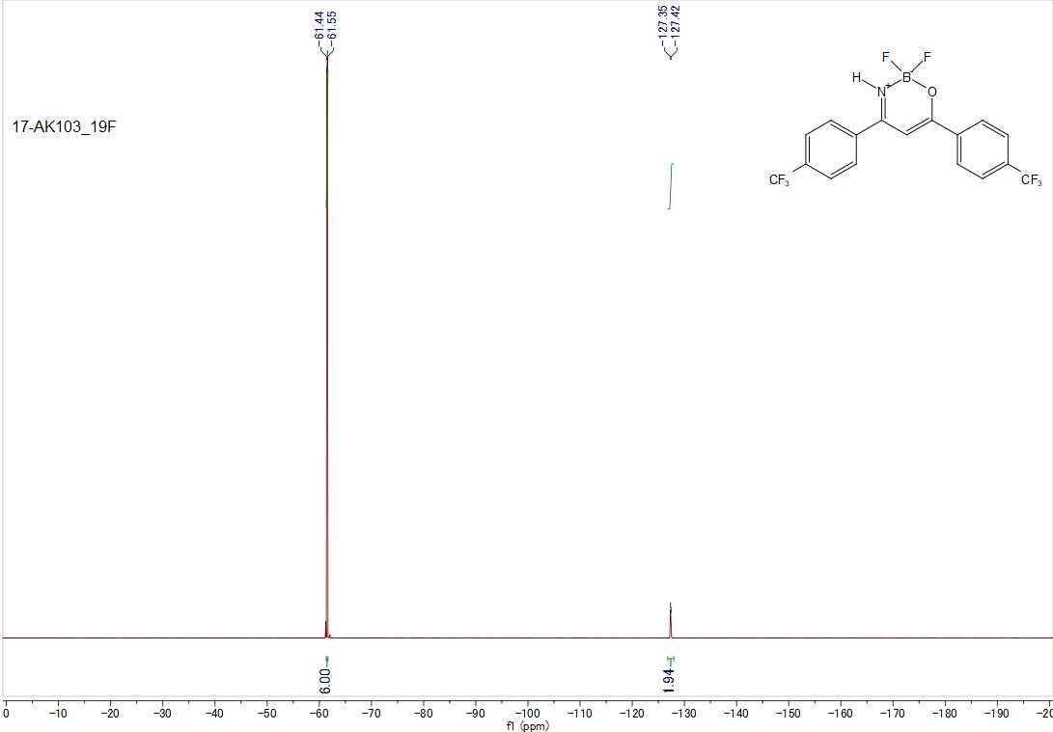

3-Amino-2-fluoro-1,3-diphenylprop-2-en-1-one (8a)
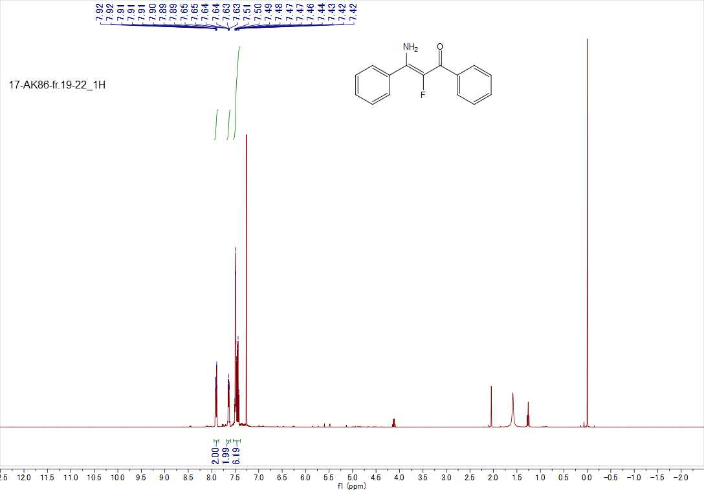

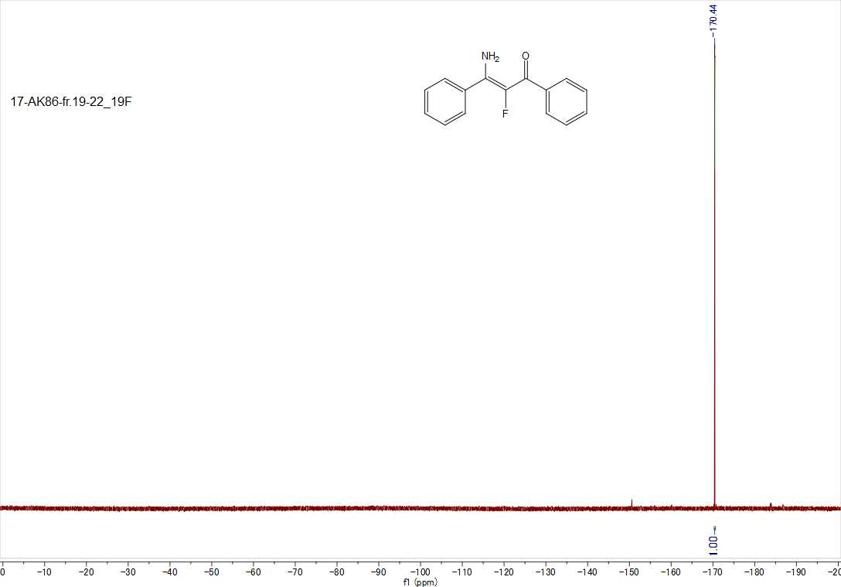
3-Amino-2-fluoro-1,3-bis(4-methoxyphenyl)prop-2-en-1-one (8b)
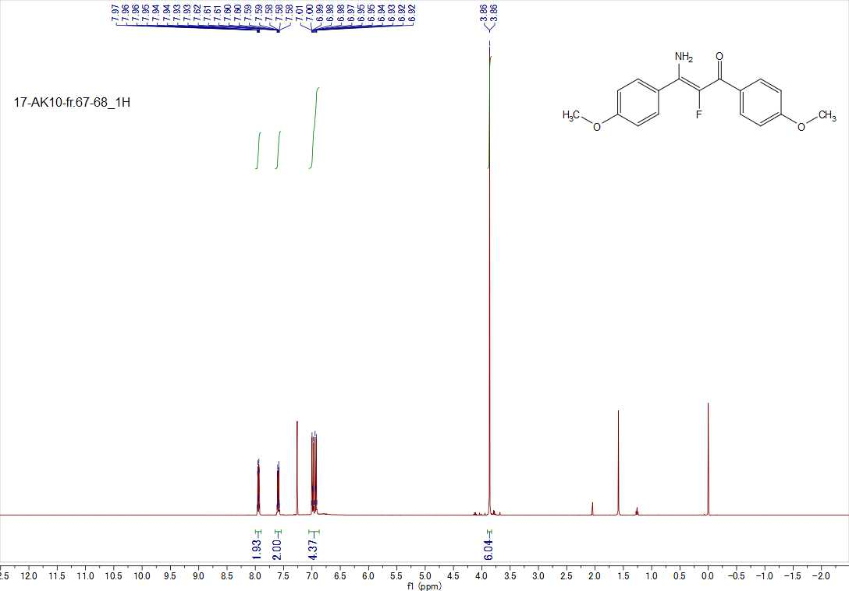

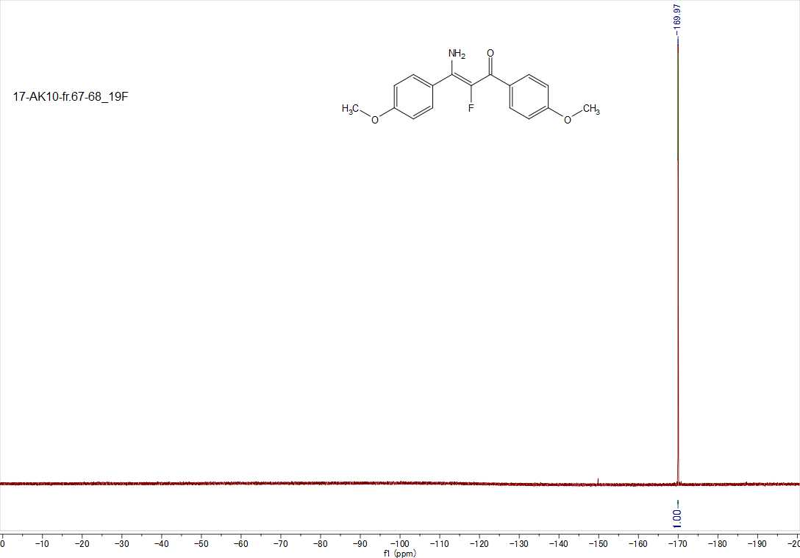
3-Amino-2-fluoro-1,3-bis(4-(trifluoromethyl)phenyl)prop-2-en-1-one (8c)
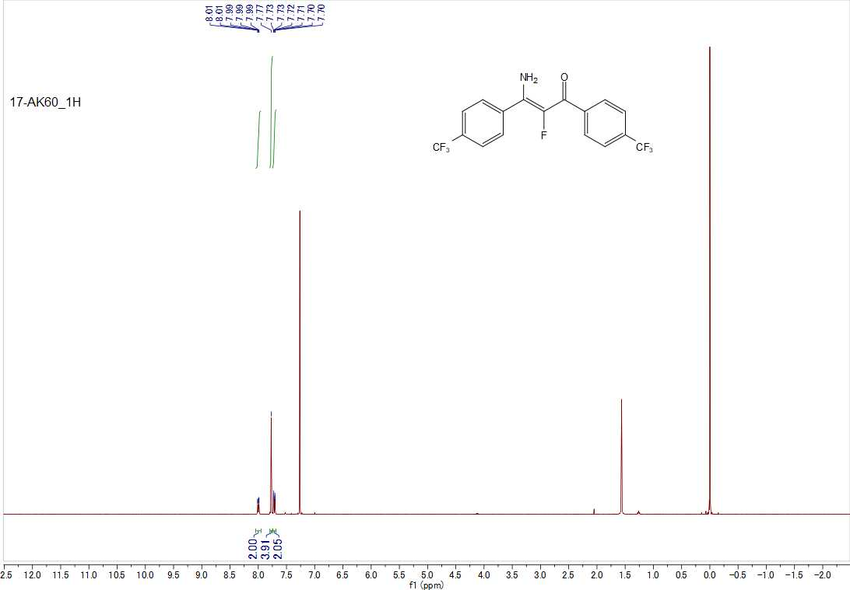

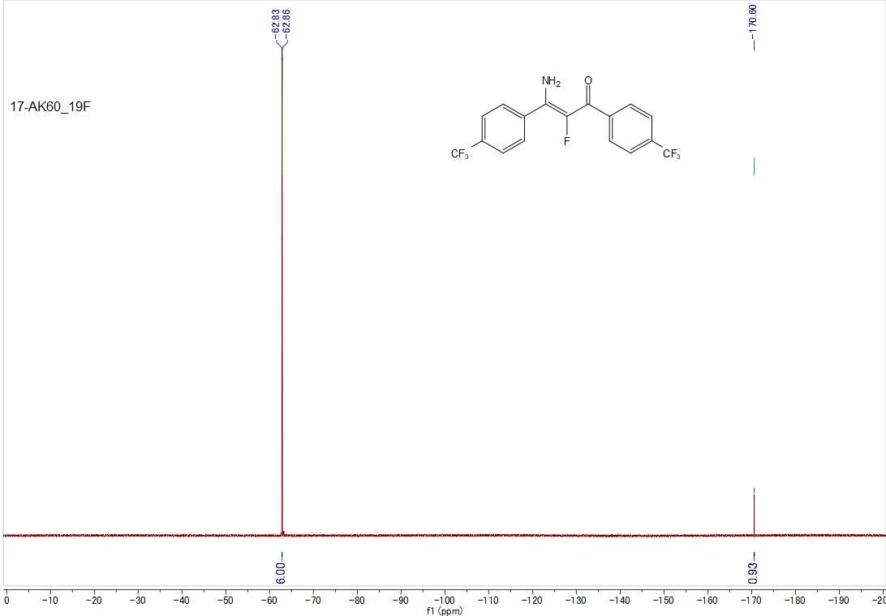
2,2,5-Trifluoro-4,6-diphenyl-2H-1,3,2λ⁴-oxazaborinine (9a)
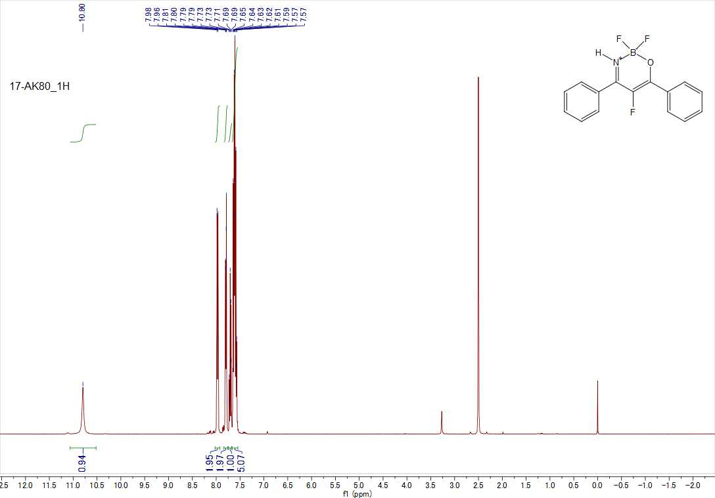

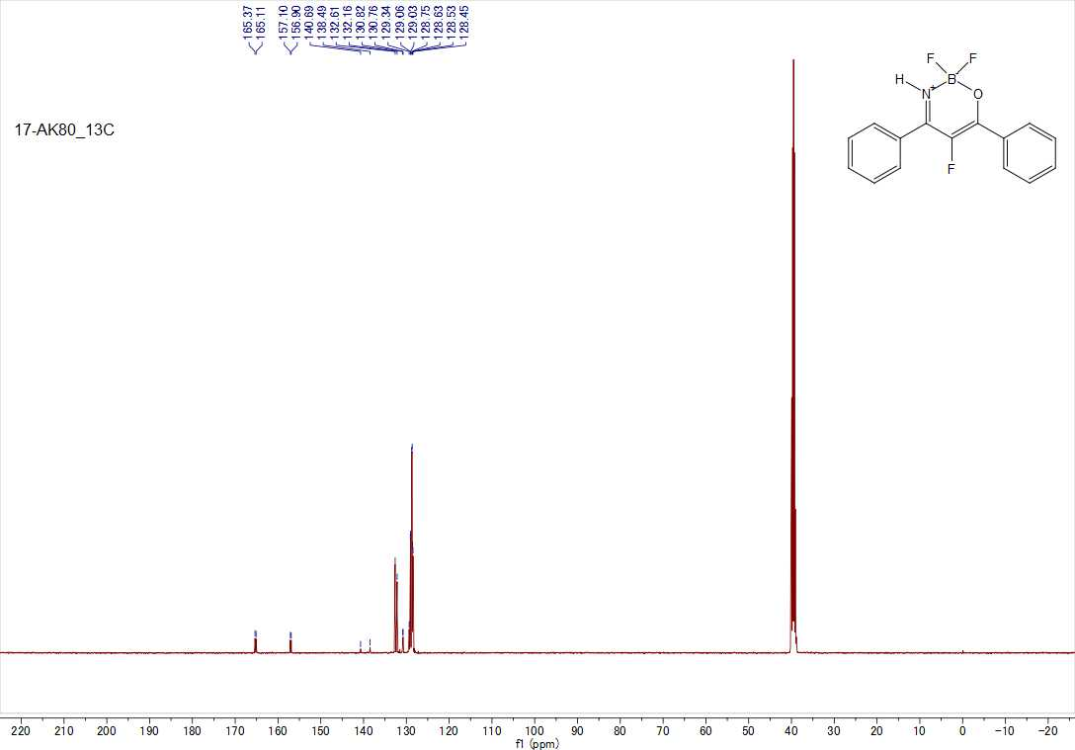
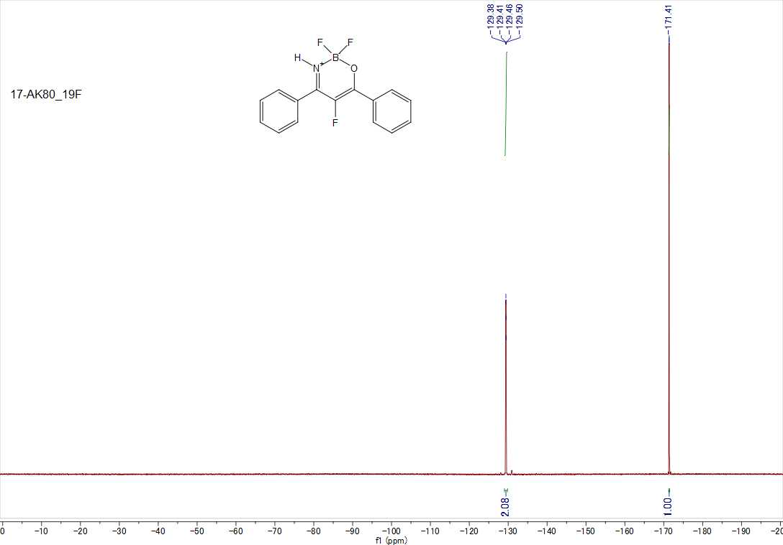

2,2,5-Trifluoro-4,6-bis(4-methoxyphenyl)-2H-1,3,2λ⁴-oxazaborinine (9b)
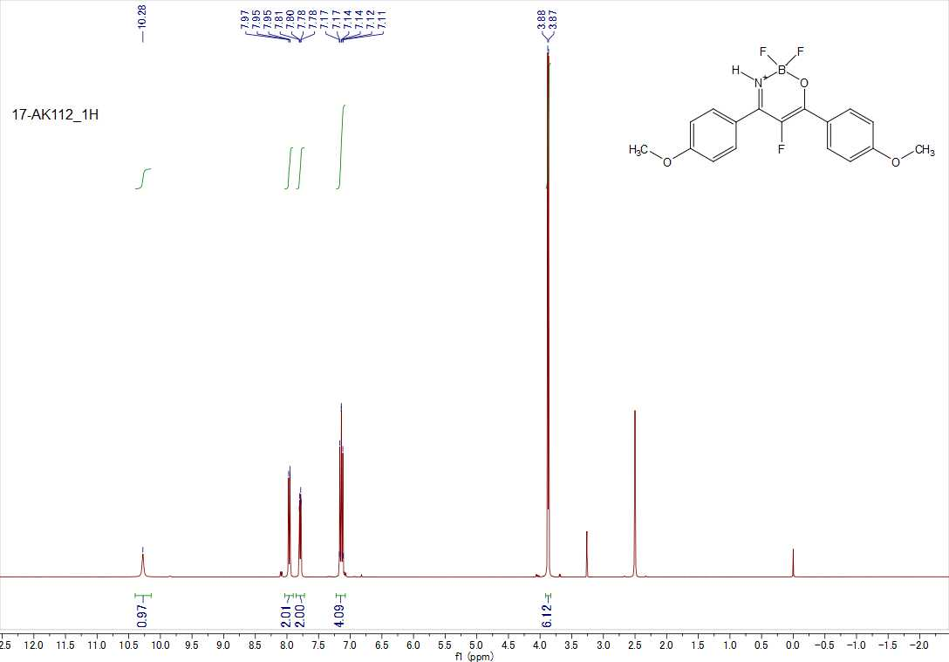
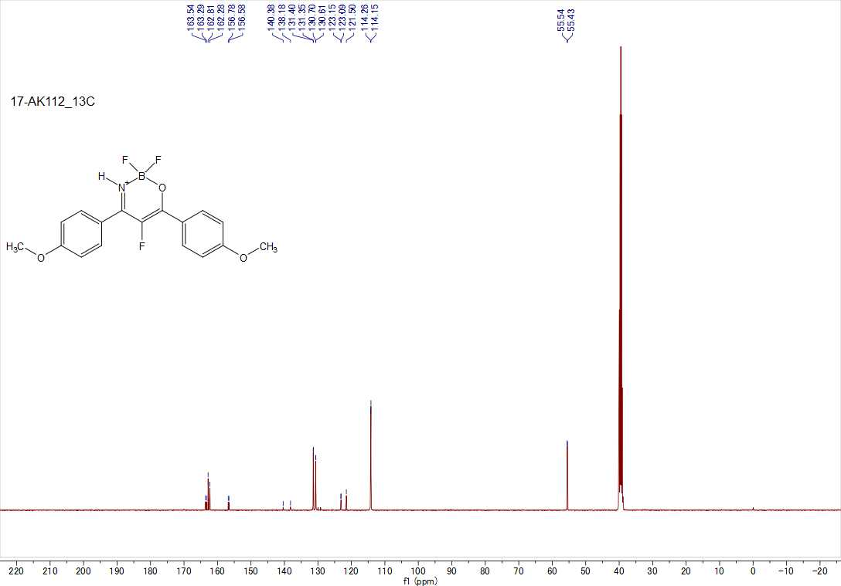

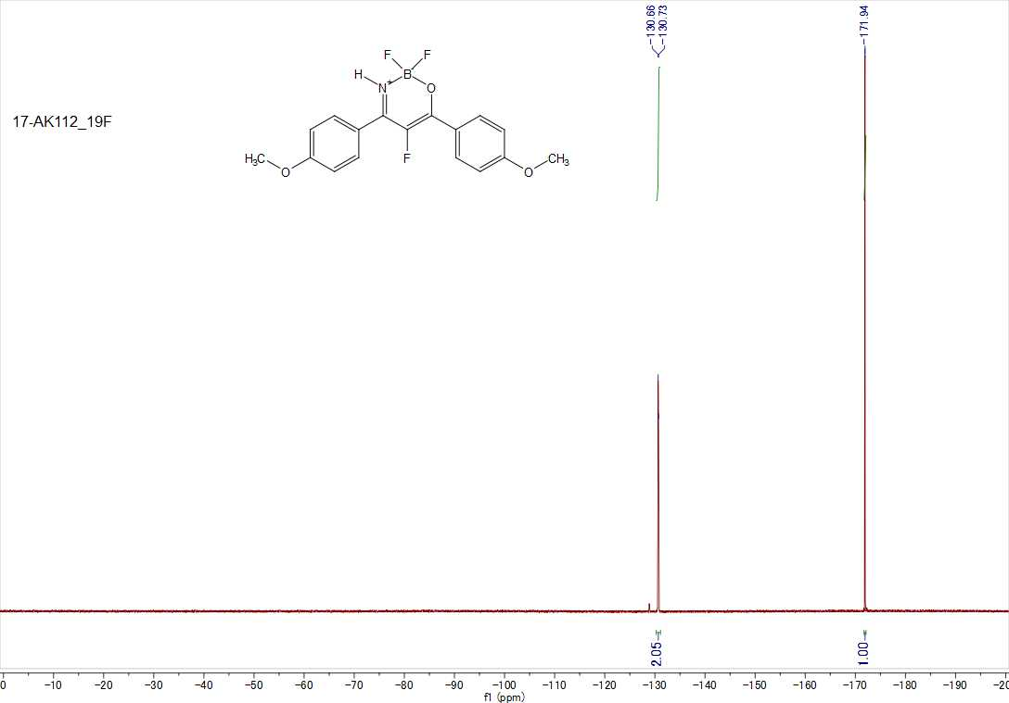

2,2,5-Trifluoro-4,6-bis(4-(trifluoromethyl)phenyl)-2H-1,3,2λ⁴-oxazaborinine (9c)
