Supporting Information
Natural dolomitic limestone catalyzed synthesis of benzimidazoles, dihydropyrimidinones and highly substituted pyridines under ultrasound irradiation
Kumar Godugu,^{a‡} Venkata Divya Sri Yadala,^{a‡} Mohammad Khaja Mohinuddin Pinjari,^{a‡} Thrivikram Reddy Gundala^{a‡}, Lakshmi Reddy Sanapareddy^{b} and Chinna Gangi Reddy Nallagonduª*
Address: ªDepartment of Chemistry, Green and Sustainable Synthetic Organic Chemistry Laboratory, Yogi Vemana University, Kadapa-516 005, Andhra Pradesh, India.
^{b} Department of Physics, S.V.D. College, Kadapa-516003, Andhra Pradesh, India.
E-mail: ncgreddy@yogivemanauniversity.ac.in

Table of Contents
Contents | Page No.
Experimental section | S2,S3
Physical, spectral data and copies of ¹H &¹³C NMR, Mass and HRMS spectra of some representative compounds (3,7&10) | S4-S23

Experimental
Materials and Methods
The ¹H (300, 400 and 500 MHz) and ¹³C (75, 100 and 125 MHz) NMR spectroscopic data are recorded on Varian spectrometer. High-Resolution Mass Spectra are recorded on Bruker micrOTOF-QII mass spectrometer. Mass spectral data are acquired on Exactive Orbitrap mass spectrometer (Thermo Scientific, Waltham, MA, USA) equipped with Thermo Accela 600 quaternary gradient pump and MS source is equipped with electro spray ionization (ESI) probe. XRD pattern is recorded using a Rigaku Miniflex 600 diffractometer. FT-IR spectrum is recorded on PerkinElmer FT IR spectroscopy (PerkinElmer, Spectrum Two model, Singapore). Raman spectrum is recorded on Lab RAM high-resolution Raman spectrometer (Horiba). Scanning Electron Microscopy (SEM) images are recorded on JSM-IT500 Scanning Electron Microscope (JEOL). Thin-layer chromatography is performed on 0.25 mm Merck silica gel plates and visualized with UV light. Melting points of various products obtained are determined (uncorrected). Chemicals and solvents are purchased from Avra, Acros organics Ltd and Merck and are used as received.

General Experimental procedure for the synthesis of 2-aryl-1-arylmethyl-1H-benzo[d]imidazoles (3)
A mixture of o-phenylenediamine (1, 1.0 mmol),), aromatic/heteroaromatic aldehyde (2, 1.0 mmol), (1 mmol) and dolomitic limestone (5.0 wt %) was irradiated by ultrasound in 1:1 ratio of ethanol: H₂O (3.0 mL) at 45-50°C for 10-15 min. After completion of the reaction (monitored by TLC), the reaction mass was allowed to cool to RT and then the catalyst was separated by centrifugation. The separated catalyst was washed with ethyl acetate twice (2.0 mL).The filtrate was concentrated under reduced pressure to obtain the crude product (3). The formed crude solid (3) was purified by recrystallization using hot aqueous ethanol.

General Experimental procedure for the synthesis of Dihydropyrimidinones /thiones derivatives (7):
A mixture of aromatic/heteroaromatic aldehyde (2, 1.0 mmol), ethyl acetoacetate (4, 1.0 mmol), urea/thiourea (5/6, 1.0 mmol) and dolomitic limestone (5.0 wt %) was irradiated by ultrasound in 1:1 ratio of ethanol:H₂O (3.0 mL) at 45-50°C for 10-20 min. After completion of the reaction (monitored by TLC), the reaction mass was allowed to cool to RT and then the catalyst was separated by centrifugation. The separated catalyst was washed with ethyl acetate twice (2.0 mL).The filtrate was concentrated under reduced pressure to obtain the crude product (7). The formed crude solid (7) was purified by recrystallization using hot aqueous ethanol.
General Experimental Procedure for the Synthesis of 2-amino-4-aryl-3,5-dicarbonitrile-6-sulfanyl-pyridines (10).
A mixture of aromatic/heteroaromatic aldehyde (2, 1.0 mmol), malononitrile (8, 2.0 mmol), thiol (9) and added dolomitic limestone (5.0 wt%) was irradiated by ultrasound in 1:1 ratio of ethanol:H₂O (1:1) at 70-75°C for 10-20 min. The progress of the reaction was monitored by TLC. After completion of the reaction (monitored by TLC), the reaction mass was allowed to cool to RT and then the catalyst was separated by centrifugation. The separated catalyst was washed with ethyl acetate twice (2.0 mL).The filtrate was concentrated under reduced pressure to obtain the crude product (10). The formed crude solid (10) was purified by recrystallization using hot aqueous ethanol.

Physical and spectral data of the synthesized compounds
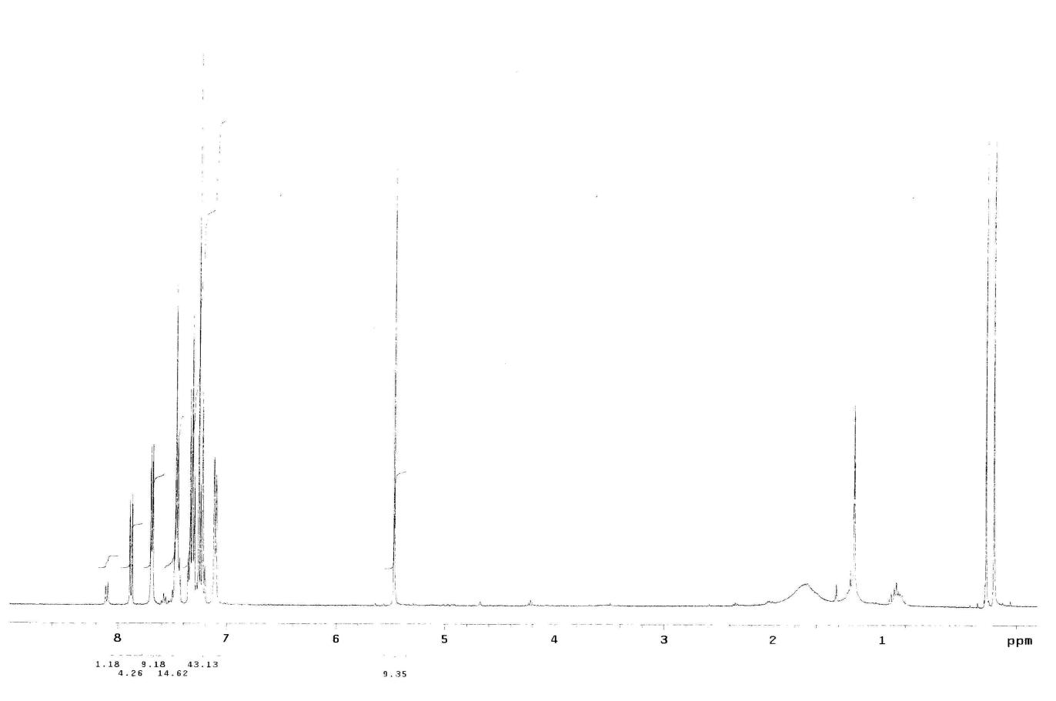
1-benzyl-2-phenyl-1H-benzo[d]imidazole (3a): White solid, m.p. 128–131 °C. ¹H NMR (300 MHz, CDCl₃, δ/ppm): 7.88 (d, J = 6.0 Hz, 1H, arom H), 7.69 (dd, J = 6.0 Hz, J = 1.5 Hz, 2H, arom H), 7.49-7.44 (m, 3H, arom H), 7.33-7.20 (m, 6H, arom H), 7.11 (d, J = 6.3 Hz, 2H, arom H), 5.46 (s, 2 H, -CH₂-); MS (ESI): [M+H]⁺ 284.90
Fig. S1.¹H NMR spectrum of 3a
Fig. S2.Mass spectrum of 3a

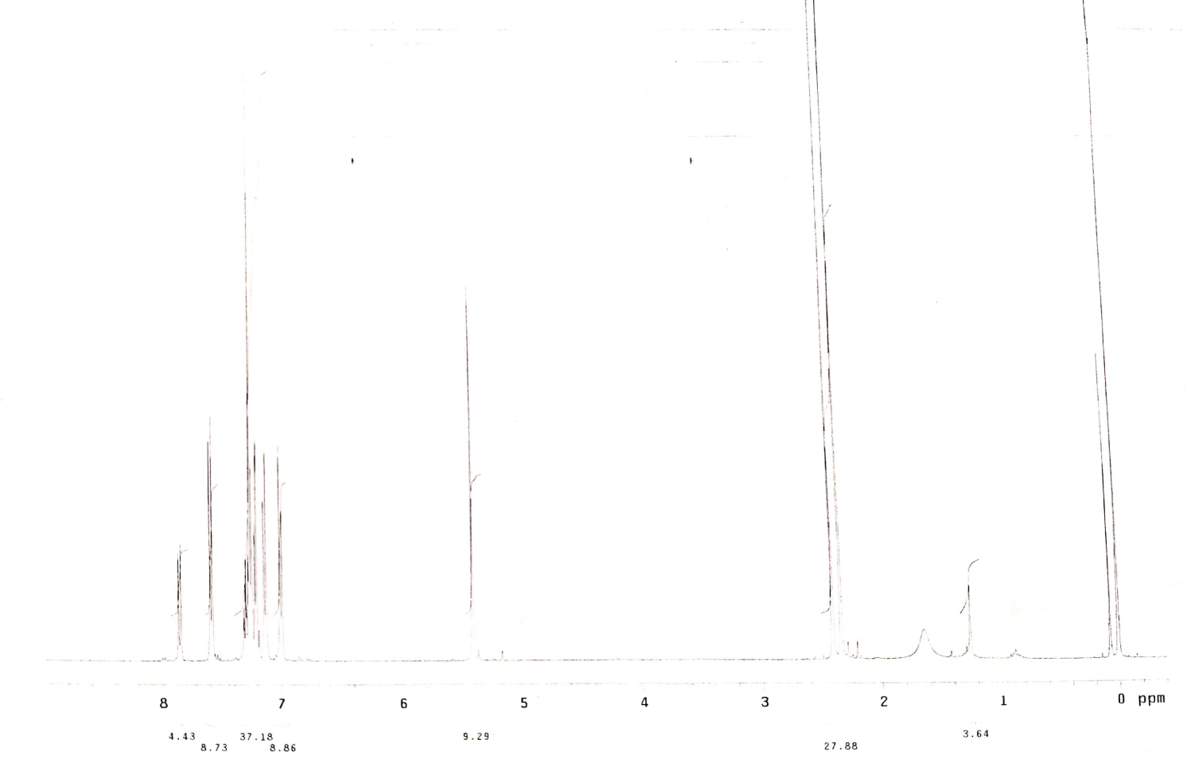
1-(4-methylbenzyl)-2-(p-tolyl)-1H-benzo[d]imidazole (3b): White solid, m.p. 127-128 °C. ¹H NMR (300 MHz, CDCl₃, δ/ppm): 7.85 (d, J = 6.0 Hz, 1H, arom H), 7.59 (d, J = 6.0 Hz, 2H, arom H), 7.31-7.18 (m, 5H, arom H), 7.13 (d, J = 6.0 Hz, 2H, arom H), 7.0 (d, J = 6.0 Hz, 2H, arom H), 5.41 (s, 2 H, -CH₂-), 2.65 (s, 3H, -CH₃), 2.40 (s, 3H, -CH₃); MS (ESI): [M+H]⁺ 313.00
Fig. S3.¹H NMR spectrum of 3b

Fig. S4.Mass spectrum of 3b

1-(4-(tert-butyl)benzyl)-2-(4-(tert-butyl)phenyl)-1H-benzo[d]imidazole (3c): White solid, m.p. 124-125 °C. ¹H NMR (300 MHz, CDCl₃, δ/ppm): 7.86 (d, J = 6.3 Hz, 1H, arom H), 7.66 (dd, J = 4.8 Hz, J = 1.2 Hz, 2H, arom H), 7.44(dd, J = 6.6 Hz, J = 1.5 Hz, 2H, arom H), 7.31-7.20 (m, 5H, arom H), 7.05 (d, J = 6.3 Hz, 2H, arom H), 5.45 (s, 2 H, -CH₂-), 1.34 (s, 9H, -C(CH₃)₃), 1.30 (s, 9H, -C(CH₃)₃); Anal. Calcd. For C₂₈H₃₂N₂: C, 84.80; H, 8.13; N, 7.06 Found: C, 84.82; H, 8.15; N, 7.09; MS (ESI): [M+H]⁺ 397.30
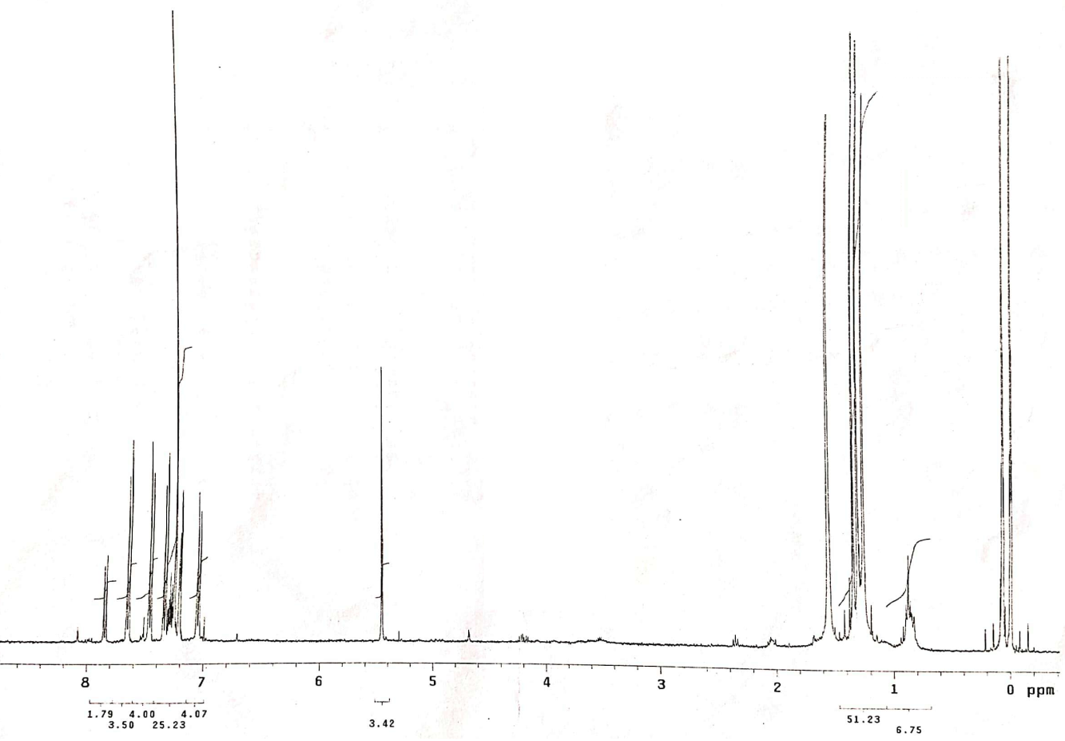

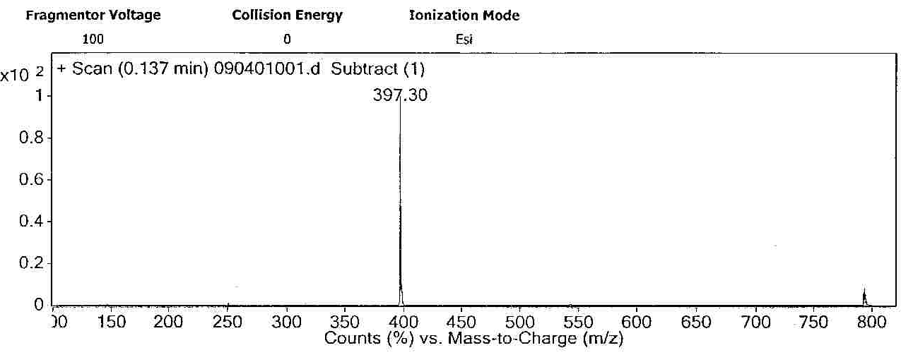
Fig. S5.¹H NMR spectrum of 3c

Fig. S6.Mass spectrum of 3c
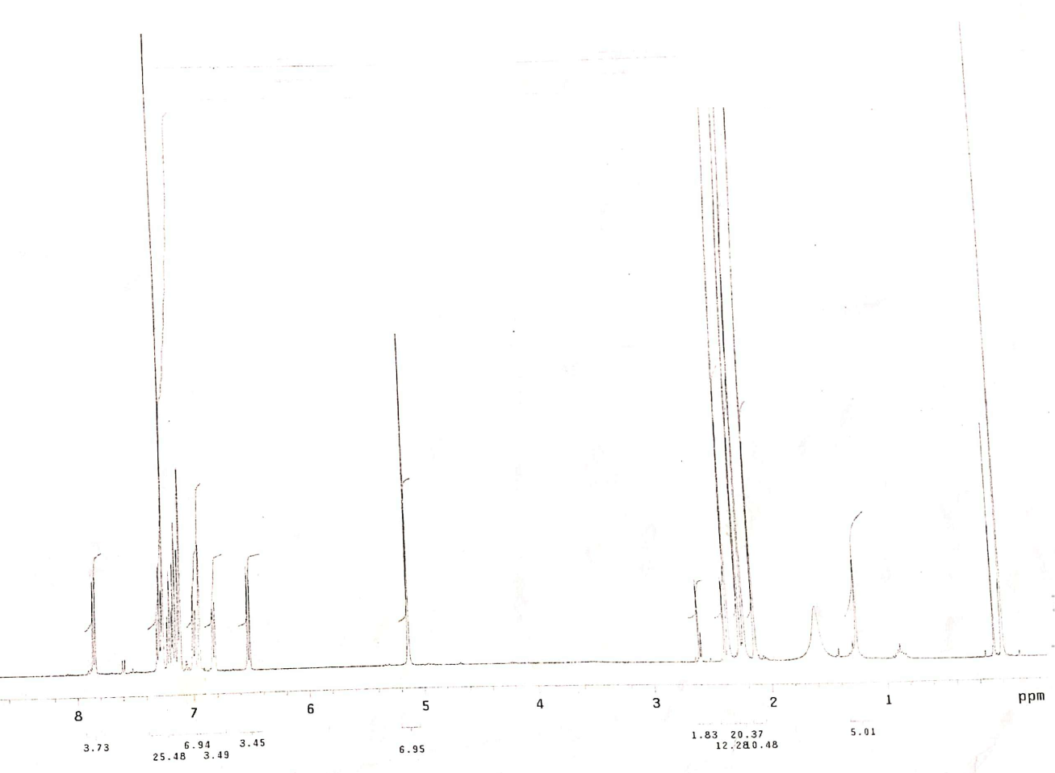
1-(2,4-dimethylbenzyl)-2-(2,4-dimethylphenyl)-1H-benzo[d]imidazole (3d): White solid, m.p. 120-122 °C. ¹H NMR (300 MHz, CDCl₃, δ/ppm): 7.85 (d, J = 6.3 Hz, 1H, arom H), 7.31-7.22 (m, 2H, arom H), 7.2-7.15 (m, 4H, arom H), 7.1-6.95 (m, 2H, arom H), 6.84 (d, J = 5.7 Hz, 1H, arom H), 6.52 (d, J = 5.7 Hz, 1H, arom H), 5.13 (s, 2 H, -CH₂-), 2.35 (s, 3H, -CH₃), 2.26(s, 3H, -CH₃) 2.22 (s, 3H, -CH₃), 2.13 (s, 3H, -CH₃); Anal. Calcd. For C₂₄H₂₄N₂: C, 84.67; H, 7.11; N, 8.23 Found: C, 84.68; H, 7.15; N, 8.21; MS (ESI): [M+H]⁺ 341.10
Fig. S7.¹H NMR spectrum of 3d

Fig. S8. Mass spectrum of 3d
1-(4-methoxybenzyl)-2-(4-methoxyphenyl)-1H-benzo[d]imidazole (3e): Brown solid, m.p. 157-159 °C. MS (ESI): [M+H]⁺ 345.10
Fig. S9. Mass spectrum of 3e

1-(3,4-dimethoxybenzyl)-2-(3,4-dimethoxyphenyl)-1H-benzo[d]imidazole (3f): Off white solid, m.p. 167-169 °C. MS (ESI): [M+H]⁺ 405.20
Fig. S9. Mass spectrum of 3f
2,2'-((1E,1'E)-(1,2-phenylenebis(azanylylidene))bis (methanylylidene))diphenol (Diimide) (3h): White solid, m.p. 247-248 °C. ¹H NMR (500 MHz, CDCl₃, δ/ppm): 13.09 (s, 2H,-OH), 8.66 (s, 2H, -NH), 7.42-7.36 (m, 6H, arom H), 7.27-7.25 (m, 2H, arom H), 7.07 (d, J = 8.5 Hz, 2H, arom H), 6.94 (td, J = 7.5 Hz, J = 1.0 Hz, 2H, arom H). ¹³C NMR (125 MHz, CDCl₃, δ/ppm): 164.52, 160.86, 142.75, 133.92, 132.94, 128.92, 120.24, 119.97, 119.57, 117.16. HRMS (ESI): Anal. Calcd. For C₂₀H₁₆N₂O₂: [M+H]⁺ 317.1290; Found : 317.1285.
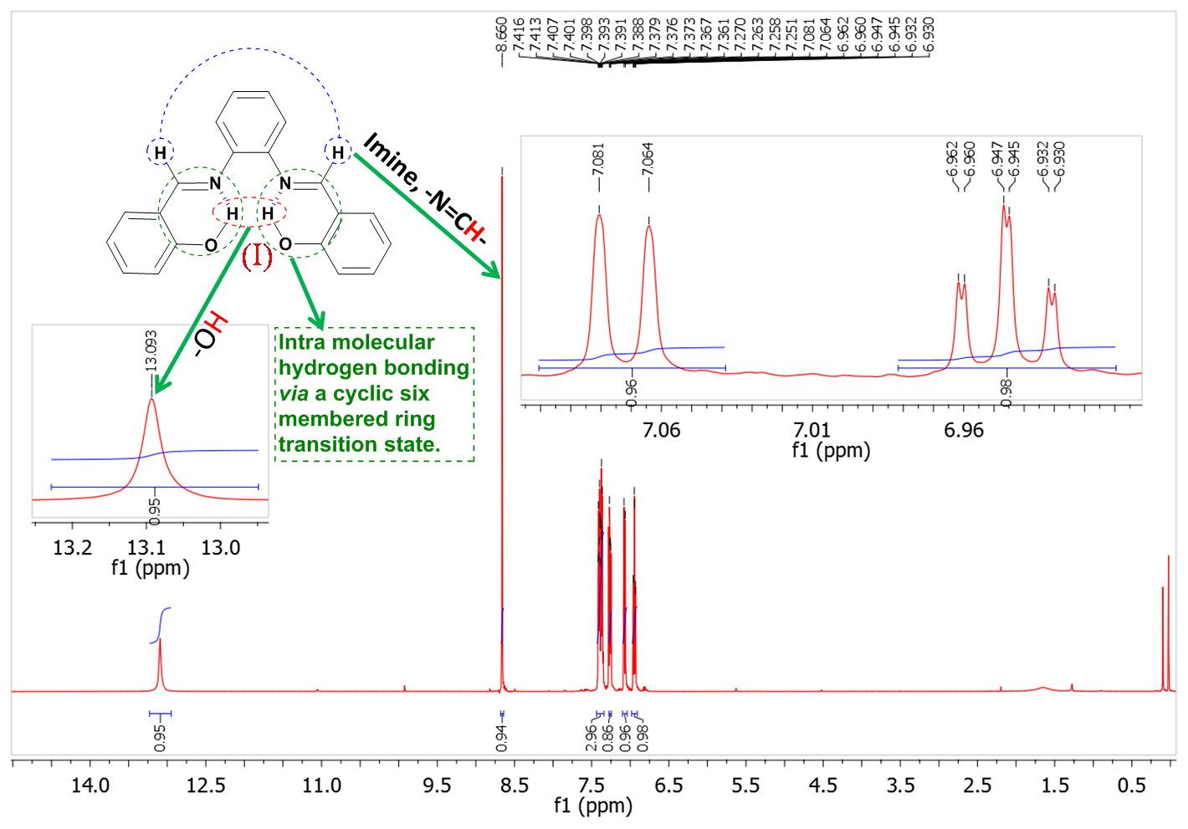
Fig. S10. ¹HNMR spectrum of 3h
Fig. S11. ¹³CNMR spectrum of 3h

Fig. S12. HRMS spectrum of 3h
6,6'-((1E,1'E)-(1,2-phenylenebis(azanylylidene))bis(methanylylidene))bis(2-ethoxyphenol) (3i): White solid, m.p. 235-237 °C. ¹H NMR (500 MHz, CDCl₃, δ/ppm): 13.52 (s, 2H,-OH), 8.66 (s, 2H, -NH), 7.12 (dd, J =7.5 Hz, J =1.0 Hz, 1H, arom H), 7.11 (dd, J =8.5 Hz, J =1.5 Hz, 1H, arom H), 7.10-7.08 (m, 1H, arom H), 7.06 (dd, J =7.0 Hz, J =1.5 Hz, 2H, arom H), 7.02 (dd, J =8.0 Hz, J =1.0 Hz, 2H, arom H), 6.91 (t, J=8.0 Hz, 2H, arom H), 6.81 (td, J=7.0 Hz, J=1. Hz, 3H, arom H), 4.17 (q, J=7.0 Hz, 4H, -2OCH₂), 1.53 (t, J=7.0 Hz, 6H, -2CH₃).
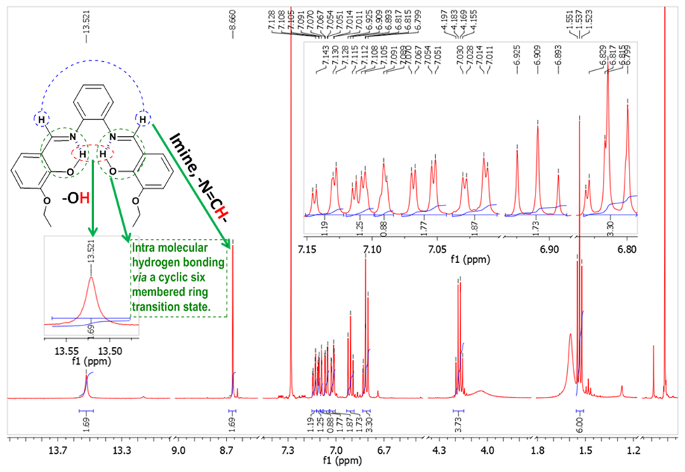

Fig. S13. ¹HNMR spectrum of 3i
4-(1-(4-hydroxy-3-methoxybenzyl)-1H-benzo[d]imidazol-2-yl)-2-methoxyphenol (3j): Light yellow solid, m.p. 181-183°C. MS (ESI): [M+H]⁺ 377.10
Fig. S14. Mass spectrum of 3j
2-ethoxy-4-(1-(3-ethoxy-4-hydroxybenzyl)-1H-benzo[d]imidazol-2-yl)phenol (3k): White solid, m.p. 228-230 °C. ¹H NMR (500 MHz, CDCl₃, δ/ppm): 9.77 (s, 1H,-OH), 7.79 (d, J =8.0 Hz, 1H, arom H), 7.27-7.20 (m, 3H, arom H), 7.12 (dd, J =8.0 Hz, J =2.0 Hz, 1H, arom H), 6.93 (d, J =8.0 Hz, 1H, arom H), 6.83 (d, J =8.0 Hz, 1H, arom H), 6.58 (dd, J =8.0 Hz, J =2.0 Hz, 1H, arom H), 6.54 (d, J =2.0 Hz, 1H, arom H), 6.33 (brs, 1H,-OH), 5.34 (s, 2H, -CH₂), 3.98 (q, J=7.0 Hz, 2H, -OCH₂), 3.91 (q, J=7.0 Hz, 2H, -OCH₂), 1.36 (t, J=7.0 Hz, 3H, -CH₃), 1.34 (t, J=7.0 Hz, 3H, -CH₃). HRMS (ESI) Anal. Calcd. For C₂₄H₂₄N₂O₄: [M+H]⁺ 405.1809, found: 405.1810.

Fig. S15. ¹HNMR spectrum of 3k

Fig. S16. HRMS spectrum of 3k

1-(4-nitrobenzyl)-2-(4-nitrophenyl)-1H-benzimidazole (3l): Yellow solid, m.p. 190-192 °C. MS (ESI): [M+H]⁺ 375.10
Fig. S17. Mass spectrum of 3l
1-(4-chlorobenzyl)-2-(4-chlorophenyl)-1H-benzimidazole (3n): Yellow solid, m.p. 138-140°C. ¹H NMR (300 MHz, CDCl₃, δ/ppm): 7.88 (d, J = 6.3 Hz, 1H, arom H), 7.60 (dd, J = 4.8 Hz, J = 1.5 Hz, 2H, arom H), 7.44(d, J = 6.0 Hz, 2H, arom H), 7.36-7.20 (m, 5H, arom H), 7.02 (d, J = 6.3 Hz, 2H, arom H), 5.40 (s, 2 H, -CH₂); MS (ESI): [M+H]⁺ 353.10
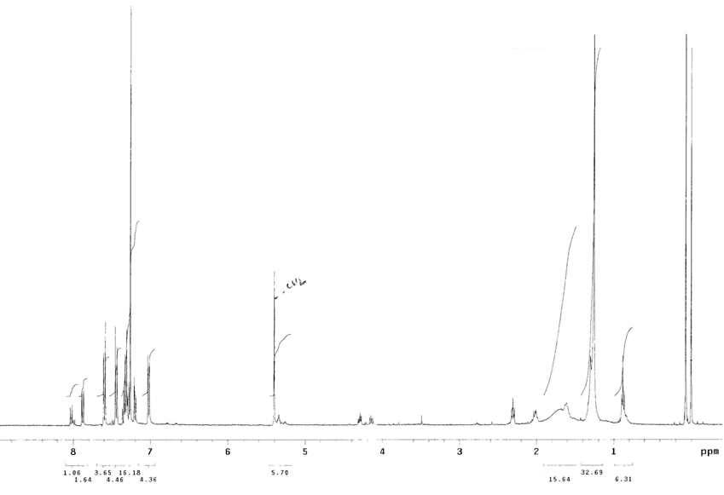
Fig. S18. ¹HNMR spectrum of 3n

Fig. S19. Mass spectrum of 3n

2-(thiophen-2-yl)-1-(thiophen-2-ylmethyl)-1H-benzo[d]imidazole (3q): White solid, m.p. 149-150°C; ¹H NMR (300 MHz, CDCl_{3,} δ/ppm): 7.83 (d, J = 6.6 Hz, 1H, arom H); 7.53 (d, J = 6.3, 1H, arom H), 7.47 (d, J = 6.0, 1H, arom H), 7.40(d, J = 6.6 Hz, 1H, arom H), 7.32-7.23 (m, 3H, arom H), 7.17 (d, J = 6.0 Hz, 1H), 6.90 (dd, J = 8.0 and 2.0 Hz, 1H, arom H), 6.87 (d, J = 6.2 Hz, 1H, arom H), 5.72 (s, 2H, -CH₂), MS (ESI): [M+H]⁺ 297.00

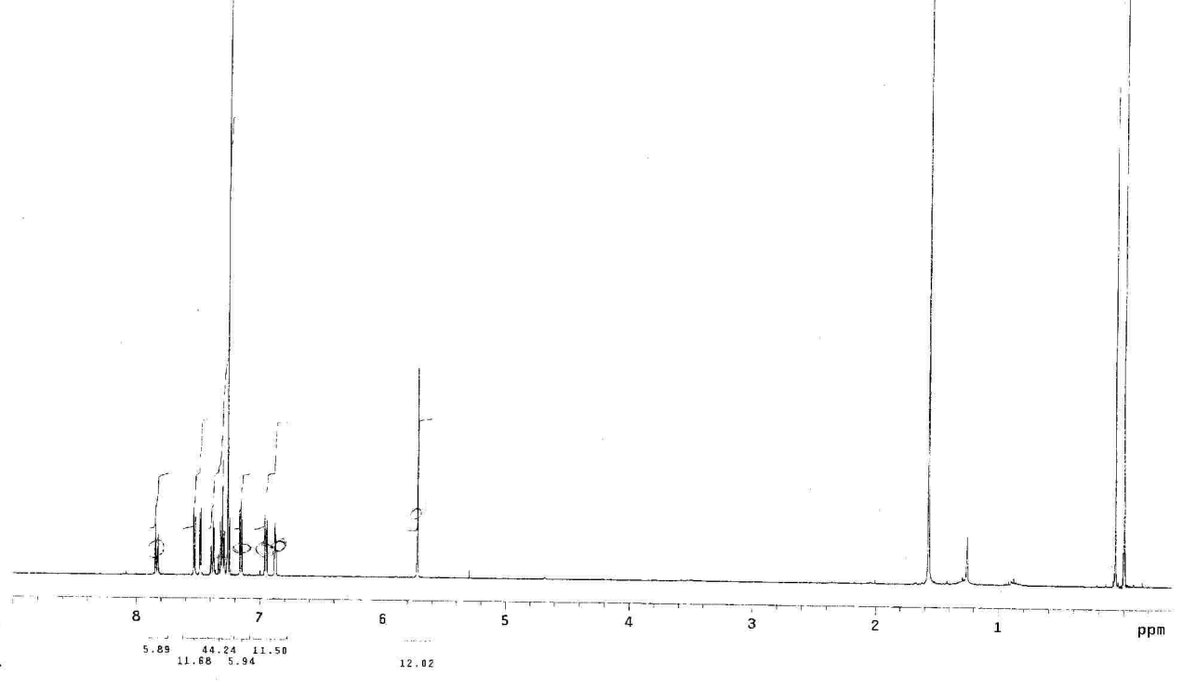

Fig.20. ¹HNMR spectrum of 3q
Fig. S21. Mass spectrum of 3q

Ethyl 6-methyl-2-oxo-4-phenyl-1,2,3,4-tetrahydropyrimidine-5-carboxylate (7a):
Off white solid, m.p. 207-209°C; ¹H NMR (400MHz, d₆-DMSO, δ/ppm): 9.19 (s, 1H, -NH), 7.75 (s, 1H, -NH), 7.34-7.31 (m, 2H, arom H), 7.26-7.23 (m, 3H, arom H), 5.15 (d, J = 3.2 Hz, 1H, -CH), 3.95 (q, J = 7.2 Hz, 2H, -CH₂), 2.25 (s, 3H, -CH₃), 1.09 (t, J = 7.2 Hz, 3H, -CH₃); ¹³C NMR (100 MHz, d₆-DMSO): 𝛿 165.83 (1C), 152.63 (1C), 148.81 (1C), 145.27 (1C), 128.87 (2C), 127.77 (1C), 126.70 (2C), 99.75 (1C), 59.70 (1C), 54.40 (1C), 18.22 (1C), 14.52 (1C); HRMS: Anal. Calcd. For C₁₄ H₁₇ O₃ N₂: 261.1234; Found: 261.1225.

Fig. S21. ¹H NMR spectrum of 7a
Fig. S22. Expanded ¹H NMR spectrum of 7a

Fig. S23. Expanded ¹H NMR spectrum of 7a
Fig. S24. ¹³C NMR spectrum of 7a
Fig. S25. DEPT-135 spectrum of 7a
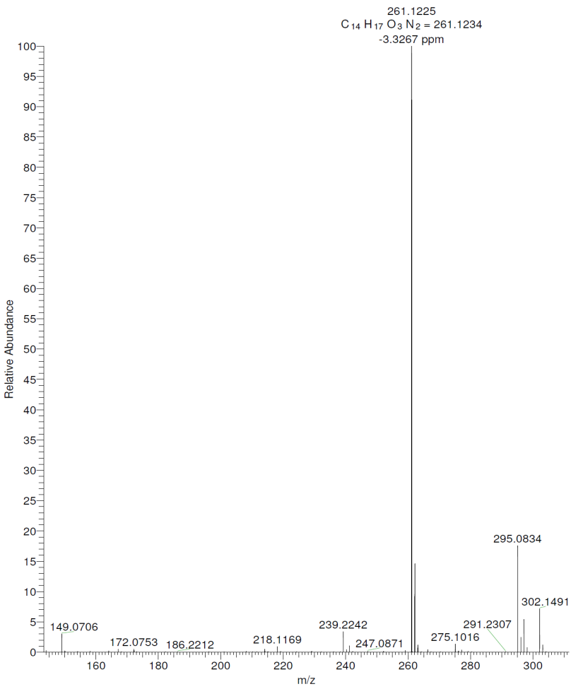
Fig. S26. HRMS spectrum of 7a

2-amino-4-(3, 4, 5-trimethoxyphenyl)-6-(pyridine-2-ylthio) pyridine-3,5-dicarbonitrile (10c):White solid, m.p. 267-269°C; ¹H NMR (500 MHz, DMSO-d_{6,} δ/ppm): 8.58 (ddd, J = 4.5 Hz, J = 1.5 Hz, J = 1.0 Hz, 1H, arom H), 7.96 (brs, 2H, -NH₂), 7.88 (td, J = 8.0 Hz, J = 2.0 Hz, 1H, arom H), 7.80 (d, J = 8.0 Hz, 1H, arom H), 7.45-7.42 (m, 1H, arom H), 6.95 (s, 2H, arom H), 3.83 (s, 6H, -2OCH₃), 3.76 (s, 3H, -OCH₃).
Fig. S27. ¹H NMR spectrum of 10c
Fig. S28. Expanded ¹H NMR spectrum of 10c
2-amino-4-(3-hydroxyphenyl)-6-(pyridine-2-ylthio) pyridine-3, 5-dicarbonitrile (10d): White solid; m.p. 223-224°C; ¹H NMR (500 MHz, DMSO-d_{6,} δ/ppm): 9.87 (s, 1H, -OH), 8.54 (s, 1H, arom H), 7.92 (br, 2H, -NH₂), 7.85-7.76 (m,2H, arom H), 7.40-7.32 (m, 2H, arom H), 6.94-6.87 (m, 3H, arom H).

Fig. S29. ¹H NMR spectrum of 10d

2-amino-4-(4-nitrophenyl)-6-(pyridine-2-ylthio) pyridine-3, 5-dicarbonitrile (10e): White solid; Yield= 85%; m.p. 241-243°C; ¹H NMR (500 MHz, DMSO-d_{6,} δ/ppm): 8.58 (d, J = 6.5 Hz, 1H, arom H), 8.44 (d, J = 8.5 Hz, 2H, arom H), 8.12 (brs, 2H, -NH₂), 7.89 (d, J = 8.5 Hz, 2H, arom H), 7.87 (d, J = 1.5 Hz, 1H, arom H), 7.81 (d, J = 8.0 Hz, 1H, arom H), 7.44 (dd, J = 7.5 Hz, J = 5.0 Hz, 1H, arom H).
Fig. S30. ¹H NMR spectrum of 10e
Fig. S31. Expanded ¹H NMR spectrum of 10e

2-amino-4-(3, 4-difluorophenyl)-6-(pyridine-2-ylthio) pyridine-3, 5-dicarbonitrile (10h): White solid; m.p. 252-253°C;¹H NMR (500 MHz, DMSO-d_{6,} δ/ppm): 8.58 (dd, J= 5.0 Hz, J= 1.0 Hz, 1H, arom H), 8.06 (br, 2H, -NH₂), 7.88 (td, J = 8.0 Hz, J=2.0 Hz, 1H, arom H), 7.83 (td, J = 7.5 Hz, J=2.0 Hz, 1H, arom H), 7.80 (d, J= 8.0 Hz, 1H, arom H), 7.70 (dt, J = 8.5 Hz, J=2.0 Hz,1H, arom H), 7.83 (ddd, J = 7.5 Hz, J = 5.0 Hz, J=1.0 Hz, 1H, arom H).
Fig. S32. ¹H NMR spectrum of 10h
Fig. S33. Expanded ¹H NMR spectrum of 10h

6-amino-4-(pyridin-2-ylthio)-[2,4'-bipyridine]-3,5-dicarbonitrile (10i): White solid; m.p. 230-231ºC; ¹H NMR (500 MHz, DMSO-d_{6,} δ/ppm): 8.82 (dd, J = 4.5 Hz, J = 2.0 Hz, 2H, arom H), 8.58 (ddd, J = 5.0 Hz, J = 2.0 Hz, J = 1.0 Hz, 1H, arom H), 8.1 (brs, 2H, -NH₂), 7.88 (td, J = 8.0 Hz, J = 2.0 Hz, 1H, arom H), 7.81 (d, J = 8.5 Hz, 1H, arom H), 7.61 (dd, J = 4.5 Hz, J = 2.0 Hz, 2H, arom H), 7.44 (ddd, J = 7.0 Hz, J = 4.5 Hz, J = 1.0 Hz, 1H, arom H).
Fig. S34. ¹H NMR spectrum of 10i

Fig. S35. Expanded ¹H NMR spectrum of 10i

