Supporting Information for:
Two-step continuous-flow synthesis of α-terpineol
Beatriz L. C. de Carvalho,ª Anderson R. Aguillon ,ª Raquel A. C. Leão,^{a,b} Rodrigo O. M. A. de Souza.ª
a – Biocatalysis and Organic Synthesis Group, Chemistry Institute, Federal University of Rio de Janeiro, 21941909, Brazil;
b – Pharmacy Faculty, Federal University of Rio de Janeiro, Av. Carlos Chagas Filho, 373, Rio de Janeiro, RJ, 21941-170, Brazil.
Keywords: Continuous-flow, α-terpineol, cascade reactions.
CONTENTS
1. STUDY OF OPTIMIZATION IN BATCH REACTORS S2
2.1 Study of the batch reaction optimization for de α-terpineol synthesis starting from α-pinene S2
2.2 Study of the batch reaction optimization for de α-terpineol synthesis starting from limonene S3
2. STUDY OF OPTIMIZATION IN CONTINUOUS FLOW REACTORS S4
2.3 Study of the first step flow reaction optimization for de α-terpineol synthesis starting from limonene S4
3. CHROMATOGRAFIC ANALYSIS S5
3.1 Chromatogram from α-terpineol synthesis starting from α-pinene S5
3.2 Chromatogram from α-terpineol flow synthesis starting from α-pinene S5
3.3 Chromatogram from ‘batch’ cascade reaction for the synthesis of α-terpineol from limonene S6
3.4 Chromatogram from cascade reaction in continuous flow system for the synthesis of α-terpineol from limonene S6
4. ESPECTRAL DATA S7
4.1 ¹H-NMR spectra: α-terpineol (CDCl₃) S7
4.2 ¹³C-NMR spectra: α-terpineol (CDCl₃) S8

STUDY OF OPTIMIZATION IN BATCH REACTORS

2.1 Study of the batch reaction optimization for de α-terpineol synthesis starting from α-pinene

The process studied using α-pinene was reproduced according to Román-Aguirre et al.¹ The synthesis was performed using α-pinene (73 mmol), chloroacetic acid in water (23 mol/ L), at 70 ºC for 4 h, in this reaction the acid acts as catalyst for the hydration of α-pinene using water as hydroxyl donor. This procedure resulted conversion values of 90 % and selectivity of 58 %. Looking forward to the synthesis optimization we tested the reaction conditions such as acid concentration (influencing directly in the molar ratio between substrate and acid), reaction temperature and reaction time, study described in the table S1. All the measurements were taken every 30 min, all conversion and selectivity values were determined by GC/MS considering the substrate, α-pinene, consumption. Values were measured in triplicate; the medium value is reported, as well as the standard deviation (SD).
The best condition was found, using α-pinene (10 mmol), chloroacetic acid in water (27 mol/ L) at 70 ºC for 3 h, with a conversion value of 84 % and selectivity of 67 %. From the batch reaction studies we learned that: the reaction showed sensibility to temperature, we could reduce in one hour the reaction time described by Roman-Aguirre et al,¹ and the best molar ratio between the substrate and the acid was 1:1. The best batch conditions were adapted to continuous flow systems.

Table S1: α-pinene hydration batch reaction with chloroacetic acid aqueous solution.
Entry | Acid Conc. (M) | Molar ratio  (substrate:acid) | T (ºC) | Time (h) | Conv. (%) | Seletv. (%)
1 | 27 | 1:1 | 70 | 3 | 84 | 67
2 | 9 | 2:1 | 70 | 4 | 27 | 27
3 | 27 | 1:1 | 100 | 1 | 86 | 55
4 | 9 | 2:1 | 100 | 1 | 57 | 61
5 | 27 | 1:1 | rt | 4 | N.R | N.R
* N.R it was not register any change on the variable.

2.2 Study of the batch reaction optimization for de α-terpineol synthesis starting from limonene

Table S2: Study of the reaction time starting from limonene using cyclohexane, to obtain the ester intermediate.
Entry | Time (min) | Conv. (%) | Select. (%)
1 | 30 | 88 | 87
2 | 60 | 90 | 89
3 | 90 | 92 | 91
4 | 120 | 92 | 92
Reaction using limonene 10 mmol and CF₃CO₂H 10 mmol (1:1), cyclohexane, at room temperature. All conversion and selectivity values were determined by a GC/MS considering the substrate, limonene, consumption.

Table S3: Study of the reaction time for the first step solvent-free reaction using (1:1) limonene/ trifluoroacetic acid.
Entry | Time (min) | Conv. (%) | Select. (%)
1 | 5 | 93 | 89
2 | 10 | 83 | 96
3 | 15 | 78 | 96
4 | 20 | 90 | 92
5 | 25 | 92 | 91
Reaction using limonene (5) 10 mmol and CF₃CO₂H 10 mmol (1:1), solvent-free, at room temperature. All conversion and selectivity values were determined by a GC/ MS considering the substrate, limonene (5), consumption.

STUDY OF OPTIMIZATION IN CONTINUOUS FLOW REACTORS

2.3 Study of the first step flow reaction optimization for de α-terpineol synthesis starting from limonene

Table S4: Experimental results of the continuous flow optimization for the first step reaction using limonene as starting material.
Entry | Res. Time (min) | Conv. (%) ± SD | Seletv. (%) ± SD
1 | 10 | 71 ± 2.36 | 97 ± 0.47
2 | 5 | 70 ± 1.25 | 95 ± 0.94
3 | 2.5 | 68 ± 4.55 | 94 ± 0.47
4 | 1 | 73 ± 0.47 | 93 ± 0.82
All conversion and selectivity values were determined by a GC/ MS considering the substrate, limonene (5), consumption. Values were measured in triplicate; the medium value is reported, as well as the standard deviation (SD).

CHROMATOGRAFIC ANALYSIS

3.1 Chromatogram from α-terpineol synthesis starting from α-pinene
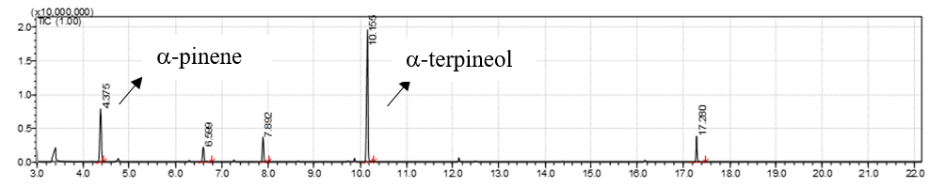
Figure S1: GC-MS Chromatogram from the batch reaction of the α-pinene hydration reaction using chloroacetic acid to obtain α-terpineol. Conditions: α-pinene (10 mmol), aqueous solution of chloroacetic acid (27 M), at 70 ºC, for 2 h.

3.2 Chromatogram from α-terpineol flow synthesis starting from α-pinene
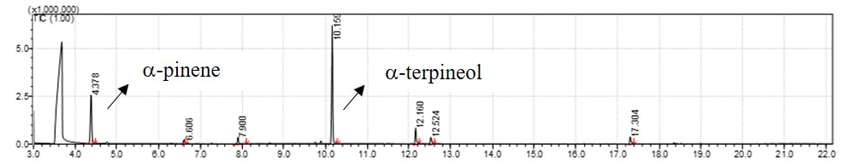
Figure S2: GC-MS Chromatogram from the continuous flow reaction between α-pinene and an aqueous solution of chloroacetic acid for the obtainment of α-terpineol. Conditions: α-pinene (0.34 mL/min), aqueous solution of chloroacetic acid (27M, 0.23 mL/min), 80 ºC, 30 min.

3.3 Chromatogram from ‘batch’ cascade reaction for the synthesis of α-terpineol from limonene
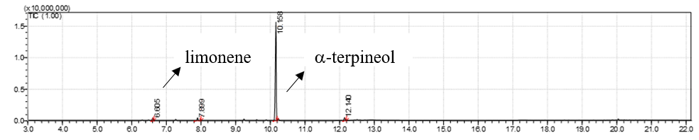
Figure S3: GC-MS Chromatogram from batch cascade reaction using limonene as starting material. Conditions: limonene (10 mmol), TFA (10 mmol), stir for 10 min, add methanolic solution of NaOH (4.5 mol/L), rt., 160 min.

3.4 Chromatogram from cascade reaction in continuous flow system for the synthesis of α-terpineol from limonene
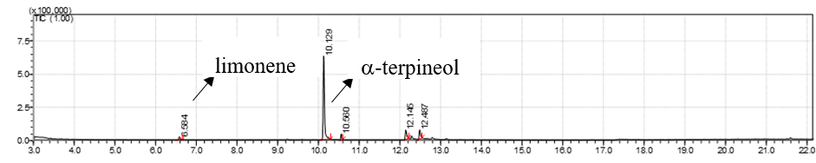
Figure S4: GC-MS Chromatogram from continuous flow cascade reaction using limonene as starting material. Conditions: limonene (0.14 mL/min), TFA (0.06 mL/min), methanolic solution of NaOH (2.25 M, 0.86 mL/min), rt total, residence time of 40 min.

ESPECTRAL DATA

4.1 ¹H-NMR spectra: α-terpineol (CDCl₃)
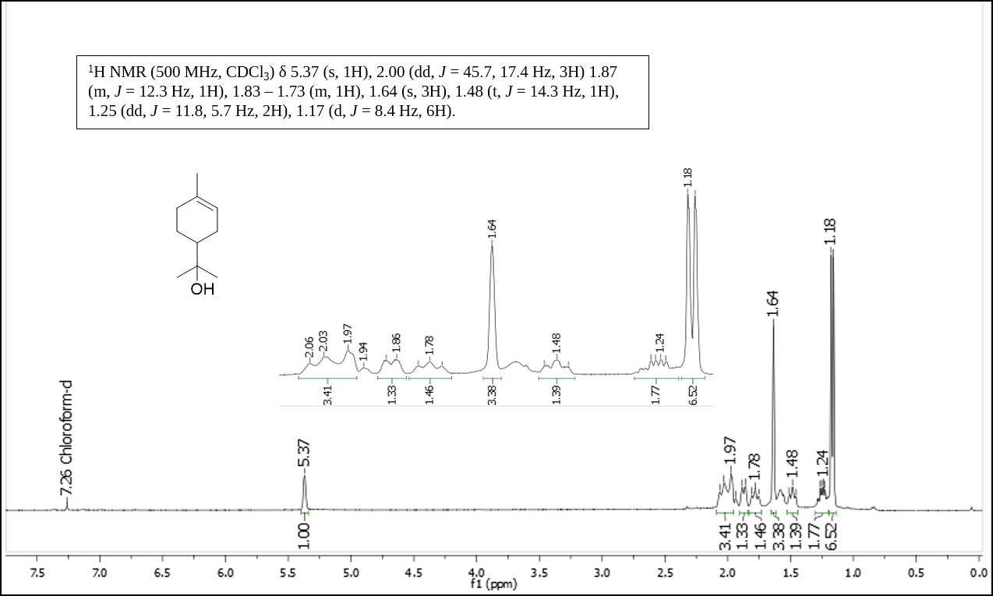
Figure S5: ¹H-NMR spectra from α-terpineol purified by column chromatography (ethyl acetate/ hexane 20%).

4.2 ¹³C-NMR spectra: α-terpineol (CDCl₃)
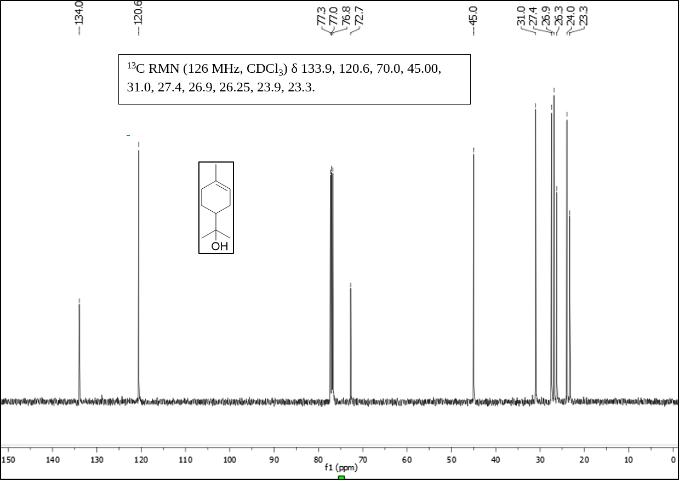
Figure S6: ¹³C-NMR spectra from α-terpineol purified by column chromatography (ethyl acetate/hexane 20%).

REFERENCES
1. Román-Aguirre, M., De La Torre-Sáenz, L., Flores, W. A., Robau-Sánchez, A. & Elguézabal, A. A. Synthesis of terpineol from α-pinene by homogeneous acid catalysis. Catal. Today 107–108, 310–314 (2005).

