Supporting Information

Facile Synthesis of Tetrahydronaphthyridines as Arginine Mimetics Using a Horner–Wadsworth–Emmons Based Approach
Rhys A. Lippa, John A. Murphy and Tim N. Barrett
Table of contents

Experimental 1
General procedures 1
Compound Synthesis and Characterisation 3
¹H and ¹³C NMR Spectra of Compounds 21
Chiral HPLC Trace of Compound 23 and (R)-23 35

Experimental

General procedures

Starting materials and all solvents were of analytical grade purchased from commercial sources. Solvents were purchased in anhydrous form unless stated otherwise. Reactions were stirred magnetically. Air- and moisture- sensitive reactions were performed using standard Schlenk manifold techniques. Reagents were used as supplied unless otherwise stated.
Melting points were recorded using a BUCHI Melting Point M-565.
Infrared spectra were recorded using a Perkin Elmer FTIR Spectrometer as neat or film in the range 4000–600 cm⁻¹.
Nuclear magnetic resonance spectra were recorded in the solvent stated on Bruker DPX-400/600/700 spectrometers. Spectra were referenced to the residual solvent peak. Chemical shifts (δ) are quoted in parts per million (ppm) to the nearest 0.01 ppm for ¹H and NMR spectroscopy and 0.1 ppm for ¹³C and ³¹P NMR spectroscopy. Coupling constants (J) are quoted in Hertz (Hz) to the nearest 0.1 Hz. 2D NMR spectra were obtained to confirm structures where necessary. Multiplicity is quoted as follows: s (singlet), d (doublet), t (triplet), q (quartet), quin. (quintet), m (multiplet).
Liquid chromatography mass spectra (LC-MS) were recorded using the following methods:
LC conditions:
The UPLC analysis was conducted on an Acquity UPLC CSH C18 column (50 mm
x 2.1 mm i.d. 1.7 μm packing diameter) at 40 °C.
HpH:
2 min HpH:
The solvents employed were: A = 10 mM ammonium bicarbonate in water adjusted
to pH 10 with ammonia solution, B = Acetonitrile.
The gradient employed was:
Time (min) | Flow rate (mL/min) | % A | % B
0.00 | 1 | 97 | 3
0.05 | 1 | 97 | 3
1.50 | 1 | 5 | 95
1.90 | 1 | 5 | 95
2.00 | 1 | 97 | 3

For:
2 min For:
The solvents employed were: A = 0.1% v/v solution of formic acid in water adjusted, B = 0.1% v/v solution of formic acid in acetonitrile.
The gradient employed was:
Time (min) | Flow rate (mL/min) | % A | % B
0.00 | 1 | 97 | 3
0.05 | 1 | 97 | 3
1.50 | 1 | 5 | 95
1.90 | 1 | 5 | 95
2.00 | 1 | 97 | 3

High resolution mass spectra (HRMS) were recorded using an Acquity UPLC CSH C18 column (LC) and Waters XEVO G2-XS QTof (ES+) (MS)

Compound Synthesis and Characterisation

tert-Butyl 2-(8-(diethoxyphosphoryl)-5,6,7,8-tetrahydro-1,8-naphthyridin-2-yl)acetate 9
To a stirred solution of tert-butyl 7-methyl-3,4-dihydro-1,8-naphthyridine-1(2H)-carboxylate 8 (267 mg, 1.0 mmol) in THF (4 mL) under nitrogen at −42 °C, was added sec-BuLi (1.15 M in cyclohexane) (2.6 mL, 2.99 mmol). The reaction was stirred for 20 min and then diethyl chlorophosphate (0.16 mL, 1.107 mmol) was added and the reaction was stirred for 10 min. After this time, the reaction was quenched with sat. NH₄Cl (10 mL). The phases were separated and the aqueous phase was extracted with ethyl acetate (2 x 10 mL). The combined organics were passed through a hydrophobic frit and concentrated in vacuo. The residue was dissolved in a minimum volume of DMSO and purified by HPLC using Mass Directed AutoPrep (Xselect C18 column eluting with 30–70% acetonitrile in water with 10 mM ammonium bicarbonate modifer) to afford the title comound (55 mg, 0.143 mmol, 14% yield) as a colourless gum.
¹H NMR (400 MHz, CDCl₃) δ = 7.28–7.25 (m, 1H), 6.78 (d, J = 7.3 Hz, 1H), 4.27–4.06 (m, 4H), 3.85–3.79 (m, 2H), 3.58 (s, 2H), 2.74 (t, J = 6.4 Hz, 2H), 1.96–1.88 (m, 2H), 1.44 (s, 9H), 1.28 (td, J = 7.1, 1.0 Hz, 6H); ¹³C NMR (176 MHz, CDCl₃) δ = 170.2, 152.0 (d, J = 1.9 Hz), 150.6, 137.7 (d, J = 1.3 Hz), 117.9 (d, J = 7.6 Hz), 116.6, 80.8, 63.3 (d, J = 5.7 Hz), 46.0 (d, J = 2.5 Hz), 44.5, 28.0, 26.8, 22.3 (d, J = 4.5 Hz), 16.1 (d, J = 7.0 Hz); IR (neat): 2937, 2867, 1680, 1629 cm⁻¹; LC-MS (For): 1.07 min (385) ([M+H]⁺, 96%); HRMS: calculated for C₁₈H₃₀N₂O₅P⁺ ([M+H]⁺) 385.1887 found 385.1888.
Diethyl (7-methyl-3,4-dihydro-1,8-naphthyridin-1(2H)-yl)phosphonate 13
To a stirred solution of 7-methyl-1,2,3,4-tetrahydro-1,8-naphthyridine 11 (1.46 g, 9.85 mmol) in THF (35 mL) at rt was added diethyl chlorophosphate (1.70 mL, 11.76 mmol). Isopropylmagnesium chloride (1.42 M in THF) (10.4 mL, 14.77 mmol) was added dropwise over 5 min. After 5 min, the reaction was quenched slowly with sat. NH₄Cl (45 mL). The phases were separated and the aqueous phase was extracted with ethyl acetate (2 x 40 mL). The combined organics were washed with brine (100 mL), passed through a hydrophobic frit and concentrated in vacuo. The residue was purified using automated flash chromatography on silica (0–40% 3:1 EtOAc/EtOH in cyclohexane) to afford the title comound (2.63 g, 9.25 mmol, 94% yield) as a pale-yellow oil.
¹H NMR (400 MHz, CDCl₃) δ = 7.16 (d, J = 7.5 Hz, 1H), 6.61 (d, J = 7.5 Hz, 1H), 4.28–4.07 (m, 4H), 3.81–3.74 (m, 2H), 2.69 (t, J = 6.4 Hz, 2H), 2.36 (s, 3H), 1.93–1.85 (m, 2H), 1.27 (td, J = 7.1, 0.8 Hz, 6H); ¹³C NMR (101 MHz, CDCl₃) δ = 154.0, 151.8 (d, J = 2.2 Hz), 137.4, 116.3 (d, J = 7.3 Hz), 115.95, 63.20 (d, J = 6.6 Hz), 45.9 (d, J = 2.2 Hz), 26.6, 23.6, 22.4 (d, J = 4.4 Hz), 16.0 (d, J = 7.3 Hz); ³¹P{¹H} NMR (162 MHz, CDCl₃) δ = 3.0; IR (neat): 3472, 2930, 2981, 2864, 1600, 1577 cm^{–1}; LC-MS (For): 0.63 min (285) ([M+H]⁺, 100%); HRMS: calculated for C₁₃H₂₂N₂O₃P⁺ ([M+H]⁺) 285.1363, found 285.1367.
Diethyl (7-((diethoxyphosphoryl)methyl)-3,4-dihydro-1,8-naphthyridin-1(2H)-yl)phosphonate 7
To a stirred solution of diethyl (7-methyl-3,4-dihydro-1,8-naphthyridin-1(2H)-yl)phosphonate 13 (4.74 g, 15.51 mmol) in THF (62 mL) under nitrogen at −42 °C, was added sec-BuLi (1.4 M in cyclohexane) (33 mL, 46.2 mmol). The reaction was stirred for 20 min and then diethyl chlorophosphate (2.4 mL, 16.61 mmol) was added and the reaction was stirred for 20 min. After this time, the reaction was quenched with sat. NH₄Cl (80 mL). The phases were separated and the aqueous phase was extracted with ethyl acetate (3 x 70 mL). The combined organics were passed through a hydrophobic frit and concentrated in vacuo. The residue was dissolved in a minimum volume of DMSO and purified by automated reverse-phase flash chromatography on C18 modified silica (0–60% acetonitrile in 10 mM ammonium bicarbonate solution) to afford the title compound (4.45 g, 10.59 mmol, 68% yield) as a yellow oil.
¹H NMR (400 MHz, CDCl₃) δ = 7.26 (d, J = 7.7 Hz, 1H), 6.93 (dd, J = 7.7, 2.4 Hz, 1H), 4.27–4.02 (m, 8H), 3.85–3.76 (m, 2H), 3.26 (d, J = 22.0 Hz, 2H), 2.80–2.69 (m, 2H), 1.92 (quin, J = 5.7 Hz, 2H), 1.33–1.24 (m, 12H); ¹³C NMR (101 MHz, CDCl₃) δ = 152.3–152.1 (m), 148.0 (d, J = 7.3 Hz), 137.8 (dd, J = 2.9, 1.5 Hz), 118.0 (dd, J = 7.3, 3.7 Hz), 117.1 (d, J = 4.4 Hz), 63.2 (d, J = 5.9 Hz), 62.0 (d, J = 6.6 Hz), 46.0 (d, J = 2.2 Hz), 35.8 (d, J = 135.7 Hz), 26.7 (s), 22.3 (d, J = 5.1 Hz), 16.3 (d, J = 5.9 Hz), 16.1 (d, J = 7.3 Hz); ³¹P{¹H} NMR (162 MHz, CDCl₃) δ = 25.7, 3.0; IR (neat): 3472, 2981, 2932, 1576 cm^{–1}; LC-MS (HpH): 0.90 min (421) ([M+H]⁺, 99%); HRMS: calculated for C₁₇H₃₁O₆P₂⁺ ([M+H]⁺) 421.1652, found 421.1667.
Benzyl (R)-3-(2-(8-(diethoxyphosphoryl)-5,6,7,8-tetrahydro-1,8-naphthyridin-2-yl)vinyl)-3-fluoropyrrolidine-1-carboxylate 15
A stirred solution of benzyl (S)-3-fluoro-3-(hydroxymethyl)pyrrolidine-1-carboxylate 14 (760 mg, 3 mmol), T3P® (50% w/w in DCM) (5.73 g, 9.00 mmol) and DMSO (0.64 mL, 9.02 mmol) in DCM (10 mL) was cooled to 0 °C and DIPEA (1.310 mL, 7.50 mmol) was added dropwise over ca. 2 min. The reaction was stirred at 0 °C for 1 h and then was washed with water (2 x 10 mL). The combined aqueous layers were back-extracted with DCM (15 mL) and the combined organics were passed through a hydrophobic frit and concentrated in vacuo.
To the residue was added a solution of diethyl ((8-(diethoxyphosphoryl)-5,6,7,8-tetrahydro-1,8-naphthyridin-2-yl)methyl)phosphonate 7 (509 mg, 1.211 mmol) in THF (10 mL) and the solution was cooled to 0 °C. potassium tert-butoxide (1 M in THF) (7.2 mL, 7.2 mmol) was added in equal portions over 70 min until LC-MS showed complete reaction had taken place and the reaction was quenched with sat. NH₄Cl (15 mL). The phases were separated and the aqueous layer was extracted using ethyl acetate (2 x 15 mL). The combined organics were dried using MgSO₄, filtered and concentrated under a stream of nitrogen. The residue was purified by automated flash chromatography on silica (0–40% 3:1 EtOAc/EtOH in cyclohexane) to afford the title comppound as a 94:5 mix of geometric isomers (by LCMS), combined 584 mg (1.128 mol, 93% yield) as a yellow oil.
¹H NMR (700 MHz, CDCl₃) δ = 7.41–7.28 (m, 6H), 6.95–6.84 (m, 1H), 6.73 (dd, J = 7.2, 4.7 Hz, 1H), 6.68 (t, J = 15.0 Hz, 1H), 5.22–5.10 (m, 2H), 4.25–4.15 (m, 2H), 4.13–4.03 (m, 2H), 3.88–3.71 (m, 4H), 3.70–3.61 (m, 1H), 3.60–3.50 (m, 1H), 2.77 (t, J = 6.4 Hz, 2H), 2.26 (td, J = 14.6, 6.4 Hz, 1H), 2.20–2.06 (m, 1H), 1.98–1.92 (m, 2H), 1.30–1.24 (m, 6H); ¹³C NMR (176 MHz, CDCl₃) δ = 154.7 (d, J = 22.3 Hz), 152.0, 149.8, 137.8, 136.7 (d, J = 8.3 Hz), 129.9 (dd, J = 14.6, 10.2 Hz), 129.4 (d, J = 21.0 Hz), 128.4, 128.0, 127.9 (d, J = 9.5 Hz), 119.7 (d, J = 7.6 Hz), 116.2 (d, J = 9.5 Hz), 100.9 (dd, J = 179.9, 147.5 Hz), 66.9 (d, J = 3.2 Hz), 62.9 (d, J = 5.7 Hz), 56.3 (dd, J = 54.0, 25.4 Hz), 45.9 (d, J = 2.5 Hz), 44.8 (d, J = 61.0 Hz), 37.1 (dd, J = 131.6, 24.2 Hz), 27.0, 22.3 (d, J = 4.5 Hz), 16.2 (d, J = 7.0 Hz); IR (neat): 1704, 1591, 1570 cm⁻¹; LC-MS: minor: 1.23 min (518) ([M+H]⁺, 5%); major: 1.27 min (518) ([M+H]^{+,} 94%); HRMS: calculated for C₂₆H₃₄N₃O₅P⁺ ([M+H]⁺) 518.2215, found 518.2224.
*${\left[α\right]}_{D}^{20}$ not recorded as two components present
Benzyl (S)-3-(2-(8-(diethoxyphosphoryl)-5,6,7,8-tetrahydro-1,8-naphthyridin-2-yl)ethyl)-3-fluoropyrrolidine-1-carboxylate 16
A stirred suspension of benzyl (R)-3-(2-(8-(diethoxyphosphoryl)-5,6,7,8-tetrahydro-1,8-naphthyridin-2-yl)vinyl)-3-fluoropyrrolidine-1-carboxylate 15 (522 mg, 1.009 mmol) and potassium carbonate (558 mg, 4.03 mmol) in DMF (10 mL) was heated to 100 °C and to this, was added benzenesulfonyl hydrazide (521 mg, 3.03 mmol) portionwise over 4 min. The reaction was stirred for 30 min and then was cooled to rt and partitioned between DCM (20 mL) and sat. LiCl (20 mL). The phases were separated and the aqueous phase was further extracted with DCM (2 x 20 mL). The combined organics were passed through a hydrophobic frit and co-evaporated with toluene (10 mL). The residue was purified by automated flash chromatography on silica (0–40% 3:1 EtOAc/EtOH in cyclohexane) to afford the title compound (421 mg, 0.810 mmol, 80% yield) as a pale yellow oil.
${\left[α\right]}_{D}^{20}$ (c = 16.7 mg/mL, MeOH): −11; ¹H NMR (400 MHz, CDCl₃) δ = 7.38–7.28 (m, 5H), 7.22 (d, J = 7.3 Hz, 1H), 6.66 (dd, J = 7.3, 1.5 Hz, 1H), 5.18–5.09 (m, 2H), 4.25–4.03 (m, 4H), 3.88–3.50 (m, 5H), 3.46–3.29 (m, 1H), 2.87–2.68 (m, 4H), 2.34–2.12 (m, 3H), 2.00–1.80 (m, 3H), 1.31–1.24 (m, 6H); ¹³C NMR (101 MHz, CDCl₃) δ = 156.2, 154.7 (d, J = 11.7 Hz), 152.0 (d, J = 2.2 Hz), 137.7 (br s), 136.8 (d, J = 5.1 Hz), 128.4, 127.9 (d, J = 2.2 Hz), 127.9 (d, J = 5.9 Hz), 117.2 (d, J = 7.3 Hz), 115.6, 102.5 (dd, J = 176.8, 90.2 Hz), 66.8, 62.9 (d, J = 5.9 Hz), 55.8 (dd, J = 30.1, 24.9 Hz), 45.9 (d, J = 2.2 Hz), 44.6 (d, J = 33.0 Hz), 35.8 (dd, J = 76.3, 23.5 Hz), 35.0 (d, J = 22.7 Hz), 31.8 (d, J = 2.9 Hz), 26.7, 22.4 (d, J = 5.1 Hz), 16.2 (d, J = 7.3 Hz); IR (neat): 1702, 1599, 1577 cm⁻¹; LC-MS (HpH): 1.24 min (520) ([M+H]⁺, 97%); HRMS: calculated for C₂₆H₃₆FN₃O₅P⁺ ([M+H]⁺) 520.2371, found 520.2392.
(S)-7-(2-(3-Fluoropyrrolidin-3-yl)ethyl)-1,2,3,4-tetrahydro-1,8-naphthyridine 6
A stirred solution of benzyl (S)-3-(2-(8-(diethoxyphosphoryl)-5,6,7,8-tetrahydro-1,8-naphthyridin-2-yl)ethyl)-3-fluoropyrrolidine-1-carboxylate 16 (387 mg, 0.745 mmol) in 7.4 M HCl (8 mL, 59.2 mmol) and was heated at 100 °C for 1.5 h. After this time, the reaction was allowed to cool to rt, diluted with water (20 mL) and washed with DCM (2 x 20 mL). The aqeuos phase was adjusted to pH 14 using 2 M NaOH and the organics were extracted with DCM (3 x 50 mL). The combined organics were passed through a hydrophoic frit and concentrated in vacuo to afford the title compound (160 mg, 0.642 mmol, 86% yield) as a pale brown gum.
${\left[α\right]}_{D}^{20}$ (c = 10.3 mg/mL, MeOH): −2; ¹H NMR (400 MHz, CDCl₃)* δ = 7.02 (d, J = 7.3 Hz, 1H), 6.33 (d, J = 7.3 Hz, 1H), 4.99 (br s, 1H), 3.36 (t, J = 5.4 Hz, 2H), 3.21–3.07 (m, 2H), 2.93–2.85 (m, 1H), 2.76–2.61 (m, 5H), 2.16–1.96 (m, 3H), 1.94–1.70 (m, 3H); ¹³C NMR (101 MHz, CDCl₃) δ = 157.3, 155.7, 136.6, 113.3, 111.0, 105.5 (d, J = 174.6 Hz), 57.7 (d, J = 25.7 Hz), 46.0, 41.4, 37.9 (d, J = 22.7 Hz), 36.3 (d, J = 24.2 Hz), 32.6 (d, J = 3.7 Hz), 26.2, 21.4; IR (neat): 3254, 2928, 2844, 1597, 1586 cm⁻¹; LC-MS (HpH): 0.87 min (250) ([M+H]⁺, 100%); HRMS: calculated for C₁₄H₂₁FN₃⁺ ([M+H]⁺) 250.1714, found 250.1716.
*One exchangeable ¹H not observed
tert-Butyl (R)-3-formylpiperidine-1-carboxylate 19
To a stirred solution of tert-butyl (R)-3-(hydroxymethyl)piperidine-1-carboxylate 18 (431 mg, 2 mmol) in bench-grade ethyl acetate (15 mL) was added IBX (1.68 g, 6.00 mmol) and the slurry stirred at 85 °C for 3 h. After this time the reaction was cooled to rt and filtered under reduced pressure and the residue was washed with ethyl acetate (2 x 10 mL). The filtrate was concentrated in vacuo to afford the title compound (455 mg) as a colourless gum which was used without further purification.
7-(2-(piperidin-3-yl)ethyl)-1,2,3,4-tetrahydro-1,8-naphthyridine 20

To a stirred solution of diethyl ((8-(diethoxyphosphoryl)-5,6,7,8-tetrahydro-1,8-naphthyridin-2-yl)methyl)phosphonate 7 (418 mg, 0.994 mmol) and tert-butyl (R)-3-formylpiperidine-1-carboxylate 19 (455 mg, prepared as above) in THF (10 mL), under nitrogen at 0 °C, was added potassium tert-butoxide (1 M in THF) (1.79 mL, 1.79 mmol) dropwise over ca. 1 min. The reaction was stirred for 20 min and then additional potassium tert-butoxide (1 M in THF) (0.45 mL, 0.45 mmol) was added. The reaction was stirred for 20 min and then was quenched with sat. NH₄Cl (10 mL). The phases were separated and the aqueous phase was extracted with ethyl acetate (2 x 15 mL). The combined organics were passed through a hydrophobic frit and concentrated in vacuo.
The residue was dissolved in DMF (10 mL) and the flask was charged with potassium carbonate (550 mg, 3.98 mmol). The stirred suspension was heated to 100 °C and benzenesulfonyl hydrazide (514 mg, 2.98 mmol) was added portionwise over 5 min. The reaction was stirred for 80 min and then was cooled to rt. The mixture was partitioned between DCM (50 mL) and sat. LiCl (50 mL). The phases were separated and the organics phase was further extracted with DCM (2 x 30 mL). The combined organics were washed with sat. LiCl (70 mL), passed through a hydrophobic frit and concentrated in vacuo.
The residue was dissolved in 7.4 M HCl (8 mL) and was heated at 100 °C for 2 h and then was cooled to rt. The mixture was diluted with water (40 mL). The aqueous phase was washed with DCM (3 x 40 mL), basified with 2 M NaOH to pH ~14 and extracted with DCM (8 x 50 mL). The combined organics were passed through a hydrophobic frit and concentrated in vacuo to the title compound (201 mg, 0.819 mmol, 82% yield) as a pale brown gum.
${\left[α\right]}_{D}^{20}$ (c = 10.0 mg/mL) = 0; ¹H NMR (700 MHz, CDCl₃) δ = 7.05 (d, J = 7.2 Hz, 1H), 6.33 (d, J = 7.2 Hz, 1H), 4.88 (br s, 1H), 3.42–3.38 (m, 2H), 3.26 (br d, J = 11.4 Hz, 1H), 3.18 (br d, J = 12.7 Hz, 1H), 2.68 (t, J = 6.4 Hz, 2H), 2.63 (td, J = 12.3, 2.5, 1H), 2.60–2.50 (m, 2H), 2.38 (t, J = 11.7 Hz, 1H), 1.94–1.88 (m, 3H), 1.78–1.69 (m, 2H), 1.69–1.51 (m, 4H), 1.14–1.06 (m, 1H); ¹³C NMR (176 MHz, CDCl₃) δ = 158.0, 155.7, 136.7, 113.3, 111.2, 51.3, 45.9, 41.6, 35.4, 34.7, 34.3, 30.5, 26.4, 24.8, 21.5; IR (neat): 3254, 2924, 2844, 1599 cm⁻¹; LC-MS (HpH): 0.90 min (246) ([M+H]⁺, 95%); HRMS: calculated for C₁₅H₂₄N₃⁺ ([M+H]⁺) 246.1965, found 246.1961.
tert-Butyl (R)-3-formylpyrrolidine-1-carboxylate 22
To a stirred solution of tert-butyl (R)-3-(hydroxymethyl)pyrrolidine-1-carboxylate 21 (0.207 g, 1.028 mmol) in bench-grade ethyl acetate (7 mL) was added IBX (0.864 g, 3.09 mmol) and the slurry stirred at 85 °C for 2.25 h. After this time the reaction was cooled to rt and filtered under reduced pressure and the residue was washed with ethyl acetate (2 x 10 mL). The filtrate was concentrated in vacuo to afford the title compound (216 mg) as a colourless gum which was used without further purification.
7-(2-(pyrrolidin-3-yl)ethyl)-1,2,3,4-tetrahydro-1,8-naphthyridine 23
To a stirred solution of diethyl ((8-(diethoxyphosphoryl)-5,6,7,8-tetrahydro-1,8-naphthyridin-2-yl)methyl)phosphonate 7 (210 mg, 0.5 mmol) and tert-butyl (R)-3-formylpyrrolidine-1-carboxylate 22 (216 mg, prepared as above) in THF (10 mL), under nitrogen at 0 °C, was added potassium tert-butoxide (1 M in THF) (0.75 mL, 0.750 mmol) dropwise over ca. 1 min. The reaction was stirred for 7 min and then was quenched by addition of NH₄Cl (10 mL). The phases were separated and the aqueous phase was extracted with ethyl acetate (2 x 10 mL). The combined organics were passed through a hydrophobic frit and concentrated under a flow of nitrogen.
The residue was dissolved in DMF (10 mL) and the flask was charged with potassium carbonate (276 mg, 2.0 mmol). The stirred suspension was heated to 100 °C and benzenesulfonyl hydrazide (258 mg, 1.5 mmol) was added portionwise over 4 min. After 10 min additional potassium carbonate (276 mg, 2.0 mmol) was added followed by benzenesulfonyl hydrazide (258 mg, 1.5 mmol) portionwise over 4 min. After 1 h, the reaction mixture was cooled to rt and partitioned between DCM (20 mL) and sat. LiCl (20 mL). The phases were separated and the organics phase was further extracted with DCM (2 x 30 mL). The combined organics were washed with sat. LiCl (70 mL), passed through a hydrophobic frit and concentrated in vacuo.
The residue was dissolved in 7.4 M HCl (8 mL) and was heated at 100 °C for 2 h and then was cooled to rt. The mixture was diluted with water (20 mL). The aqueous phase was washed with DCM (2 x 20 mL), basified with 2 M NaOH to pH ~14 and extracted with DCM (3 x 70 mL). The combined organics were passed through a hydrophobic frit and concentrated in vacuo to afford the title compound (96 mg, 0.415 mmol, 83% yield) as the (R) enantiomer as a brown gum in 24% e.e.
¹H NMR (400 MHz, CDCl₃)* δ = 7.04 (d, J = 7.3 Hz, 1H), 6.33 (d, J = 7.3 Hz, 1H), 4.81 (br s, 1H), 3.38 (t, J = 5.4 Hz, 2H), 3.08 (dd, J = 10.8, 7.4 Hz, 1H), 2.98–2.83 (m, 2H), 2.67 (t, J = 6.4 Hz, 2H), 2.54 (td, J = 8.1, 2.9 Hz, 2H), 2.48 (dd, J = 11.0, 7.6 Hz, 1H), 2.37 (br s, 1H), 2.09–1.85 (m, 4H), 1.70 (q, J = 7.8 Hz, 2H), 1.35 (dq, J = 12.2, 7.7 Hz, 1H); ¹³C NMR (101 MHz, CDCl₃) δ = 158.3, 155.7, 136.6, 113.1, 111.1, 53.1, 46.8, 41.6, 39.5, 37.0, 34.7, 32.6, 26.3, 21.5; IR (neat): 3253, 2926, 2855, 1599 cm⁻¹; LC-MS (HpH): 0.75 min (232) ([M+H]⁺, 100%); HRMS: calculated for C₁₄H₂₂N₃⁺ ([M+H]⁺) 232.1808, found 232.1816.
*A sample of analytical purity was obtained for ¹H NMR spectroscopy and chiral HPLC analysis by mass-directed HPLC
7-(2-(Azetidin-3-yl)ethyl)-1,2,3,4-tetrahydro-1,8-naphthyridine 25
To a stirred solution of diethyl ((8-(diethoxyphosphoryl)-5,6,7,8-tetrahydro-1,8-naphthyridin-2-yl)methyl)phosphonate 7 (417 mg, 0.992 mmol) and tert-butyl 3-formylazetidine-1-carboxylate 24 (276 mg, 1.488 mmol) in THF (8 mL) under nitrogen at 0 °C, was added potassium tert-butoxide (1 M in THF) (1.8 mL, 1.800 mmol) dropwise over ca. 1 min. The reaction was stirred for 5 min and then was quenched with sat. NH₄Cl (10 mL). The phases were separated and the organic phase was extracted with ethyl acetate (2 x 15 mL). The combined organics were passed through a hydrophobic frit and concentrated in vacuo.
The residue was dissolved in DMF (10 mL) and the flask was charged with potassium carbonate (548 mg, 3.97 mmol). The stirred suspension was heated to 100 °C and benzenesulfonyl hydrazide (512 mg, 2.98 mmol) was added portionwise over 5 min. The reaction was stirred for 75 min and then was cooled to rt. The mixture was partitioned between DCM (50 mL) and sat. LiCl (50 mL). The phases were separated and the aqueous phase was extracted with DCM (3 x 40 mL). The combined organics were washed with sat. LiCl (70 mL), passed through a hydrophobic frit and concentrated in vacuo.
The residue was dissolved in 7.4 M HCl (9 mL) and stirred at 100 °C for 3.5 h. The reaction then stirred at rt for 1 h and was diluted with water (40 mL). The aqueous phase was washed with DCM (2 x 40 mL), basified with 2 M NaOH to pH ~14 and extracted with DCM (5 x 100 mL). The combined organics were passed through a hydrophobic frit and concentrated in vacuo to afford the title compound (171 mg, 0.787 mmol, 79% yield) as a brown gum.
¹H NMR (400 MHz, CDCl₃) δ = 7.03 (d, J = 7.3 Hz, 1H), 6.30 (d, J = 7.3 Hz, 1H), 4.87 (br s, 1H), 3.63 (t, J = 8.1 Hz, 2H), 3.45–3.33 (m, 4H), 3.01 (br s, 1H), 2.84–2.71 (m, 1H), 2.68 (t, J = 6.3 Hz, 2H), 2.48–2.40 (m, 2H), 1.95–1.86 (m, 4H); ¹³C NMR (101 MHz, CDCl₃) δ = 157.8, 155.7, 136.5, 113.2, 111.2, 53.2, 41.6, 35.4, 35.0, 34.6, 26.3, 21.5; IR (neat): 3352, 2938, 2844, 1598 cm⁻¹; LC-MS (HpH): 0.67 min (218) ([M+H]⁺, 100%); HRMS: calculated for C₁₃H₂₀N₃⁺ ([M+H]⁺) 218.1652, found 218.1648.
7-(3-(Azetidin-3-yl)propyl)-1,2,3,4-tetrahydro-1,8-naphthyridine 27
To a stirred solution of diethyl ((8-(diethoxyphosphoryl)-5,6,7,8-tetrahydro-1,8-naphthyridin-2-yl)methyl)phosphonate 7 (455 mg, 1.082 mmol) at 0 °C was added sodium hydride (60% dispersion in mineral oil) (51.9 mg, 1.299 mmol). After 5 min, tert-butyl 3-(2-oxoethyl)azetidine-1-carboxylate 26 (237 mg, 1.191 mmol) was added in one portion. After 15 min, a further 1.3 eq. of sodium hydride (60% dispersion in mineral oil) (51.9 mg, 1.299 mmol) was added. After stirring for 50 min, the reaction was quenched with sat. NH₄Cl (10 mL). The phases were separated and the organic phase was extracted with ethyl acetate (2 x 15 mL). The combined organics were passed through a hydrophobic frit and concentrated in vacuo.
The residue was dissolved in DMF (10 mL). The stirred suspension was heated to
100 °C and benzenesulfonyl hydrazide (559 mg, 3.25 mmol) was added portionwise over 5 min. After 2 h, the reaction was cooled to rt and was partitioned between DCM (25 mL) and sat. LiCl solution. The organic phase was extracted with DCM (3 x 30 mL) and the combined organics were washed with sat. LiCl solution (80 mL), passed through a hydrophobic frit and concentrated in vacuo.
The residue was dissolved in 7.4 M HCl (5 mL) and stirred at 100 °C for 2 h. The reaction then stirred at rt for 2 h and was diluted with water (40 mL). The aqueous phase was washed with DCM (2 x 40 mL), basified with 2 M NaOH to pH ~14 and extracted with DCM (5 x 50 mL). The combined organics were dried over Na₂SO₄, filtered and concentrated in vacuo to afford the title compound (158 mg, 0.683 mmol, 63% yield) as a pale brown gum.
¹H NMR (400 MHz, CDCl₃)* δ = 7.05 (d, J = 7.3 Hz, 1H), 6.33 (d, J = 7.3 Hz, 1H), 4.81 (br s, 1H), 3.67 (t, J = 7.6 Hz, 2H), 3.45–3.32 (m, 4H), 2.79–2.65 (m, 3H), 2.52 (t, J = 7.3 Hz, 2H), 1.95–1.86 (m, 2H), 1.68–1.50 (m, 4H); ¹³C NMR (101 MHz, CDCl₃) δ = 158.0, 155.7, 136.6, 113.2, 111.2, 53.1, 41.6, 37.7, 35.1, 34.2, 27.3, 26.3, 21.5; IR (neat): 3262, 2937, 1599 cm⁻¹; LC-MS (HpH): 0.85 min (232) ([M+H]⁺, 98%); HRMS: calculated for C₁₄H₂₂N₃⁺ ([M+H]⁺) 232.1808, found 232.1812.
*One exchageable ¹H not observed
Diethyl (E)-(7-(2-(8-(diethoxyphosphoryl)-5,6,7,8-tetrahydro-1,8-naphthyridin-2-yl)vinyl)-3,4-dihydro-1,8-naphthyridin-1(2H)-yl)phosphonate 28
To a stirred solution of diethyl ((8-(diethoxyphosphoryl)-5,6,7,8-tetrahydro-1,8-naphthyridin-2-yl)methyl)phosphonate 7 (75 mg, 0.178 mmol) in THF (2 mL) was added potassium tert-butoxide (1 M in THF) (0.21 mL, 0.210 mmol). The reaction was stirred for 1 h and then was diluted with ethyl acetate (10 mL) and quenched with sat. NH₄Cl (15 mL). The phases were separated and the aqueous phase was extracted with ethyl acetate (2 x 20 mL). The combined organics were passed through a hydrophobic frit and concentrated in vacuo to afford the title compound (34 mg, 0.060 mmol, 68% yield) as a yellow oil.
¹H NMR (700 MHz, CDCl₃) δ = 7.57 (s, 2H), 7.29 (d, J = 7.6 Hz, 2H), 6.85 (d, J = 7.6 Hz, 2H), 4.29–4.21 (m, 4H), 4.18–4.11 (m, 4H), 3.89–3.84 (m, 4H), 2.79 (t, J = 6.1 Hz, 4H), 1.96 (quin, J = 5.5 Hz, 4H), 1.30 (t, J = 7.0 Hz, 12H); ¹³C NMR (176 MHz, CDCl₃) δ = 152.1, 151.5, 137.7, 131.1, 119.3 (d, J = 7.3 Hz), 116.7, 63.1 (d, J = 6.0 Hz), 46.0 (d, J = 2.2 Hz), 27.1, 22.4 (d, J = 4.8 Hz), 16.2 (d, J = 7.3 Hz); IR (neat): 2984, 2939, 1573, 1456, 1409 cm⁻¹; LC-MS (HpH): 1.17 min (565) ([M+H]⁺, 95%); HRMS: calculated for C₂₆H₃₉N₄O₆P₂⁺ ([M+H]⁺), 565.2339, found 565.2346.
The ¹³C satellites of the alkene present as a 15 Hz doublet, indicative of the trans alkene geometry
tert-Butyl (R)-3-(2-(8-(diethoxyphosphoryl)-5,6,7,8-tetrahydro-1,8-naphthyridin-2-yl)ethyl)pyrrolidine-1-carboxylate 29, diethyl (7-(hydroxymethyl)-3,4-dihydro-1,8-naphthyridin-1(2H)-yl)phosphonate 30 and tetraethyl (ethane-1,2-diylbis(3,4-dihydro-1,8-naphthyridine-7,1(2H)-diyl))bis(phosphonate) 31
To a stirred solution of diethyl (7-methyl-3,4-dihydro-1,8-naphthyridin-1(2H)-yl)phosphonate 13 (284 mg, 1 mmol) in THF (5 mL), at −78 °C under nitrogen, was added sec-butyllithium (1.1 M in cyclohexane) (1.35 mL, 1.485 mmol). The reaction was stirred for 20 min and then a solution of tert-butyl (R)-3-(iodomethyl)pyrrolidine-1-carboxylate 29 (405 mg, 1.300 mmol) in THF (5 mL) was added. The reaction was stirred for 10 min and then was quenched by addition of sat. NH₄Cl (10 mL) and extracted with ethyl acetate (3 x 10 mL). The combined organics were dried over Na₂SO₄ and concentrated in vacuo. The residue was purified by automated flash chromatography on silica (0–70% 3:1 EtOAc/EtOH) to afford:
tert-butyl (R)-3-(2-(8-(diethoxyphosphoryl)-5,6,7,8-tetrahydro-1,8-naphthyridin-2-yl)ethyl)pyrrolidine-1-carboxylate 30 (99 mg, 0.212 mmol, 21% yield) as a pale yellow oil. ${\left[α\right]}_{D}^{20}$ (c = 10.0 mg/mL, MeOH): −4; ¹H NMR (400 MHz, CDCl₃) δ = 7.20 (d, J = 7.7 Hz, 1H), 6.63 (d, J = 7.7 Hz, 1H), 4.28–3.99 (m, 4H), 3.88–3.77 (m, 2H), 3.64–3.34 (m, 2H), 3.29–3.15 (m, 1H), 2.95–2.80 (m, 1H), 2.73 (t, J = 6.4 Hz, 2H), 2.64 (t, J = 7.6 Hz, 2H), 2.21–1.96 (m, 2H), 1.92 (quin, J = 5.9 Hz, 2H), 1.86–1.75 (m, 2H), 1.58–1.41 (m, 10H), 1.28 (t, J = 7.1 Hz, 6H); ¹³C NMR (101 MHz, CDCl₃) δ = 157.3, 154.5, 151.9 (d, J = 1.5 Hz), 137.5, 116.9 (d, J = 7.3 Hz), 115.5, 78.9, 62.9 (d, J = 5.9 Hz), 51.4 (d, J = 45.5 Hz), 46.0 (d, J = 2.9 Hz), 45.6 (d, J = 33.0 Hz), 38.1 (d, J = 82.9 Hz), 36.0, 32.8, 31.4 (d, J = 76.3 Hz), 28.5, 26.8 (3C), 22.4 (d, J = 4.4 Hz), 16.2 (d, J = 7.3 Hz); IR (neat): 2976, 2931, 2866, 1693, 1576, 1466, 1409 cm⁻¹; LC-MS (HpH): 1.32 min (468) ([M+H]⁺, 100%); HRMS: calculated for C₂₃H₃₉N₃O₅P⁺ ([M+H]⁺) 468.2622, found 468.2639.
Diethyl (7-(hydroxymethyl)-3,4-dihydro-1,8-naphthyridin-1(2H)-yl)phosphonate 31 (61 mg, 0.203 mmol, 20% yield) as a yellow oil. ¹H NMR (600 MHz, CDCl₃) δ = 7.32 (d, J = 7.7 Hz, 1H), 6.69 (d, J = 7.7 Hz, 1H), 4.61 (s, 2H), 4.30 (br s, 1H), 4.22–4.14 (m, 2H), 4.11–4.03 (m, 2H), 3.89–3.83 (m, 2H), 2.79 (t, J = 6.4 Hz, 2H), 1.96 (quin, J = 5.9 Hz, 2H), 1.29 (t, J = 7.2 Hz, 6H); ¹³C NMR (151 MHz, CDCl₃) δ = 154.6, 151.1 (d, J = 1.1 Hz), 138.2, 117.9 (d, J = 7.2 Hz), 112.7, 62.9, 62.9 (d, J = 6.1 Hz), 45.9 (d, J = 2.8 Hz), 26.7 (d, J = 1.1 Hz), 22.2 (d, J = 4.4 Hz), 16.1 (d, J = 7.2 Hz); IR (neat): 3378, 2982, 2932, 1579, 1466, 1410 cm⁻¹; LC-MS (HpH): 0.80 min (301) ([M+H]⁺, 98%); HRMS: calculated for C₁₃H₂₂N₂O₄P ([M+H]⁺) 301.1312, found 301.1315.
Tetraethyl (ethane-1,2-diylbis(3,4-dihydro-1,8-naphthyridine-7,1(2H)-diyl))bis(phosphonate) 32 (28 mg, 0.049 mmol, 5% yield) as an off-white amorphous solid. Mp: dec >130 °C; ¹H NMR (600 MHz, CDCl₃) δ = 7.20 (d, J = 7.5 Hz, 2H), 6.63 (d, J = 7.5 Hz, 2H), 4.27–4.18 (m, 4H), 4.17–4.07 (m, 4H), 3.86–3.82 (m, 4H), 3.05 (s, 4H), 2.74 (t, J = 6.3 Hz, 4H), 1.93 (quin, J = 5.8 Hz, 4H), 1.30 (td, J = 7.1, 0.6 Hz, 12H); ¹³C NMR (151 MHz, CDCl₃) δ = 157.4, 151.9 (d, J = 1.9 Hz), 137.5, 116.9 (d, J = 7.2 Hz), 115.6, 63.0 (d, J = 5.8 Hz), 46.0 (d, J = 2.5 Hz), 37.1, 26.8, 22.5 (d, J = 4.4 Hz), 16.2 (d, J = 7.2 Hz); IR (neat): 2981, 2935, 2868, 1575, 1465, 1410 cm⁻¹; LC-MS (HpH): 1.19 min (567) ([M+H]⁺, 93%); HRMS: calculated for C₂₆H₄₁N₄O₆P₂⁺ ([M+H]⁺) 567.2496, found 567.2506.
(R)-7-(2-(pyrrolidin-3-yl)ethyl)-1,2,3,4-tetrahydro-1,8-naphthyridine (R)-23
A stirred solution of tert-butyl (R)-3-(2-(8-(diethoxyphosphoryl)-5,6,7,8-tetrahydro-1,8-naphthyridin-2-yl)ethyl)pyrrolidine-1-carboxylate 30 (103 mg, 0.221 mmol) in 7.4 M HCl (5 mL, 37.0 mmol) and was heated at 100 °C for 3.5 h. After this time, the reaction was allowed to cool to rt, diluted with water (10 mL) and washed with DCM (2 x 15 mL). The aqeuos phase was adjusted to pH ~14 using 2 M NaOH and the organics were extracted with 10:1 CHCl₃/IPA (5 x 20 mL). The combined organics were passed through a hydrophobic frit and concentrated in vacuo to afford (R)-7-(2-(pyrrolidin-3-yl)ethyl)-1,2,3,4-tetrahydro-1,8-naphthyridine (47 mg, 0.203 mmol, 92% yield) as a brown gum in in 99% e.e.
${\left[α\right]}_{D}^{20}$ (c = 10.0 mg/mL): −4. Remaining analytical data are consistent with racemised compound 23.

¹H and ¹³C NMR Spectra of Compounds

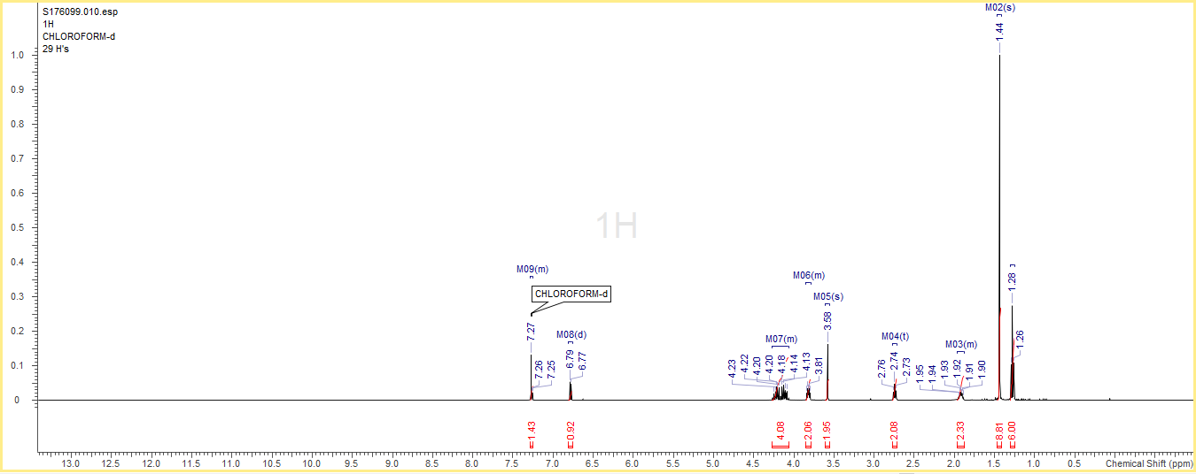

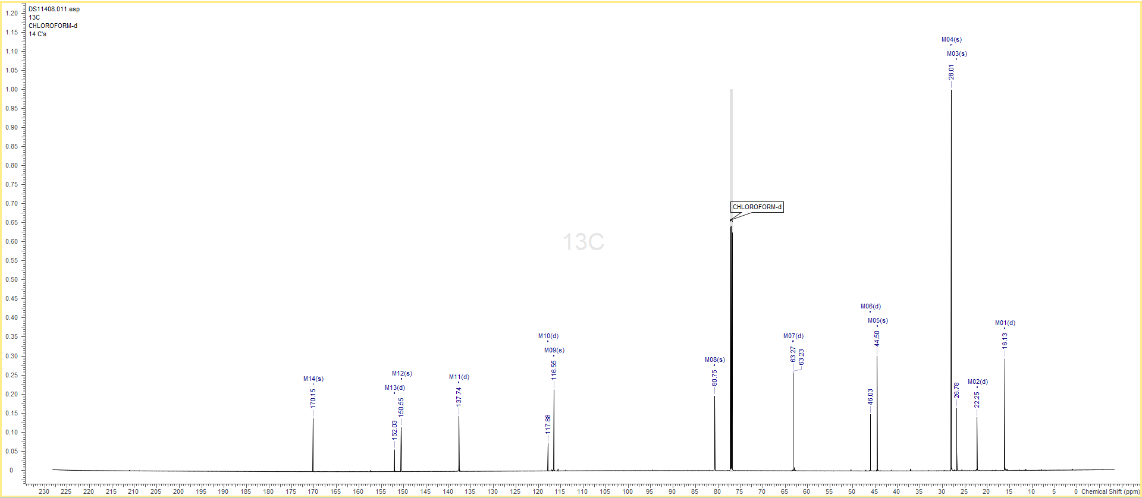

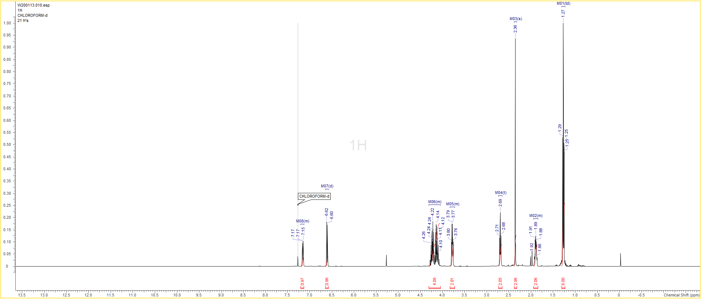

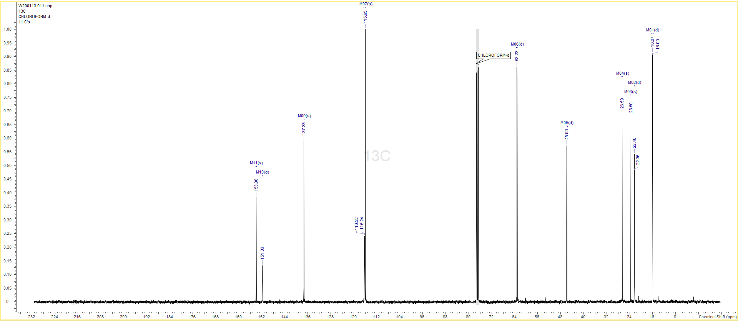

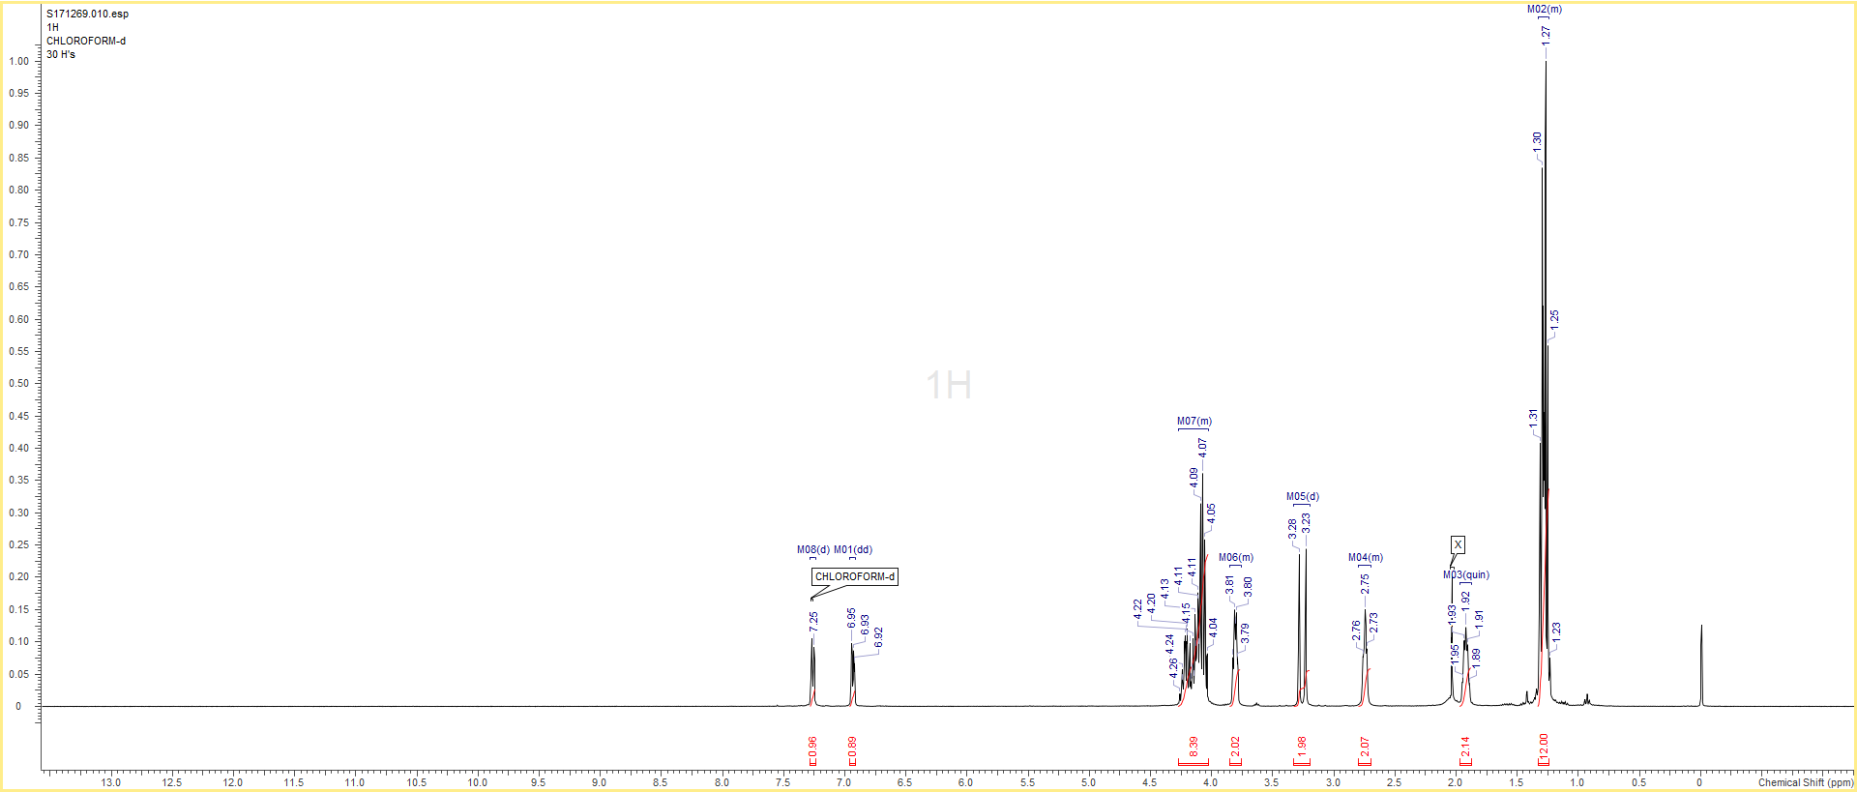

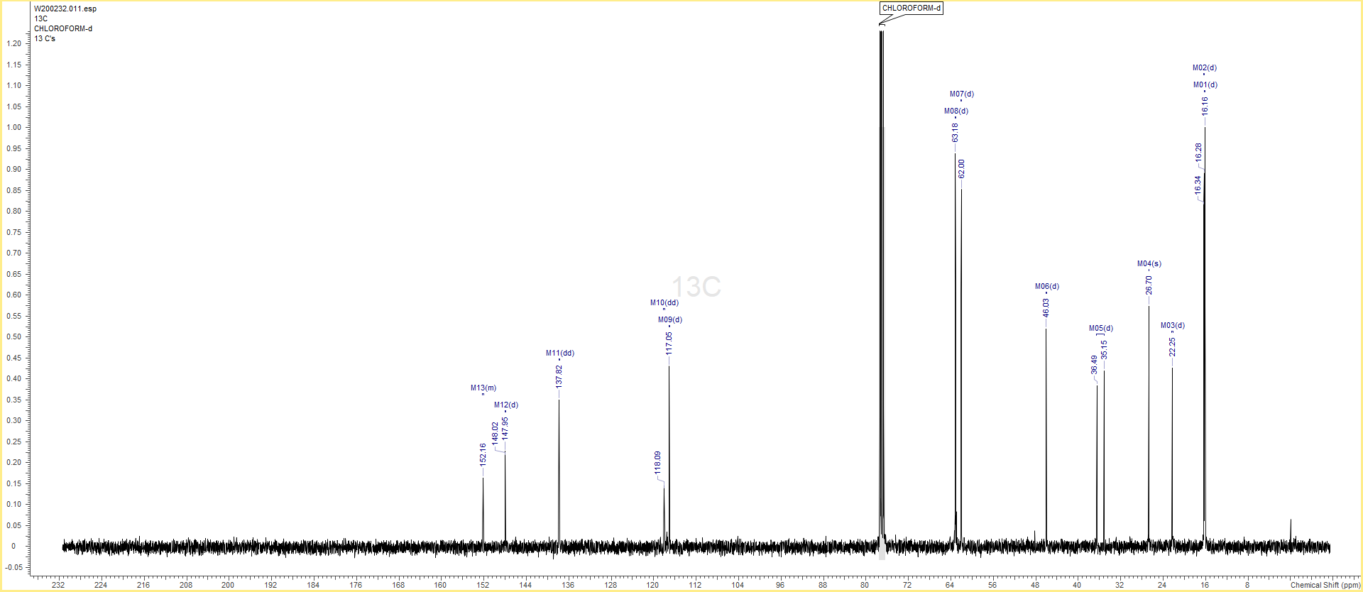

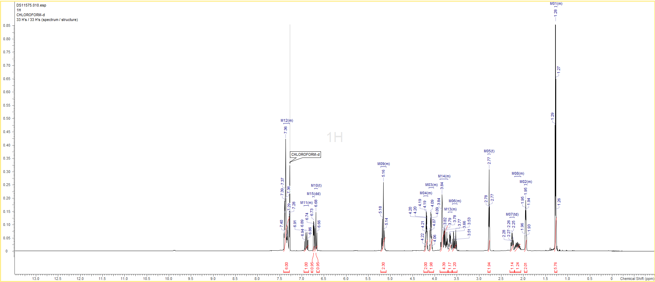

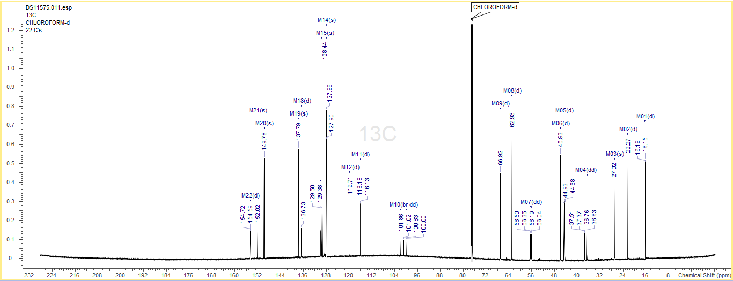

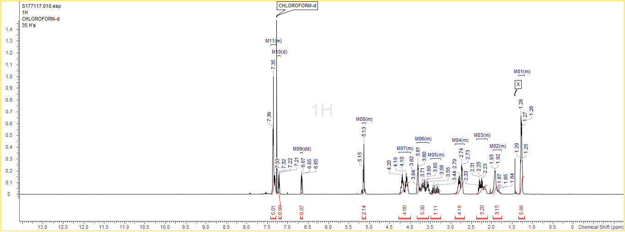

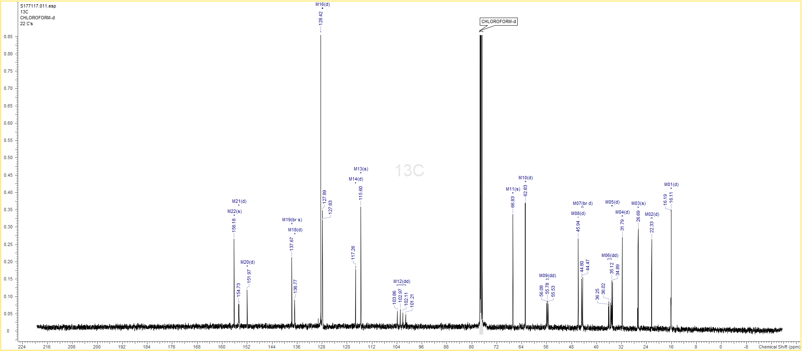

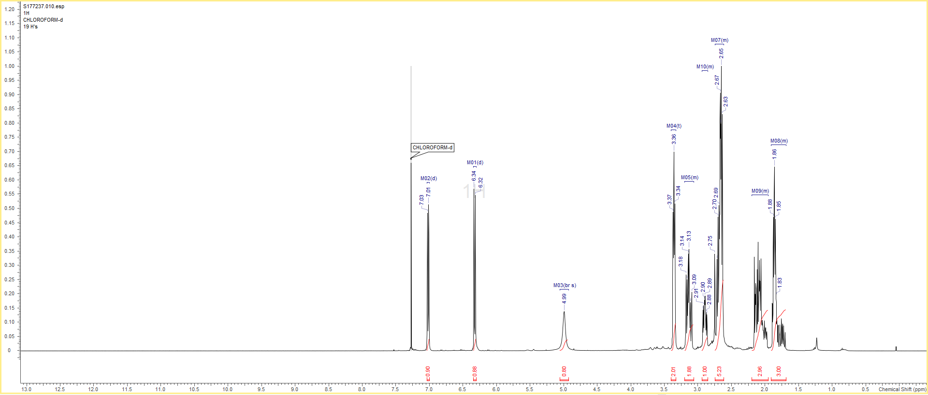

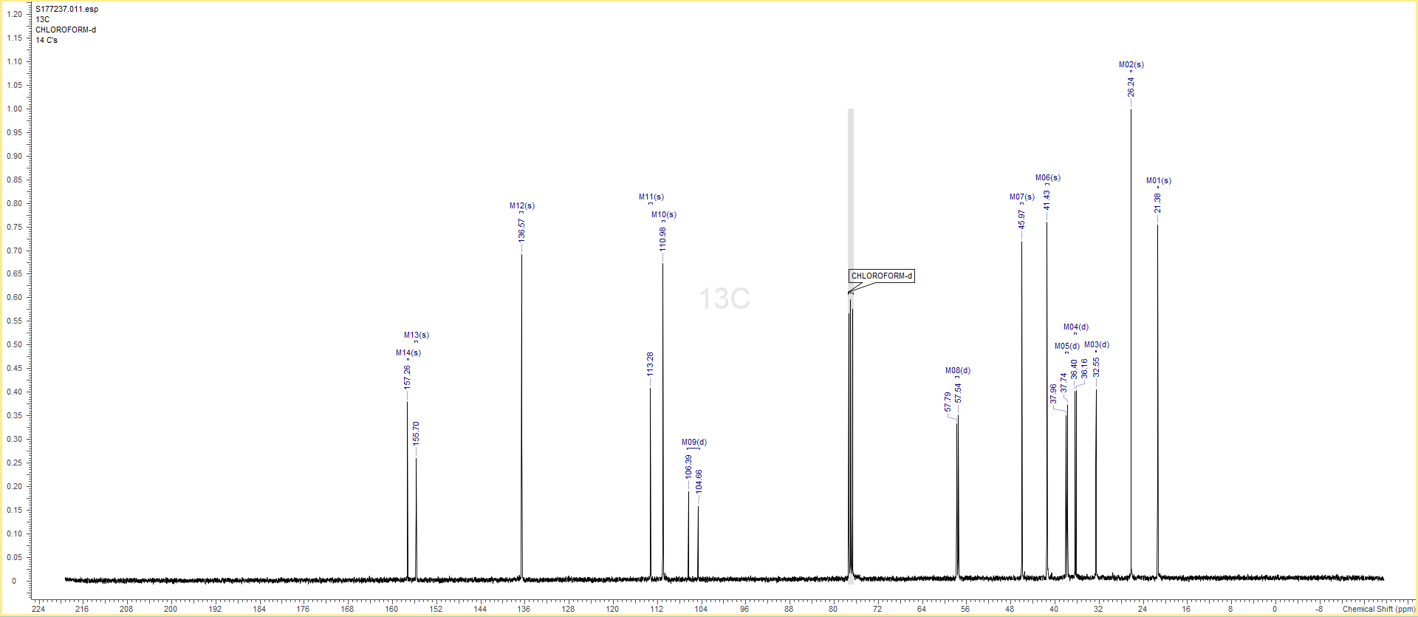

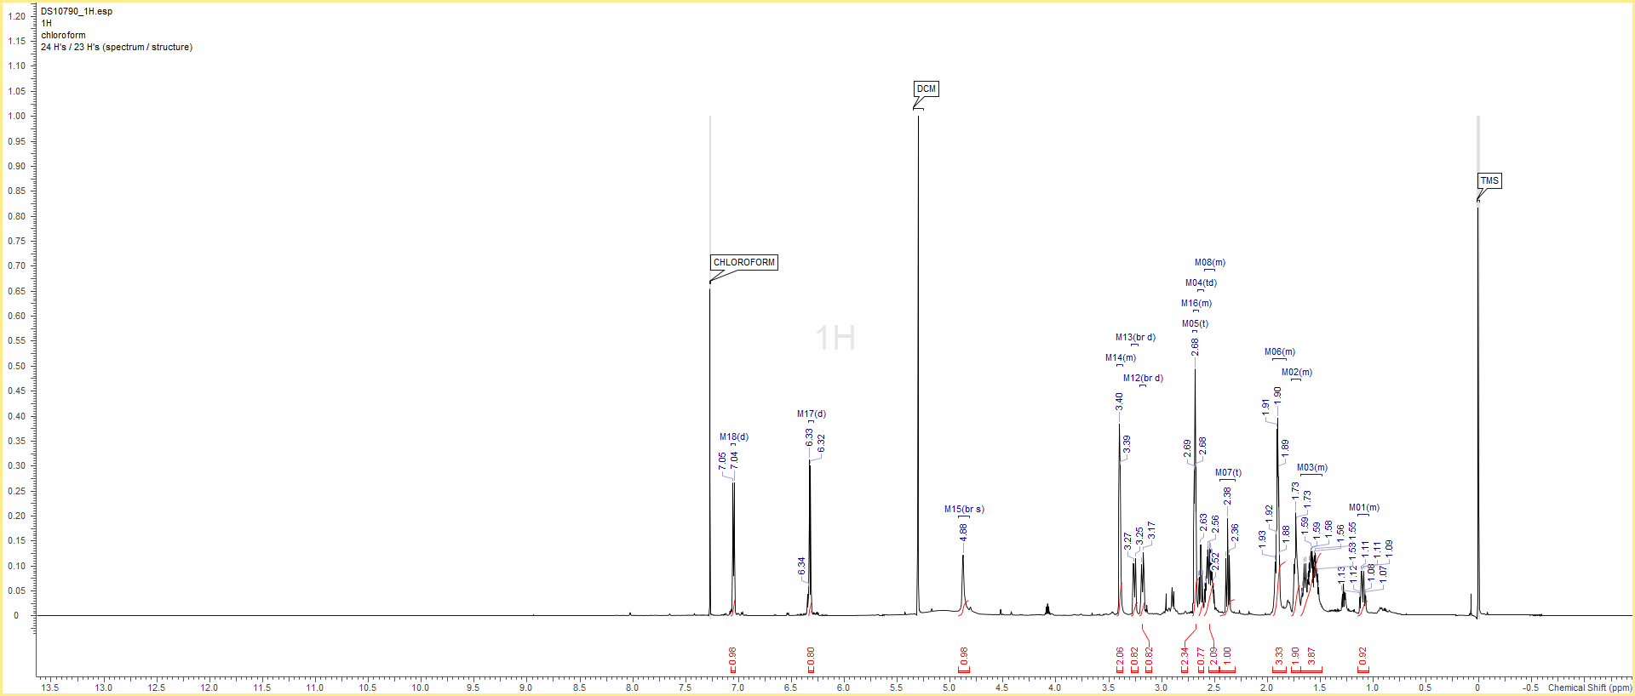

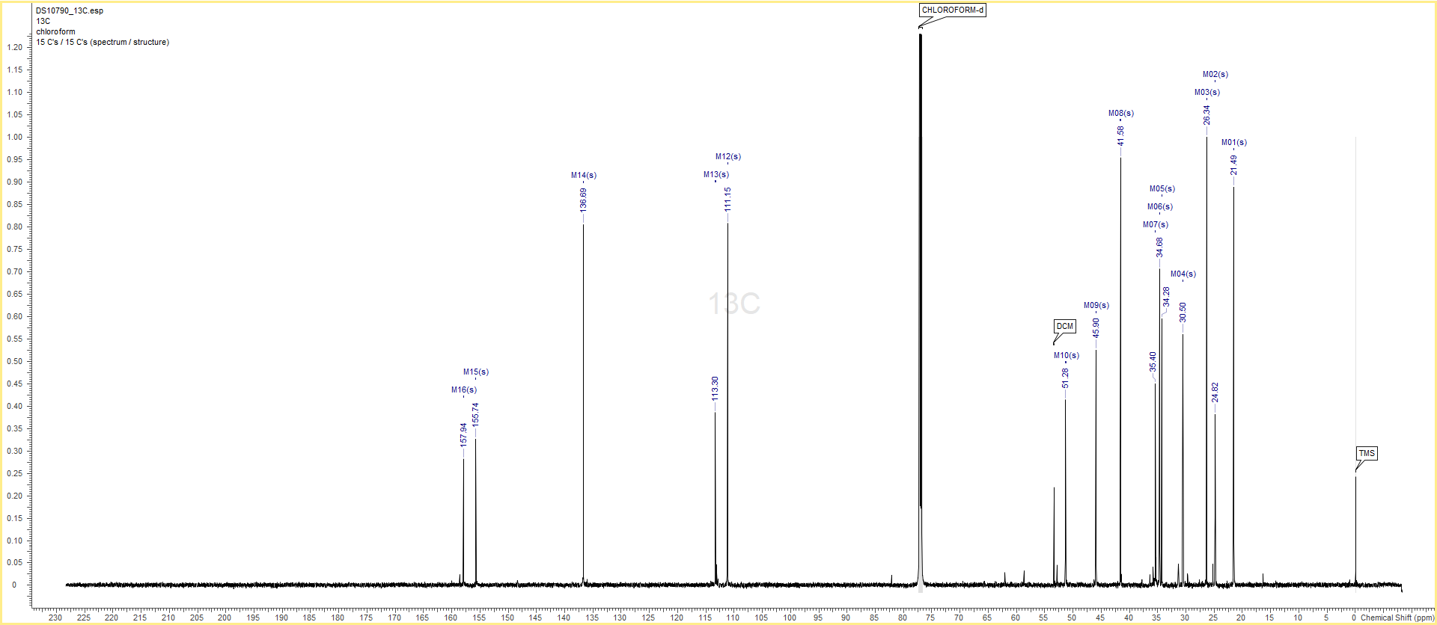

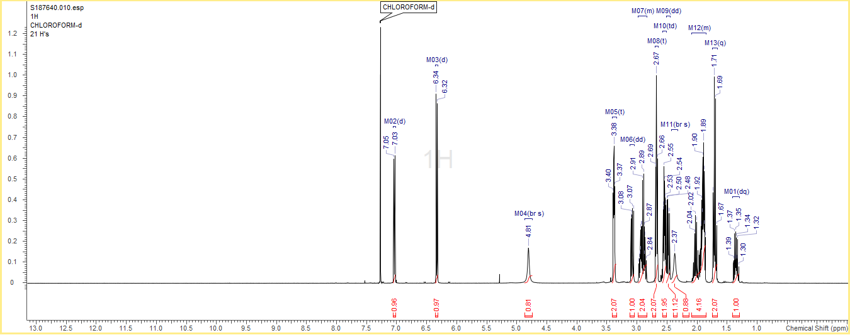

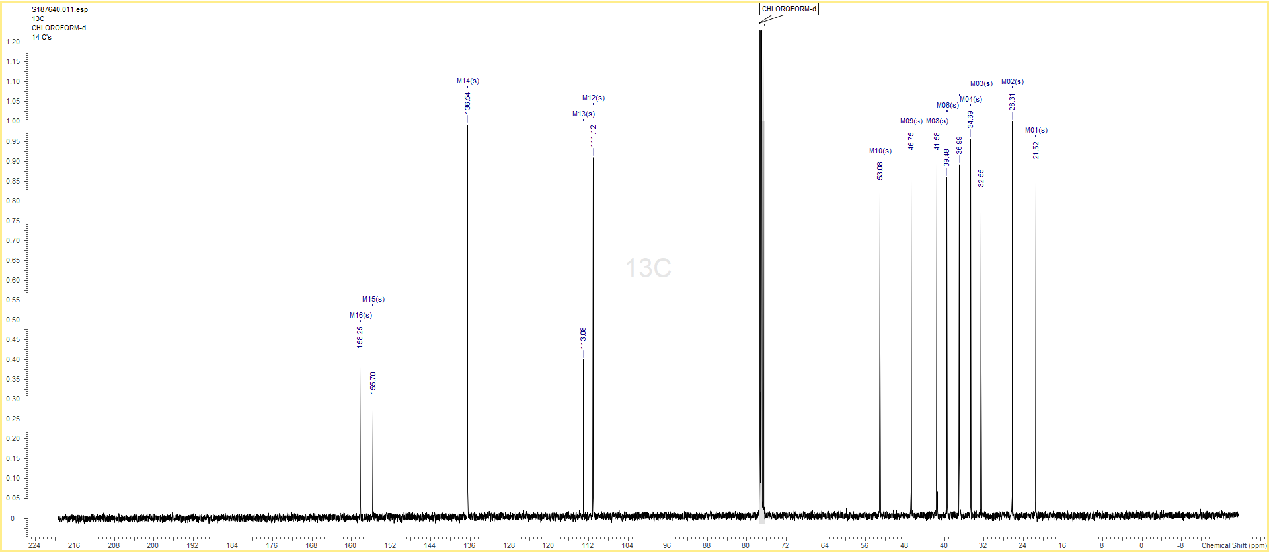

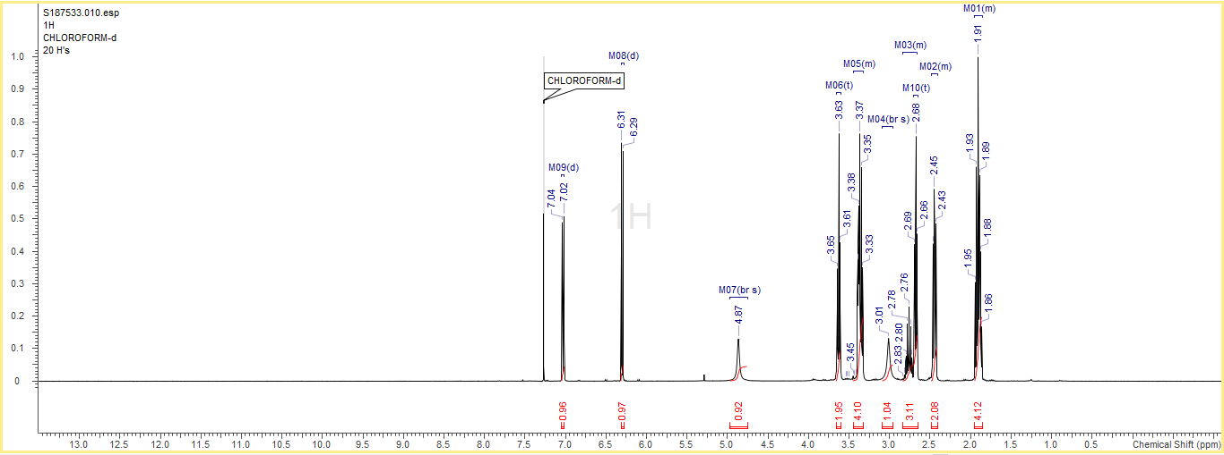

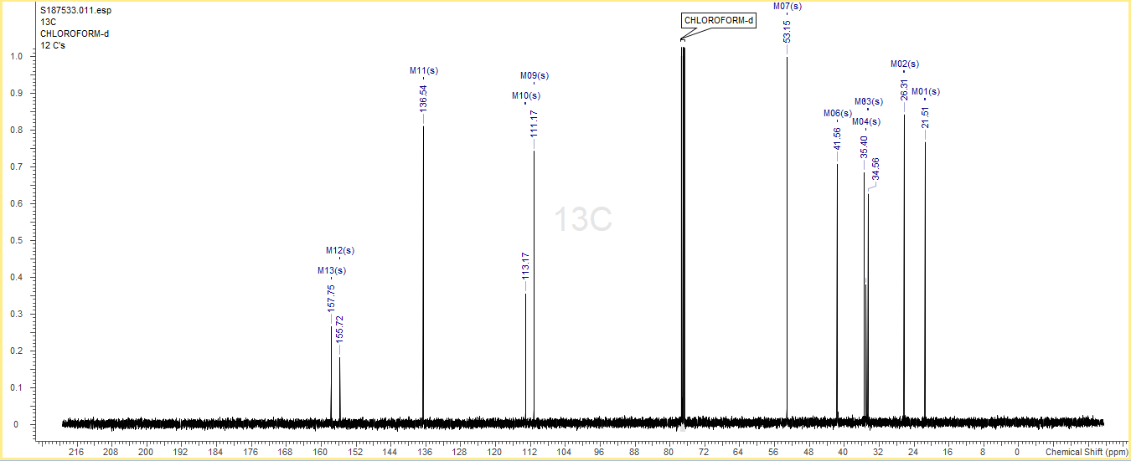

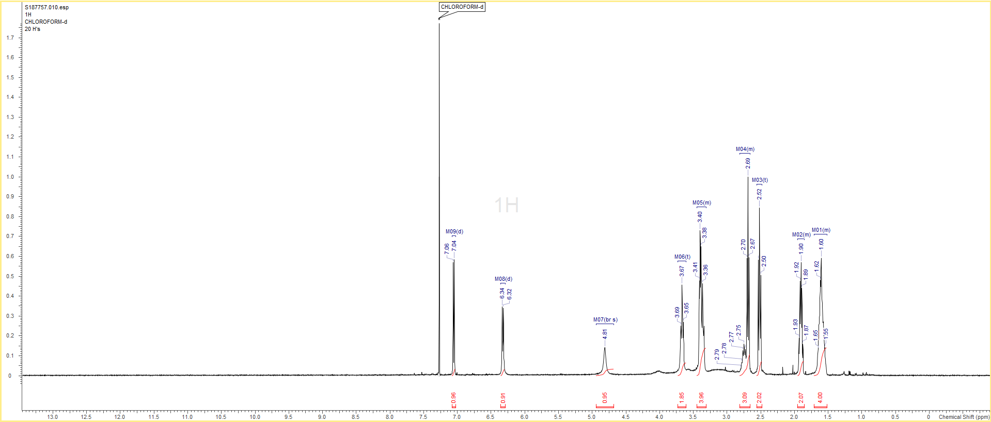

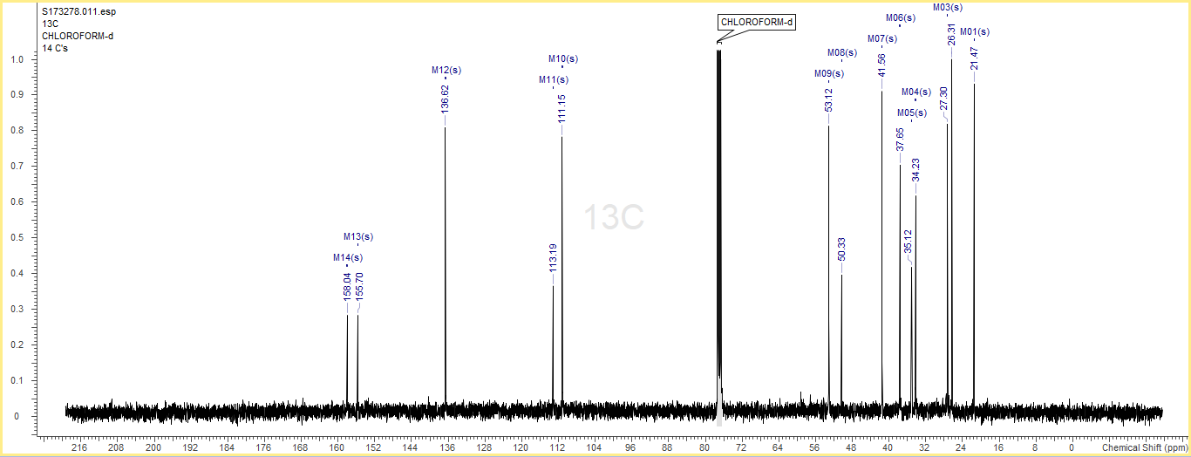

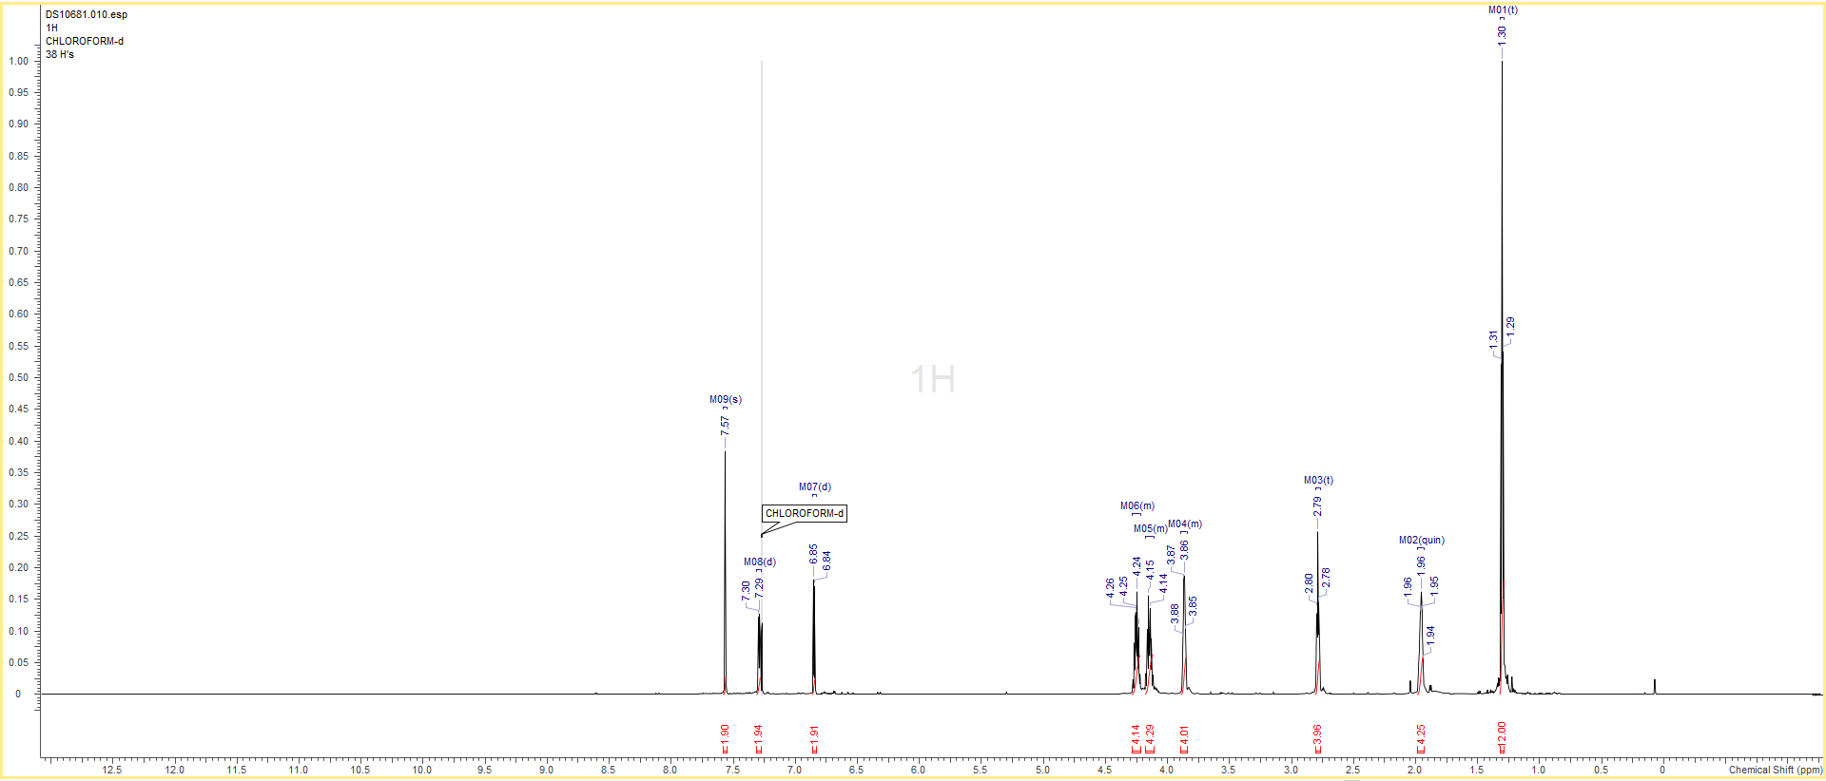

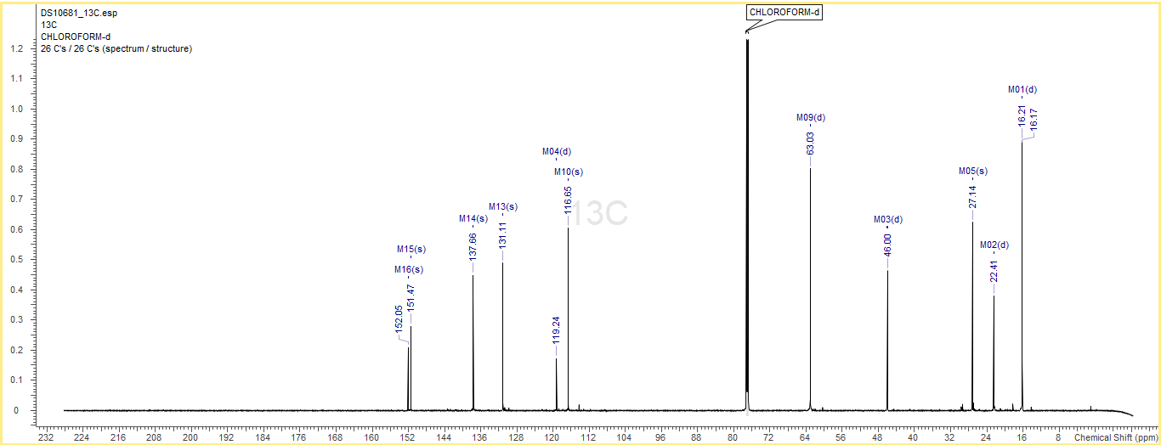

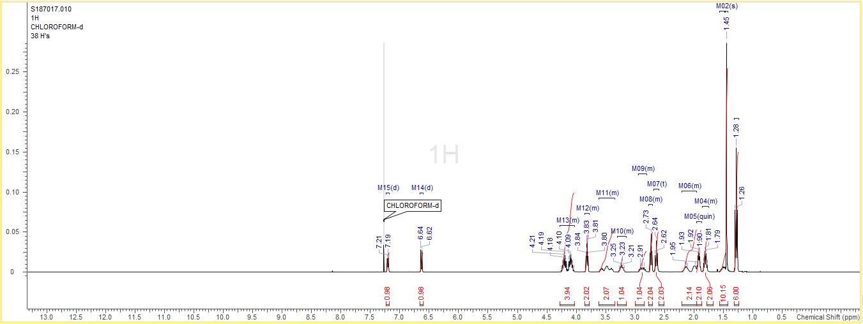

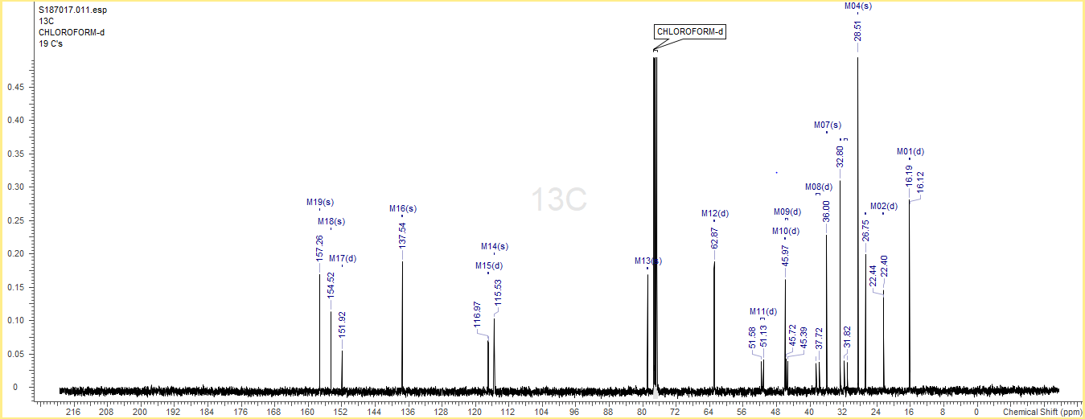

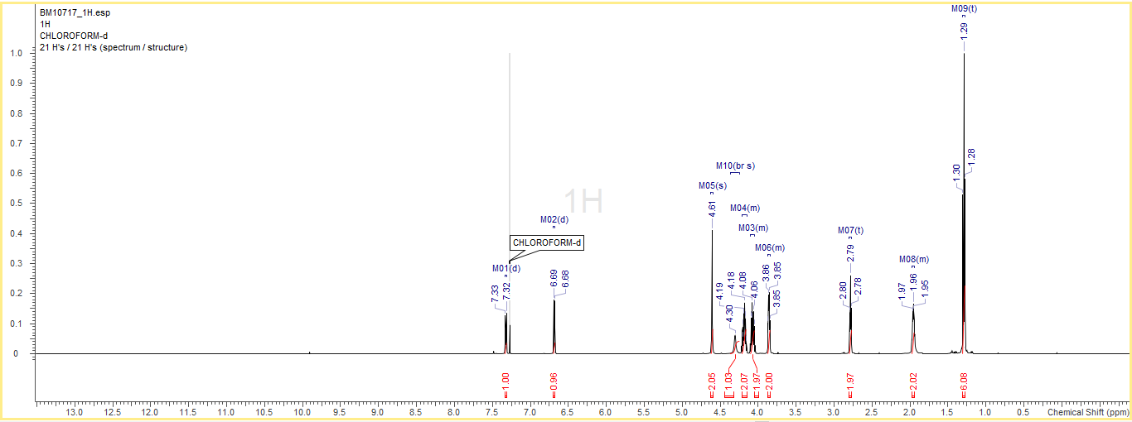

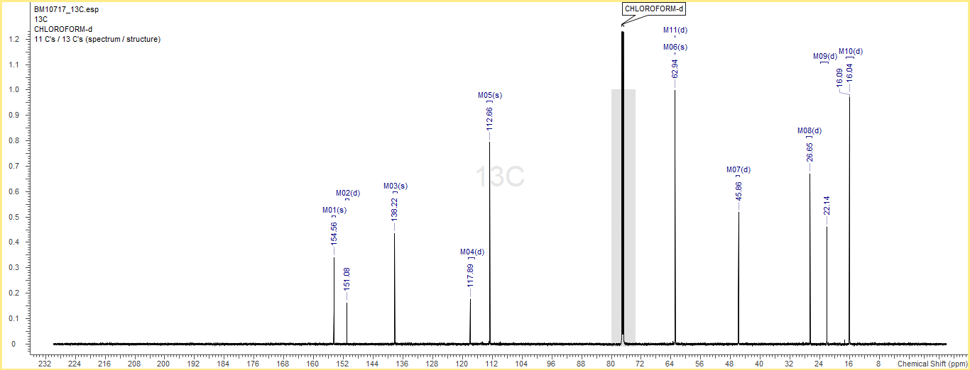

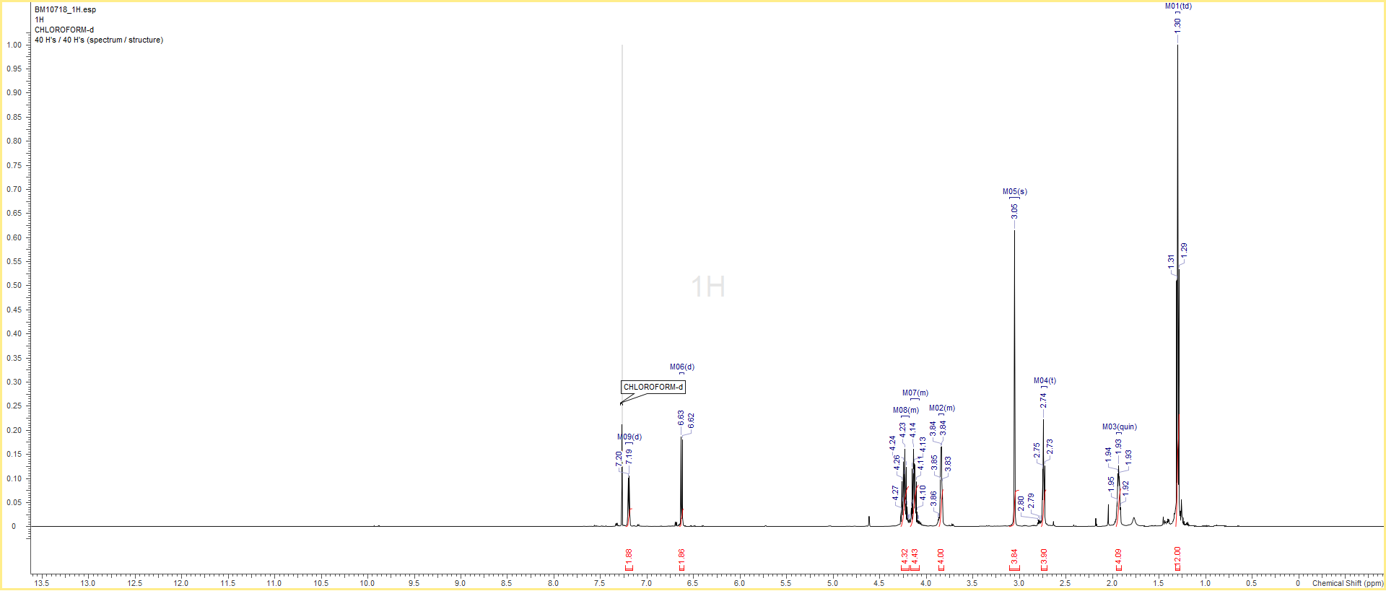

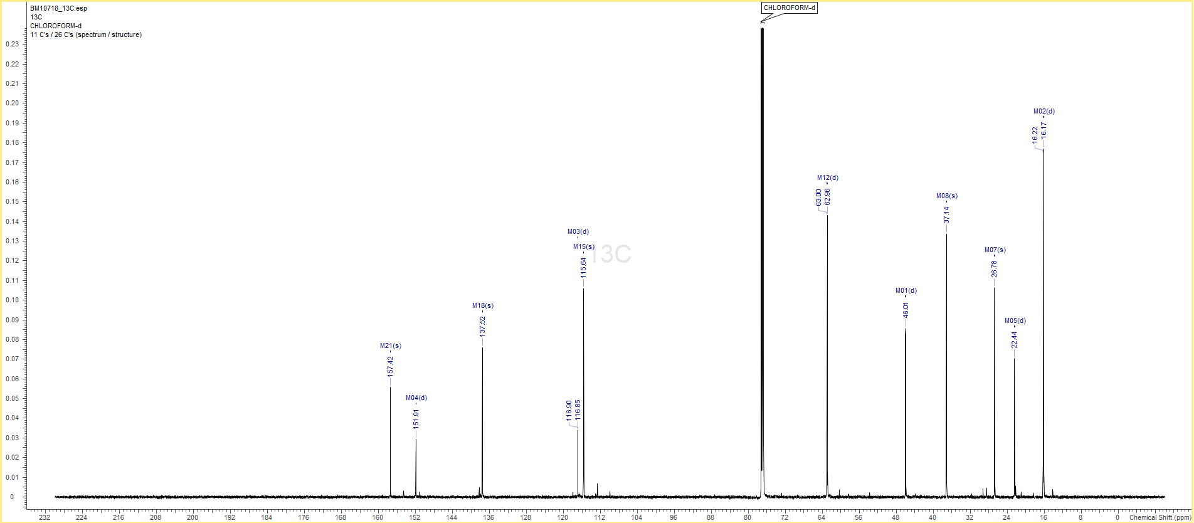

Chiral HPLC Trace of Compound 23 and (R)-23
The S enantiomer was prepaed by the tandem HWE/reduction/deprotection route for reference; the product was obtained in 30% e.e.
Sample obtained from HWE/reduction/deprotection route
Method: Chiralpak ID (250 x 4.6 mm, 5 μm); flow rate: 1mL/min; column temperature: 25 °C; mobile phase: heptane:ethanol:isopropylamine 70:30:0.1; run time: 30 min; detection: UV at 250 nm (band width 40 nm); injection: 5 μL of ethanol solution.

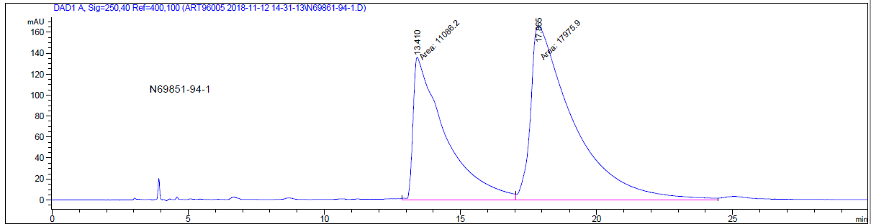
Sample obtained from alkylation/deprotection route
Method: Chiralpak ID (250 x 4.6 mm, 5 μm; flow rate: 1mL/min; column temperature = 25 °C; mobile phase: heptane:ethanol:isopropylamine 70:30:0.2; runtime: 20 min; detection: UV at 250 nm (Bandwidth 40 nm); injection: 5 μL of ethanol solutions.

