Supporting information
for
A novel and practical synthesis of iclaprim
Weiyuan Liu, Liang Chen, Jing Pan, Ting Zhou, Kuaile Lin, and Weicheng Zhou*
State Key Lab of New Drug & Pharmaceutical Process, Shanghai Key Lab of Anti-Infectives, Shanghai Institute of Pharmaceutical Industry, China State Institute of Pharmaceutical Industry, No. 285, Gebaini Rd., Shanghai 201203, P. R. of China
Email: Weicheng Zhou* - zhouweicheng58@163.com
* Corresponding author

Preparation of 14a and 1a.
¹H-NMR, ¹³C-NMR, HPLC and MS spectra of compound 10-14, 14a, 1 and 1a.

Table of contents
- Preparation of 14a and 1a
- ¹H-NMR ¹³C-NMR, HPLC and MS spectra of compound 10-14, 14a, 1 and 1a.

1. Preparation of 14a and 1a
Preparation of 14a
To a suspension of 14 (0.501 g, 1.348 mmol) in methanol (8 ml) was added p-toluenesulfonic acid monohydrate (0.387 g, 2.035 mmol) at room temperature, and the whole was heated for 4 h at refluxing. After the reaction was completed, and the pH of the solution was adjusted to 9-10 with saturated aqueous Na₂CO₃. Evaporation of the methanol under vacuum and the crude product 14a was collected by filtration. The crude was recrystallized from isopropanol-water to give 14a (0.346 g, 66.4 %). Mp. 237-240℃. ¹H-NMR(600 MHz, DMSO-d₆): δ 7.44 (s, 1H), 6.30 (s, 1H), 6.15 (s, 2H), 5.74 (s, 2H), 4.42-4.41 (t, 1H), 3.70 (s, 6H), 3.59-3.57(d, 1H), 3.52-3.49(d,1 H), 3.42-3.39(m, 4H), 2.42-2.39(d, 2H), 1.70-1.65(m, 1H), 1.24-1.20(m, 1H), 0.69-0.61 (m, 2H), 0.56-0.52 (m, 1H), 0.42-0.38 (m, 1H); ¹³C-NMR (100 MHz, DMSO-d₆): δ 162.34, 162.19, 155.50, 152.28, 148.76, 134.86, 134.77, 114.58, 105.22, 104.96, 74.62, 69.49, 59.79, 55.71, 54.80, 29.97, 28.91, 15.14, 3.21, 1.60.; MS (ESI+): m/z, 387 ([M+H]+).
Preparation of 1a
Compound 14 (20.004 g, 53.774 mmol) in 200 ml of toluene was added to a 500 ml round bottom flask . Trifluoroacetic acid (30.007 g, 263.219 mmol) was added to the reaction mixture, and then, the mixture was heated for 2 h at refluxing. The mixture was cooled to room temperature. The pH was adjusted to 7-8 with saturated aqueous Na₂CO₃ and the mixture was evaporated on vacuo. The solid was collected by filtration and recrystallized from ethanol-water to give 6.002 g compound 1. The filtrate was concentrated and the residue was recrystallized again from ethanol-water to give 2.003 g compound 1. The second recrystallization filtrate was separated by column chromatography to give Impunity 1a (1.207 g, 6.3 %). Mp. 202-204℃; ¹H-NMR (600 MHz, DMSO-d₆): δ 7.51 (s, 1H), 6.90 (s, 1H), 6.52 (s, 1H), 5.55 (s, 2H), 5.05-5.06 (d, 1H), 4.38-4.40 (d, 1H), 3.37 (s, 3H), 3.63(s, 3H), 3.27-3.30(d,1H), 3.13-3.15(d, 2H), 2.24-2.27(d, 1H), 1.81-1.87(m, 1H), 1.03-1.09 (m, 1H), 0.57-0.63 (m, 2H), 0.47-0.51 (m, 1H), 0.42-0.45 (m, 1H); ¹³C-NMR (100 MHz, DMSO): δ 162.05, 161.73, 155.43, 151.87, 147.58, 135.81, 135.16, 115.35, 103.96, 103.71, 75.10, 59.90, 55.81, 42.87, 33.44, 32.22, 15.06, 3.40, 1.25; MS (ESI+): m/z, 355 ([M+H]+).

- ¹H-NMR ¹³C-NMR, HPLC and MS spectra of compound 10-14, 14a, 1 and 1a.
¹H-NMR, ¹³C-NMR and MS spectra of compound 10
¹H-NMR(600 MHz, DMSO-d₆)
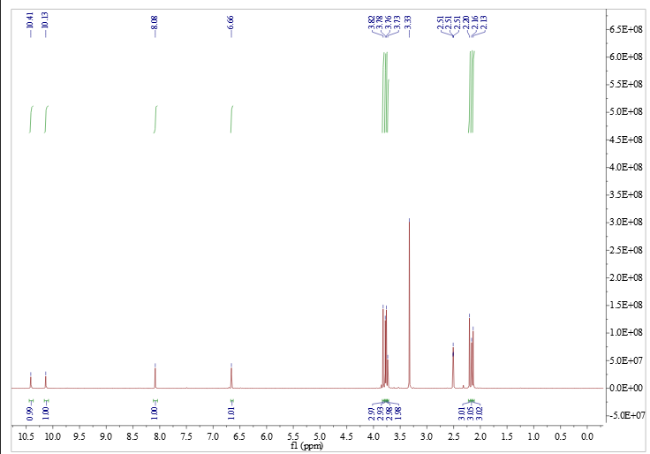

¹³C-NMR (100 MHz, DMSO-d₆)
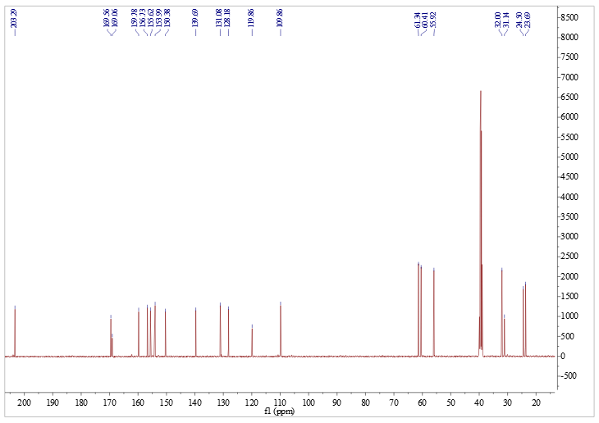
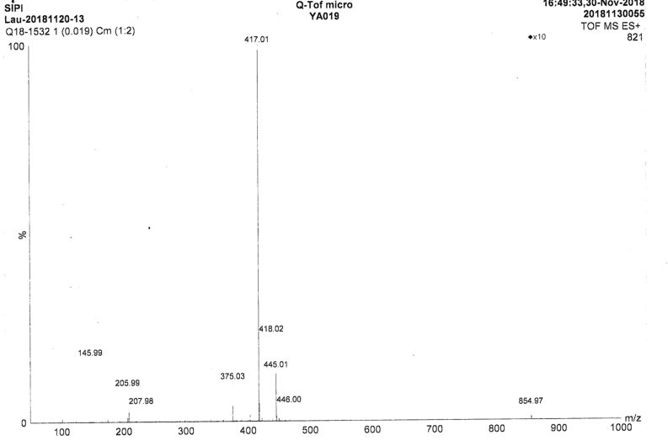

¹H-NMR and ¹³C-NMR spectra of compound 11
¹H-NMR (400 MHz, DMSO-d₆)
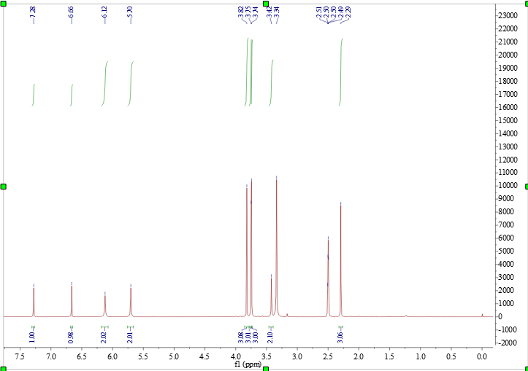

¹³C-NMR (100 MHz, DMSO-d₆)
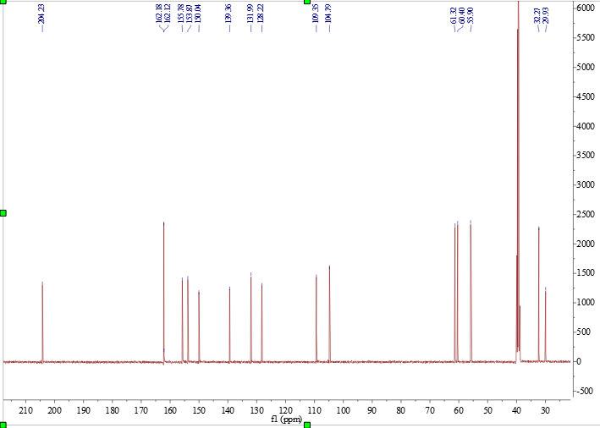

¹H-NMR, ¹³C-NMR and MS spectra of compound 12
¹H-NMR (400 MHz, DMSO-d₆)
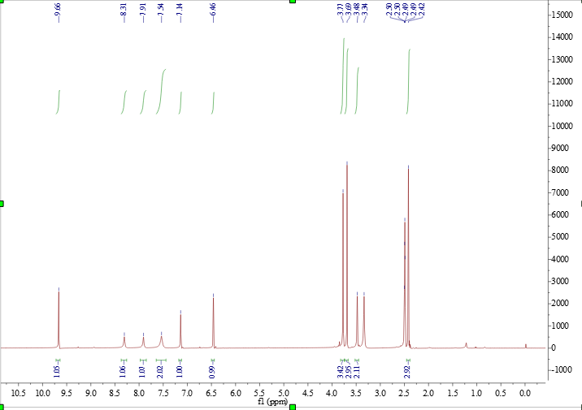

¹³C-NMR (100 MHz, DMSO-d₆)
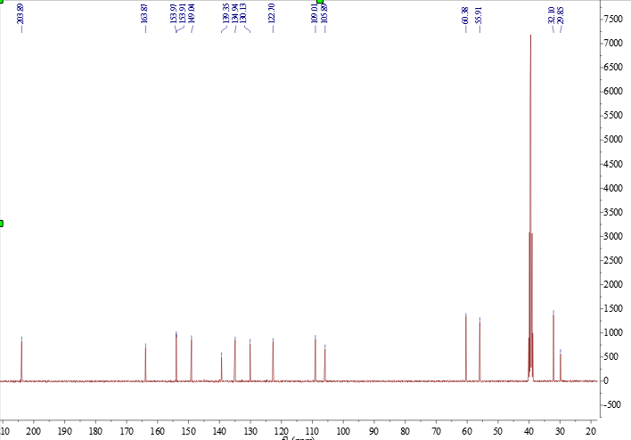

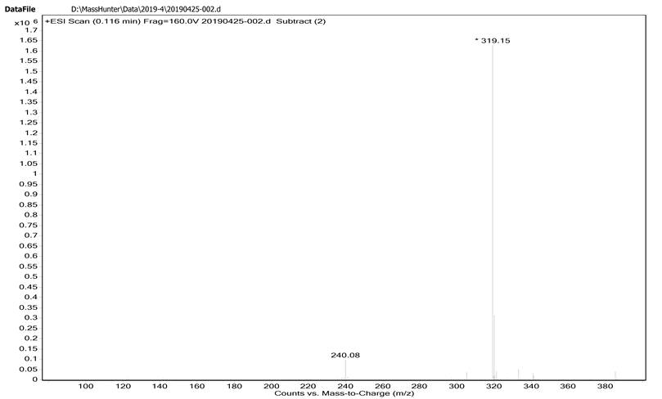

¹H-NMR and MS spectra of compound 13
¹H-NMR (600 MHz, DMSO-d₆)
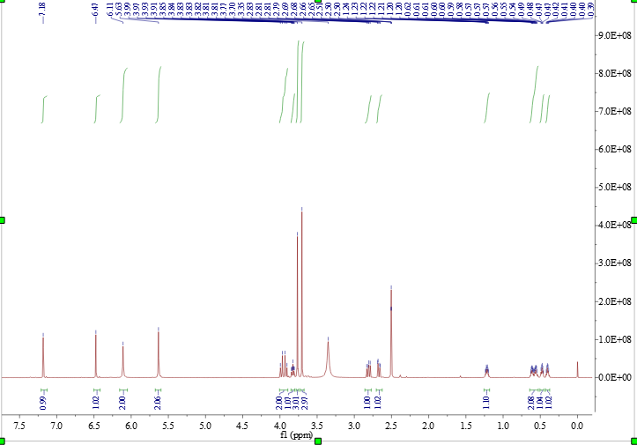
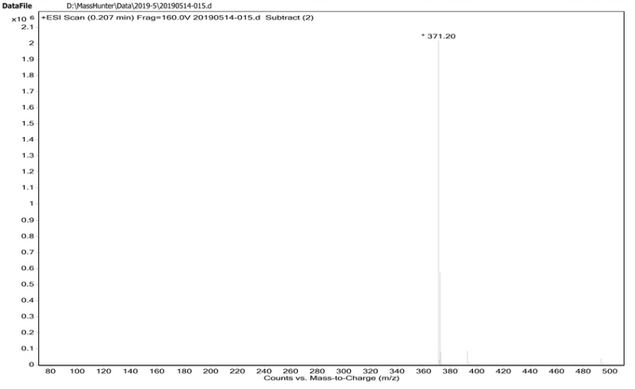

¹H-NMR , ¹³C-NMR and MS spectra of compound 14
¹H-NMR (400 MHz, DMSO-d₆)
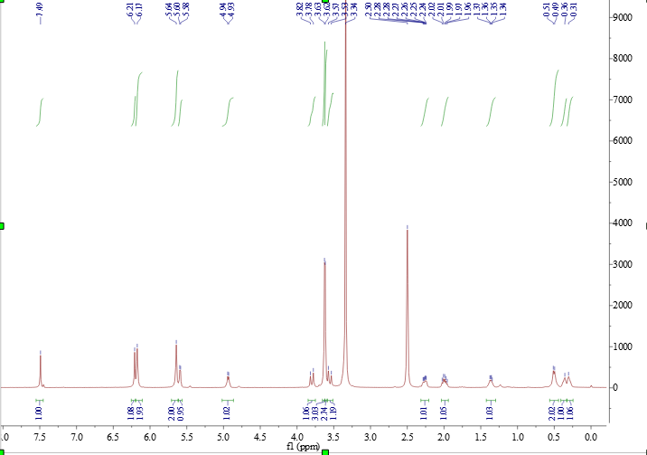

¹³C-NMR (100 MHz, DMSO-d₆)
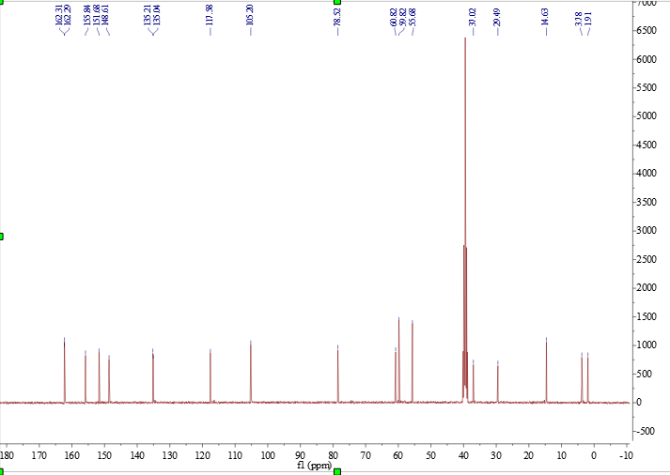

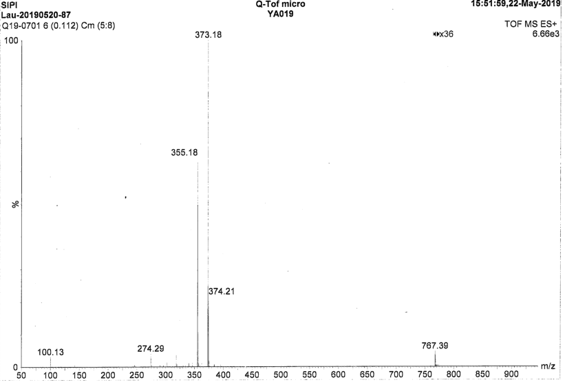
¹H-NMR, ¹³C-NMR and MS spectra of compound 14a
¹H-NMR (600 MHz, DMSO-d₆)
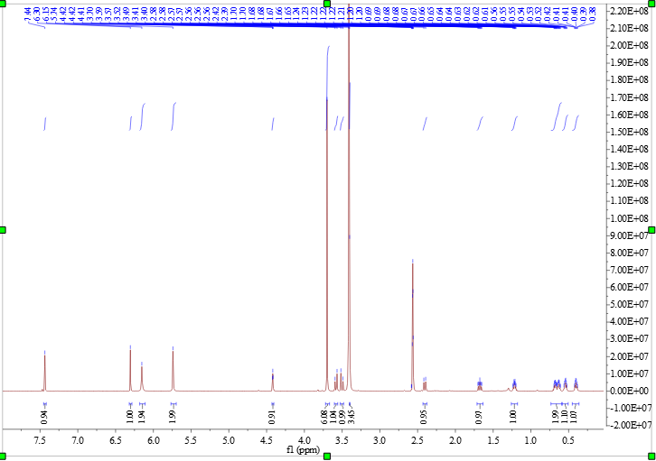

¹H-NMR (600 MHz, DMSO-d₆ + D₂O)
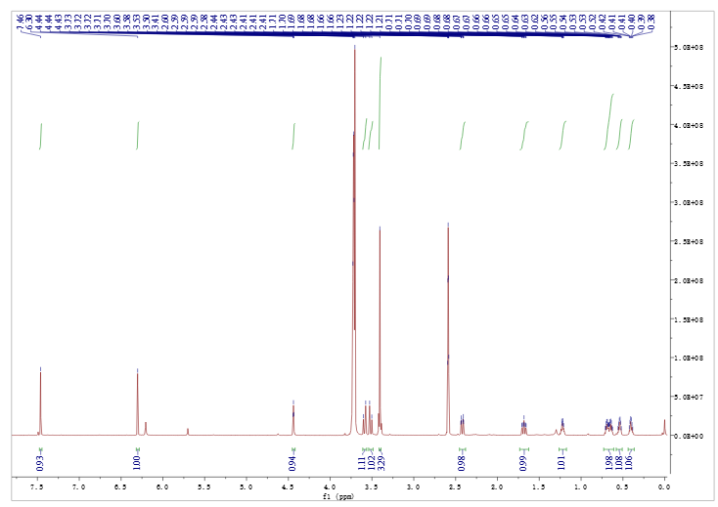

¹³C-NMR (100 MHz, DMSO-d₆)
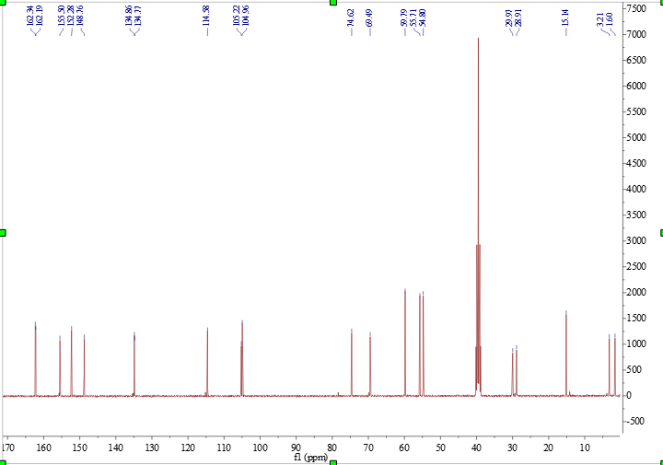
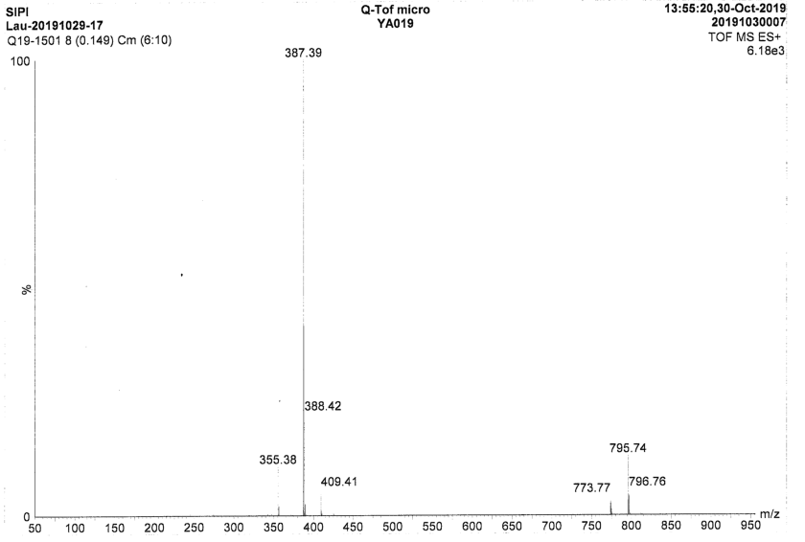

¹H-NMR, ¹³C-NMR, MS and HPLC spectra of compound 1
¹H-NMR (600 MHz, DMSO-d₆)
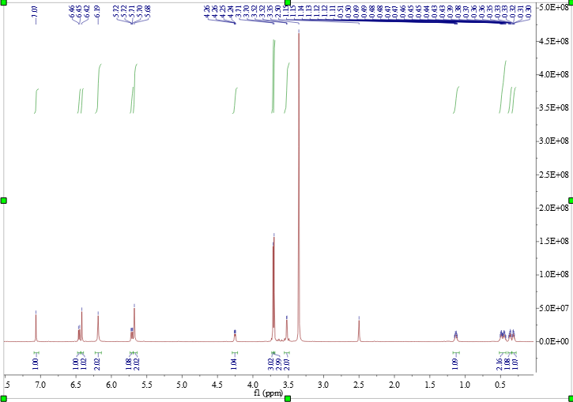

¹³C-NMR (100 MHz, DMSO-d₆)
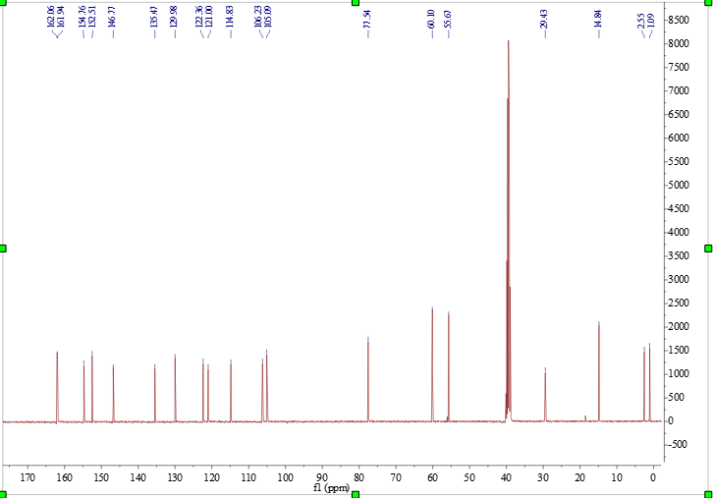

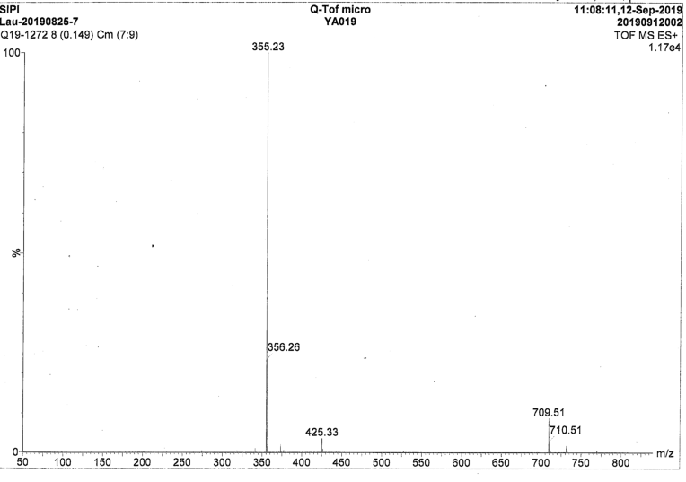

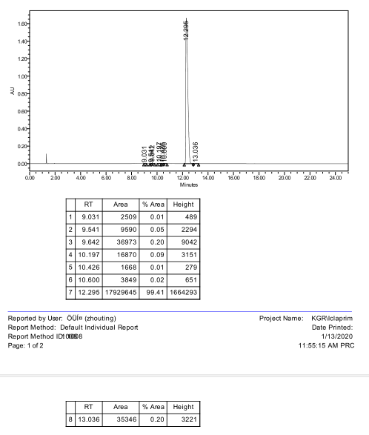

¹H-NMR, ¹³C-NMR and MS spectra of compound 1a
¹H-NMR(600 MHz, DMSO-d₆)
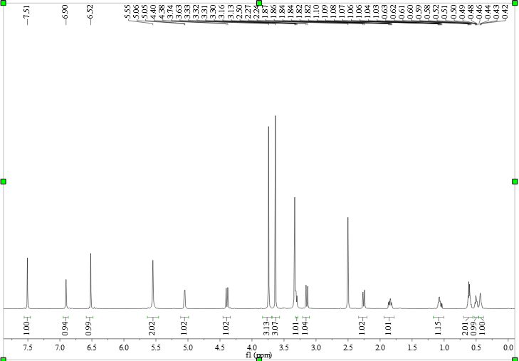

¹H-NMR(600 MHz, DMSO-d₆ + D₂O)
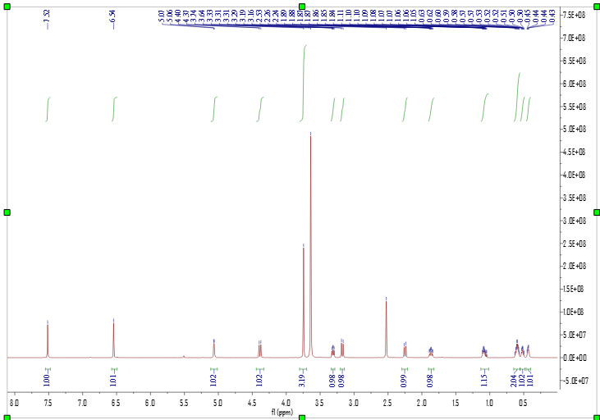

¹³C-NMR (100 MHz, DMSO-d₆)
