Supplementary data

Dibenzocyclooctadiene Lignans from Artemisia sieversiana and Their Nitric Oxide Inhibitory Effects
Xu-Dong Zhou ^{a, b}, Chao-Xi Chen ^{c}, Xi-Kang Zheng ª, Li-Min Gong ^{b}, Ke-Wu Zeng ª, Wei Wang ^{b*}, Peng-Fei Tu ^{a*}

ª State Key Laboratory of Natural and Biomimetic Drugs, School of Pharmaceutical Sciences, Peking University Health Science Center, Beijing 100191, China
^{b} TCM and Ethnomedicine Innovation & Development International Laboratory, Innovative Materia Medica Research Institute, School of Pharmacy, Hunan University of Chinese Medicine, Changsha, 410208, P.R. China
^{c} Collge of Life Since and Technology, Southwest Minzu University, Chengdu, Sichuan 610041, China

*Corresponding author. Tel: +86 731 8845 8240; fax:+86 8845 8227.
E-mail address: wangwei402@hotmail.com (W. Wang).
*Corresponding author. Tel/Fax: +86 10 8280 2750
E-mail address: pengfeitu@vip.163.com (P.-F. Tu).

Contents:
Fig. S1. ¹H NMR spectrum of sieverlignan D (1) (CD₃OD, 500 MHz).
Fig. S2. ¹³C NMR spectrum of sieverlignan D (1) (CD₃OD, 125 MHz).
Fig. S3. gHSQC spectrum of sieverlignan D (1).
Fig. S4. gHMBC spectrum of sieverlignan D (1).
Fig. S5. ¹H-¹H gCOSY spectrum of sieverlignan D (1).
Fig. S6. NOESY spectrum of sieverlignan D (1).
Fig. S7. HR-ESIMS spectrum of sieverlignan D (1).
Fig. S8. IR spectrum of sieverlignan D (1).
Fig. S9. CD spectrum of sieverlignan D (1).
Fig. S10. ¹H NMR spectrum of sieverlignan E (2) (CDCl₃, 500 MHz).
Fig. S11. ¹³C NMR spectrum of sieverlignan E (2) (CDCl₃, 125 MHz).
Fig. S12. gHSQC spectrum of sieverlignan E (2).
Fig. S13. gHMBC spectrum of sieverlignan E (2).
Fig. S14. ¹H-¹H gCOSY spectrum of sieverlignan E (2).
Fig. S15. NOESY spectrum of sieverlignan E (2).
Fig. S16. HR-ESIMS spectrum of sieverlignan E (2).
Fig. S17. IR spectrum of sieverlignan E (2).
Fig. S18. CD spectrum of sieverlignan E (2).

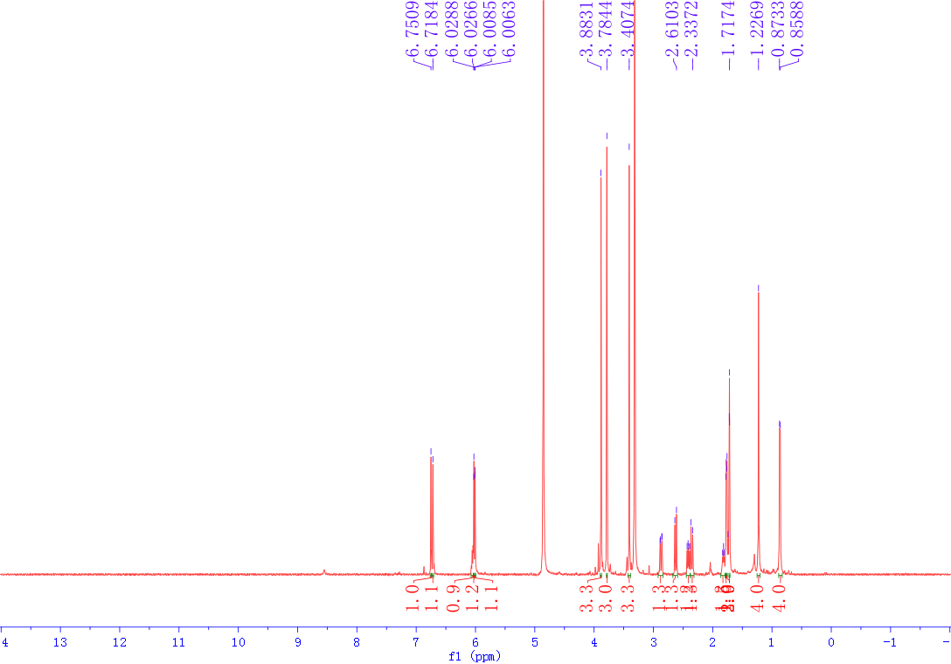
Fig. S1. ¹H NMR spectrum of sieverlignan D (1) (CD₃OD, 500 MHz).
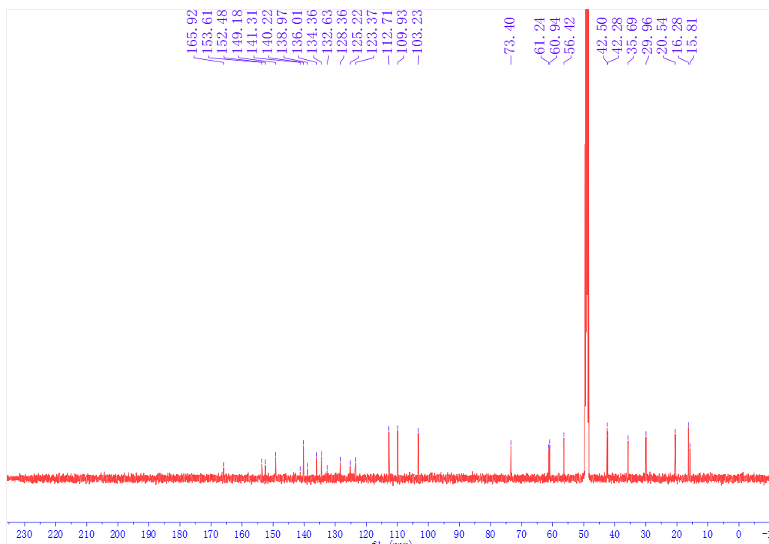
Fig. S2. ¹³C NMR spectrum of sieverlignan D (1) (CD₃OD, 125 MHz).
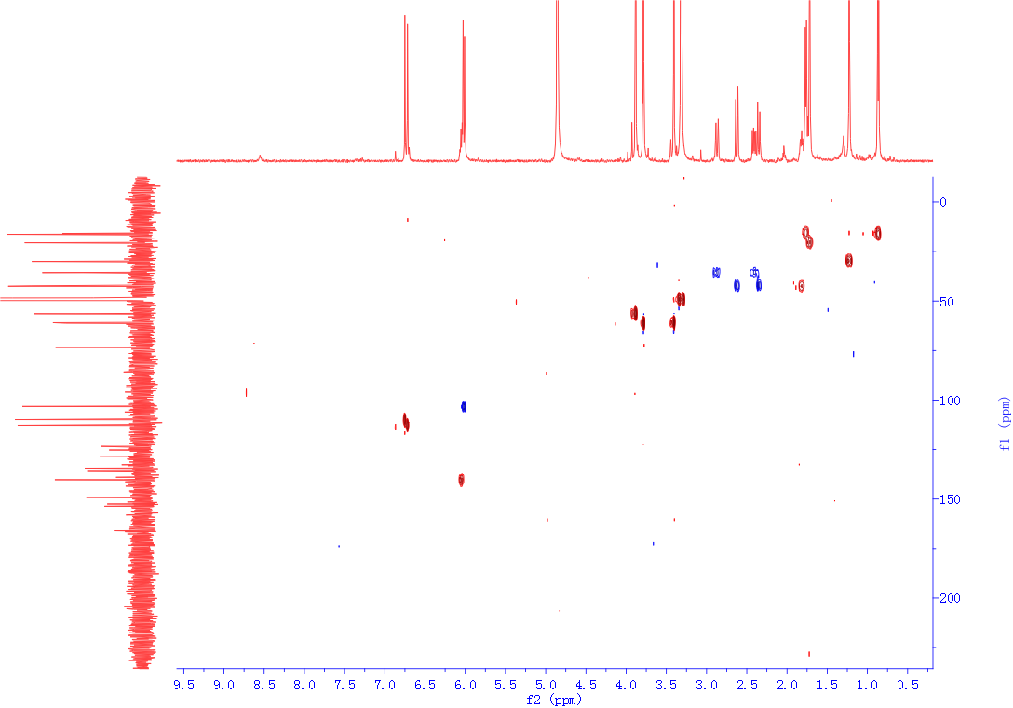
Fig. S3. gHSQC spectrum of sieverlignan D (1).
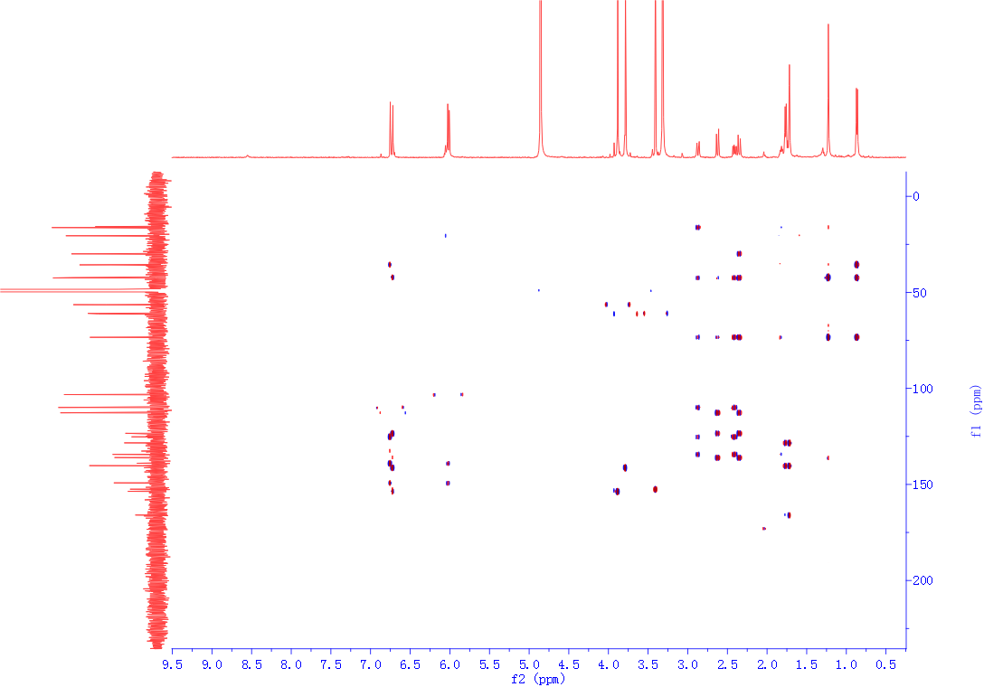
Fig. S4. gHMBC spectrum of sieverlignan D (1).
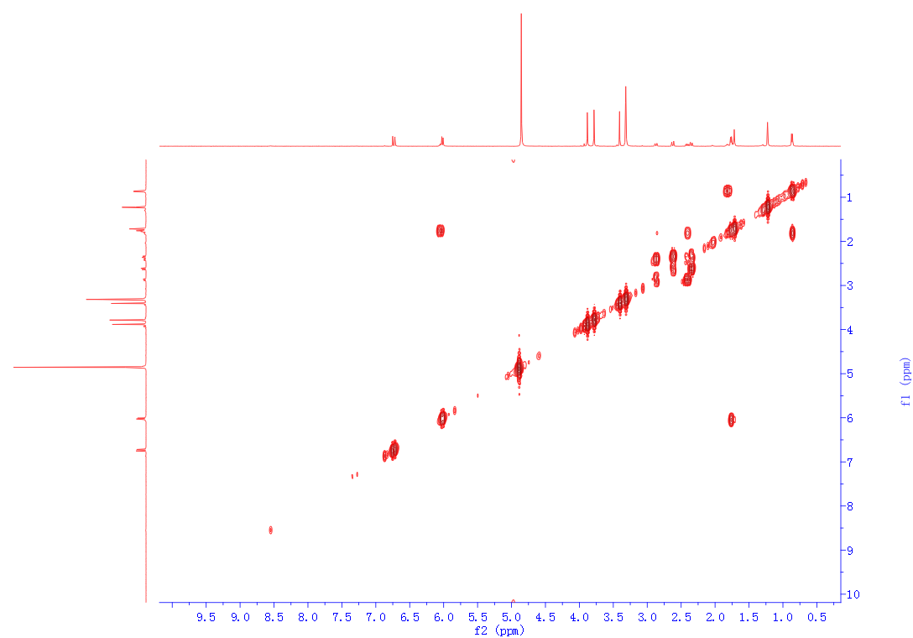
Fig. S5. ¹H-¹H gCOSY spectrum of sieverlignan D (1).
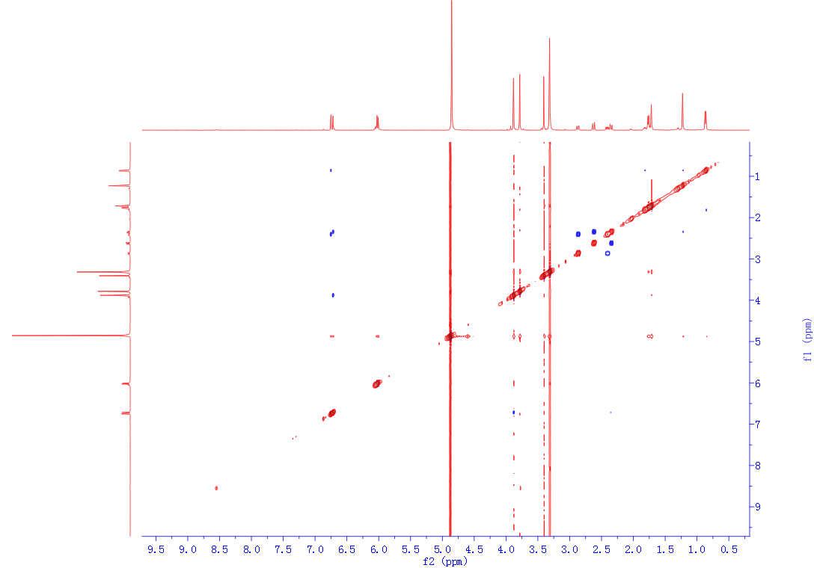
Fig. S6. NOESY spectrum of sieverlignan D (1).
Fig. S7. HR-ESIMS spectrum of sieverlignan D (1).
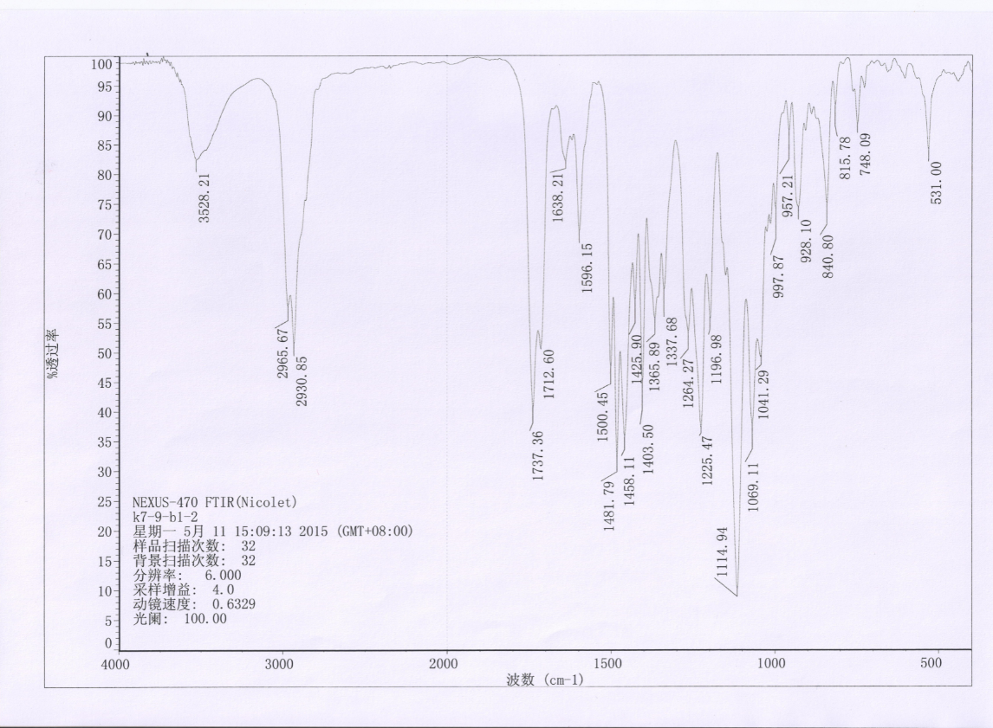
Fig. S8. IR spectrum of sieverlignan D (1).
Fig. S9. CD spectrum of sieverlignan D (1).
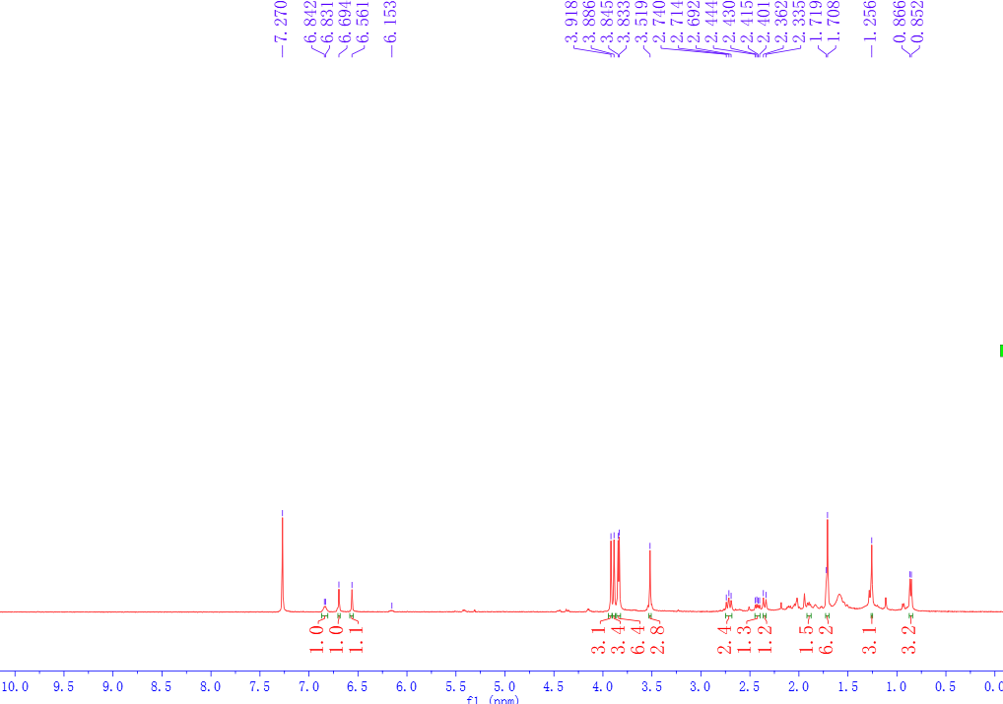
Fig. S10. ¹H NMR spectrum of sieverlignan E (2) (CDCl₃, 500 MHz).
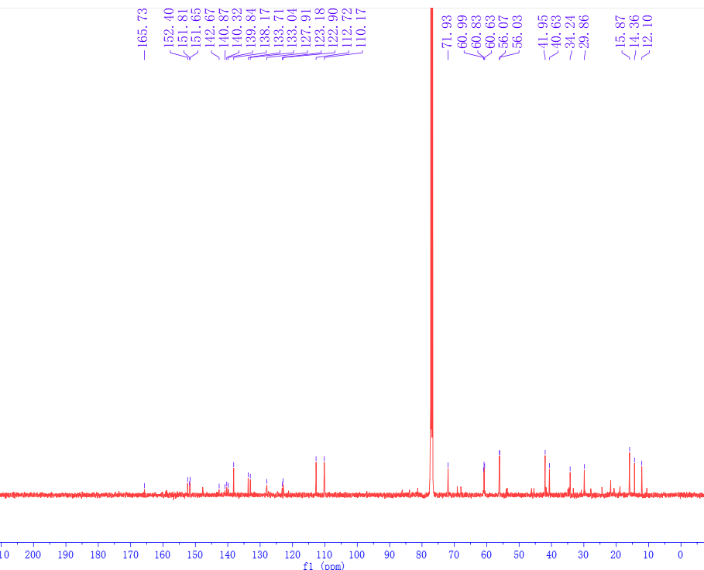
Fig. S11. ¹³C NMR spectrum of sieverlignan E (2) (CDCl₃, 125 MHz).
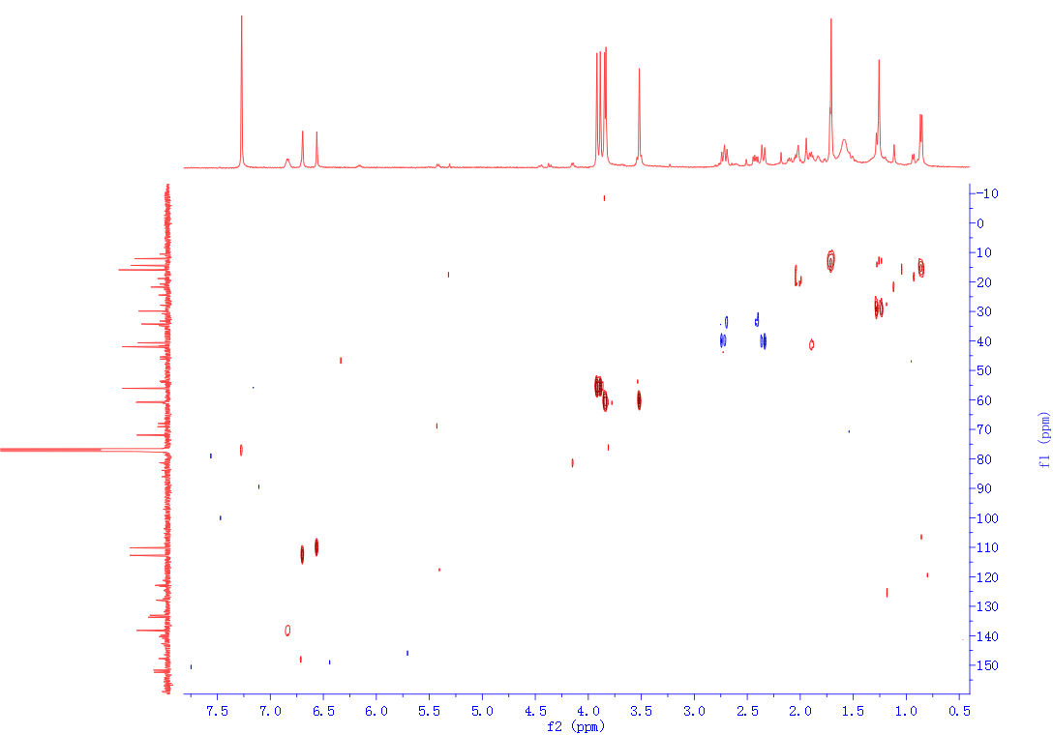
Fig. S12. gHSQC spectrum of sieverlignan E (2).
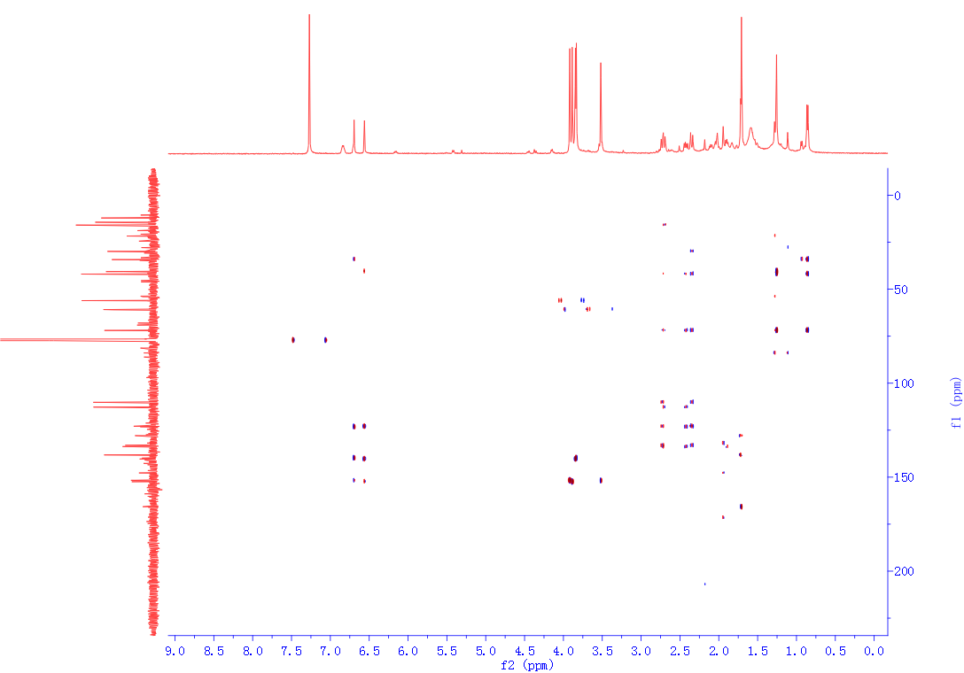
Fig. S13. gHMBC spectrum of sieverlignan E (2).
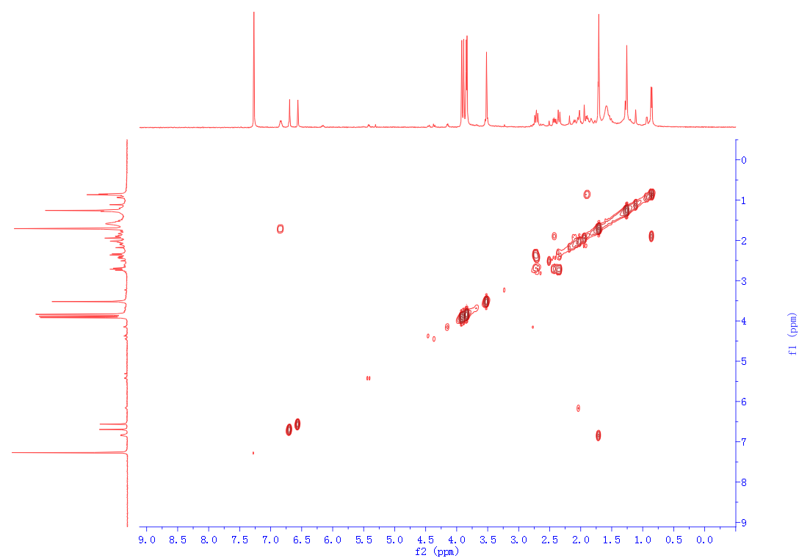
Fig. S14. ¹H-¹H gCOSY spectrum of sieverlignan E (2).
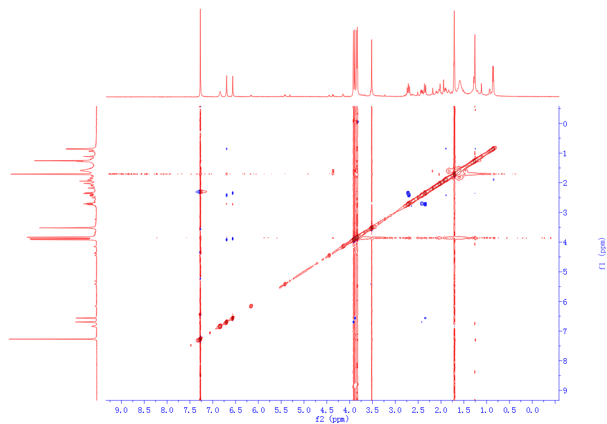
Fig. S15. NOESY spectrum of sieverlignan E (2).
Fig. S16. HR-ESIMS spectrum of sieverlignan E (2).
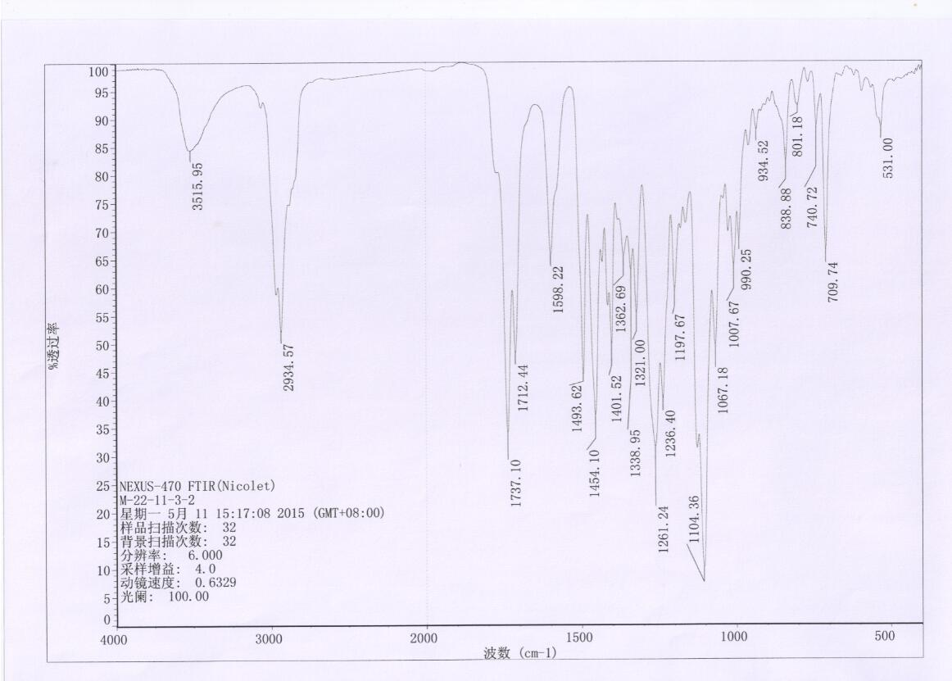
Fig. S17. IR spectrum of sieverlignan E (2).
Fig. S18. CD spectrum of sieverlignan E (2).

