Supporting Information

Hierarchically assembled helicates as reaction platform – From stoichiometric Diels-Alder reactions to enamine catalysis

David Van Craen¹, Jenny Begall¹, Johannes Großkurth¹, Leonard Himmel¹, Oliver Linnenberg¹, Elisabeth Isaak¹ and Markus Albrecht*¹

Address: ¹Institute of Organic Chemistry, RWTH Aachen University, Landoltweg 1, 52074 Aachen, Germany

Email: Prof. Dr. Markus Albrecht - markus.albrecht@oc.rwth-aachen.de
* Corresponding author
Materials and methods: Chemicals were obtained from Sigma Aldrich, Alfa Aesar and Acros. Solvents were purified via distillation before use. TLC plates were obtained from Merck (Silica 60, F 254, 0.25 mm thickness) and the visualization was achieved with UV light (254 nm) and KMnO₄ solution. NMR spectra were measured at a Mercury 300, a Varian VNMRS 400 and 600 device. ESI mass spectrometry was carried out at a LTQ Orbitrap XL. IR spectra were obtained from a Perkin-Elmer Spektrum 100 spectrometer and melting points were determined at a BÜCHI B-54 device. Elemental analysis was carried out at a Heraeus CHN-O-Rapid device.
Synthesis procedure for ligands: 2,3-Dihydroxybenzoic acid is converted into the corresponding acid chloride via refluxing with thionyl chloride (30 eq.). The excess of thionyl chloride is removed under reduced pressure after full conversion (change from a dispersion to a solution) is observed. The following esterification takes place in chloroform (0.2 mol L⁻¹). The initially obtained 2,3-dioxosulfinylbenzoyl chloride is not further purified and dissolved in four fifths of the necessary chloroform. A solution of the corresponding alcohol (3 eq.) and triethylamine (6 eq.) dissolved in one fifths of the chloroform is added and the mixture is refluxed for three days. The ligand L-H₂ is obtained after washing the reaction mixture with saturated NaHCO₃ solution, drying over MgSO₄ and a purification via column chromatography with silica gel 60 (35-70 µm).
Synthesis procedure for statistical complexes: The corresponding achiral ligand (3 eq.) and chiral ligand (3 eq.) are dissolved in methanol (0.02 mol L⁻¹). The complexation is achieved by adding TiO(acac)₂ (2 eq.) as well as Li₂CO₃ (2 eq.) and stirring the reaction mixture over night. No purification is necessary to obtain the statistical complexes except for removing the solvent under reduced pressure. The complexes consisting of the amine ligands are obtained by mixing the amine ligand (1 eq.) with the chiral ligand (5 eq.) in methanol/chloroform (50:50, 0.02 mol L⁻¹) as solvent mixture. The rest of the procedure follows the one described above.
Diels-Alder reactions at hierarchical helicates as platform: Complex Li₄[(1)₃(L*)₃Ti₂] (200 mg, 1 eq.) is post-functionalized with dienophile 8 (9 eq.) in the corresponding solvent (2 mL) under the given conditions in a closed reaction tube. Hydrochloric acid (37 %, 24 eq.) mixed with 0.5 mL water is added to the solution, if the solvent is THF, dioxane, acetone or acetonitrile. If dichloromethane or chloroform is used, the solvent is removed and the residue is dissolved in THF before hydrochloric acid (37 %, 24 eq.) mixed with 0.5 mL water is added. The cleavage is finished after mixing the solution for one hour. The mixture is diluted with dichloromethane (40 mL), washed with saturated sodium bicarbonate solution (4 mL) and dried over MgSO₄. The product is obtained via column chromatography according to the literature^{[1]} after removal of the solvent.
Synthesis of N-Boc protected alcohols: Amino alcohol 10 (1.2 eq.) is dissolved in dichloromethane (0.67 mol L⁻¹) and cooled to 0 °C. A solution of Boc anhydride (1 eq.) in dichloromethane (0.33 mol L⁻¹) is added dropwise in one hour to the amino alcohol solution. The mixture is stirred at room temperature overnight and the solvent is removed under reduced pressure. Purification is achieved via column chromatography with silica gel 60 (35-70 µm).
Cleavage of the Boc group resulting in ligands 13-H₂: Boc protected catechol ester 12 (1 eq.) is poured into glacial acetic acid and hydrochloric acid (37 %, 10 eq.) is added to this solution. The reaction mixture is stirred for one hour. If the product precipitates, it is filtered off and washed with diethylether. If precipitation does not occur, the solvent is removed under reduced pressure and the product is dried.
Nitro-Michael reaction with hierarchical helicates as catalysts: The catalyst Li₄[(13)₁(L*)₅Ti₂] and β-nitrostyrene (52.2 mg, 0.35 mmol, 1 eq.) are dissolved in deuterated chloroform (0.75 mL). Propanal (125 µL, 1.75 mmol, 5 eq.) is added and the reaction mixture is stirred under the given conditions. The conversion is checked via TLC and ¹H NMR spectroscopy afterwards. The product is isolated via column chromatography (pentane/diethylether 3:1, R_{f} = 0.14).
The compounds 1-H₂^{[1]}, 2-H₂^{[2]}, 3-H₂^{[3]}, (S)-1-indanole^{[4]}, 5-H₂^{[5]}, 6-H₂^{[5]}, Li₄[(1)₃(2)₃Ti₂]^{[1]}, Li₄[(1)₆Ti₂]^{[1]}, 9a-e^{[1]}, 11a^{[6]}, 11b^{[6]} and 16^{[7,8,9]} are already described in the literature.
(S)-1-Indanyl-2,3-dihydroxybenzoate (4-H₂): Two eq. alcohol and four eq. triethylamine are used in this case. Y = 50 % (409 mg, 1.51 mmol, colorless oil). R_{f} = 0.21 (pentane/ethylacetate 18:1). ¹H NMR (400 MHz, CDCl₃, 25 °C): δ = 11.02 (s, 1H, OH), 7.48 (d, 1H, J = 7.5 Hz, H_{arom.}), 7.35-7.28 (m, 3H, H_{arom.}), 7.27-7.21 (m, 1H, H_{arom.}), 7.09-7.05 (m, 1H, H_{arom.}), 6.73 (t, 1H, J = 8.0 Hz, H_{arom.}), 6.45 (dd, 1H, J = 7.0, 3.7 Hz, CO₂CH), 5.62 (s, 1H, OH), 3.24-3.14 (m, 1H, H_{cycl.}), 2.95 (ddd, 1H, J = 16.1, 8.5, 4.8 Hz, H_{cycl.}), 2.66-2.56 (m, 1H, H_{cycl.}), 2.31-2.22 (m, 1H, H_{cycl.}) ppm. ¹³C NMR (101 MHz, CDCl₃, 25 °C): δ = 170.3 (CO₂CH), 148.9 (C_{arom.}), 145.0 (C_{arom.}), 144.5 (C_{arom.}), 140.2 (C_{arom.}), 129.3 (C_{arom.}), 126.8 (C_{arom.}), 125.7 (C_{arom.}), 124.9 (C_{arom.}), 120.7 (C_{arom.}), 119.7 (C_{arom.}), 119.0 (C_{arom.}), 112.7 (C_{arom.}), 79.8 (CO₂CH), 32.3 (C_{cycl.}), 30.2 (C_{cycl.}) ppm. MS (positive ESI-FTMS, MeOH, acidified): m/z (%) = 293.07837 (95, [M+Na⁺], C₁₆H₁₄O₄Na⁺, calc. 293.07843). IR (in KBr): ν̃ (cm⁻¹) = 3793, 2971, 2105, 1739, 1367, 1222, 1009, 739. Elemental analysis C₁₆H₁₄O₄: calc. C 71.10 %, H 5.22 %; found C 71.38 %, H = 5.24 %.
Cholesteryl-2,3-dihydroxybenzoate (7-H₂): Three eq. alcohol and triethylamine were used in this case. Y = 53 % (1.38 g, 2.64 mmol, colorless solid). R_{f} = 0.54 (dichloromethane). ¹H NMR (600 MHz, CDCl₃, 25 °C): δ = 11.07 (s, 1H, OH), 7.38 (dd, 1H, J = 8.0, 1.4 Hz, H_{arom.}), 7.13-7.02 (m, 1H, H_{arom.}), 6.79 (t, 1H, J = 8.0 Hz, H_{arom.}), 5.62 (s, 1H, OH), 5.43 (d, 1H, J = 5.1 Hz, CH_{double}), 4.93-4.83 (m, 1H, CO₂CH), 2.52-2.43 (m, 2H), 2.06-1.91 (m, 4H), 1.88-1.72 (m, 2H), 1.62-1.45 (m, 6H), 1.42-1.30 (m, 3H), 1.29-1.08 (m, 8H), 1.07 (s, 3H, CCH₃), 1.05-0.96 (m, 3H), 0.92 (d, 3H, J = 6.6 Hz, CHCH₃), 0.87 (dd, 6H, J = 6.7, 2.8 Hz, CH(CH₃)₂), 0.69 (s, 3H, CCH₃) ppm. ¹³C NMR (151 MHz, CDCl₃, 25 °C): δ = 170.0 (CO₂CH), 149.1 (C_{arom.}), 145.1 (C_{arom.}), 139.4 (C_{double}), 123.3 (CH_{double}), 120.7 (C_{arom.}), 119.7 (C_{arom.}), 119.2 (C_{arom.}), 113.0 (C_{arom.}), 75.7 (CO₂CH), 56.8 (CH), 56.3 (CH), 50.2 (CH), 42.5 (C), 39.9 (CH₂), 39.7 (CH₂), 38.2 (CH₂), 37.1 (CH₂), 36.8 (C), 36.3 (CH₂), 35.9 (CH), 32.1 (CH₂), 32.0 (CH), 28.4 (CH₂), 28.2 (CH), 27.9 (CH₂), 24.4 (CH₂), 24.0 (CH₂), 23.0 (1×CH₃ of CH(CH₃)₂), 22.7 (1×CH₃ of CH(CH₃)₂), 21.2 (CH₂), 19.5 (CCH₃), 18.9 (CHCH₃), 12.0 (CCH₃) ppm. MS (EI, 70 eV): m/z (%) = 522.6 ([M⁺], C₃₄H₅₀O₄⁺). IR (in KBr): ν̃ (cm⁻¹) = 3540, 3049, 2945, 2865, 2320, 2164, 2081, 1995, 1923, 1743, 1666, 1613, 1522, 1465, 1408, 1374, 1303, 1260, 1234, 1199, 1152, 1064, 1027, 984, 922, 886, 843, 801, 783, 755, 704. Elemental analysis C₃₄H₅₀O₄: calc. C 78.12 %, H 9.64 %; found C 77.84 %, H 9.22 %.
Li₄[(1)₃(3)₃Ti₂]: Y = quantitative (494.8 mg, red solid). MS (negative ESI-FTMS, MeOH): m/z (%) = 1509.43884 (15, [Li₃[(1)₆Ti₂]]‾, C₇₈H₇₂O₂₄Li₃Ti₂‾, calc. 1509.38581), 1583.45935 (60, [Li₃[(1)₅(3)₁Ti₂]]‾, C₈₄H₇₄O₂₄Li₃Ti₂‾, calc. 1583.40146), 1657.47815 (99, [Li₃[(1)₄(3)₂Ti₂]]‾, C₉₀H₇₆O₂₄Li₃Ti₂‾, calc. 1657.41711), 1731.49585 (100, [Li₃[(1)₃(3)₃Ti₂]]‾, C₉₆H₇₈O₂₄Li₃Ti₂‾, calc. 1731.43276), 1805.51208 (66, [Li₃[(1)₂(3)₄Ti₂]]‾, C₁₀₂H₈₀O₂₄Li₃Ti₂‾, calc. 1805.44841), 1879.52905 (20, [Li₃[(1)₁(3)₅Ti₂]]‾, C₁₀₈H₈₂O₂₄Li₃Ti₂‾, calc. 1879.46406).
Li₄[(1)₃(4)₃Ti₂]: Y = quantitative (577.7 mg, red solid). MS (negative ESI-FTMS, MeOH): m/z (%) = 1509.44092 (21, [Li₃[(1)₆Ti₂]]‾, C₇₈H₇₂O₂₄Li₃Ti₂‾, calc. 1509.38581), 1545.44312 (69, [Li₃[(1)₅(4)₁Ti₂]]‾, C₈₁H₇₂O₂₄Li₃Ti₂‾, calc. 1545.38581), 1581.44385 (100, [Li₃[(1)₄(4)₂Ti₂]]‾, C₈₄H₇₂O₂₄Li₃Ti₂‾, calc. 1581.38581), 1617.44373 (95, [Li₃[(1)₃(4)₃Ti₂]]‾, C₈₇H₇₂O₂₄Li₃Ti₂‾, calc. 1617.38581), 1653.44324 (64, [Li₃[(1)₂(4)₄Ti₂]]‾, C₉₀H₇₂O₂₄Li₃Ti₂‾, calc. 1653.38581), 1689.44287 (22, [Li₃[(1)₁(4)₅Ti₂]]‾, C₉₃H₇₂O₂₄Li₃Ti₂‾, calc. 1689.38581).
Li₄[(1)₃(5)₃Ti₂]: Y = quantitative (359.8 mg, red solid). MS (negative ESI-FTMS, MeOH): m/z (%) = 1509.42029 (20, [Li₃[(1)₆Ti₂]]‾, C₇₈H₇₂O₂₄Li₃Ti₂‾, calc. 1509.38581), 1565.48572 (62, [Li₃[(1)₅(5)₁Ti₂]]‾, C₈₂H₈₀O₂₄Li₃Ti₂‾, calc. 1565.44841), 1621.54980 (93, [Li₃[(1)₄(5)₂Ti₂]]‾, C₈₆H₈₈O₂₄Li₃Ti₂‾, calc. 1621.51101), 1677.61292 (100, [Li₃[(1)₃(5)₃Ti₂]]‾, C₉₀H₉₆O₂₄Li₃Ti₂‾, calc. 1677.57361), 1733.67554 (82, [Li₃[(1)₂(5)₄Ti₂]]‾, C₉₄H₁₀₄O₂₄Li₃Ti₂‾, calc. 1733.63621), 1789.73779 (45, [Li₃[(1)₁(5)₅Ti₂]]‾, C₉₈H₁₁₂O₂₄Li₃Ti₂‾, calc. 1789.69881), 1845.80078 (10, [Li₃[(5)₆Ti₂]]‾, C₁₀₂H₁₂₀O₂₄Li₃Ti₂‾, calc. 1845.76141).
Li₄[(1)₃(6)₃Ti₂]: Y = quantitative (599.1 mg, red solid). MS (negative ESI-FTMS, MeOH): m/z (%) = 1509.42932 (22, [Li₃[(1)₆Ti₂]]‾, C₇₈H₇₂O₂₄Li₃Ti₂‾, calc. 1509.38581), 1565.49512 (71, [Li₃[(1)₅(6)₁Ti₂]]‾, C₈₂H₈₀O₂₄Li₃Ti₂‾, calc. 1565.44841), 1621.55920 (100, [Li₃[(1)₄(6)₂Ti₂]]‾, C₈₆H₈₈O₂₄Li₃Ti₂‾, calc. 1621.51101), 1677.62231 (99, [Li₃[(1)₃(6)₃Ti₂]]‾, C₉₀H₉₆O₂₄Li₃Ti₂‾, calc. 1677.57361), 1733.68555 (85, [Li₃[(1)₂(6)₄Ti₂]]‾, C₉₄H₁₀₄O₂₄Li₃Ti₂‾, calc. 1733.63621), 1789.74841 (58, [Li₃[(1)₁(6)₅Ti₂]]‾, C₉₈H₁₁₂O₂₄Li₃Ti₂‾, calc. 1789.69881), 1845.81116 (23, [Li₃[(6)₆Ti₂]]‾, C₁₀₂H₁₂₀O₂₄Li₃Ti₂‾, calc. 1845.76141).
Li₄[(1)₃(7)₃Ti₂]: The complexation was performed in methanol/chloroform (50:50). Y = quantitative (312.1 mg, red solid). MS (negative ESI-FTMS, MeOH): m/z (%) = 1509.43311 (100, [Li₃[(1)₆Ti₂]]‾, C₇₈H₇₂O₂₄Li₃Ti₂‾, calc. 1509.38581), 1797.72168 (34, [Li₃[(1)₅(7)₁Ti₂]]‾, C₉₉H₁₀₈O₂₄Li₃Ti₂‾, calc. 1797.66751), 2086.01392 (10, [Li₃[(1)₄(7)₂Ti₂]]‾, C₁₂₀H₁₄₄O₂₄Li₃Ti₂‾, calc. 2085.94921).
Tertbutyl-(2-hydroxyethyl)(isopropyl)carbamate (11c): Y = 88 % (5.36 g, 26.4 mmol, colorless oil). R_{f} = 0.44 (dichloromethane/MeOH 30:1). ¹H NMR (600 MHz, CDCl₃, 25 °C): δ = 4.11 (br, 1H, CH(CH₃)₂), 3.66 (t, 2H, J = 5.6 Hz, CH₂), 3.25 (br, 2H, CH₂), 1.43 (s, 9H, C(CH₃)₃), 1.09 (d, 6H, J = 6.9 Hz, CH(CH₃)₂) ppm. The hydroxyl signal is not observed. ¹³C NMR (151 MHz, CDCl₃, 25 °C): δ = 157.7 (CO₂C(CH₃)₃), 80.1 (CH(CH₃)₂ or C(CH₃)₃), 64.0 (CH₂), 47.9 (CH(CH₃)₂ or C(CH₃)₃), 44.8 (CH₂), 28.4 (C(CH₃)₃), 20.7 (CH(CH₃)₂) ppm. MS (positive ESI-FTMS, MeOH): m/z (%) = 226.14088 (100, [M+Na⁺], C₁₀H₂₁NO₃Na⁺, calc. 226.14136). IR (in KBr): ν̃ (cm⁻¹) = 3436, 2973, 2323, 2090, 1669, 1550, 1460, 1405, 1361, 1250, 1164, 1119, 1037, 957, 896, 771, 697. Elemental analysis C₁₀H₂₁NO₃: calc. C 59.09 %, H 10.41 %, N 6.89 %; found C 58.64 %, H 10.56 %, N 7.39 %.
Tertbutyl-4-hydroxypiperidine-1-carboxylate (11d): Y = quantitative (6.06 g, 30.1 mmol, colorless solid). R_{f} = 0.16 (dichloromethane/MeOH 20:1). Mp = 67 °C - 69 °C (dichloromethane). ¹H NMR (400 MHz, CDCl₃, 25 °C): δ = 3.86-3.75 (m, 3H, H_{cycl.}), 2.98 (ddd, 2H, J = 13.4, 9.8, 3.3 Hz, H_{cycl.}), 1.97-1.91 (m, 1H, H_{cycl.}), 1.85-1.76 (m, 2H, H_{cycl.}), 1.47-1.36 (m, 10H, C(CH₃)₃ and H_{cycl.}) ppm. The hydroxyl group is not visible. ¹³C NMR (101 MHz, CDCl₃, 25 °C): δ = 155.0 (CO₂C(CH₃)₃), 79.7 (C(CH₃)₃), 67.8 (C_{cycl.}), 41.4 (2×C_{cycl.}), 34.3 (2×C_{cycl.}), 28.6 (C(CH₃)₃) ppm. MS (positive ESI-FTMS, MeOH): m/z (%) = 240.15611 (100, [M+K⁺], C₁₀H₁₉NO₃K⁺, calc. 240.09965). IR (in KBr): ν̃ (cm⁻¹) = 3464, 2930, 2317, 2069, 1929, 1664, 1430, 1249, 1158, 1071, 852, 765. Elemental analysis C₁₀H₁₉NO₃: calc. C 59.68 %, H 9.52 %, N 6.96 %; found C 59.63 %, H 9.56 %, N 6.84 %.
2-((Tertbutoxycarbonyl)(methyl)amino)ethyl-2,3-dihydroxybenzoate (12a): Y = 79 % (1.23 g, 3.95 mmol, colorless solid). R_{f} = 0.32 (pentane /ethylacetate 4:1). Mp = 104 °C - 105 °C (last solvent: dichloromethane). ¹H NMR (400 MHz, CDCl₃, 50 °C): δ = 10.74 (s, 1H, OH), 7.34 (dd, 1H, J = 7.9, 1.3 Hz, H_{arom.}), 7.08 (d, 1H, J = 7.9 Hz, H_{arom.}), 6.76 (t, 1H, J = 7.9 Hz, H_{arom.}), 5.67 (s, 1H, OH), 4.45 (t, 2H, J = 5.4 Hz, CH₂), 3.60 (t, 2H, J = 5.4 Hz, CH₂), 2.94 (s, 3H, NCH₃), 1.41 (s, 9H, C(CH₃)₃) ppm. ¹³C NMR (101 MHz, CDCl₃, 50 °C): δ = 170.0 (CO₂CH₂), 155.6 (NCO₂C(CH₃)₃), 148.9 (C_{arom.}), 145.2 (C_{arom.}), 120.6 (C_{arom.}), 119.9 (C_{arom.}), 119.2 (C_{arom.}), 112.4 (C_{arom.}), 79.9 (OC(CH₃)₃), 63.2 (CH₂), 47.6 (CH₂), 35.1 (NCH₃), 28.3 (C(CH₃)₃) ppm. MS (negative ESI-FTMS, MeOH): m/z (%) = 310.12549 (100, [M−H⁺], C₁₅H₂₀NO₆‾, calc. 310.12961). IR (in KBr): ν̃ (cm⁻¹) = 3341, 2971, 2465, 2299, 1668, 1465, 1385, 1294, 1149, 1065, 1017, 965, 849, 736. Elemental analysis C₁₅H₂₁NO₆: calc. C 57.87 %, H 6.80 %, N 4.50 %; found C 57.81 %, H 6.77 %, N 4.46 %.
2-((Tertbutoxycarbonyl)(ethyl)amino)ethyl-2,3-dihydroxybenzoate (12b): Y = 76 % (1.23 g, 3.78 mmol, colorless solid). R_{f} = 0.24 (pentane /ethylacetate 8:1). Mp = 52 °C - 57 °C (dichloromethane). ¹H NMR (400 MHz, CDCl₃, 50 °C): δ = 10.75 (s, 1H, OH), 7.34 (dd, 1H, J = 8.0, 1.5 Hz, H_{arom.}), 7.11-7.05 (m, 1H, H_{arom.}), 6.77 (t, 1H, J = 8.0 Hz, H_{arom.}), 5.63 (s, 1H, OH), 4.44 (t, 2H, J = 5.6 Hz, CH₂), 3.57 (t, 2H, J = 5.6 Hz, CH₂), 3.36-3.24 (m, 2H, NCH₂CH₃), 1.43 (s, 9H, C(CH₃)₃), 1.12 (t, 3H, J = 7.1 Hz, CH₂CH₃) ppm. ¹³C NMR (101 MHz, CDCl₃, 50 °C): δ = 170.0 (CO₂CH₂), 155.3 (NCO₂C(CH₃)₃), 148.9 (C_{arom.}), 145.1 (C_{arom.}), 120.6 (C_{arom.}), 119.8 (C_{arom.}), 119.2 (C_{arom.}), 112.4 (C_{arom.}), 79.8 (OC(CH₃)₃), 63.6 (CH₂), 45.6 (CH₂), 42.8 (NCH₂CH₃), 28.3 (C(CH₃)₃), 13.6 (CH₂CH₃) ppm. MS (negative ESI-FTMS, MeOH, acidified): m/z (%) = 324.14200 (100, [M−H⁺], C₁₆H₂₂NO₆‾, calc. 324.14526). IR (in KBr): ν̃ (cm⁻¹) = 3360, 2973, 2723, 2316, 2091, 1993, 1911, 1673, 1465, 1411, 1278, 1149, 1072, 1011, 853, 754. Elemental analysis C₁₆H₂₃NO₆: calc. C 59.07 %, H 7.13 %, N 4.31 %; found C 58.95 %, H 6.94 %, N 4.28 %.
2-((Tertbutoxycarbonyl)(isopropyl)amino)ethyl-2,3-dihydroxy-benzoate (12c): Y = 65 % (1.11 g, 3.27 mmol, colorless solid). R_{f} = 0.21 (pentane/ethylacetate 8:1). Mp = 76 % - 81 % (dichloro-methane). ¹H NMR (400 MHz, CDCl₃, 50 °C): δ = 10.80 (s, 1H, OH), 7.35 (dd, 1H, J = 8.0, 1.5 Hz, H_{arom.}), 7.08 (d, 1H, J = 8.0 Hz, H_{arom.}), 6.76 (t, 1H, J = 8.0 Hz, H_{arom.}), 5.67 (s, 1H, OH), 4.43 (t, 2H, J = 6.3 Hz, CH₂), 4.17 (br, 1H, CH(CH₃)₂), 3.46 (br, 2H, CH₂), 1.45 (s, 9H, C(CH₃)₃), 1.15 (d, 6H, J = 6.8 Hz, CH(CH₃)₂) ppm. ¹³C NMR (101 MHz, CDCl₃, 50 °C): δ = 170.1 (CO₂CH₂), 155.3 (NCO₂C(CH₃)₃), 148.9 (C_{arom.}), 145.2 (C_{arom.}), 120.5 (C_{arom.}), 119.8 (C_{arom.}), 119.1 (C_{arom.}), 112.4 (C_{arom.}), 79.9 (OC(CH₃)₃), 64.1 (CH₂), 47.7 (CH(CH₃)₂), 41.5 (CH₂), 28.4 (C(CH₃)₃), 20.8 (CH(CH₃)₂) ppm. MS (positive ESI-FTMS, MeOH): m/z (%) = 362.15637 (72, [M+Na⁺], C₁₇H₂₅NO₆Na⁺, calc. 362.15741). IR (in KBr): ν̃ (cm⁻¹) = 3349, 3114, 2972, 2297, 2102, 1987, 1919, 1669, 1458, 1386, 1281, 1233, 1150, 1049, 957, 899, 842, 753. Elemental analysis C₁₇H₂₅NO₆: calc. C 60.16 %, H 7.43 %, N 4.13 %; found C 59.86 %, H 7.26 %, N 4.47 %.
Tertbutyl-4-((2,3-dihydroxybenzoyl)oxy)piperidine-1-carboxylate (12d): Y = 48 % (813 mg, 2.41 mmol, colorless solid). R_{f} = 0.27 (pentane /ethylacetate 6:1). Mp = 103 °C - 109 °C (dichloromethane). ¹H NMR (600 MHz, CDCl₃, 25 °C): δ = 10.89 (s, 1H, OH), 7.31 (dd, 1H, J = 8.0, 1.4 Hz, H_{arom.}), 7.09-7.05 (m, 1H, H_{arom.}), 6.73 (t, 1H, J = 8.0 Hz, H_{arom.}), 6.35 (s, 1H, OH), 5.24-5.15 (m, 1H, CO₂CH), 3.69 (br, 2H, H_{cycl.}), 3.39-3.31 (m, 2H, H_{cycl.}), 1.96-1.89 (m, 2H, H_{cycl.}), 1.78-1.71 (m, 2H, H_{cycl.}), 1.44 (s, 9H, C(CH₃)₃) ppm. ¹³C NMR (151 MHz, CDCl₃, 25 °C): δ = 169.6 (CO₂CH), 154.8 (NCO₂C(CH₃)₃), 149.3 (C_{arom.}), 145.2 (C_{arom.}), 120.3 (C_{arom.}), 120.2 (C_{arom.}), 119.1 (C_{arom.}), 112.6 (C_{arom.}), 79.9 (OC(CH₃)₃), 71.0 (CO₂CH), 41.1 (C_{cycl.}), 40.4 (C_{cycl.}), 30.4 (2×C_{cycl.}), 28.4 (C(CH₃)₃) ppm. MS (negative ESI-FTMS, MeOH): m/z (%) = 336.14859 (100, [M−H⁺], C₁₇H₂₂NO₆‾, calc. 336.14526). IR (in KBr): ν̃ (cm⁻¹) = 3377, 3094, 2961, 2306, 2100, 1668, 1443, 1267, 1143, 1012, 850, 749. Elemental analysis C₁₇H₂₃NO₆ × 0.5 H₂O: calc. C 58.95 %, H 6.98 %, N 4.04 %; found C 58.59 %, H 6.47 %, N 4.07 %.
2-(Methylamino)ethyl-2,3-dihydroxybenzoate hydrochloride (13a-H₂): Y = 93 % (230 mg, 0.93 mmol, colorless solid). Mp = 234 °C - 237 °C (last solvent: glacial acetic acid). ¹H NMR (600 MHz, DMSO-d₆, 25 °C): δ = 10.24 (s, 1H, OH), 9.53 (s, 1H, OH), 9.19 (s, 2H, NH₂), 7.46 (dd, 1H, J = 7.9, 1.5 Hz, H_{arom.}), 7.08 (dd, 1H, J = 7.9, 1.5 Hz, H_{arom.}), 6.76 (t, 1H, J = 7.9 Hz, H_{arom.}), 4.60-4.53 (m, 2H, CH₂), 3.33 (br, 2H, CH₂), 2.61 (s, 3H, NCH₃) ppm. ¹³C NMR (151 MHz, DMSO-d₆, 25 °C): δ = 169.4 (CO₂CH₂), 149.8 (C_{arom.}), 146.5 (C_{arom.}), 121.4 (C_{arom.}), 120.9 (C_{arom.}), 119.2 (C_{arom.}), 113.4 (C_{arom.}), 61.2 (CH₂), 47.2 (CH₂), 33.1 (NCH₃) ppm. MS (positive ESI-FTMS, MeOH): m/z (%) = 212.09157 (100, [M−Cl‾], C₁₀H₁₄NO₄⁺, calc. 212.09173). IR (in KBr): ν̃ (cm⁻¹) = 3362, 3036, 2956, 2731, 2465, 2295, 2183, 2059, 1987, 1867, 1675, 1606, 1465, 1386, 1276, 1141, 1069, 1019, 968, 900, 847, 751, 700. Elemental analysis C₁₀H₁₄NO₄Cl: calc. C 48.50 %, H 5.70 %, N 5.66 %; found C 48.62 %, H 5.89 %, N 5.71 %.
2-(Ethylamino)ethyl-2,3-dihydroxybenzoate hydrochloride (13b-H₂): Y = quantitative (263 mg, 1.01 mmol, colorless solid). Mp = decomposition above 197 °C. ¹H NMR (600 MHz, DMSO-d₆, 25 °C): δ = 10.24 (s, 1H, OH), 9.54 (s, 1H, OH), 9.25 (s, 2H, NH₂), 7.46 (dd, 1H, J = 7.9, 1.5 Hz, H_{arom.}), 7.08 (dd, 1H, J = 7.9, 1.5 Hz, H_{arom.}), 6.76 (t, 1H, J = 7.9 Hz, H_{arom.}), 4.60-4.54 (m, 2H, CH₂), 3.35-3.30 (m, 2H, CH₂), 3.06-2.98 (m, 2H, NCH₂CH₃), 1.23 (t, 3H, J = 7.3 Hz, CH₂CH₃) ppm. ¹³C NMR (151 MHz, DMSO-d₆, 25 °C): δ = 169.4 (CO₂CH₂), 149.8 (C_{arom.}), 146.5 (C_{arom.}), 121.3 (C_{arom.}), 120.9 (C_{arom.}), 119.2 (C_{arom.}), 113.5 (C_{arom.}), 61.3 (CH₂), 45.2 (CH₂), 42.7 (NCH₂CH₃), 11.3 (CH₂CH₃) ppm. MS (positive ESI-FTMS, MeOH): m/z (%) = 226.10776 (100, [M−Cl‾], C₁₁H₁₆NO₄⁺, calc. 226.10738). IR (in KBr): ν̃ (cm⁻¹) = 3346, 3202, 3058, 2957, 2724, 2489, 2401, 2261, 2099, 1925, 1816, 1676, 1595, 1469, 1409, 1363, 1267, 1142, 1066, 1024, 967, 907, 847, 805, 750, 696. Elemental analysis C₁₁H₁₆NO₄Cl × 0.25 H₂O: calc. C 49.63 %, H 6.25 %, N 5.26 %; found C 49.70 %, H 6.21 %, N 5.40 %.
2-(Isopropylamino)ethyl-2,3-dihydroxybenzoate hydrochloride (13c-H₂): Y = 61 % (168 mg, 0.61 mmol, colorless solid). Mp = decomposition above 212 °C. ¹H NMR (600 MHz, DMSO-d₆, 25 °C): δ = 10.22 (s, 1H, OH), 9.52 (s, 1H, OH), 9.19 (s, 2H, NH₂), 7.42 (dd, 1H, J = 7.9, 1.4 Hz, H_{arom.}), 7.06 (dd, 1H, J = 7.9, 1.4 Hz, H_{arom.}), 6.75 (t, 1H, J = 7.9 Hz, H_{arom.}), 4.60-4.52 (m, 2H, CH₂), 3.39-3.28 (m, 3H, CH₂ and CH(CH₃)₂), 1.26 (d, 6H, J = 6.5 Hz, CH(CH₃)₂) ppm. ¹³C NMR (151 MHz, DMSO-d₆, 25 °C): δ = 169.4 (CO₂CH₂), 149.8 (C_{arom.}), 146.5 (C_{arom.}), 121.3 (C_{arom.}), 120.8 (C_{arom.}), 119.2 (C_{arom.}), 113.5 (C_{arom.}), 61.4 (CH₂), 50.3 (CH(CH₃)₂), 42.9 (CH₂), 18.9 (CH(CH₃)₂) ppm. MS (positive ESI-FTMS, MeOH, acidified): m/z (%) = 240.12228 (100, [M−Cl‾], C₁₂H₁₈NO₄⁺, calc. 240.12303). IR (in KBr): ν̃ (cm⁻¹) = 3780, 3610, 3276, 2976, 2779, 2686, 2505, 2449, 2342, 2190, 2121, 2077, 2012, 1918, 1881, 1664, 1609, 1556, 1460, 1350, 1302, 1260, 1143, 1065, 1024, 960, 894, 848, 787, 719. Elemental analysis C₁₂H₁₈NO₄Cl × 0.25 H₂O: calc. C 51.43 %, H 6.65 %, N 5.00 %; found C 51.45 %, H 6.62 %, N 4.87 %.
Piperidin-4-yl-2,3-dihydroxybenzoate hydrochloride (13d-H₂): Y = 57 % (93.1 mg, 0.34 mmol, colorless solid). Mp = decomposition above 277 °C. ¹H NMR (600 MHz, DMSO-d₆, 25 °C): δ = 10.30 (s, 1H, OH), 9.51 (s, 1H, OH), 9.02 (s, 2H, NH₂), 7.30 (dd, 1H, J = 7.9, 1.4 Hz, H_{arom.}), 7.05 (dd, 1H, J = 7.9, 1.4 Hz, H_{arom.}), 6.75 (t, 1H, J = 7.9 Hz, H_{arom.}), 5.25-5.18 (m, 1H, CO₂CH), 3.28-3.18 (m, 2H, H_{cycl.}), 3.16-3.08 (m, 2H, H_{cycl.}), 2.16-2.07 (m, 2H, H_{cycl.}), 1.98-1.91 (m, 2H, H_{cycl.}) ppm. ¹³C NMR (151 MHz, DMSO-d₆, 25 °C): δ = 168.9 (CO₂CH), 149.9 (C_{arom.}), 146.6 (C_{arom.}), 121.2 (C_{arom.}), 120.3 (C_{arom.}), 119.4 (C_{arom.}), 113.8 (C_{arom.}), 68.0 (CO₂CH), 40.6 (2×C_{cycl.}), 27.3 (2×C_{cycl.}) ppm. MS (positive ESI-FTMS, MeOH, acidified): m/z (%) = 238.10698 (100, [M−Cl‾], C₁₂H₁₆NO₄⁺, calc. 238.10738). IR (in KBr): ν̃ (cm⁻¹) = 3280, 3206, 2942, 2786, 2753, 2548, 2512, 2456, 2328, 2196, 2165, 2079, 1991, 1952, 1868, 1677, 1593, 1533, 1464, 1374, 1345, 1312, 1252, 1217, 1141, 1065, 1023, 981, 937, 907, 844, 817, 782, 750, 689. Elemental analysis C₁₂H₁₆NO₄Cl: calc. C 52.66 %, H 5.89 %, N 5.12 %; found C 52.61 %, H 5.89 %, N 5.09 %.
Li₄[(13a)₁(2)₅Ti₂]: Y = quantitative (266.6 mg, red solid). MS (negative ESI-FTMS, THF): m/z (%) = 1559.41724 (3, [Li₃[(13a)₂(2)₄Ti₂]]‾, C₈₀H₇₀N₂O₂₄Li₃Ti₂‾, calc. 1559.37631), 1606.42517 (28, [Li₃[(13a)₁(2)₅Ti₂]]‾, C₈₅H₇₁NO₂₄Li₃Ti₂‾, calc. 1606.38106), 1653.42896 (100, [Li₃[(2)₆Ti₂]]‾, C₉₀H₇₂O₂₄Li₃Ti₂‾, calc. 1653.38581).
Li₄[(13b)₁(2)₅Ti₂]: Y = quantitative (332.9 mg, red solid). MS (negative ESI-FTMS, THF): m/z (%) = 1587.45703 (4, [Li₃[(13b)₂(2)₄Ti₂]]‾, C₈₂H₇₄N₂O₂₄Li₃Ti₂‾, calc. 1587.40761), 1620.44763 (52, [Li₃[(13b)₁(2)₅Ti₂]]‾, C₈₆H₇₃NO₂₄Li₃Ti₂‾, calc. 1620.39671), 1653.43530 (100, [Li₃[(2)₆Ti₂]]‾, C₉₀H₇₂O₂₄Li₃Ti₂‾, calc. 1653.38581).
Li₄[(13c)₁(2)₅Ti₂]: Y = quantitative (335.7 mg, red solid). MS (negative ESI-FTMS, THF): m/z (%) = 1615.48438 (5, [Li₃[(13c)₂(2)₄Ti₂]]‾, C₈₄H₇₈N₂O₂₄Li₃Ti₂‾, calc. 1615.43891), 1634.45715 (40, [Li₃[(13c)₁(2)₅Ti₂]]‾, C₈₇H₇₅NO₂₄Li₃Ti₂‾, calc. 1634.41236), 1653.42725 (100, [Li₃[(2)₆Ti₂]]‾, C₉₀H₇₂O₂₄Li₃Ti₂‾, calc. 1653.38581).
Li₄[(13d)₁(2)₅Ti₂]: Y = quantitative (335.3 mg, red solid). MS (negative ESI-FTMS, THF): m/z (%) = 1632.44849 (5, [Li₃[(13d)₁(2)₅Ti₂]]‾, C₈₇H₇₃NO₂₄Li₃Ti₂‾, calc. 1632.39671), 1653.43445 (100, [Li₃[(2)₆Ti₂]]‾, C₉₀H₇₂O₂₄Li₃Ti₂‾, calc. 1653.38581).
Li₄[(13b)₁(4)₅Ti₂]: Y = quantitative (241.2 mg, red solid). MS (negative ESI-FTMS, THF): m/z (%) = 1680.45349 (51, [Li₃[(13b)₁(4)₅Ti₂]]‾, C₉₁H₇₃NO₂₄Li₃Ti₂‾, calc. 1680.39671), 1725.44128 (100, [Li₃[(4)₆Ti₂]]‾, C₉₆H₇₂O₂₄Li₃Ti₂‾, calc. 1725.38581).
Li₄[(13b)₁(5)₅Ti₂]: Y = quantitative (155.5 mg, red solid). MS (negative ESI-FTMS, THF): m/z (%) = 1780.75793 (11, [Li₃[(13b)₁(5)₅Ti₂]]‾, C₉₆H₁₁₃NO₂₄Li₃Ti₂‾, calc. 1780.70971), 1845.80933 (100, [Li₃[(5)₆Ti₂]]‾, C₁₀₂H₁₂₀O₂₄Li₃Ti₂‾, calc. 1845.76141).
Separation of enantio-/diastereomers: Diels-Alder products were separated using supercritical fluid chromatography (Thar SFC). 9a: IA column, 5 % - 40 % MeOH/CO₂, gradient, 35 min, 4.0 ml/min, t_{ret} (major) = 14.1 min, t_{ret} (minor) = 20.1 min; 9b: IA column, 35 % MeOH/CO₂, 4.0 ml/min, t_{ret} (major) = 3.9 min, t_{ret} (minor) = 9.2 min; 9d: OJ-H column, 8 % - 30 % MeOH/CO₂, gradient, 35 min, 4.0 ml/min, t_{ret} (major) = 7.2 min, t_{ret} (minor) = 12.3 min; 9e: IA column, 5 % - 40 % MeOH/CO₂, gradient, 35 min, 4.0 ml/min, t_{ret} (major) = 16.7 min, t_{ret} (minor) = 23.7 min. Diels-Alder product 9c was separated with chiral HPLC: IA column, n-heptane/isopropyl alcohol 95:5, gradient, 40 min, 1.0 ml/min, t_{ret} (major) = 25.0 min, t_{ret} (minor) = 29.8 min. Nitro-Michael product 16 was separated with chiral HPLC. 16:^{[9]} OD-H column, n-heptane/isopropyl alcohol 75:25, 0.8ml/min, t_{ret} (major diastereomer pair) = 16.6 min & 23.4 min, t_{ret} (minor diastereomer pair) = 20.5 min & 26.8 min.
(S)-1-Indanyl-2,3-dihydroxybenzoate (4-H₂):

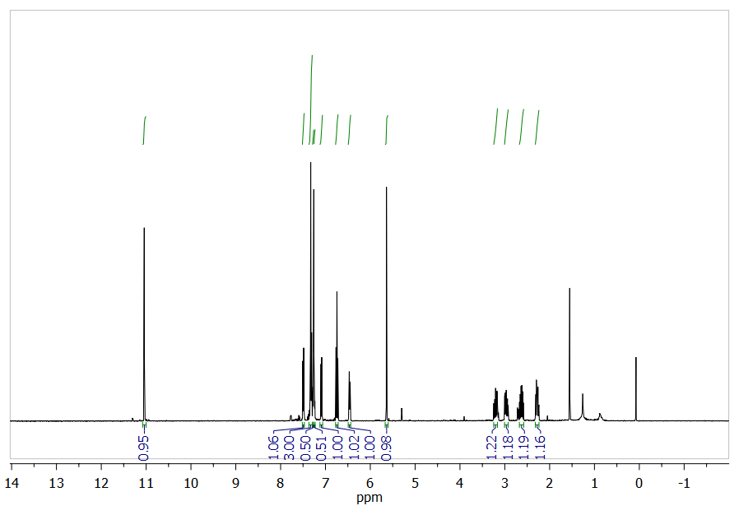
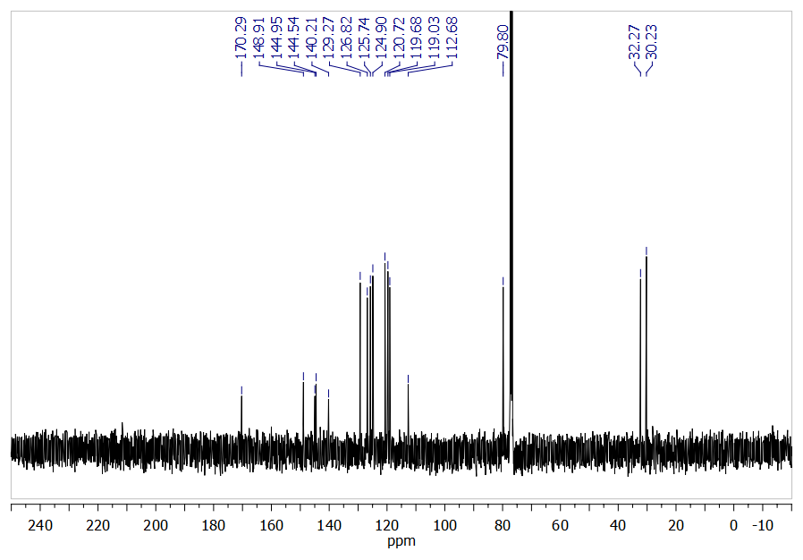
Cholesteryl-2,3-dihydroxybenzoate (7-H₂):
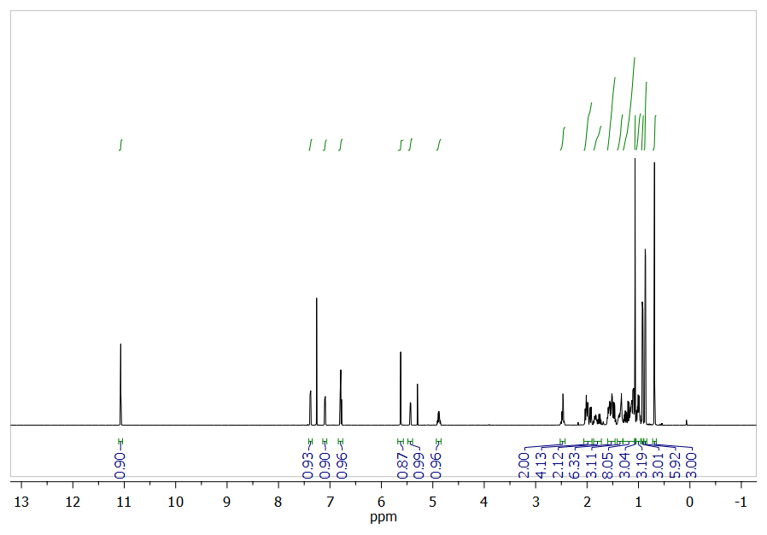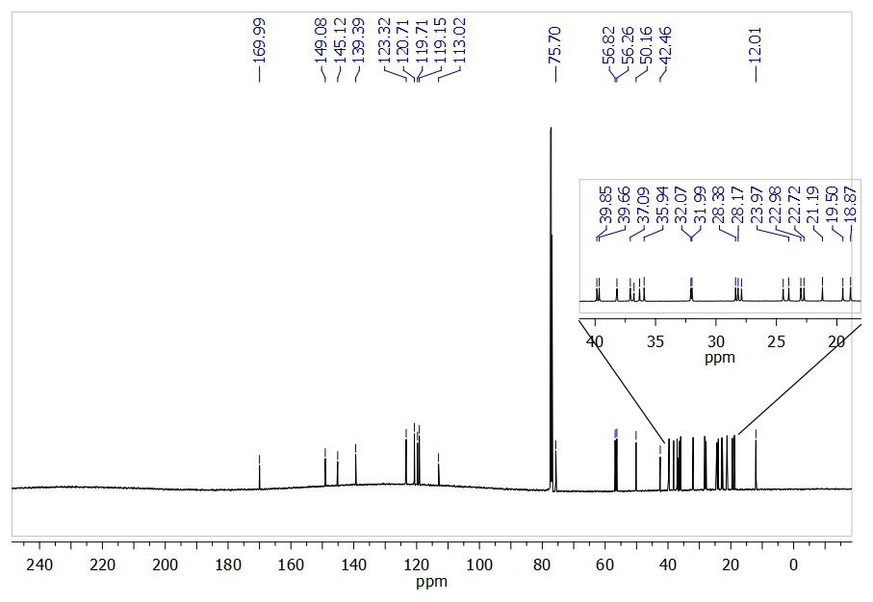
Tertbutyl-(2-hydroxyethyl)(isopropyl)carbamate (11c):

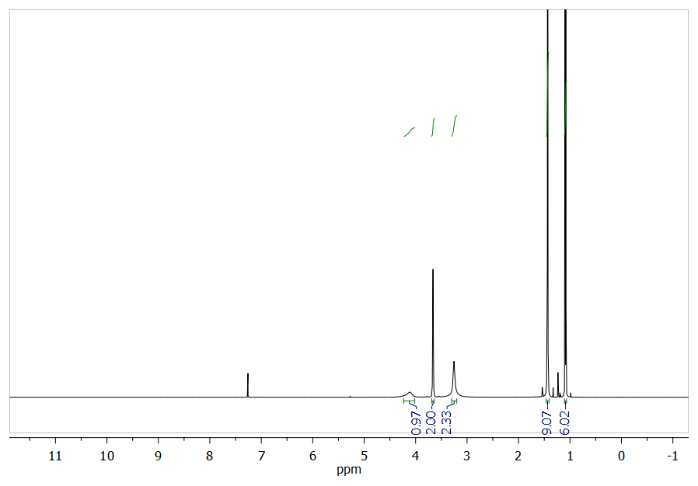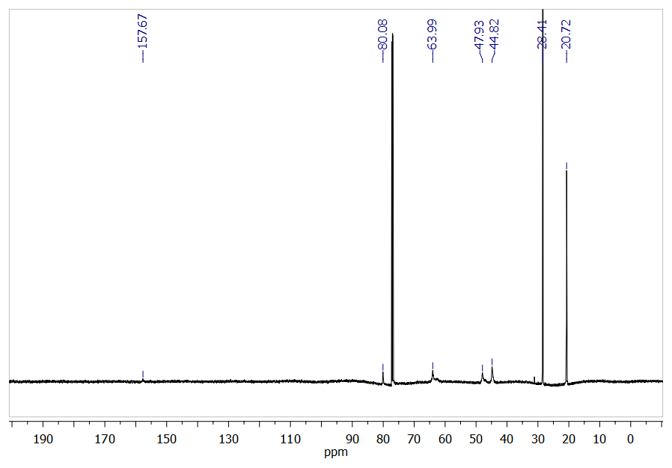
Tertbutyl-4-hydroxypiperidine-carboxylate (11d):
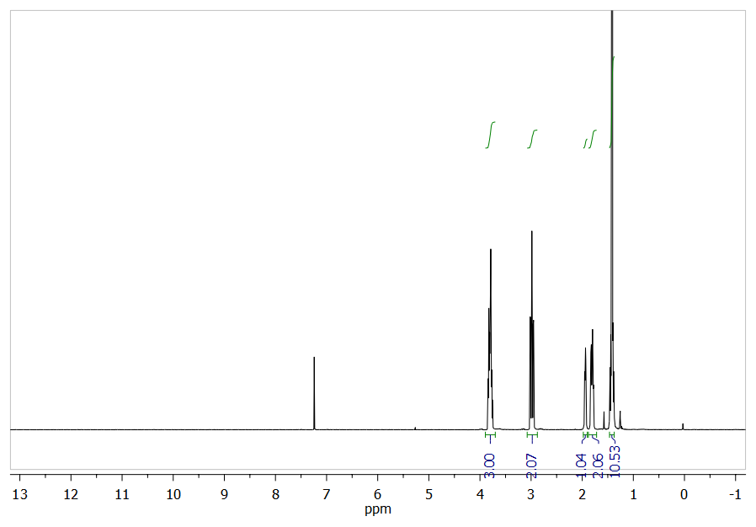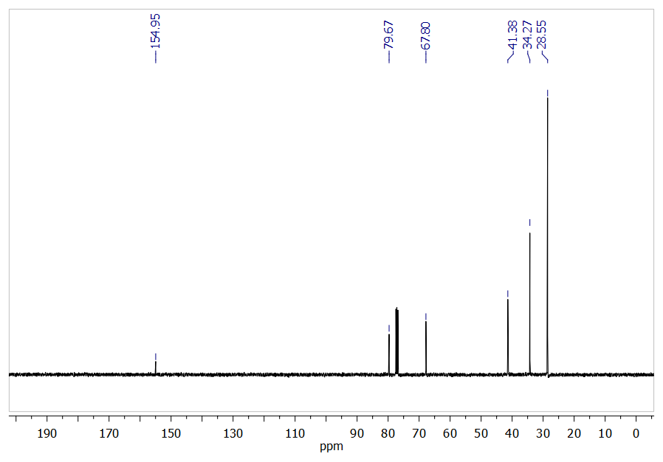
2-((Tertbutoxycarbonyl)(methyl)amino)ethyl-2,3-dihydroxybenzoate (12a):
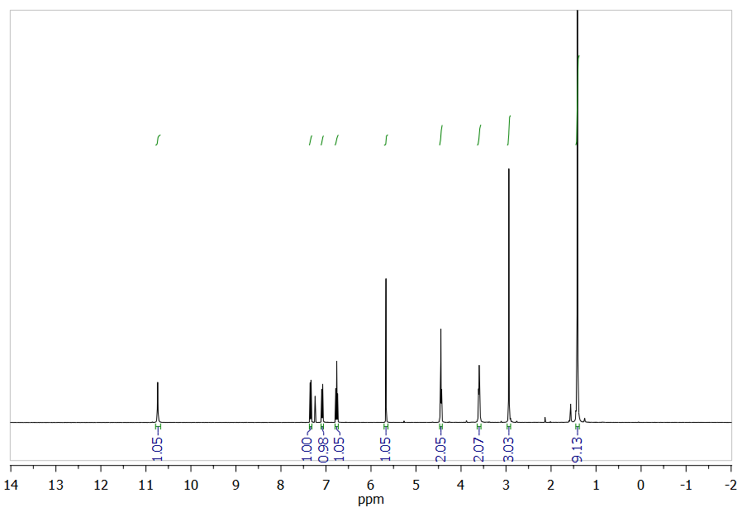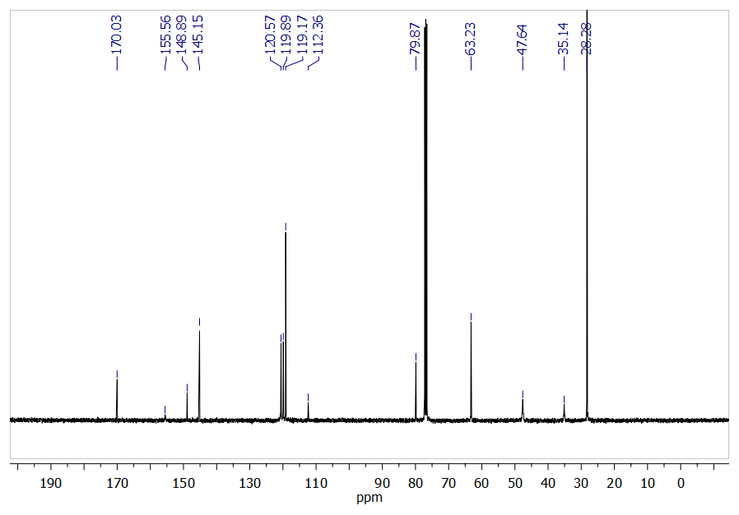
2-((Tertbutoxycarbonyl)(ethyl)amino)ethyl-2,3-dihydroxybenzoate (12b):
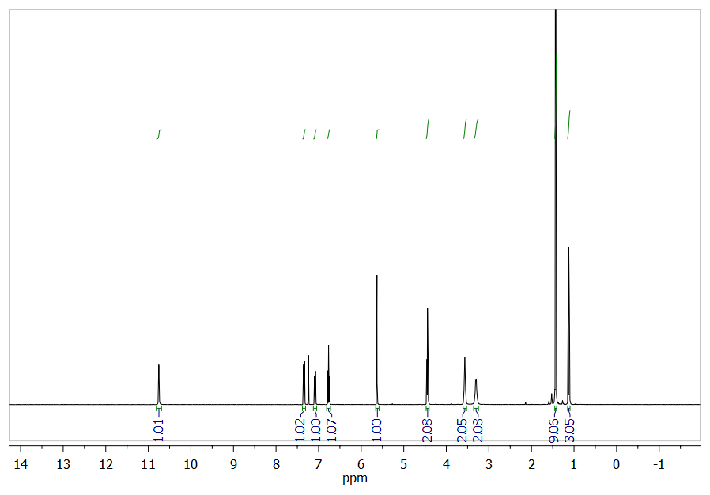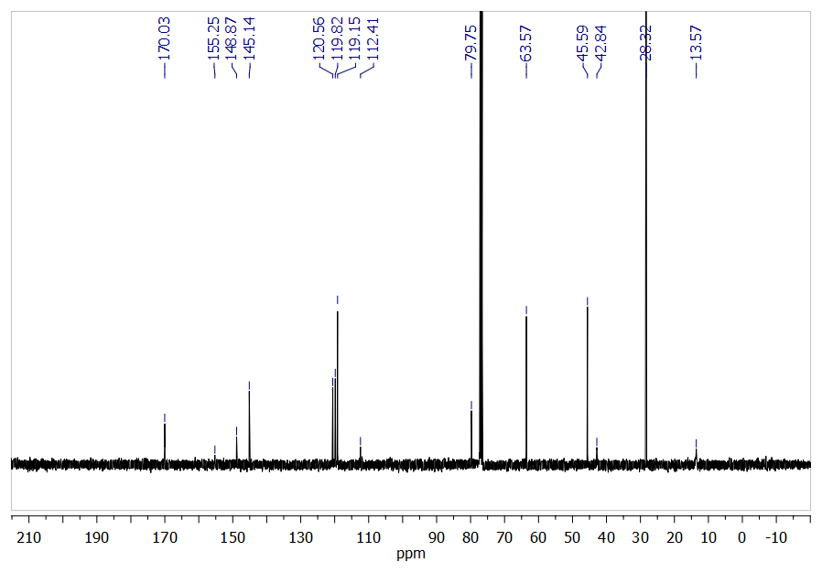
2-((Tertbutoxycarbonyl)(isopropyl)amino)ethyl-2,3-dihydroxy-benzoate (12c):
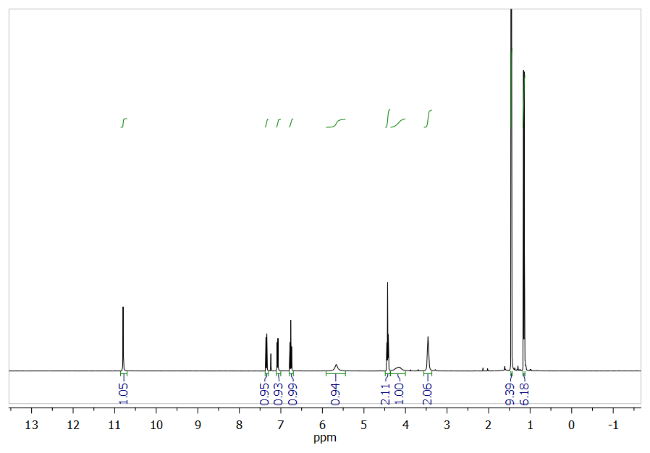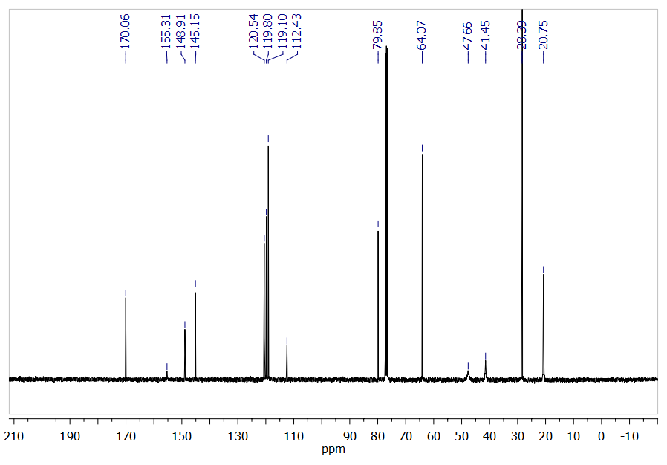
Tertbutyl-4-((2,3-dihydroxybenzoyl)oxy)piperidine-1-carboxylate (12d):
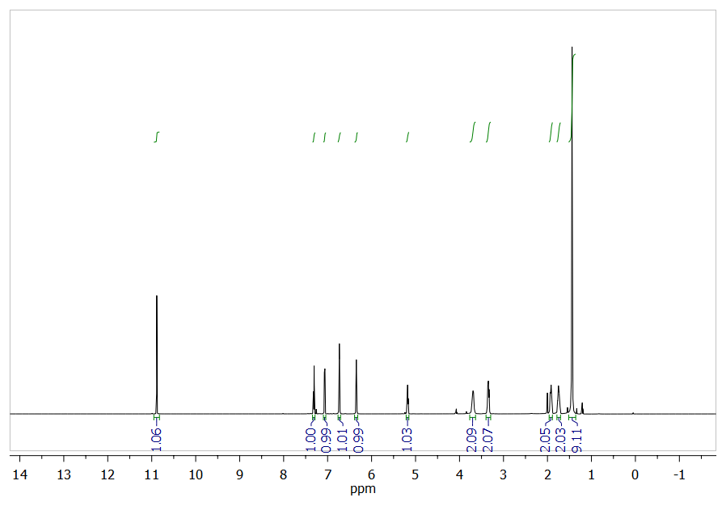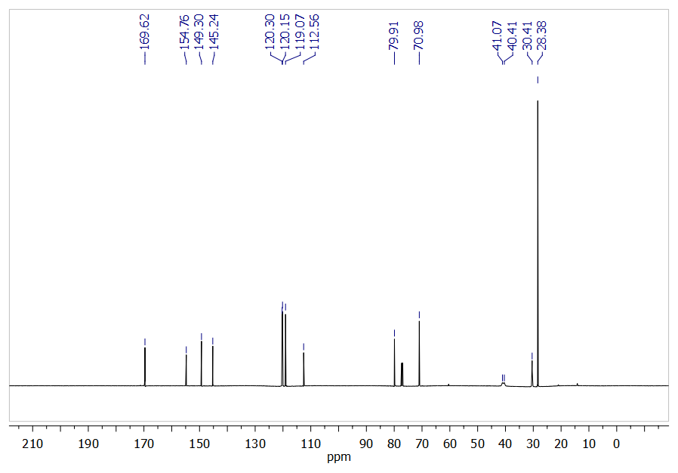
2-(Methylamino)ethyl-2,3-dihydroxybenzoate hydrochloride (13a-H₂):
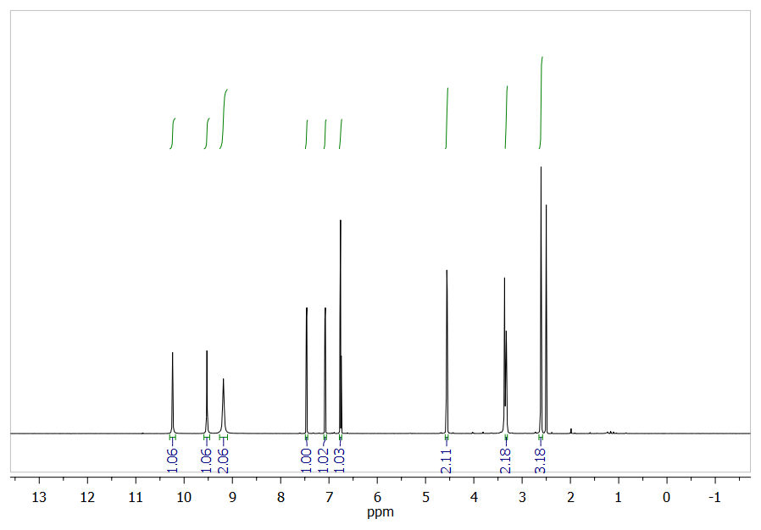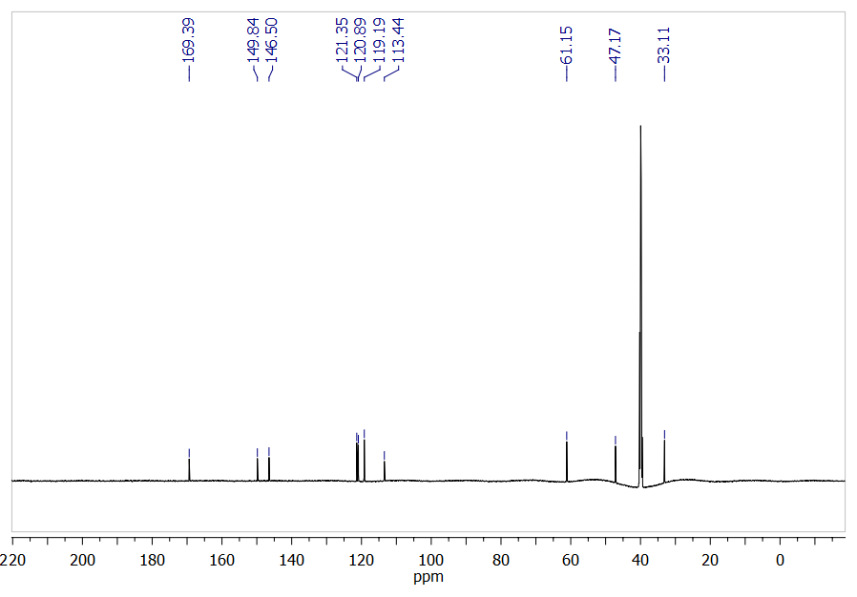
2-(Ethylamino)ethyl-2,3-dihydroxybenzoate hydrochloride (13b-H₂):
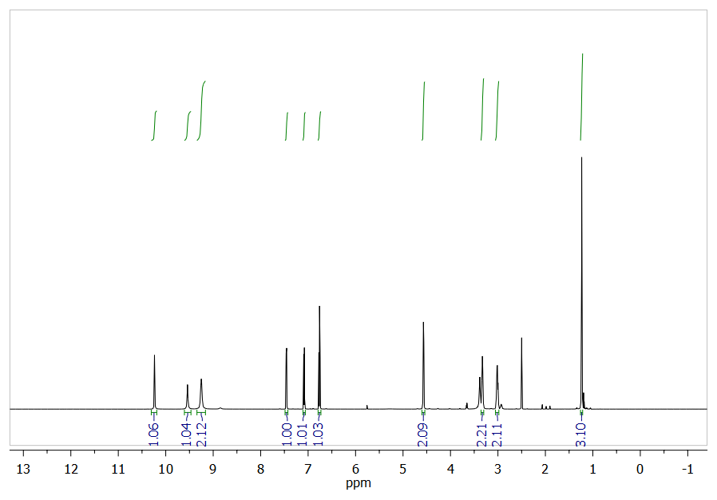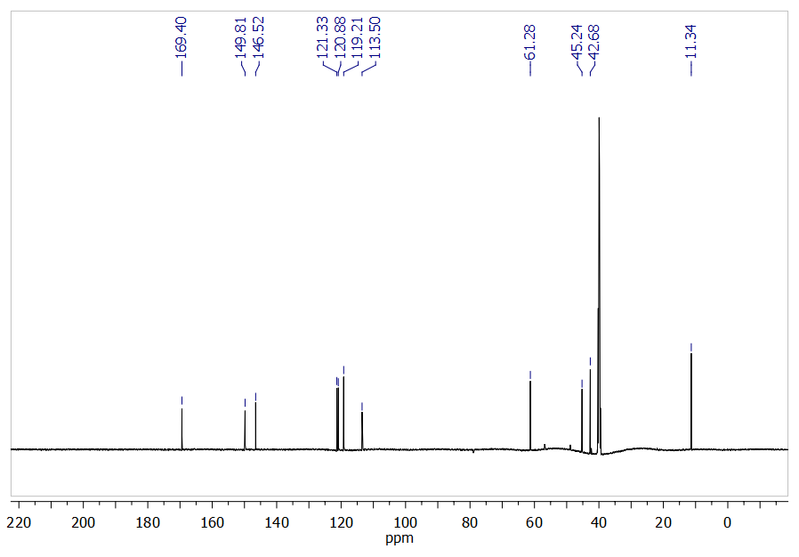
2-(Isopropylamino)ethyl-2,3-dihydroxybenzoate hydrochloride (13c-H₂):
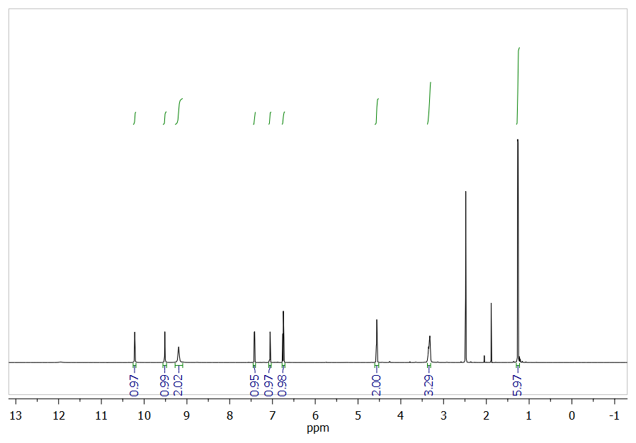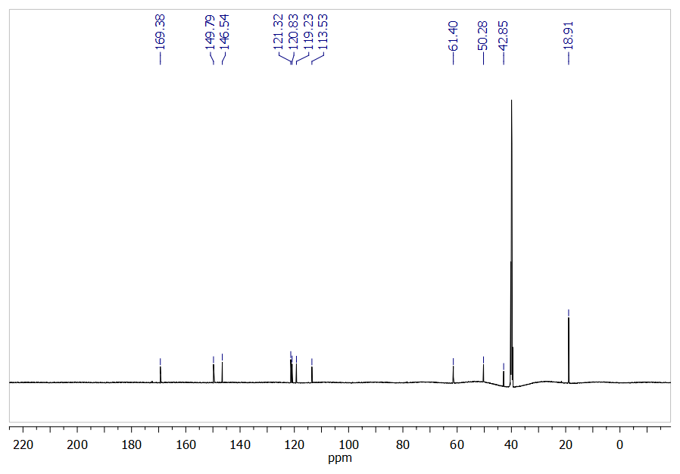
Piperidin-4-yl-2,3-dihydroxybenzoate hydrochloride (13d-H₂):
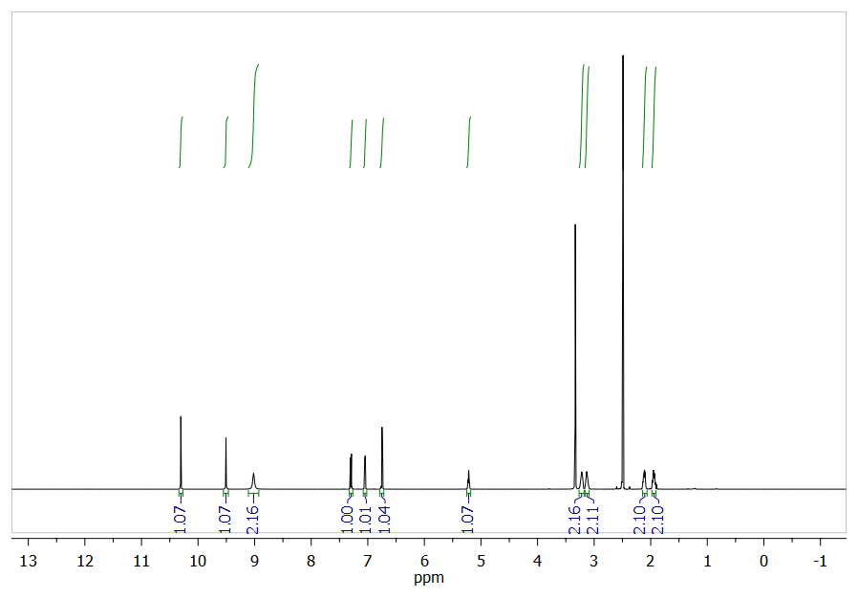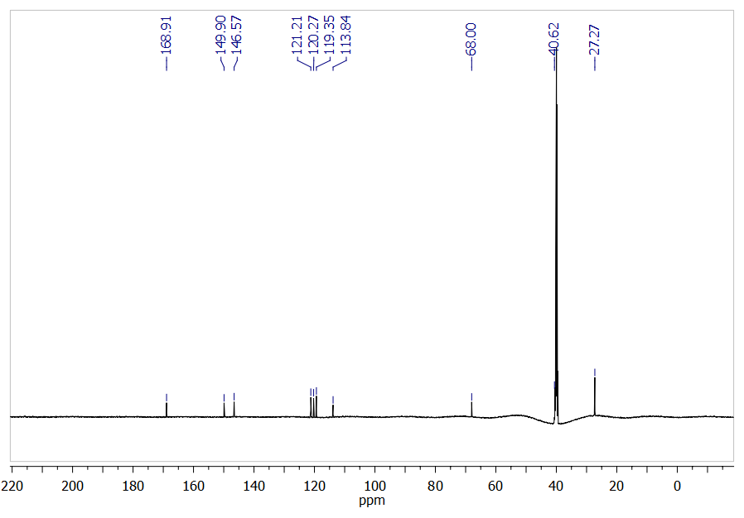

References:
- Van Craen, D.; Albrecht, M.; Raabe, G.; Pan, F.; Rissanen, K. Chem. Eur. J. 2016, 22, 3255-3258.
- Albrecht, M.; Isaak, E.; Baumert, M.; Gossen, V.; Raabe, G.; Fröhlich, R. Angew. Chem. 2011, 123, 2903-2906; Angew. Chem. Int. Ed. 2011, 50, 2850-2853.
- Albrecht, M.; Isaak, E.; Moha, V.; Raabe, G.; Fröhlich, R. Chem. Eur. J. 2014, 20, 6650-6658.
- Teitelbaum, A. M.; Meissner, A.; Harding, R. A.; Wong, C. A.; Aldrich, C. C.; Remmel, R. P. Bioorg. Med. Chem. 2013, 21, 5605-5617.
- Albrecht, M.; Isaak, E.; Shigemitsu, H.; Moha, V.; Raabe, G.; Fröhlich, R. Dalton Trans. 2014, 43, 14636-14643.
- (a) Krapcho, A. P.; Maresch, M. J.; Lunn, J. Synth. Commun. 1993, 23, 2443-2449. (b) Saari, W. S.; Schwering, J. E.; Lyle, P. A.; Smith, S. J.; Engelhardt, E. L. J. Med. Chem. 1990, 33, 97-101.
- (a) Seebach, D.; Goliński, J. Helv. Chim. Acta 1981, 64, 1413-1423. (b) Blarer, S. J.; Schweizer, W. B.; Seebach, D. Helv. Chim. Acta 1982, 65, 1637-1654. (c) Hayashi, Y.; Gotoh, H.; Hayashi, T.; Shoji, M. Angew. Chem. Int. Ed. 2005, 44, 4212-4215. (d) Burés, J.; Armstrong, A.; Blackmond, D. G. J. Am. Chem. Soc. 2011, 133, 8822-8825.
- Burés, J.; Armstrong, A.; Blackmond, D. G. J. Am. Chem. Soc. 2012, 134, 6741-6750.
- Husmann, R.; Jörres, M.; Raabe, G.; Bolm, C. Chem. Eur. J. 2010, 16, 12549.

