Supporting Information
for

Experimental investigation on the correlation between the physicochemical properties and catalytic activity of six DESs in Kabachnik-Fields reaction

Shaibuna Machingal and Sreekumar Krishnapillai*
Department of Applied Chemistry, Cochin University of Science and Technology, Cochin, India.
* E-mail: kskpolymer.cusat@gmail.com

Content | Page no
GC-MS spectra of imine formed (intermediate)  Spectral data, GC- MS, ¹H and ¹³C spectra of the of compounds | 2  2-37

Gas chromatogram of the imine formed from benzaldehyde and aniline in DES 1 (MW- 181)
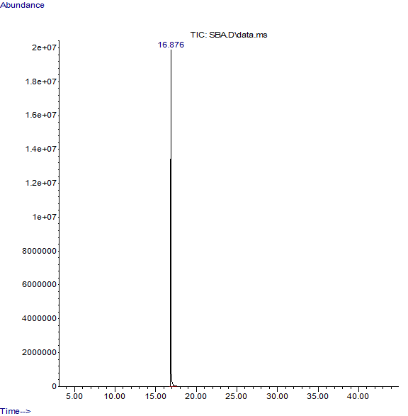
Mass spectrum of the imine formed from benzaldehyde and aniline in DES 1
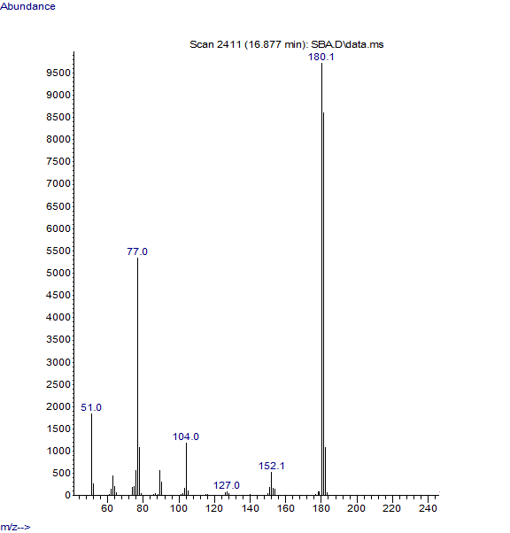

- Dimethyl (phenyl-phenylaminomethyl)phosphonate
White solid; m. p. 91 °C; GC-MS (M⁺): 291
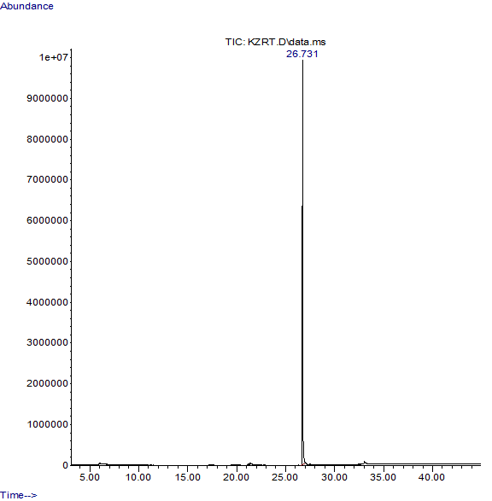
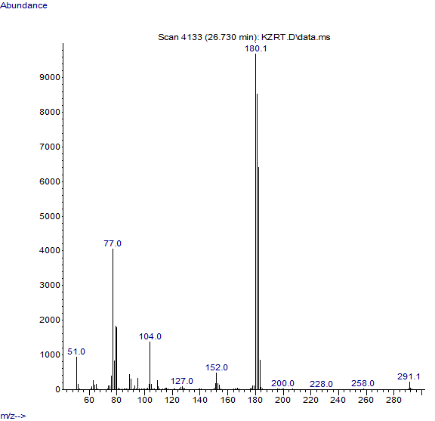

- Dimethyl [(phenyl)-(3-chlorophenylamino)methyl]phosphonate
White solid; GC-MS (M⁺): 325
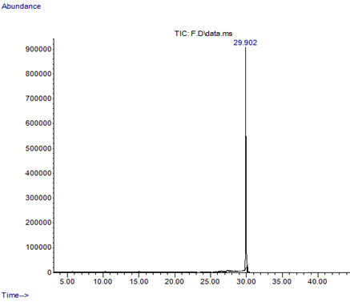
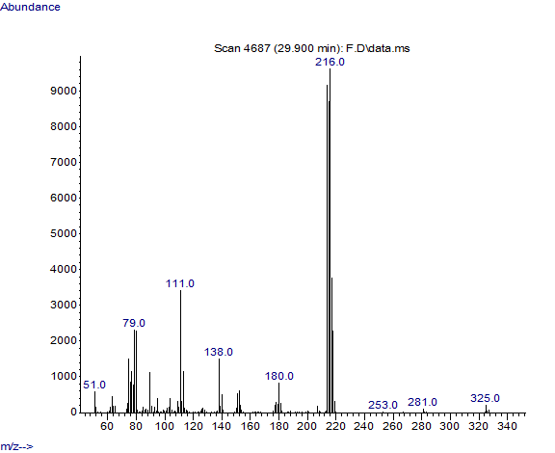

- Dimethyl [(phenyl)-(4-bromophenylamino)methyl]phosphonate
White solid; m. p. 97 °C; GC-MS (M⁺): 370; ¹H NMR (400 MHz, CDCl₃): δ (ppm) 7.43 (d, J = 7.4 Hz, 2H), 7.38 – 7.22 (m, 3H), 7.16 (d, J = 8.8 Hz, 2H), 6.48 (d, J = 8.9 Hz, 2H), 4.74 (d, J = 24.4 Hz, 1H), 3.75 (d, J = 10.7 Hz, 3H), 3.44 (d, J = 10.6 Hz, 3H); ¹³C NMR (100 MHz, CDCl₃): δ(ppm) 145.31, 135.10, 131.99, 130.10, 128.91, 127.88, 115.60, 110.37, 56.44, 54.93, 54.04.

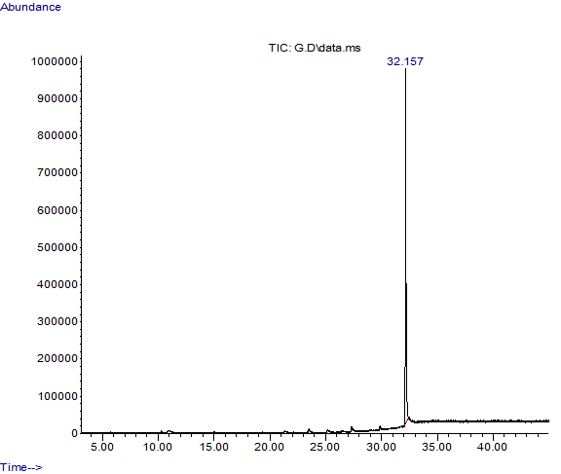
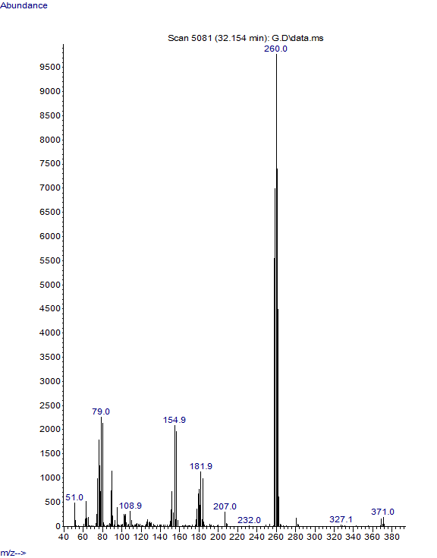
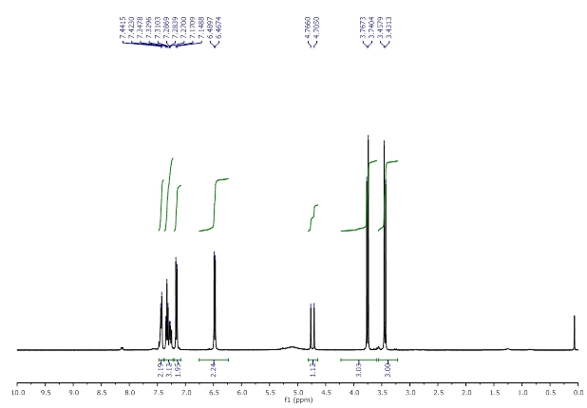

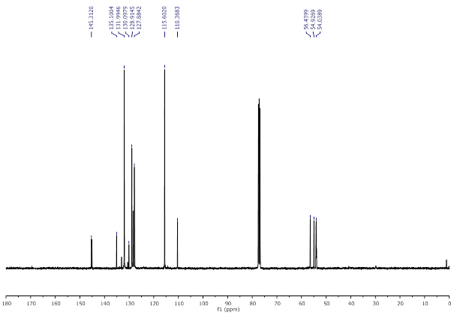

- Dimethyl [(phenyl)-(4-methoxyphenylamino)methyl]phosphonate
White solid; m. p. 86 °C; GC-MS (M⁺): 321; ¹H NMR (400 MHz, CDCl₃): δ (ppm) 7.50 – 7.41 (m, 2H), 7.37 – 7.23 (m, 3H), 6.68 (d, J = 9.0 Hz, 2H), 6.55 (d, J = 9.0 Hz, 2H), 4.73 (d, J = 24.1 Hz, 1H), 3.76 (d, J = 10.7 Hz, 3H), 3.66 (s, 3H), 3.47 (d, J = 10.5 Hz, 3H); ¹³C NMR (100 MHz, CDCl₃): δ(ppm) 152.83, 140.08, 135.78, 128.79, 128.11, 127.90, 115.39, 114.83, 57.42, 55.71, 53.90, 53.83.
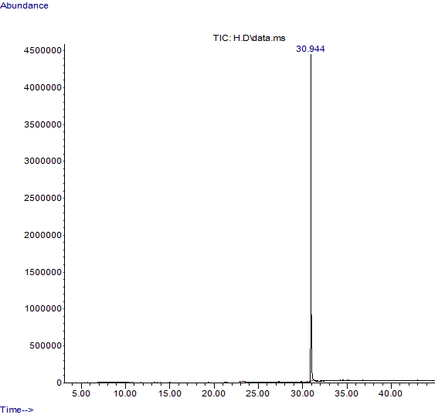
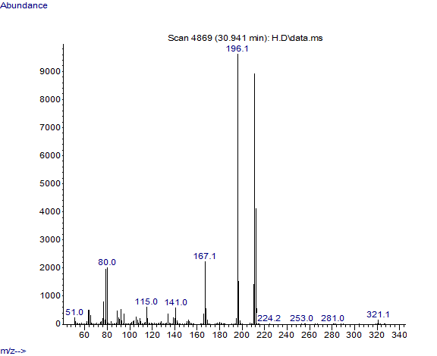
- Dimethyl [(4-chlorophenyl)phenylaminomethyl]phosphonate
White solid; m. p. 113 °C. GC-MS (M⁺): 325; ¹H NMR (400 MHz, CDCl₃) δ (ppm): 7.40 (dd, J = 8.5, 2.2 Hz, 2H), 7.37 – 7.22 (m, 2H), 7.10 (t, J = 7.9 Hz, 2H), 6.71 (t, J = 7.3 Hz, 1H), 6.55 (d, J = 8.0 Hz, 2H), 4.76 (d, J = 24.8 Hz, 2H), 3.75 (d, J = 10.8 Hz, 3H), 3.53 (d, J = 10.5 Hz, 3H); ¹³C NMR (100 MHz, CDCl₃) δ 145.93, 134.34, 133.97, 129.34, 129.15, 129.02, 118.92, 113.96, 55.99, 53.94.
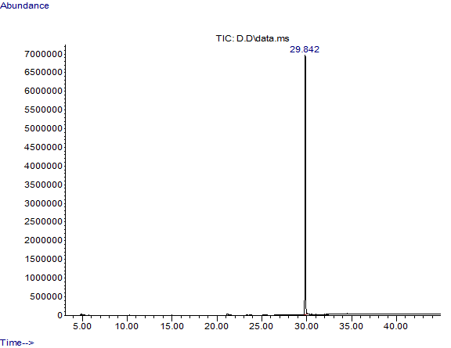

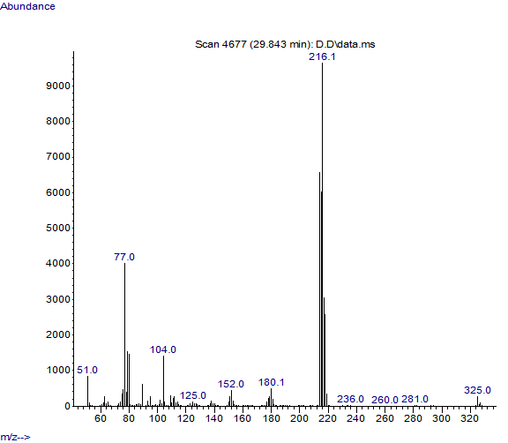

- Dimethyl [(4-chlorophenyl)-(3-chlorophenylamino)methyl]phosphonate
Yellow solid; mp: 134 °C; GC-MS (M⁺): 359.
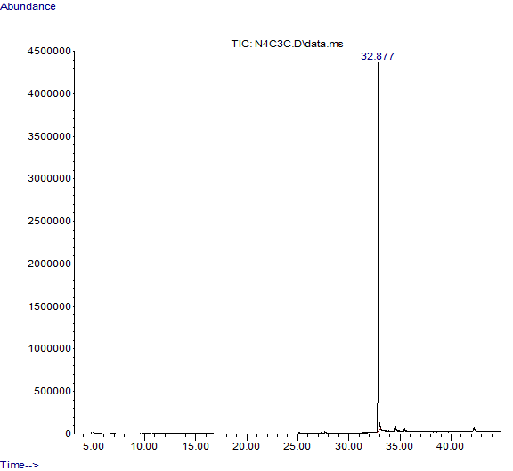
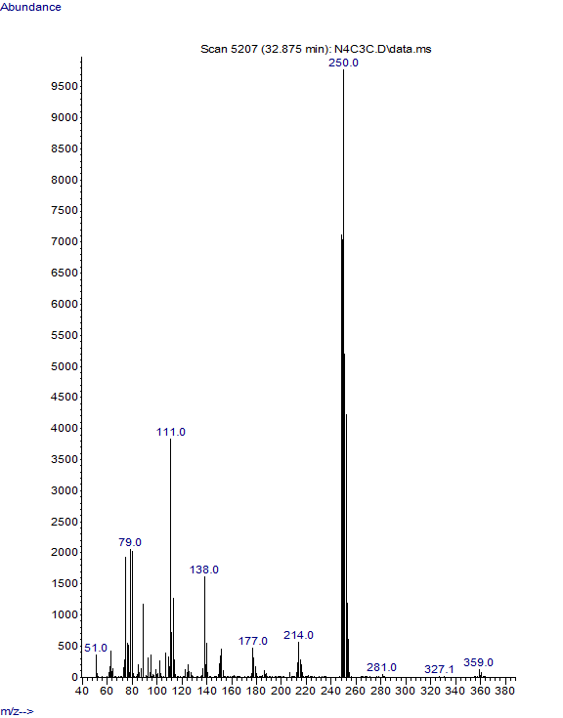
- Dimethyl [(4-chlorophenyl)-(4-bromophenylamino)methyl]phosphonate
Green colored solid, mp: 106 °C; GC-MS (M⁺): 355. ¹H NMR (400 MHz, CDCl₃) δ (ppm) 7.37 (d, J = 2.3 Hz, 2H), 7.30 (d, J = 8.4 Hz, 2H), 6.68 (d, J = 8.9 Hz, 2H), 6.50 (d, J = 8.9 Hz, 2H), 4.69 (d, J = 24.2 Hz, 1H), 3.75 (d, J = 10.7 Hz, 3H), 3.67 (s, 3H), 3.54 (d, J = 10.6 Hz, 3H); ¹³C NMR (100 MHz, CDCl₃) δ 153.03, 139.88, 134.49, 133.95, 129.24, 129.01, 115.40, 114.87, 57.17, 55.71, , 53.90.
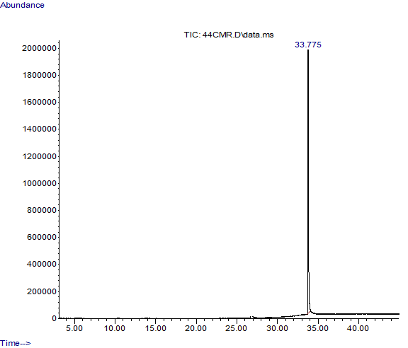
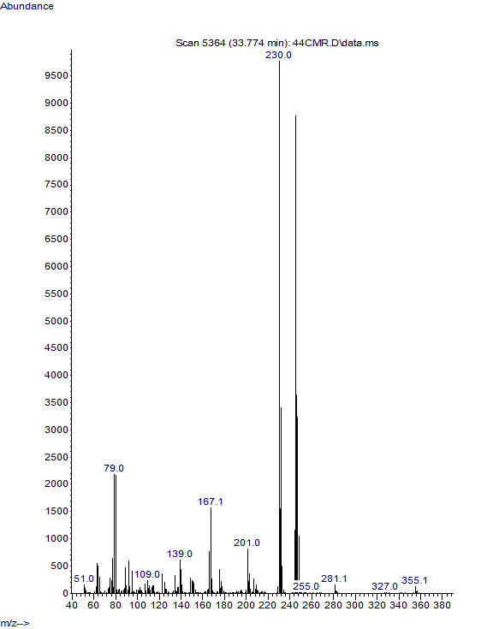

- Dimethyl (2-methoxyphenyl)(phenylamino)methylphosphonate
White solid, GC-MS (M⁺): 321; ¹H NMR (400 MHz, CDCl₃) δ (ppm) 7.49 – 7.43 (m, 1H), 7.27 – 7.20 (m, 1H), 7.13 – 7.04 (m, 2H), 6.96 – 6.87 (m, 2H), 6.71 – 6.57 (m, 3H), 5.42 (d, J = 24.7 Hz, 1H), 3.93 (s, 3H), 3.80 (d, J = 10.7 Hz, 3H), 3.42 (d, J = 10.5 Hz, 3H); ¹³C NMR (100 MHz, CDCl₃) δ 157.28, 146.08, 129.22, 128.32, 124.25, 121.19, 118.38, 113.68, 110.69, 55.92, 53.84, 53.78, 46.96.
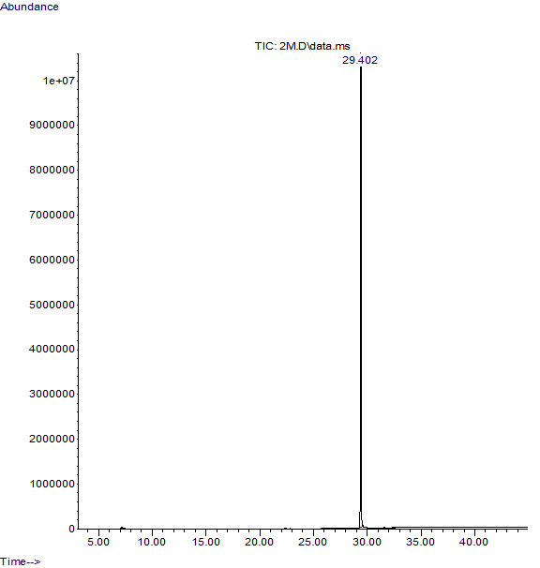
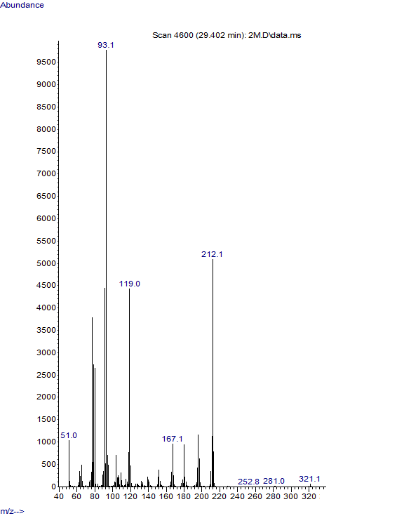

- Dimethyl [(2-methoxyphenyl)-(3-chlorophenylamino)methyl]phosphonate
White solid, GC-MS (M⁺): 355, MP- 140 ℃, ¹H NMR (400 MHz, CDCl₃) ) δ (ppm) 7.79 – 7.37 (m, 1H), 7.34 – 7.16 (m, 1H), 7.04 – 6.83 (m, 3H), 6.68 – 6.54 (m, 2H), 6.47 (dd, J = 7.4, 1.9 Hz, 1H), 5.35 (d, J = 24.7 Hz, 1H), 3.94 (s, 3H), 3.79 (d, J = 10.6 Hz, 3H), 3.41 (d, J = 10.4 Hz, 3H). ¹³C NMR (100 MHz, CDCl₃) δ 157.22, 147.48, 147.33, 134.93, 130.19, 129.49, 129.46, 128.36, 128.31, 123.74, 121.28, 121.26, 118.27, 113.45, 112.03, 110.81, 55.95, 53.97, 53.90, 48.23, 46.66.

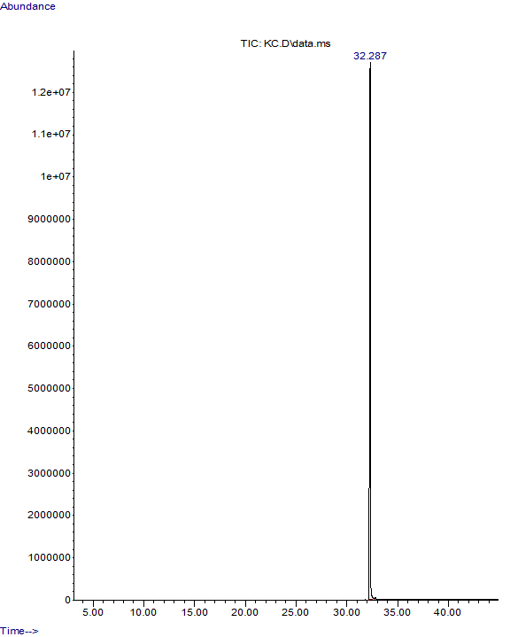
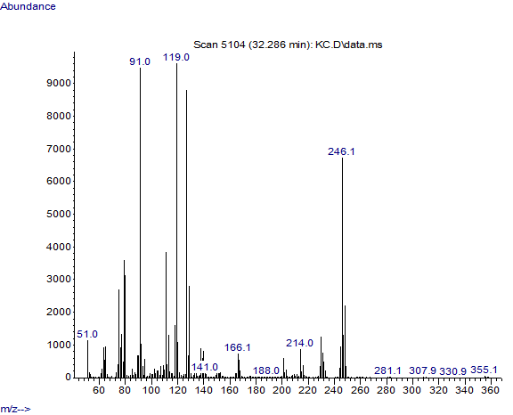
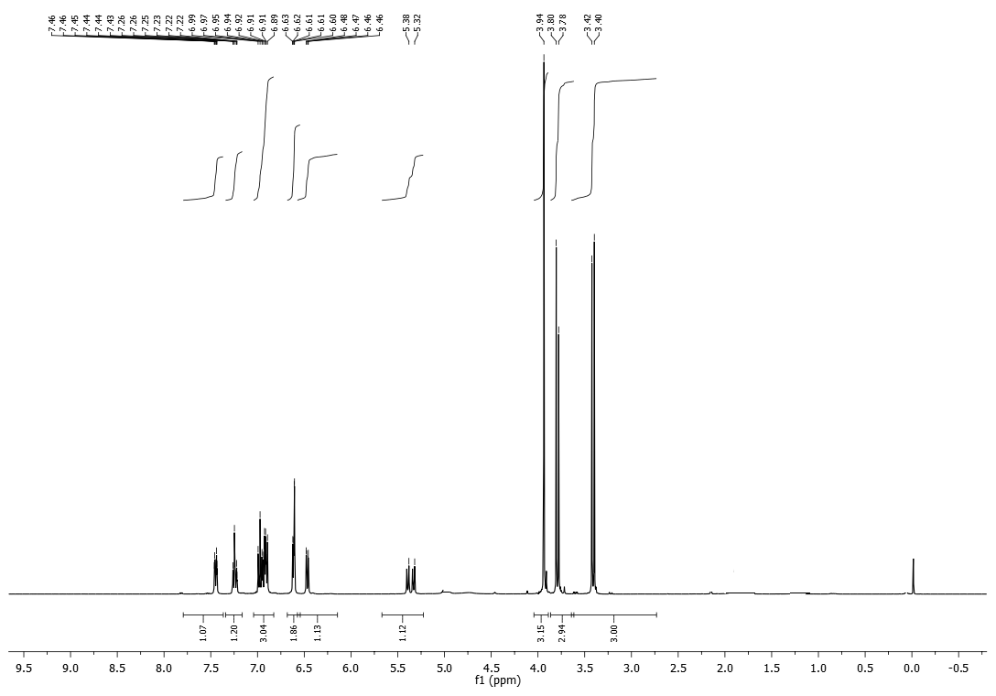

- Dimethyl [(2-methoxyphenyl)-(4-bromophenylamino)methyl]phosphonate
White solid, MP- 149 ℃, GC-MS (M⁺): 399. ¹H NMR (400 MHz, CDCl₃) ) δ (ppm) 7.53 – 7.34 (m, 1H), 7.31 – 7.07 (m, 3H), 7.00 – 6.82 (m, 2H), 6.60 – 6.35 (m, 2H), 5.33 (d, J = 24.6 Hz, 1H), 3.92 (s, 3H), 3.79 (d, J = 10.6 Hz, 3H), 3.40 (d, J = 10.4 Hz, 3H).¹³C NMR (100 MHz, CDCl₃) δ 157.19, 145.28, 131.95, 129.43, 129.40, 128.25, 128.21, 123.70, 121.25, 121.23, 115.32, 110.72, 110.14, 55.92, 53.94, 53.87, 48.54, 46.98.
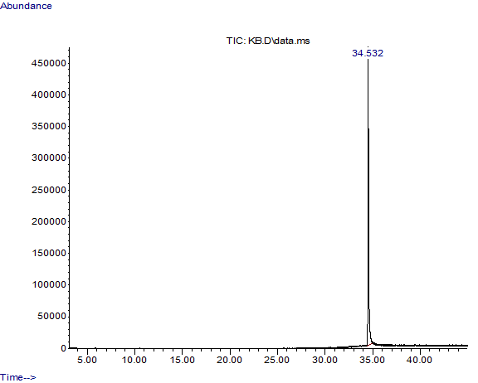
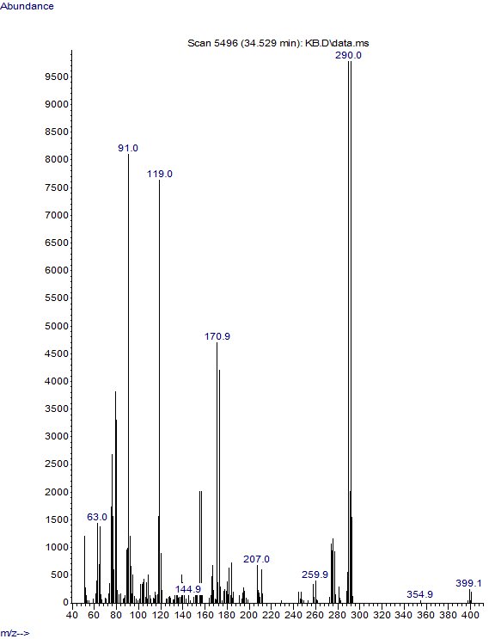
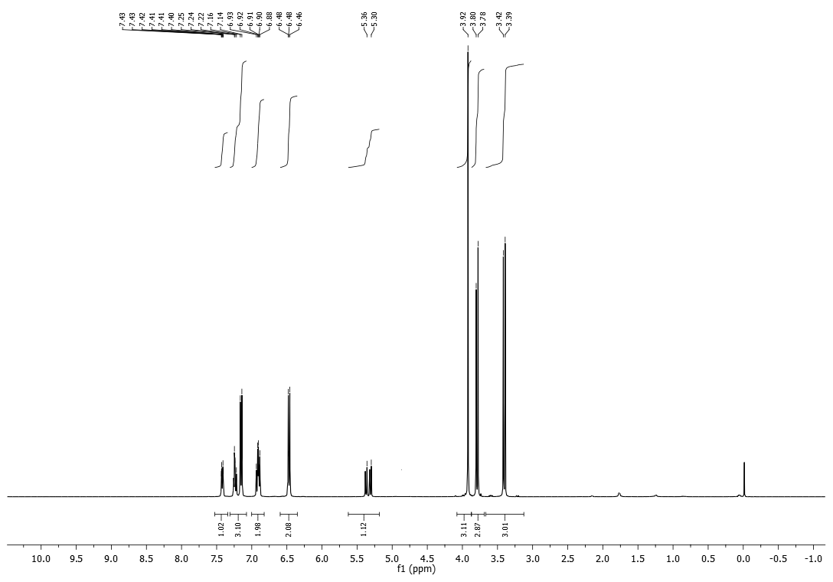

- Dimethyl [(2-methoxyphenyl)-(4-methoxyphenylamino)methyl]phosphonate
Brown crystals, MP- 132 ℃, GC-MS (M⁺): 351, ¹H NMR (400 MHz, CDCl₃) ) δ (ppm) 7.46 – 7.44 (d, 1H), 7.25(m, 1H), 7.25 – 7.21 (m, 2H), 6.94 – 6.88 (m, 2H), 6.69 – 6.55 (m, 2H), 5.32 (d, J = 24.6 Hz, 1H), 3.92 (s, 3H), 3.79 (d, J = 10.6 Hz, 3H), 3.42 (d, J = 10.4 Hz, 3H).¹³C NMR (100 MHz, CDCl₃) δ 157.285, 152.659, 140.236, 129.148, 128.303, 124.347, 121.182, 114.987, 114. 756, 55.657, 53,667, 49.395, 47.852.

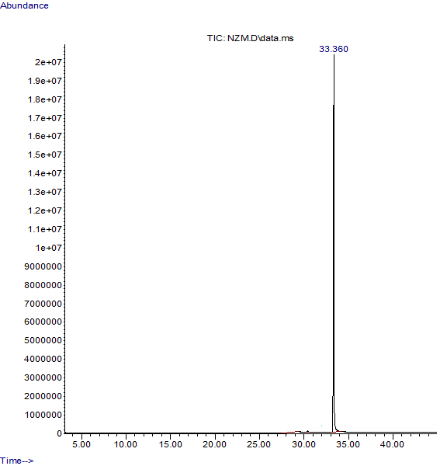
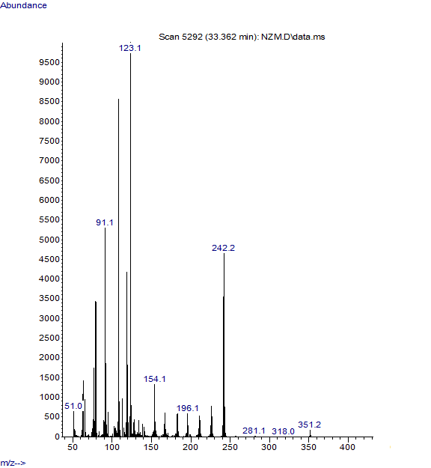
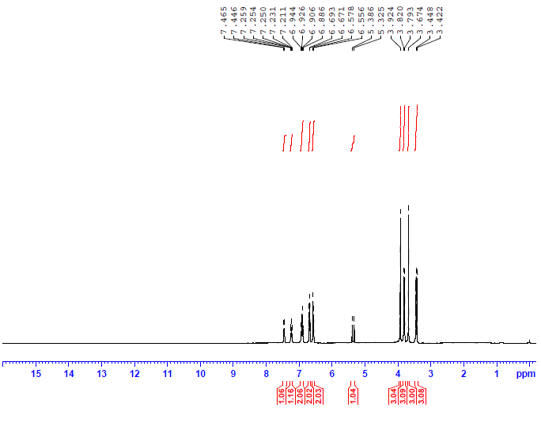

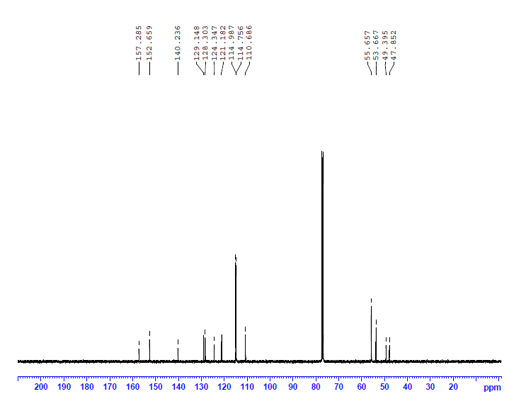
- Dimethyl [(4-methoxyphenyl)phenylaminomethyl]phosphonate
Greenish blue solid, mp: 125 °C; GC-MS (M⁺): 321; ¹H NMR (400 MHz, CDCl₃) ) δ (ppm) 7.43 – 7.33 (m, 2H), 7.09 (dd, J = 8.4, 7.4 Hz, 2H), 6.86 (d, J = 8.6 Hz, 2H), 6.69 (t, J = 7.3 Hz, 1H), 6.63 – 6.54 (m, 2H), 4.74 (d, J = 23.1 Hz, 2H), 3.75 (d, J = 10.9 Hz, 6H), 3.48 (d, J = 10.5 Hz, 3H); ¹³C NMR (100 MHz, CDCl₃) δ 159.49, 159.46, 146.27, 146.12, 129.26, 129.03, 128.97, 127.41, 118.59, 114.29, 114.27, 114.00, 55.84, 55.30, 54.30, 53.90.
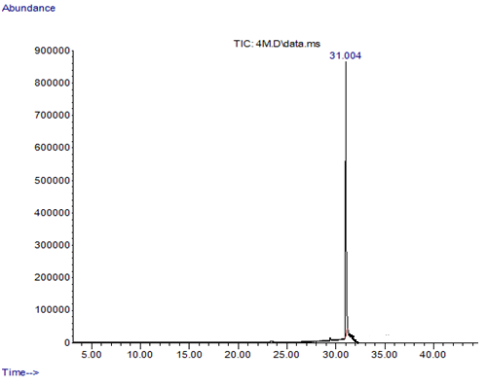
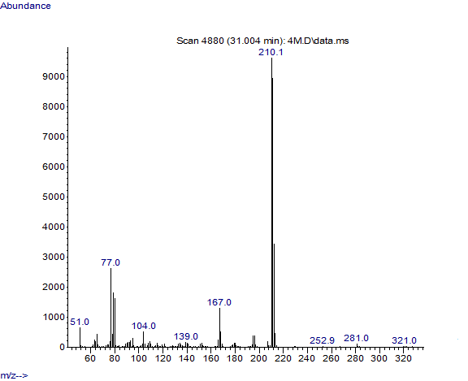

- Dimethyl [(4-methoxyphenyl)-(3-chlorophenylamino)methyl]phosphonate
mp: 91 °C; GC-MS (M⁺): 355; ¹H NMR (400 MHz, CDCl₃) ) δ (ppm) 7.41 – 7.30 (m, 2H), 6.99 (t, J = 8.1 Hz, 1H), 6.87 (d, J = 8.6 Hz, 2H), 6.73 – 6.60 (m, 1H), 6.57 (t, J = 2.1 Hz, 1H), 6.45 (dd, J = 8.1, 2.1 Hz, 1H), 4.68 (d, J = 23.8 Hz, 1H), 3.77 (s, 3H), 3.74 (d, J = 10.7 Hz, 3H), 3.46 (d, J = 10.6 Hz, 3H); ¹³C NMR (100 MHz, CDCl₃) δ 159.62, 147.49, 134.96, 130.24, 128.93, 126.88, 126.85, 118.50, 114.39, 113.80, 112.15, 55.65, 55.32, 54.10, 54.04.
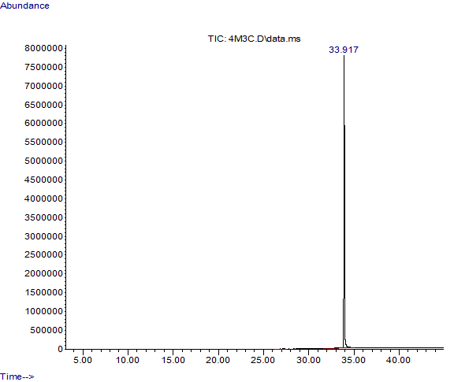
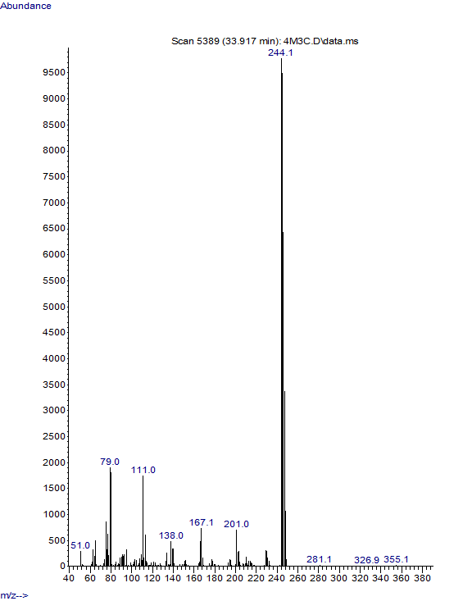

- Dimethyl phenylamino-(3, 4-dimethoxyphenyl)methyl]phosphonate
White solid, mp: 78 °C; GC-MS (M⁺): 351.
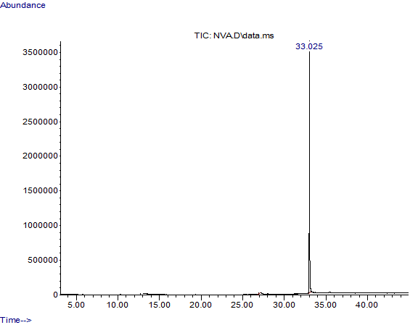
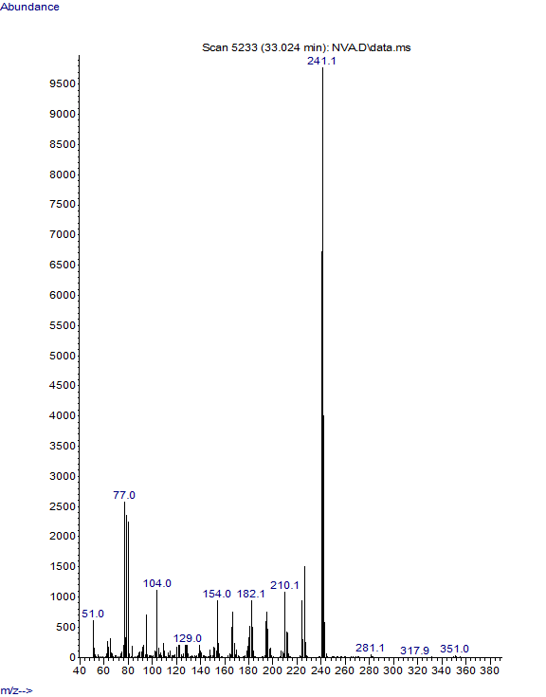

- Dimethyl (3-chlorophenylamino) (3,4-dimethoxyphenyl) methyl phosphonate
White solid, MP- 128 ℃, GC-MS (M⁺): 385, ¹H NMR (400 MHz, CDCl₃) δ 7.01 (ppm) (dd, J = 12.8, 4.9 Hz, 3H), 6.84 (d, J = 7.9 Hz, 1H), 6.67 (ddd, J = 7.9, 1.8, 0.8 Hz, 1H), 6.60 (t, J = 2.1 Hz, 1H), 6.46 (ddd, J = 8.2, 2.3, 0.8 Hz, 1H), 4.65 (d, J = 23.8 Hz, 1H), 3.85 (d, J = 7.2 Hz, 6H), 3.75 (d, J = 10.7 Hz, 3H), 3.47 (d, J = 10.5 Hz, 3H). ¹³C NMR (101 MHz, CDCl₃) δ 148.97, 147.34, 134.90, 130.19, 127.31, 120.15, 118.50, 113.73, 112.08, 111.25, 110.62, 55.86, 54.02, 53.72.
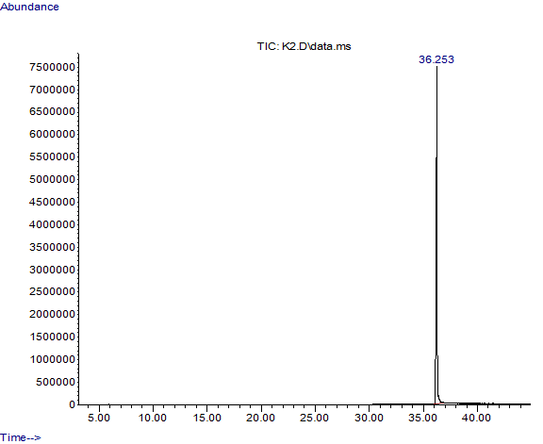
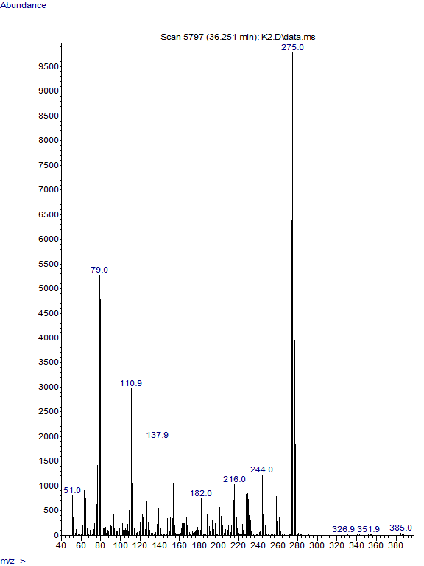

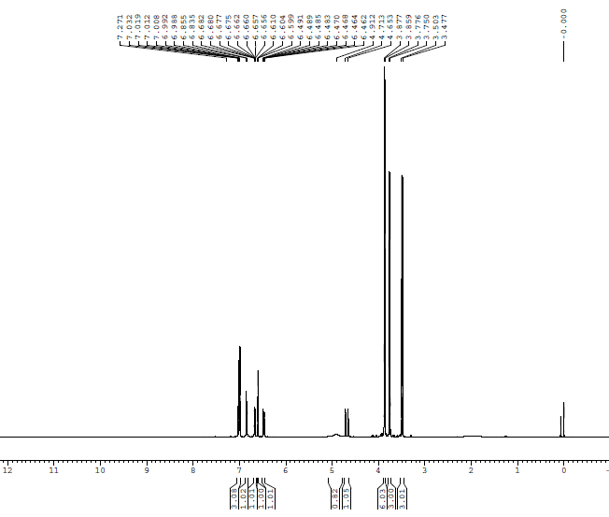

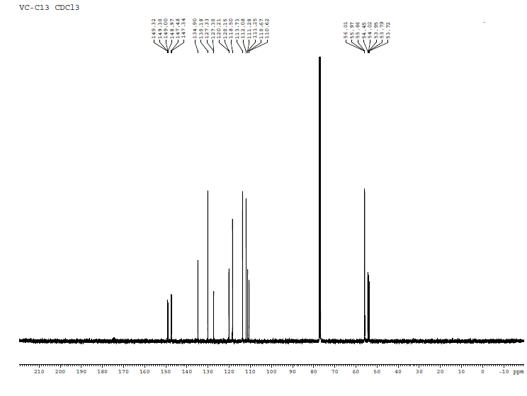

- Dimethyl (4-bromophenylamino) (3,4-dimethoxyphenyl) methyl phosphonate
White solid, MP- 92 ℃, GC-MS (M⁺): 431, ¹H NMR (400 MHz, CDCl₃) δ 7.26 – 7.00 (m, 2H), 6.98 (t, J = 4.8 Hz, 2H), 6.84 (d, J = 8.5 Hz, 1H), 6.49 (d, J = 8.9 Hz, 2H), 4.67 (d, J = 23.8 Hz, 1H), 3.86 (d, J = 6.0 Hz, 6H), 3.76 (d, J = 10.7 Hz, 3H), 3.49 (d, J = 10.5 Hz, 3H), ¹³C NMR (101 MHz, CDCl₃) δ 149.31, 148.97, 145.29, 145.14, 131.93, 127.27, 120.15, 115.55, 111.24, 110.62, 110.41, 55.86, 54.65, 53.73.
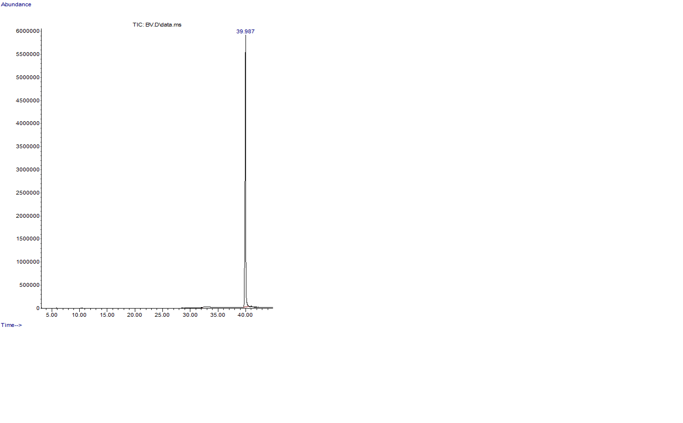
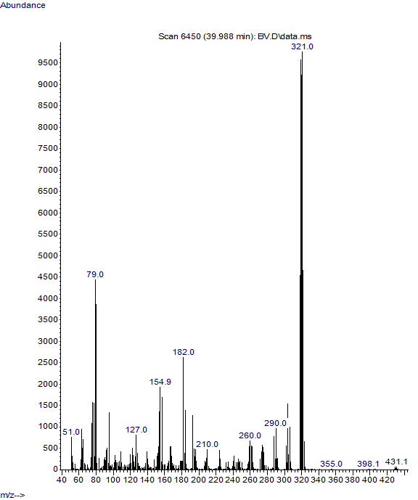
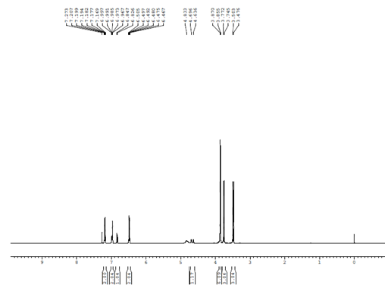
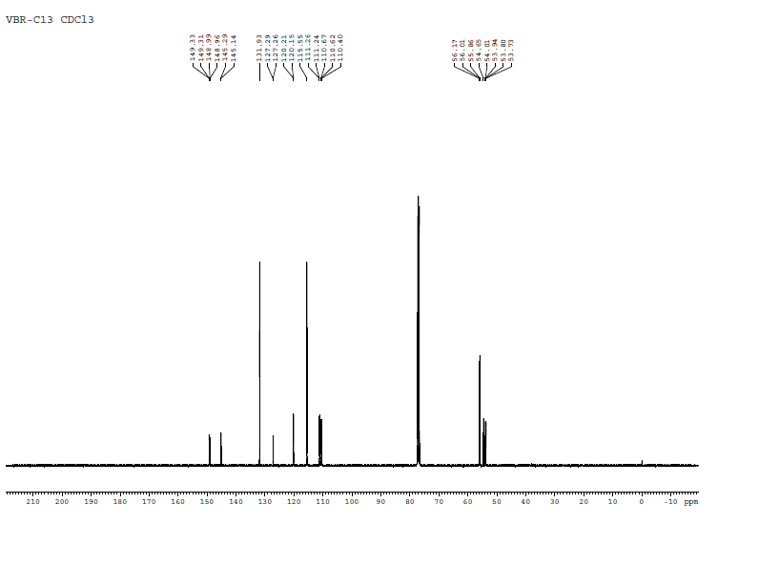
- Dimethyl phenylamino-(3, 4, 5-trimethoxyphenyl)methyl]phosphonate
Yellowish green solid, mp: 136 °C; GC-MS (M⁺): 381.
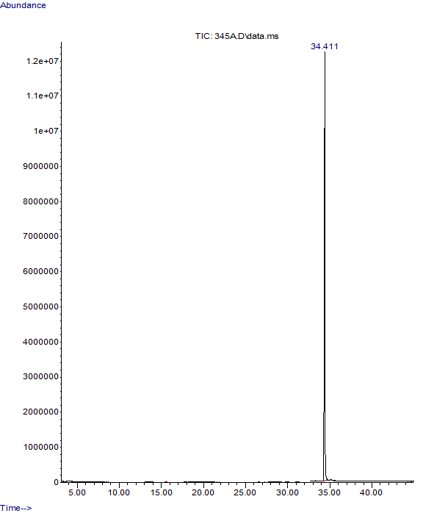
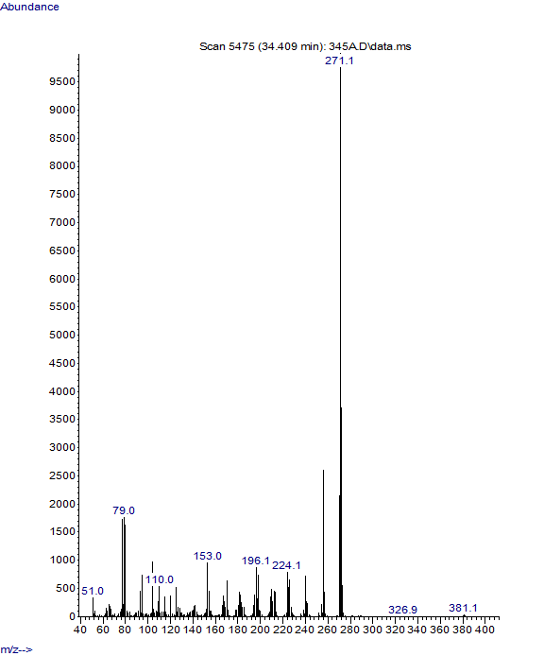
- Dimethyl (3-chlorophenylamino) (3,4,5-dimethoxyphenyl) methyl phosphonate
White solid, MP- 158 ℃, GC-MS (M⁺): 415, ¹H NMR (400 MHz, CDCl₃) δ 7.04 (t, J = 8.1 Hz, 1H), 6.69 (dd, J = 5.6, 1.6 Hz, 3H), 6.62 (t, J = 2.1 Hz, 1H), 6.49 (ddd, J = 8.2, 2.3, 0.6 Hz, 1H), 4.66 (d, J = 24.0 Hz, 1H), 3.85 (s, 6H), 3.83 (s, 3H), 3.77 (d, J = 10.7 Hz, 3H), 3.52 (d, J = 10.6 Hz, 3H), ¹³C NMR (100 MHz, CDCl₃) δ 153.57, 153.54, 147.48, 147.33, 137.91, 137.87, 134.94, 130.68, 130.65, 130.25, 118.62, 113.68, 112.01, 104.75, 104.69, 60.86, 60.84, 56.51, 56.23, 55.00, 54.04, 53.97, 53.82, 53.75.

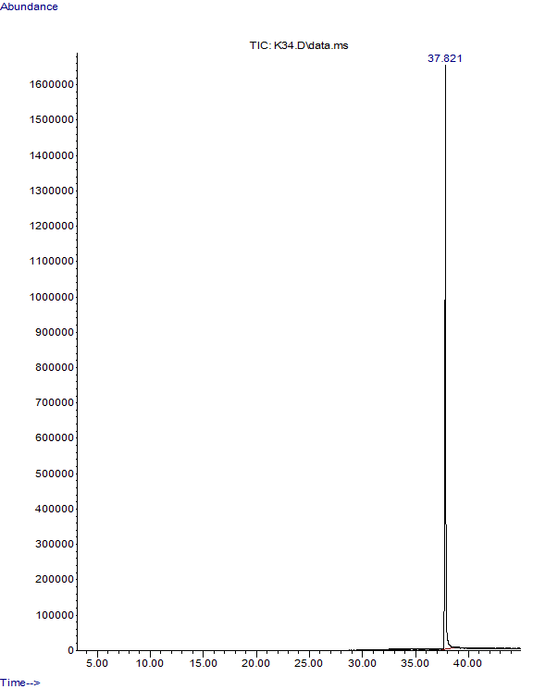
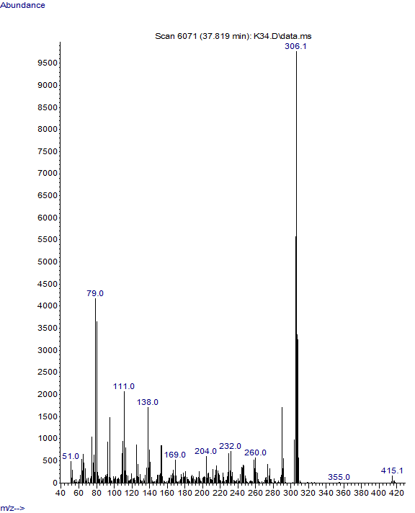

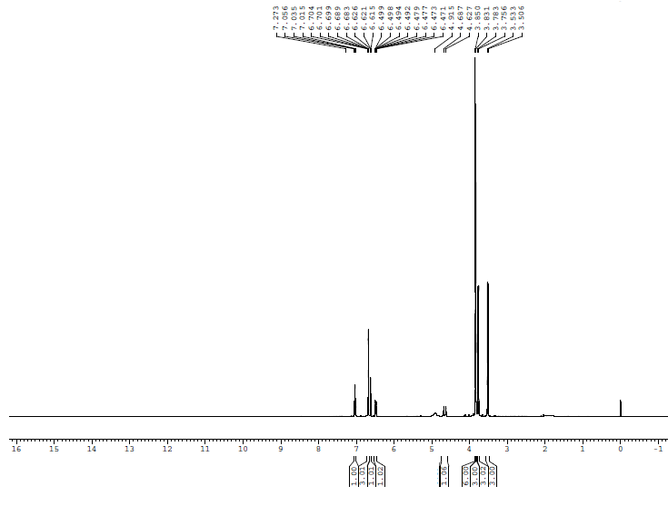

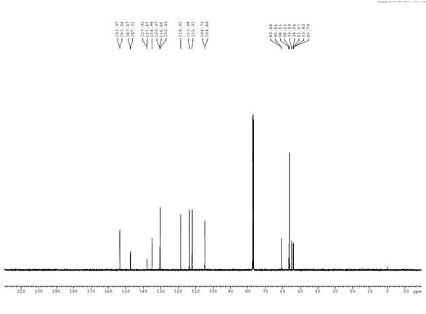

- Dimethyl (3-nitrophenyl)( phenylamino) methylphosphonate
Yellow crystals, mp 131 ℃, GC-MS (M⁺): 336.
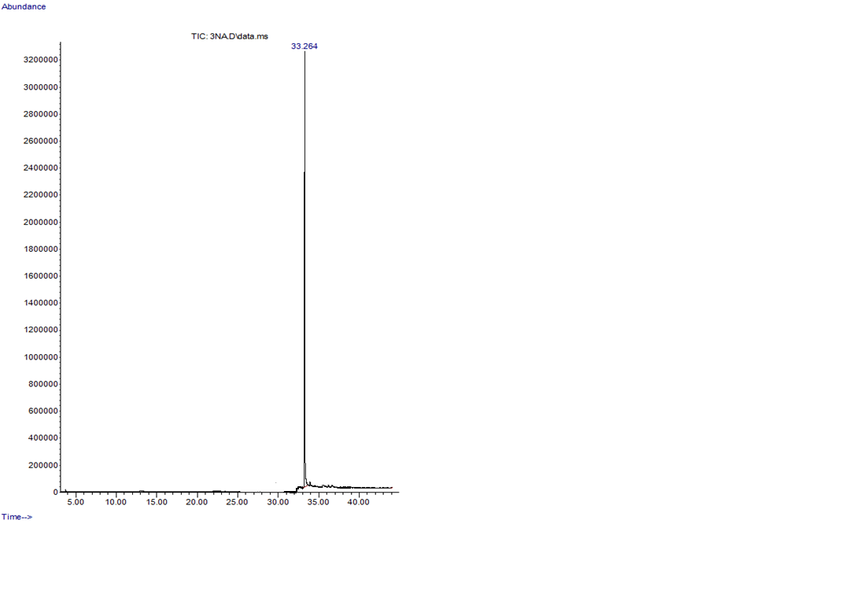
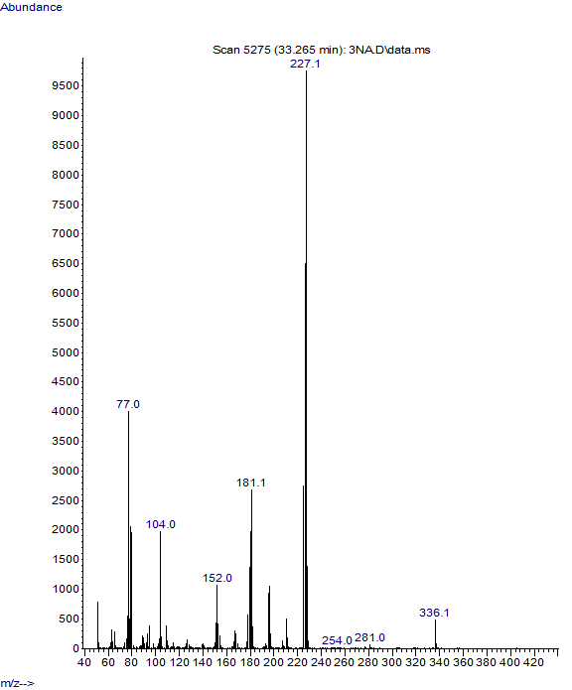
- Dimethyl (furan-2-yl-phenylaminomethyl)phosphonate
Brownish black solid, mp 104 ℃, GC-MS (M⁺): 281.
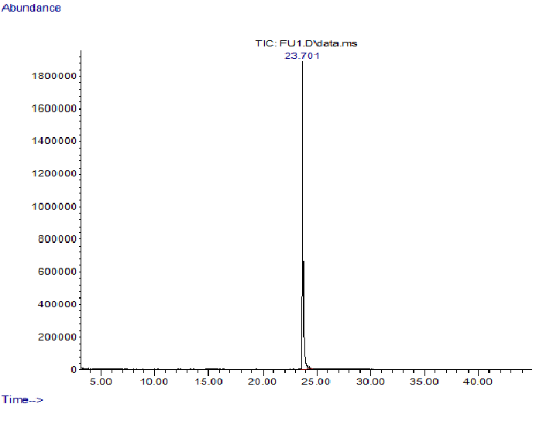
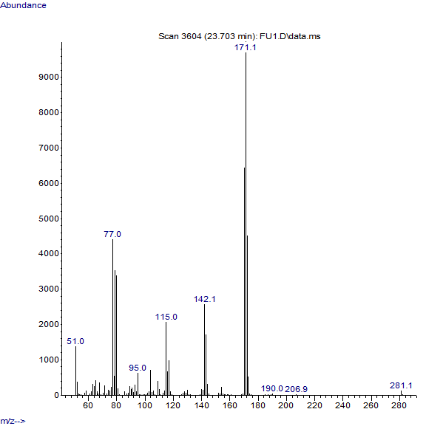

- Dimethyl (naphthalen-1-yl-phenylaminomethyl)phosphonate
Light yellow solid, mp 127 ℃, GC-MS (M⁺): 341.
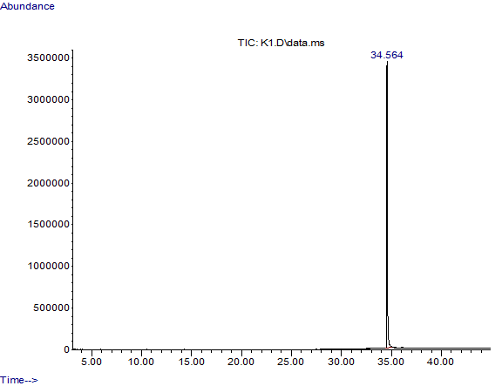
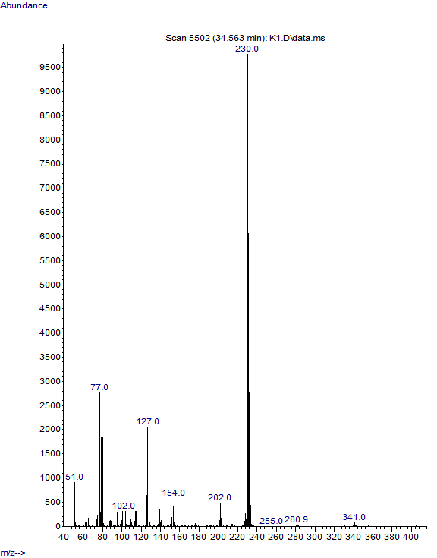
- Dimethyl (3-phenyl-1-phenylaminoallyl)phosphonate
Yellowish brown solid, mp ℃, GC-MS (M⁺): 317.
