Supporting Information
Computational model predicts protein binding sites of a luminescent ligand equipped with guanidiniocarbonyl-pyrrole groups

Neda Rafieiolhosseini¹, Matthias Killa², Niklas Tötsch¹, Jean-Noël Grad³,
Alexander Höing⁴, Christian Ottmann⁵, Shirley K. Knauer⁴, Jens Voskuhl², Daniel Hoffmann^{1*}

¹ Bioinformatics and Computational Biophysics, Center for Medical Biotechnology (ZMB), University of Duisburg-Essen, Universitätsstraße 5, 45141 Essen, Germany
² Faculty of Chemistry (Organic Chemistry) and CENIDE, University of Duisburg-Essen, Universitätsstraße 7, 45141 Essen, Germany
³ Institute for Computational Physics, University of Stuttgart, Allmandring 3, 70569 Stuttgart, Germany
⁴ Department of Molecular Biology II, Center for Medical Biotechnology (ZMB), University of Duisburg-Essen, Universitätsstraße 5, 45141 Essen, Germany
⁵ Laboratory of Chemical Biology, Department of Biomedical Engineering and Institute for Complex Molecular Systems, Eindhoven University of Technology, PO Box 513, 5600 MB Eindhoven, Netherlands

1. Electrostatic Potential Surface of 14-3-3ζ
The electrostatic potential surface of the protein in the presence and absence of C-Raf peptides is illustrated in Figure S1.
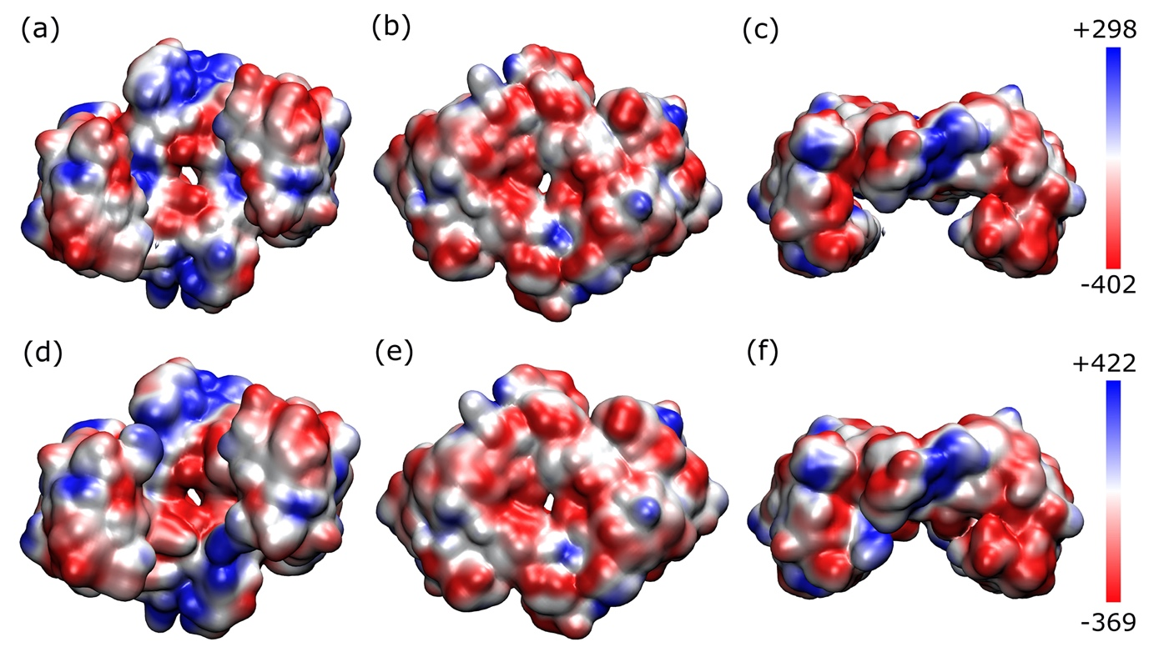
Figure S1: The electrostatic potential on the surface of 14-3-3ζ in the absence (a-c) and presence (d-f) of C-Raf peptides. The coloring method is based on the surface potential from dark red (most negative) to dark blue (most positive). The values in the color bar are in units of k_{B}T/|e|. The column in the left shows the top view, the one in the middle shows the bottom view, and the one in the right shows the side view.

2. Total energy of a simulation
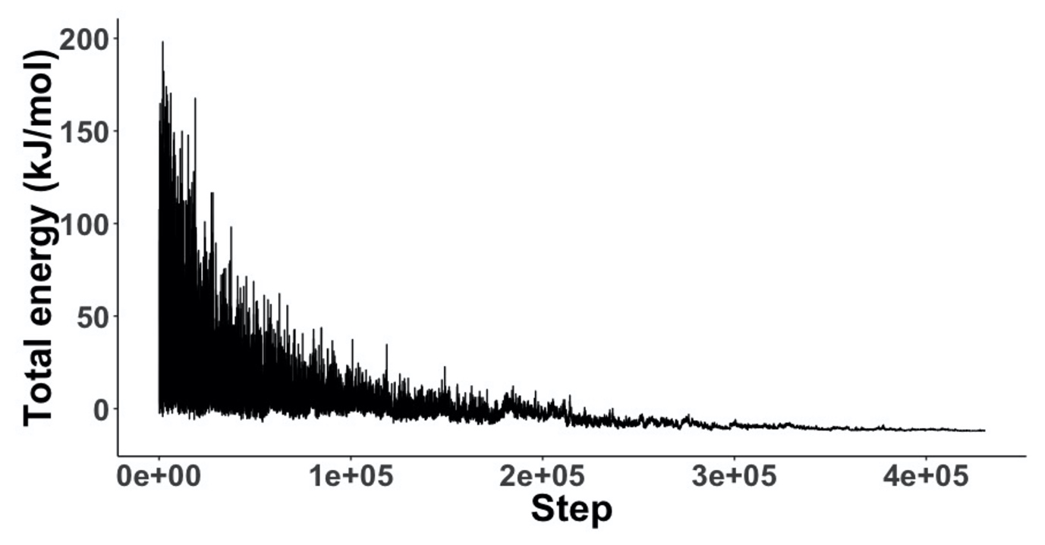
Figure S2: The total energy of the ligand throughout a representative single simulated annealing run.

3. Clustering
The optimal number of clusters is obtained for two series of simulations (in the presence and absence of C-Raf peptides) using the Silhouette average method. The clustered data points obtained from each series of simulations are then mapped in 2D using their principal components as is illustrated in Figures S3 and S4.
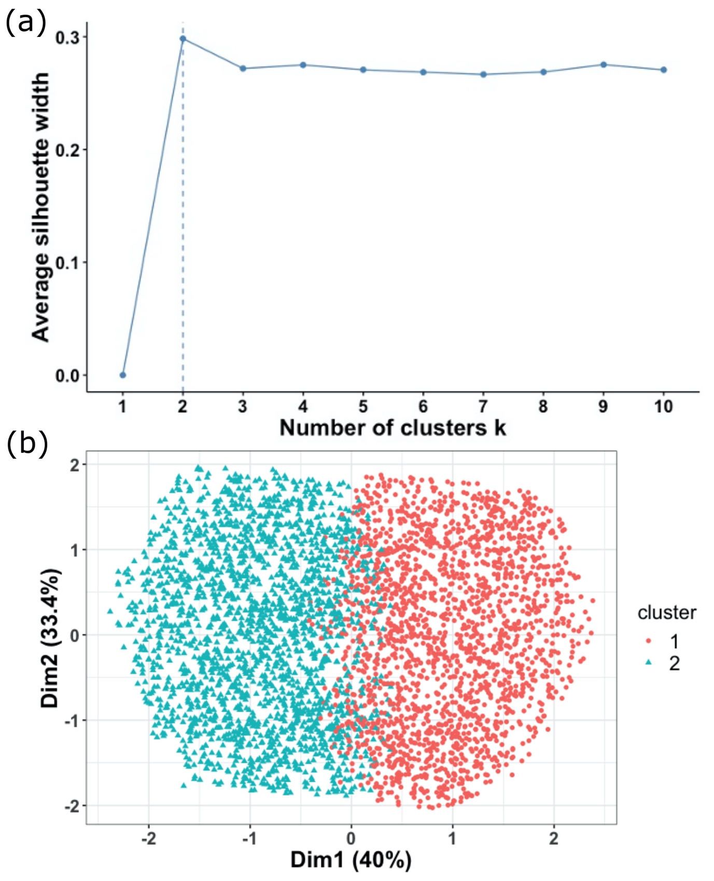
Figure S3: (a) The final positions of AIE in the absence of C-Raf peptides can be optimally clustered in two groups as the Silhouette method suggests. (b) A 2D projection of the clustered data on the two principal components.

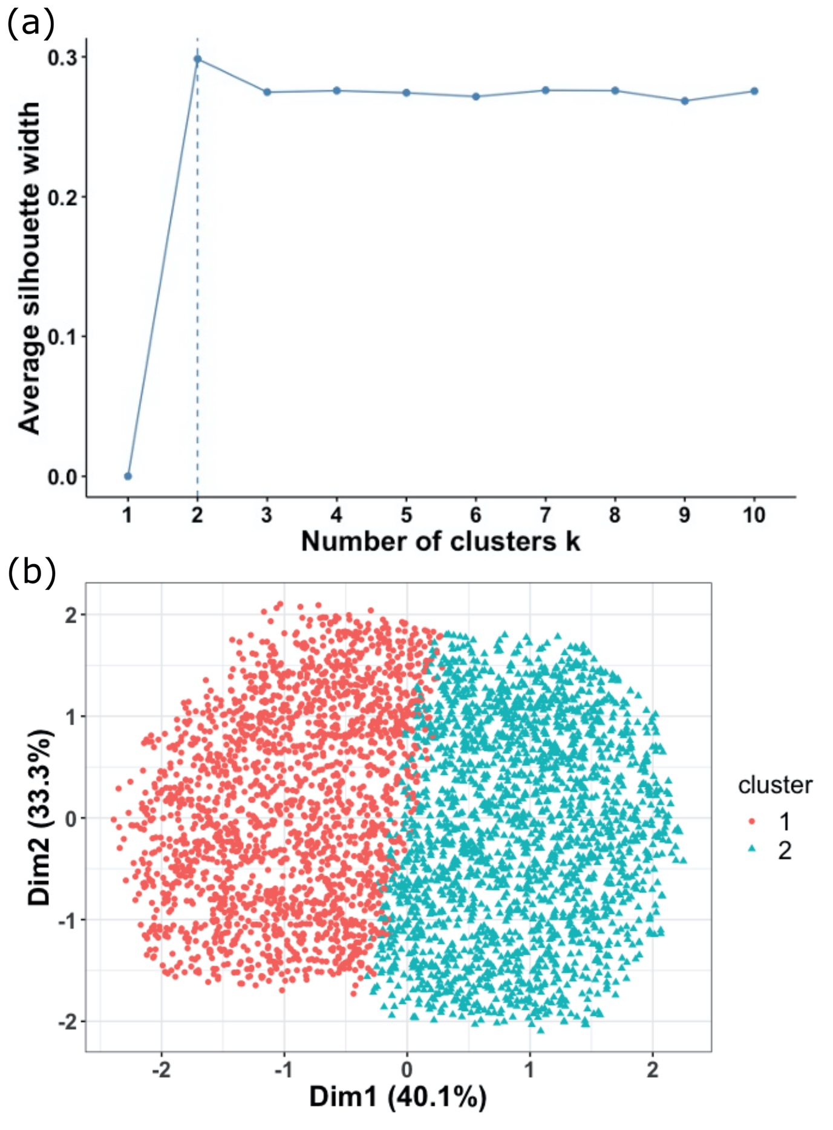
Figure S4: (a) The final positions of AIE in the presence of C-Raf peptides can be optimally clustered in two groups as the Silhouette method suggests. (b) A 2D projection of the clustered data on the two principal components.

4. General information and instrumentation
The used solvents for the synthesis and purification were dried and distilled before use. The purification of the water was performed with a TKA MicroPure ultrapure water system. The used chemicals for the synthesis were bought from commercial sources and used without any preparations (mainly from, Alfa Aeser, Fluorochem, Sigma-Aldrich, TCI). The reaction control was performed with TLC on normal phase silica gel plates (Macherey-Nagel, POLYGRAM SIL G/UV254) and UV light with a wavelength of 254 and 366 nm. The lyophilisation was performed with a Christ Alpha 1-4 LD plus freeze dryer. The determination of the Melting points was carried out with a Büchi Melting-Point B-540 apparatus and open-end glass capillary tubes. A Bruker DMX 300 and DRX 500 spectrometer were used for the characterization of the final compounds. The measurements took place at room temperature. The shifts of the signals are depending on the appropriate deuterated solvents. The chemical shifts are presented in parts per million. The determination of the molecular weight was carried out with a Bruker BioTOF II. HPLC-grade MeOH and ultrapure water were used as the mobile phase for the MPLC and HPLC. The Armen Instrument Spot Flash Liquid Chromatography MPLC apparatus was used for the purification and was equipped with a RediSep C₁₈ reversed-phase column. The analytical HPLC for the determination of the purity contained a Dionex UltiMate 3000 pump, ASI100 Automated Sample Injector, UVD 340U detector and a YMC ODS-A column (15 cm × 3.0 mm, 5 μm). The IR spectra were recorded with an IR-Tracer-100 FTIR-Spectrophotometer from Shimadzu. The 14-3-3ζ protein was received from the working group of Dr. Christian Ottmann (Eindhoven University of Technology). The buffer contained 25 mM HEPES, 150 mM NaCl, 0.5 mM TCEP, 10 mM MgCl and the pH value was 6.5.
Synthetic routes
Compound (A) [1] and the active ester (C) [2] were synthesized as described in the literature before. The activated azide (F) (Tosylethylazide) can be prepared in analogy to a known two-step synthetic route [3]. The spectra obtained were in accordance with those reported in the literature.
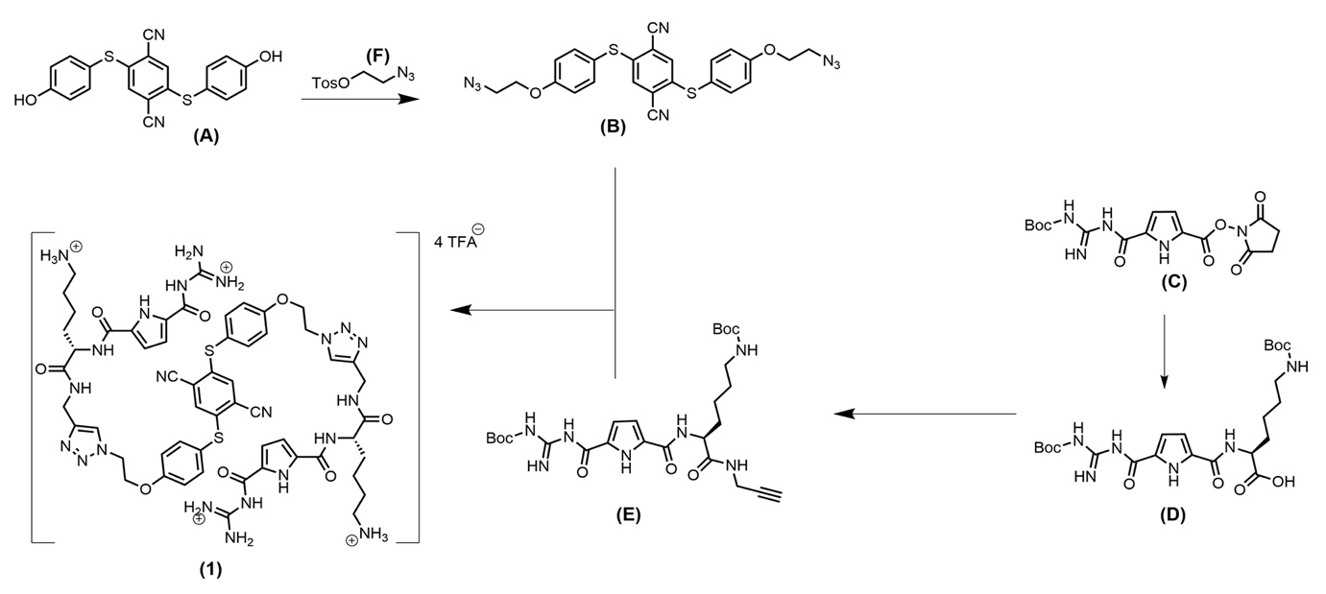
Figure S5: Synthetic routes to the corresponding desired GCP containing compound (1) featuring AIE- properties.

Diazide (B)

Compound (A) (871 mg, 2.31 mmol, 1eq.) was dissolved in 20 mL of DMF and tosylethylazide (F) (1.23 g, 5.10 mmol, 2.2 eq) was added followed by the addition of K₂CO₃ (1.93 g, 14 mmol, 6.1 eq). The mixture was stirred for 12 h at 50°C followed by the addition of water. The precipitate was filtered and washed with water. The residue was recrystallized from acetone yielding the desired product as a light yellow solid. Yield: 820 mg, 69%, M: C₂₄H₁₈N₈O₂S₂, ¹H-NMR (400 MHz, Acetone-d₆) δ = 7.62 – 7.57 (m, 4 H), 7.33 (d, J = 0.9 Hz, 2 H), 7.18 – 7.11 (m, 4 H), 4.32 (t, J = 4.7 Hz, 4 H), 3.72 (t, J = 4.8 Hz, 4 H) ppm. ¹³C-NMR (101 MHz, Acetone-d₆) δ = 161.21, 142.52, 137.67, 133.37, 120.91, 117.43, 116.14, 115.84, 68.28, 50.83 ppm. IR (ATR): v = 3082, 2938, 2876, 2224, 2100, 1591, 1572, 1491, 1462, 1449, 1408, 1395, 1346, 1302, 1285, 1242, 1221, 1175, 1148, 1101, 1053, 1007, 943, 912, 895, 851, 831, 812, 800, 723, 708, 673, 644. HR-ESI-pos (MeOH): m/z = 537.08875 (calcd. 537.08863 for [M+Na]⁺).

BocGCPlys(Boc)OH (D)
100 mg GCP-active-ester (C) (1 eq, 0.25 mmol) and 62 mg H-lys(Boc)-OH (1 eq, 0.25 mmol) were solved in 5 mL DMF. After that 0.35 mL Et₃N (10 eq, 2.52 mmol, 254 mg) were added at 0°C and stirred at room temperature for 24 h. 100 mL ethyl acetate was added to the reaction mixture and washed three times with 50 mL 0.5 M NaHSO₄ solution, 50 mL brine, and 50 mL water. The organic phase was dried with MgSO₄, filtered and the solvent removed with the evaporator. The residue was freeze dried. The product was obtained as a white solid. Yield: 115 mg, 87%, M(C₂₃H₃₆N₆O₈) = 524.58 g/mol. Rf = 0.15 (CyHex/ EtOAc/ 0.1% AcOH), Mp: 270°C (decomposition), ¹H-NMR (300 MHz, DMSO-d6): δ = 1.40 (2 s+ m, 22H, lys-γ, δCH₂ +2Boc), 1.73 (m, 2H, lys-βCH₂), 2.90 (m, 2H, lys-εCH₂), 4.32 (m, 1H, lys-αCH), 6.86 (m, 3H, pyrrole-H + 2 amide N-H), 8.50 (d, H, amide-N-H) 8.77 (s, H, N-H), 9.47 (s, H, N-H), 11.66 (s, 3H, 2N-H + COO-H) ppm, ¹³C-NMR (150 MHZ, DMSO-d6): δ = 23.0 (lys-γCH₂), 27.7 (Boc-CH₃), 28.2 (Boc-CH₃), (lys-δCH₂), 30.6 (lys-βCH₂), 39.5 (lys-εCH₂), 52.0 (lys-αCH), 77.3 (Boc-C-CH₃), 112.8 (pyrrole), 155.5, 159.5, 173.6 (C_{q}) ppm, IR max/cm⁻¹: 3323 (b), 2976 (w), 2934 (w), 1688 (s), 1634 (w), 1553 (w), 1472 (w), 1393 (w), 1368 (w), 1242 (s), 1142 (s), 1047 (w), 993 (w), 833 (w), 754 (w). HR-MS (pos. ESI) m/z calculated [M+H]¹⁺ 525.2667, [M+Na]¹⁺ 547.2487; found [M+H]¹⁺ 525.2682 (100), [M+Na]¹⁺ 547.2495 (10).

BocGCPlys(Boc)alkyne (E)
100 mg BocGCPlys(Boc)OH (D) (1 eq, 0.19 mmol), 0.13 mL Et₃N (5 eq, 0.95 mmol, 96.5 mg) and 86 mg HBTU (1.2 eq, 0.23 mmol) were dissolved in 10 mL DMF and stirred for 30 min. After that, 14.5 μL propargylamine (1.2 eq, 0.23 mmol, 12 mg) was added and the reaction mixture was stirred overnight. 100 mL ethyl acetate was added and the organic phase was washed three times with 50 mL 0.5 M NaHSO₄-solution, 50 mL brine, and 50 mL water. The organic phase was dried with MgSO₄, filtered and the solvent removed with the evaporator. The crude product was purified with normal phase chromatography (SiO₂, 1EA/ 1Cy). The product was freeze dried and was obtained as a white solid. Yield: 80 mg, 74%, M(C₂₆H₃₉N₇O₇) = 561.64 g/mol, Rf = 0.4 (CyHex/EtOAc), Mp: 190°C (decomposition). ¹H-NMR (300 MHz, DMSO-d6): δ = 1.46 (2 s+ m, 22H, lys-γ, δCH₂ +2Boc), 1.64 (m, 2H, lys-βCH₂), 2.88 (m, 2H, lys-εCH₂), 3.09 (m, 1H, alkyne-H), 3.87 (m, 2H, alkyne), 4.36 (m, 1H, lys-αCH), 6.76 (m, 3H, pyrrole-H + 2 amide N-H), 8.46 (m, 2H, amide N-H), 9.34 (s, H, N-H), 10.75 (s, 2H, 2N-H), 11.39 (s, 1H, 2N-H) ppm. ¹³C-NMR (150 MHZ, DMSO-d6): δ = 23.0 (lys-γCH₂), 27.6 (lys-δCH₂), 27.8 (Boc-CH₃), 27.9 (alkyne CH₂), 28.2 (Boc-CH₃), 29.2 (lys-βCH₂), 31.6 (lys-εCH₂), 52.6 (lys-αCH), 72.9 (alkyne CH), 77.3 (Boc-C-CH₃), 81.1 (alkyne C_{q}) 112.9 (pyrrole), 155.5, 159.4, 171.6 (C_{q}) ppm. IR max/cm⁻¹: 3370 (b), 3285 (b), 2976 (w), 2930 (w), 2866 (w), 2349 (w), 1634 (s), 1532 (s), 1456 (w), 1393 (w), 1368 (w), 1289 (s), 1240 (s), 1148 (s), 1047 (w), 841 (s), 756 (w). HR-MS (pos. ESI) m/z calculated [M+H]¹⁺ 562.2984, [M+Na]¹⁺ 584.2803; found [M+H]¹⁺ 562.2965 (100), [M+Na]¹⁺ 584.2779 (24).
(GCPlys)₂AIE (1)
70 mg BocGCPlys(Boc)alkyne (E) (2 eq, 0.12 mmol) and 32 mg AIE-diazide (B) (1 eq, 0.06 mmol) were dissolved in 40 mL distillated THF under argon atmosphere. Then, 10 mL degassed water were added. A solution of 3.7 mg copper sulfate pentahydrate (0.1eq, 6.23 μmol) and 3.0 mg sodium ascorbate (0.1 eq, 6.23 μmol) in 1 mL degassed water were added. Every hour 3.0 mg sodium ascorbate was added until the reaction started (TLC). After the complete conversion of the starting materials, the solvent was removed with the evaporator. The residue was dissolved in 10 mL DCM and 20 mL TFA was added. The reaction mixture was stirred overnight and the solvent was removed with the evaporator. The residue was freeze dried. Finally, the crude product was purified with reversed-phase chromatography (MPLC RP₁₈: gradient from 3 MeOH/7 H₂O/0.1%TFA to MeOH/0.1%TFA). The product was obtained as yellow solid as the corresponding TFA salt (4 TFA). Yield: 30 mg, 30%, M(C₅₆H₆₄N₂₂O₈S₂) = 1237.39 g/mol. Purity: 94.2%, Mp: 230°C (decomposition), ¹H-NMR (600 MHz, D₂O): δ = 1.37 (m, 4H ,lys-γCH₂), 1.65 (m, 4H, lys-δCH₂), 1.86 (m, 4H, lys-βCH₂), 2.96 (m, 4H, lys-εCH₂), 4.37 (m, 6H, CH₂ + lys-αCH), 4.49 (m, 4H, CH₂), 4.78 (m, 4H, CH₂), 6.77 (m, 6H, Ar-H), 6.94 (m, 4H, pyrrole-H), 7.18 (m, 4H, Ar-H), 7.96 (s, 2H, triazole) ppm. ¹³C-NMR (150 MHZ, D₂O): δ = 22.2 (lys-γCH₂), 26.3 (C-triazole), 30.8 (lys-βCH₂), 34.5 (lys-δCH₂), 39.2 (lys-εCH₂), 49.9 (C-triazole), 53.8 (lys-αCH), 66.6 (CH₂), 112.9 (pyrrole-CH), 115.5 (pyrrole-CH), 116.4 (Ar-CH), 117.4 (C_{q}), 124.7 (Ar-CH), 125.8, 130.9 (C_{q}), 136.3 (Ar-CH), 141.4, 144.6, 155.0, 159.3, 160.2, 161.2, 173.6 (C_{q}) ppm. IR max/cm⁻¹: 3310 (b), 3080 (b), 2945 (b), 2104 (w), 1655 (s), 1593 (w), 1493 (w), 1474 (w), 1452 (w), 1431 (w), 1344 (w), 1246 (w), 1175 (s), 1128 (s), 1049 (w), 1007 (w), 907 (w), 831 (w), 799 (w), 752 (w), 719 (s), 704 (w). HR-MS (pos. ESI) m/z calculated [M+H]¹⁺ 1237.4792, [M+2H]²⁺ 619.2432, [M+3H]³⁺ 413.3036, [M+4H]⁴⁺ 310.1252; found [M+H]¹⁺ 1237.4798 (3), [M+2H]²⁺ 619.2434 (22), [M+3H]³⁺ 413.1649 (73), [M+4H]⁴⁺ 310.1262 (100).

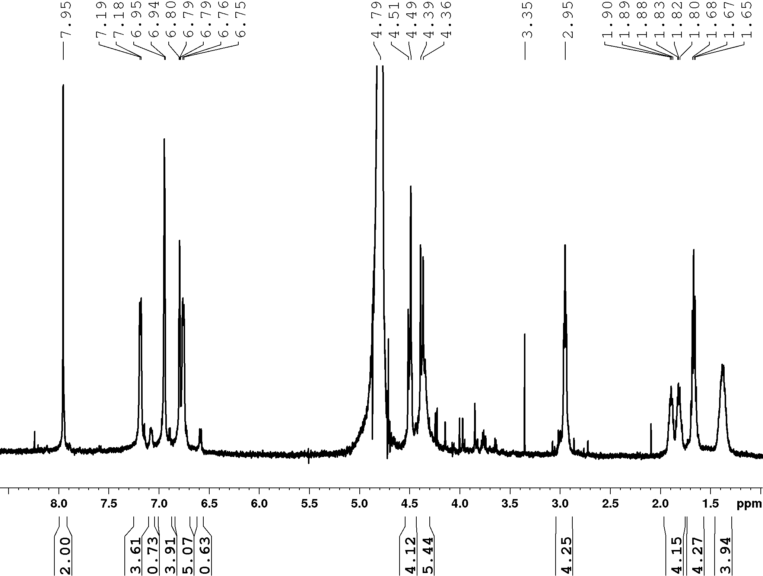
Figure S6: ¹H-NMR spectrum of (1) (600 MHz, D₂O).
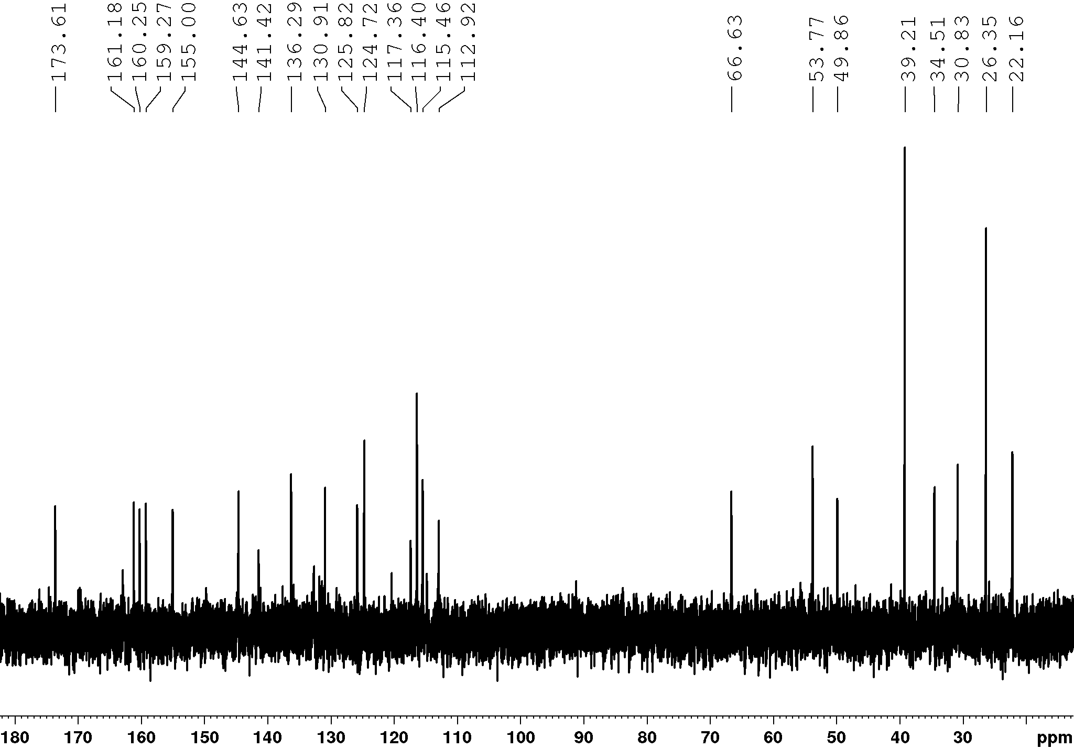
Figure S7: ¹³C-NMR spectrum of (1) (150 MHz, D₂O).

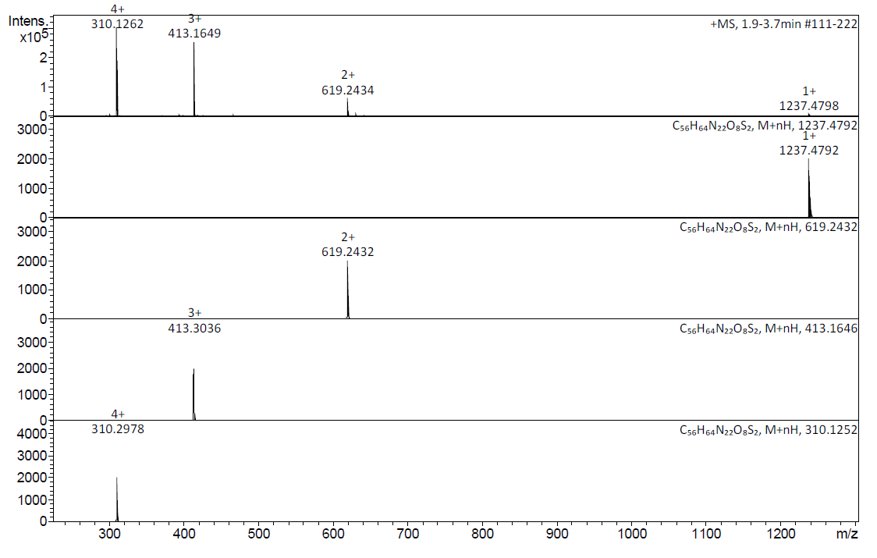
Figure S8: HR-ESI mass spectrum of (1) (positive ion mode, MeOH) and predicted mass spectra of the corresponding peaks.

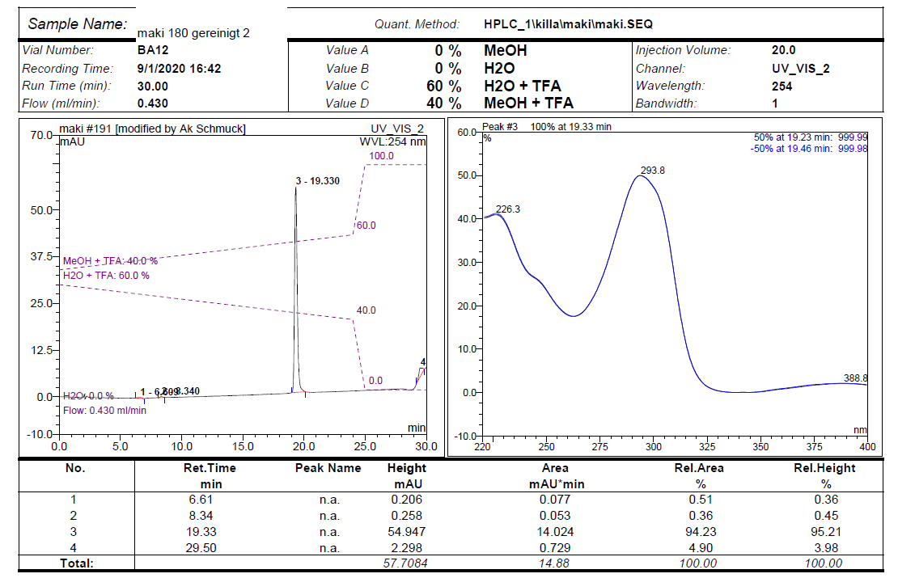
Figure S9: HPLC analysis of (1) gradient from 40% MeOH/ 60% H₂O/TFA (0.1%) to 60% MeOH/ 40% H₂O/TFA (0.1%) in 30 min, flow rate: 0.43 ml/min, retention time tR = 19.330 min, purity: > 94% (peak integration based on UV-detection at 254 nm).

5. Native gel electrophoresis
For native gel electrophoresis, a discontinuous polyacrylamide gel was prepared (1.5 mm, 10 wells) using 12.5% (w/v) acrylamide for the separation gel and 4% (w/v) acrylamide for the stacking gel (Table S1). The experimental setup (Table S2) included a 1 mM stock solution of 14-3-3ζ in the running buffer and water-dissolved ligand [1] in water was used for the experiment. To avoid damage to the protein caused by the low salt conditions introduced by the addition of increasing volumes of ligand solved in water, we used 4x concentrated sample buffer to equalize the buffer conditions and added the proteins in a final step (Table S1). Negative controls (wells #3 and #4) contained either protein or ligand alone.
Electrophoresis was performed with a Mini-Protean Tetra Cell (BioRad) for 2 hours at 175 V. To avoid denaturation of the protein due to the heat generated by the electric current over time, cold pack was added to the experimental setup. The fluorescence of the ligand was detected using a ChemiDoc (BioRad) or E-Box VX2 (Vilber) system. To additionally allow visualization of the protein bands, we subsequently performed a coomassie staining of the gel. Here, the gel was incubated in the staining solution for 1 hour and destained overnight. The composition of the gels, buffers, and solutions are summed up in the following table.

Table S1: Composition of the gel, buffers and solutions.
Component | Composition
Native stacking gel buffer(4**) | 0.5 M tris-HCl, pH 6.8
Native separation gel buffer (4**) | 1.5 M tris-HCl, pH 8.8
Native running buffer (10*) | 25 mM tris-HCl, 192 mM glycine,  pH 8.8
Native sample buffer | 2.5 mM tris-HCl, 19.2 mM glycine,  30% (v/v) glycerol, pH 8.8
Coomassie staining solution | 10% (v/v) acetic acid, 40% (v/v) ethanol, 0.1% (w/v) coomassie G-250
Destain solution | 10% (v/v) acetic acid, 40% (v/v) ethanol
4% stacking gel | 2.5 mL ddH2O, 1.3 mL native stacking gel buffer, 0.65 mL 30% acrylamide, 5 μL TEMED, 50 μL 10% APS
12.5% separation gel | 1.6 mL ddH2O, 1.3 mL native stacking gel buffer, 2.1 mL 30% acrylamide, 5 μL TEMED, 50 μL 10% APS

Table S2: Experimental setup.
Well | #2  (empty) | #3 | #4 | #5  (empty) | #6 | #7  (empty) | #8 | #9 (empty) | #10
Sample buffer (4*) |  | 3 μL | 3 μL |  | 3 μL |  | 3 μL |  | 3 μL
Ligand [1] |  | / | 10 μL |  | 1 μL |  | 5 μL |  | 10 μL
Running buffer |  | 10 μL | / |  | 9 μL |  | 5 μL |  | /
Protein  14-3-3ζ |  | 1 μL | / |  | 1 μL |  | 1 μL |  | 1 μL

The electrophoresis was performed with a Mini-Protean Tetra Cell (BioRad) for 2 hours at 175 V. To avoid denaturing of the protein due to the heat caused by the electric current over time, we added a cold pack. The fluorescence of the ligand was detected using a ChemiDoc (BioRad) or E-Box VX2 (Vilber) system. After the fluorescence of the ligand was detected, we performed coomassie staining of the gel to colorimetrically visualize the protein bands. The gel was incubated in the staining solution for 1 hour and then destained overnight. The composition of the gels, buffers, and solutions are summed up in the following table.

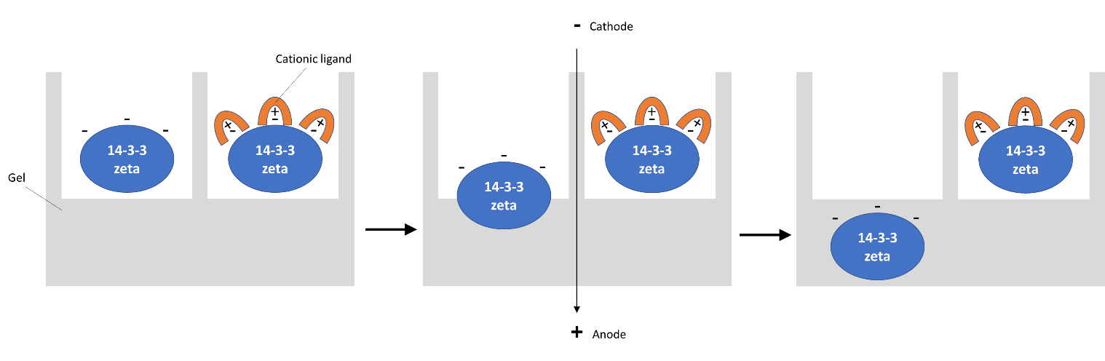
Figure S10: Schematic overview of the effects of ligands binding on the protein’s migratory behavior during polyacrylamide gel electrophoresis. The cationic ligand is suggested to mask the negative charges in the protein and thereby prevents its movement through the gel towards the anode.

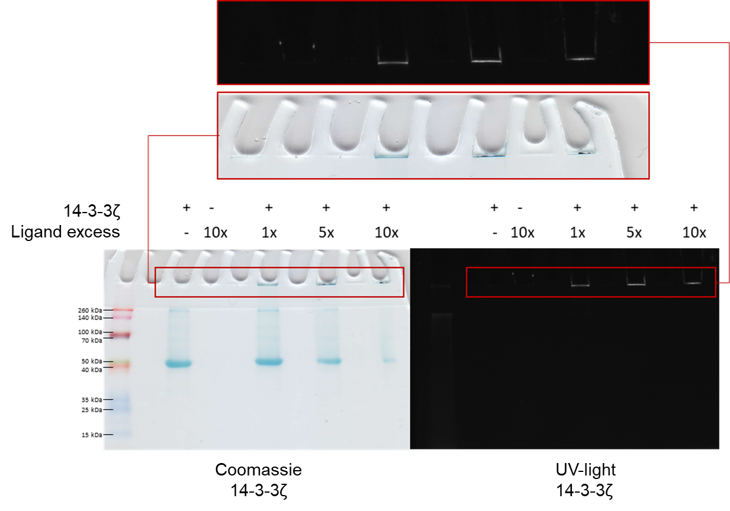
Figure S11: Binding of ligand (1) prevents the protein 14-3-3ζ from entering the gel. The amount of protein (blue bands) that migrated into the gel correlates with the amount of ligand added. At the same time, the ligand (UV) was only detectable in the well if protein was added. In addition, the ligand in the well co-localized with the protein retained in the well. Of note, not the complete amount of protein present in the well was detectable.

6. Fluorescence titration
The fluorescence spectroscopy was performed in quartz cuvettes by using an FP-8300 Fluorescence Spectrometer. The titration started with 1 μM ligand in the cuvette. Then a 10 μM protein with 1 μM ligand solution was added in that way to receive the concentrations 0, 0.5, 1, 1.5, 2, and 2.5 μM and the appropriate equivalents 0, 0.5, 1, 1.5, 2, and 2.5 of the protein. The control is a buffer titration. The titration was a single point titration with a λ_{ex} 395 and λ_{em} 475 nm. Every point was recorded 10 times. Both bandwidths were 5 nm and the PMT voltage was 600 V. The temperature was 25°C. The fluorescence titration was performed 3 times and the mean and standard deviation were calculated in Microsoft Excel. The extrapolation of the two first and last titration points and the intersection of the straights were performed in Origin 2019b. This so-called mole ratio method is used for the determination of stoichiometry [4]. It could be shown that one ligand binds to one protein monomer or consequently two ligands to the protein dimer.
Figure S12: Mean of the fluorescence titration of 14-3-3ζ to (1) with the buffer control. The intersection of the extrapolations of the two first and last data points is at x = 1.05051 eq. and y = 1052.72807.
References
- Riebe S.; Vallet C.; van der Vight F.; Gonzalez-Abradelo D.; Wölper C.; Strassert C. A.; Jansen G.; Knauer S.; Voskuhl J. Chem.—Eur. J. 2017, 23, 13660-13668.
- Maity D.; Li M.; Ehlers M.; Schmuck C. Chem. Commun. 2017, 53, 208-211.
- Choi, H.; Shirley, H.J.; Hume, P.A.; Brimble, M.A.; Furkert, D.P. Angew. Chem., Int. Ed. 2017, 56, 7420-7424.
- a) Ntoi L. L. A.; von Eschwege K. G. Afr. J. Chem. Educ. 2017, 7, 59-92; b) Shalaby A. A.; Mohamed A. A. Chem. Pap. 2020, 74, 3589-3595.

