Novel coumarin compounds potentiate the effect of cisplatin in lung cancer cells by enhancing pro-apoptotic expressions, G2/M cell arrest, oxidative and antiangiogenic effects
Adem Güner^{a,*}, Hakan Bektaş^{b}, Emre Menteşe^{c}

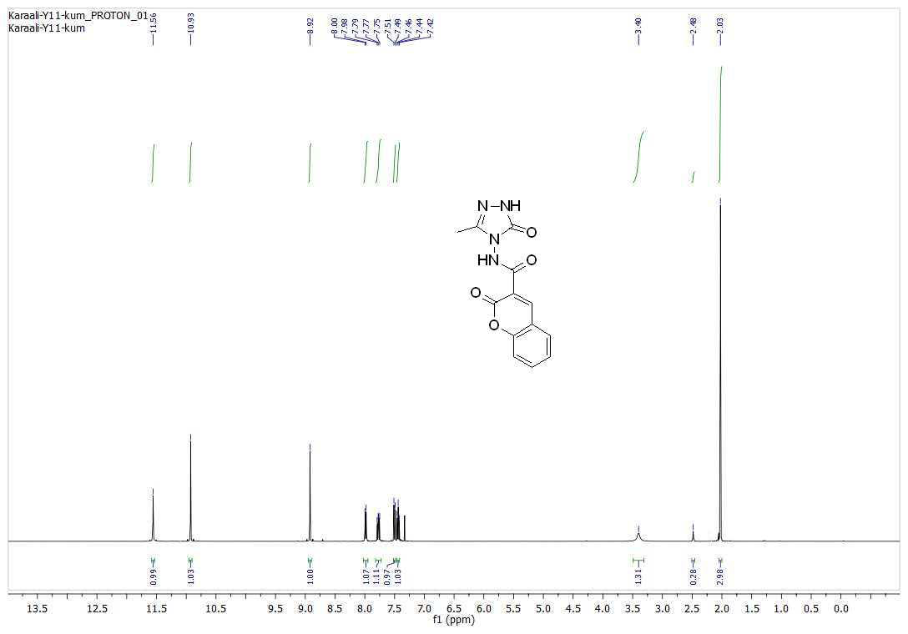
Figure S1
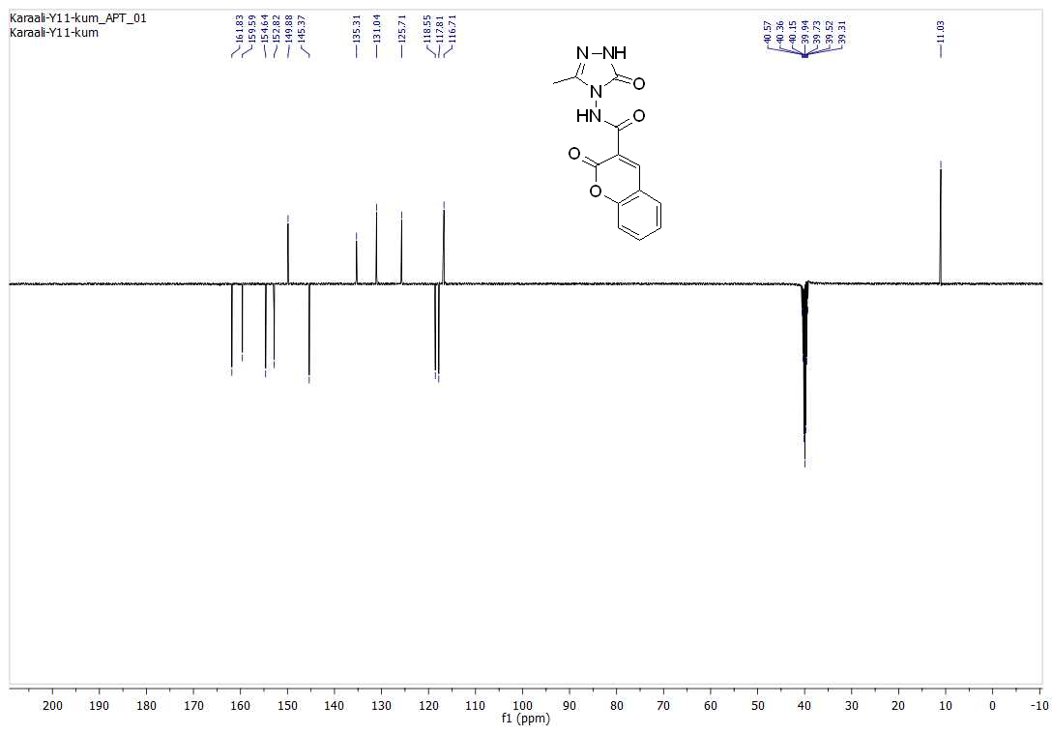
Figure S2

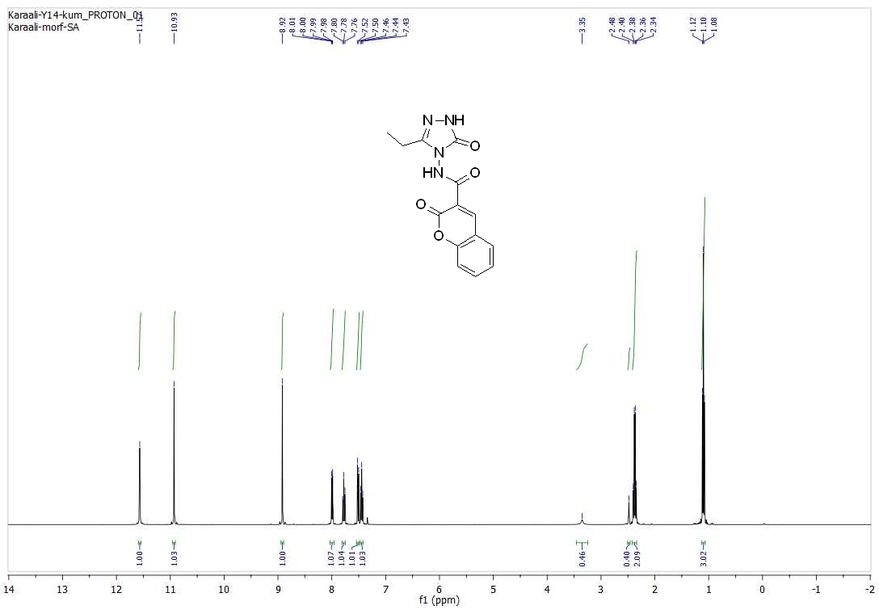
Figure S3

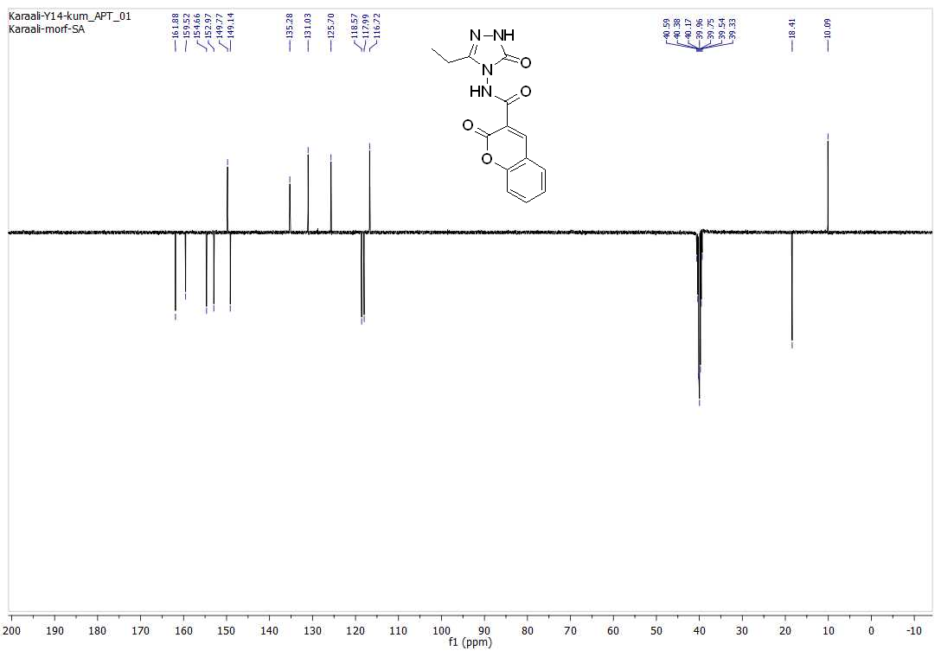
Figure S4

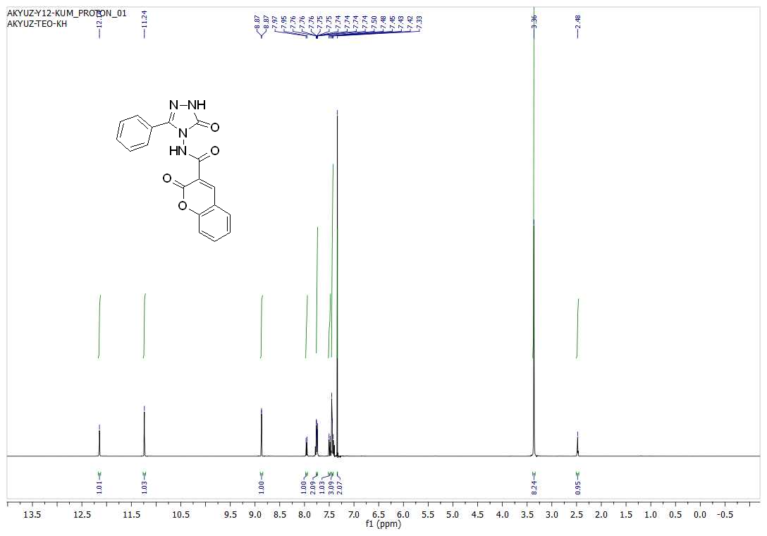
Figure S5

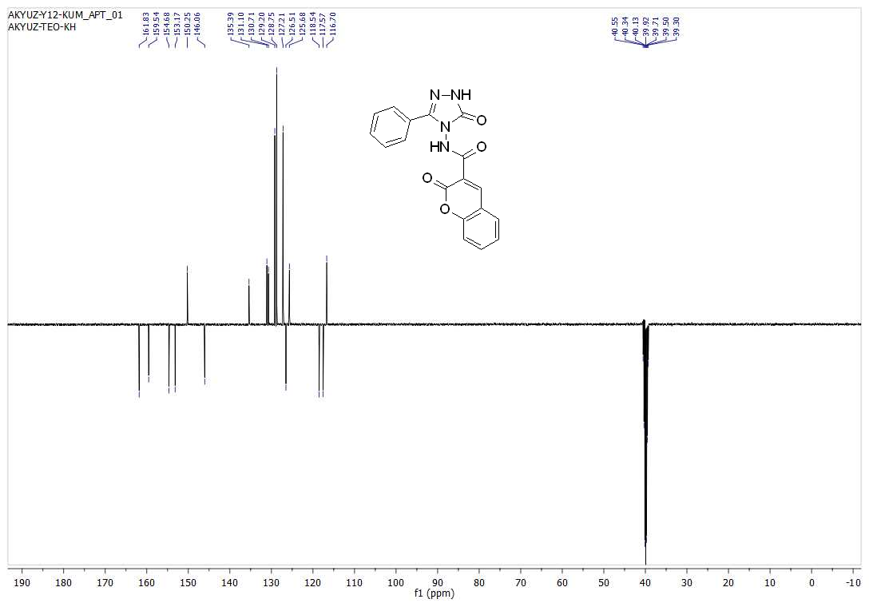
Figure S6

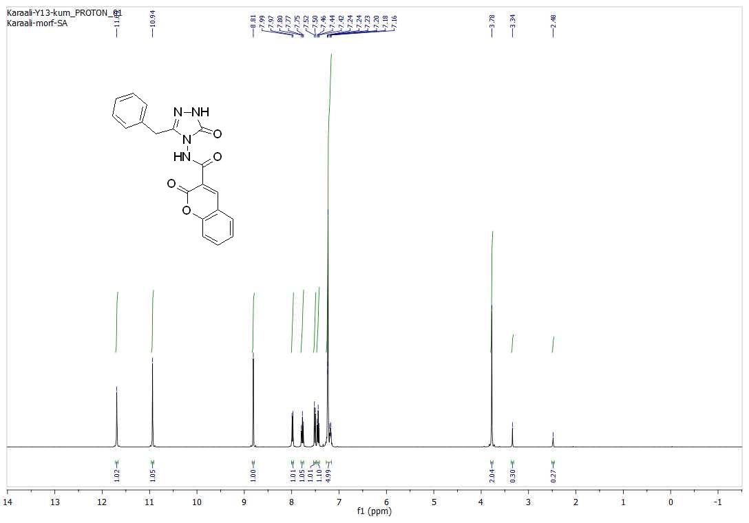
Figure S7

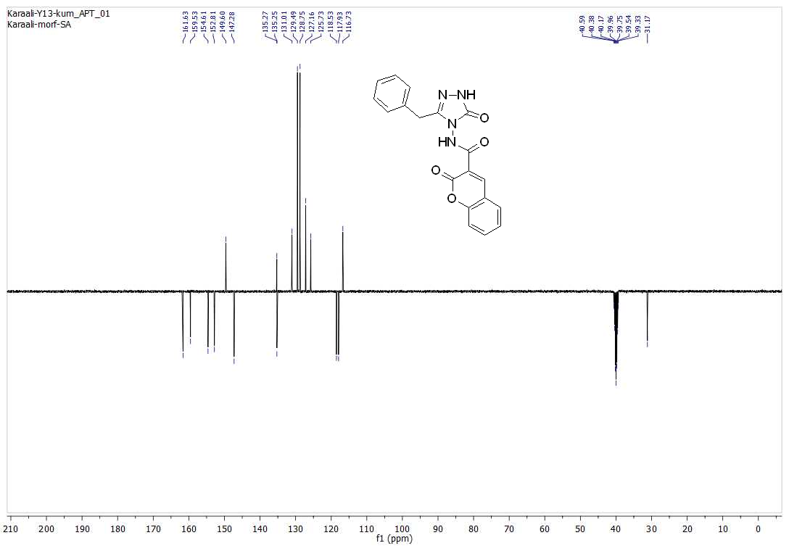
Figure S8

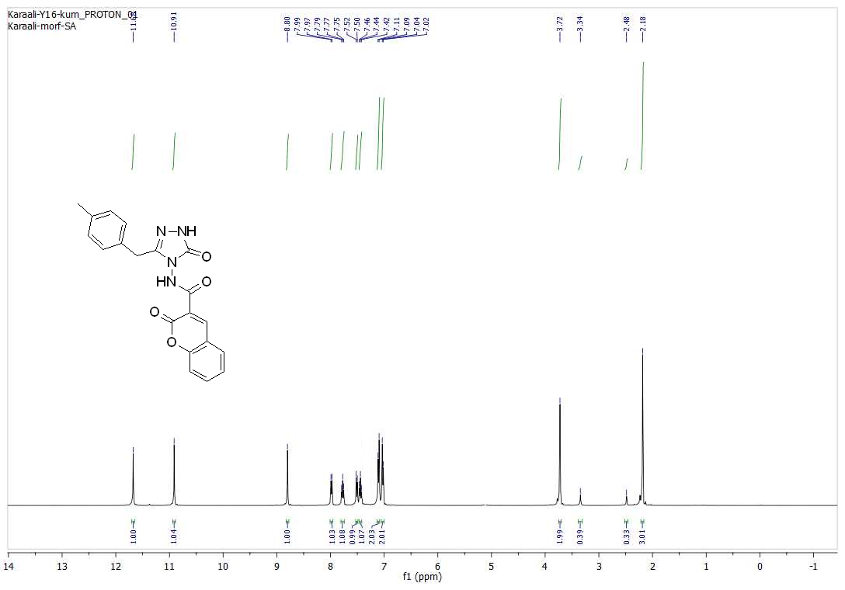
Figure S9

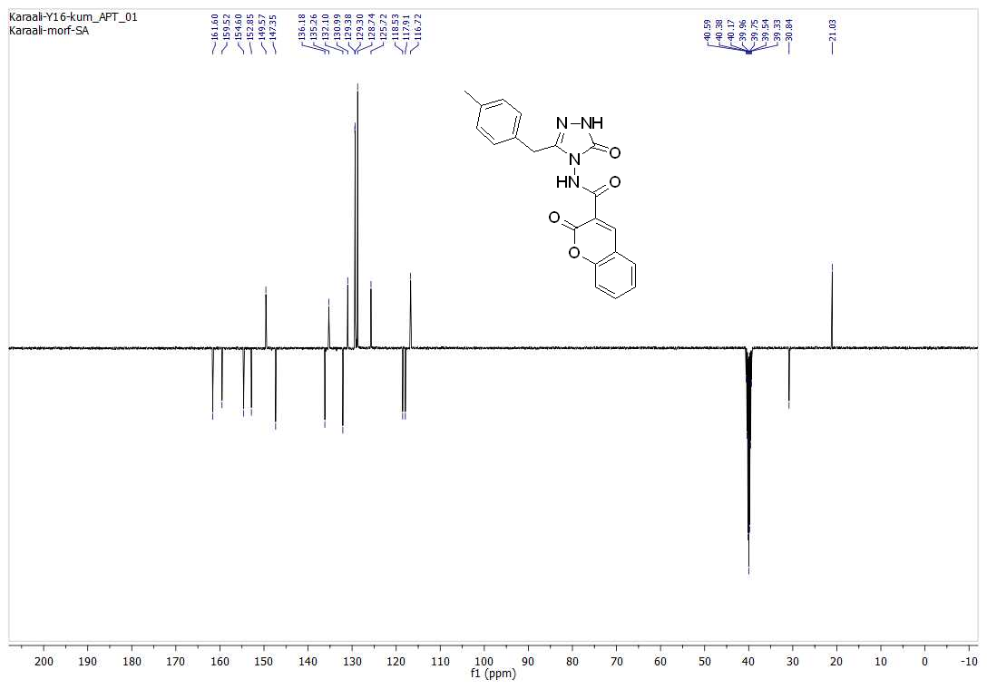
Figure S10

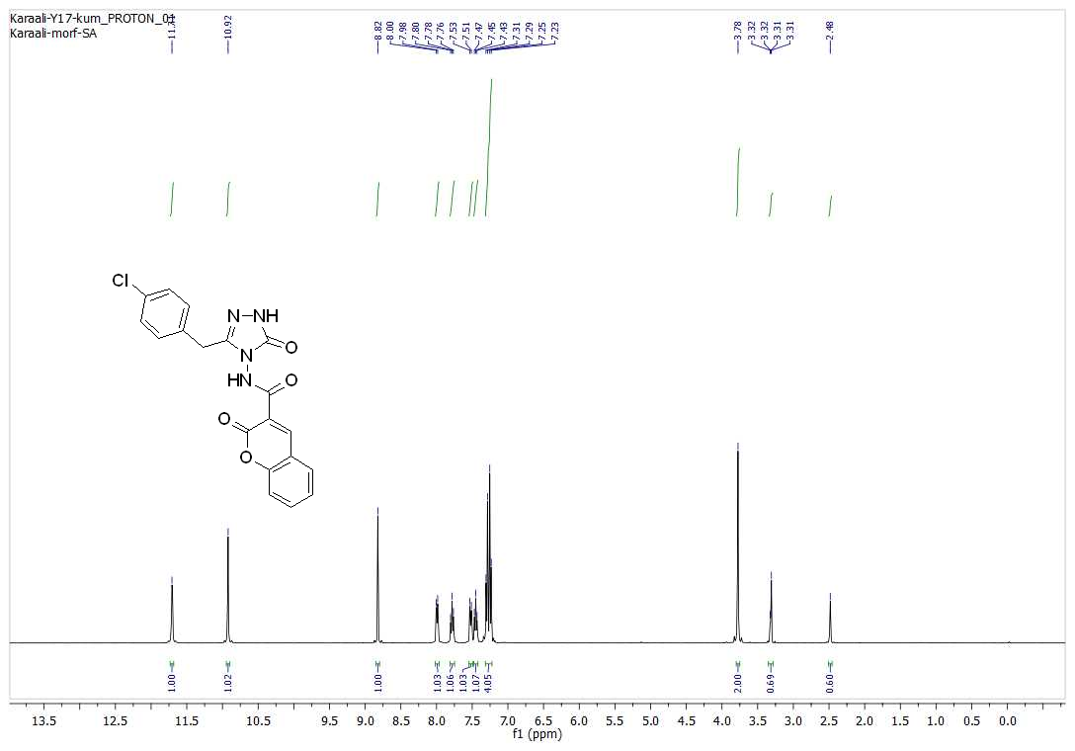
Figure S11

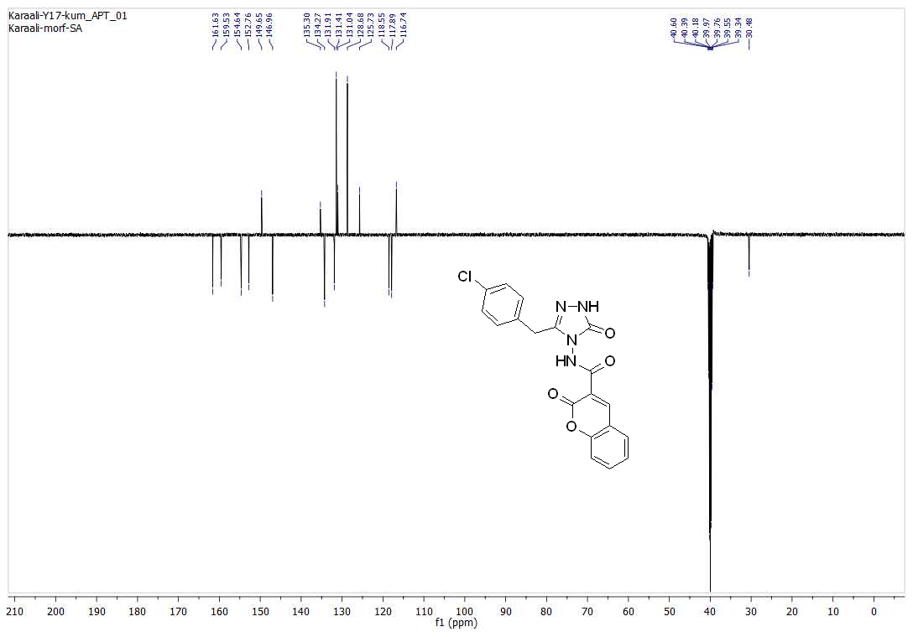
Figure S12

