Supplementary Materials for

Unexpected synthesis and structure of a cage-like aza[3,3,3]propllane carbene
Ziqi Su¹, Qi Zhang¹, Guangwei Zhou¹, Qianzhu Chen¹, Yahan Xue¹, Lizhu Zhang¹, Qunsheng Yan¹, Juan Xu²*, Quansong Li¹*, Jiarong Li¹*

¹School of Chemistry & Chemical Engineering, Beijing Institute of Technology, Beijing, China, 102488
²National Research Institute for Family Planning, Beijing, China, 100081
*Correspondence to: jrli@bit.edu.cn，liquansong@bit.edu.cn，xujuan@nrifp.org.cn

Contents

Experimental
1.Materials and Methods
2.Supplementary Text
Reference
Fig. 1-2. Solid state structures of 3a and 4a
Fig. 3-4. Single crystal structure 3a and 4a
Fig. 5-6. Crystal stacking diagram 3a and 4a
Fig. 7-8. DTA and TGA of 3a and 4a
Fig. 9-12. ¹³C NMR, ¹H NMR, IR, MS of 2a
Fig. 13-16. ¹³C NMR, ¹H NMR, IR, MS of 2b
Fig. 17-20. ¹³C NMR, ¹H NMR, IR, MS of 2c
Fig. 21-24. ¹³C NMR, ¹H NMR, IR, MS of 3a
Fig. 25-28. ¹³C NMR, ¹H NMR, IR, MS of 3b
Fig. 29-32. ¹³C NMR, ¹H NMR, IR, MS of 3c
Fig. 33-36. ¹³C NMR, ¹H NMR, IR, MS of 4a
Fig. 37-40. ¹³C NMR, ¹H NMR, IR, MS of 4b
Fig. 41-44. ¹³C NMR, ¹H NMR, IR, MS of 4c
Fig. 45. Ultraviolet absorption spectrum of 3a and 4a
Table 1-3. Crystal data and structure refinement for 3a and 4a

Materials and Methods
The reactions involving solvents and reagents are commercially available without further purification unless otherwise stated. All experimental operations were not required to be completed in the glove box and dry argon atmosphere protection, and the solvents were not dried and deoxygenated prior to use. Infrared spectra were recorded as KBr pellets in Shimadzu IR Affinity-1s and reported in cm⁻¹. NMR spectra were measured in CDCl₃ and DMSO-d₆ solvent with TMS internal standard. ¹H, ¹³C NMR were recorded on Bruker Ascend 400MHZ and Bruker Ascend 700 MHZ NMR spectrometer. Chemical shift were reported as followed in ppm from the internal standard (TMS, 0.0 ppm). High resolution mass spectra were obtained with Q-TOF 6520 liquid chromatography-mass spectrometer and performed using electrospray ionization (ESI⁺) source in methanol or acetonitrile solvent. Single crystal diffraction data were collected on Bruker APEX DUO Ⅱ diffractometers using MoKα radiation (λ = 0.71073 Å). Melting points were determined on micro melting point instrument without corrected (50). The UV absorption spectrum was measured at TU - 1901 dual beam UV-visible spectrophotometer with BaSO₄ as a blank control in the 200-600 nm range.

Supplementary Text
Experimental procedures and characterization data

3,7,9,11-Tetraoxo-2,4,6,8,10-pentabenzyl-2,4,6,8,10-pentaaza[3.3.3] propellane (2a)
Compound 1 (25, 26) (10 mmol, 3.01 g) and BnBr (60 mmol, 10.26 g) were dissolved in a mixture of solvents (V_{DMSO} : V_{DMF} = 1 : 4) under Ar atmosphere. The reaction temperature was cooled using an ice bath. After 5 min, NaH (50 mmol, 2.00 g) was added and the resulting mixture was stirred for 1 h. Then the reaction temperature was raised to room temperature and the reaction continued for another 12 h. When the end of the reaction is detected, the reaction mixture was cooled again and diluted with diethyl ether (30 mL). A solution of aq. HCl was slowly added into the mixture to quench the reaction. The resulting mixture was diluted with H₂O and the resulting mixture was extracted with EtOAc. The combined organic layers were dried with MgSO₄, filtered, and concentrated under reduced pressure. The residue oil was purified by silica gel column chromatography, to give the compound 2a as a white solid (5.18 g, 78.37%).
Characterization data: m. p. 151-152 ℃; ¹H NMR (400 MHz, CDCl₃) δ 7.84 – 6.43 (m, 25H), 4.44 (s, 8H), 4.26 (s, 2H); ¹³C NMR (100 MHz, CDCl₃) δ 166.01 (s), 156.05 (s), 135.71 (s), 132.56 (s), 127.90 (s), 127.48 (d, J = 33.3 Hz), 126.56 (s), 125.99 (s), 74.39 (s), 44.65 (s), 41.62 (s) ; IR (KBr) 2925, 1718, 1690, 1446, 1146, 936, 694 cm⁻¹; HRMS (ESI⁺): calcd. for C₄₁H₃₆N₅O₄ [M+H]⁺ 662.2762, found 662.2779.
3,7,9,11-Tetraoxo-2,4,6,8-(4-methyl)benzyl-10-benzyl-2,4,6,8,10-pentaaza[3.3.3] propellane (2b)
Prepared following a nearly identical procedure to 2a except 4-Me-BnBr replace of BnBr, the final product 2b was as a white solid (3.88 g, 54%).
Characterization data: m. p. 172.4-172.9 ℃; ¹H NMR (400 MHz, CDCl₃) δ 7.37 – 6.69 (m, 21H), 4.41 (s, 8H), 4.25 (d, J = 14.7 Hz, 2H), 2.22 (s, 12H); ¹³C NMR (100 MHz, CDCl₃) δ 166.13 (s), 156.07 (s), 136.04 (s), 132.69 (d), 128.26 (s), 127.65 (d), 127.17 (s), 125.97 (s), 74.32 (s), 44.38 (s), 41.52 (s), 20.09 (d); IR (KBr) 3086, 2962, 2924, 1716, 1456, 1386, 1336, 1244, 1168, 1139, 1109, 991, 948, 916, 866, 729, 524 cm⁻¹; HRMS (ESI⁺): calcd. for C₄₅H₄₃N₅O₄ [M+H]⁺ 718.3388, found 718.3378.
3,7,9,11-Tetraoxo-2,4,6,8-(4-fluoro)benzyl-10-benzyl-2,4,6,8,10-pentaaza[3.3.3] propellane (2c)
Prepared following a nearly identical procedure to 2a except 4-F-BnBr replace of BnBr, the final product 2c was as a white solid (4.04 g, 55%).
Characterization data: m. p. 108.4-110.1 ℃; ¹H NMR (400 MHz, DMSO-d₆) δ 7.55 – 6.49 (m, 21H), 5.06 – 4.11 (m, 10H); ¹³C NMR (100 MHz, DMSO-d₆) δ 167.19 (s), 162.99 (s), 160.57 (s), 157.26 (s), 134.79 (s), 133.58 (d), 129.53 – 128.96 (m), 128.33 (s), 115.58 (d), 115.41 – 115.23 (m), 75.16 (s), 44.82 (s); IR (KBr) 3068, 2924, 1720, 1606, 1510, 1456, 1411, 1342, 1232, 1147, 1099, 947, 844, 815, 736, 698, 665, 526, 491 cm⁻¹; HRMS (ESI⁺): calcd. for C₄₁H₃₁F₄N₅O₄ [M+H]⁺ 734.2385, found 734.2374.
2,4,6,8,10-Pentabenzyl-2,4,6,8,10-pentaaza[3.3.3]propellane (3a)
Compound 2a was dissolved in 50 mL THF at 0 ℃ with an ice bath. After 5 min, LiAH (60 mmol, 2.28 g) was added slowly, then warmed to reflux for 12h. When the reaction was completed, the reaction mixture was cooled to 0 ℃ again. EtOAc (6 mL) was slowly added to the reaction mixture and the resulting mixture was stirred for 30 min to quench the reaction. A solution of aq. NaOH (10%, 12 mL) was added until the sludgy phase disappeared. After stirring for another 20 min, the mixture was diluted with EtOAc (30 mL), filtered, and the filtrate was evaporated. The yellow oil was purified by silica gel column chromatography (ethyl acetate : petroleum, 4 : 1) to give white solid compound 3a (2.57 g, 85.10%).
Characterization data: m. p. 142-144 ℃; ¹H NMR (400 MHz, CDCl₃) δ 7.93 – 6.69 (m,25H), 3.92 (d, J = 14.2 Hz, 6H), 3.80 – 3.62 (m, 6H), 3.30 (d, J = 2.0 Hz, 2H), 2.74 (s, 4H); ¹³C NMR (100 MHz, DMSO-d₆) δ 140.00 (s), 138.66 (s), 128.71 (s), 128.18 (s), 128.07 (s), 127.91 (s), 126.93 (s), 126.55 (s), 96.10 (s), 74.23 (s), 59.83 (s), 56.41 (s), 51.74 (s); IR (KBr) 3061, 3024, 2900, 2800, 1602, 1493, 1453, 773, 698 cm⁻¹; Anal. calcd for C₄₁H₄₃N₅: C 81.29, H 7.15 , N 11.56; found: C 81.325, H 7.185, N 11.284; HRMS (ESI⁺): calcd. for C₄₁H₄₃N₅ [M+H]⁺ 606.3591, found 606.3589.
2,4,6,8-(4-Methyl)benzyl-10-benzyl-2,4,6,8,10-pentaaza[3.3.3]-propellane (3b)
Prepared following a nearly identical procedure to 3a except 2b replace of 2a, the final product 3b was as a white solid (2.60 g, 78%).
Characterization data: m. p. 122.7-125.5 ℃; ¹H NMR (400 MHz, CDCl₃) δ 7.52 – 6.77 (m, 21H), 3.81 (d, J = 19.9, 8.6 Hz, 6H), 3.60 (d, J = 13.2 Hz, 6H), 3.19 (d, J = 3.5 Hz, 2H), 2.63 (s, 4H), 2.17 (d, J = 23.8 Hz, 12H); ¹³C NMR (100 MHz, CDCl₃) δ 135.87 (s), 135.12 (s), 127.85 (s), 127.26 (s), 126.93 (s), 126.00 (s), 95.09 (s), 73.46 (s), 58.94 (s), 55.52 (s), 50.51(s), 20.04(s); IR (KBr) 3022.45,2916, 2893, 2819, 2779, 2696, 1514, 1452, 1377, 1359, 1290, 1261, 1174, 1101, 1020, 877, 798, 742, 698, 476 cm⁻¹; HRMS (ESI⁺) calcd. for C₄₅H₅₁N₅ [M+H]⁺ 662.4217, found 662.4220.
2,4,6,8-(4-Fluoro)benzyl-10-benzyl-2,4,6,8,10-pentaaza[3.3.3]-propellane (3c)
Prepared following a nearly identical procedure to 3a except 2c replace of 2a, the final product 3c was as a white solid (2.06 g, 61%).
Characterization data: m.p. 111.2-113.0℃; ¹H NMR (400 MHz, CDCl₃) δ 7.46 – 6.66 (m, 22H), 3.75 (d, J = 13.8 Hz, 6H), 3.68 – 3.49 (m, 6H), 3.15 (d, J = 4.5 Hz, 2H), 2.61 (s, 4H); ¹³C NMR (100MHz, CDCl₃) δ 161.99 (s), 159.56 (s), 137.47 (s), 134.40 (d), 128.33 (d), 127.86 (s), 127.34 (s), 127.34 – 126.66 (m), 126.18 (s), 95.04 (s), 58.90 (s), 55.26 (s), 50.04 (s). IR (KBr) 3035, 2912, 2806, 1602, 1508, 1452, 1375, 1220, 1151, 1091, 1014, 848, 821, 700 cm⁻¹; HRMS (ESI⁺): calcd. for C₄₁H₃₉F₄N₅ [M+H]⁺ 678.3214, found 678.3225.
APC 4a
Compound 3a (1.20 g, 2 mmol) was dissolved in a 6 mL mixed solvent (CH₂Cl₂ : CH₃OH = 1 : 2), then 0.10 g of Pd(OH)₂/C was added to the solution, and the mixture was stirring under refluxing conditions. When the completion of the reaction was detected, the catalyst was filtered out, and the solvent was evaporated in vacuo to give a brown-black oily liquid. The liquid was purified by column chromatography (AcOEt : MeOH, 10 : 1) and recrystallization from ethyl acetate to give white powder 4a (62.71%).
Characterization data: m. p. 192.0-193.0 ℃; ¹H NMR (700 MHz, CDCl₃) δ 10.58 (s, 1H), 7.67 – 6.83 (m, 20H), 5.29 – 4.98 (m, 2H), 4.66 – 4.35 (m, 2H), 3.98 (t, J = 12.3 Hz, 3H), 3.89 (d, J = 14.0 Hz, 2H), 3.75 (d, J = 47.8, 9.6 Hz, 1H), 3.32 (s, 2H), 2.98 (d, J = 11.1 Hz, 2H), 2.04 – 1.70 (m, 5H), 1.45 – 1.27 (m, 1H)；¹³C NMR (100 MHz, CDCl₃) δ 156.65 (s), 137.60 (s), 135.88 (s), 132.82 (s), 127.87 (d, J = 35.0, 12.9 Hz), 127.54 – 127.34 (m), 127.20 (s), 126.75 (d, J = 6.1 Hz), 98.46 (s), 75.05 (s), 57.79 (s), 57.33 (s), 52.86 (s), 48.64 (s), 45.00 (s), 7.78 (s); IR (KBr) 3024, 2926, 2819, 1618, 1494, 1454, 1369, 1274, 1220, 1105, 1028, 950, 738, 700, 60 cm⁻¹; Anal. calcd for C₄₁H₄₁N₅: C 81.56, H 6.84, N 11.60; found: C 72.997, H 6.738, N 10.627; HRMS (ESI⁺): calcd. for C₄₁H₄₁N₅ [M+H]⁺ 604.3435, found 604.3430.
APC 4b
Prepared following a nearly identical procedure to 4b except 3b replace of 3a, the final product 4b was as a white solid (63.7%).
Characterization data: ¹H NMR (400 MHz, CDCl₃) δ 10.38 (s, 1H), 7.44 – 6.82 (m, 17H), 5.08 (d, J = 14.6 Hz, 2H), 4.47 (d, J = 14.4 Hz, 2H), 3.81 (d, J = 13.9 Hz, 2H), 3.72 (d, J = 11.1 Hz, 3H), 3.25 (s, 1H), 2.94 (d, J = 10.8 Hz, 4H), 2.33 (d, J = 12.3 Hz, 10H), 1.76 (s, 1H), 1.31 (d, J = 10.7 Hz, 6H) ; ¹³C NMR (100 MHz, CDCl₃) δ 157.57 (s), 138.64 (s), 137.50 (s), 137.08 (s), 135.56 (s), 130.85 (s), 129.53 (d, J = 20.6 Hz), 129.11 (d, J = 9.9 Hz), 128.83 – 128.61 (m), 128.57 (s), 128.15 (t, J = 40.7 Hz), 99.39 (s), 75.68 (s), 58.68 (d, J = 41.4 Hz), 58.41 – 57.96 (m), 53.59 (s), 49.42 (s), 21.11 (s) ; IR (KBr) 3383, 3024, 2974, 2937, 2819, 2738, 2677, 2492, 1627, 1514, 1454, 1435, 1371, 1276, 1205, 1101, 1035, 844, 806, 754, 698, 590, 474 cm⁻¹; HRMS (ESI⁺) calcd.for C₄₅H₄₉N₅ [M+H]⁺ 660.4061 , found 660.4076.
APC 4c
Prepared following a nearly identical procedure to 4c except 3c replace of 3a, the final product 4c was as a white solid (54.8%).
Characterization data: ¹H NMR (400 MHz, CDCl₃) δ 10.07 (d, J = 19.3 Hz, 1H), 7.40 – 6.68 (m, 19H), 5.13 (d, J = 14.7 Hz, 2H), 4.54 (d, J = 14.8 Hz, 2H), 4.09 – 3.79 (d, J = 29.4, 13.0 Hz, 4H), 3.77 – 3.61 (m, 3H), 3.33 (d, J = 19.8 Hz, 2H), 2.95 (d, J = 10.7 Hz, 2H), 1.90 (t, J = 17.9 Hz, 2H) ; ¹³C NMR (100 MHz, CDCl₃) δ 163.15 (s), 162.48 (s), 160.68 (s), 160.02 (s), 157.12 (s), 133.23 (s), 130.19 (s), 128.73 (s), 127.72 (s), 115.04 (d, J = 21.4 Hz), 114.69 (d, J = 21.4 Hz), 98.29 (s), 74.83 (s), 52.08 (s), 48.03 (s), 44.93 (s), 7.67 (s); IR (KBr) 2927, 2738, 2675, 2621, 2493, 1633, 1602, 1510, 1473, 1454, 1396, 1259, 1224, 1093, 1035, 1016, 802, 763, 750 cm⁻¹; HRMS (ESI⁺) calcd. for C₄₁H₃₇F₄N₅ [M+H]⁺ 676.3058 , found 676.3053.
X-Ray crystal structure determination
The single crystal of the compound 3a was obtained by dissolving the compound in mixed solvent of CH₂Cl₂ and CH₃OH, then slowly evaporating at room temperature. The 4a single crystal was grown in a saturated solution of dichloromethane and methanol at room temperature. These suitable single crystals were selected and mounted on different models of Bruker APEX DUO Ⅱdiffractometers. The crystals were kept at 296.15 K during data collection which was performed employing Mo-Kα radiation MoKα (λ = 0.71073 Å) for 3a and 4a. The skeleton of the compound 3a and 4a have been confirmed by single crystal X-ray diffractometer.
Olex2 (51) and ShelX (52) software were employed for the resolution, refinement and the generation of crystallographic information files of every structure. The structures were solved with the ShelXs structure solution program using Direct Methods and refined with the ShelXl refinement package using Least Squares minimization.
The thermal stabilities of the crystal 3a and 4a by DTA and TGA
The thermal stability of propellane 3a is determined under a nitrogen atmosphere at a flow rate of 20 mL/min and the heating rate of 5 ℃/min, the temperature warming interval of which test is from 20 ℃ to 500 ℃. The thermal stability of propellane 4a is determined under a nitrogen atmosphere at a flow rate of 20 mL/min and the heating rate of 5 ℃/min, the temperature warming interval of which test is from 20 ℃ to 500 ℃.

References
- Dolomanov, O. V. Bourhis, L. J. Gildea, R. J. Howard, J. A. K. Puschmann, H. J. Appl. Cryst., 42, 339 (2009).
- Puschmann, H. Bourhis, L. J. Dolomanov, O. V. Acta Crystallographica. 67(a1), c593 (2011).
- Sheldrick, G. M. Acta Crystallographica, 64(1), 112 (2008).

Fig. 1.
Solid state structures of 3a. (Source: IUCr checkCIF/PLATON report)

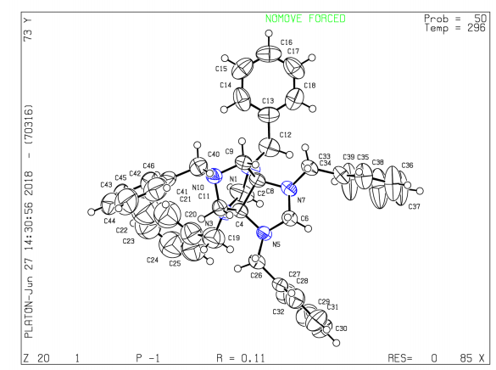

Fig. 2.
Solid state structures of 4a. (Source: IUCr checkCIF/PLATON report)

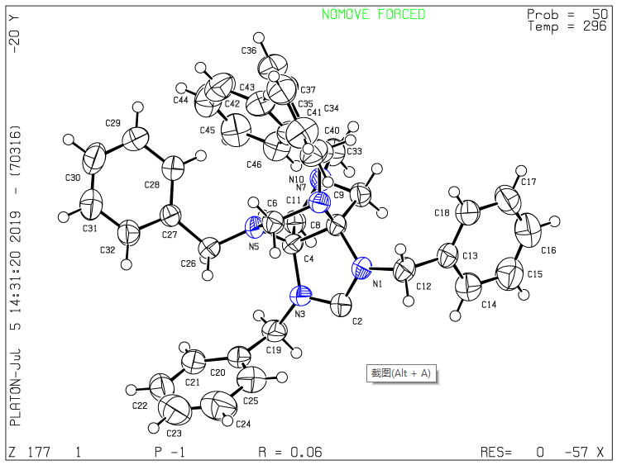

Fig. 3.
Single crystal structure 3a.
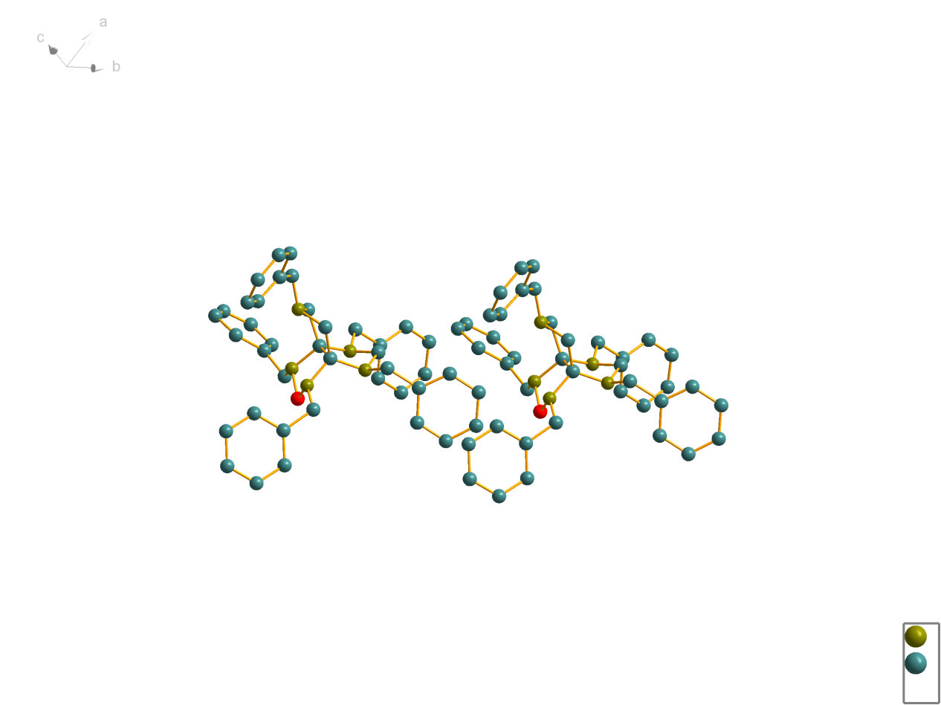

Fig. 4.
Single crystal unit cell 4a.

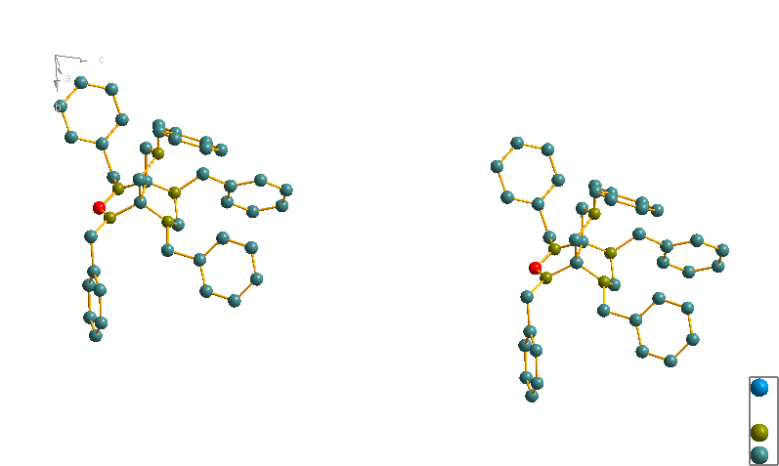Fig. 5.
Crystal stacking diagram 3a.

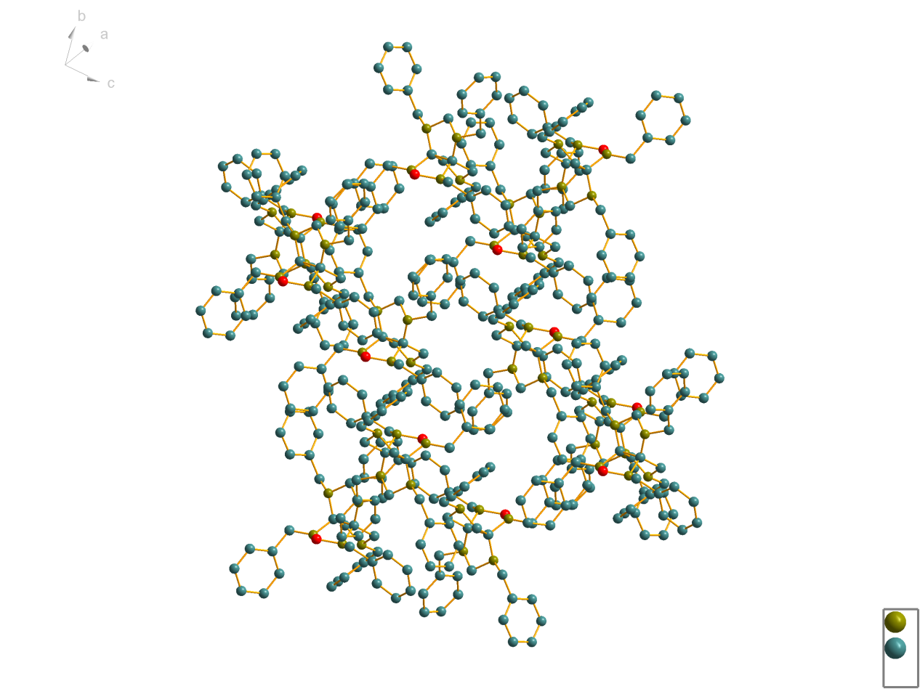

Fig. 6.
Crystal stacking diagram 4a.

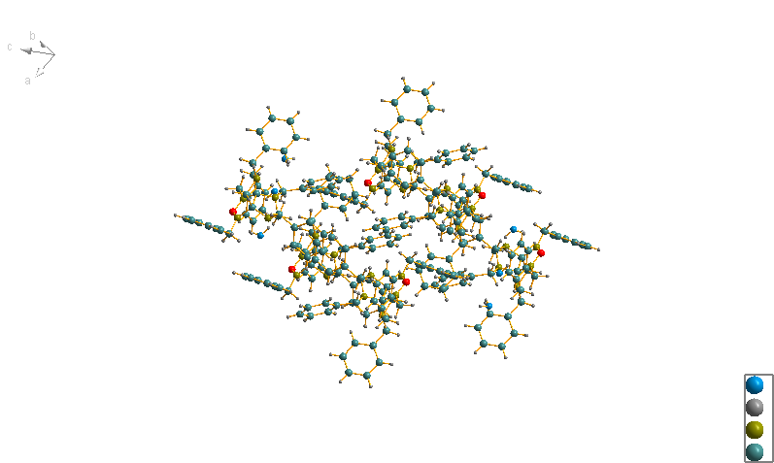

Fig. 7.
DTA and TGA of 3a.

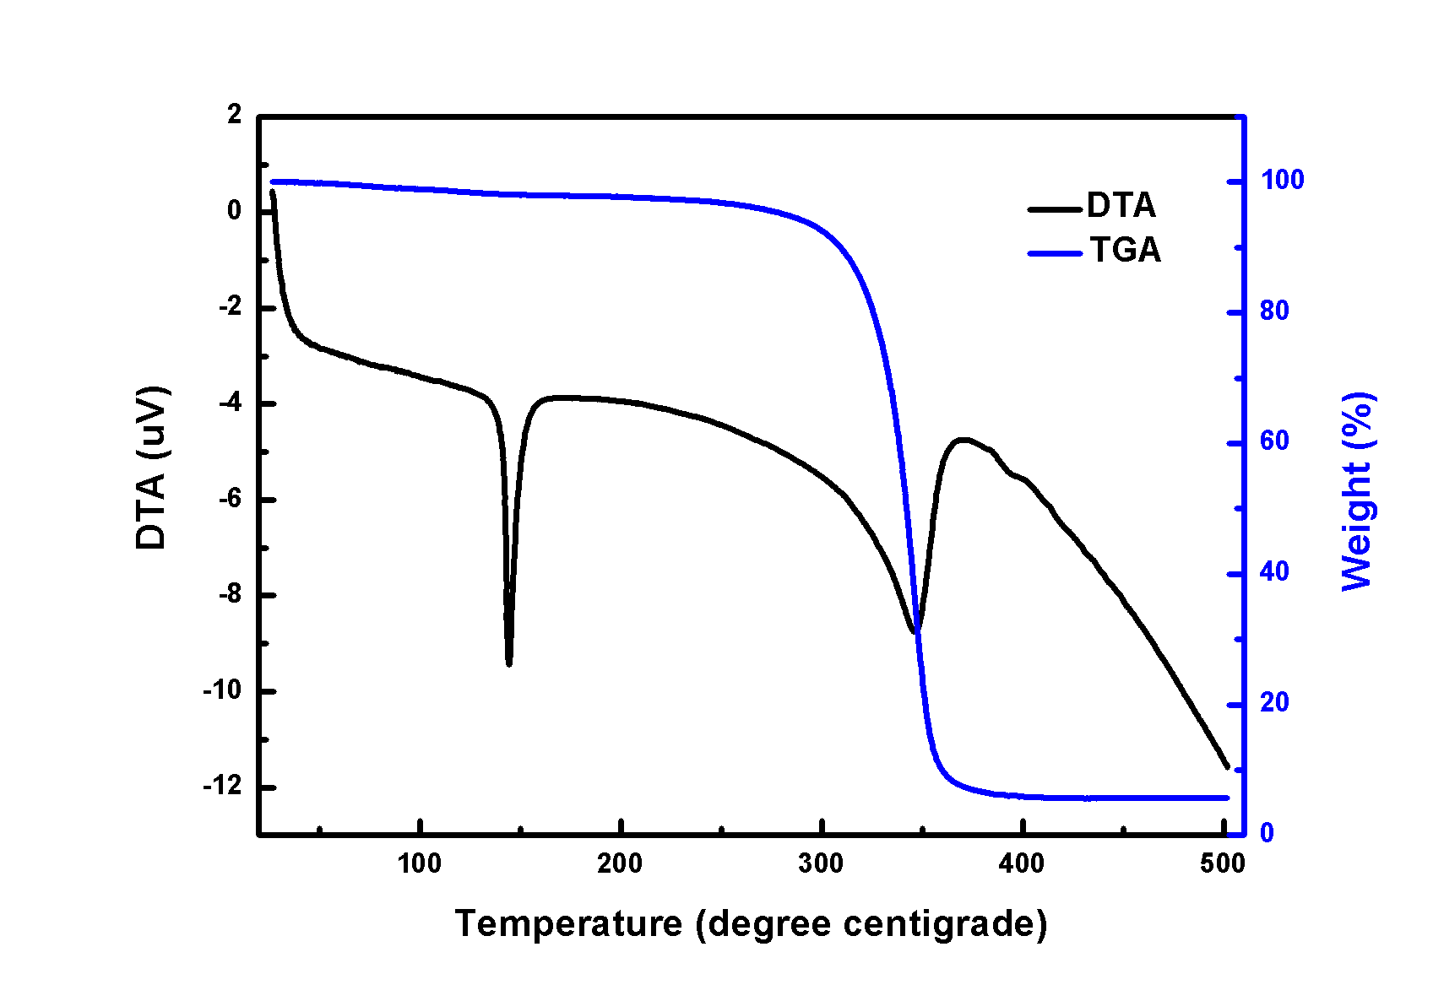

Fig. 8.
DTA and TGA of 4a.

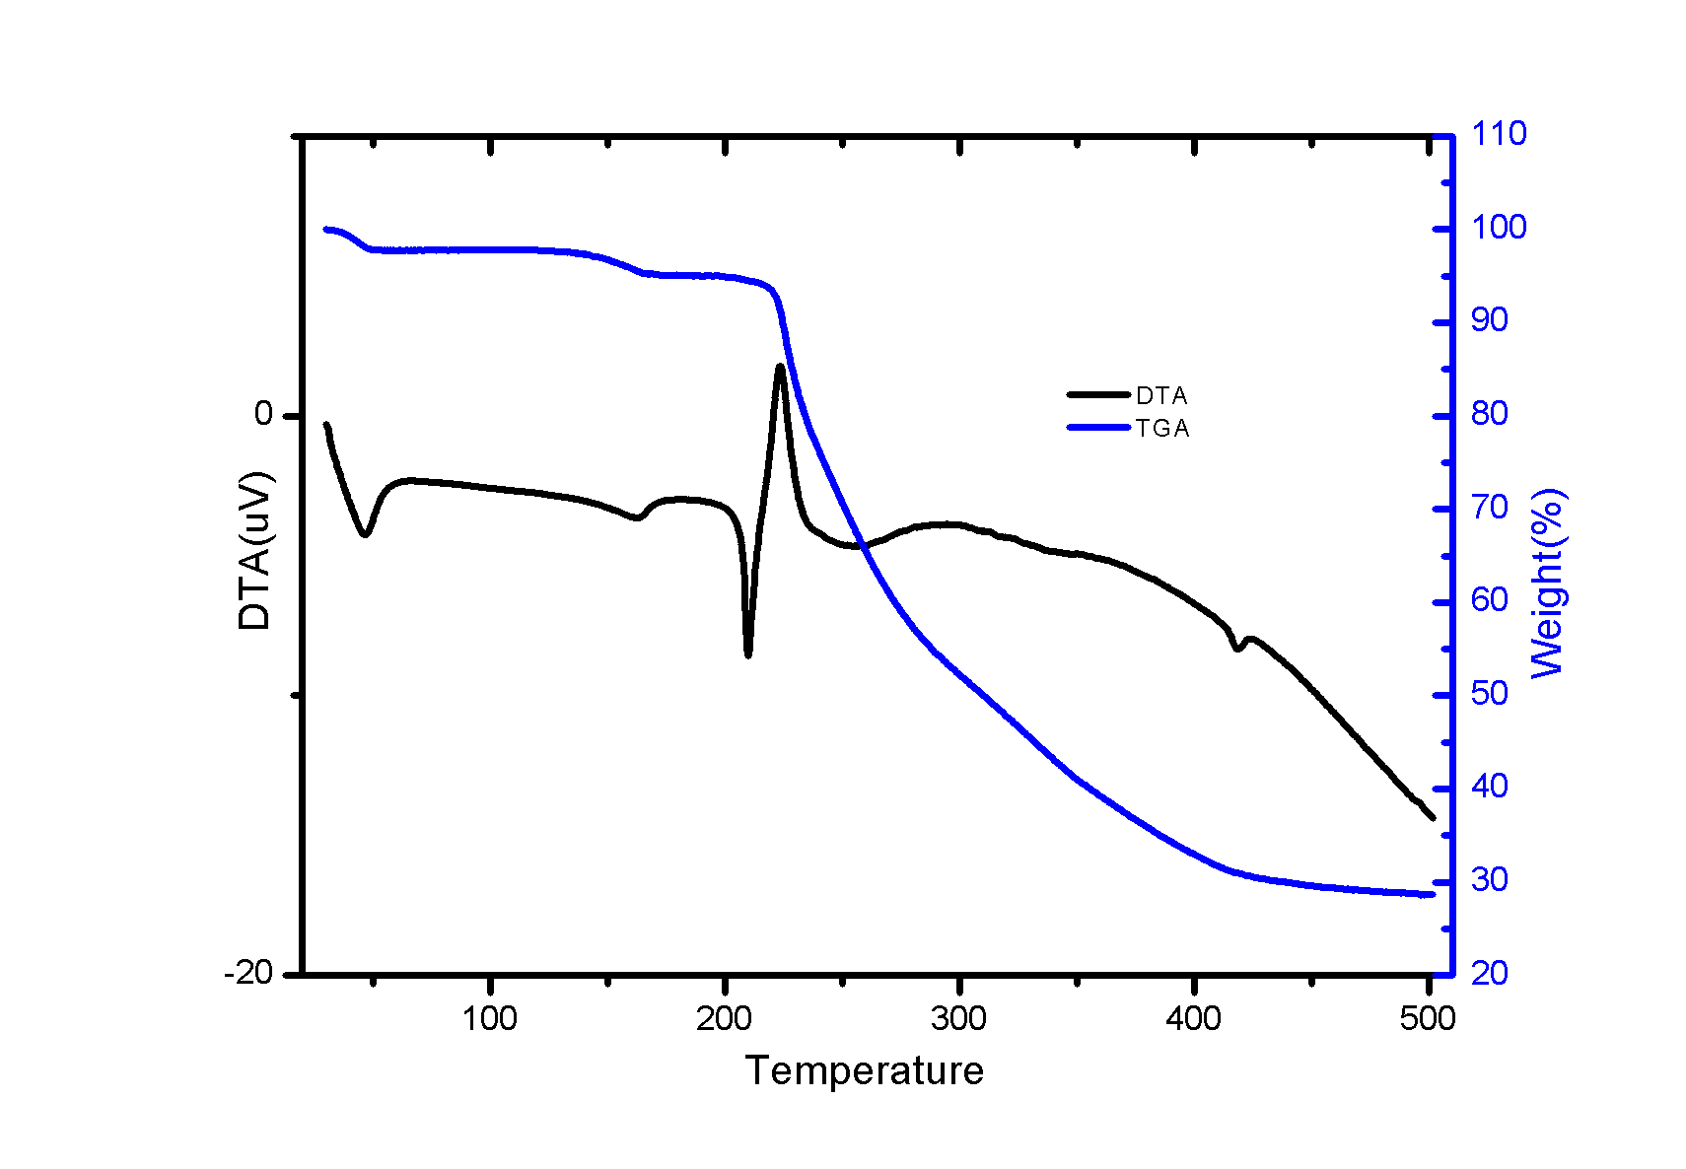

Fig. 9.
¹³C NMR (100 MHz, CDCl₃) of 2a.
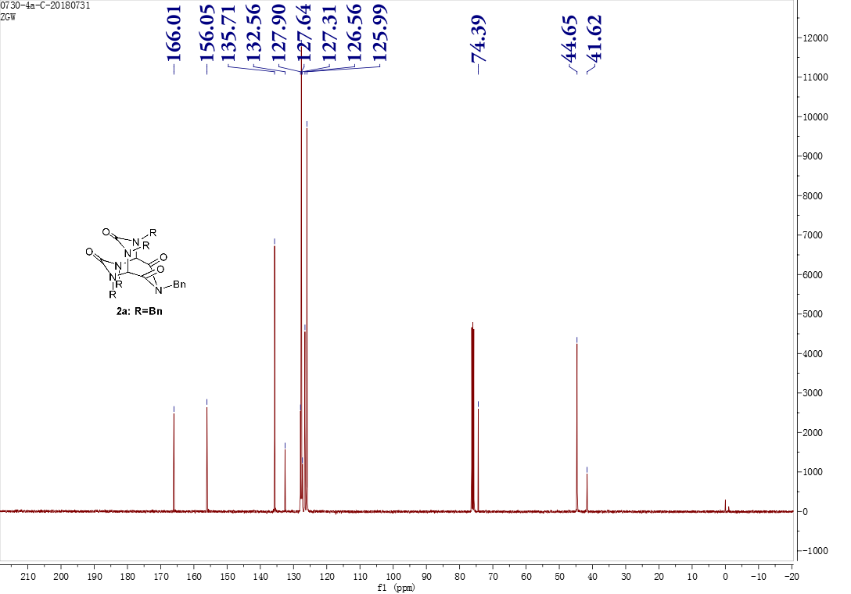

Fig. 10.
¹H NMR (400 MHz, CDCl₃) of 2a.
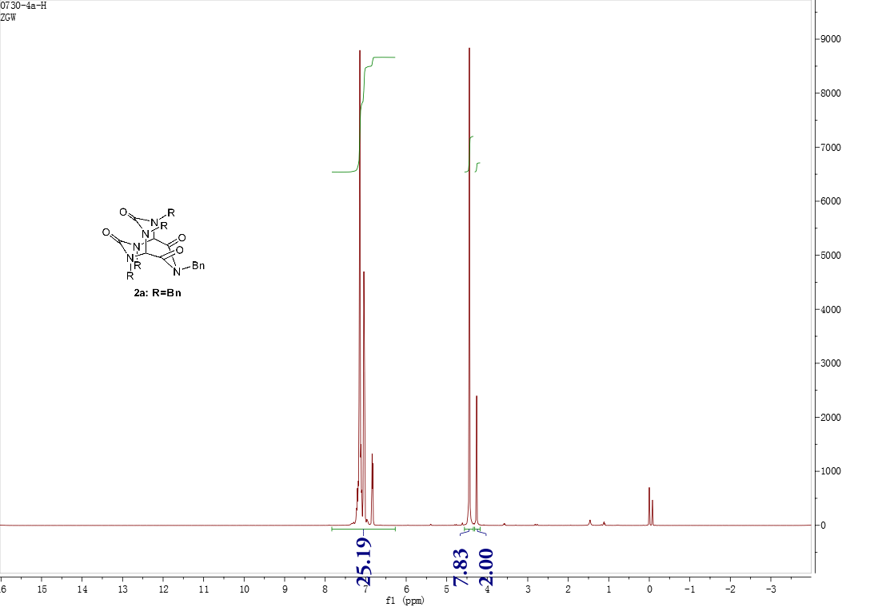

Fig. 11.
Infrared spectrum of 2a.

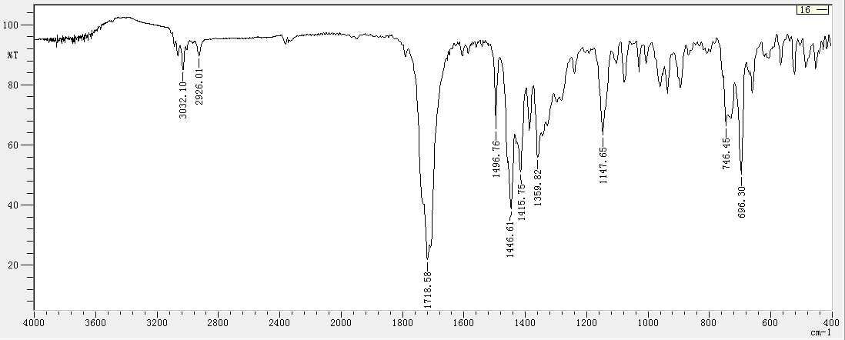

Fig. 12.
High resolution mass spectrometry of 2a.

Fig. 13.
¹³C NMR (100 MHz, CDCl₃) of 2b.

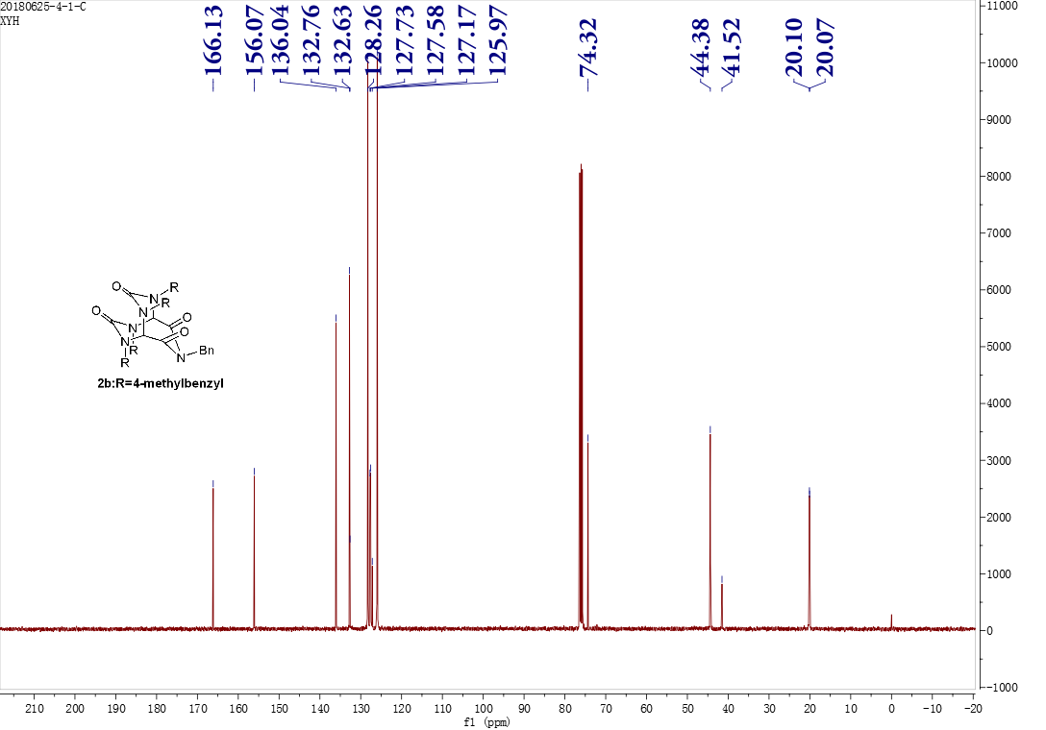

Fig. 14.
¹H NMR (400 MHz, CDCl₃) of 2b.

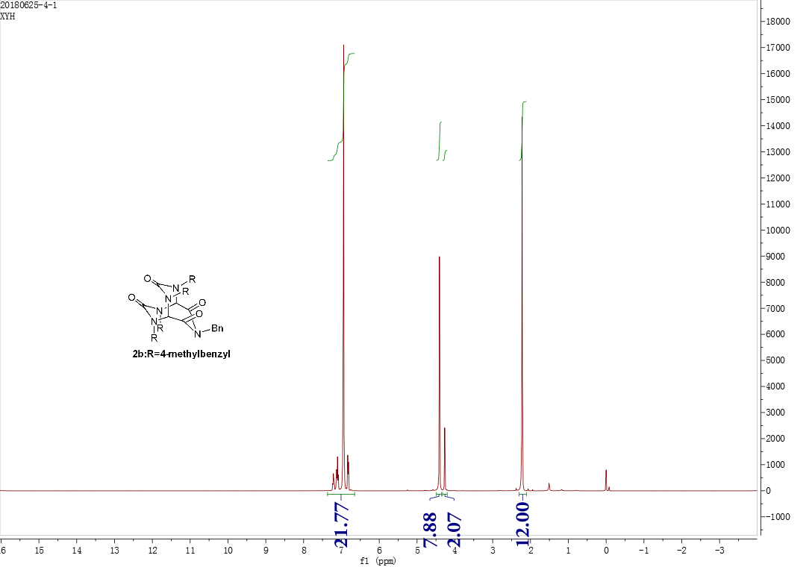

Fig. 15.
Infrared spectrum of 2b.

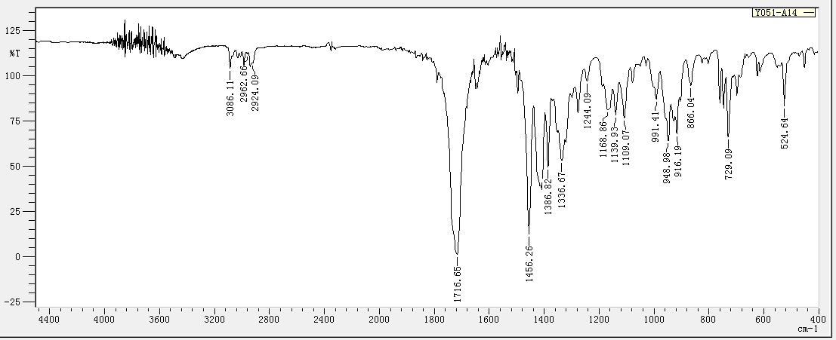

Fig. 16.
High resolution mass spectrometry of 2b.

Fig. 17.
¹³C NMR (100 MHz, DMSO-d₆) of 2c.

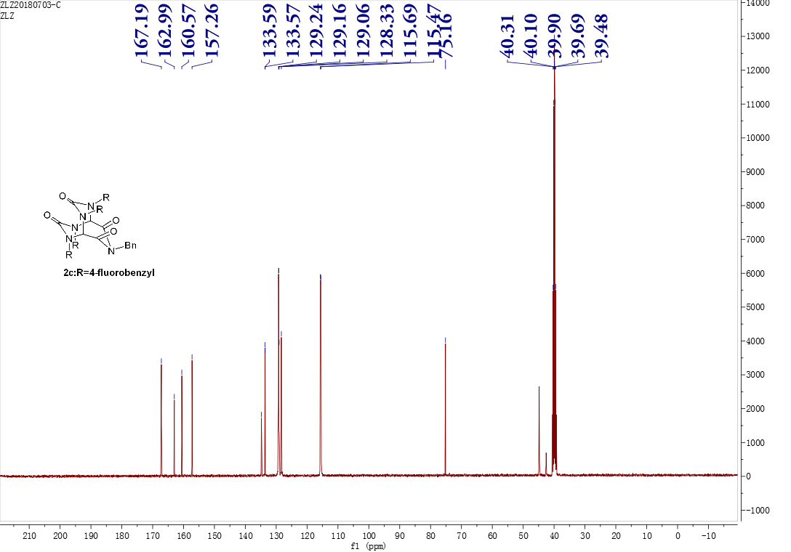

Fig. 18.
¹H NMR (400 MHz, DMSO-d₆) of 2c.

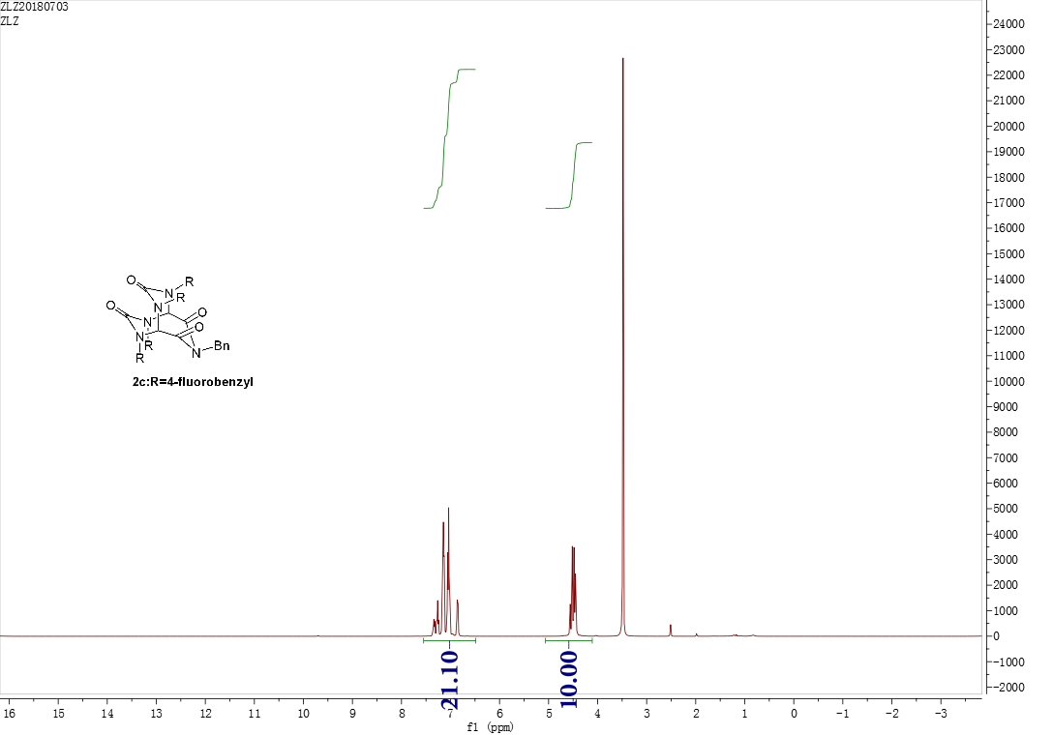

Fig. 19.
Infrared spectrum of 2c.

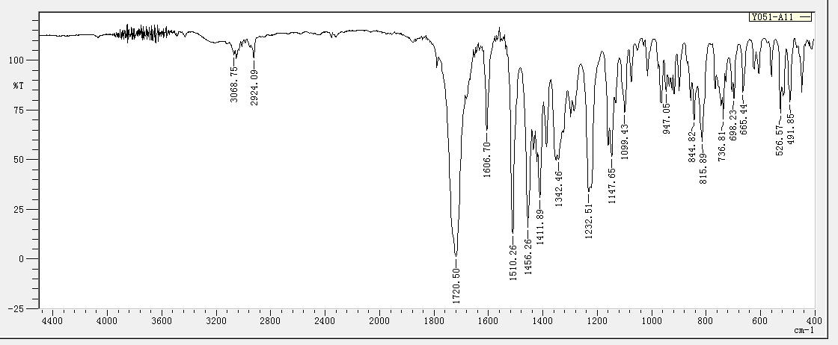

Fig. 20.
High resolution mass spectrometry of 2c.

Fig. 21.
¹³C NMR (100 MHz, CDCl₃) of 3a.

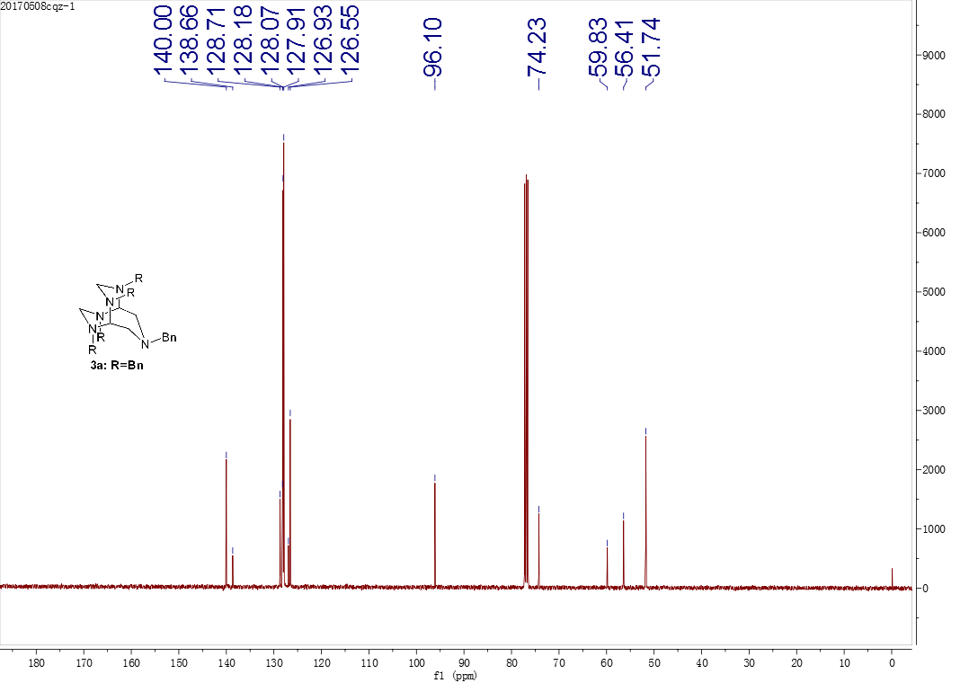

Fig. 22.
¹H NMR (400 MHz, CDCl₃) of 3a.

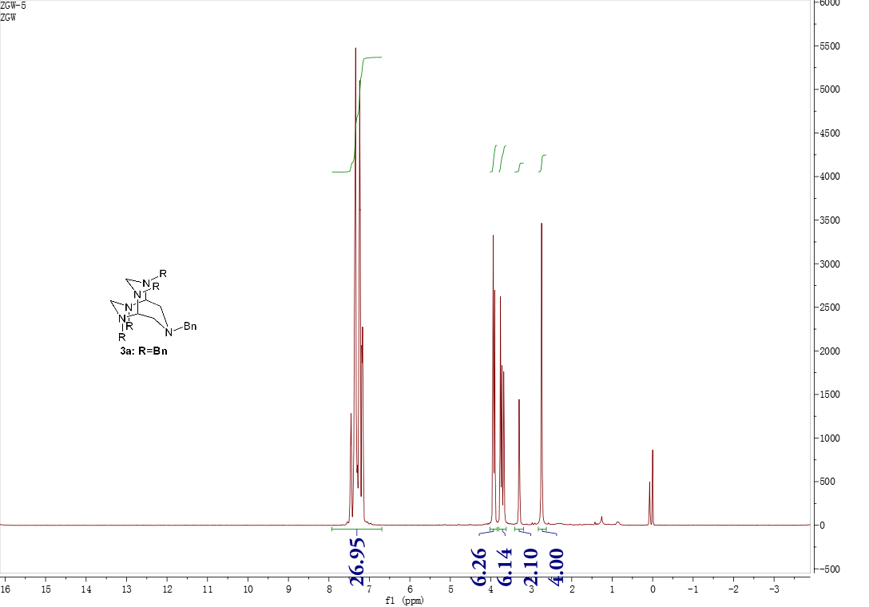

Fig. 23.
Infrared spectrum of 3a.

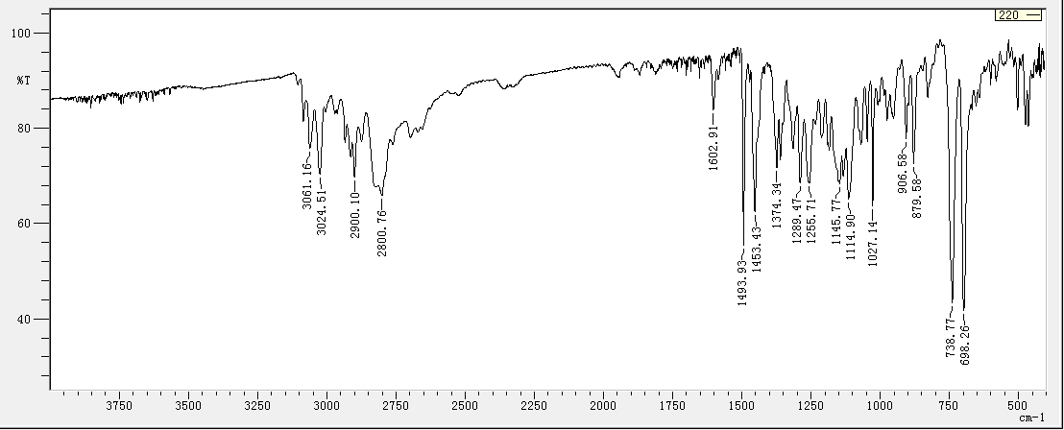

Fig. 24.
High resolution mass spectrometry of 3a.

Fig. 25.
¹³C NMR (100 MHz, CDCl₃) of 3b.

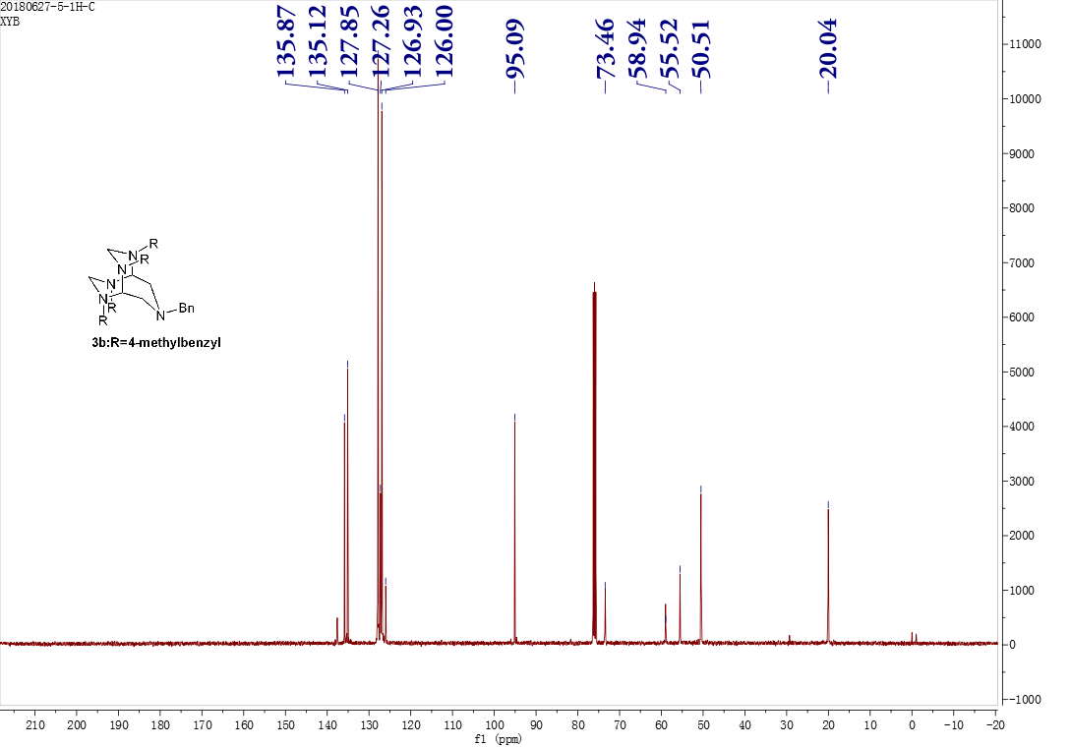

Fig. 26.
¹H NMR (400 MHz, CDCl₃) of 3b.

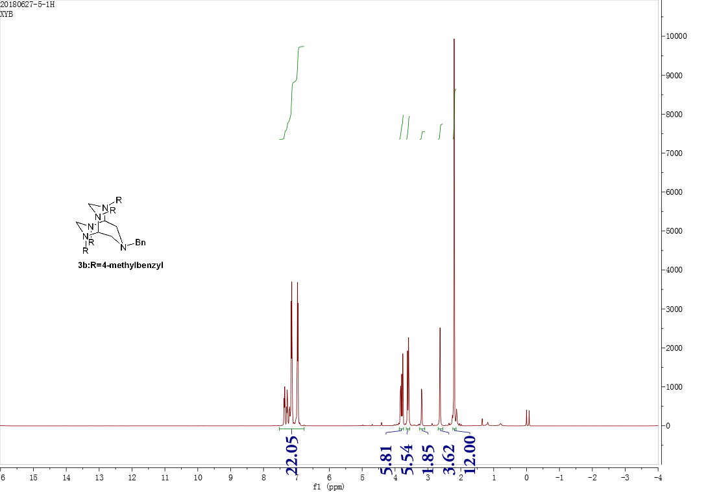

Fig. 27.
Infrared spectrum of 3b.

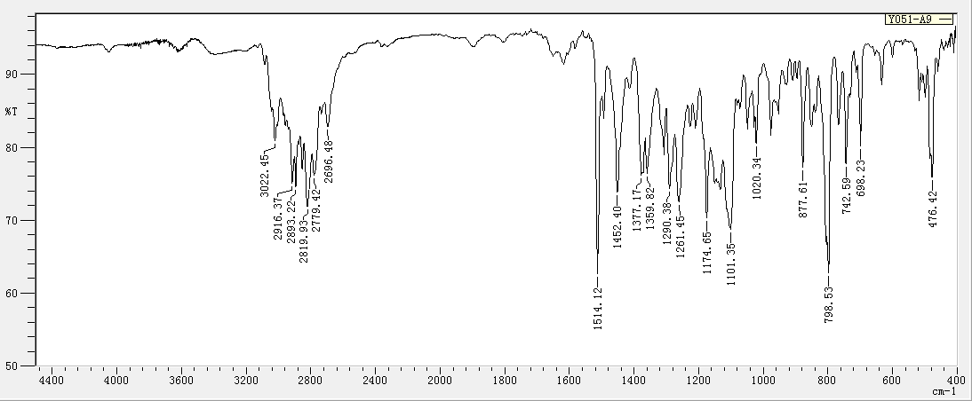

Fig. 28.
High resolution mass spectrometry of 3b.

Fig. 29.
¹³C NMR (100 MHz, CDCl₃) of 3c.

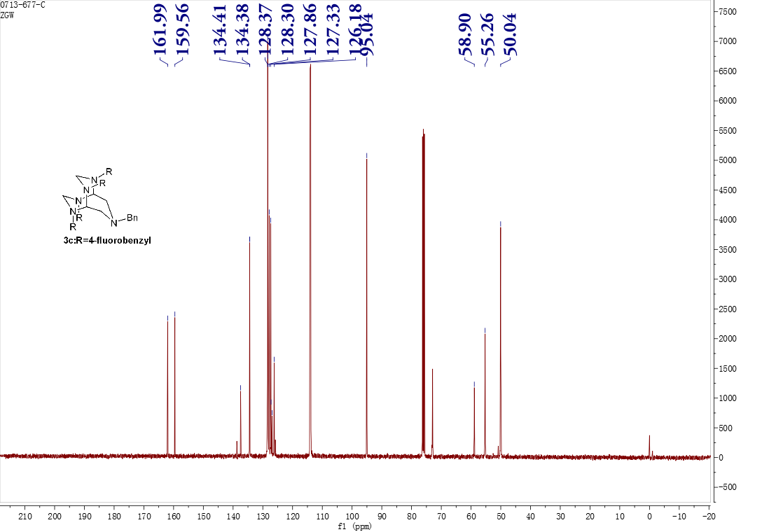

Fig. 30.
¹H NMR (400 MHz, CDCl₃) of 3c.

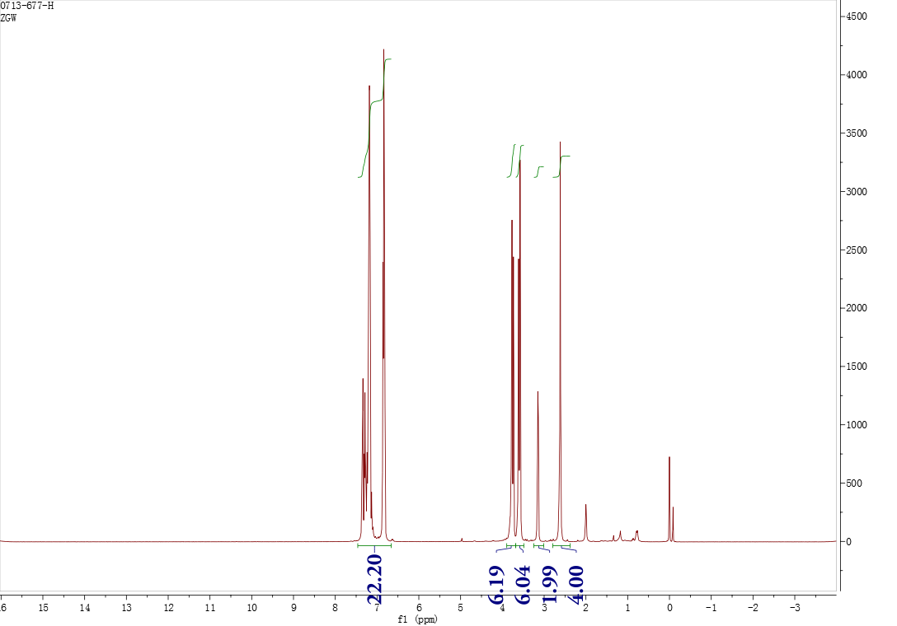

Fig. 31.
Infrared spectrum of 3c.

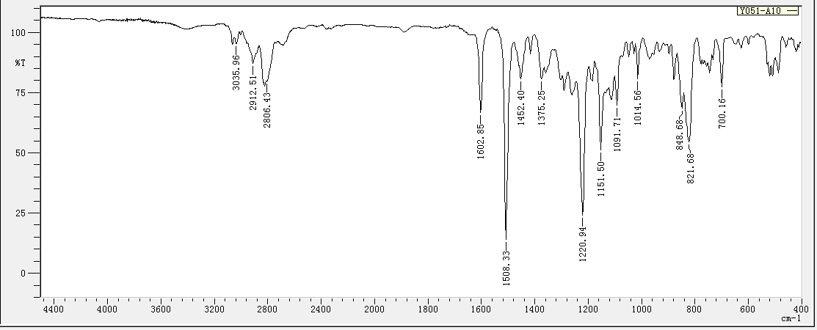

Fig. 32.
High resolution mass spectrometry of 3c.

Fig. 33.
¹³C NMR (100 MHz, CDCl₃) of 4a.

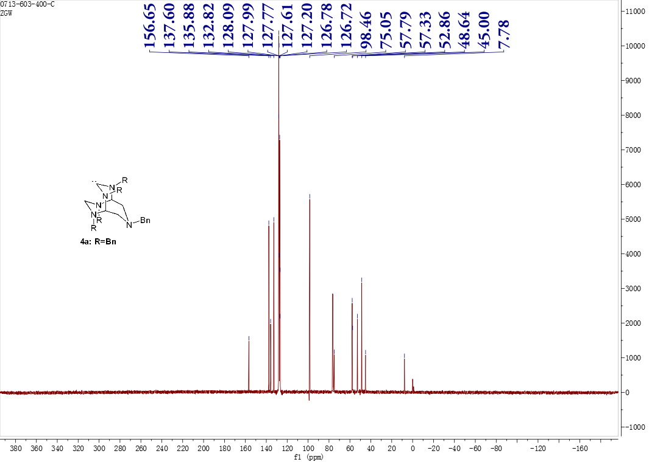

Fig. 34.
¹H NMR (400 MHz, CDCl₃) of 4a.

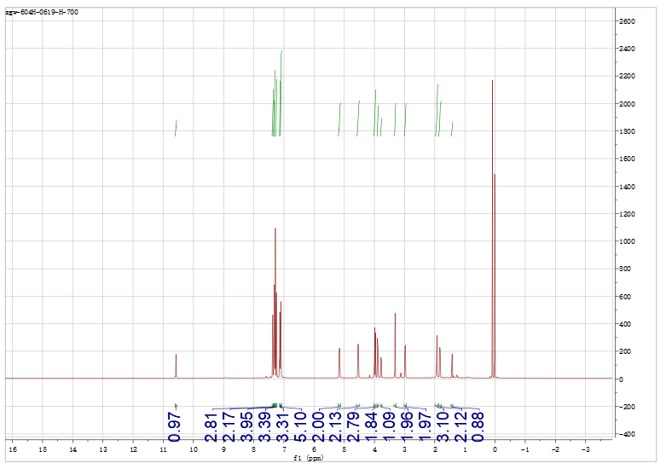

Fig. 35.
Infrared spectrum of 4a.

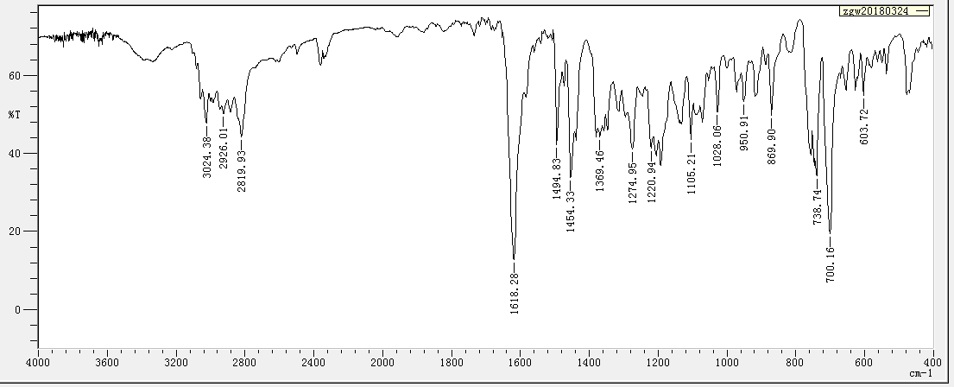

Fig. 36.
High resolution mass spectrometry of 4a.

Fig. 37.
¹³C NMR (100 MHz, CDCl₃) of 4b.

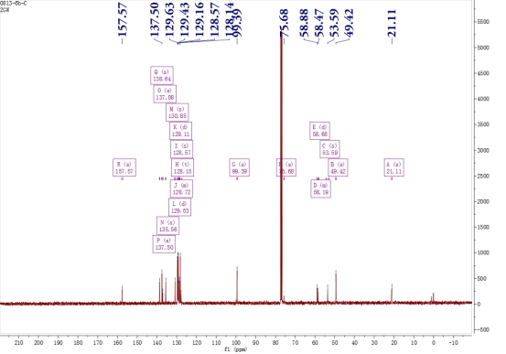

Fig. 38.
¹H NMR (400 MHz, CDCl₃) of 4b.

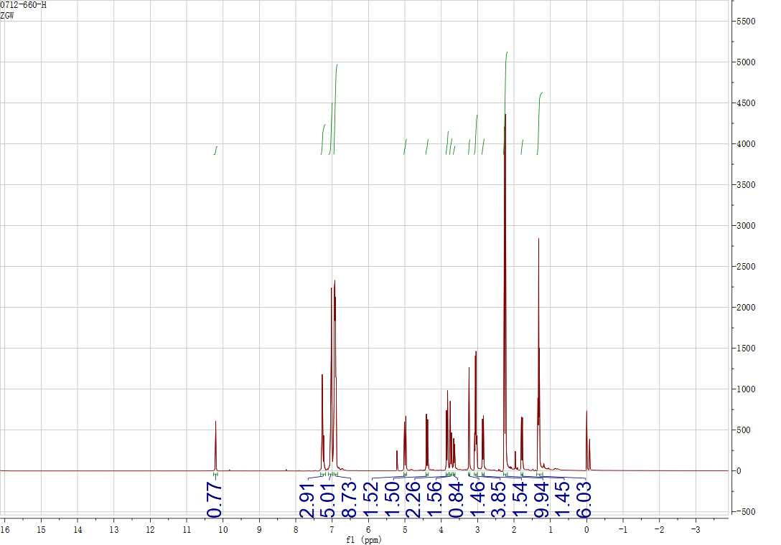

Fig. 39.
Infrared spectrum of 4b.

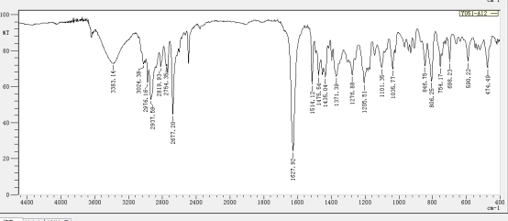

Fig. 40.
High resolution mass spectrometry of 4b.

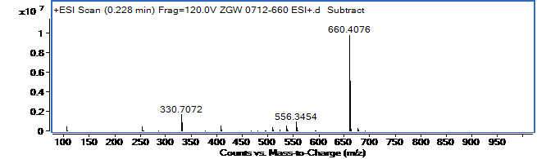

Fig. 41.
¹³C NMR (100 MHz, CDCl₃) of 4c.

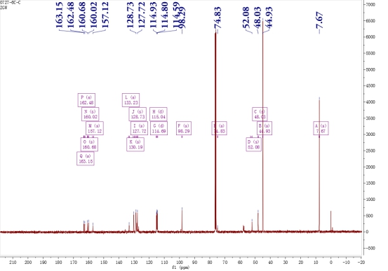

Fig. 42.
¹H NMR (400 MHz, CDCl₃) of 4c.

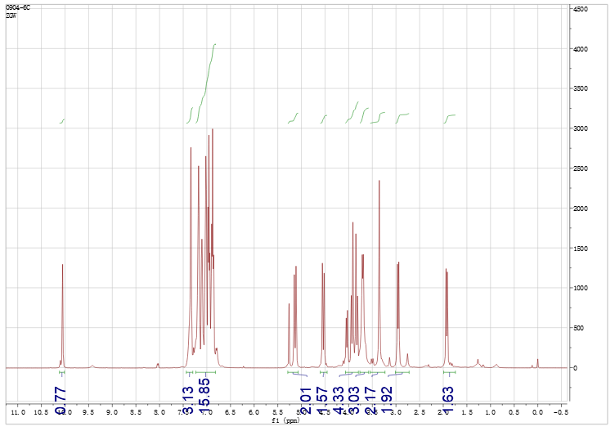

Fig. 43.
Infrared spectrum of 4c.

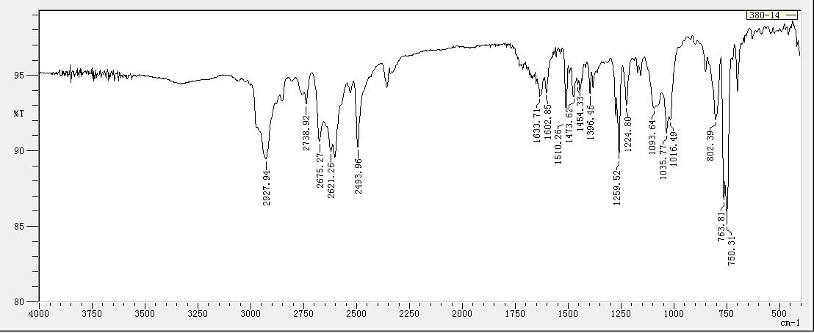

Fig. 44.
High resolution mass spectrometry of 4c.

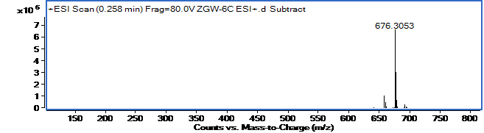

Fig. 45.

Ultraviolet absorption spectrum of 3a and 4a.
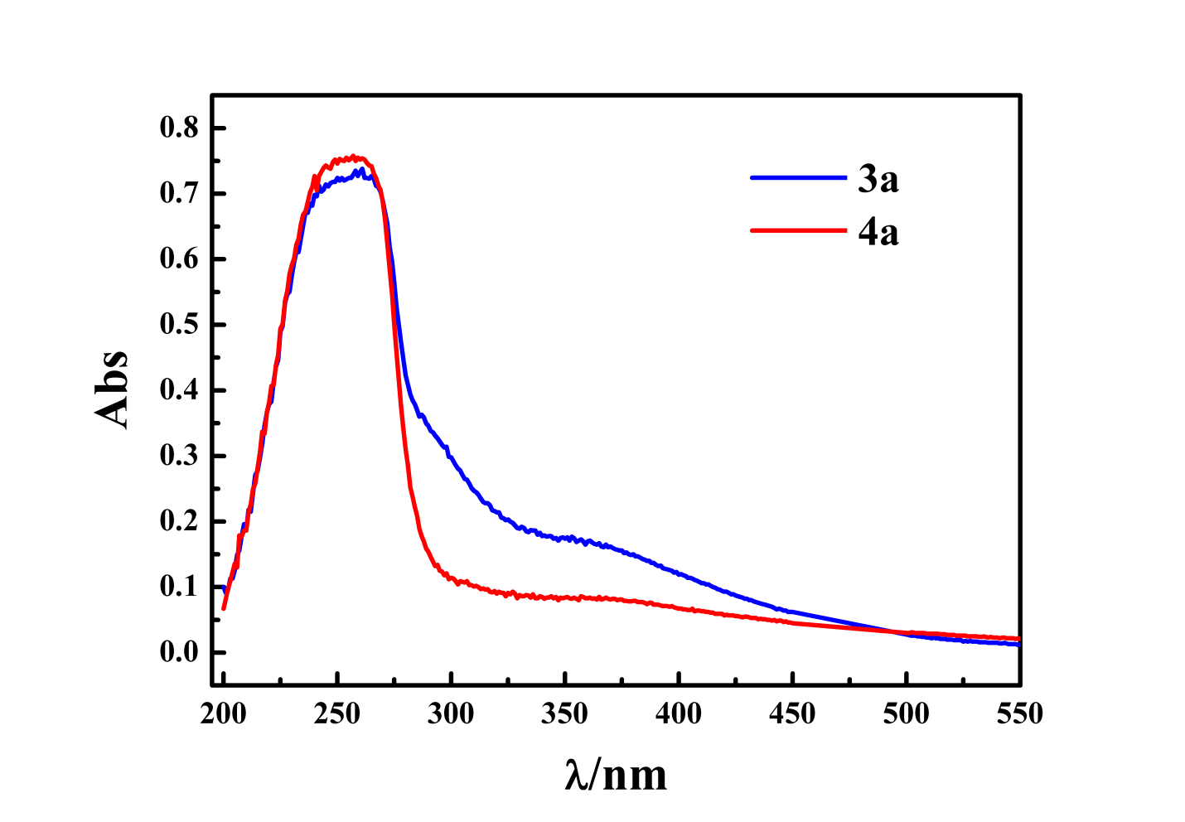

Table 1.
Crystal data and structure refinement for 3a and 4a.

 | 3a | 4a
Empirical formula | C₄₁H₄₃N₅ | C₄₁H₄₁N₅
Formula weight | 605.8 | 603.79
Temperature/K | 296.15 | 296.15
Crystal system | triclinic | triclinic
Space group | P-1 | P-1
a/Å | 10.7676(6) | 10.485(4)
b/Å | 11.2851(6) | 10.711(4)
c/Å | 16.2201(12) | 18.833(6)
α/° | 88.804(2) | 78.088(11)
β/° | 83.794(2) | 75.623(11)
γ/° | 62.8690(10) | 63.389(11)
Volume/Å³ | 1742.91(19) | 1820.7(11)
ρ_{calc}g/cm³ | 1.154 | 1.101
μ/mm⁻¹ | 0.068 | 0.065
F(000) | 648 | 644
Crystal size/mm³ | 0.3 × 0.15 × 0.1 | 0.2 × 0.15 × 0.1
Radiation | MoKα (λ = 0.71073) | MoKα (λ = 0.71073)
2Θ range for data collection/° | 4.058 to 49.476 | 4.28 to 49.69
Index ranges | -12 ≤ h ≤ 12, -13 ≤ k ≤ 13, -19 ≤ l ≤ 19 | -12 ≤ h ≤ 12, -12 ≤ k ≤ 12, -21 ≤ l ≤ 22
Reflections collected | 16540 | 17013
Independent reflections | 5948 [R_{int} = 0.0209, R_{sigma} = 0.0277] | 6219 [Rint = 0.0443, Rsigma = 0.0712]
Data/restraints/parameters | 5948/62/403 | 6219/594/415
Goodness-of-fit on F² | 1.045 | 1.084
Final R indexes [I>=2σ (I)] | R₁ = 0.1074,  wR₂ = 0.3207 | R1 = 0.0581, wR2 = 0.1597
Final R indexes [all data] | R₁ = 0.1403,  wR₂ = 0.3538 | R1 = 0.1050, wR2 = 0.1768
Largest diff. peak/hole / e Å⁻³ | 1.38/-0.51 | 0.47/-0.21

Table 2.
Bond length data for 3a and 4a.
Atom | Atom | Length for 3a /Å | Length for 4a /Å
N1 | C2 | 1.457(5) | 1.316(4)
N1 | C8 | 1.470(5) | 1.477(3)
N1 | C12 | 1.415(6) | 1.474(3)
N3 | C2 | 1.436(6) | 1.318(3)
N3 | C4 | 1.453(5) | 1.505(3)
N3 | C19 | 1.392(7) | 1.467(4)
N5 | C4 | 1.474(5) | 1.437(3)
N5 | C6 | 1.452(5) | 1.453(3)
N5 | C26 | 1.454(5) | 1.444(3)
N7 | C6 | 1.444(5) | 1.465(3)
N7 | C8 | 1.467(5) | 1.469(3)
N7 | C33 | 1.457(5) | 1.469(4)
N10 | C9 | 1.459(5) | 1.450(3)
N10 | C11 | 1.446(5) | 1.471(3)
N10 | C40 | 1.454(5) | 1.466(4)
C4 | C8 | 1.565(5) | 1.563(4)
C4 | C11 | 1.525(5) | 1.515(4)
C8 | C9 | 1.529(5) | 1.539(4)
C12 | C13 | 1.517(6) | 1.508(4)
C13 | C14 | 1.391(7) | 1.385(4)
C13 | C18 | 1.350(7) | 1.376(4)
C14 | C15 | 1.381(8) | 1.398(5)
C15 | C16 | 1.337(8) | 1.382(5)
C16 | C17 | 1.307(8) | 1.352(5)
C17 | C18 | 1.398(8) | 1.383(5)
C19 | C20 | 1.498(7) | 1.504(4)
C20 | C21 | 1.390(0) | 1.382(4)
C20 | C25 | 1.390(0) | 1.373(5)
C21 | C22 | 1.390(0) | 1.376(5)
C22 | C23 | 1.390(0) | 1.347(6)
C23 | C24 | 1.390(0) | 1.343(6)
C24 | C25 | 1.390(0) | 1.393(5)
C26 | C27 | 1.491(6) | 1.497(4)
C27 | C28 | 1.398(8) | 1.378(4)
C27 | C32 | 1.355(7) | 1.388(4)
C28 | C29 | 1.365(9) | 1.385(4)
C29 | C30 | 1.352(13) | 1.394(5)
C30 | C31 | 1.353(13) | 1.353(5)
C31 | C32 | 1.377(11) | 1.371(4)
C33 | C34 | 1.501(6) | 1.508(4)
C34 | C35 | 1.367(7) | 1.381(4)
C34 | C39 | 1.368(7) | 1.384(4)
C35 | C36 | 1.394(8) | 1.400(5)
C36 | C37 | 1.344(9) | 1.355(5)
C37 | C38 | 1.323(10) | 1.371(5)
C38 | C39 | 1.385(9) | 1.366(4)
C40 | C41 | 1.518(7) | 1.501(4)
C41 | C42 | 1.371(8) | 1.383(4)
C41 | C46 | 1.369(8) | 1.391(4)
C42 | C43 | 1.406(13) | 1.375(5)
C43 | C44 | 1.340(15) | 1.375(5)
C44 | C45 | 1.316(14) | 1.376(5)
C45 | C46 | 1.370(9) | 1.381(5)

Table 3.
Bond angle data for 3a and 4a

Atom | Atom | Atom | Angle for 3a/˚ | Angle for 4a/˚
C2 | N1 | C8 | 104.4(3) | 111.4(2)
C2 | N1 | C12 | 112.5(4) | 124.3(2)
C8 | N1 | C12 | 120.8(4) | 124.2(2)
C2 | N3 | C4 | 104.3(3) | 109.9(2)
C2 | N3 | C19 | 115.0(4) | 122.6(2)
C4 | N3 | C19 | 123.1(4) | 126.5(2)
C4 | N5 | C6 | 106.1(3) | 106.2(2)
C4 | N5 | C26 | 117.3(3) | 119.4(2)
C6 | N5 | C26 | 112.8(3) | 117.1(2)
C6 | N7 | C8 | 107.3(3) | 102.7(2)
C6 | N7 | C33 | 113.7(3) | 113.2(2)
C8 | N7 | C33 | 118.5(3) | 117.1(2)
C9 | N10 | C11 | 104.0(3) | 104.5(2)
C9 | N10 | C40 | 114.0(3) | 114.8(2)
C11 | N10 | C40 | 114.3(3) | 113.8(2)
N1 | C2 | N3 | 103.6(3) | 113.7(3)
N3 | C4 | N5 | 112.6(3) | 116.4(3)
N3 | C4 | C8 | 104.7(0) | 102.49(19)
N3 | C4 | C11 | 113.6(3) | 114.2(2)
N5 | C4 | C8 | 104.2(3) | 102.5(2)
N5 | C4 | C11 | 116.6(3) | 113.5(3)
C8 | C4 | C11 | 103.4(3) | 105.6(2)
N5 | C6 | N7 | 103.6(3) | 104.9(2)
N1 | C8 | N7 | 113.4(3) | 110.2(2)
N1 | C8 | C4 | 103.3(3) | 107.2(2)
N1 | C8 | C9 | 112.6(3) | 114.2(2)
N7 | C8 | C4 | 103.8(3) | 107.2(2)
N7 | C8 | C9 | 117.7(3) | 118.4(2)
C4 | C8 | C9 | 103.9(3) | 102.7(2)
N10 | C9 | C8 | 103.5(3) | 101.3(2)
N10 | C11 | C4 | 103.4(3) | 100.7(2)
N1 | C12 | C13 | 117.0(4) | 113.1(3)
C12 | C13 | C14 | 122.6(5) | 119.7(3)
C12 | C13 | C18 | 119.4(5) | 120.9(3)
C14 | C13 | C18 | 117.7(4) | 119.4(3)
C13 | C14 | C15 | 120.1(5) | 119.5(3)
C14 | C15 | C16 | 120.0(5) | 119.3(4)
C15 | C16 | C17 | 121.1(5) | 121.2(4)
C16 | C17 | C18 | 120.7(5) | 119.5(4)
C13 | C18 | C17 | 120.4(5) | 121.0(3)
N3 | C19 | C20 | 114.9(5) | 114.5(2)
C19 | C20 | C21 | 117.5(4) | 121.2(3)
C19 | C20 | C25 | 122.5(4) | 121.1(3)
C21 | C20 | C25 | 120.0(0) | 117.6(3)
C20 | C21 | C22 | 120.0(0) | 120.7(4)
C21 | C22 | C23 | 120.0(0) | 121.2(4)
C22 | C23 | C24 | 120.0(0) | 120.3(5)
C23 | C24 | C25 | 120.0(0) | 120.6(5)
C20 | C25 | C24 | 120.0(0) | 120.2(4)
N5 | C26 | C27 | 111.9(3) | 113.7(3)
C26 | C27 | C28 | 120.2(4) | 122.5(3)
C26 | C27 | C32 | 122.1(5) | 119.8(3)
C28 | C27 | C32 | 117.7(5) | 117.5(3)
C27 | C28 | C29 | 120.6(7) | 121.4(4)
C28 | C29 | C30 | 119.7(9) | 118.1(3)
C29 | C30 | C31 | 121.1(8) | 121.0(4)
C30 | C31 | C32 | 119.1(8) | 119.8(4)
C27 | C32 | C31 | 121.7(8) | 121.7(3)
N7 | C33 | C34 | 110.8(3) | 113.8(2)
C33 | C34 | C35 | 121.2(4) | 120.2(3)
C33 | C34 | C39 | 121.7(4) | 122.4(3)
C35 | C34 | C39 | 117.1(5) | 117.3(3)
C34 | C35 | C36 | 120.5(5) | 120.5(4)
C35 | C36 | C37 | 120.5(6) | 120.1(3)
C36 | C37 | C38 | 119.7(6) | 119.3(4)
C37 | C38 | C39 | 120.6(6) | 120.9(4)
C34 | C39 | C38 | 121.3(6) | 121.4(3)
N10 | C40 | C41 | 111.8(4) | 110.5(3)
C40 | C41 | C42 | 120.5(6) | 120.0(3)
C40 | C41 | C46 | 121.8(5) | 121.0(3)
C42 | C41 | C46 | 117.8(6) | 119.0(3)
C41 | C42 | C43 | 119.6(9) | 120.8(3)
C42 | C43 | C44 | 120.0(10) | 119.6(4)
C43 | C44 | C45 | 120.6(10) | 120.8(3)
C44 | C45 | C46 | 120.9(9) | 119.4(3)
C41 | C46 | C45 | 121.1(7) | 120.4(3)

