**Supporting Information**

**Study on the Interaction Between Melamine-Cored Schiff Bases with Cucurbiturils of Different Sizes and Its Application in Detecting Silver Ion**

Jun-Xian Gou†, Yang Luo*†, Xi-Nan Yang, Wei Zhang, Ji-Hong Lu, Zhu Tao, Xin Xiao*

Key Laboratory of Macrocyclic and Supramolecular Chemistry of Guizhou Province, Guizhou University, Guiyang 550025, China.

* Corresponding author: gyhxxiaoxin@163.com (Xin Xiao), ouyyangl@126.com (Yang Luo)

† joint first author

Content

**Materials** 2

**Measurement of UV-vis spectra** 2

**1H NMR measurements** 2

**Isothermal titration calorimetry (ITC) measurements** 3

Scheme S1 The synthesis routes of TBT 3

Figure S1 The 1H NMR of **1** 4

Figure S2 COSY of **1** 4

Figure S3 The 1H NMR of **2** 5

Figure S4 The 1H NMR and COSY of **3** 6

Figure S5 The UV-vis of TBT (20 µM) towards TMeQ[6]. 7

Figure S6 The plot of NTMeQ[6]/NTBT *vs.* abs. at λ= 286nm. 7

Figure S7 ITC of Q[7] (0.1 M) towards TBT(0.005 M). 8

Table S1 Date of ITC 8

Figure S8 The 1H NMR titration of TBT (1 mM) with an increasing amount of Q[8] from 0, 0.5, 1.0 to 2.0 from bottom to top, and free Q[8] (top) in D2O. 9

Figure S9 The plot of NQ[8]/NTBT *vs.* abs. at λ= 286nm. 9

Figure S10 The SEM of Q[8]-TBT (1 mM). 10

Figure S11 The plot of NAg+/N Q[7]-TBT *vs.* abs. at λ= 286nm. 10

**Materials**

Q[7], Q[7] and TMeQ[6] were synthesized according to a procedure developed previously in our laboratory.Melamine, 4-hydroxybenzaldehyde, K2CO3 and ethyl 4-bromobutyrate were obtained from Sigma-Aldrich (Shanghai, China) and corresponding perchlorate salts were obtained from Aladdin (Shanghai, China). All reagents were of analytical reagent grade and were used without further purification. Doubly-distilled water was used throughout.

**Measurement of UV-vis spectra**

All UV-visible spectra were recorded on an Agilent 8453 spectrophotometer (Agilent Technologies, Santa Clara, CA, USA), from solutions in 1 cm quartz cells.

Aqueous solutions of TBT (20 μM) were prepared by diluting the stock solutions, and an increasing concentration (0-80 μM) of Q[*n*] solution was added to free TBT to obtain plot of NQ[7]/NTBT vs. absorbance of TBT.

For the part of detection of Ag+: Aqueous solutions of the Q[7]-TBT complex (3:1*,* 20 μM) were prepared for characterization by UV-vis spectra. Then known quantities of metal ion solutions were added to Q[7]-TBT to obtain the corresponding plot.

**1H NMR measurements**

The 1H NMR spectra were recorded at 25°C on a Jeol JNM-ECZ400s spectrometer. D2O was used as a field-frequency lock and the observed chemical shifts are reported in parts per million (ppm) relative to that for the internaltetramethylsilane (TMS) standard (0.0 ppm).

**Isothermal titration calorimetry (ITC) measurements**

Thermodynamic parameters and binding constants (K) for the Q[7]-TBT were determined by ITC using a Nano ITC instrument (TA, USA). All solutions were prepared in doubly-distilled water and degassed prior to titration experiments. The heat evolved was recorded at 298.15 K. The heat of dilution was corrected by injecting guest solution (free guest) into an aqueous solution and subtracting the values from the corresponding values obtained for the host-guest titration. Computer simulations (curve fitting) were performed using Nano ITC analytical software. For Q[7]-TBT, the concentration of Q[7] in the sample cell (1.3 mL) was 1×10−4 mol/L. A typical ITC titration was carried out by titrating the TBT solution (1×10−3 mol/L, 10 μL aliquots, at 250 s intervals) into Q[7] solution..



Scheme S1 The synthesis routes of TBT



Figure S1 The 1H NMR of **1**



Figure S2 COSY of **1**



Figure S3 The 1H NMR of **2**

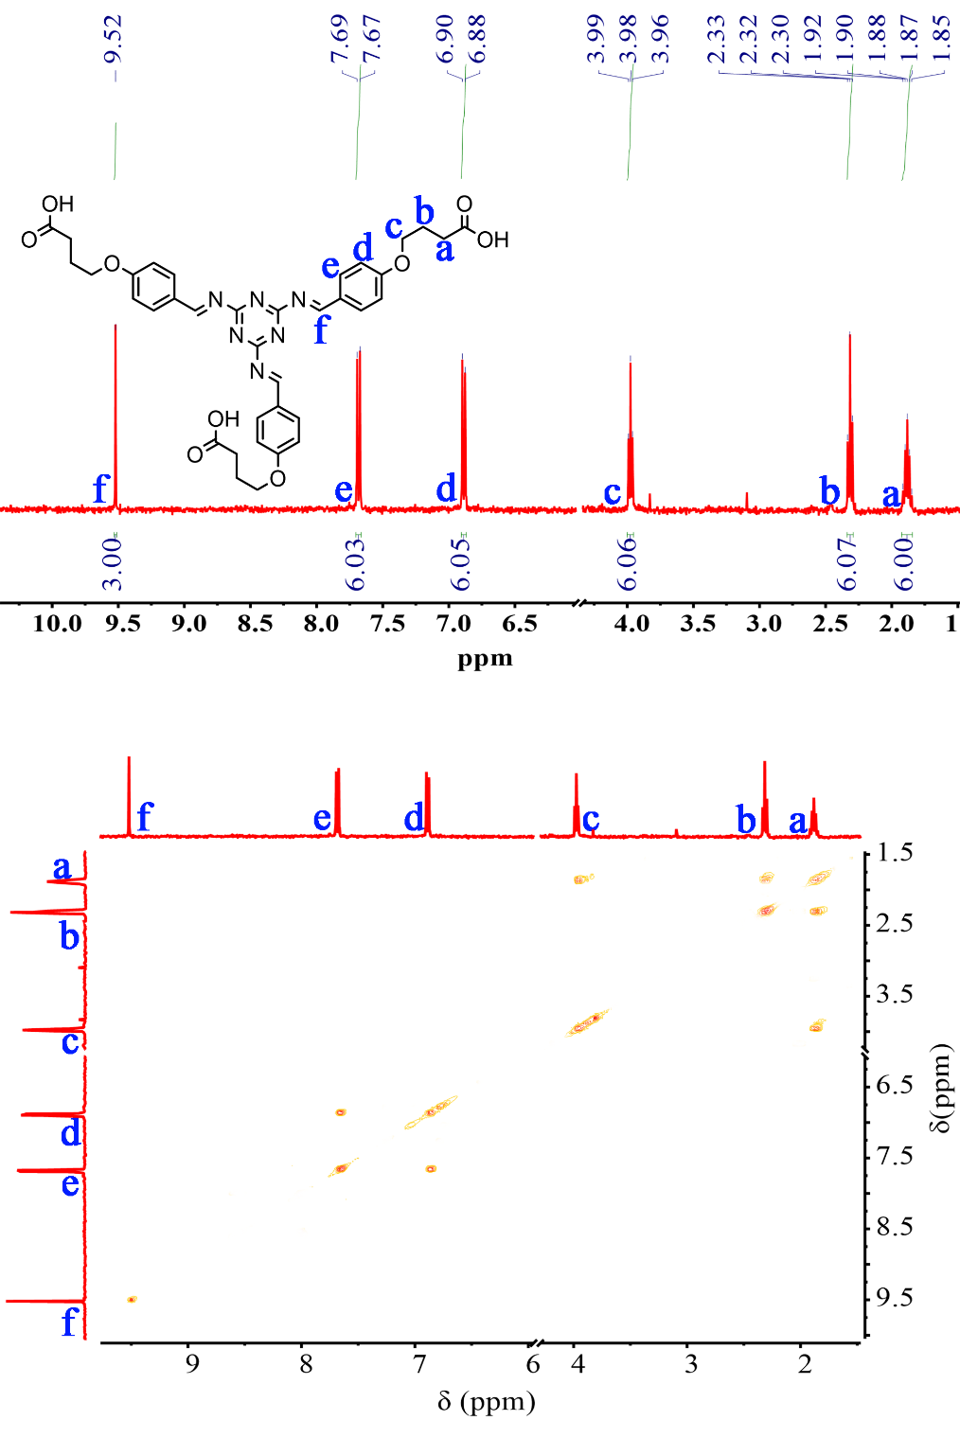

Figure S4 The 1H NMR and COSY of **TBT**



Figure S5 The UV-vis of TBT (20 µM) towards TMeQ[6].



Figure S6 The plot of NTMeQ[6]/NTBT *vs.* abs. at λ= 286nm.

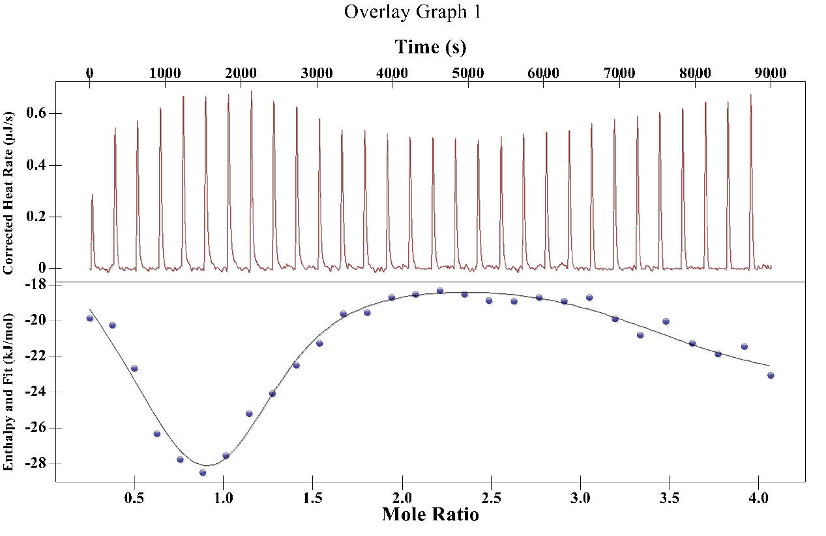

Figure S7 ITC of Q[7] (0.1 M) towards TBT(0.005 M).

Table S1 Date of ITC

|  |  |  |
| --- | --- | --- |
| Ka1 (M-1) | Ka2(M-1) | Ka3(M-1) |
| 1.422×106 | 2022 | 21.55 |
| ΔH1 (KJ/mol) | ΔH2 (KJ/mol) | ΔH3 (KJ/mol) |
| 62.72 | -3918 | -1783 |
| ΔS1 (J/mol·K) | ΔS2 (J/mol·K) | ΔS3 (J/mol·K) |
| 328.2 | -1.308×104 | -5.954×103 |

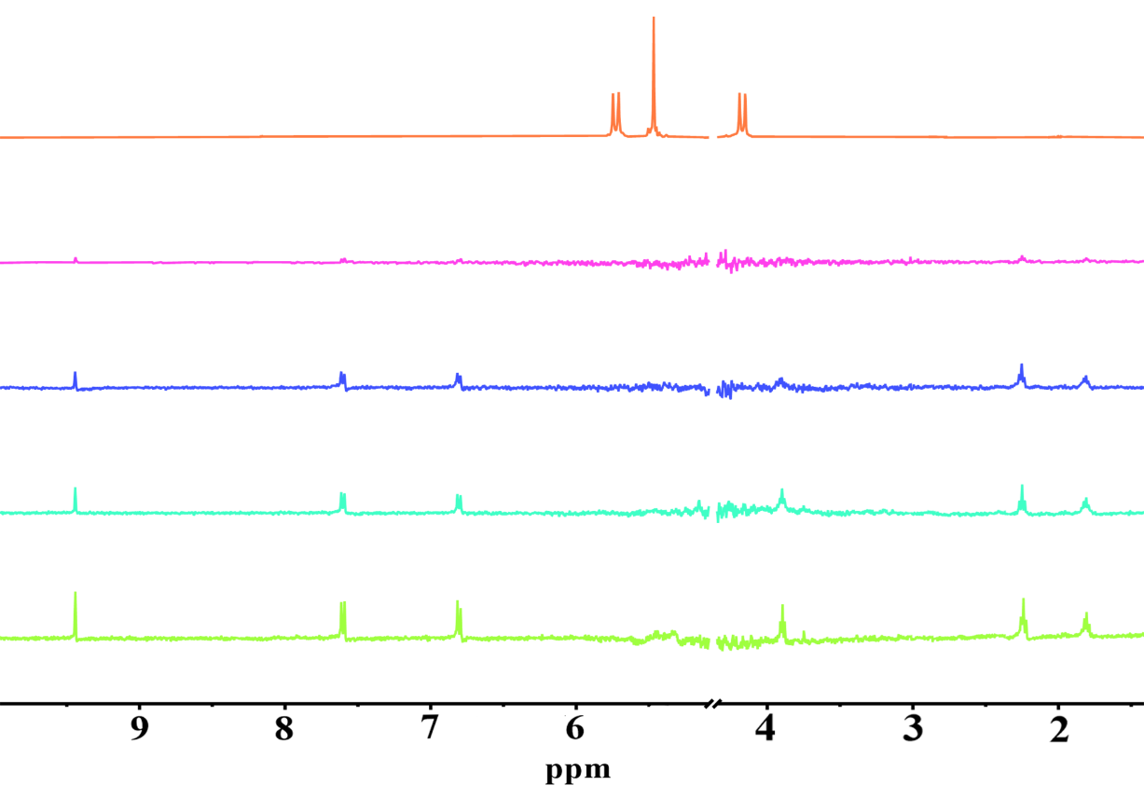

Figure S8 The 1H NMR titration of TBT (1 mM) with an increasing amount of Q[8] from 0, 0.5, 1.0 to 2.0 from bottom to top, and free Q[8] (top) in D2O.

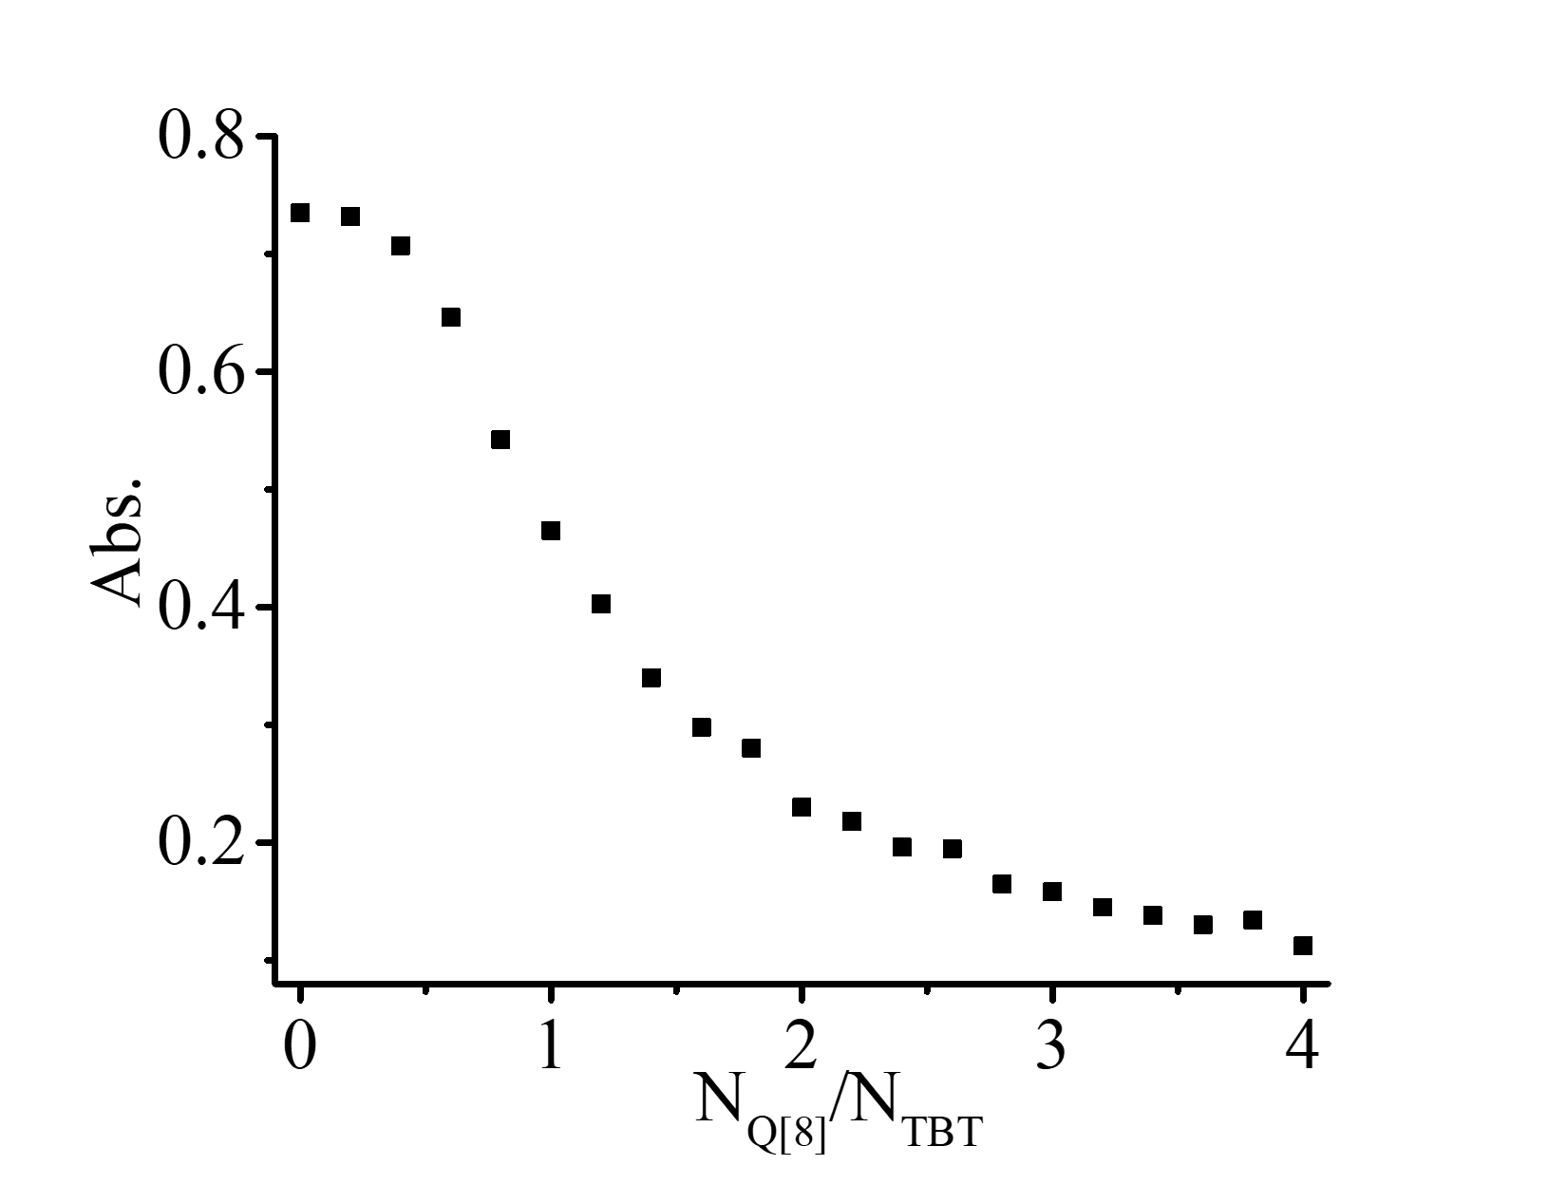

Figure S9 The plot of NQ[8]/NTBT *vs.* abs. at λ= 286nm.



Figure S10 The SEM of Q[8]-TBT (1 mM).



Figure S11 The plot of NAg+/N Q[7]-TBT *vs.* abs. at λ= 286nm.