Supporting Information

Efficient continuous flow-synthesis of novel spiro-naphthalene-1,2'-[1,3,4]oxadiazol-4-ones

Lange Yakubu Saleh^{1,2}, Bahadır Altıntaş³, Layla Filiciotto⁴, Yunus Zorlu⁵, Rafael Luque⁴, Cevher Altug*¹
Address:
¹Department of Chemistry, Bolu Abant İzzet Baysal University, 14030 Bolu, Turkey,
²Department of Chemistry, University of Turku, 20014 Turku, Finland,
³Department of Computer Education and Instructional Technologies, Bolu Abant İzzet Baysal University, 14030 Bolu, Turkey,
⁴Departamento de Química Orgánica, Universidad de Córdoba, Campus de Rabanales, Edificio Marie Curie (C-3), Ctra Nnal IV-A, Km 396, Cordoba, Spain,
⁵Gebze Technical University, Department of Chemistry, 41400, Kocaeli, Turkey

Email: altug_c@ibu.edu.tr and Name: Cevher Altug
*Corresponding author
Chemical synthesis, Single Crystal X-ray diffraction, the ¹H and ¹³C NMR spectra and computational data.
Materials and Methods
Materials and apparatus
Commercial reagents and chemicals were purchased from Sigma Aldrich. Analytical thin-layer chromatography (TLC) was carried through on Merck silica gel F-254 plates. Melting points (mp) were measured in open capillary tubes with a MELTEMP apparatus and are uncorrected. Synthesized molecules were visualized by UV-4LC. ThalesNano H-Cube Flow Chemistry Apparatus.
Spectral measurements
Fourier Transform Infrared (FT-IR) spectra were recorded on Perkin Elmer Spectrum Two FTIR-ATR spectrophotometer. NMR spectra were recorded at room temperature using Jeol 400 MHz spectrometer and on a Bruker Biospin 500 MHz NMR spectrometer in CDCl₃-d. Coupling constants (J) are expressed in Hertz (Hz) and the chemical shifts are reported in parts per million (ppm). The splitting patterns are assigned as follows: s (singlet); d (doublet); m (multi-plet); dd (doublets of doublet). High resolution mass spectra were carried out on a Bruker Daltonics micrOTOF-Q mass spectrometer (Bruker, Billerica, MA, USA) using electrospray ionization.

General procedure for the synthesis of hydrazones (3a-h)
To a well stirring 10 mL solution of phenylhydrazine hydrochloride (1.44 g, 10 mmol) in H₂O was added a 10 mL solution of the corresponding aromatic aldehyde (10 mmol) in EtOH dropwise, followed by an immediate formation of precipitate in the reaction vessel, the reaction was allowed to stirred for half an hour at room temperature. Then, the solid was filtrated to give corresponding hydrazone, and the excess reagents remaining were washed with water (2x10 mL) and EtOH (5 mL), respectively. Finally, powder hydrazone was dried completely under vacuum.
General procedure for the preparation of hydrazonyl chlorides (4a-h)
To a stirring solution of N-Chlorosuccinimide (10 mmol, 13.5 g) in CH₂Cl₂ (70 mL) at 0 ºC was added dimethyl sulfide (18 mmol, 1.12 g) and immedaitely a white precipitate was formed and it was allowed to stir for 10 min at 0 ºC. The reaction mixture was cooled to -40 ºC and a solution of corresponding hydrazone (6 mmol) was added portion wise. The progress of reaction was monitored by TLC (1-2 h) and reaction mixture was allowed to warm to 0 ºC over 1h and finally, quenched with cold water. DCM was evaporated and the desired hydrazonyl chlorides were ppt in in the water phase and filtered, dried under vacuum. Lastly, it was recrystallized from CH₂Cl₂-pet. ether for purification.
General Procedure for the synthesis of 5'-aryl-2,3-dichloro-3'-phenyl-2,3-dihydro-3'H,4H-spiro[naphthalene-1,2'-[1,3,4]oxadiazol]-4-one.
Batch chemistry
The 2,3-dichloro-1,4-naphthoquinone 5 (0.5 mmol, 114.5 mg) and a corresponding hydrazonyl chloride 4a-h (0.5 mmol) were mixed in 5 mL MeCN at room temperature and Et₃N (1.1 mmol, 51 mg) was added, and a precipitate was formed in 30 min. The solvent was decantated, washed with water (5 mL) and MeCN (5 mL) respectively.
Flow Chemistry
Flow synthesis experiments were conducted in the H-Cube Mini PlusTM reactor. The base was packed (ca. 0.1 g of base per cartridge) in 30 mm long ThalesNano CatCarts. Firstly, the system was washed with the corresponding solvent (0.3 mL/min, 20 min for each solvent). 0.5 M solutions of the reactants were subsequently pumped through, respectively for each reaction, and the optimum reaction conditions were set (80 °C, 10 bar, flow rate changes from 0.1 to 0.5 mL/min resulted similar outcomes). The system was eventually washed with the appropriate solvent in order to recover the employed base.

Experimental part
(2,3-dichloro-5'-(4-chlorophenyl)-3'-phenyl-3'H,4H-spiro[naphthalene-1,2'-[1,3,4]oxadiazol]-4-one) 6a
Light orange solid, (133 mg, 58%)*(193 mg, 85%)**, R_{f} : (EtOAc: Hex =1:5): 0.72. m.p. 180-182 ºC, ν_{max} (KBr, cm⁻¹) 3071 (ArC-H), 1677 (C=O), 1595 (C=N). ¹H NMR (400 MHz, CDCl₃ ) δ 8.28 (d, J = 7.4 Hz, 1H), 7.80 (d, J = 8.0 Hz, 2H), 7.67 (d, J = 7.9 Hz, 2H), 7.62 (d, J = 7.5 Hz, 1H), 7.41 (d, J = 8.0 Hz, 2H), 7.13 (t, J = 7.1 Hz, 2H), 6.89-6.83 (m, 3H) ¹³C NMR (100 MHz, CDCl₃) δ 175.2 (C=O), 151.0, 147.8, 141.0, 139.4, 137.0, 135.8, 135.1, 131.2, 129.4, 129.2, 128.8, 128.4, 128.3, 127.7, 123.1, 121.6, 114.2, 95.6(C_{q}). HRMS: required for C₂₃H₁₄Cl₃N₂O₂ [M+H]⁺ 455.0121 and found: 455.0137
2,3-dichloro-5'-(4-bromophenyl)-3'-phenyl-3'H,4H-spiro[naphthalene-1,2'-[1,3,4]oxadiazol]-4-one 6b
Light brown solid, (115 mg, 46%)*(205 mg, 82%)**, R_{f} : (EtOAc: Hex =1:5): 0.72. m.p. 197-199 ºC, ν_{max} (KBr, cm⁻¹) 3068 (ArC-H), 1676 (C=O), 1594 (C=N). ¹H NMR (400 MHz, CDCl₃) δ 8.29 (d, J = 7.1 Hz, 1H), 7.74 (d, J = 8.1 Hz, 2H), 7.69 (d, J = 5.3 Hz, 2H), 7.64 (d, J = 7.7 Hz, 1H), 7.59 (d, J = 8.0 Hz, 2H), 7.14 (t, J = 7.3 Hz, 2H), 6.94 – 6.80 (m, 3H).¹³C NMR (100 MHz, CDCl₃) δ 175.4 (C=O), 149.1, 140.7, 139.2, 136.6, 136.0, 135.2, 131.8, 130.8, 129.9, 129.1, 128.8, 128.8, 128.7, 127.3, 124.6, 122.6, 114.7, 96.5(C_{q}). HRMS: required for C₂₃H₁₃BrCl₂N₂NaO₂ [M+Na]⁺ 520.9435 and found: 520.9418
2,3-dichloro-5'-(4-nitrophenyl)-3'-phenyl-3'H,4H-spiro[naphthalene-1,2'-[1,3,4]oxadiazol]-4-one 6c
Light Brown Solid, (159 mg, 68%)*(172 mg, 74%)**, R_{f} : (EtOAc: Hex =1:5): 0.69. m.p. 208-210 ºC, ν_{max} (KBr, cm⁻¹) 3059 (ArC-H), 1681 (C=O), 1595 (C=N). ¹H NMR (400 MHz, CDCl₃) δ 8.35 – 8.25 (m, 4H), 8.02 (d, J = 9.4 Hz, 2H), 7.73 – 7.64 (m, 3H), 7.17 (t, J = 8.1 Hz, 1H), 6.97 – 6.71 (m, 3H). ¹³C NMR (100 MHz, CDCl₃) δ 175.4, 149.1, 140.7, 139.2, 136.6, 135.6, 135.2, 131.8, 130.8, 129.9, 129.1, 128.8, 128.8, 128.7, 127.3, 124.6, 122.6, 114.7, 96.5(C_{q}). HRMS: required for C₂₃H₁₃Cl₂KN₃O₄ [M+K]⁺ 503.9920 (100.0%) and found: 503.9904
2,3-dichloro-5'-(4-cyanophenyl)-3'-phenyl-3'H,4H-spiro[naphthalene-1,2'-[1,3,4]oxadiazol]-4-one 6d
Pale yellow solid, (118 mg, 53%)*(176 mg, 79%)**, R_{f} : (EtOAc: Hex =1:5): 0.71. m.p. 199-201 ºC, ν_{max} (KBr, cm⁻¹) 3061 (ArC-H), 2247 (CN), 1679 (C=O), 1592 (C=N). ¹H NMR (400 MHz, CDCl₃) δ 8.28 (d, J = 7.1 Hz, 1H), 7.94 (d, J = 7.8 Hz, 2H), 7.72 (d, J = 7.9 Hz, 2H), 7.69 – 7.57 (m, 3H), 7.14 (t, J = 7.3 Hz, 2H), 6.95 – 6.76 (m, 3H). ¹³C NMR (100 MHz, CDCl₃ ) δ 175.0 (C=O), 150.1, 147.2, 140.4, 138.9, 136.0, 135.2, 132.6, 131.4, 129.5, 128.8, 128.7, 128.4, 128.3, 126.6, 122.1, 118.4(CN), 114.3, 113.8, 96.0(C_{q}). HRMS: required for C₂₄H₁₃Cl₂N₃NaO₂ [M+Na]⁺ 468.0283 and found: 468.0291
2,3-dichloro-5'-(2,4-dichlorophenyl)-3'-phenyl-3'H,4H-spiro[naphthalene-1,2'-[1,3,4]oxadiazol]-4-one 6e
Dark orange solid, (164 mg, 67%)*(195mg, 80%)**, R_{f} : (EtOAc: Hex =1:5): 0.68. m.p. 196-198 ºC, ν_{max} (KBr, cm⁻¹) 3047 (ArC-H), 1672(C=O), 1595 (C=N). ¹H NMR (400 MHz, CDCl₃) δ 8.27 (d, J = 7.6 Hz, 1H), 7.76 – 7.65 (m, 3H), 7.65 – 7.58 (m, 1H), 7.55 (d, J = 1.7 Hz, 1H), 7.30 (dd, J = 8.5, 1.7 Hz, 1H), 7.13 (t, J = 7.9 Hz, 2H), 6.93 – 6.77 (m, 3H).¹³C NMR (100 MHz, CDCl₃) δ 175.2(C=O), 148.7, 147.6, 140.8, 139.3, 136.8, 135.8, 135.1, 133.7, 131.3, 131.2, 130.5, 129.4, 128.8, 128.4, 128.3, 127.3, 121.9, 121.8, 114.3, 94.8(C_{q}). HRMS: required for C₂₃H₁₂Cl₄KN₂O₂ [M+K]⁺ 528.9260 and found: 528.9236
(2,3-dichloro-5'-(2,6-dichlorophenyl)-3'-phenyl-3'H,4H-spiro[naphthalene-1,2'-[1,3,4]oxadiazol]-4-one) 6f
Brown solid, (162 mg, 66%)*(187 mg, 76%)**, R_{f} : (EtOAc: Hex =1:5): 0.69. m.p. 210-212 ºC, ν_{max} (KBr, cm⁻¹) 3055 (ArC-H), 1682 (C=O), 1598 (C=N). ¹H NMR (400 MHz, CDCl₃) δ 8.25 (d, J = 7.2 Hz, 1H), 7.95 (d, J = 7.3 Hz, 1H), 7.69 (d, J = 6.8 Hz, 1H), 7.61 (d, J = 7.0 Hz, 1H), 7.41 (d, J = 6.6 Hz, 2H), 7.37 (d, J = 6.3 Hz, 1H), 7.11 (t, J = 6.8 Hz, 2H), 6.89 – 6.75 (m, 3H). ¹³C NMR (100 MHz, CDCl₃ ) δ 175.2(C=O), 147.8, 146.7, 141.0, 138.9, 136.9, 136.1, 134.9, 132.5, 131.2, 129.4, 129.0, 128.7, 128.7, 128.2, 124.0, 121.5, 114.0, 95.9(C_{q}). HRMS: required for C₂₃H₁₂Cl₄KN₂O₂ [M+K]⁺ 528.9260 and found: 528.9236

(2,3-dichloro-5'-(4-fluorophenyl)-3'-phenyl-3'H,4H-spiro[naphthalene-1,2'-[1,3,4]oxadiazol]-4-one) 6g
Brown solid, (131 mg, 60%)*(171 mg, 78%)**, R_{f} : (EtOAc: Hex =1:5): 0.71. m.p. 191-193 ºC, ν_{max} (KBr, cm⁻¹) 3049 (ArC-H), 1682(C=O), 1595 (C=N). ¹H NMR (400 MHz, CDCl₃) δ 8.27 (d, J = 7.4 Hz, 1H), 7.95 – 7.78 (m, 2H), 7.68 (t, J = 8.9 Hz, 2H), 7.65 – 7.57 (m, 1H), 7.21 – 7.02 (m, 4H), 6.93 – 6.71 (m, 3H). ¹³C NMR (100 MHz, CDCl₃) δ 175.3(C=O), 164.3 (d, ¹J_{C-F} = 252.2 Hz), 151.0, 147.9, 141.1, 139.5, 135.8, 135.1, 131.1, 129.3, 128.8, 128.6 (d, ³J_{C-F} = 8.8 Hz), 128.4, 128.2, 121.5, 120.9 (d, ⁴J_{C-F} = 3.5 Hz), 116.1 (d, ²J_{C-F} = 22.3 Hz), 114.2, 95.5(C_{q}). HRMS: required for C₂₃H₁₄Cl₂FN₂O₂ [M+H]⁺ 439.0416 and found: 439.0434
(2,3-dichloro-3'-phenyl-5'-(p-tolyl)-3'H,4H-spiro[naphthalene-1,2'-[1,3,4]oxadiazol]-4-one) 6h
Light orange solid, (138 mg, 64%)*(182 mg, 84%)**, R_{f} : (EtOAc: Hex =1:5): 0.67. m.p. 175-177 ºC, ν_{max} (KBr, cm⁻¹) 3026 (ArC-H), 2987 (AliphC-H), 1682 (C=O), 1601 (C=N). ¹H NMR (500 MHz, CDCl₃) δ 8.33 – 8.06 (m, 3H), 7.92 – 7.78 (m, 2H), 7.70 – 7.44 (m, 3H), 7.17 – 6.90 (m, 2H), 6.82 – 6.60 (m, 3H), 2.48 (s, 3H). ¹³C NMR (125 MHz, CDCl₃) δ 174.9(C=O), 149.9, 148.7, 140.3, 138.8, 137.9, 135.1, 131.3, 130.3, 129.4, 129.0, 128.4, 128.2, 126.9, 125.3, 124.1, 122.2, 114.3, 96.2(C_{q}), 21.5. HRMS: required for C₂₄H₁₆Cl₂N₂NaO₂ [M+Na]⁺ 457.0487 and found: 457.0452
X-ray data collection and structure refinement
Single crystal X-ray diffraction data for 6h was collected using a Bruker APEX II QUAZAR three-circle diffractometer. Indexing was performed using APEX2[1]. Data reduction and integration were recorded with SAINT[2]. Absorption correction was performed by multi-scan method implemented in SADABS[3]. The structure was solved using SHELXT[4] and then refined by full-matrix least-squares refinements on F² using the SHELXL[5] in Olex2 Software Package[6]. Crystallographic data and refinement details of the data collection for 6h are given in Table S1. The aliphatic and aromatic C-bound H atoms were placed geometrically and refined using a riding mode. Crystal structure validations and geometrical calculations were performed using Platon software[7]. Mercury software[8] was used for visualization of the cif file. Additional crystallographic data with CCDC reference number 2000086 for 6h has been deposited within the Cambridge Crystallographic Data Center via www.ccdc.cam.ac.uk/deposit.

Table S1. Crystal data and refinement parameters for 6h.
CCDC | 2000086
Empirical Formula | C₂₄H₁₆Cl₂N₂O₂
Formula weight (g. mol⁻¹) | 435.29
Temperature (K) | 296.15
Radiation | MoKα (λ = 0.71073)
Crystal system | Monoclinic
Space group | P2₁/c
a (Å) | 8.393(3)
b (Å) | 20.906(7)
c (Å) | 11.854(4)
α(°) | 90
β(°) | 97.963(6)
γ(°) | 90
Crystal size (mm) | 0.18 × 0.15 × 0.12
V (Å³) | 2059.9(11)
Z | 4
ρ_{calcd} (g. cm⁻³) | 1.404
µ (mm⁻¹) | 0.339
F(000) | 896
2θ range for data collection (°) | 3.896 to 50.052
h/k/l | -9 ≤ h ≤ 9, -22 ≤ k ≤ 24, -14 ≤ l ≤ 11
Reflections collected | 8307
Independent reflections | 3593 [R_{int} = 0.0519, R_{sigma} = 0.0672]
Data/restraints/parameters | 3593/0/273
Goodness-of-fit on F² (S) | 1.001
Final R indices [I > 2σ(I)] | R₁ = 0.0441, wR₂ = 0.0958
R indices (all data) | R₁ = 0.0863, wR₂ = 0.1159
Largest diff. peak and hole (e.Å⁻³) | 0.22/-0.21

The ¹H and ¹³C NMR spectra
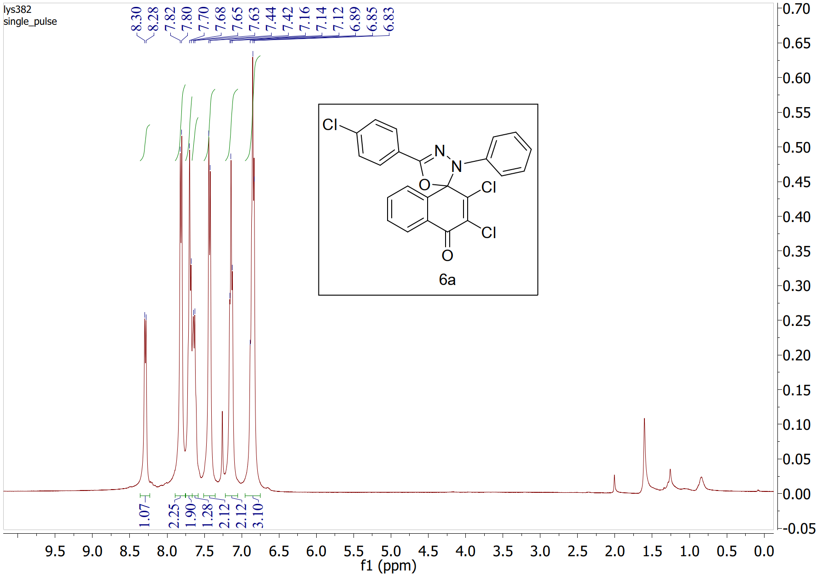Figure S1. ¹H NMR spectrum (400 MHz, CDCl₃) of compound 6a
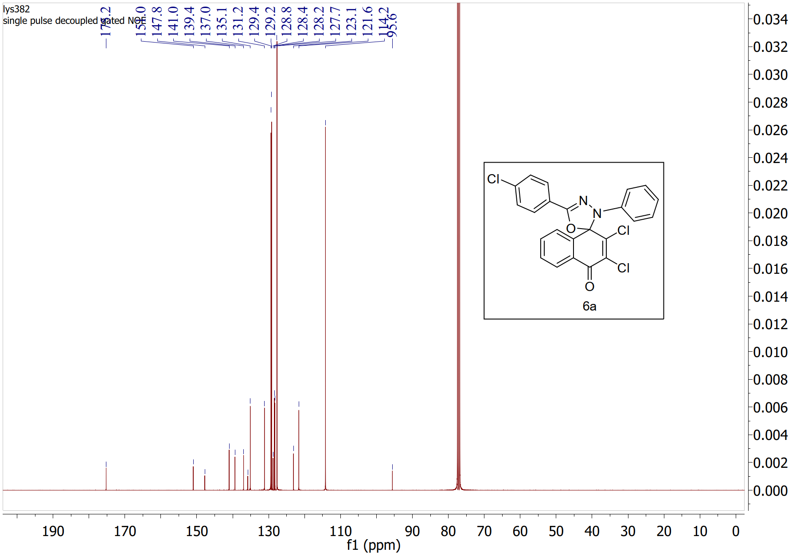Figure S2. ¹³C NMR spectrum (100 MHz, CDCl₃) of compound 6a
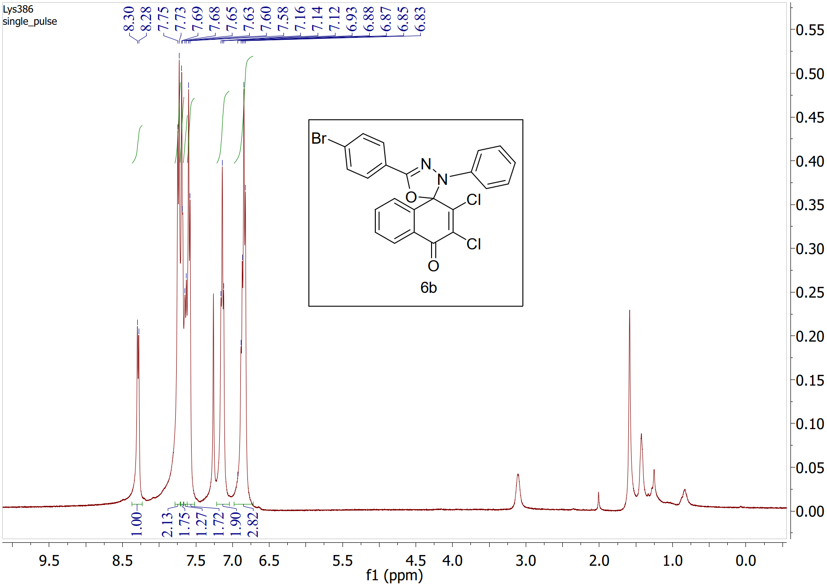
Figure S3. ¹H NMR spectrum (400 MHz, CDCl₃) of compound 6b
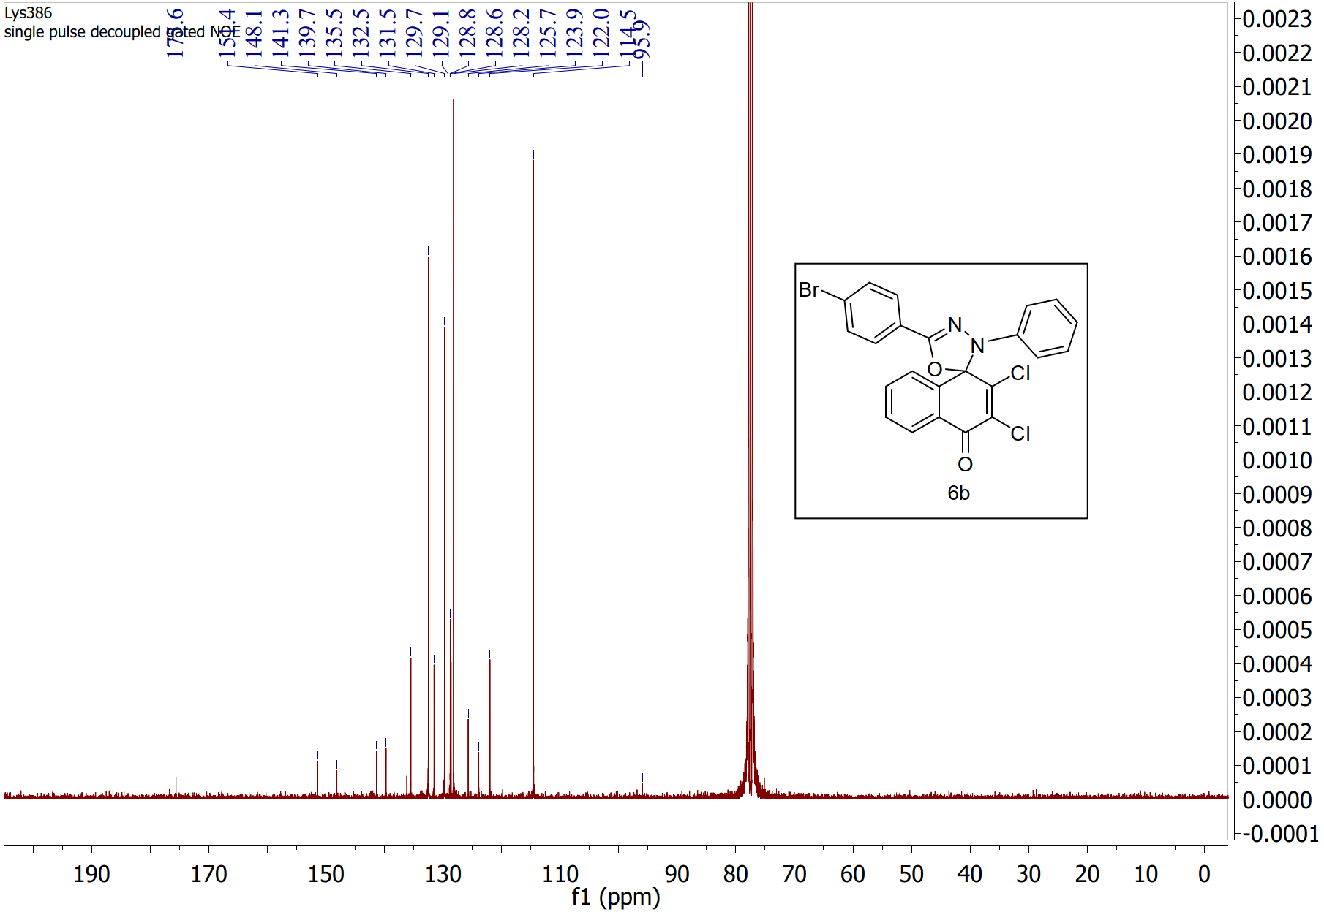
Figure S4. ¹³C NMR spectrum (100 MHz, CDCl₃) of compound 6b

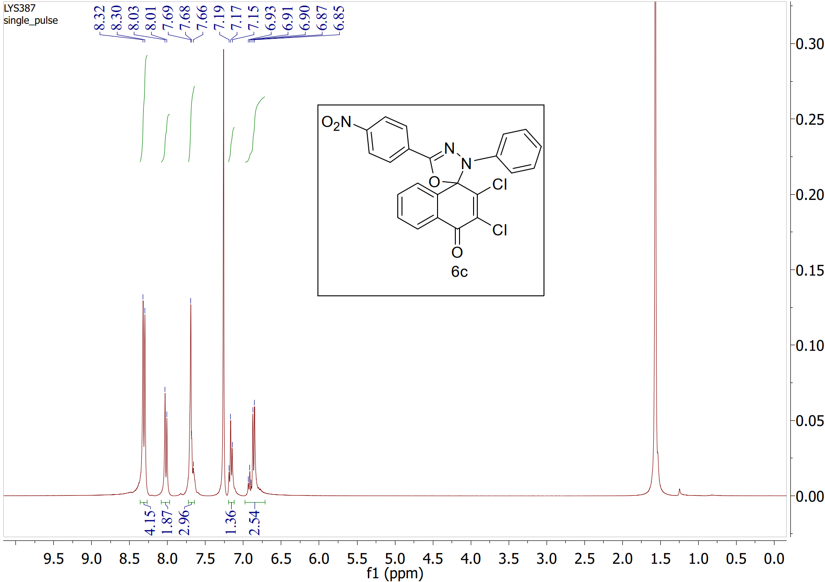
Figure S5. ¹H NMR spectrum (400 MHz, CDCl₃) of compound 6c
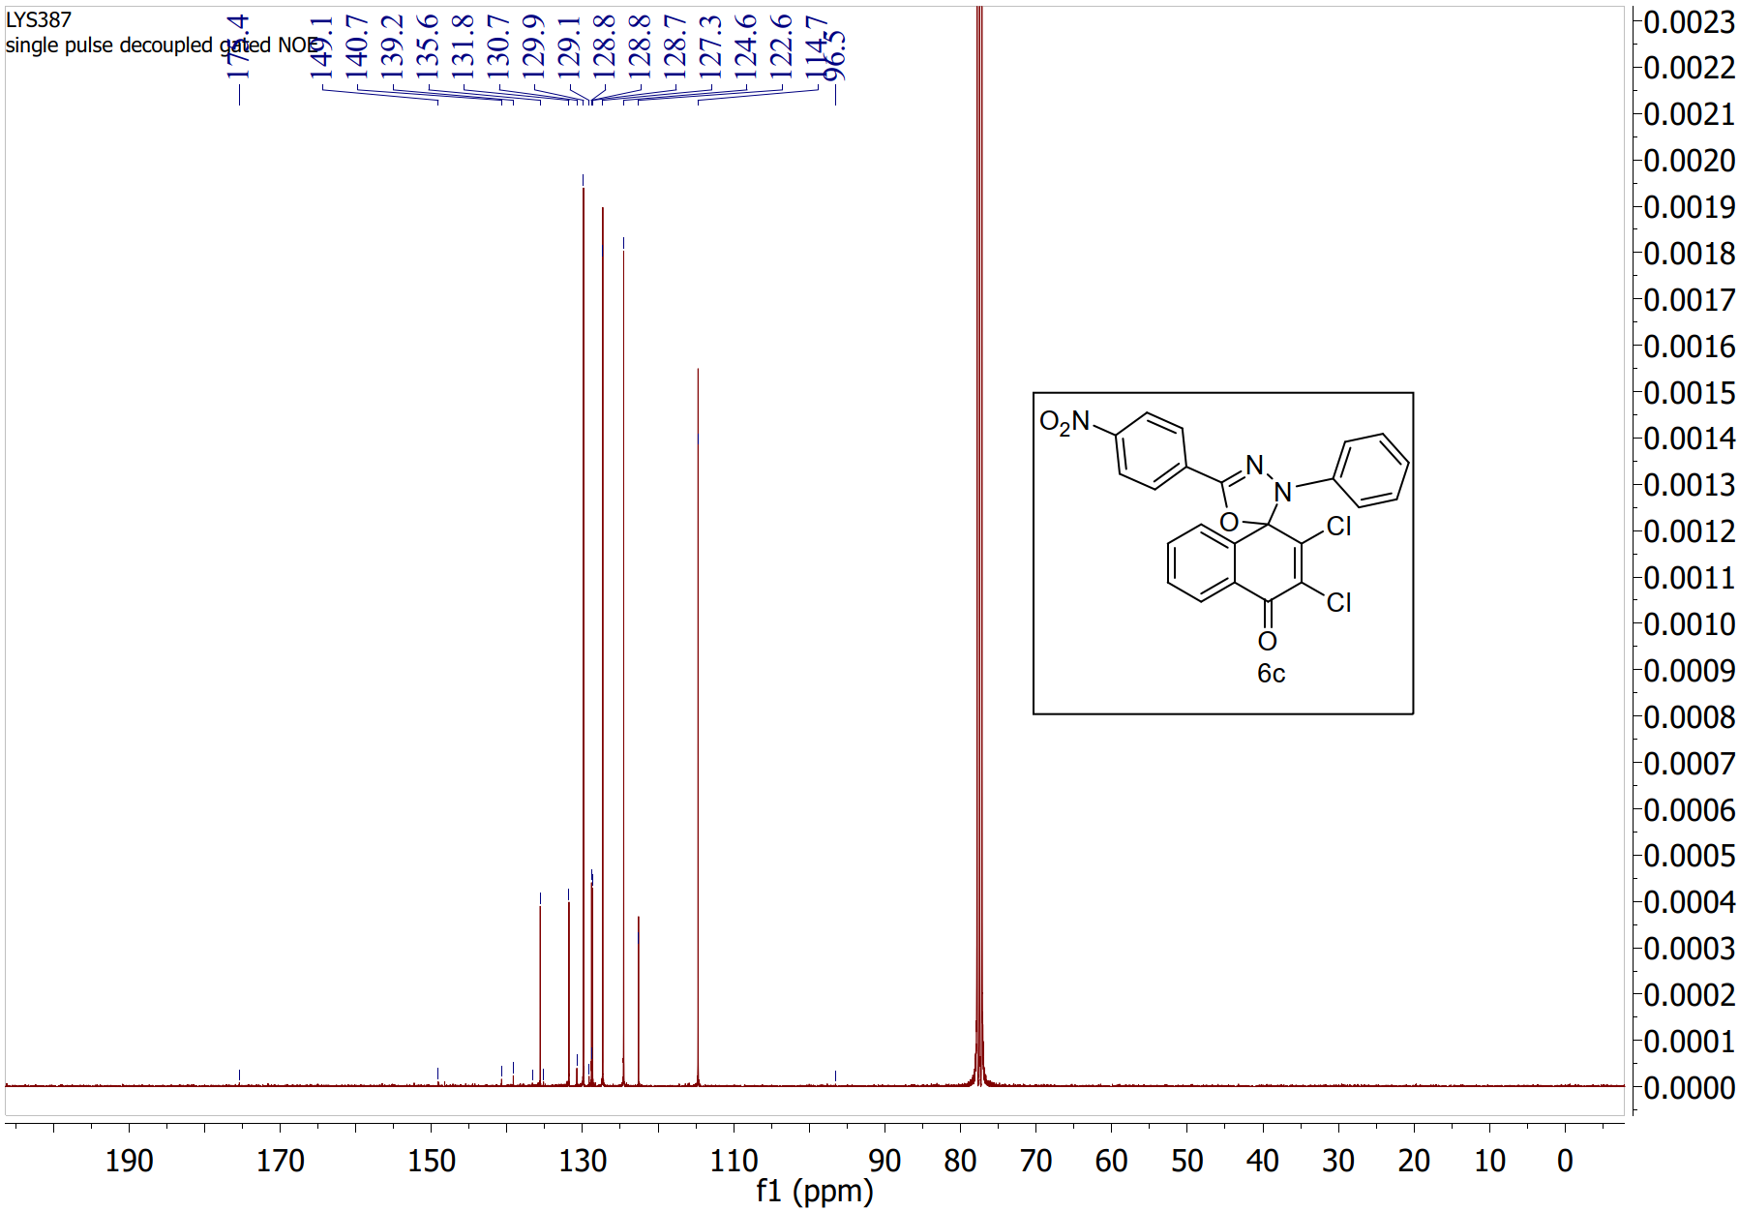Figure S6. ¹³C NMR spectrum (100 MHz, CDCl₃) of compound 6c

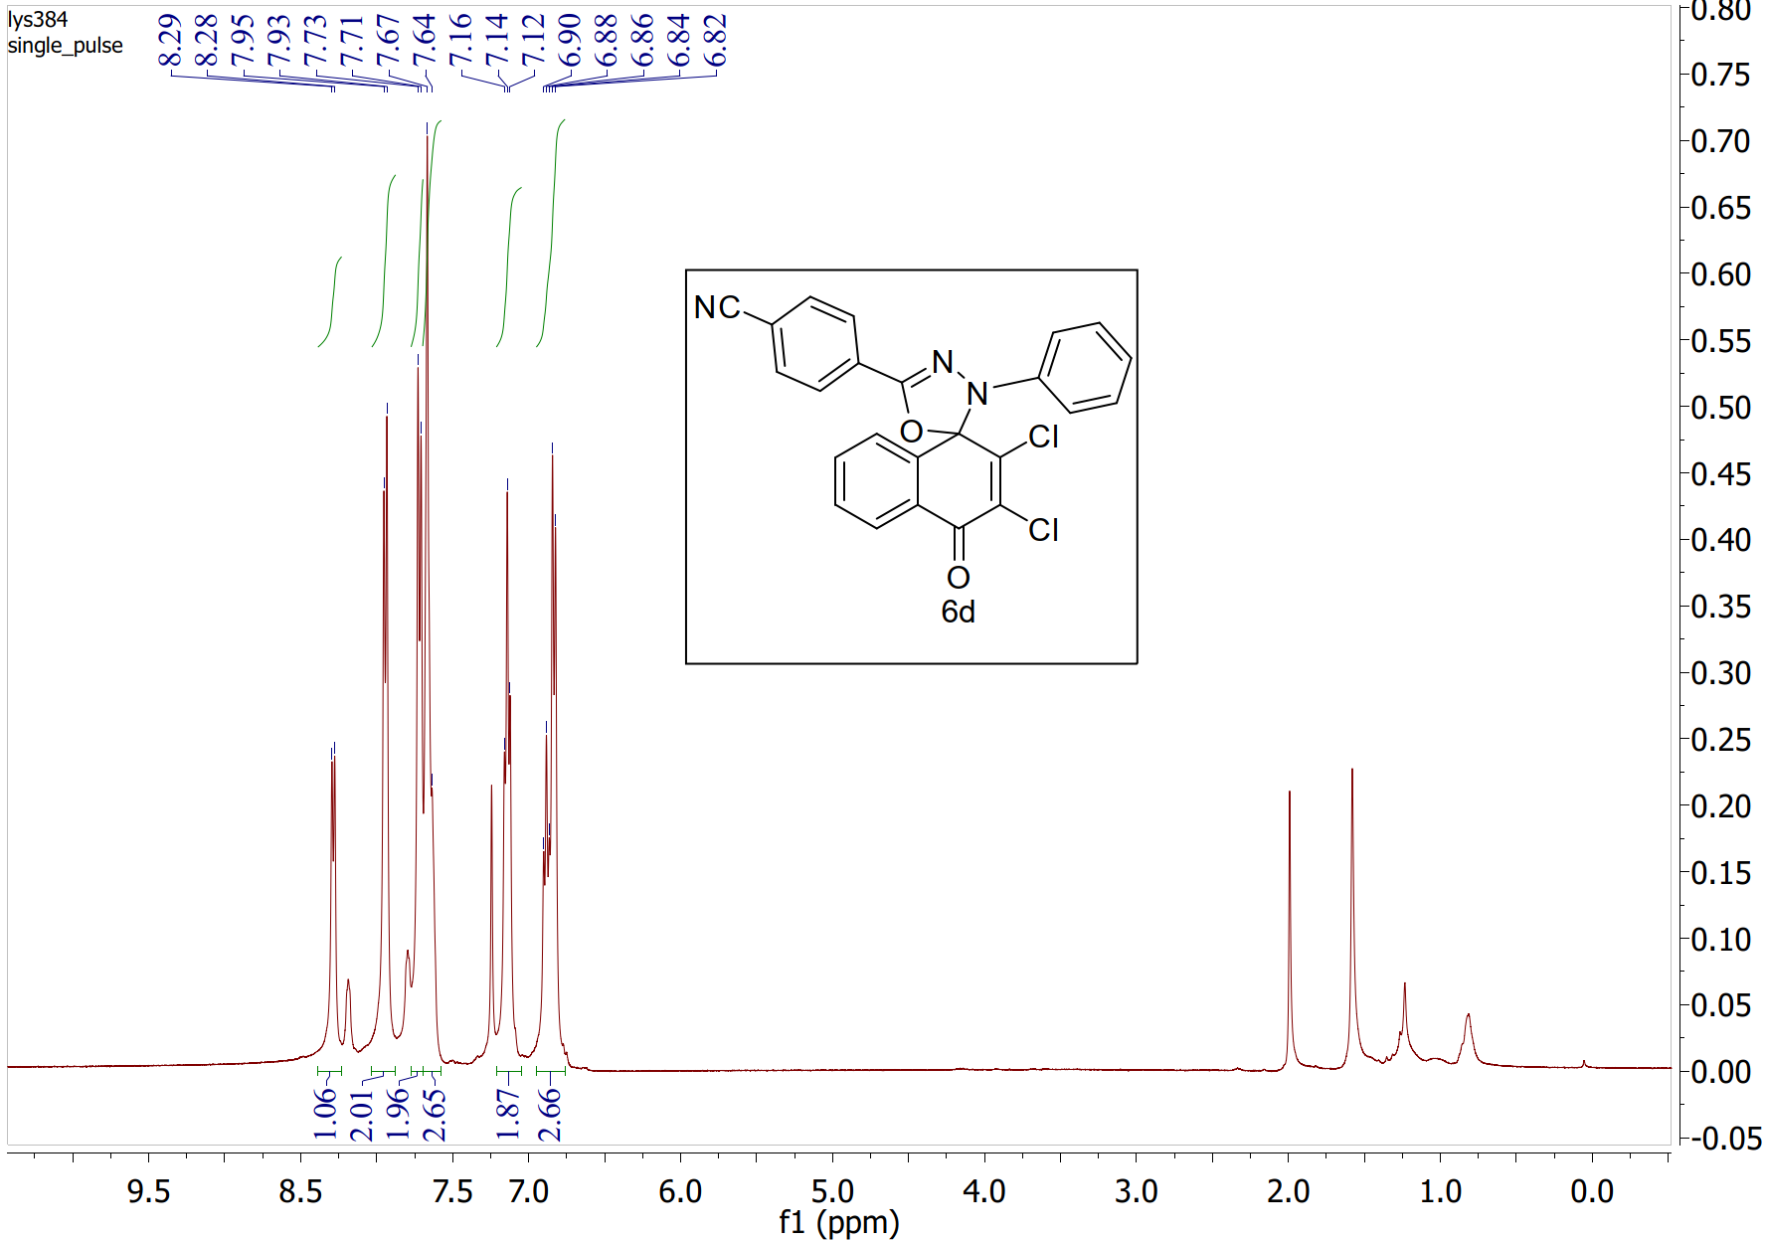
Figure S7. ¹H NMR spectrum (400 MHz, CDCl₃) of compound 6d
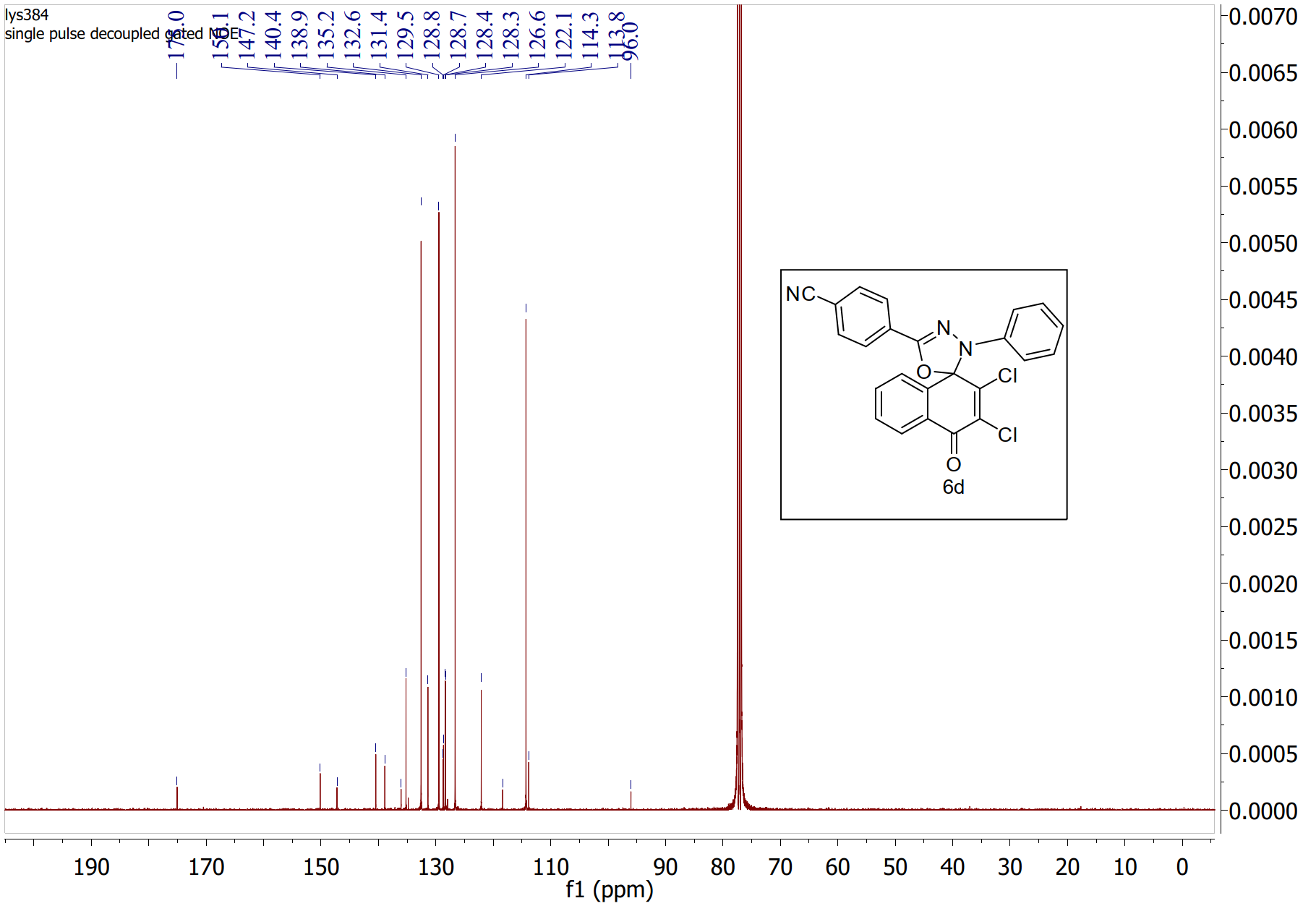
Figure S8. ¹³C NMR spectrum (100 MHz, CDCl₃) of compound 6d
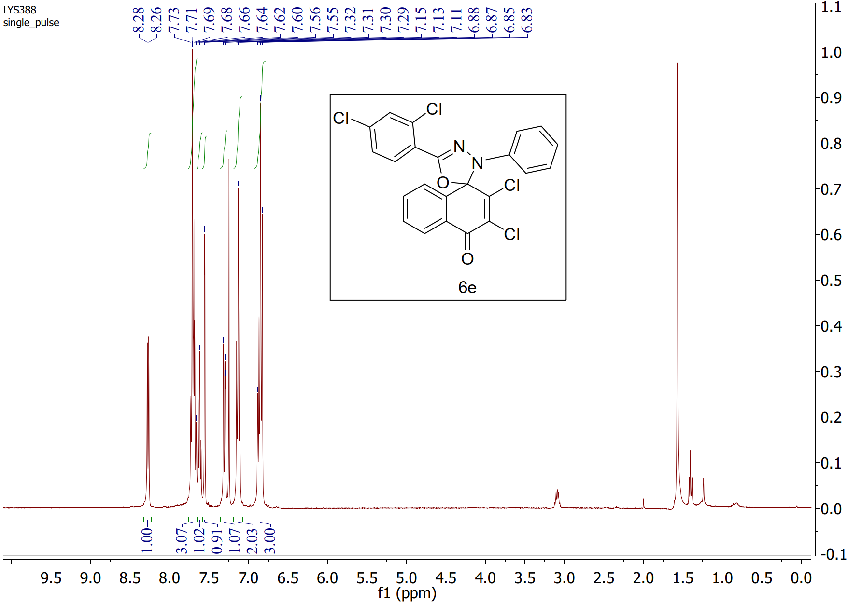
Figure S9. ¹H NMR spectrum (400 MHz, CDCl₃) of compound 6e
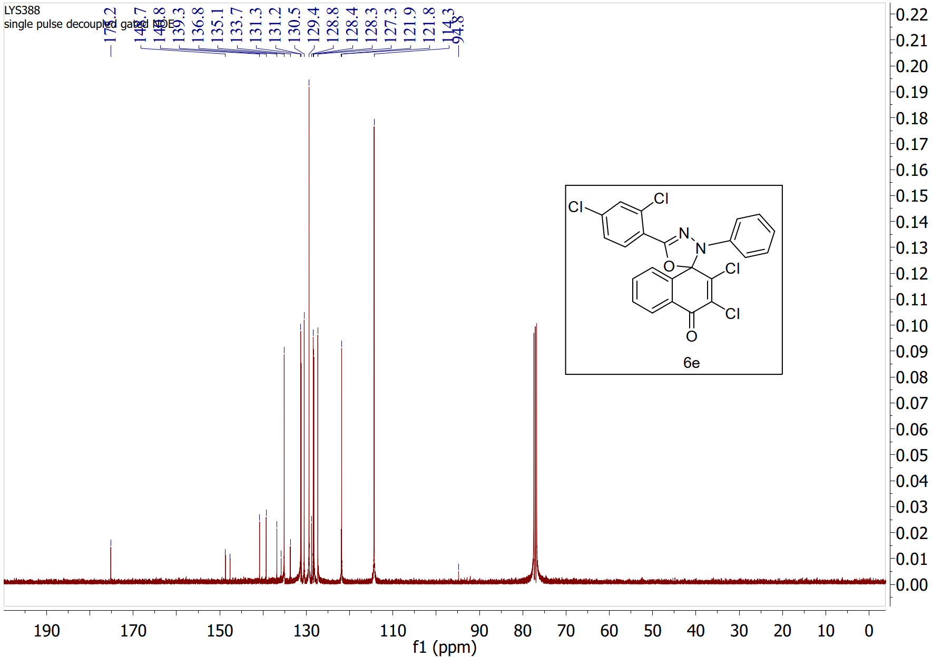Figure S10. ¹³C NMR spectrum (100 MHz, CDCl₃) of compound 6e
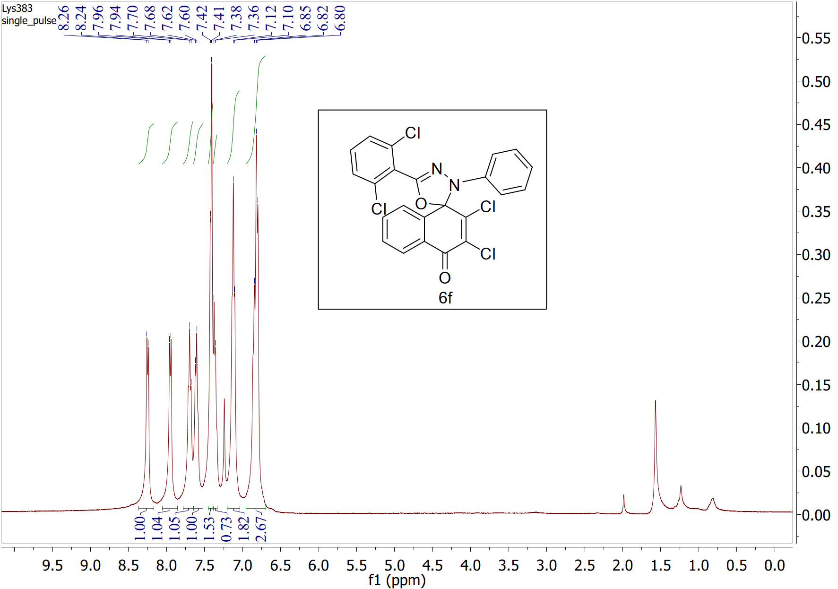
Figure S11. ¹H NMR spectrum (400 MHz, CDCl₃) of compound 6f
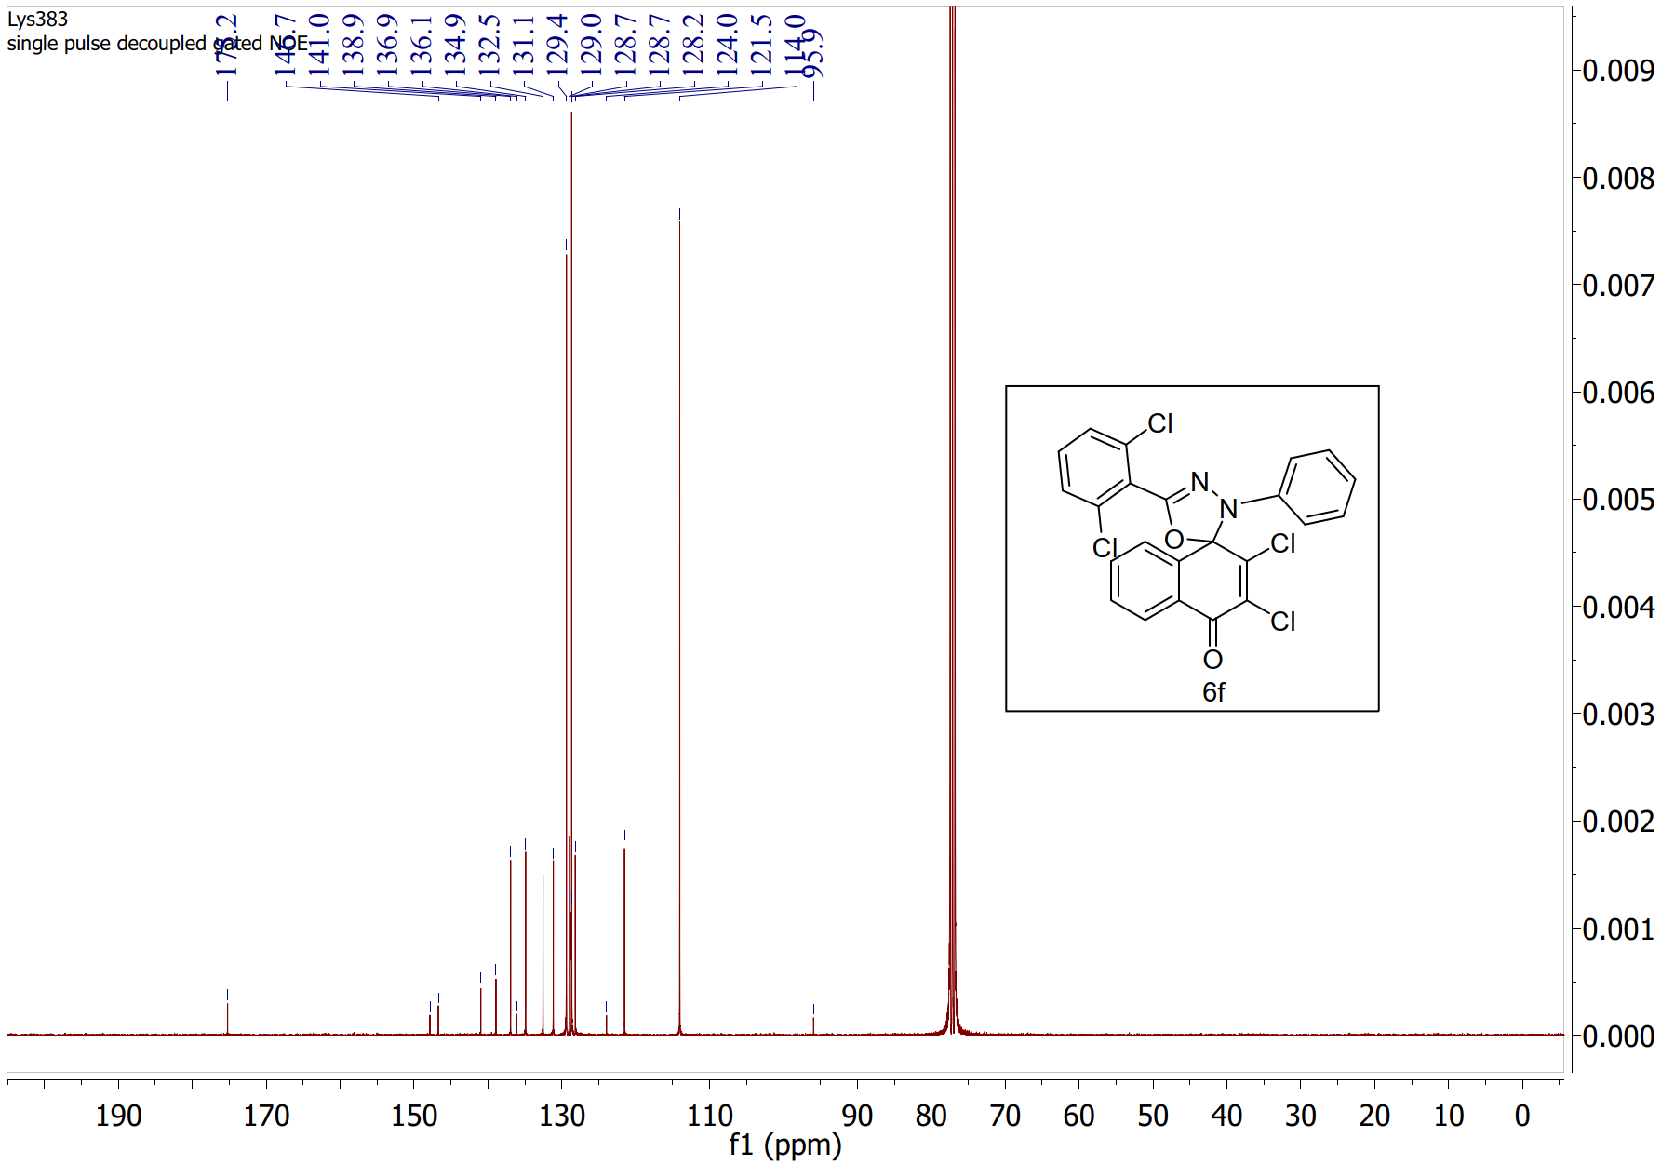Figure S12. ¹³C NMR spectrum (100 MHz, CDCl₃) of compound 6f
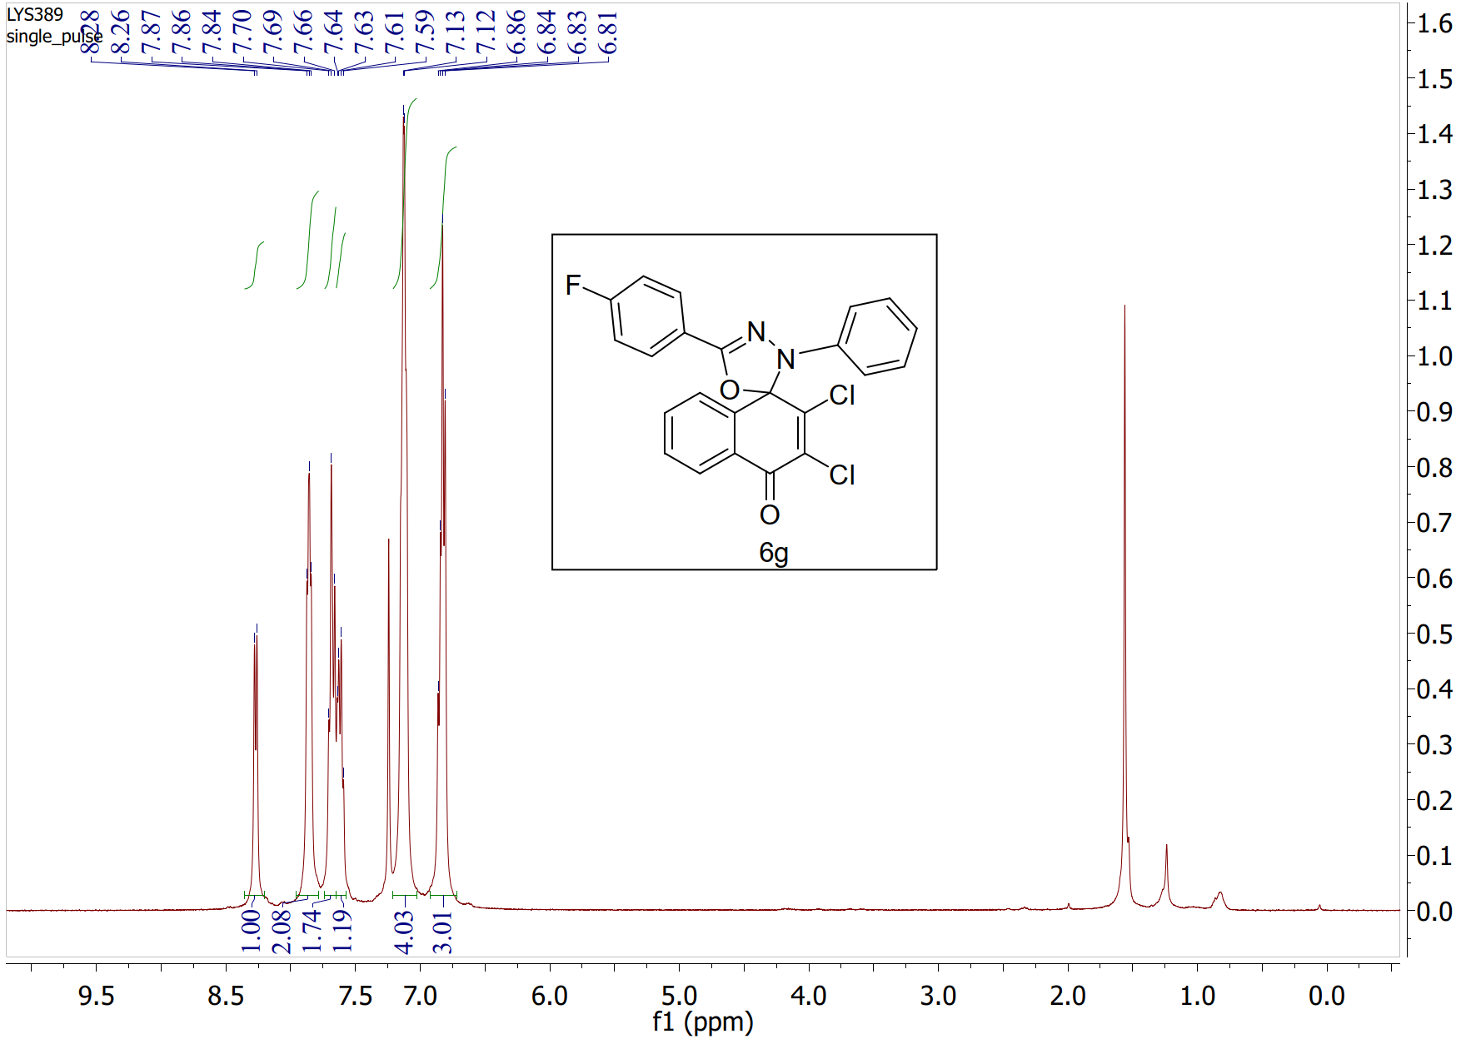
Figure S13. ¹H NMR spectrum (400 MHz, CDCl₃) of compound 6g
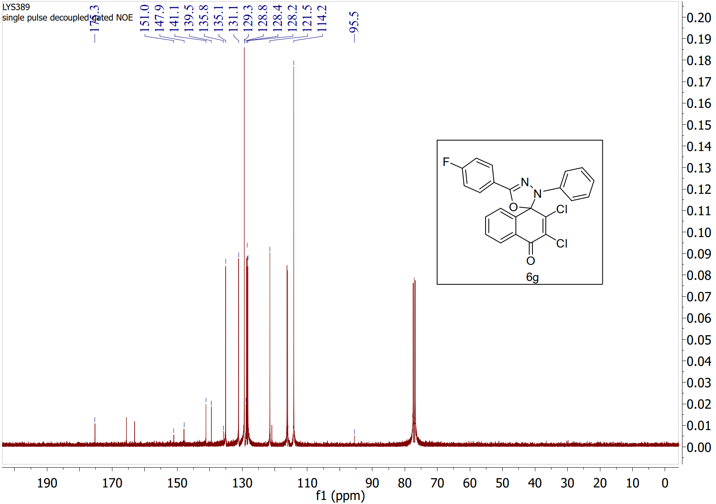
Figure S14. ¹³C NMR spectrum (100 MHz, CDCl₃) of compound 6g
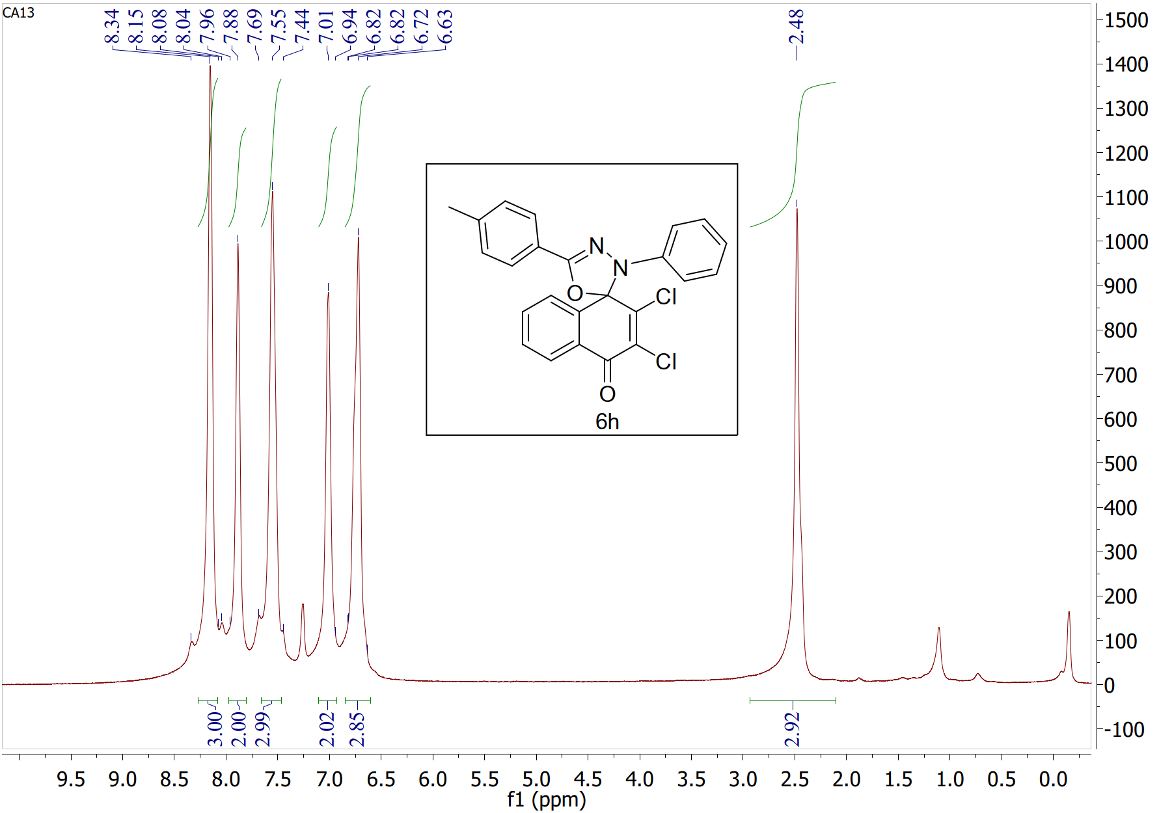
Figure S15. ¹H NMR spectrum (500 MHz, CDCl₃) of compound 6h
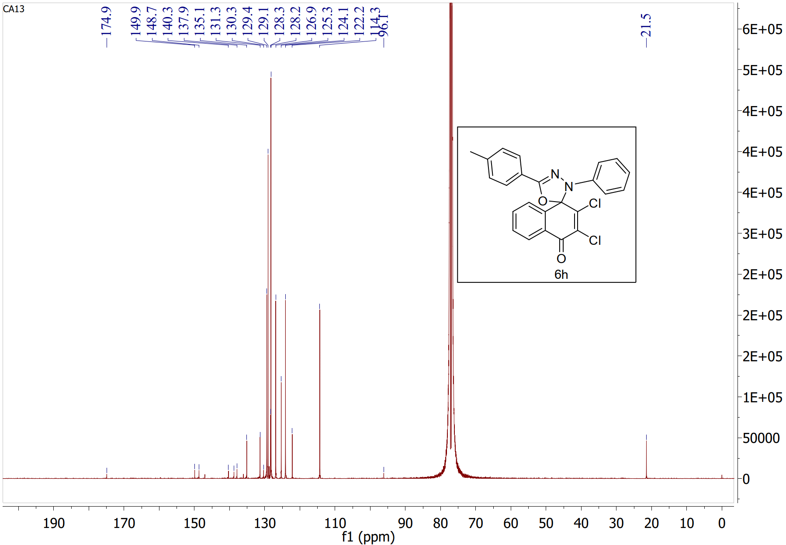Figure S16. ¹³C NMR spectrum (126 MHz, CDCl₃) of compound 6h
Computational data
Table S2: Mulliken atomic charges for 6a-g.
MULLIKEN ATOMIC CHARGES
6a | 6b | 6c | 6d
0 C : -0.134222  1 C : -0.067757  2 C : -0.040646  3 C : -0.145936  4 C : -0.087631  5 C : -0.110889  6 C : 0.424614  7 C : -0.041164  8 C : 0.001177  9 C : 0.204676  10 Cl: -0.012642  11 Cl: -0.025690  12 O : -0.249958  13 O : -0.261649  14 H : 0.145311  15 H : 0.142957  16 H : 0.122921  17 H : 0.122703  18 C : 0.307008  19 N : -0.234810  20 N : 0.091851  21 C : -0.175878  22 C : 0.188201  23 C : -0.168231  24 C : -0.162798  25 C : -0.026334  26 C : -0.202067  27 H : 0.124922  28 Cl: -0.096992  29 H : 0.125666  30 H : 0.140122  31 H : 0.132589  32 C : -0.087447  33 C : -0.228380  34 C : 0.114992  35 C : -0.135429  36 C : -0.149699  37 C : -0.144120  38 H : 0.107851  39 H : 0.136566  40 H : 0.106340  41 H : 0.107154  42 H : 0.142749 | 0 C : -0.175451  1 C : -0.012102  2 C : -0.035740  3 C : -0.138931  4 C : -0.089130  5 C : -0.110263  6 C : 0.423397  7 C : -0.029320  8 C : 0.063163  9 C : 0.147520  10 Cl: -0.020881  11 Cl: -0.027352  12 O : -0.261272  13 O : -0.297036  14 H : 0.138422  15 H : 0.140917  16 H : 0.120606  17 H : 0.120417  18 C : 0.283462  19 N : -0.269763  20 N : 0.095306  21 C : -0.161091  22 C : 0.113953  23 C : -0.156927  24 C : -0.167206  25 C : -0.002518  26 C : -0.203163  27 H : 0.128732  28 Br: -0.048956  29 H : 0.129026  30 H : 0.137102  31 H : 0.137739  32 C : -0.075871  33 C : -0.195668  34 C : 0.143207  35 C : -0.122030  36 C : -0.097258  37 C : -0.236517  38 H : 0.111817  39 H : 0.122894  40 H : 0.110687  41 H : 0.112662  42 H : 0.153418 | 0 C : -0.172773  1 C : -0.019863  2 C : -0.031056  3 C : -0.138027  4 C : -0.088361  5 C : -0.110644  6 C : 0.423230  7 C : -0.026768  8 C : 0.058280  9 C : 0.152031  10 Cl: -0.019604  11 Cl: -0.021501  12 O : -0.258378  13 O : -0.295195  14 C : 0.283014  15 N : -0.258137  16 N : 0.101424  17 C : -0.162427  18 C : 0.092000  19 C : -0.157952  20 C : -0.152723  21 C : 0.000572  22 C : -0.191082  23 N : 0.397036  24 C : -0.077418  25 C : -0.192500  26 C : 0.140703  27 C : -0.119761  28 C : -0.094173  29 C : -0.234230  30 H : 0.137930  31 H : 0.142809  32 H : 0.123172  33 H : 0.122904  34 H : 0.157757  35 H : 0.158093  36 H : 0.140957  37 H : 0.141420  38 H : 0.115340  39 H : 0.125583  40 H : 0.114219  41 H : 0.115590  42 H : 0.154093  43 O : -0.287901  44 O : -0.287687 | 0 C : -0.174865  1 C : -0.011729  2 C : -0.035051  3 C : -0.137852  4 C : -0.088805  5 C : -0.110207  6 C : 0.426933  7 C : -0.030481  8 C : 0.062217  9 C : 0.147623  10 Cl: -0.019104  11 Cl: -0.022789  12 O : -0.258734  13 O : -0.296125  14 C : 0.271882  15 N : -0.261102  16 N : 0.098318  17 C : -0.168772  18 C : 0.226319  19 C : -0.166604  20 C : -0.152706  21 C : -0.008552  22 C : -0.186785  23 C : -0.249724  24 C : -0.076537  25 C : -0.194114  26 C : 0.143534  27 C : -0.120456  28 C : -0.097520  29 C : -0.235203  30 N : 0.027145  31 H : 0.137606  32 H : 0.142450  33 H : 0.122687  34 H : 0.122347  35 H : 0.135565  36 H : 0.135814  37 H : 0.140454  38 H : 0.140944  39 H : 0.114345  40 H : 0.123868  41 H : 0.113279  42 H : 0.114926  43 H : 0.155558
6e | 6f | 6g
0 C : -0.133142  1 C : -0.058931  2 C : -0.044037  3 C : -0.141156  4 C : -0.090700  5 C : -0.111450  6 C : 0.412323  7 C : -0.033812  8 C : -0.001055  9 C : 0.206236  10 Cl: -0.014733  11 Cl: -0.026404  12 O : -0.250561  13 O : -0.241966  14 C : 0.319742  15 N : -0.239289  16 N : 0.083214  17 C : -0.198573  18 C : 0.192248  19 C : -0.241736  20 C : -0.121049  21 C : -0.091280  22 C : 0.048795  23 Cl: -0.087217  24 C : -0.090312  25 C : -0.227154  26 C : 0.109202  27 C : -0.134534  28 C : -0.148146  29 C : -0.142364  30 Cl: -0.064749  31 H : 0.144465  32 H : 0.145263  33 H : 0.124094  34 H : 0.123600  35 H : 0.127987  36 H : 0.136290  37 H : 0.150977  38 H : 0.109215  39 H : 0.138944  40 H : 0.108181  41 H : 0.109280  42 H : 0.144293 | 0 C : -0.135978  1 C : -0.063399  2 C : -0.056151  3 C : -0.136621  4 C : -0.095084  5 C : -0.107194  6 C : 0.447941  7 C : -0.054498  8 C : 0.002302  9 C : 0.201580  10 Cl: -0.014765  11 Cl: -0.029464  12 O : -0.252035  13 O : -0.243644  14 C : 0.282415  15 N : -0.207076  16 N : 0.087058  17 C : -0.199216  18 C : -0.076299  19 C : -0.203911  20 C : 0.086170  21 C : -0.104677  22 C : 0.112514  23 C : -0.088944  24 C : -0.219030  25 C : 0.101227  26 C : -0.134818  27 C : -0.149271  28 C : -0.141976  29 Cl: -0.064490  30 Cl: -0.072170  31 H : 0.151587  32 H : 0.144029  33 H : 0.122598  34 H : 0.122145  35 H : 0.130319  36 H : 0.131081  37 H : 0.109201  38 H : 0.135981  39 H : 0.106652  40 H : 0.107841  41 H : 0.144101  42 H : 0.123969 | 0 C : -0.176116  1 C : -0.010896  2 C : -0.036780  3 C : -0.138961  4 C : -0.089338  5 C : -0.109949  6 C : 0.424819  7 C : -0.030630  8 C : 0.064759  9 C : 0.145702  10 Cl: -0.021097  11 Cl: -0.028144  12 O : -0.261554  13 O : -0.298062  14 C : 0.287572  15 N : -0.273609  16 N : 0.093578  17 C : -0.210273  18 C : 0.332867  19 C : -0.208942  20 C : -0.153764  21 C : -0.022626  22 C : -0.189781  23 C : -0.075394  24 C : -0.196519  25 C : 0.143899  26 C : -0.122557  27 C : -0.098914  28 C : -0.236380  29 F : -0.167690  30 H : 0.138282  31 H : 0.140660  32 H : 0.120267  33 H : 0.119986  34 H : 0.126479  35 H : 0.126915  36 H : 0.111140  37 H : 0.121964  38 H : 0.110059  39 H : 0.112150  40 H : 0.153950  41 H : 0.141391  42 H : 0.141537

Calculated optimized structures
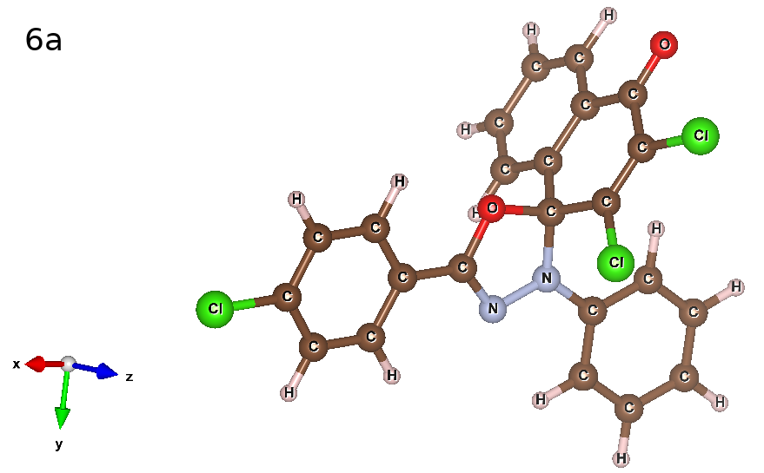
Figure S17. Optimized structure for 6a
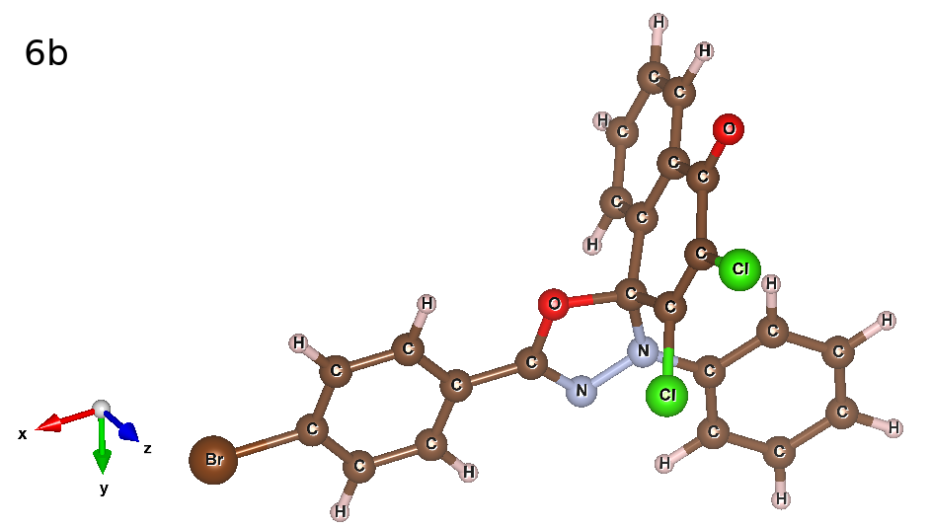
Figure S18. Optimized structure for 6b

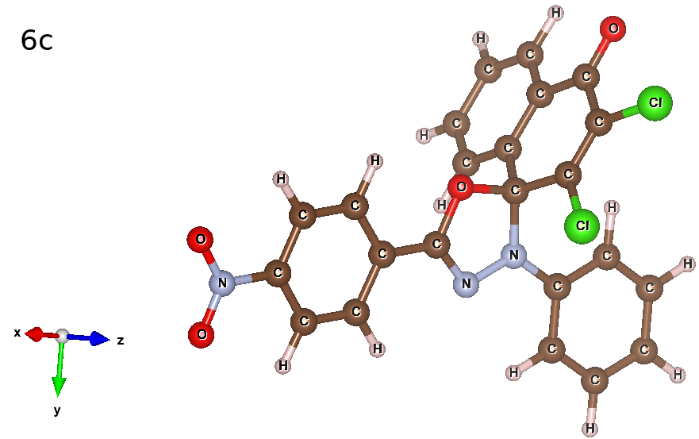
Figure S19. Optimized structure for 6c

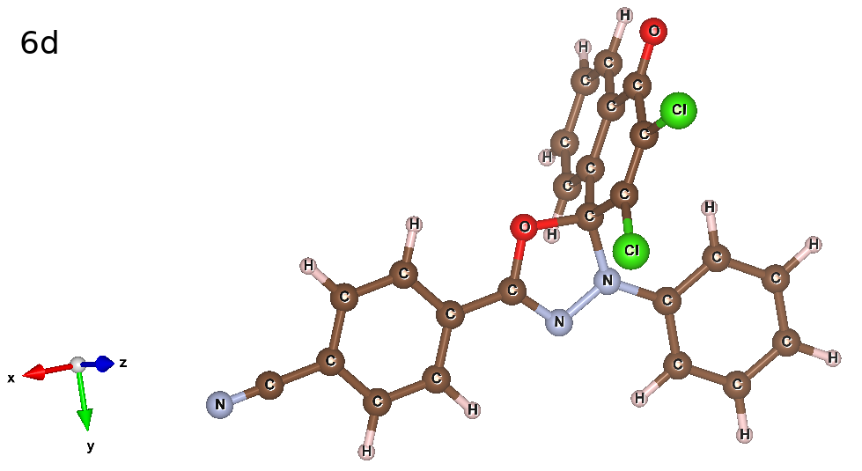
Figure S20. Optimized structure for 6d

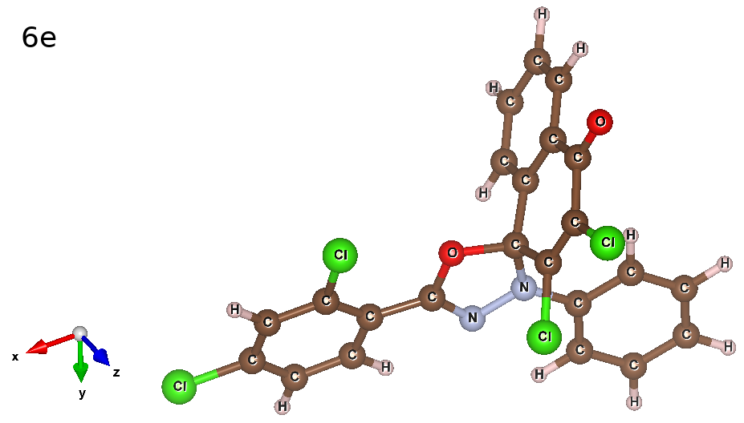
Figure S21. Optimized structure for 6e
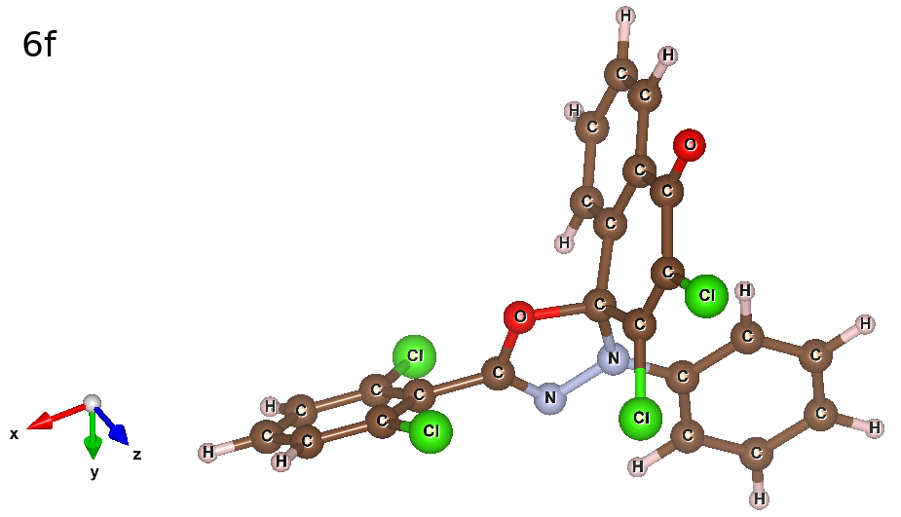
Figure S22. Optimized structure for 6f

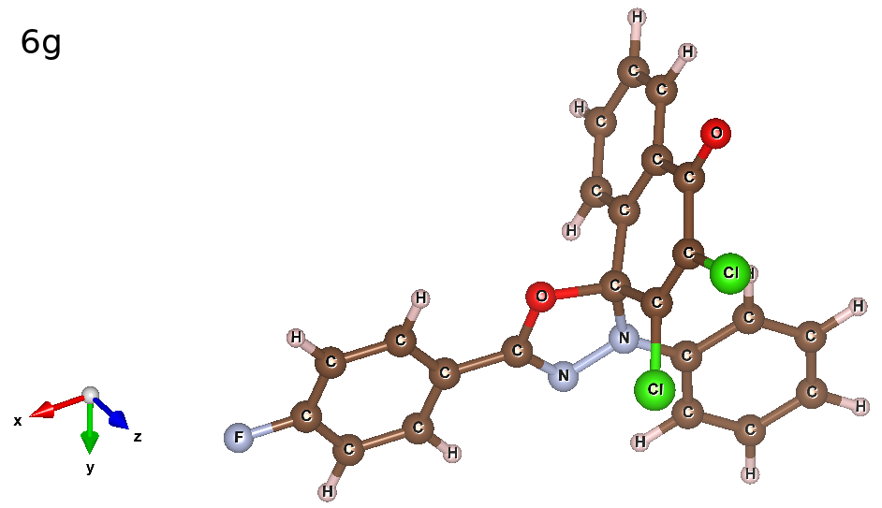
Figure S23. Optimized structure for 6g

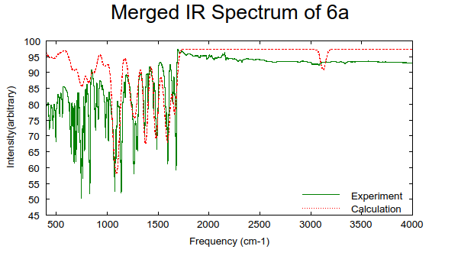
IR spectra of the compounds

Figure S24. Calculated (red dashed) IR spectrum of 6a along with the experimental (green) spectrum.
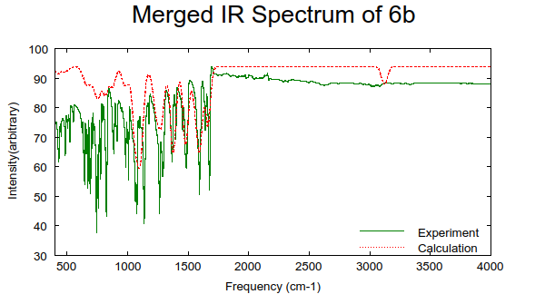
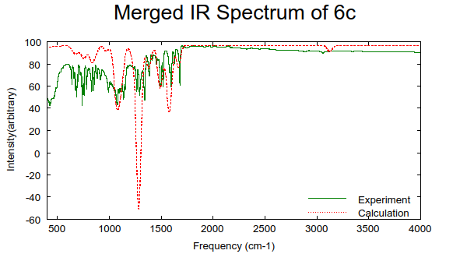
Figure S25. Calculated (red dashed) IR spectrum of 6b along with the experimental (green) spectrum.

Figure S26: Calculated (red dashed) IR spectrum of 6c along with the experimental (green) spectrum.
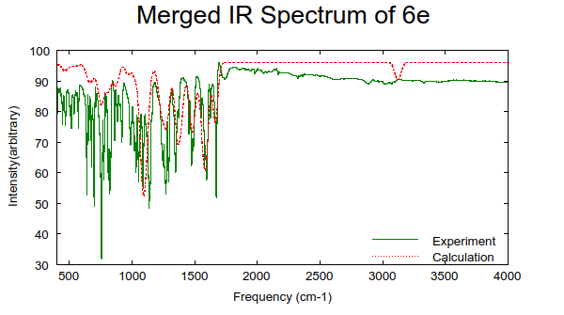
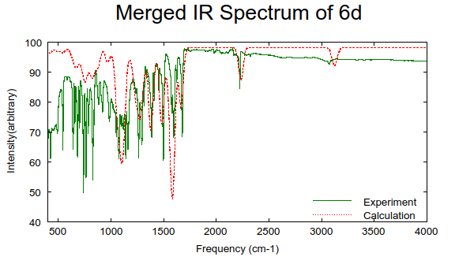
Figure S27. Calculated (red dashed) IR spectrum of 6d along with the experimental (green) spectrum.
Figure S28: Calculated (red dashed) IR spectrum of 6e along with the experimental (green) spectrum.
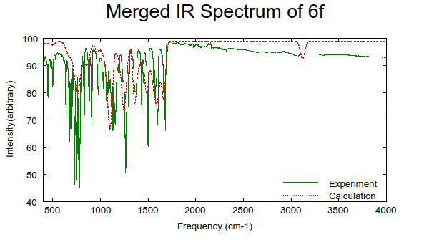
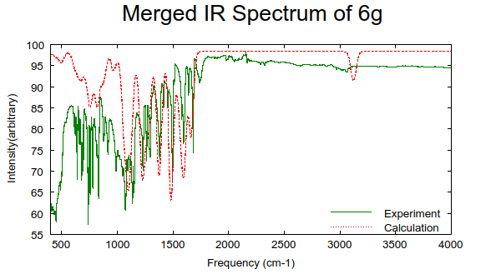
Figure S29. Calculated (red dashed) IR spectrum of 6f along with the experimental (green) spectrum.
Figure S30. Calculated (red dashed) IR spectrum of 6g along with the experimental (green) spectrum.

Reference
- APEX2, version 2014.11-0, Bruker (2014), Bruker AXS Inc., Madison, WI
- SAINT, version 8.34A, Bruker (2013), Bruker AXS Inc., Madison, WI
- SADABS, version2014/5, Bruker (2014), Bruker AXS Inc., Madison, WI.
- Sheldrick, G. M. SHELXT - Integrated Space-Group and Crystal-Structure Determination. Acta Crystallogr. Sect. A Found. Crystallogr. 2015, 71 (1), 3–8.
- Sheldrick, G. M. Crystal Structure Refinement with SHELXL. Acta Crystallogr. Sect. C Struct. Chem. 2015, 71, 3–8.
- O.V. Dolomanov, L.J. Bourhis, R.J. Gildea, J.A.K. Howard, H. Puschmann, J. Appl. Cryst., 2009, 42, 339-341
- A. L. Spek, Acta Cryst. 2020, E76, 1-11
- C. F. Macrae, I. Sovago, S. J. Cottrell, P. T. A. Galek, P. McCabe, E. Pidcock, M. Platings, G. P. Shields, J. S. Stevens, M. Towler and P. A. Wood, J. Appl. Cryst., 53, 2020

