Effects of substrate stiffness on the viscoelasticity and migration of prostate cancer cells by atomic force microscopy
Xiaoqiong Tang^{‡1}, Yan Zhang^{‡1}, Jiangbing Mao¹, Yuhua Wang¹, Zhenghong Zhang², Zhengchao Wang*² and Hongqin Yang*¹

¹ Key Laboratory of Optoelectronic Science and Technology for Medicine of Ministry of Education, Fujian Provincial Key Laboratory for Photonics Technology, Fujian Normal University, Fuzhou 350007, China
² Fujian Provincial Key Laboratory for Developmental Biology and Neurosciences, College of Life Sciences, Fujian Normal University, Fuzhou 350007, China

Email:
Zhengchao Wang* - zcwang@fjnu.edu.cn (Z.W.)
Hongqin Yang* - hqyang@fjnu.edu.cn (H.Y.)
* Corresponding author
‡ Equal contributors

Supporting Information
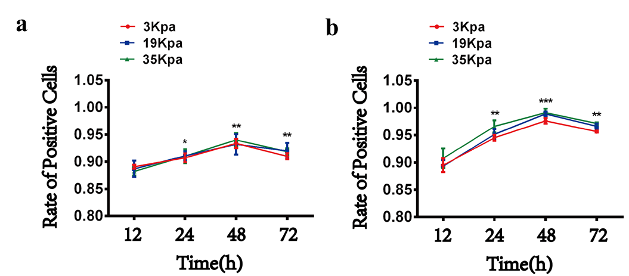
Supplementary Figure 1: The toxic effect of polyacrylamide hydrogel substrates on prostate cancer cells. (a-b) Quantitatively count the positive rate of Calcein-AM/PI staining in HPV-PZ-7 and PC 3 cells.

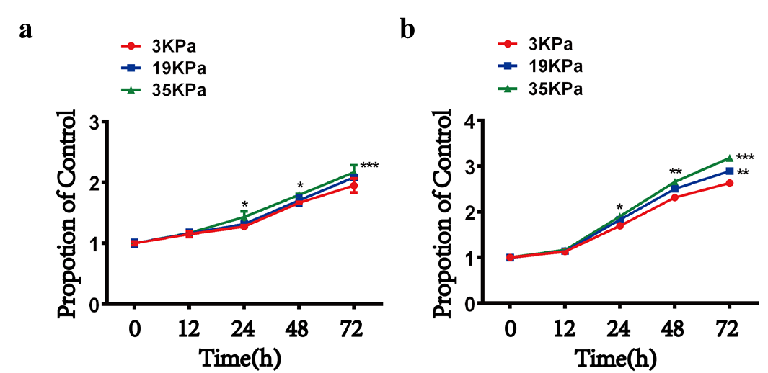
Supplementary Figure 2: The effect of substrate stiffness on cell proliferation. (a-b) CCK8 detects the proliferation of HPV-PZ-7 and PC 3 cells, and compares the cells at 19 kPa and 35 kPa with the cells at 3 kPa, respectively.

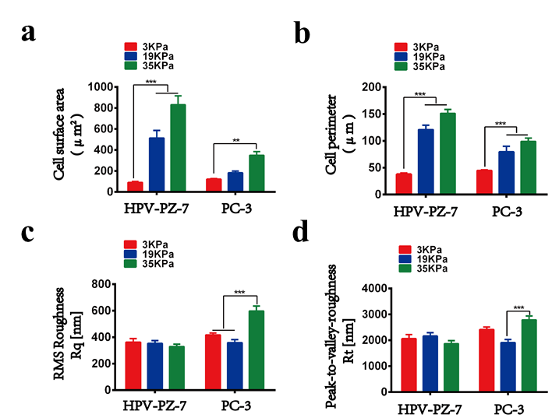
Supplementary Figure 3: The effect of substrate stiffness on cell morphology. (a) Phase contrast microscopy imaging of PZ-HPV-7 and PC 3 cells on different stiffness substrates, and quantitative statistics of cell area. (b) Quantitative statistics of cell circumference. (c) Atomic force microscopy imaging of HPV-PZ-7 and PC 3 cells on different stiffness substrates, and quantitative statistics of average root mean square surface roughness (RQ). (d) Quantitative statistics of peak-to-valley ratio roughness (RT). ** p <0.01, *** p <0.001.

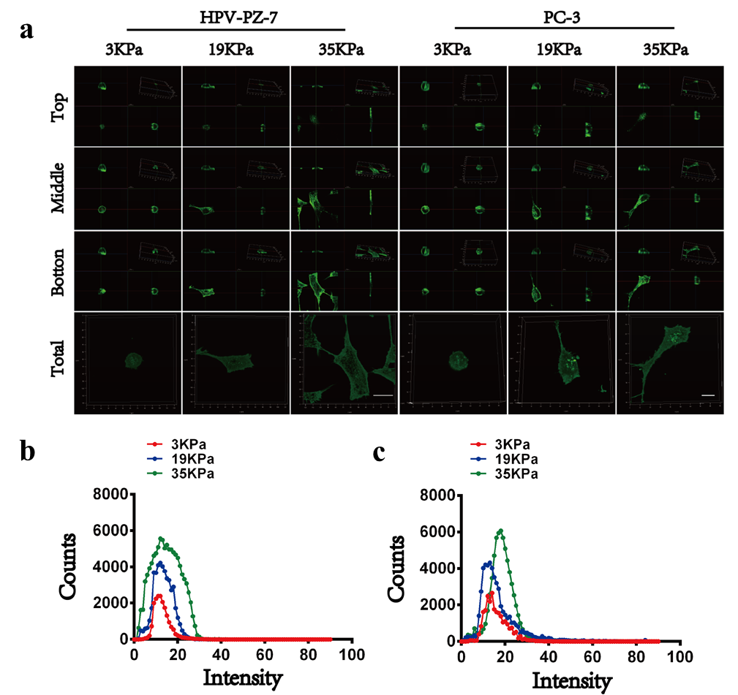
Supplementary Figure 4: The effect of Blebbistatin on PCa cytoskeleton microfilaments. (a) Three-dimensional fluorescence images of cytoskeletal microfilaments of HPV-PZ-7 and PC 3 cells on substrates of different stiffness after Blebbistatin treatment. The scale bar of HPV-PZ-7 cells is 20 μm and the scale bar of PC 3 cells is 10 μm. (b) Fluorescence intensity distribution of HPV-PZ-7 cells at different stiffness after Blebbistatin treatment.(c) Fluorescence intensity distribution of PC 3 cells at different stiffness after Blebbistatin treatment.

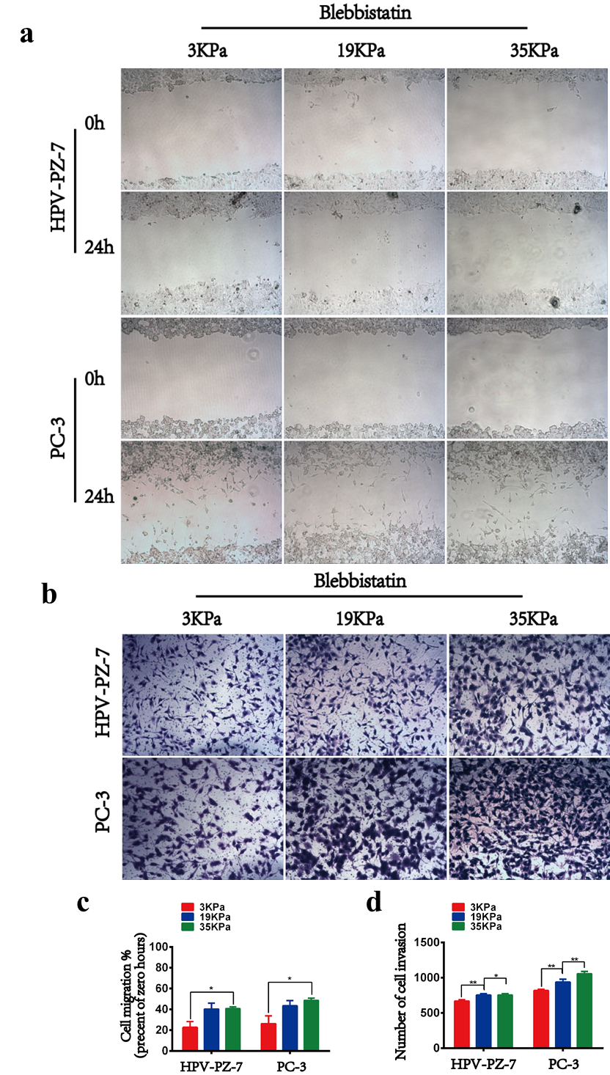
Supplementary Figure 5: The effect of Blebbistatin on PCa cell migration. (a) Cell wound healing analysis of the migration ability of HPV-PZ-7 and PC 3 cells on different stiffness; (b) Transwell analysis of the invasion ability of HPV-PZ-7 and PC 3 cells on different stiffness; (c) Quantitative statistics on the migration ability of HPV-PZ-7 and PC 3 cells at different stiffness after Blebbistatin treatment; (d) Quantitative statistics on the invasion ability of HPV-PZ-7 and PC 3 cells at different stiffness after Blebbistatin treatment.* p <0.05, ** p <0.01, *** p <0.001.

