Supporting Information for

Coordination-assembled Nanoarchitectonics of Antioxidant Peptide and Flavonoid Myricetin for Sustainably Scavenging Free Radicals

Materials and instruments.
Materials: Myricetin (95%) was bought from Thermo Fisher Scientific, CO., Ltd.. L-Glutathione (Reduced) was obtained from Solarbio, CO., Ltd.. Zinc (II) chloride (ZnCl₂) (98%) was purchased from Beijing Chemical Works. 2,2'-Azinobis-(3-ethylbenzthiazoline-6-sulphonate) was bought from Innochem (Beijing) Co., Ltd.. 2',7'-Dichlorodihydrofluorescein diacetate was got from MedChemexpress CO., Ltd..
Instruments: TEM images of nanoparticles were exhibited by a model JEM-1011 transmission scanning electron microscope (JEM-1011, JEOL, Japan). The size distribution and zeta potential of nanoparticles were measured by a Malvern DLS instrument (Zetasizer Nano ZS ZEN3600). UV/vis absorption spectra were tested by a Shimadzu UV-2600 spectrophotometer. FTIR spectra were obtained by a TENSOR 27 FTIR spectrometer (BRUKER). The cell viability was evaluated using MTT assay, in which the absorbance was measured by a microplate reader (Multiskan FC, Thermo Fisher Scientific). Confocal laser scanning microscopy (CLSM) images of cells were captured by CLSM (Olympus FV1000).

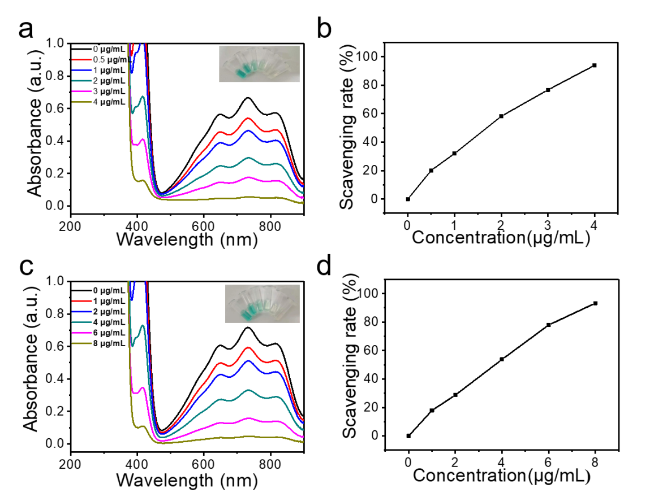
Figure S1. a) UV/vis absorption spectra of ABTS solution incubated with different concentrations of Myr. The sample picture was shown in the inset. b) The scavenging rate of Myr. c) UV−vis absorption spectra of ABTS solution incubated with different concentrations of GSH. The inset showed the sample picture. d) The scavenging rate of GSH.

