Supporting Information
for
Automated Grindstone Chemistry: A Simple and Facile Way for PEG-assisted Stoichiometry-controlled Halogenation of Phenols and Anilines Using N-Halosuccinimide
Dharmendra Das, Akhil A. Bhosle, Amrita Chatterjee* and Mainak Banerjee*

Experimental procedures, spectral data, and copies of spectra

Table of contents
Experimental procedures……………………………….......................... | 03
Spectral data of products………………………………………………... | 04-13
Comparative table..……………………………………………………... | 14-15
¹H & ¹³C NMR spectra of products……………………………………... | 16-64
References…………………………………………………………........ | 65-67

Experimental Procedures
General information
All the reagents and solvents of AR grade were procured from commercial sources and used without further purification. The mechanochemical grinding reactions were carried out in an indigenous electrical grinder (Scientech instruments, India) with Agate-made mortar and pestle. The thin-layer chromatography (TLC) of 0.25 mm silica gel aluminum plates (60F-254) were used to monitor the progress of the reaction, and visualization was done using UV light (254 or 365 nm). The synthesized products were purified by flash chromatography or conventional column chromatography with 100-200 mesh silica gel. ¹H NMR and ¹³C NMR spectra were recorded on Bruker AVANCE (400 MHz and 500 MHz) instrument and tetramethylsilane as the internal standard. The multiplicity of NMR peaks was represented using standard abbreviations, and chemical shifts are reported in parts per million (δ) units. CHN data were recorded with the Vario MICRO elementar CHNS analyzer. IR spectra were recorded in KBr pellets with IR Affinity 1, Shimadzu.

General procedure for di-halogenation of the substrates
The phenol (or aniline) derivative (1.0 mmol) was taken in an Agate mortar attached to an electrical grinder and to it NXS (2.1 mmol; X = Br, I) and PEG-400 (0.2 mL) were added one after another, and grinding was continued by an electrically operated pestle for the specific time period as mentioned in Table 3. The completion of the reaction was monitored by TLC. After complete conversion, 1 g of silica gel (230-400 mesh) was added and the slurry was subjected to flash chromatography and eluted with a mixture of EtOAc-petroleum ether to afford the pure di-bromo phenol (or aniline) derivative. Once again, the side product succinimide was subsequently eluted using 1:10 MeOH-CHCl₃.

General procedure for tri-halogenation of the substrates
Phenol or aniline derivatives (1, 1.0 mmol), NXS (3.0 mmol; X = Br, I) were taken in an agate mortar containing PEG-400 (0.2 mL) and electrical grinding was continued with a pestle at 100 rpm for the specific time period as mentioned for respective substrates in Table 4. 1 g of silica gel (230-400 mesh) was added and the slurry was subjected to flash chromatography and eluted with a mixture of EtOAc-petroleum ether to afford the pure tri-bromo phenol (or aniline) derivative.
Characterization data of products 2a-aj, 3a-j and 4a-c
2-Bromo-4-methylphenol (2a) [1]: Off-white solid, 170 mg (91%), m.p. 57-59 °C (lit. m.p. 55-57 °C); ¹H NMR (400 MHz, CDCl₃): δ (ppm) 2.27 (s, 3H), 5.36 (s, 1H), 6.91 (d, J = 8.2 Hz, 1H), 7.01 (dd, J₁ = 1.4 Hz, J₂ = 8.2 Hz, 1H), 7.271-7.274 (m, 1H). ¹³C NMR (100 MHz, CDCl₃): δ (ppm) 20.2, 109.8, 115.7, 129.8, 131.4, 132.1, 150.0. Anal. Calcd for C₇H₇BrO: C, 44.95; H, 3.77. Found: C, 45.01; H, 3.76. IR (KBr) ν̃: 3498, 2924, 1608, 1493, 1040, 866, 812, 760, 671 and 550 cm⁻¹.

4-Bromo-2-tert-butylphenol (2b) [2]: Light-grey liquid, 210 mg (92%), ¹H NMR (400 MHz, CDCl₃): δ (ppm) 1.39 (s, 9H), 4.14 (br, 1H), 6.56 (d, J = 8.4 Hz, 1H), 7.16 (dd, J₁ = 2.4 Hz, J₂ = 8.4 Hz, 1H), 7.35 (d, J = 2.4 Hz, 1H). ¹³C NMR (100 MHz, CDCl₃): δ (ppm) 29.3, 34.7, 112.8, 118.1, 129.5, 130.1, 138.5, 153.3. Anal. Calcd for C₁₀H₁₃BrO: C, 52.42; H, 5.72. Found: C, 52.51; H, 5.74. IR (KBr) ν̃: 3549, 2959, 1597, 1489, 1398, 1249, 1176, 1082, 880, 806, 706, 631 and 567 cm⁻¹.

4-Bromo-2,6-dimethylphenol (2c) [1]: Light-brown solid, 190 mg (95%), m.p. 79-80 °C (lit. m.p. 74-78 °C); ¹H NMR (400 MHz, CDCl₃): δ (ppm) 2.22 (s, 3H), 4.58 (s, 1H), 7.10 (s, 2H). ¹³C NMR (100 MHz, CDCl₃): δ (ppm) 15.7, 112.0, 125.2, 131.0, 151.3. Anal. Calcd for C₈H₉BrO: C, 47.79; H, 4.51. Found: C, 47.65; H, 4.49. IR (KBr) ν̃: 3383, 2916, 1609, 1476, 1329, 1190, 941, 853, 718 and 555 cm⁻¹.

4-Bromo-3-methylphenol (2d) [1,2]: Off-white solid, 164 mg (88%), m.p. 59-60 °C (lit. m.p. 59-61 °C); ¹H NMR (400 MHz, CDCl₃): δ (ppm) 2.34 (s, 3H), 4.97 (s, 1H), 6.55 (dd, J₁ = 3.0 Hz, J₂ = 8.8 Hz, 1H), 6.73 (d, J = 3.0 Hz, 1H), 7.35 (d, J = 8.4 Hz, 1H). ¹³C NMR (100 MHz, CDCl₃): δ (ppm) 22.9, 114.5, 115.5, 117.8, 133.0, 139.2, 154.6. Anal. Calcd for C₇H₇BrO: C, 44.95; H, 3.77. Found: C, 45.05; H, 3.73. IR (KBr) ν̃: 3383, 2922, 1587, 1169, 1028, 860, 810 and 602 cm⁻¹.

2-Bromobenzene-1,4-diol (2e) [3,4]: Grey solid, 156 mg (83%), m.p. 114-116 °C (lit. m.p. 114 °C); ¹H NMR (400 MHz, CDCl₃): δ (ppm) 6.73 (dd, J₁ = 3.2 Hz, J₂ = 8.8 Hz, 1H), 6.89 (d, J = 8.8 Hz, 1H), 6.99 (d, J = 3.0 Hz, 1H). ¹³C NMR (100 MHz, CDCl₃): δ (ppm) 109.9, 115.8, 116.3, 118.6, 147.2, 149.5. Anal. Calcd for C₆H₅BrO₂: C, 38.13; H, 2.67. Found: C, 38.31; H, 2.69. IR (KBr) ν̃: 3487, 3372, 1624, 1585, 1312, 1263, 1028, 893, 746, 638 and 548 cm⁻¹.

3-Bromobiphenyl-4-ol (2f) [5]: White crystalline solid, 210 mg (85%), m.p. 93-95 °C (lit. m.p. 94-95 °C); ¹H NMR (400 MHz, CDCl₃): δ (ppm) 5.55 (br, 1H), 7.10 (d, J = 8.4 Hz, 1H), 7.31-7.36 (m, 1H), 7.40-7.48 (m, 3H), 7.50-7.53 (m, 2H), 7.71 (d, J = 2.4 Hz, 1H). ¹³C NMR (100 MHz, CDCl₃): δ (ppm) 110.6, 116.3, 126.7, 127.2, 127.9, 128.8, 130.4, 135.4, 139.4, 151.6. Anal. Calcd for C₁₂H₉BrO: C, 57.86; H, 3.64. Found: C, 58.01; H, 3.63. IR (KBr) ν̃: 3300, 2361, 1603, 1487, 1229, 1042, 882, 762, 671 and 581 cm⁻¹.
2-Bromo-4-chlorophenol (2g) [1]: Yellow oil, 180 mg (87%); ¹H NMR (400 MHz, CDCl₃): δ (ppm) 5.56 (s, 1H), 6.95 (d, J = 8.8 Hz, 1H), 7.19 (dd, J₁ = 2.4 Hz, J₂ = 8.8 Hz, 1H), 7.46 (s, 1H). ¹³C NMR (100 MHz, CDCl₃): δ (ppm) 110.3, 116.9, 125.8, 129.8, 131.3, 151.2. Anal. Calcd for C₆H₄BrClO: C, 34.7; H, 1.94. Found: C, 34.67; H, 1.93. IR (KBr) ν̃: 3501, 3070, 1703, 1578, 1275, 1180, 862, 698, and 552 cm⁻¹.
4-Bromo-2-chlorophenol (2h) [1]: Peach crystalline, 162 mg (80%); ¹H NMR (400 MHz, CDCl₃): δ (ppm) 5.54 (s, 1H), 6.90 (d, J = 8.6 Hz, 1H), 7.29 (dd, J₁ = 2.4 Hz, J₂ = 8.4 Hz, 1H), 7.46 (d, J = 2.4 Hz, 1H). ¹³C NMR (100 MHz, CDCl₃): δ (ppm) 112.3, 117.6, 120.8, 131.3, 131.4, 150.7. Anal. Calcd for C₆H₄BrClO: C, 34.74; H, 1.94. Found: C, 34.70; H, 1.97. IR (KBr) ν̃: 3520, 3080, 1580, 1327, 1186, 862, 709, and 550 cm⁻¹.

2,4-Dibromophenol (2i) [1]: White solid, 206 mg (82%), m.p. 37-38 °C (lit. m.p. 37-39 °C); ¹H NMR (400 MHz, CDCl₃): δ (ppm) 5.61 (br, 1H), 6.90 (d, J = 8.6 Hz, 1H), 7.32 (dd, J₁ = 2.0 Hz, J₂ = 8.4 Hz, 1H), 7.59 (d, J = 2.2 Hz, 1H). ¹³C NMR (100 MHz, CDCl₃): δ (ppm) 110.8, 112.6, 117.4, 132.1, 134.1, 151.7. Anal. Calcd for C₆H₄Br₂O: C, 28.61; H, 1.60. Found: C, 28.67; H, 1.57. IR (KBr) ν̃: 3406, 2984, 1699, 1277, 867, 743, 683, and 546 cm⁻¹.
2-Bromo-4-iodophenol (2j) [6]: Light-brown solid, 235 mg (79%), m.p. 50-53 °C (lit. m.p. 52-54 °C); ¹H NMR (400 MHz, CDCl₃): δ (ppm) 5.59 (br, 1H), 6.78 (d, J = 8.6 Hz, 1H), 7.49 (dd, J₁ = 2.0 Hz, J₂ = 8.4 Hz, 1H), 7.75 (d, J = 2.0 Hz, 1H). ¹³C NMR (100 MHz, CDCl₃): δ (ppm) 82.0, 111.3, 118.1, 138.0, 139.6, 152.3. Anal. Calcd for C₆H₄BrIO: C, 24.11; H, 1.35. Found: C, 24.21; H, 1.36. IR (KBr) ν̃: 3499, 1709, 1395, 1182, 868, 744, 677, 608 and 542 cm⁻¹.
5-Bromo-2-hydroxybenzaldehyde (2k) [7]: Beige solid, 144 mg (72%), m.p. 102-104 °C (lit. m.p. 104-105 °C); ¹H NMR (500 MHz, CDCl₃): δ (ppm) 6.90 (d, J = 8.8 Hz, 1H), 7.59 (dd, J₁ = 2.8 Hz, J₂ = 8.8 Hz, 1H), 7.66 (d, J = 2.6 Hz, 1H), 9.83 (s, 1H), 10.92 (s, 1H). ¹³C NMR (125 MHz, CDCl₃): δ (ppm) 111.3, 119.7, 121.7, 135.6, 139.7, 160.5, 195.4. Anal. Calcd for C₇H₅BrO₂: C, 41.83; H, 2.51. Found: C, 41.75; H, 2.47. IR (KBr) ν̃: 3229, 2923, 2866, 1677, 1472, 1169, 825, 692 cm⁻¹.
3-Bromo-4-hydroxy-5-methoxybenzaldehyde (2l) [2]: White solid, 224 mg (97%), m.p. 164-166 °C (lit. m.p. 166-168 °C); ¹H NMR (400 MHz, CDCl₃): δ (ppm) 3.98 (s, 3H), 6.54 (br, 1H), 7.36 (d, J = 1.6 Hz, 1H), 7.64 (d, J = 1.6 Hz, 1H), 9.78 (s, 1H). ¹³C NMR (100 MHz, CDCl₃): δ (ppm) 56.6, 108.0, 108.1, 130.0, 130.1, 147.7, 148.9, 189.7. Anal. Calcd for C₈H₇BrO₃: C, 41.59; H, 3.05. Found: C, 41.70; H, 3.06. IR (KBr) ν̃: 3298, 2941, 2848, 2745, 1674, 1591, 1159, 1047, 855, 831, 795, 681cm⁻¹.

5-Bromo-2-hdroxyacetophenone (2m) [7]: Off-white solid, 179 mg (83%), m.p. 58-60 °C (lit. m.p. 59-60 °C); ¹H NMR (500 MHz, CDCl₃): δ (ppm) 2.61 (s, 3H), 6.87 (d, J = 8.5 Hz, 1H), 7.53 (dd, J₁ = 2.5 Hz, J₂ = 8.6 Hz, 1H), 7.82 (d, J = 2.5 Hz, 1H), 12.14 (s, 1H). ¹³C NMR (125 MHz, CDCl₃): δ (ppm) 26.7, 110.4, 120.4, 120.8, 132.9, 139.1, 161.2, 203.5. Anal. Calcd for C₈H₇BrO₂: C, 44.68; H, 3.28. Found: C, 44.51; H, 3.19. IR (KBr) ν̃: 3014, 1753, 1643, 1457, 1194, 802, 730, 615 cm⁻¹.

2-Bromo-4-nitrophenol (2n) [1]: Off-white solid, 210 mg (97%), m.p. 110-112 °C (lit. m.p. 111-114 °C); ¹H NMR (400 MHz, CDCl₃): δ (ppm) 6.82 (d, J = 9.2 Hz, 1H), 8.0 (d, J = 9.2 Hz, 1H), 8.26 (s, 1H). ¹³C NMR (100 MHz, CDCl₃): δ (ppm) 109.7, 114.5, 124.6, 126.6, 139.0, 156.1. Anal. Calcd for C₆H₄BrNO₃: C, 33.06; H, 1.85; N, 6.42. Found: C, 33.16; H, 1.87; N, 6.38. IR (KBr) ν̃: 3375, 3078, 1514, 1327, and 633 cm⁻¹.
4-Bromo-2-nitrophenol (2o) [8]: White solid, 185 mg (85%), m.p. 90-92 °C (lit. m.p. 89-92 °C); ¹H NMR (500 MHz, CDCl₃): δ (ppm) 7.10 (d, J = 8.9 Hz, 1H), 7.69 (dd, J₂ = 2.5 Hz, J₁ = 9.0 Hz, 1H), 8.27 (d, J = 2.5 Hz, 1H), 10.60 (s, 1H). ¹³C NMR (125 MHz, CDCl₃): δ (ppm) 111.7, 121.7, 127.3, 134.0, 140.3, 154.1. Anal. Calcd for C₆H₄BrNO₃: C, 33.06; H, 1.85; N, 6.42. Found: C, 33.13; H, 1.83; N, 6.39. IR (KBr) ν̃: 3249, 3078, 1536, 1327, and 519 cm⁻¹.
2-Bromo-4-nitrophenol (2p) [9]: White solid, 188 mg (95%), m.p. 155-157 °C (lit. m.p. 156 °C); ¹H NMR (500 MHz, CDCl₃): δ (ppm) 6.60 (s, 1H,) 7.08 (d, J = 8.4 Hz, 1H), 7.52 (dd, J₁ = 2.0 Hz, J₂ = 8.4 Hz, 1H), 7.79 (d, J = 2.0 Hz, 1H). ¹³C NMR (125 MHz, CDCl₃): δ (ppm) 105.0. 110.6, 116.9, 117.6, 133.3, 136.2, 156.6. Anal. Calcd for C₆H₄BrNO₃: C, 42.46; H, 2.04; N, 7.07. Found: C, 42.39; H, 2.01; N, 6.33. IR (KBr) ν̃: 3438, 3089, 2228, 1661, 1428, 1121, 638 and 575 cm⁻¹.
1-Bromonaphthalen-2-ol (2q) [1,2]: Off-white solid, 219 mg (98%), m.p. 77-79 °C (lit. m.p. 78-81 °C); ¹H NMR (400 MHz, CDCl₃): δ (ppm) 5.97 (s, 1H), 7.29–7.31 (m, 1H), 7.41–7.45 (m, 1H), 7.58–7.62 (m, 1H), 7.76–7.82 (m, 2H), 8.07 (d, J = 8.8 Hz, 1H). ¹³C NMR (100 MHz, CDCl₃): δ (ppm) 106.1, 117.1, 124.1, 125.3, 127.8, 128.2, 129.3, 129.7, 132.3, 150.6. Anal. Calcd for C₁₀H₇BrO: C, 53.84; H, 3.16. Found: C, 54.02; H, 3.17. IR (KBr) ν̃: 3279, 3055, 1499, 808, 644 and 519 cm⁻¹.
3-Bromo-4-hydroxycoumarin (2r) [6,10]: White solid, 232 mg (96%), m.p. 189-191 °C (lit. m.p. 192-194 °C); ¹H NMR (400 MHz, CDCl₃): δ (ppm) 7.36–7.42 (m, 2H), 7.64–7.69 (m, 1H), 7.95 (dd, J₁ = 1.6 Hz, J₂ = 8.0 Hz, 1H ), 9.18 (br, 1H). ¹³C NMR (100 MHz, CDCl₃): δ (ppm) 89.1, 115.9, 116.4, 123.4, 124.4, 132.8, 151.7, 158.5, 162.3. Anal. Calcd for C₉H₅BrO₃: C, 44.85; H, 2.09. Found: C, 44.94; H, 2.13. IR (KBr) ν̃: 3184, 2344, 1699, 1551, 1211, 826, 746 and 590 cm⁻¹.

4-Bromoaniline (2s) [11,12]: Brown solid, 130 mg (75%), m.p. 62-63 °C (lit. m.p. 63-64 °C); ¹H NMR (400 MHz, CDCl₃): δ (ppm) 3.51 (br, 2H), 6.56 (d, J = 8.8 Hz, 2H), 7.23 (d, J = 8.8 Hz, 2H). ¹³C NMR (100 MHz, CDCl₃): δ (ppm) 110.2, 116.7, 132.0, 145.3. Anal. Calcd for C₆H₆BrN: C, 41.89; H, 3.52; N, 8.14. Found: C, 41.78; H, 3.50; N, 8.09. IR (KBr) ν̃: 3474, 3381, 1612, 1489, 1287, 1180, 1070, 1005, 818, 692 and 604 cm⁻¹.
2-bromo-4-methylbenzenamine (2t) [12]: Brown oil, 164 mg (88%); ¹H NMR (500 MHz, CDCl₃): δ (ppm) 2.23 (s, 3H), 3.83 (br, 2H), 6.73 (d, J = 7.5 Hz, 1H), 6.97 (d, J = 7.5 Hz, 1H), 7.29 (s, 1H). ¹³C NMR (125 MHz, CDCl₃): δ (ppm) 20.0, 109.2, 115.7, 128.9, 130.1, 132.7, 141.5. Anal. Calcd for C₇H₈BrN: C, 45.19; H, 4.33; N, 7.53. Found: C, 45.22; H, 4.30; N, 7.61. IR (KBr) ν̃: 3477, 3371, 3018, 1624, 1489, 1309, 746, 1038 and 810 cm⁻¹.

2,4-Dibromoaniline (2u) [13]: Brown solid, 213 mg (85%), m.p. 78-80 °C (lit. m.p. 79-80 °C); ¹H NMR (400 MHz, CDCl₃): δ (ppm) 4.08 (br, 2H), 6.64 (d, J = 8.4 Hz, 1H), 7.19 (dd, J₁ = 2.4 Hz, J₂ = 8.8 Hz, 1H), 7.53 (d, J = 2.4 Hz, 1H). ¹³C NMR (100 MHz, CDCl₃): δ (ppm) 108.8, 109.5, 116.7, 131.1, 134.4, 143.2. Anal. Calcd for C₆H₅Br₂N: C, 28.72; H, 2.01; N, 5.58. Found: C, 28.69; H, 2.02; N, 5.56. IR (KBr) ν̃: 3404, 3302, 3075, 2924, 1618, 1479, 1393, 1288, 1032, 866, 810, 684 and 536 cm⁻¹.

2-Bromo-4-nitroaniline (2v) [14]: Yellow solid, 174 mg (80%), m.p. 88-90 °C (lit. m.p. 89-93 °C); ¹H NMR (400 MHz, CDCl₃): δ (ppm) 4.86 (br, 2H), 6.74 (d, J = 8.8 Hz, 1H), 8.01 (dd, J₁ = 2.4 Hz, J₂ = 8.8 Hz, 1H), 8.35 (d, J = 2.4 Hz, 1H). ¹³C NMR (100 MHz, CDCl₃): δ (ppm) 106.9, 113.4, 124.9, 129.1, 138.9, 149.9. Anal. Calcd for C₆H₅BrN₂O₂: C, 33.21; H, 2.32; N, 12.91. Found: C, 33.29; H, 2.30; N, 12.99. IR (KBr) ν̃: 3487, 3372, 3098, 1624, 1489, 1312, 746, 698, 638 and 548 cm⁻¹.

2-Amino-5-bromopyridine (2w) [15,16]: Light brown solid, 148 mg (85%), m.p. 133-135 °C (lit. m.p. 135-138 °C); ¹H NMR (400 MHz, CDCl₃): δ (ppm) 4.57 (br, 2H), 6.40 (d, J = 8.8 Hz, 1H), 7.48 (dd, J₁ = 2.4 Hz, J₂ = 8.8 Hz, 1H), 8.06 (s, 1H). ¹³C NMR (100 MHz, CDCl₃): δ (ppm) 108.2, 110.0, 140.1, 148.6, 157.0. Anal. Calcd for C₅H₅BrN₂: C, 34.71; H, 2.91; N, 16.19. Found: C, 34.60; H, 2.90; N, 16.24. IR (KBr) ν̃: 3453, 3294, 3152, 1707, 1589, 1549, 1487, 1389, 1261, 1142, 1090, 1001, 927, 825, 633 and 515 cm⁻¹.

3-Bromo-5-chloropyridin-2-amine (2x) [16]: Pale-yellow solid, 160 mg (77%), m.p. 78-79 °C (lit. m.p. 78-84 °C); ¹H NMR (400 MHz, CDCl₃): δ (ppm) 5.03 (br, 2H), 6.66 (d, J = 2.2 Hz, 1H), 7.97 (d, J = 2.0 Hz, 1H). ¹³C NMR (100 MHz, CDCl₃): δ (ppm) 104.1, 120.4, 139.6, 145.2, 154.0. Anal. Calcd for C₅H₄BrClN₂: C, 28.95; H, 1.94; N, 13.50. Found: C, 28.93; H, 1.93; N, 13.47. IR (KBr) ν̃: 3474, 3291, 3146, 2345, 1638, 1389, 1242, 1124, 889, 741, 656 and 507 cm⁻¹.
3,5-Dibromopyridin-2-amine (2y) [16,17]: White crystalline solid, 224 mg (89%), m.p. 99-101 °C (lit. m.p. 104-105 °C); ¹H NMR (400 MHz, CDCl₃): δ (ppm) 4.99 (br, 2H), 7.76 (d, J = 2.4 Hz, 1H), 8.05 (d, J = 2.2 Hz, 1H). ¹³C NMR (100 MHz, CDCl₃): δ (ppm) 104.5, 107.2, 141.9, 147.6, 154.3. Anal. Calcd for C₅H₄Br₂N₂: C, 23.84; H, 1.60; N, 11.12. Found: C, 23.80; H, 1.64; N, 11.04. IR (KBr) ν̃: 3464, 3279, 3140, 2345, 1570, 1385, 1240, 893, 743, 694, and 544 cm⁻¹.
2-Bromo-1,4-dimethoxybenzene (2z) [18]: Light brown liquid, 146 mg (67%); ¹H NMR (500 MHz, CDCl₃): δ (ppm) 6.97-7.00 (m, 2H), 7.28 (d, J = 2.7 Hz, 1H). ¹³C NMR (125 MHz, CDCl₃): δ (ppm) 55.8, 56.8, 112.8, 113.6, 114.6, 118.9, 150.2, 153.9. Anal. Calcd for C₈H₉BrO₂: C, 44.27; H, 4.18. Found: C, 44.21; H, 4.12. IR (KBr) ν̃: 3030, 2947, 1633, 1509, 1237, 1032, 816, 702, 515 cm⁻¹.
2-Iodo-4-methylphenol (2aa) [19]: Yellow oil, 206 mg (88%); ¹H NMR (400 MHz, CDCl₃): δ (ppm) 2.25 (s, 3H), 5.16 (br, 1H), 6.88 (d, J = 8.4 Hz, 1H), 7.04 (dd, J₁ = 1.6 Hz, J₂ = 8.4 Hz, 1H), 7.48 (s, 1H). ¹³C NMR (100 MHz, CDCl₃): δ (ppm) 19.9, 85.4, 114.7, 130.8, 131.9, 138.3, 152.6. Anal. Calcd for C₇H₇IO: C, 35.92; H, 3.01. Found: C, 36.01; H, 3.04. IR (KBr) ν̃: 3482, 2920, 1601, 1485, 1246, 858, 754, 665 and 544 cm⁻¹.
4-Iodo-3-methylphenol (2ab) [20]: Yellow liquid, 201 mg (86%); ¹H NMR (500 MHz, CDCl₃): δ (ppm) 2.36 (s, 3H), 6.42 (dd, J₁ = 3.2 Hz, J₂ = 8.5 Hz, 1H), 6.76 (d, J = 3.0 Hz, 1H), 7.60 (d, J = 8.5 Hz, 1H), 7.48 (s, 1H). ¹³C NMR (125 MHz, CDCl₃): δ (ppm) 29.1, 89.6, 114.9, 117.1, 139.5, 142.6, 155.7. Anal. Calcd for C₇H₇IO: C, 35.92; H, 3.01. Found: C, 36.01; H, 3.02. IR (KBr) ν̃: 3351, 1571, 1465, 1285, 1160, 1010, 807, 682 cm⁻¹.
4-Hydroxy-3-iodo-5-methoxybenzaldehyde (2ac) [2]: Pale-yellow solid, 272 mg (98%), m.p. 179-181 °C (lit. m.p. 180-182 °C); ¹H NMR (400 MHz, CDCl₃): δ (ppm) 3.97 (s, 3H), 6.71 (br, 1H), 7.38 (d, J = 1.6 Hz, 1H), 7.82 (d, J = 1.6 Hz, 1H), 9.77 (s, 1H). ¹³C NMR (100 MHz, CDCl₃): δ (ppm) 56.5, 80.5, 108.6, 131.1, 136.2, 146.5, 151.4, 189.5. Anal. Calcd for C₈H₇IO₃: C, 34.56; H, 2.54. Found: C, 34.77; H, 2.55. IR (KBr) ν̃: 3156, 2847, 1460, 1416, 1354, 1294, 855, 785, 673 and 584 cm⁻¹.

1-Iodonaphthalen-2-ol (2ad) [21]: Off-white solid, 256 mg (95%), m.p. 94-96 °C (lit. m.p. 93-94 °C); ¹H NMR (500 MHz, CDCl₃): δ (ppm) 5.82 (s, 1H), 7.25 (d, J = 8.2 Hz, 1H), 7.38 (t, J = 8.2 Hz, 1H), 7.55 (t, J = 8.0 Hz, 1H), 7.73-7.75 (m, 2H), 7.93 (d, J = 8.2 Hz, 1H). ¹³C NMR (125 MHz, CDCl₃): δ (ppm) 86.2, 116.4, 124.1, 128.2, 128.3, 129.6, 130.2, 130.6, 134.8, 153.7. Anal. Calcd for C₁₀H₇IO: C, 44.47; H, 2.61. Found: C, 44.31; H, 2.58. IR (KBr) ν̃: 3363, 1590, 1482, 1213, 999, 813, 593 cm⁻¹.
2-Iodo-4-methylaniline (2ae) [22]: Yellow solid, 198 mg (85%), m.p. 38-40 °C (lit. m.p. 39 °C); ¹H NMR (400 MHz, CDCl₃): δ (ppm) 2.21 (s, 3H), 3.74 (br, 2H), 6.70 (d, J = 8.0 Hz, 1H), 6.95 (dd, J₁ = 1.4 Hz, J₂ = 8.0 Hz, 1H), 7.48 (d, J = 1.4 Hz, 1H). ¹³C NMR (100 MHz, CDCl₃): δ (ppm) 19.8, 84.3, 114.7, 129.6, 130.0, 139.0, 144.2. Anal. Calcd for C₇H₈IN: C, 36.08; H, 3.46; N, 6.01. Found: C, 36.18; H, 3.43; N, 5.94. IR (KBr) ν̃: 3447, 3360, 2920, 1732, 1495, 1155, 810, 665 and 540 cm⁻¹.
2-Iodo-4-nitroaniline (2af) [23]: Yellow solid, 209 mg (79%), m.p. 100-102 °C (lit. m.p. 98-107 °C); ¹H NMR (400 MHz, CDCl₃): δ (ppm) 4.83 (br, 2H), 6.70 (d, J = 8.8 Hz, 1H), 8.05 (dd, J₁ = 2.4 Hz, J₂ = 8.8 Hz, 1H), 8.55 (d, J = 2.6 Hz, 1H). ¹³C NMR (100 MHz, CDCl₃): δ (ppm) 80.5, 112.2, 125.7, 135.5, 139.2, 152.4. Anal. Calcd for C₆H₅IN₂O₂: C, 27.29; H, 1.91; N, 10.61. Found: C, 27.34; H, 1.94; N, 10.54. IR (KBr) ν̃: 3478, 3372, 2924, 2347, 1609, 1491,1258, 1117, 899, 746, 681 and 638 cm⁻¹.

5-Iodopyridin-2-amine (2ag) [24]: Yellow solid, 167 mg (76%), m.p. 128-131 °C (lit. m.p. 128-130 °C); ¹H NMR (500 MHz, DMSO-d₆): δ (ppm) 5.90 (s, 2H), 6.45 (t, J = 8.0 Hz, 1H), 7.36 (t, J = 8.2 Hz, 1H), 7.89 (d, J = 8.0 Hz, 1H). ¹³C NMR (125 MHz, DMSO-d₆): δ (ppm) 72.3, 111.9, 147.4, 152.9, 159.4. Anal. Calcd for C₆H₅IN₂O₂: C, 27.30; H, 2.29; N, 12.73. Found: C, 27.21; H, 2.32; N, 12.59. IR (KBr) ν̃: 3459, 3360, 3184, 1601, 1482, 1154, 777, 646 cm⁻¹.

1-Chloronaphthalen-2-ol (2ah) [25]: White solid, 160 mg (90%), m.p. 65-67 °C (lit. m.p. 64-66 °C); ¹H NMR (500 MHz, CDCl₃): δ (ppm) 5.94 (s, 1H), 7.27 (d, J = 8.8 Hz, 1H), 7.41 (t, J = 8.6 Hz, 1H), 7.58 (t, J = 8.6 Hz, 1H), 7.71 (d, J = 8.8 Hz, 1H), 7.80 (d, J = 8.8 Hz, 1H), 8.07 (d, J = 8.6 Hz, 1H). ¹³C NMR (125 MHz, CDCl₃): δ (ppm) 113.3, 117.2, 122.7, 124.1, 127.5, 128.2, 128.4, 129.4, 131.0, 149.3. Anal. Calcd for C₁₀H₇ClO: C, 67.25; H, 3.95. Found: C, 67.21; H, 3.92. IR (KBr) ν̃: 3300, 1590, 1494, 1232, 1093, 812, 644 cm⁻¹.

5-Chloro-2-hydroxybenzaldehyde (2ai) [26]: White solid, 115 mg (74%), m.p. 100-102 °C (lit. m.p. 98-100 °C); ¹H NMR (500 MHz, CDCl₃): δ (ppm) 6.94 (d, J = 8.5 Hz, 1H), 7.45 (dd, J₁ = 3.0 Hz, J₂ = 8.6 Hz, 1H), 7.52 (d, J = 3.0 Hz, 1H), 9.83 (s, 1H), 10.90 (s, 1H). ¹³C NMR (125 MHz, CDCl₃): δ (ppm) 119.3, 121.1, 124.6, 132.6, 136.8, 160.1, 195.6. Anal. Calcd for C₇H₅ClO₂: C, 53.70; H, 3.22. Found: C, 53.64; H, 3.18. IR (KBr) ν̃: 3220, 3038, 2876, 1686, 1471, 1265, 1160, 898, 697, 635 cm⁻¹.

5-Chloropyridin-2-amine (2aj) [27]: Brown solid, 102 mg (80%), m.p. 135-137 °C (lit. m.p. 136-137 °C); ¹H NMR (500 MHz, CDCl₃): δ (ppm) 4.57 (s, 2H), 6.43 (d, J = 8.8 Hz, 1H), 7.35 (dd, J₁ = 2.6 Hz, J₂ = 8.7 Hz, 1H), 7.99 (d, J = 2.6 Hz, 1H). ¹³C NMR (125 MHz, CDCl₃): δ (ppm) 109.4, 120.8, 137.5, 146.3, 156.8. Anal. Calcd for C₅H₅ClN₂: C, 46.71; H, 3.92; N, 21.79. Found: C, 46.60; H, 3.84; N, 21.63. IR (KBr) ν̃: 3459, 3296, 3148, 1624, 1476, 821, 754, 649 cm⁻¹.

2,6-Dibromo-4-methylphenol (3a) [1]: Off-white solid, 231 mg (87%), m.p. 47-49 °C (lit. m.p. 49-50 °C); ¹H NMR (400 MHz, CDCl₃): δ (ppm) 2.18 (s, 3H), 5.65 (s, 1H), 7.18 (s, 2H). ¹³C NMR (100 MHz, CDCl₃): δ (ppm) 20.0, 109.4, 132.4, 147.1. Anal. Calcd for C₇H₆Br₂O: C, 31.62; H, 2.27. Found: C, 31.60; H, 2.28. IR (KBr) ν̃: 3420, 2922, 1560, 1476, 1323, 1273, 1231, 1163, 851, 775, 739, 706, and 563 cm⁻¹.
2,4-Dibromonaphthalen-1-ol (3b) [28]: Light brown solid, 244 mg (81%), m.p. 105-106 °C (lit. m.p. 105-107 °C); ¹H NMR (400 MHz, CDCl₃): δ (ppm) 5.97 (s, 1H), 7.57 (td, J₁ = 1.2. Hz, J₂ = 6.8 Hz, 1H), 7.63 (td, J₁ = 1.2. Hz, J₂ = 6.8 Hz, 1H), 7.79 (s, 1H), 8.13 (d, J = 8.0 Hz, 1H), 8.25 (d, J = 7.6 Hz, 1H). ¹³C NMR (100 MHz, CDCl₃): δ (ppm) 103.2, 113.3, 122.8, 125.1, 126.9, 127.1, 128.1, 131.1, 131.9, 148.2. Anal. Calcd for C₁₀H₆Br₂O: C, 39.78; H, 2.00. Found: C, 39.70; H, 2.01. IR (KBr) ν̃: 3283, 3070, 1630, 1490, 1348, 1236, 985, 808, 644 and 575 cm⁻¹.
2,4-Dibromo-6-nitrophenol (3c) [29]: Yellow solid, 235 mg (79%), m.p. 107-109 °C (lit. m.p. 110 °C); ¹H NMR (400 MHz, CDCl₃): δ (ppm) 7.98 (d, J = 2.4 Hz, 1H), 8.24 (d, J = 2.4 Hz, 1H), 11.04 (s, 1H). ¹³C NMR (100 MHz, CDCl₃): δ (ppm) 112.3, 114.5, 126.7, 134.4, 142.9, 151.4. Anal. Calcd for C₆H₃Br₂NO₃: C, 24.27; H, 1.02; N, 4.72. Found: C, 24.17; H, 1.04; N, 4.65. IR (KBr) ν̃: 3338, 3372, 3098, 1624, 1510, 1439, 1312, 1121, 893, 746, 638 and 545 cm⁻¹.
3,5-Dibromo-4-hydroxybenzonitrile (3d) [30]: Off-white solid, 235 mg (85%), m.p. 185-186 °C (lit. m.p. 190-192 °C); ¹H NMR (400 MHz, CDCl₃): δ (ppm) 6.42 (br, 1H), 7.77 (s, 2H). ¹³C NMR (100 MHz, CDCl₃): δ (ppm) 106.5, 110.4, 116.2, 135.6, 153.6. Anal. Calcd for C₇H₃Br₂NO: C, 30.36; H, 1.09; N, 5.06. Found: C, 30.30; H, 1.09; N, 5.03. IR (KBr) ν̃: 3438, 3089, 2228, 1661, 1428, 1121, 893, 746, 638 and 575 cm⁻¹.
2,6-Dibromo-4-chlorophenol (3e) [31]: White solid, 245 mg (85%), m.p. 84-86 °C (lit. m.p. 79-84 °C); ¹H NMR (400 MHz, CDCl₃): δ (ppm) 5.85 (s, 1H), 7.46 (s, 2H). ¹³C NMR (100 MHz, CDCl₃): δ (ppm) 109.9, 126.2, 131.6, 148.5. Anal. Calcd for C₆H₃Br₂ClO: C, 25.17; H, 1.06. Found: C, 25.20; H, 1.06. IR (KBr) ν̃: 3483, 3076, 2924, 1558, 1456, 1387, 1312, 1273, 1217, 1155, 856, 738, 713 and 555 cm⁻¹.
2,4-Dibromo-6-chlorophenol (3f) [29]: White solid, 240 mg (84%), m.p. 87-89 °C (lit. m.p. 92 °C); ¹H NMR (400 MHz, CDCl₃): δ (ppm) 5.90 (s, 1H), 7.45 (d, J = 2.4 Hz, 1H), 7.55 (d, J = 2.0 Hz, 1H). ¹³C NMR (100 MHz, CDCl₃): δ (ppm) 110.8, 112.2, 121.5, 131.4, 133.6, 148.2. Anal. Calcd for C₆H₃Br₂ClO: C, 25.17; H, 1.06. Found: C, 25.26; H, 1.03. IR (KBr) ν̃: 3460, 3075, 2924, 1560, 1460, 1385, 1312, 1271, 1231, 1153, 855, 770, 691 and 556 cm⁻¹.
2,4,6-Tribromophenol (3g) [29]: Pale-white solid, 265 mg (80%), m.p. 91-93 °C (lit. m.p. 95 °C); ¹H NMR (400 MHz, CDCl₃): δ (ppm) 5.90 (s, 1H), 7.59 (s, 2H). ¹³C NMR (100 MHz, CDCl₃): δ (ppm) 110.4, 112.7, 134.2, 148.9. Anal. Calcd for C₆H₃Br₃O: C, 21.78; H, 0.91. Found: C, 21.88; H, 0.94. IR (KBr) ν̃: 3447, 3071, 1546, 1458, 737, 671, and 552 cm⁻¹.
2,6-Dibromo-4-iodophenol (3h) [32]: White solid, 317 mg (84%), m.p. 98-99 °C (lit. m.p. 99-101 °C); ¹H NMR (400 MHz, CDCl₃): δ (ppm) 5.91 (br, 1H), 7.74 (s, 2H). ¹³C NMR (100 MHz, CDCl₃): δ (ppm) 81.7, 110.8, 139.7, 149.6. Anal. Calcd for C₆H₃Br₂IO: C, 19.07; H, 0.80. Found: C, 19.14; H, 0.82. IR (KBr) ν̃: 3414, 3061, 1547, 1377, 1263, 856, 735, 648, and 552 cm⁻¹.
2,6-Diiodo-4-methylphenol (3i) [19]: Pale-yellow solid, 306 mg (85%), m.p. 48-50 °C (lit. m.p. 49-51 °C); ¹H NMR (400 MHz, CDCl₃): δ (ppm) 2.22 (s, 3H), 5.57 (s, 1H), 7.49 (s, 1H). ¹³C NMR (100 MHz, CDCl₃): δ (ppm) 19.4, 81.9, 133.9, 139.6, 151.4. Anal. Calcd for C₇H₆I₂O: C, 23.36; H, 1.68. Found: C, 23.30; H, 1.64. IR (KBr) ν̃: 3449, 2918, 1543, 1456, 1150, 853, 766, 710 and 556 cm⁻¹.
2,6-Dibromo-4-methylaniline (3j) [2,29]: Off-white solid, 233 mg (88%), m.p. 73-75 °C (lit. m.p. 74-76 °C); ¹H NMR (400 MHz, CDCl₃): δ (ppm) 2.21 (s, 3H), 4.32 (br, 2H), 7.20 (s, 2H). ¹³C NMR (100 MHz, CDCl₃): δ (ppm) 19.8, 108.8, 129.4, 132.2, 139.4. Anal. Calcd for C₇H₇Br₂N: C, 31.73; H, 2.66; N, 5.29. Found: C, 31.63; H, 2.65; N, 5.27. IR (KBr) ν̃: 3487, 3380, 2942, 1570, 1486, and 682 cm⁻¹.
2,4,6-Tribromoaniline (4a) [29]: White solid, 294-310 mg (89-94%), m.p. 121-122 °C (lit. m.p. 121-122 °C); ¹H NMR (400 MHz, CDCl₃): δ (ppm) 4.50 (br, 2H), 7.50 (s, 2H). ¹³C NMR (100 MHz, CDCl₃): δ (ppm) 108.8, 133.8, 141.3. Anal. Calcd for C₆H₄Br₃N: C, 21.85; H, 1.22; N, 4.25. Found: C, 21.81; H, 1.24; N, 4.29. IR (KBr) ν̃: 3414, 3287, 3073,1456, 1381, 1067, 860, 733, 706, 671 and 548 cm⁻¹.
2,4,6-Triiodophenol (4b) [33]: White solid, 439-448 mg (93-95%), m.p. 150-151 °C (lit. m.p. 148 °C); ¹H NMR (400 MHz, CDCl₃): δ (ppm) 5.76 (s, 1H), 7.93 (s, 2H). ¹³C NMR (100 MHz, CDCl₃): δ (ppm) 83.28, 83.33, 146.4, 153.7. Anal. Calcd for C₆H₃I₃O: C, 15.27; H, 0.64. Found: C, 15.30; H, 0.63. IR (KBr) ν̃: 3447, 3047, 1437, 1371, 1138, 860, 700, 650, and 542 cm⁻¹.
2,4,6-Triiodoaniline (4c) [34]: Off-white solid, 447-456 mg (95-97%), m.p. 175-177 °C (lit. m.p. 175-176 °C); ¹H NMR (400 MHz, CDCl₃): δ (ppm) 4.66 (br, 2H), 7.86 (s, 2H). ¹³C NMR (100 MHz, CDCl₃): δ (ppm) 78.7. 81.8, 146.2, 149.0. Anal. Calcd for C₆H₄I₃N: C, 15.31; H, 0.86; N, 2.97. Found: C, 15.38; H, 0.85; N, 2.90. IR (KBr) ν̃: 3396, 3306, 1607, 1437, 1051, 860, 698 and 538 cm⁻¹.

Comparative Table: Comparison of reported method with our method for aromatic halogenation with NXS.
Sl. No. |  | Method | Solvent | Catalyst (mol %)/ Additive (equiv) | Condition | X | Yield  (%) | E-factor | Ref
1 | Solution  phase |  | ACN | - | rt, 30 min-16 h | Br | 89-97 | (16.5-20.2) x 10³ | 35
2 | Solution  phase |  | ACN | - | 0 °C-rt, 18 h | Br | 18-99 | (3.6-21.7) x 10³ | 36
3 | Solution  phase |  | ACN | PTSA (0.5-2) | rt, 2 h | Br, Cl | 33-91 | (77.4-279.3) x 10³ | 37
4 | Solution  phase |  | ACN | Thiourea (5) | rt, 10 min- 64 h | Br, I, Cl | 38-98 | (58.1-159.7) x 10³ | 38
5 | Solution  phase |  | ACN | I₂ (10) | rt-50 °C, 12-48 h | Br | 78-99 | (13.2-15.8) x 10³ | 39
6 | Solution  phase |  | DCM | AgNTf₂ (7.5) | 20-45 °C, 18 min-7.3 h | I | 67-99 | 25.9-33.3 | 23
7 | Solution  phase |  | DCE | Pd(OAc)₂ (5),  PTSA (0.5) | 70 °C, 12 h | Br, I, Cl | 61-94 | 19.3-22.7 | 40
8 | Solution  phase |  | DCE | [RhCp*Cl₂]2 (1-2.5),  AgSbF₆ (4-10),  PivOH (1.1) or Cu(OAc)₂ (2.2) | 60-120 °C, 16-52 h | Br, I | 35-99 | 23.1-87.5 | 41
9 | Solution  phase |  | DCM | DABCO (5) | rt, 1 h | Br, I, Cl | 53-99 | 26.6-29.1 | 42
10 | Solution  phase |  | HFIP | - | rt (or 0-100 °C), 5 min -16 h | Br, I, Cl | 74-99 | 30.8-35.7 | 2
11 | Milling |  | Neat milling | - | 21 Hz, rt, 45 min-2 h | Br, I, Cl | 70-98 | 0.43-1.2 | 43
12 | Milling |  | Neat milling | MCM41-SO₃H (0.2 g/mmol of substrate) | 30 Hz, rt, 1-20 min | Br | 92-96 | 1.2-1.4 | 44
13 | Automated  grinding |  | PEG-400 | - | 100 rpm, rt, 2-15 min | Br, I, Cl | 67-98 | 2.1-3.6 | Present  work

¹H & ¹³C NMR spectra of products
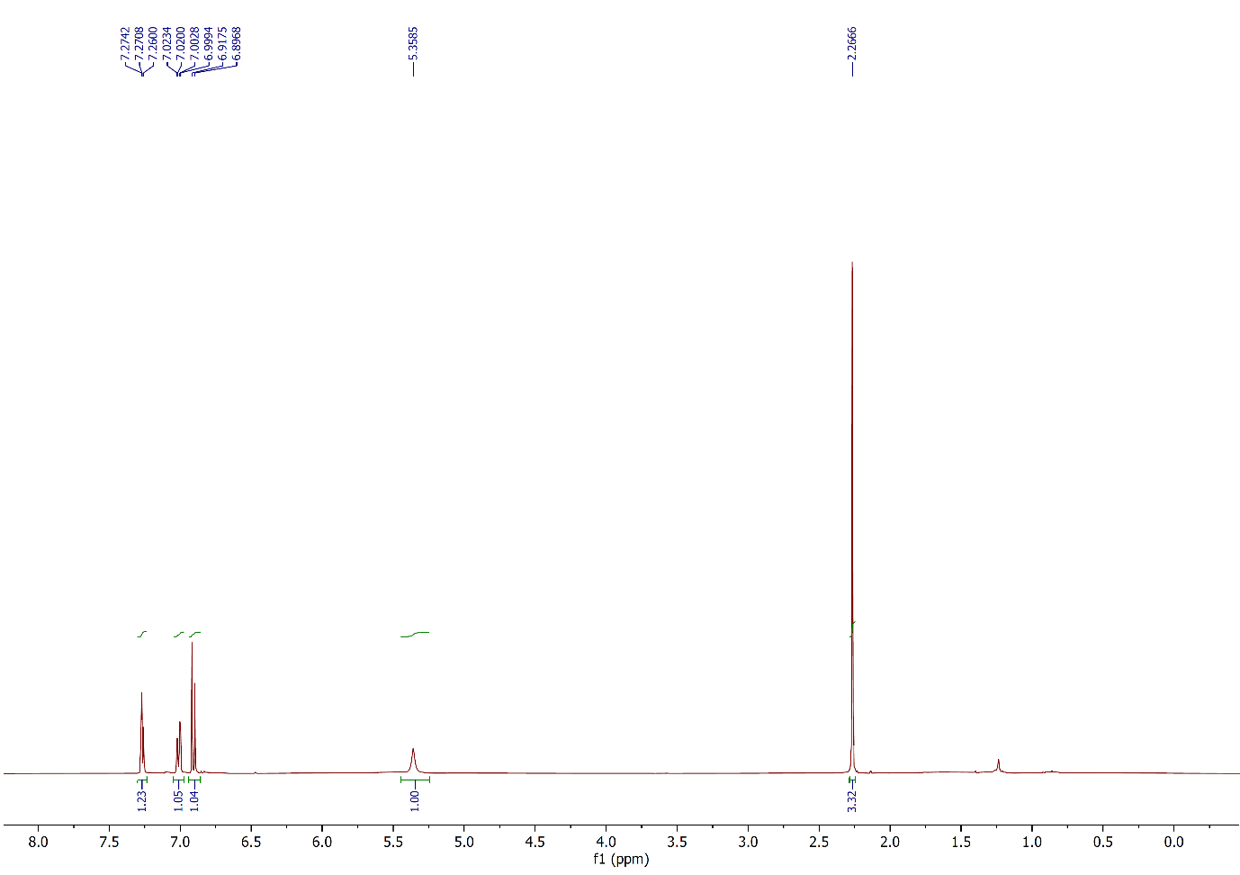 Figure 1: ¹H NMR spectrum of compound 2a, (CDCl₃, 400 MHz).
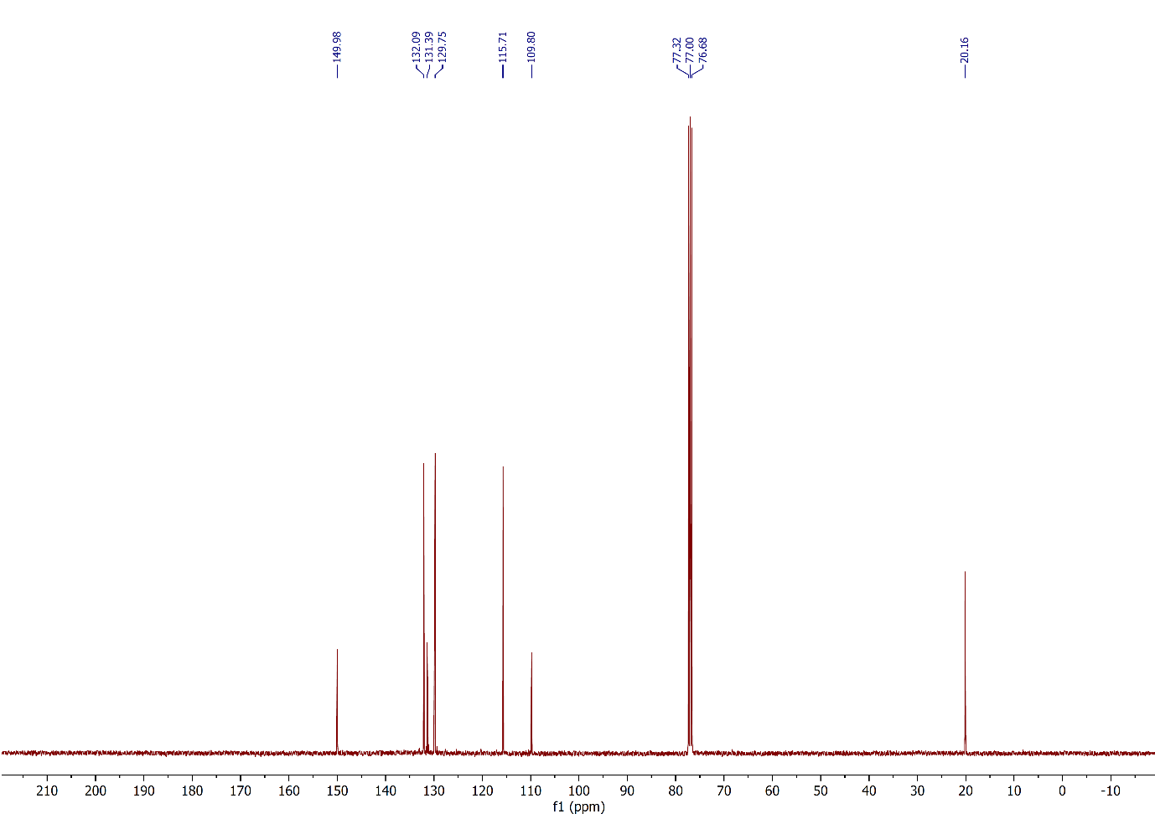
Figure 2: ¹³C NMR spectrum of compound 2a, (CDCl₃, 100 MHz).
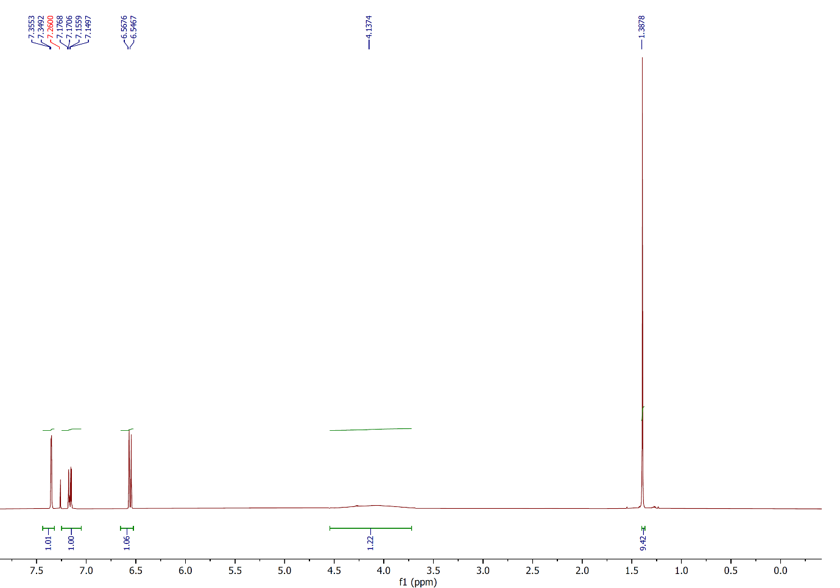
Figure 3: ¹H NMR spectrum of compound 2b, (CDCl₃, 400 MHz).
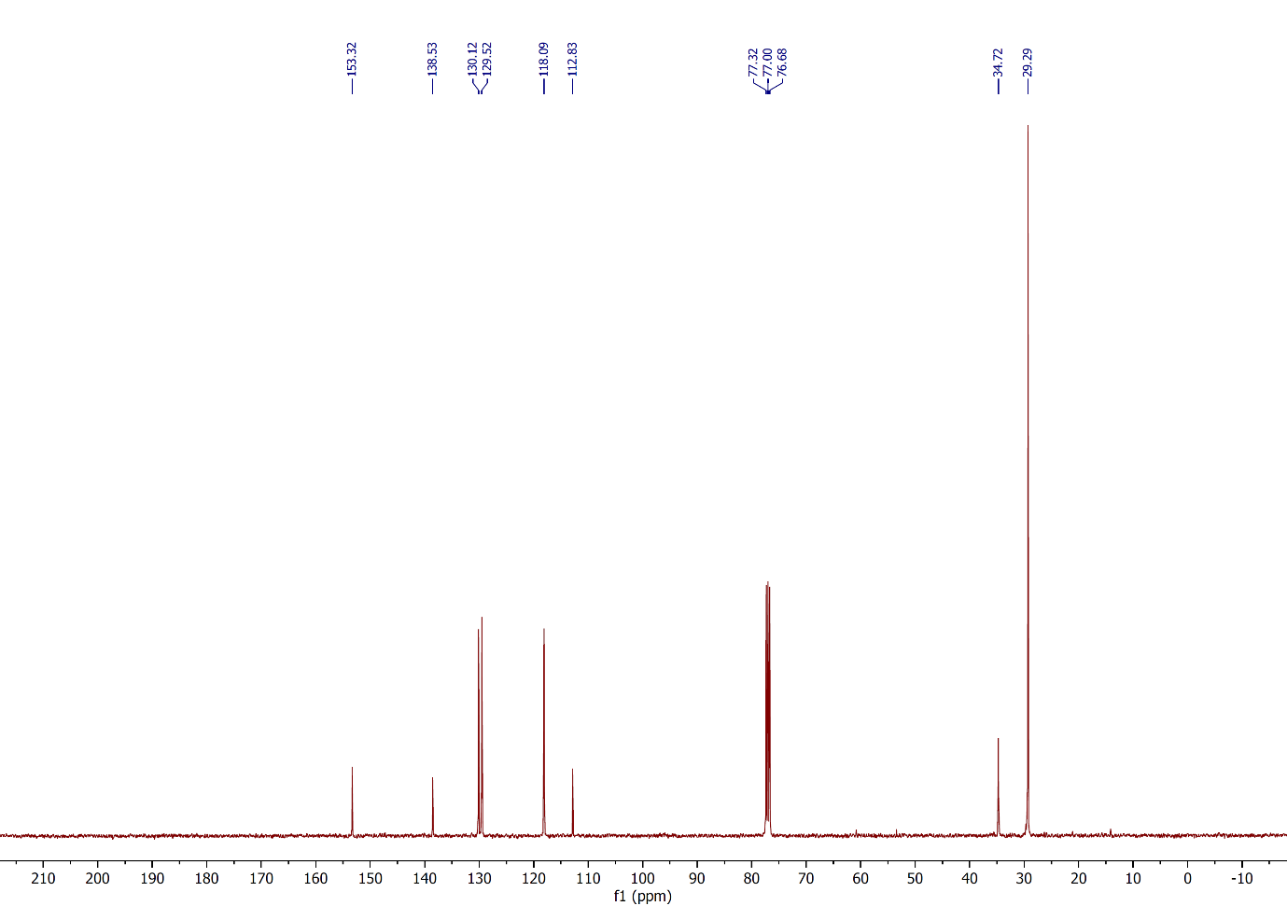
Figure 4: ¹³C NMR spectrum of compound 2b, (CDCl₃, 100 MHz).
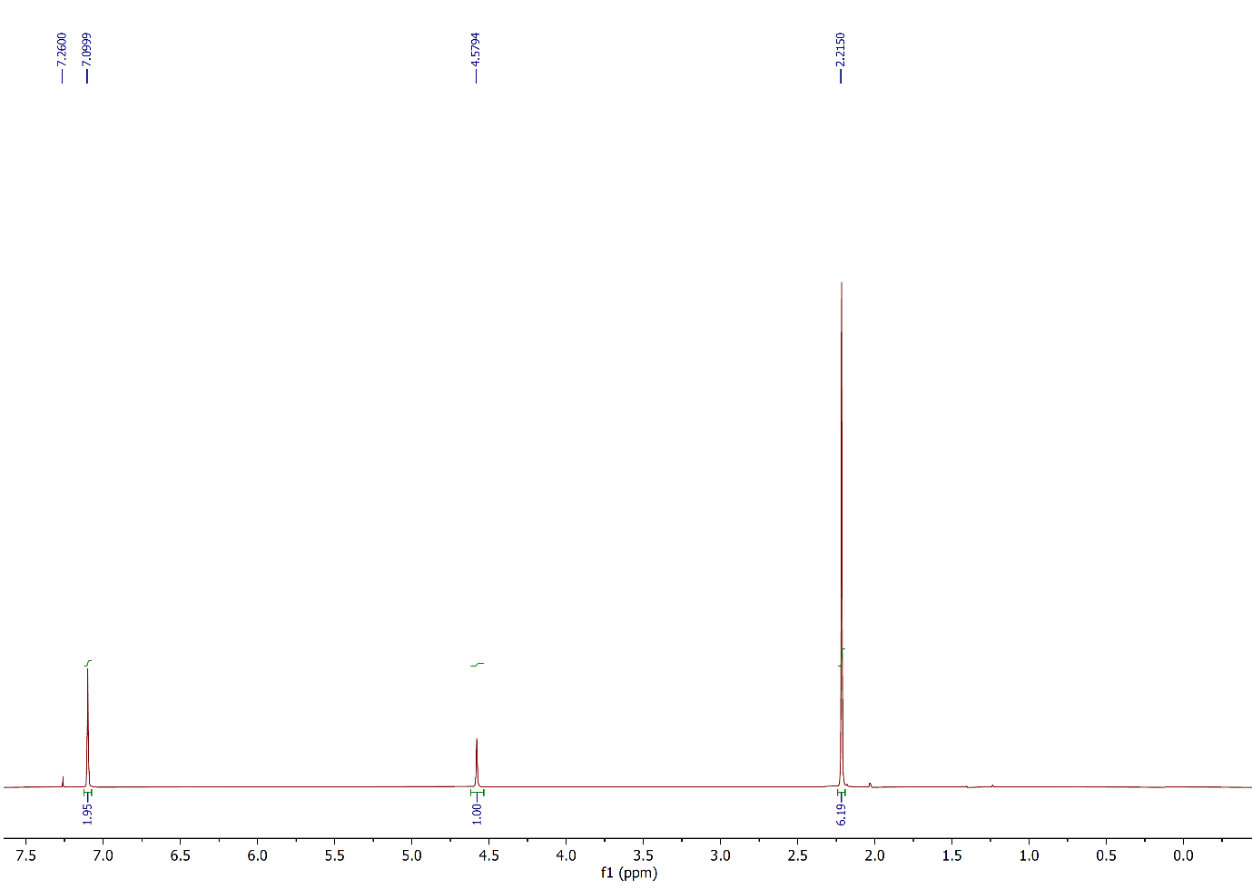 Figure 5: ¹H NMR spectrum of compound 2c, (CDCl₃, 400 MHz).
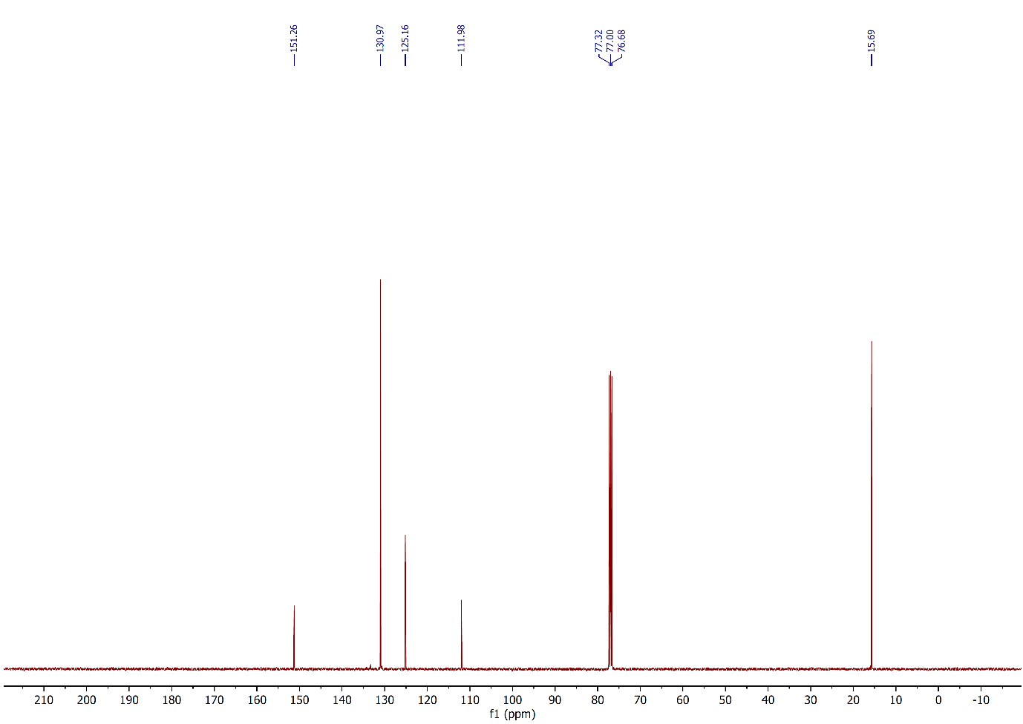
Figure 6: ¹³C NMR spectrum of compound 2c, (CDCl₃, 100 MHz).
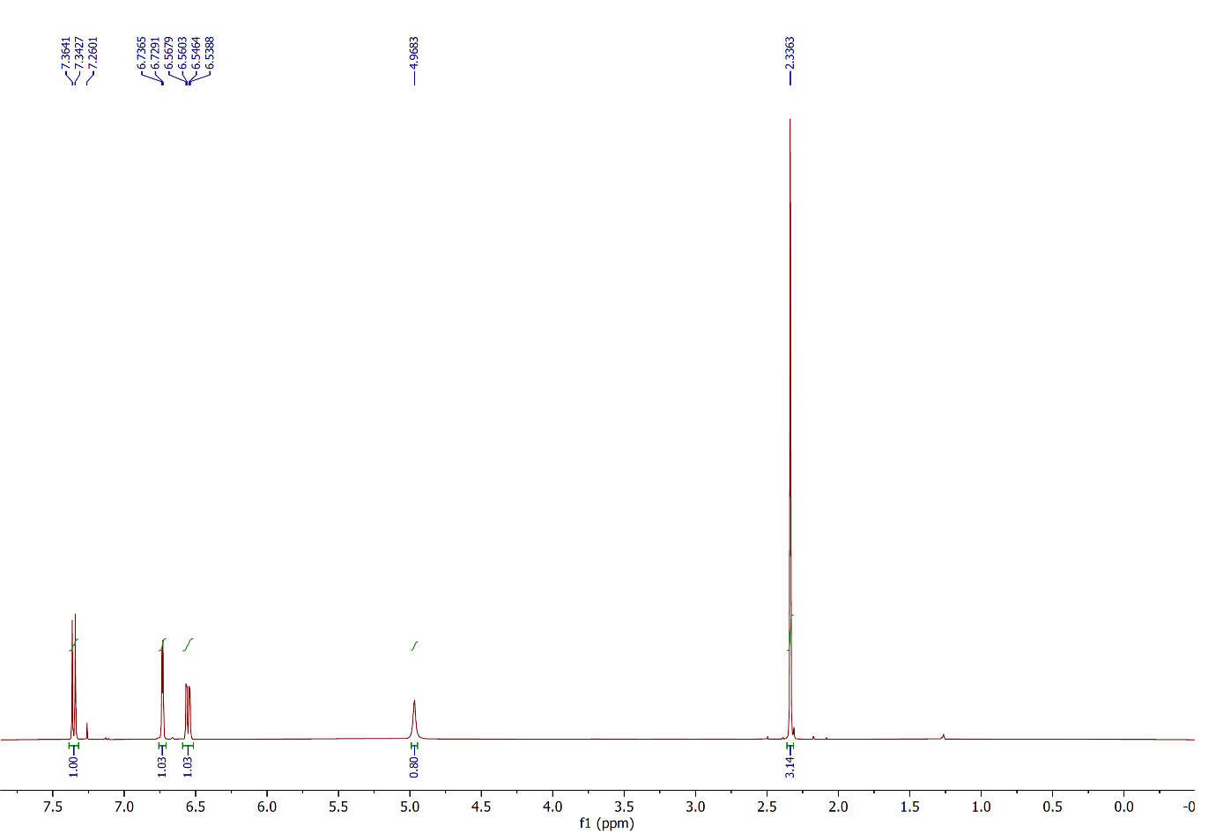
Figure 7: ¹H NMR spectrum of compound 2d, (CDCl₃, 400 MHz).
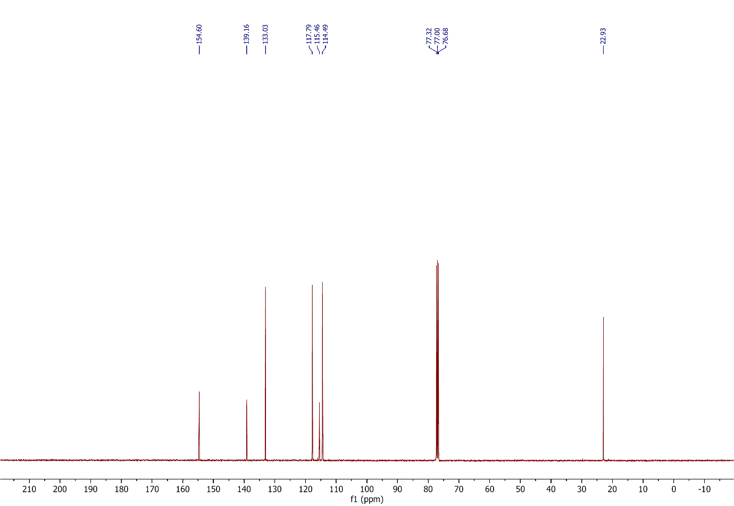
Figure 8: ¹³C NMR spectrum of compound 2d, (CDCl₃, 100 MHz).
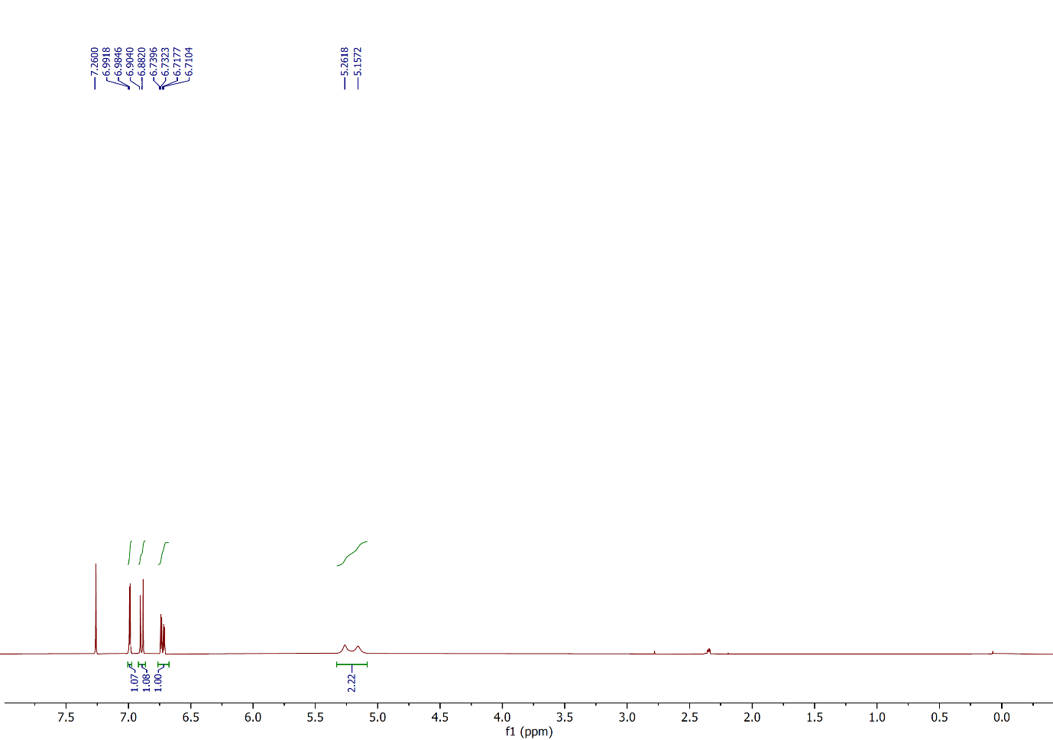
Figure 9: ¹H NMR spectrum of compound 2e, (CDCl₃, 400 MHz).
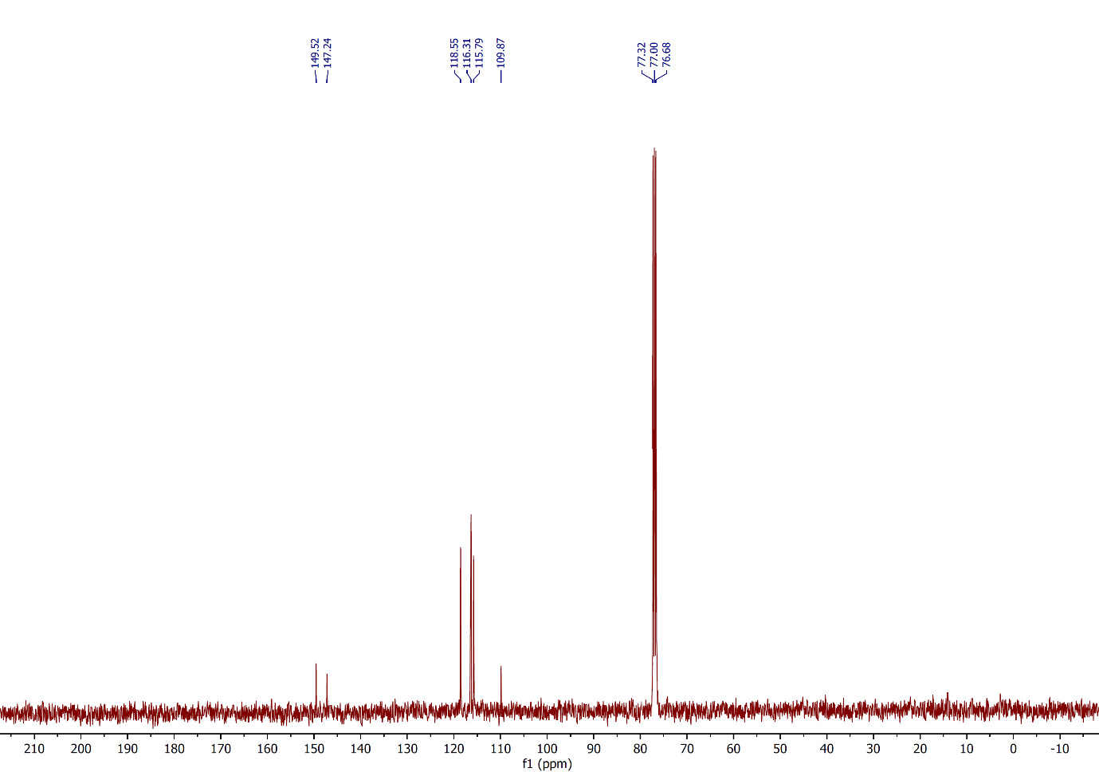
Figure 10: ¹³C NMR spectrum of compound 2e, (CDCl₃, 100 MHz).
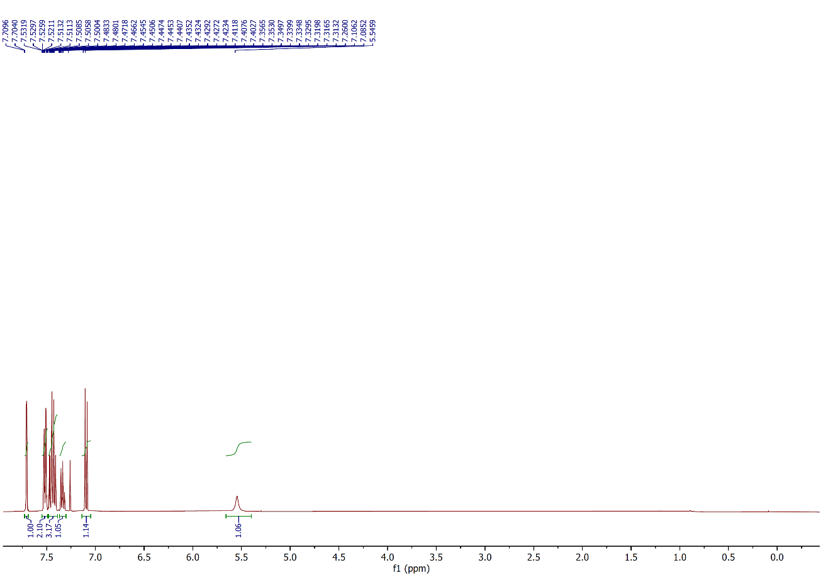
Figure 11: ¹H NMR spectrum of compound 2f, (CDCl₃, 400 MHz).
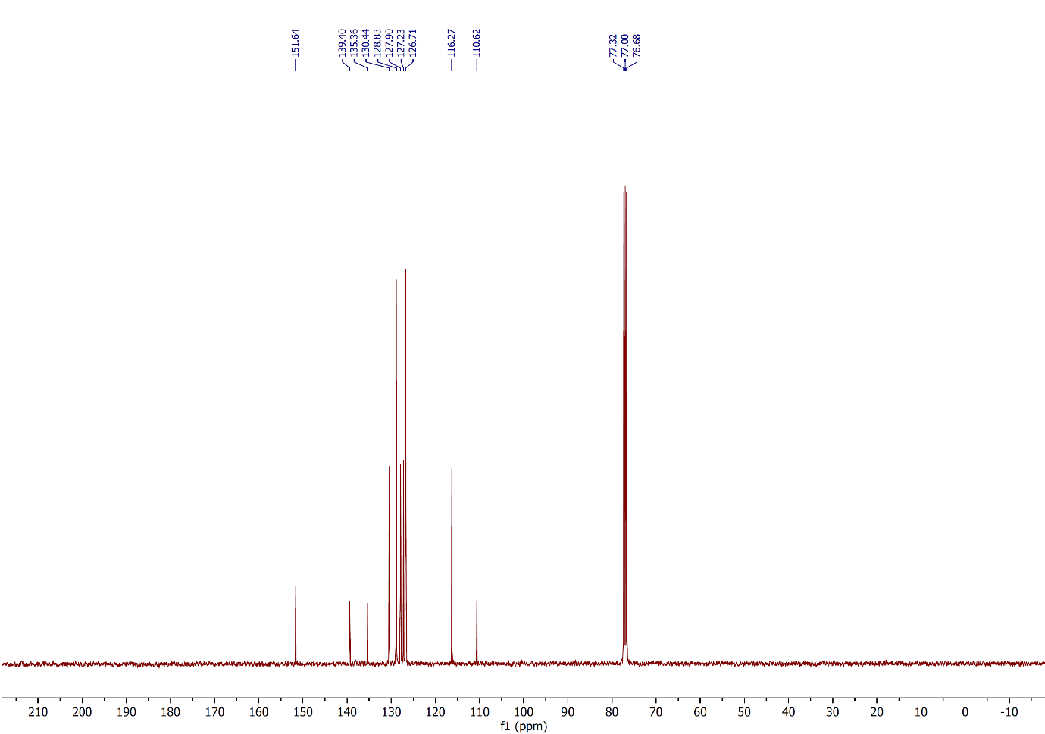
Figure 12: ¹³C NMR spectrum of compound 2f, (CDCl₃, 100 MHz).
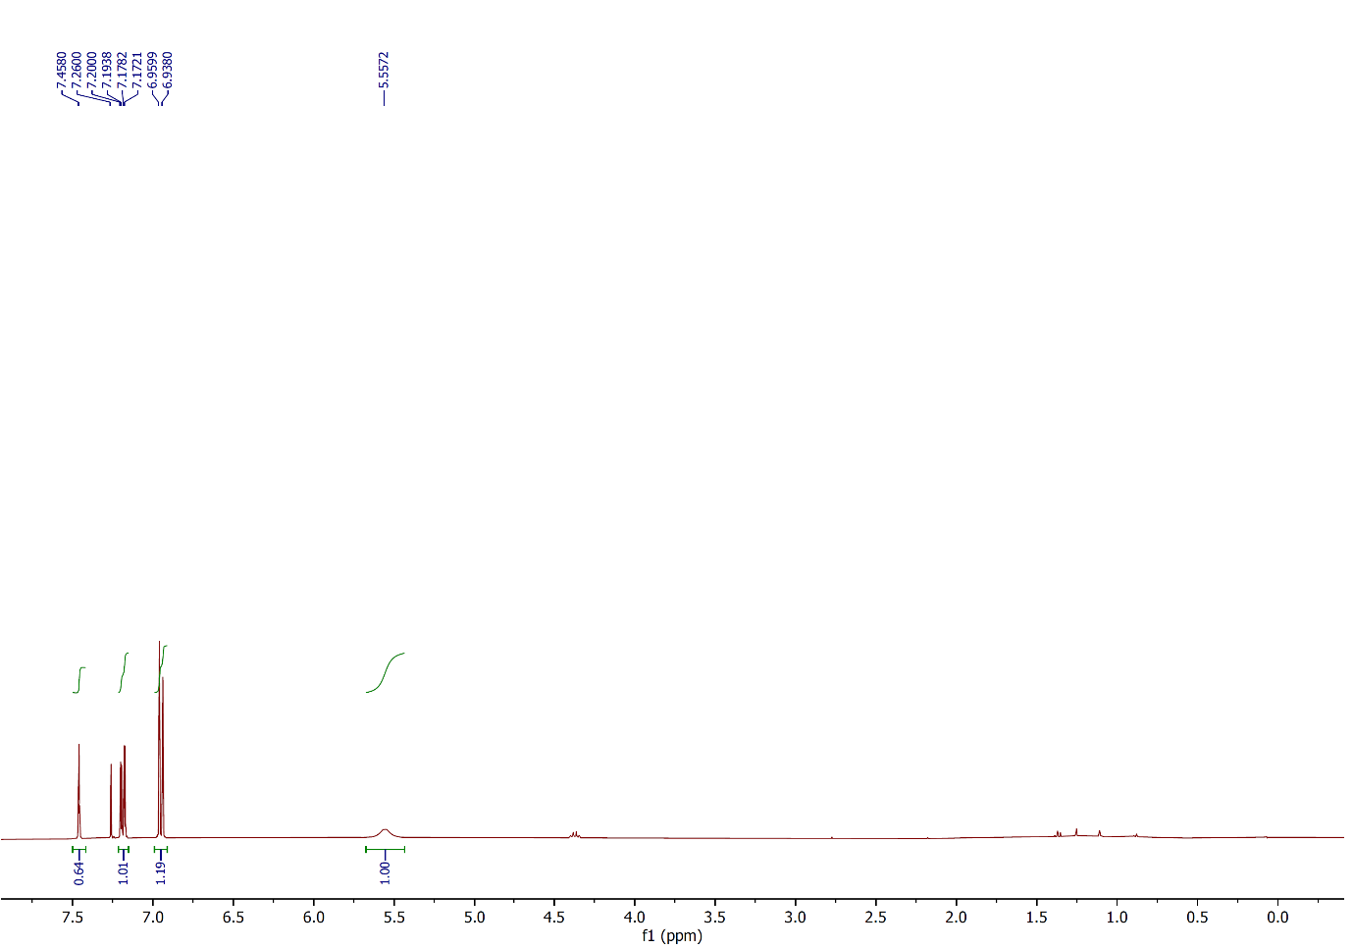
Figure 13: ¹H NMR spectrum of compound 2g, (CDCl₃, 400 MHz).
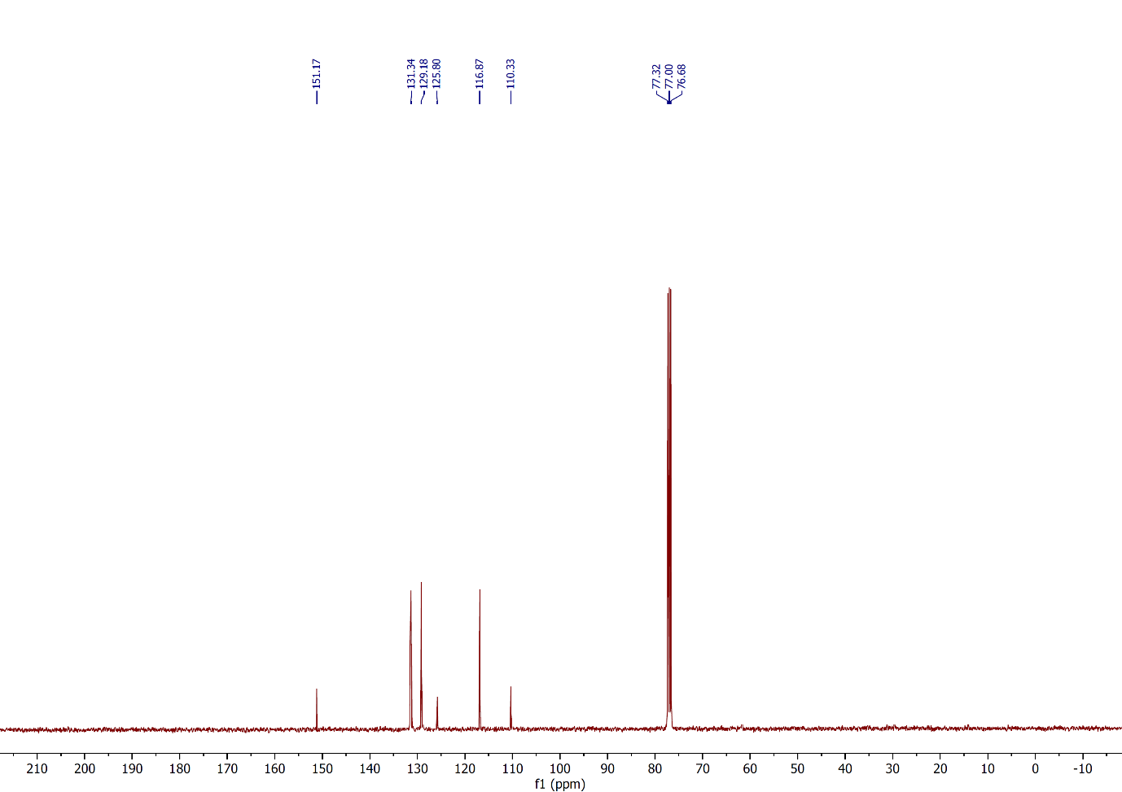
Figure 14: ¹³C NMR spectrum of compound 2g, (CDCl₃, 100 MHz).
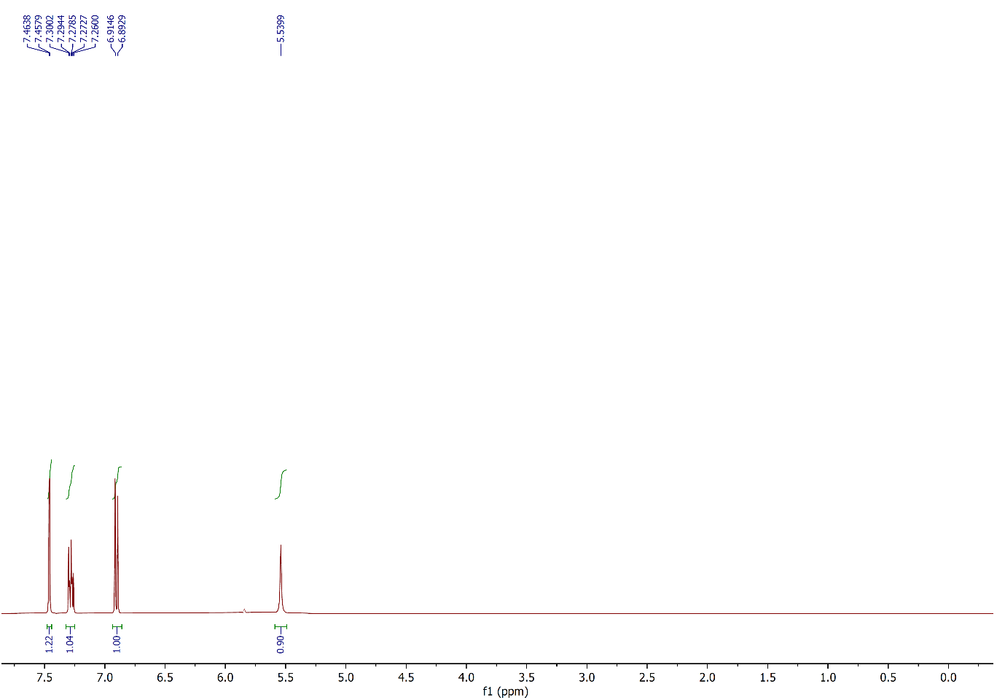
Figure 15: ¹H NMR spectrum of compound 2h, (CDCl₃, 400 MHz).
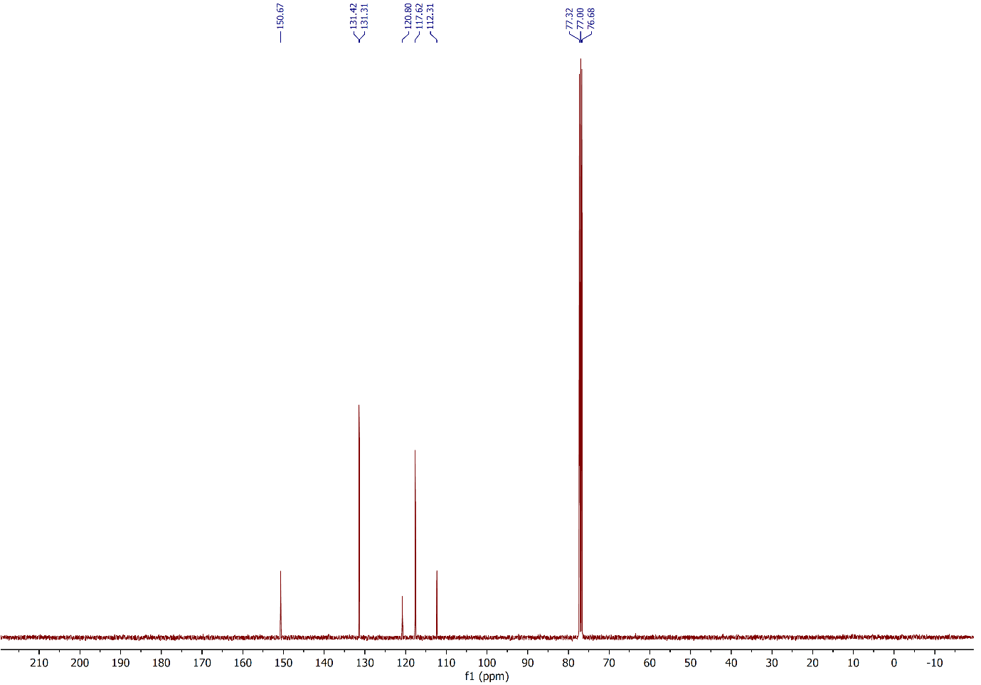 Figure 16: ¹³C NMR spectrum of compound 2h, (CDCl₃, 100 MHz).
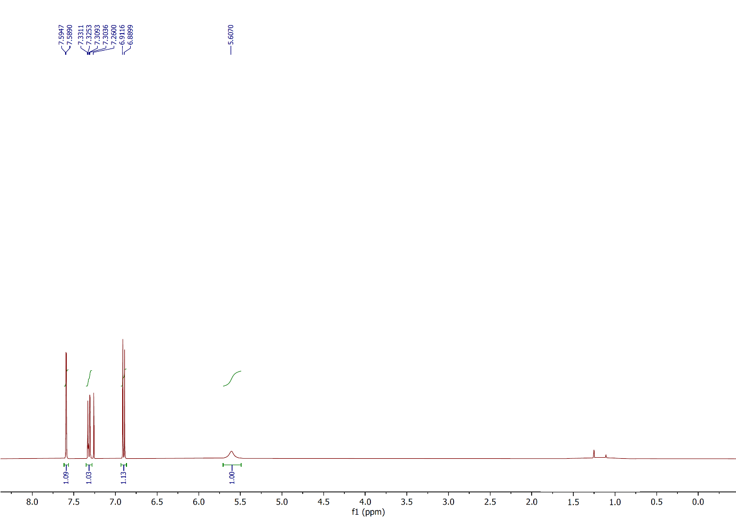
Figure 17: ¹H NMR spectrum of compound 2i, (CDCl₃, 400 MHz).
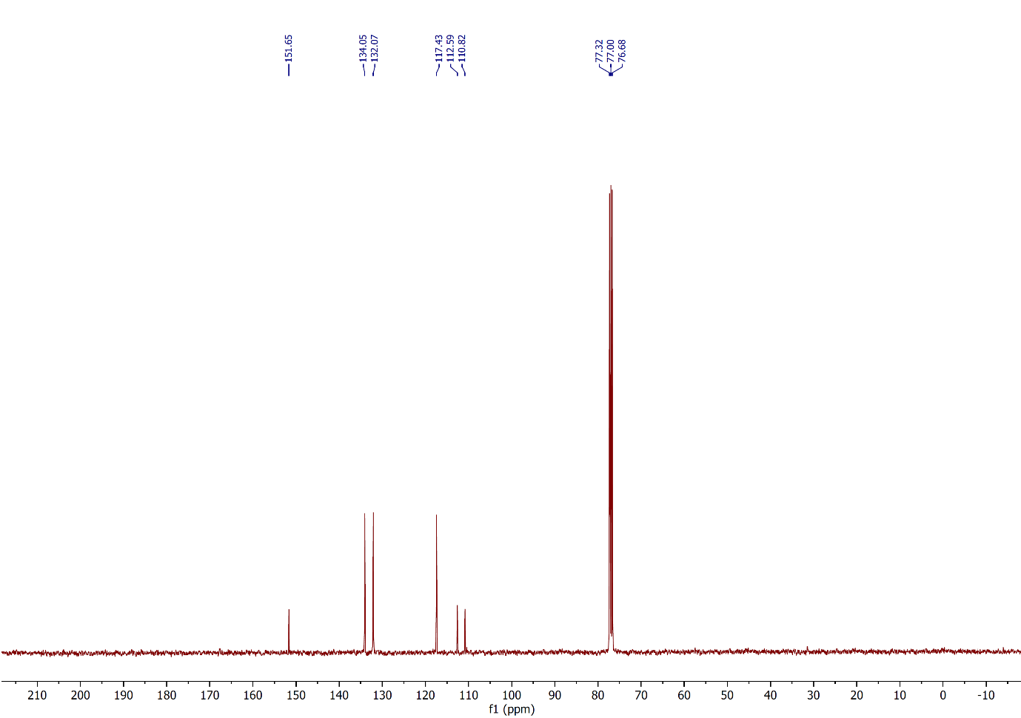
Figure 18: ¹³C NMR spectrum of compound 2i, (CDCl₃, 100 MHz).
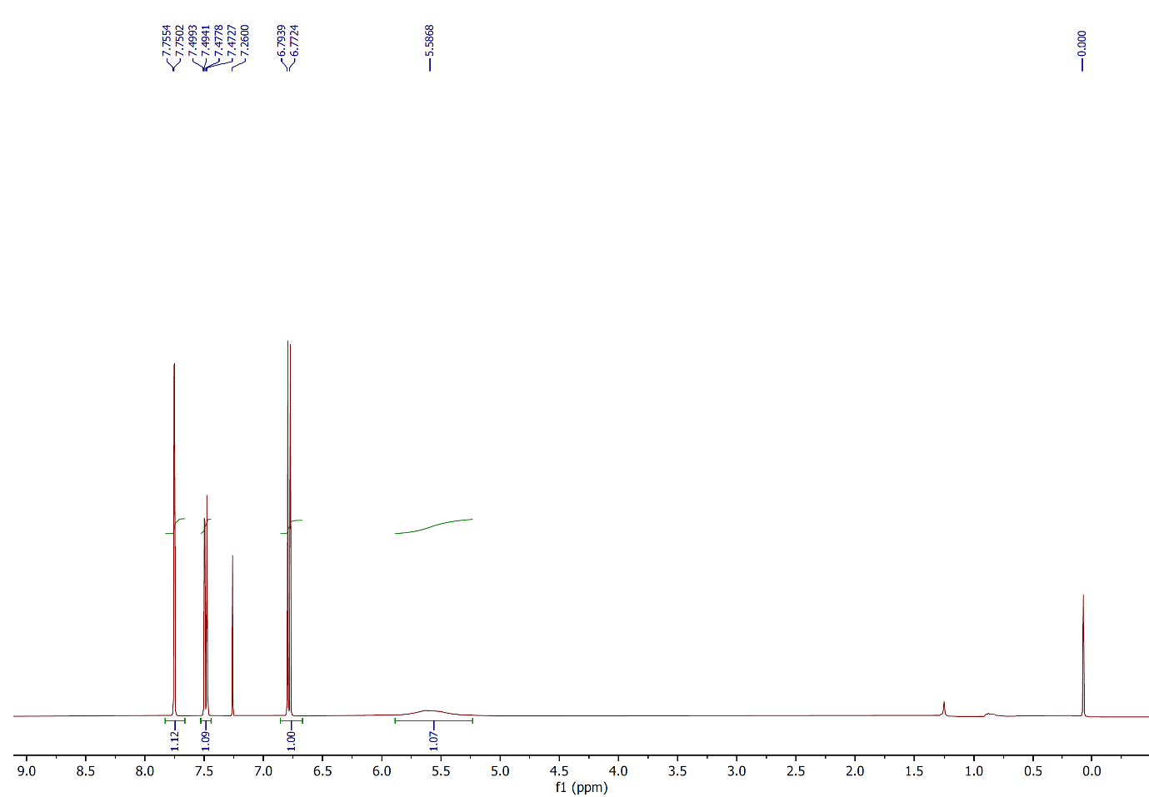
Figure 19: ¹H NMR spectrum of compound 2j, (CDCl₃, 400 MHz).
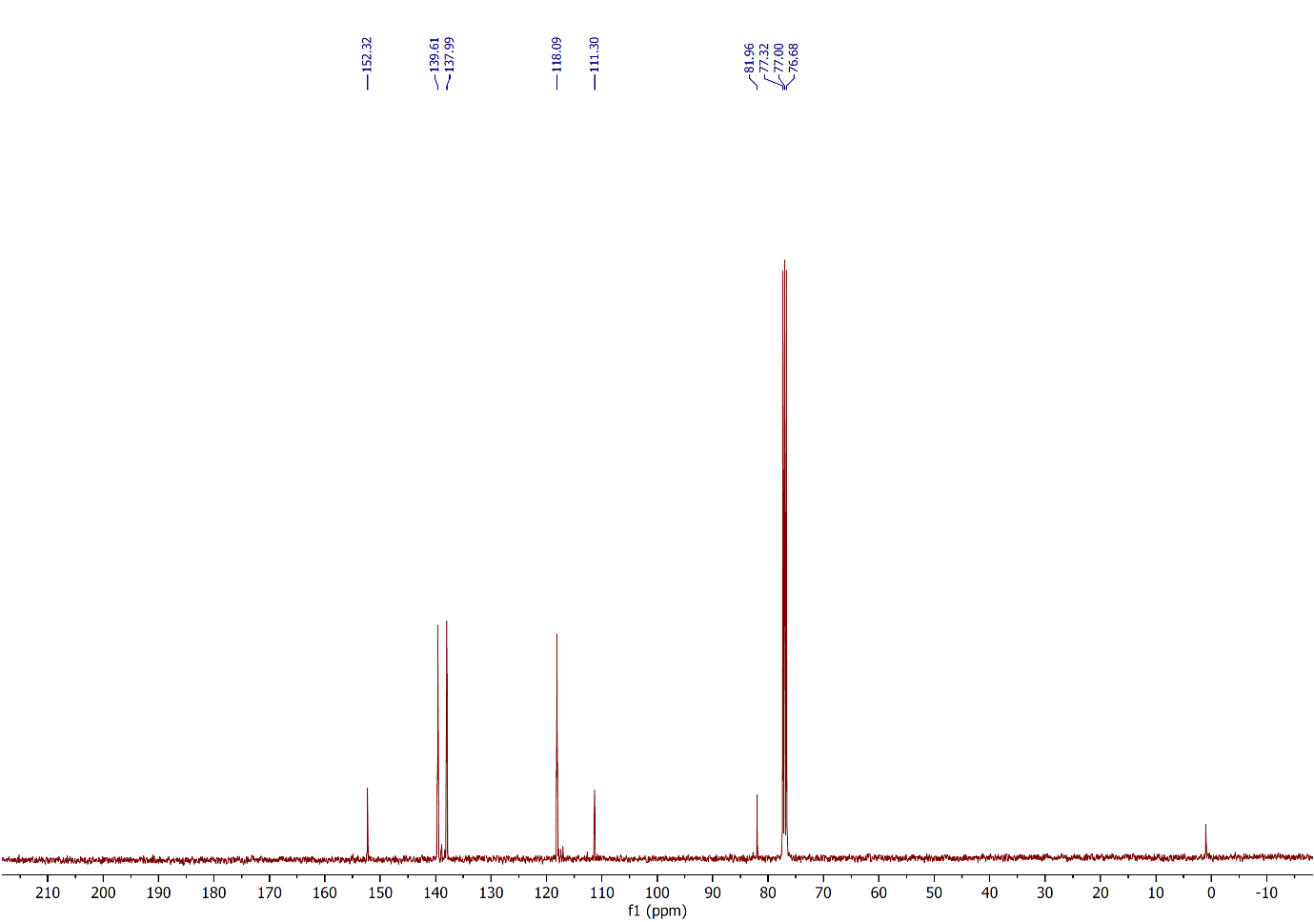
Figure 20: ¹³C NMR spectrum of compound 2j, (CDCl₃, 100 MHz).
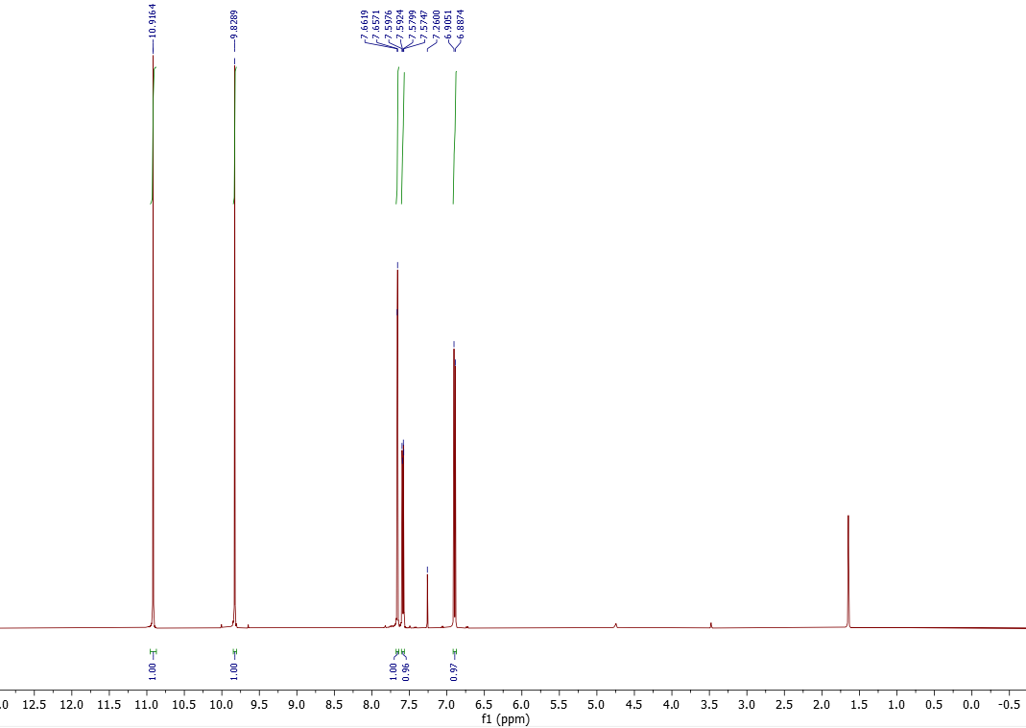
Figure 21: ¹H NMR spectrum of compound 2k, (CDCl₃, 500 MHz).

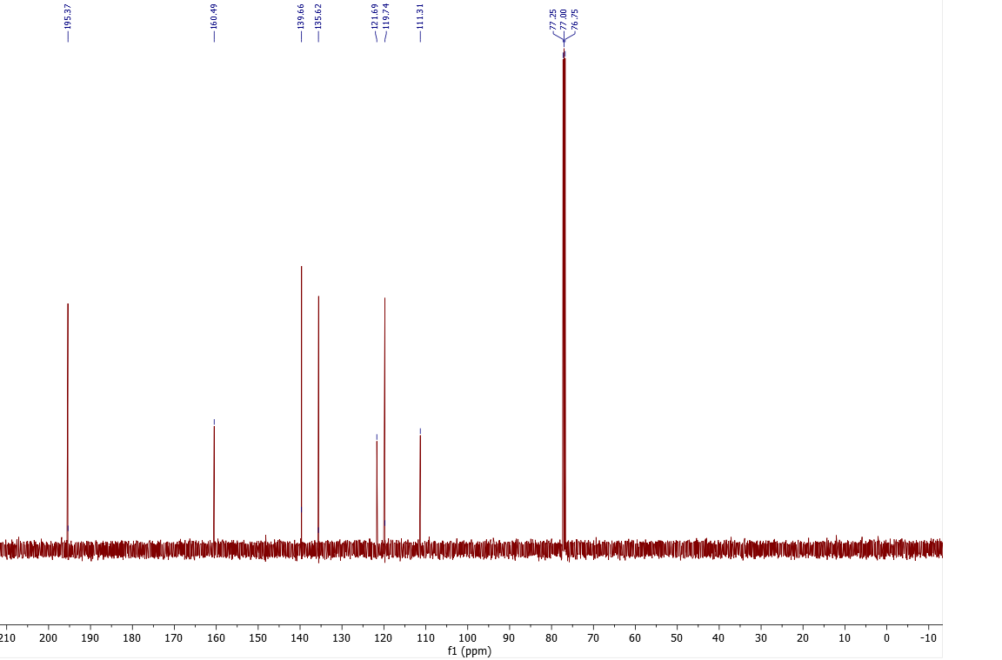
Figure 22: ¹³C NMR spectrum of compound 2k, (CDCl₃, 125 MHz).
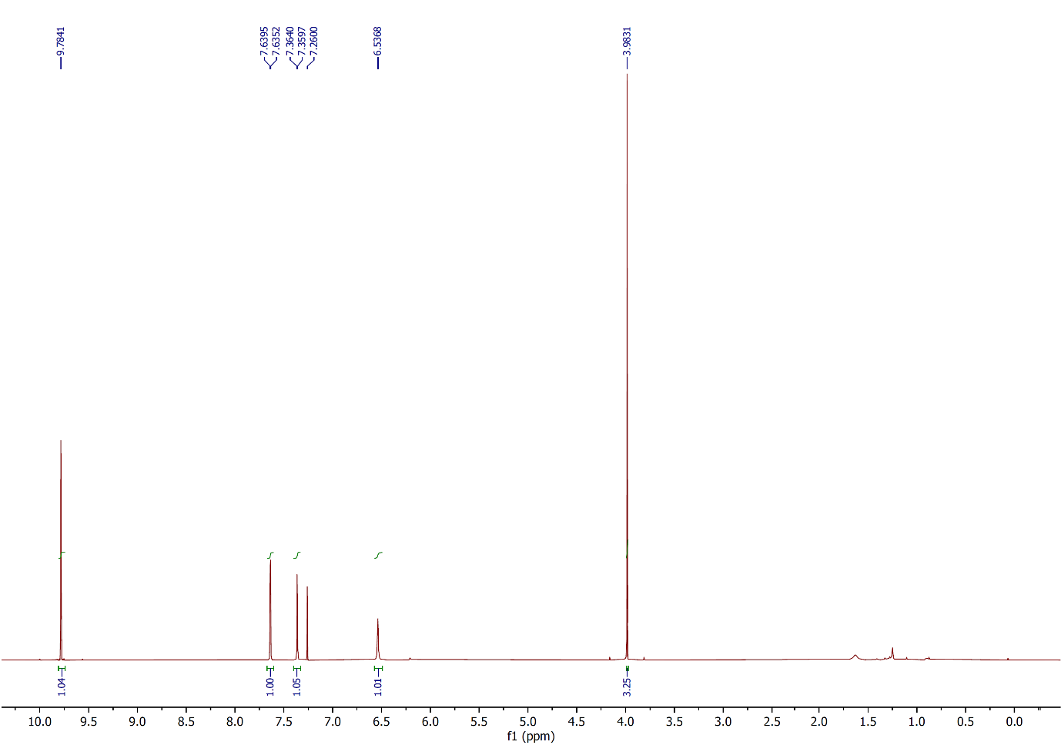
Figure 23: ¹H NMR spectrum of compound 2l, (CDCl₃, 400 MHz).
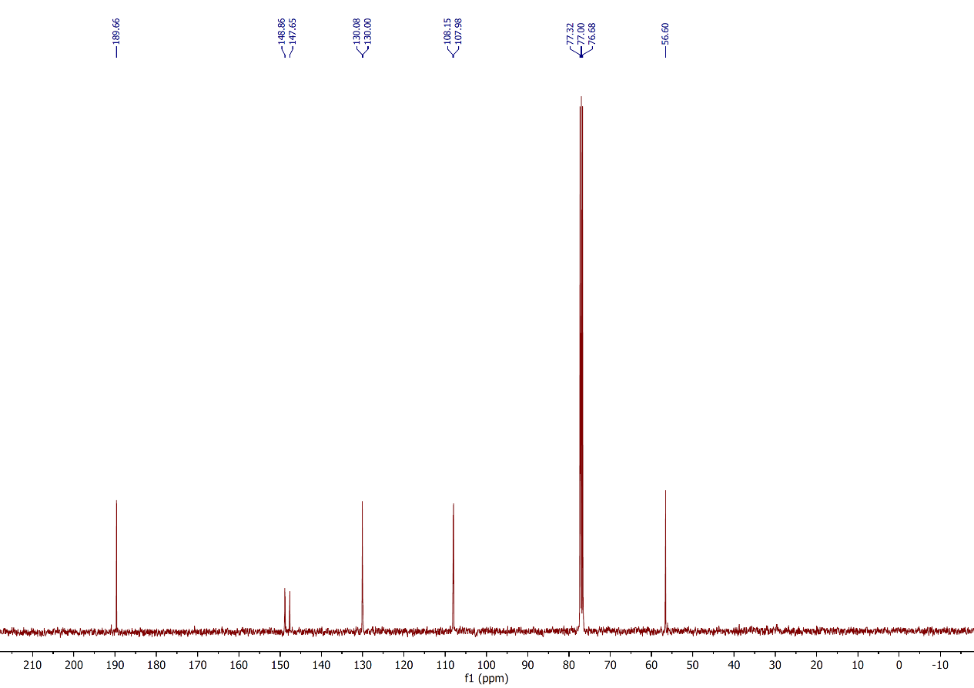
Figure 24: ¹³C NMR spectrum of compound 2l, (CDCl₃, 100 MHz).
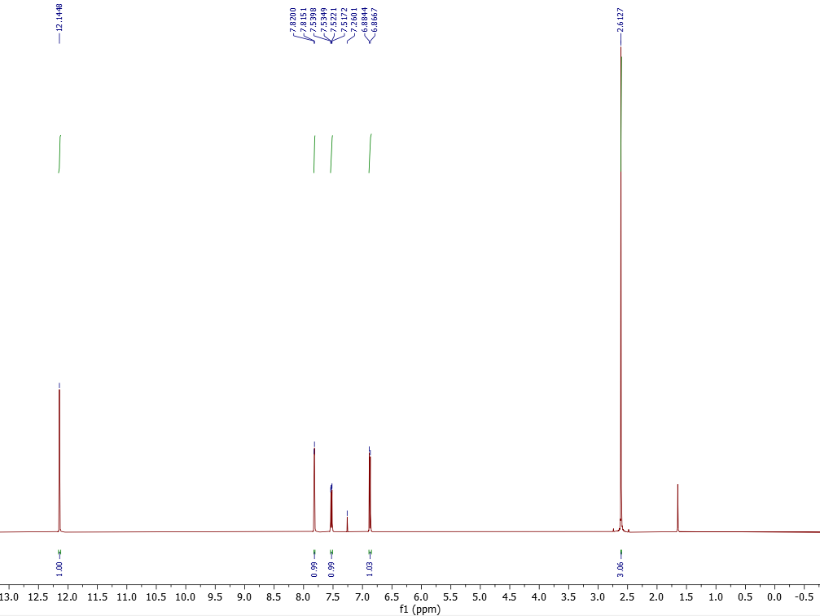
Figure 25: ¹H NMR spectrum of compound 2m, (CDCl₃, 500 MHz).
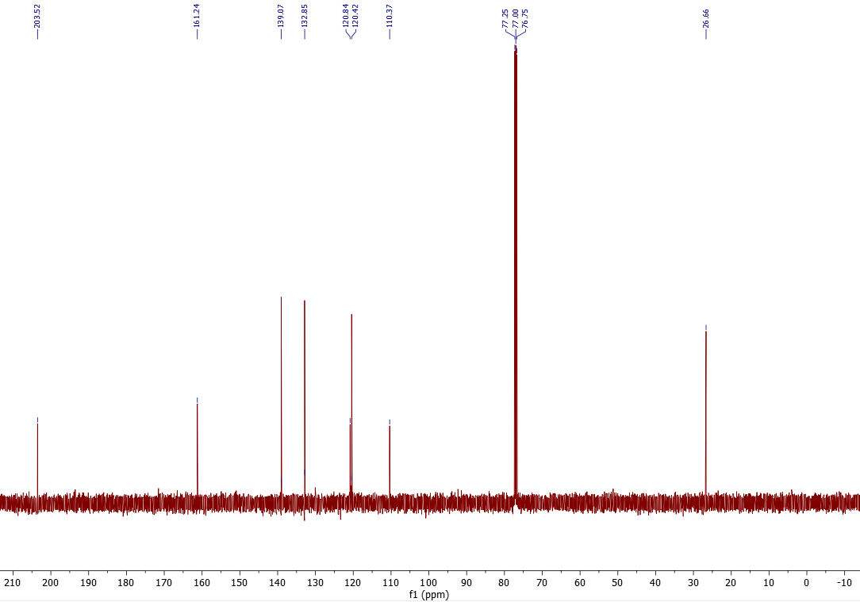
Figure 26: ¹³C NMR spectrum of compound 2m, (CDCl₃, 125 MHz).
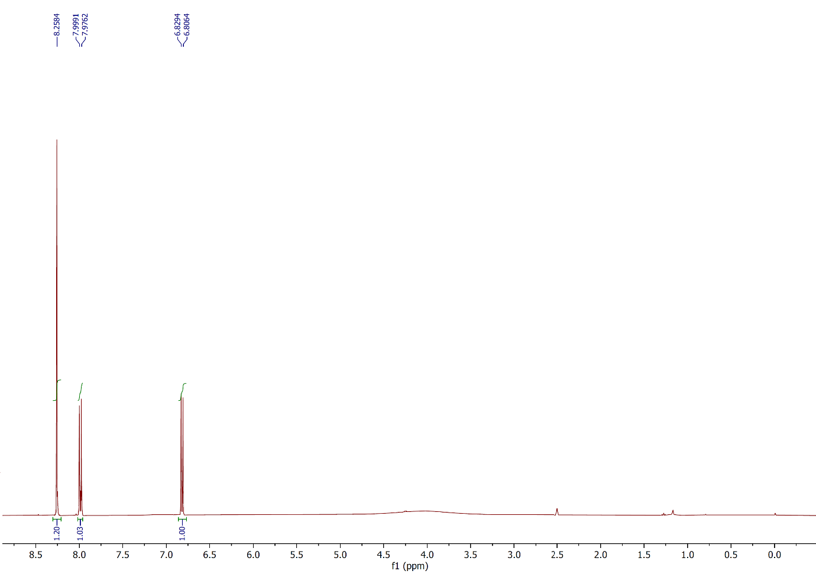
Figure 27: ¹H NMR spectrum of compound 2n, (CDCl₃, 400 MHz).
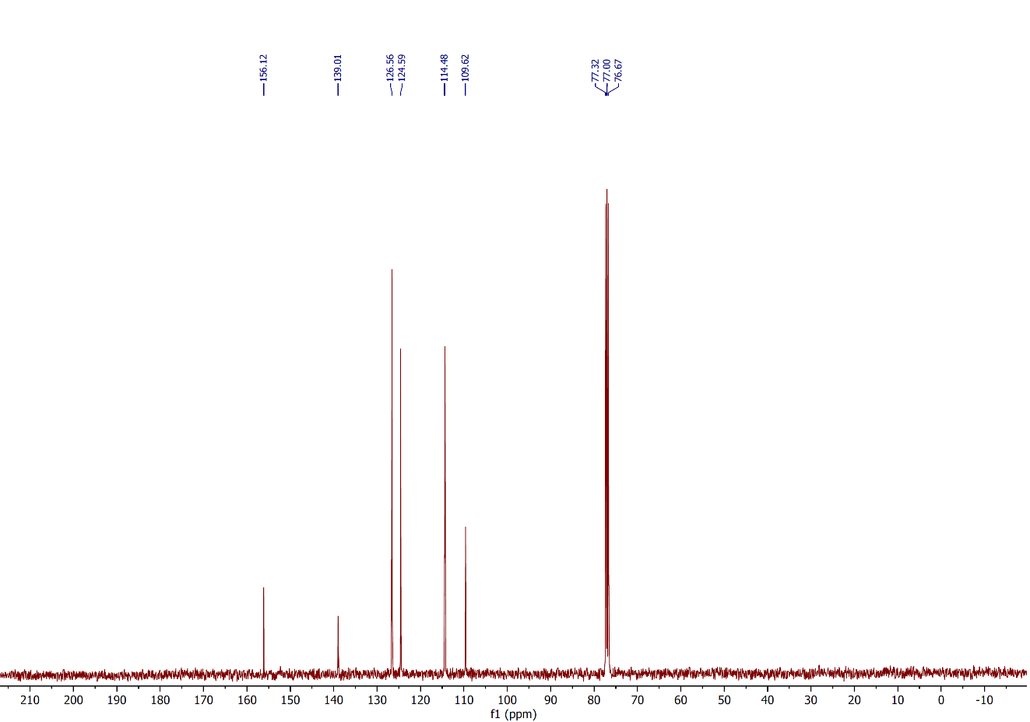
Figure 28: ¹³C NMR spectrum of compound 2n, (CDCl₃, 100 MHz).
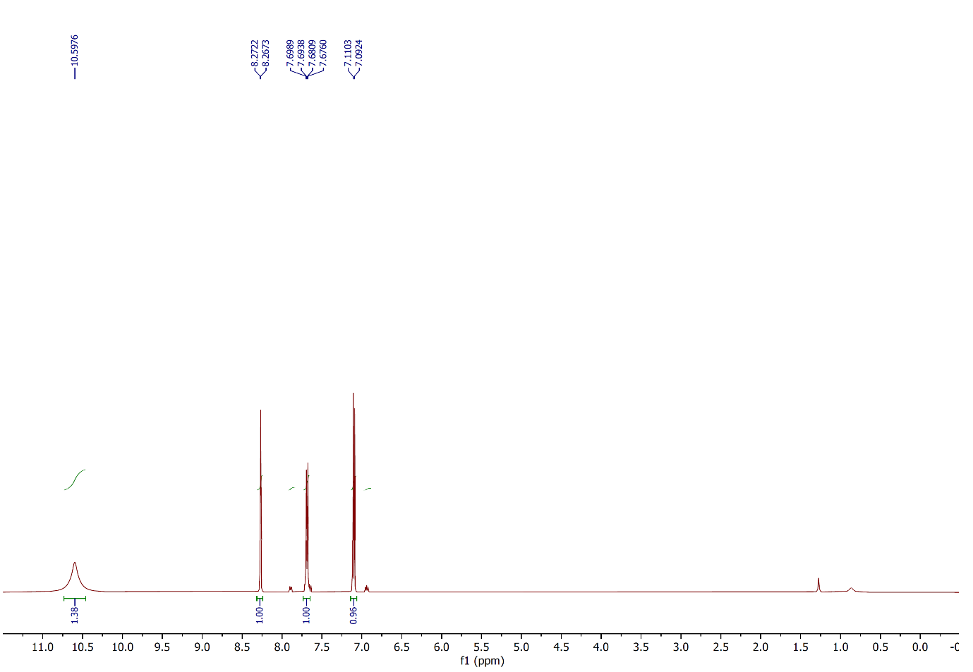Figure 29: ¹H NMR spectrum of compound 2o, (CDCl₃, 500 MHz).
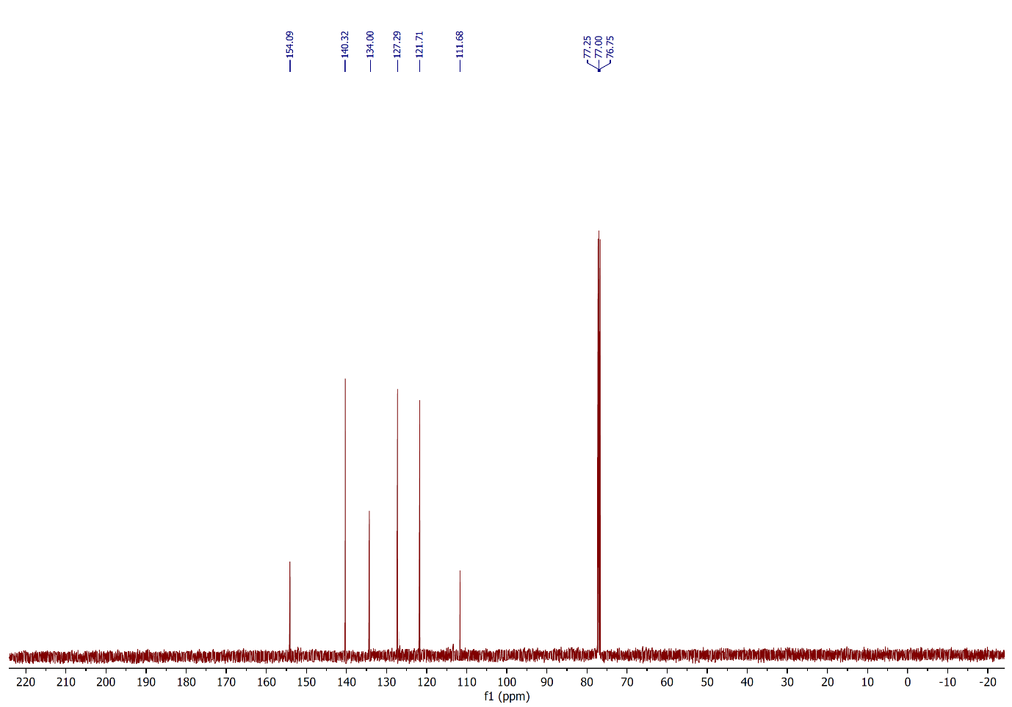
Figure 30: ¹³C NMR spectrum of compound 2o, (CDCl₃, 125 MHz).
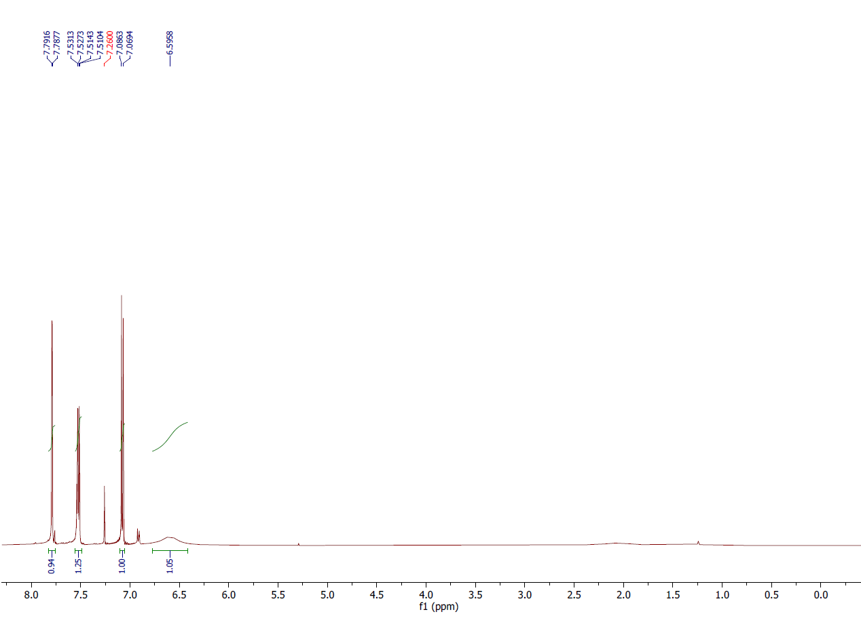Figure 31: ¹H NMR spectrum of compound 2p, (CDCl₃, 500 MHz).
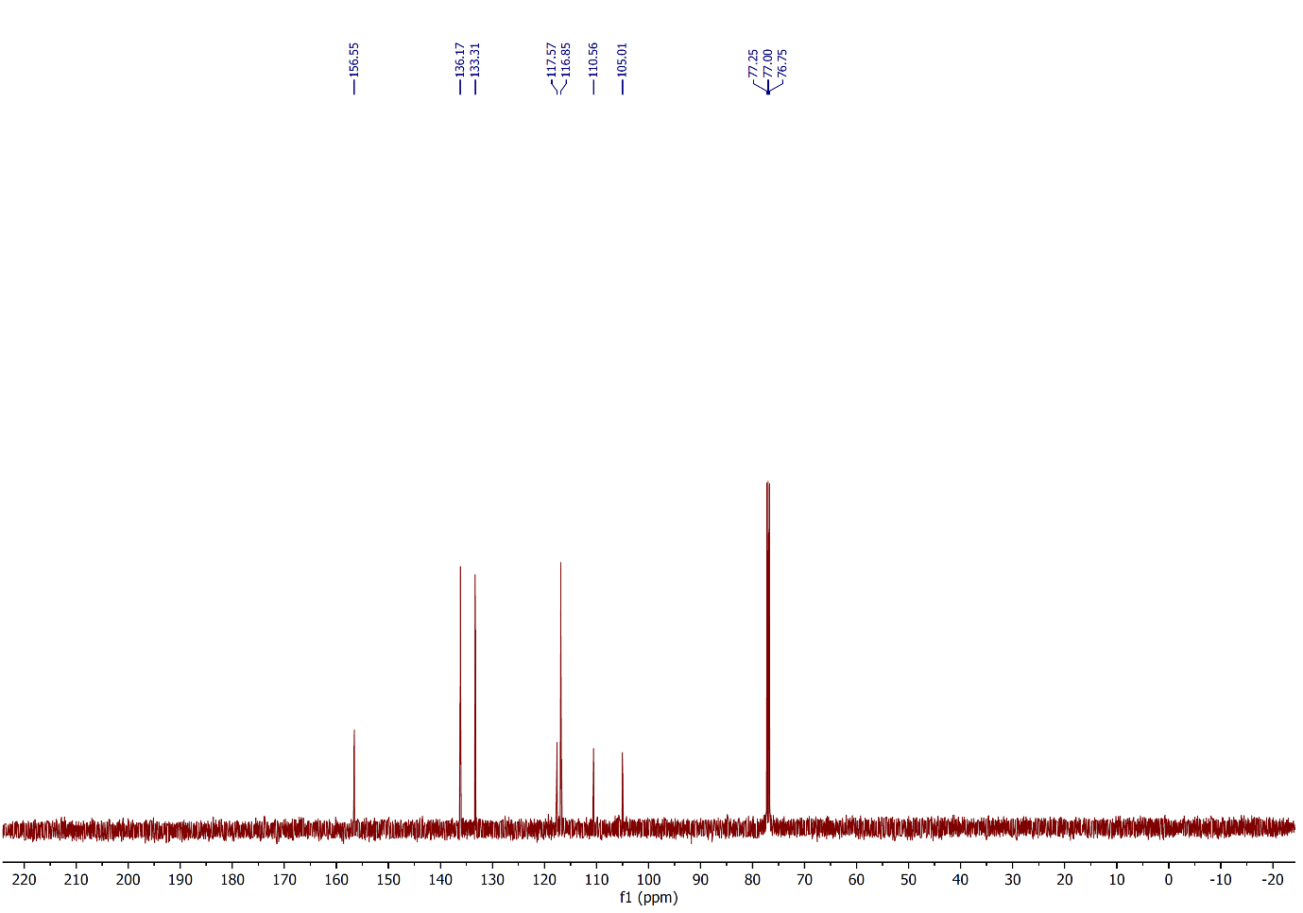
Figure 32: ¹³C NMR spectrum of compound 2p, (CDCl₃, 125 MHz).

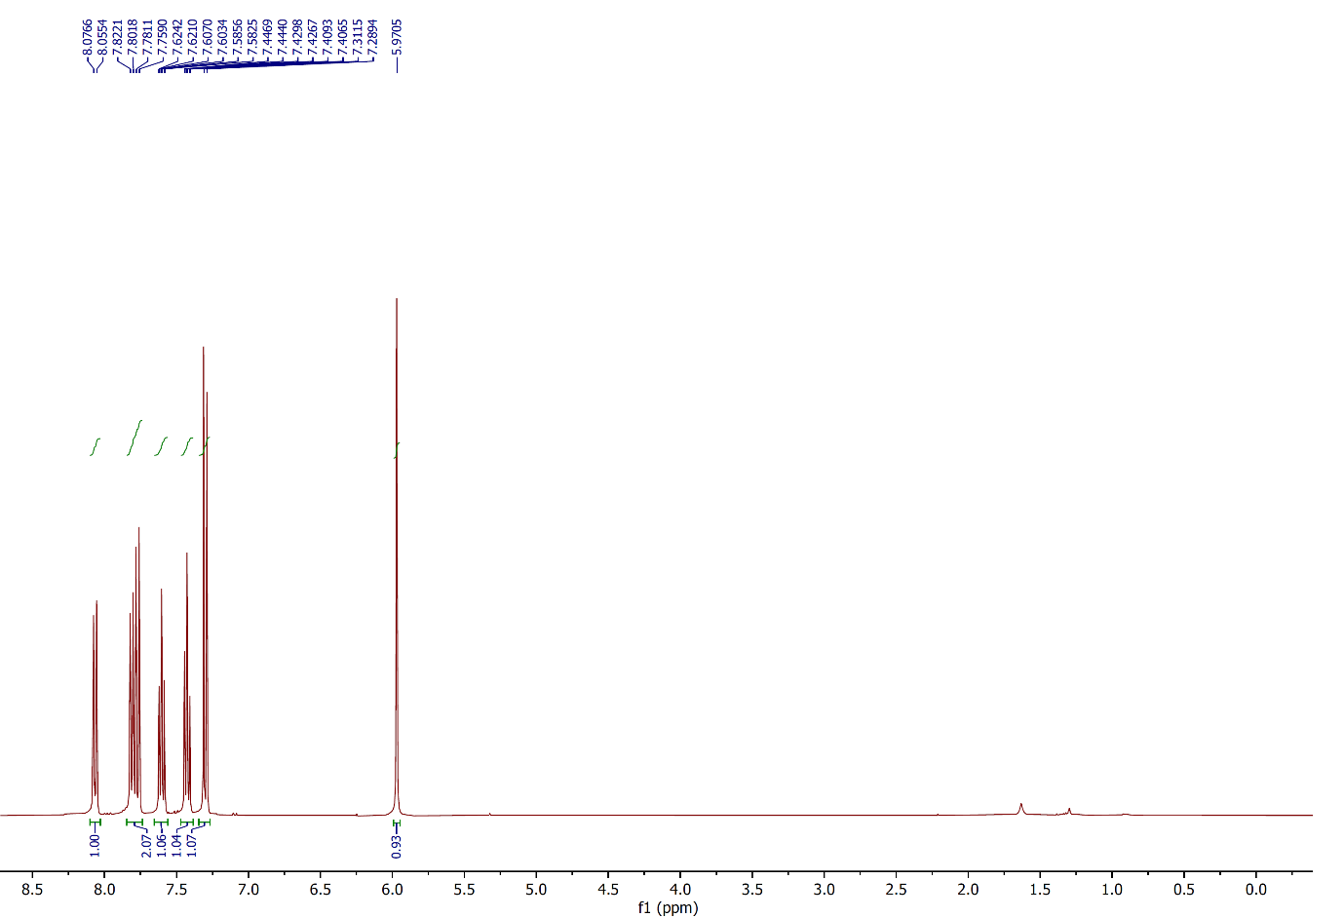
Figure 33: ¹H NMR spectrum of compound 2q, (CDCl₃, 400 MHz).
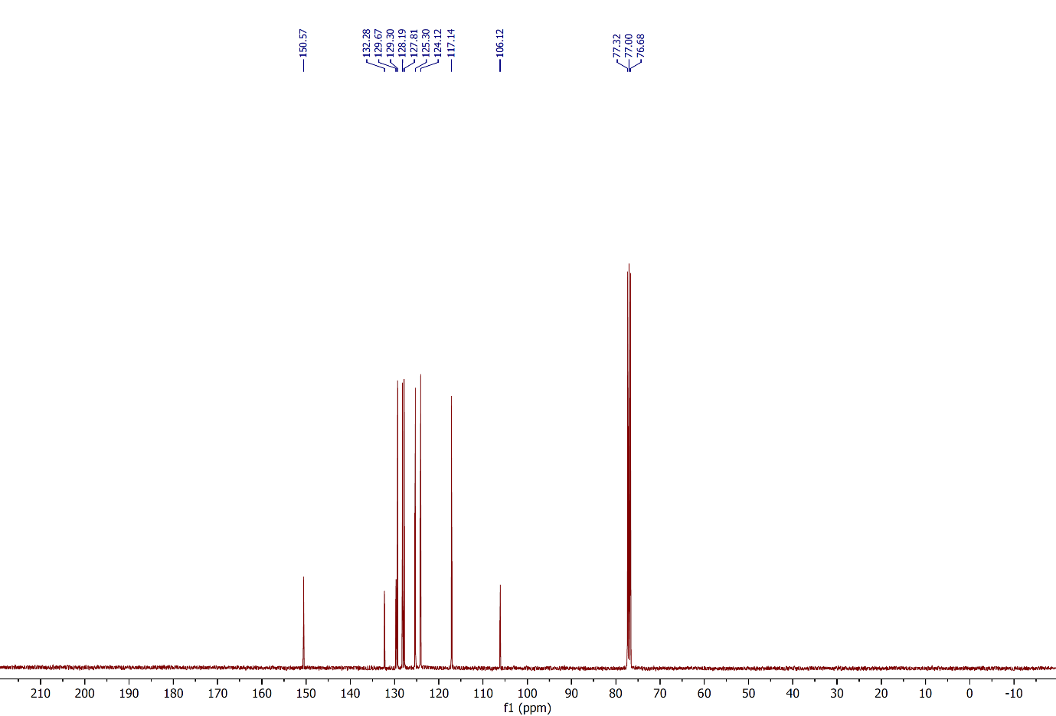 Figure 34: ¹³C NMR spectrum of compound 2q, (CDCl₃, 100 MHz).
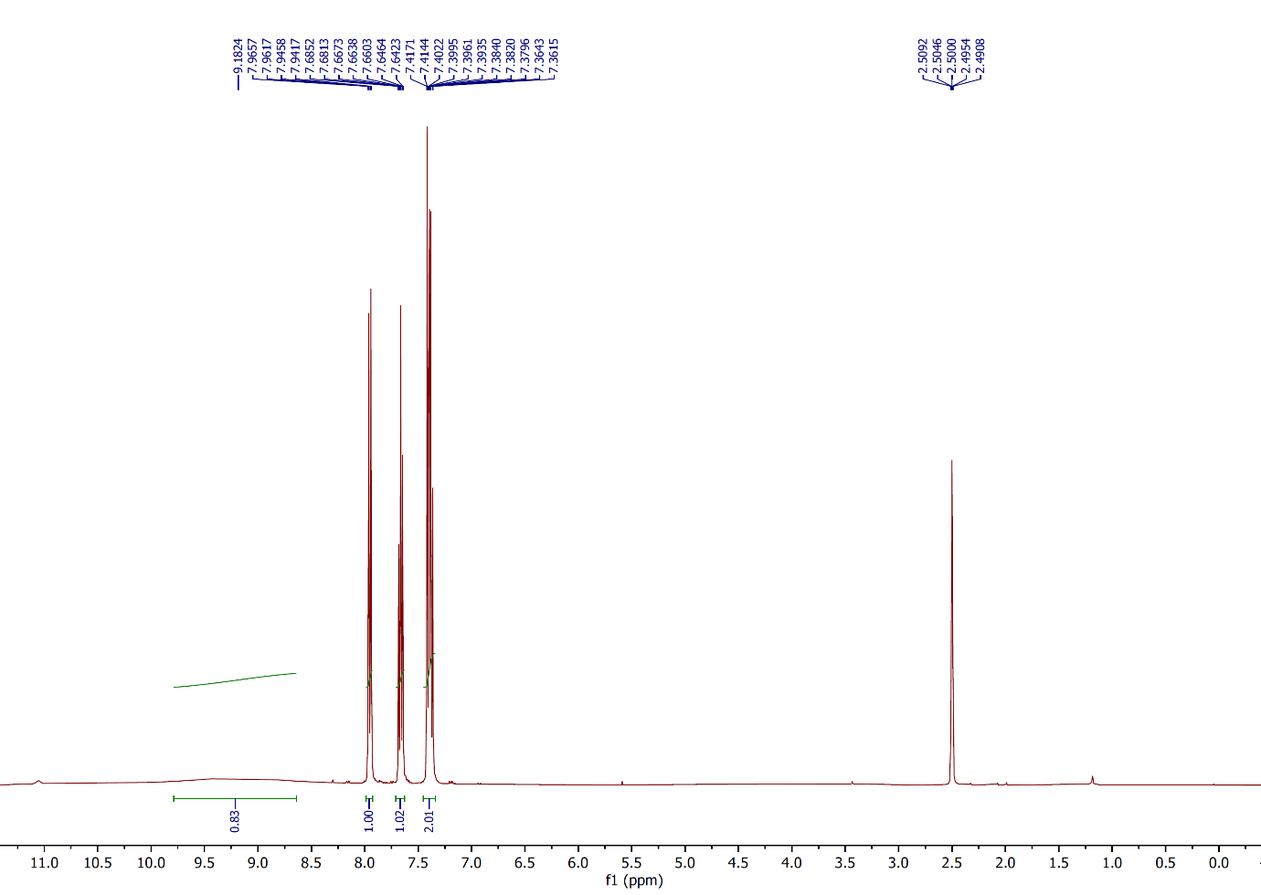
Figure 35: ¹H NMR spectrum of compound 2r, (CDCl₃, 400 MHz).
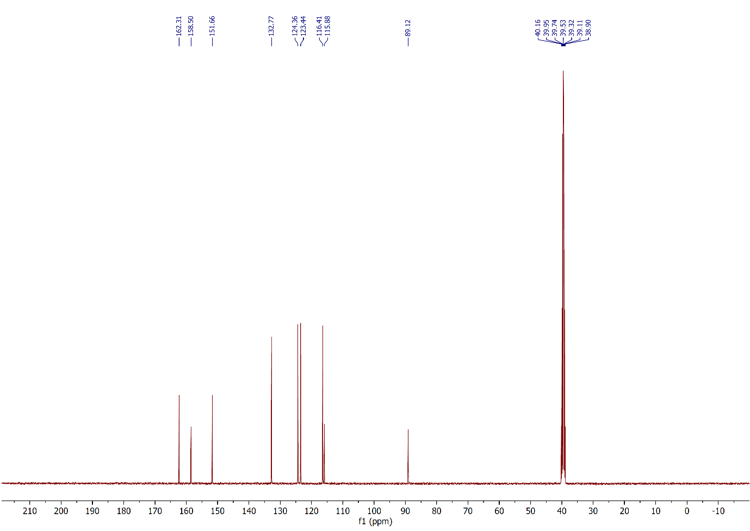
Figure 36: ¹³C NMR spectrum of compound 2r, (CDCl₃, 100 MHz).
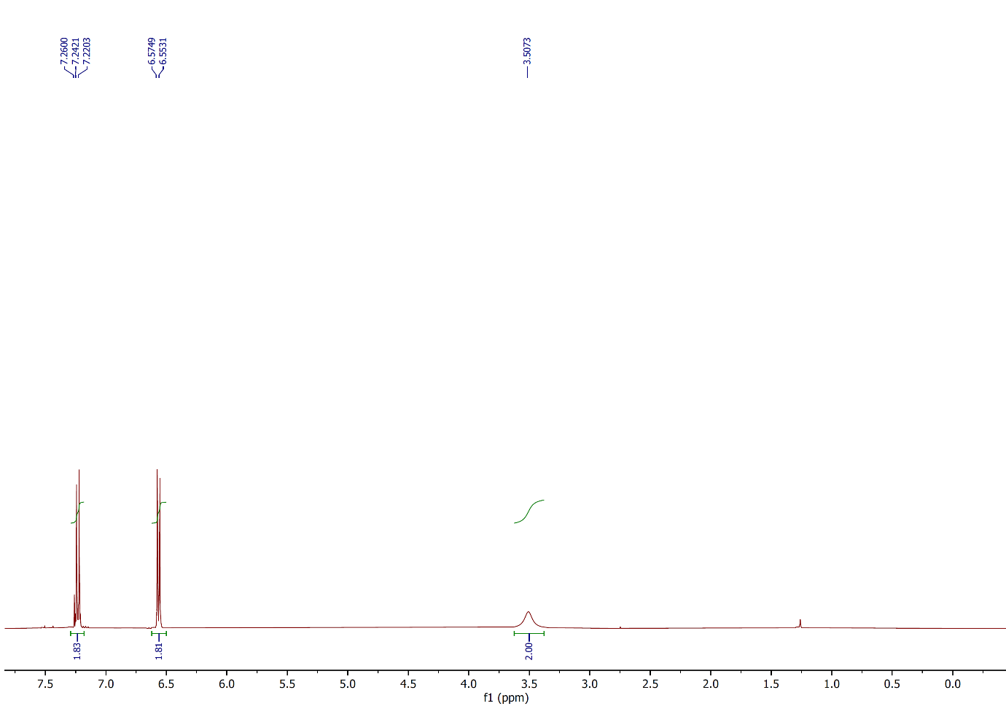
Figure 37: ¹H NMR spectrum of compound 2s, (CDCl₃, 400 MHz).
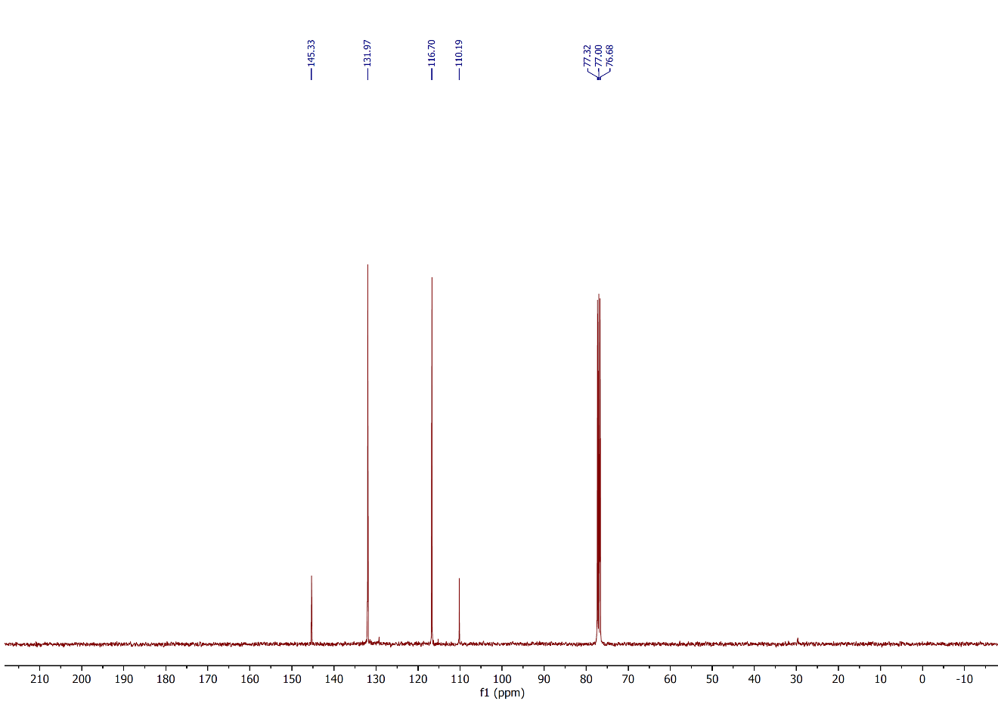
Figure 38: ¹³C NMR spectrum of compound 2s, (CDCl₃, 100 MHz).
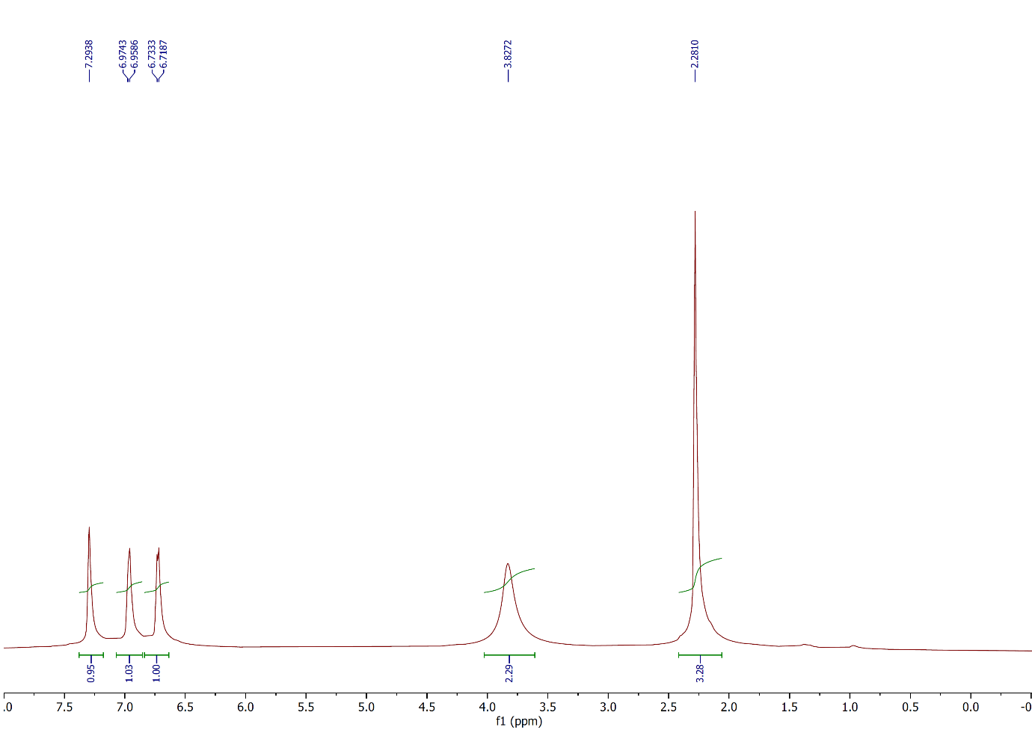Figure 39: ¹H NMR spectrum of compound 2t, (CDCl₃, 500 MHz).
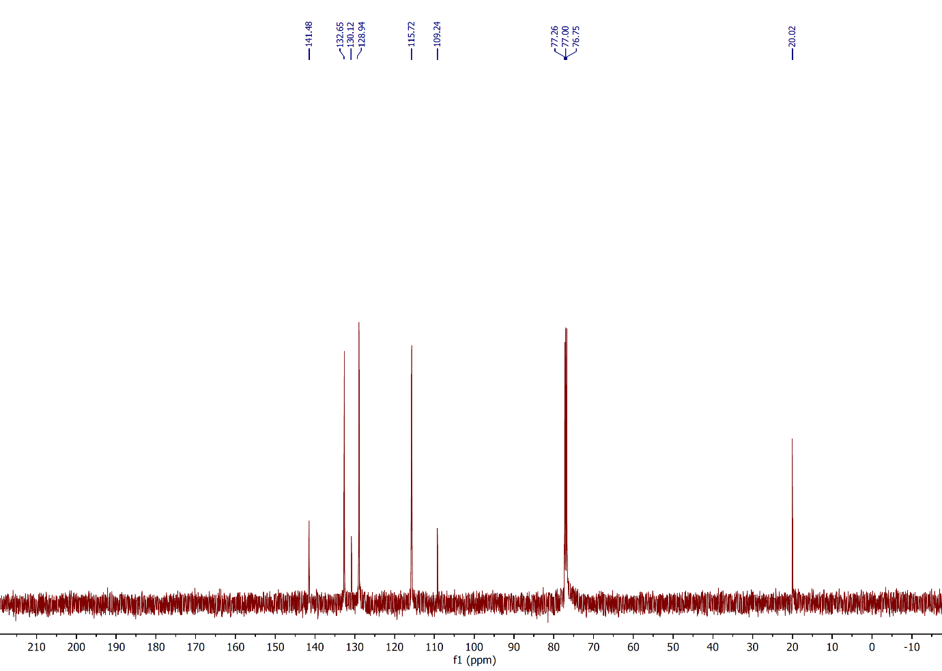
Figure 40: ¹³C NMR spectrum of compound 2t, (CDCl₃, 125 MHz).
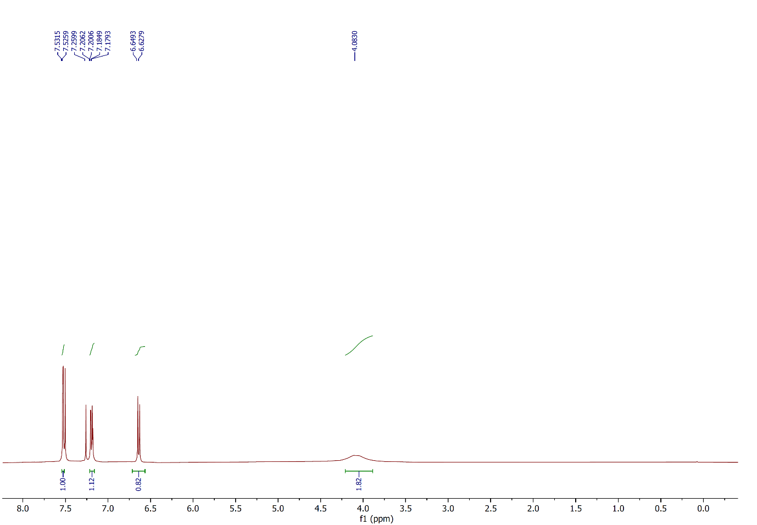
Figure 41: ¹H NMR spectrum of compound 2u, (CDCl₃, 400 MHz).
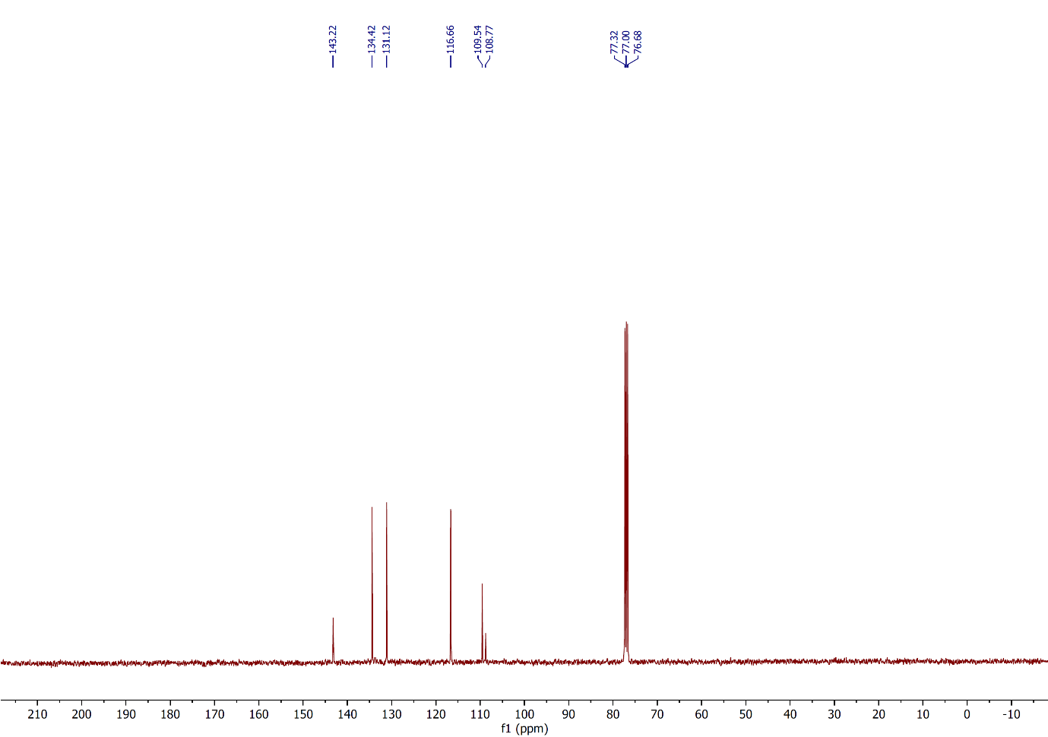
Figure 42: ¹³C NMR spectrum of compound 2u, (CDCl₃, 100 MHz).
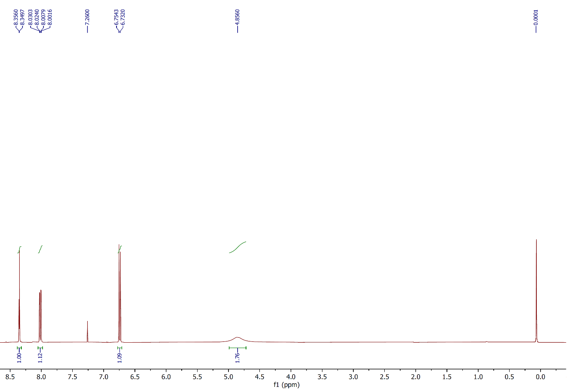
Figure 43: ¹H NMR spectrum of compound 2v, (CDCl₃, 400 MHz).
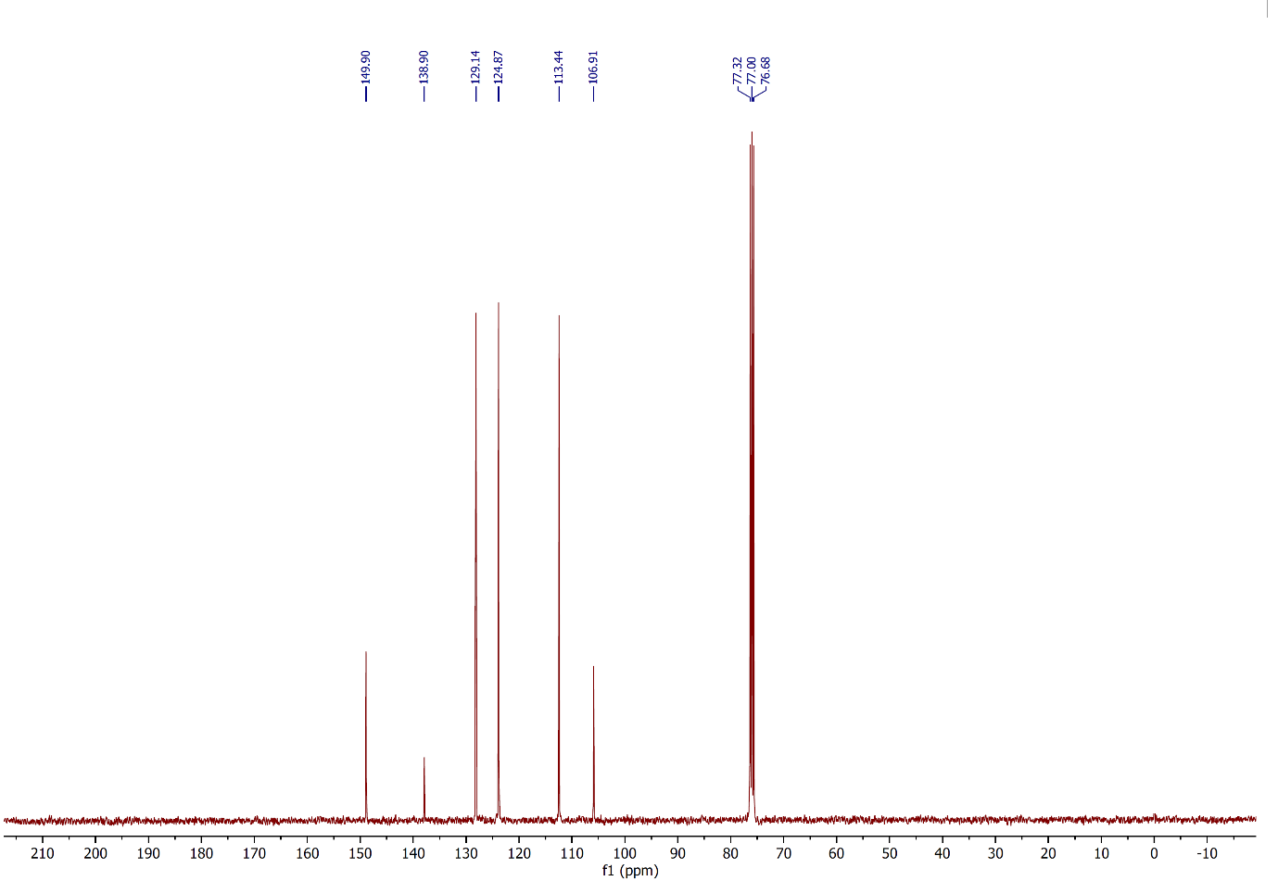
Figure 44: ¹³C NMR spectrum of compound 2v, (CDCl₃, 100 MHz).

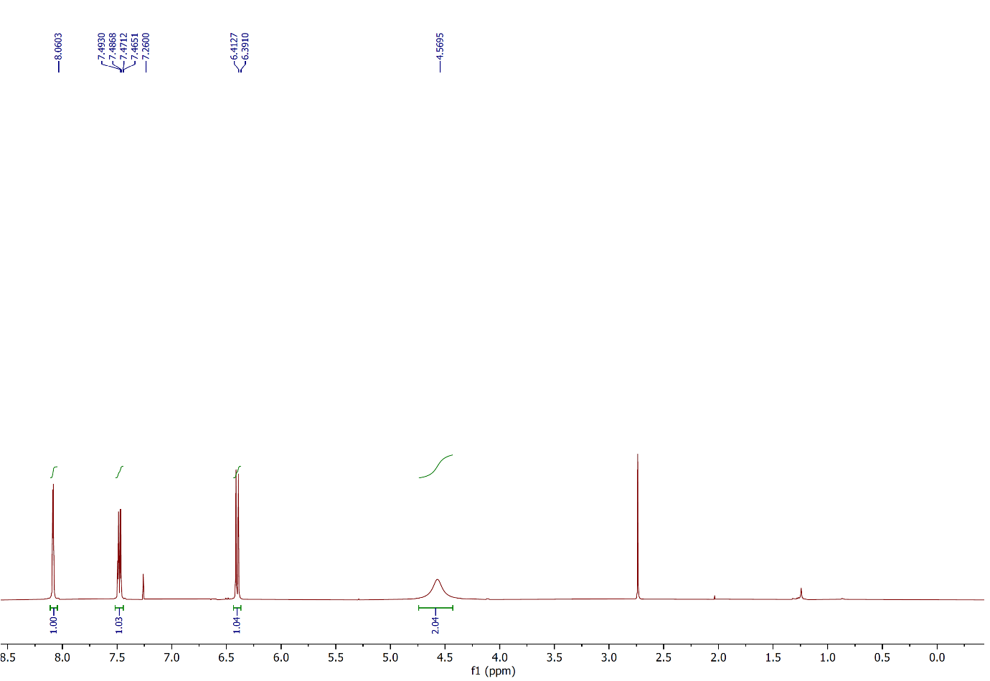
Figure 45: ¹H NMR spectrum of compound 2w, (CDCl₃, 400 MHz).
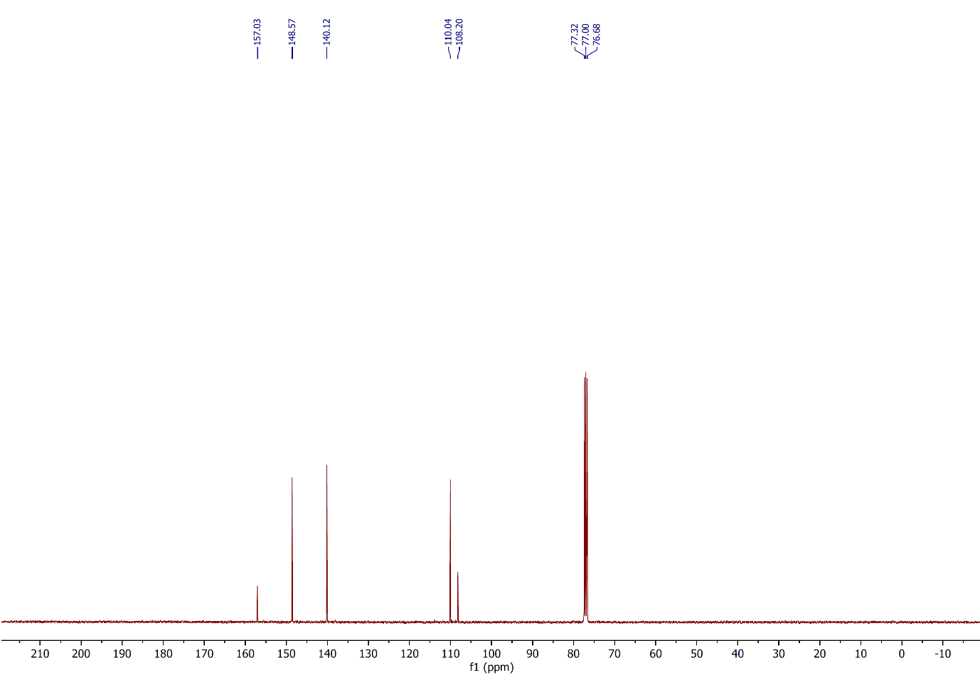
Figure 46: ¹³C NMR spectrum of compound 2w, (CDCl₃, 100 MHz).

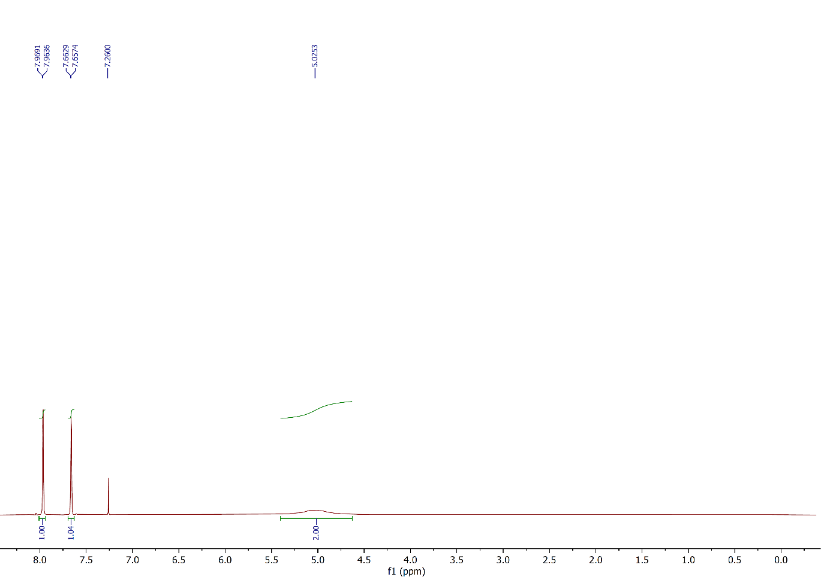
Figure 47: ¹H NMR spectrum of compound 2x, (CDCl₃, 400 MHz).
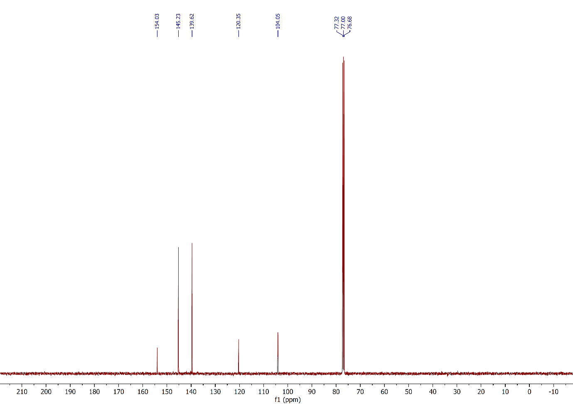
Figure 48: ¹³C NMR spectrum of compound 2x, (CDCl₃, 100 MHz).
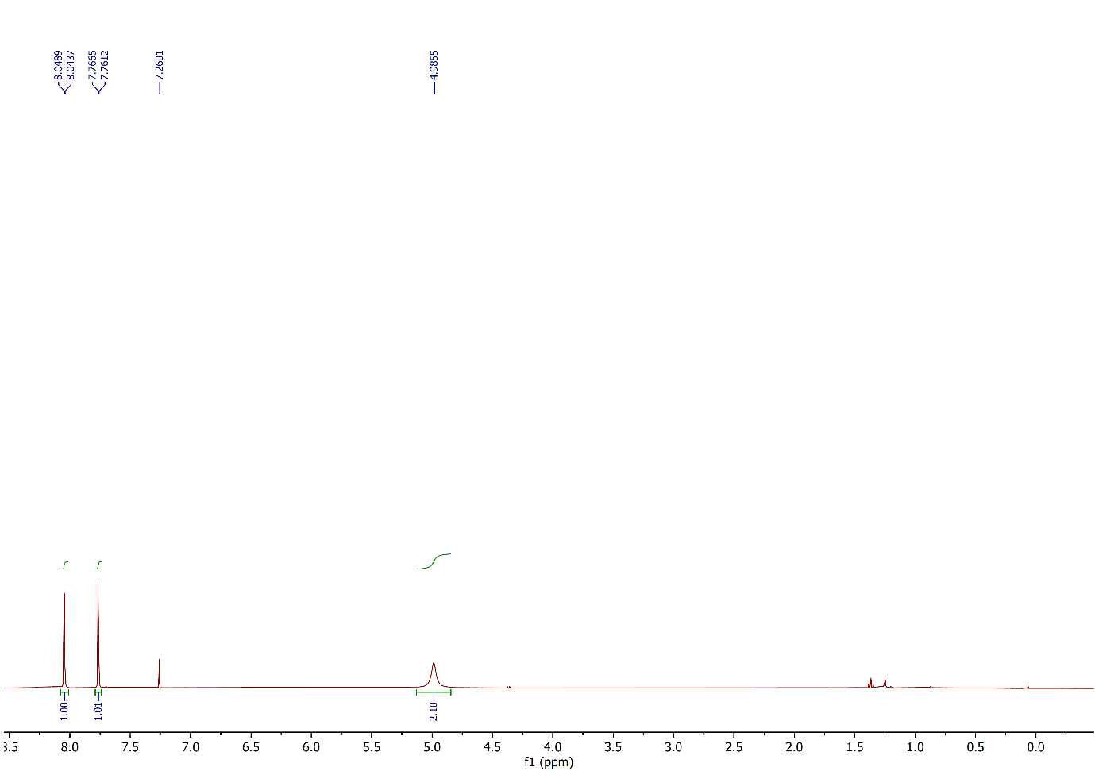
Figure 49: ¹H NMR spectrum of compound 2y, (CDCl₃, 400 MHz).
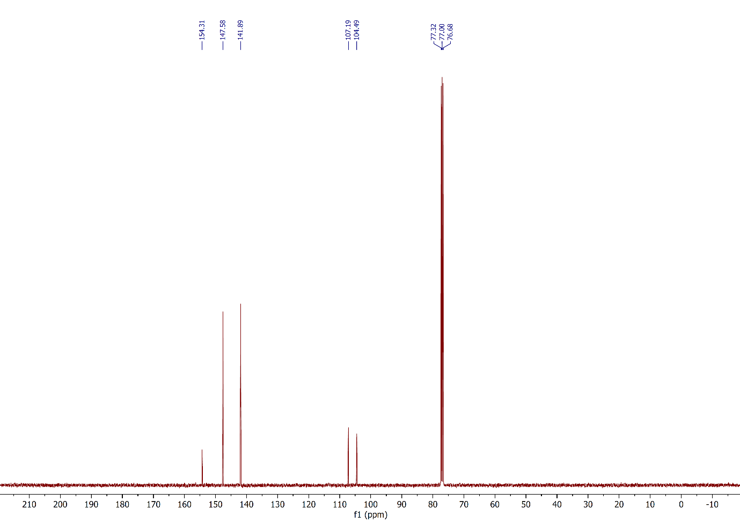
Figure 50: ¹³C NMR spectrum of compound 2y, (CDCl₃, 100 MHz).
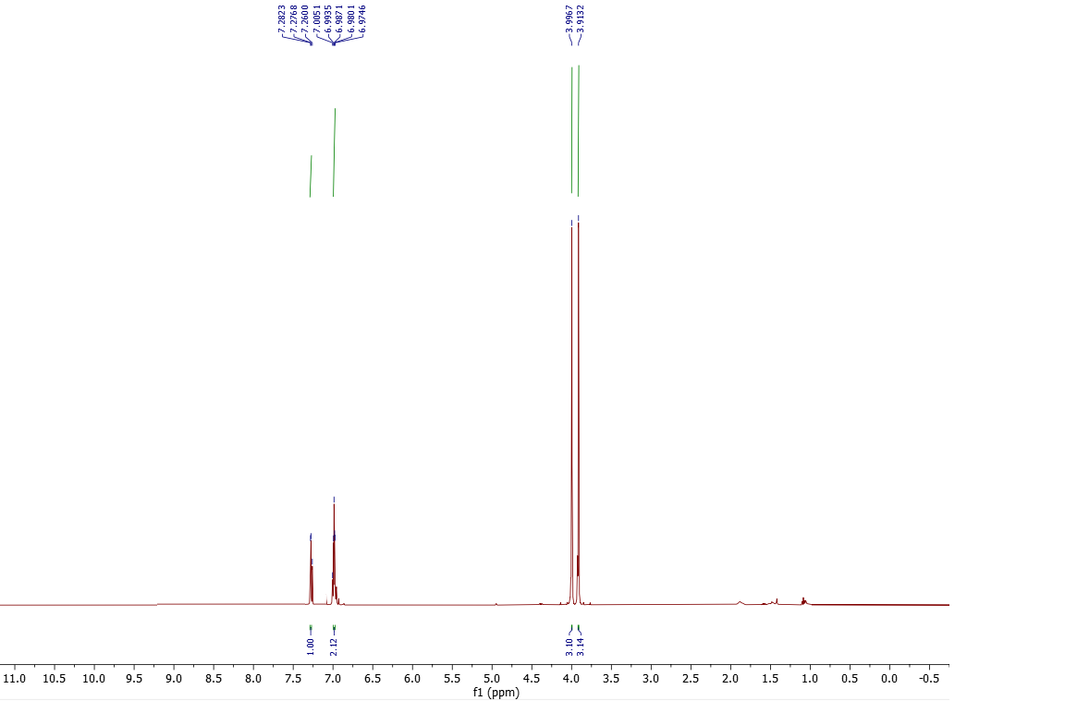
Figure 51: ¹H NMR spectrum of compound 2z, (CDCl₃, 500 MHz).
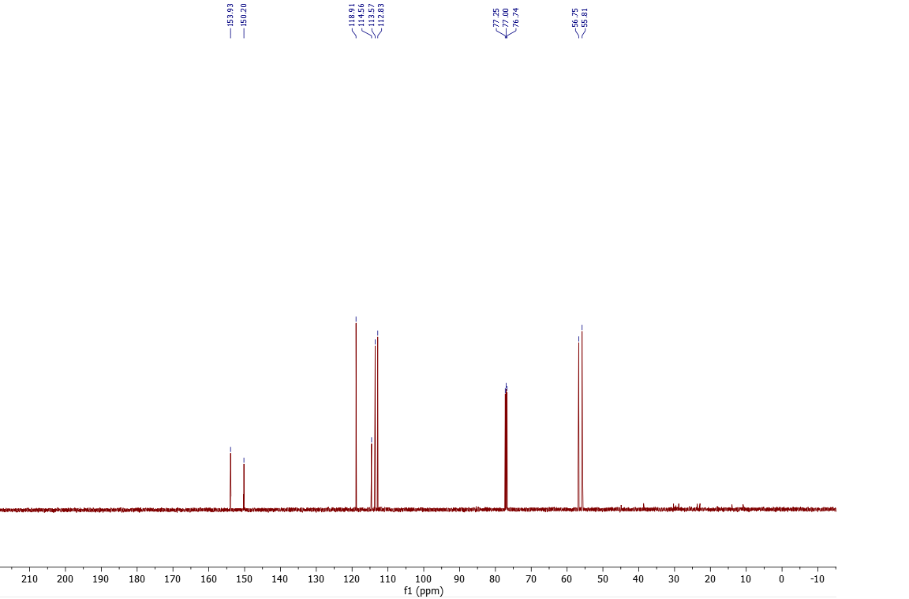
Figure 52: ¹³C NMR spectrum of compound 2z, (CDCl₃, 125 MHz).

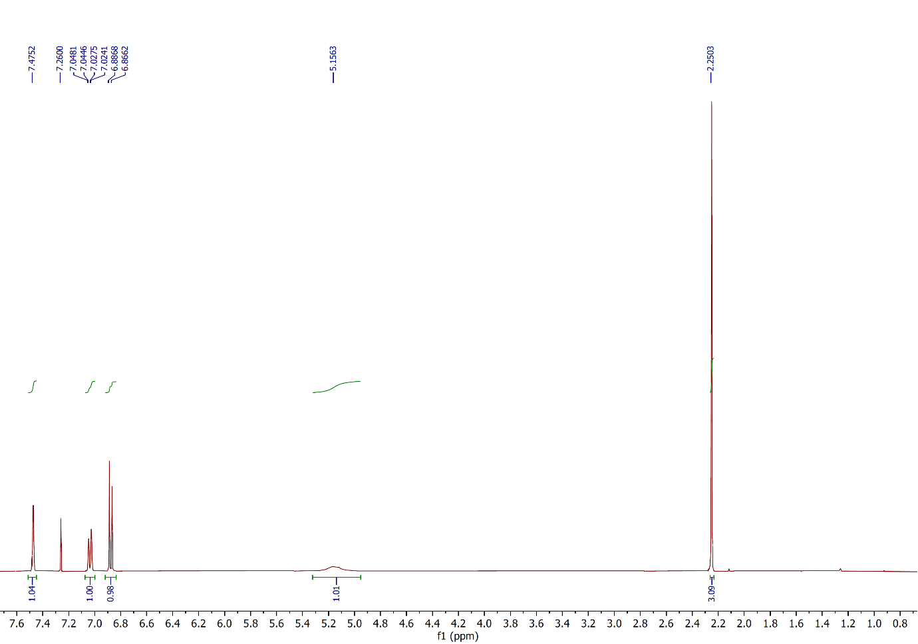
Figure 53: ¹H NMR spectrum of compound 2aa, (CDCl₃, 400 MHz).
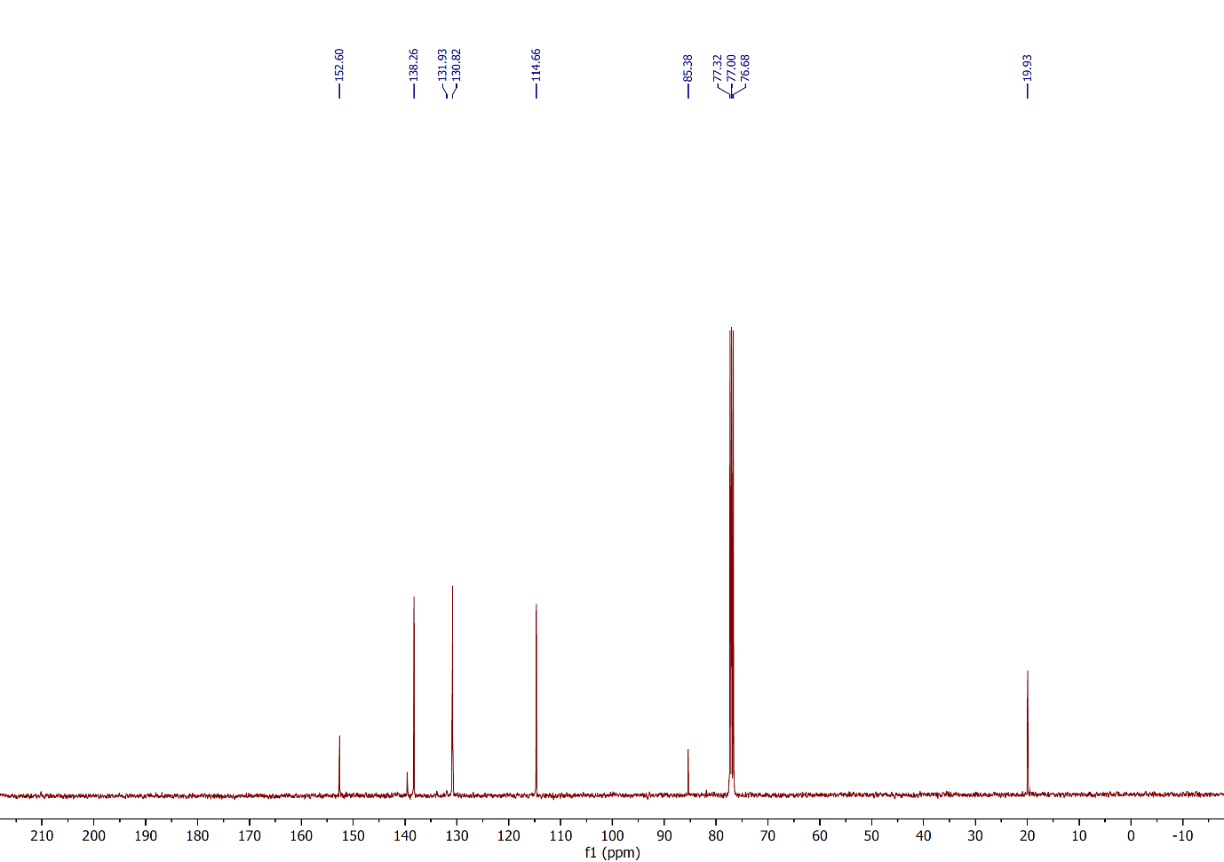
Figure 54: ¹³C NMR spectrum of compound 2aa, (CDCl₃, 100 MHz).
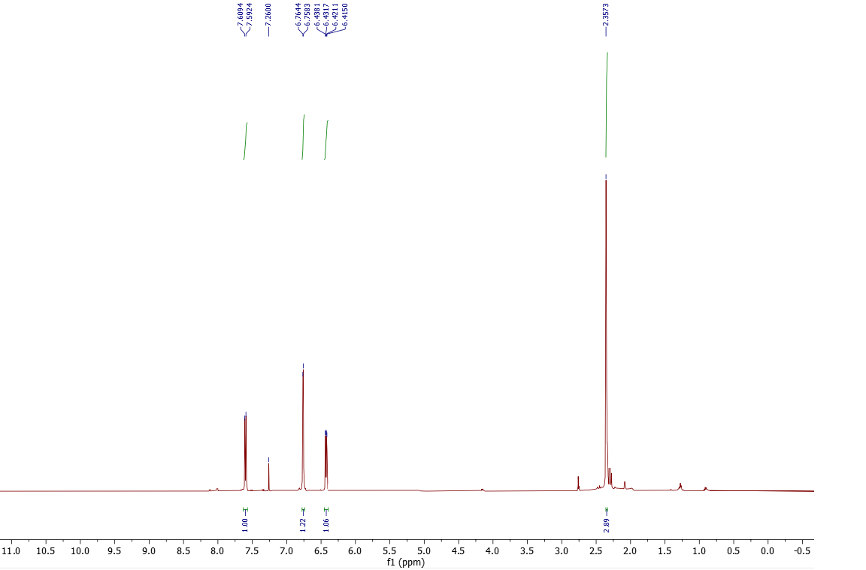
Figure 55: ¹H NMR spectrum of compound 2ab, (CDCl₃, 500 MHz).
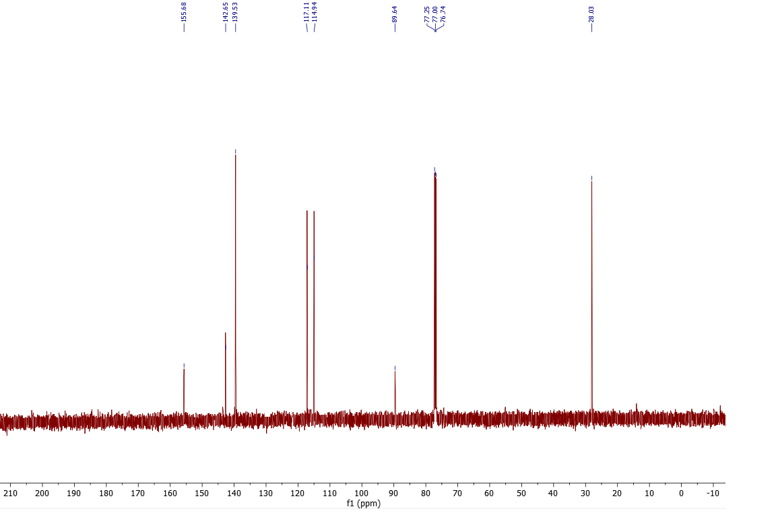
Figure 56: ¹³C NMR spectrum of compound 2ab, (CDCl₃, 125 MHz).

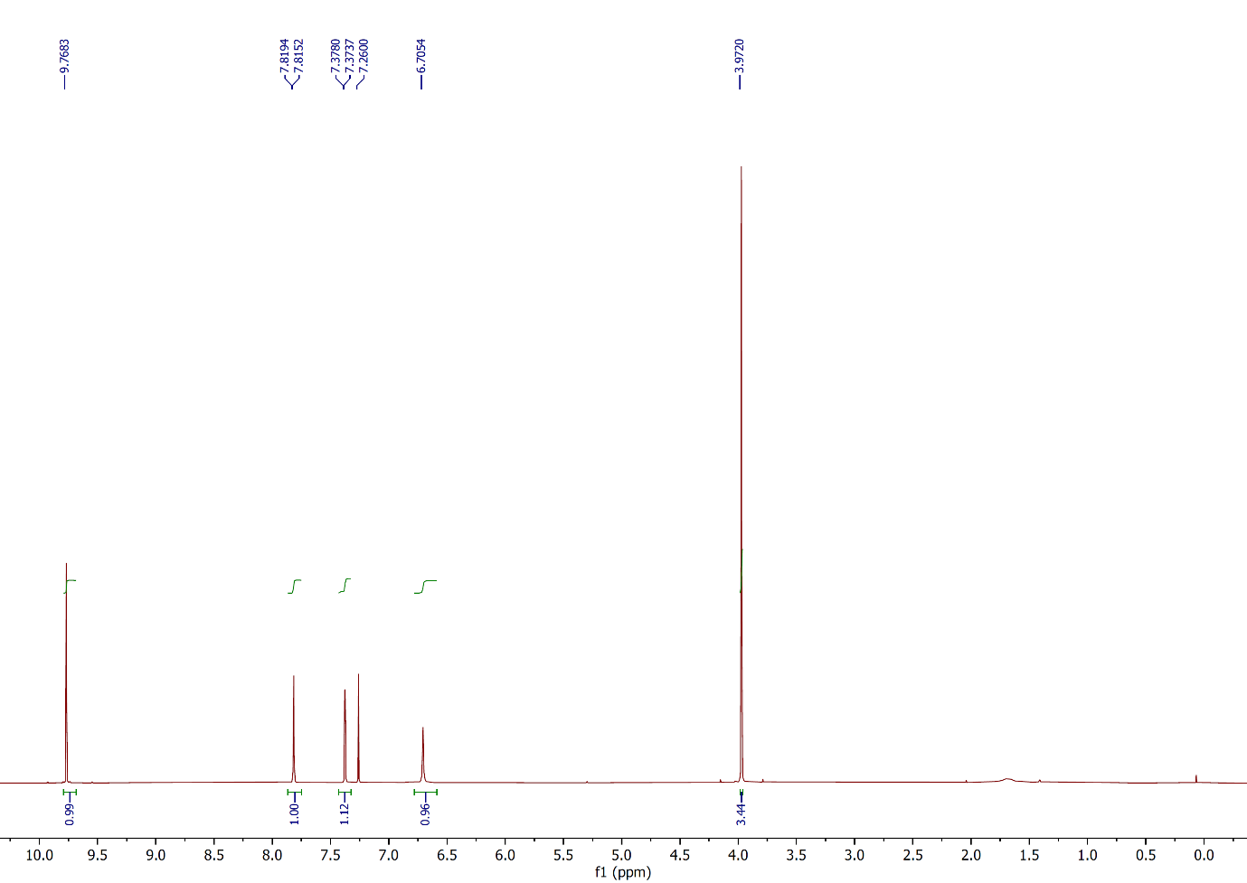
Figure 57: ¹H NMR spectrum of compound 2ac, (CDCl₃, 400 MHz).
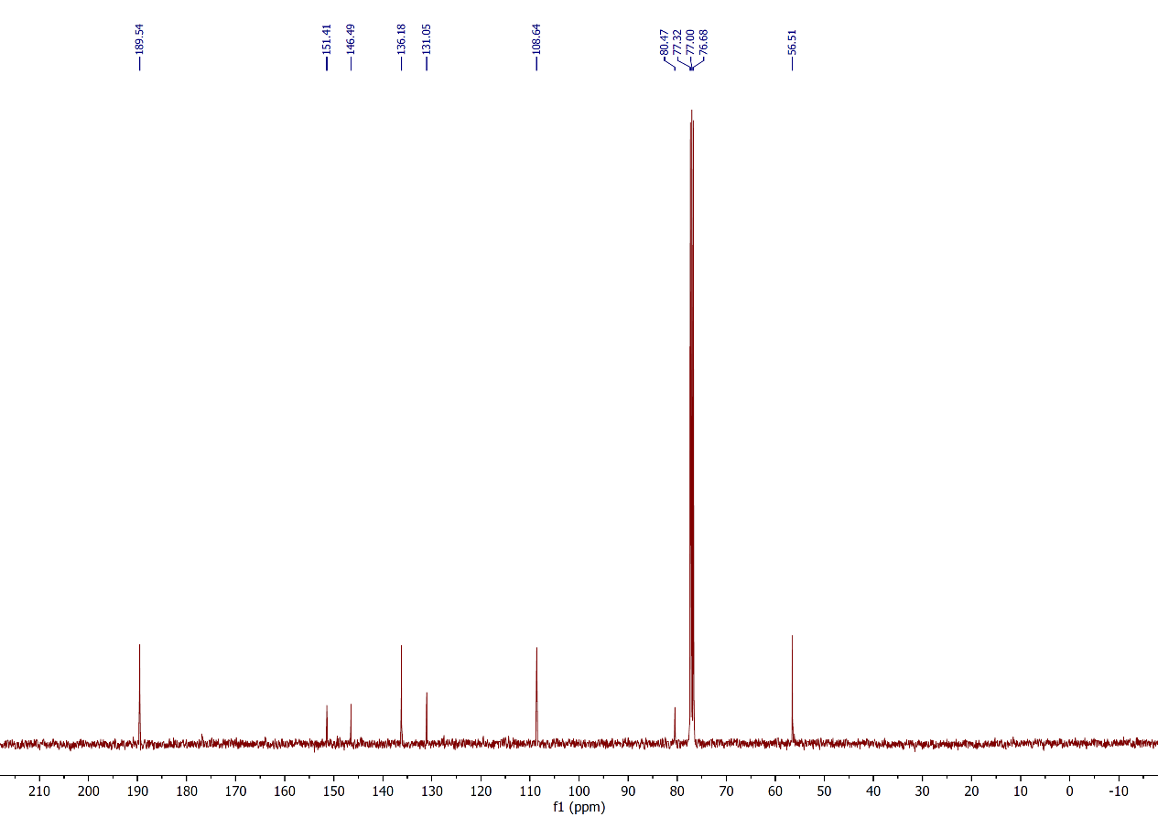
Figure 58: ¹³C NMR spectrum of compound 2ac, (CDCl₃, 100 MHz).
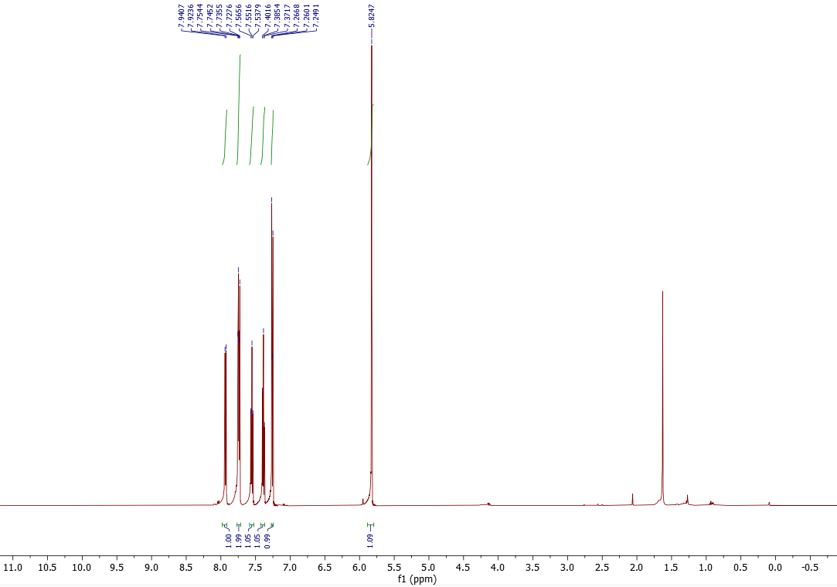
Figure 59: ¹H NMR spectrum of compound 2ad, (CDCl₃, 500 MHz).
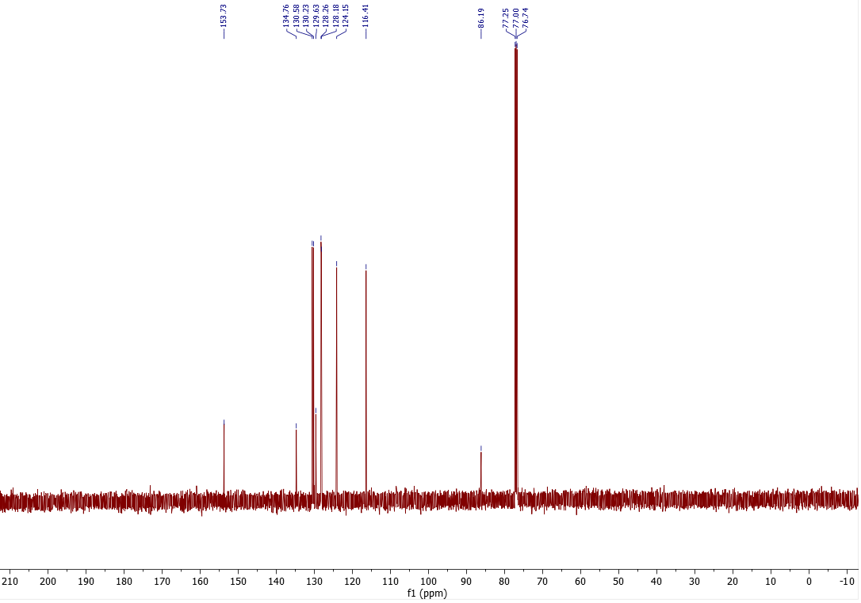
Figure 60: ¹³C NMR spectrum of compound 2ad, (CDCl₃, 125 MHz).
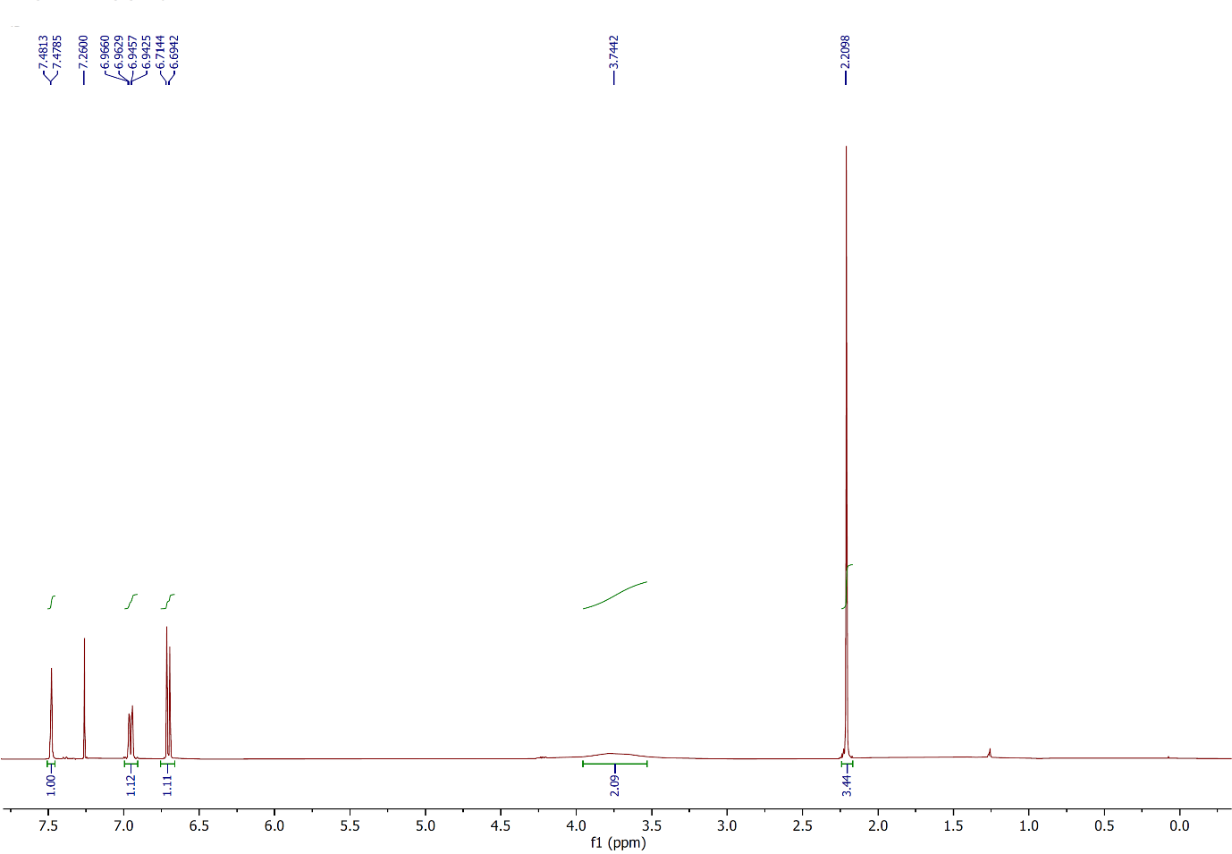
Figure 61: ¹H NMR spectrum of compound 2ae, (CDCl₃, 400 MHz).
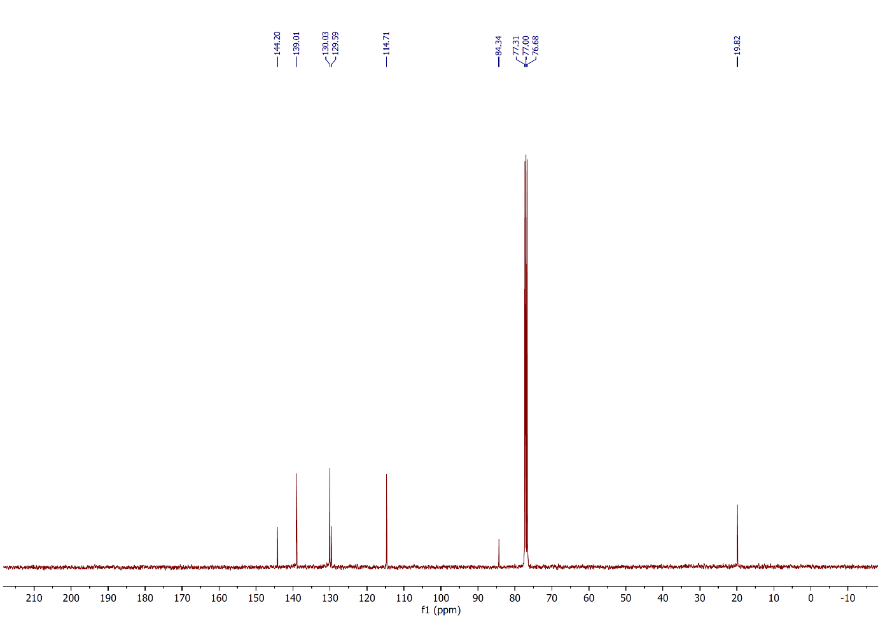
Figure 62: ¹³C NMR spectrum of compound 2ae, (CDCl₃, 100 MHz).
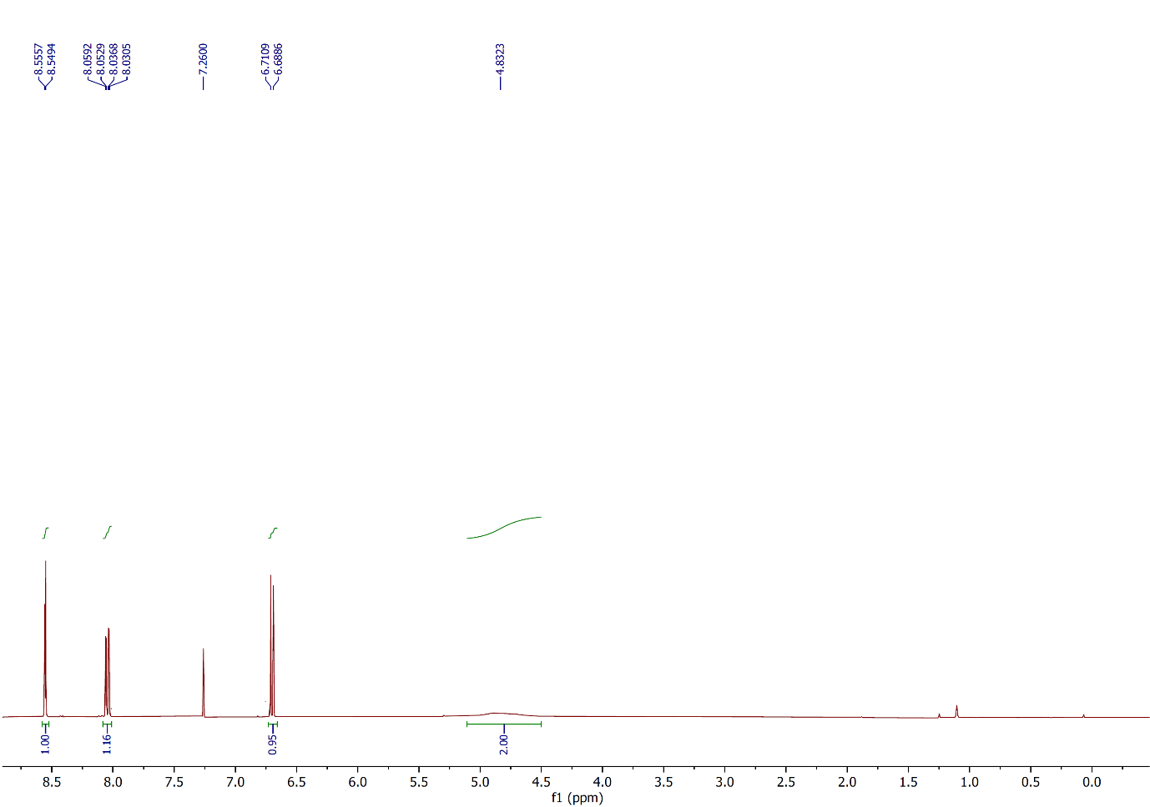
Figure 63: ¹H NMR spectrum of compound 2af, (CDCl₃, 400 MHz).
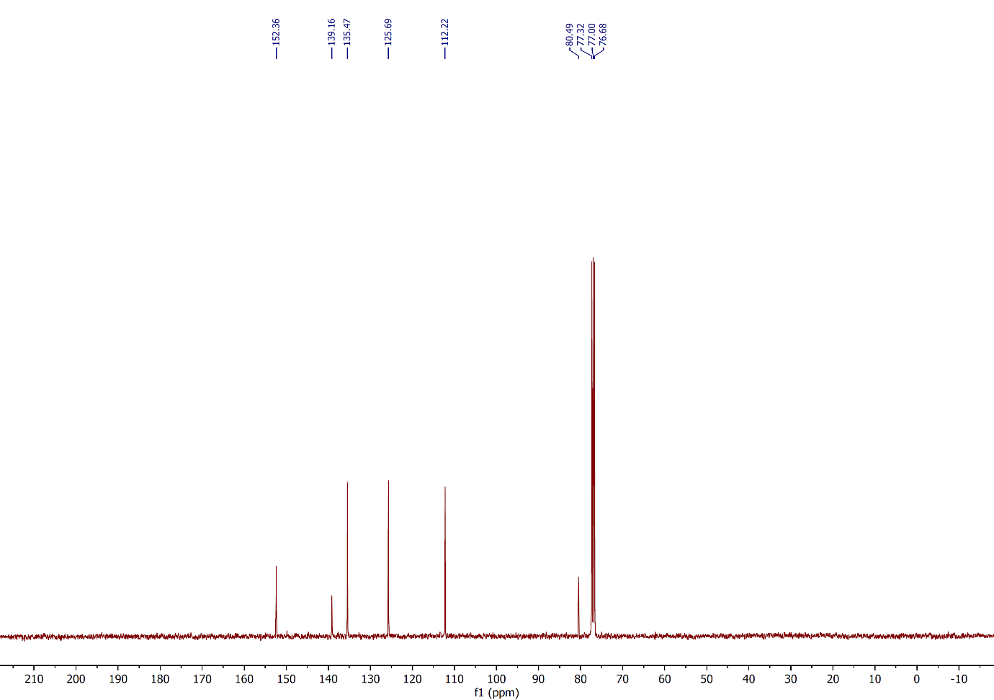
Figure 64: ¹³C NMR spectrum of compound 2af, (CDCl₃, 100 MHz).
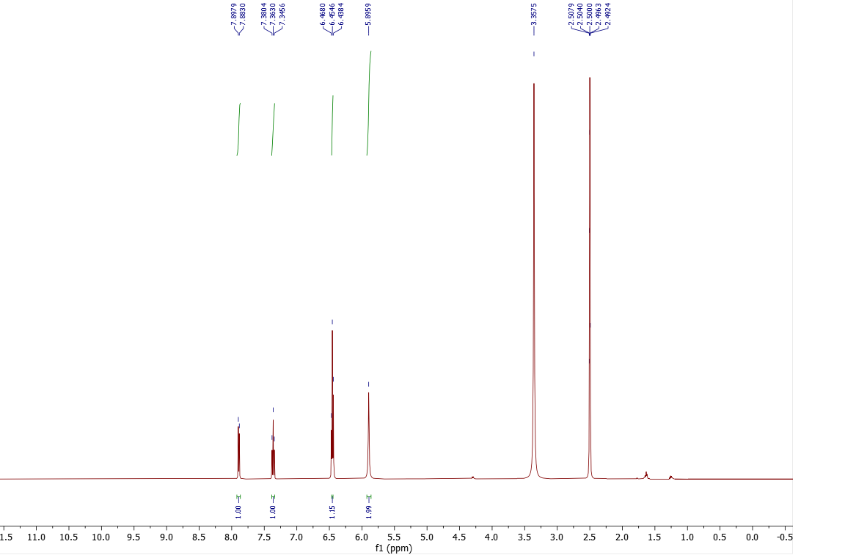
Figure 65: ¹H NMR spectrum of compound 2ag, (DMSO-d₆, 500 MHz).
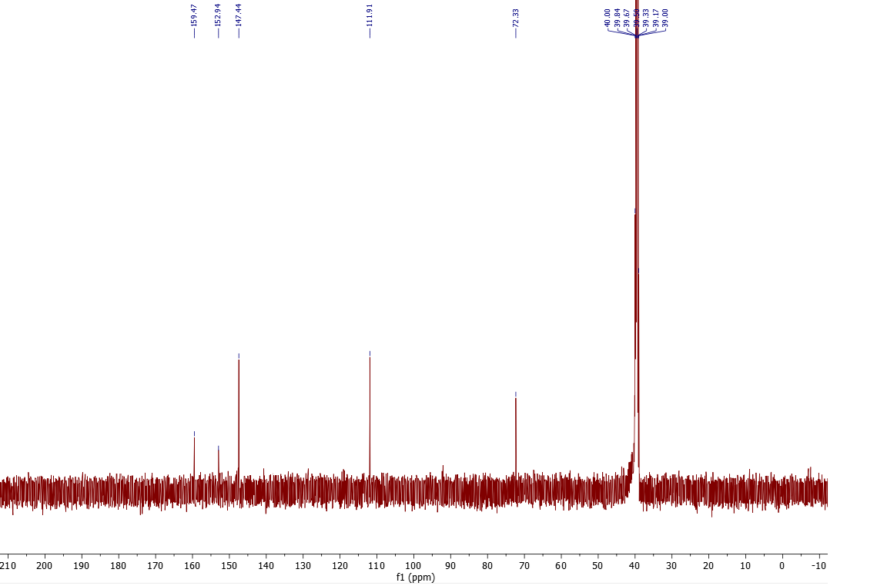
Figure 66: ¹³C NMR spectrum of compound 2ag, (DMSO-d₆, 125 MHz).

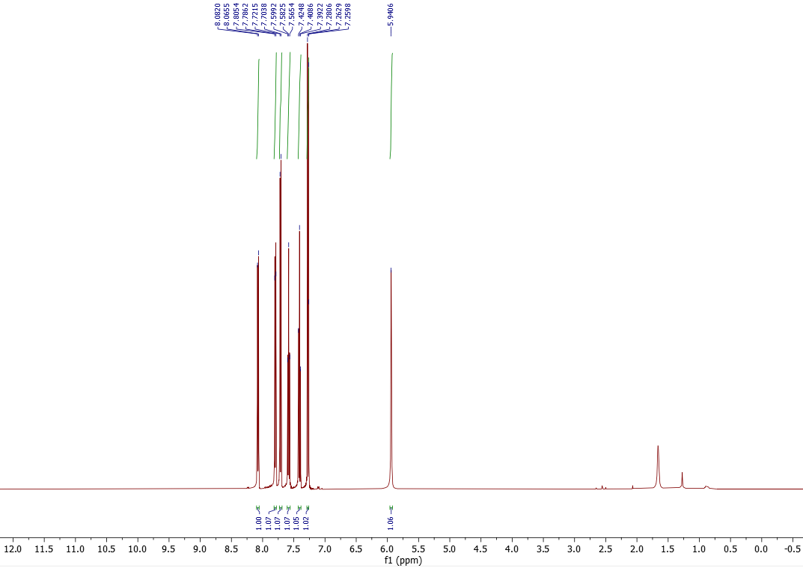
Figure 67: ¹H NMR spectrum of compound 2ah, (CDCl₃, 500 MHz).
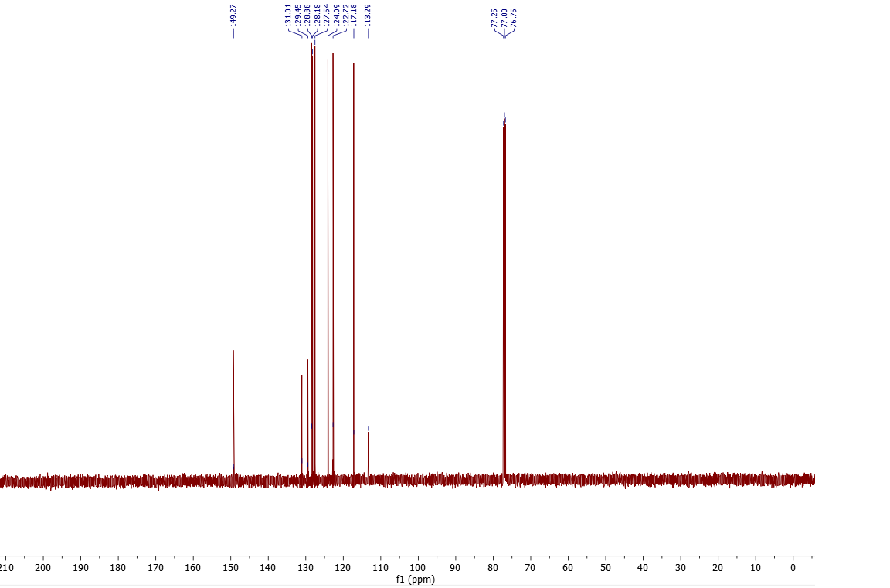
Figure 68: ¹³C NMR spectrum of compound 2ah, (CDCl₃, 125 MHz).
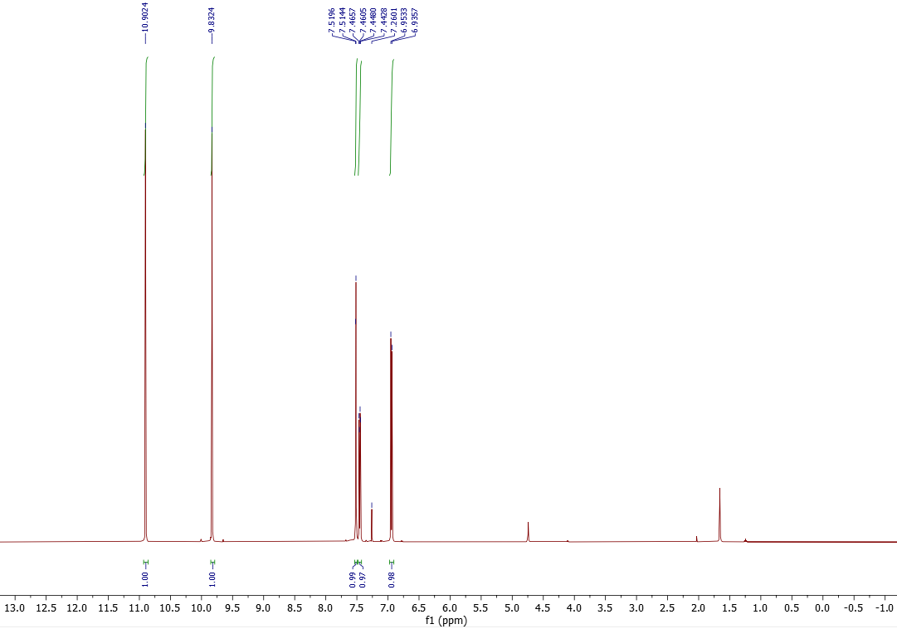
Figure 69: ¹H NMR spectrum of compound 2ai, (CDCl₃, 500 MHz).
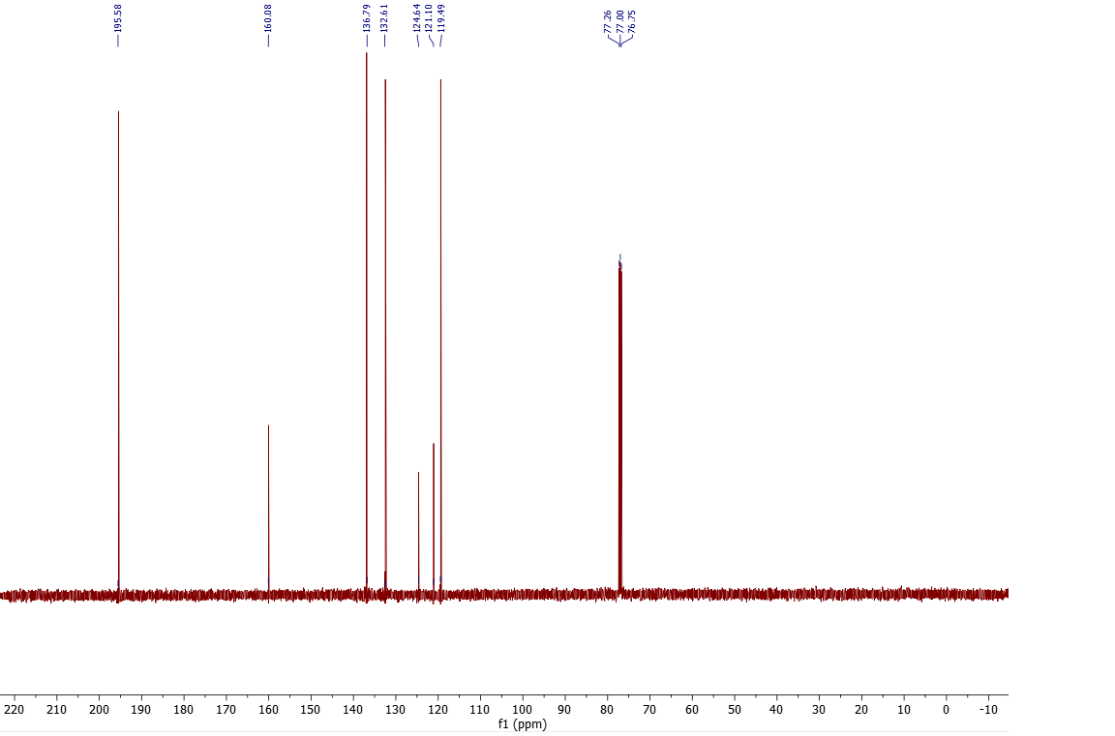
Figure 70: ¹³C NMR spectrum of compound 2ai, (CDCl₃, 125 MHz).
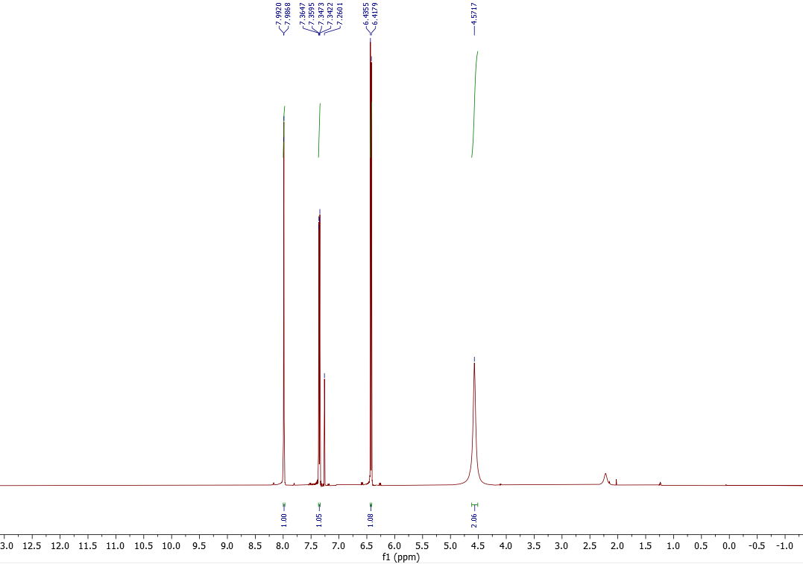
Figure 71: ¹H NMR spectrum of compound 2aj, (CDCl₃, 500 MHz).
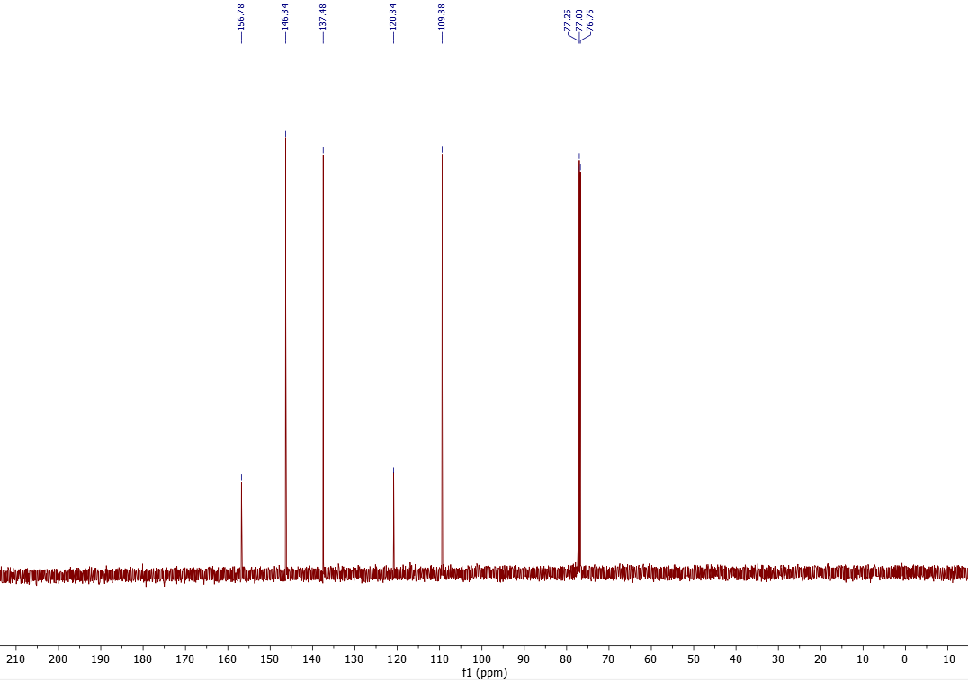
Figure 72: ¹³C NMR spectrum of compound 2aj, (CDCl₃, 125 MHz).
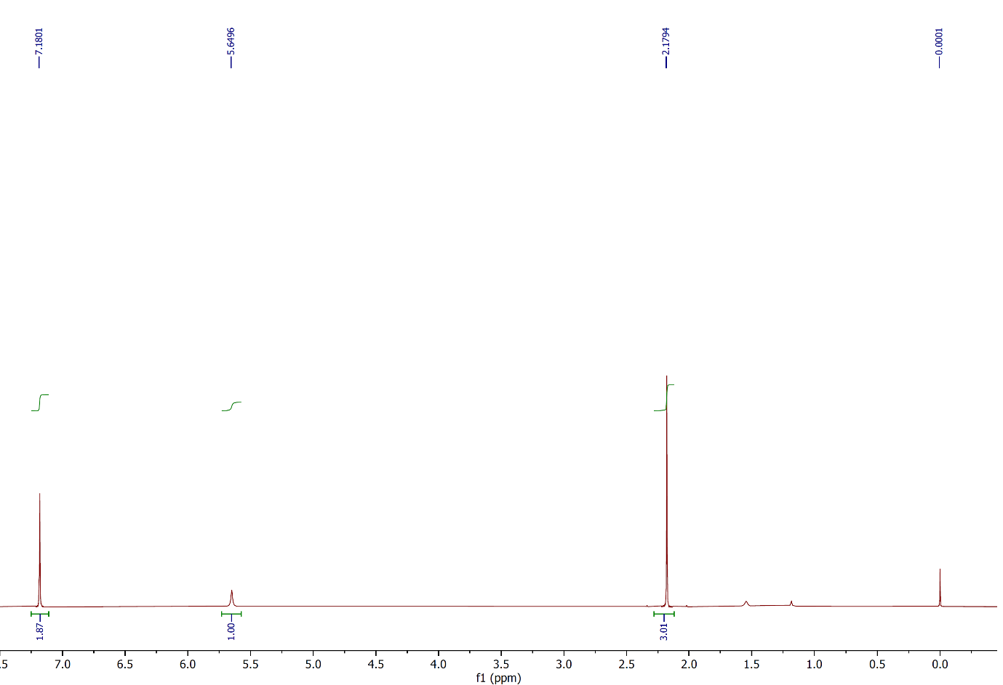
Figure 73: ¹H NMR spectrum of compound 3a, (CDCl₃, 400 MHz).
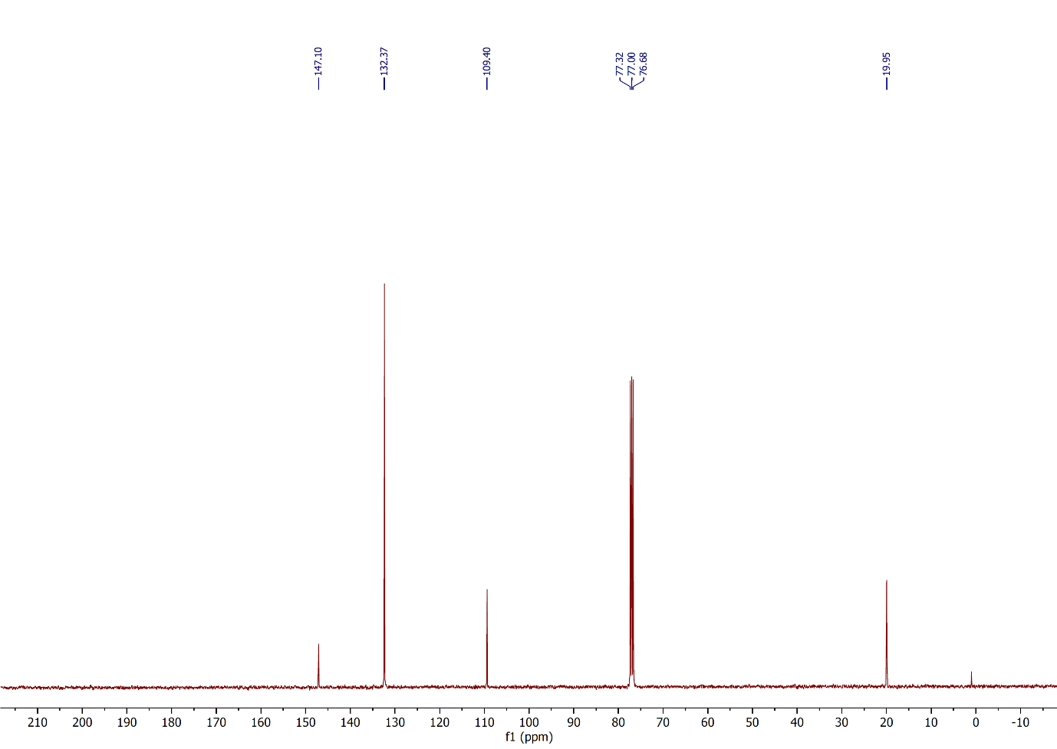
Figure 74: ¹³C NMR spectrum of compound 3a, (CDCl₃, 100 MHz).
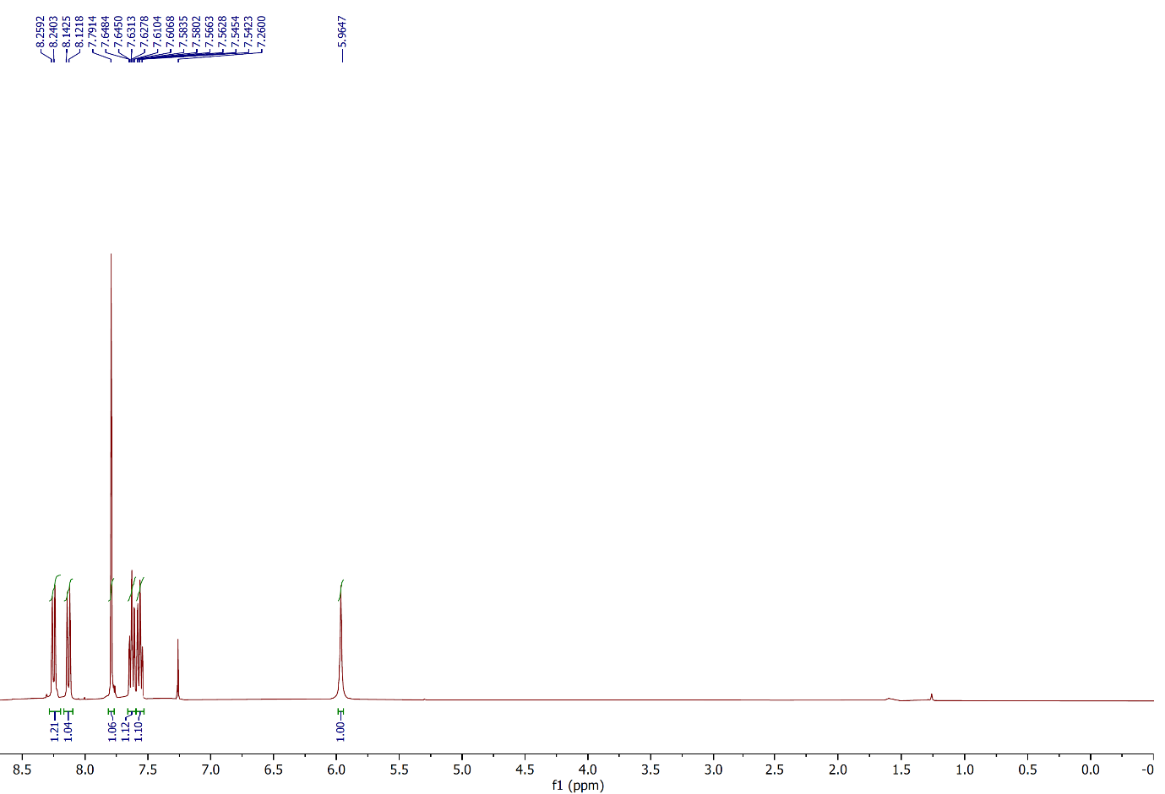
Figure 75: ¹H NMR spectrum of compound 3b, (CDCl₃, 400 MHz).
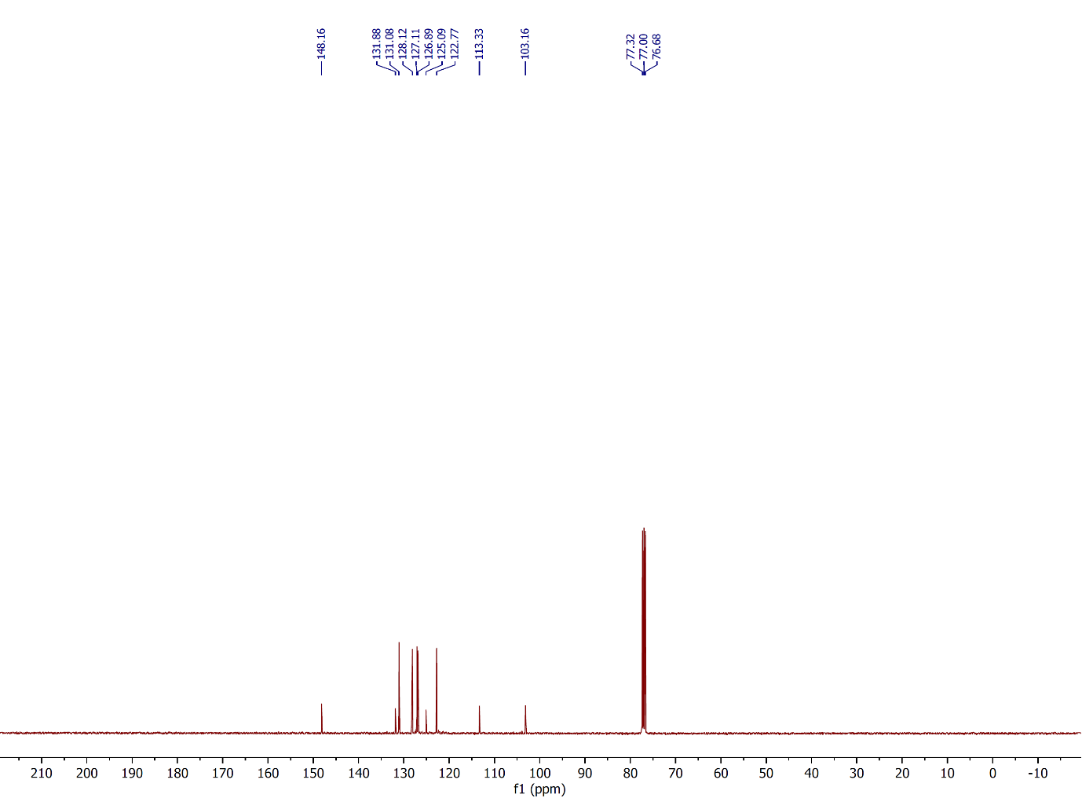
Figure 76: ¹³C NMR spectrum of compound 3b, (CDCl₃, 100 MHz).
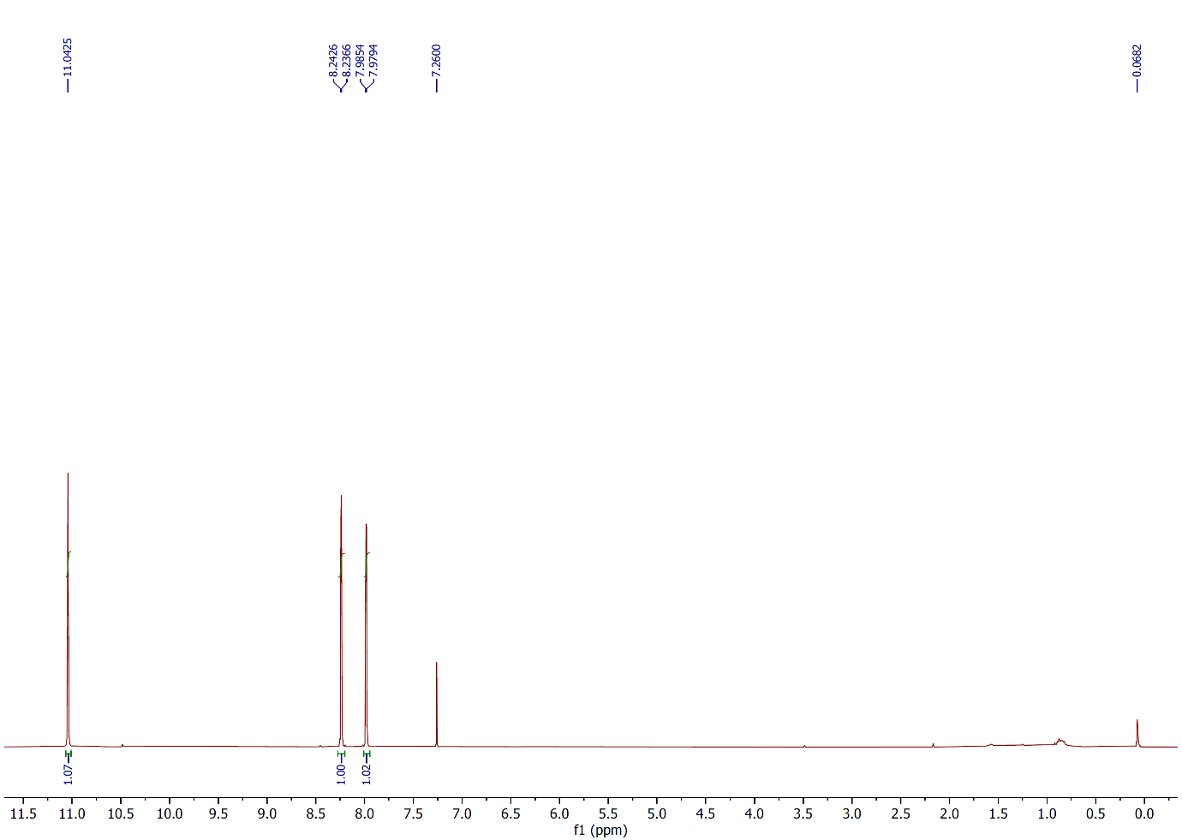
Figure 77: ¹H NMR spectrum of compound 3c, (CDCl₃, 400 MHz).
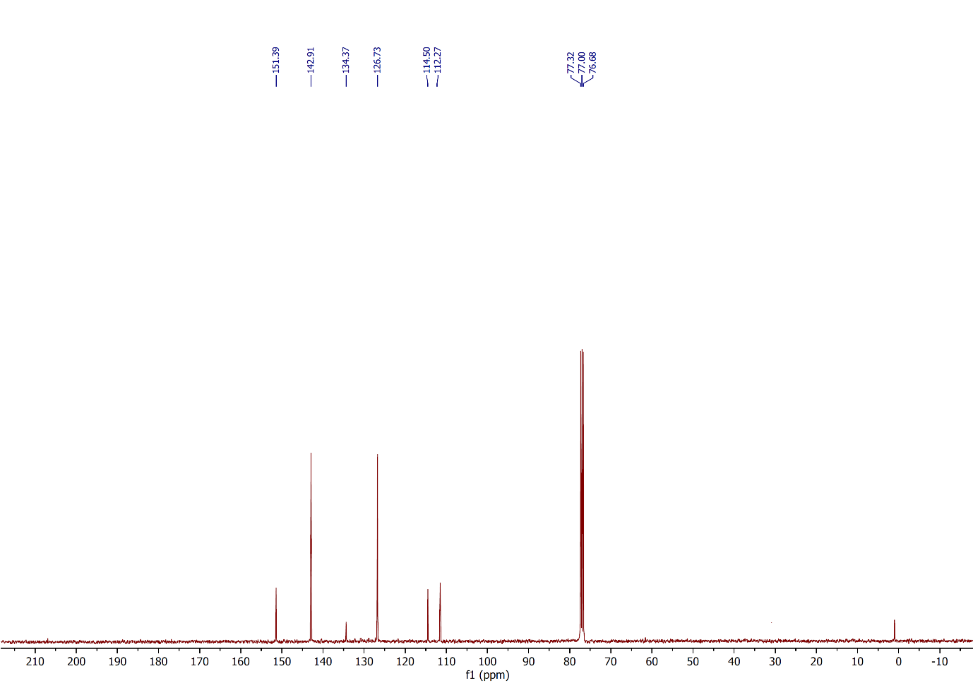
Figure 78: ¹³C NMR spectrum of compound 3c, (CDCl₃, 100 MHz).
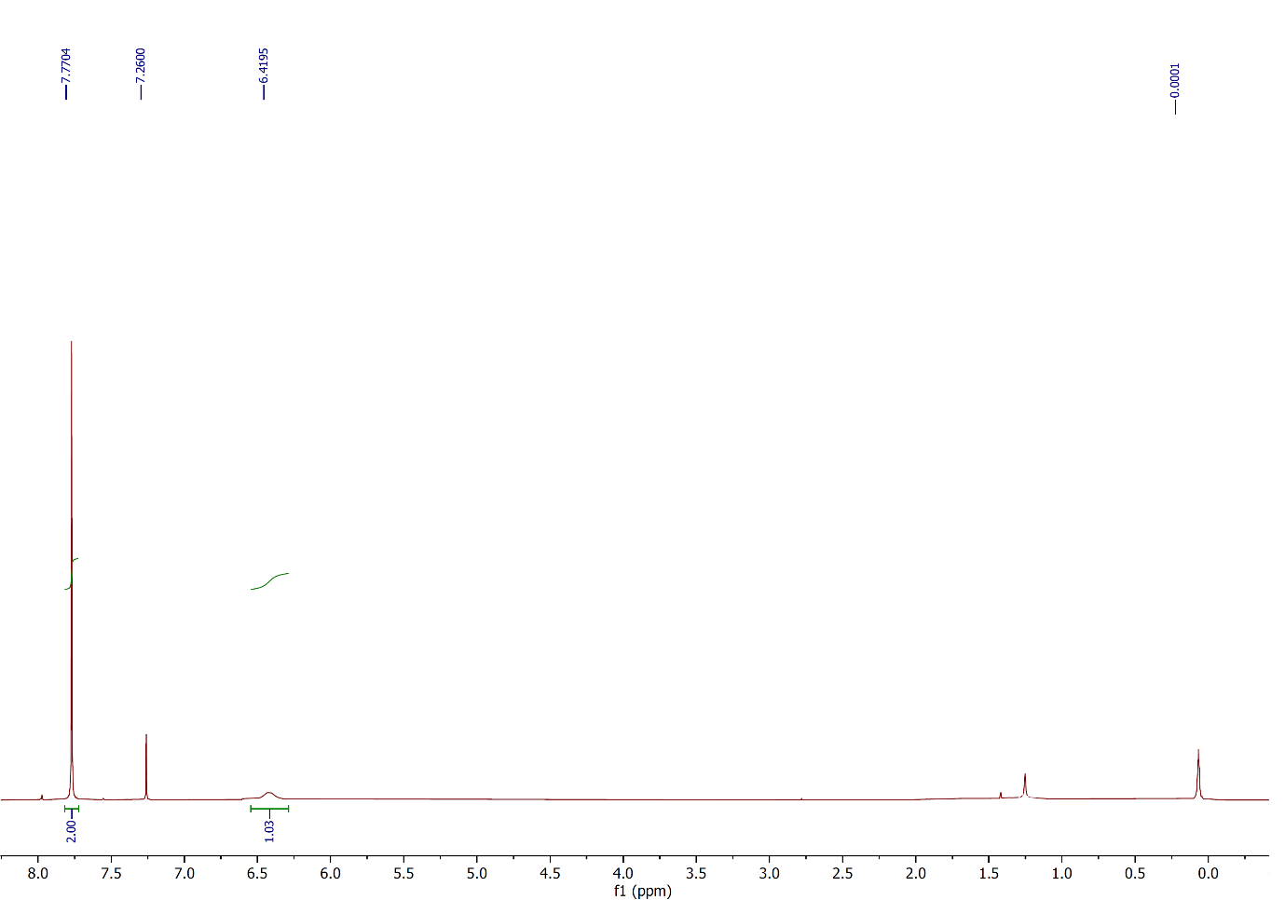
Figure 79: ¹H NMR spectrum of compound 3d, (CDCl₃, 400 MHz).
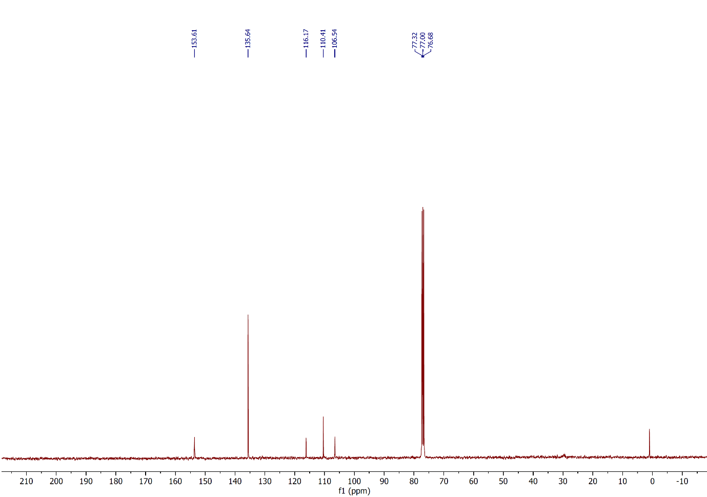
Figure 80: ¹³C NMR spectrum of compound 3d, (CDCl₃, 100 MHz).
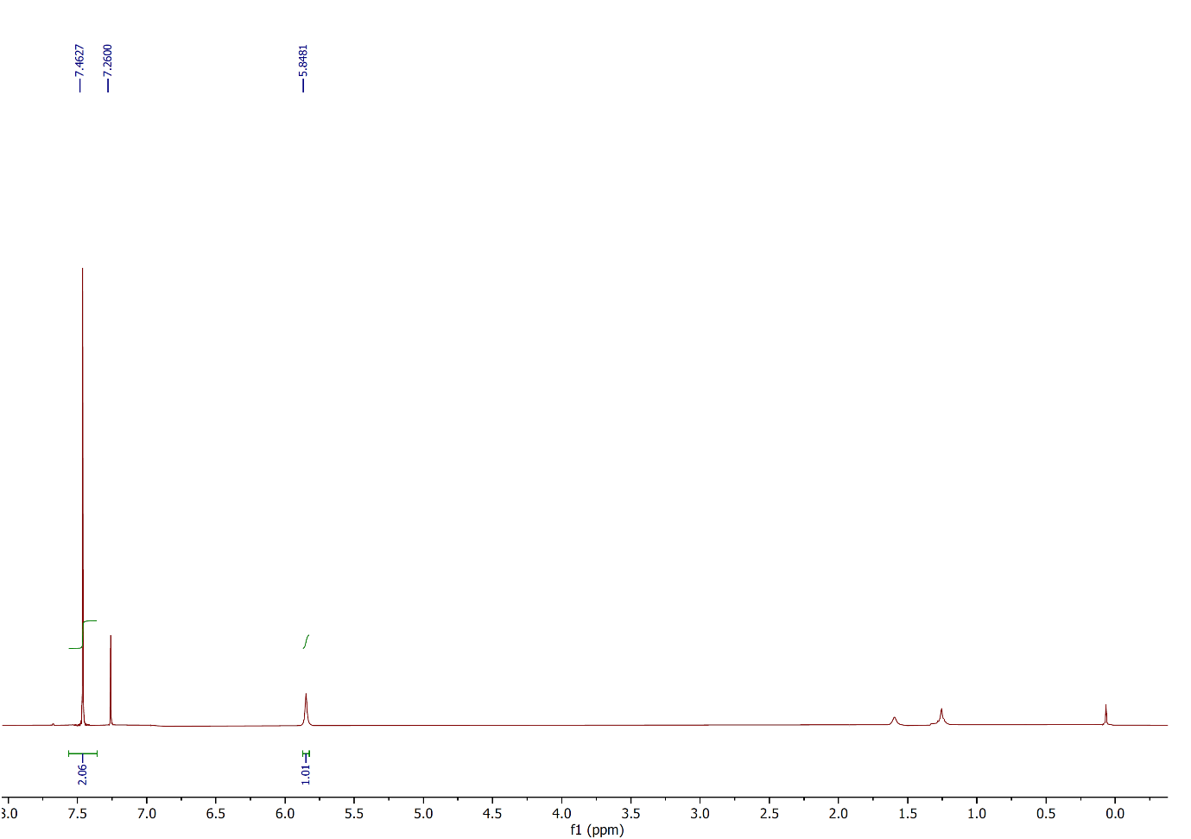
Figure 81: ¹H NMR spectrum of compound 3e, (CDCl₃, 400 MHz).
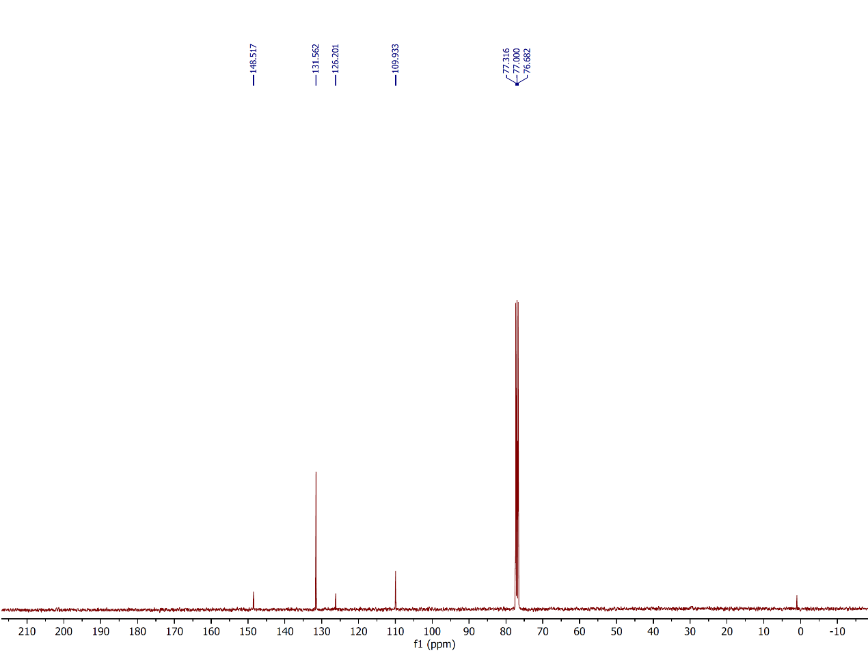
Figure 82: ¹³C NMR spectrum of compound 3e, (CDCl₃, 100 MHz).
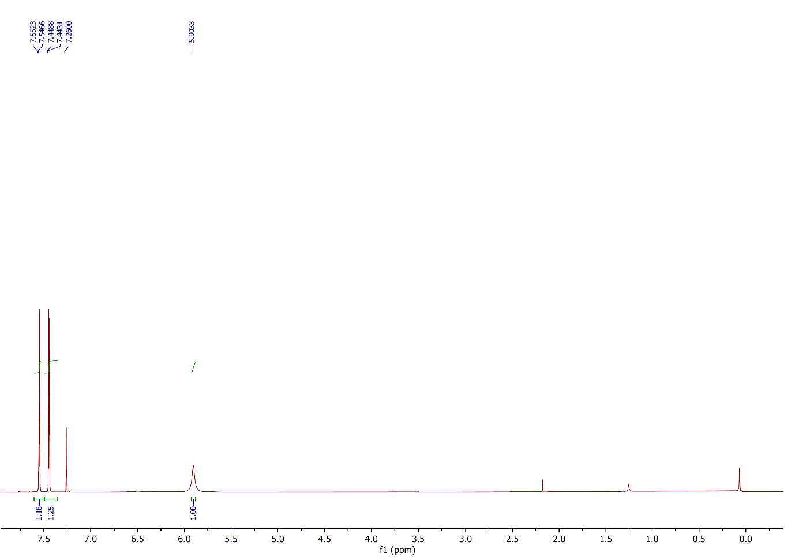
Figure 83: ¹H NMR spectrum of compound 3f, (CDCl₃, 400 MHz).
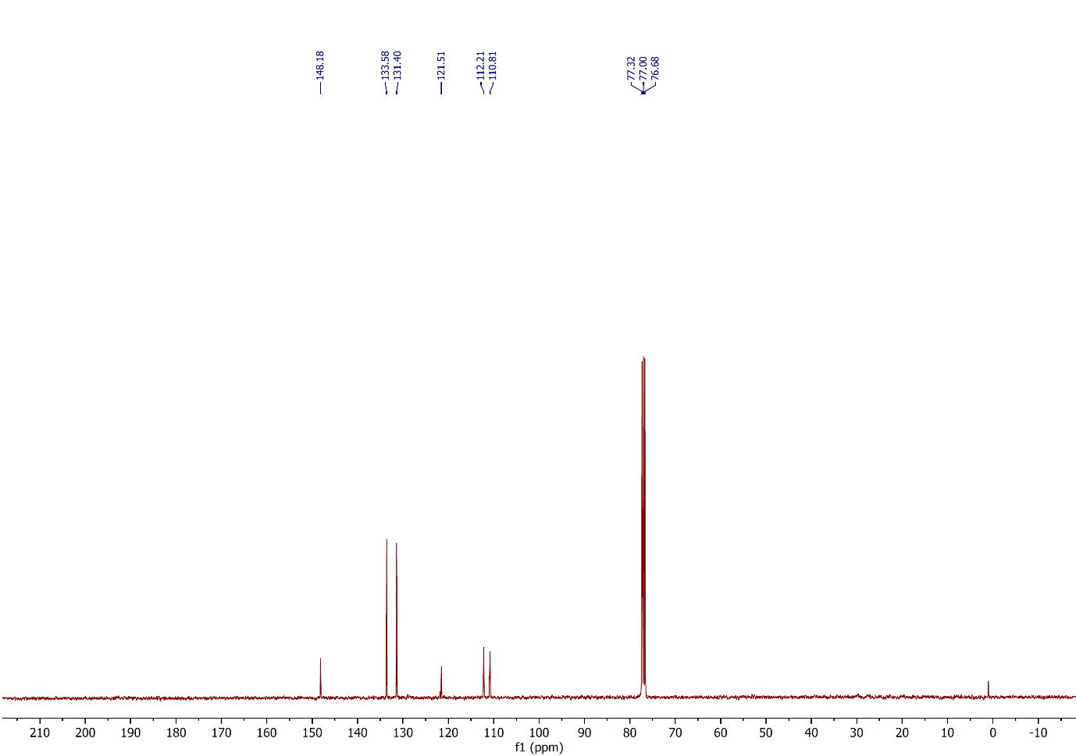
Figure 84: ¹³C NMR spectrum of compound 3f, (CDCl₃, 100 MHz).
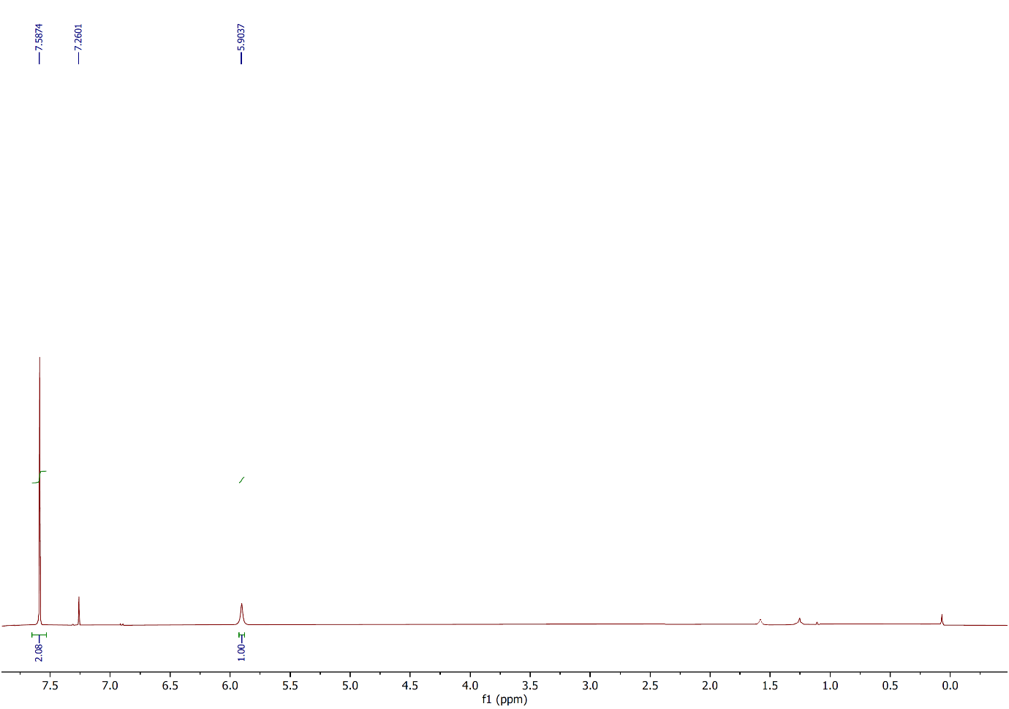
Figure 85: ¹H NMR spectrum of compound 3g, (CDCl₃, 400 MHz).
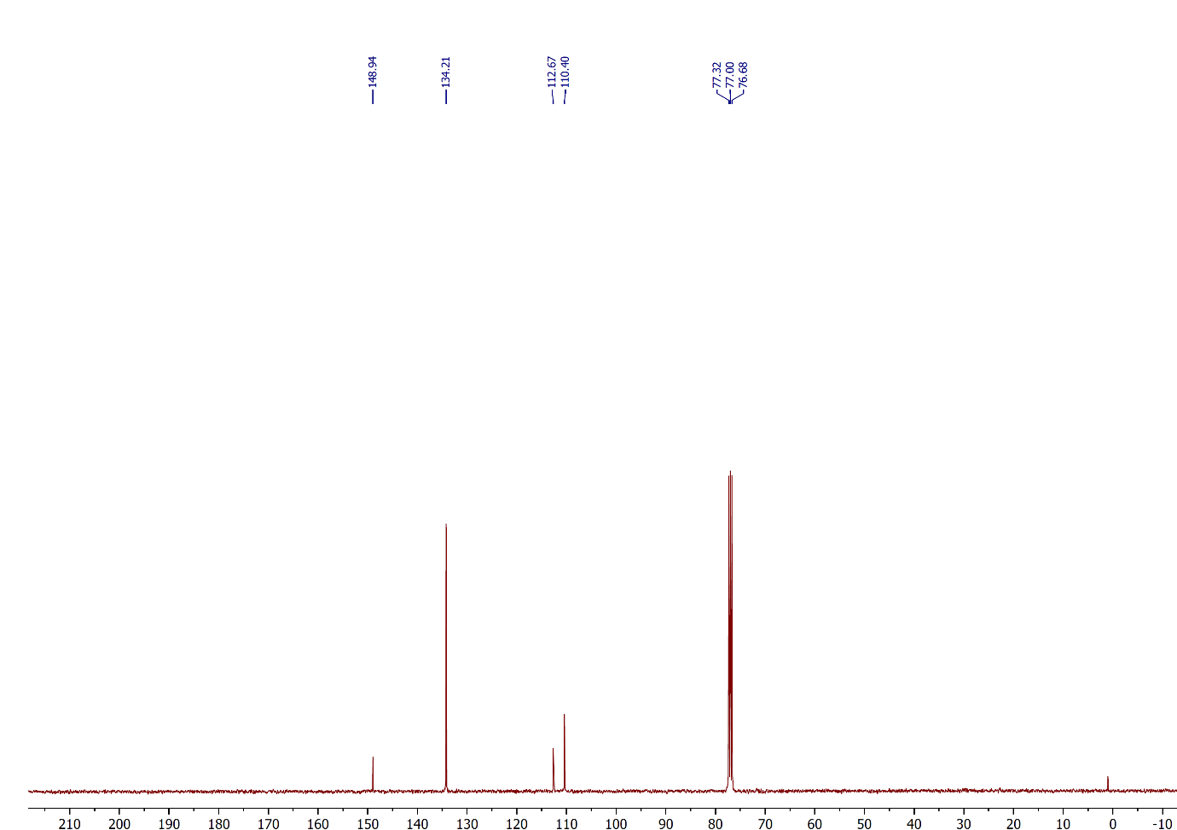
Figure 86: ¹³C NMR spectrum of compound 3g, (CDCl₃, 100 MHz).
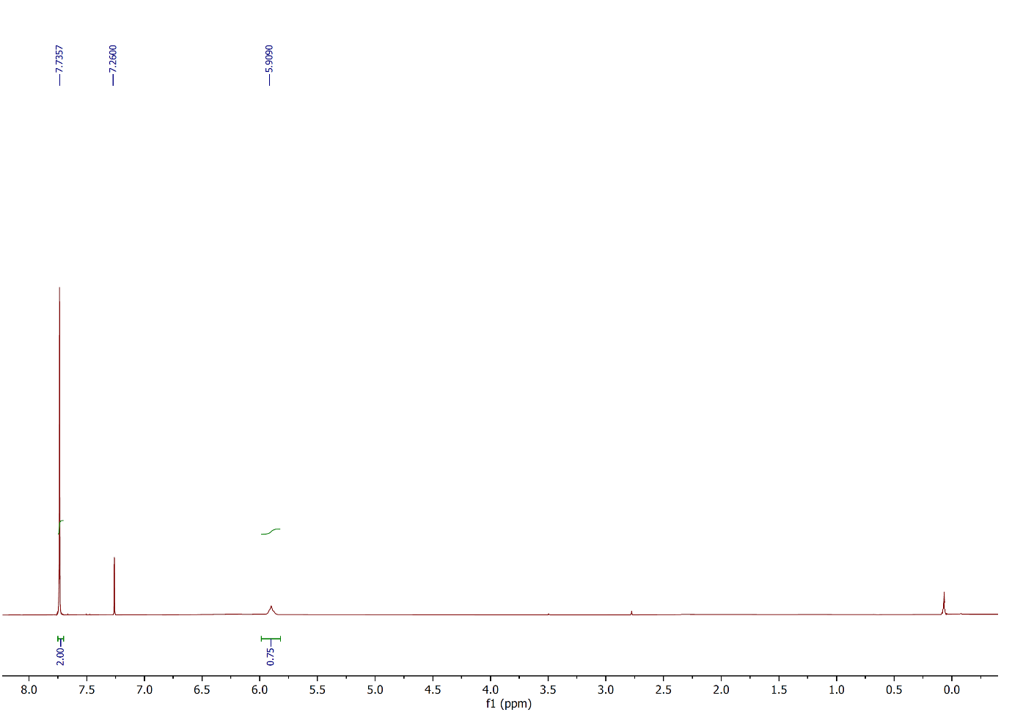
Figure 87: ¹H NMR spectrum of compound 3h, (CDCl₃, 400 MHz).
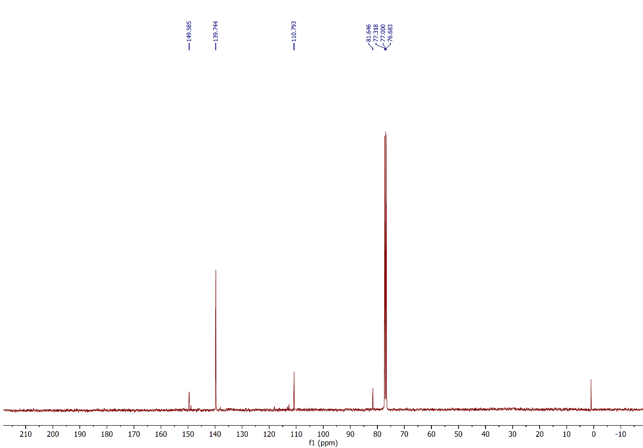
Figure 88: ¹³C NMR spectrum of compound 3h, (CDCl₃, 100 MHz).
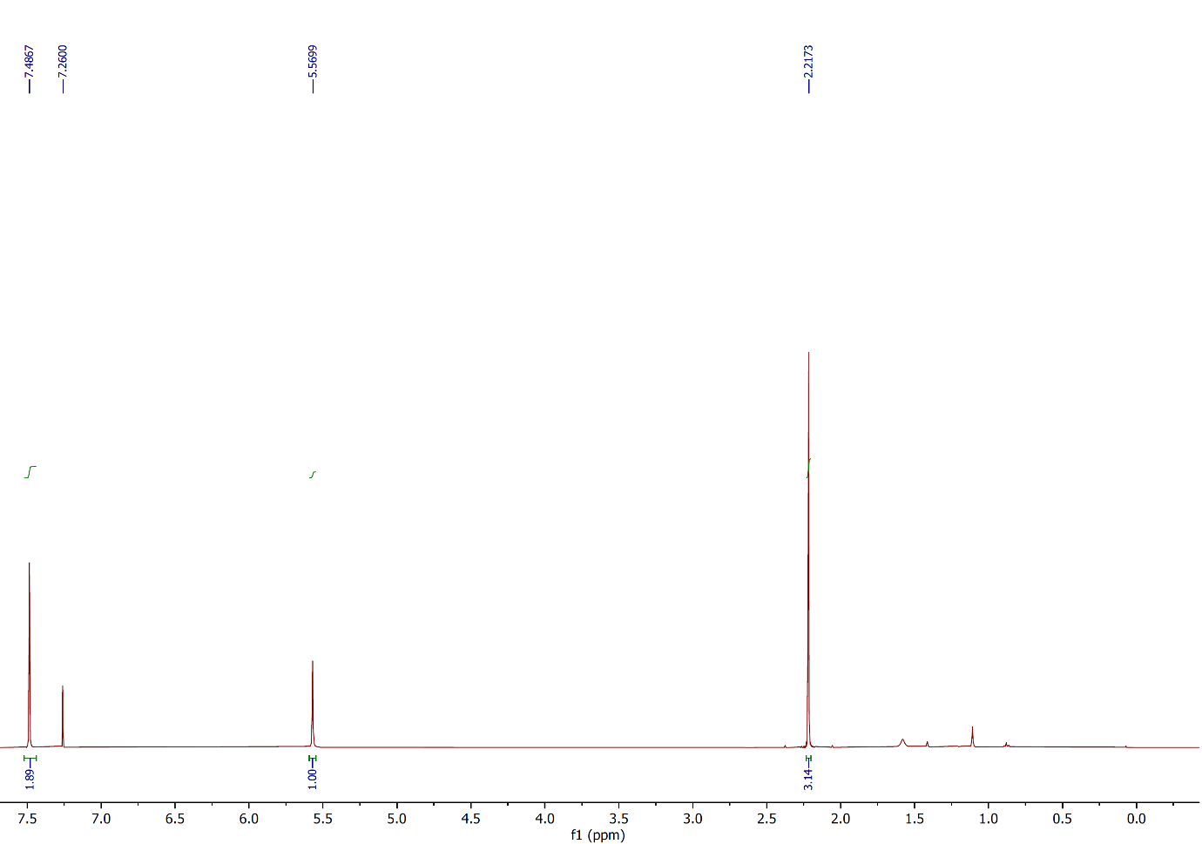
Figure 89: ¹H NMR spectrum of compound 3i, (CDCl₃, 400 MHz).
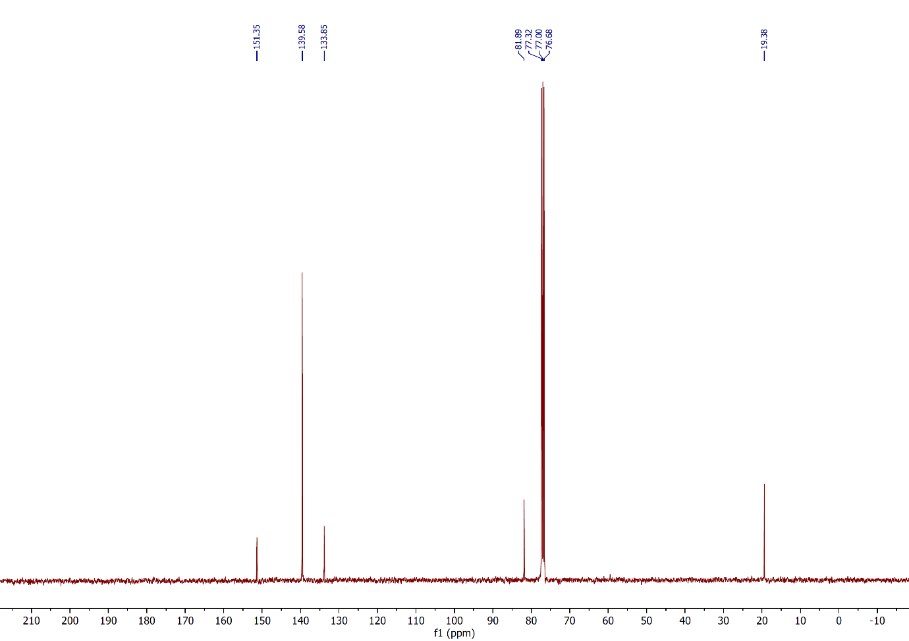
Figure 90: ¹³C NMR spectrum of compound 3i, (CDCl₃, 100 MHz).
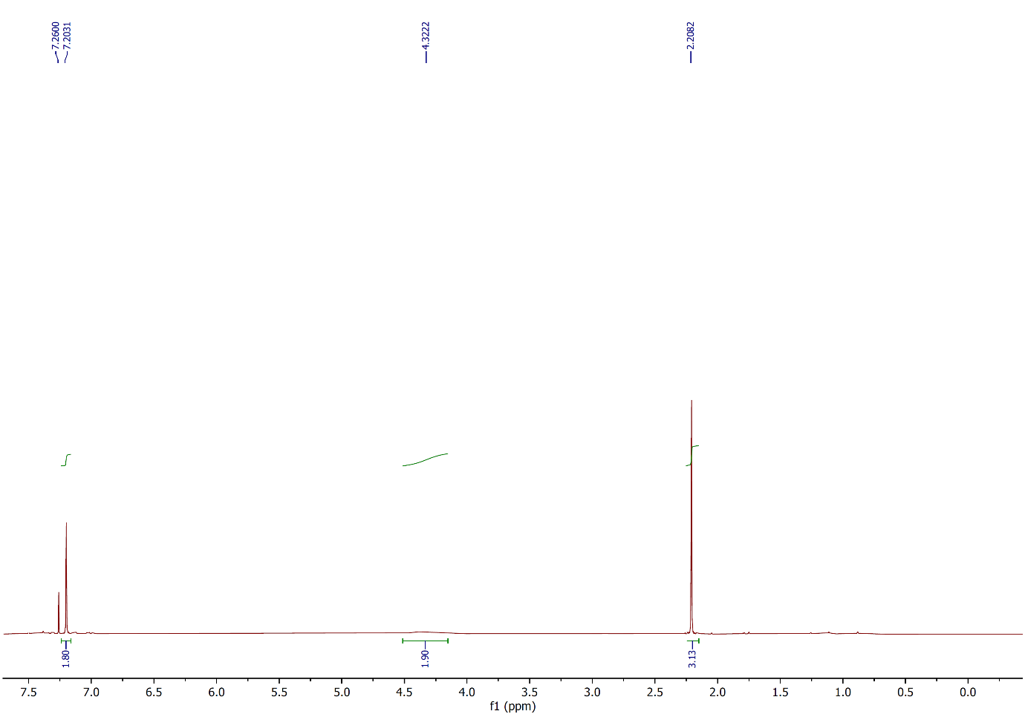
Figure 91: ¹H NMR spectrum of compound 3j, (CDCl₃, 400 MHz).
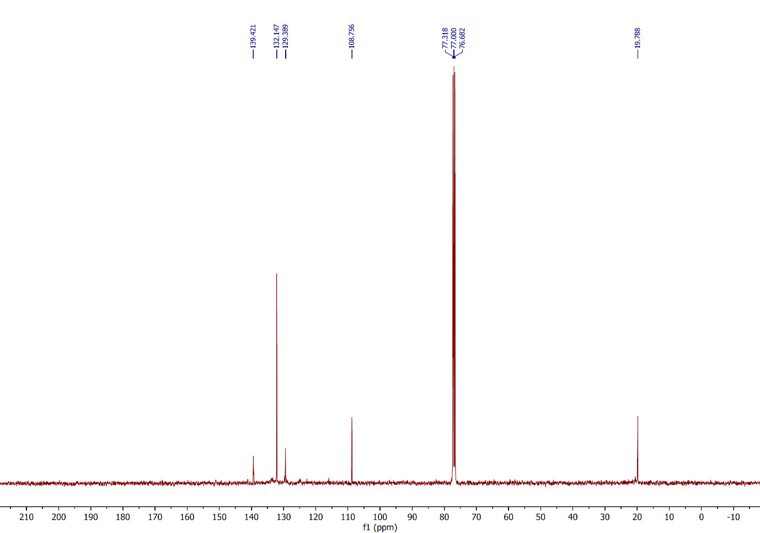
Figure 92: ¹³C NMR spectrum of compound 3j, (CDCl₃, 100 MHz).
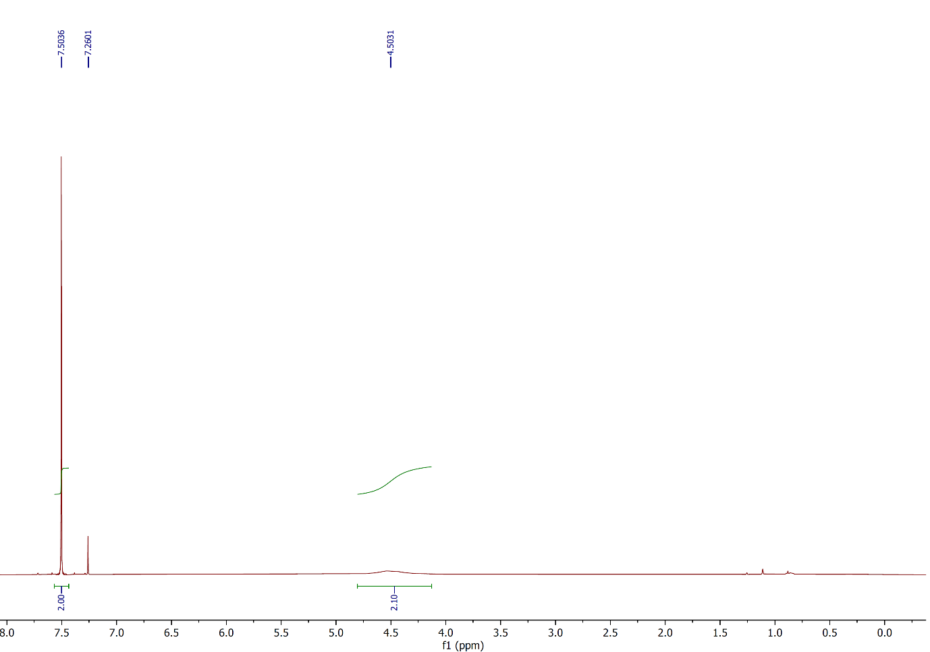
Figure 93: ¹H NMR spectrum of compound 4a, (CDCl₃, 400 MHz).
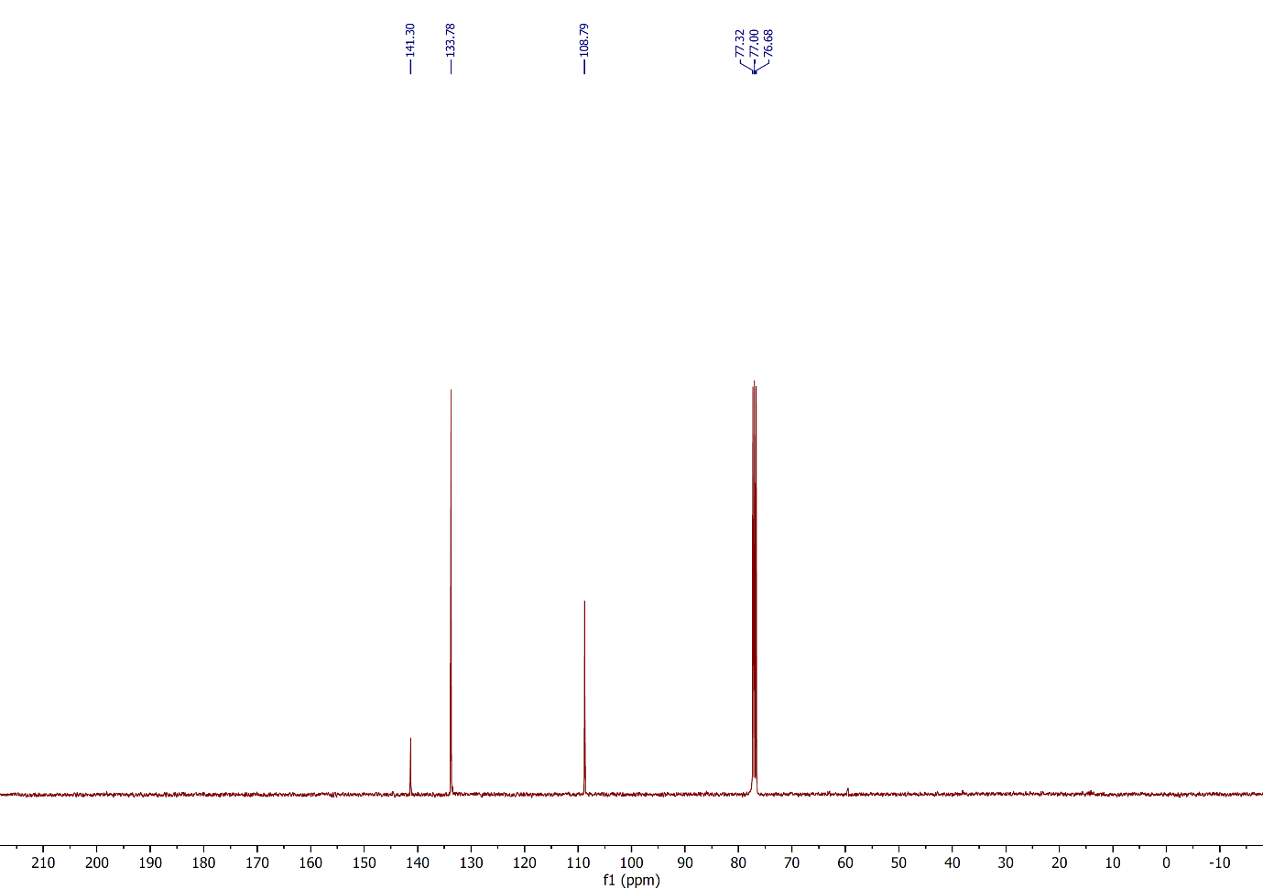
Figure 94: ¹³C NMR spectrum of compound 4a, (CDCl₃, 100 MHz).
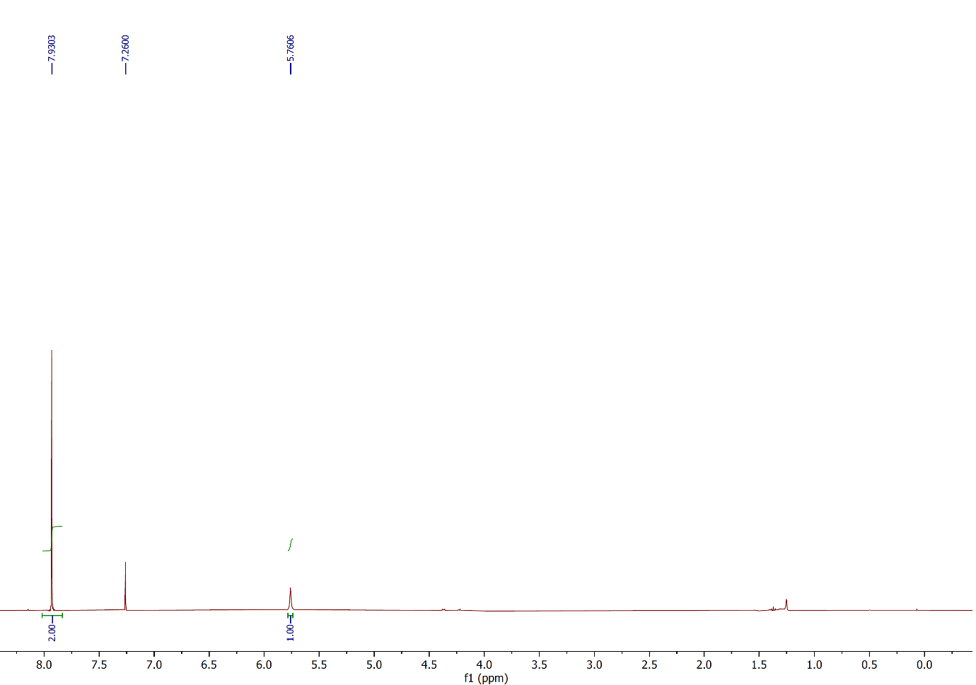
Figure 95: ¹H NMR spectrum of compound 4b, (CDCl₃, 400 MHz).
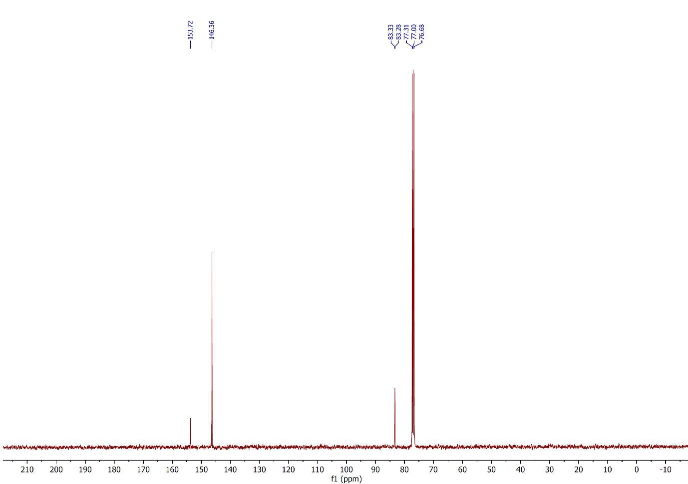
Figure 96: ¹³C NMR spectrum of compound 4b, (CDCl₃, 100 MHz).
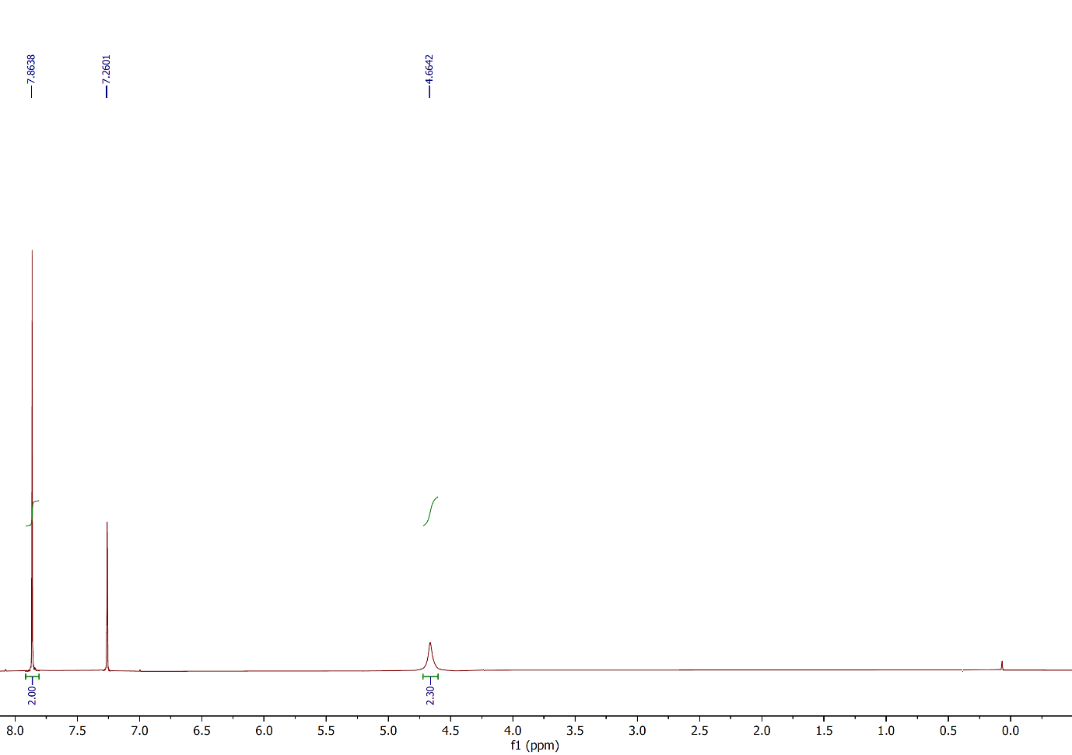
Figure 97: ¹H NMR spectrum of compound 4c, (CDCl₃, 400 MHz).
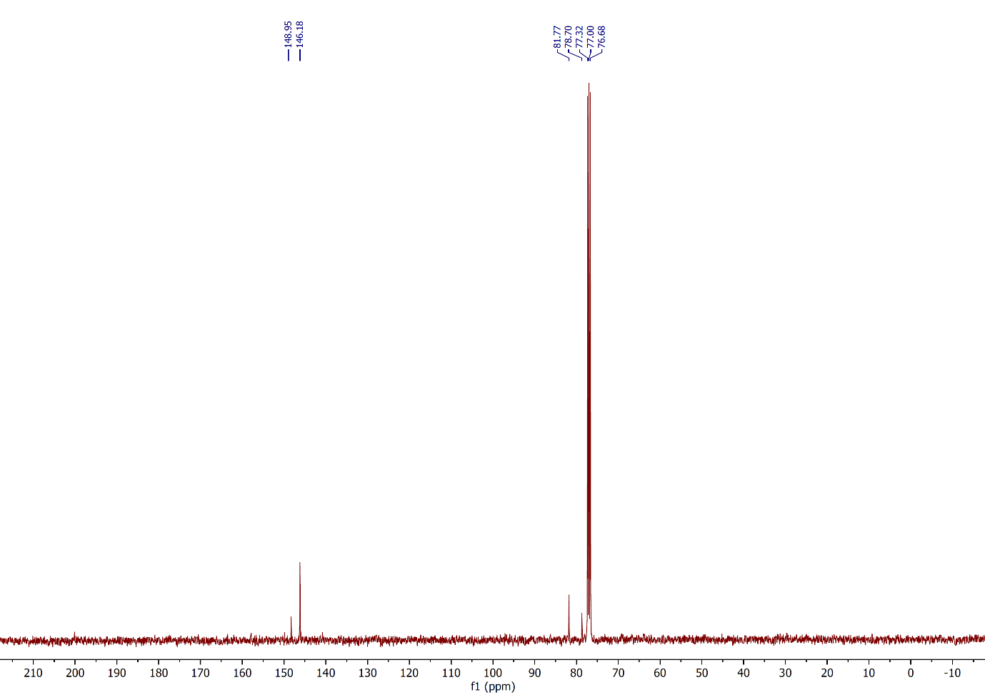
Figure 98: ¹³C NMR spectrum of compound 4c, (CDCl₃, 100 MHz).
References
- Wang, L.; Feng, C.; Zhang, Y.; Hu, J. Molecules 2020, 25, 914. doi:10.3390/molecules25040914
- Tang, R.-J.; Milcent, T.; Crousse, B. J. Org. Chem. 2018, 83, 930−938. doi:10.1021/acs.joc.7b02920
- Otomatsu, T.; Bai, L. M.; Fujita, N.; Shindo, K.; Shimizu, K.; Misawa, N. J. Mol. Catal. B Enzym. 2010, 66, 234–240. doi:10.1016/j.molcatb.2010.05.015
- Boruah, J. J.; Das, S. P.; Borah, R.; Gogoi, S. R.; Islam, N. S. Polyhedron 2013, 52, 246−254. doi:10.1016/j.poly.2012.09.036
- Schmidt, B.; Holter, F. Org. Biomol. Chem. 2011, 9, 4914−4920. doi:10.1039/c1ob05256j
- Eisenhauer, H. R.; Link, K. P. J. Am. Chem. Soc. 1954, 76, 6, 1647–1649. doi: 10.1021/ja01635a054
- Ma, X.; Yu, J.; Jiang, M.; Wang, M.; Tang, L.; Wei, M.; Zhou, Q. Eur. J. Org. Chem. 2019, 28, 4593–4596. doi:10.1002/ejoc.201900794ax
- Clewley, R. G.; Cross, G. G.; Fischer, A. Henderson, G. N. Tetrahedron, 1989, 45, 1299–1310. doi: 10.1016/0040-4020(89)80128-0
- Denton, R. M.; An, J.; Lindovska, P.; Lewis, W. Tetrahedron, 2012, 68, 2899–2905. doi:10.1016/j.tet.2012.01.067
- Popa, M. M.; Draghici, C.; Barbu, L.; Dumitrescu, D. E.; Dumitrascu, F. Synth. Commun. 2017, 47, 344–350. doi:10.1080/00397911.2016.1264603
- Vijaykumar, G.; Mandal, S. K. Dalton Trans. 2016, 45, 7421−7426. doi:10.1039/c6dt00470a
- Le, Z. G.; Chen, Z. C.; Hu, Y.; Zheng, Q. G. Synthesis 2004, 17, 2809−2812. doi:10.1055/s-2004-831239
- Ageshina, A. A.; Chesnokov, G. A.; Topchiy, M. A.; Alabugin, I. V.; Nechaev, M. S.; Asachenko, A. F. Org. Biomol. Chem. 2019, 17, 4523−4534. doi:10.1039/c9ob00615j
- Khalifa, A.; Conway, L.; Geoghegan, K.; Evans, P. Tetrahedron Lett. 2017, 58, 4559–4562. doi:10.1016/j.tetlet.2017.10.053
- Zhou, Y.; Zhou, H.; Liu, S.; Pi, D.; Shen, G. Tetrahedron 2017, 73, 3898– 3904. doi:10.1016/j.tet.2017.05.056
- Wu, Y.; Xu, S.; Wang, H.; Shao, D.; Qi, Q.; Lu, Y.; Ma, L.; Zhou, J.; Hu, W.; Gao, W.; Chen, J. J. Org. Chem. 2021, 86, 16144–16150. doi: 10.1021/acs.joc.1c00923
- Zhou, Z.; Ma, Z.; Behnke, N. E.; Gao, H.; Kürti, L. J. Am. Chem. Soc. 2017, 139, 115−118. doi: 10.1021/jacs.6b12712
- Syvret, R. G.; Butt, K. M.; Nguyen, T. P.; Bulleck, V. L.; Rieth, R. D. J. Org. Chem. 2002, 67, 4487–4493. doi:10.1021/jo020053u
- Satkar, Y.; Yera-Ledesma, L. F.; Mali, N.; Patil, D.; Navarro-Santos, P.; Segura-Quezada, L. A.; Ramírez-Morales, P. I.; Solorio-Alvarado, C. R. J. Org. Chem. 2019, 84, 4149–4164. doi:10.1021/acs.joc.9b00161
- Rao, A. S.; Ramesh, K.; Rajanna, K. C.; Chakrvarthi, I. Asian. J. Chem. 2018, 30, 1892–1896. doi:10.14233/ajchem.2018.21413
- Moorthy, J. N.; Senapati, K.; Kumar, S. J. Org. Chem. 2009, 74, 6287–6290. doi:10.1021/jo9007892
- Rong, N.; Yuan, Y.; Chen, H.; Yao, C.; Li, T.; Wanga, Y.; Yang, W. Org. Chem. Front., 2021, 8, 4479–4484. doi:10.1039/d1qo00461a
- Racys, D. T.; Sharif, S. A. I.; Pimlott, S. L.; Sutherland, A. J. Org. Chem. 2016, 81, 772– 780. doi:10.1021/acs.joc.5b02761
- Shinde, A. T.; Zangade, S. B.; Chavan, S. B.; Vibhute, A. Y.; Nalwar, Y. S.; Vibhute, Y. B. Synth. Commun. 2010, 40, 3506–3513. doi:10.1080/00397910903457332
- Tavana, M.; Montazeri, N.; Imanzadeh, G. Asian J. Chem. 2011, 23, 3097–3100.
- Vibhute, Y. B.; Lonkar, S. M.; Sayyed, M. A.; Baseer, M. A. Mendeleev Commun. 2007, 17, 51. doi:10.1016/j.mencom.2007.01.020.
- Kress, T. J.; Moore, L. L.; Costantino, S. M. J. Org. Chem. 1976, 41, 93−96. doi:10.1021/jo00863a020
- Satkar, Y.; Ramadoss, V.; Nahide, P. D.; García-Medina, E.; Juárez-Ornelas, K. A.; Alonso-Castro, A. J.; Chávez-Rivera, R.; ́ Jiménez-Halla, J. O. C.; Solorio-Alvarado, C. R. RSC Adv. 2018, 8, 17806−17812. doi: 10.1039/c8ra02982b
- Ghorpade, P. V.; Pethsangave, D. A.; Some, S.; Shankarling, G. S. J. Org. Chem. 2018, 83, 7388–7397. doi:10.1021/acs.joc.8b00188
- Mostafa, M. A. B.; Calder, E. D. D.; Racys, D. T.; Sutherland, A. Chem. Eur. J. 2017, 23, 1044−1047. doi:10.1002/chem.201605671
- Rogers, D. A.; Brown, R. G.; Brandeburg, Z. C.; Ko, E. Y.; Hopkins, M. D.; LeBlanc, G.; Lamar, A. A. ACS Omega 2018, 3, 12868−12877. doi:10.1021/acsomega.8b02320
- Chae, J.; Buchwald, S. L. J. Org. Chem. 2004, 69, 3336−3339. doi:10.1021/jo035819k
- Kösel, T.; Dräger, G.; Kirschning, A. Org. Biomol. Chem. 2021, 19, 2907–2911. doi: 10.1039/d1ob00083g
- Ferreira, I. M.; Casagrande, G. A.; Pizzuti, L.; Raminelli, C. Synth. Commun. 2014, 44, 2094–2102. doi:10.1080/00397911.2013.879900
- Carreno, M. C.; Garcia Ruano, J. L.; Sanz, G.; Toledo, M. A.; Urbano, A. J. Org. Chem. 1995, 60, 5328−5331. doi:10.1021/jo00121a064
- Zysman-Colman, E.; Arias, K.; Siegel, J. S. Can. J. Chem. 2009, 87, 440−447. doi:10.1139/v08-176
- Bovonsombat, P.; Ali, R.; Khan, C.; Leykajarakul, J.; Pla-on, K.; Aphimanchindakul, S.; Pungcharoenpong, N.; Timsuea, N.; Arunrat, A.; Punpongjareorn, N. Tetrahedron 2010, 66, 6928–6935. doi:10.1016/j.tet.2010.06.041
- Bovonsombat, P.; Teecomegaet, P.; Kulvaranon, P.; Pandey, A.; Chobtumskul, K.; Tungsirisurp, S.; Sophanpanichkul, P.; Losuwanakul, S.; Soimaneewan, D.; Kanjanwongpaisan, P.; Siricharoensang, P.; Choosakoonkriang, S. Tetrahedron 2017, 73, 6564–6572. doi:10.1016/j.tet.2017.10.005
- Pramanick, P. K.; Hou, Z.-L.; Yao, B. Tetrahedron 2017, 73, 7105–7114. doi:10.1016/j.tet.2017.10.073
- Du, B.; Jiang, X.; Sun, P. J. Org. Chem. 2013, 78, 6, 2786–2791. doi: 10.1021/jo302765g
- Schröder, N.; Wencel-Delord, J.; Glorius, F. J. Am. Chem. Soc. 2012, 134, 8298−8301. doi:10.1021/ja302631j
- Xu, H.; Hu, L.; Zhu, G.; Zhu Y.; Wang, Y.; Zheng-Guang Wu, Z.-G.; Zi, Y.; Huang, W. RSC Adv. 2022, 12, 7115–7119. doi: 10.1039/d2ra00197g
- Bose, A.; Mal, P. Tetrahedron Lett. 2014, 55, 2154–2156. doi:10.1016/j.tetlet.2014.02.064
- Ghanbarin, N.; Ghafuri, H.; Zand, H. R. E.; Eslami, M. SynOpen, 2017, 1, 143–146. doi:10.1055/s-0036-1590959

