Supporting Information

for

Thienothiophene based organic light-emitting diode: synthesis, photophysical properties and application

Recep Isci and Turan Ozturk

General experimental device methods and theoretical computation data

Table of contents
- General experimental device methods…………………………………………..S2
- Computational data…………………………………………………………...…...S3

General experimental device methods
TFB (Cambridge Display Technology Ltd.) solution was prepared by dissolving TFB in toluene in 2 mg/mL concentration. Active layer solution was prepared by controlling the host material concentration fixed at 15 mg/mL and blending the emitter at 10 wt% in chlorobenzene. Prepatterned ITO substrates were rinsed in an ultrasonic bath with acetone, isopropyl alcohol, Hellmanex III and deionized water before deposition of top layers. PEDOT: PSS and TFB were deposited on ITO sequentially via spin-coating at 2500 and 1000 rpms, respectively. Then, the prepared active layer was spin-coated on annealed TFB (180 °C for 1 h in a nitrogen-glovebox) at 2000 rpms to form a 50 nm film. Afterwards, TPBi, LiF and Ca/Ag were thermally evaporated onto the organic layer under vacuum level of ~5×10-7 mbar. J-V-L characterization (pixel area = 0.045 cm²) was performed using a Keithley 2400 and Konica Minolta LS-110 Luminance Meter. OLED emission profile was assumed to be Lambertian. EL spectrum was measured using an Ocean Optics USB 2000 charge-coupled device spectrophotometer.
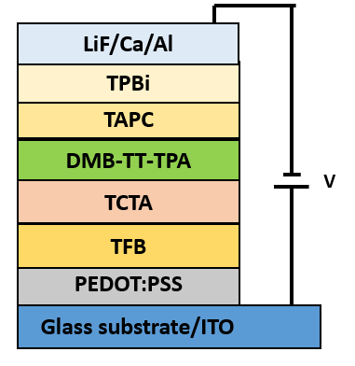
Figure S1: Schematic illustration of the device configuration.

Computational data
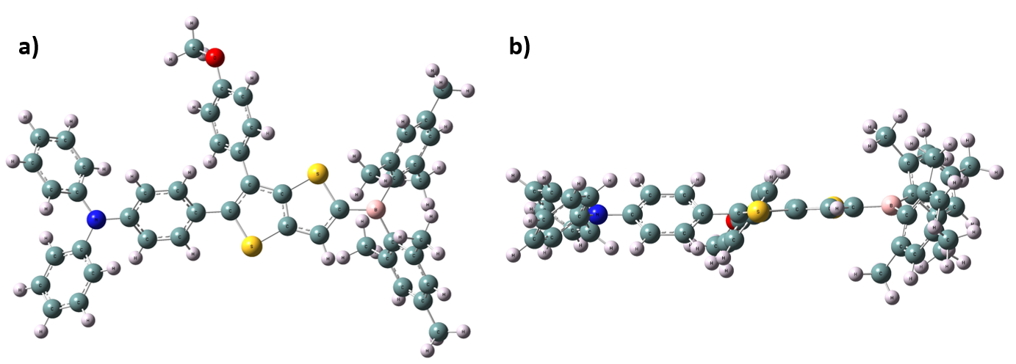
Figure S3: Optimized geometry of DMB-TT-TPA of a) top view and b) side view.
Figure S3: Theoretical UV-Vis spectrum of DMB-TT-TPA.

