Supporting Information
for
Ferrocenophanes with two nitrogen atoms in bridging positions via olefin metathesis: synthesis, structure, and solution dynamics

Karol Rawiak, Maria Mazur, Tsenguun Enkhbold, Michał Sitek, Stanisław Kulczyk, Piotr Paluch, Piotr A. Guńka, Mariola Koszytkowska-Stawińska, Włodzimierz Buchowicz

Experimental details, characterization of amino dienes 1, amino aldehydes S, additional X-ray data, VT ¹H NMR spectra, 2D NMR spectra, and details of theoretical calculations

General remarks. N-allyl-4-methoxyaniline [] and N-allyl-2-ethoxyaniline [] were synthesized according to published procedures. Compounds 1a, 1e, 1f, and S1 were described previously []. Reductive amination reactions were carried out using Schlenk tube techniques under an argon atmosphere according to the general conditions described by Abdel-Magid et al. []. The resulting products were isolated without exclusion of air. The progress of the reactions was monitored using TLC (hexanes:ethyl acetate, 4:1, v/v). 1,2-Dichloroetane (DCE) and dichloromethane were distilled from CaH₂. All other reagents and solvents were commercial and were used as received. Column chromatography was performed on silica gel 60 (230–400 mesh). The NMR spectra were recorded on a Varian V NMRS 500 MHz spectrometer at ambient temperature unless otherwise noted. The VT NMR spectra were measured on an Avance III 600 MHz Bruker Spectrometer.
Synthesis of diamine 1b
N-allyl-4-methoxyaniline (0.850 g, 5.21 mmol), 1,2-dichloroetane (20 mL), 1,1′-ferrocene-dicarboxaldehyde (0.360 g, 1.50 mmol) and NaBH(OAc)₃ (0.850 g, 4.01 mmol) were placed in a dry Schlenk tube equipped with a stirring bar. The resulting mixture was stirred at room temperature for 24 h. An aqueous solution of NaOH (100 mL, 1M) was added. The organic phase was separated. The aqueous phase was extracted with CH₂Cl₂ (3 × 20 mL). The combined organic solutions were dried over MgSO₄. The volatiles were removed on a rotary evaporator to obtain a brown-red oil. This residue was subjected to column chromatography (SiO₂, hexanes:ethyl acetate, 4:1, v/v). Three coloured fractions were collected which were further purified by crystallization from n-hexane at −70°C.
Diamine 1b: yellow crystals, 0.430 g (0.80 mmol, 53%). mp: 68-71 °C (from n-hexane). ¹H NMR (500 MHz, CDCl₃) δ (ppm): 6.80 (dt, J = 9.0, 2.5 Hz, 4H, C₆H₄), 6.74 (dt, J = 9.0, 2.5 Hz, 4H, C₆H₄), 5.80 (ddt, J = 16.0, 11.5, 5.5 Hz, 2H, -CH=), 5.16 (dd, J = 11.5, 1.5 Hz, 2H, =CH₂), 5.14-5.12 (m, 2H, =CH₂), 4.17 (s, 4H, -CH₂-N), 4.06 (app. t, J = 1.5 Hz, 4H, C₅H₄), 4.03 (app. t, J = 2.0 Hz, 4H, C₅H₄), 3.76 (d, J = 5.5 Hz, 4H, -CH₂-CH=), 3.75 (s, 6H, OCH₃). ¹³C{¹H} NMR (126 MHz, CDCl₃) δ (ppm): 152.04 (p-C₆H₄), 143.53 (ipso-C₆H₄), 134.86 (-CH=), 116.41 (=CH₂), 116.18 (C₆H₄), 114.46 (C₆H₄), 84.49 (C₅H₄), 69.80 (C₅H₄), 68.44 (C₅H₄), 55.67 (OCH₃), 52.88 (-CH₂-N), 50.97 (-CH₂-CH=). HR MS (ESI) m/z found for C₃₂H₃₆⁵⁶FeN₂O₂Na [M+Na]⁺ 559.2028 (Calc. 559.2024). Anal. Calc. for C₃₂H₃₆FeN₂O₂: C 71.64, H 6.76, N 5.22; Found: C 71.12, H 6.48, N 5.18.
Amino aldehyde S2: red crystals, 0.200 g (0.51 mmol, 34%). mp: 41-43 °C (from ethyl acetate/n-hexane). ¹H NMR (500 MHz, CDCl₃) δ (ppm): 9.95 (s, 1H, CHO), 6.79 (dt, J = 9.5, 2.5 Hz, 2H, C₆H₄), 6.71 (dt, J = 9.0, 2.0 Hz, 2H, C₆H₄), 5.79 (ddt, J = 17.0, 10.5, 5.5 Hz, 1H, -CH=), 5.17 (dq, J = 7.7, 1.6 Hz, 1H, =CH₂), 5.14 (app. t, J = 1.6 Hz, 1H, =CH₂), 4.75 (app. t, J = 2.0 Hz, 2H, C₅H₄), 4.57 (app. t, J = 2.0 Hz, 2H, C₅H₄), 4.21 (app. t, J = 2,0 Hz, 2H, C₅H₄), 4.18 (app. t, J = 2.0 Hz, 2H, C₅H₄), 4.10 (s, 2H, -CH₂-N), 3.75 (s, OCH₃) overlapping with 3.74 (dt, -CH₂-CH=), 5H. ¹³C{¹H} NMR (126 MHz, CDCl₃) δ (ppm): 193.42 (-CHO=), 152.49 (p-C₆H₄), 143.38 (ipso-C₆H₄), 134.89 (-CH=), 116.82 (=CH₂), 116.68 (C₆H₄), 114.66 (C₆H₄), 86.58 (C₅H₄), 79.85 (C₅H₄), 73.94 (C₅H₄), 70.84 (C₅H₄), 70.30 (C₅H₄), 69.53 (C₅H₄), 55.82 (OCH₃), 53.43 (-CH₂-CH=), 50.62 (-CH₂-N). MS (EI) m/z (%), ⁵⁶Fe: 389 (47, M⁺), 348 (22), 254 (12), 227 (100), 199 (71), 121 (43). HR MS (EI) m/z found for C₂₂H₂₃⁵⁶FeNO₂ [M]⁺ 389.1085 (Calc. 389.1078). Anal. Calc. for C₂₂H₂₃FeNO₂: C 67.88, H 5.96, N 3.60; Found: C 68.19, H 5.91, N 3.64.
Amino alcohol S2-2H: brown oil, 0.060 g (0.15 mmol, 10%). ¹H NMR (500 MHz, CDCl₃) δ (ppm): 6.80 (dt, J = 9.0, 3.0 Hz, 2H, C₆H₄), 6.76 (dt, J = 9.5, 3.0 Hz, 2H, C₆H₄), 5.81 (ddt, J = 17.1, 10.7, 5.5 Hz, 1H, CH=), 5.17 (dq, J = 9.5, 1.5 Hz, 1H, =CH₂), 5.14 (app. sextet, J = 1.5 Hz, 1H, =CH₂), 4.34 (d, J = 4.5 Hz, 2H, CH₂-OH), 4.18 (app. t, J = 2.0 Hz, 2H, C₅H₄), 4.16 (s, 2H, -CH₂-N), 4.14 (app. t, J = 1.5 Hz, 2H, C₅H₄), 4.10 (app. t, J = 1.5 Hz, 2H, C₅H₄), 4.08 (t, J = 2.0 Hz, 2H, C₅H₄), 3.77 (dt, J = 5.0 Hz, 1.7 Hz, 2H, -CH₂-CH=), 3.75 (s, 3H, OCH₃), 1.82 (bs, 1H, OH). ¹³C{¹H} NMR (126 MHz, CDCl₃) δ (ppm): 151.56 (p-C₆H₄), 142.59 (ipso-C₆H₄), 133.84 (-CH=), 115.93 (C₆H₄ or =CH₂), 115.88 (C₆H₄ or =CH₂), 113.63 (C₆H₄), 87.84 (C₅H₄), 84.20 (C₅H₄), 68.58 (C₅H₄), 68.08 (C₅H₄), 67.47 (C₅H₄), 67.11 (C₅H₄), 59.84 (CH₂OH), 54.82 (OCH₃), 53.00 (CH₂N), 50.03 (CH₂-CH=). HR MS (ESI) m/z found for C₂₂H₂₅⁵⁶FeNO₂Na [M+Na]⁺ 414.1125 (Calc. 414.1132). Anal. Calc. for C₂₂H₂₃FeNO₂ × 0.5 H₂O: C 66.03, H 6.00, N 3.50; Found: C 66.66, H 6.10, N 3.90.
Synthesis of diamine 1d
Similarly as described above, N-allyl-2-ethoxyaniline (1.14 g, 7.09 mmol), 1,2-dichloroetane (30 mL), 1,1′-ferrocenedicarboxaldehyde (0.400 g, 1.65 mmol) and NaBH(OAc)₃ (0.800 g, 3.37 mmol) were stirred at room temperature for 1 week. The usual work-up and column chromatography (SiO₂, hexanes:ethyl acetate, 4:1, v/v) provided two compounds.
Diamine 1d: yellow crystals from n-hexane at −70 °C; 204 mg (0.361 mmol, 22%). mp: 58-61 °C (from n-hexane). ¹H NMR (500 MHz, CDCl₃) δ (ppm): 6.92 (m, 2H, C₆H₄), 6.85 (dd, J = 8.1, 1.5 Hz, 2H, C₆H₄), 6.79 (m, 2H, C₆H₄), 6.71 (dd, J = 7.9, 1.6 Hz, 2H, C₆H₄), 5.83 (ddt, J = 16.3, 10.2, 6.1 Hz, 2H, -CH=), 5.17 (dq, J = 17.2, 1.8 Hz, 2H, =CH₂), 5.11 (dq, J = 10, 2 Hz, 2H, =CH₂), 4.12 (q, J = 6.7 Hz, 4H, O-CH₂-) overlapping with: 4.10 (s, 4H, -CH₂-N), 3.92 (app. t, J = 1.8 Hz, 4H, C₅H₄), 3.84 (app t, J = 1.8 Hz, 4H, C₅H₄), 3.60 (dt, J = 6.1, 1.3 Hz, 4H, -CH₂-CH=), 1.48 (t, J = 7.0 Hz, 6H, -CH₃). ¹³C{¹H} NMR (126 MHz, CDCl₃) δ (ppm): 151.99 (C₆H₄), 139.94 (C₆H₄), 136.22 (CH=), 122.34 (C₆H₄), 121.84 (C₆H₄), 120.52 (C₆H₄), 116.83 (=CH₂), 113.01 (C₆H₄), 83.26 (C₅H₄), 70.27 (C₅H₄), 68.06 (C₅H₄), 63.80 (O-CH₂-), 53.34 (-CH₂-N), 50.64 (-CH₂-CH=), 15.15 (-CH₂-CH₃). HR MS (ESI) m/z found for C₃₄H₄₀⁵⁶FeN₂O₂ [M]⁺ 564.2435 (Calc. 564.2439). Anal. Calc. for C₃₄H₄₀FeN₂O₂ × 0.5 H₂O: C 71.20, H 7.15, N 4.88; Found: C 71.21, H 6.58, N 5.10.
Amino aldehyde S3: red micro-crystalline solid, 170 mg (0.422 mmol, 25%). mp: 44-45 °C (from ethyl acetate/n-hexane). ¹H NMR (500 MHz, CDCl₃) δ (ppm): 9.89 (s, 1H, CHO), 6.94 (m, 1H, C₆H₄), 6.87 (dd, J = 8.1, 1.5 Hz, 1H, C₆H₄), 6.79 (td, J = 7.5, 1.3 Hz, 1H, C₆H₄), 6.70 (dd, J = 7.9, 1.6 Hz, 1H, C₆H₄), 5.84 (ddt, J = 16.3, 10.2, 6.1 Hz, 1H, -CH=), 5.18 (dq, J = 17.3, 1.6 Hz, 1H, =CH₂), 5.14 (dq, J = 10.3, 1.5 Hz, 1H, =CH₂), 4.68 (app. t, J = 2.0 Hz, 2H, C₅H₄), 4.50 (app. t, J = 2.0 Hz, 2H, C₅H₄), 4.14 (q, J = 7.0 Hz, 2H, O-CH₂-) overlapping with 4.13 (app. t, J = 1.7 Hz, 2H, C₅H₄), 4.08 (s, 2H, -CH₂-N), 4.03 (app. t, J = 1.8 Hz, 2H, C₅H₄), 3.60 (dt, J = 6.1, 1.4 Hz, 2H, -CH₂-CH=), 1.52 (t, J = 7.0 Hz, 3H, -CH₃). ¹³C{¹H} NMR (126 MHz, CDCl₃) δ (ppm): 193.20 (CHO), 152.12 (C₆H₄), 139.48 (C₆H₄), 136.01 (CH=), 122.76 (C₆H₄), 122.00 (C₆H₄), 120.54 (C₆H₄), 117.10 (=CH₂), 113.02 (C₆H₄), 85.56 (C₅H₄), 79.60 (C₅H₄), 73.63 (C₅H₄), 71.21 (C₅H₄), 69.93 (C₅H₄), 69.25 (C₅H₄), 63.85 (O-CH₂-), 53.85 (-CH₂-CH=), 49.92 (-CH₂-N), 15.14 (-CH₂-CH₃). HR MS (ESI) m/z found for C₂₃H₂₄⁵⁶FeNO₂Na [M+Na]⁺ 426.1133 (Calc. 426.1132). Anal. Calc. for C₂₃H₂₅FeNO₂: C 68.50, H 6.25, N 3.47; Found: C 68.12, H 5.85, N 3.61.
Synthesis of diamine 1c
Method A
N-allylaniline (0.060 g, 0.510 mmol), 1,2-dichloroetane (20 mL), amino aldehyde S2 (0.200 g, 0.510 mmol) and NaBH(OAc)₃ (0.100 g, 0.500 mmol) were placed in a dry Schlenk tube equipped with a stirring bar. The resulting mixture was stirred at room temperature for 24 h. An aqueous solution of NaOH (100 mL, 1M) was added. The phases were separated, the aqueous phase was extracted with CH₂Cl₂ (3 × 20 mL). The combined organic solutions were dried over MgSO₄. The volatiles were removed on a rotary evaporator. The product was isolated by column chromatography (SiO₂ (hexanes:ethyl acetate, 4:1, v/v). A yellow fraction was collected which was further purified by crystallization from n-hexane at −70 °C. The product 1c was obtained as yellow-orange oil at room temperature that solidified upon standing at 4 °C. Yield: 0.160 g (0.316 mmol, 62%).
Method B
Compound 1c was also similarly obtained from amino aldehyde S1 [3] and N-allyl-4-methoxyaniline [1].
Diamine 1c: ¹H NMR (500 MHz, CDCl₃) δ (ppm): 7.21 (d, J = 7.5 Hz, 1H, C₆H₅), 7.19 (d, J = 7.5 Hz, 1H, C₆H₅), 6.80 (d, J = 9.5 Hz, 2H, C₆H₄), 6.78–6.76 (m, 2H, C₆H₅), 6.74 (d, J = 9.0 Hz, 2H, C₆H₄), 6.69 (dt, J = 7.2, 1.0 Hz, 1H, C₆H₅), 5.85–5.75 (m, 2H, -CH=), 5.19-5.12 (m, 4H, -CH₂=), 4.26 (s, 2H, -CH₂-N), 4.19 (s, 2H, -CH₂-N), 4.14 (app. t, J = 2.0 Hz, 2H, C₅H₄), 4.09 (t, J = 2.0 Hz, 2H, C₅H₄), 4.07-4.04 (two overlapping triplets, 4H, C₅H₄), 3.89 (dt, J = 5.0, 2.0 Hz, 2H, -CH₂-CH=), 3.77 (dt, J = 5.0, 1.5 Hz, 2H, -CH₂-CH=), 3.75 (s, 3H, OCH₃). ¹³C{¹H} NMR (126 MHz, CDCl₃) δ (ppm): 151.26, 147.81, 142.70, 134.04, 133.31, 128.19, 115.74, 115.62, 115.40, 115.34, 113.65, 112.15 (12 signals, C₆H₅, C₆H₄, or CH=CH), 84.11 (C₅H₄), 83.75 (C₅H₄), 69.02 (C₅H₄), 68.79 (C₅H₄), 67.68 (two overlapping signals, C₅H₄), 54.84 (OCH₃), 52.09 (-CH₂-N), 51.18 (-CH₂-N), 50.18 (-CH₂-CH=), 48.65 (-CH₂-CH=). HR MS (ESI) m/z found for C₃₁H₃₄⁵⁶FeN₂ONa [M+Na]⁺ 529.1920 (Calc. 529.1918). Anal. Calc. for C₃₁H₃₄FeN₂O × 0.5 H₂O: C 72.23, H 6.79, N 5.43; Found: C 71.78, H 6.49, N 5.39.

Synthesis of diamine 1g
Obtained from amino aldehyde S1 (139 mg, 0.386 mmol) and N-allylmethylamine (90 μL, 66.7 mg, 0.94 mmol). Eluted with hexanes:ethyl acetate 50:50 containing 1% Et₃N. Yield: 144 mg, (0.347 mmol, 90%), yellow oil. ¹H NMR (500 MHz, CDCl₃) δ (ppm): 7.22 – 7.18 (m, 2H, C₆H₅), 6.76 (d, J = 7.9 Hz, 2H, C₆H₅), 6.68 (t, J = 7.2 Hz, 1H, C₆H₅), 5.91 – 5.75 (m, 2H, =CH₂), 5.22 – 5.11 (m, 4H, -CH=), 4.25 (s, 2H, C₅H₄-CH₂-N), 4.14 (app. t, J = 1.7 Hz, 2H, C₅H₄), 4.13 (app. t, J = 1.8 Hz, 2H, C₅H₄), 4.11 (app. t, J = 1.8 Hz, 2H, C₅H₄), 4.04 (app. t, J = 1.8 Hz, 2H, C₅H₄), 3.89 (m, 2H, -CH₂-CH=), 3.40 (s, 2H, C₅H₄-CH₂-N), 2.97 (d, J = 6.4 Hz, 2H, -CH₂-CH=), 2.15 (s, 3H, N-CH₃). ¹³C{¹H} NMR (126 MHz, CDCl₃) δ (ppm): 148.82 (C₆H₅), 136.17 (=CH₂), 134.34 (=CH₂), 129.19 (C₆H₅), 117.67 (-CH=), 116.70 (-CH=), 116.32 (C₆H₅), 113.13 (C₆H₅), 85.04 (C₅H₄), 83.35 (C₅H₄), 70.98 (C₅H₄), 69.78 (C₅H₄), 68.93 (C₅H₄), 68.62 (C₅H₄), 59.99 (-CH₂-CH=), 56.58 (C₅H₄-CH₂-N), 52.15 (-CH₂-CH=), 49.60 (C₅H₄-CH₂-N), 41.73 (N-CH₃). HR MS (ESI) m/z found for C₂₅H₃₀⁵⁶FeN₂Na [M+Na]⁺ 437.1652 (Calc. 437.1656). Anal. Calc. for C₂₅H₃₀FeN₂ × 0.25 H₂O: C 71.69, H 7.28, N 6.68; Found: C 71.73, H 7.05, N 6.54.
Attempted metathesis of 1g
Diamine 1g (40.2 mg, 0.097 mmol) and CH₂Cl₂ (10 mL) were placed in a Schlenk tube equipped with a stirring bar. Then, the second-generation Grubbs catalyst GII (4.0 mg, 5% mol) was added. The mixture was stirred at 50 °C and at room temperature for 48 h under an argon atmosphere. Then, a small amount of ethyl-vinyl ether was added to deactivate the catalyst. A black-green solid was obtained after removal of the solvent on a rotary evaporator. This solid was dissolved in toluene and filtered through a Celite® pad and washed with additional portions of toluene. A dark green filtrate was obtained which was reduced in volume. This solution was subjected to column chromatography (Al₂O₃, toluene:ethyl acetate, 19:1, v/v). Two yellow fractions were collected. The amino aldehyde S4 was the main component of the first fraction according to ¹H NMR, the second one was identified as 1g (20.0 mg, 50% recovered yield).
Figure S1: The olefinic range of the ¹H NMR (500 MHz, CDCl₃) spectrum of the crude reaction mixture of amino diene 1a with catalyst GII showing that only one isomer of the newly formed C=C bond is present. Residual CH₂Cl₂ marked with an asterisk (*).

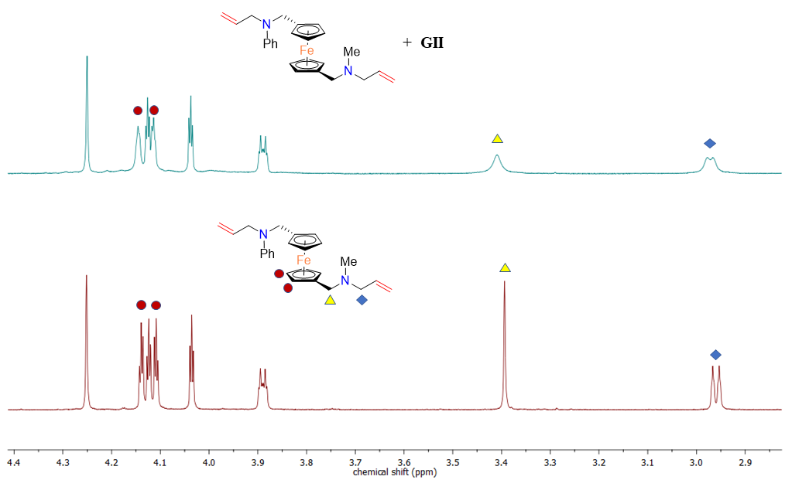
Figure S2: The selected range of ¹H NMR (500 MHz, CDCl₃) spectra of 1g (lower trace) and 1g with 10 mol% of catalyst GII (upper trace). Signals assigned to the aliphatic part of the molecule are marked.

Table S1. Reactions of compound 1f with ruthenium alkylidenes. Metathesis products were not detected under all studied conditions.
Catalyst | Solvent | Temperature [°C] | Additive
GI | C₆H₆ | 20 | -
GII | CH₂Cl₂ | 20 | -
GII | CH₂Cl₂ | 40 | -
GII | C₇H₈ | 80 | -
GII | CH₂Cl₂ | 40 | Ti(O-iPr)₄ []
GII | CH₂Cl₂ | 40 | NaCl []
Grubbs-Hoveyda II | CH₂Cl₂ | 20 | -
Grubbs-Hoveyda II | CH₂Cl₂ | 40 | HCl/Et₂O []
Grubbs-Hoveyda II | CH₂Cl₂ | 40 | Ti(O-iPr)₄ [5]
Grubbs-Hoveyda II | C₇H₈ | 80 | -

X-ray crystal structure determination
Single crystals suitable for X-ray diffraction measurements were grown from n-hexane (1a, 1b) at −70 °C or dichloromethane/n-hexane (2a, 2b, 3b) at 4 °C. Crystals suitable for diffraction experiments were selected under a polarizing microscope and glued with a two-component epoxy resin to cactus needles (1a, 1b and 2a) or mounted on a MiTeGen MicroLoopsTM using a perfluorinated oil (2b and 3b). Diffraction data were collected at room temperature using a Rigaku Oxford Diffraction Gemini A Ultra diffractometer with Mo Kα radiation. CrysAlis^{PRO} software suite was used for controlling diffractometer as well as data collection and reduction. Crystal structures were solved using ShelxT and independent atom model refinements were carried out with ShelxL invoked from Olex2 program [,,]. Crystal structure of compound 2b contained heavily disordered solvent molecules which were impossible to model. Therefore, SQUEEZE procedure implemented in PLATON has been applied []. It revealed two solvent accessible voids with volumes of 435 and 149 Å³ and electron counts of 129 and 55, respectively. The larger void forms channels and might contain three molecules of dichloromethane per asymmetric unit, whereas the smaller one is discreet and may contain a molecule of hexane. Note that this is only tentative proposal of void contents. Single crystals of 2b diffracted X-rays weakly, and the obtained diffraction data are only significantly different from zero to ~1 Å which makes the derivation of any geometrical parameters of the structure impossible. Crystal structure and refinement details are given in Table S4.
CCDC 2222236-2222238 and 2242035-2242036 contain the supplementary crystallographic data for this paper. All the data can be obtained free of charge from The Cambridge Crystallographic Data Centre via https://www.ccdc.cam.ac.uk/structures/. Raw diffraction data are available at https://doi.org/10.5281/zenodo.7330815.
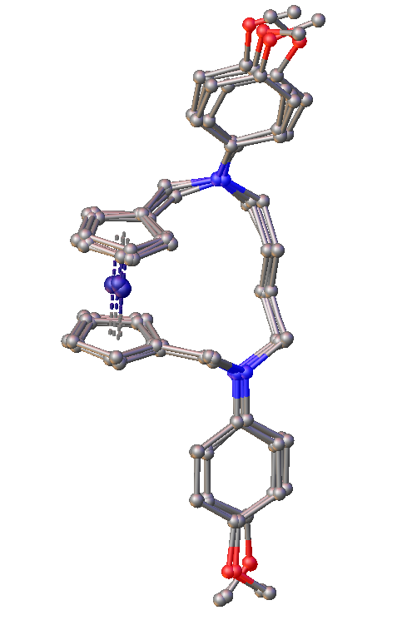
Figure S3: The overlay of four molecules, depicted in a ball-and-stick model, present in the asymmetric unit of compound 2b. Hydrogen atoms are omitted for clarity.

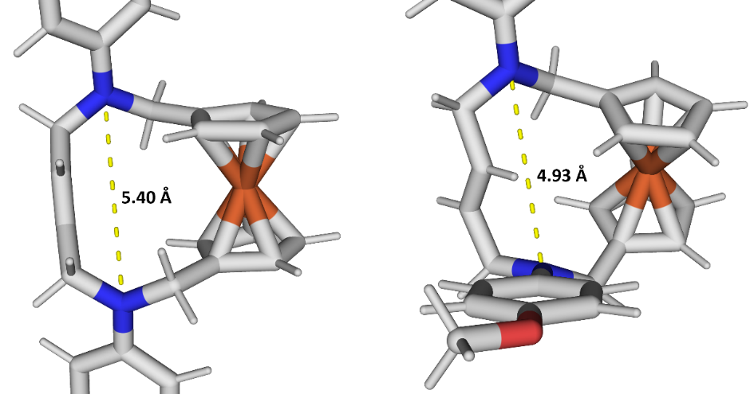
Figure S4: The calculated size of the cavity (defined as the distance between the two nitrogen atoms) in compound 2b for two conformers with different orientations of the aromatic substituents. See below for details of theoretical calculations.

Crystal structures of compound 1a and 1b
Compounds 1a and 1b (see Figure S4 and Figure S5 for molecular structures, respectively) crystallize in centrosymmetric space groups P2₁/c and $P\overline{1}$, respectively. Both molecules lie in special positions, and they exhibit the exact symmetry of the point group $\overline{1}$. Consequently, ferrocene moiety adopts staggered conformation with parallel Cp rings. The nitrogen atom in molecule 1a departs by only 0.0362(15) Å from the plane formed by the three adjacent carbon atoms. Analogous distance in compound 1b of 0.3299(18) Å is significantly larger which points to lower conjugation of the nitrogen lone electron pair with the π electrons of the phenyl ring. This is the result of electron-donating properties of the methoxy group in para position with respect to the nitrogen atom.
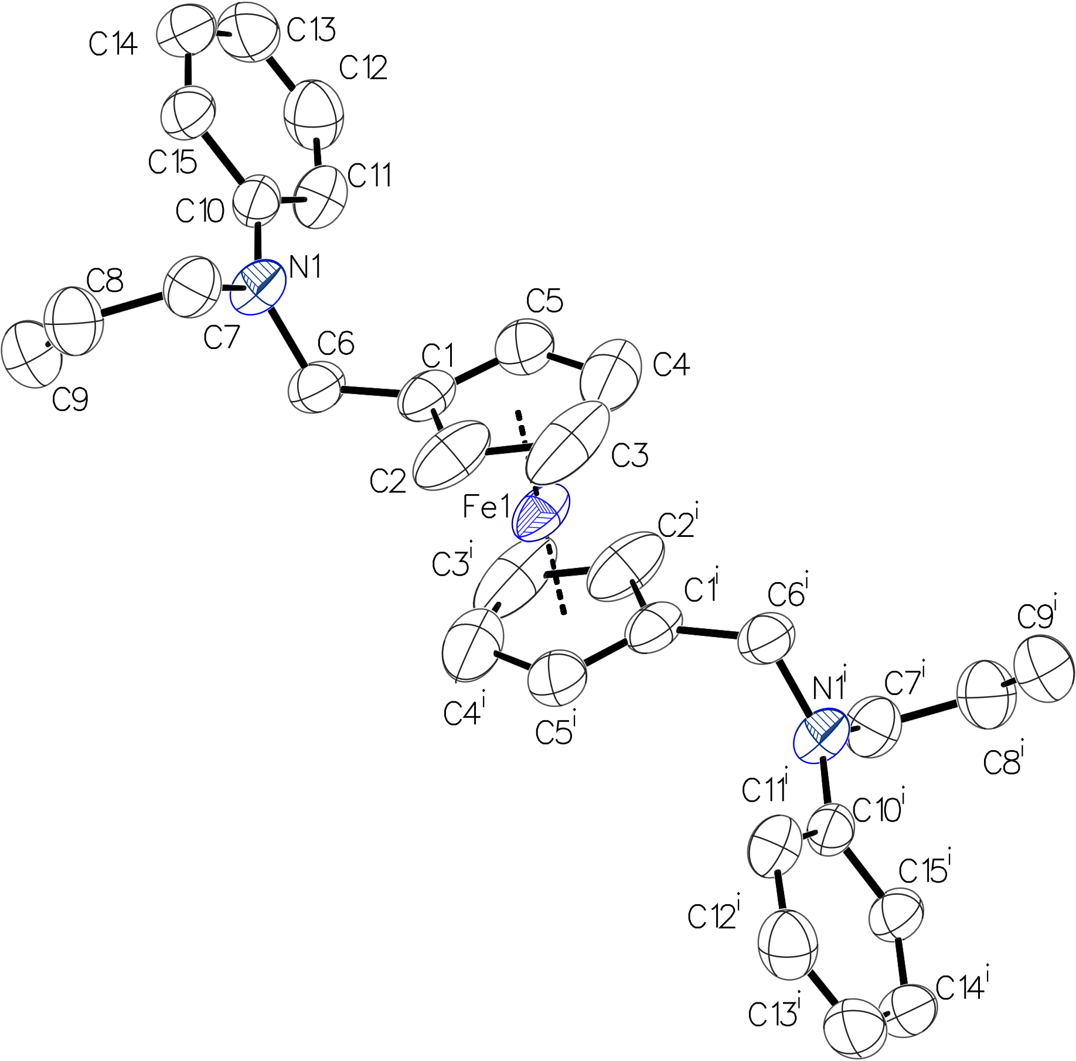
Figure S5: Molecular structure of compound 1a. One molecule from the asymmetric unit shown. Hydrogen atoms omitted for clarity. ADPs shown at the 50% probability level. Symmetry codes ^{i} = 1 − x, −y, 1 – z.
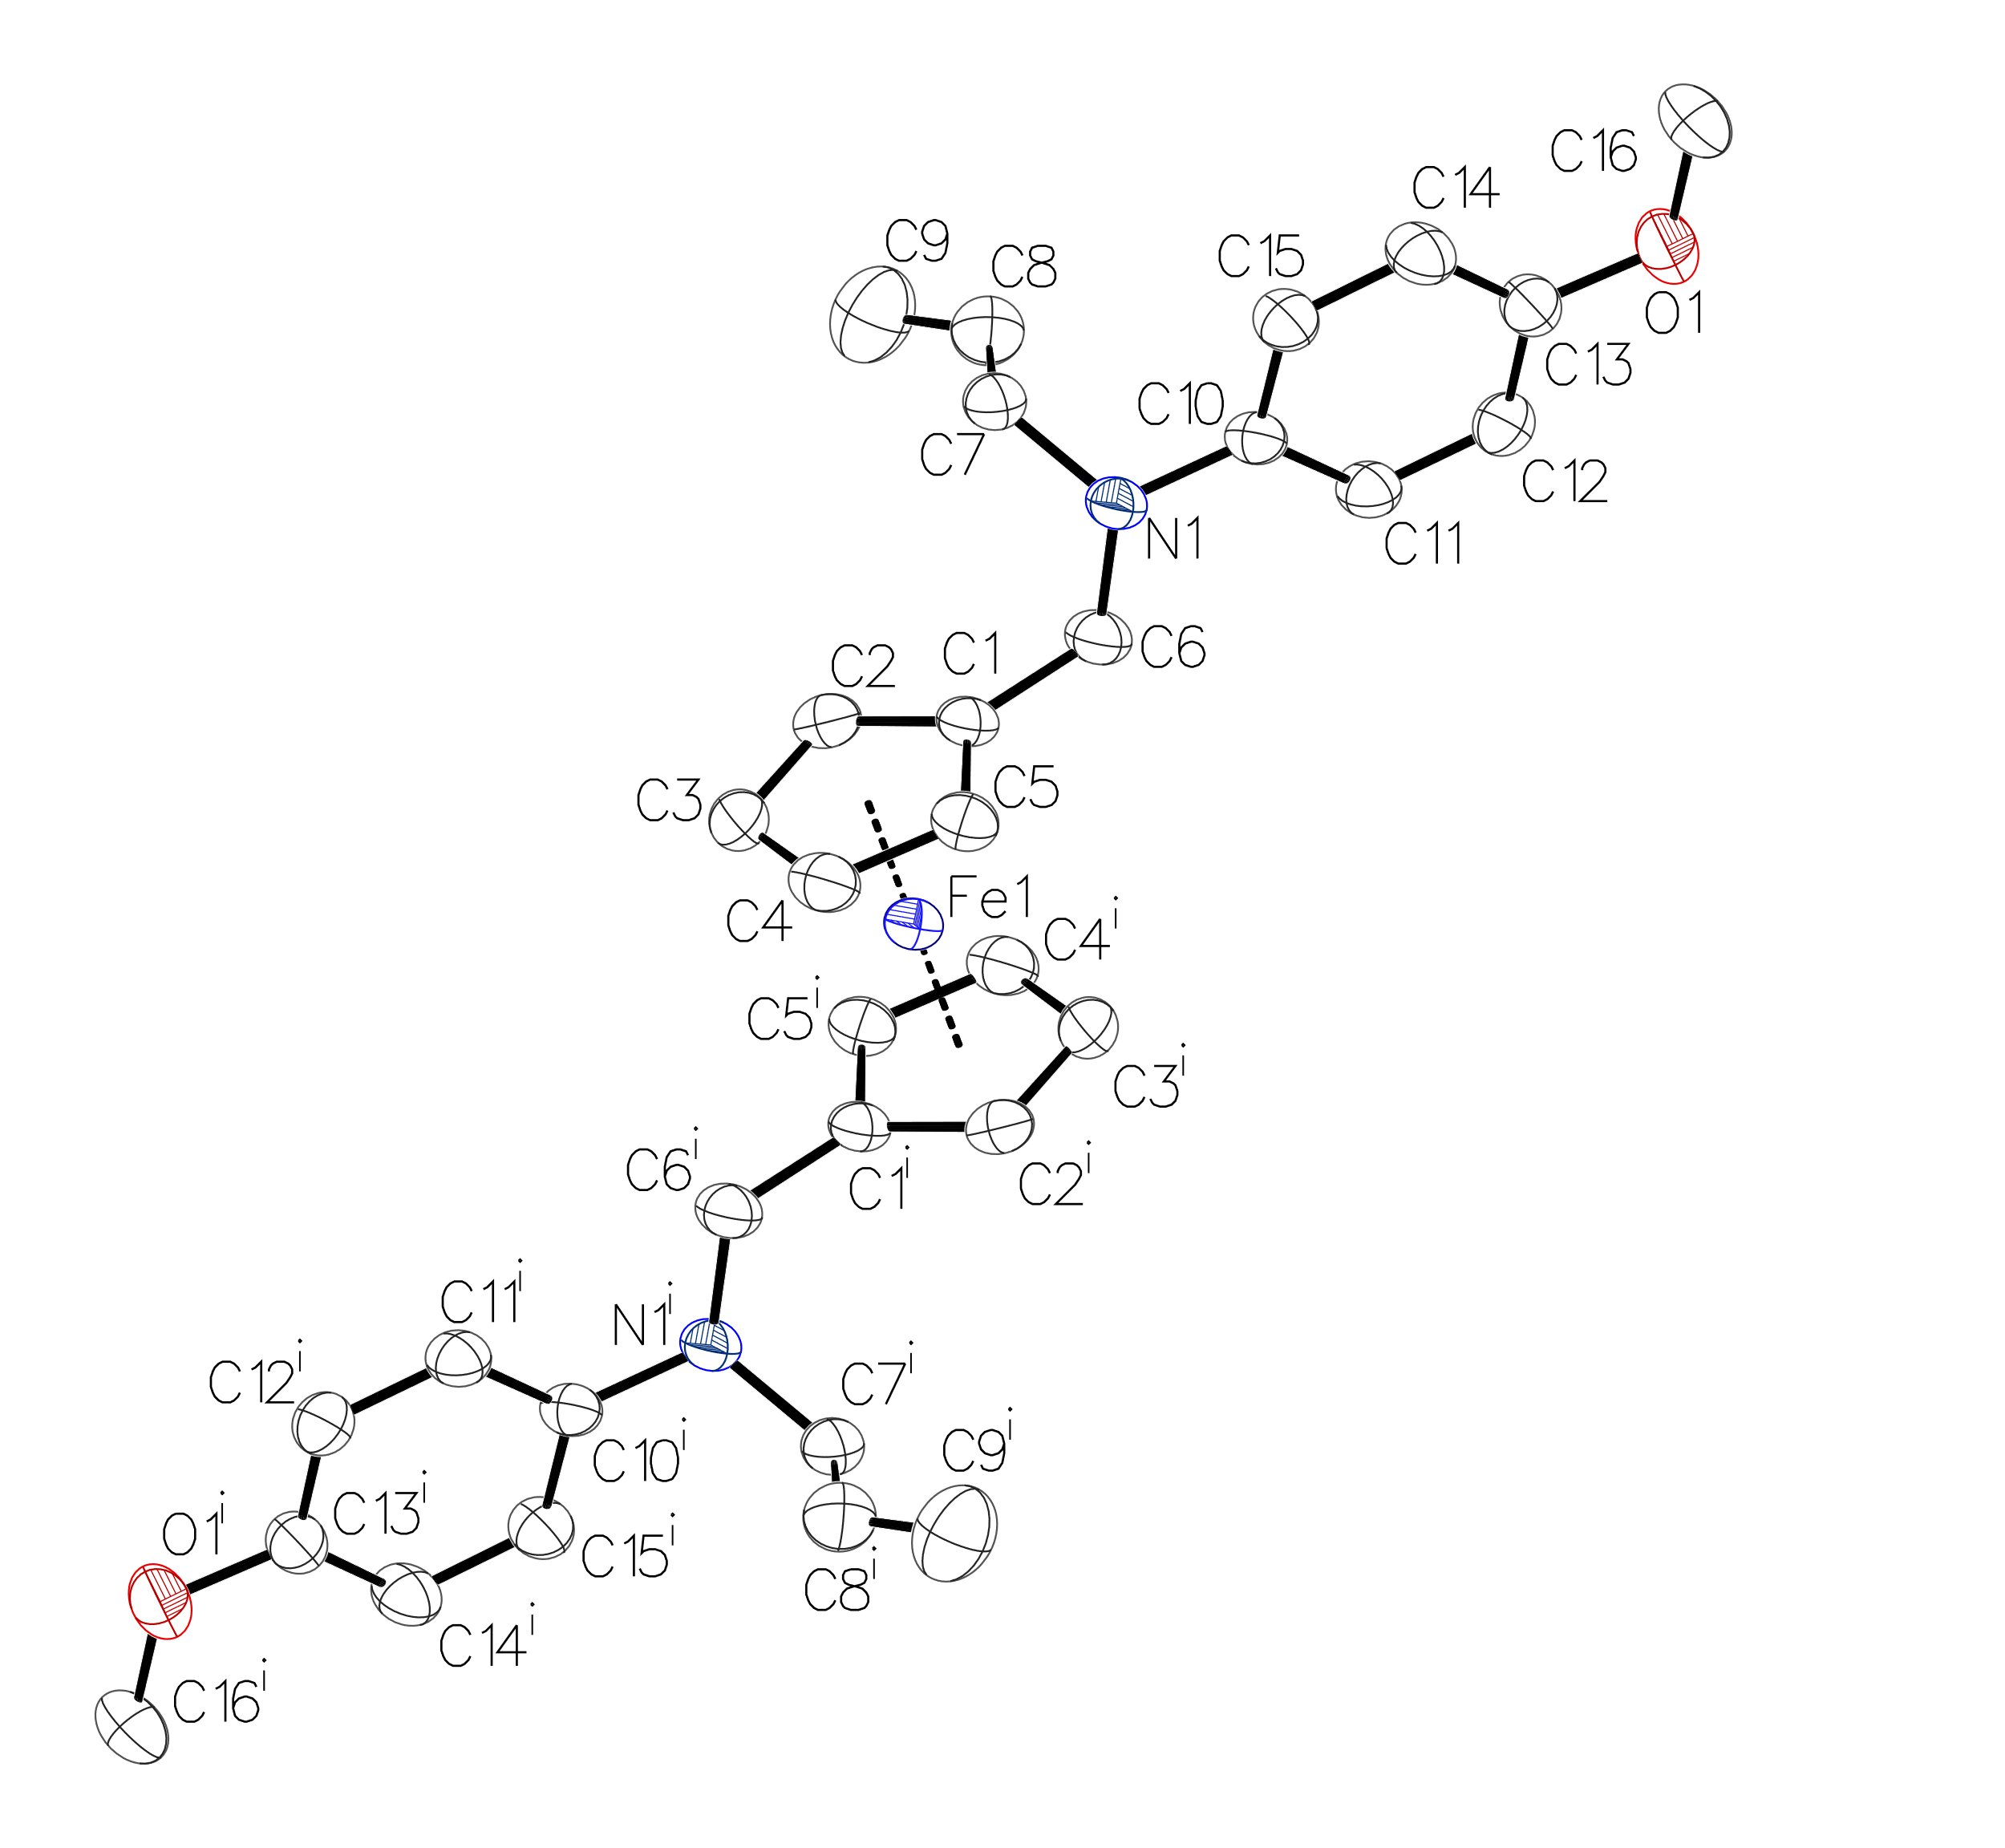
Figure S6: Molecular structure of compound 1b. One molecule from the asymmetric unit shown. Hydrogen atoms omitted for clarity. ADPs shown at the 50% probability level. Symmetry codes ^{i} = 1 − x, −y, – z.

Table S2. The departure of nitrogen atoms from the plane of adjacent carbon atoms in Ångstroms.
 | 1a | 1b | 2a
N1 | 0.0364(16) | 0.330(2) | 0.027(3)
N2 |  |  | 0.057(3)

Table S3. Dihedral angle between planes of cyclopentadienyl rings in degrees.
1a | 1b | 2a | 3b
0 | 0 | 0.99(13) | 9.61(12)

Table S4. Crystal structure and refinement details for compound 1a, 1b, 2a, 2b and 3b.
 | 1a | 1b | 2a | 2b | 3b
CCDC number | 2222237 | 2222238 | 2222236 | 2242035 | 2242036
Molecular formula | C₃₀H₃₂FeN₂ | C₃₂H₃₆FeN₂O₂ | C₂₈H₂₈FeN₂ | C₃₀H₃₂FeN₂O₂ | C₁₉H₁₉FeNO
Formula weight | 476.42 | 536.48 | 448.37 | 508.42 | 333.20
T /K | 293(2) | 293(2) | 293(2) | 293(2) | 293(2)
Crystal system | monoclinic | triclinic | monoclinic | triclinic | orthorhombic
Space group | P2₁/c | $$P\overline{1}$$ | P2₁/c | $P\overline{1}$ | Pbca
a /Å | 10.2946(2) | 8.1888(2) | 13.5944(8) | 9.0866(2) | 19.3669(2)
b /Å | 10.13360(10) | 9.2298(4) | 9.3269(5) | 16.2580(3) | 7.51090(10)
c /Å | 12.3564(3) | 9.9792(5) | 18.0996(10) | 36.9507(9) | 20.7273(3)
α /° | 90 | 74.069(4) | 90 | 88.673(2) | 90
β /° | 104.866(2) | 84.518(3) | 107.951(7) | 87.895(2) | 90
γ /° | 90 | 67.755(4) | 90 | 81.185(2) | 90
V /Å³ | 1245.89(4) | 671.26(5) | 2183.2(2) | 5389.8(2) | 3015.05(7)
Z | 2 | 1 | 4 | 8 | 8
ρ_{calc} /g/cm³ | 1.27 | 1.33 | 1.36 | 1.25 | 1.47
μ/mm⁻¹ | 0.625 | 0.594 | 0.709 | 0.588 | 1.00
F(000) | 504 | 284 | 944 | 2144 | 1392
Crystal size/mm³ | 0.51 × 0.38 × 0.26 | 0.42 × 0.20 × 0.05 | 0.59 × 0.20 × 0.03 | 0.35 × 0.15 × 0.024 | 0.48 × 0.38 × 0.12
Radiation | Mo Kα (λ = 0.71073 Å)
2Θ range for data collection/° | 6.8 to 65.7 | 6.4 to 66.0 | 6.4 to 57.2 | 4.9 to 55.0 | 6.9 to 65.7
Index ranges | −15 ≤ h ≤ 15,  −15 ≤ k ≤ 15,  −18 ≤ l ≤ 18 | −12 ≤ h ≤ 12,  −13 ≤ k ≤ 14,  −14 ≤ l ≤ 15 | −17 ≤ h ≤ 18,  −12 ≤ k ≤ 10,  −23 ≤ l ≤ 19 | −11 ≤ h ≤ 11,  −21 ≤ k ≤ 21,  −47 ≤ l ≤ 47 | −28 ≤ h ≤ 29,  −11 ≤ k ≤ 11,  −31 ≤ l ≤ 29
Reflections collected | 74020 | 30443 | 21873 | 137542 | 85694
Independent reflections | 4514 [R_{int} = 0.0359, R_{sigma} = 0.0149] | 4756 [R_{int} = 0.0540, R_{sigma} = 0.0428] | 5006 [R_{int} = 0.0418, R_{sigma} = 0.0390] | 24739 [R_{int} = 0.1072, R_{sigma} = 0.0921] | 5438 [R_{int} = 0.0372, R_{sigma} = 0.0156]
Data/restraints/parameters | 4514/8/161 | 4756/0/170 | 5006/28/299 | 24739/0/1269 | 5438/0/200
Goodness−of−fit on F² | 1.010 | 1.034 | 1.068 | 0.979 | 1.031
Final R indexes [I≥2σ (I)] | R₁ = 0.0402,  wR₂ = 0.0929 | R₁ = 0.0471,  wR₂ = 0.1077 | R₁ = 0.0488,  wR₂ = 0.1115 | R₁ = 0.0624,  wR₂ = 0.1454 | R₁ = 0.0341,  wR₂ = 0.0818
Final R indexes [all data] | R₁ = 0.0663,  wR₂ = 0.1084 | R₁ = 0.0768,  wR₂ = 0.1226 | R₁ = 0.0859,  wR₂ = 0.1323 | R₁ = 0.1400,  wR₂ = 0.1846 | R₁ = 0.0481,  wR₂ = 0.0897
Largest diff. peak/hole /eÅ⁻³ | +0.29/−0.21 | +0.38/−0.25 | +0.77/−0.46 | +0.41/−0.28 | +0.33/−0.27

Figure S7: VT ¹H NMR (600 MHz, CD₂Cl₂) spectra of 2b (R = 4-MeO-C₆H₄).

Figure S8: (a) ¹H-¹³C HSQC NMR spectrum of 2b (600 MHz, −93 °C, CD₂Cl₂); (b) ¹H-¹³C HSQC NMR spectrum of 2b (600 MHz, −80 °C, toluene-d₈). Cross-peaks for CH₂ are shown in blue; cross-peaks for CH and CH₃ are shown in red.
Theoretical calculations
Methods
Theoretical calculations were performed using Orca 4.0 program []. Molecules were optimized using BP86 method [] with def2-TZVPP basis set [] augmented with def2/J auxiliary basis set []. Unless stated otherwise, the calculations were performed in the presence of the solvent field with the polarizable continuum model (PCM) using the CPCM polarizable conductor calculation model []. The parameters of toluene were used. The starting geometries were adopted from the crystal structure or manually modified in the Avogadro program [], if crystal data was not available. Following geometry optimization, the vibrational frequencies were calculated, and the results showed that optimized structures are stable geometric structures (no imaginary frequencies). Gibbs free energies at 25 °C and –80 °C were obtained from the frequency calculations. NMR shieldings of ¹H nuclei were calculated using default settings. In this method, the chemical shifts are calculated for rigid molecules in their lowest energy geometry. An optimized toluene molecule was used as a reference to calculate chemical shifts (shielding of the proton in para position was used as a reference).
Geometry scan: The scan was done using BP86 method [13] and def2-TZVP basis set [14], augmented with def2/J auxiliary basis set [15], with RI approximation [], without a solvation model. The atoms (1, 2, 3, 4) defining the dihedral angle subjected to the scan are shown in Figure S7. During the scan procedure, the molecule was optimized with the following dihedral angle values constrained: 0, –30, –60, –90, –110, –111, –112, –113, –114, –115, –120, –125, –130°. The bond length between atoms 2 and 3 (Figure S8) was computed for every scanned conformation. The conformation with the biggest bond length (conformation D, dihedral angle: –113°) was subjected to Gibbs free energy calculation and NMR shielding prediction.
Figure S9: Schematic representation of compound 2b with the dihedral angle subjected to the scan shown in red. The dashed line represents the rest of the molecule.
To get further insight into the dynamic processes that could account for the observed coalescence of signals on the VT NMR spectra, four possible conformations of compound 2b were considered (Figure S10). In conformation A, both phenyl rings were directed outside the cavity of the compound. This conformation was found in the crystal structure. In conformation B, one of the phenyl rings was directed towards the cavity. In conformation C, both rings were directed towards the cavity. Conformation D was derived from conformation A by rotating one of the phenyl rings, thus minimizing its conjugation with the lone electron pair on the adjacent N atom. This conformation was unstable and it was generated via a geometry scan. It was meant to illustrate the ring rotation that takes place in a solution.
Figure S10: The generated conformations of compound 2b. Conformation D was derived from conformation A by rotating the aromatic ring shown in cyan.
In each conformation, the 11-membered ring of compound 2b was in a conformation analogous to the chair conformation of cyclohexane. In conformation A, both aromatic rings were in pseudoequatorial positions. In conformation B, one of the aromatic rings was in pseudoaxial position, and the other was in pseudoequatorial position. In conformation C, both aromatic rings were in pseudoaxial positions.
Relative energies of conformations A, B, C and D were calculated (Table S5). The energy of the conformations increased in the order: E(A) < E(B) < E(C), that is the conformations with substituents in pseudoaxial positions had higher energies. Consequently, this behaviour was analogous to the behaviour of cyclohexane derivatives. Conformation B had large entropy and its concentration significantly increased with the temperature. At 25 °C, approximately 2% of compound 2b could be present in this form. According to these calculations, conformations C and D are unlikely to be present in a solution in large amounts.
Table S5. Predicted relative free Gibbs energies of four conformations of compound 2b at −80 °C and 25 °C.
Conformation | ΔG⁰ [kJ/mol]
 | −80 °C | 25 °C
A | 0 | 0
B | +13.1 | +9.9
C | +28.4 | +28.7
D | +16.3 | +15.6

The predicted NMR shifts of protons in each conformation were calculated. The protons that display considerable broadening or decoalescene at low temperature are of particular interest. The chemical shifts of these protons are shown on Figure S11.
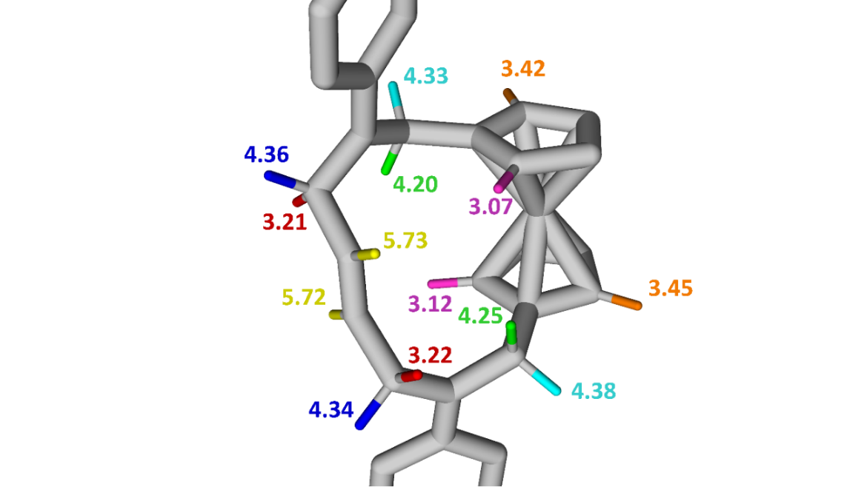
Figure S11: The predicted chemical shifts (in ppm) for selected protons in 2b (conformation A).

The predicted proton shifts in conformations A, B and C were generally similar. Therefore, it is unlikely that these conformations are the cause of shift changes observed at low temperatures. The complete list of calculated proton NMR chemical shifts for each conformation is shown on Figures S12-S15.

proton δ [ppm]
35 3.071
36 3.523
37 3.450
38 3.424
39 5.732
40 5.724
41 3.117
42 3.497
43 3.421
44 3.446
45 5.829
46 6.259
47 6.546
48 6.519
49 6.485
50 6.454
proton δ [ppm]
51 6.357
52 5.931
53 4.378
54 4.195
55 3.214
56 4.359
57 3.216
58 4.336
59 4.325
60 4.253
61 3.152
62 3.481
63 3.140
64 3.490
65 3.185
66 3.198

Figure S12: The predicted chemical shifts for all protons of in compound 2b (conformation A).

proton δ [ppm]
35 2.828
36 3.746
37 3.458
38 3.505
39 5.698
40 5.818
41 3.818
42 3.623
43 3.495
44 3.594
45 6.236
46 6.456
47 6.637
48 6.718
49 6.259
50 6.308
proton δ [ppm]
51 6.337
52 6.216
53 4.098
54 3.944
55 3.625
56 4.239
57 3.009
58 3.976
59 3.258
60 4.434
61 3.253
62 3.535
63 3.236
64 3.496
65 3.175
66 3.171

Figure S13: The predicted chemical shifts for all protons of in compound 2b (conformation B).

proton δ [ppm]
35 3.010
36 3.583
37 3.465
38 3.619
39 6.376
40 5.475
41 2.932
42 2.943
43 3.341
44 3.398
45 6.410
46 6.480
47 6.605
48 6.573
49 6.588
50 6.517
proton δ [ppm]
51 6.550
52 6.233
53 4.297
54 3.319
55 3.364
56 4.141
57 3.560
58 4.262
59 4.124
60 3.650
61 3.245
62 3.540
63 3.258
64 3.571
65 3.296
66 3.258

Figure S14: The predicted chemical shifts for all protons of in compound 2b (conformation C).

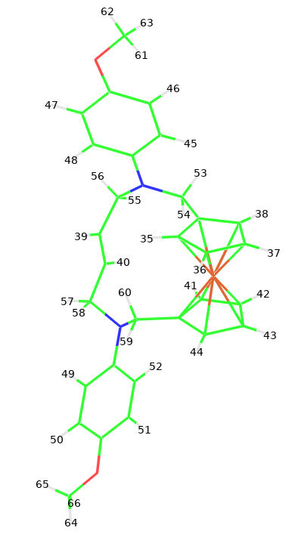
proton δ [ppm]
35 2.958
36 3.432
37 3.373
38 3.462
39 5.758
40 5.777
41 3.680
42 3.703
43 3.214
44 3.154
45 5.844
46 6.227
47 6.549
48 6.530
49 7.148
50 6.621
proton δ [ppm]
51 6.474
52 6.672
53 4.419
54 4.366
55 3.281
56 4.226
57 3.300
58 2.965
59 3.193
60 4.505
61 3.184
62 3.487
63 3.137
64 3.596
65 3.292
66 3.249

Figure S15: The predicted chemical shifts for all protons of in compound 2b (conformation D).

References

. Correa, A.; Tellitu, I.; Domínguez, E.; SanMartin, R. J. Org. Chem. 2006, 71, 8316–8319.
. Cadogan, J. I. G.; Hickson, C. L.; McNab, H. J. Chem. Soc. Perkin Trans. I 1985, 1885–1889.
. Mazur, M.; Ziemkiewicz, K.; Rawiak, K.; Kisiel, K.; Wińska, P.; Deresz, K.; Jarzembska, K. N.; Buchowicz, W. Eur. J. Inorg. Chem. 2022, e202101098.
. Abdel-Magid, A. F.; Carson, K. G.; Harris, B. D.; Maryanoff, C. A.; Shah, R. D. J. Org. Chem. 1996, 61, 3849–3862.
. For examples of Ti(O-iPr)₄ assisted ruthenium-catalyzed olefin metathesis, see: (a) Fürstner, A.; Langemann, K. J. Am. Chem. Soc. 1997, 119, 9130–9136. (b) Yang, Q.; Xiao, W.-J.; Yu, Z. Org. Lett., 2005, 7, 871–874. (d) Au, C. W. G.; Pyne, S. J. J. Org. Chem. 2006, 71, 7097–7099. (d) Miller, B.; Mao, S.; Rosenker, K. M. G.; Pierce, J. G.; Wipf, P. Beilstein J. Org. Chem. 2012, 8, 1091–1097.
. For successful olefin metathesis in the presence of NaCl, see: Foster, J. C.; Grocott, M. C.; Arkinstall, L. A.; Varlas, S.; Redding, M. J.; Grayson, S. M.; O’Reilly, R. K. J. Am. Chem. Soc. 2020, 142, 13878−13885.
. For olefin metathesis of amine hydrochlorides, see (a) Fu, G. C.; Nguyen, S. T.; Grubbs, R. H. J. Am. Chem. Soc. 1993, 115, 9856−9857. (b) Hong, S. H.; Grubbs, R. H. J. Am. Chem. Soc. 2006, 128, 3508−3509. (c) Skowerski, K.; Szczepaniak, G.; Wierzbicka, C.; Gułajski, Ł.; Bieniek, M.; Grela, K. Catal. Sci. Technol. 2012, 2, 2424−2427.
. Sheldrick, G. Acta Crystallogr. Sect. A 2015, 71, 3–8.
. Sheldrick, G. Acta Crystallogr. Sect. C 2015, 71, 3–8.
. Dolomanov, O. V.; Bourhis, L. J.; Gildea, R. J. ; Howard, J. A. K.; Puschmann, H. J. Appl. Crystallogr. 2009, 42, 339–341.
. Spek, A. L. Acta Crystallogr. Sect. C 2015, 71, 9–18.
. Neese, F.; Wennmohs, F.; Becker, U.; Riplinger, C. J. Chem. Phys. 2020, 152, 224108.
. Becke, A. D. Phys. Rev. A 1988, 38, 3098–3100.
. Weigend, F.; Ahlrichs, R. Phys. Chem. Chem. Phys. 2005, 7, 3297.
. Weigend, F. Phys. Chem. Chem. Phys. 2006, 8, 1057.
. Tomasi, J.; Mennucci, B.; Cammi, R. Chem. Rev. 2005, 105, 2999–3094.
. Hanwell, M. D.; Curtis, D. E.; Lonie, D. C.; Vandermeersch, T.; Zurek, E.; Hutchison, G. R. J. Cheminformatics 2012, 4, 17.
. Dunlap, B. I.; Connolly, J. W. D.; Sabin, J. R. J. Chem. Phys. 1979, 71, 3396–3402.
. This was calculated using the Van ‘t Hoff equation.

