**SUPPLEMENTARY MATERIAL**

**Cytotoxicity and molecular docking analysis of new** **sesquiterpenoids from the leaves of** ***Datura stramonium* L.**

Juan Pan, Yan Liu, Ao-Fei Wang, Jia-Tong Wu, Rui Yang, Wei Guan, Adnan Mohammed Algradi, Hai-Xue Kuang* and Bing-You Yang*

*Key Laboratory of Basic and Application Research of Beiyao (Heilongjiang University of Chinese Medicine), Ministry of Education; Harbin 150040, P.R. China*

* Corresponding authors

Hai-xue Kuang, Email: hxkuang@yahoo.com, Tel.: +86-451-87267188;

Bing-you Yang, Email: ybywater@163.com, Tel.: +86-451-82193007.

|  |  |
| --- | --- |
| **Table of Contents** |  |
| **Figure S1**. HR-ESI-MS spectrum of **1**. | **Figure S30**. NOESY spectrum of **3**. |
| **Figure S2**. 1H NMR spectrum of **1**. | **Figure S31**. UV spectrum of **3**. |
| **Figure S3**. 13C NMR spectrum of **1**. | **Figure S32**. CD spectrum of **3** |
| **Figure S4**. DEPT 135 spectrum of **1**. | **Figure S33**. IR spectrum of **3** |
| **Figure S5**. HSQC spectrum of **1**. | **Figure S34**. HR-ESI-MS spectrum of **4.** |
| **Figure S6**. 1H-1H COSY spectrum of **1**. | **Figure S35**. 1H NMR data of compounds **4** |
| **Figure S7**. HMBC spectrum of **1**. | **Figure S36**. 13C NMR spectrum of **4**. |
| **Figure S8**. NOESY spectrum of **1**. | **Figure S37.** DEPT 135 spectrum of **4**. |
| **Figure S9**. UV spectrum of **1**. | **Figure S38**. HSQC spectrum of **4**. |
| **Figure S10**. CD spectrum of **1**. | **Figure S39**. 1H-1H COSY spectrum of **4**. |
| **Figure S11**. IR spectrum of **1**. | **Figure S40**. HMBC spectrum of **4**. |
| **Figure S12**. HR-ESI-MS spectrum of **2**. | **Figure S41**. NOESY spectrum of **4**. |
| **Figure S13**. 1H NMR spectrum of **2**. | **Figure S42**. UV spectrum of **4**. |
| **Figure S14**. 13C NMR spectrum of **2**. | **Figure S43**. CD spectrum of **4** |
| **Figure S15**. DEPT 135 spectrum of **2**. | **Figure S44**. IR spectrum of **4** |
| **Figure S16**. HSQC spectrum of **2**. | **Figure S45**. HR-ESI-MS spectrum of **5**. |
| **Figure S17**. 1H-1H COSY spectrum of **2**. | **Figure S46**. 1H NMR spectrum of **5**. |
| **Figure S18**. HMBC spectrum of **2**. | **Figure S47** 13C NMR spectrum of **5**. |
| **Figure S19**. NOESY spectrum of **2**. | **Figure S48**. DEPT 135 spectrum of **5**. |
| **Figure S20**. UV spectrum of **2**. | **Figure S49**. HSQC spectrum of **5**. |
| **Figure S21**. CD spectrum of **2** | **Figure S50**. 1H-1H COSY spectrum of **5**. |
| **Figure S22**. IR spectrum of **2** | **Figure S51**. HMBC spectrum of **5**. |
| **Figure S23**. HR-ESI-MS spectrum of **3**. | **Figure S52**. NOESY spectrum of **5**. |
| **Figure S24**. 1H NMR spectrum of **3**. | **Figure S53** UV spectrum of **5**. |
| **Figure S25**. 13C NMR spectrum of **3**. | **Figure S54**. CD spectrum of **5** |
| **Figure S26**. DEPT 135 spectrum of **3**. | **Figure S55**. IR spectrum of **5** |
| **Figure S27**. HSQC spectrum of **3**. | **Figure S56**. GC chromatogram of the sugars of **1-3**. |
| **Figure S28** 1H-1H COSY spectrum of **3**. | **Table S57**.13C NMR data of compounds **6-8** |
| **Figure S29**. HMBC spectrum of **3**. |  |

**Figure S1**. HR-ESI-MS spectrum of **1**.



**Figure S2**. 1H NMR spectrum of **1**.

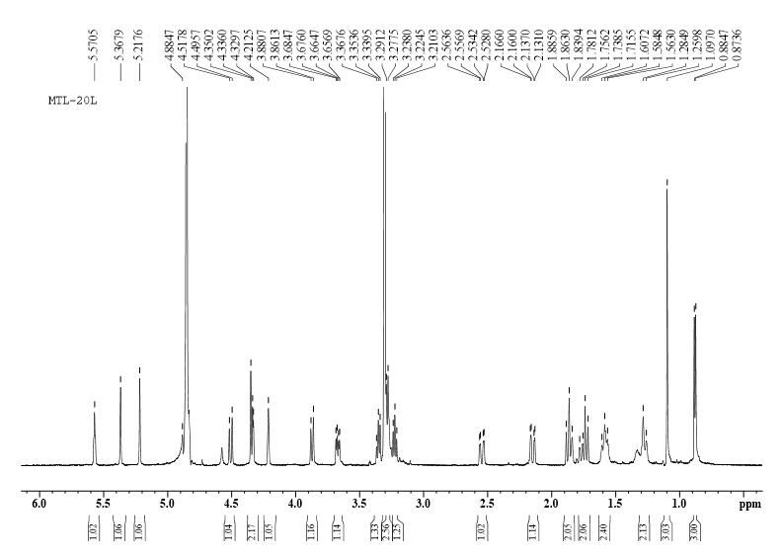

**Figure S3**. 13C NMR spectrum of **1**.

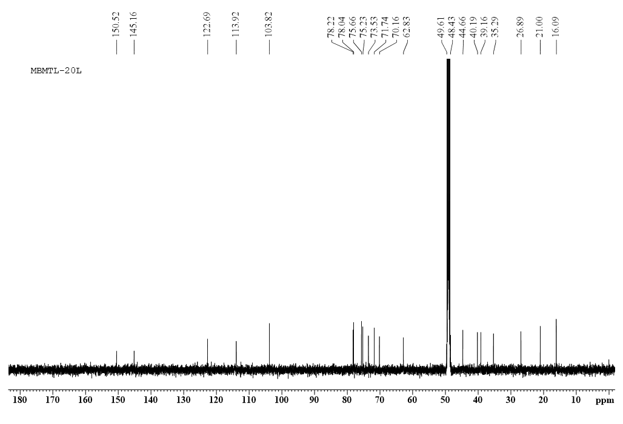

**Figure S4**. DEPT 135 spectrum of **1**.

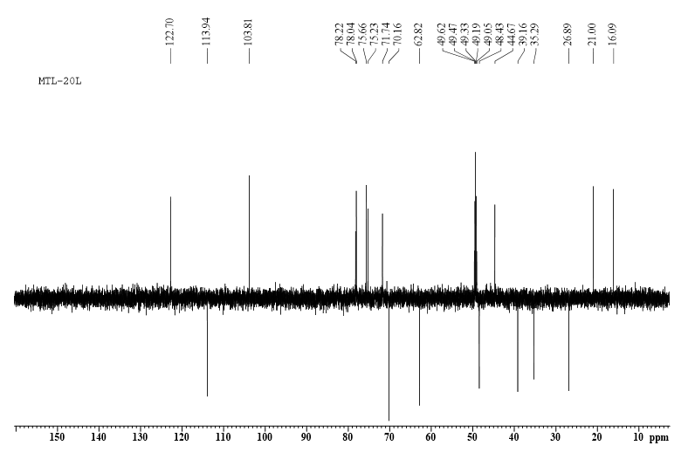

**Figure S5**. HSQC spectrum of **1**.

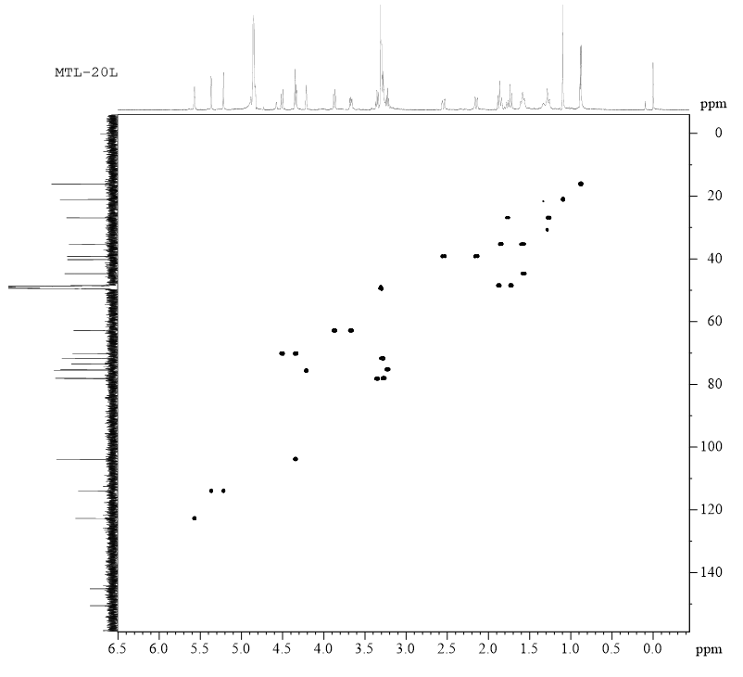

**Figure S6.** 1H-1H COSY spectrum of **1.**

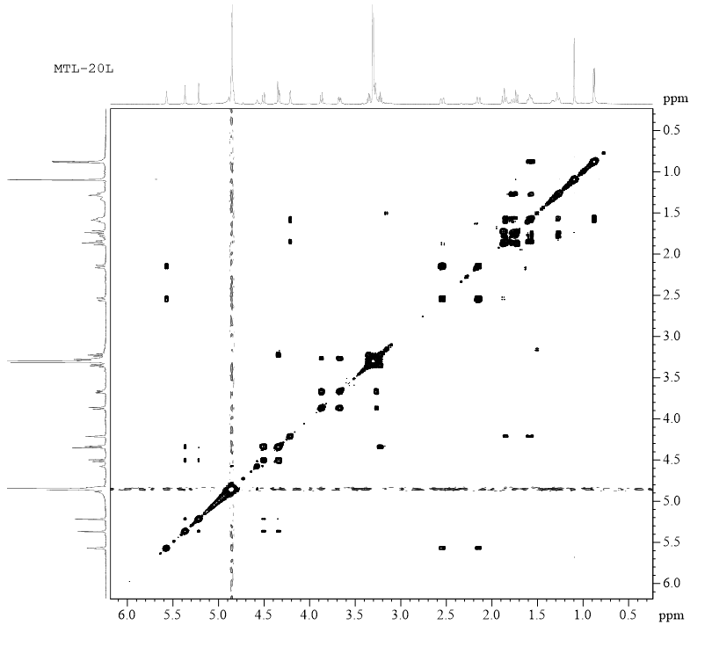

**Figure S7.** HMBC spectrum of **1.**

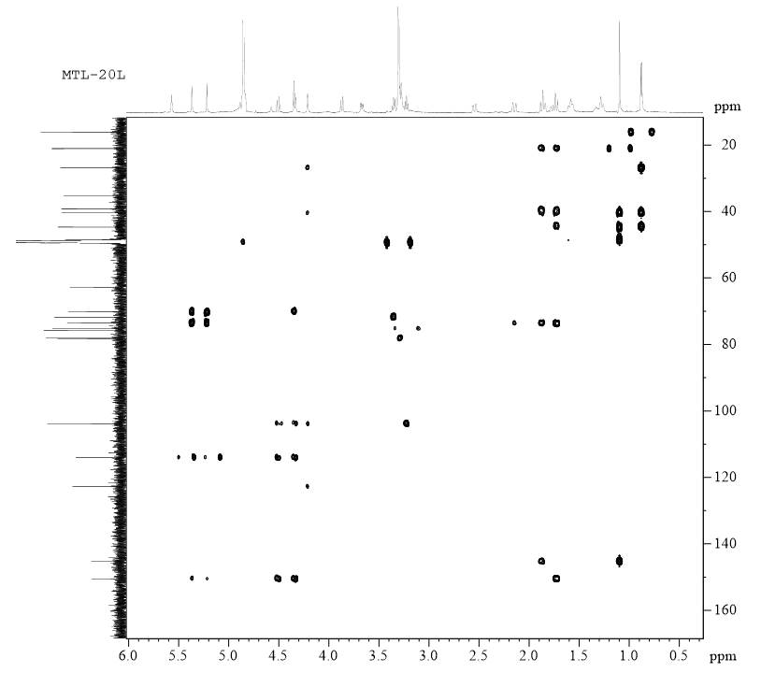

**Figure S8**. NOESY spectrum of **1**.

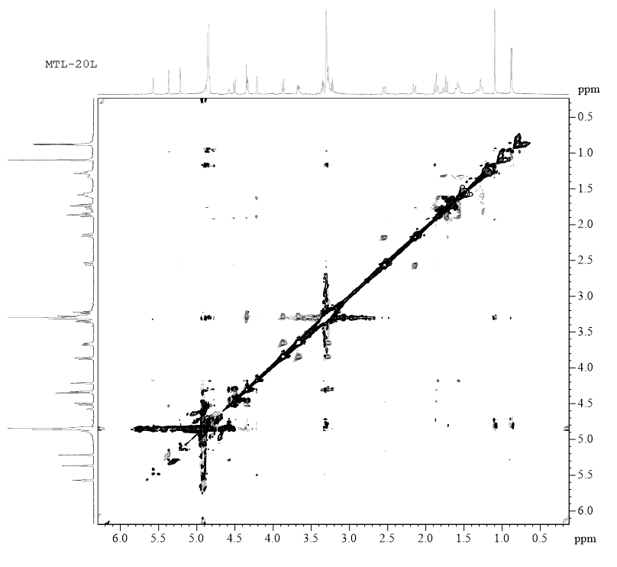

**Figure S9**. UV spectrum of **1**.



**Figure S10**.CD spectrum of **1**.



**Figure S11**. IR spectrum of **1**.



**Figure S12.** HR-ESI-MS spectrum of **2.**



**Figure S13.** 1H NMR spectrum of **2**.

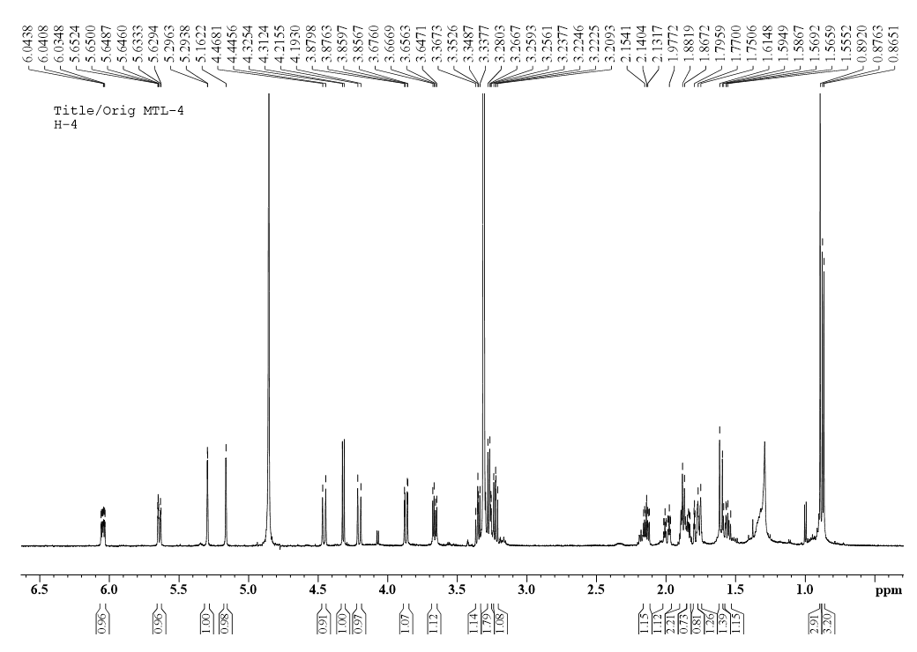

**Figure S14.** 13C NMR spectrum of **2**.

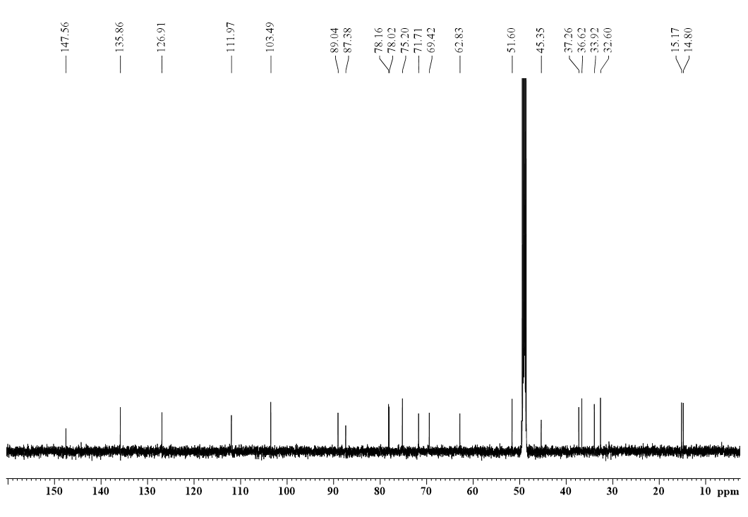

**Figure S15.** DEPT 135 spectrum of **2**.

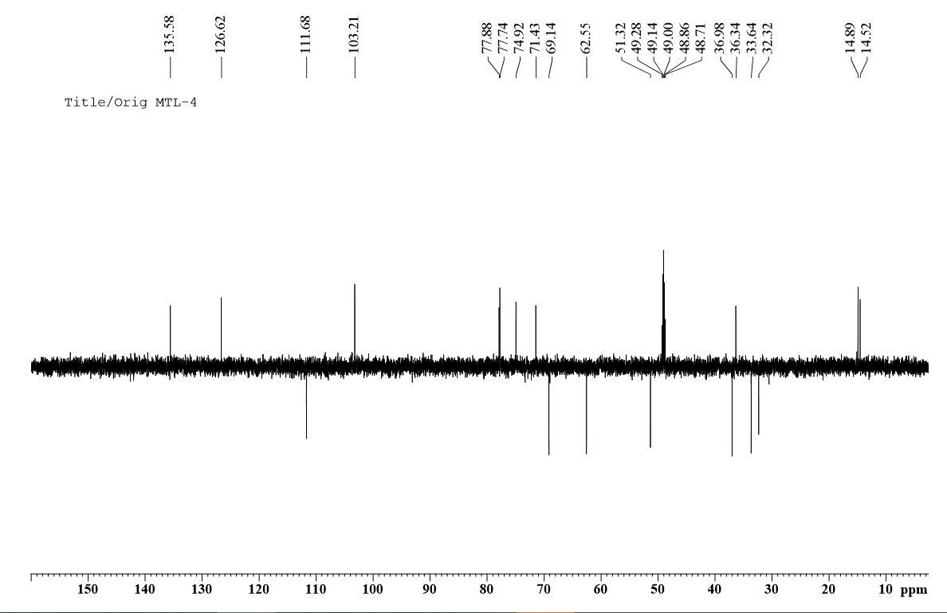

**Figure S16.** HSQC spectrum of **2**.

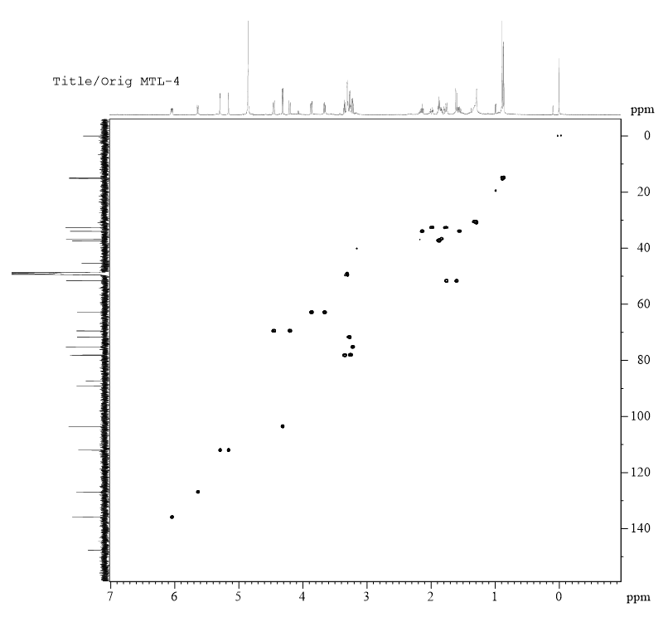

**Figure S17.** 1H-1H COSY spectrum of **2**.

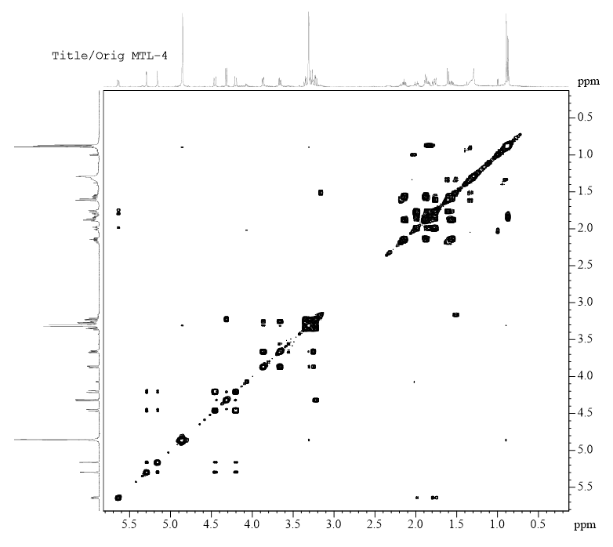

**Figure S18.** HMBC spectrum of **2**.

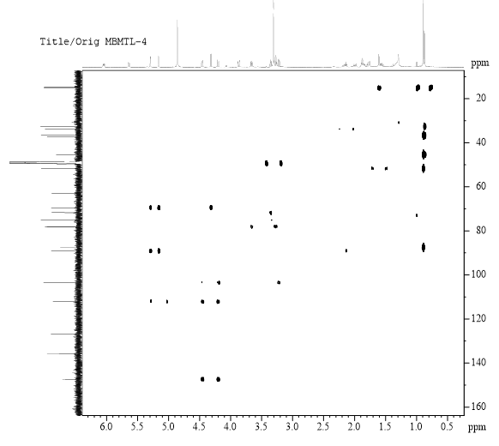

**Figure S19.** NOESY spectrum of **2**.

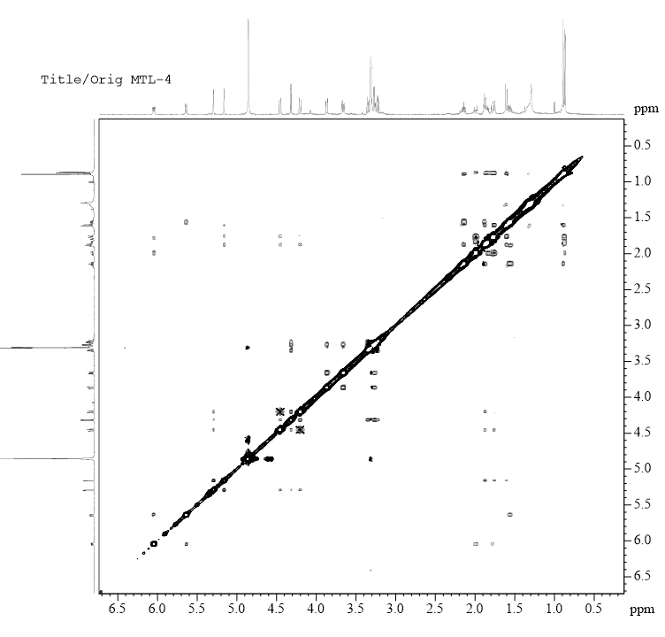

**Figure S20**. UV spectrum of **2**.



**Figure S21**. CD spectrum of **2**.



**Figure S22.** IR spectrum of **2**



**Figure S23**. HR-ESI-MS spectrum of **3**.



**Figure S24**. 1H NMR spectrum of **3**.

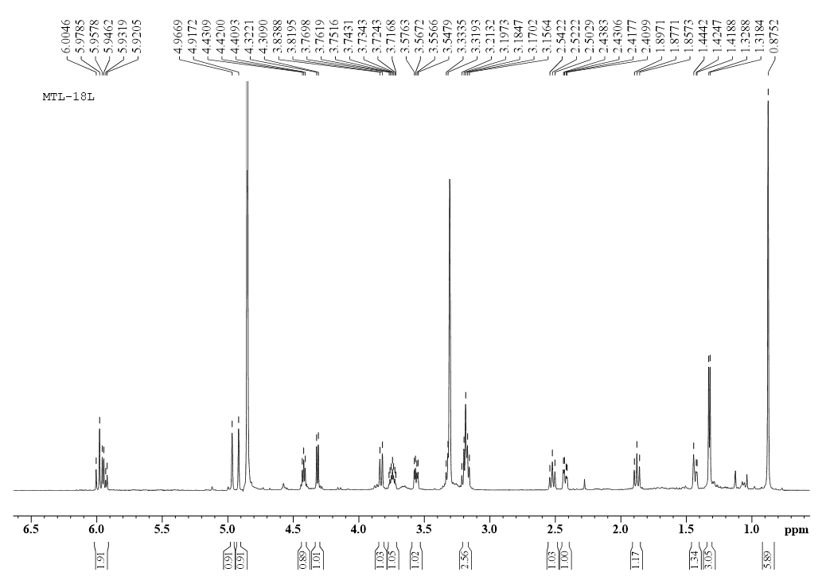

**Figure S25**. 13C NMR spectrum of **3**

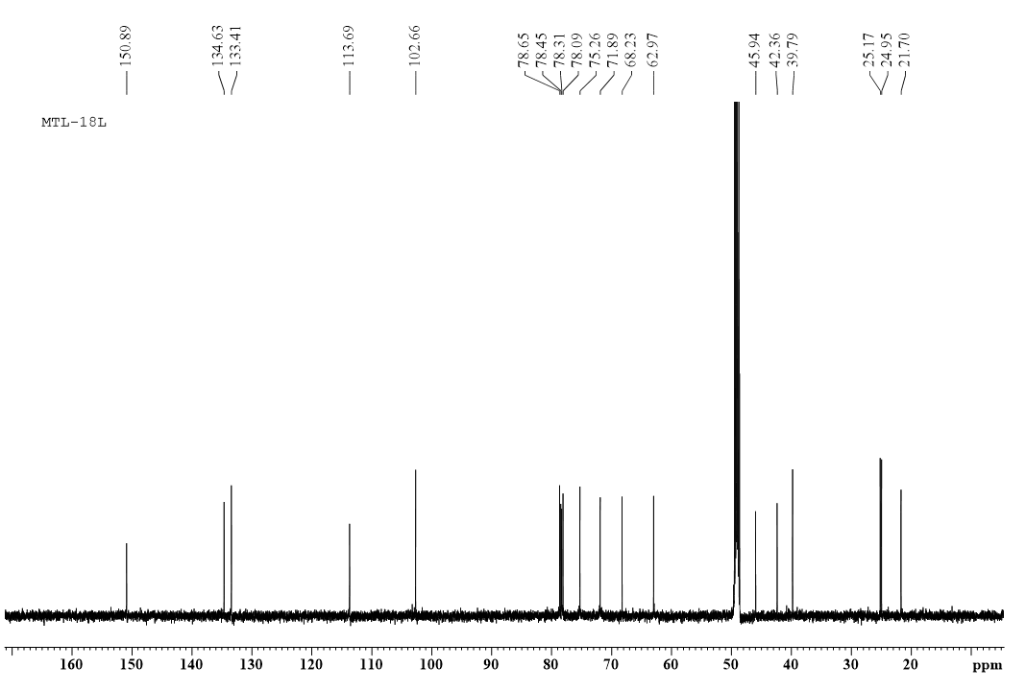 **Figure S26**. DEPT 135 spectrum of **3**.

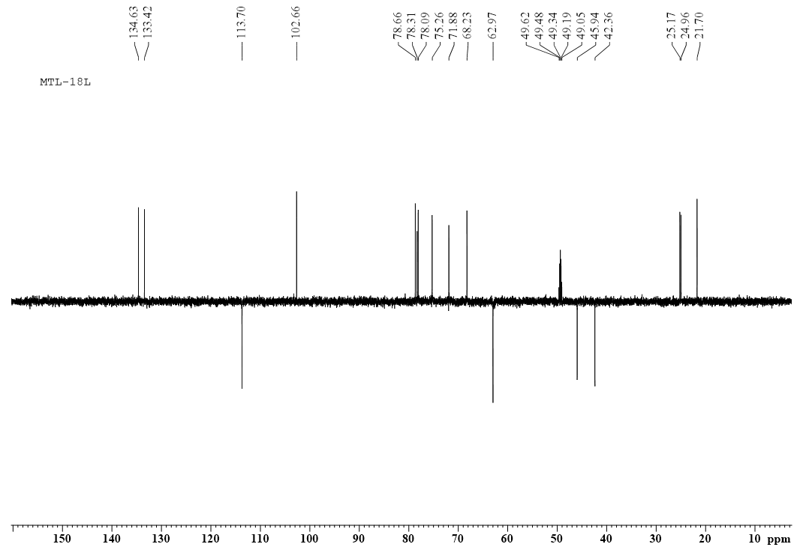

**Figure S27**. HSQC spectrum of **3**.

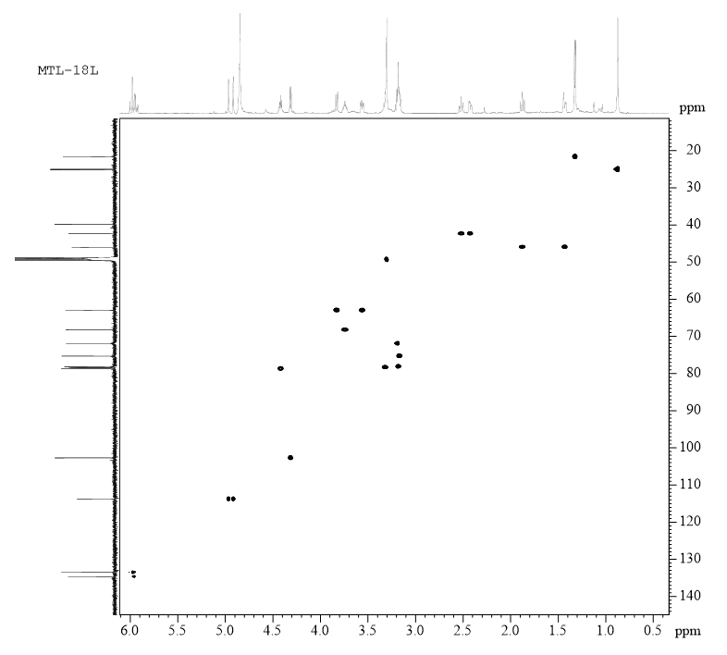

**Figure S28**. 1H-1H COSY spectrum of **3**.

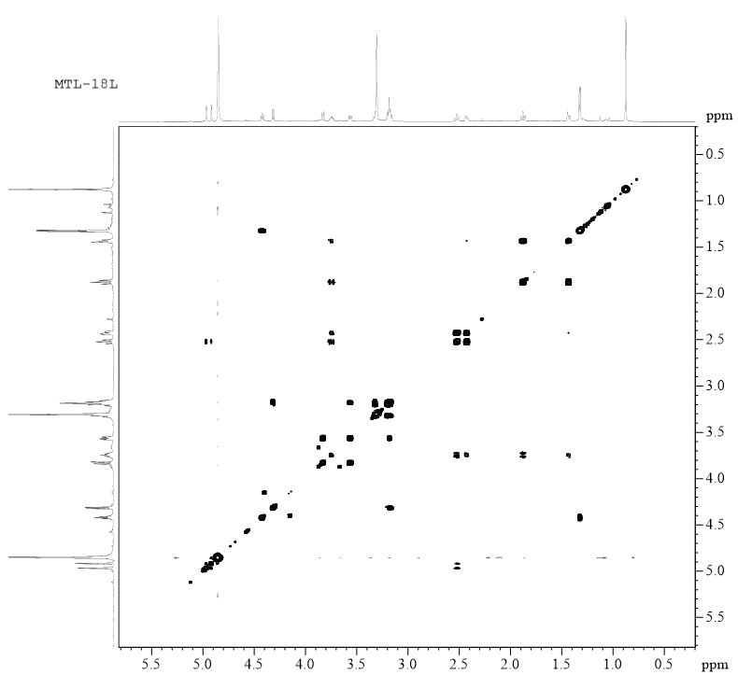

**Figure S29**. HMBC spectrum of **3**.

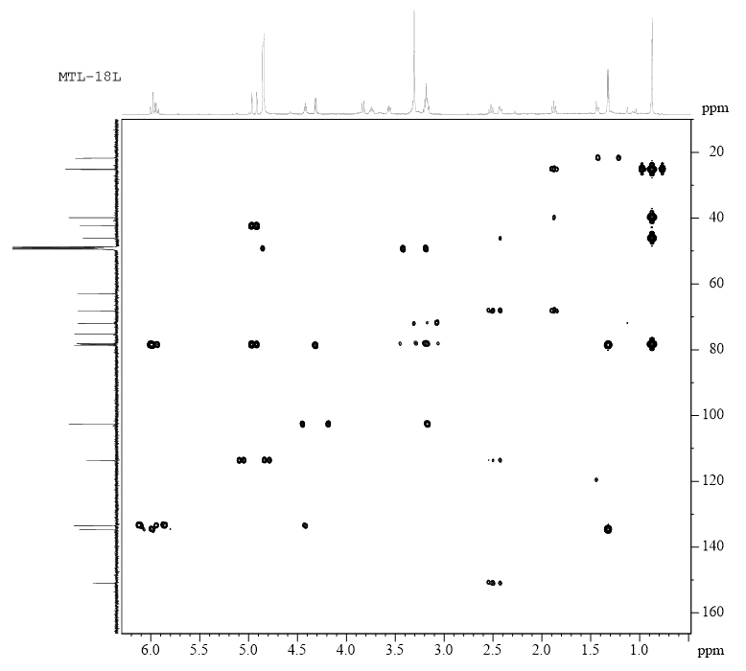

**Figure S30**. NOESY spectrum of **3**.

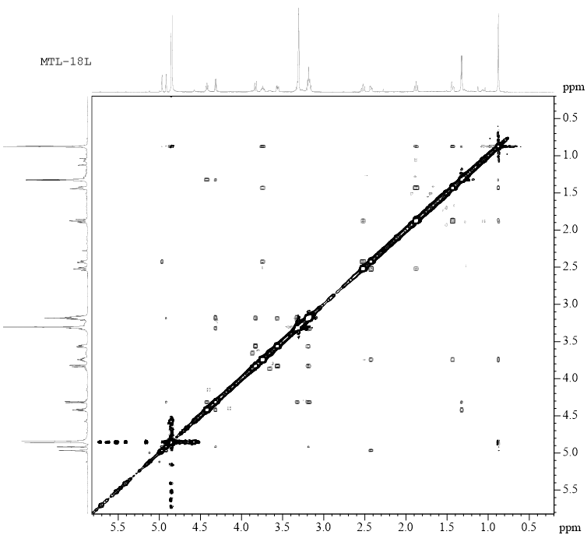

**Figure S31**. UV spectrum of **3**.



**Figure S32**. CD spectrum of **3**.



**Figure S33**. IR spectrum of **3**.



**Figure S34**. HR-ESI-MS spectrum of **4**.



**Figure S35**. 1H NMR spectrum of **4**.

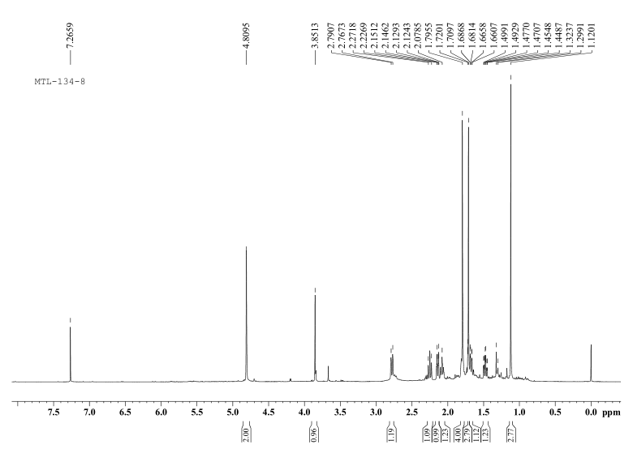

**Figure S36**. 13C NMR spectrum of **4**.

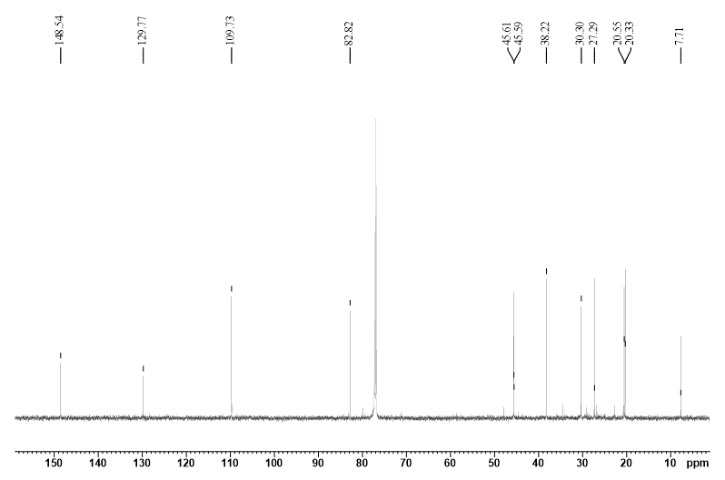 **Figure S37**. DEPT 135 spectrum of **4**.

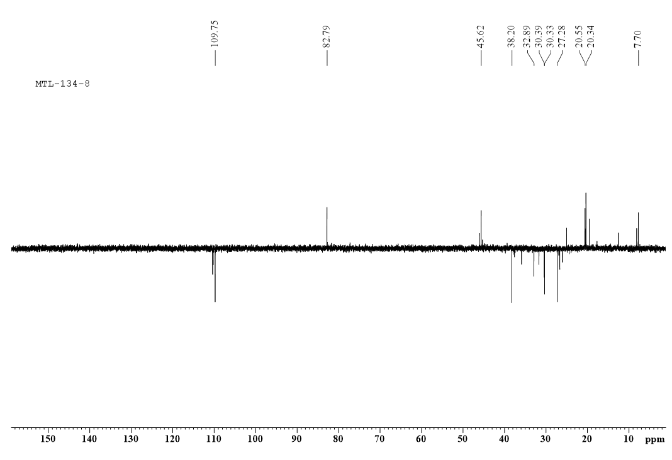

**Figure S38**. HSQC spectrum of **4**.

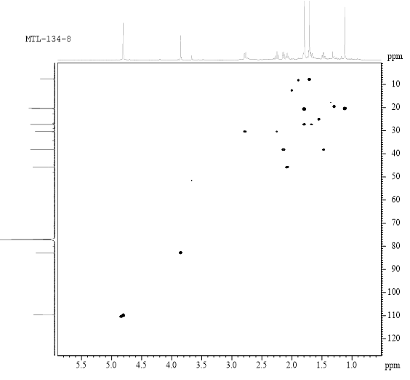

**Figure S39**. 1H-1H COSY spectrum of **4**.

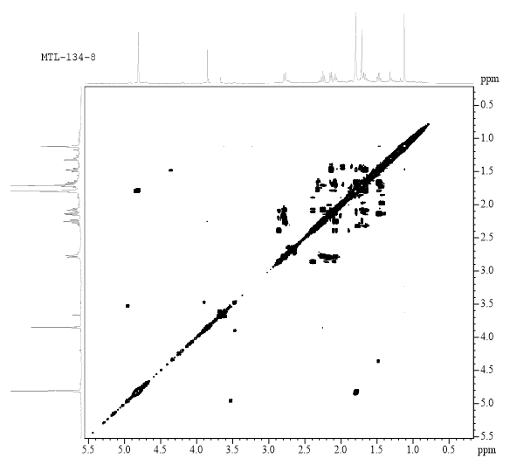

**Figure S40**. HMBC spectrum of **4**.

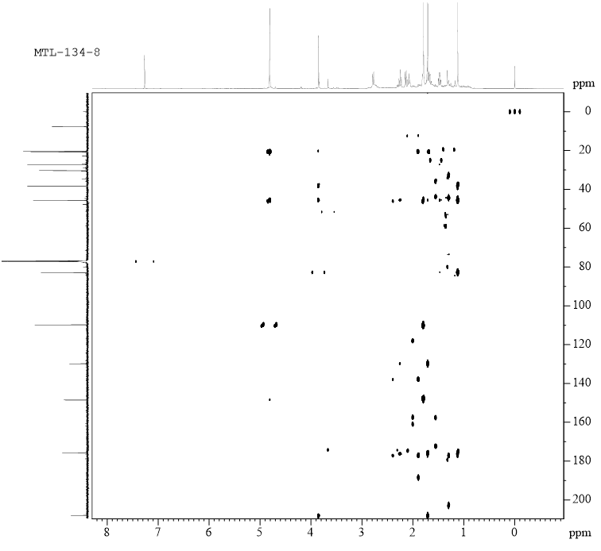

**Figure S41**. NOESY spectrum of **4**.

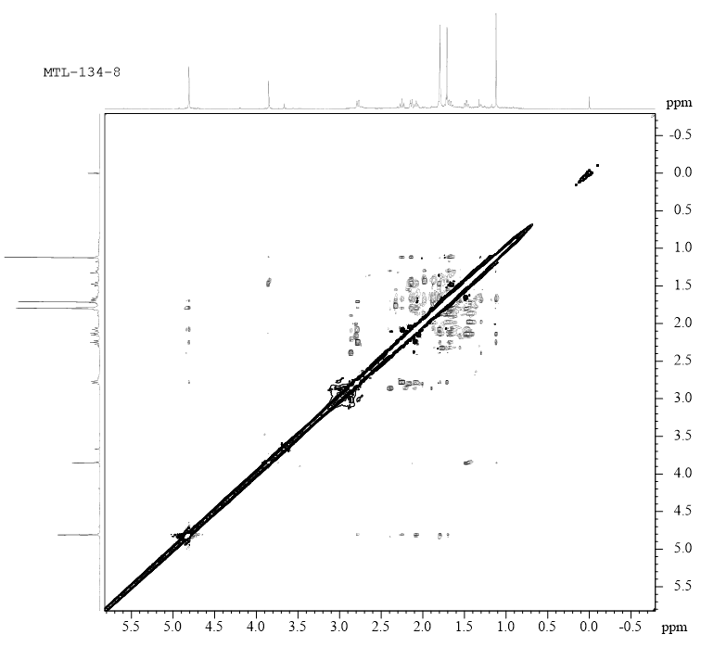

**Figure S42**. UV spectrum of **4**.



**Figure S43**. CD spectrum of **4**.



**Figure S44**. IR spectrum of **4**.



**Figure S45**. HR-ESI-MS spectrum of **5**.

**Figure S46**. 1H NMR spectrum of **5**.

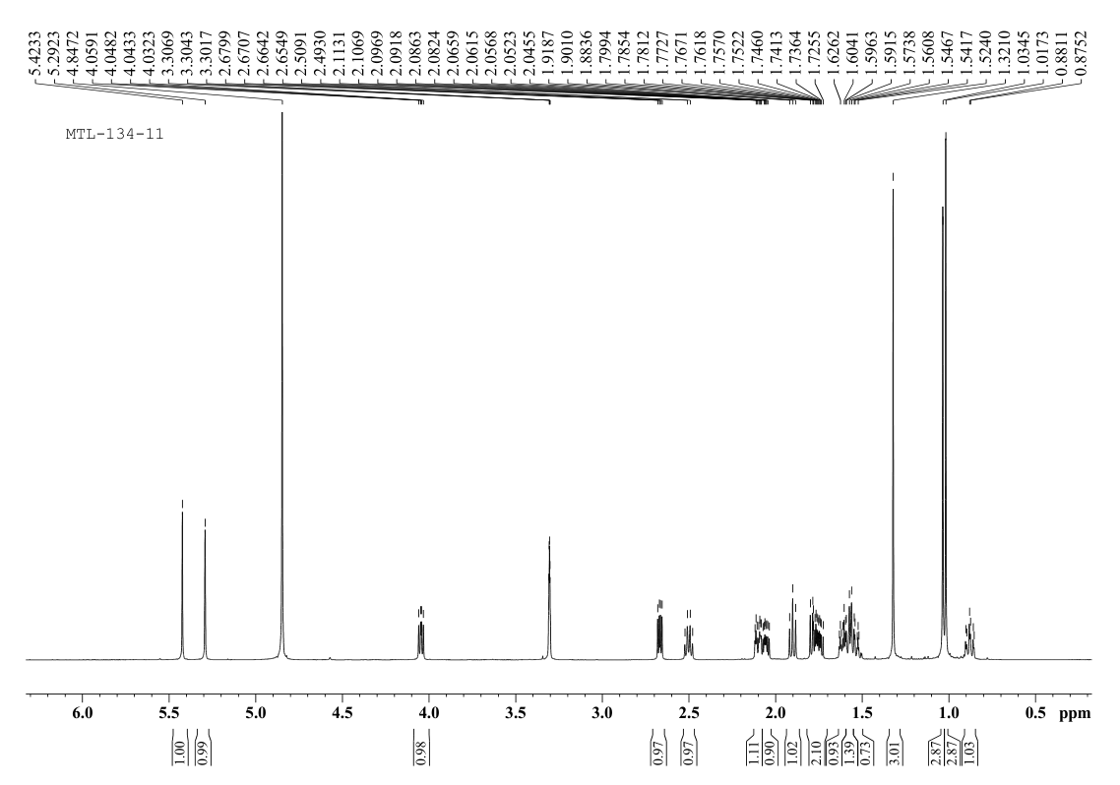

**Figure S47**. 13C NMR spectrum of **5.**

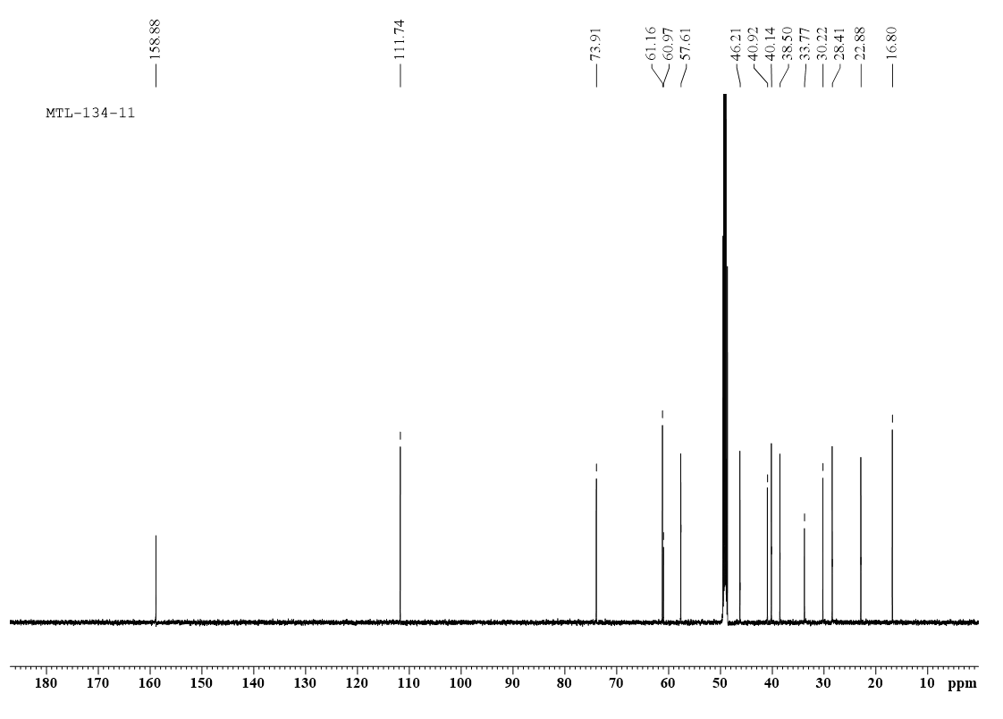

**Figure S48**. DEPT 135 spectrum of **5**.

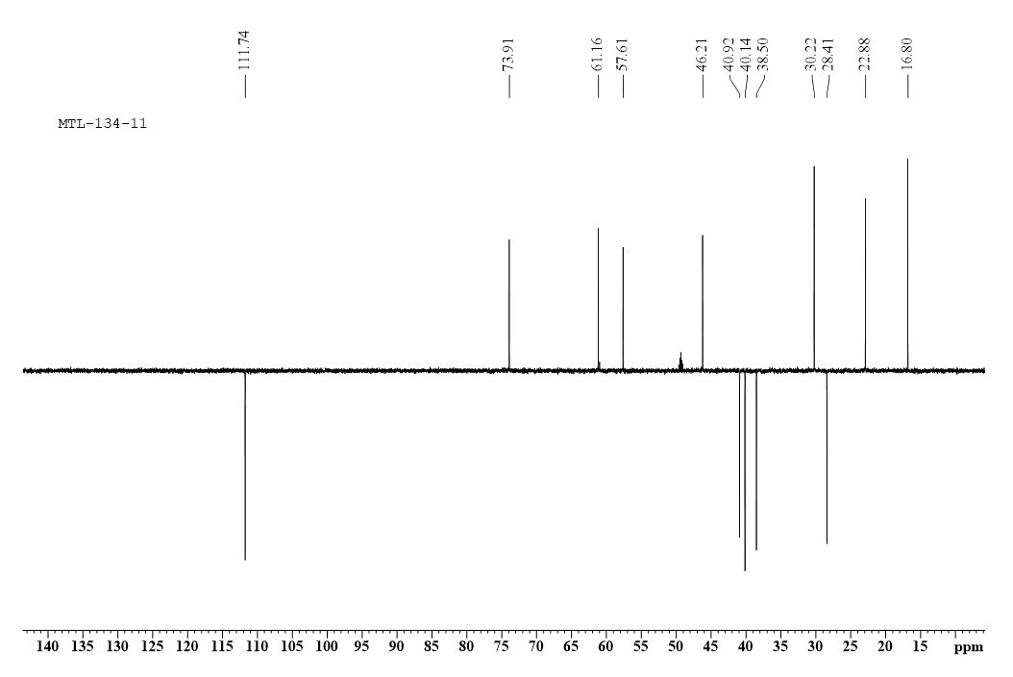

**Figure S49**. HSQC spectrum of **5**.

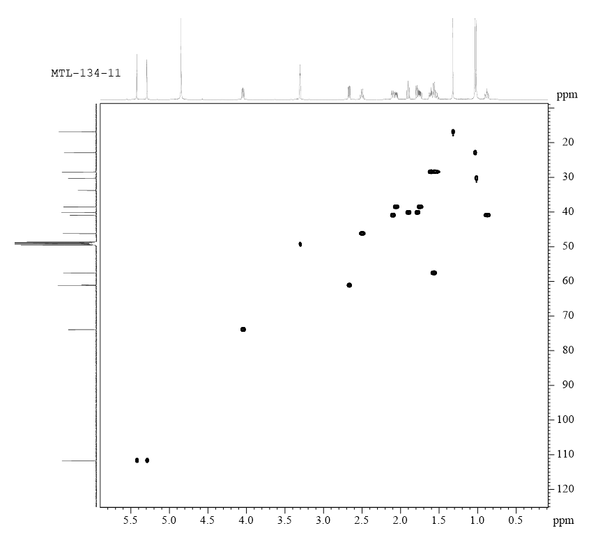

**Figure S50**. 1H-1H COSY spectrum of **5**.

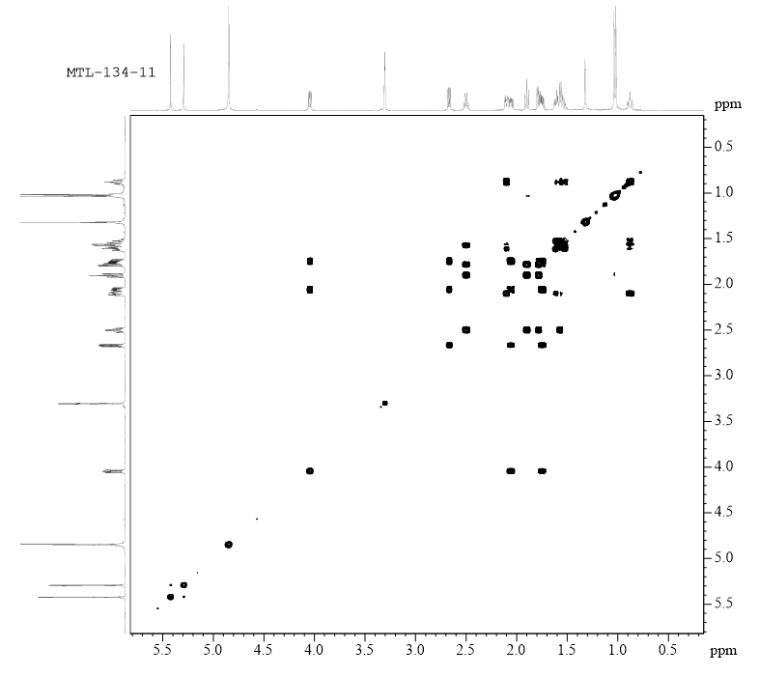

**Figure S51**. HMBC spectrum of **5**.

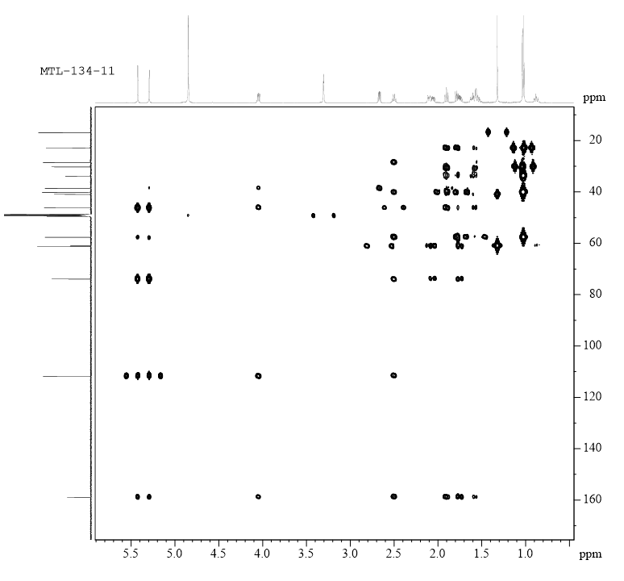

**Figure S52**. NOESY spectrum of **5**.

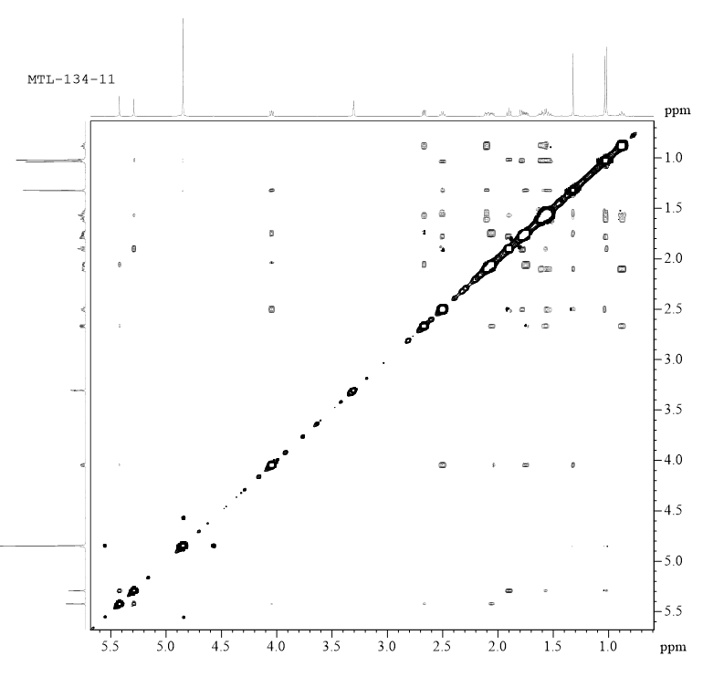

**Figure S53**. UV spectrum of **5**.



**Figure S54**. CD spectrum of **5**.

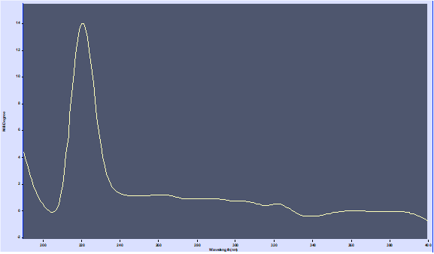

**Figure S55**. IR spectrum of **5**.



**Figure S56.** GC-MS chromatogram of the sugars of compounds **1-3.**

**Fig.S56-1** the GC chromatogram of hydrolyzed *D*-glucose



**Fig.S56-2** the GC chromatogram of compound **1** after hydrolysis



**Fig.S56-3** the GC chromatogram of compound **2** after hydrolysis



**Fig.S56-4** the GC chromatogram of compound **3** after hydrolysis



**Table S57** 13C-NMR data of compounds **6-8** (MeOD, *δ* in ppm)

|  |  |  |  |
| --- | --- | --- | --- |
| **NO.** | **6** | **7** | **8** |
| **1** | 49.0 | 204.6 | 50.7 |
| **2** | 26.5 | 125.6 | 27.5 |
| **3** | 28.7 | 153.5 | 39.8 |
| **4** | 62.8 | 70.7 | 59.1 |
| **5** | 65.0 | 52.2 | 57.5 |
| **6** | 30.2 | 26.4 | 34.6 |
| **7** | 33.5 | 45.0 | 69.3 |
| **8** | 151.4 | 26.3 | 61.1 |
| **9** | 49.9 | 34.8 | 42.9 |
| **10** | 39.9 | 44.7 | 33.8 |
| **11** | 34.5 | 149.7 | 32.9 |
| **12** | 21.4 | 108.8 | 16.3 |
| **13** | 29.9 | 21.1 | 45.0 |
| **14** | 62.1 | 22.3 | 30.0 |
| **15** | 113.3 | 18.1 | 22.8 |