Supporting Information for

Multi-redox Indenofluorene Chromophores Incorporating Dithiafulvene Donor and Ene/Enediyne Acceptor Units
Christina Schøttler^{1,2}, Kasper Lund-Rasmussen¹, Line Broløs¹, Philip Vinterberg¹, Ema Bazikova¹, Viktor B. R. Pedersen¹, and Mogens Brøndsted Nielsen*¹

Address: ¹Department of Chemistry, University of Copenhagen, Universitetsparken 5 DK-2100 Copenhagen Ø (Denmark) and ²Sino-Danish College (SDC), University of Chinese Academy of Sciences

E-mail: Mogens Brøndsted Nielsen – mbn@chem.ku.dk
* Corresponding author

Table of Contents
Synthesis of 7 and 8 ………………………………………………………………………………. | p. S2
UV-Vis absorption studies of compounds 10 and 11 (different solvents) ……………….. | p. S4
UV-Vis absorption studies of 20 (degradation studies) …………………………………….. | p. S4
¹H and ¹³C NMR spectra ………………………………………………………………………….. | p. S6
Electrochemistry ………………………………………………………………………………….. | p. S27
X-Ray crystallographic data …………………….………………………………………………. | p. S30
References …………………………………………………………………………………………. | p. S72

Synthesis of 7 and 8
Compound 7
4,5-Bis(bromomethyl)-1,3-dithiole-2-thione (1.31 g, 4.09 mmol) was dissolved in a mixture of anhydrous MeCN (100 mL) and anhydrous THF (50 mL). Hexylamine (0.850 mL, 6.22 mmol) and cesium carbonate (5.42 g, 16.6 mmol) were added to the stirring mixture, which was then heated to reflux for 1 h. The reaction mixture was then cooled to rt before it was filtered, and the filtrate was concentrated under reduced pressure. The residue was dissolved in CH₂Cl₂ (150 mL), washed with water (4 x 50 mL), dried over MgSO4, and concentrated under reduced pressure resulting in a brown oil that was purified by flash column chromatography (SiO2, 20% EtOAc/heptane), yielding compound 7 (811 mg, 77%) as a yellow oil, which solidified upon cooling. R_{f} = 0.32 (20% EtOAc/heptane). M.p.: 40-42 °C. ¹H NMR (500 MHz, CDCl3) δ 3.84 (s, 4H), 2.74 (t, J = 7.4 Hz, 2H), 1.50 (p, 7.7 Hz, 2H), 1.42 – 1.17 (m, 6H), 0.89 (t, J = 6.9 Hz, 3H). ¹³C NMR (126 MHz, CDCl3) δ 217.7, 138.7, 57.6, 56.5, 31.8, 28.9, 27.0, 22.7, 14.2 ppm. HRMS (MALDI⁺, FT-ICR, dithranol) m/z = 260.0595 [M + H⁺], calcd for (C₁₁H₁₈NS₃⁺) = 260.0596.

Compound 8
A mixture of compound 7 (311 mg, 1.20 mmol) and DDQ (599 mg, 2.64 mmol) in anhydrous PhMe (15 mL) was heated to reflux for 2 hours. The reaction mixture was then cooled to rt and filtered. The filtrate was washed with 10% aqueous NaOH (3 x 10 mL), dried over MgSO₄, and filtered. The organic phase was then filtered through a silica plug (SiO2, PhMe) and concentrated under reduced pressure. The residue was purified by flash column chromatography (SiO2, 10% EtOAc/heptane), yielding compound 8 (220 mg, 71%) as a brown oil. R_{f} = 0.33 (20% EtOAc/heptane). ¹H NMR (500 MHz, (CD₃)₂SO) δ 7.15 (s, 2H), 4.02 (t, J = 7.1 Hz, 2H), 1.71 (p, J = 7.1 Hz, 2H), 1.46 – 1.04 (m, 6H), 0.84 (t, J = 7.9 Hz, 3H) ppm. ¹³C NMR (126 MHz, (CD₃)₂SO) δ 219.5, 121.0, 113.3, 50.3, 30.9, 30.7, 25.6, 22.0, 13.8 ppm. HRMS (MALDI⁺, FT-ICR, dithranol) m/z = 258.0439 [M + H⁺], calcd for (C₁₁H₁₆NS₃⁺) = 258.0439.

UV-Vis absorption studies of compounds 10 and 11 (different solvents)
Figure S1: UV-Vis absorption spectra of compounds 10 and 11 in PhMe and CH₂Cl₂ at 25 °C. The redshift of the longest-wavelength absorption when changing the solvent to CH₂Cl₂ indicates some charge-transfer character of this absorption.

UV-Vis absorption studies of 20 (degradation studies)
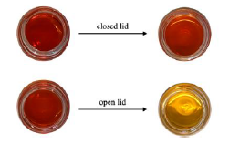
Figure S2: Visual experiment of compound 20 dissolved in CH₂Cl₂ in two vials, one with closed lid (top) and one with open lid (bottom), to observe the impact of the presence of oxygen. The solutions were not shielded from light.
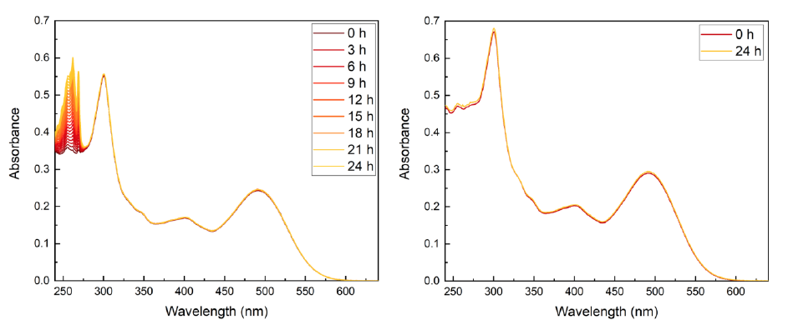
Figure S3: UV-Vis absorption spectra of 20 in CH₂Cl₂ at 25 °C. Left: Recorded for 0-24 h in the presence of oxygen and absence of light; the absorption from 280 nm to 600 nm remains unchanged; however, an increase was observed in the absorption between 240 nm and 280 nm. Right: Recorded at 0 h and 24 h in the absence of both oxygen (sample degassed with argon) and light; no changes in the absorption were observed, indicating that the sample was stable in the absence of oxygen and light.
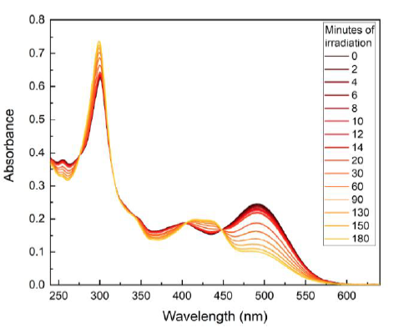
Figure S4: UV-Vis absorption spectra of 20 in CH₂Cl₂ at 25 °C irradiated at 565 nm for 0-180 min in the presence of oxygen; a decrease in the absorption was observed between 475 nm and 575 nm, while an increase in the absorption was observed between 400 nm and 450 nm. These changes in absorption might explain the change in color observed for the samples in Figure S2.

¹H and ¹³C NMR spectra
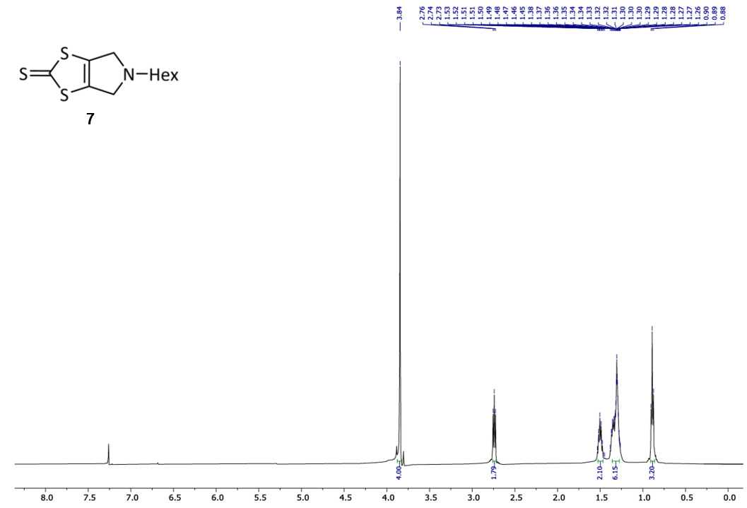
¹H NMR spectrum (500 MHz, CDCl₃) of 7.
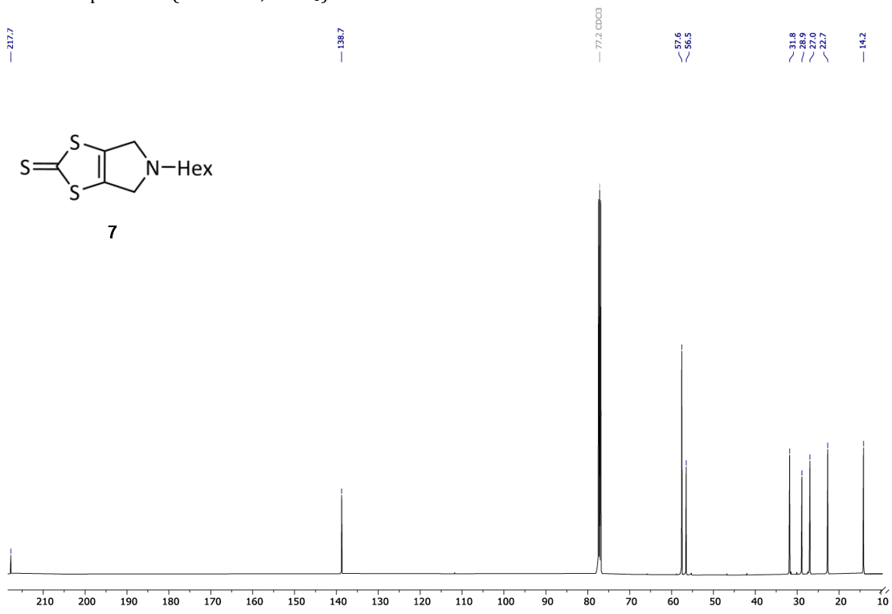
¹³C NMR spectrum (126 MHz, CDCl₃) of 7.
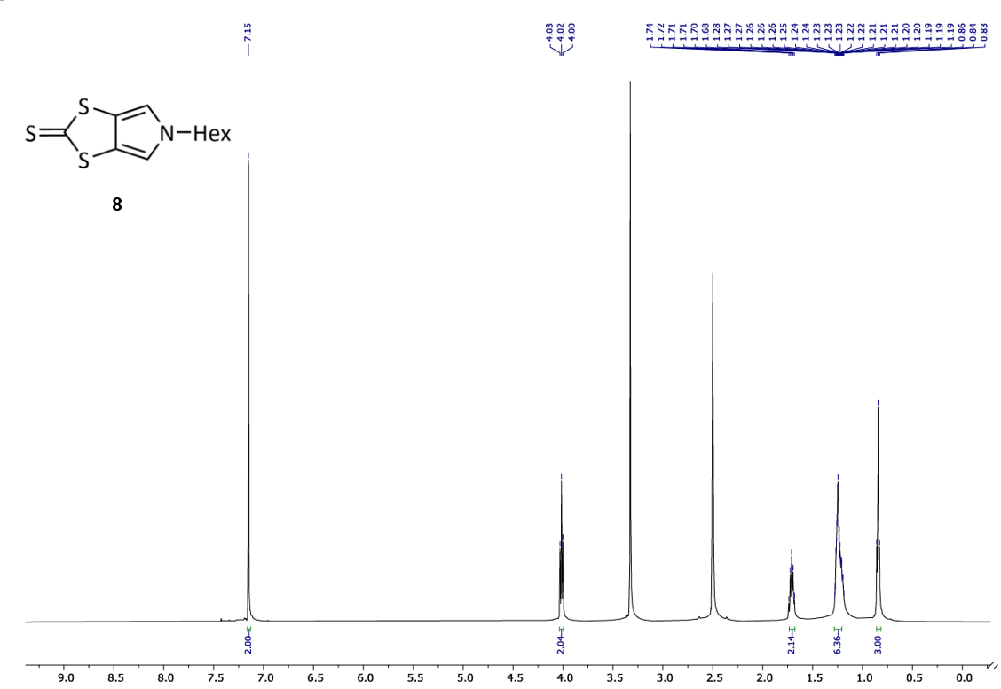
¹H NMR spectrum (500 MHz, (CD₃)₂SO) of 8.
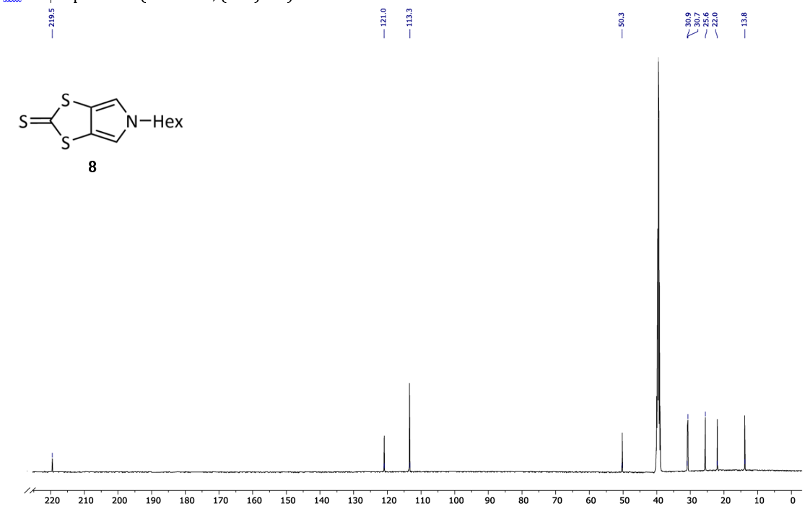
¹³C NMR spectrum (126 MHz, (CD₃)₂SO) of 8.

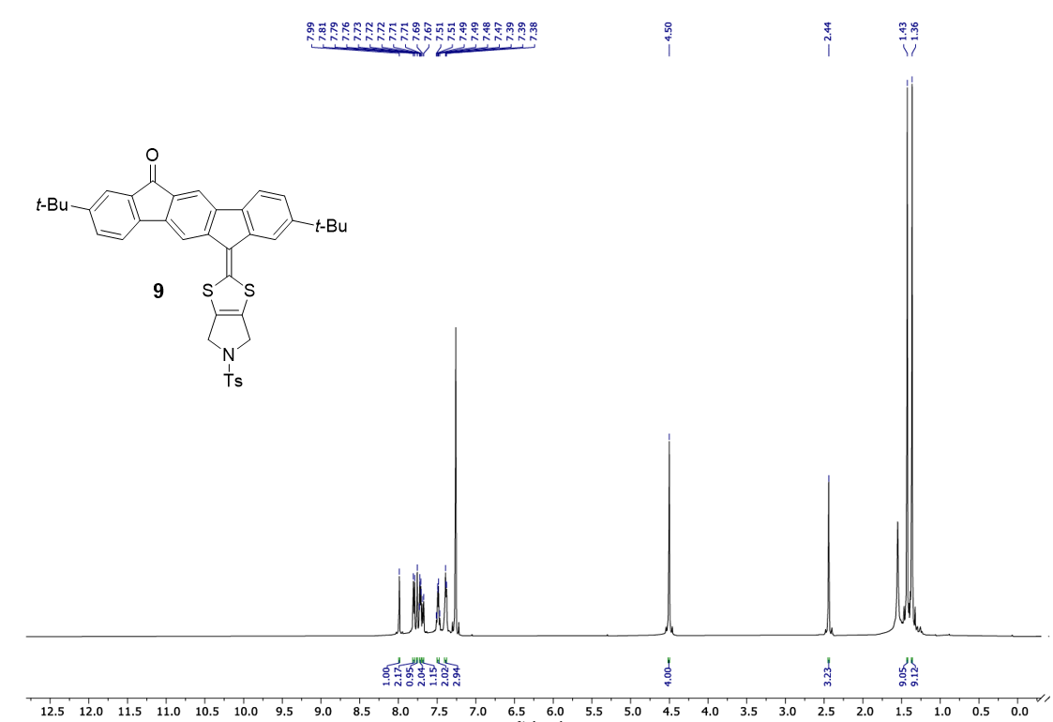
¹H NMR spectrum (500 MHz, CDCl₃) of 9.
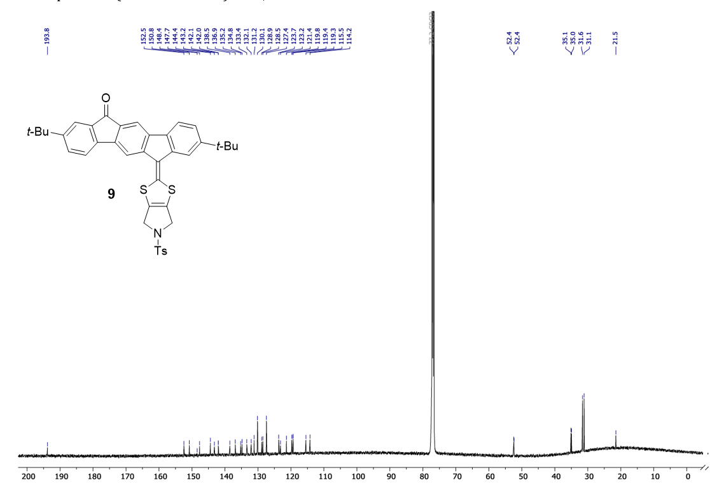
¹³C NMR spectrum (126 MHz, CDCl₃) of 9.
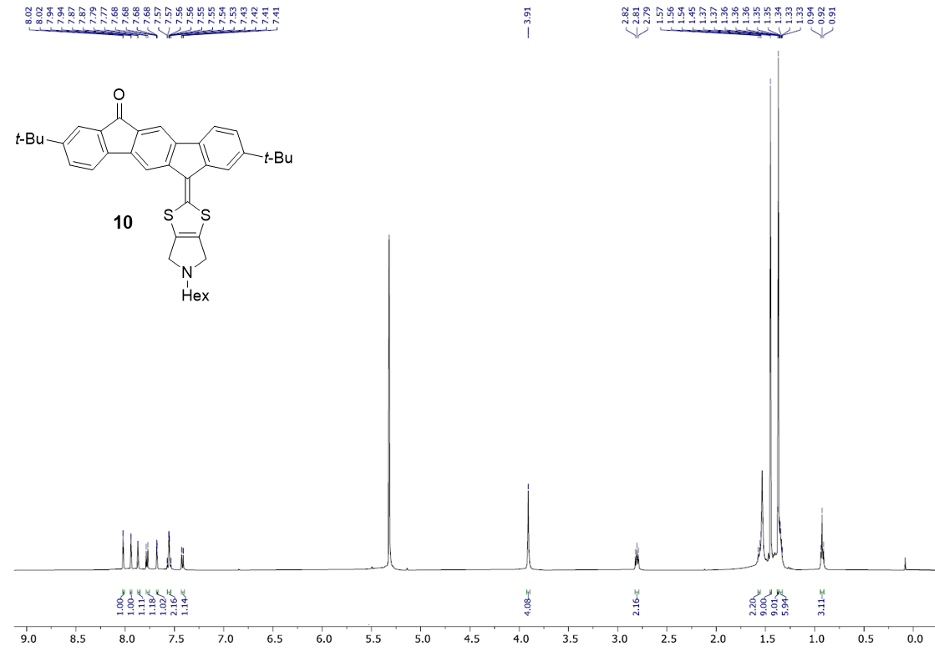
¹H NMR spectrum (500 MHz, CD₂Cl₂) of 10.
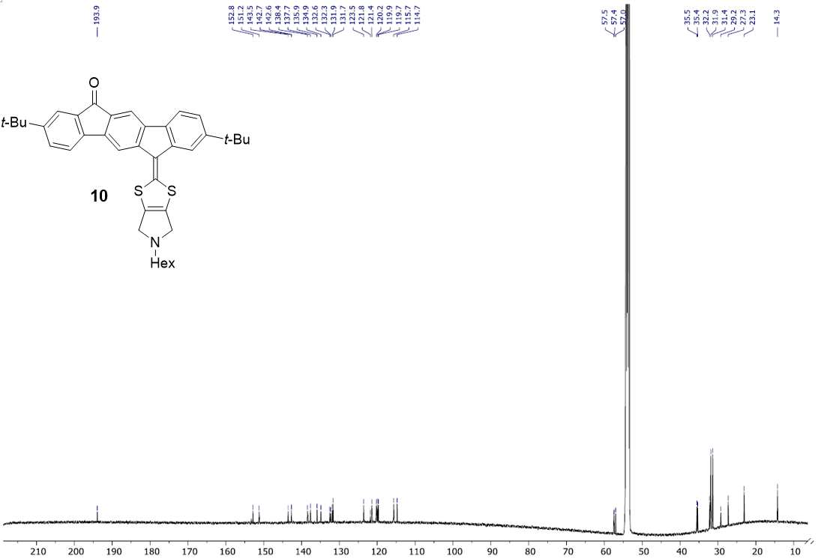
¹³C NMR spectrum (126 MHz, CD₂Cl₂) of 10.
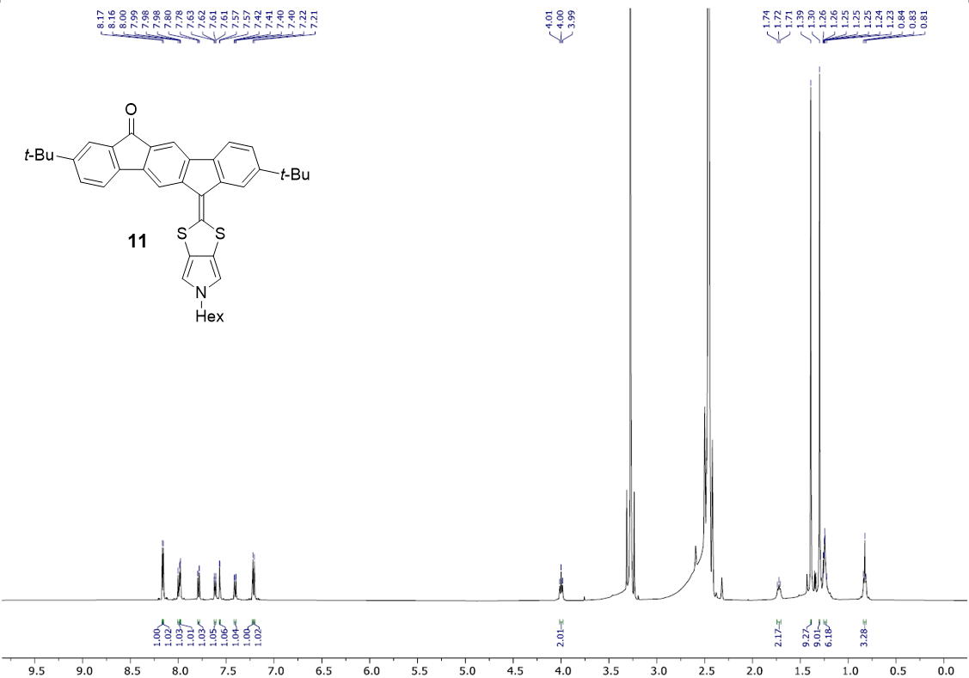
¹H NMR spectrum (500 MHz, (CD₃)₂SO) of 11.
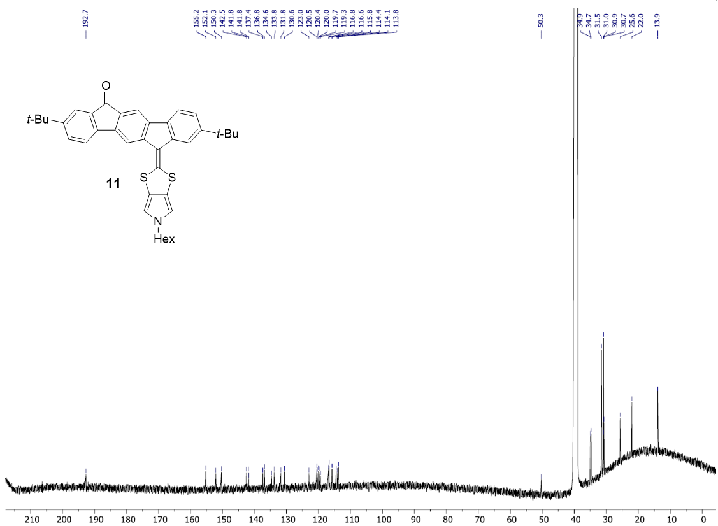
¹³C NMR spectrum (126 MHz, (CD₃)₂SO) of 11.
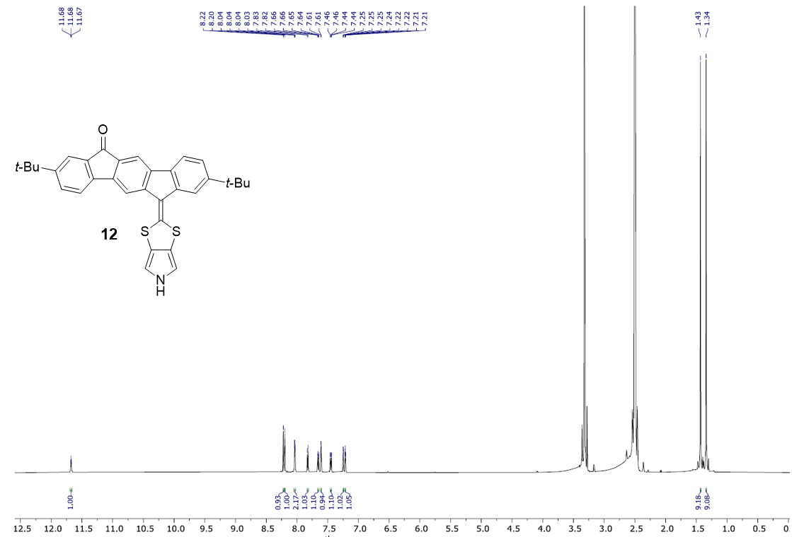
¹H NMR spectrum (500 MHz, (CD₃)SO) of 12.
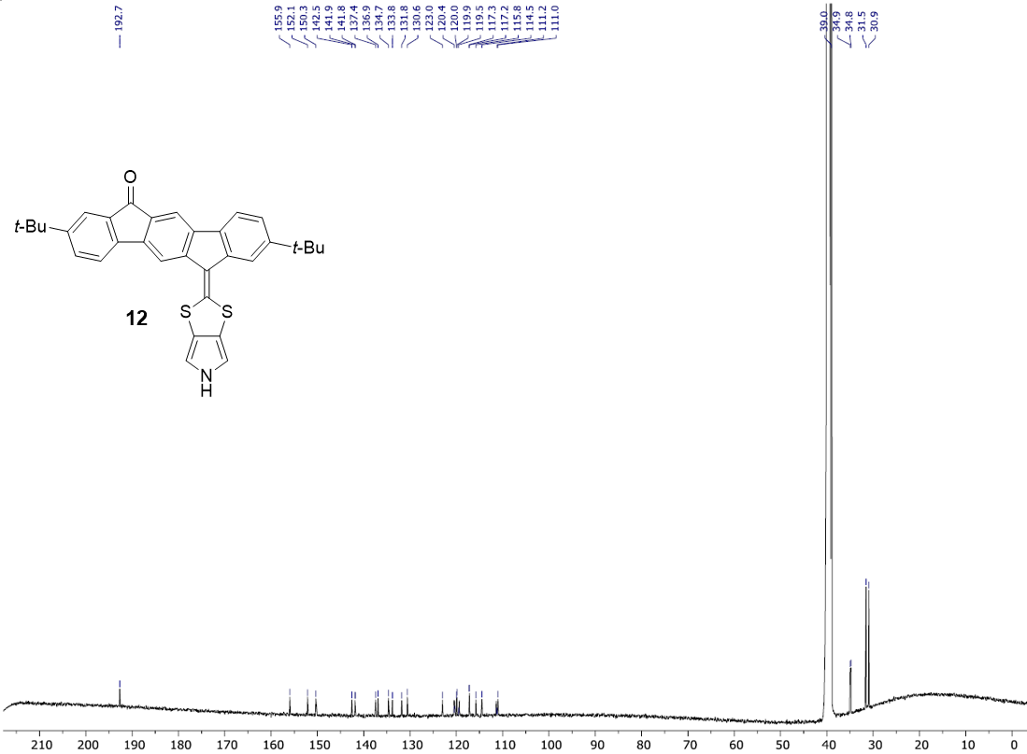
12
¹³C NMR spectrum (126 MHz, (CD₃)₂SO) of 12.
¹H NMR spectrum (500 MHz, CDCl₃) of 13.
¹³C NMR spectrum (126 MHz, CDCl₃) of 13.
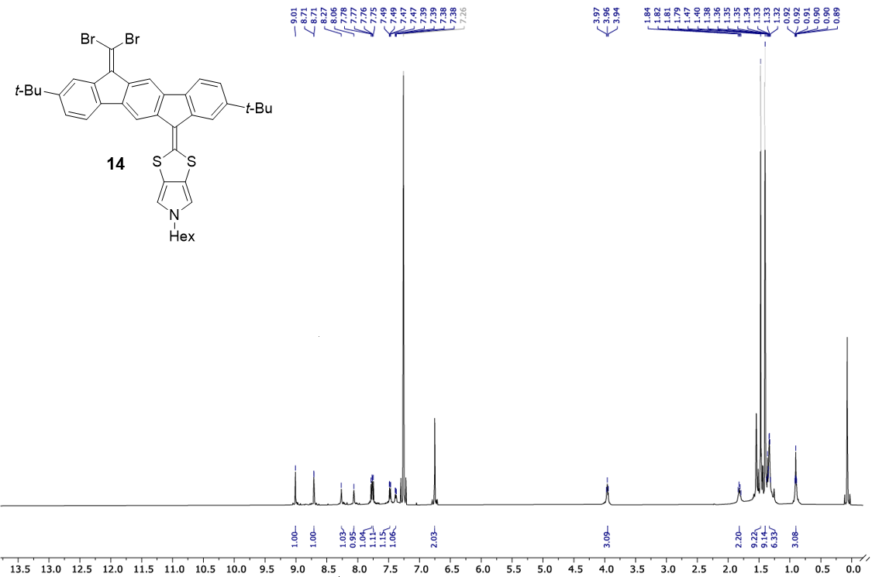
¹H NMR spectrum (500 MHz, CDCl₃) of 14.
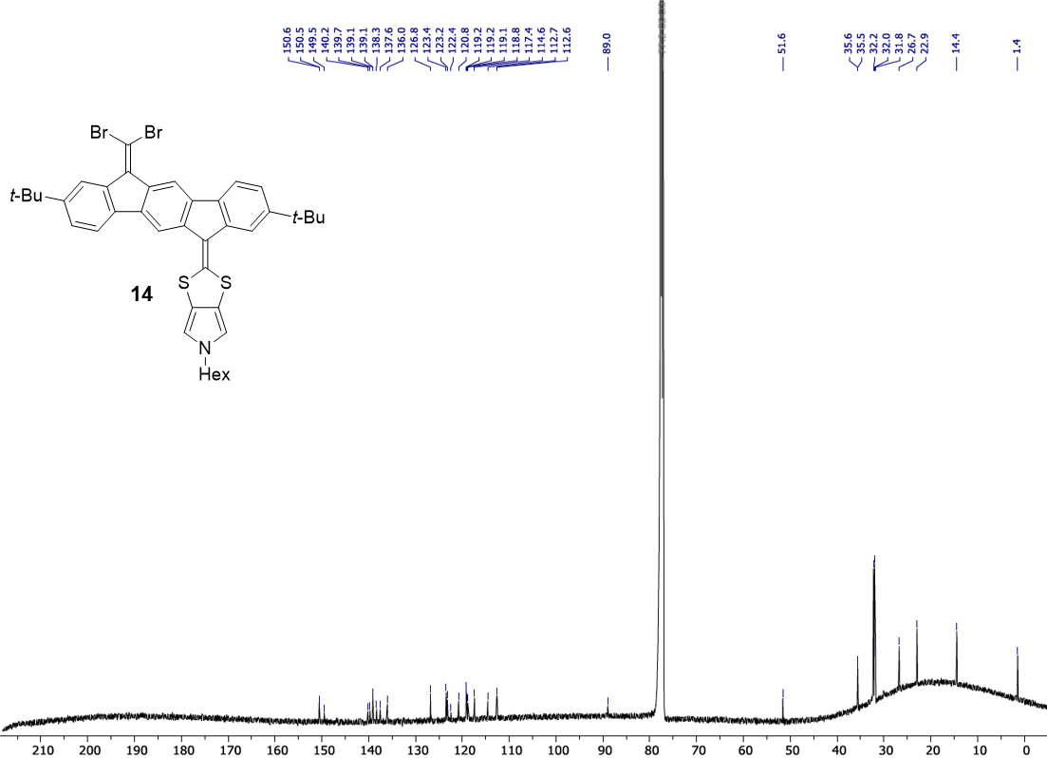
¹³C NMR spectrum (126 MHz, CDCl₃) of 14.
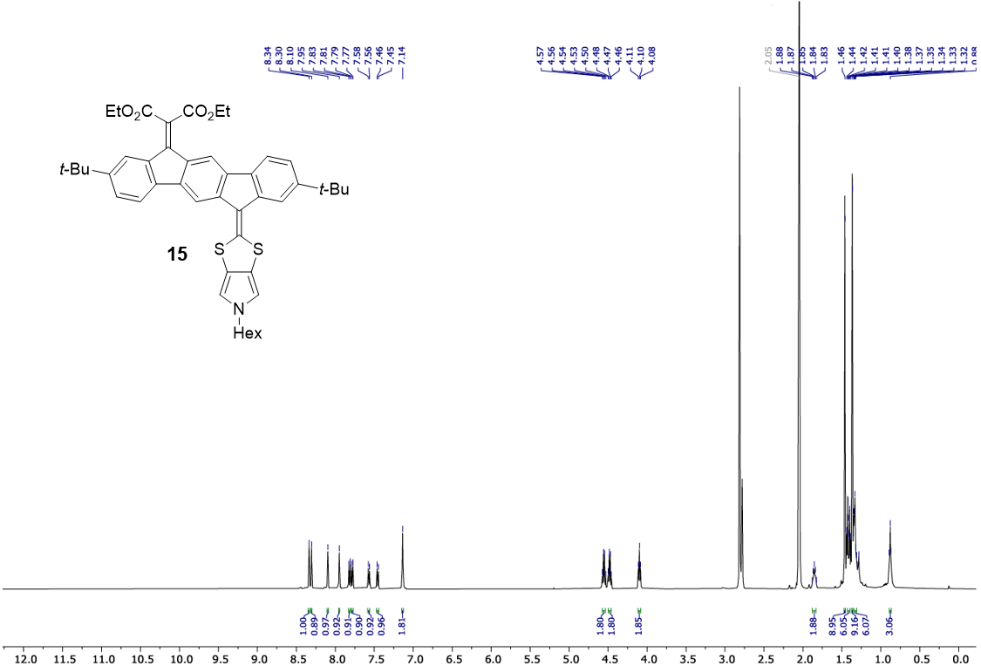
¹H NMR spectrum (500 MHz, (CD₃)₂CO) of 15.
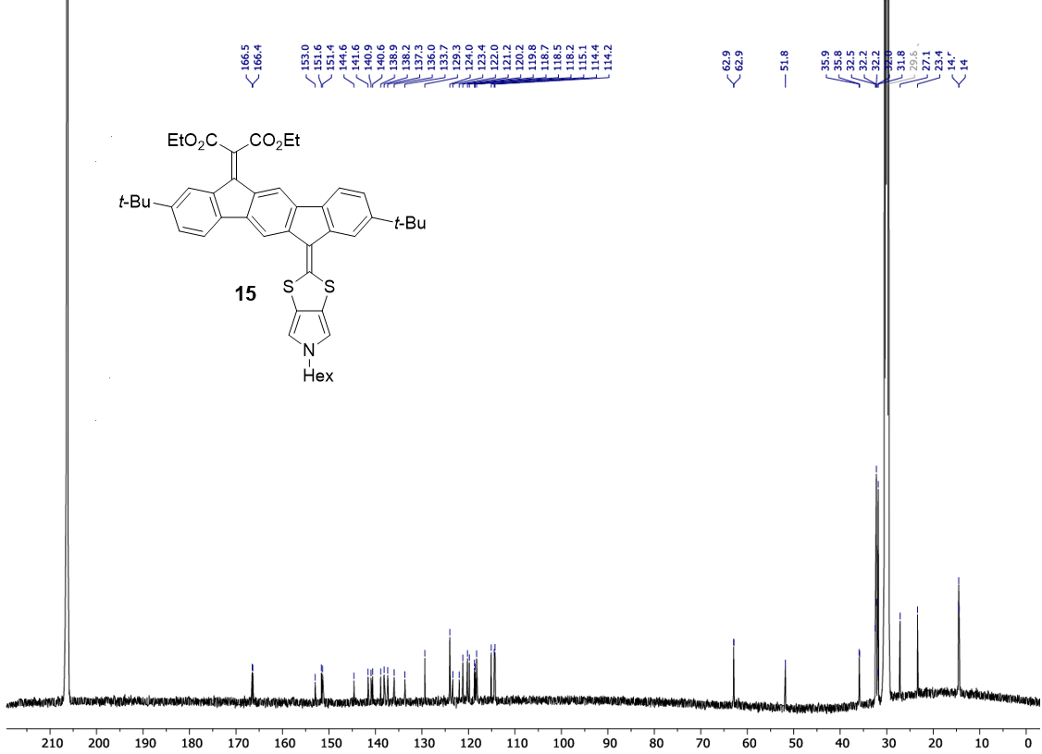
¹³C NMR spectrum (126 MHz, (CD₃)₂CO) of 15.

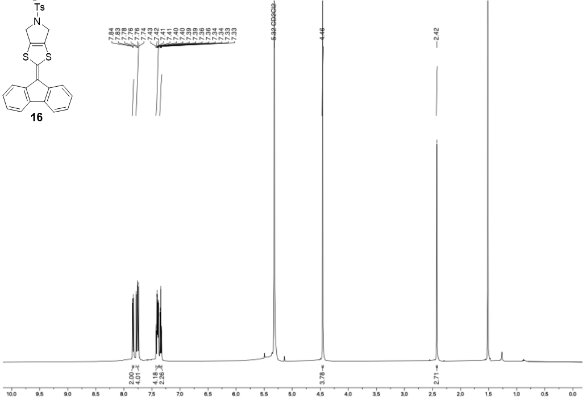
¹H NMR spectrum (500 MHz, CD₂Cl₂) of 16.
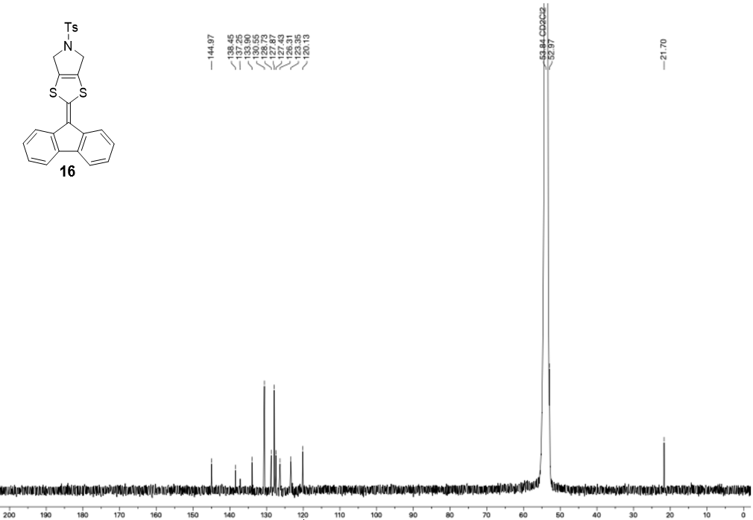
¹³C NMR spectrum (126 MHz, CD₂Cl₂) of 16.
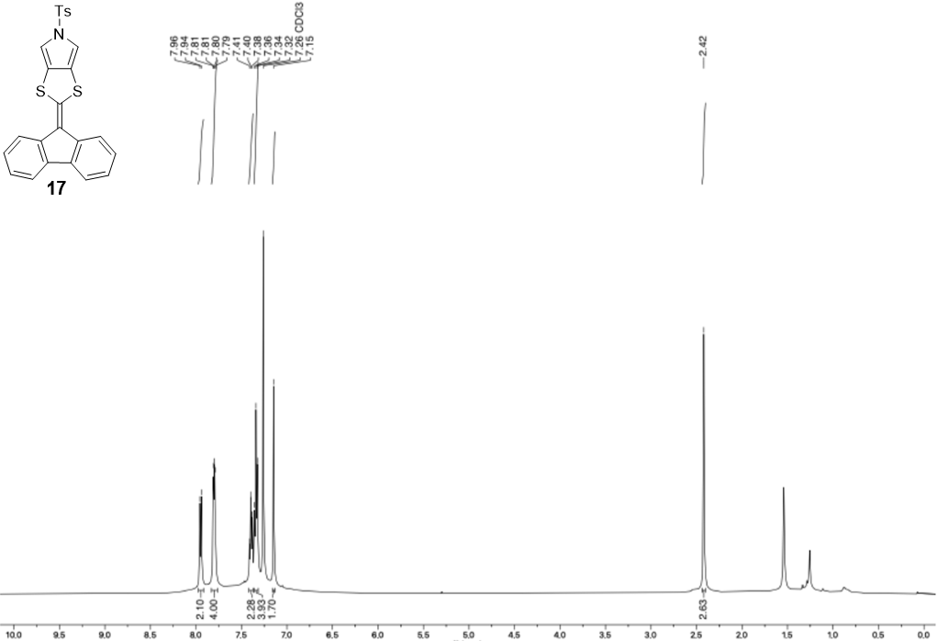
¹H NMR spectrum (500 MHz, CDCl₃) of 17.
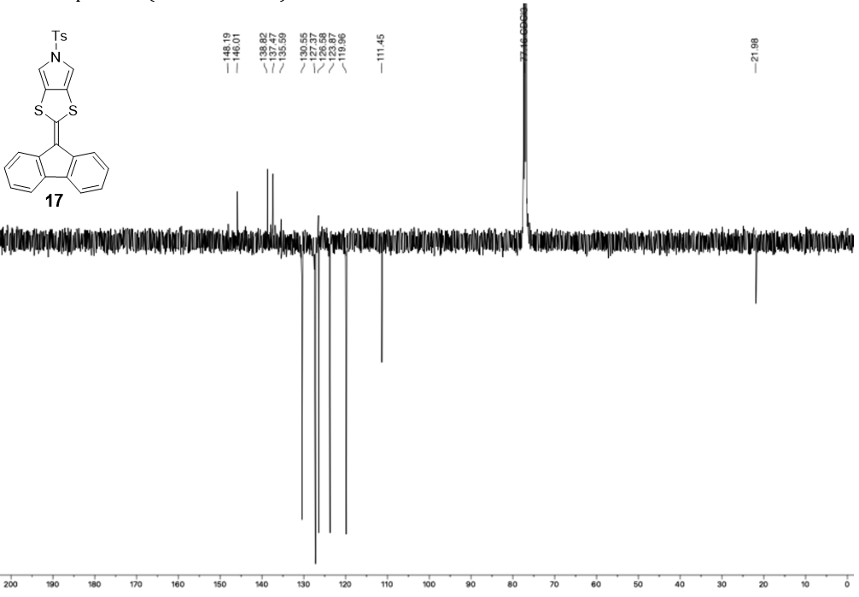
¹³C NMR spectrum (126 MHz, CDCl₃) of 17.
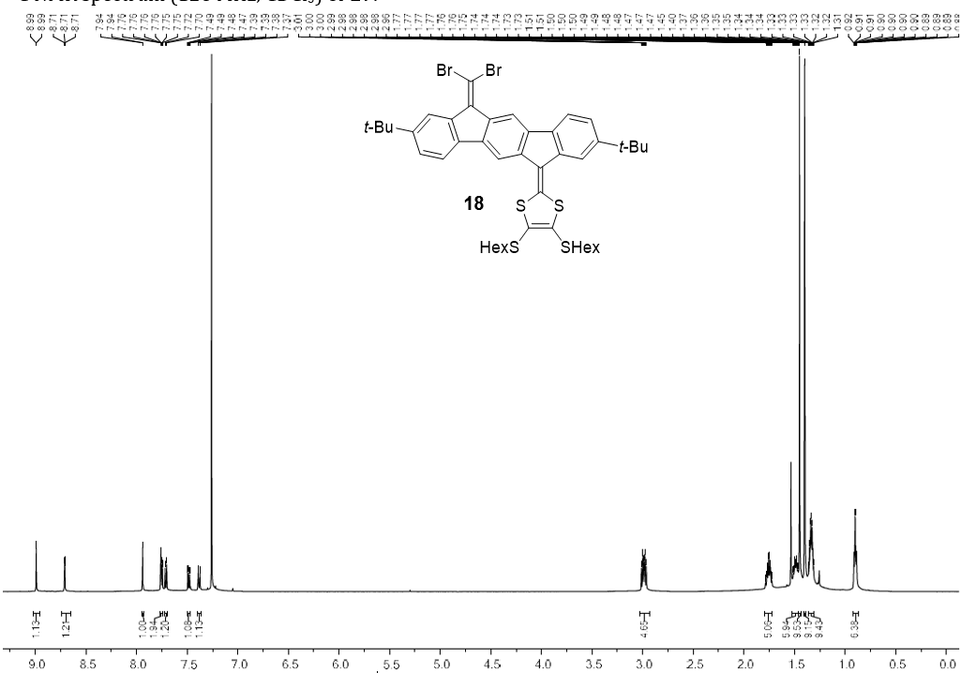
¹H NMR spectrum (500 MHz, CDCl₃) of 18.
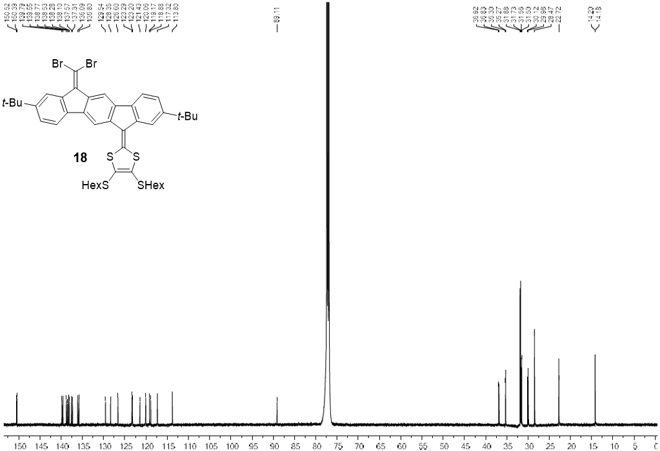
¹³C NMR spectrum (126 MHz, CDCl₃) of 18.
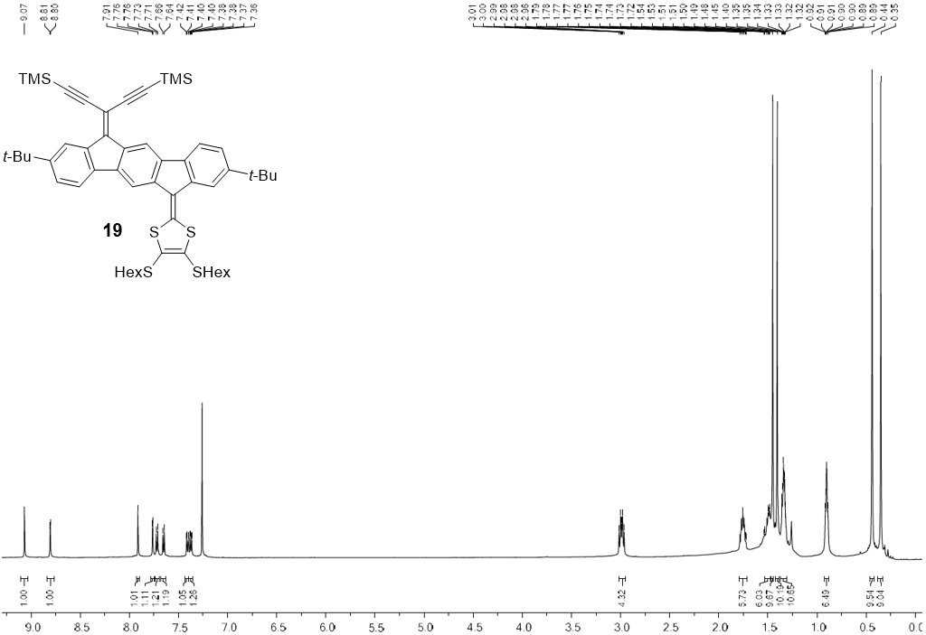
¹H NMR spectrum (500 MHz, CDCl₃) of 19.
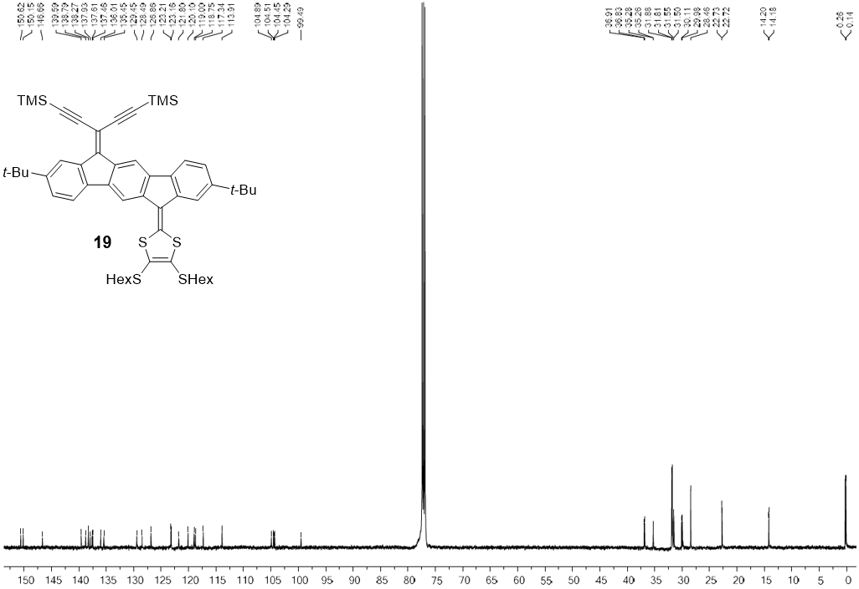
¹³C NMR spectrum (126 MHz, CDCl₃) of 19.
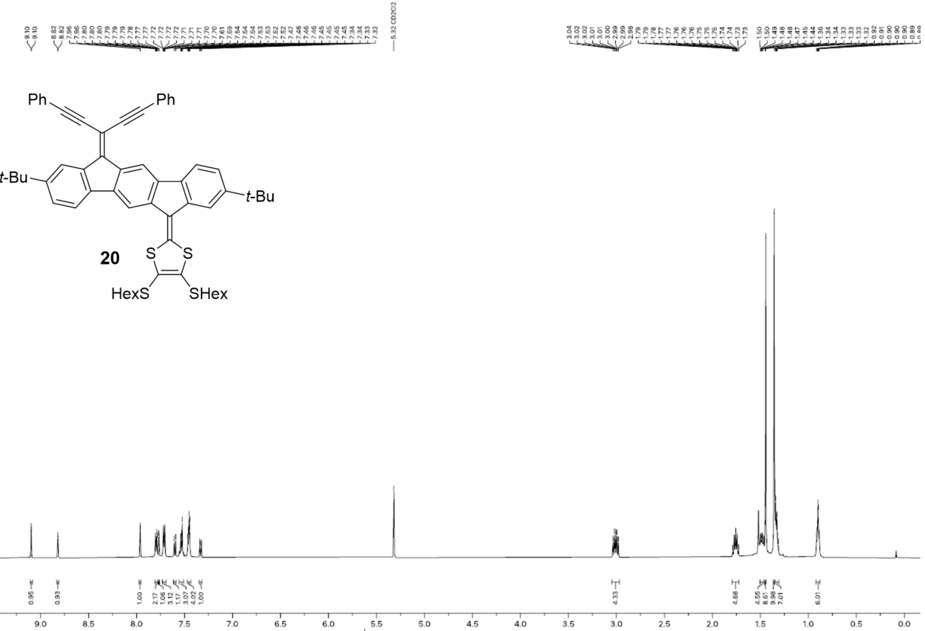
¹H NMR spectrum (500 MHz, CD₂Cl₂) of 20.
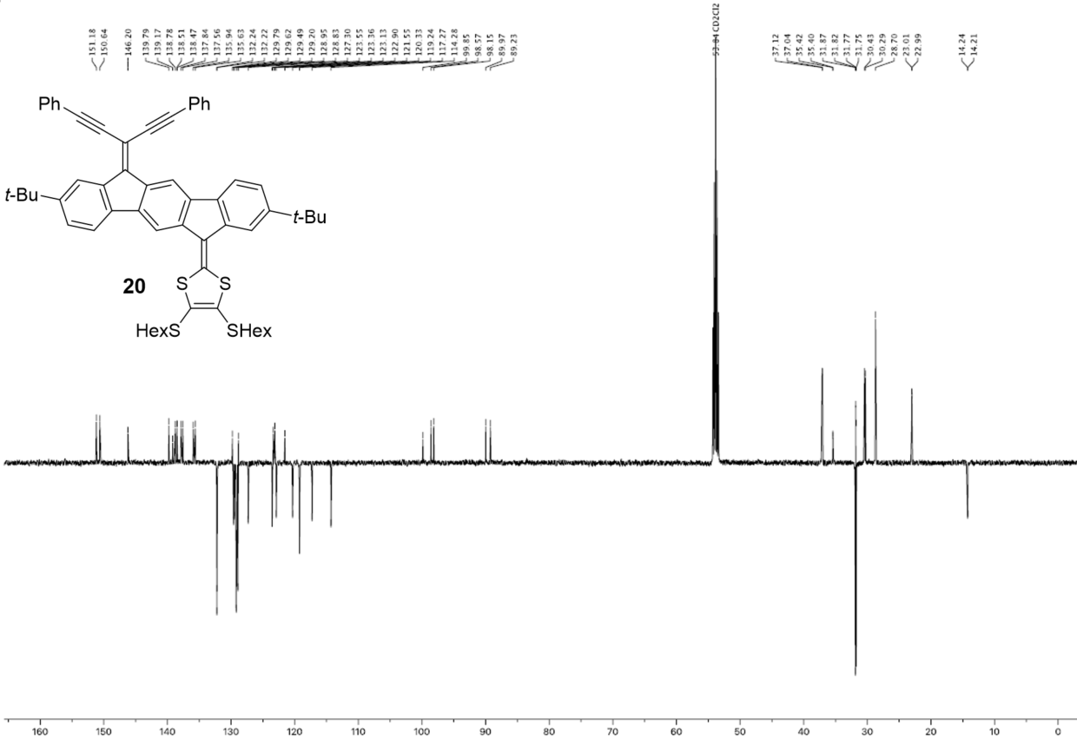
¹³C NMR spectrum (126 MHz, CD₂Cl₂) of 20.
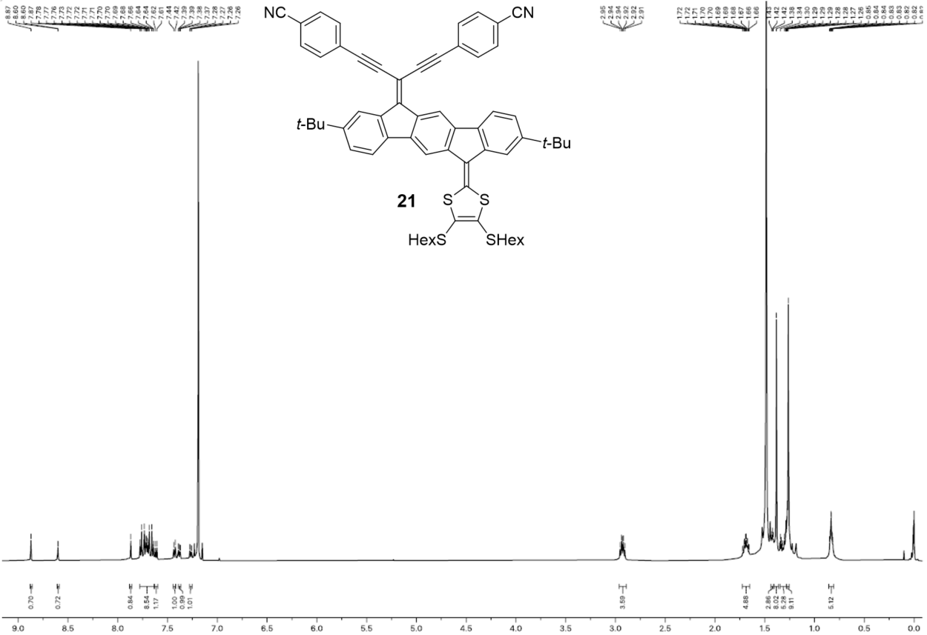
¹H NMR spectrum (500 MHz, CDCl₃) of 21.
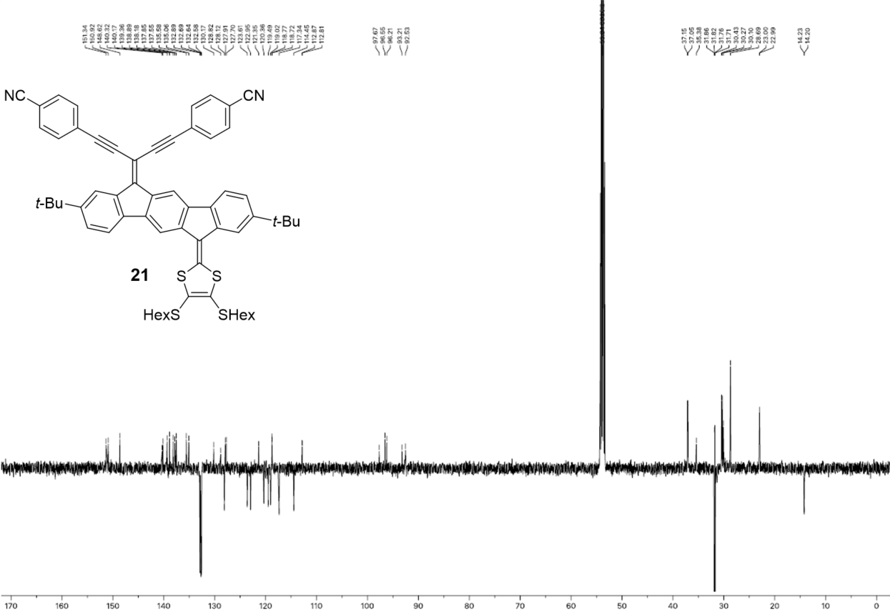
¹³C NMR spectrum (126 MHz, CDCl₃) of 21.
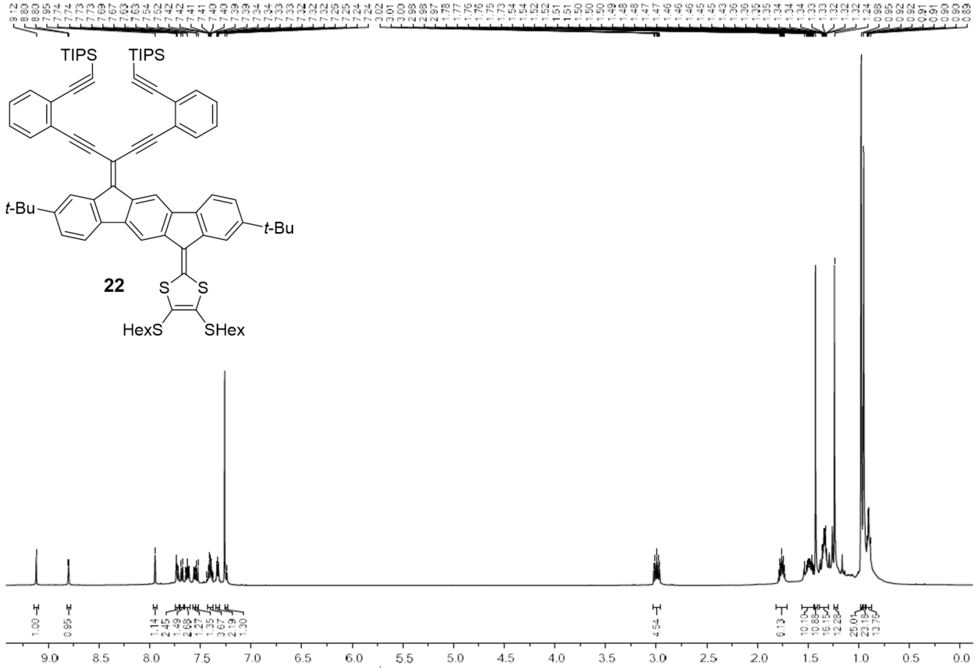
¹H NMR spectrum (500 MHz, CDCl₃) of 22.
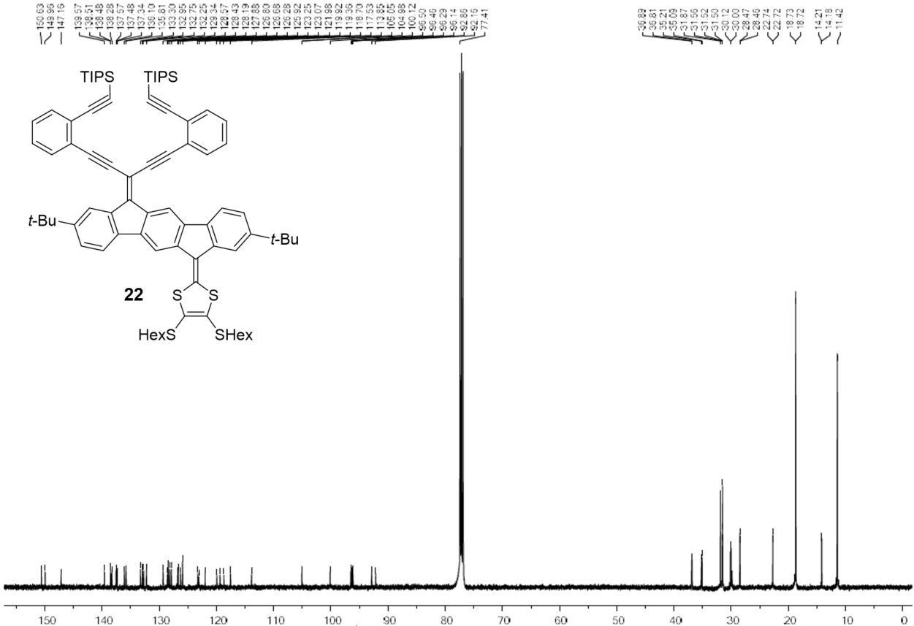
¹³C NMR spectrum (126 MHz, CDCl₃) of 22.
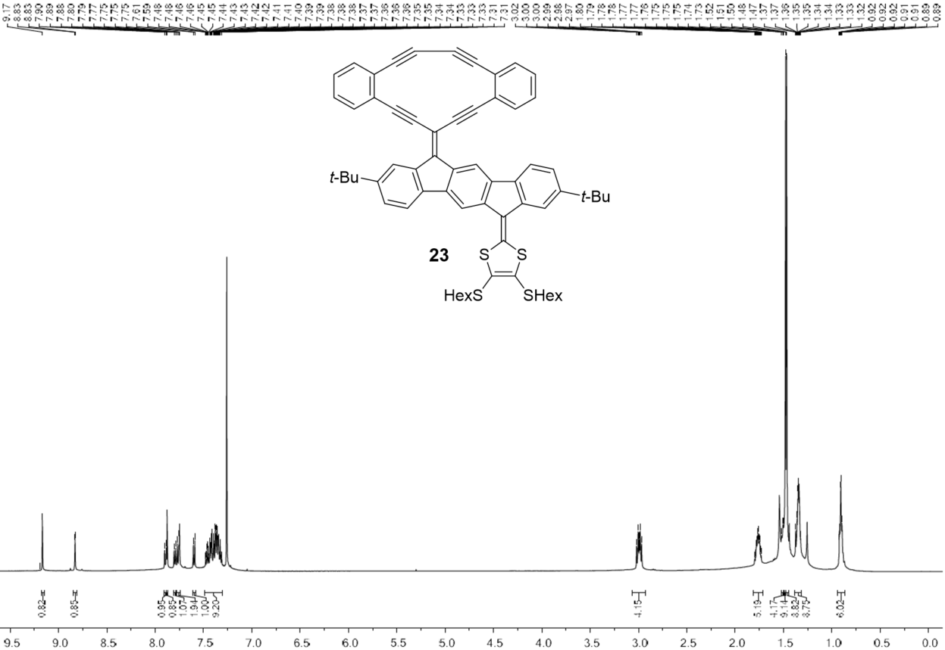
¹H NMR spectrum (500 MHz, CDCl₃) of 23.
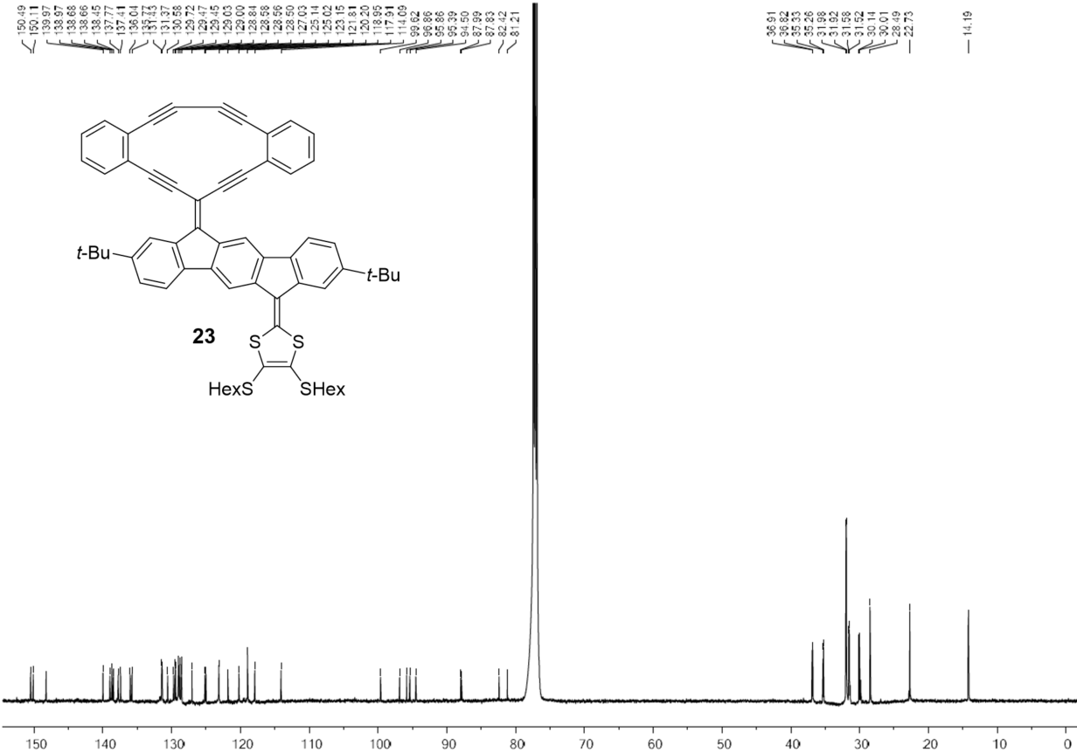
¹³C NMR spectrum (126 MHz, CDCl₃) of 23.
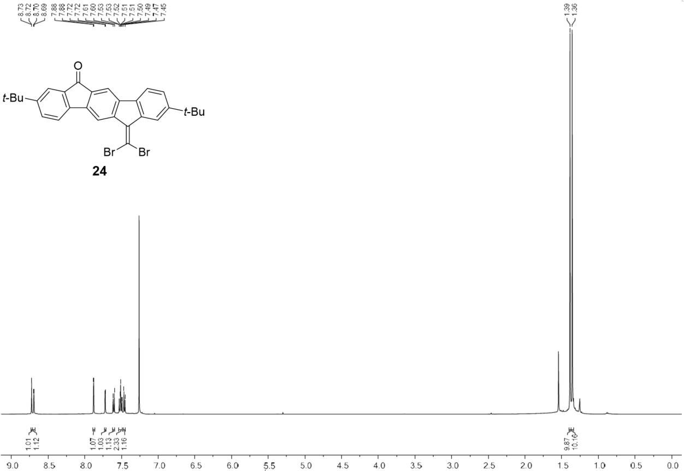
¹H NMR spectrum (500 MHz, CDCl₃) of 24.
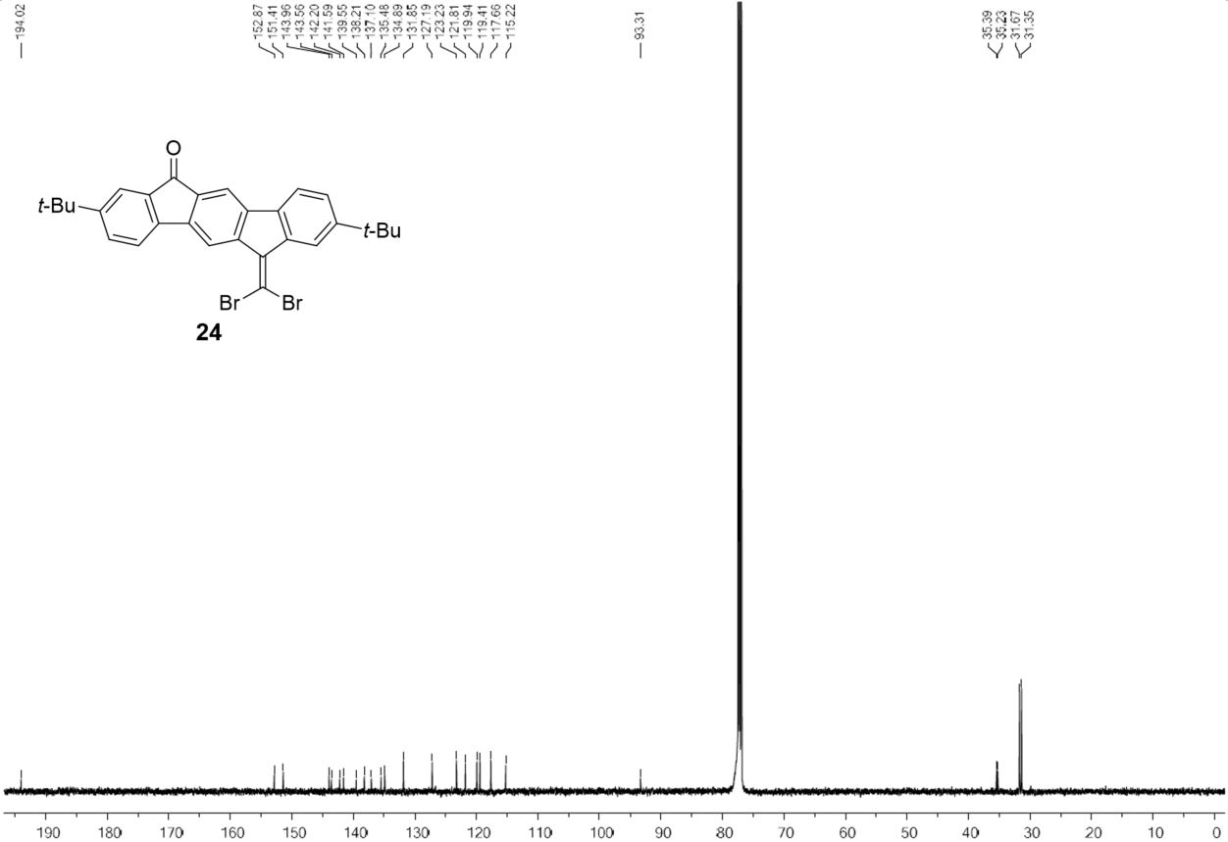
¹³C NMR spectrum (126 MHz, CDCl₃) of 24.

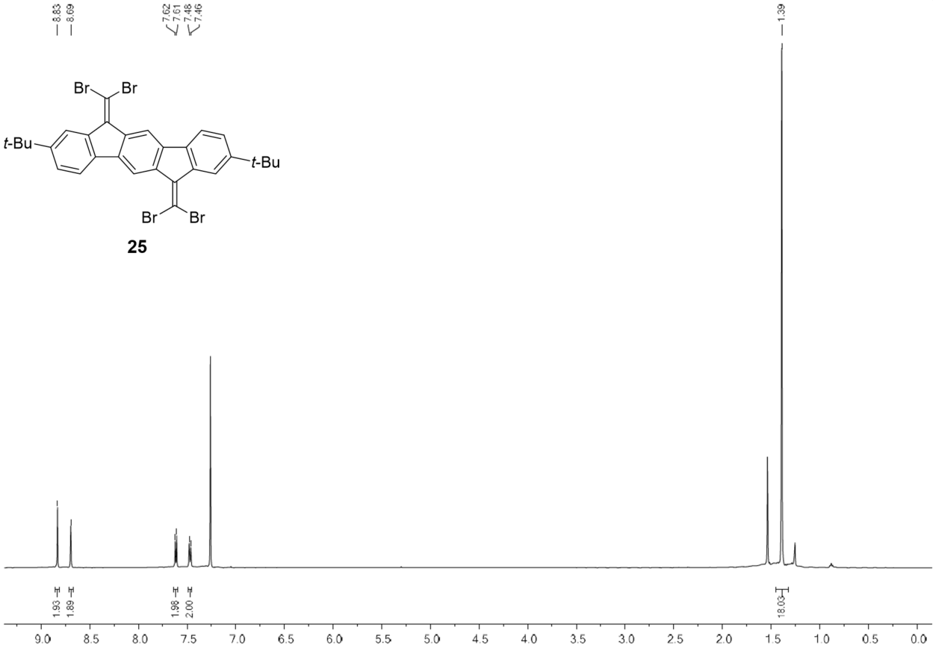
¹H NMR spectrum (500 MHz, CDCl₃) of 25.
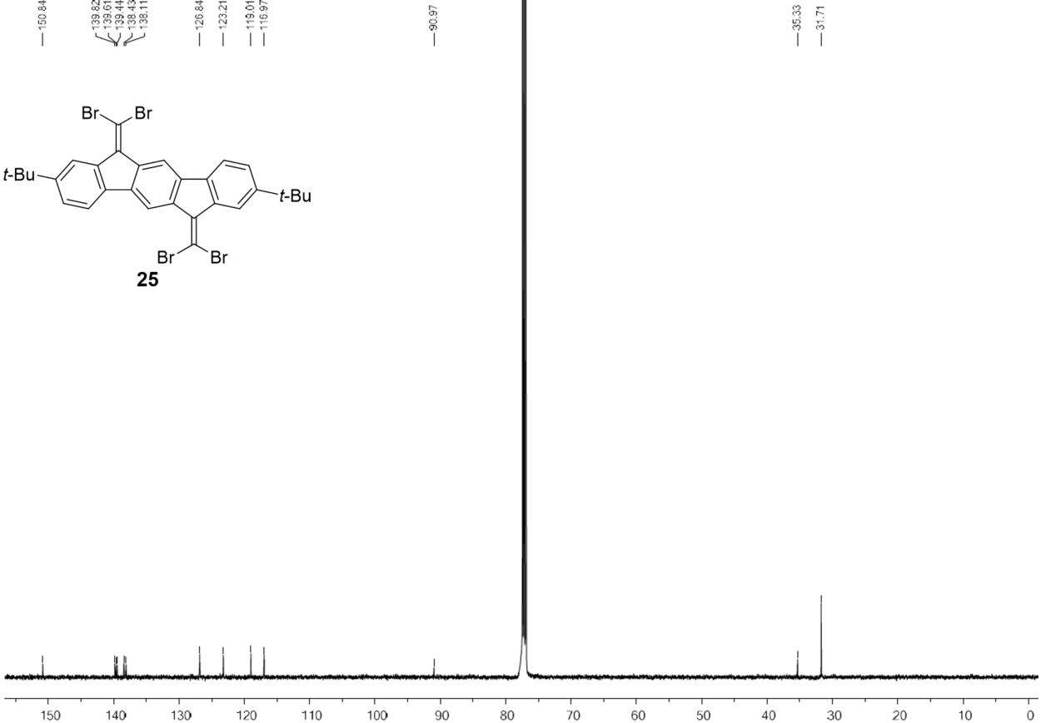
¹³C NMR spectrum (126 MHz, CDCl₃) of 25.
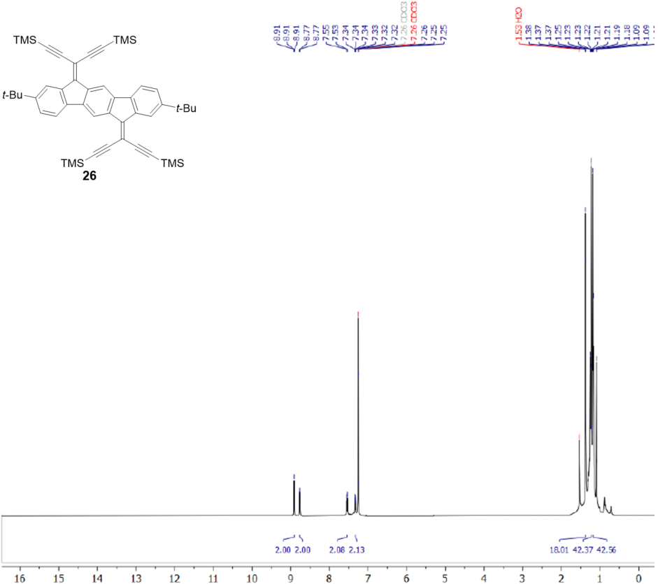
¹H NMR spectrum (500 MHz, CDCl₃) of 26.
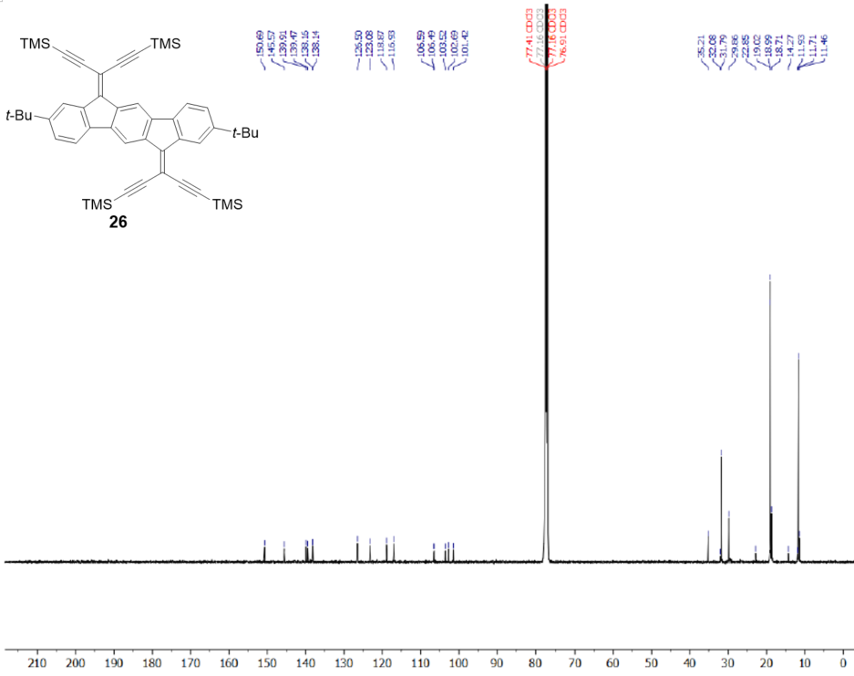
¹³C NMR spectrum (126 MHz, CDCl₃) of 26.
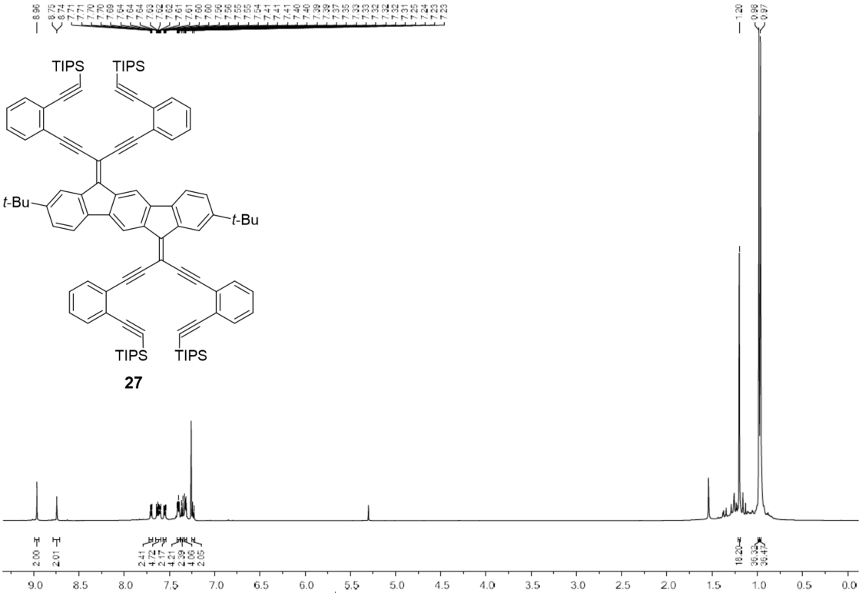
¹H NMR spectrum (500 MHz, CDCl₃) of 27.
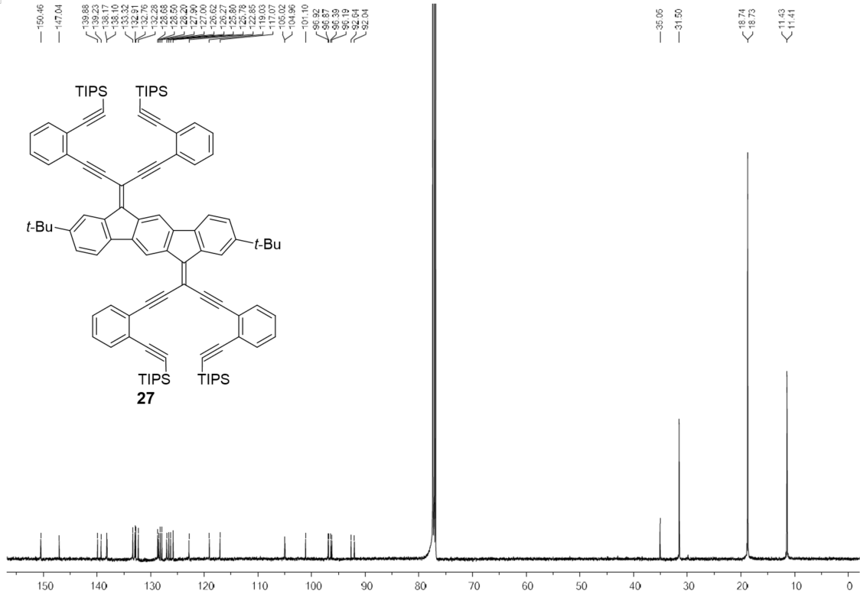
¹³C NMR spectrum (126 MHz, CDCl₃) of 27.

Electrochemistry
Compounds 11 and 15 were studied in MeCN and compounds 13, 16, 17, 22, 23, 26, and 27 in CH₂Cl₂ (all measurements with 0.1 M Bu₄NPF₆ as supporting electrolyte).
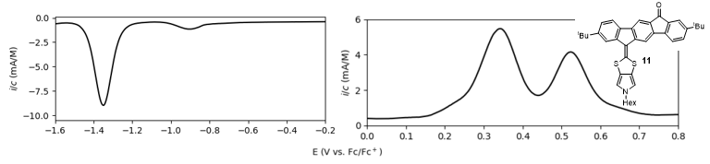
Figure S5. Differential pulse voltammograms of 11.
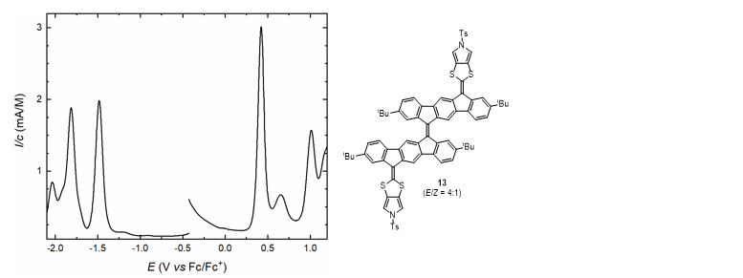
Figure S6. Differential pulse voltammograms of 13.
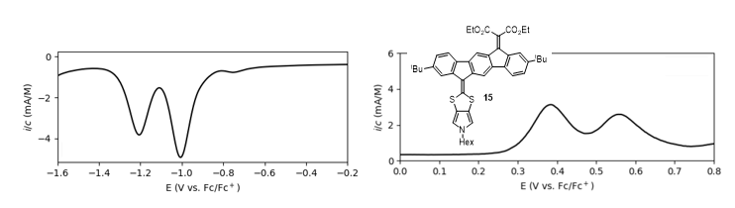
Figure S7. Differential pulse voltammograms of 15.
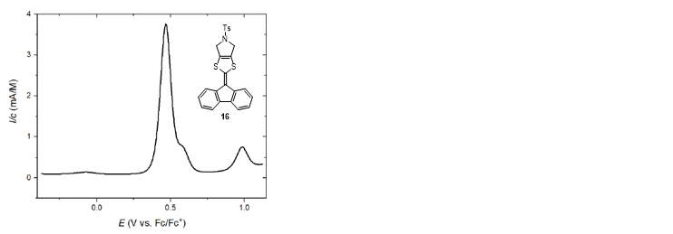
Figure S8. Differential pulse voltammogram of 16.
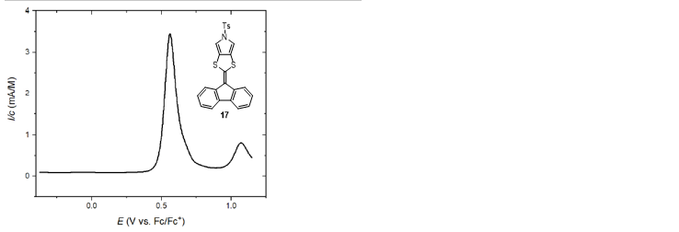
Figure S9. Differential pulse voltammogram of 17.
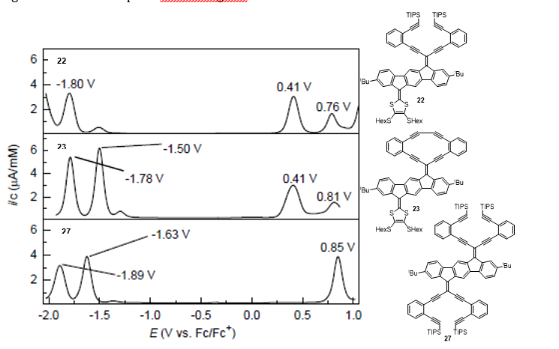
Figure S10. Differential pulse voltammograms of 22, 23, and 27.
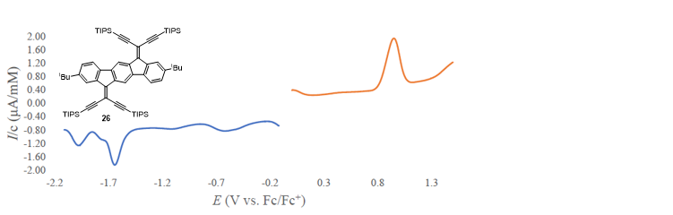
Figure S11. Differential pulse voltammograms of 26.

X-Ray crystallographic data
X-Ray crystallographic data for compound 25
A yellow, Prism-shaped crystal of mo_D8V5310_0m-1 was mounted on a MiTeGen micromount with perfluoroether oil. Data were collected from a shock-cooled single crystal at 100(2) K on a Bruker D8 VENTURE dual wavelength Mo/Cu three-circle diffractometer with a microfocus sealed X-ray tube using a mirror optics as monochromator and a Bruker PHOTON II detector. The diffractometer was equipped with an Oxford Cryostream 800 low temperature device and used MoK_{α} radiation (λ = 0.71073 Å). All data were integrated with SAINT and a multi-scan absorption correction using SADABS was applied.^{[1,2]} The structure was solved by direct methods using SHELXT and refined by full-matrix least-squares methods against F² by SHELXL-2019/2.^{[3,4]} All non-hydrogen atoms were refined with anisotropic displacement parameters. All hydrogen atoms were refined isotropic on calculated positions using a riding model with their U_{iso} values constrained to 1.5 times the U_{eq} of their pivot atoms for terminal sp³ carbon atoms and 1.2 times for all other carbon atoms. Crystallographic data for the structures reported here have been deposited with the Cambridge Crystallographic Data Centre.^{[5]} CCDC 2298562 contains the supplementary crystallographic data for this paper. These data can be obtained free of charge from The Cambridge Crystallographic Data Centre via www.ccdc.cam.ac.uk/​structures. This report and the CIF file were generated using FinalCif.^{[6]}

Table S1. Crystal data and structure refinement for mo_D8V5310_0m-1
CCDC number | 2298652
Empirical formula | C₃₀H₂₆Br₄
Formula weight | 706.15
Temperature [K] | 100(2)
Crystal system | monoclinic
Space group (number) | $P2_{1}/n$ (14)
a [Å] | 13.2258(8)
b [Å] | 7.3391(4)
c [Å] | 13.3672(7)
α [°] | 90
β [°] | 95.467(2)
γ [°] | 90
Volume [Å³] | 1291.59(13)
Z | 2
ρ_{calc} [gcm⁻³] | 1.816
μ [mm⁻¹] | 6.250
F(000) | 692
Crystal size [mm³] | 0.198×0.157×0.057
Crystal colour | yellow
Crystal shape | Prism
Radiation | MoK_{α} (λ=0.71073 Å)
2θ range [°] | 4.55 to 57.40 (0.74 Å)
Index ranges | −17 ≤ h ≤ 17  −9 ≤ k ≤ 9  −18 ≤ l ≤ 14
Reflections collected | 27084
Independent reflections | 3334  R_{int} = 0.0635  R_{sigma} = 0.0364
Completeness to  θ = 25.242° | 99.9 %
Data / Restraints / Parameters | 3334/0/157
Goodness-of-fit on F² | 1.080
Final R indexes  [I≥2σ(I)] | R₁ = 0.0251  wR₂ = 0.0579
Final R indexes  [all data] | R₁ = 0.0321  wR₂ = 0.0602
Largest peak/hole [eÅ⁻³] | 0.51/-0.64

Table S2. Atomic coordinates and U_{eq} [Å²] for mo_D8V5310_0m-1
Atom | x | y | z | U_{eq}
Br1 | 0.29892(2) | 0.63650(3) | 0.30213(2) | 0.01543(7)
C1 | 0.42044(14) | 0.6095(2) | 0.61240(15) | 0.0093(4)
Br2 | 0.27288(2) | 0.33569(3) | 0.45940(2) | 0.01515(7)
C2 | 0.39622(14) | 0.4607(3) | 0.67120(15) | 0.0099(4)
H2 | 0.360185 | 0.360102 | 0.640588 | 0.012
C3 | 0.42458(14) | 0.4592(2) | 0.77425(15) | 0.0098(4)
C4 | 0.48072(15) | 0.6061(3) | 0.81784(15) | 0.0121(4)
H4 | 0.500465 | 0.605415 | 0.888057 | 0.014
C5 | 0.50796(15) | 0.7526(3) | 0.76017(15) | 0.0121(4)
H5 | 0.547176 | 0.850073 | 0.790283 | 0.015
C6 | 0.47708(14) | 0.7546(2) | 0.65808(14) | 0.0093(4)
C7 | 0.39576(15) | 0.6547(2) | 0.50379(15) | 0.0090(4)
C8 | 0.33639(15) | 0.5603(3) | 0.43508(15) | 0.0107(4)
C9 | 0.39588(15) | 0.3015(3) | 0.84160(15) | 0.0114(4)
C10 | 0.33549(17) | 0.1523(3) | 0.78209(17) | 0.0163(4)
H10A | 0.318839 | 0.054926 | 0.827957 | 0.024
H10B | 0.376382 | 0.102253 | 0.731176 | 0.024
H10C | 0.272658 | 0.204144 | 0.749091 | 0.024
C11 | 0.49324(14) | 0.8929(3) | 0.58244(14) | 0.0090(4)
C12 | 0.55456(15) | 1.1656(2) | 0.51102(15) | 0.0092(4)
C13 | 0.54697(14) | 1.0558(3) | 0.59519(14) | 0.0104(4)
H13 | 0.577596 | 1.091211 | 0.659426 | 0.012
C14 | 0.49348(16) | 0.2167(3) | 0.89362(16) | 0.0154(4)
H14A | 0.475682 | 0.116329 | 0.937021 | 0.023
H14B | 0.531492 | 0.309495 | 0.934294 | 0.023
H14C | 0.535435 | 0.170132 | 0.842669 | 0.023
C15 | 0.32980(17) | 0.3753(3) | 0.92187(16) | 0.0168(4)
H15A | 0.317177 | 0.277610 | 0.969085 | 0.025
H15B | 0.264946 | 0.419227 | 0.889055 | 0.025
H15C | 0.365369 | 0.475861 | 0.958382 | 0.025
U_{eq} is defined as 1/3 of the trace of the orthogonalized U_{ij} tensor.

Table S3. Anisotropic displacement parameters [Å²] for mo_D8V5310_0m-1.
The anisotropic displacement factor exponent takes the form: −2π²[ h²(a*)²U₁₁ + k²(b*)²U₂₂ + … + 2hka*b*U₁₂ ]
Atom | U₁₁ | U₂₂ | U₃₃ | U₂₃ | U₁₃ | U₁₂
Br1 | 0.02016(12) | 0.01511(10) | 0.01020(11) | 0.00171(7) | −0.00281(8) | −0.00646(7)
C1 | 0.0103(9) | 0.0088(8) | 0.0090(9) | −0.0009(7) | 0.0018(7) | 0.0007(7)
Br2 | 0.01921(12) | 0.01176(10) | 0.01395(11) | 0.00077(7) | −0.00127(8) | −0.00786(7)
C2 | 0.0086(9) | 0.0086(8) | 0.0129(9) | 0.0002(7) | 0.0018(7) | 0.0004(7)
C3 | 0.0095(9) | 0.0090(8) | 0.0112(9) | 0.0022(7) | 0.0027(7) | 0.0014(7)
C4 | 0.0143(10) | 0.0121(9) | 0.0096(9) | 0.0018(7) | 0.0005(8) | −0.0015(7)
C5 | 0.0139(10) | 0.0090(9) | 0.0133(10) | 0.0002(7) | 0.0007(8) | −0.0020(7)
C6 | 0.0091(9) | 0.0076(8) | 0.0114(9) | 0.0013(7) | 0.0022(7) | −0.0003(7)
C7 | 0.0092(9) | 0.0073(8) | 0.0109(9) | 0.0002(7) | 0.0027(7) | 0.0011(6)
C8 | 0.0122(9) | 0.0092(8) | 0.0109(9) | 0.0008(7) | 0.0020(7) | −0.0001(7)
C9 | 0.0127(10) | 0.0108(8) | 0.0107(9) | 0.0035(7) | 0.0019(7) | −0.0020(7)
C10 | 0.0187(11) | 0.0131(9) | 0.0168(11) | 0.0047(8) | 0.0001(8) | −0.0047(7)
C11 | 0.0107(9) | 0.0093(8) | 0.0074(9) | 0.0004(7) | 0.0033(7) | 0.0003(7)
C12 | 0.0100(9) | 0.0086(8) | 0.0094(9) | −0.0006(7) | 0.0024(7) | 0.0004(7)
C13 | 0.0120(9) | 0.0105(8) | 0.0087(9) | −0.0013(7) | 0.0011(7) | −0.0006(7)
C14 | 0.0179(10) | 0.0117(9) | 0.0160(10) | 0.0047(8) | −0.0011(8) | −0.0002(8)
C15 | 0.0188(11) | 0.0187(10) | 0.0138(10) | 0.0046(8) | 0.0061(8) | −0.0016(8)

Table S4. Bond lengths and angles for mo_D8V5310_0m-1

Atom–Atom | Length [Å]
Br1–C8 | 1.884(2)
C1–C2 | 1.400(3)
C1–C6 | 1.408(3)
C1–C7 | 1.495(3)
Br2–C8 | 1.8923(19)
C2–C3 | 1.393(3)
C2–H2 | 0.9500
C3–C4 | 1.404(3)
C3–C9 | 1.536(3)
C4–C5 | 1.391(3)
C4–H4 | 0.9500
C5–C6 | 1.387(3)
C5–H5 | 0.9500
C6–C11 | 1.463(3)
C7–C8 | 1.343(3)
C7–C12^{#1} | 1.495(2)
C9–C10 | 1.533(3)
C9–C14 | 1.538(3)
C9–C15 | 1.545(3)
C10–H10A | 0.9800
C10–H10B | 0.9800
C10–H10C | 0.9800
C11–C13 | 1.393(3)
C11–C12^{#1} | 1.412(3)
C12–C13 | 1.395(3)
C13–H13 | 0.9500
C14–H14A | 0.9800
C14–H14B | 0.9800
C14–H14C | 0.9800
C15–H15A | 0.9800
C15–H15B | 0.9800
C15–H15C | 0.9800
Atom–Atom–Atom | Angle [°]
C2–C1–C6 | 119.17(18)
C2–C1–C7 | 132.69(18)
C6–C1–C7 | 108.13(16)
C3–C2–C1 | 120.46(18)
C3–C2–H2 | 119.8
C1–C2–H2 | 119.8
C2–C3–C4 | 119.09(17)
C2–C3–C9 | 121.84(17)
C4–C3–C9 | 119.06(17)
C5–C4–C3 | 121.24(19)
C5–C4–H4 | 119.4
C3–C4–H4 | 119.4
C6–C5–C4 | 119.07(18)
C6–C5–H5 | 120.5
C4–C5–H5 | 120.5
C5–C6–C1 | 120.91(17)
C5–C6–C11 | 129.69(17)
C1–C6–C11 | 109.39(17)
C8–C7–C1 | 127.52(17)
C8–C7–C12 | 126.90(18)
C1–C7–C12 | 105.46(16)
C7–C8–Br1 | 125.19(15)
C7–C8–Br2 | 124.91(15)
Br1–C8–Br2 | 109.84(10)
C10–C9–C3 | 112.32(17)
C10–C9–C14 | 108.56(16)
C3–C9–C14 | 109.05(15)
C10–C9–C15 | 108.04(16)
C3–C9–C15 | 109.33(16)
C14–C9–C15 | 109.50(17)
C9–C10–H10A | 109.5
C9–C10–H10B | 109.5
H10A–C10–H10B | 109.5
C9–C10–H10C | 109.5
H10A–C10–H10C | 109.5
H10B–C10–H10C | 109.5
C13–C11–C12 | 123.31(17)
C13–C11–C6 | 128.13(18)
C12–C11–C6 | 108.55(17)
C13–C12–C11 | 118.53(17)
C13–C12–C7 | 133.03(18)
C11–C12–C7 | 108.44(16)
C11–C13–C12 | 118.16(18)
C11–C13–H13 | 120.9
C12–C13–H13 | 120.9
C9–C14–H14A | 109.5
C9–C14–H14B | 109.5
H14A–C14–H14B | 109.5
C9–C14–H14C | 109.5
H14A–C14–H14C | 109.5
H14B–C14–H14C | 109.5
C9–C15–H15A | 109.5
C9–C15–H15B | 109.5
H15A–C15–H15B | 109.5
C9–C15–H15C | 109.5
H15A–C15–H15C | 109.5
H15B–C15–H15C | 109.5
Symmetry transformations used to generate equivalent atoms:
#1: 1-X, 2-Y, 1-Z;

Table S5. Torsion angles for mo_D8V5310_0m-1

Atom–Atom–Atom–Atom | Torsion Angle [°]
C6–C1–C2–C3 | 2.3(3)
C7–C1–C2–C3 | −175.90(18)
C1–C2–C3–C4 | −2.1(3)
C1–C2–C3–C9 | 177.71(17)
C2–C3–C4–C5 | 0.2(3)
C9–C3–C4–C5 | −179.55(17)
C3–C4–C5–C6 | 1.3(3)
C4–C5–C6–C1 | −1.1(3)
C4–C5–C6–C11 | 178.26(19)
C2–C1–C6–C5 | −0.7(3)
C7–C1–C6–C5 | 177.91(17)
C2–C1–C6–C11 | 179.83(16)
C7–C1–C6–C11 | −1.6(2)
C2–C1–C7–C8 | 4.0(3)
C6–C1–C7–C8 | −174.36(19)
C2–C1–C7–C12^{#1} | −179.75(19)
C6–C1–C7–C12^{#1} | 1.9(2)
C1–C7–C8–Br1 | 174.07(14)
C12^{#1}–C7–C8–Br1 | −1.4(3)
C1–C7–C8–Br2 | −2.9(3)
C12^{#1}–C7–C8–Br2 | −178.39(14)
C2–C3–C9–C10 | 0.6(3)
C4–C3–C9–C10 | −179.60(18)
C2–C3–C9–C14 | 120.99(19)
C4–C3–C9–C14 | −59.2(2)
C2–C3–C9–C15 | −119.3(2)
C4–C3–C9–C15 | 60.5(2)
C5–C6–C11–C13 | 2.0(3)
C1–C6–C11–C13 | −178.58(18)
C5–C6–C11–C12^{#1} | −178.83(19)
C1–C6–C11–C12^{#1} | 0.6(2)
C12^{#1}–C11–C13–C12 | −0.6(3)
C6–C11–C13–C12 | 178.42(18)
C11^{#1}–C12–C13–C11 | 0.6(3)
C7^{#1}–C12–C13–C11 | 179.59(19)
Symmetry transformations used to generate equivalent atoms:
#1: 1-X, 2-Y, 1-Z;

X-Ray crystallographic data for compound 26

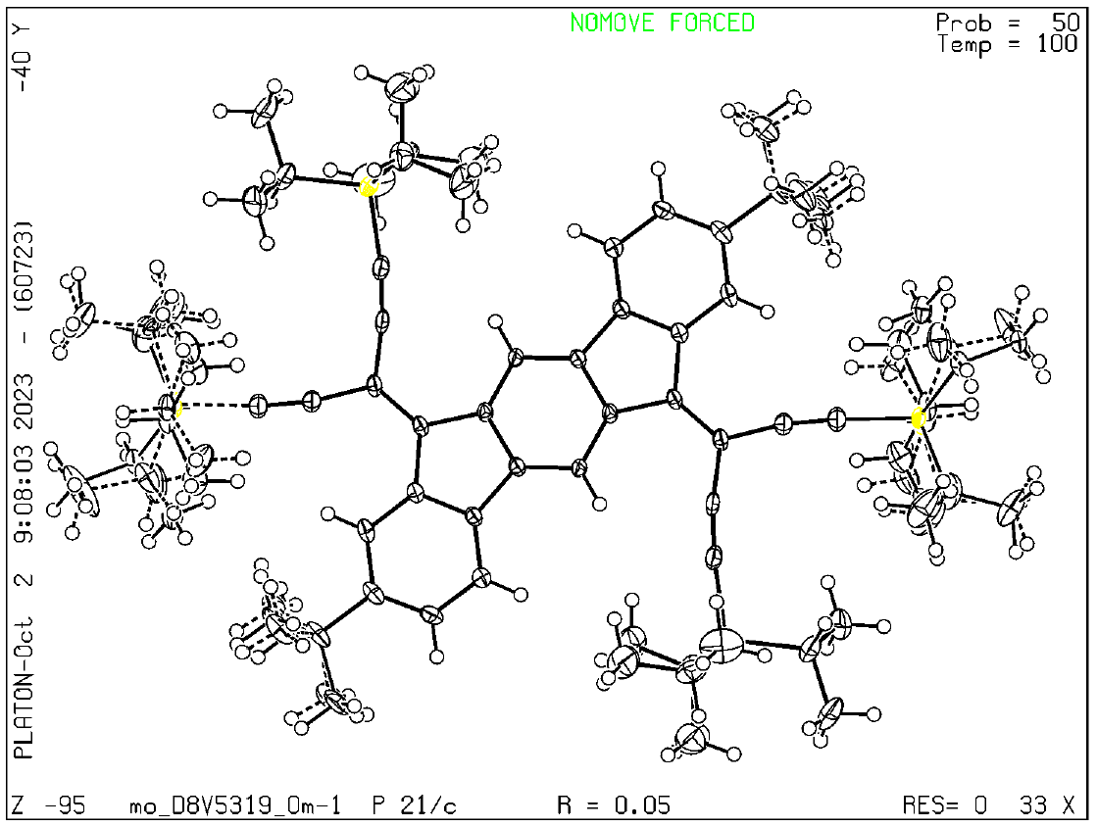 A red, Prism-shaped crystal of mo_D8V5319_0m-1 was mounted on a MiTeGen micromount with perfluoroether oil. Data were collected from a shock-cooled single crystal at 100(2) K on a Bruker D8 VENTURE dual wavelength Mo/Cu three-circle diffractometer with a microfocus sealed X-ray tube using a mirror optics as monochromator and a Bruker PHOTON II detector. The diffractometer was equipped with an Oxford Cryostream 800 low temperature device and used MoK_{α} radiation (λ = 0.71073 Å). All data were integrated with SAINT and a multi-scan absorption correction using SADABS was applied.^{[1,2]} The structure was solved by direct methods using SHELXT and refined by full-matrix least-squares methods against F² by SHELXL-2019/2.^{[3,4]} All non-hydrogen atoms were refined with anisotropic displacement parameters. All hydrogen atoms were refined with isotropic displacement parameters. Some were refined freely and some on calculated positions using a riding model with their U_{iso} values constrained to 1.5 times the U_{eq} of their pivot atoms for terminal sp³ carbon atoms and 1.2 times for all other carbon atoms. The disordered Si-trisisopropyl groups were modeled as tw parts using SADI, RIGU and SIMU restraints. Two pairs of C-atoms were restrained using EADP due to their high displacement factors. The disordered tert-butyl group was modelled as two parts using SADI, RIGU and SIMU restraints.Crystallographic data for the structures reported here have been deposited with the Cambridge Crystallographic Data Centre.^{[5]} CCDC 2298654 contains the supplementary crystallographic data for this paper. These data can be obtained free of charge from The Cambridge Crystallographic Data Centre via www.ccdc.cam.ac.uk/​structures. This report and the CIF file were generated using FinalCif.^{[6]}

Table S6. Crystal data and structure refinement for mo_D8V5319_0m-1
CCDC number | 2298654
Empirical formula | C₇₄H₁₁₀Si₄
Formula weight | 1111.97
Temperature [K] | 100(2)
Crystal system | monoclinic
Space group (number) | $P2_{1}/c$ (14)
a [Å] | 17.1710(13)
b [Å] | 12.6070(11)
c [Å] | 18.4564(15)
α [°] | 90
β [°] | 117.037(3)
γ [°] | 90
Volume [Å³] | 3558.7(5)
Z | 2
ρ_{calc} [gcm⁻³] | 1.038
μ [mm⁻¹] | 0.121
F(000) | 1220
Crystal size [mm³] | 0.193×0.119×0.102
Crystal colour | red
Crystal shape | Prism
Radiation | MoK_{α} (λ=0.71073 Å)
2θ range [°] | 4.07 to 53.46 (0.79 Å)
Index ranges | −21 ≤ h ≤ 21  −15 ≤ k ≤ 15  −23 ≤ l ≤ 23
Reflections collected | 66001
Independent reflections | 7555  R_{int} = 0.0889  R_{sigma} = 0.0416
Completeness to  θ = 25.242° | 99.9 %
Data / Restraints / Parameters | 7555/180/495
Goodness-of-fit on F² | 1.056
Final R indexes  [I≥2σ(I)] | R₁ = 0.0505  wR₂ = 0.1116
Final R indexes  [all data] | R₁ = 0.0766  wR₂ = 0.1236
Largest peak/hole [eÅ⁻³] | 0.41/-0.39

Table S7. Atomic coordinates and U_{eq} [Å²] for mo_D8V5319_0m-1
Atom | x | y | z | U_{eq}
C1 | 0.10143(11) | 0.31813(14) | 0.51153(11) | 0.0185(4)
Si2 | 0.38701(3) | 0.59837(4) | 0.77968(3) | 0.02454(14)
C2 | 0.03976(11) | 0.24713(13) | 0.45658(10) | 0.0164(4)
C3 | 0.06520(13) | 0.14571(14) | 0.44642(11) | 0.0202(4)
H1C | 0.0229(14) | 0.0996(17) | 0.4096(13) | 0.030
C4 | 0.15256(13) | 0.11411(14) | 0.49002(11) | 0.0234(4)
C5 | 0.21203(14) | 0.18690(17) | 0.54253(13) | 0.0303(5)
H1B | 0.2710(16) | 0.1674(19) | 0.5704(15) | 0.045
C6 | 0.18773(13) | 0.28850(16) | 0.55375(13) | 0.0284(4)
H1 | 0.2301(16) | 0.3350(19) | 0.5923(14) | 0.043
C7 | 0.05680(11) | 0.41734(13) | 0.51183(10) | 0.0167(4)
C8 | 0.03246(11) | 0.59339(13) | 0.54361(10) | 0.0162(3)
C9 | 0.04599(11) | 0.69892(13) | 0.58181(11) | 0.0164(4)
C10 | 0.12129(11) | 0.73580(14) | 0.64396(11) | 0.0190(4)
C11 | 0.12931(12) | 0.83560(15) | 0.68468(12) | 0.0236(4)
C12 | 0.14696(13) | 0.91324(16) | 0.72614(13) | 0.0304(5)
C15 | 0.17895(15) | 0.00121(15) | 0.47813(13) | 0.0311(5)
C17 | 0.09023(11) | 0.50995(14) | 0.55550(11) | 0.0181(4)
H1AA | 0.1491(14) | 0.5164(16) | 0.5911(13) | 0.027
C18 | 0.20237(12) | 0.67874(15) | 0.67912(11) | 0.0223(4)
C19 | 0.27379(12) | 0.64176(15) | 0.71509(12) | 0.0259(4)
C20 | 0.44068(14) | 0.5768(2) | 0.71240(14) | 0.0387(5)
H20 | 0.502545 | 0.555043 | 0.747880 | 0.046
C21 | 0.4430(2) | 0.6795(3) | 0.67013(19) | 0.0658(8)
H21A | 0.471623 | 0.666899 | 0.635544 | 0.099
H21B | 0.475644 | 0.733347 | 0.711049 | 0.099
H21C | 0.383108 | 0.704486 | 0.636566 | 0.099
C29 | 0.38165(15) | 0.47717(17) | 0.83689(14) | 0.0366(5)
H29 | 0.363467 | 0.502743 | 0.878219 | 0.044
C30 | 0.31338(18) | 0.3960(2) | 0.78506(17) | 0.0537(7)
H30A | 0.257123 | 0.431561 | 0.753830 | 0.081
H30B | 0.307234 | 0.342063 | 0.820373 | 0.081
H30C | 0.331825 | 0.362025 | 0.747603 | 0.081
C31 | 0.43939(15) | 0.71311(19) | 0.85077(14) | 0.0425(6)
H31 | 0.426723 | 0.777801 | 0.815871 | 0.051
C32 | 0.39801(18) | 0.7320(2) | 0.90777(16) | 0.0598(8)
H32A | 0.334761 | 0.741452 | 0.875504 | 0.090
H32B | 0.423351 | 0.795854 | 0.940319 | 0.090
H32C | 0.409460 | 0.670809 | 0.943948 | 0.090
C33 | 0.39781(18) | 0.4895(3) | 0.64939(16) | 0.0567(8)
H33A | 0.335784 | 0.506079 | 0.616161 | 0.085
H33B | 0.403333 | 0.421558 | 0.677161 | 0.085
H33C | 0.426764 | 0.484665 | 0.614384 | 0.085
C36 | 0.47032(18) | 0.4244(2) | 0.88450(19) | 0.0636(8)
H36A | 0.493002 | 0.401814 | 0.846882 | 0.095
H36B | 0.463983 | 0.362435 | 0.913455 | 0.095
H36C | 0.511067 | 0.474929 | 0.923804 | 0.095
C37 | 0.53924(17) | 0.7044(2) | 0.89770(18) | 0.0639(8)
H37A | 0.563138 | 0.689844 | 0.859554 | 0.096
H37B | 0.554986 | 0.646503 | 0.937325 | 0.096
H37C | 0.563402 | 0.771199 | 0.926226 | 0.096
C16A | 0.1372(5) | -0.0763(3) | 0.5091(4) | 0.0386(14)
H16A | 0.073530 | -0.069812 | 0.478490 | 0.058
H16B | 0.155467 | -0.062538 | 0.566839 | 0.058
H16C | 0.154914 | -0.148154 | 0.502589 | 0.058
C27A | 0.1569(6) | -0.0139(10) | 0.3879(4) | 0.0274(13)
H27A | 0.093966 | -0.004197 | 0.353892 | 0.041
H27B | 0.173725 | -0.085561 | 0.379807 | 0.041
H27C | 0.189060 | 0.038401 | 0.372615 | 0.041
C28A | 0.2817(3) | -0.0129(4) | 0.5276(3) | 0.0409(13)
H28A | 0.297756 | -0.084948 | 0.519615 | 0.061
H28B | 0.300043 | -0.000950 | 0.585565 | 0.061
H28C | 0.310711 | 0.038548 | 0.508148 | 0.061
C16B | 0.0994(6) | -0.0806(6) | 0.4708(7) | 0.0294(17)
H16D | 0.044362 | -0.059732 | 0.424345 | 0.044
H16E | 0.092829 | -0.076684 | 0.520810 | 0.044
H16F | 0.114152 | -0.153356 | 0.463020 | 0.044
C27B | 0.1764(13) | -0.009(2) | 0.3966(8) | 0.041(3)
H27D | 0.118952 | 0.013759 | 0.354493 | 0.061
H27E | 0.186808 | -0.082687 | 0.387248 | 0.061
H27F | 0.221818 | 0.036421 | 0.394472 | 0.061
C28B | 0.2577(7) | -0.0419(8) | 0.5450(7) | 0.048(2)
H28D | 0.268232 | -0.113670 | 0.531054 | 0.072
H28E | 0.249900 | -0.044400 | 0.594356 | 0.072
H28F | 0.307710 | 0.003490 | 0.554358 | 0.072
C13A | 0.1368(8) | 0.9862(10) | 0.8672(6) | 0.029(2)
H13A | 0.151448 | 1.043984 | 0.908421 | 0.034
C14A | 0.1747(6) | 0.8821(10) | 0.9133(6) | 0.0383(18)
H14A | 0.162370 | 0.824107 | 0.874168 | 0.057
H14B | 0.147869 | 0.866357 | 0.948913 | 0.057
H14C | 0.238093 | 0.889415 | 0.946077 | 0.057
C22A | 0.2995(8) | 1.0302(16) | 0.8492(11) | 0.049(5)
H22A | 0.316393 | 0.958074 | 0.873896 | 0.059
C23A | 0.337(3) | 1.032(4) | 0.7842(19) | 0.063(3)
H23A | 0.310954 | 0.973838 | 0.745476 | 0.095
H23B | 0.400473 | 1.024090 | 0.812267 | 0.095
H23C | 0.321742 | 1.099902 | 0.754887 | 0.095
C24A | 0.1479(3) | 1.1596(4) | 0.7490(3) | 0.0230(11)
H24A | 0.197592 | 1.187020 | 0.740264 | 0.028
C25A | 0.0668(4) | 1.1584(4) | 0.6668(3) | 0.0293(12)
H25A | 0.053920 | 1.230624 | 0.644973 | 0.044
H25B | 0.017043 | 1.130871 | 0.673443 | 0.044
H25C | 0.077324 | 1.112770 | 0.629150 | 0.044
C26A | 0.0353(4) | 0.9775(5) | 0.8205(4) | 0.0348(14)
H26A | 0.010477 | 1.046735 | 0.797475 | 0.052
H26B | 0.012667 | 0.954854 | 0.858202 | 0.052
H26C | 0.018852 | 0.925338 | 0.776641 | 0.052
C34A | 0.347(3) | 1.101(4) | 0.918(3) | 0.051(3)
H34A | 0.345291 | 1.173546 | 0.898402 | 0.076
H34B | 0.408285 | 1.077669 | 0.947501 | 0.076
H34C | 0.320333 | 1.099063 | 0.954945 | 0.076
C35A | 0.1344(4) | 1.2372(8) | 0.8076(5) | 0.0285(15)
H35A | 0.121213 | 1.308210 | 0.783368 | 0.043
H35B | 0.187814 | 1.239987 | 0.859500 | 0.043
H35C | 0.085664 | 1.212510 | 0.817093 | 0.043
Si1A | 0.1796(4) | 1.0244(6) | 0.7973(5) | 0.0194(8)
C13B | 0.1462(7) | 0.9670(9) | 0.8880(6) | 0.0226(18)
H13B | 0.156071 | 1.026397 | 0.927090 | 0.027
C14B | 0.2034(6) | 0.8726(10) | 0.9368(6) | 0.040(2)
H14D | 0.197227 | 0.814075 | 0.899603 | 0.060
H14E | 0.184568 | 0.849007 | 0.976948 | 0.060
H14F | 0.264766 | 0.894841 | 0.964805 | 0.060
C22B | 0.3053(7) | 1.0138(15) | 0.8521(9) | 0.0208(18)
H22B | 0.325338 | 0.943951 | 0.880164 | 0.025
C23B | 0.345(3) | 1.025(4) | 0.7979(19) | 0.063(3)
H23D | 0.319353 | 0.972764 | 0.753827 | 0.095
H23E | 0.408121 | 1.012631 | 0.828323 | 0.095
H23F | 0.334335 | 1.096536 | 0.774873 | 0.095
C24B | 0.1095(5) | 1.1320(4) | 0.7542(3) | 0.0349(15)
H24B | 0.047557 | 1.106640 | 0.729571 | 0.042
C25B | 0.1258(6) | 1.1746(4) | 0.6846(3) | 0.047(2)
H25D | 0.123833 | 1.115794 | 0.649074 | 0.070
H25E | 0.183340 | 1.208537 | 0.707005 | 0.070
H25F | 0.080525 | 1.226595 | 0.653171 | 0.070
C26B | 0.0502(4) | 0.9392(7) | 0.8497(4) | 0.0400(17)
H26D | 0.015426 | 1.002671 | 0.824473 | 0.060
H26E | 0.035192 | 0.912587 | 0.891685 | 0.060
H26F | 0.037701 | 0.884474 | 0.808216 | 0.060
C34B | 0.342(4) | 1.102(4) | 0.921(3) | 0.051(3)
H34D | 0.317796 | 1.171357 | 0.897742 | 0.076
H34E | 0.405639 | 1.104153 | 0.945485 | 0.076
H34F | 0.324021 | 1.084801 | 0.963591 | 0.076
C35B | 0.1165(10) | 1.2244(11) | 0.8103(8) | 0.101(5)
H35D | 0.069749 | 1.275610 | 0.780830 | 0.152
H35E | 0.173405 | 1.259217 | 0.828492 | 0.152
H35F | 0.111008 | 1.197796 | 0.857644 | 0.152
Si1B | 0.1810(5) | 1.0155(6) | 0.8089(5) | 0.0273(14)
U_{eq} is defined as 1/3 of the trace of the orthogonalized U_{ij} tensor.

Table S8. Anisotropic displacement parameters [Å²] for mo_D8V5319_0m-1.
The anisotropic displacement factor exponent takes the form: −2π²[ h²(a*)²U₁₁ + k²(b*)²U₂₂ + … + 2hka*b*U₁₂ ]
Atom | U₁₁ | U₂₂ | U₃₃ | U₂₃ | U₁₃ | U₁₂
C1 | 0.0192(9) | 0.0152(8) | 0.0234(9) | −0.0034(7) | 0.0116(8) | 0.0003(7)
Si2 | 0.0173(3) | 0.0230(3) | 0.0277(3) | −0.0062(2) | 0.0053(2) | −0.0045(2)
C2 | 0.0183(9) | 0.0139(8) | 0.0218(9) | −0.0024(7) | 0.0133(7) | −0.0024(7)
C3 | 0.0280(10) | 0.0127(8) | 0.0262(10) | −0.0036(7) | 0.0177(8) | −0.0026(7)
C4 | 0.0345(11) | 0.0164(9) | 0.0243(9) | 0.0027(7) | 0.0178(8) | 0.0083(8)
C5 | 0.0261(10) | 0.0297(11) | 0.0297(11) | −0.0047(9) | 0.0078(9) | 0.0129(9)
C6 | 0.0215(10) | 0.0263(10) | 0.0310(11) | −0.0108(9) | 0.0064(9) | 0.0034(8)
C7 | 0.0161(8) | 0.0138(8) | 0.0225(9) | −0.0035(7) | 0.0108(7) | −0.0009(7)
C8 | 0.0155(8) | 0.0138(8) | 0.0223(9) | −0.0050(7) | 0.0112(7) | −0.0040(7)
C9 | 0.0183(8) | 0.0122(8) | 0.0243(9) | −0.0047(7) | 0.0147(7) | −0.0028(7)
C10 | 0.0194(9) | 0.0171(9) | 0.0256(9) | −0.0091(7) | 0.0147(8) | −0.0054(7)
C11 | 0.0169(9) | 0.0255(10) | 0.0318(10) | −0.0116(8) | 0.0140(8) | −0.0049(8)
C12 | 0.0213(10) | 0.0302(11) | 0.0412(12) | −0.0181(9) | 0.0155(9) | −0.0059(8)
C15 | 0.0471(12) | 0.0166(9) | 0.0362(11) | 0.0031(8) | 0.0248(10) | 0.0131(8)
C17 | 0.0130(8) | 0.0166(9) | 0.0237(9) | −0.0077(7) | 0.0073(7) | −0.0028(7)
C18 | 0.0216(10) | 0.0213(9) | 0.0262(10) | −0.0147(8) | 0.0127(8) | −0.0097(8)
C19 | 0.0223(10) | 0.0251(10) | 0.0298(10) | −0.0133(8) | 0.0115(9) | −0.0079(8)
C20 | 0.0215(10) | 0.0560(15) | 0.0376(12) | −0.0003(11) | 0.0124(9) | −0.0004(10)
C21 | 0.0562(17) | 0.084(2) | 0.070(2) | 0.0195(17) | 0.0393(16) | 0.0017(16)
C29 | 0.0418(13) | 0.0307(11) | 0.0358(12) | −0.0019(9) | 0.0165(10) | −0.0033(10)
C30 | 0.0531(16) | 0.0376(14) | 0.0643(17) | 0.0014(12) | 0.0212(14) | −0.0187(12)
C31 | 0.0323(12) | 0.0330(12) | 0.0407(13) | −0.0107(10) | −0.0022(10) | −0.0070(10)
C32 | 0.0594(17) | 0.0531(16) | 0.0455(15) | −0.0261(13) | 0.0051(13) | 0.0121(14)
C33 | 0.0467(15) | 0.083(2) | 0.0463(15) | −0.0214(14) | 0.0263(13) | 0.0005(14)
C36 | 0.0534(17) | 0.0399(15) | 0.072(2) | 0.0127(14) | 0.0058(15) | 0.0001(13)
C37 | 0.0396(15) | 0.0557(17) | 0.0641(18) | −0.0215(14) | −0.0046(13) | −0.0184(13)
C16A | 0.065(4) | 0.0178(17) | 0.042(3) | 0.0113(19) | 0.033(3) | 0.010(2)
C27A | 0.031(3) | 0.022(3) | 0.038(2) | −0.0040(18) | 0.023(2) | 0.005(2)
C28A | 0.052(3) | 0.021(2) | 0.044(2) | 0.0024(16) | 0.0175(19) | 0.0195(19)
C16B | 0.040(3) | 0.016(3) | 0.026(4) | 0.008(3) | 0.011(3) | 0.009(2)
C27B | 0.058(8) | 0.027(5) | 0.049(3) | 0.002(3) | 0.035(4) | 0.013(5)
C28B | 0.050(4) | 0.020(4) | 0.059(4) | 0.004(3) | 0.013(3) | 0.012(3)
C13A | 0.039(3) | 0.022(4) | 0.030(5) | −0.010(3) | 0.021(3) | −0.007(2)
C14A | 0.052(5) | 0.032(3) | 0.044(4) | −0.001(3) | 0.034(4) | 0.000(3)
C22A | 0.053(7) | 0.050(10) | 0.051(6) | −0.013(5) | 0.031(5) | −0.018(5)
C23A | 0.042(6) | 0.103(6) | 0.051(7) | −0.021(7) | 0.027(7) | −0.030(5)
C24A | 0.029(2) | 0.018(2) | 0.028(2) | −0.0059(15) | 0.0183(18) | −0.0052(17)
C25A | 0.036(3) | 0.024(2) | 0.028(2) | −0.0026(15) | 0.0153(19) | −0.0069(19)
C26A | 0.038(3) | 0.039(3) | 0.037(4) | −0.008(2) | 0.025(3) | −0.008(2)
C34A | 0.043(5) | 0.064(2) | 0.036(3) | −0.0132(19) | 0.010(3) | −0.028(2)
C35A | 0.026(2) | 0.023(3) | 0.031(3) | −0.013(2) | 0.008(2) | 0.001(2)
Si1A | 0.0184(13) | 0.0191(14) | 0.0194(16) | −0.0101(11) | 0.0073(10) | −0.0029(9)
C13B | 0.031(3) | 0.024(4) | 0.022(4) | −0.009(3) | 0.019(3) | −0.008(3)
C14B | 0.055(5) | 0.025(3) | 0.046(5) | −0.001(3) | 0.028(4) | −0.001(4)
C22B | 0.011(3) | 0.017(3) | 0.026(3) | −0.002(2) | 0.000(3) | −0.006(2)
C23B | 0.042(6) | 0.103(6) | 0.051(7) | −0.021(7) | 0.027(7) | −0.030(5)
C24B | 0.056(4) | 0.023(2) | 0.035(3) | 0.0012(19) | 0.029(3) | 0.007(2)
C25B | 0.082(6) | 0.027(3) | 0.038(3) | −0.003(2) | 0.033(3) | −0.012(3)
C26B | 0.034(3) | 0.063(5) | 0.028(3) | −0.014(3) | 0.018(3) | −0.018(3)
C34B | 0.043(5) | 0.064(2) | 0.036(3) | −0.0132(19) | 0.010(3) | −0.028(2)
C35B | 0.214(14) | 0.042(5) | 0.054(5) | 0.008(4) | 0.065(7) | 0.057(7)
Si1B | 0.0369(17) | 0.0155(13) | 0.025(2) | −0.0109(13) | 0.0102(12) | −0.0004(9)

Table S9. Bond lengths and angles for mo_D8V5319_0m-1

Atom–Atom | Length [Å]
C1–C6 | 1.376(3)
C1–C2 | 1.405(2)
C1–C7 | 1.468(2)
Si2–C19 | 1.842(2)
Si2–C20 | 1.872(2)
Si2–C29 | 1.883(2)
Si2–C31 | 1.884(2)
C2–C3 | 1.391(2)
C2–C9^{#1} | 1.478(2)
C3–C4 | 1.400(3)
C3–H1C | 0.94(2)
C4–C5 | 1.387(3)
C4–C15 | 1.539(2)
C5–C6 | 1.392(3)
C5–H1B | 0.94(2)
C6–H1 | 0.95(2)
C7–C17 | 1.386(2)
C7–C8^{#1} | 1.410(2)
C8–C17 | 1.393(2)
C8–C9 | 1.474(2)
C9–C10 | 1.362(2)
C10–C18 | 1.434(3)
C10–C11 | 1.440(2)
C11–C12 | 1.194(3)
C12–Si1A | 1.826(7)
C12–Si1B | 1.877(8)
C15–C28B | 1.459(8)
C15–C16A | 1.472(4)
C15–C27B | 1.491(11)
C15–C27A | 1.543(6)
C15–C28A | 1.585(5)
C15–C16B | 1.668(7)
C17–H1AA | 0.93(2)
C18–C19 | 1.192(3)
C20–C21 | 1.521(4)
C20–C33 | 1.526(3)
C20–H20 | 1.0000
C21–H21A | 0.9800
C21–H21B | 0.9800
C21–H21C | 0.9800
C29–C36 | 1.522(3)
C29–C30 | 1.522(3)
C29–H29 | 1.0000
C30–H30A | 0.9800
C30–H30B | 0.9800
C30–H30C | 0.9800
C31–C32 | 1.532(4)
C31–C37 | 1.534(3)
C31–H31 | 1.0000
C32–H32A | 0.9800
C32–H32B | 0.9800
C32–H32C | 0.9800
C33–H33A | 0.9800
C33–H33B | 0.9800
C33–H33C | 0.9800
C36–H36A | 0.9800
C36–H36B | 0.9800
C36–H36C | 0.9800
C37–H37A | 0.9800
C37–H37B | 0.9800
C37–H37C | 0.9800
C16A–H16A | 0.9800
C16A–H16B | 0.9800
C16A–H16C | 0.9800
C27A–H27A | 0.9800
C27A–H27B | 0.9800
C27A–H27C | 0.9800
C28A–H28A | 0.9800
C28A–H28B | 0.9800
C28A–H28C | 0.9800
C16B–H16D | 0.9800
C16B–H16E | 0.9800
C16B–H16F | 0.9800
C27B–H27D | 0.9800
C27B–H27E | 0.9800
C27B–H27F | 0.9800
C28B–H28D | 0.9800
C28B–H28E | 0.9800
C28B–H28F | 0.9800
C13A–C14A | 1.539(10)
C13A–C26A | 1.557(12)
C13A–Si1A | 1.816(10)
C13A–H13A | 1.0000
C14A–H14A | 0.9800
C14A–H14B | 0.9800
C14A–H14C | 0.9800
C22A–C34A | 1.46(6)
C22A–C23A | 1.60(3)
C22A–Si1A | 1.835(11)
C22A–H22A | 1.0000
C23A–H23A | 0.9800
C23A–H23B | 0.9800
C23A–H23C | 0.9800
C24A–C25A | 1.523(7)
C24A–C35A | 1.552(9)
C24A–Si1A | 1.885(8)
C24A–H24A | 1.0000
C25A–H25A | 0.9800
C25A–H25B | 0.9800
C25A–H25C | 0.9800
C26A–H26A | 0.9800
C26A–H26B | 0.9800
C26A–H26C | 0.9800
C34A–H34A | 0.9800
C34A–H34B | 0.9800
C34A–H34C | 0.9800
C35A–H35A | 0.9800
C35A–H35B | 0.9800
C35A–H35C | 0.9800
C13B–C26B | 1.510(11)
C13B–C14B | 1.545(9)
C13B–Si1B | 1.912(10)
C13B–H13B | 1.0000
C14B–H14D | 0.9800
C14B–H14E | 0.9800
C14B–H14F | 0.9800
C22B–C23B | 1.45(3)
C22B–C34B | 1.59(6)
C22B–Si1B | 1.909(9)
C22B–H22B | 1.0000
C23B–H23D | 0.9800
C23B–H23E | 0.9800
C23B–H23F | 0.9800
C24B–C35B | 1.526(13)
C24B–C25B | 1.530(9)
C24B–Si1B | 1.887(8)
C24B–H24B | 1.0000
C25B–H25D | 0.9800
C25B–H25E | 0.9800
C25B–H25F | 0.9800
C26B–H26D | 0.9800
C26B–H26E | 0.9800
C26B–H26F | 0.9800
C34B–H34D | 0.9800
C34B–H34E | 0.9800
C34B–H34F | 0.9800
C35B–H35D | 0.9800
C35B–H35E | 0.9800
C35B–H35F | 0.9800
Atom–Atom–Atom | Angle [°]
C6–C1–C2 | 120.00(16)
C6–C1–C7 | 131.22(17)
C2–C1–C7 | 108.78(15)
C19–Si2–C20 | 107.87(10)
C19–Si2–C29 | 107.31(10)
C20–Si2–C29 | 114.72(11)
C19–Si2–C31 | 104.60(9)
C20–Si2–C31 | 110.51(11)
C29–Si2–C31 | 111.22(11)
C3–C2–C1 | 120.19(16)
C3–C2–C9 | 131.60(16)
C1–C2–C9 | 108.21(14)
C2–C3–C4 | 120.28(17)
C2–C3–H1C | 118.7(13)
C4–C3–H1C | 121.0(13)
C5–C4–C3 | 118.01(17)
C5–C4–C15 | 122.70(18)
C3–C4–C15 | 119.29(17)
C4–C5–C6 | 122.52(19)
C4–C5–H1B | 118.6(15)
C6–C5–H1B | 118.9(15)
C1–C6–C5 | 118.97(18)
C1–C6–H1 | 121.1(14)
C5–C6–H1 | 119.9(14)
C17–C7–C8 | 121.93(15)
C17–C7–C1 | 129.85(16)
C8–C7–C1 | 108.22(14)
C17–C8–C7 | 120.21(15)
C17–C8–C9 | 131.31(16)
C7–C8–C9 | 108.46(15)
C10–C9–C8 | 126.43(16)
C10–C9–C2 | 127.16(15)
C8–C9–C2 | 106.26(14)
C9–C10–C18 | 124.38(16)
C9–C10–C11 | 124.54(17)
C18–C10–C11 | 111.06(15)
C12–C11–C10 | 170.9(2)
C11–C12–Si1A | 174.9(3)
C11–C12–Si1B | 168.3(3)
C28B–C15–C27B | 114.4(10)
C28B–C15–C4 | 116.3(4)
C16A–C15–C4 | 109.4(2)
C27B–C15–C4 | 110.2(10)
C16A–C15–C27A | 114.4(5)
C4–C15–C27A | 108.9(5)
C16A–C15–C28A | 108.2(3)
C4–C15–C28A | 110.1(2)
C27A–C15–C28A | 105.7(4)
C28B–C15–C16B | 104.4(5)
C27B–C15–C16B | 102.7(9)
C4–C15–C16B | 107.4(3)
C7–C17–C8 | 117.86(16)
C7–C17–H1AA | 121.1(13)
C8–C17–H1AA | 121.0(13)
C19–C18–C10 | 171.70(19)
C18–C19–Si2 | 172.85(17)
C21–C20–C33 | 109.8(2)
C21–C20–Si2 | 110.59(18)
C33–C20–Si2 | 113.44(16)
C21–C20–H20 | 107.6
C33–C20–H20 | 107.6
Si2–C20–H20 | 107.6
C20–C21–H21A | 109.5
C20–C21–H21B | 109.5
H21A–C21–H21B | 109.5
C20–C21–H21C | 109.5
H21A–C21–H21C | 109.5
H21B–C21–H21C | 109.5
C36–C29–C30 | 110.6(2)
C36–C29–Si2 | 112.79(17)
C30–C29–Si2 | 114.41(16)
C36–C29–H29 | 106.1
C30–C29–H29 | 106.1
Si2–C29–H29 | 106.1
C29–C30–H30A | 109.5
C29–C30–H30B | 109.5
H30A–C30–H30B | 109.5
C29–C30–H30C | 109.5
H30A–C30–H30C | 109.5
H30B–C30–H30C | 109.5
C32–C31–C37 | 111.8(2)
C32–C31–Si2 | 111.96(17)
C37–C31–Si2 | 113.29(17)
C32–C31–H31 | 106.4
C37–C31–H31 | 106.4
Si2–C31–H31 | 106.4
C31–C32–H32A | 109.5
C31–C32–H32B | 109.5
H32A–C32–H32B | 109.5
C31–C32–H32C | 109.5
H32A–C32–H32C | 109.5
H32B–C32–H32C | 109.5
C20–C33–H33A | 109.5
C20–C33–H33B | 109.5
H33A–C33–H33B | 109.5
C20–C33–H33C | 109.5
H33A–C33–H33C | 109.5
H33B–C33–H33C | 109.5
C29–C36–H36A | 109.5
C29–C36–H36B | 109.5
H36A–C36–H36B | 109.5
C29–C36–H36C | 109.5
H36A–C36–H36C | 109.5
H36B–C36–H36C | 109.5
C31–C37–H37A | 109.5
C31–C37–H37B | 109.5
H37A–C37–H37B | 109.5
C31–C37–H37C | 109.5
H37A–C37–H37C | 109.5
H37B–C37–H37C | 109.5
C15–C16A–H16A | 109.5
C15–C16A–H16B | 109.5
H16A–C16A–H16B | 109.5
C15–C16A–H16C | 109.5
H16A–C16A–H16C | 109.5
H16B–C16A–H16C | 109.5
C15–C27A–H27A | 109.5
C15–C27A–H27B | 109.5
H27A–C27A–H27B | 109.5
C15–C27A–H27C | 109.5
H27A–C27A–H27C | 109.5
H27B–C27A–H27C | 109.5
C15–C28A–H28A | 109.5
C15–C28A–H28B | 109.5
H28A–C28A–H28B | 109.5
C15–C28A–H28C | 109.5
H28A–C28A–H28C | 109.5
H28B–C28A–H28C | 109.5
C15–C16B–H16D | 109.5
C15–C16B–H16E | 109.5
H16D–C16B–H16E | 109.5
C15–C16B–H16F | 109.5
H16D–C16B–H16F | 109.5
H16E–C16B–H16F | 109.5
C15–C27B–H27D | 109.5
C15–C27B–H27E | 109.5
H27D–C27B–H27E | 109.5
C15–C27B–H27F | 109.5
H27D–C27B–H27F | 109.5
H27E–C27B–H27F | 109.5
C15–C28B–H28D | 109.5
C15–C28B–H28E | 109.5
H28D–C28B–H28E | 109.5
C15–C28B–H28F | 109.5
H28D–C28B–H28F | 109.5
H28E–C28B–H28F | 109.5
C14A–C13A–C26A | 109.4(7)
C14A–C13A–Si1A | 114.4(9)
C26A–C13A–Si1A | 109.8(6)
C14A–C13A–H13A | 107.7
C26A–C13A–H13A | 107.7
Si1A–C13A–H13A | 107.7
C13A–C14A–H14A | 109.5
C13A–C14A–H14B | 109.5
H14A–C14A–H14B | 109.5
C13A–C14A–H14C | 109.5
H14A–C14A–H14C | 109.5
H14B–C14A–H14C | 109.5
C34A–C22A–C23A | 113(3)
C34A–C22A–Si1A | 122(2)
C23A–C22A–Si1A | 110.3(18)
C34A–C22A–H22A | 103.0
C23A–C22A–H22A | 103.0
Si1A–C22A–H22A | 103.0
C22A–C23A–H23A | 109.5
C22A–C23A–H23B | 109.5
H23A–C23A–H23B | 109.5
C22A–C23A–H23C | 109.5
H23A–C23A–H23C | 109.5
H23B–C23A–H23C | 109.5
C25A–C24A–C35A | 110.1(4)
C25A–C24A–Si1A | 113.5(4)
C35A–C24A–Si1A | 110.0(5)
C25A–C24A–H24A | 107.7
C35A–C24A–H24A | 107.7
Si1A–C24A–H24A | 107.7
C24A–C25A–H25A | 109.5
C24A–C25A–H25B | 109.5
H25A–C25A–H25B | 109.5
C24A–C25A–H25C | 109.5
H25A–C25A–H25C | 109.5
H25B–C25A–H25C | 109.5
C13A–C26A–H26A | 109.5
C13A–C26A–H26B | 109.5
H26A–C26A–H26B | 109.5
C13A–C26A–H26C | 109.5
H26A–C26A–H26C | 109.5
H26B–C26A–H26C | 109.5
C22A–C34A–H34A | 109.5
C22A–C34A–H34B | 109.5
H34A–C34A–H34B | 109.5
C22A–C34A–H34C | 109.5
H34A–C34A–H34C | 109.5
H34B–C34A–H34C | 109.5
C24A–C35A–H35A | 109.5
C24A–C35A–H35B | 109.5
H35A–C35A–H35B | 109.5
C24A–C35A–H35C | 109.5
H35A–C35A–H35C | 109.5
H35B–C35A–H35C | 109.5
C13A–Si1A–C12 | 102.4(6)
C13A–Si1A–C22A | 111.2(9)
C12–Si1A–C22A | 108.1(7)
C13A–Si1A–C24A | 116.9(5)
C12–Si1A–C24A | 115.2(4)
C22A–Si1A–C24A | 103.0(7)
C26B–C13B–C14B | 111.4(7)
C26B–C13B–Si1B | 111.8(6)
C14B–C13B–Si1B | 110.8(8)
C26B–C13B–H13B | 107.6
C14B–C13B–H13B | 107.6
Si1B–C13B–H13B | 107.6
C13B–C14B–H14D | 109.5
C13B–C14B–H14E | 109.5
H14D–C14B–H14E | 109.5
C13B–C14B–H14F | 109.5
H14D–C14B–H14F | 109.5
H14E–C14B–H14F | 109.5
C23B–C22B–C34B | 111(3)
C23B–C22B–Si1B | 119.8(19)
C34B–C22B–Si1B | 106(2)
C23B–C22B–H22B | 106.4
C34B–C22B–H22B | 106.4
Si1B–C22B–H22B | 106.4
C22B–C23B–H23D | 109.5
C22B–C23B–H23E | 109.5
H23D–C23B–H23E | 109.5
C22B–C23B–H23F | 109.5
H23D–C23B–H23F | 109.5
H23E–C23B–H23F | 109.5
C35B–C24B–C25B | 108.3(7)
C35B–C24B–Si1B | 113.5(7)
C25B–C24B–Si1B | 113.5(5)
C35B–C24B–H24B | 107.0
C25B–C24B–H24B | 107.0
Si1B–C24B–H24B | 107.0
C24B–C25B–H25D | 109.5
C24B–C25B–H25E | 109.5
H25D–C25B–H25E | 109.5
C24B–C25B–H25F | 109.5
H25D–C25B–H25F | 109.5
H25E–C25B–H25F | 109.5
C13B–C26B–H26D | 109.5
C13B–C26B–H26E | 109.5
H26D–C26B–H26E | 109.5
C13B–C26B–H26F | 109.5
H26D–C26B–H26F | 109.5
H26E–C26B–H26F | 109.5
C22B–C34B–H34D | 109.5
C22B–C34B–H34E | 109.5
H34D–C34B–H34E | 109.5
C22B–C34B–H34F | 109.5
H34D–C34B–H34F | 109.5
H34E–C34B–H34F | 109.5
C24B–C35B–H35D | 109.5
C24B–C35B–H35E | 109.5
H35D–C35B–H35E | 109.5
C24B–C35B–H35F | 109.5
H35D–C35B–H35F | 109.5
H35E–C35B–H35F | 109.5
C12–Si1B–C24B | 102.3(4)
C12–Si1B–C22B | 102.0(7)
C24B–Si1B–C22B | 124.4(7)
C12–Si1B–C13B | 108.1(6)
C24B–Si1B–C13B | 107.7(5)
C22B–Si1B–C13B | 110.8(8)
Symmetry transformations used to generate equivalent atoms:
#1: -X, 1-Y, 1-Z;

Table S10. Torsion angles for mo_D8V5319_0m-1
Atom–Atom–Atom–Atom | Torsion Angle [°]
C6–C1–C2–C3 | 1.9(3)
C7–C1–C2–C3 | −178.43(16)
C6–C1–C2–C9^{#1} | −177.91(17)
C7–C1–C2–C9^{#1} | 1.79(19)
C1–C2–C3–C4 | −0.8(3)
C9^{#1}–C2–C3–C4 | 178.87(17)
C2–C3–C4–C5 | −0.4(3)
C2–C3–C4–C15 | 179.59(17)
C3–C4–C5–C6 | 0.7(3)
C15–C4–C5–C6 | −179.3(2)
C2–C1–C6–C5 | −1.6(3)
C7–C1–C6–C5 | 178.8(2)
C4–C5–C6–C1 | 0.3(3)
C6–C1–C7–C17 | 0.1(3)
C2–C1–C7–C17 | −179.52(18)
C6–C1–C7–C8^{#1} | 179.4(2)
C2–C1–C7–C8^{#1} | −0.3(2)
C17–C8–C9–C10 | −4.7(3)
C7^{#1}–C8–C9–C10 | 173.49(17)
C17–C8–C9–C2^{#1} | 179.36(18)
C7^{#1}–C8–C9–C2^{#1} | −2.40(19)
C8–C9–C10–C18 | 4.2(3)
C2^{#1}–C9–C10–C18 | 179.29(17)
C8–C9–C10–C11 | −173.72(17)
C2^{#1}–C9–C10–C11 | 1.3(3)
C5–C4–C15–C28B | 24.0(7)
C3–C4–C15–C28B | −156.0(7)
C5–C4–C15–C16A | 113.9(4)
C3–C4–C15–C16A | −66.1(4)
C5–C4–C15–C27B | −108.3(8)
C3–C4–C15–C27B | 71.7(8)
C5–C4–C15–C27A | −120.3(4)
C3–C4–C15–C27A | 59.6(4)
C5–C4–C15–C28A | −4.9(4)
C3–C4–C15–C28A | 175.1(3)
C5–C4–C15–C16B | 140.5(4)
C3–C4–C15–C16B | −39.5(4)
C8^{#1}–C7–C17–C8 | 0.5(3)
C1–C7–C17–C8 | 179.65(17)
C7^{#1}–C8–C17–C7 | −0.5(3)
C9–C8–C17–C7 | 177.58(17)
C19–Si2–C20–C21 | 61.4(2)
C29–Si2–C20–C21 | −179.11(17)
C31–Si2–C20–C21 | −52.4(2)
C19–Si2–C20–C33 | −62.5(2)
C29–Si2–C20–C33 | 57.0(2)
C31–Si2–C20–C33 | −176.32(18)
C19–Si2–C29–C36 | 172.53(18)
C20–Si2–C29–C36 | 52.7(2)
C31–Si2–C29–C36 | −73.6(2)
C19–Si2–C29–C30 | 45.0(2)
C20–Si2–C29–C30 | −74.8(2)
C31–Si2–C29–C30 | 158.84(18)
C19–Si2–C31–C32 | 65.06(19)
C20–Si2–C31–C32 | −179.10(17)
C29–Si2–C31–C32 | −50.5(2)
C19–Si2–C31–C37 | −167.4(2)
C20–Si2–C31–C37 | −51.5(2)
C29–Si2–C31–C37 | 77.1(2)
C14A–C13A–Si1A–C12 | 61.0(8)
C26A–C13A–Si1A–C12 | −62.4(8)
C14A–C13A–Si1A–C22A | −54.3(11)
C26A–C13A–Si1A–C22A | −177.7(9)
C14A–C13A–Si1A–C24A | −172.1(6)
C26A–C13A–Si1A–C24A | 64.5(9)
C34A–C22A–Si1A–C13A | −60(3)
C23A–C22A–Si1A–C13A | 164(2)
C34A–C22A–Si1A–C12 | −171(2)
C23A–C22A–Si1A–C12 | 53(2)
C34A–C22A–Si1A–C24A | 66(3)
C23A–C22A–Si1A–C24A | −70(2)
C25A–C24A–Si1A–C13A | −93.0(7)
C35A–C24A–Si1A–C13A | 30.8(7)
C25A–C24A–Si1A–C12 | 27.4(6)
C35A–C24A–Si1A–C12 | 151.2(4)
C25A–C24A–Si1A–C22A | 144.8(8)
C35A–C24A–Si1A–C22A | −91.3(8)
C11–C12–Si1B–C24B | −150.6(13)
C11–C12–Si1B–C22B | 79.8(16)
C11–C12–Si1B–C13B | −37.1(17)
C35B–C24B–Si1B–C12 | 173.6(7)
C25B–C24B–Si1B–C12 | −62.1(7)
C35B–C24B–Si1B–C22B | −72.3(11)
C25B–C24B–Si1B–C22B | 51.9(10)
C35B–C24B–Si1B–C13B | 59.8(9)
C25B–C24B–Si1B–C13B | −176.0(6)
Symmetry transformations used to generate equivalent atoms:
#1: -X, 1-Y, 1-Z;

X-Ray crystallographic data for compound 29

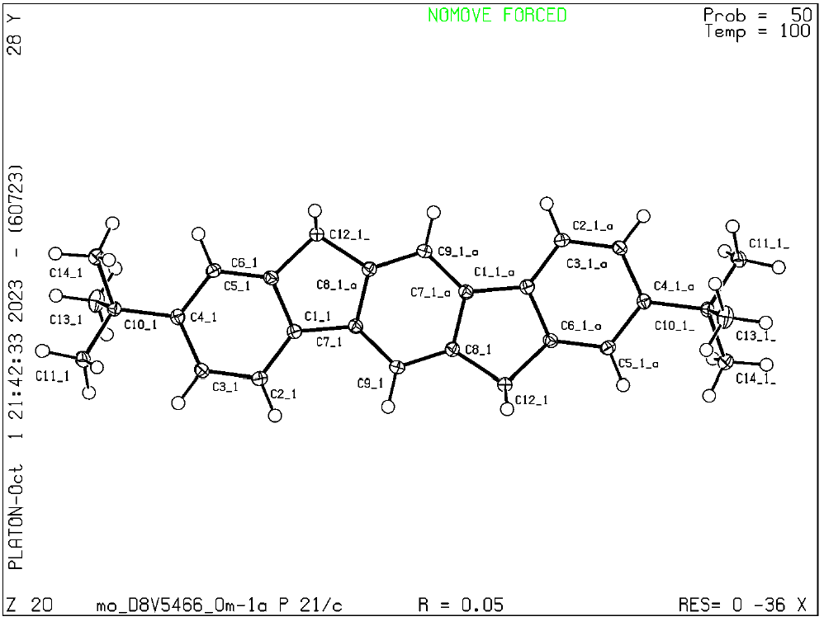 A yellow, Prism-shaped crystal of mo_D8V5466_0m-1a was mounted on a MiTeGen micromount with perfluoroether oil. Data were collected from a shock-cooled single crystal at 100(2) K on a Bruker D8 VENTURE dual wavelength Mo/Cu three-circle diffractometer with a microfocus sealed X-ray tube using a mirror optics as monochromator and a Bruker PHOTON II detector. The diffractometer was equipped with an Oxford Cryostream 800 low temperature device and used MoK_{α} radiation (λ = 0.71073 Å). All data were integrated with SAINT and a multi-scan absorption correction using SADABS was applied.^{[1,2]} The structure was solved by direct methods using SHELXT and refined by full-matrix least-squares methods against F² by SHELXL-2019/2.^{[3,4]} All non-hydrogen atoms were refined with anisotropic displacement parameters. All hydrogen atoms were refined isotropic on calculated positions using a riding model with their U_{iso} values constrained to 1.5 times the U_{eq} of their pivot atoms for terminal sp³ carbon atoms and 1.2 times for all other carbon atoms. Crystallographic data for the structures reported here have been deposited with the Cambridge Crystallographic Data Centre.^{[5]} CCDC 2298651 contains the supplementary crystallographic data for this paper. These data can be obtained free of charge from The Cambridge Crystallographic Data Centre via www.ccdc.cam.ac.uk/​structures. This report and the CIF file were generated using FinalCif.^{[6]}

Table S10. Crystal data and structure refinement for mo_D8V5466_0m-1a
CCDC number | 2298651
Empirical formula | C₂₈H₃₀
Formula weight | 366.52
Temperature [K] | 100(2)
Crystal system | monoclinic
Space group (number) | $P2_{1}/c$ (14)
a [Å] | 16.0713(8)
b [Å] | 5.9999(3)
c [Å] | 10.4377(5)
α [°] | 90
β [°] | 92.484(2)
γ [°] | 90
Volume [Å³] | 1005.52(9)
Z | 2
ρ_{calc} [gcm⁻³] | 1.211
μ [mm⁻¹] | 0.068
F(000) | 396
Crystal size [mm³] | 0.219×0.177×0.173
Crystal colour | yellow
Crystal shape | Prism
Radiation | MoK_{α} (λ=0.71073 Å)
2θ range [°] | 5.07 to 60.02 (0.71 Å)
Index ranges | −22 ≤ h ≤ 22  −8 ≤ k ≤ 8  −14 ≤ l ≤ 14
Reflections collected | 26009
Independent reflections | 2946  R_{int} = 0.0642  R_{sigma} = 0.0365
Completeness to  θ = 25.242° | 99.7 %
Data / Restraints / Parameters | 2946/0/130
Goodness-of-fit on F² | 1.038
Final R indexes  [I≥2σ(I)] | R₁ = 0.0477  wR₂ = 0.1152
Final R indexes  [all data] | R₁ = 0.0670  wR₂ = 0.1250
Largest peak/hole [eÅ⁻³] | 0.40/-0.24

Table S12. Atomic coordinates and U_{eq} [Å²] for mo_D8V5466_0m-1a
Atom | x | y | z | U_{eq}
C1_1 | 0.37323(7) | 0.42327(18) | 0.67566(10) | 0.0123(2)
C2_1 | 0.35447(7) | 0.26514(19) | 0.76761(11) | 0.0145(2)
H2_1 | 0.390867 | 0.142983 | 0.784831 | 0.017
C3_1 | 0.28160(7) | 0.28830(19) | 0.83411(10) | 0.0143(2)
H3_1 | 0.268773 | 0.179677 | 0.896469 | 0.017
C4_1 | 0.22656(7) | 0.46733(18) | 0.81174(10) | 0.0120(2)
C5_1 | 0.24746(7) | 0.62659(19) | 0.72008(10) | 0.0135(2)
H5_1 | 0.211718 | 0.750362 | 0.703608 | 0.016
C6_1 | 0.31967(7) | 0.60515(18) | 0.65340(10) | 0.0129(2)
C7_1 | 0.44327(7) | 0.44208(18) | 0.59044(10) | 0.0123(2)
C8_1 | 0.56725(7) | 0.36132(19) | 0.48252(10) | 0.0125(2)
C9_1 | 0.51099(7) | 0.30090(19) | 0.57375(10) | 0.0136(2)
H9_1 | 0.518328 | 0.168547 | 0.622910 | 0.016
C10_1 | 0.14528(7) | 0.48775(19) | 0.88233(10) | 0.0129(2)
C11_1 | 0.15002(8) | 0.3645(2) | 1.01127(11) | 0.0184(3)
H11A_1 | 0.099596 | 0.395180 | 1.057781 | 0.028
H11B_1 | 0.198958 | 0.415824 | 1.062280 | 0.028
H11C_1 | 0.154544 | 0.203879 | 0.996096 | 0.028
C12_1 | 0.64618(7) | 0.24406(19) | 0.44759(11) | 0.0153(2)
H12A_1 | 0.634131 | 0.093489 | 0.412712 | 0.018
H12B_1 | 0.685600 | 0.230986 | 0.522764 | 0.018
C13_1 | 0.07415(7) | 0.3858(2) | 0.79820(12) | 0.0201(3)
H13A_1 | 0.021736 | 0.398780 | 0.842224 | 0.030
H13B_1 | 0.086071 | 0.228181 | 0.782513 | 0.030
H13C_1 | 0.069317 | 0.465424 | 0.716238 | 0.030
C14_1 | 0.12359(7) | 0.7330(2) | 0.90859(11) | 0.0168(2)
H14A_1 | 0.073207 | 0.739939 | 0.958079 | 0.025
H14B_1 | 0.113853 | 0.811444 | 0.826968 | 0.025
H14C_1 | 0.169885 | 0.803625 | 0.957429 | 0.025
U_{eq} is defined as 1/3 of the trace of the orthogonalized U_{ij} tensor.

Table S13. Anisotropic displacement parameters [Å²] for mo_D8V5466_0m-1a.
The anisotropic displacement factor exponent takes the form: −2π²[ h²(a*)²U₁₁ + k²(b*)²U₂₂ + … + 2hka*b*U₁₂ ]
Atom | U₁₁ | U₂₂ | U₃₃ | U₂₃ | U₁₃ | U₁₂
C1_1 | 0.0133(5) | 0.0127(5) | 0.0108(5) | −0.0005(4) | 0.0000(4) | 0.0005(4)
C2_1 | 0.0160(5) | 0.0125(5) | 0.0152(5) | 0.0025(4) | 0.0017(4) | 0.0034(4)
C3_1 | 0.0172(5) | 0.0129(5) | 0.0130(5) | 0.0019(4) | 0.0035(4) | 0.0008(4)
C4_1 | 0.0130(5) | 0.0124(5) | 0.0106(5) | −0.0015(4) | 0.0011(4) | −0.0009(4)
C5_1 | 0.0143(5) | 0.0126(5) | 0.0137(5) | 0.0006(4) | 0.0013(4) | 0.0028(4)
C6_1 | 0.0144(5) | 0.0127(5) | 0.0117(5) | 0.0007(4) | 0.0010(4) | 0.0003(4)
C7_1 | 0.0129(5) | 0.0127(5) | 0.0113(5) | 0.0005(4) | 0.0006(4) | 0.0000(4)
C8_1 | 0.0127(5) | 0.0122(5) | 0.0125(5) | −0.0002(4) | 0.0013(4) | 0.0003(4)
C9_1 | 0.0152(5) | 0.0121(5) | 0.0136(5) | 0.0023(4) | 0.0013(4) | 0.0010(4)
C10_1 | 0.0132(5) | 0.0122(5) | 0.0136(5) | −0.0004(4) | 0.0031(4) | 0.0001(4)
C11_1 | 0.0234(6) | 0.0172(6) | 0.0152(5) | 0.0021(4) | 0.0081(4) | 0.0038(5)
C12_1 | 0.0152(5) | 0.0146(5) | 0.0165(5) | 0.0044(4) | 0.0041(4) | 0.0037(4)
C13_1 | 0.0157(5) | 0.0248(6) | 0.0199(6) | −0.0069(5) | 0.0026(4) | −0.0029(5)
C14_1 | 0.0182(5) | 0.0142(5) | 0.0184(5) | −0.0003(4) | 0.0054(4) | 0.0024(4)

Table S14. Bond lengths and angles for mo_D8V5466_0m-1a

Atom–Atom | Length [Å]
C1_1–C2_1 | 1.3919(15)
C1_1–C6_1 | 1.4030(15)
C1_1–C7_1 | 1.4690(15)
C2_1–C3_1 | 1.3940(15)
C2_1–H2_1 | 0.9500
C3_1–C4_1 | 1.4046(15)
C3_1–H3_1 | 0.9500
C4_1–C5_1 | 1.4032(15)
C4_1–C10_1 | 1.5322(15)
C5_1–C6_1 | 1.3849(15)
C5_1–H5_1 | 0.9500
C6_1–C12_1^{#1} | 1.5102(15)
C7_1–C9_1 | 1.3960(15)
C7_1–C8_1^{#1} | 1.4103(15)
C8_1–C9_1 | 1.3894(15)
C8_1–C12_1 | 1.5090(15)
C9_1–H9_1 | 0.9500
C10_1–C11_1 | 1.5345(15)
C10_1–C13_1 | 1.5380(16)
C10_1–C14_1 | 1.5393(16)
C11_1–H11A_1 | 0.9800
C11_1–H11B_1 | 0.9800
C11_1–H11C_1 | 0.9800
C12_1–H12A_1 | 0.9900
C12_1–H12B_1 | 0.9900
C13_1–H13A_1 | 0.9800
C13_1–H13B_1 | 0.9800
C13_1–H13C_1 | 0.9800
C14_1–H14A_1 | 0.9800
C14_1–H14B_1 | 0.9800
C14_1–H14C_1 | 0.9800
Atom–Atom–Atom | Angle [°]
C2_1–C1_1–C6_1 | 119.65(10)
C2_1–C1_1–C7_1 | 131.64(10)
C6_1–C1_1–C7_1 | 108.70(9)
C1_1–C2_1–C3_1 | 119.15(10)
C1_1–C2_1–H2_1 | 120.4
C3_1–C2_1–H2_1 | 120.4
C2_1–C3_1–C4_1 | 122.01(10)
C2_1–C3_1–H3_1 | 119.0
C4_1–C3_1–H3_1 | 119.0
C5_1–C4_1–C3_1 | 117.81(10)
C5_1–C4_1–C10_1 | 120.51(10)
C3_1–C4_1–C10_1 | 121.67(10)
C6_1–C5_1–C4_1 | 120.66(10)
C6_1–C5_1–H5_1 | 119.7
C4_1–C5_1–H5_1 | 119.7
C5_1–C6_1–C1_1 | 120.70(10)
C5_1–C6_1–C12_1 | 129.26(10)
C1_1–C6_1–C12_1 | 110.04(9)
C9_1–C7_1–C8_1 | 121.07(10)
C9_1–C7_1–C1_1 | 130.61(10)
C8_1–C7_1–C1_1 | 108.31(9)
C9_1–C8_1–C7_1 | 121.47(10)
C9_1–C8_1–C12_1 | 128.52(10)
C7_1–C8_1–C12_1 | 109.99(9)
C8_1–C9_1–C7_1 | 117.47(10)
C8_1–C9_1–H9_1 | 121.3
C7_1–C9_1–H9_1 | 121.3
C4_1–C10_1–C11_1 | 111.86(9)
C4_1–C10_1–C13_1 | 108.77(9)
C11_1–C10_1–C13_1 | 108.46(10)
C4_1–C10_1–C14_1 | 111.50(9)
C11_1–C10_1–C14_1 | 107.90(9)
C13_1–C10_1–C14_1 | 108.26(10)
C10_1–C11_1–H11A_1 | 109.5
C10_1–C11_1–H11B_1 | 109.5
H11A_1–C11_1–H11B_1 | 109.5
C10_1–C11_1–H11C_1 | 109.5
H11A_1–C11_1–H11C_1 | 109.5
H11B_1–C11_1–H11C_1 | 109.5
C8_1–C12_1–C6_1 | 102.95(9)
C8_1–C12_1–H12A_1 | 111.2
C6_1–C12_1–H12A_1 | 111.2
C8_1–C12_1–H12B_1 | 111.2
C6_1–C12_1–H12B_1 | 111.2
H12A_1–C12_1–H12B_1 | 109.1
C10_1–C13_1–H13A_1 | 109.5
C10_1–C13_1–H13B_1 | 109.5
H13A_1–C13_1–H13B_1 | 109.5
C10_1–C13_1–H13C_1 | 109.5
H13A_1–C13_1–H13C_1 | 109.5
H13B_1–C13_1–H13C_1 | 109.5
C10_1–C14_1–H14A_1 | 109.5
C10_1–C14_1–H14B_1 | 109.5
H14A_1–C14_1–H14B_1 | 109.5
C10_1–C14_1–H14C_1 | 109.5
H14A_1–C14_1–H14C_1 | 109.5
H14B_1–C14_1–H14C_1 | 109.5
Symmetry transformations used to generate equivalent atoms:
#1: 1-X, 1-Y, 1-Z;

Table S15. Torsion angles for mo_D8V5466_0m-1a

Atom–Atom–Atom–Atom | Torsion Angle [°]
C6_1–C1_1–C2_1–C3_1 | 1.35(16)
C7_1–C1_1–C2_1–C3_1 | −179.04(11)
C1_1–C2_1–C3_1–C4_1 | −0.36(17)
C2_1–C3_1–C4_1–C5_1 | −0.65(16)
C2_1–C3_1–C4_1–C10_1 | 178.11(10)
C3_1–C4_1–C5_1–C6_1 | 0.68(16)
C10_1–C4_1–C5_1–C6_1 | −178.10(10)
C4_1–C5_1–C6_1–C1_1 | 0.29(16)
C4_1–C5_1–C6_1–C12_1^{#1} | −179.68(11)
C2_1–C1_1–C6_1–C5_1 | −1.33(16)
C7_1–C1_1–C6_1–C5_1 | 178.98(10)
C2_1–C1_1–C6_1–C12_1^{#1} | 178.65(10)
C7_1–C1_1–C6_1–C12_1^{#1} | −1.04(12)
C2_1–C1_1–C7_1–C9_1 | 2.4(2)
C6_1–C1_1–C7_1–C9_1 | −177.98(11)
C2_1–C1_1–C7_1–C8_1^{#1} | −178.71(11)
C6_1–C1_1–C7_1–C8_1^{#1} | 0.93(12)
C7_1^{#1}–C8_1–C9_1–C7_1 | 0.17(18)
C12_1–C8_1–C9_1–C7_1 | 178.26(11)
C8_1^{#1}–C7_1–C9_1–C8_1 | −0.17(18)
C1_1–C7_1–C9_1–C8_1 | 178.63(11)
C5_1–C4_1–C10_1–C11_1 | −156.41(10)
C3_1–C4_1–C10_1–C11_1 | 24.86(14)
C5_1–C4_1–C10_1–C13_1 | 83.82(13)
C3_1–C4_1–C10_1–C13_1 | −94.91(12)
C5_1–C4_1–C10_1–C14_1 | −35.48(14)
C3_1–C4_1–C10_1–C14_1 | 145.78(11)
C9_1–C8_1–C12_1–C6_1^{#1} | −178.11(11)
C7_1^{#1}–C8_1–C12_1–C6_1^{#1} | 0.15(12)
Symmetry transformations used to generate equivalent atoms:
#1: 1-X, 1-Y, 1-Z;

References
[1] Bruker, SAINT, V8.40A, Bruker AXS Inc., Madison, Wisconsin, USA.
[2] L. Krause, R. Herbst-Irmer, G. M. Sheldrick, D. Stalke, J. Appl. Cryst. 2015, 48, 3–10, doi:10.1107/S1600576714022985.
[3] G. M. Sheldrick, Acta Cryst. 2015, A71, 3–8, doi:10.1107/S2053273314026370.
[4] G. M. Sheldrick, Acta Cryst. 2015, C71, 3–8, doi:10.1107/S2053229614024218.
[5] C. R. Groom, I. J. Bruno, M. P. Lightfoot, S. C. Ward, Acta Cryst. 2016, B72, 171–179, doi:10.1107/S2052520616003954.
[6] D. Kratzert, FinalCif, V125, https://dkratzert.de/finalcif.html

