BEILSTEIN JOURNAL OF ORGANIC CHEMISTRY

Supporting Information
for
Synthesis of photo- and ionochromic N-acylated 2-aminomethylenebenzo[b]thiophene-3(2Н)-ones with a terminal phenanthroline group

Vladimir P. Rybalkin, Sofiya Yu. Zmeeva, Lidiya L. Popova, Irina V. Dubonosova,
Olga Yu. Karlutova, Oleg P. Demidov, Alexander D. Dubonosov and Vladimir A. Bren

Copies of IR, ¹Н, ¹³С NMR and HRMS spectra of all novel compounds
1, 2a–c and 3a–c

Fig. S1. ¹H NMR spectrum of compound 1 in CDCl₃.
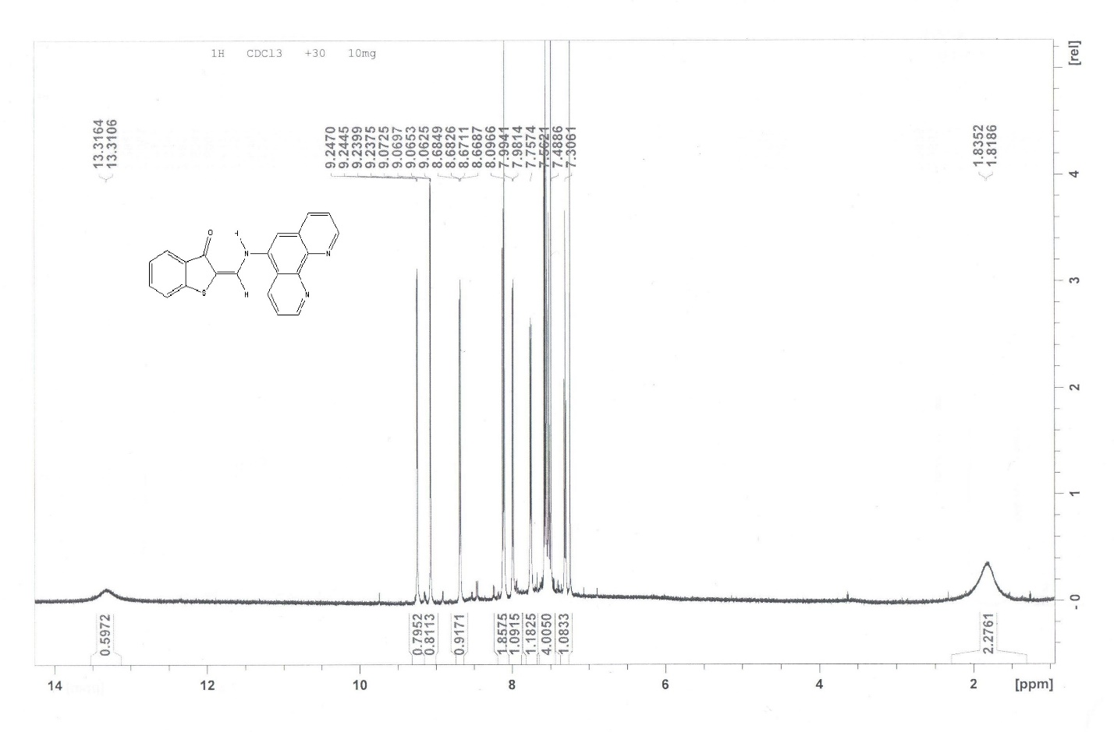
Fig. S2. ¹H NMR spectrum of compound 2a in CDCl₃.
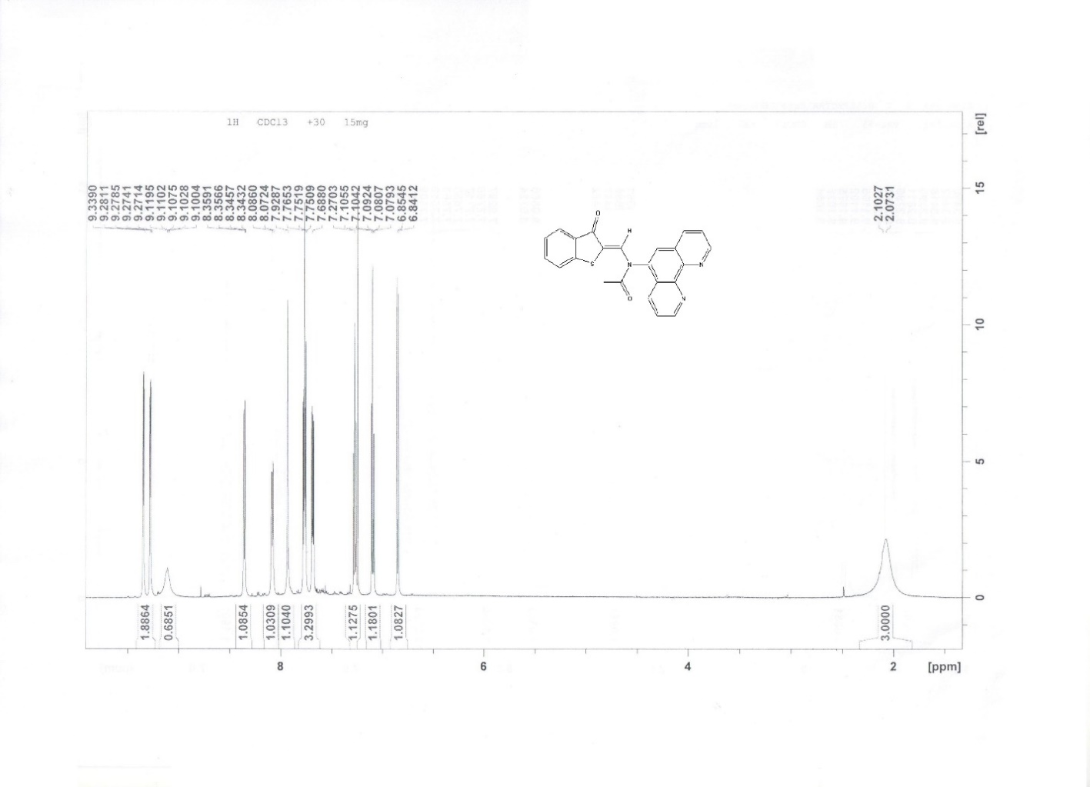
Fig. S3. ¹H NMR spectrum of compound 2b in CDCl₃.

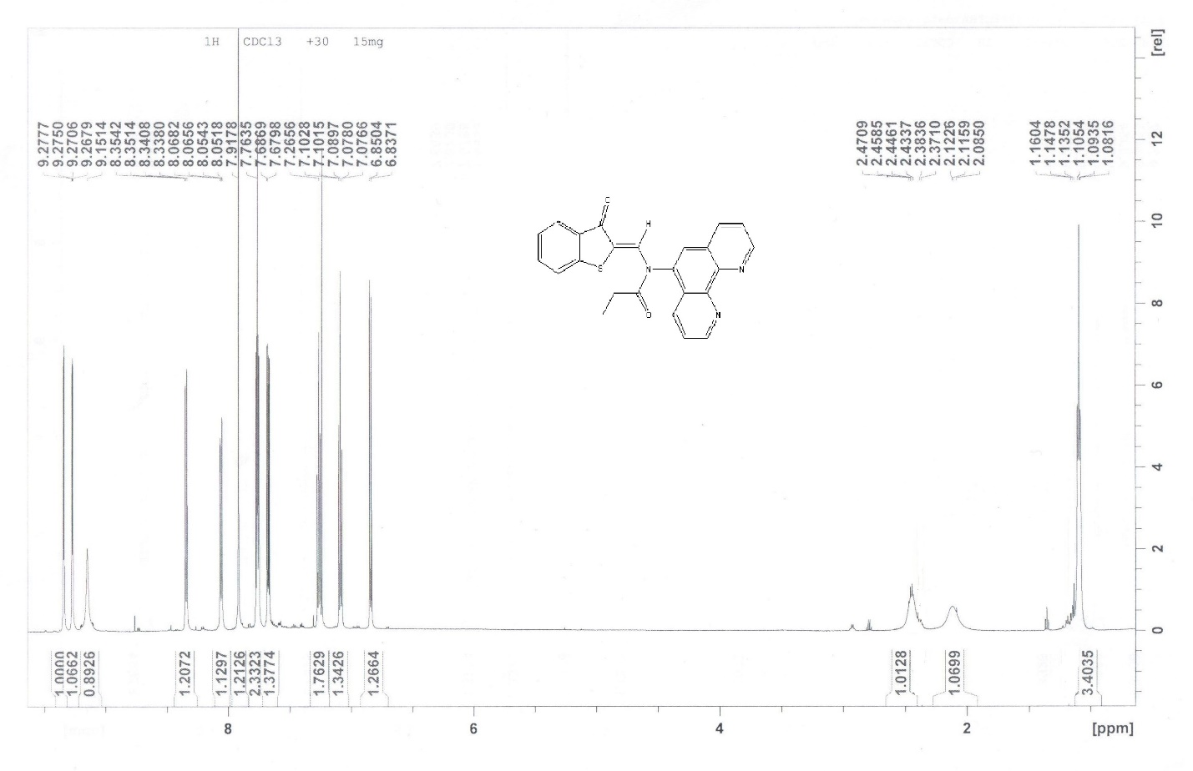
Fig. S4. ¹H NMR spectrum of compound 2c in CDCl₃.
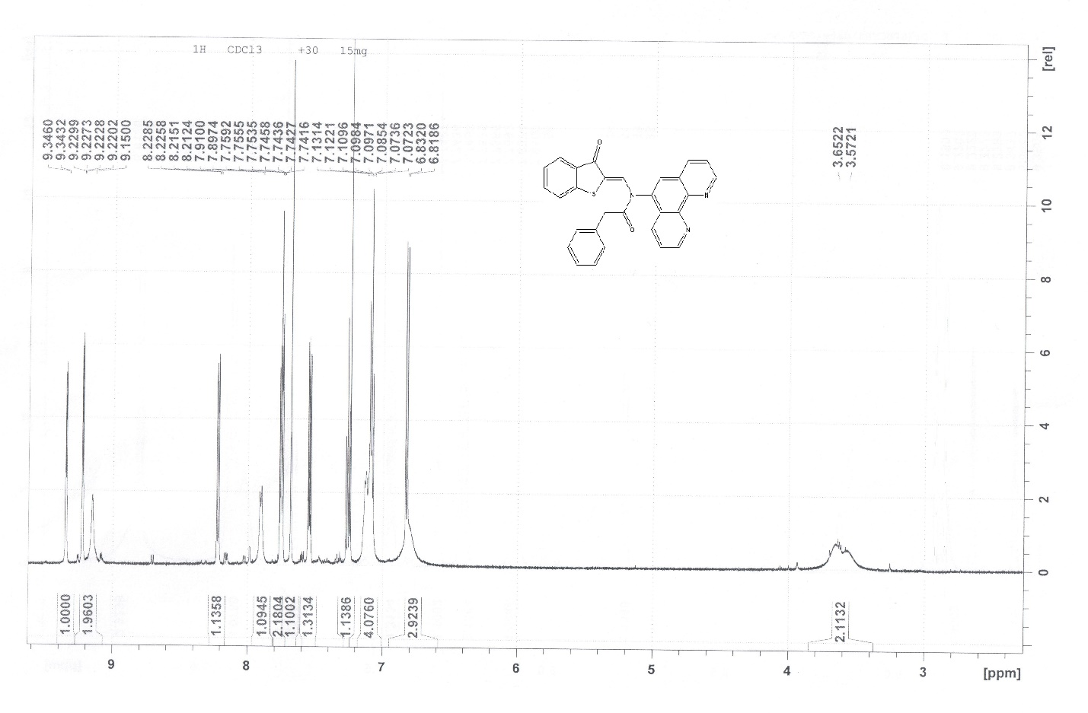

Fig. S5. ¹H NMR spectrum of compound 3a in CDCl₃.
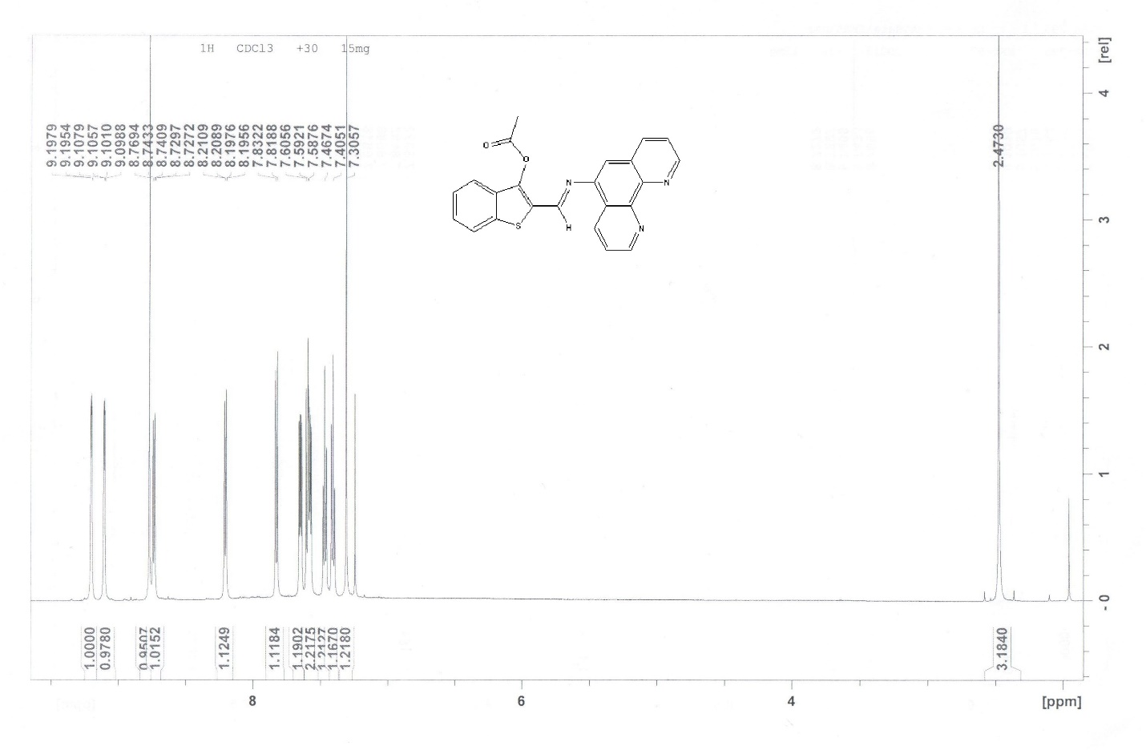

Fig. S6. ¹H NMR spectrum of compound 3b in CDCl₃.

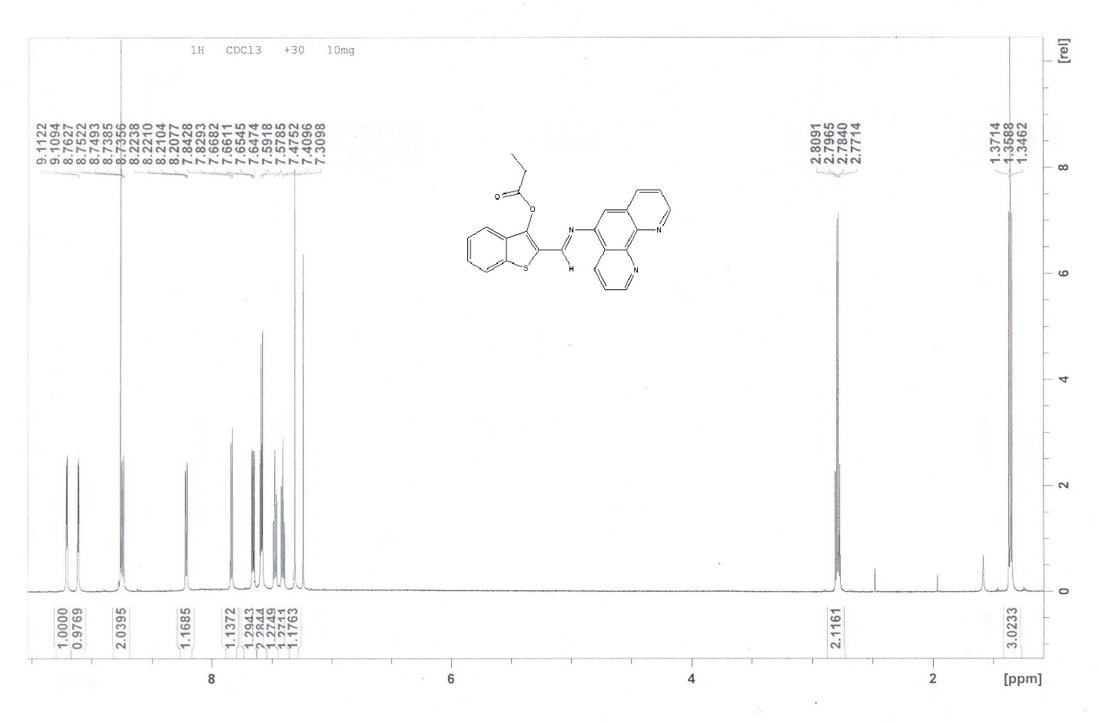

Fig. S7. ¹H NMR spectrum of compound 3c in CDCl₃.

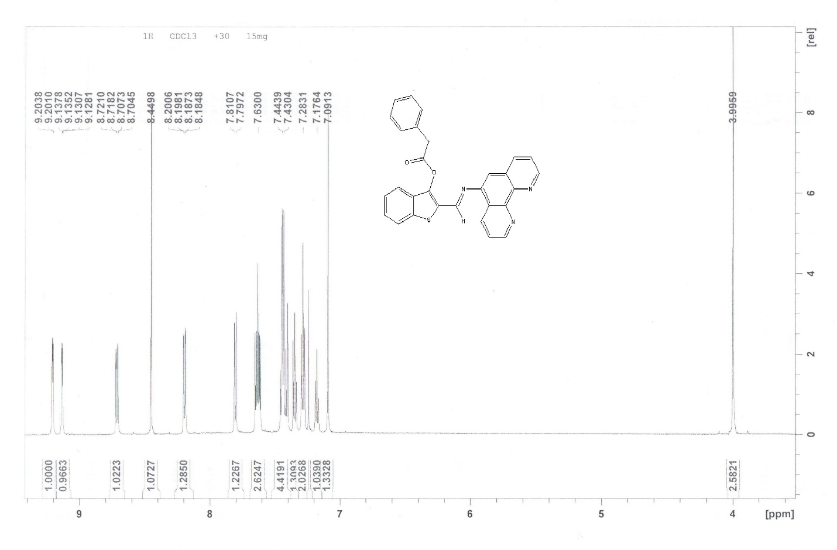

Fig. S8. ¹³C NMR spectrum of compound 1 in CDCl₃.

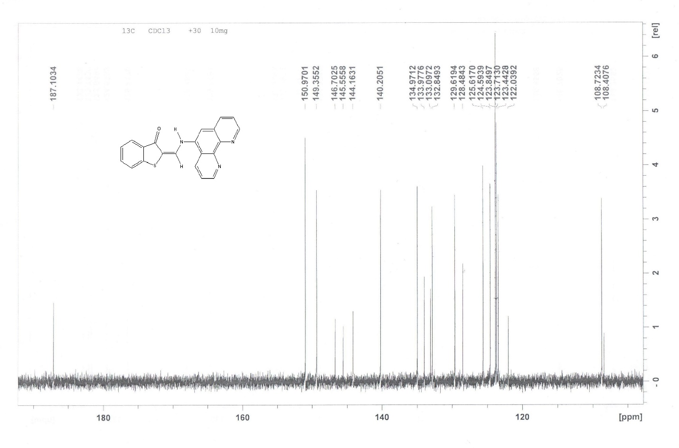
Fig. S9. ¹³C NMR spectrum of compound 2a in CDCl₃.

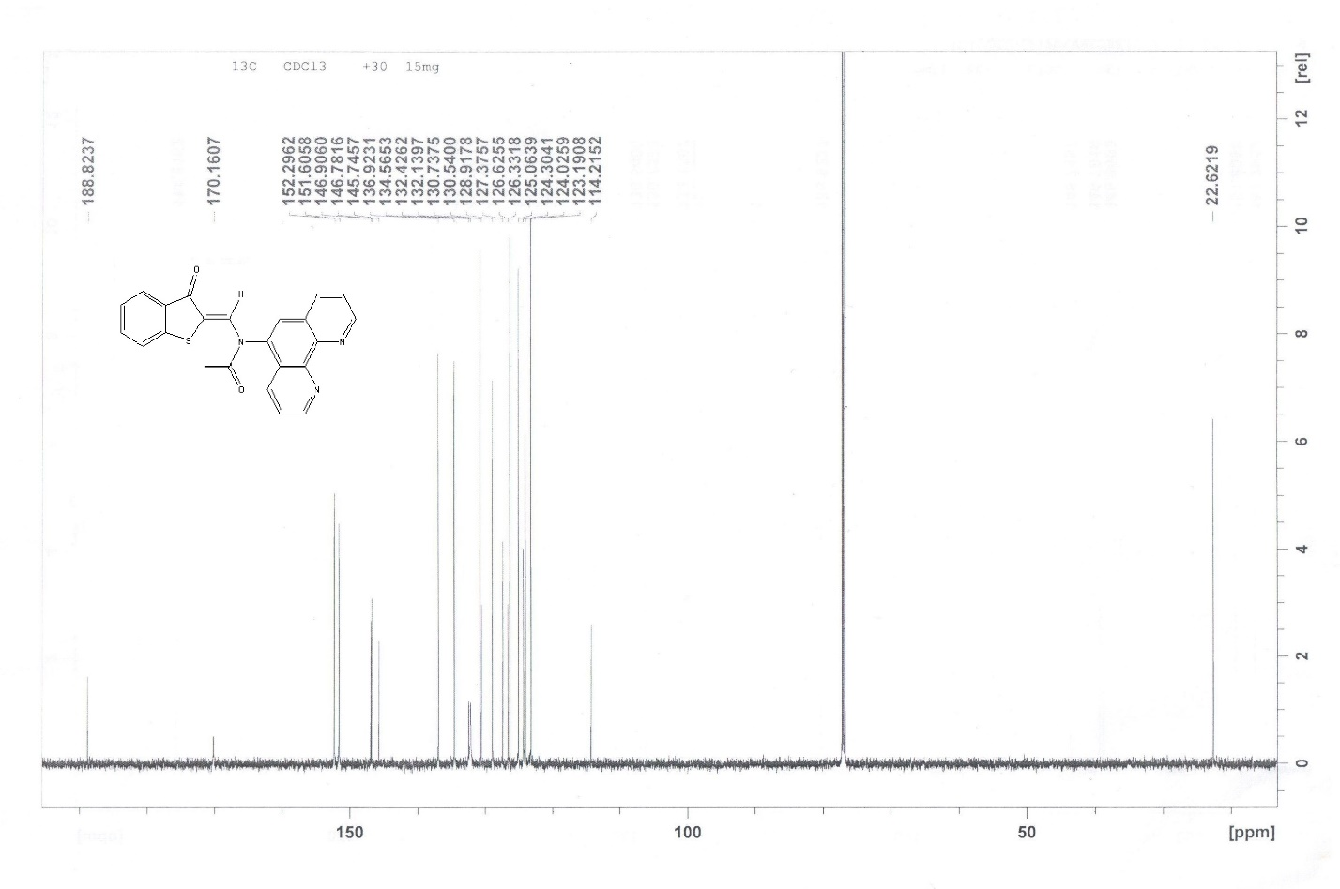

Fig. S10. ¹³C NMR spectrum of compound 2b in CDCl₃.

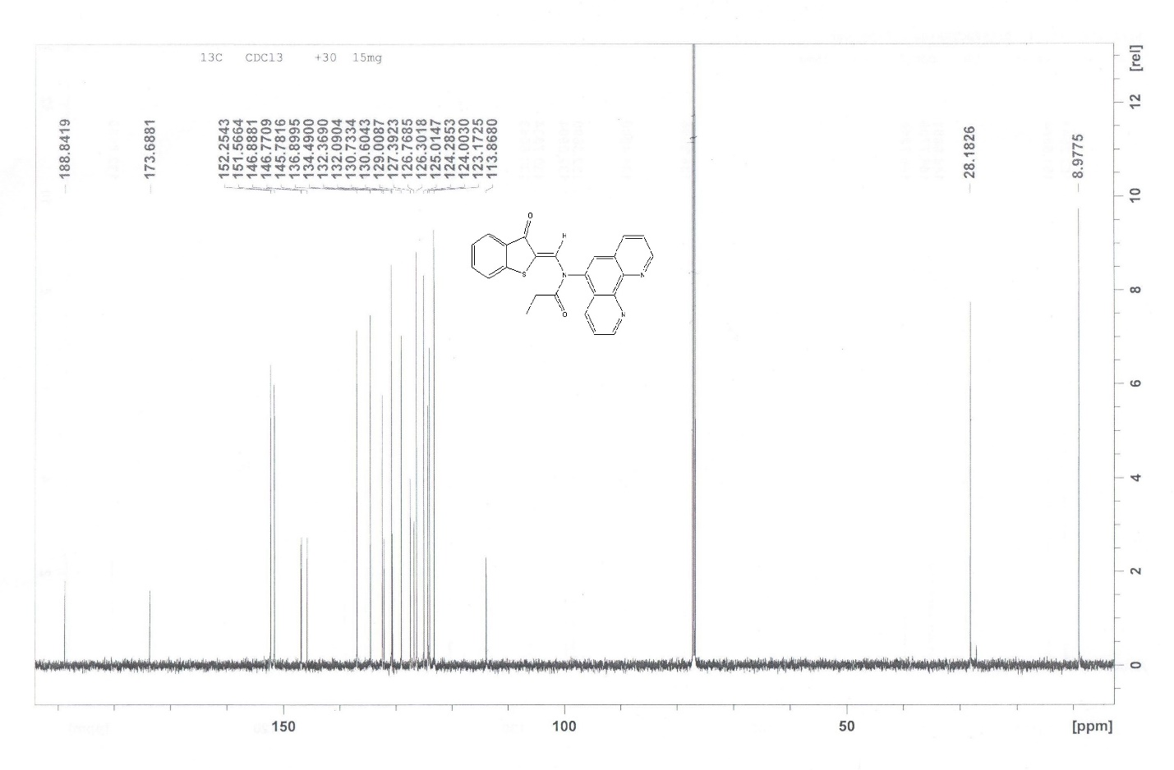
Fig. S11. ¹³C NMR spectrum of compound 2с in CDCl₃.

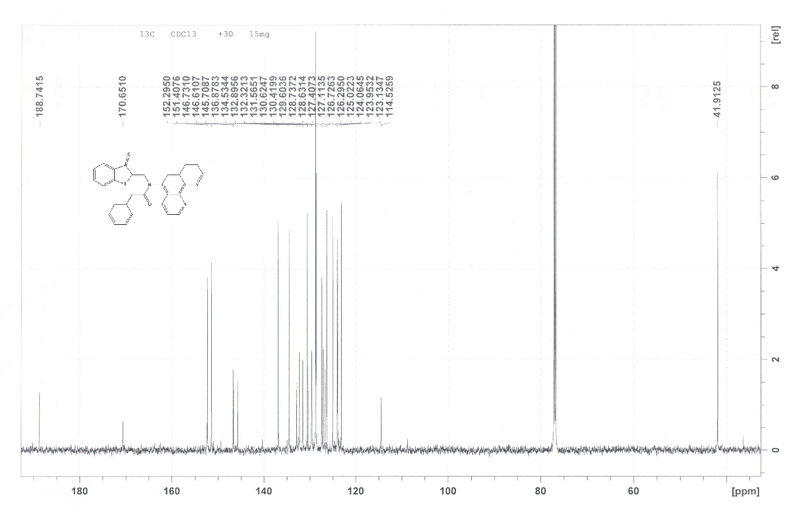

Fig. S12. ¹³C NMR spectrum of compound 3a in CDCl₃.

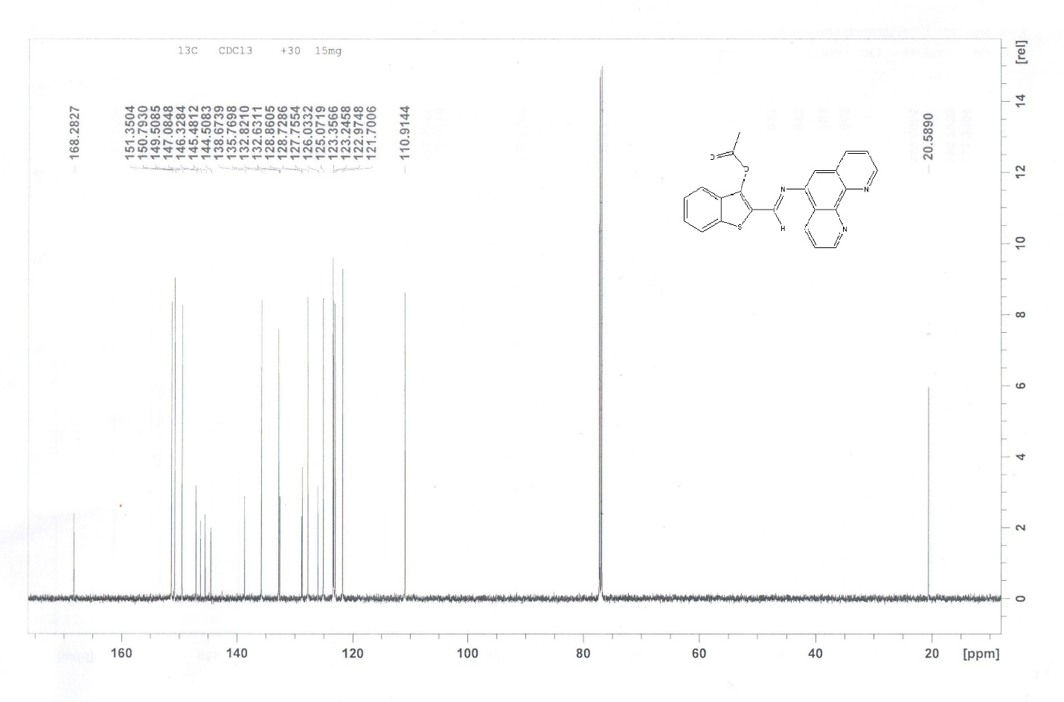

Fig. S13. ¹³C NMR spectrum of compound 3b in CDCl₃.

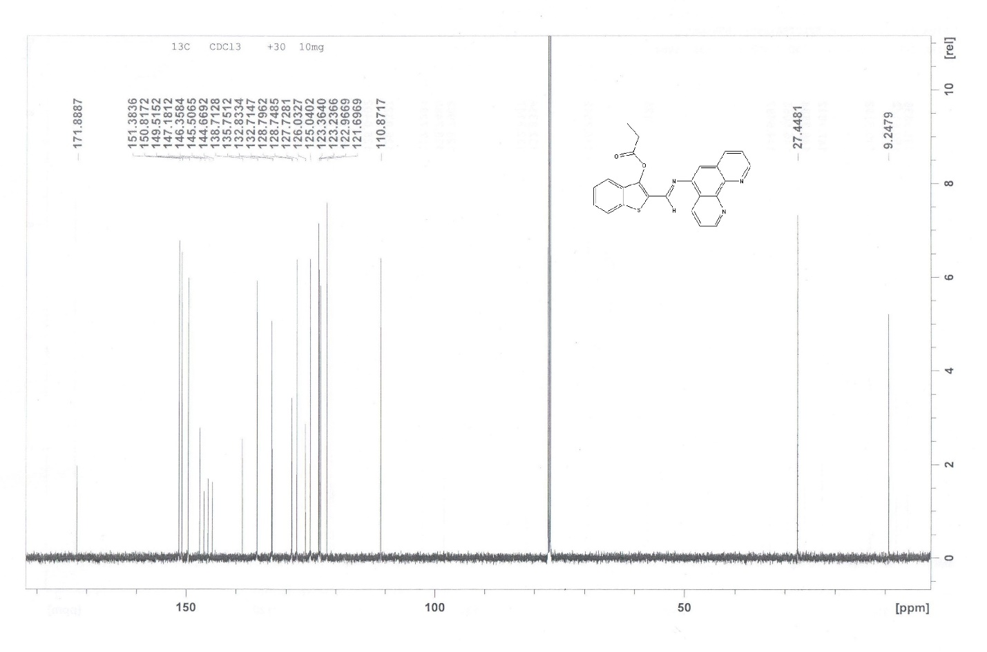

Fig. S14. ¹³C NMR spectrum of compound 3c in CDCl₃.

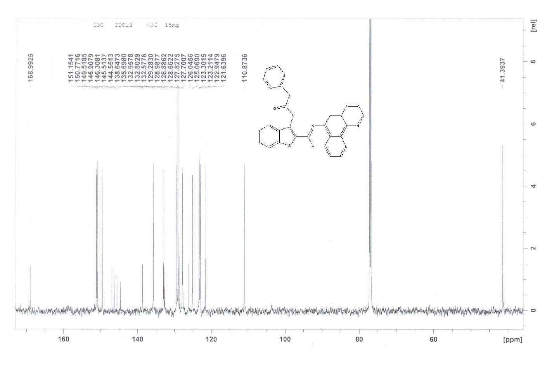

Figure S15. IR spectrum of compound 1.
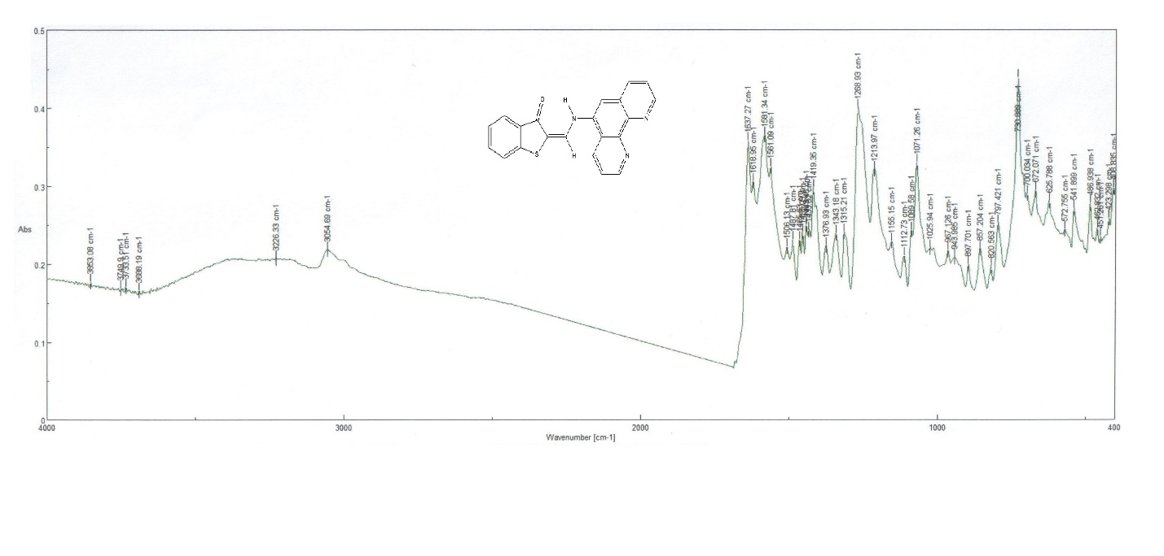

Figure S16. IR spectrum of compound 2a.
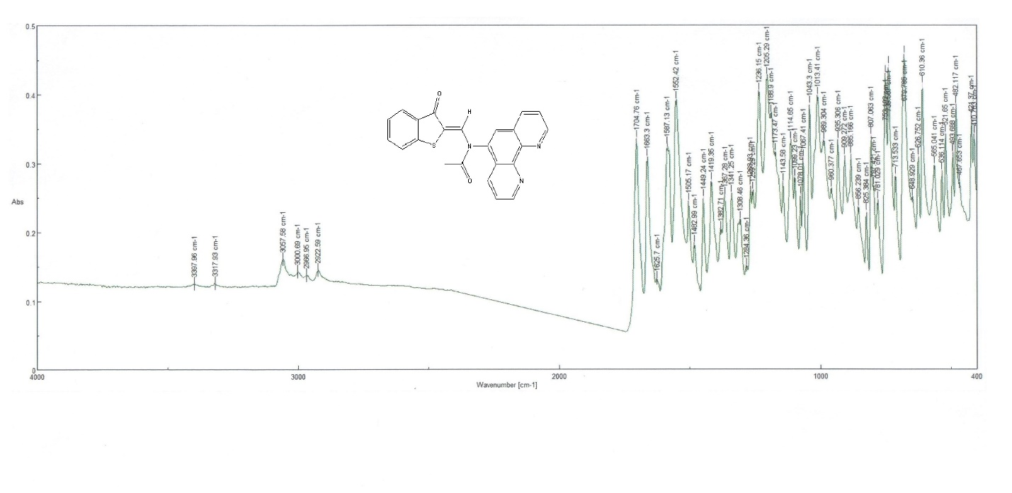

Figure S17. IR spectrum of compound 2b.
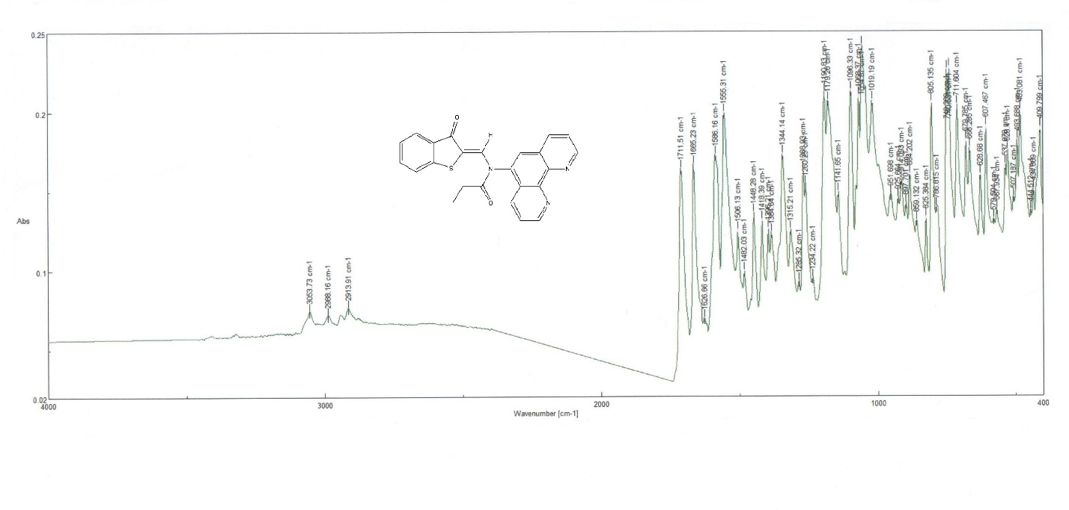

Figure S18. IR spectrum of compound 2с.
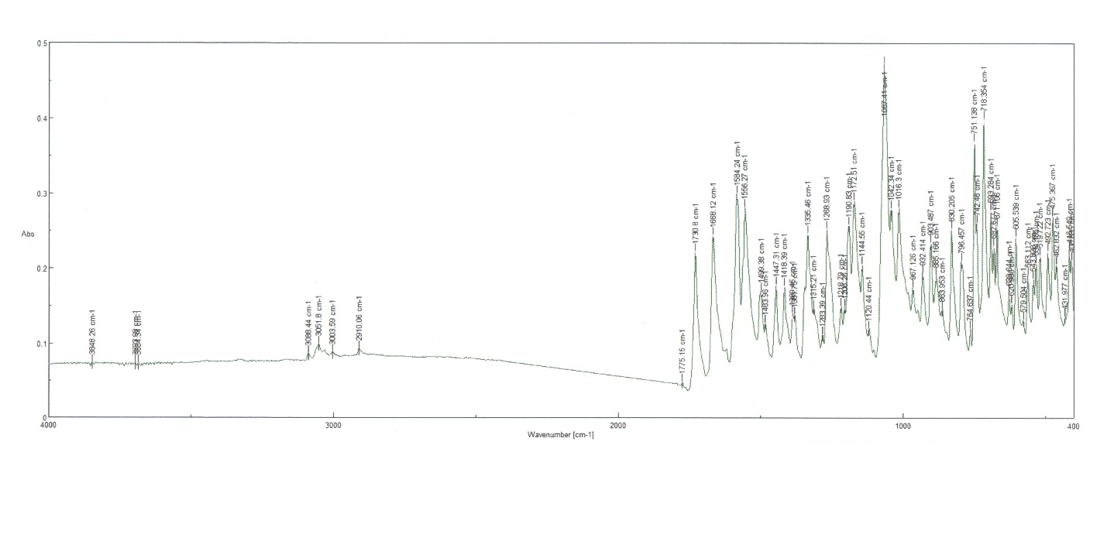

Figure S19. IR spectrum of compound 3a.
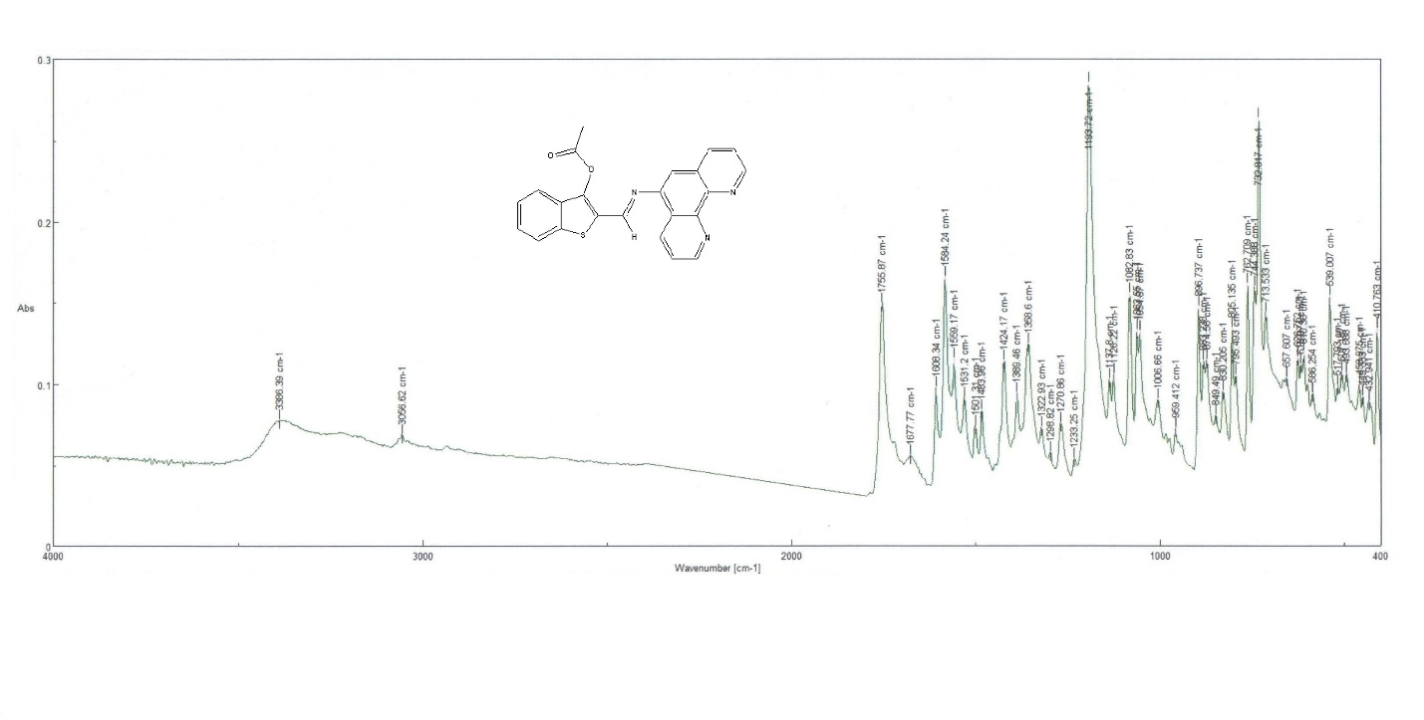

Figure S20. IR spectrum of compound 3b.
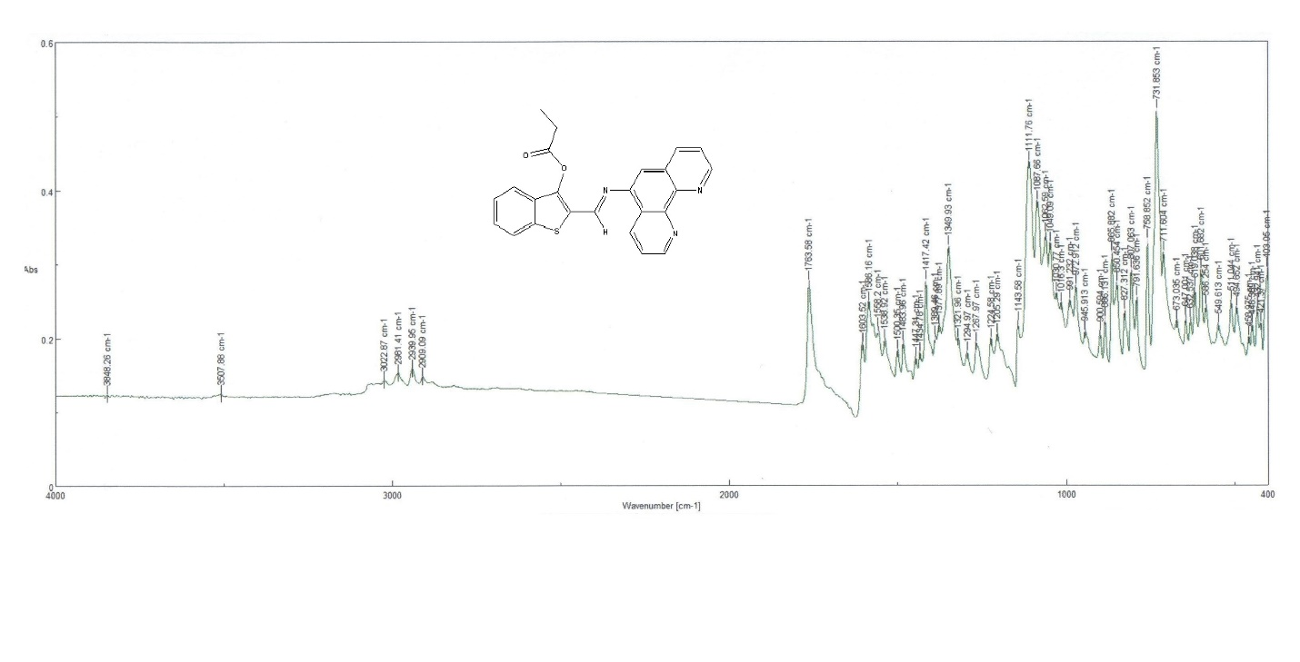

Figure S21. IR spectrum of compound 3c.
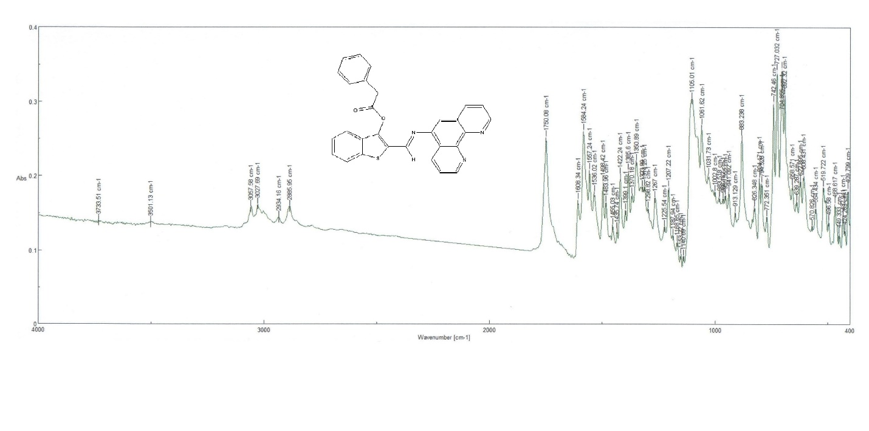

Figure S22. Mass spectrum of compound 1.

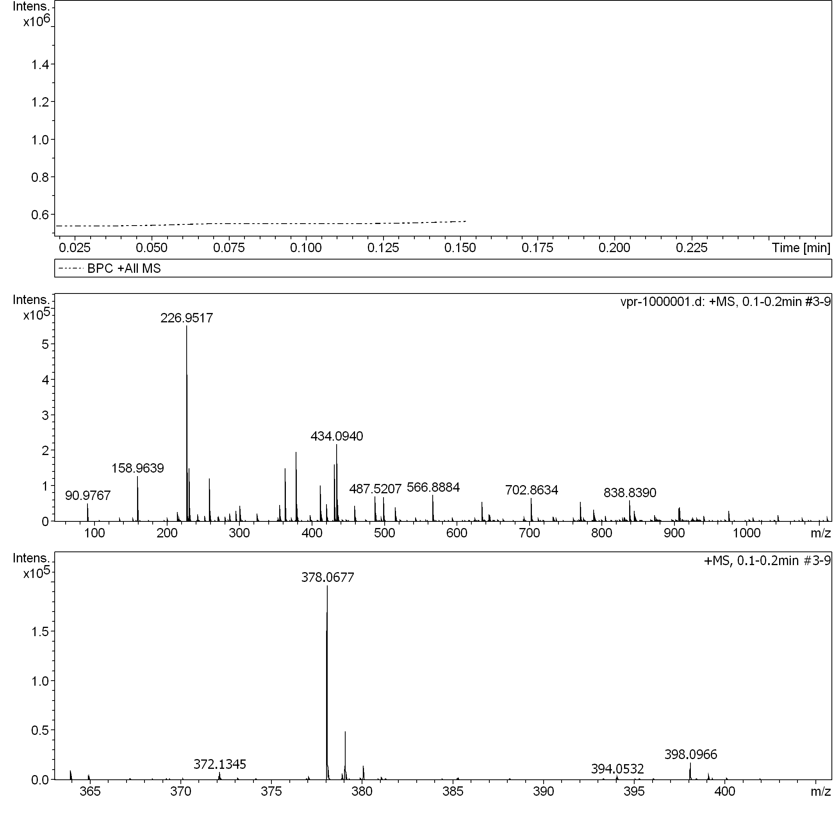
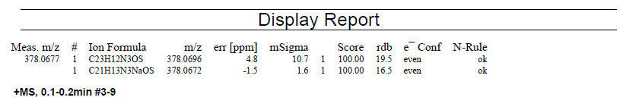

Figure S23. Mass spectrum of compound 2a.

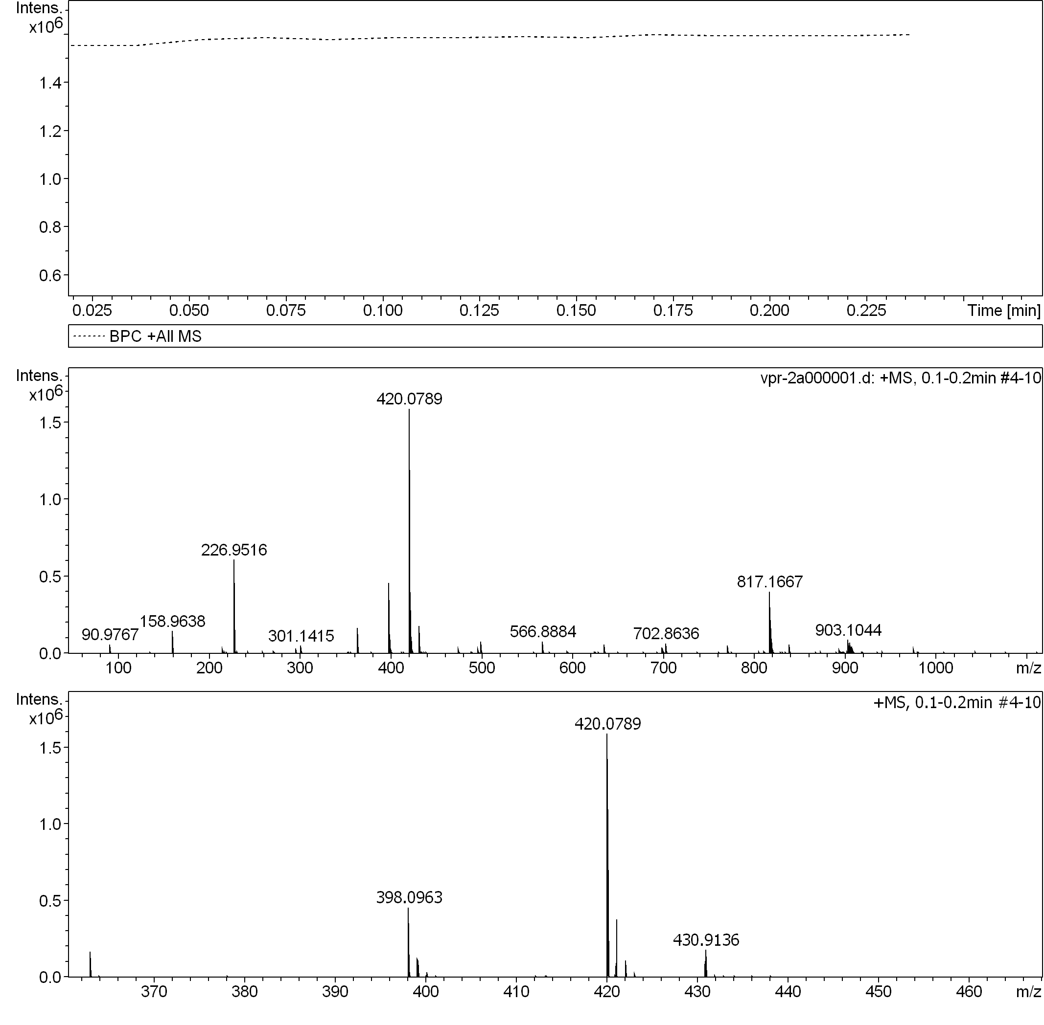
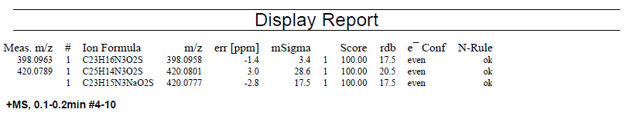

Figure S24. Mass spectrum of compound 2b.

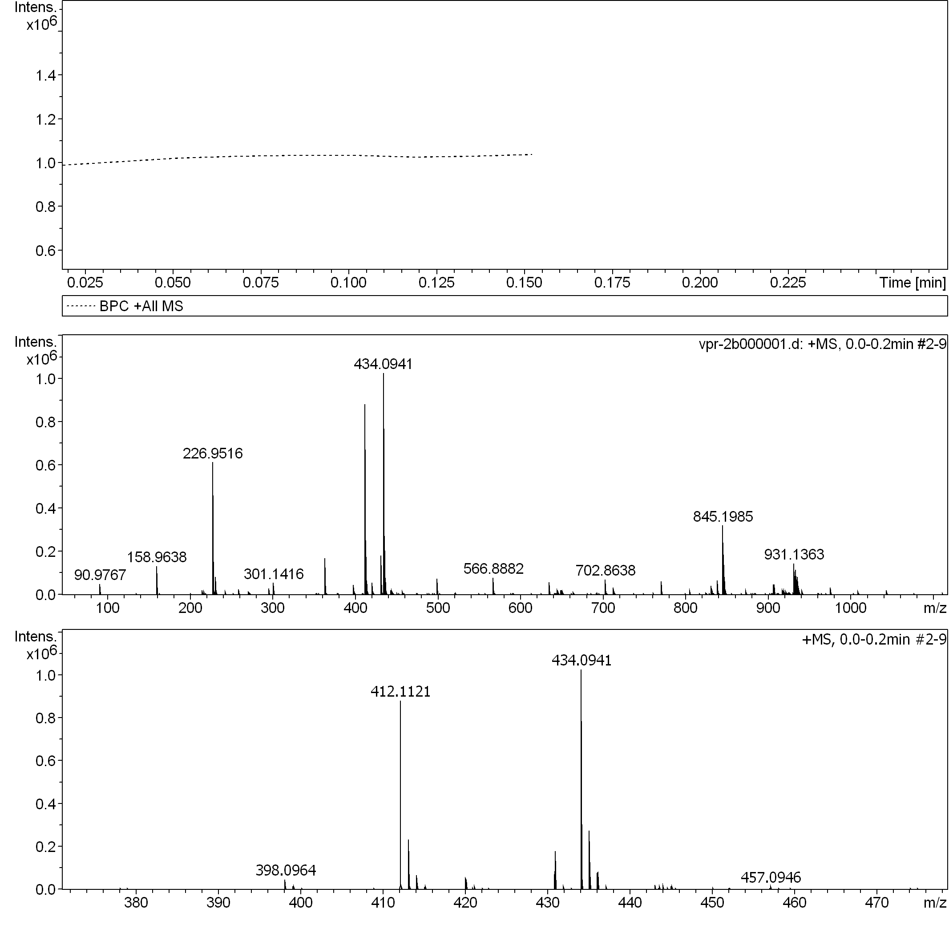
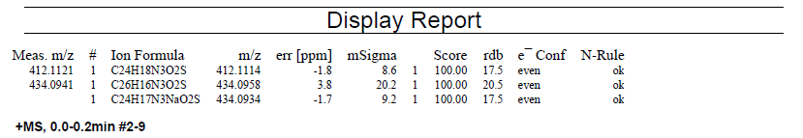

Figure S25. Mass spectrum of compound 2с.

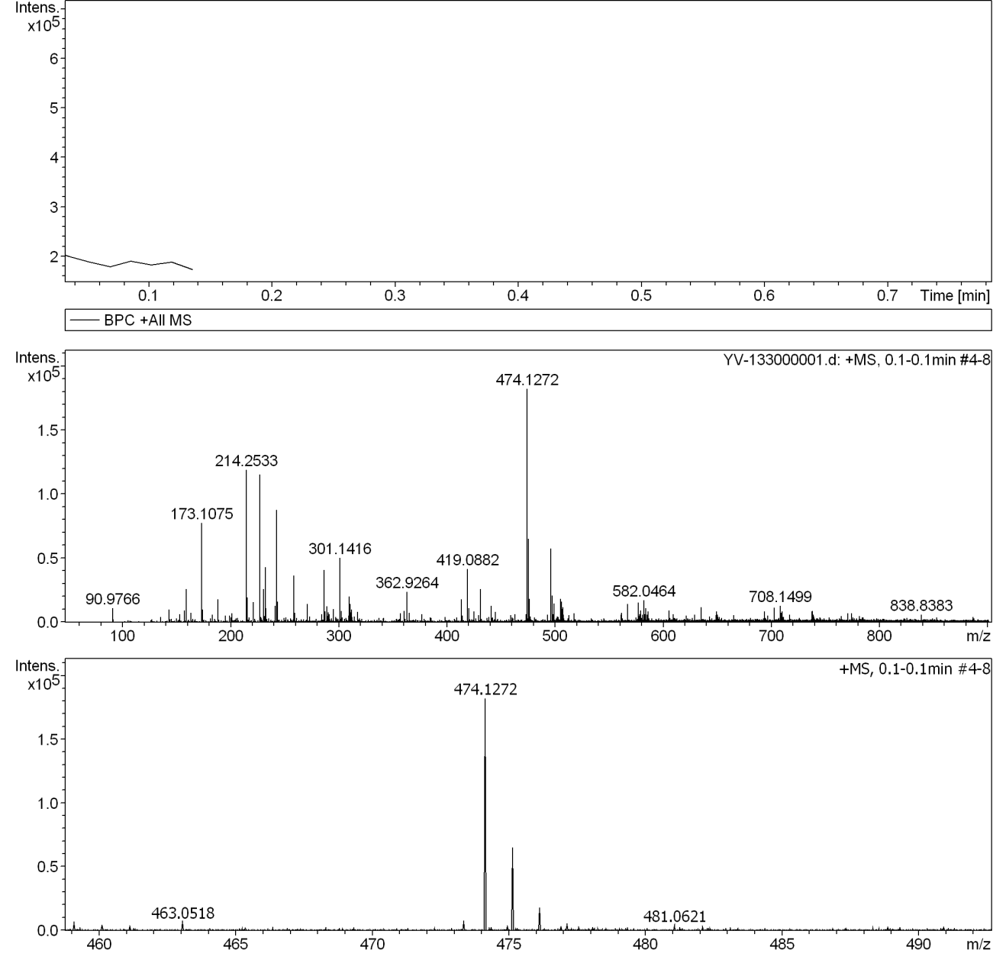

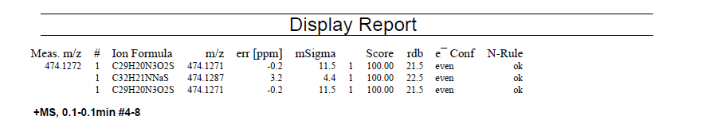

Figure S26. Mass spectrum of compound 3a.

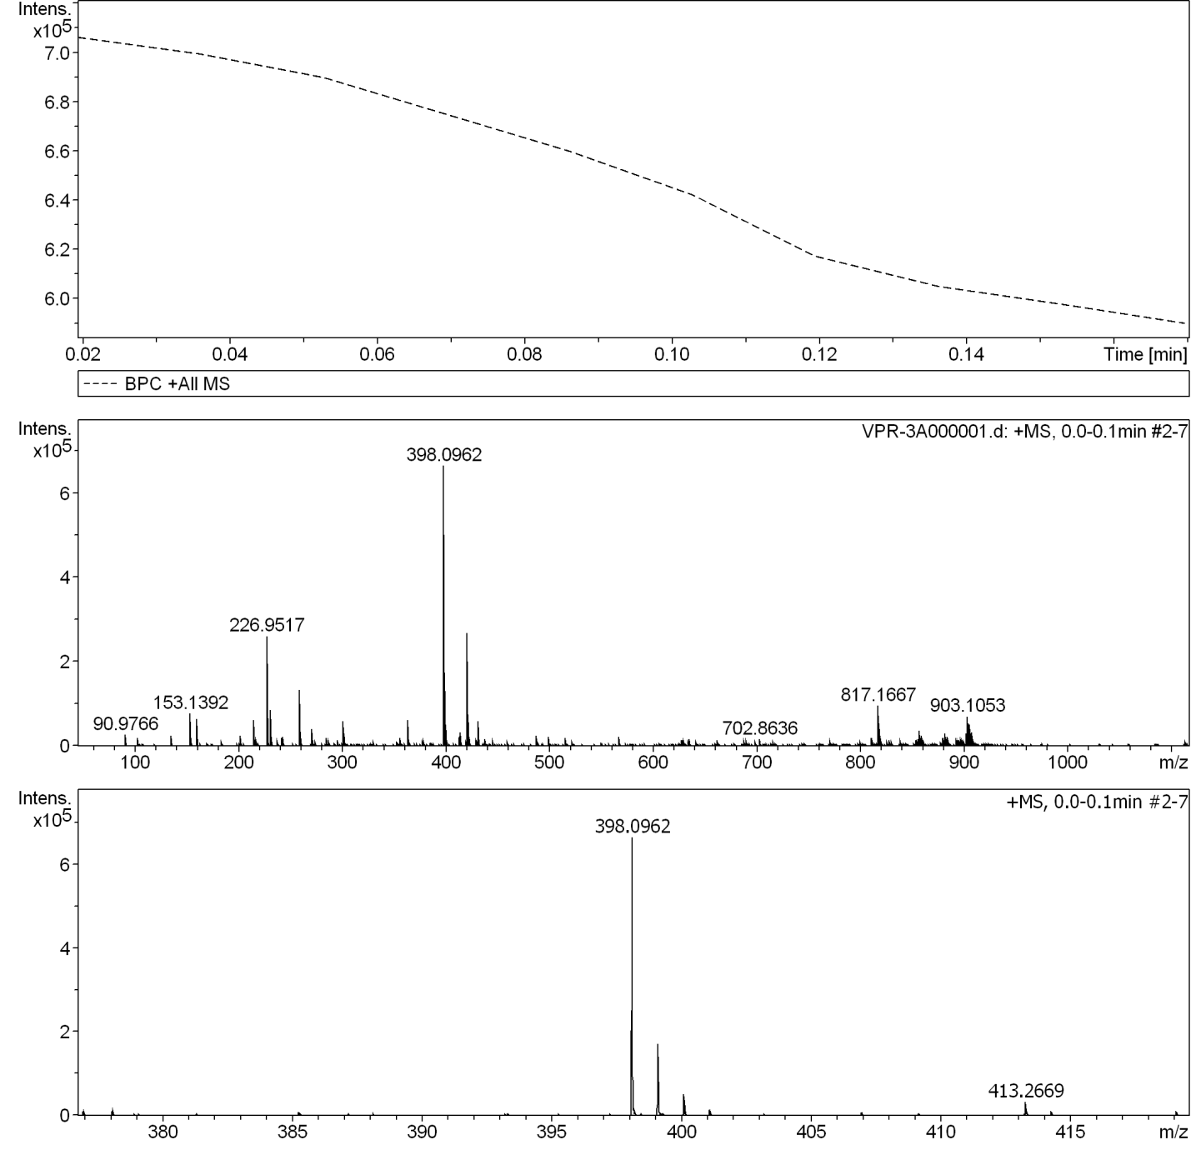
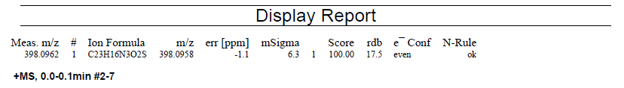

Figure S27. Mass spectrum of compound 3b.

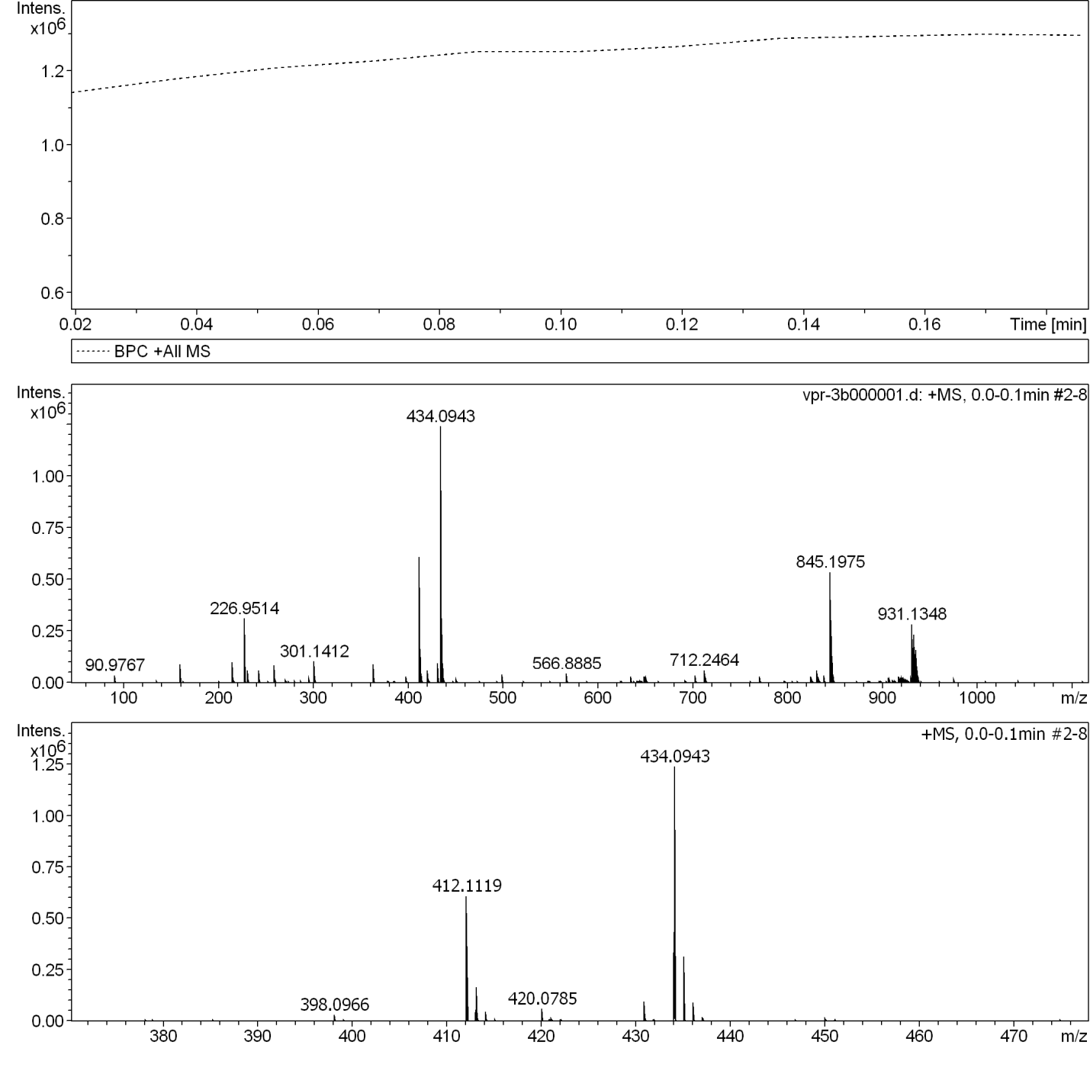
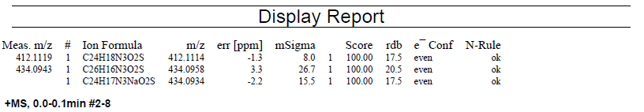

Figure S28. Mass spectrum of compound 3c.

