Supplemental Information for
Enzymatic evidence that the natural product N-nitroglycine is degraded by diverse bacteria
Authors: Kara A. Strickland,^{1,‡} Brenda Martinez Rodriguez,^{1,‡} Ashley A. Holland,¹ Shelby Wagner,¹ Michelle Luna-Alva,¹ David E. Graham,² Jonathan D. Caranto^{1,*}

¹Department of Chemistry, University of Central Florida, Orlando, FL 32816
²Biosciences Division, Oak Ridge National Laboratory, Oak Ridge, TN 37831

‡These authors contributed equally to this work
* Corresponding author: Jonathan D. Caranto-jonathan.caranto@ucf.edu

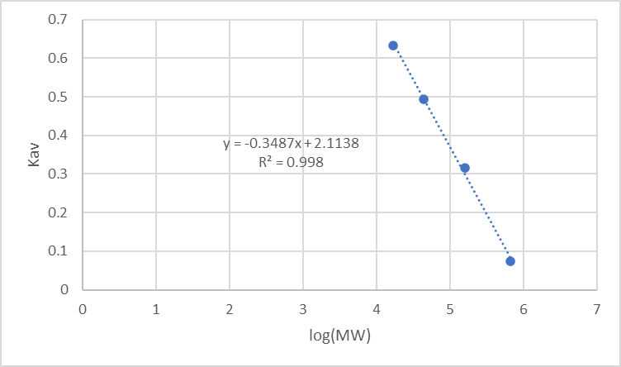
Figure S1. Analytical size exclusion chromatography calibration curve of standards. Flow rate 0.75 mL/min, 100 mM Tricine and 100 mM NaCl buffer pH 7.5.
Figure S2. Representative LC-MS EICs monitoring molecular anion of 2-NAE (m/z 105.03) in samples containing 2 mM 2-NAE, excess titanium citrate, and either no Vs NnlA for the control sample or 20 µM reduced Vs NnlA (Fe^{II}-NnlA) for the reaction samples. Samples were incubated overnight at room temperature in deoxygenated 23.3 mM tricine buffer, pH 7.5.
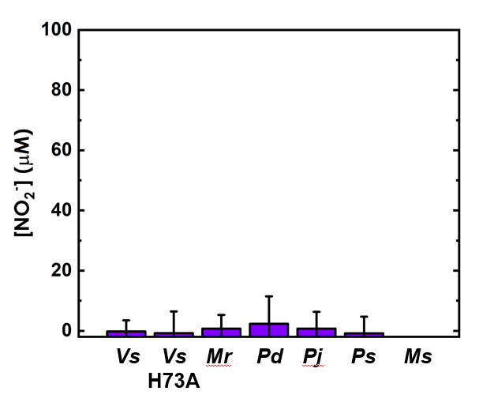
Figure S3. Nitrite concentrations observed in overnight cultures of E. coli transformed with NnlA homologs or variants grown in the presence of 2-NAE. Cells were incubated overnight in diluted LB containing IPTG and 3 mM NNG and incubated overnight at 37°C.

MBW2064617 --------------MAGNGDKRLTELIRLAMECMGVAVTIIDPQGTLLYYNKQAEKILDR 46
MCK4988321 -------------MNENERKTKLGELVNLAMDCLGVAVTIIDTKGTLLYYNQHSAKILDR 47
WP_189438608 MSQNQHSAFRKQVADRTLDGWELEGCAEWLIDQQGVGVSIIDTEGRLLFYNQWADNKMPR 60
WP_054784913 -MTDNNNELPEVTDQRILEAWKLSGWADRLLEEAGIGVTIIDKDGKLLYYNKWASENLDR 59
WP_282531508 ----MDEKLPEVTQQRVLPGWTVSQWAGGLIEHAGVGVTILDREGRVMFYNQWAANRLDR 56
NnlA_(OUM02170) MNQVNTEELPEVVDQRILAGWRLSEWADRILEYAGVGVTLVDRLGRCVYYNQWAKDHLDR 60
WP_066989343 --MTTHADLTEVFEHRIVADWALGEWADRLLEQAGLGVTIVDRHGVVMYYNKWAAEHLDR 58
WP_051342206 ---MTQAILPEVTDARILDGWQLSGWADRLLEQAGVGVTIVDRTGRVLYYNKWADEHLDR 57
WP_030511367 --MTSQAEPAEAAESRIATDWGLDEWADRLIDQAGVGVTILNRHGTVMYYNKWASEHLDR 58
WP_191054027 --MSSQVELAEVAESRIATDWGLDQWADRILEQAGFGVTVLDRHGTVMYYNKWASEHLDR 58
WP_195903080 --MSSQVELAEVAESRIATDWGLDQWADRILEQAGVGVTILDRHGTVMYYNKWASEHLDR 58
: :: *..*:::: * ::**: : . : *
MBW2064617 KPEYIGKDVHSHHKRAASNKKLDMMLEDFQ-KGRTEPFHYQARPYGE-TILVILSPIFED 104
MCK4988321 KPEYIGTDIHSHHKEAAINKKVDLMLKEFE-GGRKDHFHYEAKPYGK-IIFVTLAPIIKN 105
WP_189438608 EPEYLGQKVQEHHRKQITNVRFEAMLDLFRKEGRTEAVKYVAKPYEGLTIIVIVTPIIVE 120
WP_054784913 QPRHIGHNVKENHRRSITNPRFDAMLQLFR-DGRKDPVRYVANPYGTTTILVTVSPIHID 118
WP_282531508 KPEYIGKDVRNHHRRKITNPRFDAMLKLFE-EGRTDPVHYVARPYGKITILVTVSPIKVD 115
NnlA_(OUM02170) KPGYIGDEIHNRHRRAITNPRFDAMLKLFE-EGRMEPVRYVARPYGKTTILVTVSPIYVE 119
WP_066989343 QPGYLGHSVHERHHRKITNPRFDAMLKLFV-DGRIEPVQYVARPYGKTTILVTVSPIRIG 117
WP_051342206 KPEYIGNDVRDRHRQPITNPRFDAMIALFE-EGRVEPVRYVARPYGKTIILVTVSPIWVD 116
WP_030511367 RPEYIGNDVRKRHRRAVTNPRFDAMLKLFE-DGRVEPVRYVARPYGKTTILVTVSPIRVD 117
WP_191054027 KPEYIGNDVRKRHRRAVTNPRFDAMLRLFE-EGRVEPVRYVARPYGRTTILVTVSPIRVD 117
WP_195903080 MPEYIGNDVRKHHRRAVTNPRFDAMLRLFE-EGRVEPVSYVARPYGKITILVTVSPIRVN 117
* ::* .::..*:. * :.: *: * ** : . * *.** *:* ::**
MBW2064617 AKFVGCVQCVRLKDDTESR-------------------------------------- 123
MCK4988321 GEFLGCVQTVRLKNTVSANQ------------------------------------- 125
WP_189438608 GELVAFCQTVLDKDEIQGMCETFDESGNITFQRDILPGSEPG--------------- 162
WP_054784913 EELVGFSQFVLLKEEVQELCCLFDQHGRDPFEKDMLPNGPPT--------------- 160
WP_282531508 GELVGYSQIVLMKDEIQELFRRFDESGRESFEKDMLPAWPFSGND------------ 160
NnlA_(OUM02170) GELVGYSQIVLLKDEVEALCQRFNASGRESFEREMLPDSTPSNDD------------ 164
WP_066989343 GELVGLAQLVLLKDEVQELFSRFDDSGRESFERDMLPDGYPGA-------------- 160
WP_051342206 GELVGFSQIVLLKNEVQELCERFDASGRESFEREMLPNGATGY-------LTYKKNT 166
WP_030511367 GELVGFSQIVLLKDEVQELCARFDESGRESFEREMLPNGPPAT-------------- 160
WP_191054027 GELVGFSQVVLLKDEIQELCARFDESGRESFEREMLPDTPAVARDPAAGQCSSRRS- 173
WP_195903080 GELVGFSQIVLLKDEVQELFALFDESGRESFEREMLPNGLPTA-------------- 160
:::. * * *: .
Figure S4. Amino sequence alignment of NnlA homologs shown in Figure 6 of main text. Conserved basic residues are colored red.

Table S1. Elution times for standard by size exclusion chromatography.ª

Standards | MW | Elution volumes | Gel phase distribution coefficient Kav
Thyroglobulin | 670000 | 10.19 | 0.073
γ-globulin | 158000 | 13.82 | 0.317
Ovalbumin | 44000 | 16.45 | 0.493
Myoglobin | 17000 | 18.54 | 0.634
ªFlow rate 0.75 mL/min, 100 mM Tricine and 100 mM NaCl buffer pH 7.5.

Table S2. NnlA Homologs Analytical Size Exclusion Values.ª

Protein Sample | MW | Elution Volume | Gel phase distribution coefficient Kav
Pd NnlA | 49,000 | 16.23 | 0.478
Ps NnlA | 38,200 | 16.79 | 0.516
Ms NnlA | 36,400 | 16.90 | 0.523
Mr NnlA | 35,900 | 16.93 | 0.526
Oligomer Vs NnlA | 397,000 | 11.51 | 0.162
Dimer Vs NnlA | 41,400 | 16.61 | 0.504
ªFlow rate 0.75 mL/min, 100 mM Tricine and 100 mM NaCl buffer pH 7.5.
Table S3. Nitrogen mass balance resulting from NnlA reaction with NNG

NnlAª | Reduced NnlA [NO₂⁺]_{final} (µM) | As Isolated NnlA [NO₂⁺]_{final} (µM)
Mr | 250 ± 10 | 10.6 ± 1.7
Pd | 260 ± 10 | 51.3 ± 5.3
Ps | 250 ± 10 | 31.0 ± 6.7
Ms | 250 ± 20 | 22.2 ± 8.5
ªReaction conditions: 5 μM NnlA, 10 µM sodium dithionite for reduced NnlA and no reducing agent for as isolated NnlA, 350 μM NNG in 30 mM tricine buffer at pH 7.5 and room temperature in anaerobic glovebox.

Table S4. Test of 2-NAE degradation Vs NnlA (m/z 105.03).ª

Sample | [NO₂⁺]_{final} (µM) | Area of Integration
Control samples | -5.5 ± 1.4 | 2.4 ± 0.4 x 10⁶
Reaction samples | 1.8 ± 11.0 | 2.0 ± 0.5 x 10⁶
ªSamples containing 2 mM 2-NAE, excess titanium citrate, and either no Vs NnlA for the control samples or 20 µM reduced NnlA (Fe^{II}-NnlA) for the reaction samples. Samples were incubated overnight at room temperature in deoxygenated 23.3 mM tricine buffer pH 7.5

Table S5: Expected NNG degrading bacteria based on this study.
Species | Bacterial Class | Location isolated | Ref.
Variovorax sp. Strain JS 1663 | betaproteobacteria | USA: activated sludge from  Ammunition Plant | Ref. 1
Pseudovibrio denitrificans JCM 12308 | alphaproteobacteria | Taiwan: seawater | Ref. 2.
Pseudovibrio japonicus strain KCTC 12861 | alphaproteobacteria | Japan: seawater | Ref. 3.
Pseudonocardia spinosispora DSM 44797 | actinomycetia | S. Korea: soil | Ref. 4
Mycobacterium sp. 1465703.0 | actinomycetia | Mozambique: Host cultures | J. Craig Venter Institute Genome Center for Infectious Diseases.Accession: PRJNA305922
Microbispora rosea subsp. nonnitritogenes strain NRRL B-2631 | actinomycetia | Unknown: acidic volcanic ash | Ref. 5

- Mahan, K. M.; Zheng, H.; Fida, T. T.; Parry, R. J.; Graham, D. E.; Spain, J. C., A novel, iron-dependent enzyme that catalyzes the initial step in the biodegradation of N-nitroglycine by Variovorax sp. strain JS1663. Appl. Environ. Microbiol. 2017, 83, e00457-17.
- Shieh, W. Y., Lin, Y. T., Jean, W. D. Pseudovibrio denitrificans gen. nov., sp. nov., a marine, facultatively anaerobic, fermentative bacterium capable of denitrification. International journal of systematic and evolutionary microbiology, 2004, 54(6), 2307-2312
- Hosoya, S., Yokota, A., Pseudovibrio japonicus sp. nov., isolated from coastal seawater in Japan. International journal of systematic and evolutionary microbiology. 2007, 57(9) 1952-1955.
- Lee, S. D., Kim, E. S., Kang, S. O., Hah, Y. C. Pseudonocardia spinosispora sp. nov., isolated from Korean soil. International journal of systematic and evolutionary microbiology, 2002, 52(5), 1603-1608.
- Nonomura, H. Distribution of actinomycetes in the soil. IV. Isolation and taxonomy of the genus Microbispora. J. Ferment. Technol. 1960, 38, 401-405.

