Supporting information for
Late-stage N-functionalization of diazo NH-heterocycles via alkylation by Mitsunobu reaction or with alkyl halides
Natalia Guranova*¹, Grigory Kantin¹, Olga Bakulina¹, Alexander Yanovich¹
and Dmitry Dar’in*^{1,2}

¹ Institute of Chemistry, Saint Petersburg State University, 26 Universitetskiy pr., Peterhof, Saint Petersburg 198504, Russian Federation
² Saint Petersburg Research Institute of Phthisiopulmonology, 2-4 Ligovsky pr., Saint Petersburg, 191036, Russian Federation

Table of contents
I. Materials and Methods S2
II. Experimental procedures S3
III. NMR and IR spectra S22
IV. X-ray crystallographic data S192
V. References S193

I. Materials and Methods
NMR spectroscopic data were recorded with a 400 MHz spectrometer (400.13 MHz for ¹H and 100.61 MHz for ¹³C, and 376 MHz for ¹⁹F) in DMSO-d₆ and CDCl₃, and were referenced to residual solvent proton signals (δH = 2.50 and 7.26, respectively) and solvent carbon signals (δC = 39.5 and 77.0, respectively).
Melting points were determined with a melting point apparatus RD MP in the open capillary tubes.
Mass spectra were recorded with a HRMS-ESI-qTOF Nexera LCMS-9030 spectrometer (electrospray ionization mode).
IR spectra were recorded with Fourier transform infrared Shimadzu spectrophotometer IRAffinity-1.
Analytical thin-layer chromatography was carried out on UV-254 silica gel Macherey-Nagel plates using appropriate eluents. Compounds were visualized with short-wave-length UV light. Column chromatography was carried out on silica gel Merk grade 60 (0.040–0.063 mm) 230–400 mesh.
Single crystal X-ray data were obtained using an Agilent Technologies SuperNova Atlas diffractometer. The crystals of compounds 6t, 7g, 9b were obtained by slow evaporation from n-hexane/acetone solution at room temperature. The crystals of 6t, 7g, 9b were kept at 100 K during data collection. Using Olex2[] the structure was solved with the ShelXT[] structure solution program using Intrinsic Phasing and refined with the ShelXL[] refinement package using Least Squares minimization.

II. Experimental procedures
General procedure for the preparation of diazo NH-heterocycles 1, 3-5 (GP1)
3-(Chlorosulfonyl)benzoic acid (1.65 g, 7.5 mmol) was added portionwise (gas evolution) to a stirred solution of sodium azide (0.5 g, 7.7 mmol) in sat. aq. of NaHCO₃ (30 mL) and the mixture was stirred for 10 min. To the resulting ‘SAFE’ cocktail was added the corresponding NH-heterocycles (0.5 mmol) and the mixture was vigorously stirred at ambient temperature for indicated period of time.
If solid precipitate was formed mixture was cooled to 5 °C, product was filtered, washed with water (2×15 mL) and cold water/ethanol mixture (1:1, 20 mL), and dried in air. In the case of oily precipitate or its absence, the reaction mixture was extracted with DCM or EtOAc (3×25 mL), organic phase was dried over Na₂SO₄ and evaporated to dryness. Additional purification was used if needed by flash column chromatography on silica gel (as indicated).
General procedure for the preparation of diazopyrrolidine-2,5-diones 2a,b (GP2)
Respective benzylidene succinimide (5.3 mmol) and 4-acetamidobenzenesulfonyl azide (5.3 mmol) was suspended in DCM (10 mL). Then DBU (21.2 mmol) was added to the mixture dropwise. The reaction mixture was stirring overnight at ambient temperature. The precipitate was filtered off, the filtrate was purified by column chromatography (silica gel, isocratic DCM‒MeOH 10:1). The solvent was removed under reduced pressure to give corresponding diazo pyrrolidinedione.
4-Diazoisoquinoline-1,3(2H,4H)-dione (1)[]
Prepared according to GP1 from homophthalimide[] (805 mg, 5 mmol). Reaction time ‒ 40 h. Yield 93% (870 mg). Greenish powder. Mp = 239–240 °C with decomposition. ¹H NMR (400 MHz, DMSO-d₆): δ = 11.65 (s, 1H), 8.07 (dd, J = 8.0, 1.4 Hz, 1H), 7.73 (td, J = 7.6, 1.4 Hz, 1H), 7.47 (d, J = 7.9 Hz, 1H), 7.42 – 7.23 ppm (m, 1H). ¹³C NMR (101 MHz, DMSO-d₆) δ 163.4, 163.3, 134.6, 128.9, 128.5, 125.8, 121.0, 120.9, 67.9 (C=N₂). HRMS (ESI) m/z: found: 210.0272; calcd for C₉H₅N₃O₂ +Na⁺: 210.0274 [M+Na]⁺. IR (KBr): ν∼=2124 (vs) cm⁻¹ (N≡N); 1685 (s), 1653 (s) cm⁻¹ (C=O).
(E)-3-Benzylidene-4-diazopyrrolidine-2,5-dione (2a):
Prepared according to GP2 from α-benzylidene succinimide[] (1 g, 5.3 mmol). Yield 94% (1.07 g). Orange powder. Mp = 145‒146 °C with decomposition. ¹H NMR (400 MHz, CDCl₃): δ = 8.63 (s, 1H), 7.67 (s, 1H), 7.52 – 7.37 (m, 3H), 7.37 – 7.31 ppm (m, 2H). ¹³C NMR (101 MHz, CDCl₃): δ = 167.0, 164.9, 133.2, 129.6, 129.0, 128.8, 128.2, 117.6, 60.4 (C=N₂) ppm. HRMS (ESI) m/z: found: 214.0607; calcd for C₁₁H₇N₃O₂ +H⁺: 214.0611 [M+H]⁺. IR (KBr): ν∼=2109 (s) cm⁻¹ (N≡N); 1759 (m), 1689 (br.s) cm⁻¹ (C=O).
Methyl (E)-4-((4-diazo-2,5-dioxopyrrolidin-3-ylidene)methyl)benzoate (2b):
Prepared according to GP2 from α-(4-carbomethoxybenzylidene) succinimide (1.3 g, 5.3 mmol). Yield 90% (1.29 g). Yellow powder. Mp = 217–219 °C with decomposition. ¹H NMR (400 MHz, DMSO-d₆): δ = 11.30 (s, 1H), 8.02 – 7.94 (m, 2H), 7.45 (s, 1H), 7.36 (d, J = 8.2 Hz, 2H), 3.85 ppm (s, 3H). ¹³C NMR (101 MHz, DMSO-d₆): δ = 168.0, 166.1, 165.9, 138.6, 129.9, 129.8, 129.6, 124.4, 121.0, 60.7 (C=N₂), 52.8 ppm. HRMS (ESI) m/z: found: 272.0665; calcd for C₁₃H₉N₃O₄ +H⁺: 272.0666 [M+H]⁺. IR (KBr): ν∼=2097 (s) cm⁻¹ (N≡N); 1755 (m), 1696 (br.s) cm⁻¹ (C=O).
1-Benzyl-5-diazopyrimidine-2,4,6(1H,3H,5H)-trione (3a):
Prepared according to GP1 from N-benzyl barbituric acid[] (1.09 g, 5 mmol). Reaction time ‒ 20 h. Yield 76% (928 mg). Orange powder. Mp 165–169 °C with decomposition. ¹H NMR (400 MHz, DMSO-d₆): δ = 11.73 (s, 1H), 7.52 – 7.00 (m, 5H), 4.92 ppm (s, 2H).¹³C NMR (101 MHz, CDCl₃): δ = 164.9, 164.3, 155.6, 142.1, 133.5, 132.6, 132.4, 76.0 (C=N₂), 48.6 ppm. HRMS (ESI) m/z: found: 245.0674; calcd for C₁₁H₈N₄O₃+H⁺: 245.0669 [M+H]⁺. IR (KBr): ν∼=2158 (m) cm⁻¹ (N≡N); 1736 (w), 1663 (br. vs) cm⁻¹ (C=O).
5-Diazo-1-phenylpyrimidine-2,4,6(1H,3H,5H)-trione (3b):
Prepared according to GP1 from N-phenyl barbituric acid^{[7]} (613 mg, 3 mmol). Reaction time ‒ 3 h. Product was extracted with EtOAc and purified by flash column chromatography (eluent Acetone/n-Hexane, from 20 to 60%). Yield 51% (356 mg). White powder. Mp 195–197 °C with decomposition. ¹H NMR (400 MHz, DMSO-d₆): δ = 11.84 (s, 1H), 7.56 – 7.37 (m, 3H), 7.30 ppm (dd, J = 6.9, 2.0 Hz, 2H). ¹³C NMR (126 MHz, DMSO-d₆): δ = 159.8, 159.2, 150.1, 134.7, 129.6, 129.4, 129.1, 71.8 (C=N₂) ppm. HRMS (ESI) m/z: found: 231.0515; calcd for C₁₀H₆N₄O₃+H⁺: 231.0513 [M+H]⁺. IR (KBr): ν∼=2172 (s) cm⁻¹ (N≡N); 1743 (w), 1719 (w), 1672 (br. s) cm⁻¹ (C=O).
5-Diazo-1-phenyl-2-thioxodihydropyrimidine-4,6(1H,5H)-dione (4):
Prepared according to GP1 from N-phenyl 2-thiobarbituric acid[] (661 mg, 3 mmol). Reaction time ‒ 1 h. Product was extracted with EtOAc and purified by flash column chromatography (eluent Acetone/n-Hexane, from 20 to 60%). Yield 64% (475 mg). Redish powder. Mp 230–232 °C with decomposition. ¹H NMR (400 MHz, DMSO-d₆): δ = 12.97 (s, 1H), 7.54 – 7.33 (m, 3H), 7.25 ppm (dd, J = 7.3, 1.9 Hz, 2H). ¹³C NMR (126 MHz, DMSO-d₆): δ = 179.5, 158.4, 157.0, 138.4, 129.6, 129.5, 129.1, 74.3 (C=N₂) ppm. HRMS (ESI) m/z: found: 247.0280; calcd for C₁₀H₆N₄O₂S+H⁺: 247.0284 [M+H]⁺. IR (KBr): ν∼=2176 (s) cm⁻¹ (N≡N); 1693 (s), 1663 (s) cm⁻¹ (C=O).
Ethyl 4-diazo-5-oxo-4,5-dihydro-1H-pyrazole-3-carboxylate (5a):
Prepared according to GP1 from ethyl 5-oxo-4,5-dihydro-1H-pyrazole-3-carboxylate[] (780 mg, 5 mmol). Reaction time ‒ 1.5 h. Product was extracted with DCM. Yield 52% (437 mg). Orange powder. Mp 124–126 °C with decomposition. ¹H NMR (400 MHz, CDCl₃): δ = 10.58 (s, 1H), 4.45 (q, J = 7.1 Hz, 2H), 1.42 ppm (t, J = 7.1 Hz, 3H). ¹³C NMR (126 MHz, CDCl₃): δ = 166.0, 159.1, 135.7, 66.5 (C=N₂), 62.6, 14.1 ppm. HRMS (ESI) m/z: found: 183.0510; calcd for C₆H₆N₄O₃+H⁺: 183.0513 [M+H]⁺. IR (KBr): ν∼=2156 (s) cm⁻¹ (N≡N); 1739 (m), 1709 (br.s) cm⁻¹ (C=O).
4-Diazo-5-(4-methoxyphenyl)-2,4-dihydro-3H-pyrazol-3-one (5b):
Prepared according to GP1 from 5-(4-methoxyphenyl)-2,4-dihydro-3H-pyrazol-3-one[] (950 mg, 5 mmol). Reaction time ‒ 3 h. Yield 90% (975 mg). Orange powder. Mp 181–183 °C with decomposition. ¹H NMR (400 MHz, CDCl₃): δ = 9.78 (s, 1H), 7.55 (d, J = 8.7 Hz, 2H), 7.00 (d, J = 8.5 Hz, 2H), 3.88 ppm (s, 3H). ¹³C NMR (101 MHz, CDCl₃): δ = 167.6, 161.2, 143.5, 127.1, 122.7, 114.7, 63.5 (C=N₂), 55.5 ppm. HRMS (ESI) m/z: found: 217.0719; calcd for C₁₀H₈N₄O₂ +H⁺: 217.0720 [M+H]⁺. IR (KBr): ν∼=2131 (s) cm⁻¹ (N≡N); 1663 (s) cm⁻¹ (C=O).
Alkylation of diazo NH-heterocycles with halides
General procedure for diazo homophthalimides:
To a suspension of diazo homophthalimide 1 (50 mg, 0.27 mmol) and K₂CO₃ (46 mg, 0.33 mmol, 1.25 eq) in dry DMF (1.5 mL) alkyl bromide (0.30 mmol, 1.1 eq) was added in one portion. The reaction mixture was put into pre-heated at 80°C heating block. The TLC monitoring showed that reaction was finished in 3.5h. The solvent was removed under reduced pressure. The crude was extracted with CHCl₃ (3×10 mL), washed with brine (5×10 mL), dried over Na₂SO₄. The product required no further purification.
Methyl 2-(4-diazo-1,3-dioxo-3,4-dihydroisoquinolin-2(1H)-yl)acetate (6a):
Yield 83% (70 mg). Orange powder. Mp 136-137°C. ¹H NMR (400 MHz, CDCl₃): δ = 8.31 (dd, J = 8.0, 1.3 Hz, 1H), 7.71 (td, J = 7.7, 1.4 Hz, 1H), 7.42 – 7.33 (m, 1H), 7.17 (d, J = 7.9 Hz, 1H), 4.87 (s, 2H), 3.79 ppm (s, 3H). ¹³C NMR (101 MHz, CDCl₃): δ = 168.2, 162.3, 162.2, 134.5, 130.4, 126.6, 125.8, 120.5, 118.7, 68.3 (C=N₂), 52.5, 41.4 ppm. HRMS (ESI) m/z: found: 282.0488; calcd for C₁₂H₉N₃O₄ +Na⁺: 282.0485 [M+Na]⁺. IR (KBr): ν∼=2110 (vs) cm⁻¹ (N≡N); 1750 (s), 1698 (vs), 1687 (vs) cm⁻¹ (C=O).
tert-Butyl 2-(4-diazo-1,3-dioxo-3,4-dihydroisoquinolin-2(1H)-yl)acetate (6b):
Yield 79% (64 mg). Yellow oil. ¹H NMR (400 MHz, CDCl₃): δ = 8.27 (dd, J = 7.9, 1.4 Hz, 1H), 7.67 (td, J = 7.7, 1.4 Hz, 1H), 7.36 – 7.29 (m, 1H), 7.13 (d, J = 7.9 Hz, 1H), 4.73 (s, 2H), 1.49 ppm (s, 9H). ¹³C NMR (101 MHz, CDCl₃): δ = 166.8, 162.3, 162.2, 134.4, 130.3, 126.6, 125.7, 120.5, 118.7, 82.4, 68.2 (C=N₂), 42.2, 28.0 ppm. HRMS (ESI) m/z: found: 324.0951; calcd for C₁₅H₁₅N₃O₄ +Na⁺: 324.0954 [M+Na]⁺. IR (KBr): ν∼= 2107 (vs) cm⁻¹ (N≡N); 1745 (s), 1692 (vs), 1653 (vs) cm⁻¹ (C=O).
2-Benzyl-4-diazoisoquinoline-1,3(2H,4H)-dione (6c):
Yield 69% (51 mg). Orange powder. Mp 144-146 °C. ¹H NMR (400 MHz, CDCl₃): δ = 8.32 (dd, J = 8.0, 1.3 Hz, 1H), 7.67 (td, J = 7.7, 1.4 Hz, 1H), 7.56 – 7.49 (m, 2H), 7.38 – 7.23 (m, 5H), 7.12 (d, J = 7.9 Hz, 1H), 5.30 ppm (s, 2H). ¹³C NMR (101 MHz, CDCl₃): δ = 162.7, 162.6, 136.9, 134.2, 130.3, 129.0, 128.5, 127.6, 126.5, 125.7, 120.9, 118.6, 68.3 (C=N₂), 43.9 ppm. HRMS (ESI) m/z: found: 278.0921; calcd for C₁₆H₁₁N₃O₂ +H⁺: 278.0924 [M+H]⁺. IR (KBr): ν∼= 2097 (vs) cm⁻¹ (N≡N); 1681 (vs), 1639 (vs) cm⁻¹ (C=O).
General procedure for the synthesis of diazo benzylidene diazopyrrolidine-2,5-diones 7a-e:
To a solution of corresponding diazo pyrrolidinedione 2 (0.12 mmol) and K₂CO₃ (21 mg, 0.15 mmol, 1.25 eq) in dry DMF (0.75 mL) alkyl bromide (0.13 mmol, 1.1 eq) was added in one portion. The reaction mixture was put into pre-heated at 50°C heating block. The TLC monitoring showed that reaction was finished in 1.5-2h. The solvent was removed under reduced pressure. The crude was extracted with CHCl₃ (3×5 mL), washed with brine (5×8 mL), dried over Na₂SO₄, and subjected to flash column chromatography on SiO₂ using gradient of acetone in hexane (1:5 to 1:3).
Methyl (E)-2-(3-benzylidene-4-diazo-2,5-dioxopyrrolidin-1-yl)acetate (7a):
Prepared from 2a.Yield 61% (20 mg). Orange oil. ¹H NMR (400 MHz, CDCl₃): δ = 7.71 (s, 1H), 7.50 – 7.36 (m, 2H), 7.37 – 7.31 (m, 2H), 4.43 (s, 2H), 3.80 ppm (s, 3H). ¹³C NMR (101 MHz, CDCl₃): δ = 167.3, 166.3, 164.2, 133.2, 129.6, 129.0, 128.7, 128.4, 116.8, 52.8, 39.8 ppm. HRMS (ESI) m/z: found: 308.0641; calcd for C₁₄H₁₁N₃O₄ +Na⁺: 308.0642 [M+Na]⁺. IR (KBr): ν∼= 2101 (s) cm⁻¹ (N≡N); 1751 (s), 1705 (s) cm⁻¹ (C=O).
Methyl (E)-4-((4-diazo-1-(1-ethoxy-1-oxopropan-2-yl)-2,5-dioxopyrrolidin-3-ylidene) methyl)benzoate (7b):
Prepared from 2b (41 mg, 0.15 mmol). Yield 32% (18 mg). Yellow oil. ¹H NMR (400 MHz, CDCl₃): δ = 8.17 – 8.03 (m, 2H), 7.66 (s, 1H), 7.40 (d, J = 8.2 Hz, 2H), 4.97 (q, J = 7.3 Hz, 1H), 4.25 (q, J = 7.1 Hz, 2H), 3.96 (s, 3H), 1.69 (d, J = 7.3 Hz, 3H), 1.30 ppm (t, J = 7.1 Hz, 3H). ¹³C NMR (101 MHz, CDCl₃): δ = 169.0, 166.2, 165.8, 163.8, 137.6, 130.7, 129.9, 128.8, 126.1, 118.6, 62.0, 52.4, 48.8, 14.9, 14.1 ppm. HRMS (ESI) m/z: found: 372.1196; calcd for C₁₈H₁₇N₃O₆ +H⁺: 372.1190 [M+H]⁺. IR (KBr): ν∼=2103 (m) cm⁻¹ (N≡N); 1719 (br. vs) cm⁻¹ (C=O).
(E)-3-benzylidene-1-(cyclobutylmethyl)-4-diazopyrrolidine-2,5-dione (7c):
Prepared from 2a.Yield 44% (15 mg). Orange oil. ¹H NMR (400 MHz, CDCl₃): δ = 7.66 (s, 1H), 7.46 – 7.40 (m, 2H), 7.40 – 7.37 (m, 1H), 7.35 – 7.30 (m, 2H), 3.71 (d, J = 7.4 Hz, 2H), 2.75 (h, J = 7.7 Hz, 1H), 2.10 – 2.03 (m, 2H), 1.95 – 1.78 ppm (m, 4H). ¹³C NMR (126 MHz, CDCl₃): δ = 167.3, 165.1, 133.4, 129.4, 128.9, 128.7, 127.4, 117.2, 59.5 (C=N₂), 44.5, 34.3, 26.0, 18.1 ppm. HRMS (ESI) m/z: found: 282.1259; calcd for C₁₆H₁₅N₃O₂ +H⁺: 282.1237 [M+H]⁺. IR (KBr): ν∼= 2098 (m) cm⁻¹ (N≡N); 1751 (w), 1700 (br. vs) cm⁻¹ (C=O).
(E)-3-benzylidene-1-(5-bromopentyl)-4-diazopyrrolidine-2,5-dione (7d):
Prepared from 2a.Yield 37% (16 mg). Orange powder. Mp = 62-64° C. ¹H NMR (400 MHz, CDCl₃): δ = 7.67 (s, 1H), 7.48 – 7.35 (m, 3H), 7.35 – 7.30 (m, 2H), 3.69 (t, J = 7.2 Hz, 2H), 3.43 (t, J = 6.7 Hz, 2H), 1.93 (p, J = 6.9 Hz, 2H), 1.72 (h, J = 6.8, 6.3 Hz, 2H), 1.57 – 1.45 ppm (m, 2H). ¹³C NMR (126 MHz, CDCl₃): δ = 167.1, 164.9, 133.4, 129.5, 128.9, 128.7, 127.6, 117.1, 59.6 (C=N₂), 39.1, 33.4, 32.2, 27.4, 25.3 ppm. HRMS (ESI) m/z: found: 362.0509; calcd for C₁₆H₁₆BrN₃O₂ +H⁺: 362.0498 [M+H]⁺. IR (KBr): ν∼= 2101 (s) cm⁻¹ (N≡N); 1750 (s), 1694 (br. vs) cm⁻¹ (C=O).
Methyl (E)-4-((1-benzyl-4-diazo-2,5-dioxopyrrolidin-3-ylidene)methyl)benzoate (7e):
Prepared from 2b (41 mg, 0.15 mmol). Yield 72% (39 mg) Orange powder. Mp 132-133°C with decomposition. ¹H NMR (400 MHz, CDCl₃): δ = 8.18 – 8.00 (m, 2H), 7.65 (s, 1H), 7.48 – 7.42 (m, 2H), 7.39 – 7.30 (m, 5H), 4.83 (s, 2H), 3.95 (s, 3H) ppm. ¹³C NMR (101 MHz, CDCl₃): δ = 166.3, 166.2, 164.3, 137.7, 135.7, 130.6, 129.9, 128.8, 128.7, 128.1, 125.9, 118.9, 59.9 (C=N₂), 52.4, 43.0 ppm. HRMS (ESI) m/z: found: 362.1133; calcd for C₂₀H₁₅N₃O₄ +H⁺: 362.1135 [M+H]⁺. IR (KBr): ν∼= 2109 (m) cm⁻¹ (N≡N); 1748 (m), 1716 (vs), 1697 (s) cm⁻¹ (C=O).
General procedure for the synthesis of diazo compounds 8a-g, 9a,b, 10a-c:
To a solution of corresponding diazo compound (0.20 mmol) and K₂CO₃ (35 mg, 0.25 mmol, 1.25 eq) in dry DMF (1.2 mL) alkyl halide (0.22 mmol, 1.1 eq) was added in one portion. The reaction mixture was put into pre-heated at 80°C heating block. The TLC monitoring showed that reaction was finished in 2h. The solvent was removed under reduced pressure. The crude was extracted with CHCl₃ (3×5 mL), washed with brine (5×10 mL), dried over Na₂SO₄, and subjected to flash column chromatography on SiO₂ using gradient of acetone in hexane (1:5 to 1:3).
tert-Butyl 2-(3-benzyl-5-diazo-2,4,6-trioxotetrahydropyrimidin-1(2H)-yl)acetate (8a):
Prepared from 3a.Yield 90 % (65 mg). Yellow powder. Mp 97-100°C. ¹H NMR (400 MHz, CDCl₃): δ = 7.45 (dd, J = 7.8, 1.7 Hz, 2H), 7.37 – 7.29 (m, 3H), 5.11 (s, 2H), 4.55 (s, 2H), 1.48 ppm (s, 9H). ¹³C NMR (101 MHz, CDCl₃): δ = 166.2, 158.0, 157.7, 149.9, 135.8, 128.9, 128.6, 128.1, 82.9, 45.3, 43.2, 28.0 ppm. HRMS (ESI) m/z: found: 381.1173; calcd for C₁₇H₁₈N₄O₅ +Na⁺: 381.1169 [M+Na]⁺. IR (KBr): ν∼= 2157 (m) cm⁻¹ (N≡N); 1753 (m), 1729 (m), 1671 (vs), 1662 (vs) cm⁻¹ (C=O).
2-((3-Benzyl-5-diazo-2,4,6-trioxotetrahydropyrimidin-1(2H)-yl)methyl)benzonitrile (8b):
Prepared from 3a. Yield 56 % (40 mg). White powder. Mp 158-159 °C. ¹H NMR (400 MHz, CDCl₃): δ = 7.69 (dd, J = 7.7, 1.4 Hz, 1H), 7.56 (td, J = 7.7, 1.4 Hz, 1H), 7.47 – 7.43 (m, 2H), 7.41 (td, J = 7.6, 1.2 Hz, 1H), 7.33 (q, J = 7.9, 6.6 Hz, 4H), 5.34 (s, 2H), 5.11 ppm (s, 2H). ¹³C NMR (101 MHz, CDCl₃): δ = 158.0, 157.8, 150.0, 139.4, 135.8, 133.2, 133.1, 129.1, 128.6, 128.2, 127.6, 117.1, 111.9, 72.1 (C=N₂), 45.5, 43.4 ppm. HRMS (ESI) m/z: found: 360.1091; calcd for C₁₉H₁₃N₅O₃ +H⁺: 360.1091 [M+H]⁺. IR (KBr): ν∼= 2228 (w) cm⁻¹ (C≡N); 2165 (s) cm⁻¹ (N≡N); 1722 (m), 1680 (s); 1656 (br. vs) cm⁻¹ (C=O).
2-(3-Benzyl-5-diazo-2,4,6-trioxotetrahydropyrimidin-1(2H)-yl)acetonitrile (8c):
Prepared from 3a. Yield 84 % (48 mg). White powder. Mp 136-138 °C. ¹H NMR (400 MHz, CDCl₃): δ = 7.53 – 7.41 (m, 2H), 7.39 – 7.28 (m, 3H), 5.11 (s, 2H), 4.78 ppm (s, 2H). ¹³C NMR (101 MHz, CDCl₃): δ = 157.3, 156.7, 149.0, 135.3, 129.3, 128.7, 128.4, 113.7, 45.7, 28.9 ppm. HRMS (ESI) m/z: found: 306.0600; calcd for C₁₃H₉N₅O₃ +Na⁺: 306.0598 [M+Na]⁺. IR (KBr): ν∼= 2171 (m) cm⁻¹ (N≡N); 1728 (m), 1680 (br., s) cm⁻¹ (C=O).
1-Benzyl-3-(cyclobutylmethyl)-5-diazopyrimidine-2,4,6(1H,3H,5H)-trione (8d):
Prepared from 3a. Yield 77% (48 mg). Yellowish transparent oil. ¹H NMR (400 MHz, CDCl₃): δ 7.50 – 7.42 (m, 2H), 7.40 – 7.29 (m, 3H), 5.10 (s, 2H), 3.98 (d, J = 7.3 Hz, 2H), 2.69 (p, J = 7.9 Hz, 1H), 2.01 (qdd, J = 8.2, 3.6, 1.6 Hz, 2H), 1.94 – 1.71 (m, 4H) ppm. ¹³C NMR (101 MHz, CDCl₃): δ = 158.2, 150.3, 136.1, 129.0, 128.6, 128.1, 71.8 (C=N₂), 46.9, 45.2, 34.3, 26.1, 18.2 ppm. HRMS (ESI) m/z: found: 313.1297; calcd for C₁₆H₁₆N₄O₃ +H⁺: 313.1295 [M+H]⁺. IR (KBr): ν∼= 2157 (s) cm⁻¹ (N≡N); 1725 (m), 1665 (vs), 1655 (s) cm⁻¹ (C=O).
Methyl 2-(3-benzyl-5-diazo-2,4,6-trioxotetrahydropyrimidin-1(2H)-yl)acetate (8e):
Prepared from 3a.Yield 84% (53 mg). Orange viscous oil. ¹H NMR (400 MHz, CDCl₃): δ = 7.51 – 7.40 (m, 2H), 7.39 – 7.29 (m, 3H), 5.10 (s, 2H), 4.67 (s, 2H), 3.79 (s, 3H) ppm. ¹³C NMR (101 MHz, CDCl₃) δ: 167.7, 157.9, 157.6, 149.9, 135.7, 128.9, 128.6, 128.1, 52.7, 72.0 (C=N₂), 45.4, 42.4 ppm. HRMS (ESI) m/z: found: 339.0701; calcd for C₁₄H₁₂N₄O₅ +Na⁺: 339.0700 [M+Na]⁺. IR (KBr): ν∼= 2163 (s) cm⁻¹ (N≡N); 1758 (m), 1730 (m), 1682 (vs), 1667 (vs) cm⁻¹ (C=O).

tert-Butyl 2-(5-diazo-2,4,6-trioxo-3-phenyltetrahydropyrimidin-1(2H)-yl)acetate (8f):
Prepared from 3b (25 mg, 0.1 mmol). Yield 81% (30 mg) Orange oil. ¹H NMR (400 MHz, CDCl₃): δ = 7.60 – 7.41 (m, 3H), 7.33 – 7.17 (m, 2H), 4.60 (s, 2H), 1.50 (s, 9H) ppm. ¹³C NMR (101 MHz, CDCl₃): δ = 166.2, 157.8, 149.9, 133.5, 129.5, 129.4, 128.6, 83.0, 72.2 (C=N₂), 43.3, 28.0 ppm. HRMS (ESI) m/z: found: 345.1194; calcd for C₁₆H₁₆N₄O₅ +H⁺: 345.1193 [M+H]⁺. IR (KBr): ν∼= 2161 (s) cm⁻¹ (N≡N); 1737 (br. s), 1685 (vs), 1675 (s) cm⁻¹ (C=O).
1-Benzyl-5-diazo-3-phenylpyrimidine-2,4,6(1H,3H,5H)-trione (8g):
Prepared from 3b (25 mg, 0.1 mmol). Yellow powder. Yield 74% (26 mg) from 0.1 mmol. ¹H NMR (400 MHz, CDCl₃): δ = 7.58 – 7.42 (m, 5H), 7.41 – 7.28 (m, 3H), 7.27 – 7.16 (m, 2H), 5.14 ppm (s, 2H).¹³C NMR (101 MHz, CDCl₃): δ = 158.1, 157.8, 150.2, 135.9, 133.6, 129.5, 129.4, 128.6, 128.6, 128.2, 72.3 (C=N₂), 45.5 ppm. HRMS (ESI) m/z: found: 321.0981; calcd for C₁₇H₁₂N₄O₃ +H⁺: 321.0982 [M+H]⁺. IR (KBr): ν∼= 2169 (m) cm⁻¹ (N≡N); 1729 (m), 1666 (br.vs) cm⁻¹ (C=O).
tert-Butyl 2-((5-diazo-4,6-dioxo-1-phenyl-1,4,5,6-tetrahydropyrimidin-2-yl)thio)acetate (9a):
Prepared from 4 (25 mg, 0.10 mmol). Eluted from SiO₂ with gradient of acetone in hexane 1:5. Yield 81% (29 mg). Yellowish oil. ¹H NMR (400 MHz, CDCl₃): δ = 7.61 – 7.52 (m, 3H), 7.37 – 7.31 (m, 2H), 3.84 (s, 2H), 1.49 ppm (s, 9H).¹³C NMR (101 MHz, CDCl₃): δ = 169.6, 166.5, 162.8, 159.1, 133.4, 130.9, 130.0, 129.4, 83.1, 74.0 (C=N₂), 36.6, 28.0, 28.0 ppm. HRMS (ESI) m/z: found: 361.0966; calcd for C₁₆H₁₆N₄O₄S +H⁺: 361.0965 [M+H]⁺. IR (KBr): ν∼= 2158 (m) cm⁻¹ (N≡N); 1734 (m), 1700 (m), 1663 (s), 1539 (vs) cm⁻¹ (C=O).
2-(Benzylthio)-5-diazo-1-phenylpyrimidine-4,6(1H,5H)-dione (9b):
Prepared from 4 (25 mg, 0.10 mmol). Eluted from SiO₂ with gradient of acetone in hexane 1:5. Yield 74% (25mg). Transparent crystals. Mp = 243-246°C with decomposition. ¹H NMR (400 MHz, CDCl₃): δ = 7.65 – 7.44 (m, 3H), 7.36 – 7.13 (m, 7H), 4.36 (s, 2H) ppm. ¹³C NMR (101 MHz, CDCl₃): δ = 170.4, 163.3, 159.2, 134.5, 133.4, 130.8, 129.9, 129.5, 129.3, 128.8, 127.9, 73.9 (C=N₂), 38.3 ppm. HRMS (ESI) m/z: found: 337.0755; calcd for C₁₇H₁₂N₄O₂S +H⁺: 337.0754 [M+H]⁺. IR (KBr): ν∼= 2136 (m) cm⁻¹ (N≡N); 1697 (w), 1650 (s) cm⁻¹ (C=O).

Ethyl 4-diazo-1-(4-fluorobenzyl)-5-oxo-4,5-dihydro-1H-pyrazole-3-carboxylate (10a):
Prepared from 5a (25 mg, 0.14 mmol). Eluted from SiO₂ with gradient of acetone in hexane 1:2. Yield 73% (30 mg). Orange powder. Mp = 65° C. ¹H NMR (400 MHz, CDCl₃): δ 7.44 – 7.31 (m, 2H), 7.11 – 6.93 (m, 2H), 5.04 (s, 2H), 4.44 (q, J = 7.1 Hz, 2H), 1.41 ppm (t, J = 7.1 Hz, 3H). ¹³C NMR (101 MHz, CDCl₃): δ = 163.5, 162.5 (d, J = 246.8 Hz), 158.9, 133.7, 131.5 (d, J = 3.2 Hz), 130.2 (d, J = 8.4 Hz), 115.6 (d, J = 21.6 Hz), 66.4 (C=N₂), 62.6, 49.2, 14.1 ppm. ¹⁹F NMR (376 MHz, CDCl₃): δ = -114.02 ppm. HRMS (ESI) m/z: found: 313.0706; calcd for C₁₃H₁₁FN₄O₅ +Na⁺: 313.0707 [M+Na]⁺. IR (KBr): ν∼= 2164 (vs) cm⁻¹ (N≡N); 1711 (s), 1695 (vs) cm⁻¹ (C=O).
Ethyl 1-(2-(tert-butoxy)-2-oxoethyl)-4-diazo-5-oxo-4,5-dihydro-1H-pyrazole-3-carboxylate (10b):
Prepared from 5a (25 mg, 0.14 mmol). Eluted from SiO₂ with gradient of acetone in hexane 1:2.5. Yield 76% (31mg). Orange viscous oil. ¹H NMR (400 MHz, CDCl₃): δ = 4.59 (s, 2H), 4.46 (q, J = 7.1 Hz, 2H), 1.49 (s, 9H), 1.43 ppm (t, J = 7.1 Hz, 3H). ¹³C NMR (101 MHz, CDCl₃): δ = 166.0, 163.8, 158.9, 134.1, 83.1, 62.6, 47.8, 28.0, 14.1 ppm. HRMS (ESI) m/z: found: 297.1188; calcd for C₁₂H₁₆N₄O₅ +H⁺: 297.1193 [M+H]⁺. IR (KBr): ν∼= 2145 (s) cm⁻¹ (N≡N); 1750 (s), 1698 (vs) cm⁻¹ (C=O).
4-Diazo-2-(3-fluorobenzyl)-5-(4-methoxyphenyl)-2,4-dihydro-3H-pyrazol-3-one (10c):
Prepared from 5b (54 mg, 0.25 mmol). Eluted from SiO₂ with gradient of acetone in hexane 1:2.5. Yield 52% (42 mg). Orange powder. Mp = 93-94° C. ¹H NMR (400 MHz, CDCl₃): δ = 7.58 – 7.47 (m, 2H), 7.37 – 7.28 (m, 1H), 7.17 (dt, J = 7.7, 1.2 Hz, 1H), 7.10 (d, J = 9.6 Hz, 1H), 7.02 – 6.96 (m, 3H), 5.03 (s, 2H), 3.86 (s, 3H) ppm. ¹³C NMR (126 MHz, CDCl₃): δ = 165.1, 162.9 (d, J = 246.5 Hz), 161.2, 142.1, 139.00 (d, J = 7.2 Hz), 130.15 (d, J = 8.3 Hz), 127.1, 123.7 (d, J = 3.0 Hz), 122.6, 115.03 (d, J = 21.9 Hz), 114.7 (d, J = 21.2 Hz), 114.6, 63.5 (C=N₂), 55.5, 48.7, 48.7 ppm. ¹⁹F NMR (376 MHz, CDCl₃): δ = -112.78 ppm. HRMS (ESI) m/z: found: 325.1095; calcd for C₁₇H₁₄FN₄O₅ +H⁺: 325.1095 [M+H]⁺. IR (KBr): ν∼= 2110 (m) (N≡N) cm⁻¹; 1668 (s) (C=O) cm⁻¹.

Alkylation of diazo compounds via Mitsunobu reaction
General procedure for the synthesis of N-substituted diazo homophthalimides: To a suspension of diazo homophthalimide 1 (0.27 mmol, 50 mg) in dry THF (3 mL) PPh₃ (0.41 mmol, 106 mg, 1.5 eq) and corresponding alcohol (0.41 mmol, 1.5 eq) were added. The mixture was stirring for 10 min at 0°C, followed by addition of DEAD (0.41 mmol, 70 mg, 1.5 eq). The mixture stirred for 5 min at 0°C, then ice bath was removed and stirring was continued overnight at room temperature. After the completion, the solvent was removed under reduced pressure and the crude was subjected to column chromatography using gradient of acetone in n-hexane.
2-Benzyl-4-diazoisoquinoline-1,3(2H,4H)-dione (6c):
Orange powder. Yield 64% (48 mg). The spectral data are on page 5 in the “alkylation with alkyl halides” section.

2-(Benzo[d][1,3]dioxol-5-ylmethyl)-4-diazoisoquinoline-1,3(2H,4H)-dione (6g):
Yield 75% (65 mg). Yellow powder. Mp 133-136°C. ¹H NMR (400 MHz, CDCl₃): δ = 8.31 (dd, J = 7.9, 1.3 Hz, 1H), 7.67 (td, J = 7.6, 1.3 Hz, 1H), 7.42 – 7.30 (m, 1H), 7.12 (d, J = 7.9 Hz, 1H), 7.03 (d, J = 1.8 Hz, 1H), 6.75 (d, J = 7.8 Hz, 1H), 5.92 (s, 2H), 5.19 ppm (s, 2H). ¹³C NMR (101 MHz, CDCl₃): δ = 162.6, 162.6, 147.5, 147.0, 134.2, 130.7, 130.3, 126.5, 125.7, 122.9, 120.9, 118.6, 109.8, 108.1, 101.0, 64.3 (C=N₂), 43.7 ppm. HRMS (ESI) m/z: found: 322.0819; calcd for C₁₇H₁₁N₃O₄ +H⁺: 322.0822 [M+H]⁺. IR (KBr): ν∼= 2112 (vs) cm⁻¹ (N≡N); 1683 (s), 1647 (s) cm⁻¹ (C=O).
4-Diazo-2-(pyridin-3-ylmethyl)isoquinoline-1,3(2H,4H)-dione (6h):
Yield 25% (18 mg). Yellow powder. Mp 164-167 °C with decomp. ¹H NMR (400 MHz, CDCl₃): δ = 8.80 (d, J = 2.4 Hz, 1H), 8.52 (dd, J = 4.7, 1.7 Hz, 1H), 8.30 (dd, J = 8.0, 1.4 Hz, 1H), 7.86 (dt, J = 7.9, 2.0 Hz, 1H), 7.68 (td, J = 7.7, 1.4 Hz, 1H), 7.42 – 7.29 (m, 1H), 7.29 (s, 1H), 7.16 – 7.06 (m, 1H), 5.29 ppm (s, 2H). ¹³C NMR (101 MHz, CDCl₃): δ = 162.6, 162.5, 150.5, 148.9, 137.0, 134.4, 132.6, 130.3, 126.5, 125.8, 123.4, 120.6, 118.6, 41.5 ppm. HRMS (ESI) m/z: found: 279.0876; calcd for C₁₅H₁₀N₄O₂ +H⁺: 279.0876 [M+H]⁺. IR (KBr): ν∼= 2106 (vs) cm⁻¹ (N≡N); 1685 (vs), 1641 (s) cm⁻¹ (C=O).

Ethyl 2-(4-diazo-1,3-dioxo-3,4-dihydroisoquinolin-2(1H)-yl)acetate (6i):
Yield 20% (15 mg). Orange oil. ¹H NMR (400 MHz, CDCl₃): δ = 8.30 (dd, J = 7.9, 1.3 Hz, 1H), 7.70 (td, J = 7.7, 1.4 Hz, 1H), 7.40 – 7.32 (m, 1H), 7.16 (d, J = 7.8 Hz, 1H), 4.84 (s, 2H), 4.25 (q, J = 7.1 Hz, 2H), 1.31 ppm (t, J = 7.1 Hz, 4H). ¹³C NMR (101 MHz, CDCl₃): δ = 167.8, 162.4, 162.2, 134.5, 130.4, 126.6, 125.8, 120.5, 118.7, 64.2 (C=N₂), 61.7, 41.5, 14.1 ppm. HRMS (ESI) m/z: found: 274.0820; calcd for C₁₃H₁₁N₃O₄ +H⁺: 274.0822 [M+H]⁺. IR (KBr): ν∼= 2113 (s) cm⁻¹ (N≡N); 1740 (s), 1688 (s), 1646 (vs) cm⁻¹ (C=O).
Ethyl 2-(4-diazo-1,3-dioxo-3,4-dihydroisoquinolin-2(1H)-yl)propanoate (6j):
Yield 39% (30 mg). Orange oil. ¹H NMR (400 MHz, CDCl₃): δ = 8.29 (dd, J = 7.9, 1.4 Hz, 1H), 7.69 (td, J = 7.6, 1.4 Hz, 1H), 7.44 – 7.29 (m, 1H), 7.15 (d, J = 7.9 Hz, 1H), 5.65 (q, J = 7.0 Hz, 1H), 4.22 (q, J = 7.1 Hz, 2H), 1.64 (d, J = 7.0 Hz, 3H), 1.25 ppm (t, J = 7.1 Hz, 3H). ¹³C NMR (101 MHz, CDCl₃): δ = 170.0, 162.0, 134.4, 130.3, 126.6, 125.8, 120.7, 118.6, 61.4, 49.6, 14.6, 14.1 ppm. HRMS (ESI) m/z: found: 288.0973; calcd for C₁₄H₁₃N₃O₄ +H⁺: 288.0979 [M+H]⁺. IR (KBr): ν∼= 2105 (s) cm⁻¹ (N≡N); 1740 (s) 1685 (s), 1653 (s) cm⁻¹ (C=O).
4-Diazo-2-((tetrahydrofuran-2-yl)methyl)isoquinoline-1,3(2H,4H)-dione (6k):
Yield 56% (41 mg). Yellow oil. ¹H NMR (400 MHz, CDCl₃): δ 8.30 (dd, J = 8.0, 1.3 Hz, 1H), 7.66 (td, J = 7.6, 1.4 Hz, 1H), 7.34 (td, J = 7.8, 1.1 Hz, 1H), 7.17 – 7.01 (m, 1H), 4.45 – 4.21 (m, 2H), 4.07 – 3.87 (m, 2H), 3.76 (td, J = 8.1, 5.8 Hz, 1H), 2.12 – 1.95 (m, 2H), 1.96 – 1.81 (m, 1H), 1.76 – 1.61 ppm (m, 1H).¹³C NMR (101 MHz, CDCl₃): δ = 162.8, 162.7, 134.1, 130.3, 126.6, 125.6, 120.9, 118.5, 75.9, 67.8, 44.0, 29.3, 25.3 ppm. HRMS (ESI) m/z: found: 272.1027; calcd for C₁₄H₁₃N₃O₃ +H⁺: 272.1030 [M+H]⁺. IR (KBr): ν∼= 2112 (vs) cm⁻¹ (N≡N); 1686 (vs), 1647 (vs) cm⁻¹ (C=O).
4-Diazo-2-(2-methoxyethyl)isoquinoline-1,3(2H,4H)-dione (6l):
Yield 35% (23 mg). Yellow powder. Mp 95-97°C. ¹H NMR (400 MHz, CDCl₃): δ = 8.30 (dd, J = 8.0, 1.4 Hz, 1H), 7.67 (td, J = 7.6, 1.4 Hz, 1H), 7.38 – 7.30 (m, 1H), 7.12 (d, J = 7.9 Hz, 1H), 4.35 (t, J = 5.8 Hz, 2H), 3.68 (t, J = 5.8 Hz, 2H), 3.38 ppm (s, 3H). ¹³C NMR (101 MHz, CDCl₃): δ = 162.8, 162.7, 134.1, 130.2, 126.6, 125.6, 120.9, 118.6, 69.5, 64.2 (C=N₂), 58.8, 39.7 ppm. HRMS (ESI) m/z: found: 268.0693; calcd for C₁₂H₁₁N₃O₃ +Na⁺: 268.0693 [M+Na]⁺. IR (KBr): ν∼= 2104 (s) cm⁻¹ (N≡N); 1684 (s), 1634 (s) cm⁻¹ (C=O).
2-(2-Chloroethyl)-4-diazoisoquinoline-1,3(2H,4H)-dione (6m):
Yield 48% (32mg). Orange powder. Mp 137-139°C. ¹H NMR (400 MHz, CDCl₃): δ = 8.32 (dd, J = 8.0, 1.3 Hz, 1H), 7.71 (td, J = 7.7, 1.4 Hz, 1H), 7.46 – 7.33 (m, 1H), 7.15 (d, J = 7.9 Hz, 1H), 4.49 (t, J = 6.7 Hz, 2H), 3.80 ppm (t, J = 6.7 Hz, 2H). ¹³C NMR (101 MHz, CDCl₃): δ = 162.6, 162.5, 134.4, 130.3, 126.6, 125.8, 120.6, 118.6, 68.3 (C=N₂), 41.5, 40.3 ppm. HRMS (ESI) m/z: found: 250.0378; calcd for C₁₁H₈ClN₃O₂ +H⁺: 250.0378 [M+H]⁺. IR (KBr): ν∼= 2117 (vs) cm⁻¹ (N≡N); 1694 (s), 1687 (s) cm⁻¹ (C=O).
2-(2-Bromoethyl)-4-diazoisoquinoline-1,3(2H,4H)-dione (6n):
Yield 58% (46 mg). Orange powder. Mp 125-127°C. ¹H NMR (400 MHz, CDCl₃): δ = 8.32 (dt, J = 8.2, 1.6 Hz, 1H), 7.70 (t, J = 7.6 Hz, 1H), 7.38 (t, J = 7.7 Hz, 1H), 7.15 (d, J = 7.9 Hz, 1H), 4.53 (tt, J = 7.1, 1.6 Hz, 2H), 3.63 ppm (td, J = 7.1, 1.4 Hz, 2H). ¹³C NMR (101 MHz, CDCl₃): δ = 162.5, 162.4, 134.4, 130.4, 126.5, 125.8, 120.6, 118.6, 68.3 (C=N₂), 41.5, 27.6 ppm. HRMS (ESI) m/z: found: 315.9692; calcd for C₁₁H₈BrN₃O₂ +Na⁺: 315.9692 [M+Na]⁺. IR (KBr): ν∼= 2103 (vs) cm⁻¹ (N≡N); 1688 (m), 1639 (vs) cm⁻¹ (C=O).
4-Diazo-2-(1-methylpiperidin-4-yl)isoquinoline-1,3(2H,4H)-dione (6o):
Yield 40% (31 mg). Orange amorphous solid. ¹H NMR (400 MHz, CDCl₃): δ = 8.27 (dd, J = 8.1, 1.3 Hz, 1H), 7.64 (td, J = 7.7, 1.3 Hz, 1H), 7.36 – 7.28 (m, 1H), 7.08 (d, J = 7.9 Hz, 1H), 4.95 (ddd, J = 12.2, 8.2, 4.0 Hz, 1H), 3.00 (dp, J = 11.3, 1.9 Hz, 2H), 2.88 (qd, J = 12.3, 4.0 Hz, 2H), 2.35 (s, 3H), 2.16 (td, J = 12.0, 2.6 Hz, 2H), 1.61 ppm (dq, J = 11.6, 2.3 Hz, 2H). ¹³C NMR (101 MHz, CDCl₃): δ = 163.0, 162.9, 134.0, 130.3, 126.6, 125.5, 121.3, 118.3, 68.5 (C=N₂), 55.8, 52.1, 45.9, 27.9 ppm. HRMS (ESI) m/z: found: 285.1346; calcd for C₁₅H₁₆N₄O₂ +H⁺: 285.1346 [M+H]⁺. IR (KBr): ν∼= 2106 (vs) cm⁻¹ (N≡N); 1686 (vs), 1646 (vs) cm⁻¹ (C=O).
tert-Butyl 4-(4-diazo-1,3-dioxo-3,4-dihydroisoquinolin-2(1H)-yl)piperidine-1-carboxylate (6p):
Yield 61% (61 mg). Orange powder. Mp 118-120°C. ¹H NMR (400 MHz, CDCl₃): δ = 8.24 (dd, J = 8.1, 1.3 Hz, 1H), 7.63 (td, J = 7.6, 1.4 Hz, 1H), 7.37 – 7.23 (m, 1H), 7.07 (d, J = 7.9 Hz, 1H), 5.08 (tt, J = 11.9, 3.9 Hz, 1H), 4.29 (dt, J = 27.1, 9.8 Hz, 2H), 2.80 (t, J = 12.5 Hz, 2H), 2.66 (qd, J = 12.2, 4.2 Hz, 2H), 1.68 – 1.52 (m, 2H), 1.48 ppm (s, 9H). ¹³C NMR (101 MHz, CDCl₃): δ = 162.9, 162.9, 154.6, 134.1, 130.2, 126.5, 125.6, 121.2, 118.4, 79.5, 68.6 (C=N₂), 52.3, 28.5, 28.1 ppm. HRMS (ESI) m/z: found: 393.1535; calcd for C₁₉H₂₂N₄O₂ +Na⁺: 393.1533 [M+Na]⁺. IR (KBr): ν∼= 2100 (vs) cm⁻¹ (N≡N); 1696 (s), 1689 (s), 1641 (s) cm⁻¹ (C=O).
tert-Butyl (2-(4-diazo-1,3-dioxo-3,4-dihydroisoquinolin-2(1H)-yl)ethyl)carbamate (6q):
Yield 35% (31 mg). Yellow amorphous solid. ¹H NMR (400 MHz, CDCl₃): δ = 8.29 (d, J = 7.9 Hz, 1H), 7.67 (t, J = 7.6 Hz, 1H), 7.34 (t, J = 7.6 Hz, 1H), 7.12 (d, J = 7.9 Hz, 1H), 4.96 (s, 1H), 4.27 (t, J = 5.7 Hz, 2H), 3.48 (q, J = 5.8 Hz, 2H), 1.35 ppm (s, 9H).¹³C NMR (101 MHz, CDCl₃): δ = 163.0, 162.9, 156.0, 134.2, 130.3, 126.6, 125.7, 120.8, 118.5, 79.1, 77.4, 68.2 (C=N₂), 40.3, 39.6, 28.2 ppm. HRMS (ESI) m/z: found: 331.1401; calcd for C₁₆H₁₈N₄O₄ +H⁺: 331.1401 [M+H]⁺. IR (KBr): ν∼= 2103 (vs) cm⁻¹ (N≡N); 1687 (vs), 1641 (vs) cm⁻¹ (C=O).
tert-Butyl benzyl(2-(4-diazo-1,3-dioxo-3,4-dihydroisoquinolin-2(1H)-yl)ethyl)carbamate (6r):
Yield 78% (88 mg). Orange viscous oil. ¹H NMR (400 MHz, DMSO-d₆): δ = 8.13 (dd, J = 8.0, 1.2 Hz, 1H), 7.75 (q, J = 7.8 Hz, 1H), 7.49 (dd, J = 13.2, 7.8 Hz, 1H), 7.32 - 7.21 (m, 5H), 4.39 (d, J = 6.5 Hz, 2H), 4.15 (t, J = 5.6 Hz, 2H), 3.49 – 3.34 (m, 2H, overlapped with H₂O signal), 1.22 (s, 9H). ¹³C NMR (101 MHz, DMSO-d₆): δ = 162.7, 162.7, 155.4, 134.6, 129.5, 128.8, 127.8, 127.4, 127.2, 125.9, 120.5, 120.4, 79.3, 68.3 (C=N₂), 44.3, 38.5, 28.2 ppm. HRMS (ESI) m/z: found: 443.1689; calcd for C₂₃H₂₄N₄O₄ +Na⁺: 443.1689 [M+Na]⁺. IR (KBr): ν∼= 2103 (s) cm⁻¹ (N≡N); 1692 (vs), 1645 (vs) cm⁻¹ (C=O).
4-Diazo-2-(4-oxopentyl)isoquinoline-1,3(2H,4H)-dione (6s):
Yield 60% (44 mg). Yellow oil. ¹H NMR (400 MHz, CDCl₃): δ = 8.28 (dd, J = 8.1, 1.3 Hz, 1H), 7.66 (td, J = 7.6, 1.4 Hz, 1H), 7.41 – 7.31 (m, 1H), 7.12 (dd, J = 7.9, 0.9 Hz, 1H), 4.11 (t, J = 6.9 Hz, 2H), 2.52 (t, J = 7.3 Hz, 2H), 2.14 (s, 3H), 1.98 ppm (p, J = 7.1 Hz, 2H). ¹³C NMR (101 MHz, CDCl₃): δ = 207.7, 162.7, 162.6, 134.2, 130.2, 126.5, 125.7, 120.8, 118.6, 62.2 (C=N₂), 40.9, 40.04, 29.8, 22.2 ppm. HRMS (ESI) m/z: found: 294.0851; calcd for C₁₄H₁₃N₃O₃ +Na⁺: 294.0849 [M+Na]⁺. IR (KBr): ν∼= 2106 (vs) cm⁻¹ (N≡N); 1715 (m), 1686 (s), 1643 (vs) cm⁻¹ (C=O).

4-Diazo-2-(prop-2-yn-1-yl)isoquinoline-1,3(2H,4H)-dione (6t):
Yield 31% (19 mg). Yellow amorphous solid. ¹H NMR (400 MHz, CDCl₃): δ = 8.35 (dd, J = 8.0, 1.4 Hz, 1H), 7.71 (td, J = 7.7, 1.4 Hz, 1H), 7.38 (ddd, J = 8.2, 7.4, 1.1 Hz, 1H), 7.16 (dt, J = 7.9, 0.7 Hz, 1H), 4.88 ppm (d, J = 2.5 Hz, 2H). ¹³C NMR (126 MHz, CDCl₃): δ = 161.9, 161.9, 134.5, 130.4, 126.5, 125.9, 120.6, 118.7, 78.2, 70.7, 68.4 (C=N₂), 29.7 ppm. HRMS (ESI) m/z: found: 226.0611; calcd for C₁₂H₇N₃O₂ +H⁺: 226.0613 [M+H]⁺.
2-Cinnamyl-4-diazoisoquinoline-1,3(2H,4H)-dione (6u):
Yield 33% (27 mg). Yellow powder. Mp 127-129 °C. ¹H NMR (400 MHz, CDCl₃): δ = 8.32 (dd, J = 8.0, 1.3 Hz, 1H), 7.67 (td, J = 7.7, 1.3 Hz, 1H), 7.43 – 7.32 (m, 3H), 7.33 – 7.25 (m, 2H), 7.25 – 7.16 (m, 1H), 7.13 (d, J = 7.9 Hz, 1H), 6.75 (d, J = 15.9 Hz, 1H), 6.34 (dt, J = 15.8, 6.7 Hz, 1H), 4.87 ppm (dd, J = 6.6, 1.3 Hz, 2H). ¹³C NMR (101 MHz, CDCl₃): δ = 162.4, 162.4, 136.5, 134.3, 134.2, 130.2, 128.5, 127.8, 126.6, 126.5, 125.7, 123.0, 120.9, 118.6, 68.2 (C=N₂), 42.4 ppm. HRMS (ESI) m/z: found: 326.0918; calcd for C₁₈H₁₃N₃O₂ +Na⁺: 326.0899 [M+Na]⁺. IR (KBr): ν∼= 2103 (vs) cm⁻¹ (N≡N); 1689 (s), 1646 (s) cm⁻¹ (C=O).
General procedure for the alkylation of diazo compounds 2a,b, 3a,b, 4 with alcohols: To a solution of PPh₃ (0.35 mmol, 91 mg, 1.5 eq) in dry THF (3 mL) DEAD (61 mg, 0.35 mmol, 1.5 eq) at 0°C was added. The mixture was stirring at this temperature for 10 min followed by addition of corresponding alcohol (0.23 mmol, 1 eq) and diazo compound (0.23 mmol, 1 eq). The ice bath was removed, and the stirring was continued overnight at room temperature. Upon the completion, the solvent was removed under reduced pressure and the crude was purified by column chromatography using gradient of acetone in hexane, 1:5.
tert-Butyl (E)-benzyl(2-(3-benzylidene-4-diazo-2,5-dioxopyrrolidin-1-yl)ethyl)carbamate (7f):
Prepared from 2a. Yield 61% (62 mg). Orange oil. ¹H NMR (400 MHz, CDCl₃): δ = 7.62 (s, 1H), 7.50 – 7.17 (m, 12H), 4.49 (d, J = 13.1 Hz, 2H), 3.82 (dt, J = 22.1, 5.7 Hz, 2H), 3.50 (dt, J = 28.4, 5.6 Hz, 2H), 1.53 – 1.44 (m, 9H).¹³C NMR (101 MHz, CDCl₃): δ = 167.0, 166.8, 164.7, 155.9, 155.7, 138.1, 138.0, 133.5, 133.3, 129.4, 129.3, 128.9, 128.7, 128.6, 128.1, 127.5, 127.2, 117.1, 80.3, 80.1, 50.7, 50.3, 44.3, 44.3, 44.3, 37.1, 28.3, 28.3. HRMS (ESI) m/z: found: 447.2028; calcd for C₂₅H₂₆N₄O₄ +H⁺: 447.2027 [M+H]⁺. IR (KBr): ν∼= 2097 (s) cm⁻¹ (N≡N); 1757 (m), 1700 (br. vs) cm⁻¹ (C=O).
tert-Butyl (E)-(2-(3-benzylidene-4-diazo-2,5-dioxopyrrolidin-1-yl)ethyl)carbamate (7g):
Prepared from 2a. Yield 91% (75 mg). Orange powder. Mp = 137°C with decomposition. ¹H NMR (400 MHz, CDCl₃): δ = 7.67 (s, 1H), 7.47 – 7.35 (m, 3H), 7.34 – 7.30 (m, 2H), 4.90 (s, 1H), 3.83 – 3.80 (m, 2H), 3.45 – 3.41 (m, 2H), 1.43 ppm (s, 9H). ¹³C NMR (101 MHz, CDCl₃): δ = 167.2, 165.1, 156.0, 133.3, 129.4, 128.9, 128.7, 127.7, 117.1, 79.5, 39.5, 39.4, 28.3 ppm. HRMS (ESI) m/z: found: 357.1553; calcd for C₁₈H₂₀N₄O₄ +H⁺: 357.1557 [M+H]⁺. IR (KBr): ν∼= 2100 (s) cm⁻¹ (N≡N); 1753 (m), 1703 (m), 1680 (m) cm⁻¹ (C=O).
(E)-3-benzylidene-4-diazo-1-(2-isopropyl-5-methylcyclohexyl)pyrrolidine-2,5-dione (7h):
Prepared from 2a.Yield 52% (16 mg). Orange oil. ¹H NMR (400 MHz, CDCl₃): δ = 7.63 (s, 1H), 7.48 – 7.40 (m, 2H), 7.40 – 7.36 (m, 1H), 7.36 – 7.31 (m, 2H), 4.82 (td, J = 5.4, 2.1 Hz, 1H), 2.30 – 2.13 (m, 1H), 1.89 (dddt, J = 15.8, 13.5, 6.7, 3.5 Hz, 2H), 1.78 (dq, J = 14.5, 2.6 Hz, 2H), 1.47 – 1.27 (m, 4H), 0.93 (d, J = 6.3 Hz, 3H), 0.87 (d, J = 2.3 Hz, 3H), 0.85 ppm (d, J = 2.5 Hz, 3H). ¹³C NMR (126 MHz, CDCl₃): δ = 168.5, 166.3, 133.6, 129.3, 128.9, 128.7, 126.9, 117.0, 59.8 (C=N₂), 51.2, 45.3, 41.2, 34.9, 29.8, 26.9, 25.9, 22.6, 21.7, 21.1 ppm. HRMS (ESI) m/z: found: 352.2021; calcd for C₂₁H₂₅N₃O₂ +H⁺: 352.2019 [M+H]⁺. IR (KBr): ν∼= 2095 (s) cm⁻¹ (N≡N); 1753 (m), 1706 (vs) cm⁻¹ (C=O).
Methyl (E)-4-((1-(2-((tert-butoxycarbonyl)amino)ethyl)-4-diazo-2,5-dioxopyrrolidin-3-ylidene)methyl)benzoate (7i):
Prepared from 2b (38 mg, 0.14 mmol). Yield 84% (47 mg) Yellow powder. ¹H NMR (400 MHz, CDCl₃): δ = 8.17 – 8.04 (m, 2H), 7.66 (s, 1H), 7.39 (d, J = 8.2 Hz, 2H), 4.84 (s, 1H), 3.96 (s, 3H), 3.83 (dd, J = 6.5, 4.6 Hz, 2H), 3.44 (d, J = 6.0 Hz, 2H), 1.44 (s, 9H) ppm. ¹³C NMR (101 MHz, CDCl₃): δ = 166.7, 166.2, 164.8, 156.5, 156.0, 137.7, 130.6, 129.8, 128.8, 125.8, 123.7, 118.8, 79.5, 52.4, 39.6, 39.2, 28.3, 28.3, 14.5 ppm. HRMS (ESI) m/z: found: 437.1431; calcd for C₂₀H₂₂N₄O₆ +Na⁺: 437.1432 [M+Na]⁺. IR (KBr): ν∼= 2101 (s) cm⁻¹ (N≡N); 1753 (w), 1723 (vs), 1703 (vs), 1682 (s) cm⁻¹ (C=O).

3-((E)-Benzylidene)-4-diazo-1-((3R,8S,9S,10R,13R,14S,17R)-10,13-dimethyl-17-((R)-6-methylheptan-2-yl)-2,3,4,7,8,9,10,11,12,13,14,15,16,17-tetradecahydro-1H-cyclopenta[a]-phenanthren-3-yl)pyrrolidine-2,5-dione (7j):
Prepared from 2a. Yield 23% (20 mg). Orange powder. Mp = 127 -128 °C with decomposition. ¹H NMR (400 MHz, CDCl₃): δ = 7.62 (s, 1H), 7.43 (dd, J = 8.1, 6.4 Hz, 2H), 7.40 – 7.34 (m, 1H), 7.34 – 7.29 (m, 2H), 5.44 – 5.36 (m, 1H), 4.59 – 4.48 (m, 1H), 2.83 – 2.70 (m, 1H), 2.42 (dd, J = 15.7, 3.5 Hz, 1H), 2.11 – 1.95 (m, 3H), 1.92 – 1.65 (m, 3H), 1.64 – 1.44 (m, 4H), 1.43 – 1.25 (m, 3H), 1.15 (ddt, J = 24.0, 19.7, 7.3 Hz, 5H), 1.06 (s, 3H), 0.94 (d, J = 6.5 Hz, 3H), 0.89 (dd, J = 6.6, 1.8 Hz, 7H), 0.72 ppm (s, 3H). ¹³C NMR (101 MHz, CDCl₃): δ = 167.4, 165.2, 138.9, 133.6, 129.2, 128.9, 128.6, 126.8, 122.5, 117.2, 56.8, 56.2, 49.9, 48.6, 42.4, 39.8, 39.5, 36.5, 36.2, 35.9, 34.6, 34.4, 32.0, 31.7, 28.3, 28.0, 24.9, 24.2, 23.9, 22.8, 22.6, 21.2, 21.0, 18.7, 12.0 ppm. HRMS (ESI) m/z: found: 582.4058; calcd for C₃₈H₅₁N₃O₂ +H⁺: 582.4054 [M+H]⁺. IR (KBr): ν∼= 2099 (vs) cm⁻¹ (N≡N); 1744 (m), 1700 (vs) cm⁻¹ (C=O).
(E)-1-(Adamantan-1-yl)-3-benzylidene-4-diazopyrrolidine-2,5-dione (7k):
Prepared from 2a. Yield 7% (6 mg). Yellow powder. ¹H NMR (400 MHz, CDCl₃): δ = 7.53 (s, 1H), 7.42 (dd, J = 8.2, 6.5 Hz, 2H), 7.38 – 7.32 (m, 1H), 7.30 (dd, J = 9.2, 2.1 Hz, 2H), 2.51 (d, J = 3.0 Hz, 6H), 2.23 – 2.14 (m, 3H), 1.85 – 1.67 ppm (m, 6H). ¹³C NMR (101 MHz, CDCl₃): δ = 168.4, 166.1, 133.9, 129.0, 128.8, 128.6, 125.7, 117.3, 62.3, 39.9, 36.1, 29.9 ppm. HRMS (ESI) m/z: found: 348.1718; calcd for C₂₁H₂₁N₃O₂ +H⁺: 348.1707 [M+H]⁺. IR (KBr): ν∼= 2104 (vs) cm⁻¹ (N≡N); 1745 (m), 1693 (vs) cm⁻¹ (C=O).
(E)-1-(Adamantan-1-ylmethyl)-3-benzylidene-4-diazopyrrolidine-2,5-dione (7l):
Prepared from 2a (25 mg, 0.12 mmol). Yield 72% (31 mg) Orange powder. ¹H NMR (400 MHz, CDCl₃): δ = 7.66 (s, 1H), 7.44 (dd, J = 8.1, 6.5 Hz, 2H), 7.41 – 7.37 (m, 1H), 7.37 – 7.31 (m, 2H), 3.39 (s, 2H), 2.03 – 1.97 (m, 3H), 1.75 – 1.60 (m, 7H), 1.58 ppm (d, J = 2.9 Hz, 6H). ¹³C NMR (101 MHz, CDCl₃): δ = 167.8, 165.8, 133.5, 129.3, 128.9, 128.7, 127.3, 117.2, 51.1, 40.7, 36.7, 35.8, 28.3 ppm. HRMS (ESI) m/z: found: 362.1871; calcd for C₂₂H₂₃N₃O₂ +H⁺: 362.1863 [M+H]⁺. IR (KBr): ν∼= 2099 (vs) cm⁻¹ (N≡N); 1748 (w), 1701 (vs) cm⁻¹ (C=O).

tert-Butyl (2-(3-benzyl-5-diazo-2,4,6-trioxotetrahydropyrimidin-1(2H)-yl)ethyl)carbamate (8h):
Prepared from 3a (50 mg, 0.20 mmol). Yield 94% (73 mg). Brown powder. Mp 116-118 °C. ¹H NMR (400 MHz, CDCl₃): δ = 7.51 – 7.42 (m, 2H), 7.37 – 7.25 (m, 3H), 5.10 (s, 2H), 4.82 (s, 1H), 4.08 (t, J = 5.6 Hz, 2H), 3.42 (q, J = 5.7 Hz, 2H), 1.41 ppm (s, 9H). ¹³C NMR (101 MHz, CDCl₃): δ = 158.4, 158.1, 156.1, 150.4, 136.0, 129.0, 128.6, 128.0, 79.4, 71.9 (C=N₂), 45.3, 42.0, 39.1, 28.3 ppm. HRMS (ESI) m/z: found: 410.1440; calcd for C₁₈H₂₁N₅O₅ +Na⁺: 410.1435 [M+Na]⁺. IR (KBr): ν∼= 2137 (s) cm⁻¹ (N≡N); 1728 (m), 1684 (br. vs), 1658 (s) cm⁻¹ (C=O).
1-(Benzo[d][1,3]dioxol-5-ylmethyl)-3-benzyl-5-diazopyrimidine-2,4,6(1H,3H,5H)-trione (8i):
Prepared from 3a (50 mg, 0.20 mmol). Transparent viscous oil. Yield 71% (54 mg) from 0.2 mmol. ¹H NMR (400 MHz, CDCl₃): δ = 7.55 – 7.39 (m, 2H), 7.38 – 7.30 (m, 3H), 7.01 – 6.94 (m, 2H), 6.76 (d, J = 7.7 Hz, 1H), 5.95 (s, 2H), 5.09 (s, 2H), 4.99 (s, 2H) ppm.¹³C NMR (101 MHz, CDCl₃): δ = 158.0, 150.1, 147.7, 147.4, 136.0, 129.70, 129.0, 128.6, 128.1, 123.0, 109.8, 108.2, 101.1, 45.3, 45.1 ppm. HRMS (ESI) m/z: found: 379.1038; calcd for C₁₉H₁₄N₄O₅ +H⁺: 379.1037 [M+H]⁺. IR (KBr): ν∼= 2165 (s) cm⁻¹ (N≡N); 1721 (m), 1665 (br. vs), cm⁻¹ (C=O).
2-((Benzo[d][1,3]dioxol-5-ylmethyl)thio)-5-diazo-1-phenylpyrimidine-4,6(1H,5H)-dione (9c):
Prepared from 4 (25 mg, 0.10 mmol). Yield 54% (20mg). Orange amorphous solid. ¹H NMR (400 MHz, CDCl₃): δ 7.61 – 7.48 (m, 3H), 7.28 – 7.25 (m, 1H), 6.82 – 6.65 (m, 3H), 5.94 (s, 2H), 4.30 ppm (s, 2H).¹³C NMR (101 MHz, CDCl₃): δ = 170.4, 163.3, 159.2, 147.9, 147.4, 133.4, 130.8, 129.9, 129.3, 127.9, 123.0, 109.7, 108.4, 101.2, 38.4 ppm. HRMS (ESI) m/z: found: 381.0652; calcd for C₁₈H₁₂N₄O₄S +2H⁺: 381.0652 [M+2H]⁺.

General procedure for the alkylation of diazo compounds 5:
To a solution of PPh₃ (0.31 mmol, 81 mg, 1.25 eq) in dry THF (3 mL) DTBAD (72 mg, 0.31 mmol, 1.25 eq) at 0°C was added. The mixture was stirring at this temperature for 10 min followed by addition of corresponding alcohol (0.25 mmol, 1 eq) and diazo compound (0.25 mmol, 1 eq). The ice bath was removed, and the stirring was continued overnight at room temperature. Upon the completion, the solvent was removed under reduced pressure and the crude was purified by column chromatography using gradient of acetone in hexane, 1:3.
Ethyl 1-(benzo[d][1,3]dioxol-5-ylmethyl)-4-diazo-5-oxo-4,5-dihydro-1H-pyrazole-3-carboxylate (10d):
Prepared from 5a (25 mg, 0.14 mmol). Yield 45% (20 mg). Yellow powder. Mp 91-93° C. ¹H NMR (400 MHz, CDCl₃): δ = 6.90 – 6.84 (m, 2H), 6.76 (d, J = 7.8 Hz, 1H), 5.95 (s, 2H), 4.97 (s, 2H), 4.44 (q, J = 7.1 Hz, 2H), 1.41 ppm (t, J = 7.1 Hz, 3H). ¹³C NMR (101 MHz, CDCl₃): δ = 163.5, 158.9, 147.9, 147.5, 133.6, 129.5, 122.0, 108.9, 108.3, 101.1, 62.5, 49.7, 14.1 ppm. HRMS (ESI) m/z: found: 339.0701; calcd for C₁₄H₁₂N₄O₅ +Na⁺: 339.0700 [M+Na]⁺. IR (KBr): ν∼= 2155 (vs) cm⁻¹ (N≡N); 1709 (s), 1674 (vs) cm⁻¹ (C=O).
tert-Butyl (2-(4-diazo-3-(4-methoxyphenyl)-5-oxo-4,5-dihydro-1H-pyrazol-1-yl)ethyl) carbamate (10e):
Prepared from 5b. Yield 56% (45 mg). Orange oil. ¹H NMR (400 MHz, CDCl₃): δ 7.57 – 7.48 (m, 2H), 7.03 – 6.92 (m, 2H), 5.08 (s, 1H), 4.02 – 3.94 (m, 2H), 3.87 (s, 3H), 3.55 - 3.53 (m, 2H), 1.44 ppm (s, 9H). ¹³C NMR (101 MHz, CDCl₃): δ = 161.1, 155.8, 141.9, 132.1, 132.0, 131.9, 128.5, 128.4, 127.0, 122.6, 114.7, 79.4, 55.4, 45.5, 39.9, 28.4 ppm. HRMS (ESI) m/z: found: 360.1661; calcd for C₁₇H₂₁N₅O₄ +H⁺: 360.1666 [M+H]⁺. IR (KBr): ν∼= 2118 (vs) cm⁻¹ (N≡N); 1709 (vs), 1673 (vs) cm⁻¹ (C=O).

4-Diazo-2-((1S,2S,5R)-2-isopropyl-5-methylcyclohexyl)-5-(4-methoxyphenyl)-2,4-dihydro-3H-pyrazol-3-one (10f):
Prepared from 5b.Yield 38% (33 mg). Yellow oil. ¹H NMR (400 MHz, CDCl₃): δ = 7.59 – 7.50 (m, 2H), 7.04 – 6.95 (m, 2H), 4.75 (q, J = 3.7, 2.9 Hz, 1H), 3.87 (s, 3H), 2.16 – 2.02 (m, 2H), 1.88 (ddq, J = 22.7, 14.0, 2.9 Hz, 2H), 1.77 (dq, J = 12.4, 3.8 Hz, 1H), 1.43 – 1.25 (m, 3H), 1.06 – 0.95 (m, 1H), 0.95 – 0.90 (m, 3H), 0.89 (d, J = 6.5 Hz, 3H), 0.85 ppm (d, J = 6.6 Hz, 3H). HRMS (ESI) m/z: found: 355.2130; calcd for C₂₀H₂₆N₄O₂ +H⁺: 355.2129 [M+H]⁺. IR (KBr): ν∼= 2106 (vs) cm⁻¹ (N≡N); 1675 (br. vs) cm⁻¹ (C=O).
Synthesis of tert-butyl 4-diazo-1,3-dioxo-3,4-dihydroisoquinoline-2(1H)-carboxylate (6v):
To a stirred suspension of diazo homophthalimide 1 (187 mg, 1 mmol) in dry acetonitrile (3 mL) was added Boc₂O (262 mg, 1.2 mmol) and DMAP (24 mg, 0.2 mmol). The mixture was stirred at ambient temperature for 4 h, evaporated to dryness, the residue was dissolved in DCM (2 mL) and subjected to flash column chromatography (eluent DCM) to give the titled compound. Yield 72% (207 mg). Yellow amorphous solid. ¹H NMR (400 MHz, CDCl₃): δ = 8.29 (dd, J = 8.0, 1.3 Hz, 1H), 7.71 (td, J = 7.7, 1.4 Hz, 1H), 7.38 (ddd, J = 8.2, 7.4, 1.1 Hz, 1H), 7.16 (dt, J = 8.0, 0.7 Hz, 1H), 1.66 ppm (s, 9H). ¹³C NMR (101 MHz, CDCl₃): δ = 160.6, 160.3, 147.8, 134.8, 130.1, 126.8, 126.0, 120.5, 119.0, 86.9, 67.9 (C=N₂), 27.5 ppm. HRMS (ESI) m/z: found: 288.0973; calcd for C₁₄H₁₃N₃O₄+H⁺: 288.0979 [M+H]⁺.

III. NMR and IR spectra

¹H NMR spectrum of 1
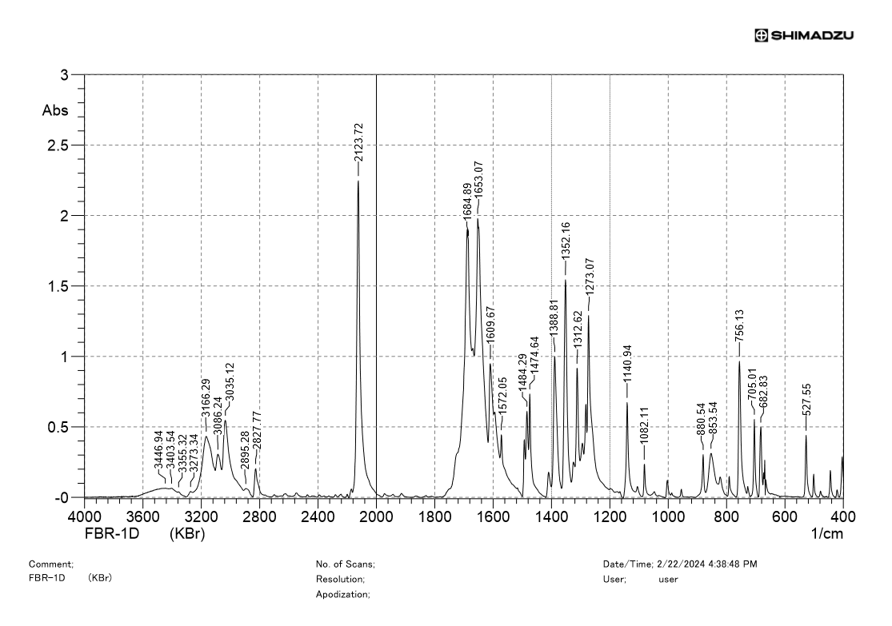
IR spectrum of 1

¹H NMR spectrum of 2a
¹³C NMR spectrum of 2a
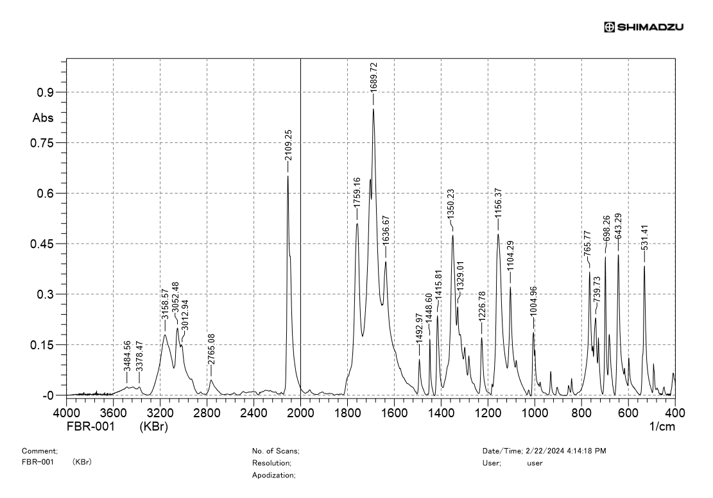
IR spectrum of 2a

¹H NMR spectrum of 2b
¹³C NMR spectrum of 2b
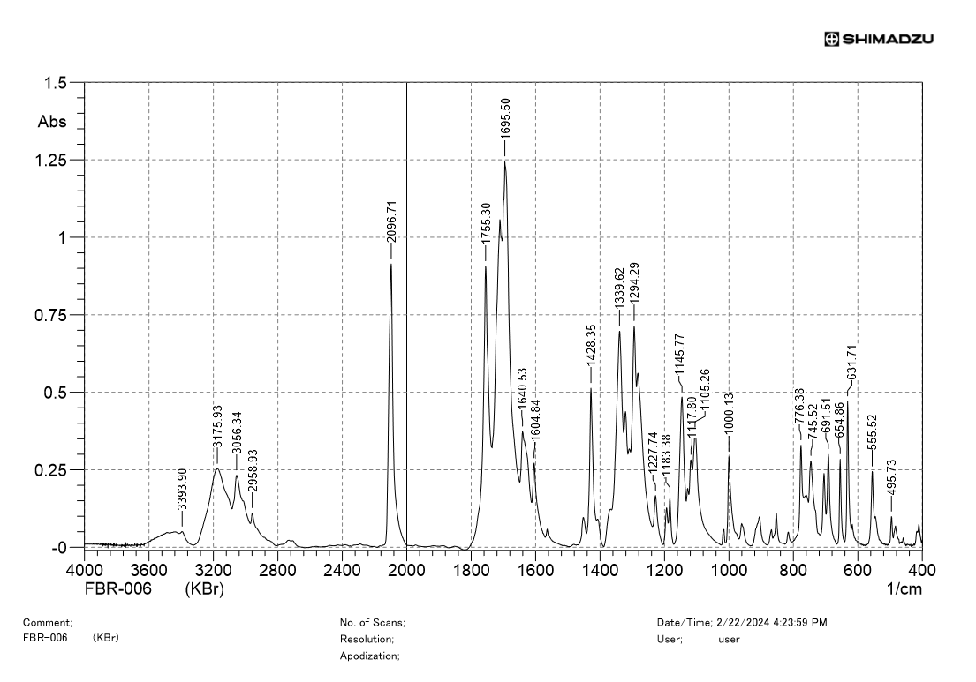
IR spectrum of 2b

¹H NMR spectrum of 3a
¹³C NMR spectrum of 3a
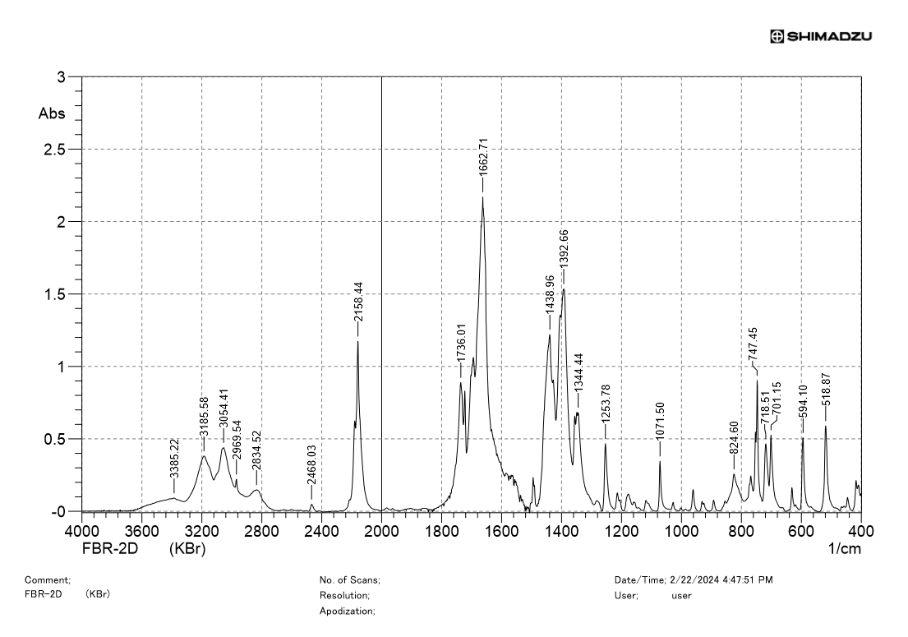
IR spectrum of 3a

¹H NMR spectrum of 3b
¹³C NMR spectrum of 3b
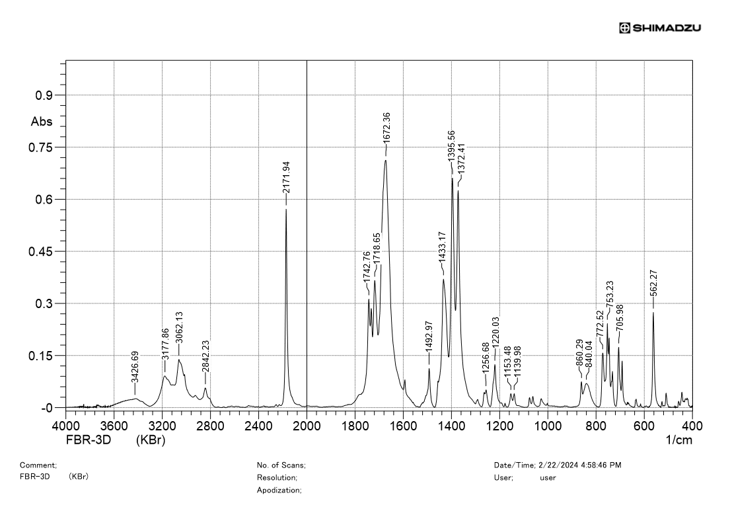
IR spectrum of 3b
¹H NMR spectrum of 4
¹³C NMR spectrum of 4
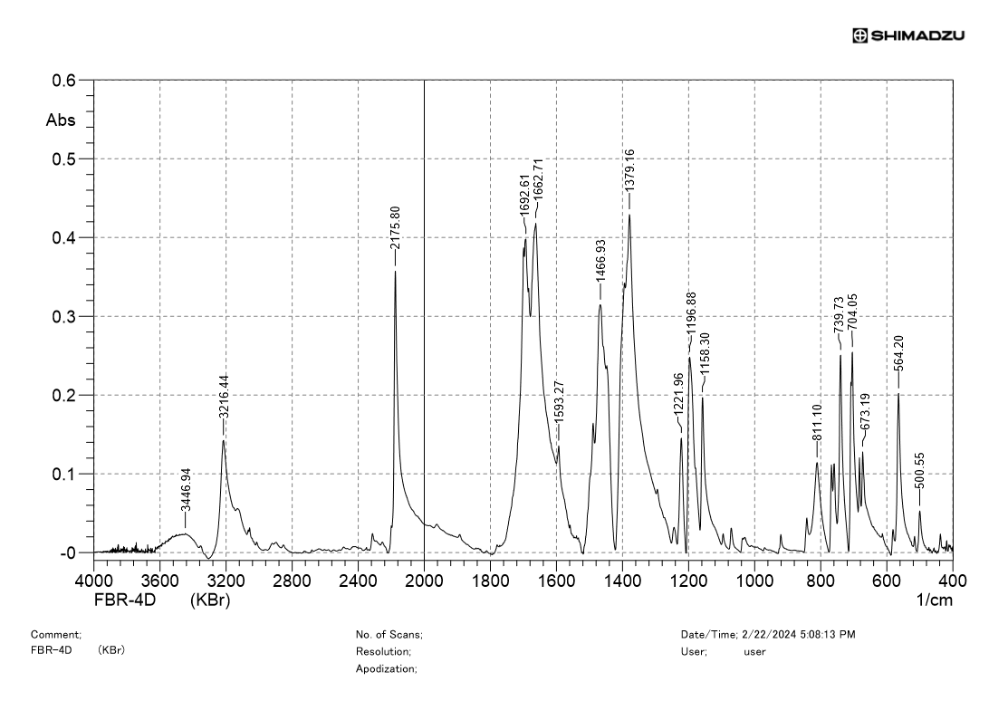
IR spectrum of 4
¹H NMR spectrum of 5a
¹³C NMR spectrum of 5a
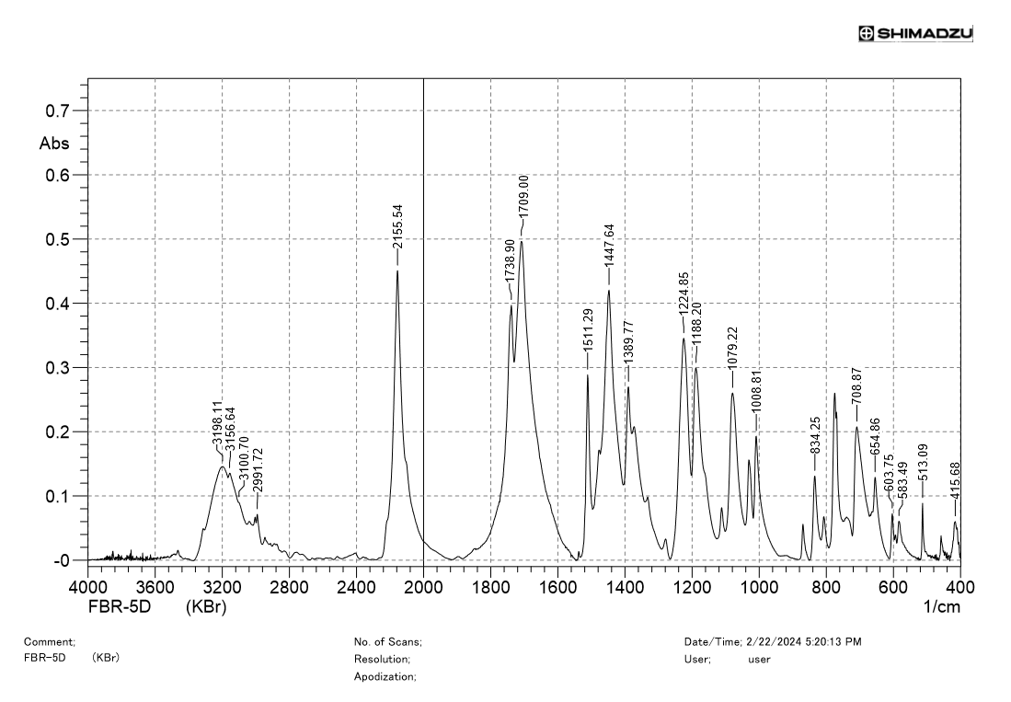
IR spectrum of 5a
¹H NMR spectrum of 5b
¹³C NMR spectrum of 5b
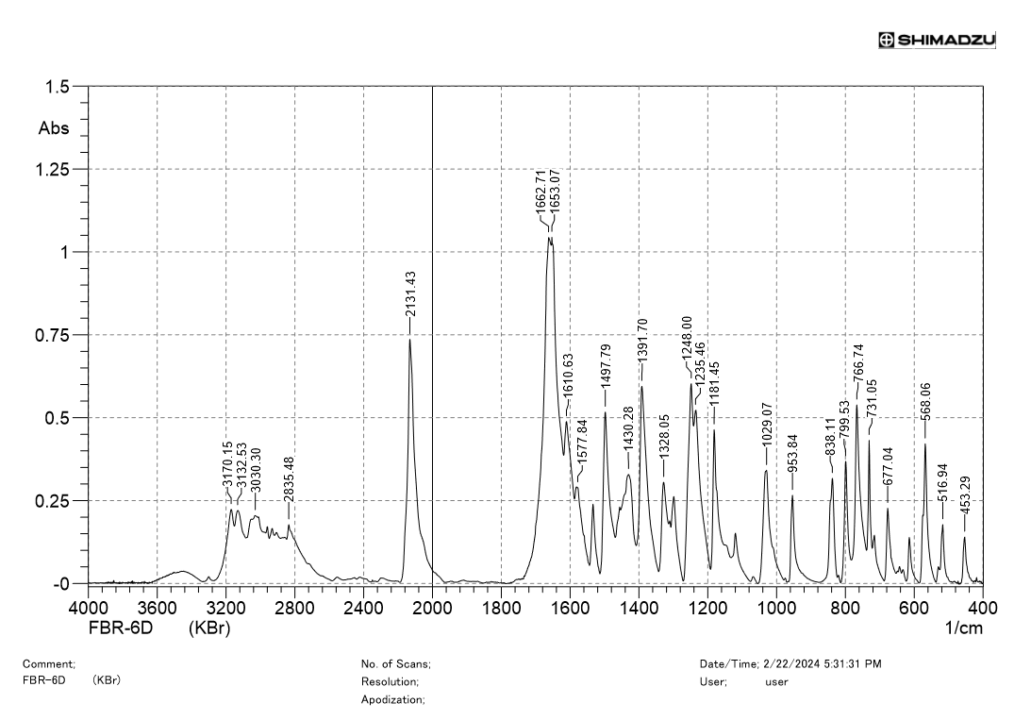
¹H NMR spectrum of 5b
¹H NMR spectrum of 6a
¹³C NMR spectrum of 6a
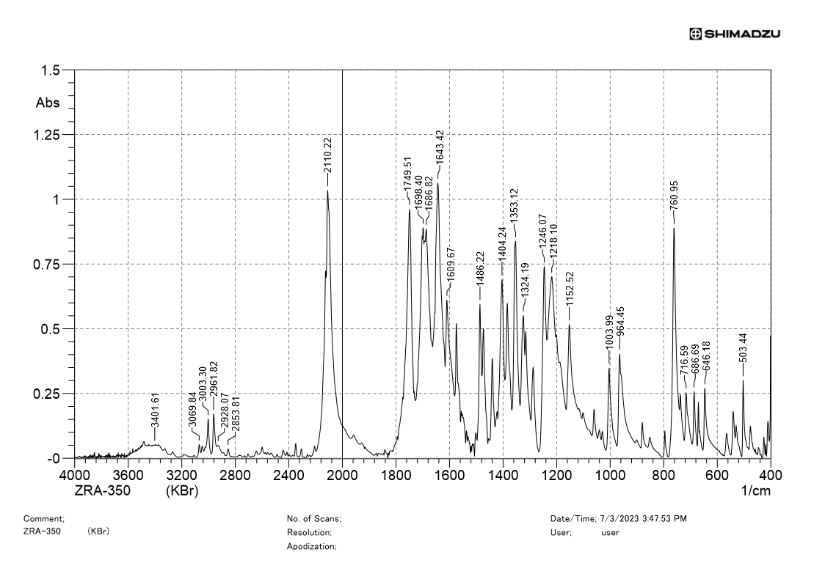
IR spectrum of 6a
¹H NMR spectrum of 6b
¹³C NMR spectrum of 6b
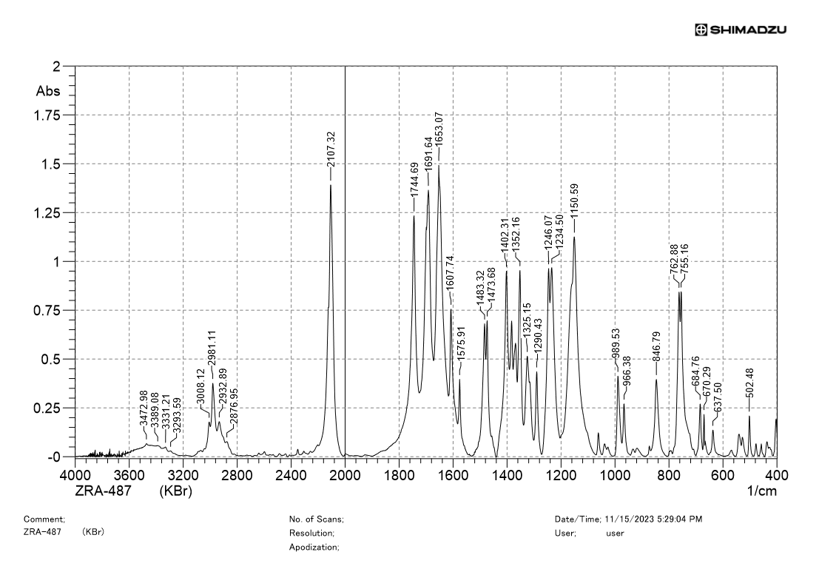
IR spectrum of 6b

¹H NMR spectrum of 6c
¹³C NMR spectrum of 6c
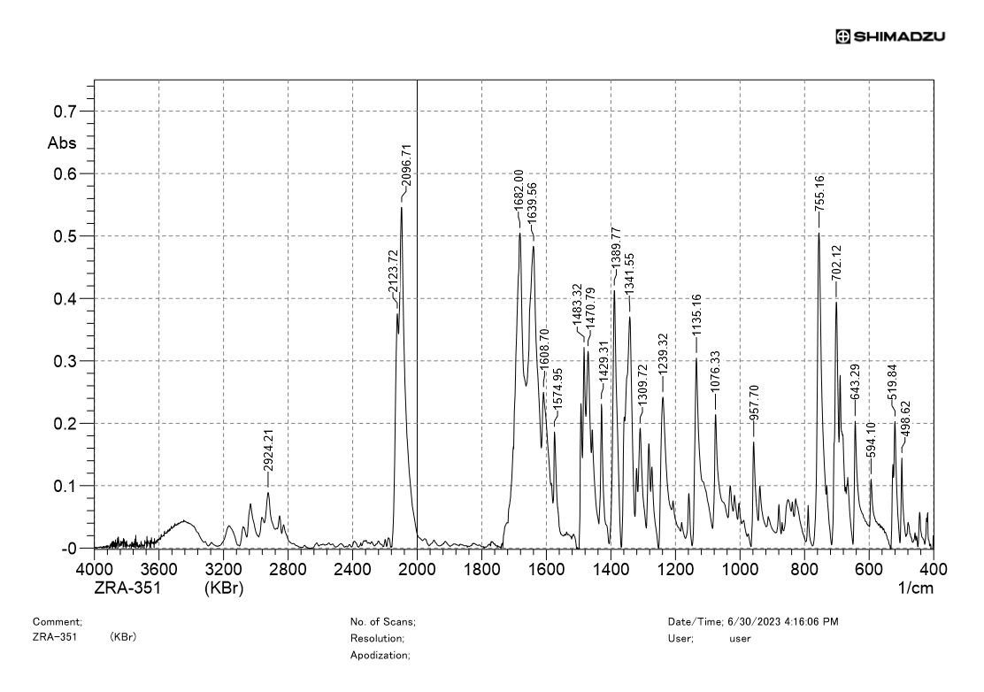
IR spectrum of 6c

¹H NMR spectrum of 7a
¹³C NMR spectrum of 7a
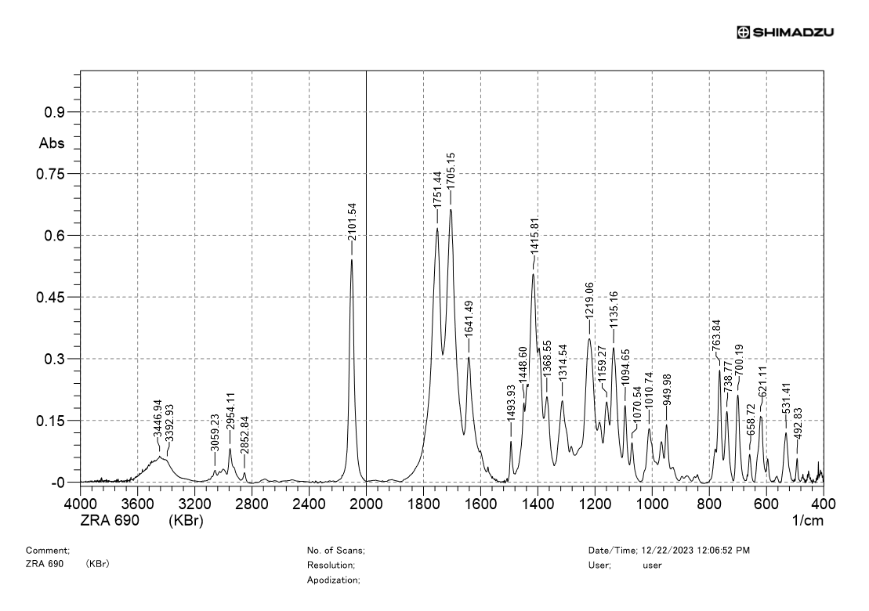
IR spectrum of 7a

¹H NMR spectrum of 7b
¹³C NMR spectrum of 7b
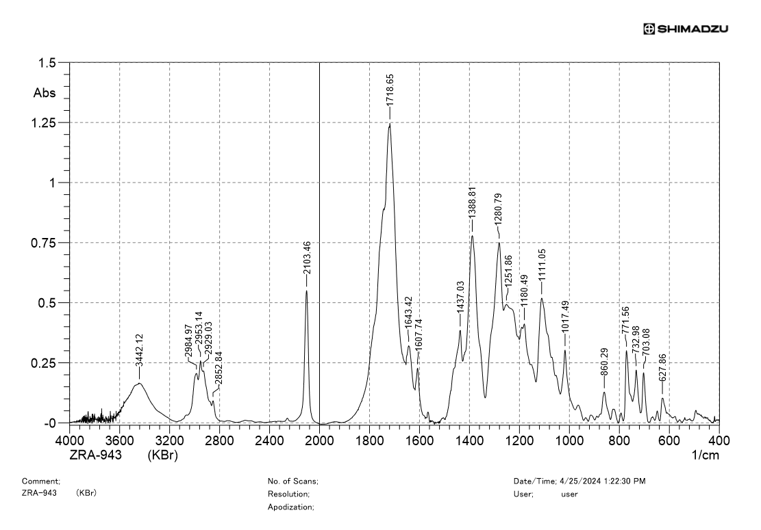
IR spectrum of 7b

¹H NMR spectrum of 7c
¹³C NMR spectrum of 7c
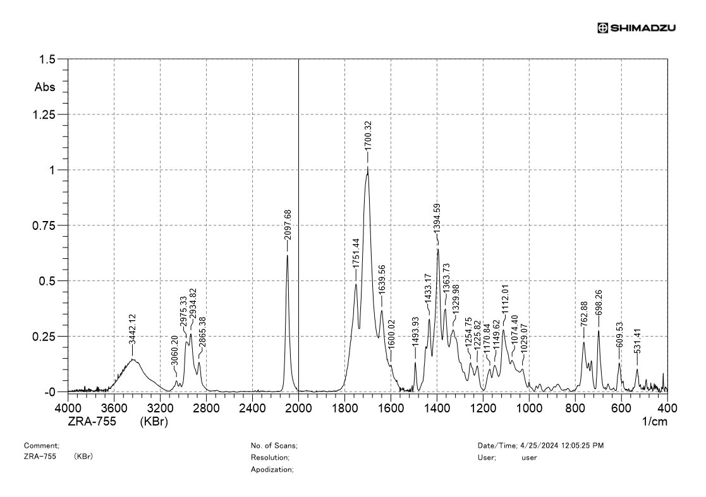
IR spectrum of 7c
¹H NMR spectrum of 7d
¹³C NMR spectrum of 7d
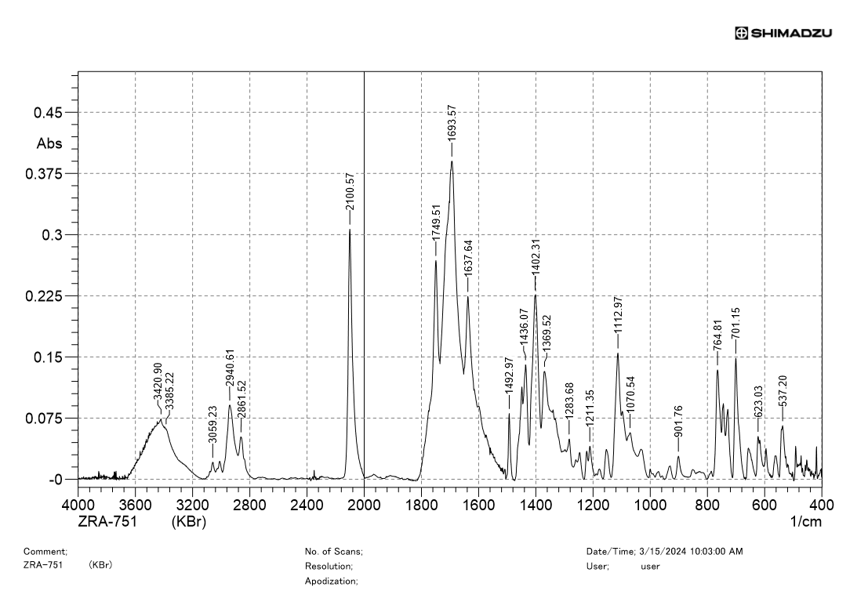
IR spectrum of 7d

¹H NMR spectrum of 7e
¹³C NMR spectrum of 7e
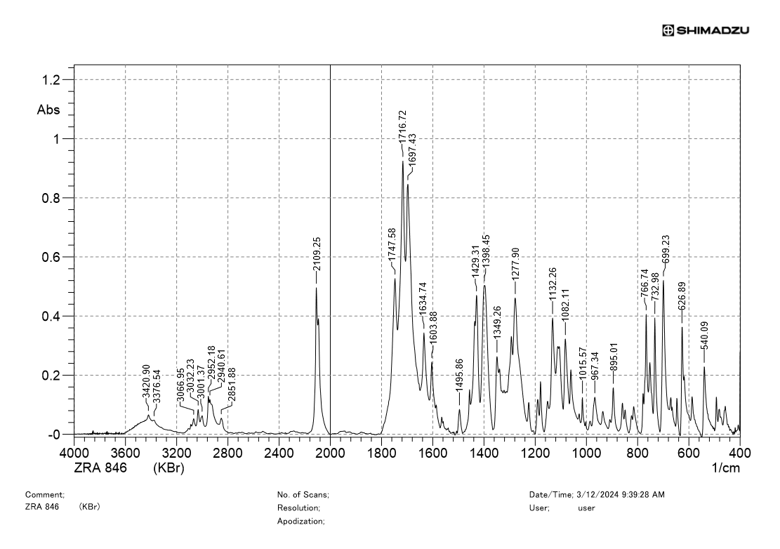
IR spectrum of 7e

¹H NMR spectrum of 8a
¹³C NMR spectrum of 8a

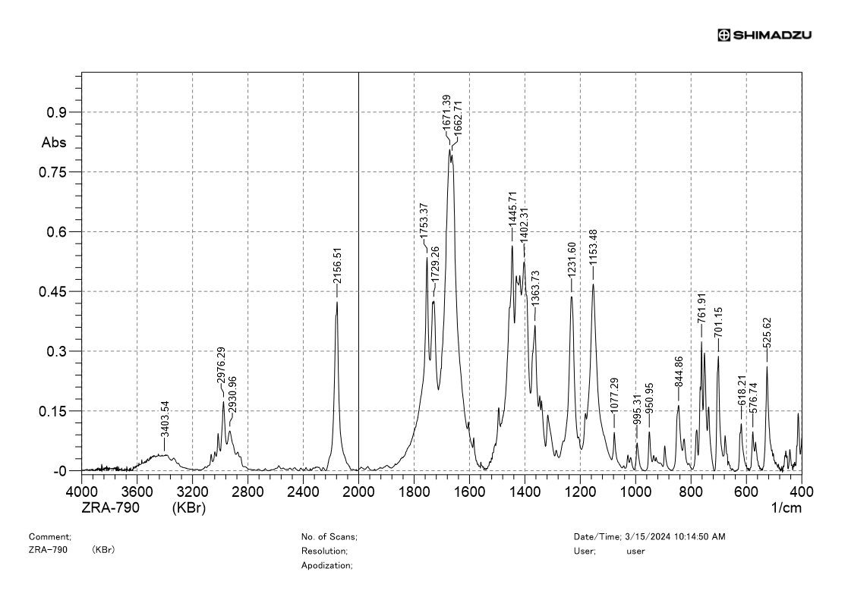
IR spectrum of 8a
¹H NMR spectrum of 8b
¹³C NMR spectrum of 8b
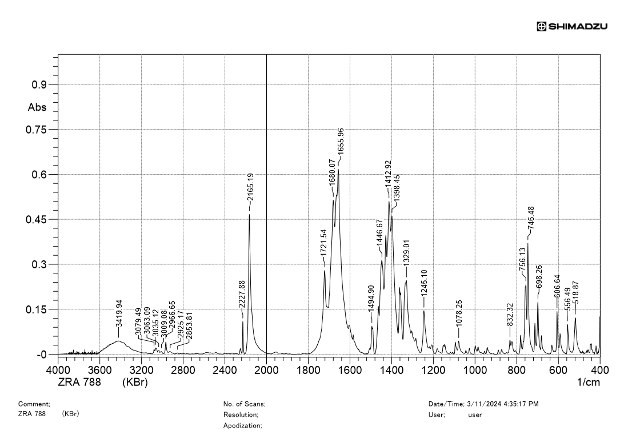
IR spectrum of 8b

¹H NMR spectrum of 8c
¹³C NMR spectrum of 8c
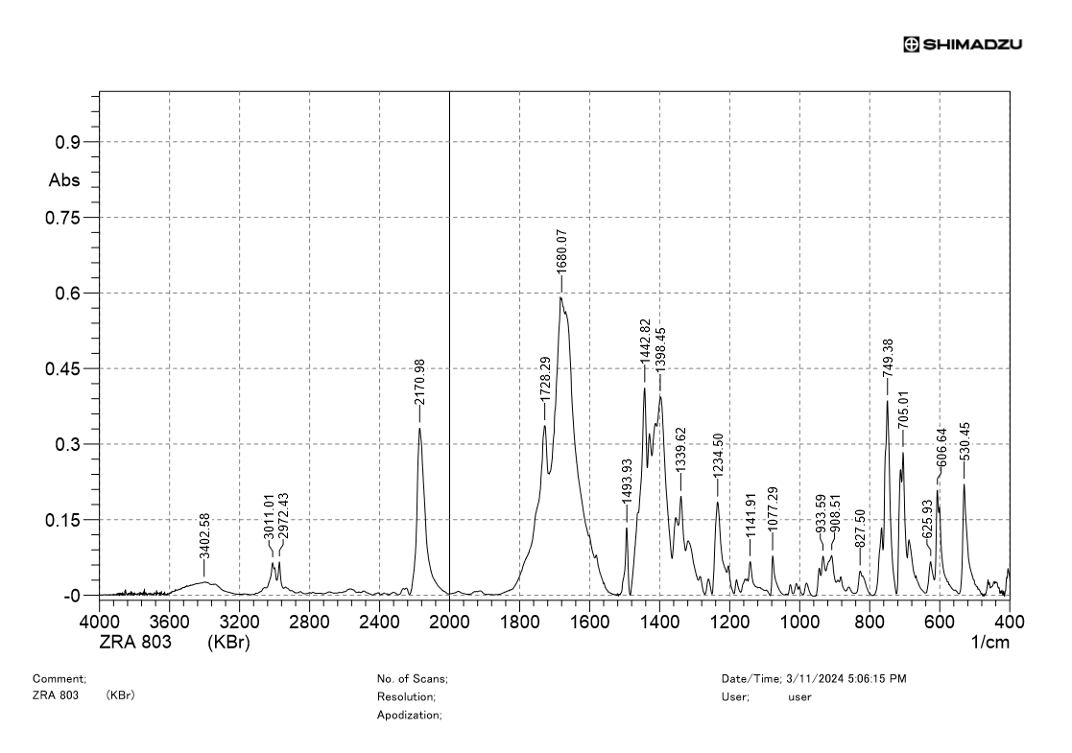
IR spectrum of 8c

¹H NMR spectrum of 8d
¹³C NMR spectrum of 8d
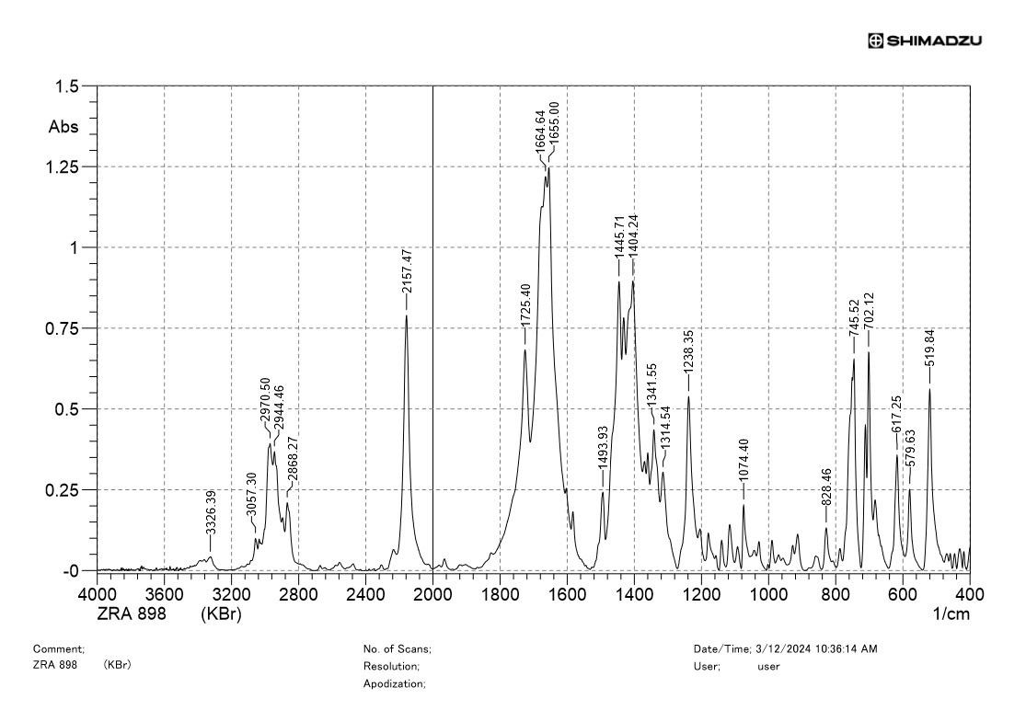
IR spectrum of 8d

¹H NMR spectrum of 8e
¹³C NMR spectrum of 8e
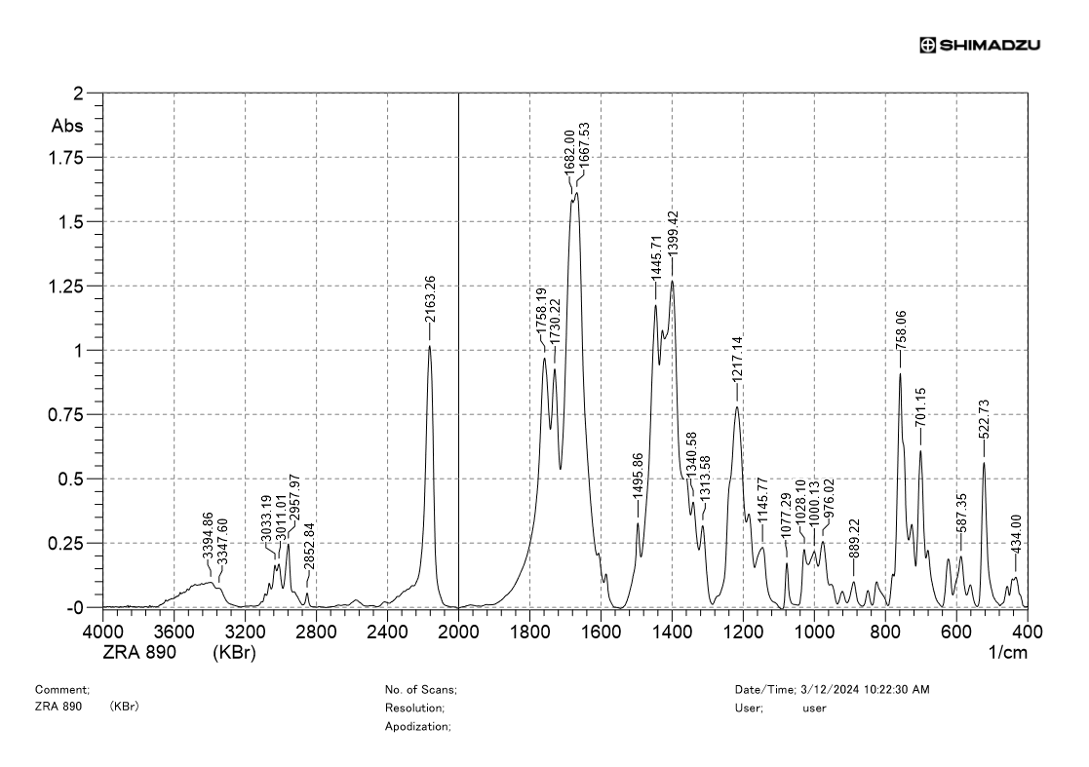
IR spectrum of 8e

¹H NMR spectrum of 8f
¹³C NMR spectrum of 8f
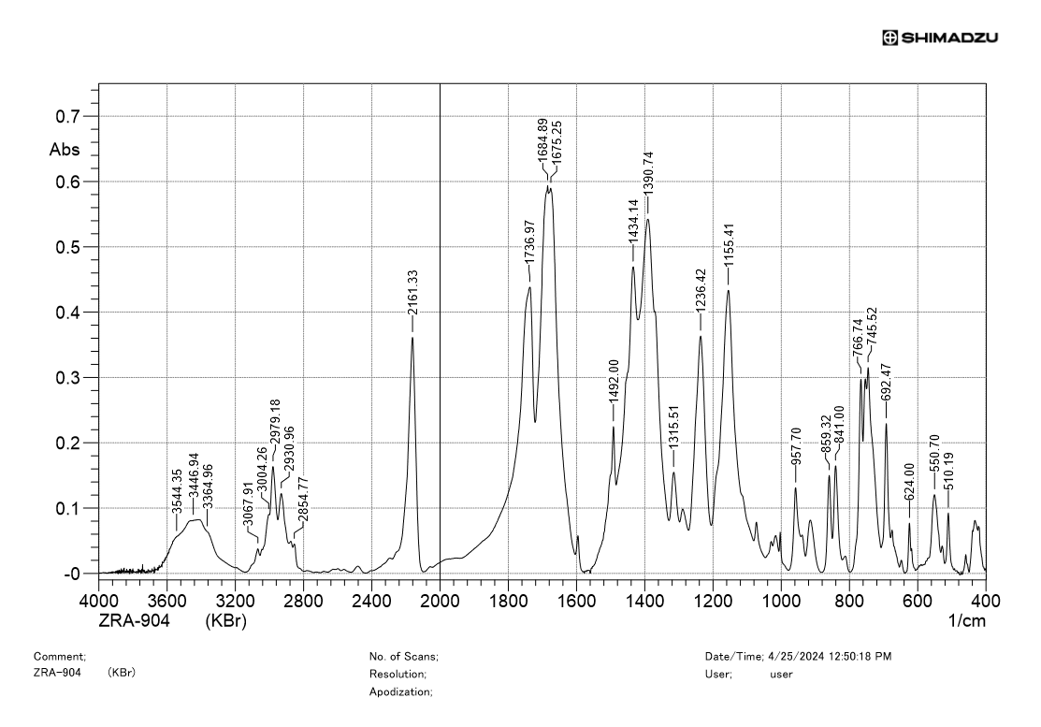
IR spectrum of 8f

¹H NMR spectrum of 8g
¹³C NMR spectrum of 8g
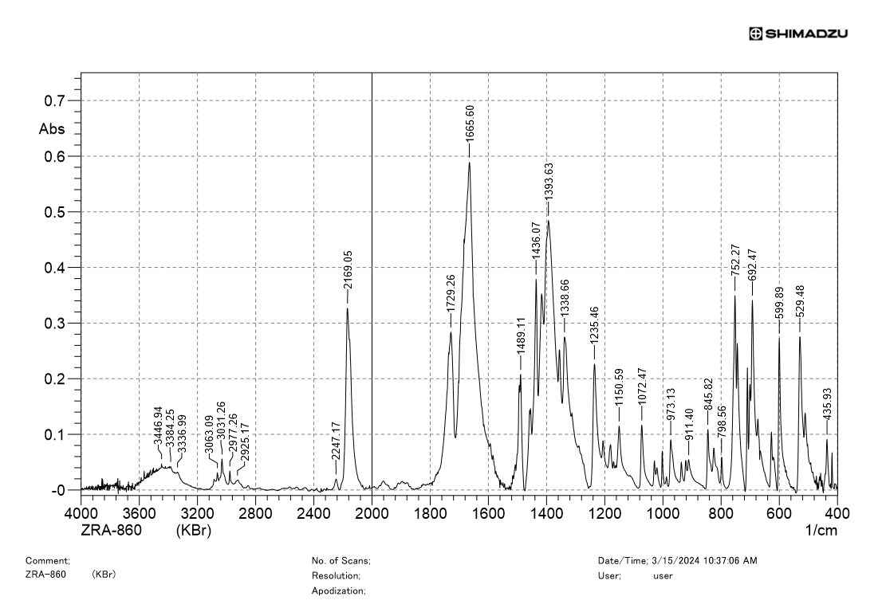
IR spectrum of 8g

¹H NMR spectrum of 9a
¹³C NMR spectrum of 9a
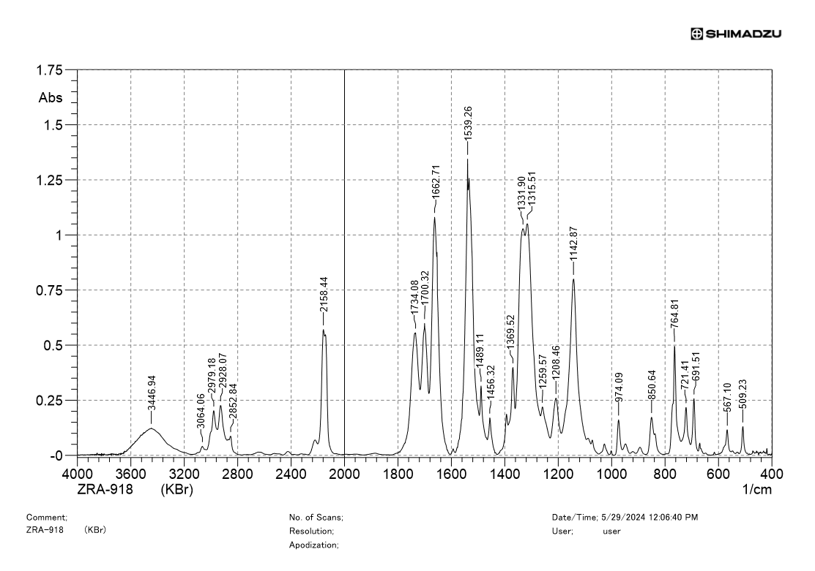
IR spectrum of 9a
¹H NMR spectrum of 9b
¹³C NMR spectrum of 9b
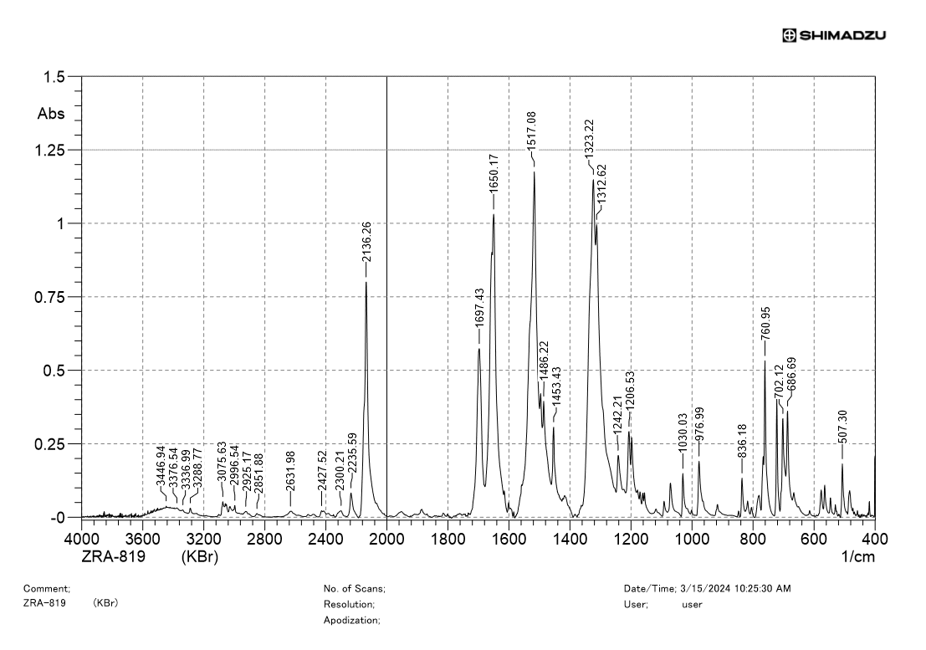
IR spectrum of 9b

¹H NMR spectrum of 10a
¹³C NMR spectrum of 10a
¹⁹F NMR spectrum of 10a
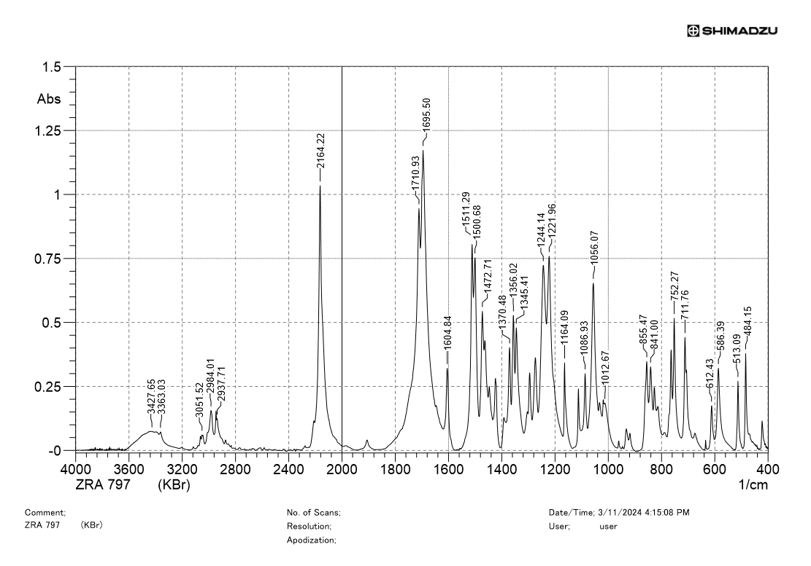
IR spectrum of 10a

¹H NMR spectrum of 10b
¹³C NMR spectrum of 10b
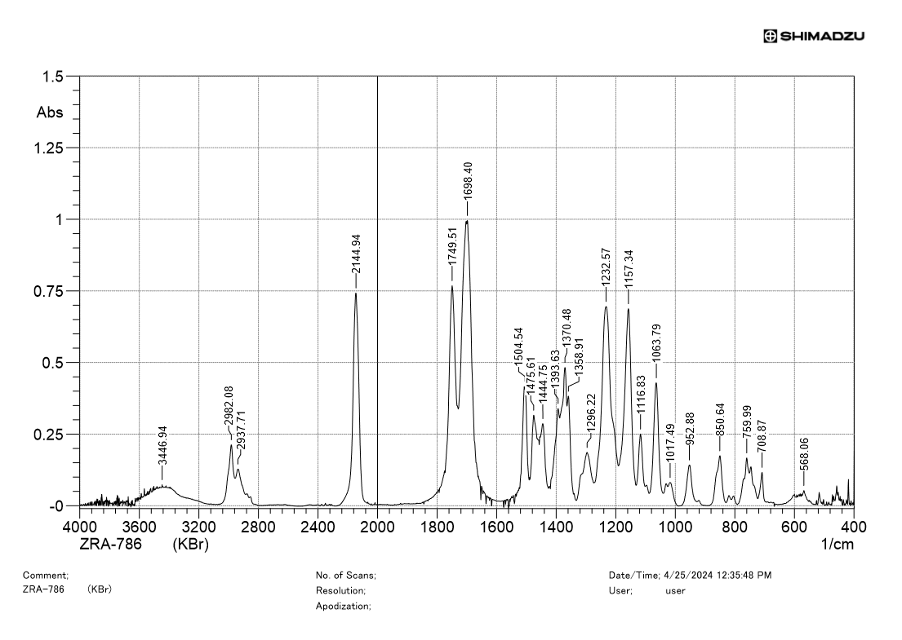
IR spectrum of 10b

¹H NMR spectrum of 10c
¹³C NMR spectrum of 10c
¹⁹F NMR spectrum of 10c
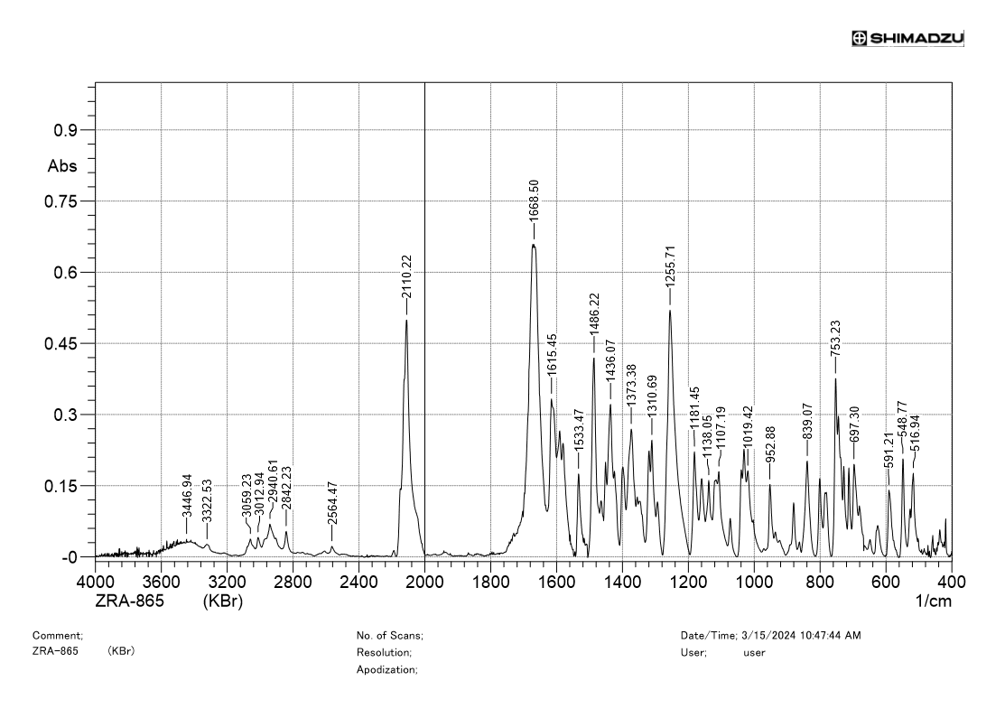
IR spectrum of 10c

¹H NMR spectrum of 6g
¹³C NMR spectrum of 6g
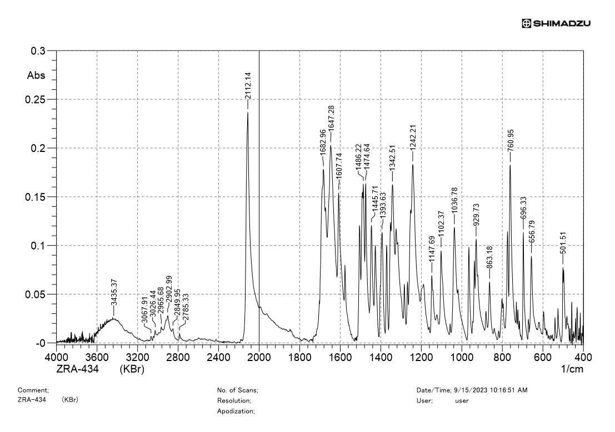
IR spectrum of 6g
¹H NMR spectrum of 6h
¹³C NMR spectrum of 6h
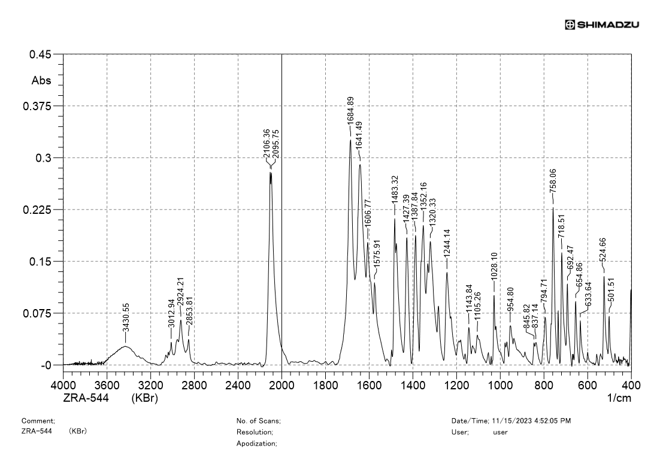
IR spectrum of 6h

¹H NMR spectrum of 6i
¹³C NMR spectrum of 6i
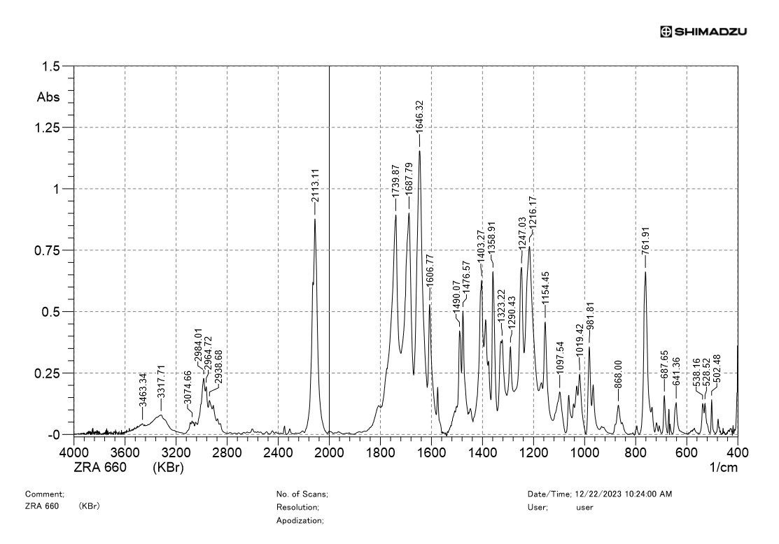
IR spectrum of 6i
¹H NMR spectrum of 6j
¹³C NMR spectrum of 6j
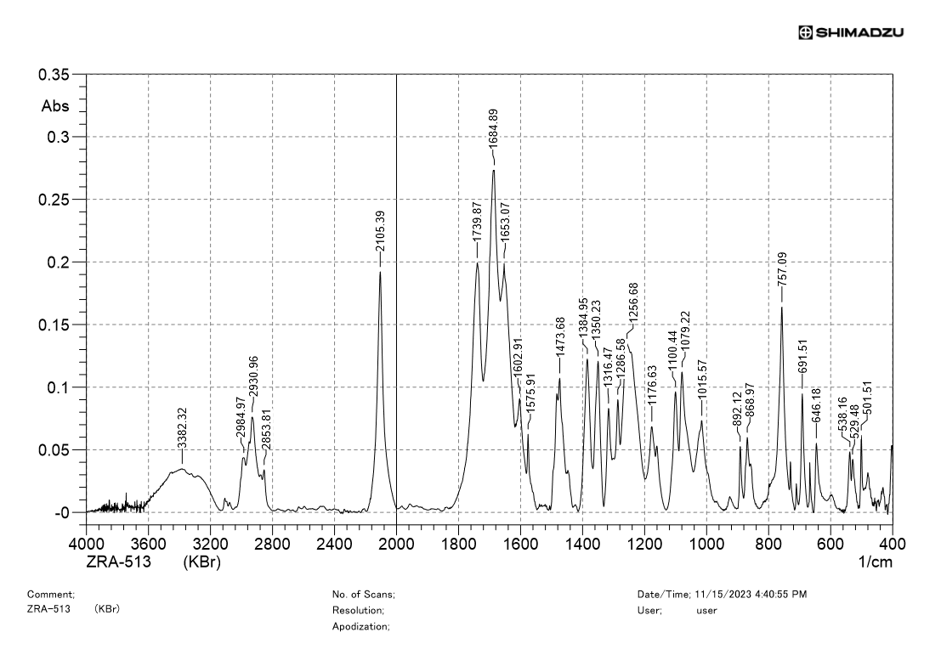
IR spectrum of 6j

¹H NMR spectrum of 6k
¹³C NMR spectrum of 6k
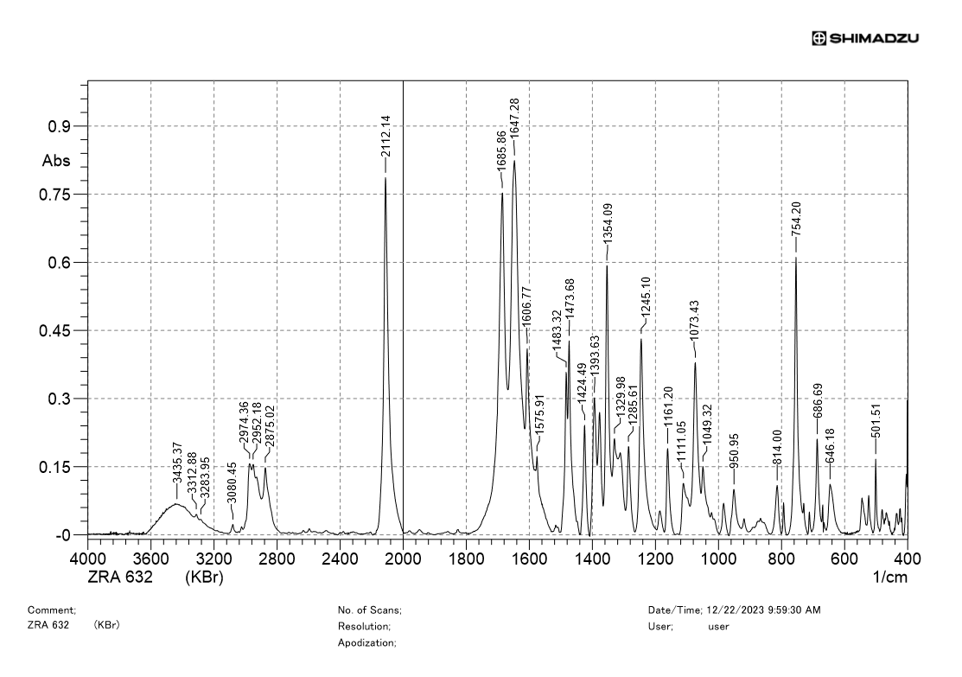
IR spectrum of 6k
¹H NMR spectrum of 6l
¹³C NMR spectrum of 6l
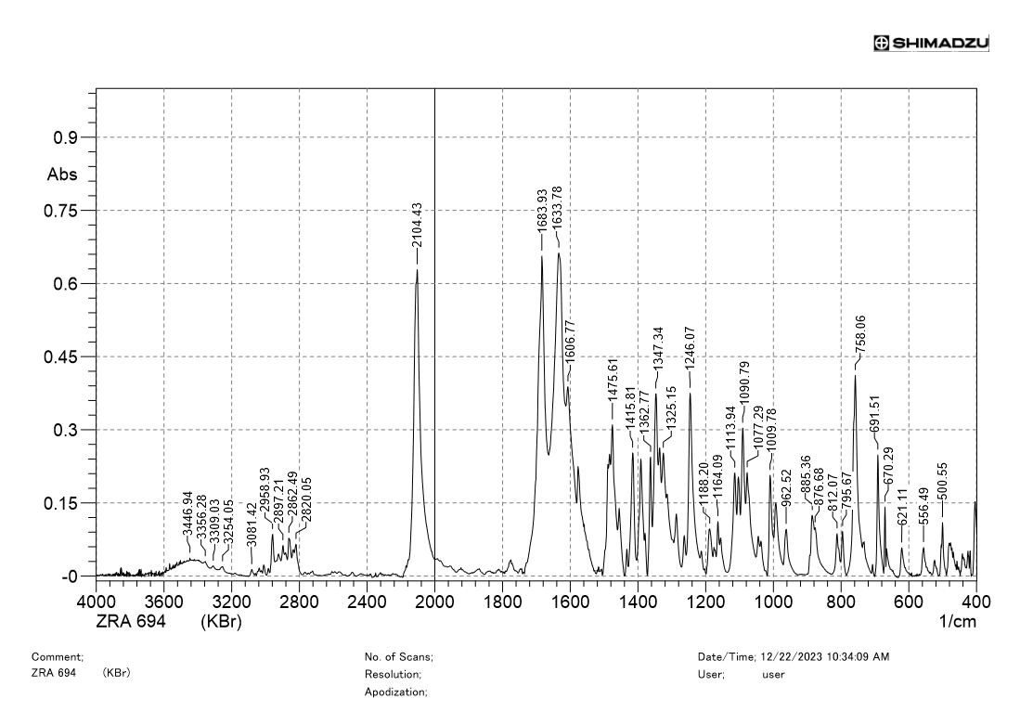
IR spectrum of 6l
¹H NMR spectrum of 6m
¹³C NMR spectrum of 6m
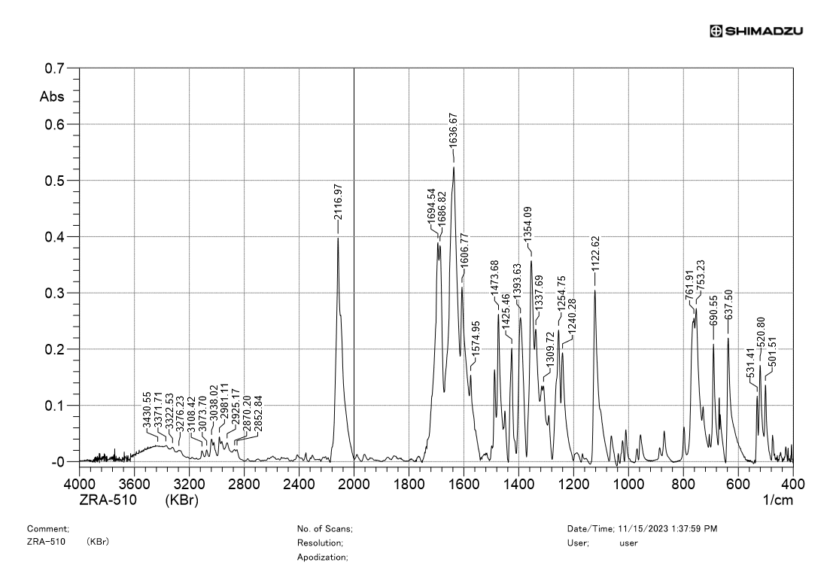
IR spectrum of 6m

¹H NMR spectrum of 6n
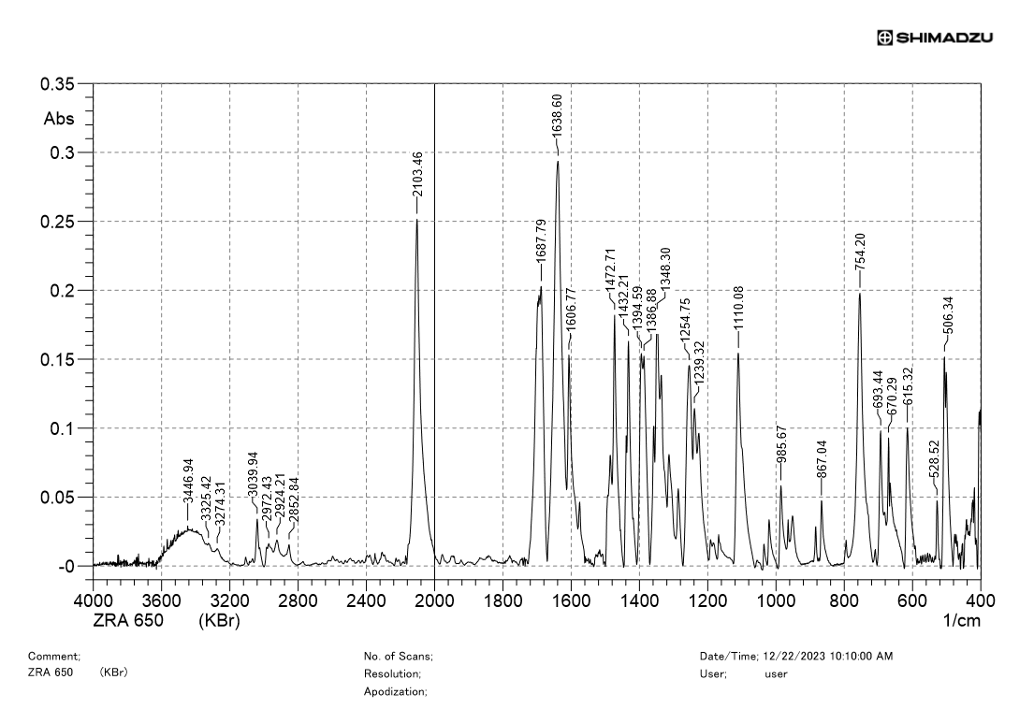
¹³C NMR spectrum of 6n
IR spectrum of 6n
¹H NMR spectrum of 6o
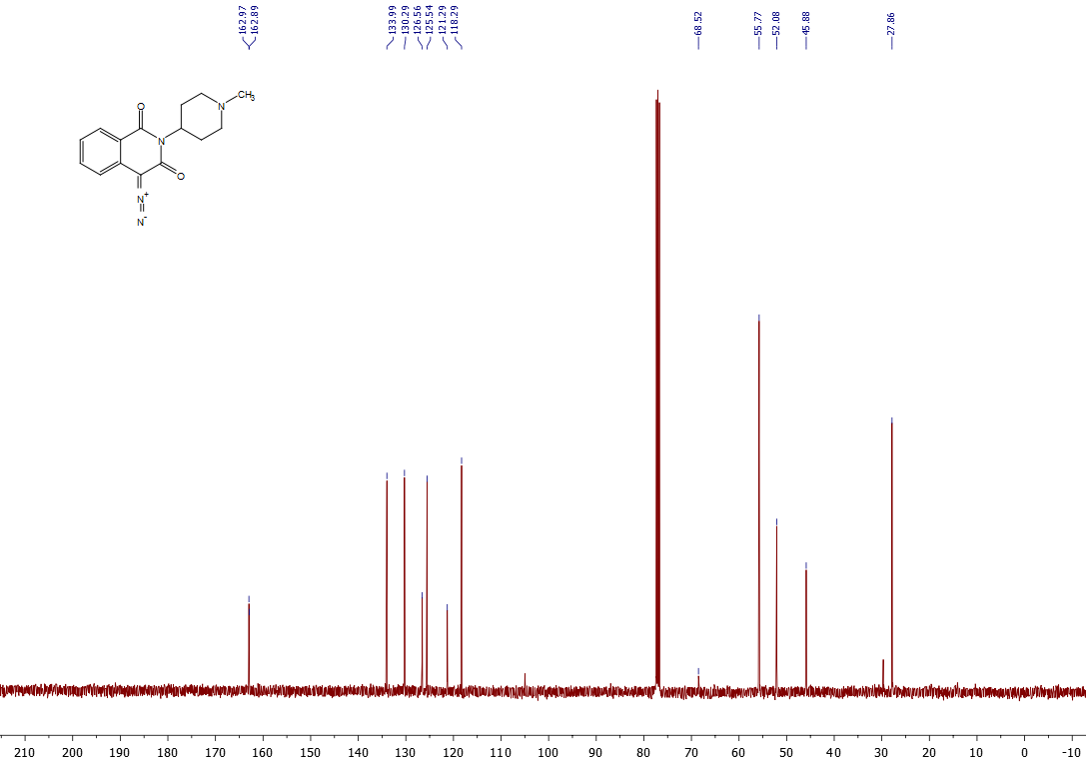
¹³C NMR spectrum of 6o

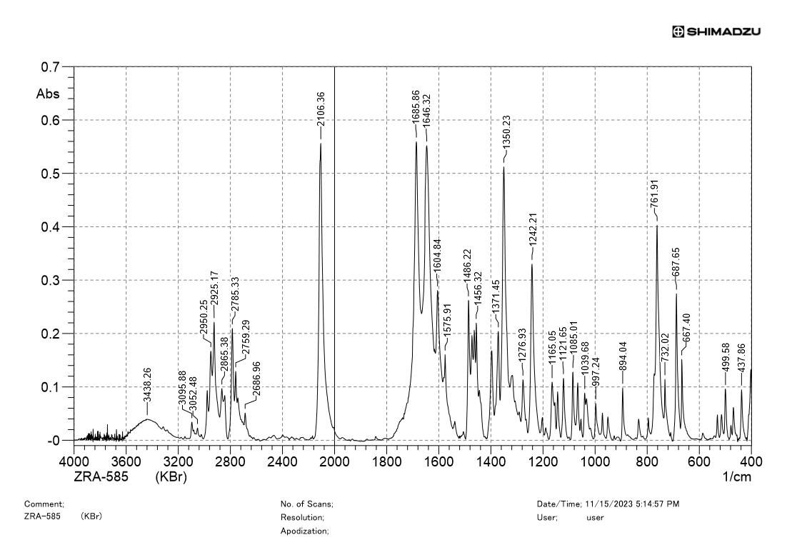
IR spectrum of 6o

¹H NMR spectrum of 6p
¹³C NMR spectrum of 6p
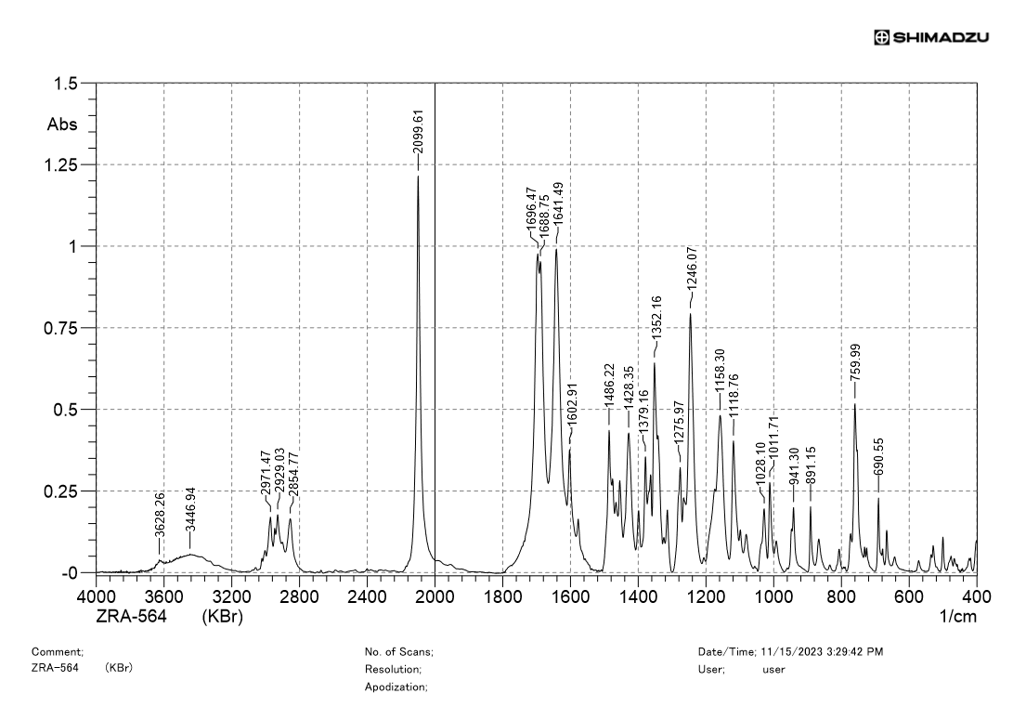
IR spectrum of 6p

¹H NMR spectrum of 6q
¹³C NMR spectrum of 6q
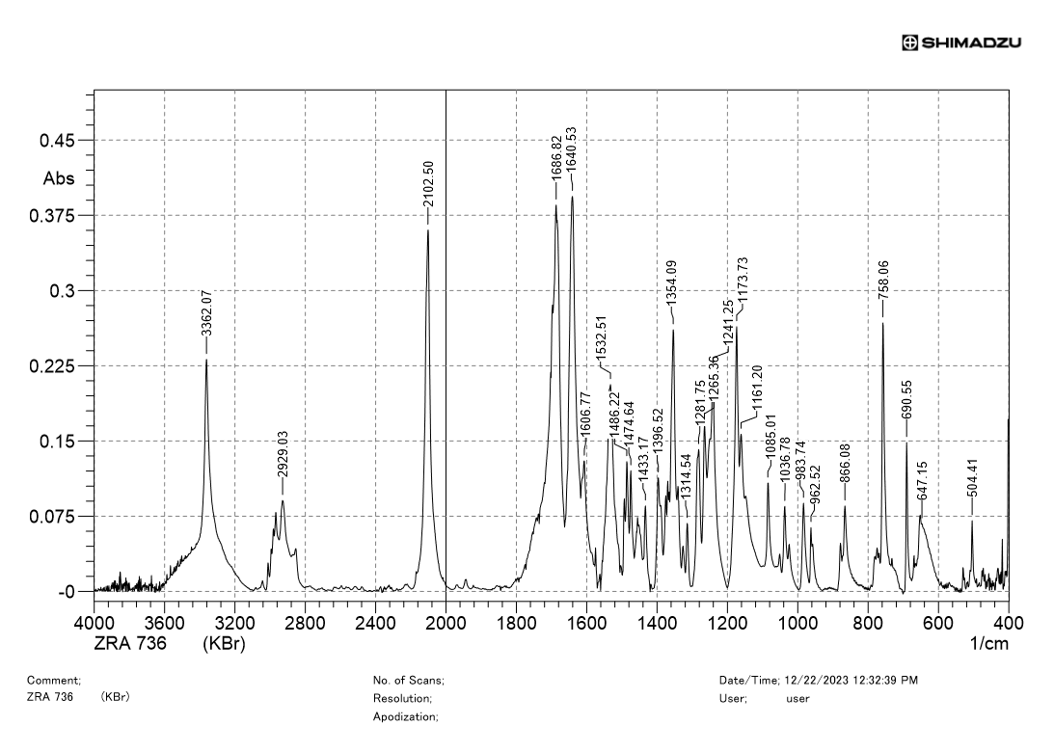
IR spectrum of 6q

¹H NMR spectrum of 6r
¹³C NMR spectrum of 6r

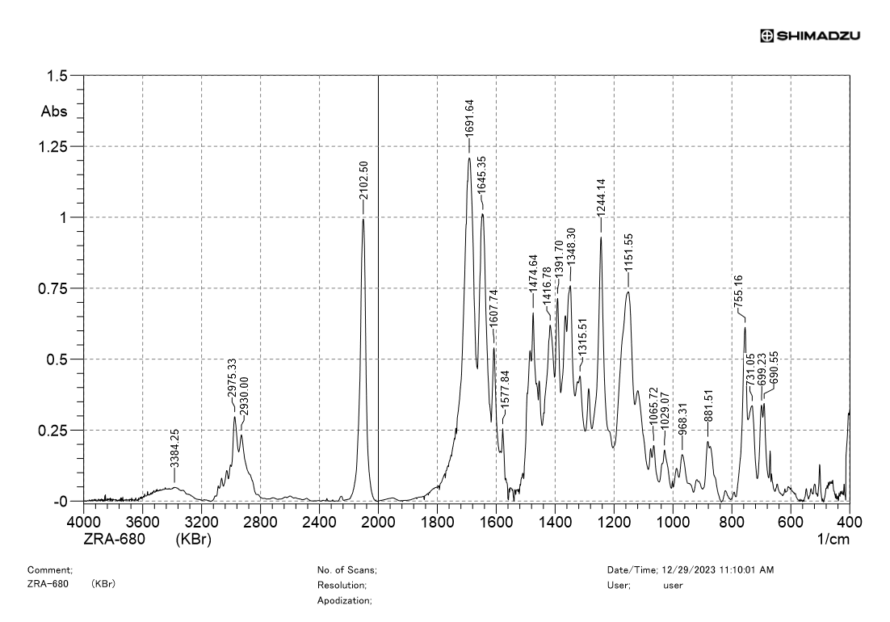
IR spectrum of 6r
¹H NMR spectrum of 6s
¹³C NMR spectrum of 6s
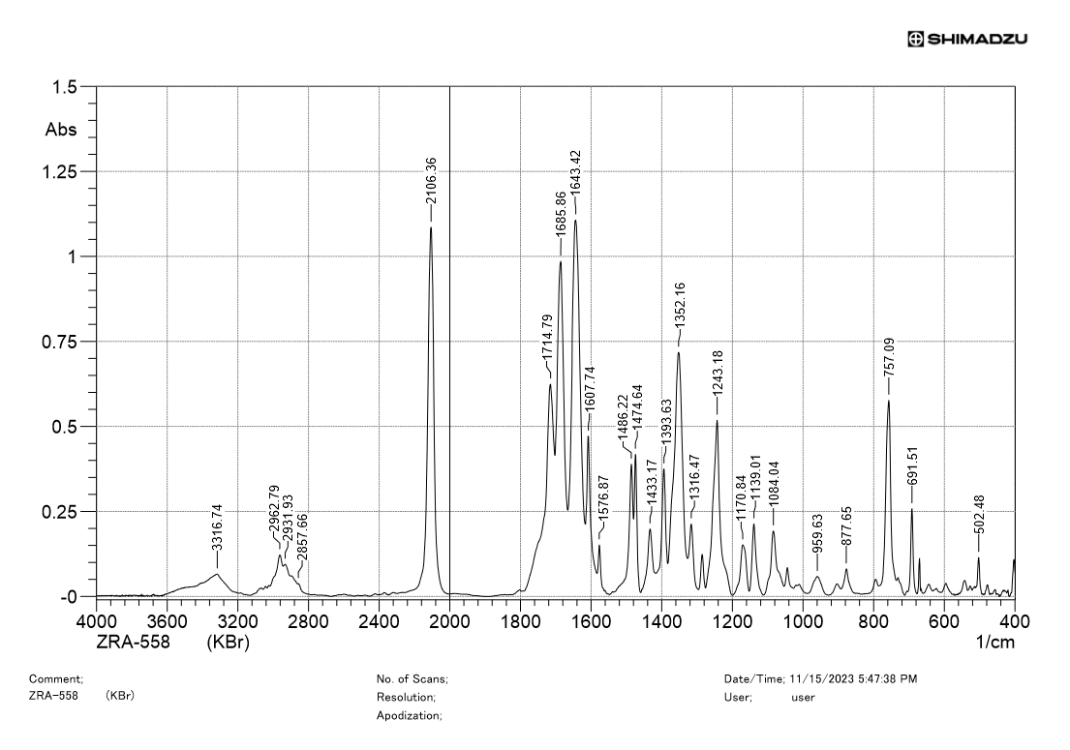

IR spectrum of 6s

¹H NMR spectrum of 6t
¹³C NMR spectrum of 6t
¹H NMR spectrum of 6u
¹³C NMR spectrum of 6u
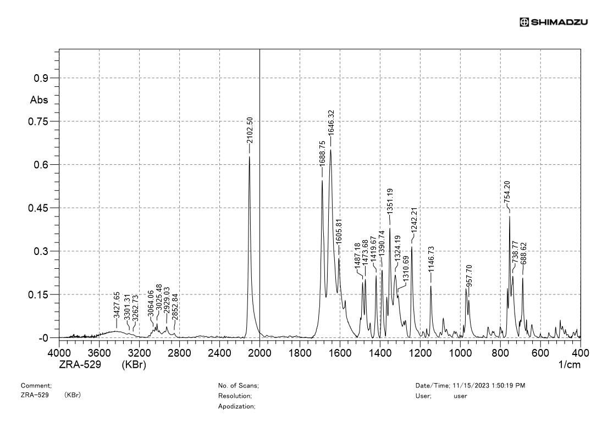
IR spectrum of 6u

¹H NMR spectrum of 7f
¹³C NMR spectrum of 7f
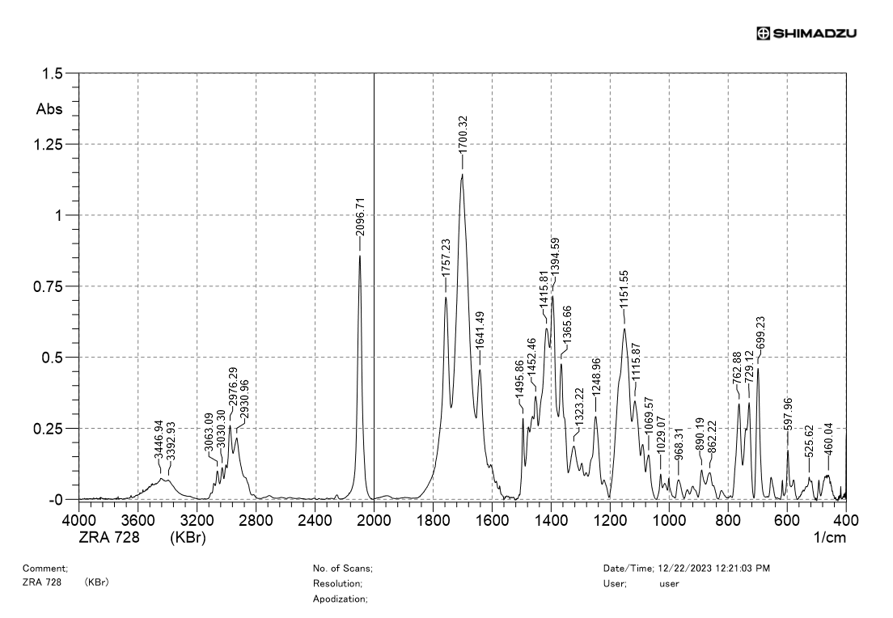

IR spectrum of 7f
¹H NMR spectrum of 7g
¹³C NMR spectrum of 7g
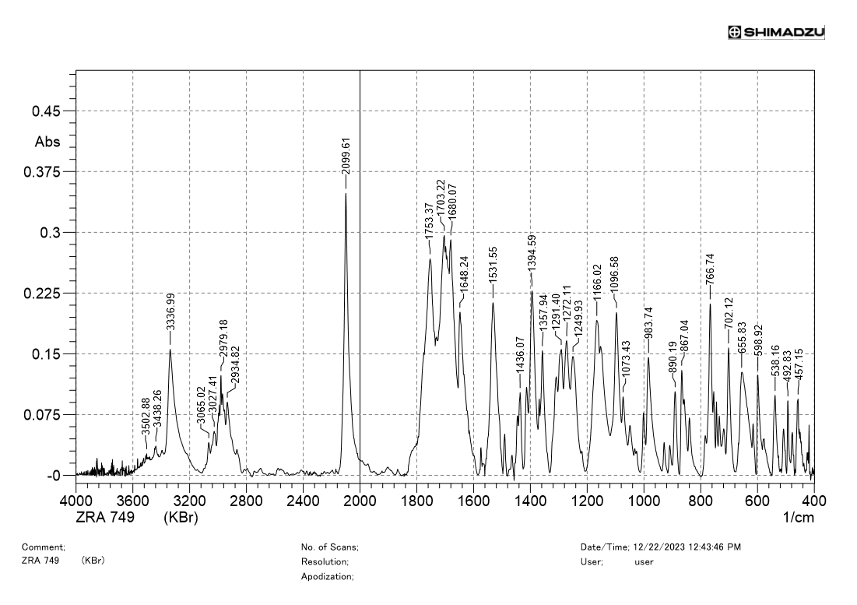
IR spectrum of 7g

¹H NMR spectrum of 7h
¹³C NMR spectrum of 7h
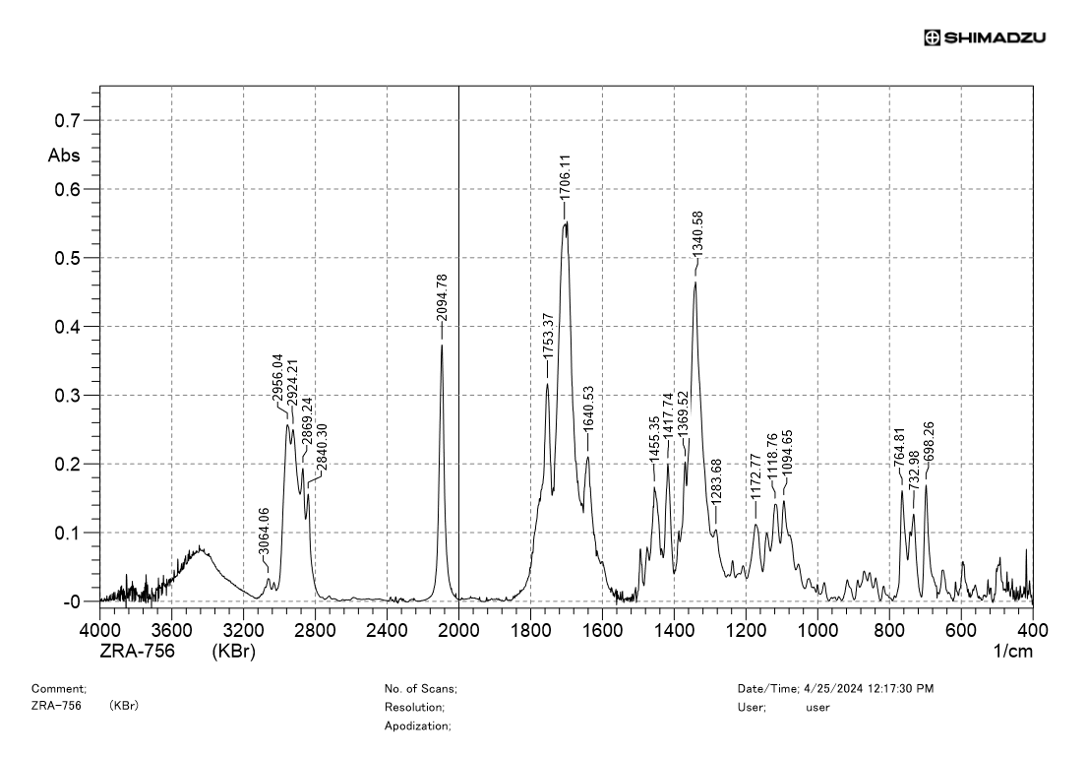
IR spectrum of 7h

¹H NMR spectrum of 7i
¹³C NMR spectrum of 7i
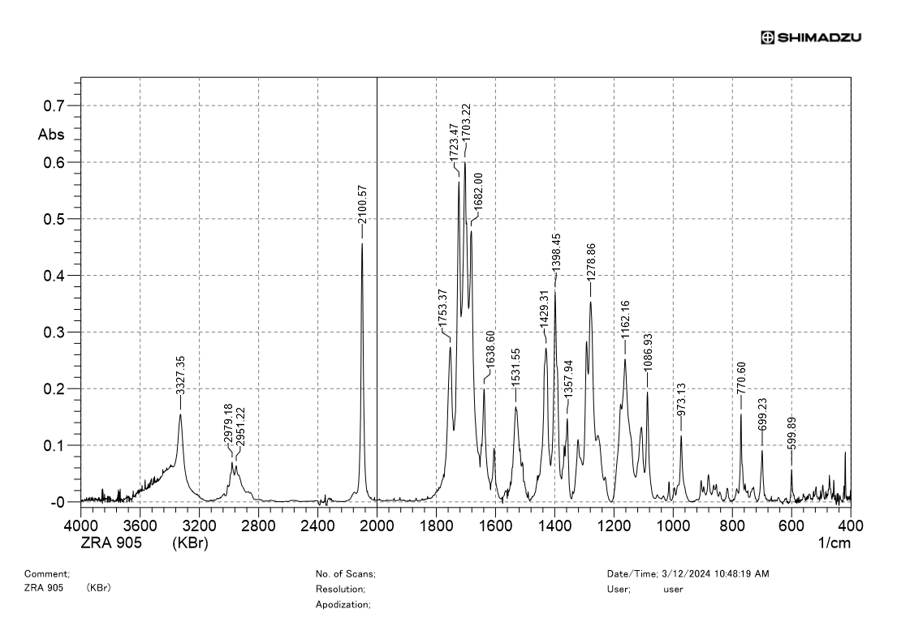
IR spectrum of 7i

¹H NMR spectrum of 7j
¹³C NMR spectrum of 7j
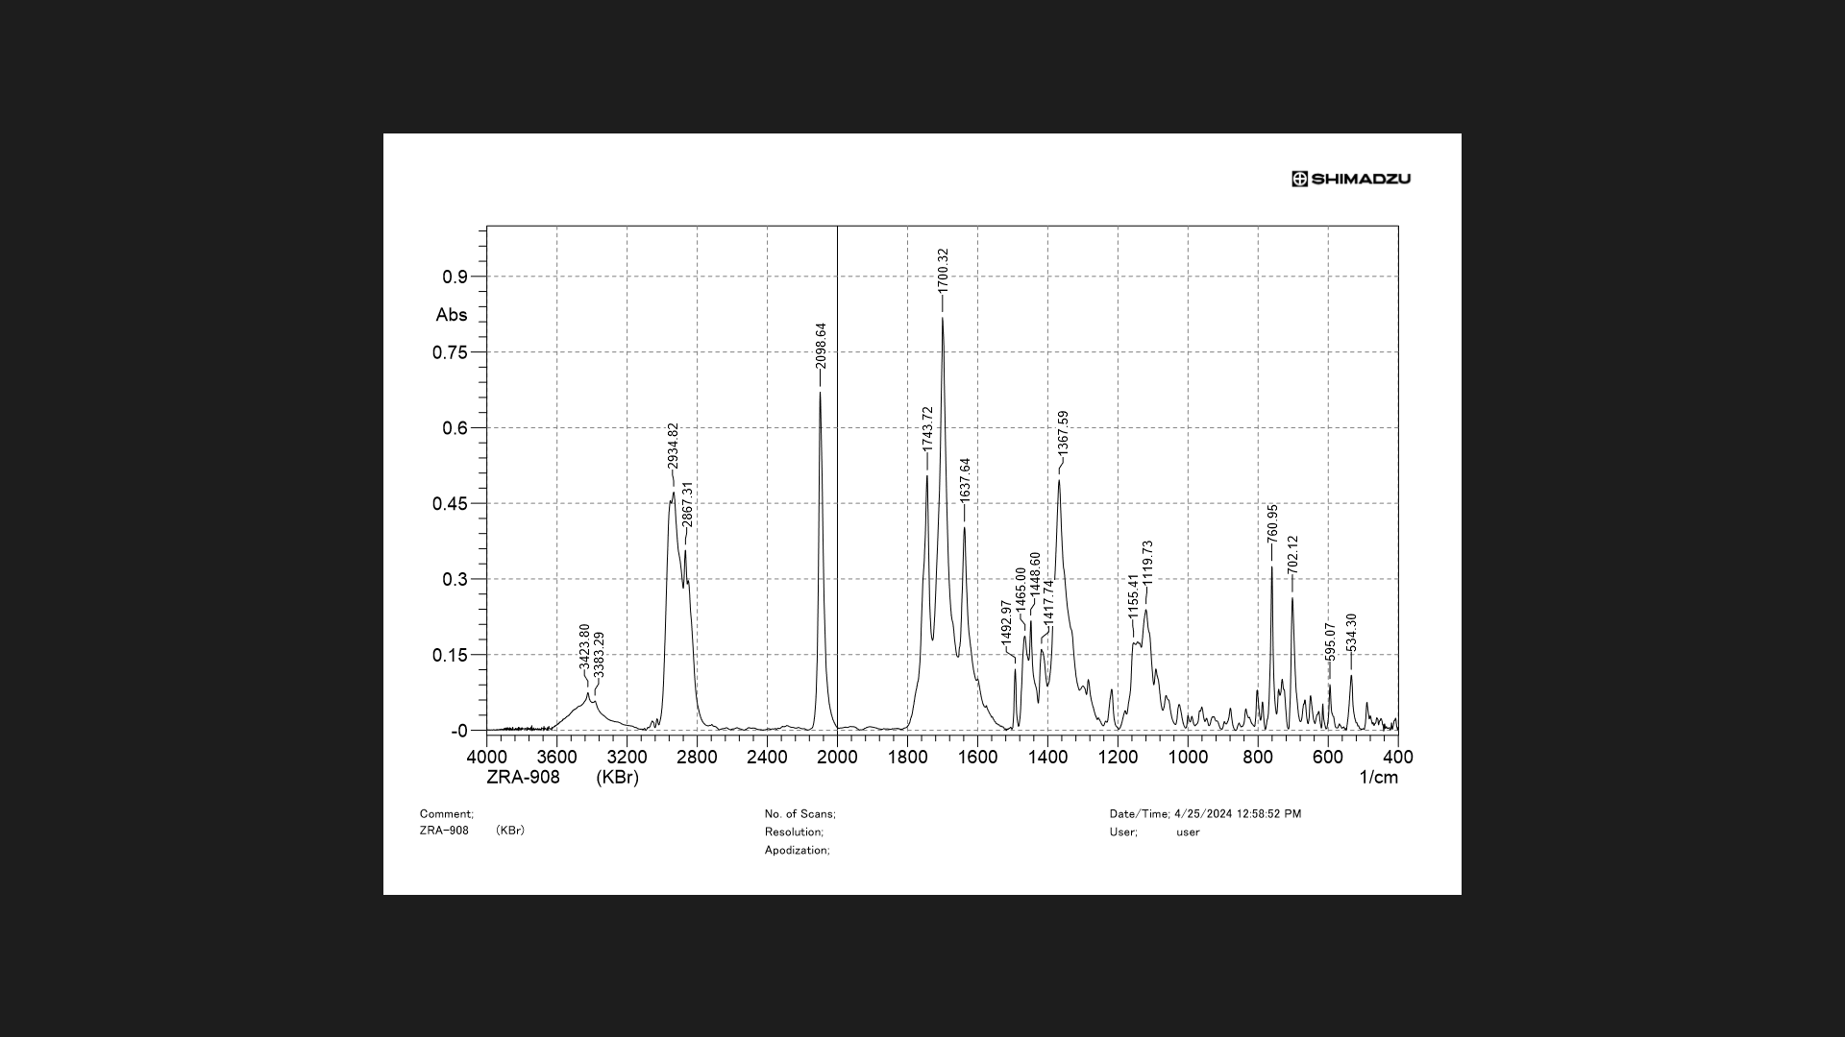

IR spectrum of 7j
¹H NMR spectrum of 7k
¹³C NMR spectrum of 7k
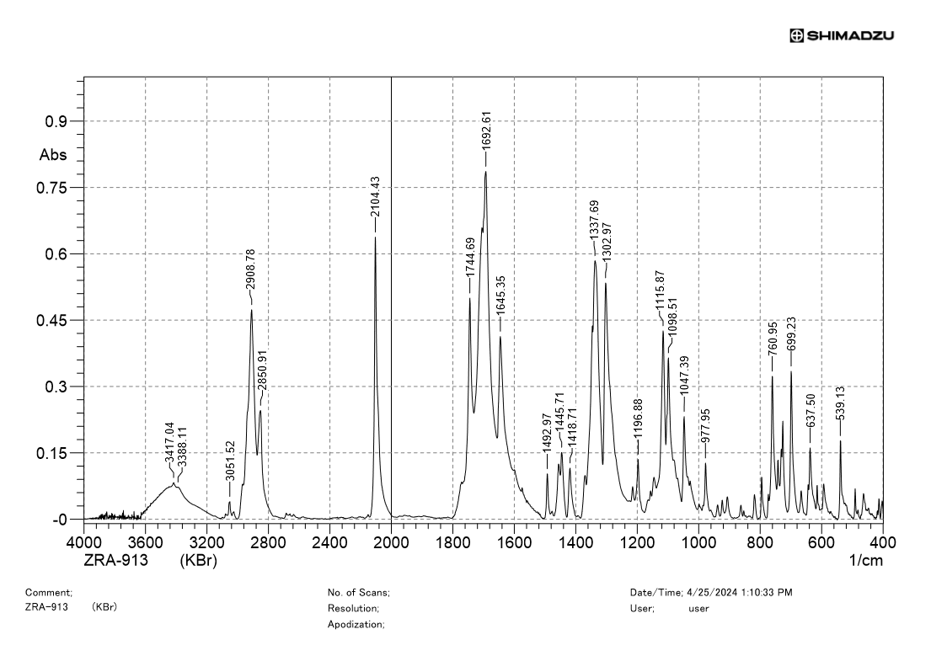
IR spectrum of 7k
¹H NMR spectrum of 7l
¹³C NMR spectrum of 7l
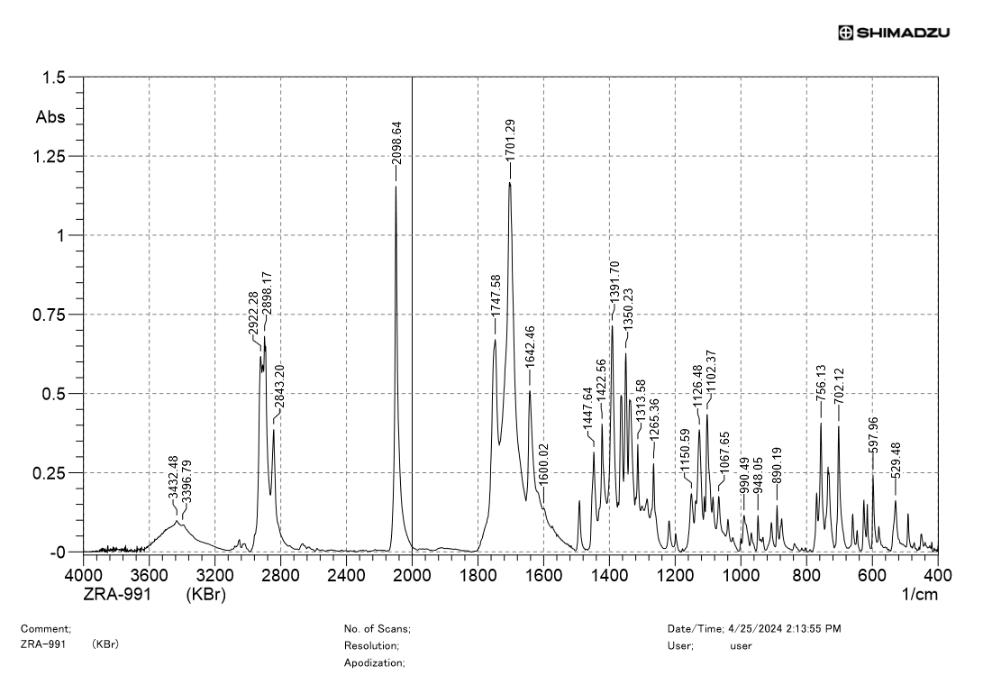
IR spectrum of 7l
¹H NMR spectrum of 8i
¹³C NMR spectrum of 8i
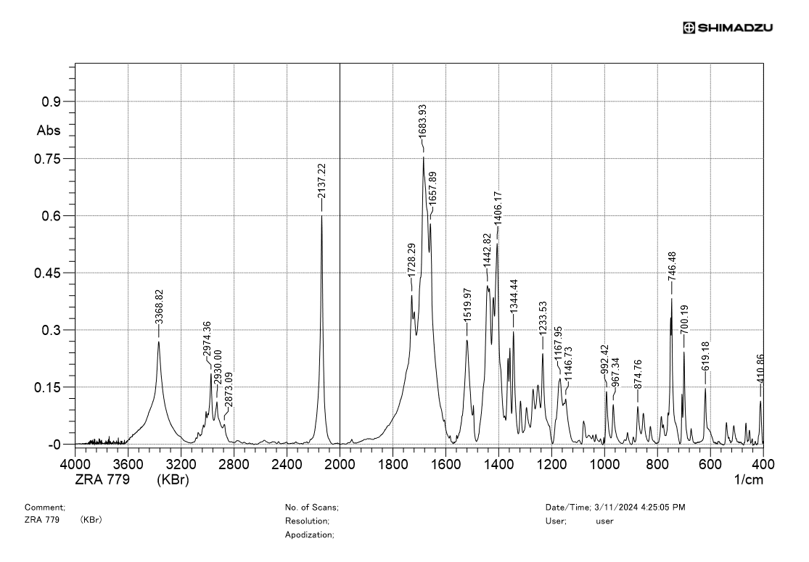
IR spectrum of 8i

¹H NMR spectrum of 8h
¹³C NMR spectrum of 8h
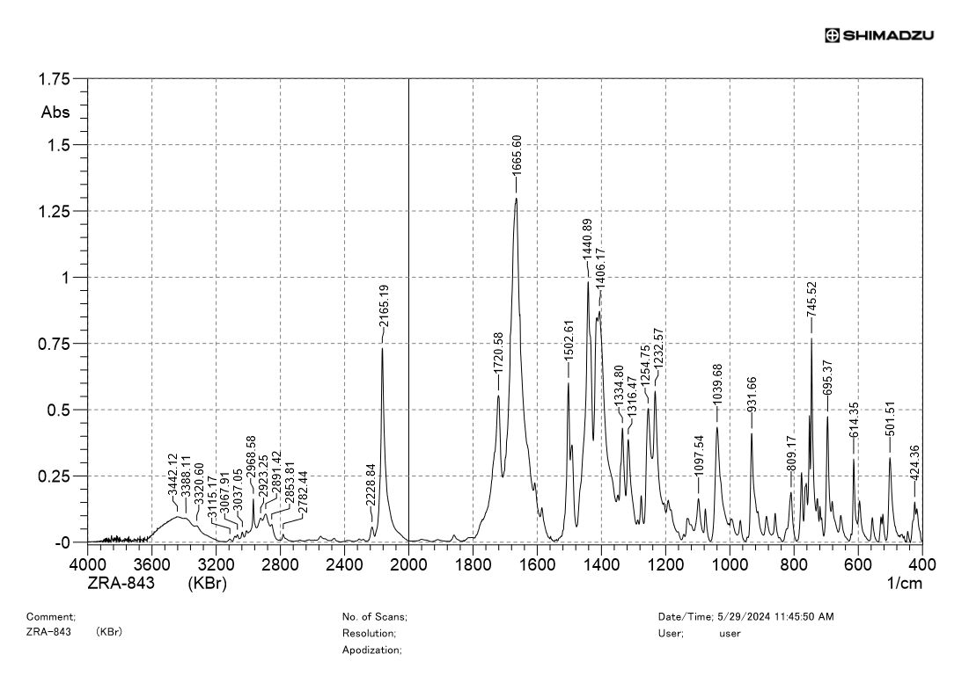
IR spectrum of 8h
¹H NMR spectrum of 9c
¹³C NMR spectrum of 9c
¹H NMR spectrum of 10d
¹³C NMR spectrum of 10d
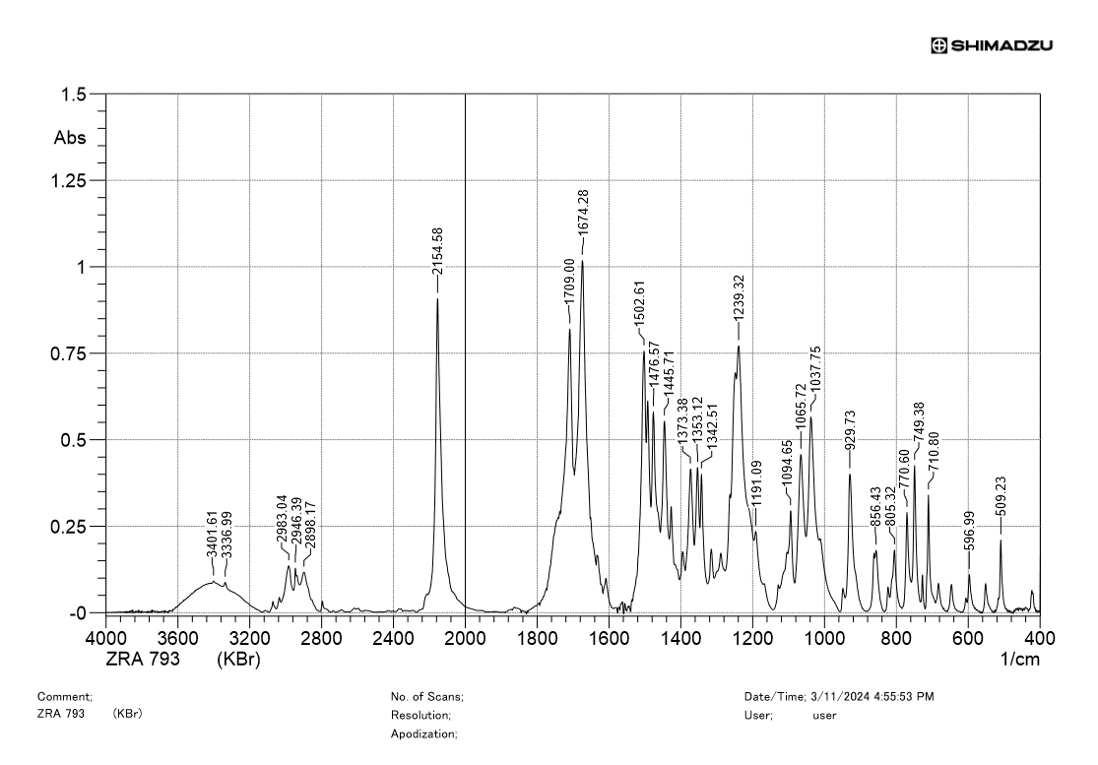
IR spectrum of 10d
¹H NMR spectrum of 10e
¹³C NMR spectrum of 10e
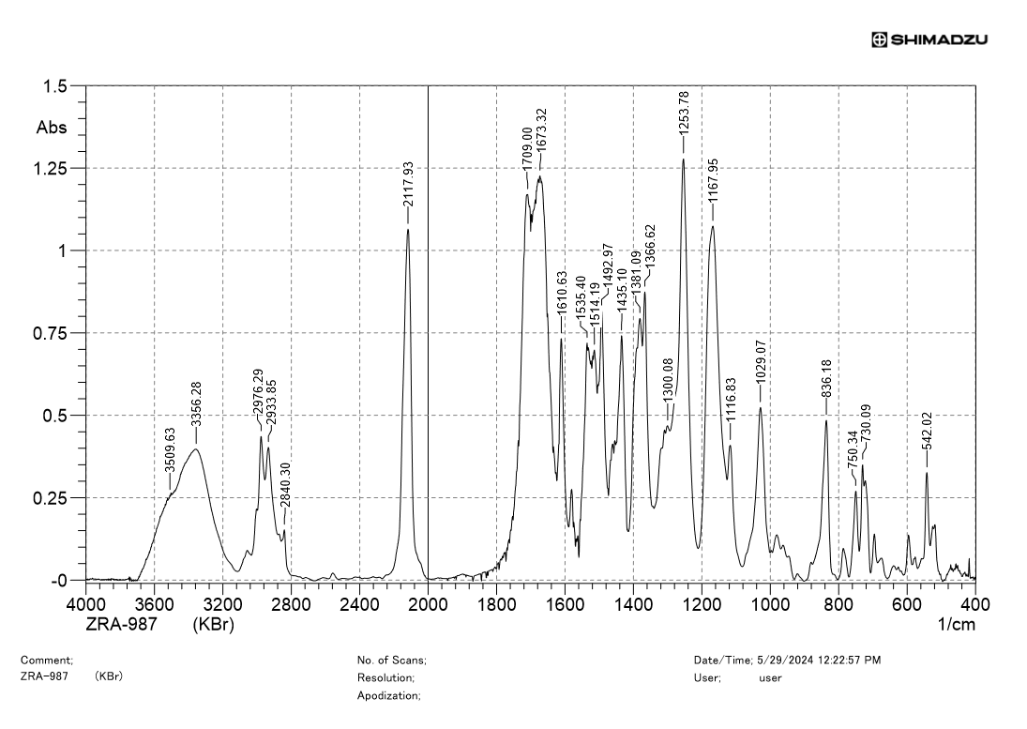
IR spectrum of 10e
¹H NMR spectrum of 10f
¹³C NMR spectrum of 10f
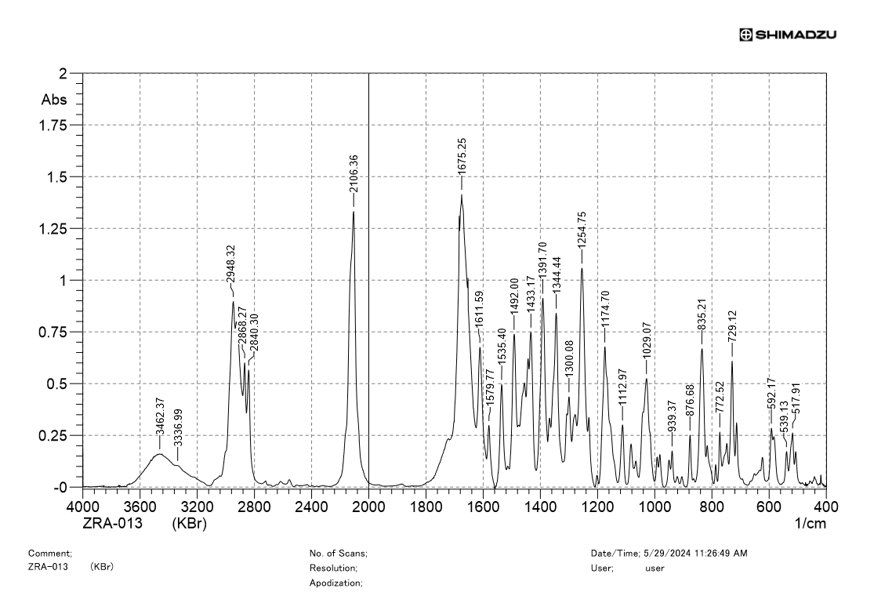
IR spectrum of 10f
¹H NMR spectrum of 6v
¹³C NMR spectrum of 6v

IV. X-ray crystallographic data
X-Ray Data
Structure | 6t | 7g | 9b
Identification code | 048006_ZRA515_auto | 110-015_ZRA-863_auto | 110-011_ZRA-819
Empirical formula | C₁₆H_{9.33}N₄O_{2.67} | C₁₈H₂₀N₄O₄ | C₁₇H₁₂N₄O₂S
Formula weight | 300.27 | 356.38 | 336.37
Temperature/K | 100.00(15) | 99.9(6) | 99.9(5)
Crystal system | monoclinic | orthorhombic | orthorhombic
Space group | P2₁/c | Pna2₁ | Pbca
a/Å | 8.9562(2) | 9.9748(5) | 12.2712(2)
b/Å | 14.1531(3) | 14.3508(7) | 8.7366(2)
c/Å | 7.9069(2) | 12.6074(6) | 29.4794(6)
α/° | 90 | 90 | 90
β/° | 91.615(2) | 90 | 90
γ/° | 90 | 90 | 90
Volume/Å³ | 1001.86(4) | 1804.70(15) | 3160.44(11)
Z | 3 | 4 | 8
ρ_{calc} g/cm³ | 1.493 | 1.312 | 1.414
µ/mm⁻¹ | 0.883 | 0.784 | 1.976
F(000) | 464.0 | 752.0 | 1392.0
Radiation | Cu Kα (λ = 1.54184) | Cu Kα (λ = 1.54184) | Cu Kα (λ = 1.54184)
2Θ range for data collection/° | 9.88 to 160.614 | 9.338 to 139.03 | 5.996 to 139.914
Index range | -11 ≤ h ≤ 11, -17 ≤ k ≤ 11, -10 ≤ l ≤ 9 | -12 ≤ h ≤ 12, -16 ≤ k ≤ 17, -15 ≤ l ≤ 15 | -14 ≤ h ≤ 13, -10 ≤ k ≤ 10, -35 ≤ l ≤ 35
Reflections collected | 6410 | 8561 | 21106
Independent reflections | 2073 [R_{int} = 0.0734, R_{sigma} = 0.0721] | 3056 [R_{int} = 0.0459, R_{sigma} = 0.0489] | 2996 [R_{int} = 0.0556, R_{sigma} = 0.0285]
Data/restraints/  parameters | 2073/0/154 | 3056/1/242 | 2996/0/217
Goodness-of-fit on F² | 1.069 | 1.036 | 1.101
Final R indexes [I>=2σ (I)] | R₁ = 0.0522,  wR₂ = 0.1376 | R₁ = 0.0514,  wR₂ = 0.1384 | R₁ = 0.0541,  wR₂ = 0.1457
Final R indexes [all data] | R₁ = 0.0591,  wR₂ = 0.1458 | R₁ = 0.0615,  wR₂ = 0.1519 | R₁ = 0.0587,  wR₂ = 0.1503
Largest diff. peak/hole/ e Å⁻³ | 0.31/-0.37 | 0.28/-0.20 | 0.76/-0.34
CCDC | CCDC 2353108 | CCDC 2353107 | CCDC 2353106

V. References

Dolomanov, O.V.; Bourhis, L.J.; Gildea, R.J.; Howard, J. A. K.; Puschmann, H. J. Appl. Cryst. 2009, 42, 339-341. doi: 10.1107/S0021889808042726.
Scheldrick, G.M. Acta Cryst. 2015, A71, 3-8.
Scheldrick, G.M. Acta Cryst. 2015, C71, 3-8.
Dar'in, D.; Kantin, G.; Krasavin, M. Chem. Commun., 2019, 55, 5239 – 5242. doi: 10.1039/c9cc02042j
Marek, L.; Váňa, J.; Svoboda, J.; Hanusek, J. Beilstein J. Org. Chem. 2023, 19, 808–819. doi:10.3762/bjoc.19.61.
Tadros, J.; Dankers, C.; Aldrich-Wright, J. R.; Polyzos, A.; Gordon, C. P. Eur. JOC., 2021, 29, 4184–4194. doi: 10.1002/ejoc.202100761.
Jurok, R.; Cibulka, R; Dvořáková. H.; Hample, F.; Hodačová, J. Eur. JOC., 2010, 27, 5217–5224. doi: 10.1002/ejoc.201000592
Wang, G.; Wang, J.; Nie, H.; Tan, S.-P.; Shi, W.-Q.; Zhao, D.-M.; Cheng, M.-S. J. Mol. Structure, 2013, 1036, 372–379. doi: 10.1016/j.molstruc.2012.12.017.
Kosower, E. M.; Faust, D.; Ben-Shoshan, M.; Goldberg, I. J. Org. Chem. 1982, 47, 214–221. doi: 10.1021/jo00341a007
Arnost, M.; Pierce, A.; Haar, E.; Lauffer, D.; Madden, J.; Tanner, K.; Green, J. Bioorg. Med. Chem. Lett., 2010, 20, 1661–1664. doi: 10.1016/j.bmcl.2010.01.072.

