SUPPLEMENTARY INFORMATION

Transition Metal Free Decarbonyl-Oxidation of 3-Arylbenzofuran-2(3H)-ones: Access to 2-Hydroxy Benzophenones

Bhaskar B. Dhotare,ª Seema V. Kanojia,ª Chahna K. Sakhiya,^{b} Amey Wadawale,^{c} Dibakar Goswami^{a,d*}

ªBio-Organic Division, Bhabha Atomic Research Centre, Trombay, Mumbai, India-400085.
^{b}NMIMS Sunandan Divatia School of Science, Vile-Parle, Mumbai, India-400056.
^{c}Chemistry Division, Bhabha Atomic Research Centre, Trombay, Mumbai, India-400085.
^{d}Homi Bhabha National Institute, Anushaktinagar, Mumbai, India-400094.
*Corresponding author (email. dibakarg@barc.gov.in)

Page No. | Description
S3 | Fig. S1 | ¹H NMR showing formation of THF-hydroperoxide in situ in THF.
S4 | Fig. S2 | ¹H and ¹³C NMR spectrum of 3bb.
S5 | Fig. S3 | ¹H and ¹³C NMR spectrum of 3ca.
S6 | Fig. S4 | ¹H and ¹³C NMR spectrum of 3cb.
S7 | Fig. S5 | ¹H and ¹³C NMR spectrum of 3dc.
S8 | Fig. S6 | ¹H and ¹³C NMR spectrum of 3fd.
S9 | Fig. S7 | ¹H and ¹³C NMR spectrum of 3ha.
S10 | Fig. S8 | ¹H and ¹³C NMR spectrum of 3ia.
S11 | Fig. S9 | ¹H and ¹³C NMR spectrum of 3ka.
S12 | Fig. S10 | ¹H and ¹³C NMR spectrum of 3la.
S13 | Fig. S11 | ¹H and ¹³C NMR spectrum of 4aa.
S14 | Fig. S12 | ¹H and ¹³C NMR spectrum of 4ba.
S15 | Fig. S13 | ¹H and ¹³C NMR spectrum of 4bb.
S16 | Fig. S14 | ¹H and ¹³C NMR spectrum of 4ca.
S17 | Fig. S15 | ¹H and ¹³C NMR spectrum of 4cb.
S18 | Fig.S16 | ¹H and ¹³C NMR spectrum of 4dc.
S19 | Fig. S17 | ¹H and ¹³C NMR spectrum of 4ea.
S20 | Fig. S18 | ¹H and ¹³C NMR spectrum of 4eb.
S21 | Fig. S19 | ¹H and ¹³C NMR spectrum of 4fa.
S22 | Fig. S20 | ¹H and ¹³C NMR spectrum of 4fb.
S23 | Fig. S21 | ¹H and ¹³C NMR spectrum of 4fd.
S24 | Fig. S22 | ¹H and ¹³C NMR spectrum of 4ga.
S25 | Fig. S23 | ¹H and ¹³C NMR spectrum of 4ha.
S26 | Fig. S24 | ¹H and ¹³C NMR spectrum of 4ia.
S27 | Fig. S25 | ¹H and ¹³C NMR spectrum of 4ja.
S28 | Fig. S26 | ¹H and ¹³C NMR spectrum of 4ka.
S29 | Fig. S27 | ¹H and ¹³C NMR spectrum of 4ma.
S30 | Fig. S28 | ¹H and ¹³C NMR spectrum of 5.
S31-S34 | Single crystal XRD data for 4ja
S35-S42 | Single crystal XRD data for 4fb
S43-S48 | Single crystal XRD data for 4ma

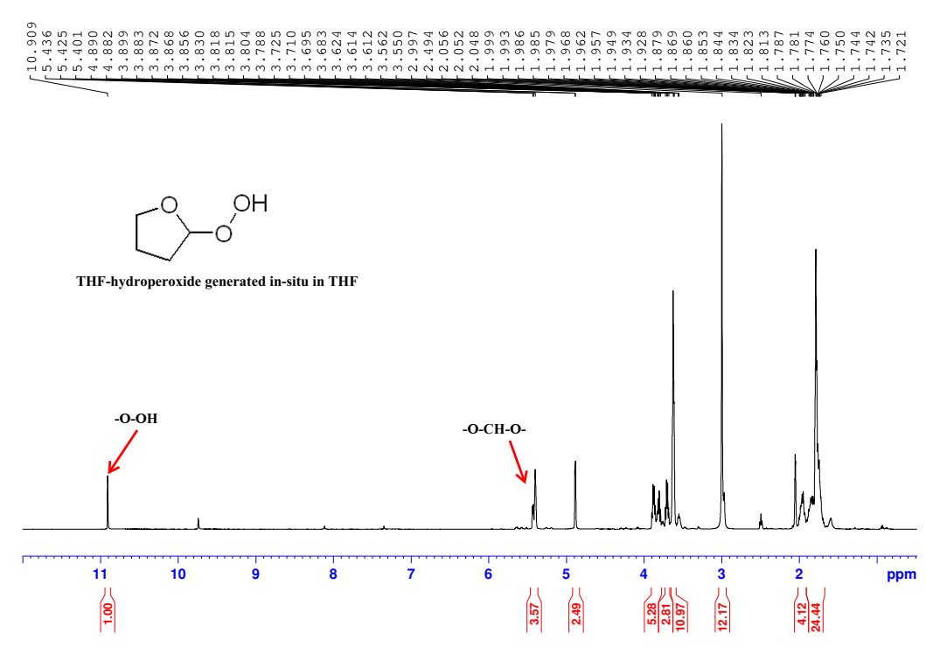
Fig. S1. ¹H NMR showing formation of THF-hydroperoxide in situ in THF.

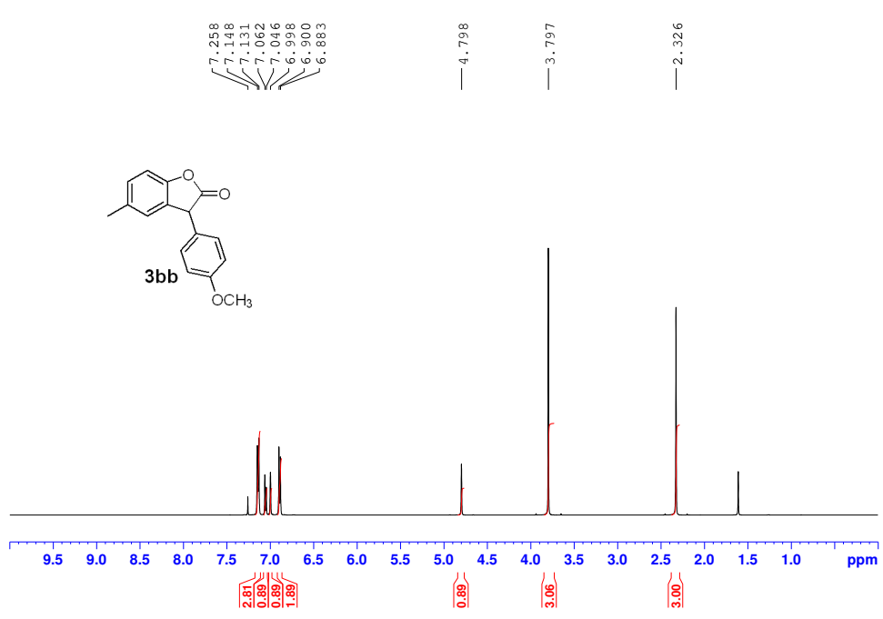
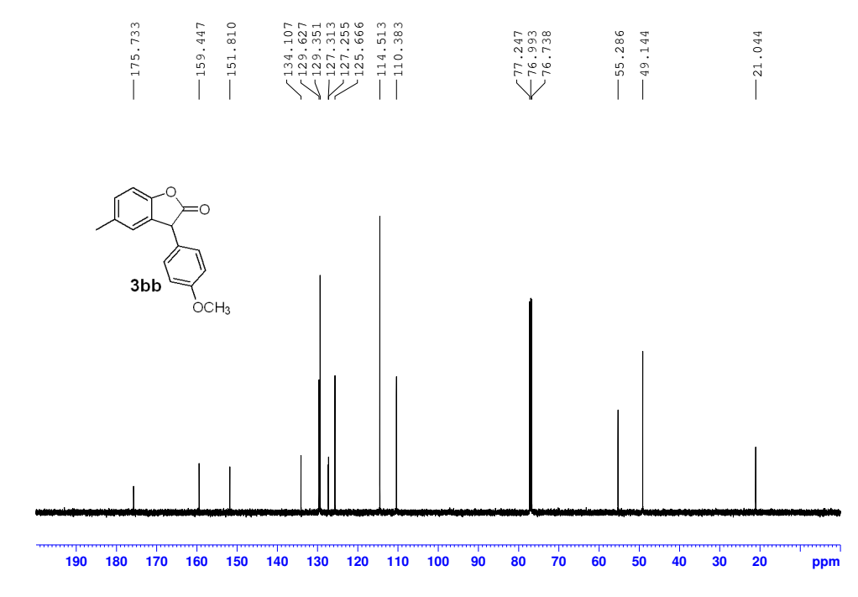
Fig. S2. ¹H and ¹³C NMR spectrum of 3bb.
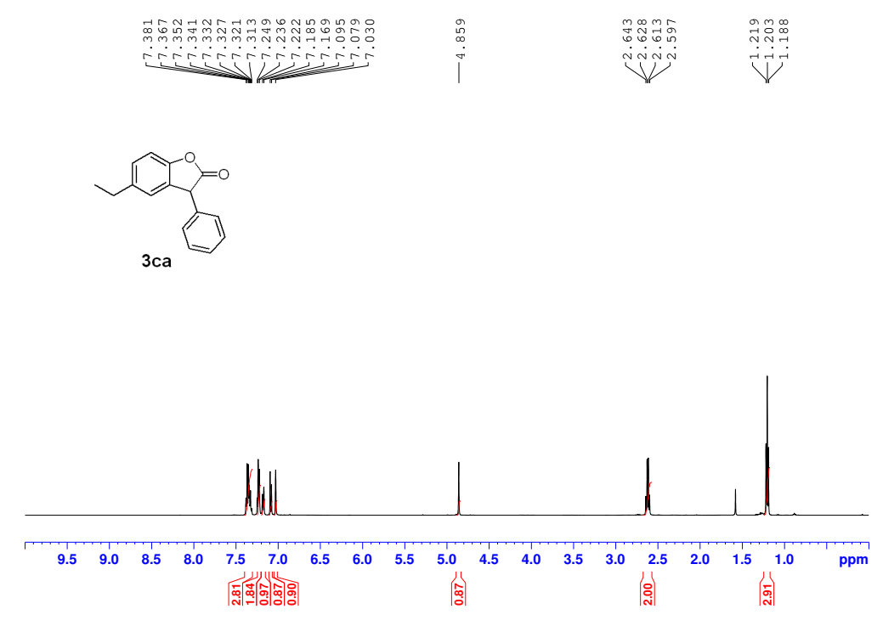
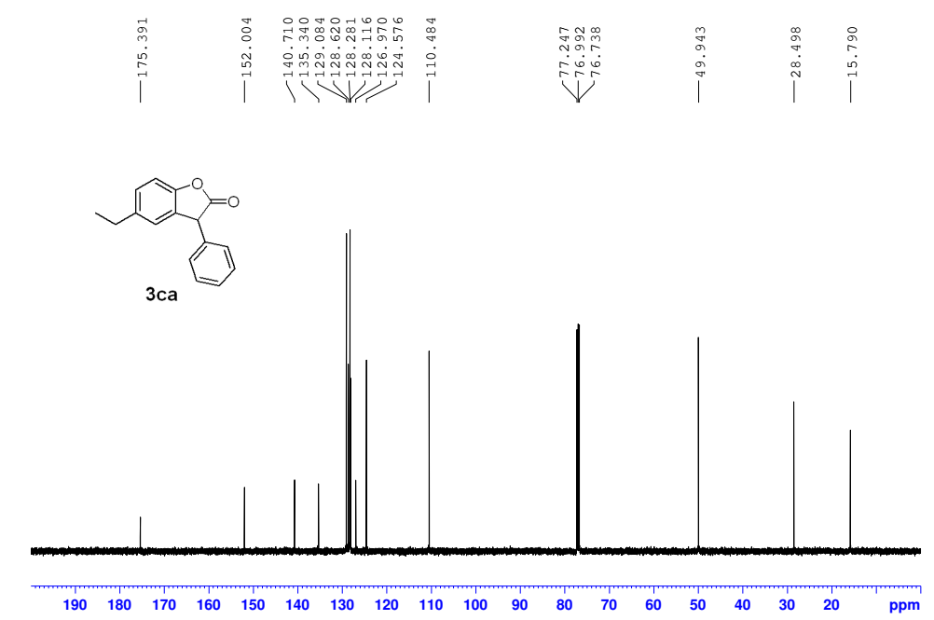
Fig. S3. ¹H and ¹³C NMR spectrum of 3ca.
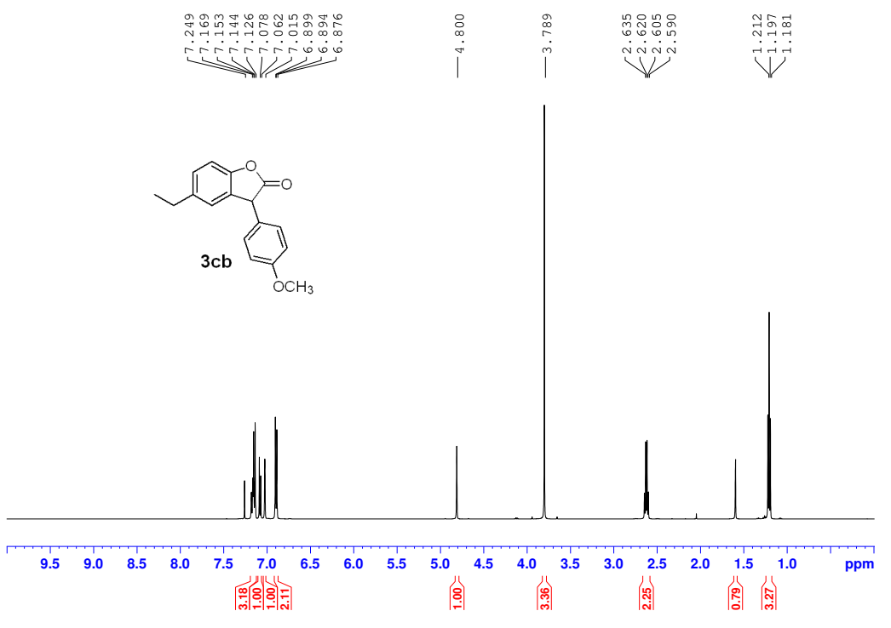
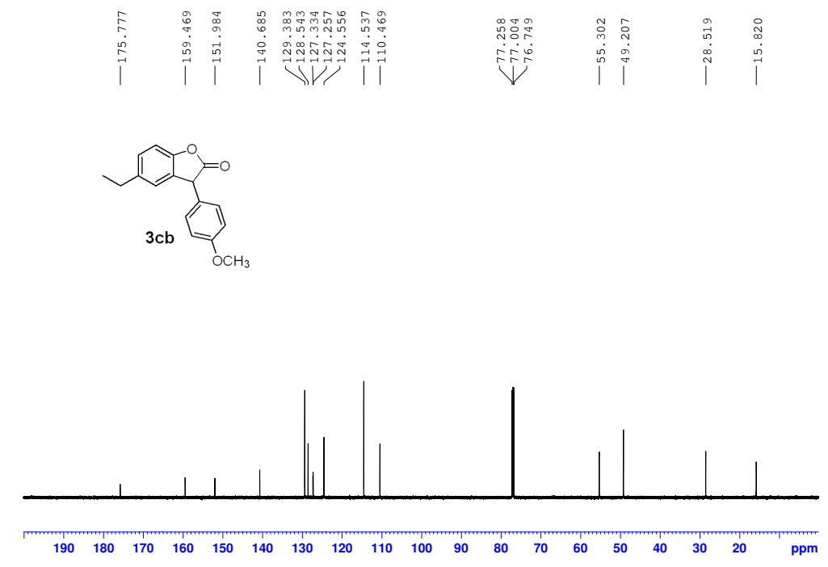
Fig. S4. ¹H and ¹³C NMR spectrum of 3cb.
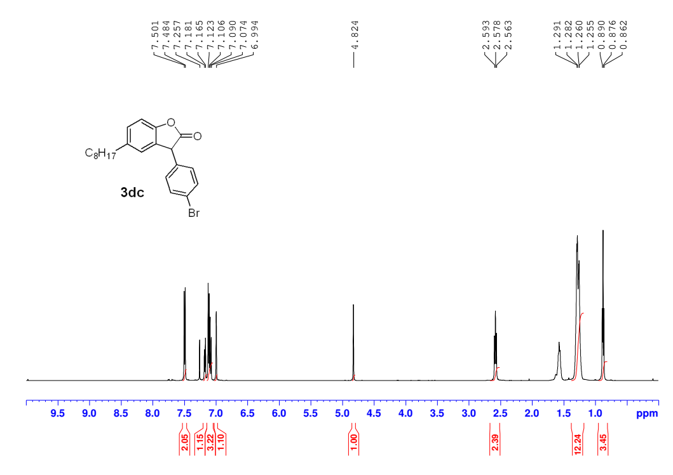
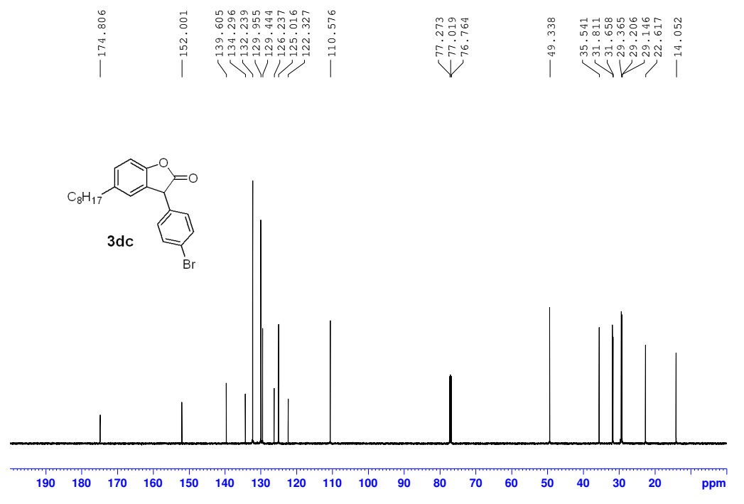
Fig. S5. ¹H and ¹³C NMR spectrum of 3dc.
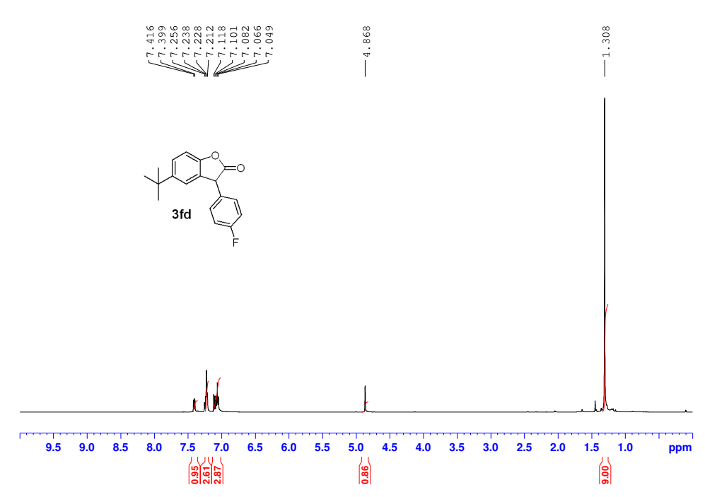
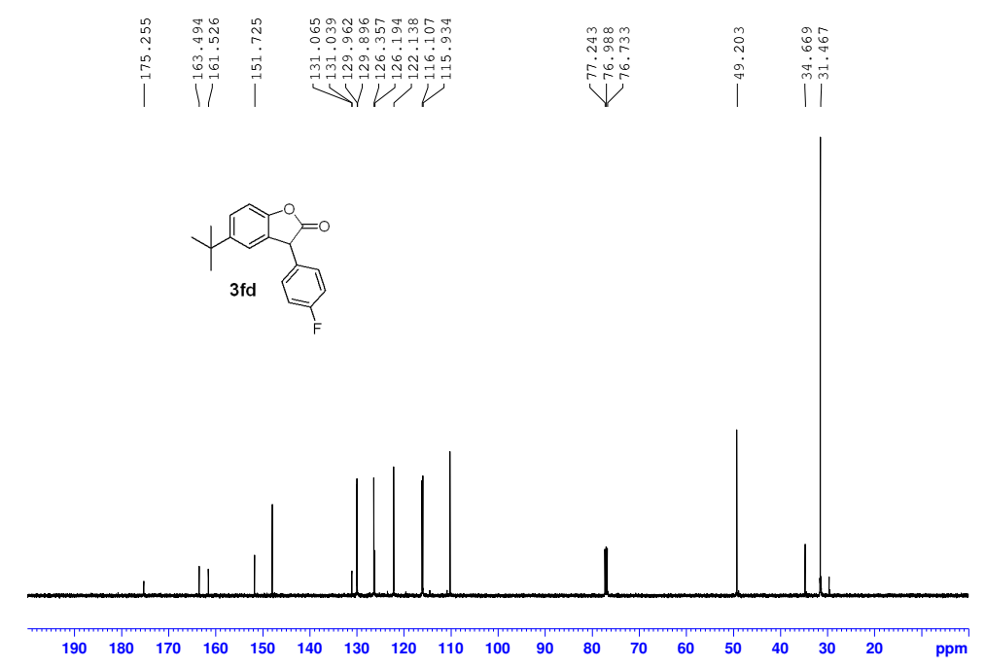
Fig. S6. ¹H and ¹³C NMR spectrum of 3fd.
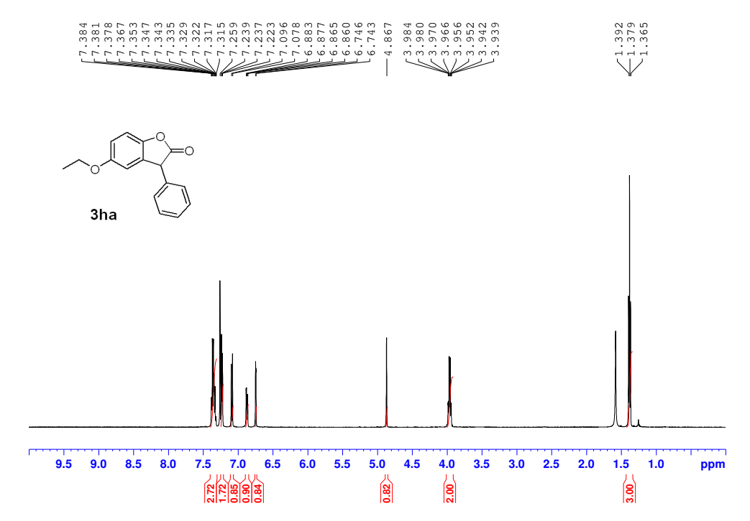
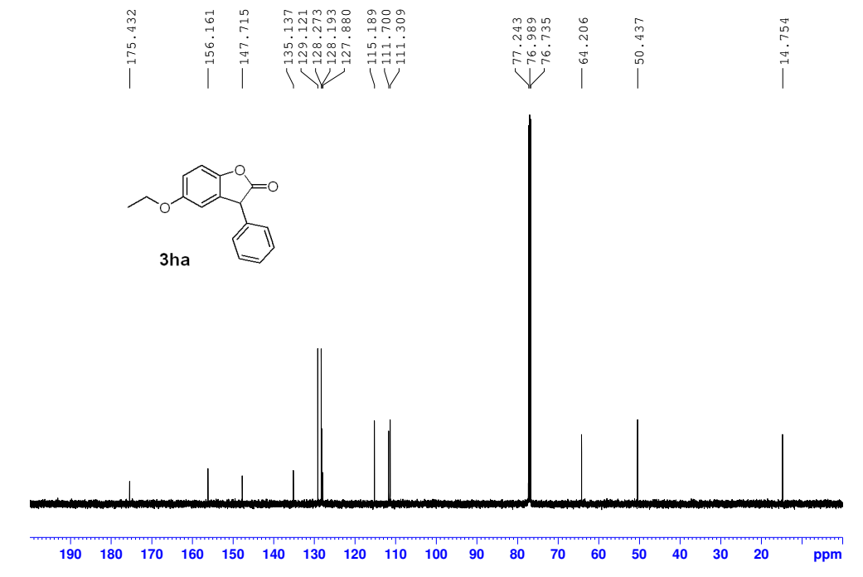
Fig. S7. ¹H and ¹³C NMR spectrum of 3ha.
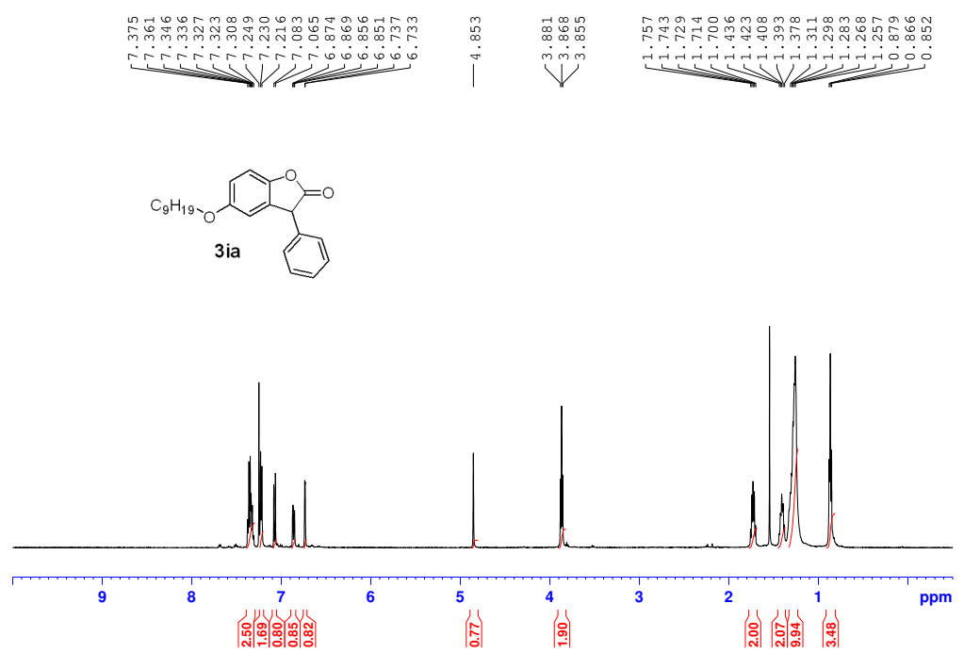
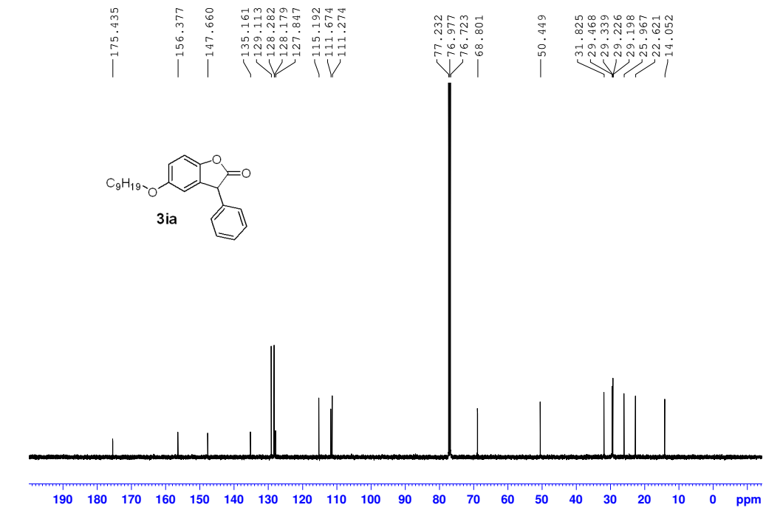
Fig. S8. ¹H and ¹³C NMR spectrum of 3ia.
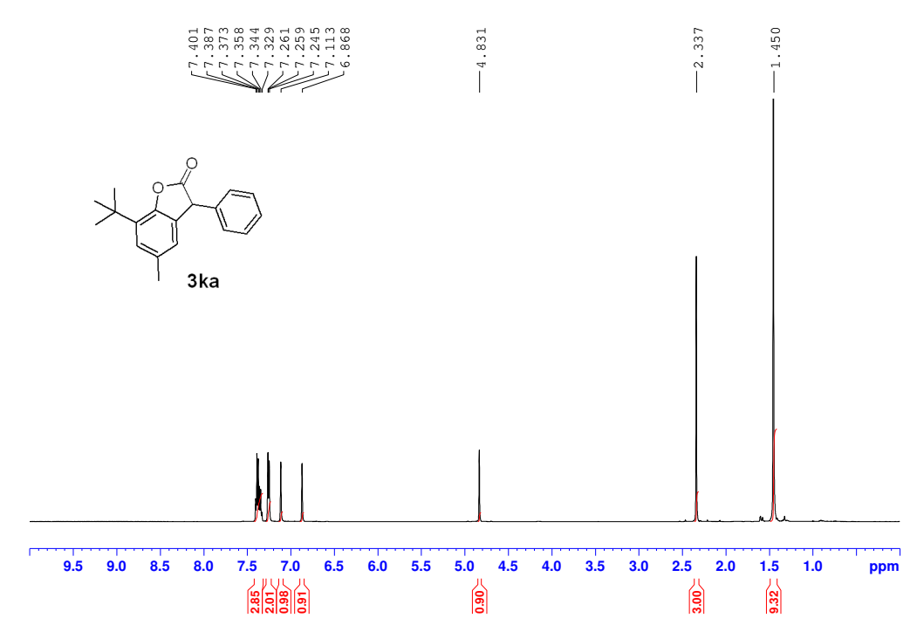
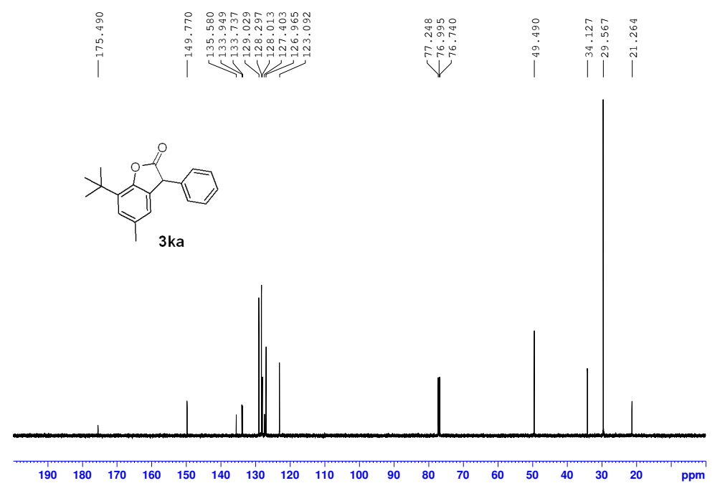
Fig. S9. ¹H and ¹³C NMR spectrum of 3ka.
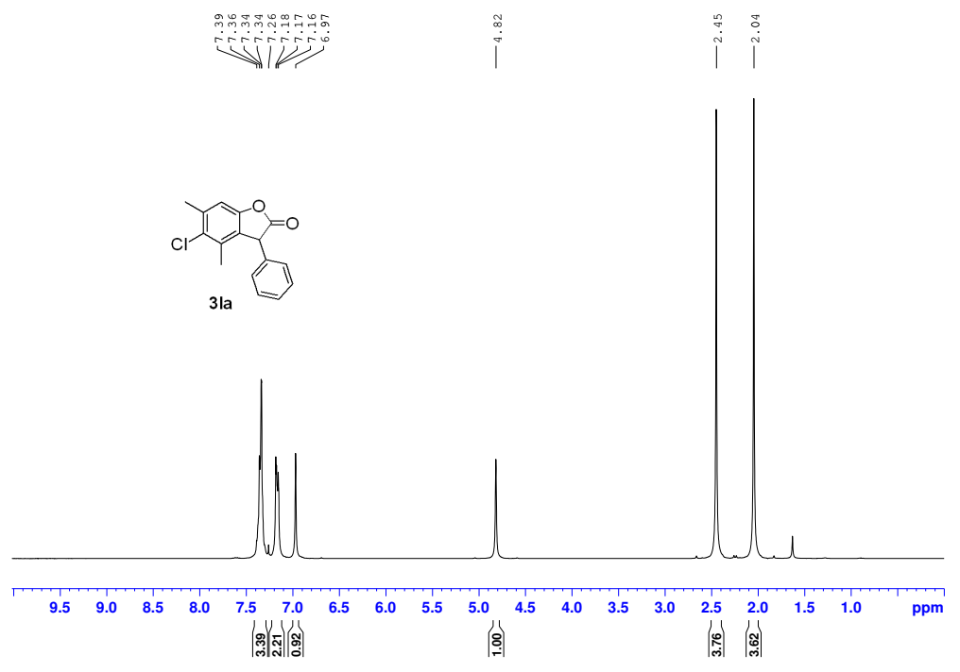

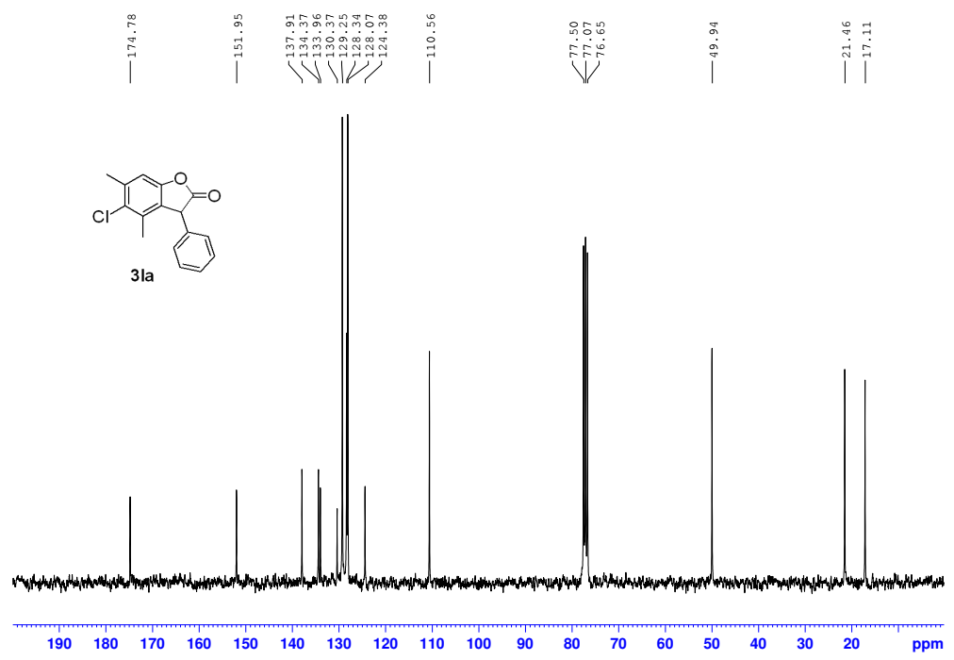
Fig. S10. ¹H and ¹³C NMR spectrum of 3la.
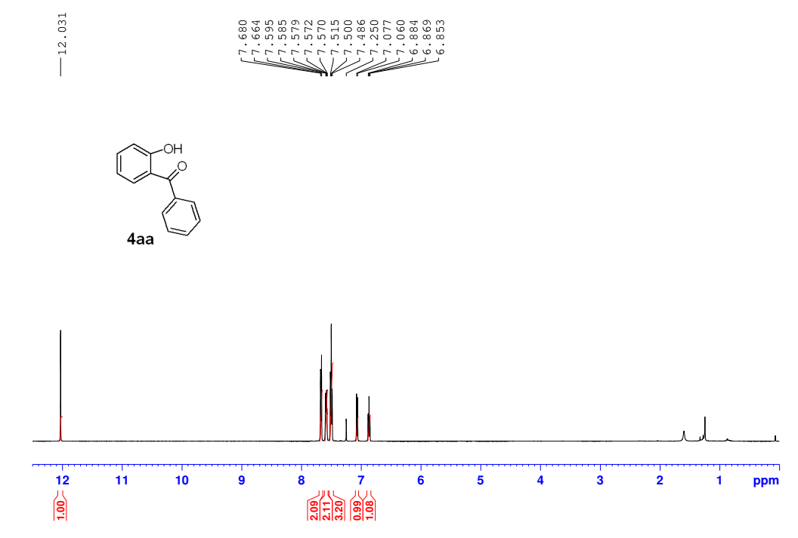
NMR solvent impurity
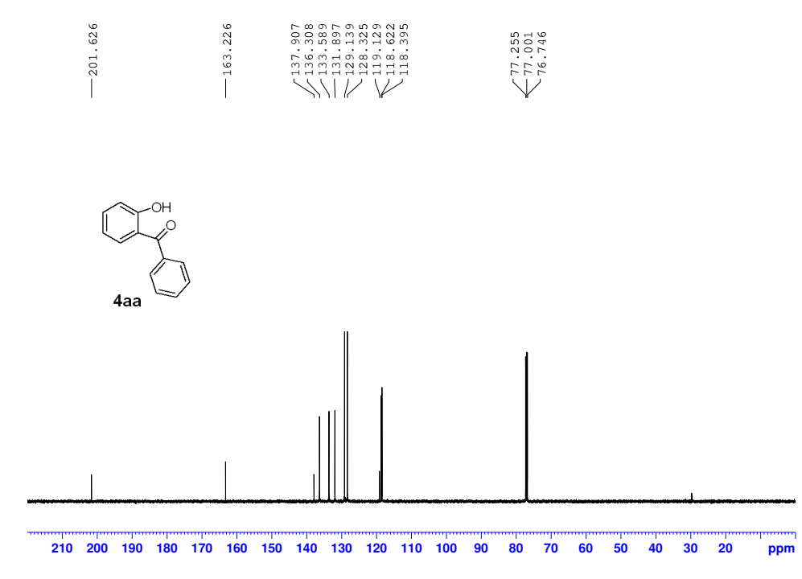F
S11. ¹H and ¹³C NMR spectrum of 4aa.
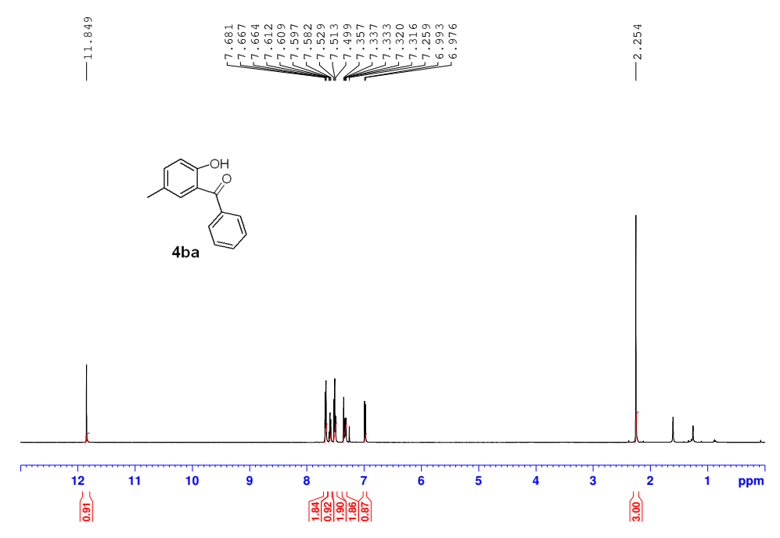
NMR solvent impurity
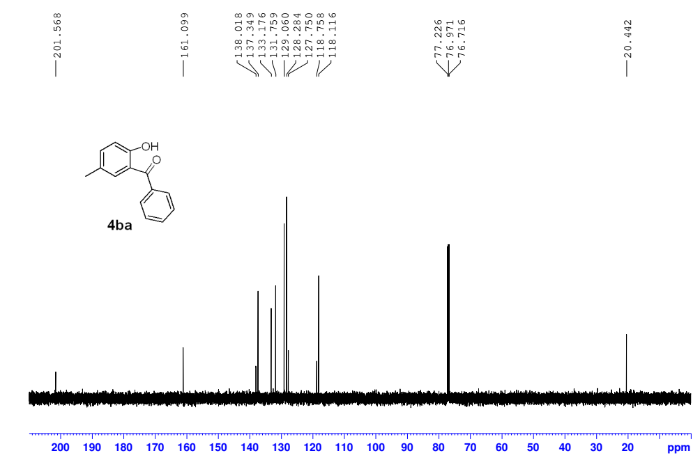
Fig. S12. ¹H and ¹³C NMR spectrum of 4ba.
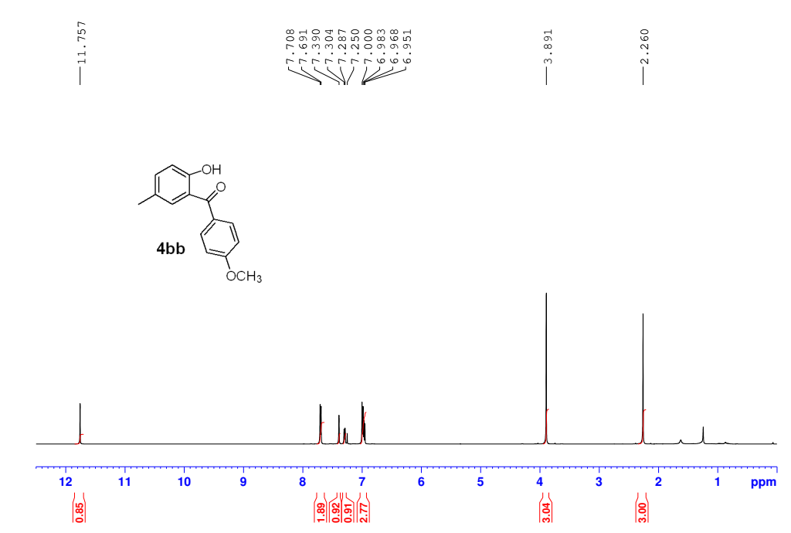
NMR solvent impurity
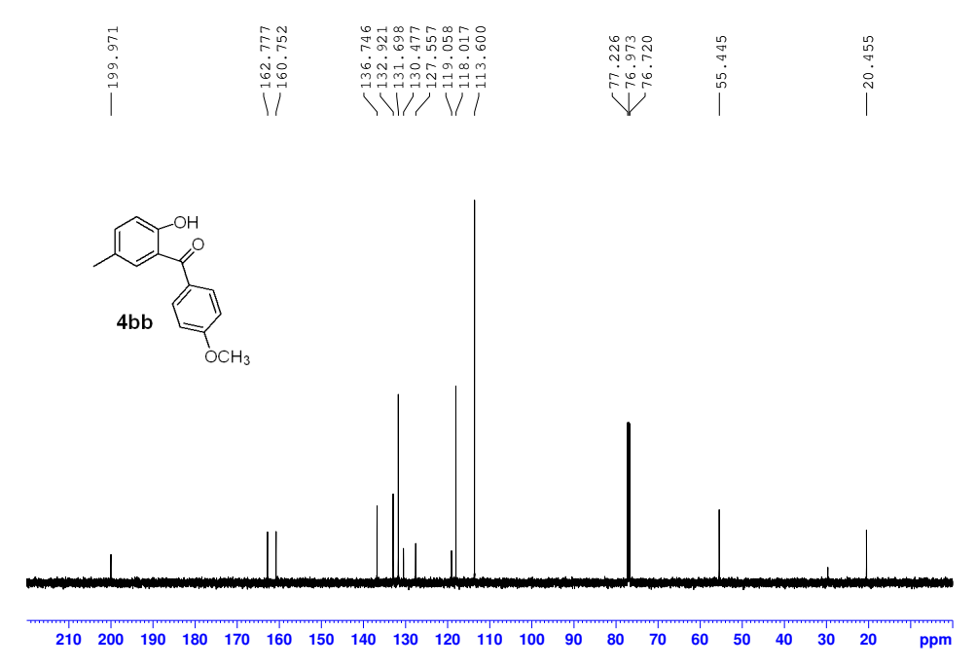
Fig. S13. ¹H and ¹³C NMR spectrum of 4bb.

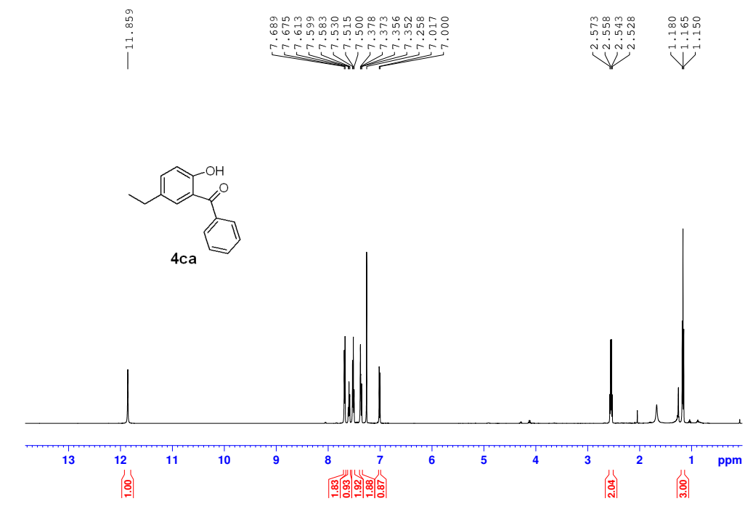
NMR solvent impurity
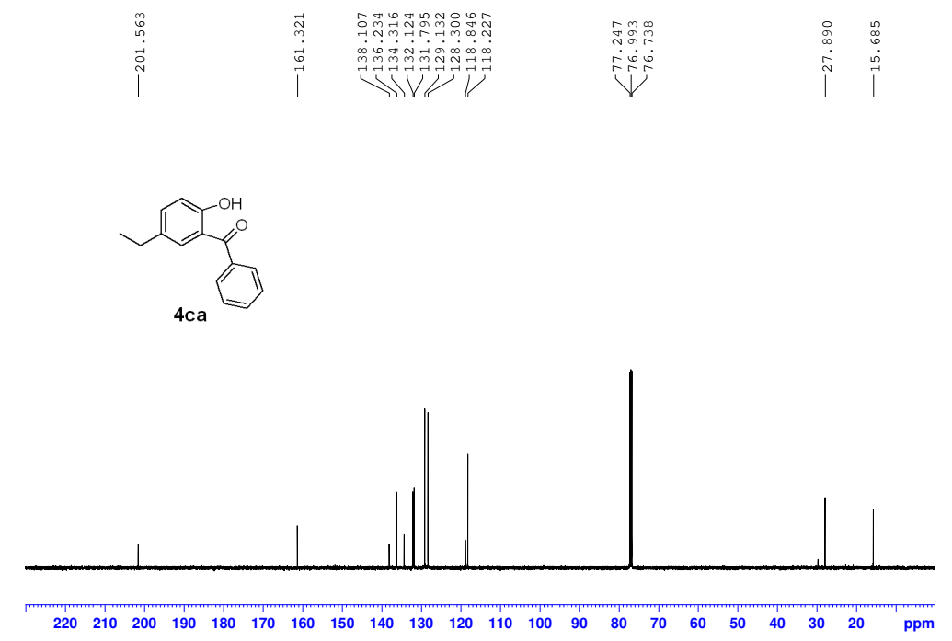
Fig. S14. ¹H and ¹³C NMR spectrum of 4ca.
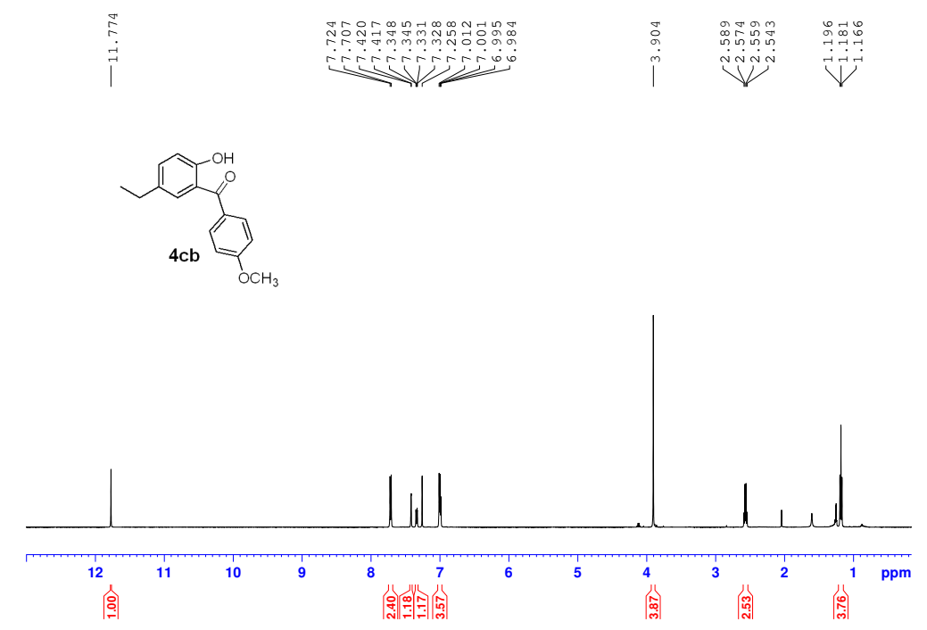
NMR solvent impurity
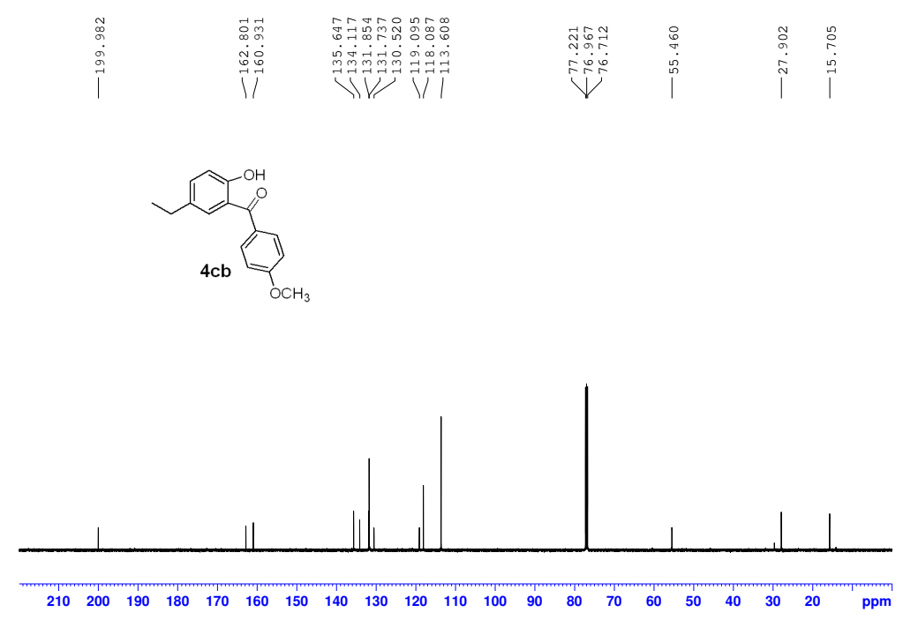

Fig. S15. ¹H and ¹³C NMR spectrum of 4cb
. 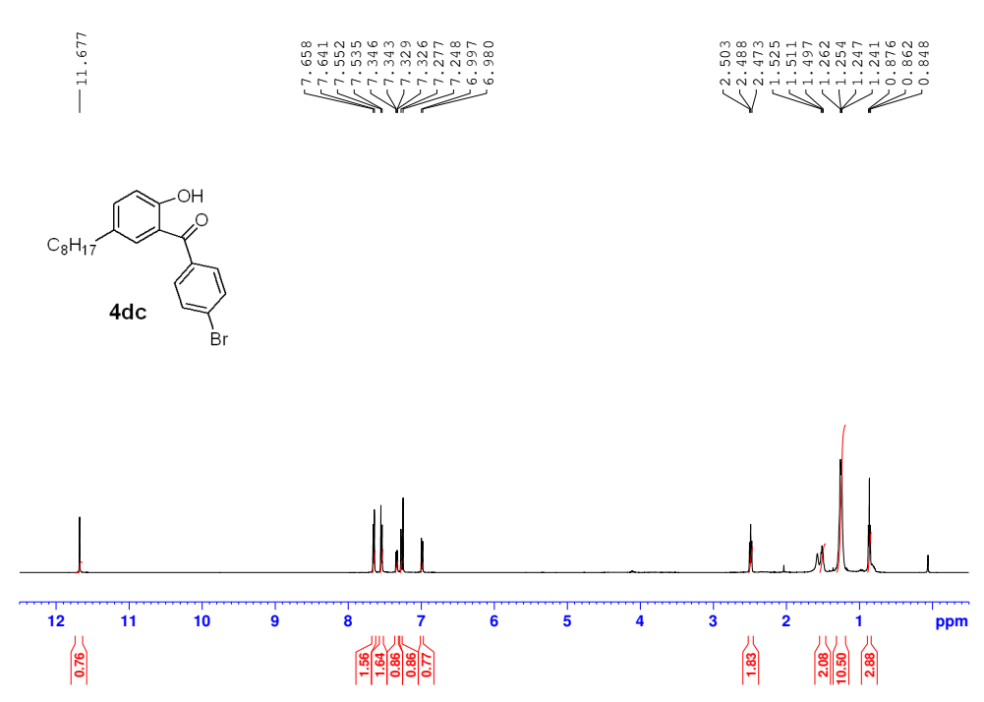
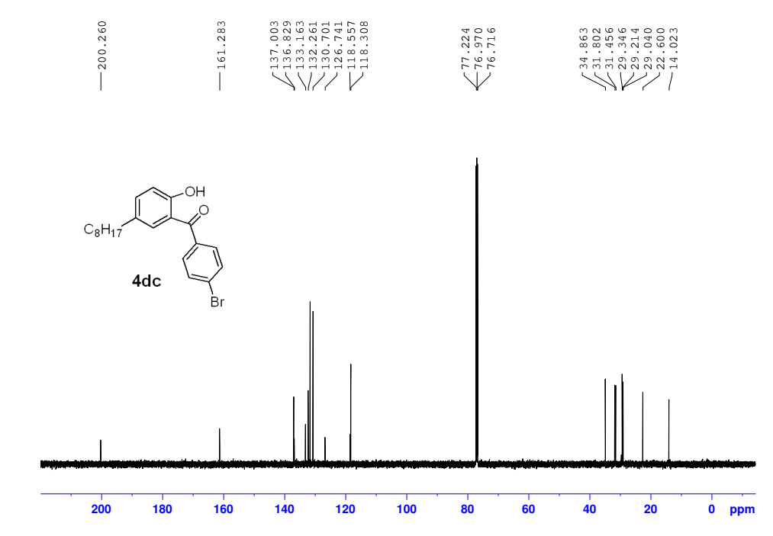
Fig. S16. ¹H and ¹³C NMR spectrum of 4dc.
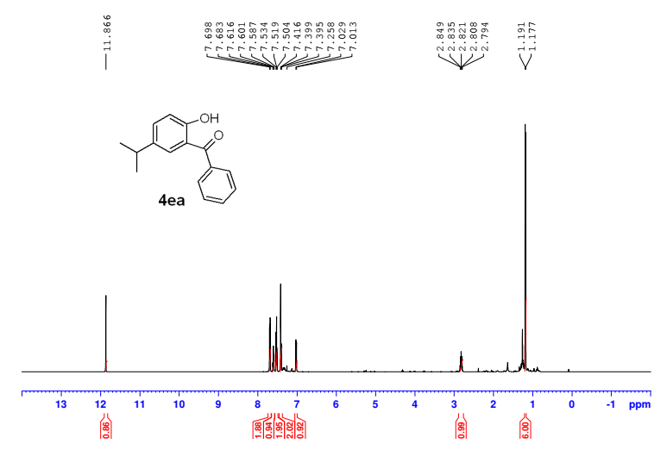
NMR solvent impurity
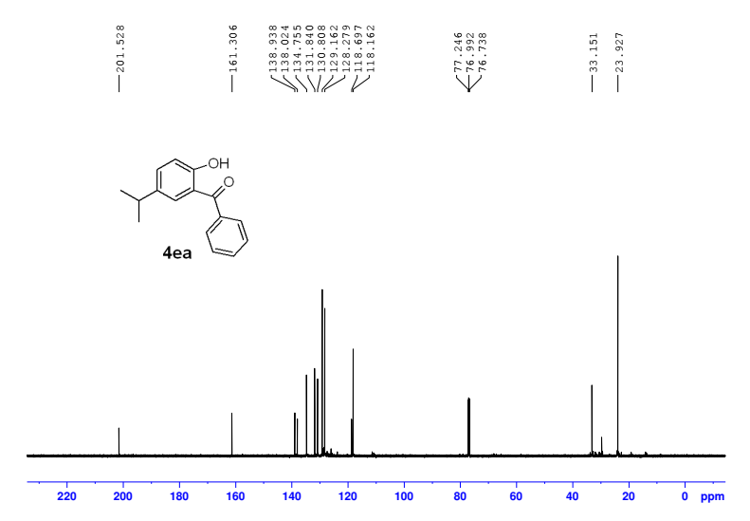
NMR solvent impurity
Fig. S17. ¹H and ¹³C NMR spectrum of 4ea.
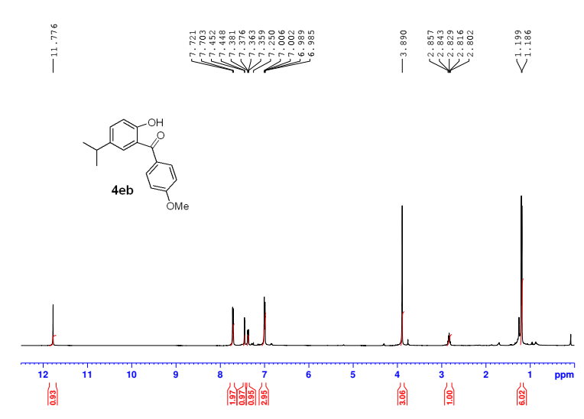
NMR solvent impurity
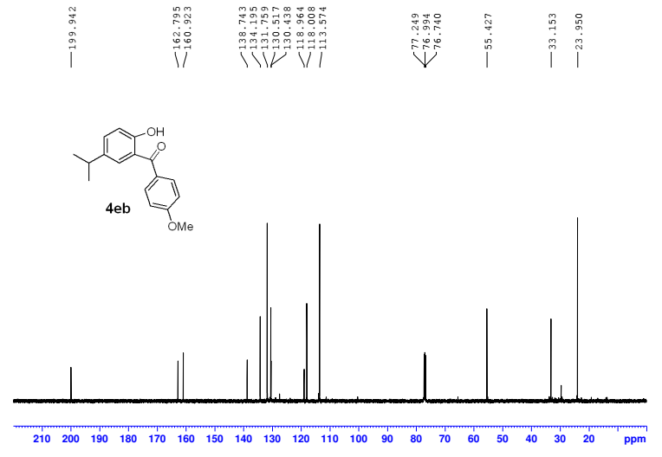
NMR solvent impurity
Fig. S18. ¹H and ¹³C NMR spectrum of 4eb.

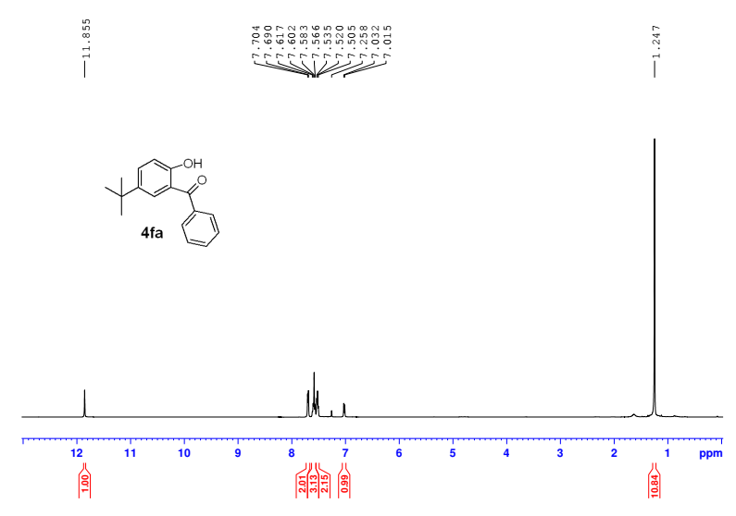
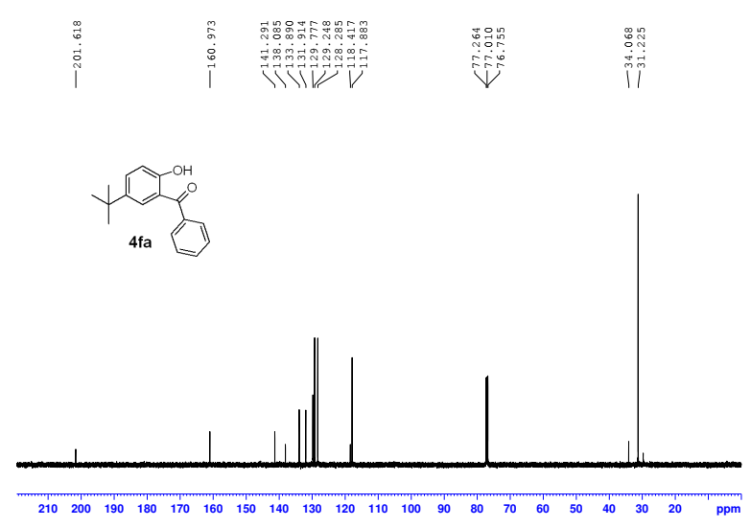
Fig. S19. ¹H and ¹³C NMR spectrum of 4fa.
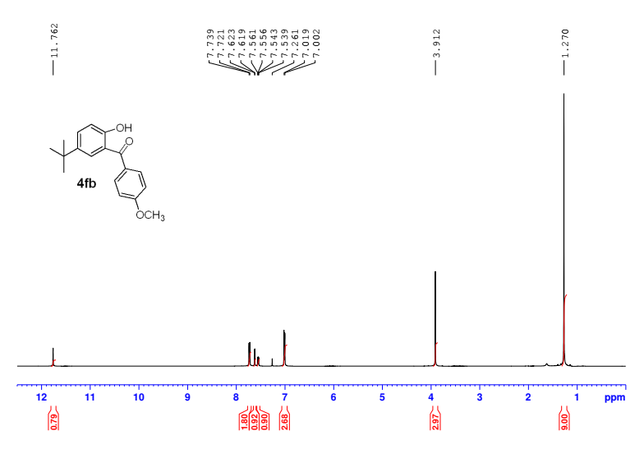
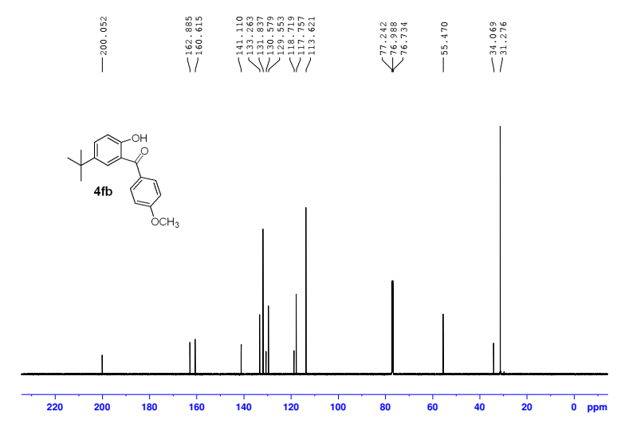
Fig. S20. ¹H and ¹³C NMR spectrum of 4fb.

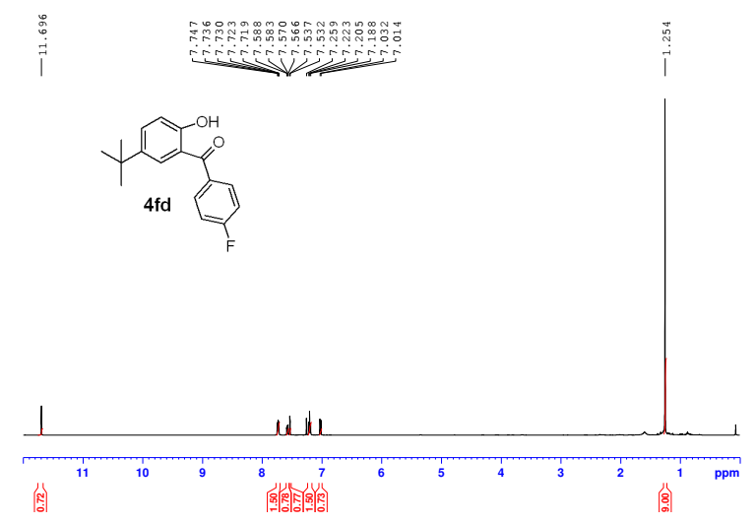
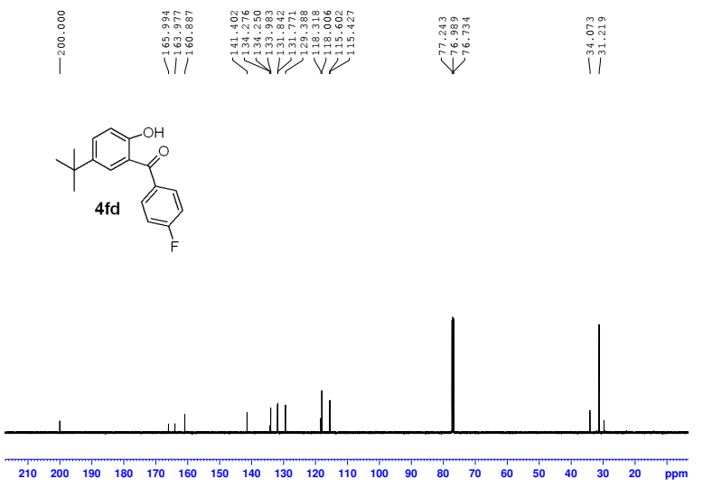
Fig. S21. ¹H and ¹³C NMR spectrum of 4fd.
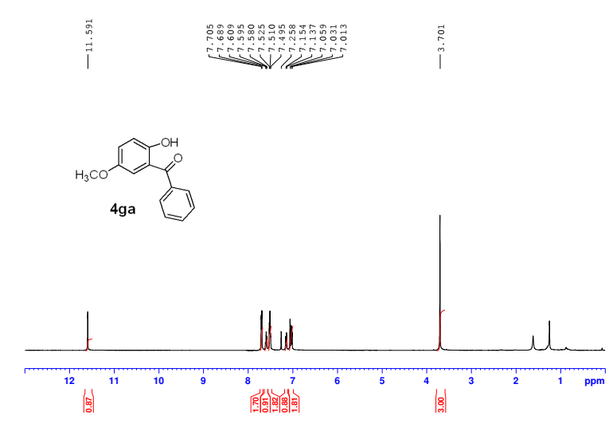
NMR solvent impurity
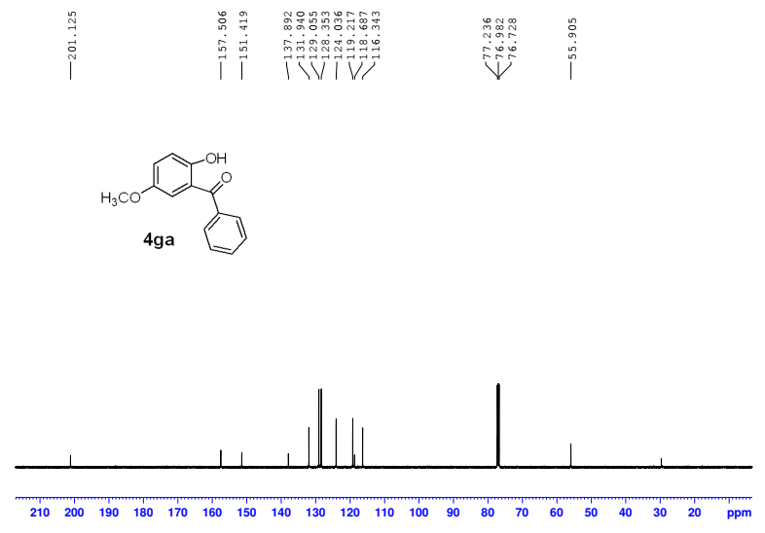
NMR solvent impurity
Fig. S22. ¹H and ¹³C NMR spectrum of 4ga.
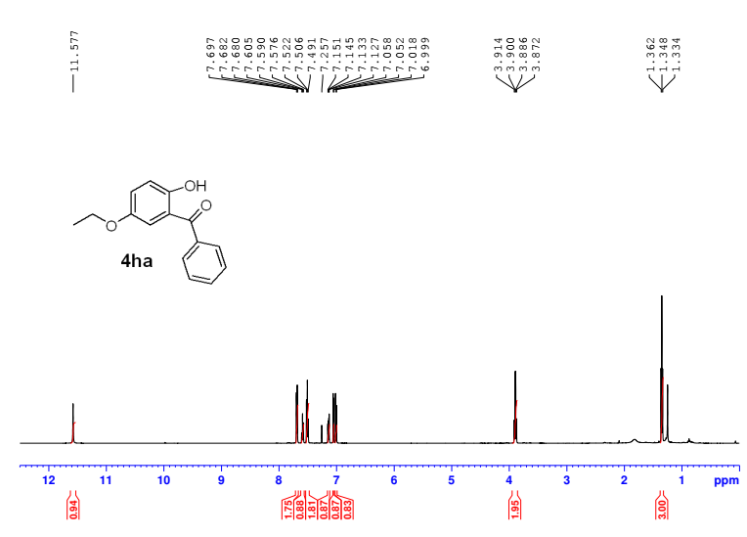
NMR solvent impurity
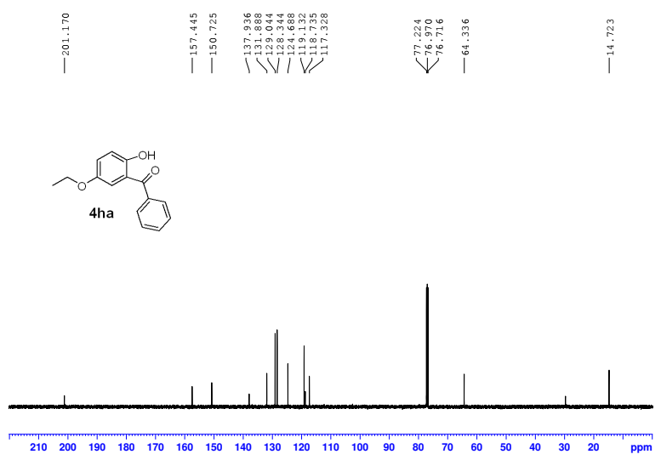
NMR solvent impurity

Fig. S23. ¹H and ¹³C NMR spectrum of 4ha.
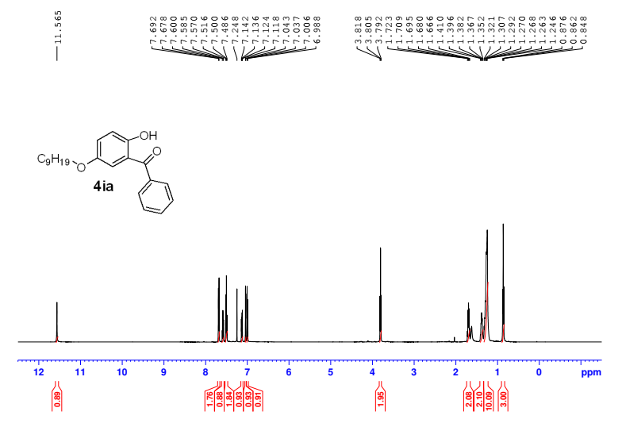
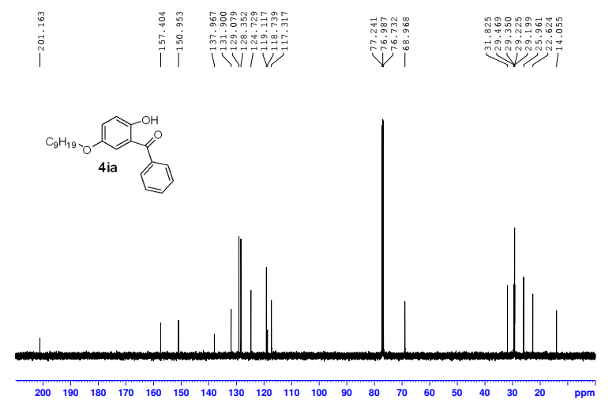
Fig. S24. ¹H and ¹³C NMR spectrum of 4ia.

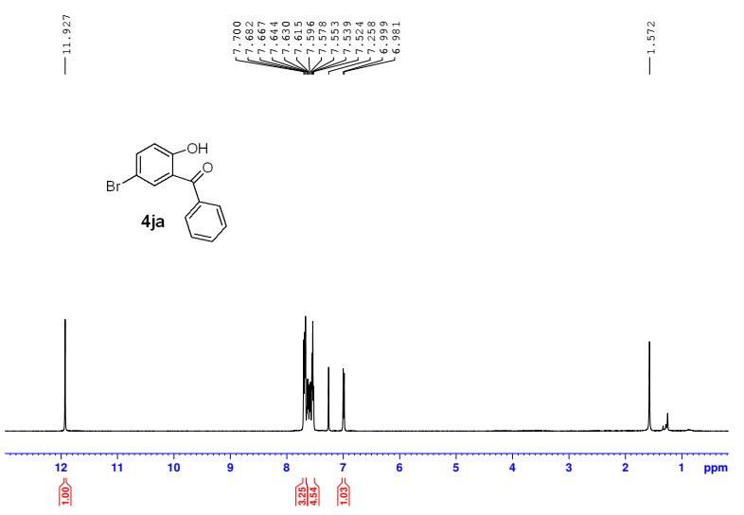
NMR solvent impurity
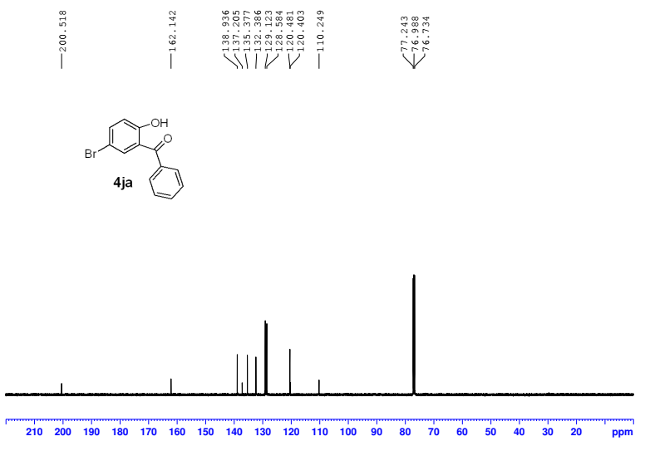
Fig. S25. ¹H and ¹³C NMR spectrum of 4ja.

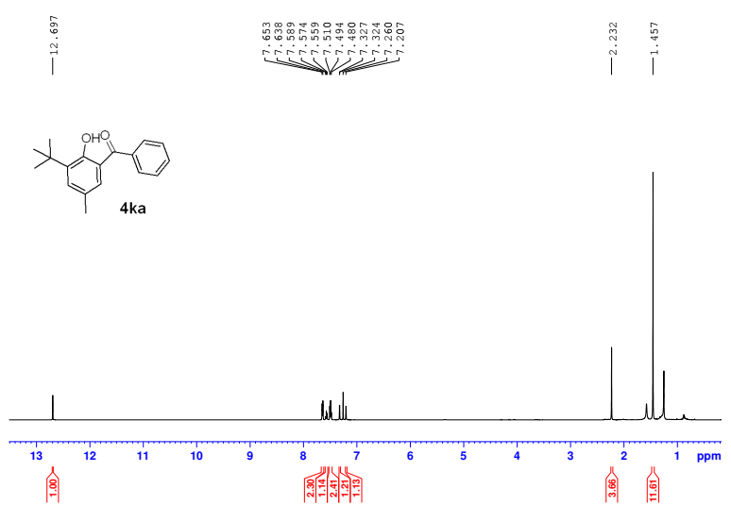
NMR solvent impurity
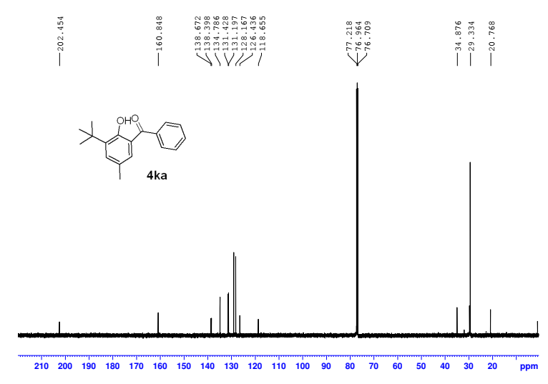
Fig. S26. ¹H and ¹³C NMR spectrum of 4ka.
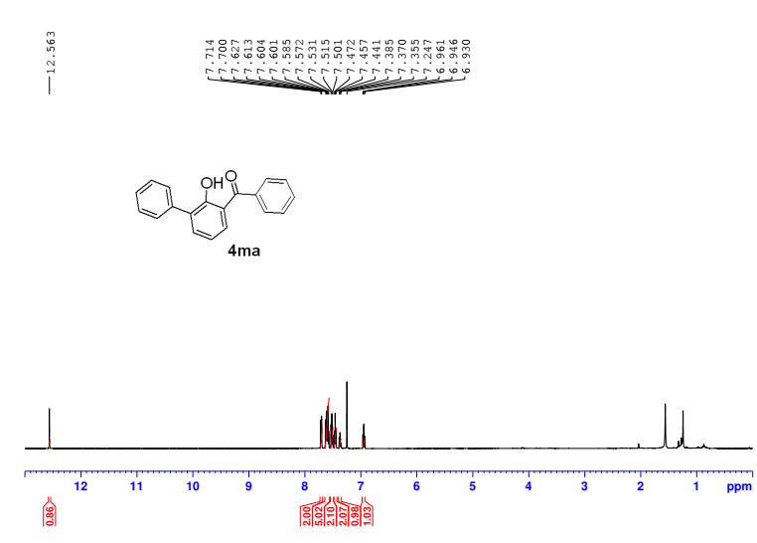
NMR solvent impurity

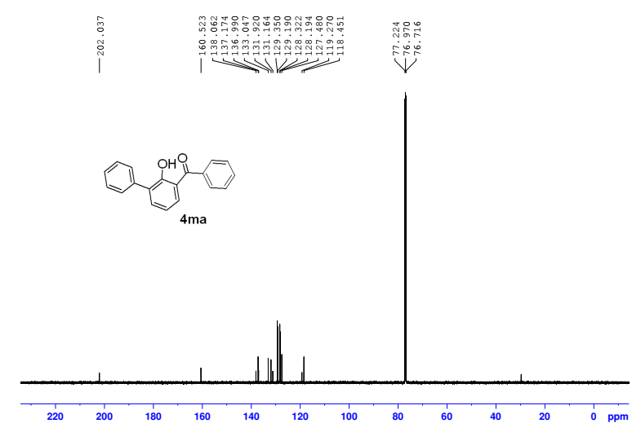
Fig. S27. ¹H and ¹³C NMR spectrum of 4ma.

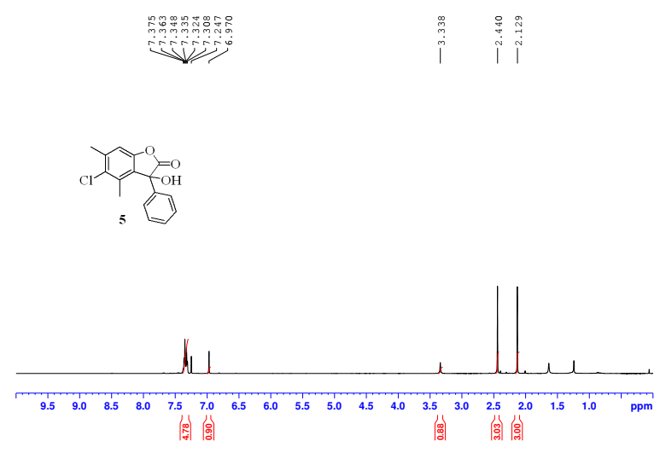
NMR solvent impurity
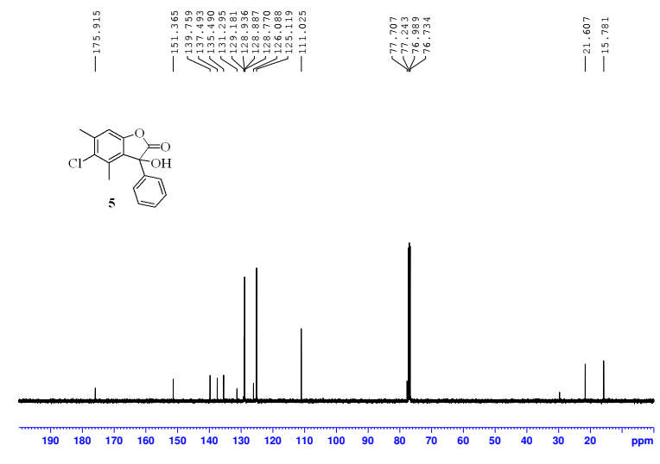
Fig. S28. ¹H and ¹³C NMR spectrum of 5.
Single crystal XRD data for compound 4ja (CCDC no. 2348642)

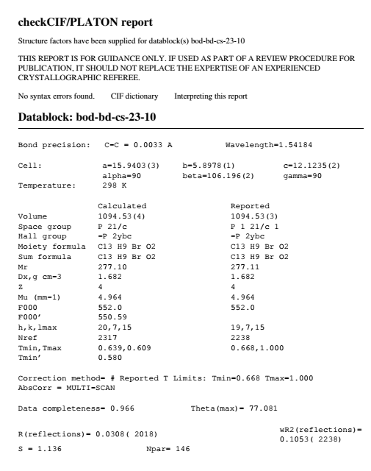
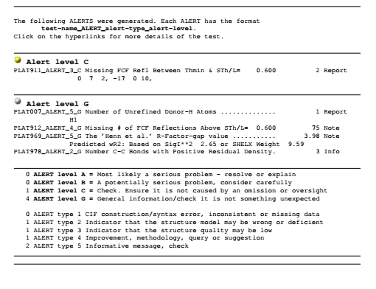
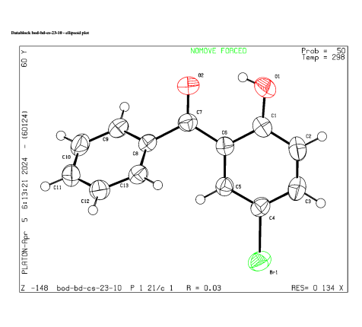

Table S2. Crystal data and structure refinement for 4ja (CCDC no. 2348642)

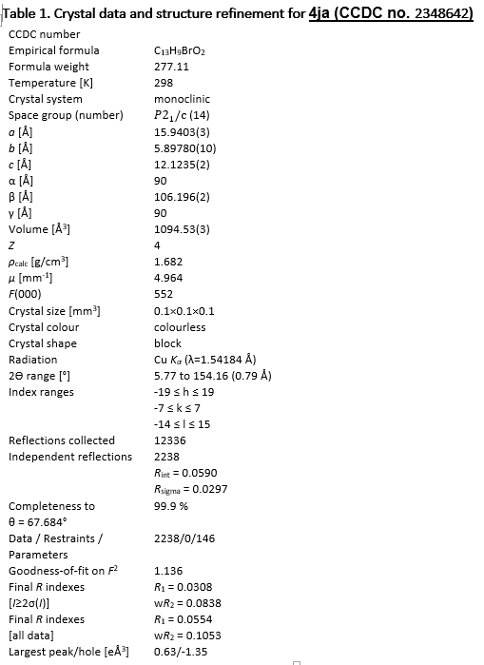

Table S3. Bond lengths and angles for 4ja (CCDC no. 2348642)

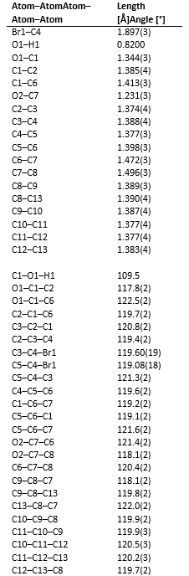

Table S4. Torsion angles for 4ja (CCDC no. 2348642).

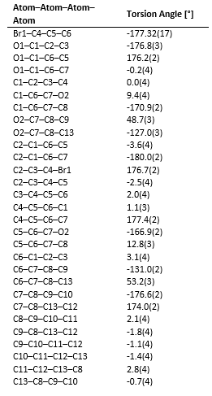

Single crystal XRD data for compound 4fb (CCDC no. 2348641)

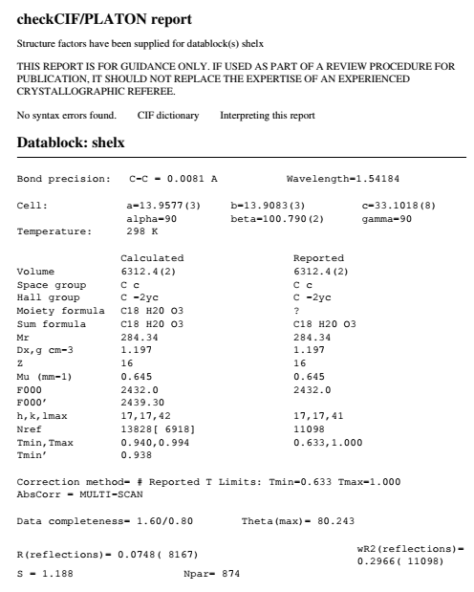

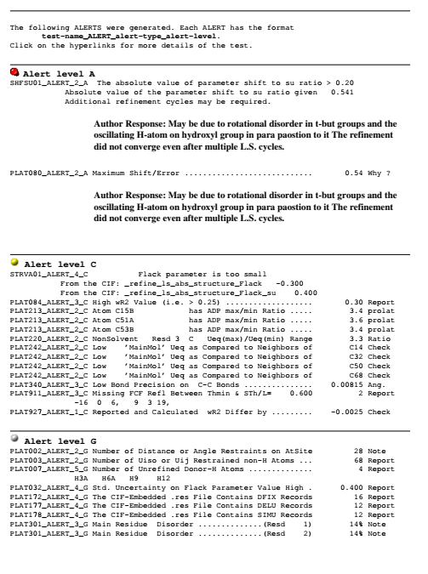
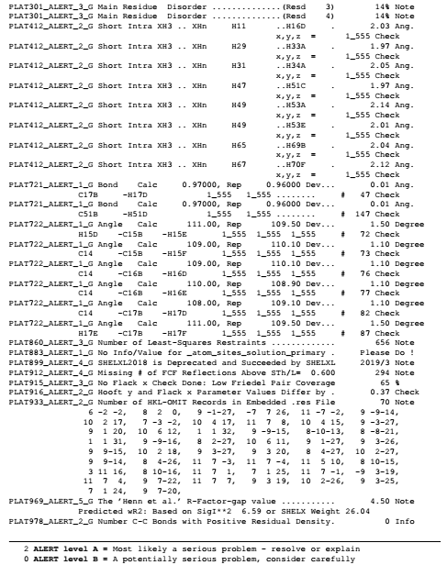
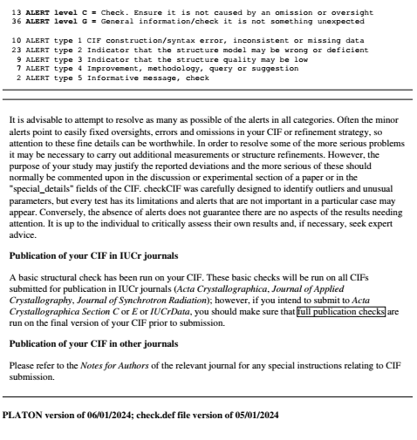
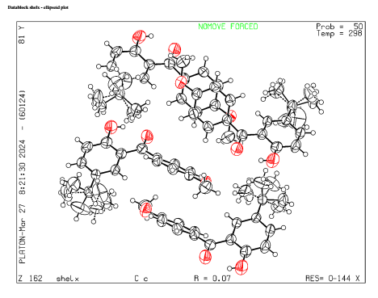

Table S5. Crystal data and structure refinement for shelx (4fb : CCDC no. 2348641)

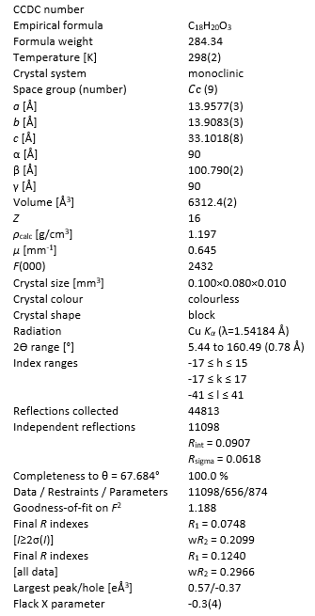

Table S6. Bond lengths and angles for shelx (4fb : CCDC no. 2348641)

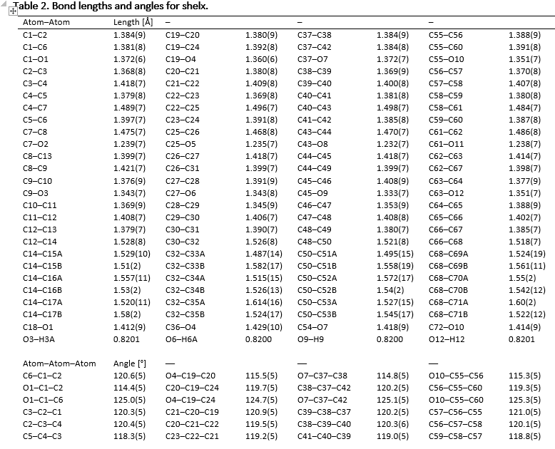
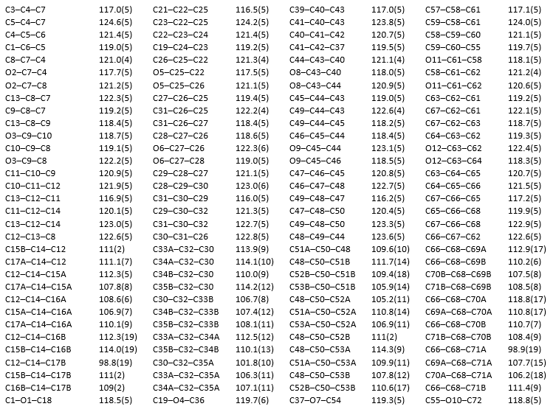

Table S7. Hydrogen bonds for shelx (4fb : CCDC no. 2348641)
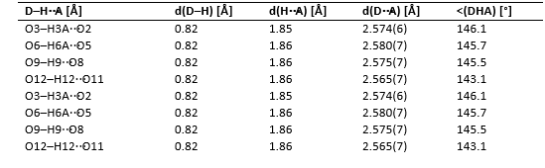
Table S8. Torsion angles for shelx (4fb : CCDC no. 2348641)
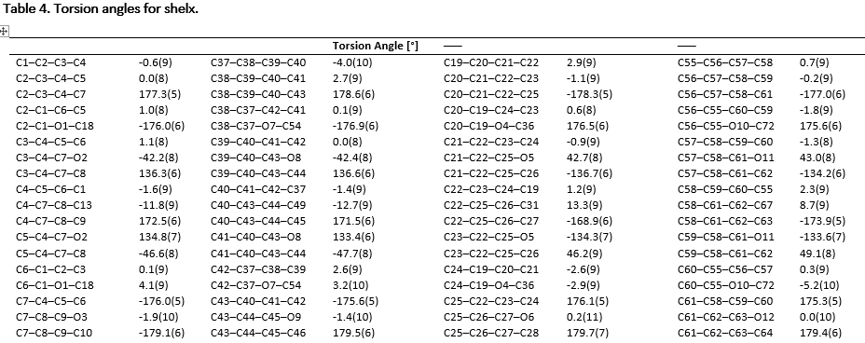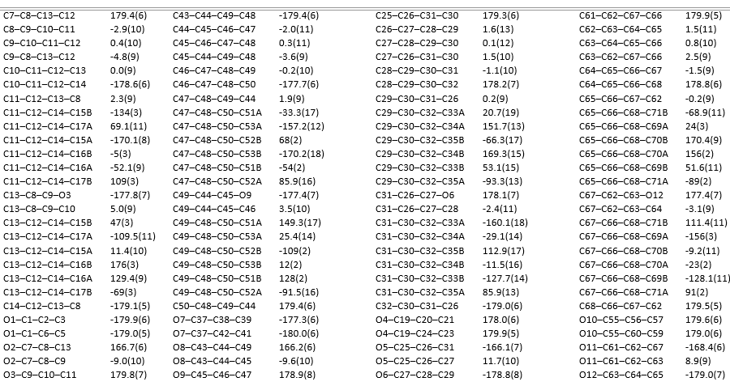

Single crystal XRD data for compound 4ma (CCDC no. 2348646)

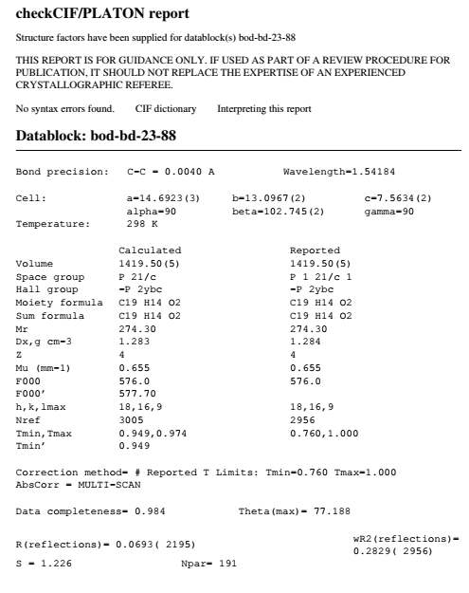
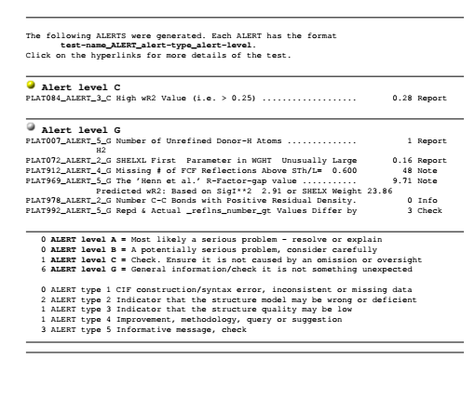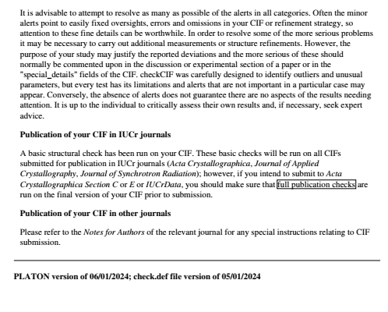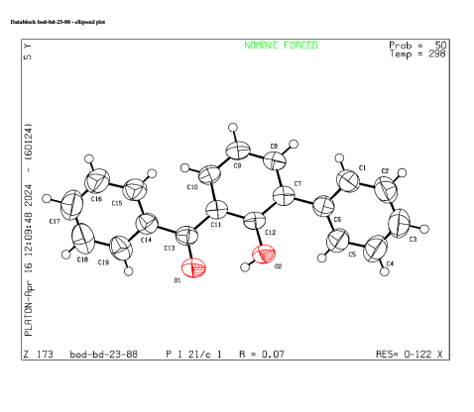

Table S9. Crystal data and structure refinement for 4ma (CCDC no. 2348646)

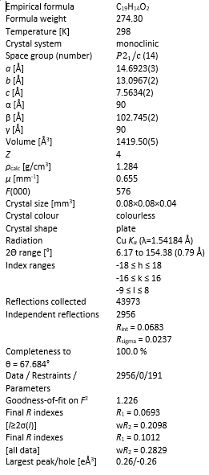

Table S10. Bond lengths and angles for 4ma (CCDC no. 2348646)
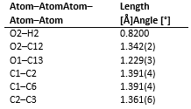 | 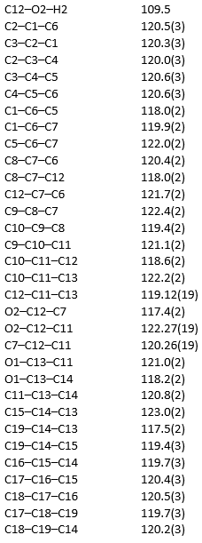
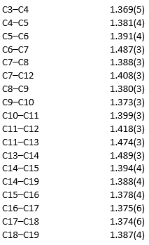

Table S11. Torsion angles for 4ma (CCDC no. 2348646)
