Supporting Information for:
Understanding the origin of stereoselectivity in the photochemical denitrogenation of 2,3-diazabicyclo[2.2.1]heptene and its derivatives with non-adiabatic molecular dynamics

Leticia A. Gomes¹ and Steven A. Lopez¹
¹Department of Chemistry and Chemical Biology, Northeastern University, Boston, Massachusetts, 02115, United States
Corresponding author: s.lopez@northeastern.edu

All optimized structures, output files for vertical excitation energy, MEP and dynamics (including energies, xyz, velocities for each trajectory) are available at https://doi.org/10.6084/m9.figshare.25326076

Table of Contents
Active Spaces 2
Dynamics Results 4

Active Spaces
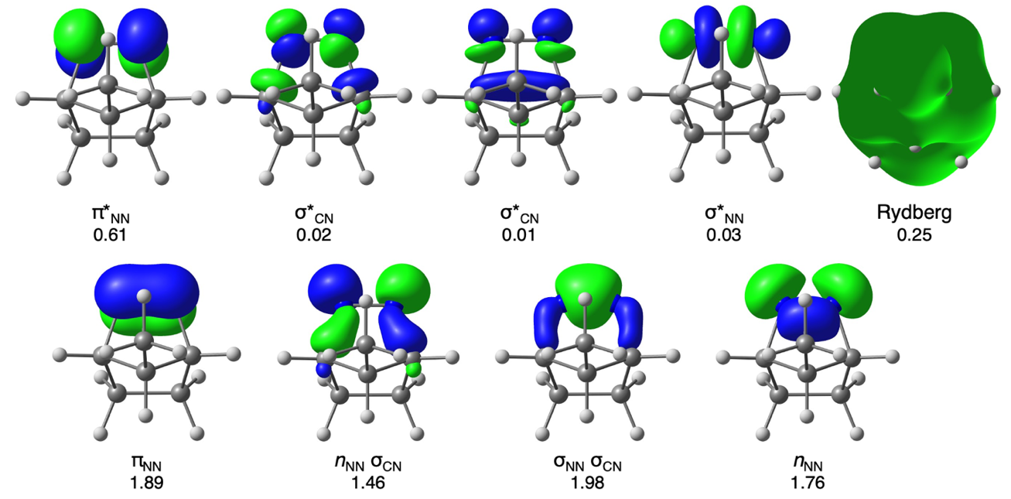
Figure S1. CASSCF(8,9) active space of 3 with average electron occupancies. Orbitals were calculated at the SA(4)-CASSCF(8,9)/ANO-S-VDZP level of theory. An isosurface value of 0.085 was used for all orbitals except Rydberg orbital, whose isosurface is 0.001.

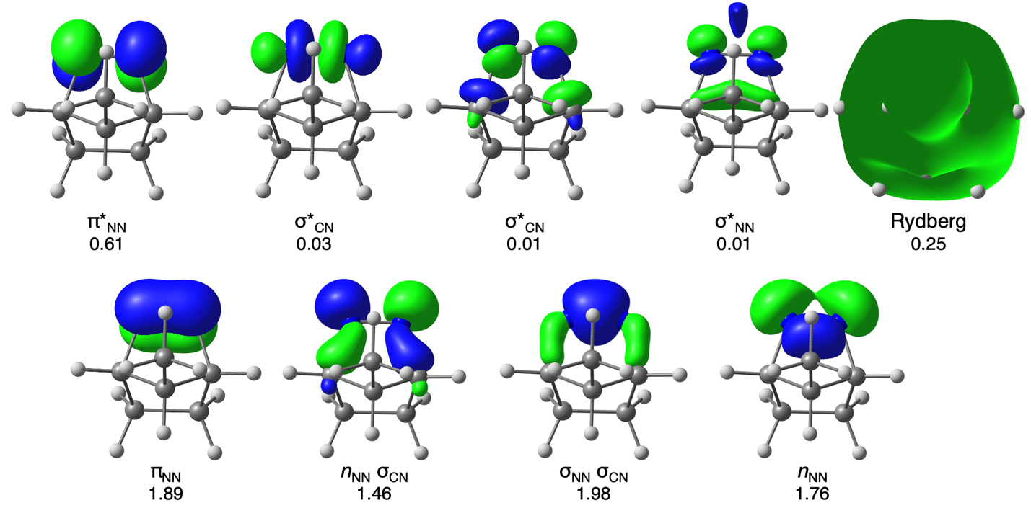

Figure S2. CASSCF(8,9) active space of 5 with average electron occupancies. Orbitals were calculated at the SA(4)-CASSCF(8,9)/ANO-S-VDZP level of theory. An isosurface value of 0.085 was used for all orbitals except Rydberg orbital, whose isosurface is 0.001.

Dynamics Results
Table S1 – Number of trajectories with 2000 fs that ended in each state for 1, 3, and 5 obtained with SA(4)-CASSCF(8,9)/ANO-S-VDZP.
Molecule | S₀ | S₁ | S₂ | S₃ | Total number of trajectories
1 | 350 | 2 | 0 | 0 | 352
3 | 390 | 6 | 0 | 0 | 396
5 | 289 | 3 | 0 | 0 | 292
The classification of the final product follows a hierarchical decision-making framework based on geometrical parameters, systematically filtering structures through progressively more specific criteria. The process begins by identifying reactants, defined as structures where both σ_{CN} values are less than 2.0, indicating no bond breaking. If this criterion is not met, the next classification step distinguishes 1-Bond species, where only one of the σ_{CN} values is less than 2.0, suggesting that the reaction is incomplete for trajectories ending on this geometry. Structures that do not fall into either of these categories are then evaluated for a Diradical classification, which is assigned when the σ_{CC} distance exceeds 2.0, indicating that no C–C bond has formed. In contrast, both σ_{CN} bonds have been broken. For structures that do not exhibit these bonding characteristics, the classification proceeds based on stereochemical parameters: if the H–C–C–C dihedral angle is less than 110.0 degrees, the product is categorized as retained housane, meaning it preserves its original stereochemistry. Finally, if none of the preceding conditions apply and the dihedral angle is equal to or greater than 110.0 degrees, the structure is classified as inverted housane, indicating a stereochemical rearrangement.
Table S2 – Number of trajectories with 2000 fs that ended in each species for S₀ of 1, 3 and 5 obtained with SA(4)-CASSCF(8,9)/ANO-S-VDZP.
Molecule | Inverted Housane | Retained Housane | Ratio Inverted/Retained | Diradical | Reactant
1 | 241 | 61 | 3.95 | 45 | 3
3 | 299 | 42 | 7.11 | 49 | 0
5 | 228 | 43 | 5.30 | 17 | 1

Figure S3. Population distribution for 1, 3 and 5 obtained with SA(4)-CASSCF(8,9)/ANO-S-VDZP.
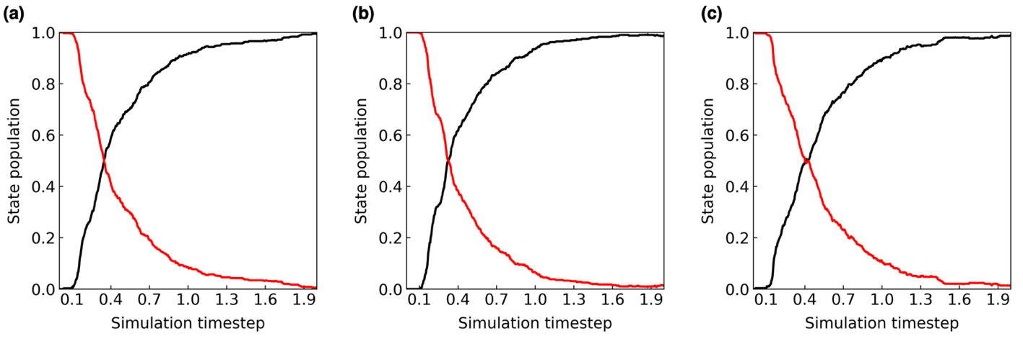
The time constant is 174 fs for 1 (a), 163 for 3 (b) and 201 for 5(c).
Table S3 – Number of trajectories with 1.5 ps for trajectories that ended initially on DR that ended in each species for S₀ of 1, 3 and 5 obtained with SA(4)-CASSCF(8,9)/ANO-S-VDZP.
Molecule | Inverted Housane | Retained Housane | Diradical | Reactant | Convergence issue | Not conserved
1 | 8 | 9 | 14 | 0 | 6 | 8
3 | 21 | 5 | 8 | 0 | 15 | 4
5 | 2 | 2 | 5 | 0 | 4 | 4

Table S4 – Energies in Hartree for each type of minimum energy conical intersection obtained with SA(4)-CASSCF(8,9)/ANO-S-VDZP for 1, 3 and 5
Molecule | Energy in Hartree
Molecule | MECI-PI | MECI-I
1 | -302.8904162 | -302.8849577
3 | -341.9334338 | -341.9265152
5 | -341.9318822 | -341.9287440

