# Supporting Information

# Supramolecular hydration structure of graphene-based hydrogels: density functional theory, green chemistry and interface application

Hon Nhien Le*1,4, Duy Khanh Nguyen5,6, Minh Triet Dang7, Huyen Trinh Nguyen3,4, Thi Bang Tam Dao1,4, Trung Do Nguyen1,4, Chi Nhan Ha Thuc*1,4 and Van Hieu Le*1,2,4

Address: 1Faculty of Materials Science and Technology, University of Science, Ho Chi Minh City, 700000, Vietnam, 2Faculty of Chemistry, VNUHCM University of Science, 227 Nguyen Van Cu Street, Ward 4, District 5, Ho Chi Minh City, 700000, Vietnam, 3Multifunctional Materials Laboratory, VNUHCM University of Science, 227 Nguyen Van Cu Street, Ward 4, District 5, Ho Chi Minh City, 700000, Vietnam, 4Vietnam National University, Linh Trung Ward, Thu Duc City, Ho Chi Minh City, 700000, Vietnam, 5Laboratory for Computational Physics, Institute for Computational Science and Artificial Intelligence, Van Lang University, Ho Chi Minh City, 700000, Vietnam, 6Faculty of Mechanical – Electrical and Computer Engineering, School of Technology, Van Lang University, Ho Chi Minh City, 700000, Vietnam and 7Faculty of Physics, School of Education, Can Tho University, Can Tho City, Viet Nam

Email: Hon Nhien Le - lhnhien@hcmus.edu.vn

Chi Nhan Ha Thuc - htcnhan@hcmus.edu.vn

Van Hieu Le - lvhieu@hcmus.edu.vn

* Corresponding author

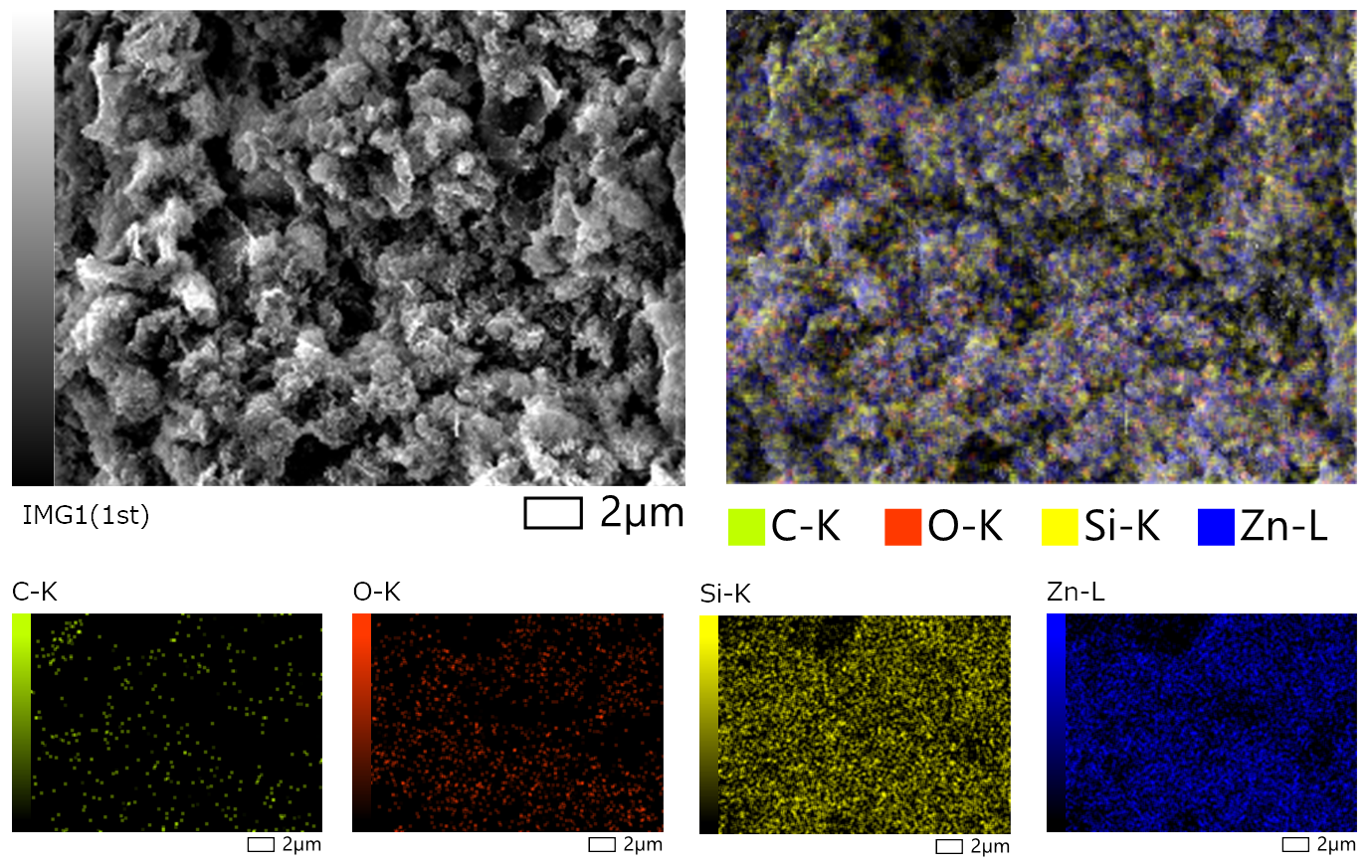

**Figure S1:** SEM-EDS elemental mapping of carbon atoms (green dots), oxygen atoms (red dots), silicon atoms (yellow dots) and zinc atoms (blue atoms) on the graphene-based nanostructures of GO-SG-ZH hydrogel after dehydration.

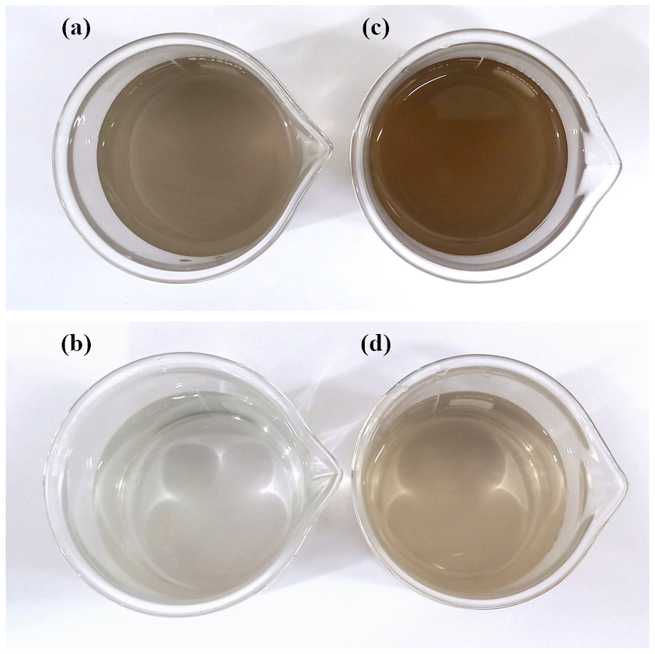

**Figure S2:** Aqueous dispersions of GO-SG-ZH powder in water at the concentrations of 200 ppm (a) and 50 ppm (b). Aqueous dispersions of GO-SG-ZH hydrogel in water at the concentrations of 200 ppm (c) and 50 ppm (d).

**Table S1:** Value results of tensile measurement of SG/PLA films.

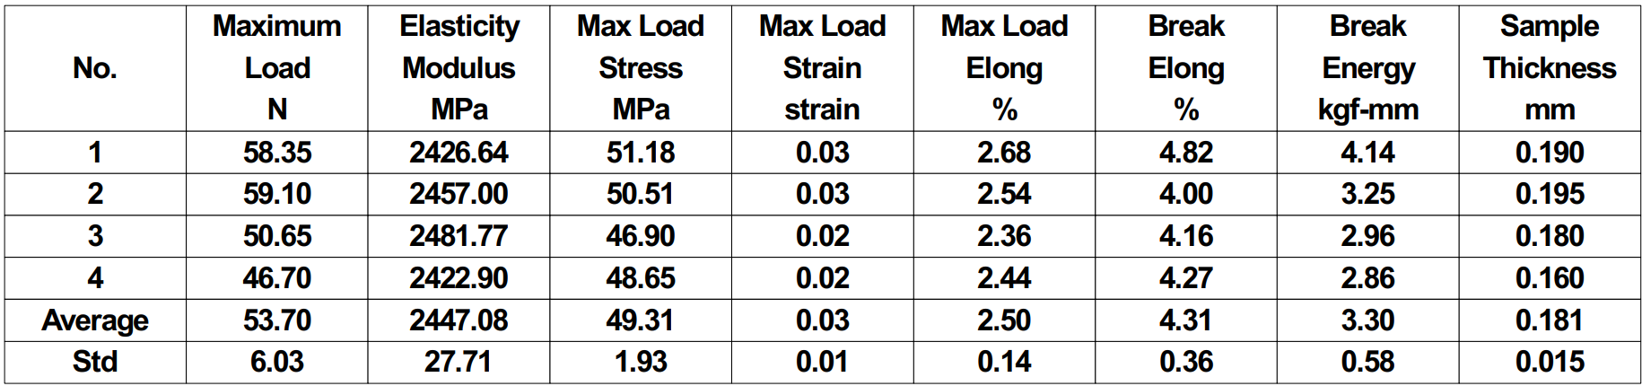

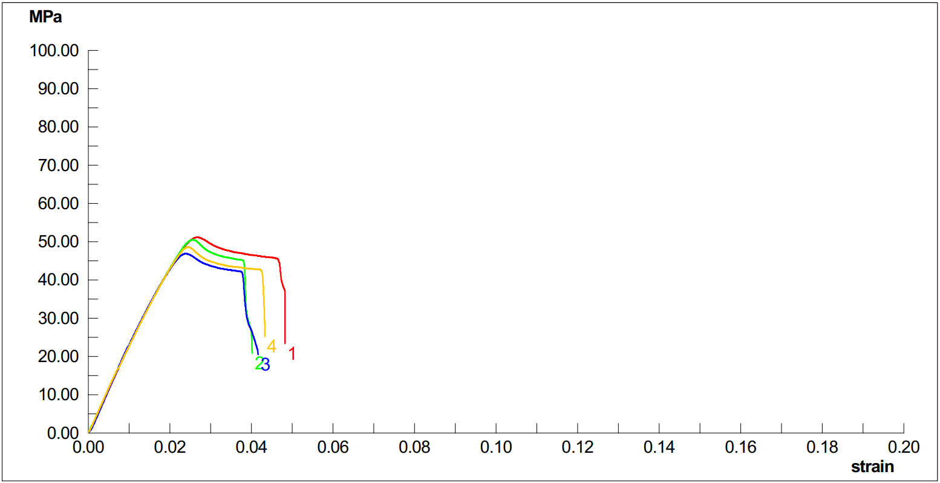

**Figure S3:** Stress – strain curves of tensile testing of SG/PLA films.

**Table S2:** Value results of tensile measurement of GO-SG-ZH/PLA films.

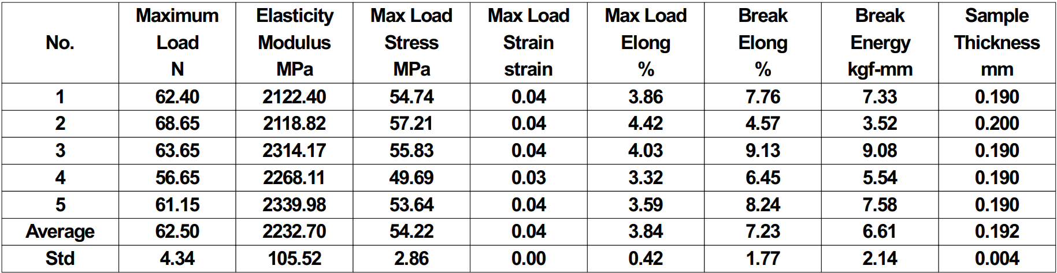

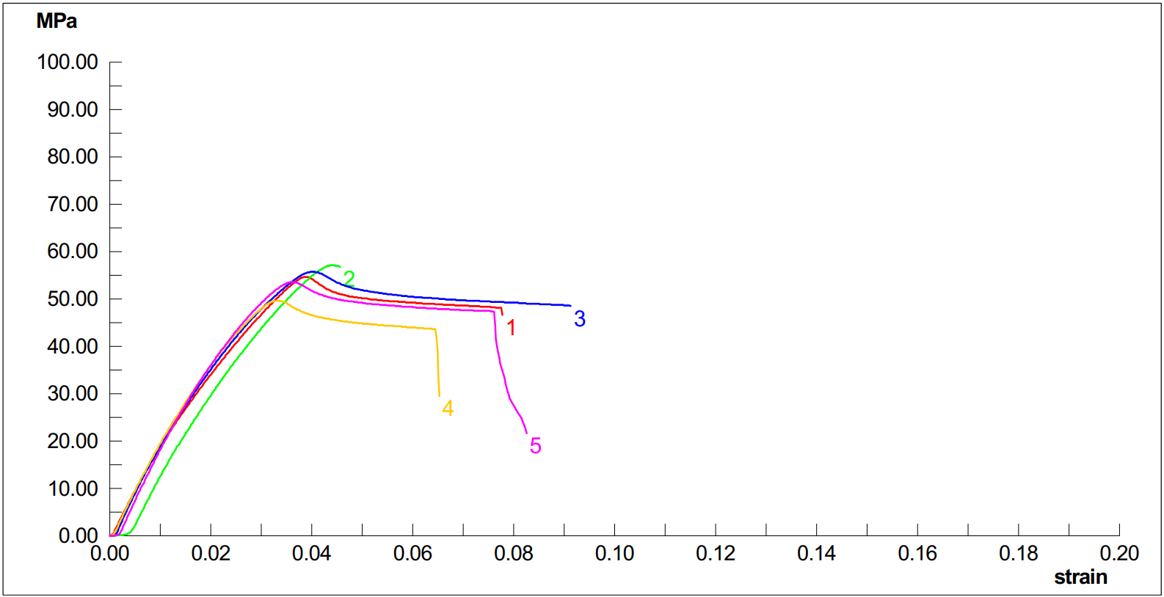

**Figure S4:** Stress – strain curves of tensile testing of GO-SG-ZH/PLA films.

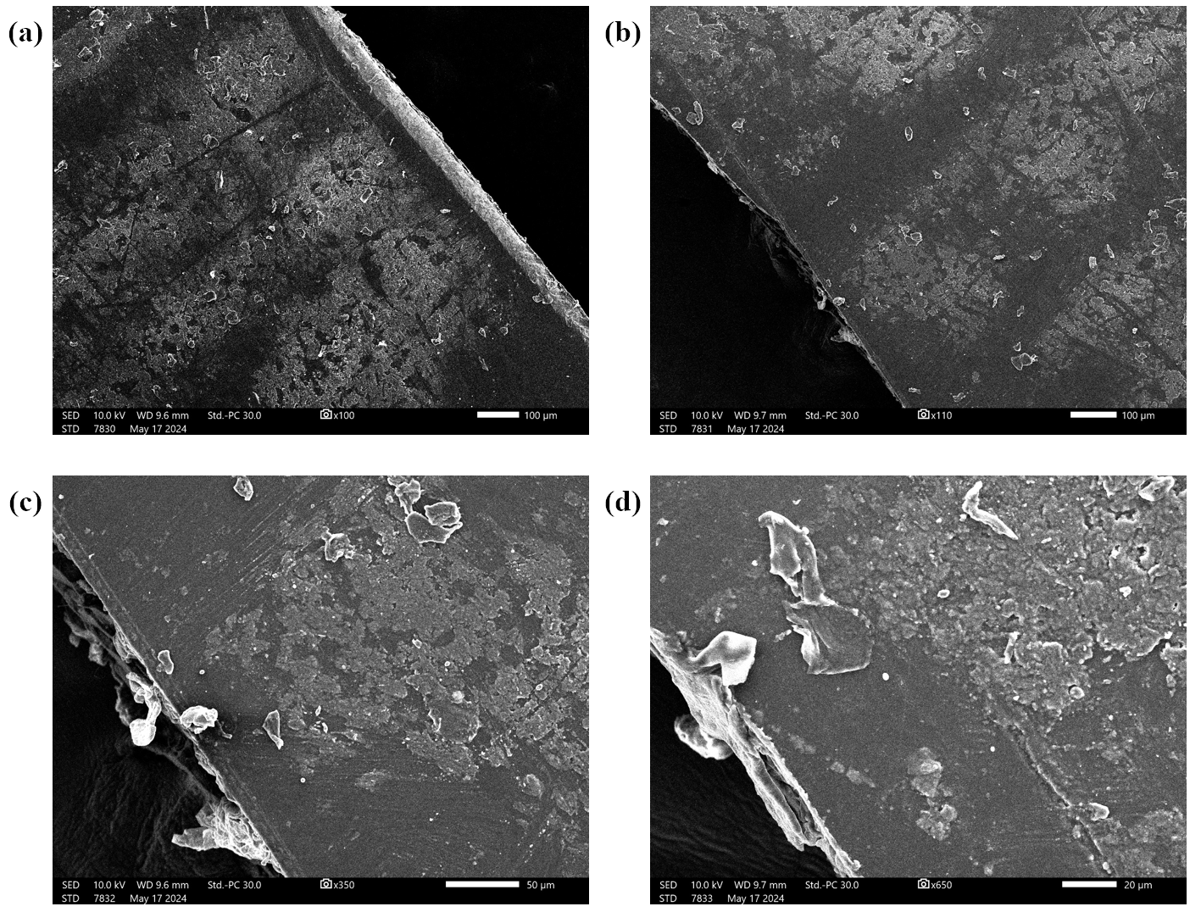

**Figure S5:** SEM images of surfaces and fractures of GO-SG-ZH/PLA films after tensile testing. The fractures were generated by the tensile measurement.